Air-sea Interaction from Space - Recent Results

W. Timothy Liu
MS 300-323, Jet Propulsion Laboratory, 4800 Oak Grove Drive,
Pasadena, CA, 91109, USA.

Tel: (1) 818-354-2394; fax: (1) 818-393-6720; email:liu@pacific.jpl.nasa.gov

Abstract

The status of satellite remote sensing of ocean-atmosphere exchanges is reviewed. Three on-going studies in air-sea interaction with potential impact are introduced. They include observation of intense biological bloom driven by typhoon with inference on global carbon cycle, new hypothesis on air-sea coupling without deep convection, and long-term trend in wind magnitude and meridional Ekman heat transport.

Keywords: winds, hurricanes, biological-productivity, carbon-cycle, heat-transport

Ocean-atmosphere Exchanges from Space

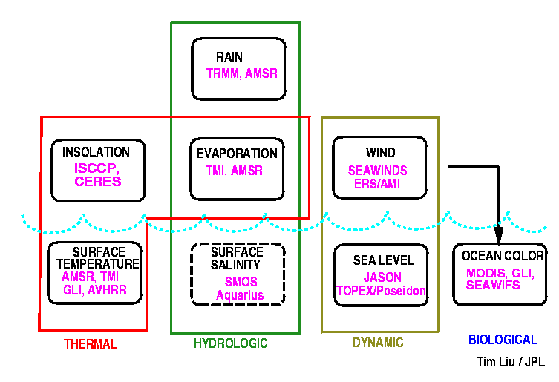
The ocean is forced at the surface largely through the exchanges of water, heat, and momentum. The exchanges drive the transport and change the storage of heat, water, and greenhouse gases, and thus moderate the world's climate. The ocean feedback to climate changes must be manifested through these exchanges, without which the Earth would be a more hostile habitat. We need to study air-sea exchanges to understand natural global changes and to discern the anthropogenic effects. The ocean and the atmosphere are under-sampled turbulent fluid with non-linear interactions; processes at one scale affect processes at other scales. Adequate observations at significant temporal and spatial scales can only be achieved from the vantage point of space.
Fig. 1 Schematic diagram of ocean surface forcing and oceanic responses, with corresponding spaceborne sensors

The atmospheric forcing and oceanic responses observed from space are summarized in Fig. 1. The momentum exchanges or the dynamic forcing of the ocean is the results of wind shear. The spacebased scatterometer is the only proven means of measuring wind speed and direction under clear and cloudy conditions night and day [Liu, 2002]. The dynamic response as ocean current is being measured by radar altimeters [Fu, 2001]. The thermal exchanges or heat flux can be divided into four components – the sensible heat flux resulting from the temperature gradient, the latent heat carried by evaporation, the short-wave radiation from the sun, and the long-wave radiation from the atmosphere and the ocean. Solar heating and evaporative cooling are the larger variable components. The variability of global surface net short-wave radiation (SR) is largely controlled by the variability of clouds, and most of the recent computations of SR over the ocean make use of data with high resolution sampled by geostationary satellites, through the International Satellite Cloud climatology Project (ISCCP). The Clouds and Earth’s Radiant Energy System (CERES) on the Tropical Rain Measuring Mission (TRMM) and NASA’s Earth Observing System (EOS) Platforms will advance the computation of the radiation forcing. Latent heat flux is usually computed from wind speed and sea-air humidity differences through bulk parameterization models or directly from the radiances measured by microwave radiometers such as the TRMM microwave imagers (TMI) and Advanced Microwave Scanning Radiometer (AMSR). New methods using neutral network to derive both sensible and latent heat fluxes have been attempted [Bourras et al., 2002 a, b; Jones et al., 2002]. The hydrologic forcing is the difference between precipitation (rain) and evaporation. TRMM, with its low-inclination orbit (higher sampling ate), opened up a new era of estimating both surface rainfall and rain profile [Kummerow et al., 1998]. Multiple AMSR on various platforms will extend TRMM rainfall measurements to higher latitudes.
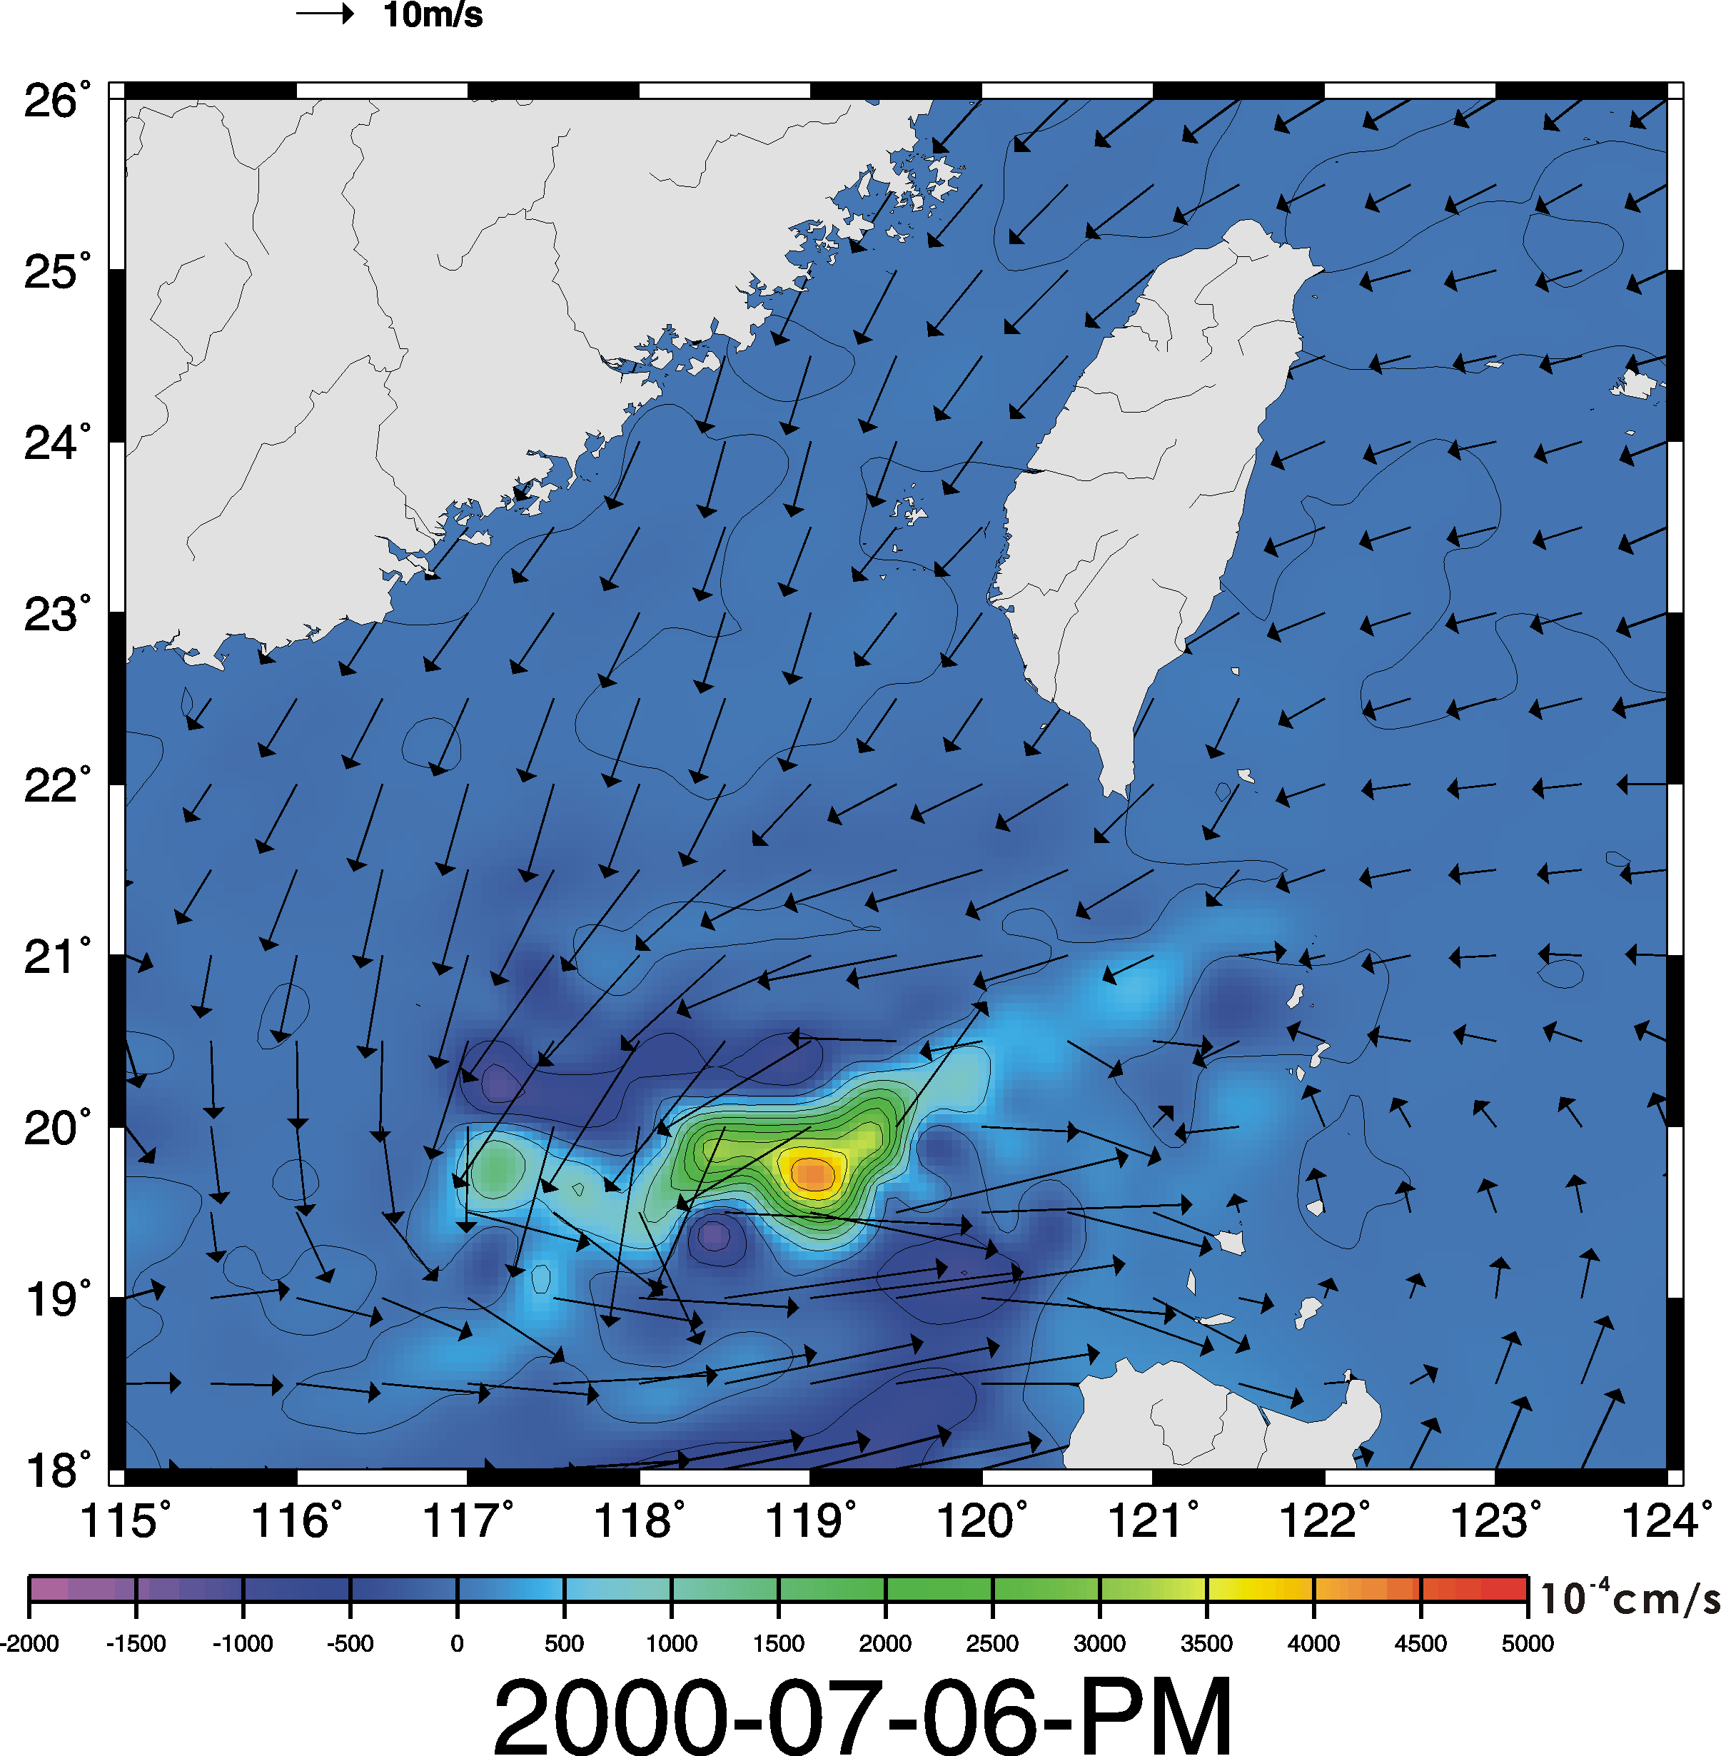
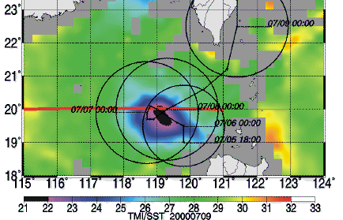
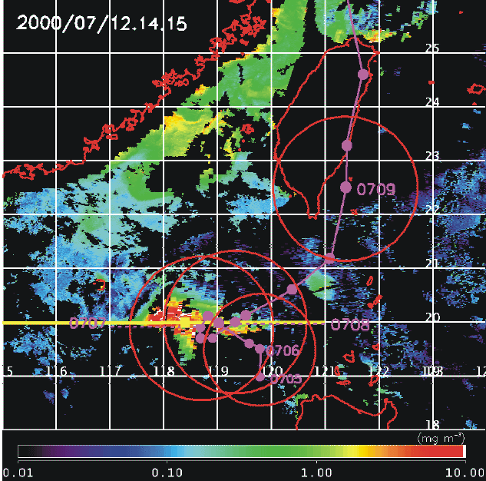
Fig. 2 Quikscat wind vectors superimposed on Ekman pumping velocity for July 6, 2000 (a); sea surface temperature from TMI for July 9, 2000 (b); Ocean color from SeaWifs for July 12-14.

A review of the remote sensing of ocean-atmosphere exchanges was given by Liu and Katsaros, 2001] and addressed by many of experts in this conference. In this report I will give three examples of breakthrough results in air-sea interaction.

Wind Forcing on Biogeochemical Balance

There has been intense search for new sources of external nutrient supply that contribute to sustaining the primary biological production in nutrient-poor (oligotrophic) surface waters, where traditional accepted mechanisms are insufficient. The vertical pumping of nutrient by transient tropical cyclones, with its intense wind vorticity, has been speculated as a possibility, but undocumented by observations. Tropical cyclones are non-stationary and violent; the oceanic responses cannot be tracked by ship or moorings. The all weather sea surface temperature (SST) from TMI has caused new revelation of the cold wakes left by hurricanes and typhoon. But there is almost no successful observational correlation between tropical cyclones and biological productivity

Typhoon Kai-Tak, with moderate intensity, was observed by QuikSCAT to linger at a near stationary slow speed in northern South China Sea (SCS), 5-8 July 2000. The slow movement and intense winds caused strong mixing and upwelling, with estimated Ekman pumping velocity reaching 0.4 cm/s at the typhoon location (Fig. 2a). TMI observed a 9°C cooling of SST immediately after the passage of the typhoon on 9 July 2000 (Fig. 2b), and 100 time increases (from 0.1 to 10 mg/m3) in chlorophyll-a (indicating biological activities), 5 day later (Fig. 2c). The Kai-Tak passage was found to generate 2-4% of the annual new production in SCS. This amount is highly significant, considering that there are , on average, 14 tropical depressions/ cyclones passing SCS annually. More comprehensive results and analysis are presented by Lin et al. [2002a].

Air-sea coupling without penetrative convection

At the major inter-tropical convergence zone (ITCZ) north of the equator, deep convection and surface wind convergence are co-located with high SST. Here the northerly and southerly trade winds, driven by surface pressure gradient, come together. Liu and Xie [2002] found weaker and year-round convergence zones south of the equator in parallel with the northern ITCZ, in both the Atlantic and Pacific, which are sustained by a different mechanism. The weaker ITCZ over cooler water is caused by the deceleration of the surface winds as they approach the cold upwelling water near the equator. Decreases in vertical mixing and increases in vertical wind shear in the atmospheric boundary layer are suggested to be the causes of the deceleration of the trade-winds as they move from warmer to colder water. The peak convergence does not co-located with local SST maximum. This model of tropical ocean atmosphere coupling through vertical mixing was first used by Xie et al. [1998] to explain the coherence between SST and surface wind in the tropical instability waves (TIW)-the westward propagating temperature front of the cold tongue. Liu et al. [2000] validated this model with rawindsonde measurements of a research cruise across the TIW, and with the phase difference between the wind components measured by QuikSCAT and SST from TMI. The same model was implied in a number of studies of TIW, including Wentz et al. [2000] who tested the model with the boundary parameterization of Liu et al. [1979], and Hashizume et al. [2002] who related boundary layer structure to pressure gradient using rawindsonde soundings.

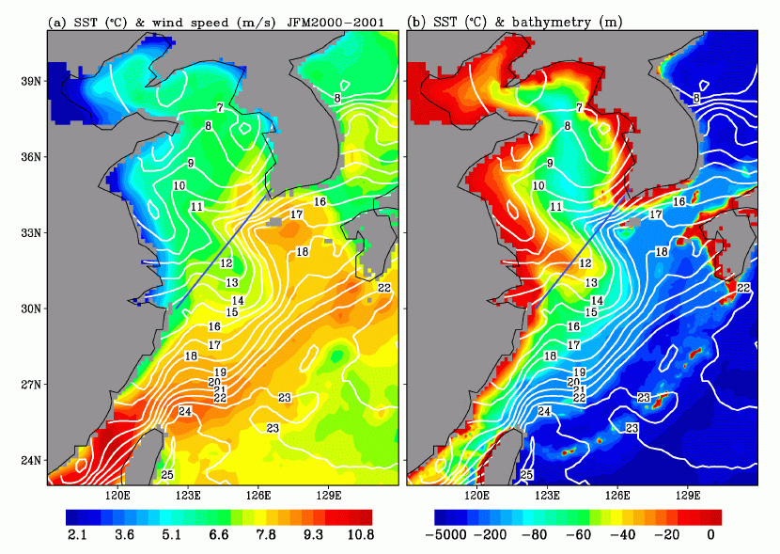
Similar relation between SST and surface winds appears to be much more prevalent. It was observed in the cold patches left behind typhoon passages [Lin et al., 2002b] and even over Gulf Stream rings [Park and Cornillon, 2002]. The vertical mixing mechanism appears to be applicable over a broad spectrum of temporal and spatial scales over different regions. Xie et al. [2002] demonstrate similar relation in the Asian marginal seas. Fig. 3a shows a strong warm tongue stretching from Cheju Island of South Korea, through the Yellow Sea to the Bohai Bay. It is separated from a similar warm tongue in East China Sea to the south by a cold tongue. The warm and cold tongues are associated with high and low winds. Fig. 3b shows that the warm tongues lie over deep channels. Under intense winter cooling, deep-water cools much slower because of thermal inertia, than shallow water, and hence stay warmer. Vertical mixing is a strong determining factor. Satellite data revealed ocean-atmosphere interaction trigger by submerged ocean topography during the winter cooling.
Fig 3 Isotherms (white lines) of sea surface temperature derived from TMI are superimposed on wind speed (color images) in (a) and over bathymetry in (b).

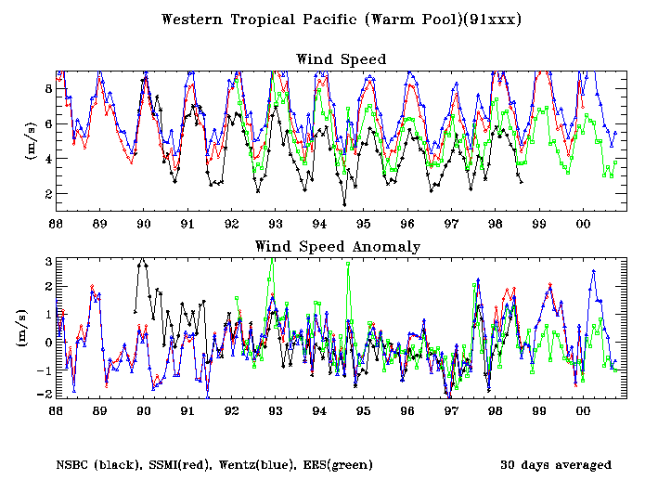
Fig. 4 Interannual anomalies of ocean surface wind speed average over ten C-Man buoy in the tropical pacific and collocated measurements by QuikSCAT and SSMI.

Intradecadal Weakening of Tradewinds and Ekman Heat Transport

Ocean plays a major role in moderation of the world’s climate through the meridional transportation of heat; a major portion of which, the Ekman heat flux (EHF), is driven by wind. El Nino (interannual anomalous warming in the equatorial Pacific) is believed to be caused by the collapse of the trade-winds. The trade-wind characteristics associated with El Nino have been largely described in terms of the zonal wind component near the equator measured at moored buoys and islands. The trade-wind system as a whole, which cover a large area in the Pacific, in relation to El Nino, has not been well-monitored

The long-term variation of the trade-wind system was examined by Liu and Tang[2001]. Fig. 4 shows an example of significant decreasing trend between the end of 1996 and the beginning of 1997, In this case, all three measurements, ERS scatterometer, the microwave radiometers on Special Sensor Microwave Imagers, and moorings, agree in the central tropical pacific. In somepart of the oceans, however, wind speed measurements by ERS and SSM/I do not show the same trend and there is no buoy measurements to compared. Using ERS scattereometer winds, Sato et al. [2002] show weakening of the magnitude of Ekman heat transport over global oceans during the same period of time, which would have significant climate impact.

Acknowledgments

This study was performed at the Jet Propulsion Laboratory, California Institute of Technology, under contract with the National Aeronautics and Space Administration (NASA). It was jointly supported by the Physical Oceanography Program, the TRMM Project, and QuikSCAT Project of NASA. Wenqing Tang, Xiaosu Xie, Olga Sato, I-I Lin, and Shangping Xie contribute to various components of the study.

References

Bourras, D., L. Eymard, and W.T. Liu, 2002: A neural network to extimate the latent heat flux over oceans from satellite observations. Int. J. Remote Sensing, 23, 2405-2423.
Bourras, D., L Eymard, W.T. Liu, H. Dupuis, 2002: Instantaneous near surface air temperature and sensible heat fluxes fields during the SEMAPHORE experiment using satellite data. J. Appl. Meteor, 41, 241-252.
Fu, L.-L.2001: Ocean circulatinand variability from lsatellite altimetry. Ocean Circulation and Climate. G. Siedler. J. Church, and J. Gould (eds), Ch. 3.3, 141-172, Academic Press, New York.
Hashizume, H., S.-P.Xie, M. Fujiwara, M. Shiotani, T. Watanabe, Y. Tanimoto, W.T. Liu, K. Takeuchi, 2002: Direct observations of atmospheric boundary layer response to slow SST variations over the eastern equatorial Pacific, J. Climate, in press.
Jones, C. P. Peterson, C. Gautier, and W.T. Liu, 2001: Satellite observations of specific humidity and air temperature over the tropical ocedans. Remote Sensing of Environment, submitted
Kummerow, C., W. Barnes, T. Kozu, J. Shiue, and J. Simpson, 1998: The tropical rainfall measuring mission (TRMM) sensor package. J. Atmos. Oceanic Tech., 15, 809-817.
Lin, I-I, W.T. Liu, C.-C. Wu, G. Wong, C. Hu, Z. Chen, W.-D. Liang, and K.-K. Liu, 2002a: The fertilization of the sea by a tropical cyclone. Nature, submitted.
Lin, I-I, W.T. Liu, C.-C. Wu, J.C. Chiang, and C.-H. Sui, 2002b: Space-based observations of modulation of boundary layer winds by typhoon-induced upper ocean cooling. Geophys. Res Lett., in press.
Liu, W.T., 2002: Progress in scatterometer application, J. Oceanogr., 58, 121-136.
Liu, W.T., and K.B. Katsaros, 2001: Air-Sea Flux from Satellite Data. Ocean Circulation and Climate. G. Siedler. J. Church, and J. Gould (eds), Ch. 3.4, 173-179, Academic Press, New York.
Liu, W.T. and W. Tang, 2001: Monitoring ocean surface wind vector from space. Eos, Trans. AGU, 82, F309.
Liu, W.T. and X. Xie, 2002: Double Intertropical Convergence Zoens – a new look using scatterometer. Geophys. Res. Lett., in press.
Liu, W.T., K.B. Katsaros, and J.A. Businger, 1979: Bulk parameterization of air-sea exchanges of heat and water vapor including the molecular constraints at the interface. J. Atmos. Sci., 36, 1722-1735.
Liu, W.T., X. Xie, P.S. Polito, S. Xie, and H. Hashizume, 2000: Atmosphere manifestation of tropical instability waves observed by QuikSCAT and Tropical Rain Measuring Missions. Geophys. Res. Lett., 27, 2545-2548.
Park, K-A., and P. Cornillon, 2002: Stability-induced modification of sea surface winds over Gulf Stream rings. Geophys. Res. Lett., in press (2002GL014236)
Sato, O., P.S. Polito, and W.T. Liu, 2002: Interannual and intra-decadal variability in the Ekman heat flux from scatterometer winds. Geophys. Res. Lett., in press.
Wentz, F.J., C. Gentemann, D. Smith, D. Chelton, 2000: Satellite measurements of sea surface temperature through clouds. Science, 288, 847-850.
Xie, S.-P., M. Ishiwatari, H. Hashizume, and K. Takeuchi, 1998: Coupled ocean-atmosphere waves on the equatorial front. Geophys. Res. Lett., 25, 3863-3866.
Xie, S.-P., J. Hafner, Y. Tanimoto, W.T. Liu, H. Tokinaga, and H. Xu, 2002: Bathymetric effect on the winter climate of the Yellow and East China Sea., Geophys. Res. Lett., submitted.

