Ocean Script by NOAA/ESRL/GSD

Intro: Earth Color One
1. Argo Buoy Tracks
-pip: Argo schematic
2. Sea Currents Model
3. Sea Surface Temperature Model
4. Sea Ice
5. Loggerhead Sea Turtles
-pip: Sea Turtle
6. SeaWiFS
-pips: phytoplankton
7. El Nino/La Nina
8. Tsunami
-pips: hazard signs
Tsunami Warning System in the Pacific
Close: Blue Marble

Intro: Earth Color One
The ocean is vast. 71% of the Earth’s surface is covered by the ocean and more than half of that area is over 9000 ft deep. The deepest part of the ocean, the Challenger Deep in the Marianas Trench, is 35, 840 feet below sea level. That’s almost 7 miles deep! So much about the ocean has been discovered through exploration and research, but the ocean still holds many more mysteries to solve and new areas to explore. This exploration and discovery is important because the ocean affects everyone, even people who don’t live anywhere near the ocean.

Argo Buoy Tracks
In order to learn more about the ocean, more information is needed. Collecting data from the ocean can be a daunting task due to its overwhelming size. Scientists need data from the whole ocean, not just the areas where it’s convenient, such as close to the shore. And not only do they need surface data, but they also need data from below the sea surface. It’s improbable to have people constantly collecting data from all over the ocean at all different depths. To complete this seemingly impossible task, oceanographers from around the world have worked together to create the Argo Buoy Network. This network of buoys, numbering 3000, is providing continuous information from the upper 6500ft of the ocean. The buoys, represented by the green dots, are placed roughly 185 miles apart and collect information about the temperature, salinity and velocity of the upper ocean. This network is providing unprecedented amounts of global information from the ocean.
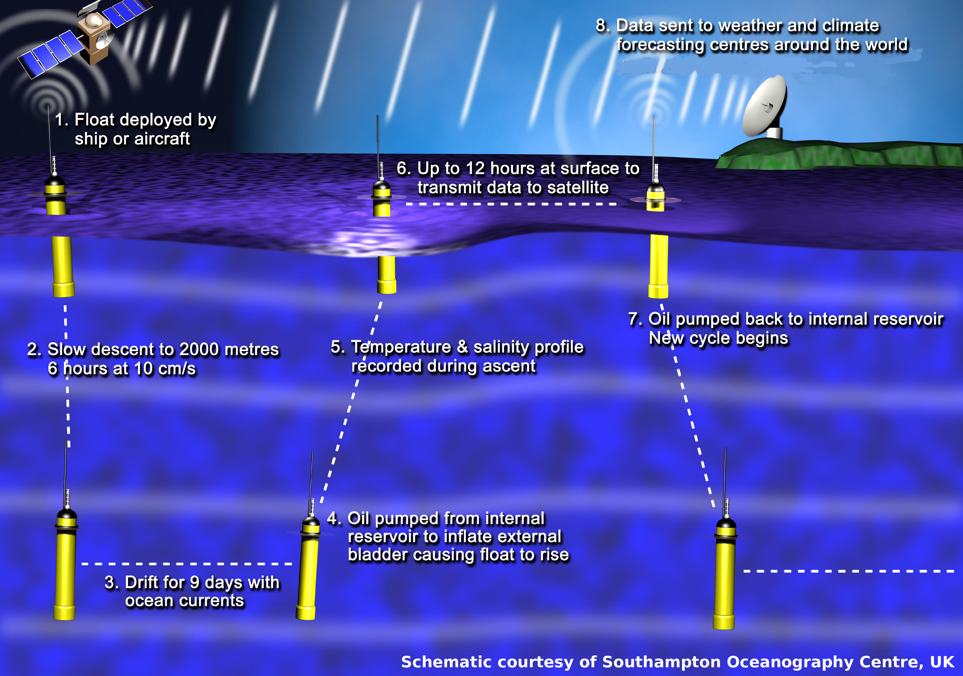
PIP: The buoys spend most of their time free floating at a depth of 6500ft. For nine days a buoy floats at this depth and collects data. After this time, the buoy rises to the surface, collecting data as it goes. Once at the surface, the buoy transmits the collected data to a satellite and then sinks back down to 6500ft to start over again. The whole cycle takes about 10 days.

The horizontal movement of the buoys is controlled only by the ocean currents. Some buoys can be seen moving slowly, while others move quickly. This is because the ocean currents vary in speed across the globe.

Ocean Currents
The ocean is not a still body of water, but is constantly in motion, as seen here. The color-coding in this animation represents the speed of the water. The green areas are fast moving currents. The currents can be traced all the way around the globe providing a good picture of how the oceans are globally connected. The surface currents, seen here, are driven mainly by the wind. Currents below the surface are driven by differences in the temperature and salinity of the ocean. The currents tend to travel along the equator and split when they reach obstacles, such as islands or continents. The water along the equator is very warm, and when the equatorial currents are forced to move north or south due to an obstacle, they bring that warm water with them. This transport of warm water is responsible for keeping some areas at high latitudes warm. The ocean is a huge reservoir of heat which not only keeps the water warm, but also warms the atmosphere, allowing the global ocean currents to play a significant role in the global climate. If the currents were to suddenly stop, many countries would experience significant temperature changes. A good example of this is the Gulf Stream along the eastern coast of the United States. The Gulf Stream is like a river of warm water in the ocean. This river flows along the coast of the United States and then crosses the Atlantic Ocean over to Europe. Many European countries have relatively temperate climates due to the inflow of heat from the Gulf Stream. Parts of Europe would become cooler if the Gulf Stream were to suddenly stop.

Sea Surface Temperature
This transport of heat by the ocean currents can be seen clearly in this animation of sea surface temperature. Here, the temperature of the ocean over the course of a year is displayed. The temperature of the ocean can vary from freezing, denoted by the blue shading to over 80°F, represented by the red shading. The Gulf Stream shows up as tongue of warm water along the eastern coast of the United States. Also, the warmer water can be clearly seen mixing with the cooler water in eddies or small whirlpools. Typically the coldest water is at the poles with the warmest water at the equator. Through the year however, the location and magnitude of the warmest and coldest water shifts north and south due to the seasons. During summer in the Northern Hemisphere the sun heats the water north of the equator, causing the water to slowly warm. Water warms up and cools down at a slower rate than air, so diurnal variations, which are the result of heating during the day and cooling during the night, that are seen in the atmosphere are hard to observe in the ocean. This allows us to easily observe the seasonal variations.

Sea Ice from 1987 – 2007
The seasonal variations in the ocean are also unmistakably displayed in the presence of sea ice. At least 15% of the ocean is covered by sea ice during some part of the year. Because summer in the Northern Hemisphere is winter in the Southern Hemisphere, the North Pole has a minimum in sea ice concentration when the South Pole has a maximum in sea ice concentration and vice versa. The minimum at the North Pole typically occurs in September while the minimum at the South Pole typically occurs in March. This dataset is from the National Snow and Ice Data Center which collects data and monitors the condition of the sea ice. These images were taken with a special sensor on a satellite. This dataset starts in 1987 and runs through 2007. The concentration of the ice changes drastically from season to season, and there is an overall change in the ice from year to year. The amount of ice in the Northern Hemisphere has been decreasing over the past several years, while the amount of the ice in the Southern Hemisphere hasn’t experienced that kind of change. As the ocean temperature continues to change, the sea ice will experience changes as well.

Loggerhead Sea Turtles
Sea ice is not the only thing that is affected by changing ocean temperatures. Many of the animals in the ocean depend on the temperature of the ocean remaining constant. Because the temperature of the ocean varies with the seasons, many animals migrate to stay in waters that are a comfortable temperature to them. By tagging animals with tags that transmit their location via satellite, researchers are able to the monitor the migration patterns of the animals. For this dataset, researchers tagged loggerhead sea turtles and then monitored them between 1997 and 2006. This animation represents a daily average of the sea turtle movement independent of the year. The size of the turtle icon is proportional to the turtle’s actual length. In the area where the turtles are, the ocean has been color coded according to the temperature of the sea surface. The loggerhead sea turtles stay in a very narrow temperature band and move their migration paths north and south to remain in waters of the same temperature throughout the year. Research from the National Marine Fisheries Service has shown that these turtles use surface chlorophyll and temperature gradients to determine their migration habits.
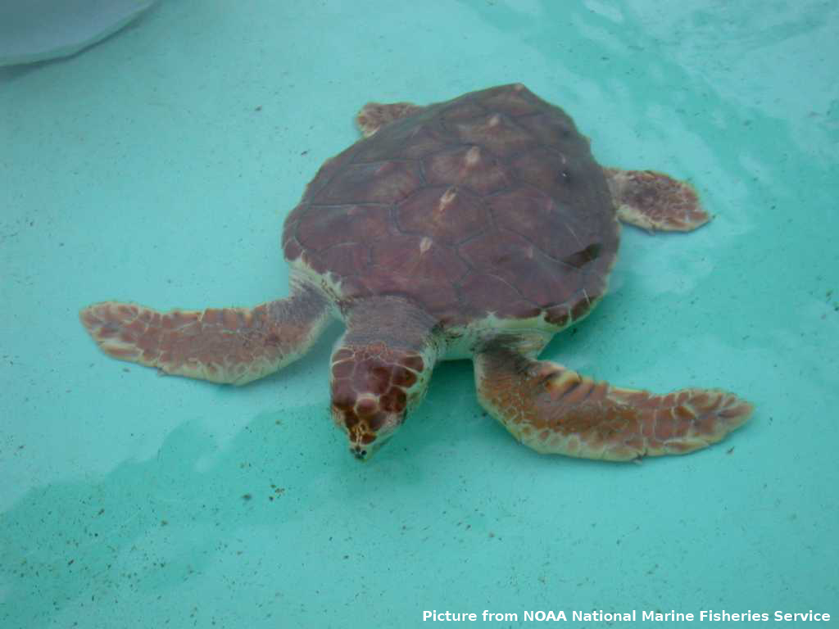
(PIP will be shown the entire time)

SeaWiFS
The location of chlorophyll in the ocean changes with the seasons, just like the temperature. What you are now looking at is the presence of chlorophyll in the ocean over the course of one year, as detected by a satellite. The green to red areas have high concentrations of chlorophyll, while the blue areas have very little chlorophyll. Chlorophyll is the green pigment in plants that captures energy from the sun. In the oceans, the presence of chlorophyll indicates the presence of phytoplankton, microscopic organisms that are abundant in the ocean. Sea turtles and many other ocean animals care about the presence of phytoplankton because it is the base of the ocean’s food chain. The world’s richest fisheries are in locations where the phytoplankton concentrations are high.
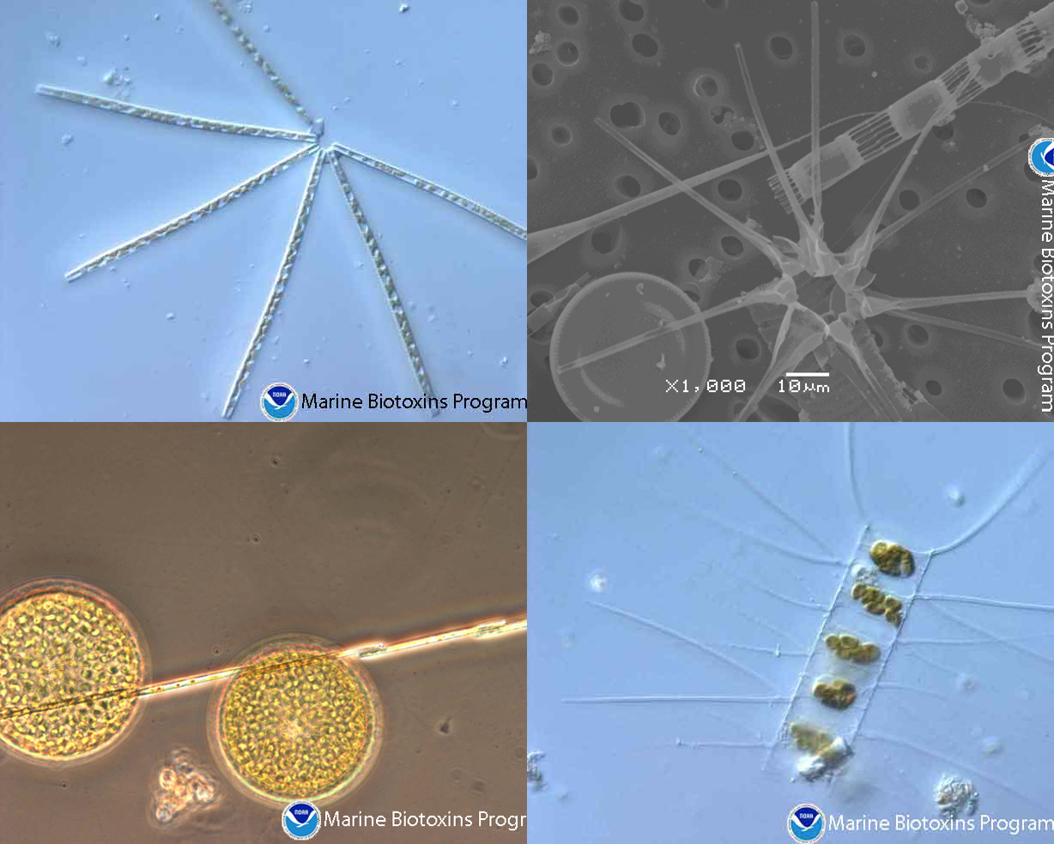
PIP: Phytoplankton collage
Phytoplankton can take on many different forms, as seen here. Not only do phytoplankton serve as the base of the ocean’s food chain, but they also play a significant role in oxygen production. Just like any other plant, phytoplankton remove carbon dioxide from the atmosphere and produce oxygen. Scientists estimate that the world’s phytoplankton produce between 50% and 90% of the oxygen that we breathe! The presence of phytoplankton in the ocean is affected not only by the seasons, but also by large scale changes in the ocean such as El Nino. By using satellite images like the ones used here, researchers have discovered that phytoplankton decline during El Nino due to a lack of available nutrients in the water and flourish during La Nina due to an abundance of nutrients in the water.

El Nino
During El Nino, the waters off of South America highlighted here, experience warmer than normal temperatures. Areas that are red are warmer than normal while blue areas are cooler than normal. Seen here is one of the strongest El Nino’s on record. It lasted from March of 1997 through June of 1998. Besides affecting the presence of phytoplankton in the ocean, El Nino also impacts the global climate. During a strong El Nino most of the United States has a wetter than normal season, while other parts of the world experience drought. Indonesia and the Philippines, for example, are drier than normal during El Nino and have increased risk of forest fires.

La Nina
The opposite of El Nino is La Nina. During La Nina, the waters off of South America are cooler than normal. The same color convention is used here, red is warmer than normal and blue is cooler than normal. During the La Nina event seen here, the cool waters extend well into the Pacific Ocean. This La Nina lasted from February of 1988 through December of 1989. The effects of La Nina are opposite of El Nino. The United States tends to be drier than normal while other parts of the world can experience major flooding events. By affecting the climate, the ocean affects everyone, even those who don’t live near the ocean.

Indian Tsunami
While El Nino and La Nina are examples of how the ocean can impact our lives indirectly, tsunamis are an example of how the ocean can impact lives directly. A tsunami is a series of waves generated when a body of water, such as an ocean, is rapidly displaced on a massive scale. This animation is a model of what happened on December 26, 2004. On the morning of the 26th an earthquake with a magnitude of at least 9.0 on the Richter scale occurred, displacing a huge amount of water, causing a tsunami. The resulting wave propagated out with incredible speed. Over deep water, the waves of a tsunami are very shallow and travel very fast. However, as the ocean gets shallower close to land the waves slow down and build up. Wave heights of over 30 feet were reported during this event. It is estimated that 250,000 people lost their lives in this single event.
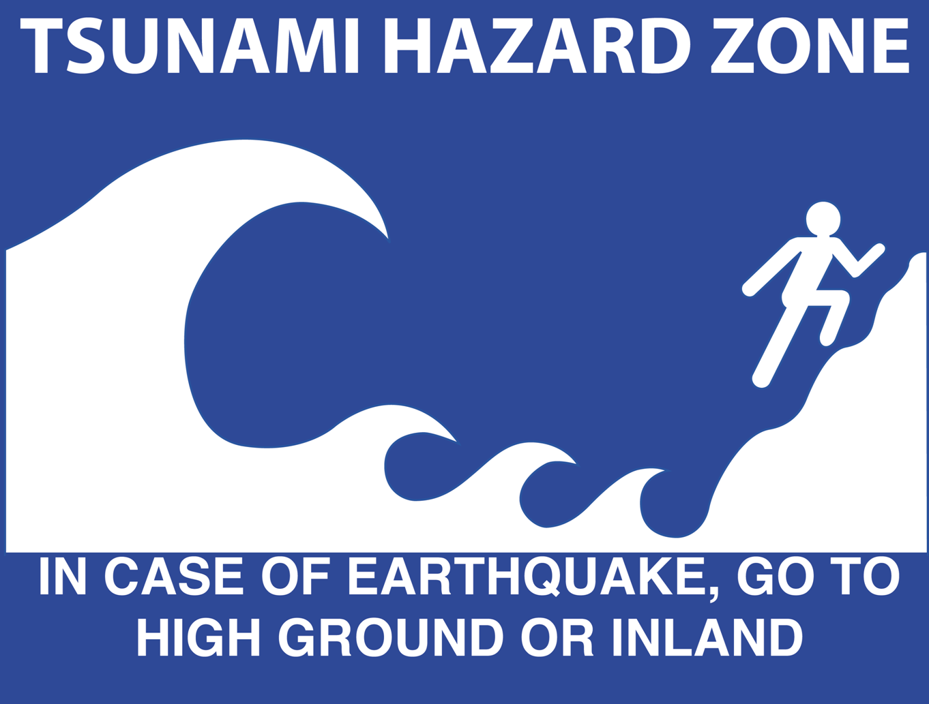
PIP: Tsunami Warning Sign
Two main reasons for the widespread devastation were the lack of a warning system and the lack of understanding about tsunamis. Previously thought unnecessary in the Indian Ocean because the last major tsunami was in 1883, efforts are underway to improve a warning system and prepare people for the next tsunami. This is an example of the signs that the Tsunami Warning System of the Pacific posts in areas that are prone to tsunamis. The best thing to do if a tsunami ever occurs near you is to seek higher ground. The first sign of a tsunami is receding waters. Wandering out to explore the exposed sea floor is the worst place to be because after the water recedes, it rushes back in as a powerful wave. Seeking high ground is the safest thing to do.

Blue Marble
The ocean has tremendous power and influence, playing a role in the climate, the food chain, and even some natural disasters. Through exploration and discovery, we have learned so much about the ocean and its impact on people and the environment. But there is still so much more to learn about our oceans. Advances in science, such as satellite monitoring of the ocean and improved buoy networks, are helping to pave the way.

