Condition Data Questions

What are the following land use codes?:

- Accessible timberland
    - 01
    - 02
    - 03
    - 20

- Improved pasture
    - 10
    - 12
    - 62
    - 90

- Non-census water
    - 40
    - 41
    - 91
    - 92

- Census water
    - 40
    - 41
    - 91
    - 92

- Improved road
    - 67
    - 30
    - 31
    - 32

- Campground
    - 67
    - 33
    - 31
    - 30

- House and yard
    - 67
    - 30
    - 31
    - 90

- Wildlife food plot
    - 10
    - 11
    - 16
    - 61

- Census water
    - 40
    - 41
    - 91
    - 92

- What is the Owner Group code for state owned land?
    - 10
    - 20
    - 30
    - 40

- What treatment codes are recorded on a pine plantation condition class that has been thinned, pruned, fertilized, and herbicided (Stand Size Class = 2).
    - 14 and 50
    - 14 and 20
    - 14, 20, and 50
    - 12 and 50

- How many years are added to an increment sample at 4.5 feet to determine stand age?
    - Longleaf pine- 7 years; other pines- 3 years; hardwoods- 2 years
    - None, just record the age at 4.5 feet
    - Add 5 years for all species

- How do you determine the new past classifications?
    - Record the same classification as the previous crew
    - Apply the current procedures and use best judgment to determine the new past land use

- How do you determine the Old Land Use code?
    - Record the same classification as the previous crew
    - Apply the current procedures and use best judgment to determine the new past land use

- If your subplot falls in a woodlot that is ½ acre in size and is surrounded by acres of pasture, what is the Condition Status and Present Land Use?
    - Condition Status = 2, Land Use = 01
    - Condition Status = 2, Land Use = 12
    - Condition Status = 1, Land Use = 12
    - Condition Status = 2, Land Use = 02
What are the Forest Type codes for the following?:

- Longleaf pine/oak
    - 43
    - 403
    - 141
    - 21

- Post oak/blackjack oak
    - 59
    - 520
    - 51
    - 501

- Loblolly pine
    - 406
    - 131
    - 31
    - 161

- White oak/red oak/hickory
    - 53
    - 504
    - 505
    - 503

- What is the minimum area for nonforest land (other than developed nonforest)?
    - 120 feet wide and 4.5 acres
    - 120 feet wide and 1.0 acre
    - 200 feet wide and 4.5 acres
    - 200 feet wide and 1.0 acre

- What is the minimum size of a non-forest developed land use?
    - 30 feet wide and 4.5 acres
    - 120 feet wide and 1.0 acre
    - 200 feet wide and 4.5 acres
    - No minimum size

- What is the minimum size of census water?
    - 120 feet wide and 4.5 acres
    - 120 feet wide and 1.0 acre
    - 200 feet wide and 4.5 acres
    - 200 feet wide and 1.0 acre

- What is the minimum size of non-census water?
    - 30 feet wide and 4.5 acres
    - 120 feet wide and 1.0 acre
    - 200 feet wide and 4.5 acres
    - 30 feet wide and 1.0 acre

- What are the minimum size requirements for a hazardous condition?
    - 30 feet wide and 4.5 acres
    - 120 feet wide and 1.0 acre
    - 200 feet wide and 4.5 acres
    - No minimum size

- Which one of the following variables does NOT define a within forest condition change?
    - Stand Size
    - Owner Class
    - Regeneration Status
    - Reserved Status

- Which one of the following scenarios does Stand Size serve as the basis for delineating separate conditions on a subplot?
    - Nonstocked forest vs. Nonforest land
    - Seedling/sapling stand vs. pole size stand
    - 18” pine stand vs. 35” pine stand
    - Nonstocked forest vs. seedling/sapling stand

- Which of the following statements regarding Similar Identified Condition is true?
    - If Similar Identified Condition = 0, then most of the condition level items do NOT need to be recorded for the condition
    - If two forest areas are identical in all aspects, but one is reverted, then lump both of the forest areas into one condition and record Similar Identified Condition = 1
    - Similar Identified Condition is only used to link reverted, landcleared, and other areas that are too small to stand on their own, but have to be broken out regardless of size, to the most similar condition on the plot
    - If Similar Identified Condition = 0, then most of the condition level items need to be recorded for the condition

- Which of the following statements regarding Similar Identified Condition is false?
    - Similar Identified Condition is required for every condition class
    - Similar Identified Condition valid codes are 0-9
    - Two forest conditions are both greater than 120 feet wide and 1.0 acre. They are almost identical, except that Stand Density is different. Furthermore, one of the conditions is reverted forest land; the other was forest at the last inventory. The cruiser should link the Similar Identified Condition code in the reverted condition to the condition number of the forest/forest condition
    - Similar Identified Condition is a shortcut to avoid duplicating condition data

Use the following scenario to answer questions 27-30:
A forested area, definitely greater than 1.0 acre, narrows to a point that extends into a large pasture. The pasture is also definitely greater than 1.0 acre (see diagram below). Subplots 1, 3, and 4 all fall completely in the pasture. Subplot 2 falls in the narrow point of woods. You determine that the angle of the point is roughly 75 degrees. You do the best you can to bisect the angle of the point and determine where the forest is 120 feet wide. You determine that the center of subplot 2 falls about 5 feet across the estimated 120 foot boundary, in the area where it is greater than 120 feet.
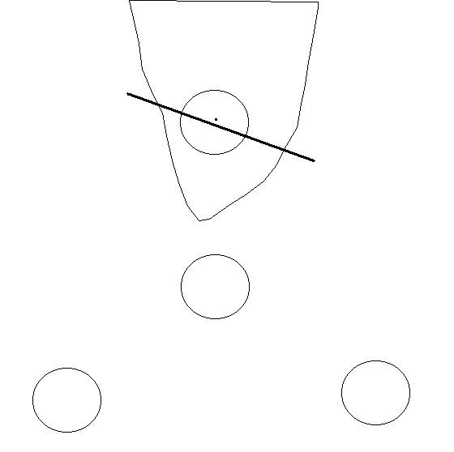
Forest > 1.0 acre
↑
N

120 ft

Pasture > 1.0 acre

- How many conditions are on the plot?
    - 1
    - 2
    - 3

- How many conditions are on subplot 2?
    - 1
    - 2
    - 3

- Should you map the 120-foot line on subplot 2?
    - Yes
    - No

- What is the Condition Status and Land Use at plot center
    - Condition Status = 2, Land Use = 61
    - Condition Status = 2, Land Use = 12
    - Condition Status = 2, Land Use = 20
    - Condition Status = 2, Land Use = 10

Use the following scenario to answer question 31-33:
Use the same diagram above, but this time the center of subplot 2 falls south of the 120-foot line.

- How many conditions are on the plot now?
    - 1
    - 2
    - 3

- Which one of the following statements is false?
    - Plot is completely nonforest
    - Boundary on subplot 2 should not be mapped
    - Condition Status at the center of subplot 2 = 2
    - There are two conditions on subplot 2

- Should you map the 120-foot line on subplot 2?
    - Yes
    - No

Use the following scenario to answer questions 36-40:
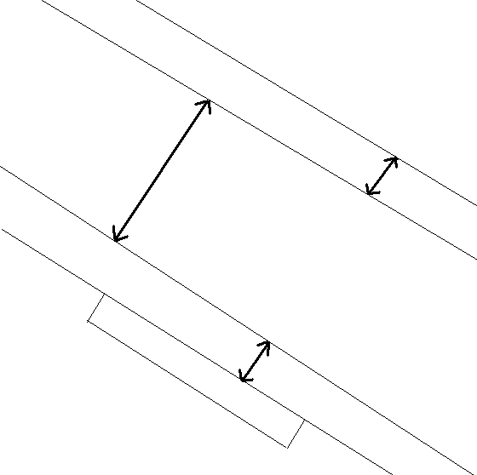
C
Forest > 120 ft wide and 1.0 acre

A
Forest 90 ft wide and 500 ft long
B
Utility line
25 ft wide

D
Forest 15 ft wide and 80 ft long

Road
30 ft wide
E
Residential Area
- What is the Condition Status and Land Use of area “A”?
    - Condition Status = 2, Land Use = 01
    - Condition Status = 2, Land Use = 31
    - Condition Status = 1, Land Use = 01
    - Condition Status = 1, Land Use = 31

- What is the Condition Status and Land Use of area “B”?
    - Condition Status = 2, Land Use = 01
    - Condition Status = 2, Land Use = 32
    - Condition Status = 1, Land Use = 01
    - Condition Status = 1, Land Use = 31

- What is the Condition Status and Land Use of area “C”?
    - Condition Status = 2, Land Use = 01
    - Condition Status = 2, Land Use = 31
    - Condition Status = 1, Land Use = 01
    - Condition Status = 1, Land Use = 31

- What is the Condition Status and Land Use of area “D”?
    - Condition Status = 2, Land Use = 30
    - Condition Status = 1, Land Use = 31
    - Condition Status = 1, Land Use = 01
    - Condition Status = 2, Land Use = 31

- What is the Condition Status and Land Use of area “E”?
    - Condition Status = 1, Land Use = 01
    - Condition Status = 3, Land Use = 31
    - Condition Status = 2, Land Use = 31
    - Condition Status = 1, Land Use = 31

