Delphi Corporation Response to NHTSA Request for Collision Warning Interface Metrics (CWIM) Information
Docket Number: NHTSA-2007-0038

Public Release

Submitted to

Docket Management Facility
M-30, U.S. Department of Transportation,
West Building Ground Floor, Room W12-140, 1200
New Jersey Avenue, S.E.,
Washington, DC 20590

14 April, 2008

Advanced Collision Avoidance Systems Field Operational Test (ACAS FOT) Program Summary

The Department of Transportation (DOT) has funded several Field Operational Tests (FOTs) to investigate the driver acceptance and potential safety benefits of collision warning systems. One of the largest of these FOTs was the Advanced Collision Avoidance Systems Field Operational Test (ACAS FOT) program that investigated adaptive cruise control (ACC) in combination with Forward Collision Warning (FCW)^{[1]}. This program was funded by NHTSA and was conducted by a team consisting of General Motors, Delphi Corporation, and the University of Michigan Transportation Research Institute (UMTRI). Ninety-six drivers drove ACAS-equipped vehicles for their own personal usage for a period of four weeks, spanning a total of 137,000 miles. The FCW system used Delphi’s forward-looking radar (FLR) to detect the range, range-rate, and azimuth angle of several vehicles in front of the driver. When it appeared that the driver’s vehicle needed to brake hard to avoid colliding with the lead vehicle, the ACAS system provided the driver with an icon on a head-up display (HUD) in conjunction with a series of rapid auditory tones.

Within the ACAS FOT program, Delphi led the Driver Vehicle Interface (DVI) task that developed and tested several display candidates, and finally selected the display that was used for the FOT phase. A new display candidate was modified from the Dingus et al. Car Icon Display^{[2]} into a version that more accurately represented a looming stimulus but also contained a six-trapezoid scale (see the “looming-plus-scale” display in Figure 1) ^{[3]}. The car-icon was simplified so that it could present a single color at any given time but could change color as threat-level increased. This display sequence was modified to allow the possibility of a purely looming display (no scale), a purely scale display (car-icon remains the same size and is used only as a reference), and the combination of scale and looming. The displays presented in Figure 1 also include a one-stage, two-stage, three-stage (looming), and five-stage (looming-plus-scale or scale) display. At the end of the display sequence, an imminent icon is presented which represents the red car-icon at the largest size, with a yellow shape over it to indicate the collision threat. The same imminent visuals were used across the conditions so that the different visual displays differed only in what icons preceded the imminent level.

These different display candidates were compared in a between-subjects driving-simulator experiment^{[3]}. Eighty participants were provided with the FCW alerts (displayed in Figure 1) that appeared on the Head-up Display (HUD) in response to an imminent lead-vehicle-braking event. Displays that mimicked the looming stimulus (expansion of the rear-end vehicle icon) with at least two visual stages (cautionary and imminent) led to significantly earlier brake reaction times (BRTs) than displays that provided no looming effect. Both BRT and subjective questionnaire responses suggest that a display featuring a “looming” stimulus is likely to be an effective visual stimulus for communicating imminent collision threat. Figure 2 displays the final display sequence that was used in the FOT phase. Although the multiple-stage alerting scheme requires a more expensive display technology, the data from this experiment suggest that a multiple phase alert sequence may be more effective than a single-stage alert. Perhaps a multiple-stage alerting sequence of a more continuous nature, which maps an increasing threat level, can avoid some of the difficulties surrounding using a single moment in time, that participants may not agree on. Unlike Lane Departure Warning (LDW) where there is a clear and tangible correlate for the warning threshold (crossing the lane marker), in the case of FCW, the threshold for alerting the driver is more arbitrary and likely differs across the driving population. For this reason, a continuous display that provides an increasingly intrusive stimulus as the threat level increases, may be more appropriate for FCW systems.

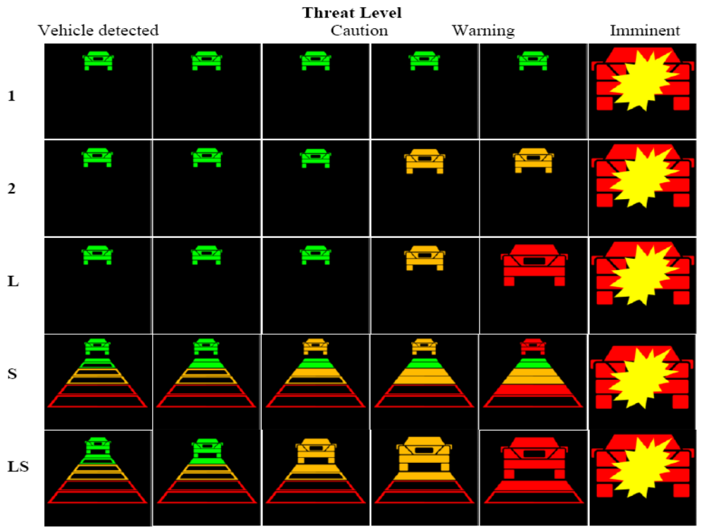
Figure 1. The one-stage (1), two-stage (2), three-stage/looming (L), scale (S), and looming plus scale (LS) displays used in the experiment as a function of threat level. Note that the number of stages does not include the “vehicle detected” icon, which is a status indicator rather than an alert stage. The imminent stage flashed on and off at 4 Hz.
Several months after the final selection of the driver-vehicle interface and the overall vehicle integration, the University of Michigan Transportation Research Institute (UMTRI) began the FOT phase of the ACAS program. The NHTSA report ^{[1]} suggests that although the ACC system was well received, participants provided mixed feedback for the FCW system as a whole. At the conclusion of the FOT, participants were asked several questions about the FCW system in general and specific questions on the interface^{[4]}.


Figure 2. The final configuration of the visual display used in the ACAS FOT. The sequence shows the four amber stages of “looming” between the cyan-colored vehicle-detected icon and the red and yellow imminent collision-warning icon. The imminent collision warning flashed at 4 Hz and was accompanied with a series of audible tones.

On a scale of 1 (very ineffective) to 7 (very effective), participants rated the visual alerts as 6.2 and the auditory alerts as 6.5 for “getting their attention quickly”. On a scale of 1 (unacceptably annoying) to 5 (not at all annoying), average annoyance ratings for the visual cautionary alert, the visual imminent alert, and the auditory imminent alert were between 3.8 and 3.9. These “luke warm” annoyance responses may, in part, reflect the rate of unnecessary alerts. The two most frequent comments for how to improve the FCW system were to reduce the rate of nuisance alerts and to allow the system to be turned off under certain circumstances^{[4]}.

During periods of manual (non-ACC) driving, FCW alerts were experienced at a rate of 14 alerts per 1000 miles. Analyses revealed that the alerts roughly broke down into even thirds, including 36 percent of the alerts resulting from out-of path events, 32 percent of the alerts resulting from transitioning-path events, and 27 percent of the alerts resulting from in-path vehicles. Determining which of these alerts were useful is an inherently subjective task that is likely to vary between different drivers’ perspectives. Common types of nuisance alerts included situations where the host vehicle approached a lead vehicle that was vacating the lane (either turning or changing lanes) or when the host vehicle was approaching the lead vehicle with an intention to pass. By asking the drivers in the study to review alerts that were issued during their own driving experiences, it was found that usefulness ratings differing significantly between the three scenario types described above ^{[4]}. Whereas in-path events yielded alerts that were judged to be useful 53 percent of the time, only 33 percent of alerts that occurred in response to transitioning-path events were judged to be useful. Out-of-path events produced alerts that were judged to be useful only 14 percent of the time. Drivers’ open-ended responses suggested that the level of perceived risk in these situations was often qualitatively different, even between in-path and transitioning-path events.

Using Lees and Lee’s^{[5]} terminology, this analysis suggests that a large percentage of the alerts were either unnecessary (alerts corresponding to situations judged as hazardous by the algorithm but not by the driver) or false (alerts corresponding to random activation of the system that does not correspond to a threat). Although there was not a strong statistical link between the frequency of unnecessary alerts and the driver acceptance measures, the qualitative data and driver comments suggest that the nuisance alert rate may have been excessive for some participants, leading to lower driver acceptance.

SAfety VEhicle(s) using adaptive Interface Technology Program (SAVE-IT) Program Summary

The Volpe National Transportation Systems Center, in support of NHTSA's Office of Vehicle Safety Research, awarded the SAVE-IT “SAfety VEhicle(s) using adaptive Interface Technology” contract to a diverse team led by Delphi Electronics & Safety including Ford, University of Michigan Transportation Research Institute (UMTRI) and University of Iowa. The goal of SAVE-IT was to develop, demonstrate, and evaluate the potential safety benefits of adaptive interface technologies (see http://www.volpe.dot.gov/hf/roadway/saveit/index.html). The countermeasures fell into two major categories: Distraction Mitigation, where the systems were designed to mitigate distraction directly, and adaptive safety warnings, where the effectiveness and acceptance of safety warning systems could be improved by adaptive interfaces.

In order to conduct this research within the constraints of the $6M budget, the SAVE-IT program carefully evaluated the relative strengths and weaknesses of the three testing venues: driving simulator, test track, field testing. In addition to the cost constraint, a reasonable production solution must address the constraints of both crash reduction effectiveness and acceptance. Table 1 displays the research constraints for the evaluation of crash reduction effectiveness compared with the evaluation of acceptance^{[6]}. Whereas the need to control driver expectations and to place the driver at a high risk of collision suggests a between-subjects design for the question of crash reduction effectiveness, the need to expose the driver to a representative system experience virtually demands an on-road evaluation. In order to directly measure whether one system provides a safety benefit over another system or whether a system compromises safety in some way, drivers must be placed in a circumstance where there is a high risk of collision, because without any collisions, there is no room for any improvement in safety. A reasonable-fidelity driving simulator likely provides the most effective environment for efficiently placing drivers at a high risk of virtual collision, without any real risk to the driver.

When a driver is placed in a surprise circumstance where there is a high risk of collision, the event likely changes the driver’s behavior to subsequent events. For this reason, an evaluation of crash reduction effectiveness is best conducted on a between-subjects basis, where each driver experiences only one surprise-collision event. Although the between-subjects methodology requires a large number of subjects, the design may potentially be streamlined to require only a short amount of time per participant. Expanding on the driving simulator work that Delphi conducted in leading the Driver Vehicle Interface task of the ACAS FOT program, the SAVE-IT program further refined the between-subjects testing methodology to provide an efficient and sensitive protocol for measuring the effectiveness of different collision warnings. In this context, this between-subjects methodology was used to measure the differences between various human machine interfaces and different methods of adapting warnings^{[6]}.

Table 1. The Research Constraints for Crash Reduction Effectiveness vs. Driver Acceptance.
Research Constraints | Crash Reduction Effectiveness | Acceptance
Central Question | Which system compromises safety the least or provides the greatest safety benefit? | Which system is preferred, least annoying, most acceptable, or is perceived as the safest?
Exposure Requirements | Expose drivers to real or simulated threatening scenarios where there is an apparent danger of collision | Expose drivers to a representative experience that balances favorable and unfavorable aspects of a system
Control Requirements | Control driver expectations | Facilitate adequate driver comprehension of the system
Participant Requirements | Between-subjects design | Span representative demographics
Dependent Measures | Objective Performance  (Reaction times, time to collision, collision rates and velocities) | Subjective Measures  (Annoyance, perceived effectiveness, buy likelihood, preference)
Number of Participants vs. Amount of Time per Participant | More participants | More time per participant
Ideal Research Facility | Driving Simulator  (Unless millions of miles of naturalistic data can be collected, an experiment must create an apparent danger of collision without actual risk) | On-road  (Only real roadways provide the necessary richness and complexity of the real environment that is difficult to anticipate a priori or to simulate)

Drivers who are exposed to an imminent event and who often receive a limited and biased exposure of the system in the driving simulator are unlikely to be able to provide representative subjective feedback. Because collision reduction effectiveness was only one of the constraints, the acceptance of the systems was examined in another venue, on-road field testings. Acceptance often varies greatly across individuals and across demographics, such as age or gender. For this reason, the subject pool must span a wider range of participants than the crash reduction effectiveness, where the effects of these demographics are less pronounced. In on-road field-testing, the driver and system must be exposed to a representative experience that balances both favorable and unfavorable aspects of the system. Field-testing is also a valuable tool for exposing the system to a wide range of circumstances that may test important aspects of the system-environment performance that have not been considered. Although field testing was used almost exclusively in the ACAS FOT (Advanced Collision Avoidance Systems Field Operational Test) program, the testing provided relatively little information about crash reduction effectiveness. The reason for this is that, given collisions are only expected at a rate of approximately one every half million miles, the mileage of ACAS FOT was insufficient to expect any collisions. Unless field testing spans millions of miles, such as the 100 Car Study^{[7]}, the results will provide relatively little information about crash reduction effectiveness. Although field testing, when it can be done on a sufficiently large scale, is clearly the ultimate test of effectiveness, in most cases testing on the scale of millions of miles is not practical. Furthermore it clearly does not allow for an iterative design process (with respect to the crash reduction effectiveness). Field testing on the scale of the ACAS FOT program, which included over one hundred thousand miles of testing^{[4]}, although relatively irrelevant to crash reduction effectiveness, provided a large amount of useful information about acceptance and how forward collision warning operates on real roadways.

In human subject testing, the test track represents a compromise in many respects between driving simulator research and on-road testing. The environment is more realistic than the driving simulator and the fidelity of the simulation cannot be called into question like it can in driving simulator research. Because of the level of control, the research can also push slightly deeper into the question of crash reduction effectiveness. In some circumstances, methods can be developed on the test track where the driver believes that they are at risk when in reality there is actually little risk to the driver. One of the difficulties with human subject research on the test track is that drivers are often at a heightened level of arousal and readiness, because they may not feel at ease in the test-track environment. The need to communicate with traffic control and other vehicles in combination with the responsibility of driving a real vehicle in a novel environment can sometimes be overwhelming for participants, preventing them from relaxing or adopting realistic driving behaviors. For example, it may be quite difficult to distract drivers at a high level. Exposing drivers to test conditions over long periods of time may help to reduce this limitation. In the SAVE-IT program, the test track exposures were primarily used to rapidly educate drivers with respect to the SAVE-IT system features prior to experiencing the system in the field.

One of the tasks within the SAVE-IT program was to further develop the human machine interfaces of the Forward Collision Warning (FCW) and Lane Departure Warning (LDW) systems. During the SAVE-IT development, a method of visually alerting drivers was developed in an attempt to remove some of the limitations of conventional visual alerts. This “exogenous display” used quick red flashes of light in the center of the driver’s forward field of view to draw the driver’s attention toward the center of the roadway. The flashes were intentionally brief so that it would provide little for the driver to glance at before quickly dissipating, leaving nothing but the external scene to communicate the threat^{[6]}. This method for warning the driver attempts to remove the icon-viewing step of traditional warning systems, in order to more rapidly draw the driver’s eyes toward the most likely location of the threat in the visual field. The ACAS FOT program revealed that drivers still needed to assess the threat for themselves when they were warned^{[1]}, implying that an effective warning draws the driver’s attention to the location of the threat as rapidly as possible.

A between-subjects comparison in the driving simulator revealed significantly faster accelerator release times for the exogenous display in comparison to a HUD icon display (see Figure 3)^{[6]}. Although both types of display appeared to be effective at reducing the number of crashes (5 or 6 versus 12), the exogenous display appeared to expedite driver responses by almost half a second compared with the HUD icon. The simplicity and low cost of the exogenous display is likely to offer a more favorable alternative for production implementations when compared to a HUD. For this reason the exogenous display was selected as the visual display interface for both the FCW system of the SAVE-IT program.

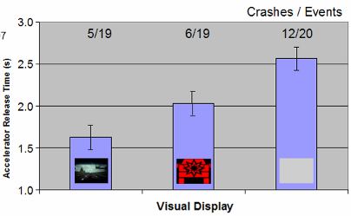

Figure 3. Comparison of accelerator release times for the exogenous display (left), HUD display (middle), and no display (right). Because the effects of an auditory and visual stimulus appeared to be additive (non-interacting), the conditions shown here were collapsed across the presence of an auditory stimulus, so that half of the subjects in each condition experienced the auditory stimulus in addition to the visual display shown above. The numbers at the top of the figure show the number of crashes over the number of events.

The fundamental principle behind adaptive warnings is that drivers who are attentive do not benefit from warnings. In order to evaluate this principle, a between-subjects design was used that factorially crossed three display alternatives (visual, visual-plus-auditory tone, and no warning) with the presence or absence of visual distraction. This design was used to investigate the effect on safety of two negative adaptation strategies: suppressing the auditory component of the alert and suppressing the alert completely. Figure 4 displays the accelerator release times of these conditions and reveals that whereas the FCW alerts clearly benefited distracted drivers, they provided little benefit for attentive (non-distracted) drivers. This result suggests that, given attention to the forward roadway can be accurately assessed, the strategies of either suppressing FCW completely (suppress strategy) or suppressing the auditory component of the FCW stimulus (auditory strategy), are unlikely to significantly compromise safety. In practicality, however, because affordable attention-monitoring technologies tend to measure head pose rather than eye gaze, the strategy of total alert suppression during attentive episodes may not be advisable. Although it was beyond the scope of the SAVE-IT program, driver impairment (e.g., drowsiness) would also need to be monitored.

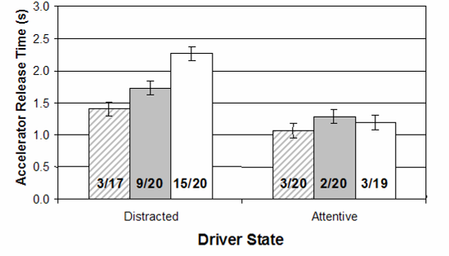
Visual+Audio
Visual only
No Warning
Crashes/Event

Figure 4. Accelerator release times and driving-simulator crash rates of distracted drivers versus attentive drivers in the SAVE-IT program. Drivers were provided with either a visual-and-auditory, visual-only, or no FCW alert. The bold numbers show the number of crashes / the number of events.

As an extension of Heinrich’s triangle, Dingus et al. ^{[7]} argued that crashes are most often the result of drivers failing to adequately respond to a precipitating event due to various contributing factors. When precipitating events (such as a lead vehicle unexpectedly braking) occur in the absence of the contributing factors, they are usually resolved by the flexible and adaptive response of the driver, resulting in what may be a near-miss, but usually not a collision. However, when contributing factors, such as visual distraction are added, they act as a catalyst for a crash by interfering with the driver’s response, converting a mere incident, or near-miss, into a collision. Other examples of catalysts that can degrade driver responses might be poor roadway conditions, mechanical failure, and driver impairment due to fatigue, alcohol, or other factors. To the extent that this simple model approximates the reality of lead-vehicle or single-vehicle crashes, it would predict that, in the absence of a catalyst such as visual distraction, drivers are unlikely to benefit significantly from warnings. If the driver is attending to the forward roadway at the moment a precipitating event occurs, the driver usually detects the event and responds appropriately. In such a circumstance, there is usually little opportunity to improve the process. A collision warning would only present information to which an attentive driver is already aware. Even if the driver is visually-attentive but is likely to react slowly due to other factors, the warning system may still be unable to hasten the process, because ultimately drivers must confirm the threat for themselves before applying the brake^{[1]}. The data presented in Figure 4 support this conclusion, showing that in this driving-simulator study, drivers who were attentive to the forward scene released the accelerator at approximately the same time regardless of whether or how they were warned^{[6]}. Although this situation was inherently threatening, with a collision rate of between 10 to 15 percent, the collision warning system was unable to improve the response of visually-attentive drivers. Only when the drivers were distracted was there a statistically significant benefit of providing a warning. This benefit was not only apparent across accelerator release times, brake reaction times, and glance reaction times, but also demonstrated by a clear trend in crash rates.

Semi-Autonomous Vehicles Research

Another relevant research activity in which Delphi is engaged is investigating the human factors issues surrounding semi-autonomous vehicles. This research will addresses a period of time where limited-ability autonomous vehicles will be available and permitted on public roads. These systems will require that the driver perform a supervisory role and be ready to intervene when a situation develops that is beyond the automation capability. These situations may be ones that the system can recognize; however, there may be situations where the driver must intervene without a warning from the system. The proposed program will develop and test strategies intended to help drivers maintain adequate situational awareness when operating vehicles that have limited-ability autonomous driving capability. The proposed project will develop adaptive, human centered concepts for helping drivers maintain the necessary situation awareness. The research will identify effective mechanisms for interaction between driver and automation, and will also identify potential misconceptions and develop countermeasures to avoid them.

Understanding the issues of semi-autonomous vehicles will be a crucial step in addressing the next generation of alerts. As the industry continues to deploy increasing levels of automation, the driver will increasingly assume a supervisory role that may require a different nature of alert. Thus, the interaction between collision warnings and autonomous systems will become increasingly important. Already on roadways today, FCW interacts with adaptive cruise control. For example, in the ACAS FOT program, the warning algorithm was different when adaptive cruise control was engaged. Rather than providing warning based on the constraints of the driver’s reactive capabilities, the alerts were based on the braking authority of the vehicle. When the circumstance required more braking than the ACC system had the authority to deliver, the driver would receive an alert that they needed to intervene. As the role of automation expands in the next decades, it is this type of “driver intervention required” alert that will become increasingly important.
Specific Item Discussion

In addition to the three federally-funded human factors programs that are described here, there are many others that provide insight into these questions. These three programs: ACAS FOT, SAVE-IT, and HF-LAAV provide information and insight relating most specifically to the items A1, B1, B2, and B3. In conclusion, we will briefly address these items directly.

(A1) What techniques, metrics, and criteria are now being used by vehicle manufacturers for developing and evaluating the human factor aspects of interface design and operation of ACWS at various stages of product development? What tools are being used (simulators, tracks, etc.) to evaluate DVIs? Are there ‘‘lessons learned’’ regarding their use, practicality, or acceptance? What measures and procedures are the most predictive of relevant safety parameters?

The SAVE-IT program identified a research strategy that was summarized in Table 1. Due to the need of efficiently producing imminent collision situations, and the fact that imminent collision events change subsequent driver responses, the SAVE-IT research strategy utilized a refined between-subjects (one event per subject) driving simulator protocol to measure the crash reduction effectiveness of different warning systems. The efficiency of the test protocols developed in the SAVE-IT program, allowed the between-subjects protocol to become practical. Furthermore, unlike repeated measures designs that are typically used in human factors evaluation, this protocol allows a building-block approach because conditions measured in previous research can be directly compared to new conditions. It is likely that the driving-simulator-based reaction time measures, including accelerator release time and brake reaction time will be the best predictors of actual safety performance. Although the crash rates are less sensitive and are likely not a good measure of the absolute crash rates that can be expected in real circumstances, driving-simulator-based crash rates may provide some indication about how well one system may reduce crashes relative to another system. To determine how these driving-simulator metrics map to crash rates in real driving, additional work must be conducted that includes both extensive field operational testing of sufficient size that numerous collisions are expected, and driving-simulator replications of the real crashes that are observed.

Although the SAVE-IT driving simulator protocol was effective in comparing the effectiveness of different alert candidates, due to the brief exposures per subject, it provided little information about acceptance. To address the acceptance constraint, SAVE-IT utilized field testing, where drivers were exposed to the systems for a more extended period of time under naturalistic conditions. Although the field exposures in SAVE-IT were relatively brief, ideally, drivers should be exposed to systems over a sufficient duration that they experience both the positive and negative consequences of the system, and so that drivers have time to overcome the novelty of the system and begin to respond to the product with a consumer mind set. Testing over these programs has demonstrated that human subjects usually begin with the opinion that more warning is better (e.g., if there is any chance of danger, you should warn the driver immediately). Only after they have begun to understand the tradeoff between crash reduction effectiveness and nuisance, can they provide acceptance data that is likely to predict the success of a given product.

(B1) What criteria should be used to determine the most sensitive, reliable, relevant, and useful metrics?

Field operational testing on the scale of the DOT field operational tests (except perhaps the 100 Car Study) is insensitive to differences in crash reduction potential. For this reason, driving simulator protocols are likely to be more effective for measuring crash reduction effectiveness. If more than one exposure per subject is used, the later exposures will be contaminated by the fact that drivers are more likely to be ready for the event. Because crashes occur in the worst cases, the test protocol must find a way to lull drivers into a state of diminished arousal that more closely approximates that of real world crashes. This lower level of arousal and expectation is more difficult to achieve on test tracks and test tracks are also less efficient. For this reason, we believe that single-exposure response time metrics to imminent driving simulator events are likely to provide the best way to distinguish between the effectiveness of different collision warning systems. For a system to be effective, it must also be acceptable to drivers.

(B2) If consumers are annoyed or otherwise dislike the system, they may turn it off or not purchase it. How should consumer acceptance or driver annoyance be evaluated with respect to their influence on system effectiveness?

Although it is more time consuming, field testing is the preferred method to expose drivers to a representative system experience and have drivers enter a consumer mind set. Because of the habitual thought patterns and the familiar experience involved in driver commuting, it is likely that exposures during driver commutes may accelerate drivers entering the appropriate mind set. One method for evaluating the relationship between system effectiveness and acceptance is allowing drivers to turn off the system during testing. In the ACAS FOT program, driver could adjust the driver vehicle interface to remove the entire pre-imminent (cautionary) phase of the warning. Had the majority of drivers turned the cautionary phase off, we would have concluded that the effectiveness of the cautionary phase would be likely to be negated by drivers not accepting the system. However, the fact that the majority of drivers left the cautionary phase active, suggests that most drivers perceived that the benefit outweighed the annoyance.

(B3) Driver response to ACWS can vary from person to person. Even the same person can vary in performance depending on their state of mind, e.g., drowsy or distracted. What subsets of the population need to be included in developing criteria for CWIM? How should their needs and capabilities be integrated into the assessment?

The ACAS FOT program demonstrated that acceptance varies greatly over driver age groups. We also know from a wealth of studies that age affects virtually every parameter that is relevant to responding effectively to a warning, including reaction times, visual acuity, hearing sensitivity, tactile sensitivity, and useful field of view^{[8,9]}. Over the next decades, the relative size of the elderly population will continue to expand^{[10]}, and more research is required to make sure that warnings adequately address the needs of the elderly. It may be appropriate to provide different production software configurations for the warning systems so that a given warning system can be placed in a mode that addresses the needs of the older driving population.

SAVE-IT focused on the differences between distracted and attentive drives and how warnings may be adapted to improve the acceptance by diminishing the warnings during attentive episodes (negative adaptation) and increasing the warnings during distracted episodes. The results of this program reveal some encouraging results for adaptive warnings, demonstrating that adaptive warnings can help resolve the tradeoff between annoying attentive drivers with unnecessary alerts while providing sufficient warning for distracted drivers. Although drowsiness was beyond the scope of the SAVE-IT program, more research is required to examine methods for alerting drowsy drivers. In severe cases, where a driver may be in a micro-sleep, traditional methods for alerting drivers may be unsuccessful in breaking through to the driver’s awareness.

Concluding Remarks

Delphi Corporation has conducted a large amount of research in the area of collision warning systems, however, even when this research and the research of many other informative programs, such as the 100 Car Study, are considered, there are still questions in the area of CWIM that need to be addressed. We believe that a key area in need of development is the validation of efficient driving simulator test protocols for measuring crash reduction potential. SAVE-IT has provided some initial steps in the process of developing efficient driving simulator research protocols, however, more work remains. As warning systems further penetrate the market, unless standards are put in place, there will be a wide range of approaches adopted by different OEMs. In order to avoid confusion and a resulting response delay, there will be a growing need for standardization of the human machine interface. More research is required, balancing the constraints of cost, crash reduction potential, and acceptance before such a standard can be created.

References
1. National Highway Transportation Safety Administration (2005). Automotive Collision Avoidance System Field Operational Test: Final Program Report (No. DOT HS 809 886). Washington, DC: National Highway Traffic Safety Administration.
2. Dingus, T.A., McGehee, D.V., Manakkal, N., Jahns, S.K., Carney, C., & Hankey, J.M. (1997). Human factors field evaluation of automotive headway maintenance/collision warning devices, Human Factors, 37(2), 216-229.
3. Smith, M. R. H. (2002). Automotive Collision Avoidance System Field Operational Test: Warning Cue Implementation Summary Report. Washington D.C.: U.S. Department of Transportation, report no. DOT HS-809-462. http://www.nrd.nhtsa.dot.gov/departments/nrd-12/pubs_rev.html.
4. Ervin, R., Sayer, J., LeBlanc, D., Bogard, S., Mefford, M., Hagan, M., Bareket, Z & Winkler, C. (2005). Automotive collision avoidance system (ACAS) field operational test methodology and results. (US DOT HS 809 901). Washington, D.C.: National Highway Traffic Safety Administration.
5. Lees, M. N. & Lee, J. D. (2007). The influence of distraction and driving context on driver response to imperfect collision warning systems, Ergonomics, 50(8), 1264-1286.
6. Smith, M. R. H., Bakowski, D. L., & Witt, G. J. (In preparation). Safety Vehicle(s) using adaptive Interface Technology (SAVE-IT) Task 9 Final Report: Safety Warning Countermeasures. http://www.volpe.dot.gov/hf/roadway/saveit/docs/safetywarn_rep.doc.
7. Dingus, T. A., Klauer, S. G., Neale, V. L., Petersen, A., Lee, S. E., Sudweeks, J., Perez, M. A., Hankey, J., Ramsey, D., Gupta, S., Bucher, C., Doerzaph, Z. R., Jermeland, J., & Knipling, R. R. (2006). The 100-Car Naturalistic Driving Study: Phase II - Results of the 100-Car Field Experiment, NHTSA DTNH22-00-C-07007.
8. Hu P.S., Trumble, D.A., Foley, D. J., Eberhard, J. W., & Wallace, R. B. (1998). Crash risks of older drivers: a panel data analysis. Accident Analysis and Prevention, 26(1), 107-112.
9. Marottoli, R. A. (2007). Enhancement of driving performance among older drivers. Report prepared for AAA Foundation for Traffic Safety, Washington, DC 20005. http://www.aaafoundation.org/pdf/EnhancingSeniorDrivingPerfReport.pdf
10. National Highway Transportation Safety Administration (2005). Traffic Safety Facts 2005: Older population. (No. DOT HS 809 662). Washington, DC: National Highway Traffic Safety Administration.

Out-of-path events were defined as situations wherein the target was never in the host vehicle’s lane, and included mostly stationary objects, such as bridges and other objects either above the roadway or on side of the road.
Transitioning-path events were defined as situations wherein a moving vehicle was is in the same lane as the host vehicle for some period of the conflict and out of the host vehicle’s lane for another period.
In-path events were defined as those wherein the host and lead vehicles occupied the same lane throughout the conflict. Almost all of the objects in this category were moveable targets (objects that the radar had previously seen to move).

