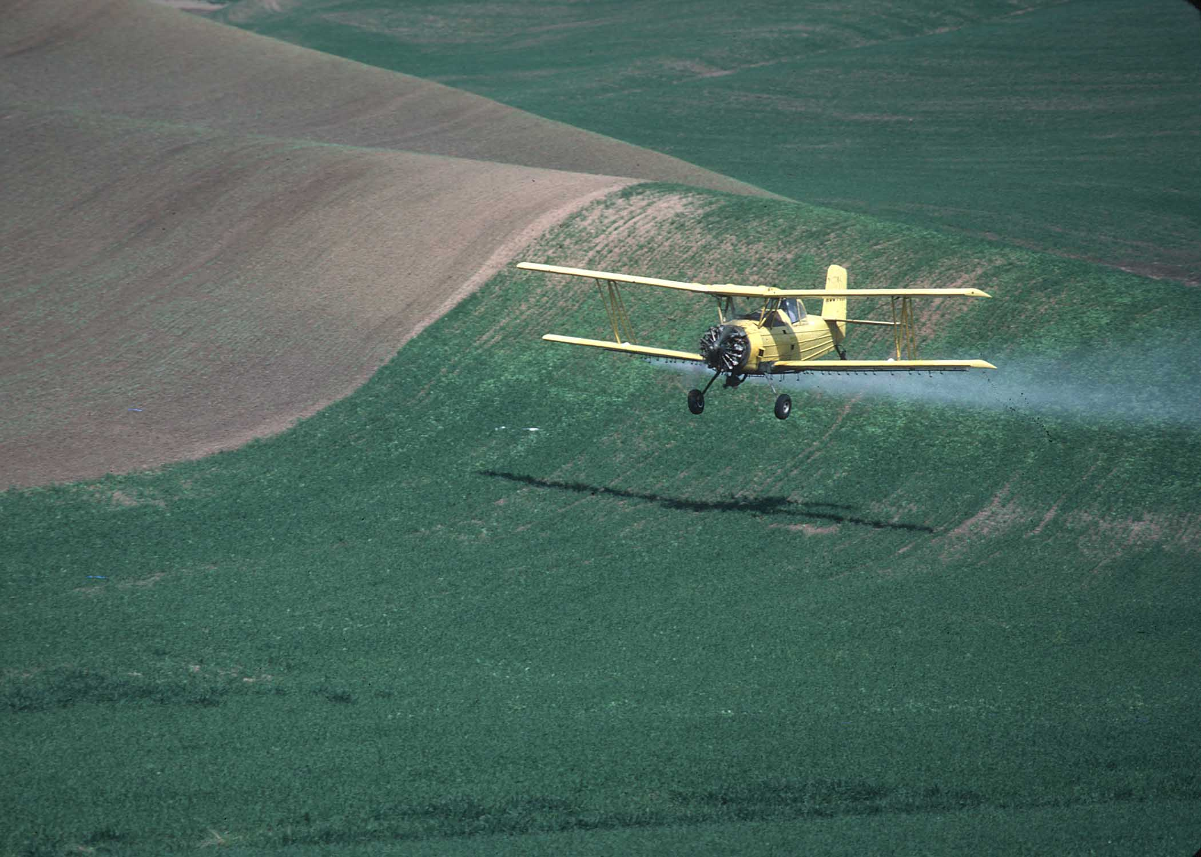
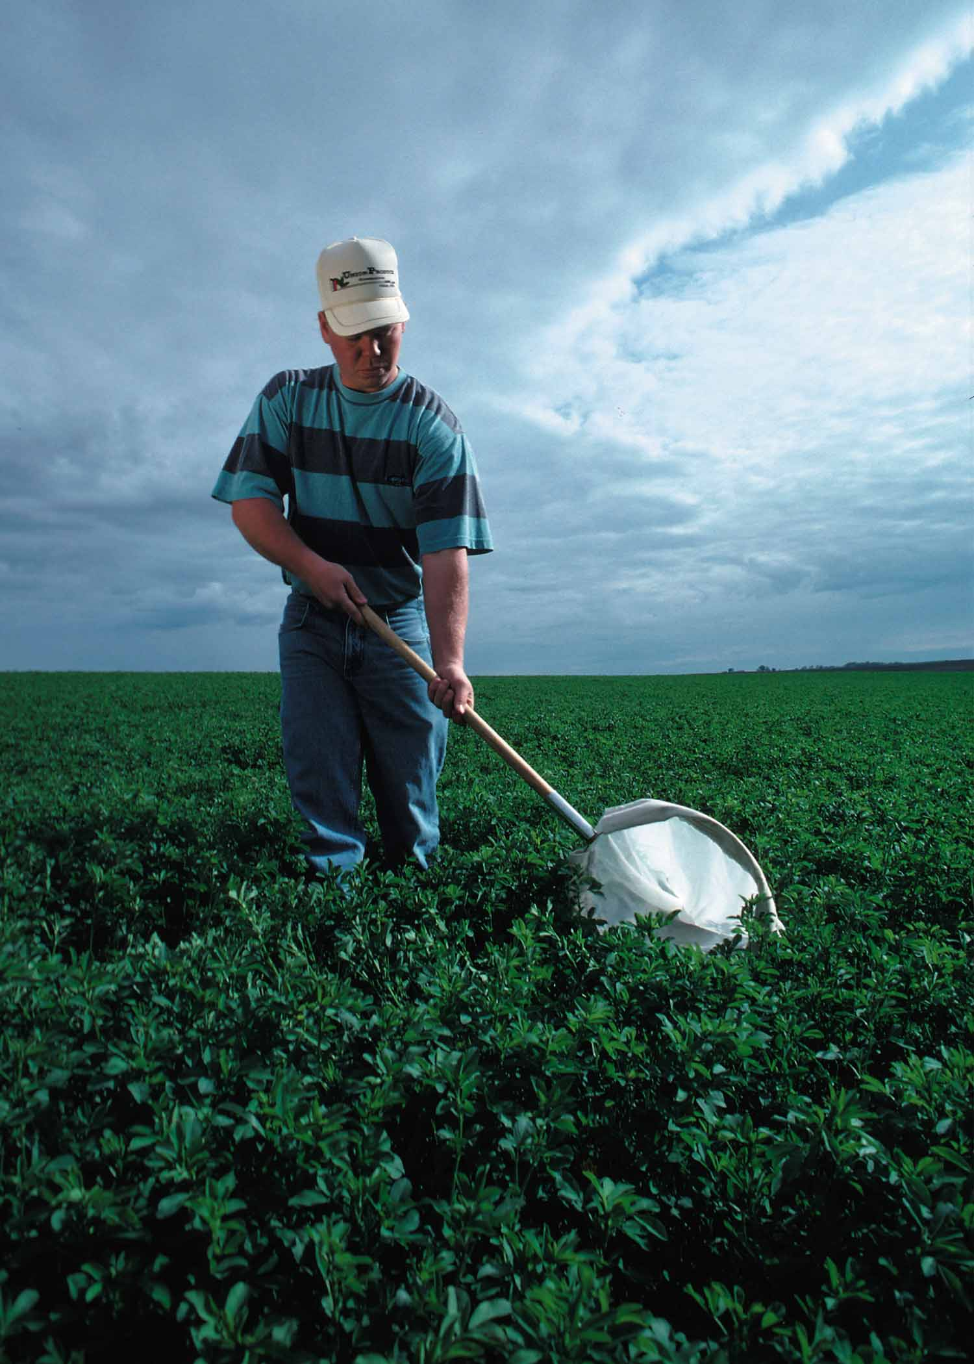
Definition
Pest management is defined as “utilizing environmentally sensitive prevention, avoidance, monitoring, and suppression strategies, to manage weeds, insects, diseases, animals and other organisms that directly or indirectly cause damage or annoyance.”
Photos courtesy of NRCS

Purpose
Pest management is applied as part of a resource management system to support one or more of the following purposes;

- Enhance quantity and quality of crops grown for food and fiber
- Minimize negative impacts of pest control on soil resources, water resources, air resources, plant resources, animal resources, and/or humans
Benefits
Pest management can result in the following benefits to the producer and the environment:
- Maximize economic returns
- Minimize environmental impacts
- Improve food, water and air quality
- Integrate all aspects of pest management within the agricultural production system (Integrated Pest Management – IPM)

Elements of Integrated Pest Management

Prevention
Prevention is the practice of keeping a pest population from infesting a crop or field, and should be the first line of defense. It includes such tactics as using pest – free seeds and transplants, preventing weeds from reproducing, and cleaning tillage and harvesting equipment between fields or operations

Avoidance
When pest populations exist in a field or site, the impact of the pest on the crop can be avoided through some cultural practice. Examples of avoidance tactics include crop rotation, choosing cultivars with genetic resistance to pests, and using trap crops or pheromone traps.

Monitoring
Activities such as scouting and pest forecasting that can help to determine if and when suppression activities are needed, or to determine if a particular pest control strategy is working or not.

Suppression
Suppression may become necessary to avoid economic loss if prevention and avoidance tactics are not successful. Pesticides are typically used to suppress pest populations. However, non-chemical suppression tactics may include cultural practices, physical suppression, and biological controls.

IPM Activity – Biological Fumigant
Green manure cover crops, such as oil radish and mustard, have been successfully used in crop rotations before sugarbeets, potatoes, onions, beans, and other row crops. Green manure crops can improve soil quality, fertility and water infiltration, and suppress soil-borne pests and diseases. Reductions in the numbers of nematodes, disease problems, and weeds are thought to be due in part to the presence of glucosinolates in green manure crops. When the crop is incorporated into the soil, the breakdown of glucosinolates produces other chemicals that act against pests. These chemicals are similar to the active chemical (methyl-isothiocyanate) produced by soil application of a synthetic fumigant, like metham sodium (from Using Green Manures in Potato Cropping Systems, Washington State University Extension Bulletin, EB1951E).

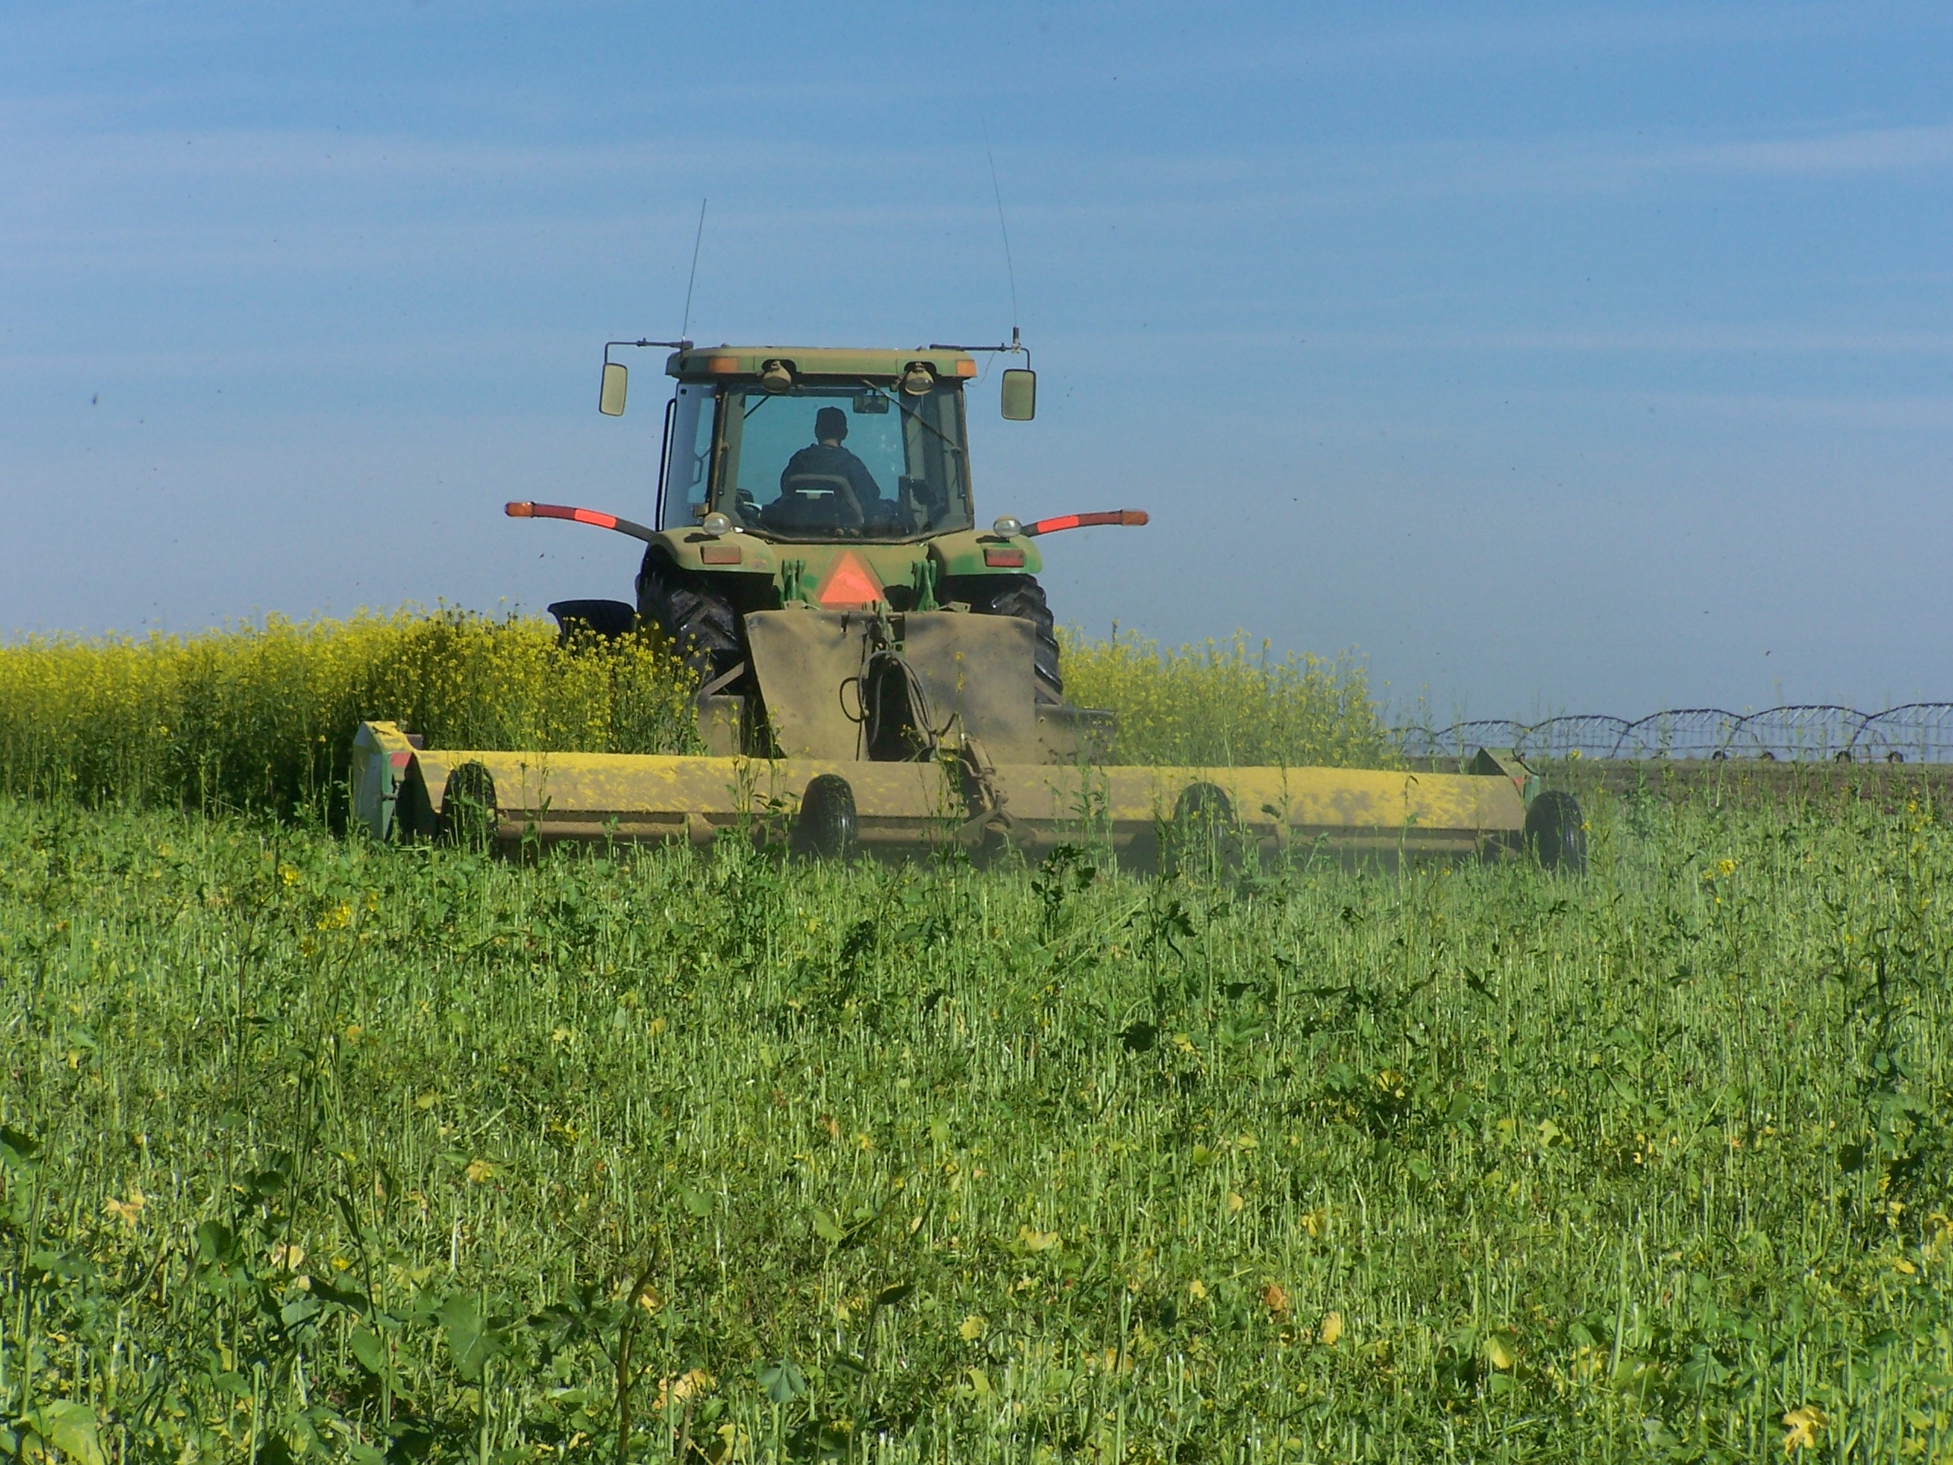

The use of mustard green manures in potato cropping systems has been successfully demonstrated on the Fort Hall Indian Reservation. In field trials, the potato crop after mustard green manure incorporation performed as well as the standard treatment with methyl-isothiocyanate releasing products. Mustard production costs averaged $120/acre/year over the 2-year trial.

Careful management is needed to realize the full benefits of green manure crops. For potato cropping systems, approximately 15 lbs/acre of mustard seed is planted in mid-August following a grain or bean crop. Planting time is important to achieve optimal green manure crop production. Poor field preparation can hinder germination and growth. Demonstration studies have shown that irrigation, fertilization, and/or weed control are required. After approximately 8-10 weeks of growth, the green manure crop is chopped and disked.

Activity Requirements
For 2006 EQIP, green manure crops are limited to oil radish or mustard. Certain varieties may be more effective than others.

Follow the Washington State University Extension Bulletins, Using Green Manures in Potato Cropping Systems (EB1951E) or Mustard (EB1952E), both available online at http://grant-adams.wsu.edu or 1-800-723-1763. These publications describe crop characteristics and requirements for use of mustard as a biofumigant. A minimum seeding rate of 15 lbs/acre for mustard and 25 lbs/acre for oilseed radish is required. For additional information on green manure cropping with radish, refer to the University of Idaho Extension publication Management of Sugarbeet Nematode, (CIS 1071), available online at http://info.ag.uidaho.edu/Resources/PDFs/CIS1071.pdf or Management of Oilseed Radish and Yellow Mustard Green Manure Crops at http://www.uidaho.edu/sugarbeet/nmtds/oilseed.htm.

Complete attached certification. It is a good idea to track green manure production costs on a yearly basis (costs include seed, planting, fertilizer, herbicide, water/power, chopping, etc.), but this is not required. Attach receipts related to green manure crop production (seed purchase, for example).

BIOFUMIGANT CERTIFICATION

Tract and Field Number or Field Name | Acres | Previous Crop | Planting Date for Green Manure Crop | Seeding Rate | Applied Irrigation, Fertilizer, and/or Weed Control? | Date of Soil Incorporation
 |  |  |  |  | YES NO
 |  |  |  |  | YES NO
 |  |  |  |  | YES NO
 |  |  |  |  | YES NO
 |  |  |  |  | YES NO
 |  |  |  |  | YES NO
 |  |  |  |  | YES NO
 |  |  |  |  | YES NO
 |  |  |  |  | YES NO
 |  |  |  |  | YES NO

Certification: I certify that I have applied the requirements of the Biofumigant component of Conservation Practice Standard 595, Pest Management, as scheduled in the Conservation Plan and/or Program Contract.
Name:_____________________________________________ Date: ______________________

Conservationist: _____________________________________ Date: _____________________

