SAVE-IT

A Final Report of
SAfety VEhicles using adaptive Interface Technology (Phase II: Task 9C):
Adaptive Safety Warning Countermeasures

Prepared By
Matthew R. H. Smith
Deborah L. Bakowski
Gerald J. Witt

Delphi Electronics & Safety
Phone: (765)-451-9816
Email: matt.smith@delphi.com

January 2008

Table of Contents

9.0. EXECUTIVE SUMMARY 3
9.1. PROGRAM OVERVIEW 7
9.2. Introduction 8
9.2.1 Differential Location 12
9.2.2 Differential Stimuli 12
9.2.3 Differential Timing 13
9.2.4 Alert Suppression 15
9.2.5 Adaptation to Cognitive vs. Visual Distraction 15
9.2.6 Phase II Research Questions 17
9.3. Experiment 3: FCW HMI DOWN SELECTION 19
9.3.1 Experiment 3 Method 21
9.3.2 Experiment 3 Results 26
9.3.3 Experiment 3 Discussion 30
9.4. Experiment 4: LDW DOWN SELECTION 32
9.4.1 Experiment 4 Method 33
9.4.2 Experiment 4 Results 35
9.4.3 Experiment 4 Discussion 37
9.5. Experiment 5: FCW ADAPTATION DOWN SELECTION 38
9.5.1 Experiment 5 Method 39
9.5.2 Experiment 5 Results 41
9.5.3 Experiment 5 Discussion 46
9.6. CONCLUSIONS 47
REFERENCES 50

9.0. EXECUTIVE SUMMARY

The objective of Task 9 (Adaptive Safety Warning Countermeasures) is to improve safety-warning systems by designing these systems to adaptively respond to real-time measures of driver distraction. The adaptation strategies emerging from Task 9 involve the modification of conventional safety-warning countermeasures, including forward collision warning (FCW) and lane departure warning (LDW), to utilize the instantaneous visual attention allocation of the driver (assessed in Task 7: Visual Distraction). Adaptive enhancements to safety warning countermeasures attempt to either reduce nuisance alerts without sacrificing safety or to provide earlier or more effective warnings when drivers need them most. The results of the 100-Car Study (Dingus, Klauer, Neale, Petersen, Lee, Sudweeks, Perez, Hankey, Ramsey, Gupta, Bucjer, Doersaph, Jermeland, & Knipling, 2006), may predict that drivers who are attentive to the forward roadway may not benefit greatly from warnings. Only one out of fourteen lead-vehicle collisions occurred in the absence of “inattention to the forward roadway”. When drivers do require warning systems (such as when they are distracted), these warnings may be presented either earlier or in a more salient manner. Because Task 9 examines potential methods for adapting warning systems, it is critical to the "Adaptive Safety Warning Countermeasure" branch of the SAVE-IT program. Task 9 focused on optimizing the human machine interface for adaptive and non-adaptive modes, and on the evaluation of different adaptation strategies.

Phase I Adaptation Strategy Research
In Phase I, two experiments were conducted. The first was a between-subjects evaluation of driver response times during cognitive and visual distractions (from Tasks 7 and 5 respectively) in comparison to a control group with no experimentally imposed distraction. Consistent with the literature, the results demonstrated a much larger effect of visual distraction than cognitive distraction. The largest differences in response times emerged between the first and second exposures, with drivers in the control group responding 1.32 s earlier on the second exposure than the first. The second experiment compared three adaptation strategies and a non-adaptive system in a repeated-measures driving simulator experiment. Both FCW and LDW were adapted according to the Differential Stimuli (suppressing the auditory component when the driver’s attention is forward), Differential Timing, and Alert Suppression adaptations. Whereas the Differential Stimuli adaptation modifies the nature of the driver vehicle interface, the Differential Timing and Alert Suppression adaptations modify the behavior of the alert-generation algorithm. The Differential Stimuli adaptation provided a visual-plus-tone alert when the driver’s attention was non-frontal and a visual-only alert when the driver’s attention was frontal. Whereas the Alert Suppression adaptation simply prevents alerts from being generated when the driver is attentive, the Differential Timing adaptation modifies the likelihood that alerts will be generated, by providing earlier alerts when the driver is distracted and later alerts when the driver is not.

These adaptation strategies were implemented using both positive and negative modifications of the warning systems. Whereas negative adaptations diminish the warnings when the driver’s attention is on the road, positive adaptations accentuate warnings when the driver’s attention is away from the road. Whereas the primary goal of negative adaptation is to improve driver acceptance by reducing nuisance alerts, the primary goal of positive adaptation is to improve the effectiveness of the warning systems.

In the second experiment of Phase I, rather than using the distraction sensing methods that were still under development, the experiments used the presence of the task as the basis for the adaptation. Half of the participants experienced the adaptation in response to a visual distraction task and half of the participants experienced the adaptation in response to a cognitive distraction task. Whereas the results provided some objective (e.g., reaction times) and subjective (questionnaire responses) support for the adaptations in response to the visual distraction task, they did not support the adaptation in response to a cognitive distraction task.

Phase II Human Machine Interface Research
Phase II focused on selecting an appropriate human machine interface for the FCW and LDW systems and providing further data for the selection of an adaptation strategy. Due to the large discrepancy in the first and subsequent exposures to imminent lead vehicle braking events, all testing in Phase II was conducted between subjects. During the early Phase II development, a new method of visually alerting drivers was developed in an attempt to remove some of the limitations of conventional visual alerts. This “exogenous display” used quick red flashes of light to draw the driver’s attention toward the center of the roadway, and then quickly dissipates leaving nothing but the external scene to communicate the threat. It attempts to remove the icon-viewing step by exogenously drawing the driver’s eyes toward the most likely location of the threat in the visual field.

A between-subjects comparison revealed significantly faster accelerator release times for the exogenous display in comparison to a HUD icon display (see Figure 9.1). Although both types of display appeared to be effective at reducing the number of crashes (5 or 6 versus 12), the exogenous display appeared to expedite driver responses by almost half a second compared with the HUD icon. The simplicity and low cost of the exogenous display is likely to offer a more favorable alternative for production implementations when compared to a HUD. For this reason the exogenous display was selected as the visual display interface for both the FCW and LDW systems.

Phase II Adaptation Strategy Research
In order to examine the benefit of providing FCW stimuli for attentive drivers, a between-subjects design was used that factorially crossed three display alternatives (visual, visual-plus-tone, and no warning) with the presence or absence of visual distraction. This design was used to investigate the effect on safety of two negative adaptation strategies: Alert Suppression and Differential Alert Modalities (suppressing just the auditory component). Figure 9.2 displays the accelerator release times of these conditions and reveals that whereas the FCW alerts clearly benefited distracted drivers, they provided little benefit for attentive (non-distracted) drivers. This result suggests that the strategies of either suppressing FCW completely (suppress strategy) or suppressing the auditory component of the FCW stimulus (auditory strategy) are unlikely to significantly compromise safety.
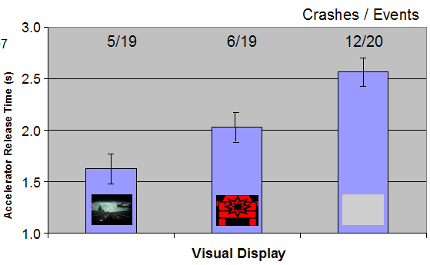

Figure 9.1. Comparison of accelerator release times for the exogenous display (left), HUD display (middle), and no display (right). Because the effects of an auditory and visual stimulus appeared to be additive (non-interacting), the conditions shown here were collapsed across the presence of an auditory stimulus, so that half of the subjects in each condition experienced the auditory stimulus in addition to the visual display shown above. The numbers at the top of the figure show the number of crashes over the number of events.

Likewise, attentive drivers appear not to require LDW alerts. The attentive and unwarned participants responded to the simulated wind-gust event so quickly (Steering reaction time = 0.67) that many of these participants were not even aware that the disturbance had even occurred. The maximum lateral disturbance was on average less than half a meter. These data support the Alert Suppression strategy for LDW, although adaptive LDW systems might also likely to benefit from driver impairment monitoring.

The positive adaptations of Differential Location and Differential Timing were also evaluated for FCW in Phase II to determine whether these adaptations could provide a detectable safety benefit. The Differential Location adaptation attempted to expedite drivers’ response to the warning by displaying the FCW visual icon (redundantly with the exogenous display) in the location of the driver’s distraction (in this case the center console). The concept was that a visual stimulus would be more useful if it was located in the position of the driver’s attention. These data did not support this adaptation method, and even showed a slight increase in accelerator release time that was not statistically significant when the redundant console (1.51 s) was compared to just an exogenous display (1.36 s). This result might be anticipated by the conceptual diagram in Figure 9.2, which predicts a temporal cost of displaying an icon away from the forward scene. The Differential Location adaptation was therefore rejected as an adaptation candidate. Another evaluation compared the responses of distracted drivers for an early FCW alert (0.5 s after the lead vehicle braking event) versus a nominal FCW alert (1.5 s after the braking event). Drivers who experienced the earlier alert began braking 2.26 s after the event compared with the late-alert drivers who began braking 3.11 s after the event.
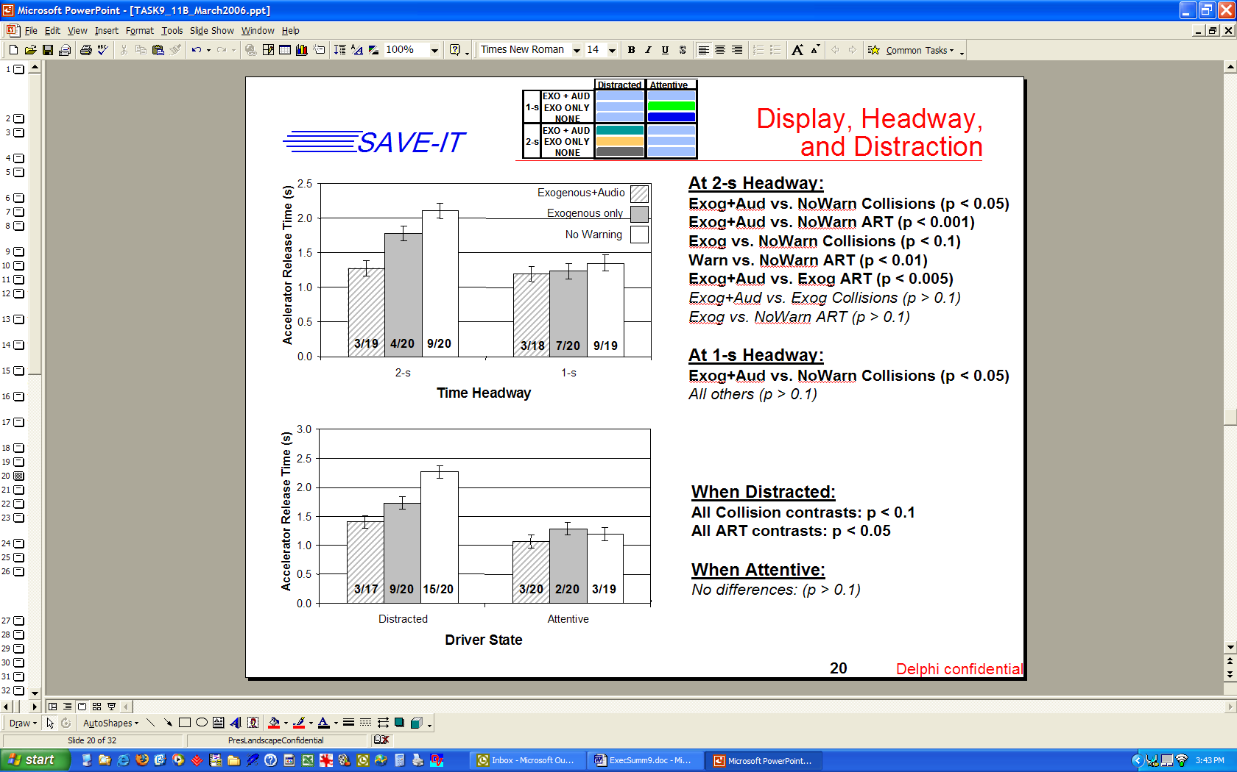
Exogenous+Tone
Exogenous only
No Warning

Figure 9.2. Accelerator Release Times (s) as a function of type of FCW stimulus and driver distraction state. The numbers along the bottom of the bars represent the number of collisions over the number of events.

Conclusions
Whereas Task 9 did not provide support for using the center-console to display FCW stimuli, it did support the timing strategy of providing earlier warnings as a means of expediting responses to FCW events from visually-distracted drivers. Furthermore, the adaptation strategies of suppressing some (Differential Stimuli) or all (Alert Suppression) warning stimuli when the driver is attentive appear unlikely to compromise safety and may provide an effective means of improving the driver acceptance associated with FCW and LDW systems. The final selection of adaptation strategies and the human machine interface was reserved for the on-road work of Task 11b (Adaptive Safety Warning Countermeasures Data Fusion).

9.1. PROGRAM OVERVIEW

Driver distraction is a major contributing factor to automobile crashes. The National Highway Traffic Safety Administration (NHTSA) has estimated that approximately 25% of crashes are attributed to driver distraction and inattention (Wang, Knipling, & Goodman, 1996). Recent estimates from the 100-Car study suggest that distraction may contribute to more than three quarters of all crashes (Dingus, Klauer, Neale, Petersen, Lee, Sudweeks, Perez, Hankey, Ramsey, Gupta, Bucjer, Doersaph, Jermeland, & Knipling, 2006). The issue of driver distraction may become more critical in the coming years because increasingly elaborate electronic devices (e.g., cell phones, navigation systems, wireless Internet and email devices) are being brought into vehicles that may further compromise safety. In response to this situation, the John A. Volpe National Transportation Systems Center (VNTSC), in support of NHTSA's Office of Vehicle Safety Research, awarded a contract to a diverse team led by Delphi Electronics & Safety including Ford, the University of Michigan Transportation Research Institute (UMTRI) and the University of Iowa. The goal of this program was to develop, demonstrate, and evaluate the potential safety benefits of adaptive interface technologies that manage the information from in-vehicle systems based on real-time monitoring of the roadway and the state of the driver. The contract, known as SAfety VEhicle(s) using adaptive Interface Technology (SAVE-IT), is designed to mitigate distraction with effective countermeasures and enhance the effectiveness of safety warning systems.

The SAVE-IT program serves several important objectives. Perhaps the most important objective is that of demonstrating a viable proof of concept that is capable of reducing distraction-related crashes and enhancing the effectiveness of safety warning systems. Program success is dependent on integrated closed-loop principles that incorporate the state of the driver. This closed-loop vehicle system is achieved by measuring the driver’s state, assessing the situational threat, prioritizing information presentation, providing adaptive countermeasures to minimize distraction, and optimizing collision warning systems.

9.2. Introduction

On national scales, automotive crashes occur with a clockwork-like regularity, incurring significant costs and excessive human suffering. On the scale of the individual, severe crashes have the potential to produce devastating consequences, ending or changing forever the lives of the people involved. Automotive crashes are the most common cause of death for Americans between the ages of 4 and 34 (Subramanian, 2006). Yet on the scale of a single individual during any given mile traveled, the chances of a collision are low. Police-reported crashes occur on average 2.1 times every million miles or once every 32 years of driving (derived from NHTSA, 2006). For a crash to occur, a confluence of unfortunate circumstances must operate in unison.

As an extension of Heinrich’s triangle (Heinrich, Petersen, & Roos, 1980), Dingus et al. (2006) argued that crashes are most often the result of the driver failing to adequately respond to a precipitating event due to various contributing factors. Figure 9.3 displays a simple model of crash causation based on the observations of Dingus and colleagues. The central theme of this model is that crashes are typically caused when contributing factors, such as inattention, interfere with an avoidance response to a precipitating event. When precipitating events (such as a lead vehicle unexpectedly braking) unfold in the absence of these contributing factors, the conflict is usually resolved by the flexible and adaptive response of the driver, resulting in what may be a scare, but is usually not a collision. However, when contributing factors, such as visual distraction are added, they act as a catalyst for a crash by interfering with the driver’s response, converting a mere incident, into a collision. Although inattention is the most common example, less frequent examples of catalysts that can degrade driver responses include poor roadway conditions, mechanical failure, driver impairment due to fatigue, alcohol, or other factors.
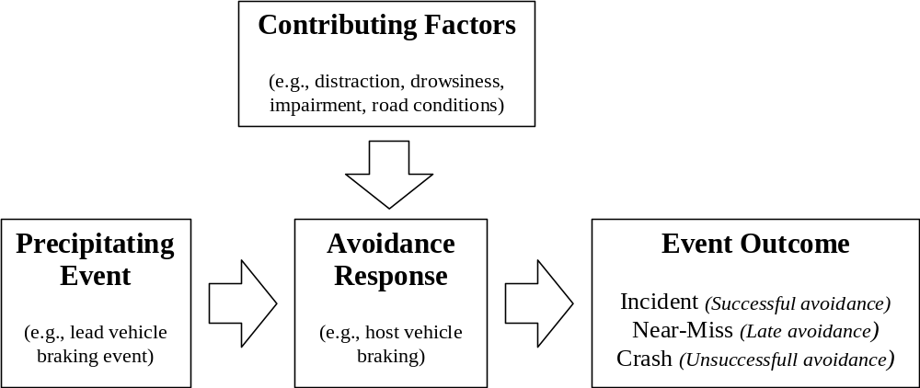
Figure 9.3. A simple model based on the 100-Car Study findings of distraction as a catalyst for collision.

To the extent that this model approximates the reality of lead-vehicle or single-vehicle crashes, it predicts that in the absence of a catalyst such as visual distraction, drivers are unlikely to benefit from warnings. If the driver is attending to the forward roadway at the moment a precipitating event occurs, the driver acts like a servomechanism, quickly detecting the event and responding appropriately. In such a circumstance, there is little opportunity to improve the process. Even in cases of mechanical failure or poor roadway conditions, the circumstance may not be aided by a warning if the driver is already aware of what is occurring. For example, if an unexpected lead-vehicle braking event requires a 1-g braking maneuver, yet the road surface or host-vehicle brakes only support 0.5 g, a warning may provide little assistance. In such cases, the crash may already be unavoidable the moment it has begun to unfold.

To the extent that FCW or LDW alerts are not beneficial for attentive drivers, suppressing warnings may be an effective strategy for reducing nuisance alerts. In the context of the simple model shown in Figure 9.3, such an adaptive warning system monitors the essential ingredients for a collision, the precipitating event in the environment and the most common contributing factor that interferes with a successful avoidance response: driver distraction. By monitoring both environmental and driver facets of a potential collision, adaptive warning systems may provide alerts when drivers need them most while simultaneously reducing the overall rate of alerts.

The CAMP workload metrics project (Angell, Anflick, Austria, Kochhar, Tijerina, Biever, Diptiman, Hogsett, & Kiger, 2006) suggested that auditory-vocal tasks can actually lead to a reduction in the standard deviation of lane position (SDLP), supporting the observation that cognitive distraction does not degrade lane keeping (Horrey & Wickens, 2006). The case for LDW may therefore be quite clear cut: in the absence of either visual distraction or drowsiness, if the vehicle is departing the lane, the driver is probably already aware of it. When a driver is already aware of the lane departure, even if it is unintentional, they still are unlikely to benefit from the warning.

In Phase I, two experiments were conducted. The first was a between-subjects evaluation of driver response times during cognitive and visual distractions (from Tasks 7 and 5 respectively) in comparison to a control group with no experimentally imposed distraction. Consistent with the literature, the results demonstrated a much larger effect of visual distraction than cognitive distraction. The largest differences in response times emerged between the first and second exposures, with drivers in the control group responding 1.32 s earlier on the second exposure than the first. The second experiment compared three adaptation strategies and a non-adaptive system in a repeated-measures driving simulator experiment. Both FCW and LDW were adapted according to the Differential Stimuli (suppressing the auditory component when the driver’s attention is forward), Differential Timing, and Alert Suppression adaptations. In Phase I, the Differential Location adaptation was not specifically tested.

Table 9.1 displays the four adaptation strategies that were considered for the SAVE-IT program, including Differential Location, Differential Stimuli, Differential Timing, and Alert Suppression adaptations. Whereas the Differential Location and Differential Stimuli adaptations modify the nature of the human-machine interface, the Differential Timing and Alert Suppression adaptations modify the algorithms that generate the alerts. The Differential Location adaptation positions the visual stimulus of the alert in the location of the visual distraction and the Differential Stimuli adaptation provides a more urgent or attention-capturing stimulus when the driver is distracted. Whereas the Alert Suppression adaptation simply prevents alerts from being generated, the Differential Timing adaptation modifies the likelihood that alerts will be generated by providing earlier alerts when the driver is distracted and later alerts when the driver is not.

Table 9.1. Adaptation Matrix displaying the adaptive safety warning countermeasure strategies and how they behave as a function of the attention being either forward or non-forward.

Attention-Based  Adaptation Strategy |  | Negative Adaptation | Positive Adaptation
 |  | Attention Forward | Attention Not-forward
 |  | Goal: Improved Acceptance | Goal: Improved Safety
Non-Adaptive |  | Nominal Alert | Nominal Alert
Modify Human-Machine Interface | Differential Location | Nominal Alert | Visual alert in location of driver’s attention
Modify Human-Machine Interface | Differential Stimuli | Less intrusive or urgent stimuli | More intrusive or urgent stimuli
Modify Algorithm | Differential Timing | Later Alert (less likely) | Earlier Alert (more likely)
Modify Algorithm | Alert Suppression | No Alert | Nominal Alert

Note. Whereas the manipulations in the “Negative Adaptation” column are designed to increase acceptance, the manipulations in the “Positive Adaptation” column are designed to improve the safety benefit.

Most types of adaptation can be either positive or negative. Whereas negative adaptations diminish the warnings when the driver is attentive, positive adaptations accentuate or enhance warnings when the driver’s attention is directed away from the road. The primary goal of negative adaptation is to improve driver acceptance by reducing the potential nuisance of unnecessary and false alerts. The primary goal of positive adaptation is to improve the safety benefit of the warning systems. Although the primary goals are separate for negative and positive adaptation, the dimensions of driver acceptance and safety benefit are certainly not independent. For a system to achieve a safety benefit, the driver must accept the alerts to some extent. Lees and Lee (in press) demonstrated that drivers complied less with their FCW system when the system was prone to false alerts. This “cry wolf” effect has been consistently shown to undermine response to warning systems (Bliss, Dunn, & Fuller, 1995; Bliss & Acton, 2003). Furthermore, it is likely that if the system apparently fails to achieve a safety benefit, drivers may be less likely to accept the system because they do not perceive the system as being useful.

In Experiment 2, in addition to the Non-Adaptive baseline, each driver experienced the Differential Timing, Differential Stimuli (with both positive and negative adaptations), and Alert Suppression adaptations. Rather than using the distraction sensing methods that were still under development, the experiments used the presence of the distraction task as the basis for the adaptation. Half of the participants experienced the visual distraction task and half of the participants experienced the cognitive distraction task. Whereas the results provided some objective (e.g., reaction times) and subjective (questionnaire responses) support for the visual distraction adaptations, they did not support the cognitive-distraction adaptations.

Table 9.2 displays the rankings of driving performance and subjective responses to the FCW system for the three types of adaptive systems. The rankings were ordered so that lower scores invariably correspond to more favorable rankings and higher scores invariably correspond to less favorable rankings. In addition to the three types of adaptation shown in the table, the non-adaptive condition was also included, drawing most of the “4” (least favorable) rankings. Note that these rankings do not necessarily represent findings that were statistically significant, but are just presented to show the trends observed in this data. The different types of adaptation shown in Table 9.1 are discussed in more detail in the remainder of this Section.

Table 9.2. The Effectiveness of Three Types of Adaptation as a Function of Distraction Type.
Dependent Measure | Visual Distraction |  |  | Cognitive Distraction
Dependent Measure | Differential  Timing | Differential Stimuli | Alert  Suppression | Differential  Timing | Differential Stimuli | Alert  Suppression
Distracted BRT | 2 | 3 | 1 | 1 | 2 | 3
Attentive BRT | 4 | 1 | 3 | 3 | 1 | 4
Annoyance | 1 | 3 | 2 | 3 | 4 | 2
Usefulness | 2 | 1 | 3 | 4 | 3 | 2
Timing | Best | Earliest | Early | Earliest | Early | Late
Trust | 2 | 1 | 3 | 4 | 2 | 1
Self-confidence | 1 | 2 | 3 | 4 | 1 | 3
Preference | 2 | 1 | 3 | 3 | 1 | 2

Note. The numbers represent numerical rankings from 1 (most favorable) to 4 (least favorable) and do not necessarily represent significant differences. The BRT rows represent the rankings for the -5 m/s² braking events. For example, the visually-distracted drivers responded fastest to the alert suppression adaptation and slowest to the non-adaptive warnings.

9.2.1 Differential Location
The Differential Location adaptation strategy modifies the placement of the visual stimulus as a function of the driver’s focus of attention. In the SAVE-IT manifestation of this adaptation, when drivers were distracted by the center-console application and the FCW or LDW systems triggered an alert, the visual stimulus (an FCW or LDW icon) was presented on the center-console. This icon temporarily replaced the material that was being displayed and was presented redundantly with the other visual and auditory stimuli only when the driver was already distracted. For non-distracted drivers, only the conventional visual and auditory warning stimuli appeared. The rationale for this adaptation is that an alert placed in the path of the driver’s glance is more likely to acquire the driver’s attention. The reason that warning icons should not be indiscriminately positioned in the center-console is that positioning an icon away from the frontal location could draw the driver’s attention away from the external threat. This adaptation attempts to circumvent this problem by only presenting an icon in the center-console when the driver’s attention was already directed toward that location. For distraction sources not located in the center console, this type of adaptation would need to position the visual warning elsewhere. As shown in Table 9.1, drivers who were attending to the forward scene at the time of the alerting event received a nominal (non-adaptive) warning. This type of adaptation was not evaluated in Phase I of the SAVE-IT program, but was evaluated in Phase II.

9.2.2 Differential Stimuli
Like the Differential Location adaptation strategy, the Differential Stimuli strategy operates by modifying the driver interface of the FCW and LDW systems. The Differential Stimuli adaptation seeks to reduce annoyance by suppressing the most intrusive component of the alert, when the driver is attentive to the forward roadway. An auditory alert is more likely to produce annoyance than a visual stimulus because it is usually more intrusive than a visual stimulus and cannot be localized to the driver, thus potentially interrupting conversations or undermining the passenger’s confidence in the driver. In the SAVE-IT manifestation of this adaptation, a visual-only alert was provided for attentive drivers and a visual-plus-tone alert was provided when drivers were distracted. The reasoning behind this strategy is that drivers who are already looking in the forward direction are likely to be able to detect a visual alert located near the forward scene and thus are unlikely to need an auditory stimulus. Whereas a distracted driver may require an orientation-independent stimulus (such as an auditory alert) to reacquire their attention, an attentive driver may be adequately alerted from an orientation-dependent stimulus (such as a visual alert).

In Experiment 2, this strategy not only used the negative adaptation of suppressing the auditory component of the alert, but also provided a positive adaptation when the driver was distracted, by providing a voice stimulus (saying “lead vehicle braking” or “drifting left” or “drifting right”) at a cautionary threshold. This adaptation was the most noticeable adaptation that participants experienced, and was the only method of adaptation that more than half of the participants in each group noticed. This was likely due to the voice messages that accompanied the cautionary alerts being more salient than the other forms of adaptation.

During the distracted-driving segments where the positive side of the adaptation functioned, participants reacted faster to the -3 m/s² braking events during the Differential Stimuli drive than the Alert Suppression drive. However, accompanying the cautionary FCW alerts with the voice message (Differential Stimuli) was not as effective at expediting the driver responses to the -5 m/s² braking events as having a more immediate imminent alert (Differential Timing). During the non-distracted segments where the negative side of the adaptation functioned, removing the audible component of the imminent FCW alerts (Differential Stimuli) delayed driver responses less than delaying the imminent alert (Differential Timing). When drivers were not engaged in a distraction task, removing the auditory stimulus from the imminent warnings did not appear to degrade driving performance. If this result is valid, it may suggest a promising way of reducing annoyance without sacrificing the benefit of potentially useful alerts.
Participants in the visual-distraction group rated the FCW system in the Differential Stimuli drive as the most preferred, most trusted, and most useful. On the less desirable side, this system was rated as the most annoying and as having the earliest timing (which could potentially annoying the driver), probably reflecting the fact that the voice message accompanied the cautionary alert level. Participants in the cognitive-distraction group also rated the FCW system in the Differential Stimuli drive as the most preferred but most annoying alternative.
The LDW system in the Differential Stimuli drive shared similar undesirable characteristics (annoyance, earliest timing) as the FCW system, however, unlike the FCW system, the Differential Stimuli adaptation for the LDW system was not the most preferred alternative of the visual-distraction group. The visual-distraction group did rate it as the most trusted LDW adaptation and the most useful of the three adaptation alternatives (but not as useful as having no adaptation at all).
One potential benefit of the Differential Stimuli adaptation is that it may be able to help reveal the underlying functionality of the warning system. For example, rather than completely suppressing an LDW alert, the adaptation might only suppress the more intrusive component, thereby saving the driver from the annoyance but still providing some indication (e.g., seat vibration) that the system detected the lane crossing. It also allows for the possibility of providing some benefit for drivers who are severely cognitively distracted if such drivers are able to benefit from the warnings.

9.2.3 Differential Timing
The Differential Timing strategy provides earlier alerts for distracted drivers and later alerts for attentive drivers. This strategy is based on data demonstrating that distracted drivers require more time to respond to an alert than attentive drivers (e.g., Lee, McGehee, Brown, & Reyes, 2002; Smith & Zhang, 2004b). By providing differential predictions for how quickly a driver will respond to the warning, an FCW algorithm can provide distracted drivers with sufficient time to respond. Many unnecessary alerts may also be avoided with a Differential Timing strategy because attentive drivers are likely to respond to the threatening conditions or the fleeting pseudo-threat is more likely to dissipate before the later alert threshold is reached. In the Phase I implementation of this adaptation, drivers would receive alerts up to 1.5 s earlier than the non-adaptive condition when drivers were distracted and up to 0.5 s later than the non-adaptive condition when drivers were not distracted. Experiment 2 demonstrated that the rate of nuisance alerts could effectively be reduced by later timing when the driver was attentive (negative adaptation), and that early alerts for distracted drivers could reverse the negative effects of distraction (positive adaptation). Lee et al.’s (2002) research also supports the positive side of this adaptation because it demonstrated that earlier warnings translated into significantly earlier responses.

In Experiment 2, the Differential Timing adaptation directly influenced the timing of the alerts, but also indirectly influenced the number of alerts that drivers received. Despite this influence, the timing adaptation was relatively unnoticed. Only one quarter of the drivers in the visual-distraction group claimed to notice the FCW and LDW adaptations. Perhaps this can be explained because these participants were distracted during the half of the drive that the timing effect would have been most salient. The time-sharing of the visual-distraction task may have made it difficult to notice the timing changes. In the cognitive-distraction group, half of the participants claimed to notice the FCW adaptation and only two of the twelve participants claimed to notice the LDW adaptation.
Compared with the other methods of adaptation, the Differential Timing adaptation had a large effect on driver-response times. During the distraction task, participants responded significantly faster during the Differential Timing drive than in the other drives. The negative side of this adaptation produced the opposite effect for the visual distraction group during the non-distraction segments, reflecting the delay in the alerts when the driver was attentive.
Consistent with the other types of adaptation, the visual-distraction group rated the Differential Timing FCW system as not annoying (approximately 2 on a seven-point scale). They rated the Differential Timing FCW system as being numerically the least annoying, having timing closest to “just right”, and inspiring the greatest self-confidence. The cognitive-distraction group did not rate the Differential Timing FCW system as favorably, rating the Differential Timing FCW system as the earliest, least useful, least trusted, and least inspiring of self-confidence.
Although the Differential Timing adaptation affected the timing and occurrences of the LDW system, there was no measurable effect on lane-keeping performance (average absolute TLC and SDLP) compared with the other two adaptive systems. Participants in the visual-distraction group rated the Differential Timing LDW system as significantly more annoying than the non-adapted LDW system. The increase in the sensitivity of the LDW system that led to an average of 17 additional cautionary alerts per driver and additional imminent alerts for five of the eleven drivers is likely to have been the cause. Despite the increased annoyance and being rated as the least useful, the visual-distraction group rated the Differential Timing adaptation as the most preferred LDW alternative. The opposite occurred in the cognitive-distraction group, with the Differential Timing adaptation being rated as the least preferred LDW alternative.

9.2.4 Alert Suppression
Alert Suppression is perhaps the most simple and obvious negative adaptation strategy, and directly governs whether the warning is issued. When the driver is attentive, the alert is suppressed, but otherwise the alert functions like a nominal warning system.

In Phase I, the effects of the Alert Suppression adaptation were quite subtle. Only six out of the twelve drivers in the visual distraction group claimed to notice the Alert Suppression adaptation, and only two of twelve did in the cognitive distraction group. By design, this adaptation suppressed all 69 FCW alerts that would have otherwise occurred during the non-distracted segments of the two groups (visual and cognitive distraction). The Alert Suppression adaptation had a smaller effect on the LDW system, suppressing only one imminent LDW alert for four out of 24 drivers that would have otherwise occurred during the non-distracted segments.
The absence of imminent alerts did appear to slow the driver’s response during the -5 m/s² braking events in both the visual and cognitive distraction groups. This adaptation actually reversed the effect of both types of distraction, with drivers responding faster to the -5 m/s² braking events during the distracted segments than the non-distracted segments.
The subjective ratings of the FCW and LDW systems during the Alert Suppression drive tended to reflect the fact that few participants noticed it. Compared with the other two drives, the visual-distraction group rated Alert Suppression for both FCW and LDW as least useful, least trusted, least inspiring of self-confidence, and least preferred. The only positive indications were that the visual-distraction group rated the Alert Suppression for the LDW system as being the least annoying and having timing closest to “just right”.

9.2.5 Adaptation to Cognitive vs. Visual Distraction
Whereas the adaptations to visual distractions usually led to more desirable ratings, adaptations to cognitive distractions did not. Adapting the LDW system to cognitive distraction in particular appears to be ineffective. Figure 9.4 displays the driver feedback for the effectiveness, annoyance, usefulness, and trust rating scales averaged over the three methods of adapting the FCW system for the visual and cognitive groups. The visual-distraction group rated the three FCW adaptations as significantly more effective, significantly less annoying, significantly more trusted, and significantly more useful than the cognitive-distraction group. This result suggests that adapting FCW to visual-distraction is more effective than adapting FCW to cognitive-distraction. This observation is mirrored by the fact that participants in the cognitive-distraction group exhibited no clear preference for any type of adaptation. Although it was not statistically significant, the non-adaptive FCW system was rated by the cognitive-distraction group as being the least annoying and most useful when compared with the three adaptive alternatives.

1
2
3
4
5
6
7
8
Effective (1-9)
Annoy (1-7)
Trust (1-10)
Useful (1-7)
Rating Scale
Average Rating
Visual
Cognitive

Figure 9.4. Responses to the effectiveness, annoyance, trust, and usefulness scales averaged over the three adaptive drives (Differential Timing, Alert Suppression, Differential Stimuli) as a function of distraction group.

Adapting to cognitive distraction did not appear to be an effective strategy for LDW either. The cognitive-distraction task did not degrade lane-keeping performance and so drivers in the cognitive-distraction group received few LDW alerts. This result is consistent with the results of the Horrey and Wickens (2004) meta-analysis that found little degradation of lane-keeping performance as a result of cell phone conversations. This experiment did not support the hypothesis that an LDW alert is more likely to be useful when the driver is distracted by a purely cognitive task. Instead these data appear to suggest that LDW systems should only adapt to the visual-manual rather than auditory-vocal dimension of distraction.
Using non-contact automotive grade sensors, cognitive distraction is more difficult to detect than visual distraction. Because of this and because Phase I was unable to develop an effective set of FCW and LDW adaptations for cognitive distraction, it was decided that Phase II would focus on selecting adaptation methods for visual distraction. Rather than implying that cognitive distraction is not important, Phase I suggests that more subtle and sophisticated adaptation techniques should be developed in the future to make use of this information when it becomes available.

Experiment 2 provided relatively low annoyance ratings in most circumstances. However, this may be misleading because when drivers are exposed to real FCW and LDW systems on public roadways, they may be more likely to experience the annoyance of inappropriate alarm activations. As such, they may learn to appreciate a system that is capable of reducing nuisance alerts. The benefit of the Alert Suppression method of adaptation may have been especially underestimated. Despite the relatively negative subjective results of the Alert Suppression adaptation, on real roadways this method of adaptation may still be useful for counteracting the potential annoyance of inappropriate LDW activations (e.g., changing-lanes and intentional lane deviations).

9.2.6 Phase II Research Questions
Table 9.3 displays the research constraints for the evaluation of safety compared with the evaluation of acceptance. Whereas the need to control driver expectations suggests a between-subjects design for the question of safety, the need to expose the driver to a representative system experience demands an on-road evaluation. Because the on-road research platform was not yet available, it was decided that the Phase II Task 9 activity would focus exclusively on safety-benefit. Whereas Phase I had collected preliminary observations with respect to safety benefit and driver acceptance by using a repeated-measures design, Phase II sought to conduct a between-subjects analysis that focused exclusively on safety benefit. The between-subjects methodology required a large number of subjects, but could be streamlined to require only a short amount of time per participant. By maximizing the effectiveness of the driving simulator, this between-subjects methodology would provide useful data to aid the down-selection of adaptation strategies. This evaluation could examine whether the various negative adaptations compromise safety benefit and whether the positive adaptations improve safety benefit over non-adaptive warning systems. Although the selection of adaptation strategies could not be made solely on the merits of safety benefit, the questions surrounding driver acceptance could be evaluated when the on-road research platform became available. The on-road exposures that were to follow were conducted as a part of Task 11b (Safety Warning Countermeasures Data Fusion) and provided the final data necessary to select the adaptive systems that would be evaluated in Task 14 (Evaluation).

Table 9.3. The Research Constraints for Safety Benefit vs. Driver Acceptance.

Research Constraints | Safety Benefit | Acceptance
Central Question | Which system compromises safety the least or provides the greatest safety benefit? | Which system is least annoying, most acceptable, most preferred, or provides the greatest perception of benefit?
Exposure Requirements | Expose drivers to real or simulated threatening scenarios where there is an apparent danger of collision | Expose drivers to a representative experience that balances favorable and unfavorable aspects of the system
Control Requirements | Control driver expectations | Facilitate adequate driver comprehension of the system
Participant Requirements | Between-subjects design | Span representative demographics
Dependent Measures | Objective Performance  (Reaction times, time to collision, collision rates and velocities) | Subjective Measures  (Annoyance, perceived effectiveness, buy likelihood, preference)
Number of Participants vs. Amount of Time per Participant | More participants | More time per participant
Ideal Research Facility | Driving Simulator  (Unless millions of miles of naturalistic data can be collected, an experiment must create an apparent danger of collision without actual risk) | On-road  (Only real roadways provide the necessary richness and complexity of the real environment that is difficult to anticipate a priori or to simulate)

The experiments of Phase II were as follow:
- Experiment 3 (FCW HMI Down Selection): Test different visual and auditory display stimulus alternatives.
- Experiment 4 (LDW Down Selection): Compare different HMI and adaptation candidates for LDW .
- Experiment 5 (FCW Adaptation Down Selection): Investigate the effectiveness of different adaptation strategies for alerting distracted versus attentive drivers.

Although most of the evaluations could be packaged into a fully-factorial design, there were several additional conditions that needed to be evaluated in addition to the three major factorial designs. The modular between-subjects design allowed several experimental conditions to be added as a series of t-tests, that were tailored to the evaluation of specific SAVE-IT concepts.

9.3. Experiment 3: FCW HMI DOWN SELECTION

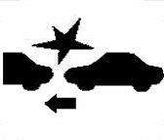
During the period between the two research phases, several observations were made about the effectiveness of icons for alerting drivers. The Society of Automotive Engineering (SAE) compared the comprehension of different active safety icons. The test procedure provided the icon to participants as an image on paper and asked participants what they believed the symbol meant. Figure 9.5 displays the icon that had the highest comprehension for FCW. For this evaluation, the concept of “best” must be considered to be relative, because 55 % of participants missed one or more major informational elements of the best-performing icon and 5 % even misunderstood the icon to such an extent that their understanding may have led them to engage in an unsafe action. Of the four icons shown to participants, one led to 89 % of participants missing one or more major informational elements and another was misunderstood by 28 % to an extent that they might engage in an unsafe action.

Figure 9.5. SAE committee’s best understood icon for FCW.

These results were collected in a circumstance that granted them more time than a real collision conflict would. In the real instance, an icon of lower contrast might be rapidly flashed at the driver, frequently requiring a response within a second or two. With such a short duration in which to comprehend the icon, drivers might have insufficient time to digest what the icon is attempting to convey, including the arrow that suggests which direction the vehicles are traveling (rather than what the appropriate action is that should be taken). Thus, in the brevity of a real collision-conflict event, the comprehension of previously unseen icons could be even worse.

To aggravate the difficulty of icons further, the constraints of automotive production may prevent a Head-up display (HUD) from being used to display the icon, requiring that the icon be placed in the instrument cluster. Such a location may lead the icon to be unnoticed, because after drivers hear the audible alert, they are most likely to direct their visual attention to the forward scene in order to detect the threat with their own perceptual systems. For this reason, instrument-cluster icons are likely to go unnoticed, providing little benefit over an auditory-only alert.

Figure 9.6 displays a conceptual diagram of some of the observations made during the ACAS FOT program and the first phase of SAVE-IT. When a distracted driver is not warned, it may take a large amount of time before the driver glances back and detects the collision threat. When a visual icon is displayed in a sub-optimal location, the distraction may be interrupted, however, an additional step is added where the driver must look at and try to interpret the warning icon. Because drivers may not completely trust the message, they most likely will need to see the threat with their own eyes before they fully respond. Although presenting an icon on the HUD may expedite the transition between viewing the icon and the forward scene, the icon-viewing step is still an addition to the process. The temporal cost of adding this stage may be justified by the interruption of distraction, however, it is an additional stage that may require several hundred milliseconds.

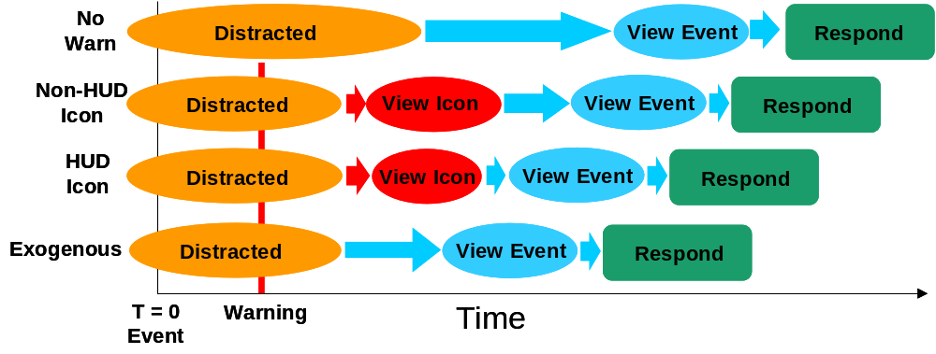
Figure 9.6. Conceptual diagram of a distracted driver responding to an imminent event.
Ideal

If drivers do not blindly trust warnings and must seek confirmation with their own eyes, the ideal type of visual display would be one that does not add an additional stage but instead just interrupts the driver’s distraction and draws their visual attention to the appropriate location in the visual field. In the case of both FCW and LDW, the conflicts are most likely to be evident near the focus of expansion of the optic flow. For this reason, rather than displaying an icon, an alternative strategy is to create a disturbance in the visual field near the focus of expansion to exogenously attract the driver’s eyes to the location where they are most likely to detect the conflict with their own perceptual system. Such a display might be referred to as an exogenous display because rather than convincing the driver that their eyes need to look in a given direction (endogenous control of attention), the visual field draws the drivers eyes to this location (exogenous control of attention; see Theeuwes, 1991). Ideally, such an exogenous display should be displayed briefly so that the occurrence outside, rather than the visual disturbance itself, becomes the focus of attention.

To test this exogenous display concept, a simple display was developed. This display created a point source of light (using a high-intensity red LED) on the vehicle dash that reflected up onto the windshield on the driver’s centerline and near the horizon. Although similar in concept to a HUD, this exogenous display differs in that it is positioned higher than a traditional HUD and does not require complex optics because there is no graphical image. Because of its simplicity, this display avoids many of the production disadvantages of the HUD including:
- Low contrast ratio due to the need to filter the light source in producing an image
- Inability to see the display when the driver wears polarized sunglasses
- Difficulty to integrate because of large size (due to complex optics)
- High cost due to complexity

Like traditional HUDs, the exogenous display must control the brightness as a function of the ambient illumination in order to both provide a bright display that competes with daylight and avoids temporarily blinding drivers at night. In order to quickly capture the driver’s attention, the red LED was programmed to flash three times at 5 Hz, using a 50 % duty cycle.

Another strategy for counteracting the problem of alert comprehension was to use an auditory stimulus with more of an associated meaning, or an auditory icon (see Graham, 1999). Whereas the ACAS FOT program used a series of tones that had no inherent meaning, an alternative approach was to use a sound that drivers could sassociate with the appropriate response, such as a car-horn sound emerging from the forward direction. Graham found a small but detectable benefit for brake reaction time in using auditory icons in comparison to simple tones in a repeated-measures experiment. The car-horn sound was ranked as the most appropriate auditory stimulus for conveying the event of a vehicle pulling out into the host vehicle’s path. Because of the well-established mapping between stimulus and response, the auditory icons seemed to trigger a nearly automatic response, which also led to inappropriate responses (braking in response to false alerts) more frequently than the speech or tonal stimuli. Balz, Robinson, and Casali (1999) also observed a reaction time benefit for auditory icons (including a car-horn sound for a side warning and tire-skidding sound for a forward collision warning) in a repeated-measures experiment in the context of commercial vehicles. Some pilot testing for this experiment also revealed that the car-horn sound provided a reasonable balance across the variables of urgency, understanding, and annoyance.

Experiment 3 was designed to compare the exogenous display concept against a traditional HUD icon and explore the potential interactions that this display might have with differing auditory stimuli.

9.3.1 Experiment 3 Method
Participants
One hundred male employees at Delphi Electronics and Safety Systems in Kokomo, Indiana, participated in the study. Only male employees were used because previous studies had shown a lower rate of motion sickness for males compared to females and the Phase I research had not revealed any relevant performance differences between the responses of males or females. Furthermore, males were far more prevalent in the subject population. Employees were informed about the study by email using a random selection process. Participants were randomly assigned (10 participants per condition) to one of the nine conditions in the 3 (visual stimulus) x 3 (auditory stimulus) experiment. All participants were between the ages of 35 and 55 years old. They were required to drive an average of at least 12,000 miles per year, have a valid U.S. driver’s license, and have normal or corrected-to-normal vision. To be eligible for the study, participants could not have participated in similar experiments, had to agree not to take driving-impairing drugs at least 4 hrs before their scheduled study, and could not work on the products that were being tested in the experiments. Participants were paid for their participation with a $30 gift certificate to the “Best Buy” store.

Apparatus
Equipment used in this experiment included a fixed-base driving simulator at Delphi Electronics and Safety Systems in Kokomo, Indiana. The simulator utilized DriveSafety™ software and projected the simulated environment on a 1024x768-pixel 50-deg-diagonal forward field-of-view image located at the front bumper of the vehicle cab. To simulate the feel of the road, steering feedback was presented with a force-feedback torque motor. The vehicle cab consisted of the front half of a 1995 Pontiac Bonneville exterior (with doors and roof removed). The simulator included a speaker that produced the auditory warning, which was located directly in front of the driver on the dashboard and presented the auditory component of the warnings at approximately 70 dB. To simulate a HUD for the HUD-based icon visual stimulus, the icon shown in Figure 9.7 was displayed directly on the main driving simulator screen, and spanned approximately 1 deg². Both the exogenous and HUD icon visual displays were presented on the driver’s centerline, however, whereas the HUD-icon was presented just above the vehicle hood, the exogenous display was presented just below the horizon for most drivers. Although the HUD-icon was presented using the brightest red color available on the projector screen, the exogenous display was considerably brighter, mirroring the real-world brightness of an exogenous display in comparison with conventional HUD images.


Figure 9.7. FCW icon presented in the location of a HUD.

A HoMedics BK 4500 Back Massager was used for the haptic-seat condition. This consumer product is a car-seat overlay with offset motors used to create vibration. It was modified to accommodate the needs of the experiment by adjusting it to provide vibration in four locations in the bottom of the seat when the warnings were issued. The motors used to provide the vibration on the back of the seat were disabled. The seat vibration was issued as a series of four bursts at 4 Hz with a 50 % duty cycle.

Design
A 3 x 3 between-subjects factorial design was used, where the three types of visual stimuli used to alert the driver (exogenous display, HUD-icon display, and no visual stimulus) were factorially crossed with the three types of auditory stimuli used to alert the driver (car-horn sound, tonal sound, and no auditory stimulus). The tonal sound that was used was the FCW sound used in the ACAS FOT program (which was a series of four 725-Hz beeps at 4 Hz with a 50 % duty cycle). Both sounds spanned a 1-s duration.

In addition to the nine conditions in the factorial design, a condition was added to evaluate the effectiveness of a haptic (seat vibration) stimulus compared to an auditory stimulus. This condition used a combination of the exogenous display and the haptic seat vibration.

The following dependent measures were analyzed:

Response-Time Measures:
- Glance Reaction Time (GRT): The time interval between the lead vehicle braking event and the driver’s eyes being returned to the forward roadway. Due to missing video data, there were nine missing values for GRT and GAT.
- Accelerator Release Time (ART): The time interval between the lead vehicle braking and the driver completely releasing the accelerator pedal.
- Brake Reaction Time (BRT): The time interval between the lead vehicle braking and the driver beginning to depress the brake pedal.
- Half Brake Time (HBT): The time interval between the lead vehicle braking and the driver depressing the brake half of the maximum.
Transition-Time Measures:
- Glance-to-Accelerator Time (GAT): The time interval between the glance return and the accelerator release (ART – GRT).
- Pedal Transition Time (PTT): The time interval between the accelerator release and the beginning of the brake depression (BRT – ART).
- Brake Travel Time Half (BTT): The time interval between the driver beginning to depress the brake pedal and the brake pedal being depressed half of the maximum (HBT – BRT).
Threat-Severity Measures:
- Minimum Time-to-collision (TTC): The minimum first-order (including only position and velocity rather than accelerations) time-to-collision between the lead-vehicle-braking event and when the host vehicle is stopped. In cases where drivers crossed the plane of the lead vehicle, the TTC was zero.
- Collision Velocity (CV): The differential velocity of the lead and host vehicles at the moment that the host vehicle crosses the longitudinal plane of the rear bumper of the lead vehicle. In the rare cases where the driver steered around the lead vehicle, collision velocity was still calculated when the front of the host vehicle crosses the plane of the lead vehicle. In cases where drivers stopped before crossing the plane, the collision velocity was zero.

Eight of the nine variables were time measures (s), with the one exception being collision velocity (m/s). In addition to the MANOVA variables, the rate of collisions for each group was also recorded.

The pilot testing in Phase I demonstrated that the variability in reaction times and driver behaviors at the time of the braking event required that the data of some participants needed to be rejected. To increase the sensitivity of the between-subjects experiment, and to avoid the necessity of a much larger number of participants, several rules were set up a priori for the removal of data under certain circumstances. Before testing began, it was decided that data from an event would be rejected if it violated any one of the following criteria:

- Speed was not maintained between 60 and 70 mph at the time of the braking events.
- The driver did not glance down at the scrolling text before responding to the braking event.
- The reaction time was two standard deviations outside the mean for the condition.

The first criterion was necessary primarily because of the lead vehicle enforcing the headway. Because the lead vehicle would speed up or slow down in order to achieve the specified headway, it was observed that some drivers rejected the targeted headway and tried to close the gap by speeding up or open the gap by slowing down. Furthermore, some drivers were not comfortable with the task of reading the scrolling text and so did not glance away just prior to the braking event, requiring the second rejection criterion. Participants who violated the first and second criteria were replaced with additional participants, however, participants violating the variability criterion (criterion 3) were removed without replacement after all testing was complete. Of the hundred subjects who participated in the study, the data of five participants (no more than one per condition) were removed as a result of the third rejection criteria and were not replaced.

Procedure
Upon their arrival at the driving simulator at Delphi Electronics and Safety, participants signed informed-consent forms and received a $30 Best Buy gift certificate. After participants were shown how to adjust the seat height and steering wheel position in the simulator, the overhead room lights were dimmed. The researcher reminded all participants that if they felt any discomfort during the experiment they were to stop driving and alert the researcher immediately. All participants were then asked to press the brake pedal once, which prompted an instruction slide to appear on the rear-projection screen in front of them. Every participant saw the same experimental agenda that indicated that there would be four drives lasting 7 min, 15 min, 15 min, and 15 min respectively (see Figure 9.8). In actuality, each participant drove two drives, lasting 10 min and approximately 5 min, respectively. The purpose of this deception was to reduce as much expectation as possible that the lead vehicle was going to brake suddenly, creating an imminent braking situation.

The slide on the screen indicated that the purpose of the study was to “investigate how FCW systems may be designed to reduce the effects of driver distraction” and that a FCW system works by using a radar that “measures the range and closure rate of the vehicle in front and calculates the threat of imminent collision” suggesting that the driver needs to “brake immediately to avoid colliding with the lead vehicle”. The researcher also read the agenda, purpose, and FCW explanation aloud. Participants were then instructed to press the accelerator pedal once to activate the FCW stimuli.

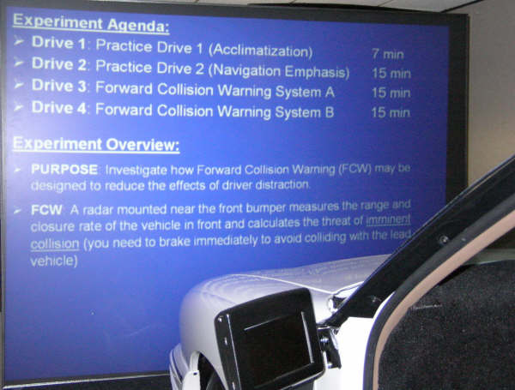

Figure 9.8. Experimental agenda shown to the participants on the driving simulator screen.

Next, the researcher pointed out the console screen to all participants and briefly explained that scrolling text would appear there to offer instructions and navigation information. Participants were then instructed to press the accelerator pedal one time to begin Drive 1. The researcher left the room at this time. As participants drove, in-vehicle text messages presented information about the appropriate speed to travel at, which highway exits to take, and what turns to make. When no instructions were present, the center-console was completely black, however, when the text was about to appear, the screen would light up green, presenting a black bar in the center of the bottom half of the screen on which the text would scroll across.

At the completion of Drive 1, the scrolling text indicated that “the next drive is also practice but will have a greater emphasis on navigation, so pay close attention for important instructions.” All participants were told that Drive 2 would end when they “park next to the red SUV”. In actuality, Drive 2 ended 5 min after it began when the lead vehicle decelerated at a rate of -5 m/s². Pilot testing in Phase I had revealed that deception was necessary to reduce the driver’s expectations that the lead vehicle was going to brake. Although the instructions suggested that the center console was present to provide instructions, the major purpose of the center console was to provide a severe visual distraction for the driver. Five hundred msec before the lead-vehicle-braking event began in Drive 2, scrolling text emerged on the center console, telling the driver “when you get to the next intersection, take the west (2nd) highway exit”. Other than the presence of the scrolling text, no clues were present in the simulation to allow the driver to predict that the lead vehicle would brake at the time it did. For several minutes prior to the braking event, the lead vehicle began stabilizing the distance between itself and the host vehicle, by adjusting speed as necessary to achieve the target time headway of 2 s.

9.3.2 Experiment 3 Results
A between-subjects MANOVA was conducted on the nine dependent measures for the 3 x 3 factorial combination of visual and auditory stimuli, excluding the haptic seat condition. The nine dependent measures that were recorded included Glance Reaction Time (GRT), Accelerator Release Time (ART), Brake Reaction Time (BRT), Half Brake Time (HBT), Glance-to-Accelerator Time (GAT), Pedal Transition Time (PTT), Brake Travel Time Half (BTT), Minimum Time-to-collision (TTC), Collision Velocity (CV). Because such a large set of interdependent variables were used in this analysis, a correlation matrix was created and is displayed in Table 9.4.

Table 9.4. Dependent Measures Correlation Matrix.
 |  | Threat Severity | Response  Time |  |  |  | Transition  Time
 |  | TTC | GRT | ART | BRT | HBT | GAT | PTT | BTT
Response  Time | GRT | -.578**
Response  Time | ART | -.686** | .699**
Response  Time | BRT | -.894** | .658** | .813**
Response  Time | HBT | -.904** | .569** | .733** | .886**
Transition  Time | GAT | -.535** | .256* | .870** | .655** | .599**
Transition  Time | PTT | -.150 | -.176 | -.444** | .116 | .077 | -.458**
Transition  Time | BTT | .083 | -.247* | -.256* | -.347** | .128 | -.182 | -.092
Threat Severity | CV | -.657** | .517** | .777** | .826** | .746** | .692** | -.053 | -.258*
* Statistically significant at the 0.05 level (2-tailed)
** Statistically significant at the 0.01 level (2-tailed)

As expected, the TTC measure was negatively correlated with most of the other dependent measures, especially HBT and BRT, demonstrating that later responses led to more threatening situations (lower TTCs). Likewise, the CV measure was positively correlated with most of the response measures, especially ART and BRT, showing that longer reaction times led to higher collision velocities. The transition measures (GAT, PTT, and BTT) show some interesting trends. Whereas GAT was positively correlated with reaction times (ART, BRT, and HBT), the later transitions (PTT and BTT) tended to be negatively correlated with reaction times. This suggests a compensatory mechanism of responding more quickly as the situation became more threatening. Whereas quick responders had more time to transition through the later stages of the response, drivers who reacted later needed to transition through the braking stages as quickly as possible. For example, drivers who released the accelerator (ART) or glanced back (GRT) later tended to transition to the brake more quickly (PTT), evidenced by the negative correlations (-0.44 and -0.46 respectively). Furthermore, drivers who began depressing the brake (BRT) later tended to transition from zero to fifty percent braking capacity (BTT) more quickly (evidenced by the negative correlation of –0.35). The negative correlation of PTT with ART tends to result in ART being a more sensitive dependent measure than BRT, because the compensatory nature of the response diminishes the between-group differences. The large correlations (near 0.9) between some of the dependent measures reveal the redundancy in this large set of variables. For example, HBT appears to provide little additional information beyond BRT and both of these variables appear to be captured by the TTC measure. The interval between the return glance and the accelerator release (GAT) also appears to be somewhat redundant with ART.

Table 9.5 displays the MANOVA results for the complete set of nine dependent measures, resulting from the 3 (visual) x 3 (auditory) factorial combination, excluding the add-on haptic condition. Whereas the visual and auditory independent measures revealed significant effects across all of the response time measures, they tended not to affect the transition measures significantly. The only exception to this was the Glance-to-Accelerator Time, which was affected significantly by the Auditory Stimuli and the Visual Stimuli effect approached statistical significance. Table 9.4 suggests that this measure is likely to be more sensitive than the other transition measures because whereas Glance-to-Accelerator Time is highly correlated with Accelerator Release Time, the other two transitions (PTT and BTT) reveal the underlying compensatory nature of the response. Because Glance-to-Accelerator Time is the only transition-time variable that is sensitive, and it appears to be relatively redundant with Accelerator Release Time, it might be concluded that the transition-time variables provided relatively little additional information to this analysis and might therefore be omitted from further analyses (Experiments 4 and 5).

Table 9.5. MANOVA Table for Experiment 4: Visual and Audible Stimuli
Dependent  Measure |  | Visual Stimuli |  |  |  | Audible Stimuli |  |  |  | Interaction
 |  | df | F | p | ε² | df | F | p | ε² | df | F | p | ε²
Response Time | GRT | 2,76 | 9.86 | <.001 | .225 | 2,76 | 12.52 | <.001 | .269 | 4,76 | 2.10 | .090 | .110
Response Time | ART | 2,85 | 11.68 | <.001 | .233 | 2,85 | 25.35 | <.001 | .397 | 4,85 | 1.85 | .127 | .088
Response Time | BRT | 2,85 | 5.03 | .009 | .116 | 2,85 | 21.59 | <.001 | .359 | 4,85 | 2.05 | .096 | .096
Response Time | HBT | 2,85 | 4.87 | .010 | .112 | 2,85 | 22.85 | <.001 | .372 | 4,85 | 4.26 | .004 | .181
Transition Time | GAT | 2,76 | 2.94 | .060 | .080 | 2,76 | 13.79 | <.001 | .288 | 4,76 | 1.61 | .182 | .086
Transition Time | PTT | 2,85 | 1.70 | .191 | .048 | 2,85 | 1.24 | .295 | .035 | 4,85 | 0.89 | .474 | .050
Transition Time | BTT | 2,85 | 1.92 | .154 | .054 | 2,85 | 0.39 | .677 | .011 | 4,85 | 1.07 | .377 | .059
Threat Severity | TTC | 2,85 | 2.98 | .056 | .072 | 2,85 | 31.54 | <.001 | .450 | 4,85 | 2.66 | .039 | .121
Threat Severity | CV | 2,85 | 6.85 | .002 | .151 | 2,85 | 8.23 | <.001 | .176 | 4,85 | 2.42 | .055 | .112

Table 9.6 displays the means and standard errors for the 3 (visual) x 3 (auditory) factorial combination of visual and auditory stimuli and the exogenous-plus-haptic condition. The means of the exogenous-plus-haptic condition appear to be quite similar to those of the exogenous-only condition across the dependent measures, and post-hoc t-tests did not reveal any statistically significant differences (p > 0.1). The sample size was small resulting in a test of relatively low sensitivity, however, the absence of a statistically significant result in combination with the numerical similarity of the means suggests that the addition of the haptic stimulus to the exogenous display provides little benefit. The means of the nine conditions in the factorial combination of visual and auditory stimuli are displayed in Figure 9.9 across the four dependent measures (GRT, ART, BRT, and TTC).

Table 9.6. Means and Standard Errors for the Different Conditions
Auditory Stimuli |  | None |  |  | Tonal |  |  | Car-Horn |  |  | Haptic
Visual Stimuli |  | None | HUD icon | ExD | None | HUD icon | ExD | None | HUD icon | ExD | ExD
Response  Time | GRT | 1.40  (0.11) | 1.41  (0.09) | 1.12  (0.10) | 1.52  (0.10) | 1.19  (0.10) | 0.86  (0.10) | 0.97  (0.10) | 0.93  (0.10) | 0.83  (0.10) | 1.17  (0.11)
Response  Time | ART | 2.77  (0.17) | 2.16  (0.17) | 1.89  (0.17) | 2.36  (0.17) | 1.93  (0.17) | 1.36  (0.18) | 1.32  (0.18) | 1.34  (0.18) | 1.15  (0.18) | 1.63  (0.18)
Response  Time | BRT | 3.21  (0.17) | 2.82  (0.17) | 2.52  (0.17) | 3.07  (0.17) | 2.54  (0.17) | 2.38  (0.17) | 1.96  (0.17) | 1.87  (0.17) | 2.10  (0.17) | 2.54  (0.18)
Response  Time | HBT | 3.67  (0.15) | 3.30  (0.15) | 3.13  (0.15) | 3.59  (0.15) | 3.04  (0.15) | 2.87  (0.16) | 2.47  (0.16) | 2.27  (0.16) | 2.89  (0.16) | 3.09  (0.16)
Transition  Time | GAT | 1.39  (0.17) | 0.75  (0.15) | 0.96  (0.16) | 0.93  (0.15) | 0.76  (0.16) | 0.50  (0.16) | 0.35  (0.15) | 0.42  (0.15) | 0.32  (0.15) | 0.46  (0.17)
Transition  Time | PTT | 0.45  (0.17) | 0.66  (0.15) | 0.60  (0.16) | 0.68  (0.15) | 0.60  (0.16) | 0.92  (0.16) | 0.81  (0.15) | 0.53  (0.15) | 0.95  (0.15) | 0.90  (0.16)
Transition  Time | BTT | 0.41  (0.12) | 0.48  (0.10) | 0.58  (0.11) | 0.52  (0.11) | 0.52  (0.11) | 0.50  (0.11) | 0.51  (0.11) | 0.39  (0.11) | 0.79  (0.11) | 0.56  (0.12)
Threat Severity | TTC | 0.56  (0.47) | 1.01  (0.47) | 1.93  (0.47) | 0.86  (0.47) | 2.08  (0.47) | 2.73  (0.49) | 4.16  (0.49) | 4.90  (0.49) | 3.44  (0.49) | 2.56  (0.55)
Threat Severity | CV* | 9.9  (1.49)  7/10 | 3.9  (1.49)  6/10 | 2.5  (1.49)  3/10 | 7.0  (1.49)  5/10 | 0.8  (1.49)  1/10 | 1.4  (1.57)  2/9 | 0.0  (1.57)  0/9 | 0.0  (1.57)  0/9 | 1.2  (1.57)  1/9 | 2.95  (1.56)  3/9
*CV cell also displays: number of drivers who crashed / number of total drivers in the condition.

LSD pairwise comparisons for the visual stimulus variable revealed that drivers reacted significantly faster to the exogenous display than the HUD-icon for both GRT (p < 0.01) and ART (p = 0.02). They also revealed that drivers responded to the HUD-icon faster than when there was no visual stimulus for ART (p = 0.02), BRT (p = 0.02), and TTC (p = 0.04). Likewise, the exogenous display yielded significantly faster responses than no visual display for all of the dependent measures shown in Figure 9.9 (GRT: p < 0.01, ART: p < 0.01, BRT: p < 0.01, TTC: p = 0.04). Figure 9.9 also displays the larger effect of the auditory stimulus. LSD pairwise comparisons across the auditory stimulus variable revealed that the car-horn was consistently superior to the tonal warning (p < 0.01 for GRT, ART, BRT, and TTC) and no auditory stimulus (p < 0.01 for GRT, ART, BRT, and TTC), and that the tonal warning also yielded faster ARTs than no auditory display (p < 0.01).

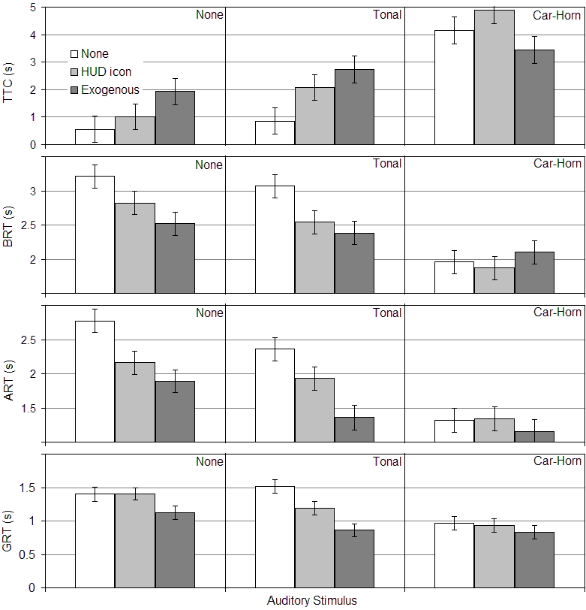

Figure 9.9. Means and Standard Errors plotted across all combinations of visual and auditory stimuli for the Glance Reaction Time (GRT), Accelerator Release Time (ART), Brake Reaction Time (BRT), and Minimum Time-to-collision (TTC) dependent measures.

The interaction between the visual and auditory stimuli approached significance for most of the response-time measures and reached statistical significance for the TTC measure (see Table 9.5). Figure 9.9 suggests that whereas the visual stimulus effect was clearly exhibited with no auditory stimulus or with the tonal stimulus, it appeared to reach a floor (GRT, ART, BRT) or ceiling (TTC) when combined with the car-horn stimulus, where the visual displays provided little additional benefit. The car-horn appears not to benefit from a visual counterpart. The exogenous display also appeared to be somewhat effective as a lone stimulus, and was significantly superior to no warning for the ART (p < 0.001) and BRT (p = 0.004) measures.

9.3.3 Experiment 3 Discussion

This pattern of results supports for the following conclusions:

- The car-horn stimulus is more effective than the tonal stimulus under these experimental conditions and may not benefit from the addition of a visual stimulus (without a visual display).
- There is little evidence to suggest that the haptic-seat stimulus provides any additional benefit over an exogenous-only display.
- The exogenous display is at least as effective as the HUD-icon, and appears to provide faster accelerator release times.

The first conclusion represents the most dominant effect in the experiment. Whereas the tonal stimulus alone produced no detectable benefit, the car-horn appeared equally effective with or without a visual counterpart. This result might be important for providing a cost-effective human-machine interface for forward collision warning and provides additional support for using an auditory icon for collision warning. However, whereas the use of a tonal stimulus for collision warning has been tested on real roadways in the ACAS FOT program and in real production vehicles, a stimulus such as the car horn must be evaluated more comprehensively before it is adopted. Using an auditory stimulus that has already been learned may produce faster reaction times in these circumstances, however, the natural mapping that produces this benefit may also have the potential to cause confusion. For example, when hearing the car horn, drivers may perceive the sound as being an activation of their real car horn. This perception might lead to annoyance especially when it is associated with nuisance or unnecessary alerts. Graham (1999) suggests another potential difficulty, where the horn may be misunderstood as the vehicle in the next lane or blind spot sounding its horn. Because nuisance alerts often occur during lane changes, this misunderstanding could be quite startling if the driver believes that there may be a previously-unseen vehicle in the blind spot. During the on-road testing of Task 11 (Data Fusion), this actually occurred and the driver perceived the alert as being overly startling. If this misunderstanding caused the driver to look at the blind spot during an actual threat, the alert could actually be counterproductive. This concern can only be adequately evaluated in the context of real driving and was not evaluated in this experiment. For this reason, although the car-horn stimulus appears to be a promising candidate for further research, the SAVE-IT program proceeded with the more conventional tonal alert.

The second conclusion is somewhat surprising but suggests that a visual-plus-tone alert is likely to be more effective than a visual-plus-haptic alert. This result mirrors our previous findings in the ACAS FOT program (Smith, 2002) where we evaluated a different haptic seat stimulus for an FCW system, prior to the field operation test. Perhaps a vibration of larger magnitude could be more effective. Seat vibration may also be a more effective candidate for an LDW system, because like the car-horn, it can capitalize on the mappings of the natural environment, where rumble strips produce a vibration that may resonate in the seat. Unlike the car-horn, the vibration of the LDW system being confused with its naturally-occurring counterpart may not be problematic. In the lane departure scenario, the stimulus of rumble strips and the action required (a counteracting steering correction) are identical, thus preserving the stimulus-response mapping.

These results also provide some support for the conceptual diagram in Figure 9.6, which predicts a benefit of an exogenous display over a conventional icon-based display. Because the exogenous display does not require the imaging complexities of a HUD, it is also an attractive proposition for reducing the cost of the human-machine interface. The exogenous display appears to present lower risk of driver confusion than the car horn and it was thus selected as the visual stimulus for the SAVE-IT program.

9.4. Experiment 4: LDW DOWN SELECTION

Up to this point in the SAVE-IT program, there had been little work conducted to guide the implementation of Lane Departure Warning (LDW). The experiment that is described in this section was designed to examine the effectiveness of different warning stimulus alternatives and to examine whether LDW is likely to provide benefit in the absence of visual distraction. Similar in scope to the ACAS FOT, a second field operational test, the RDCW ROT (the Road Departure Crash Warning System Field Operational Test: Emery, Srinivason, et al., 2005, LeBlanc et al., 2006) was carried out to evaluate the effectiveness of LDW. This program was conducted using a similar design (78 drivers for four weeks) to investigate a LDW and curve speed warning system (CSW) (Emery, Srinivason, et al., 2005, LeBlanc et al., 2006). The CSW alerted drivers of the need to reduce vehicle speed when approaching a sharp curve. Unlike most LDW systems that are emerging on production vehicles, this system was more elaborate and featured not only sensing of the lane boundary but also radar sensors to detect whether there was an obstacle beyond the lane boundary. The driver-vehicle interface for LDW used auditory cues for lateral movements of the vehicle over either solid painted lane markers or movements over dashed markers with an obstacle near that lane boundary. Haptic (seat vibration) cues were designed to give an impression similar to that of traveling over rumble strips. This alert occurred when the driver traveled over a dashed boundary with no detected obstacle. Common alerts, that might be considered to be unnecessary, included alerts where the driver knowingly strayed over the lane marker without consequence, or where the driver intentionally changed lanes without using the turn signal. Although the LDW alert rate per distance traveled was approximately six times greater for the RDCW FOT than it was for the ACAS FOT, these drivers provided more favorable acceptance ratings than the ACAS FOT drivers had for the FCW system (LeBlanc et al., 2006).

David LeBlanc (personal communication, January 2007), who worked on both FOTs, suggests a hypothesis for why the RDCW FOT yielded higher acceptance ratings for LDW than the ACAS FOT had yielded for FCW, in spite of the much higher alert rate. His hypothesis is that LDW is based on a criterion that drivers were able to understand and accept (crossing lane makers), compared with the FCW system that could potentially leave drivers confused. Whereas lane markers provide an unambiguous threshold that is visible to the driver for LDW, there is no immediately visible or universally agreed-upon threshold for FCW. Opinions about when an alert is warranted are likely to vary far less across drivers for LDW compared with FCW, and drivers can accurately predict when LDW alerts are likely to occur.

To investigate the effectiveness of different HMI candidates further, an experiment was conducted within the SAVE-IT program. Three warning stimuli were evaluated in the context of driver distraction in comparison to no warning and to each other. The three warning conditions and the no-warning condition were included in this experiment when the driver was distracted. In addition to these four conditions, the no warning condition was also applied to an attentive-driver condition. This condition was collected primarily to examine whether there was any room for additional improvement when the driver was attentive to the forward scene. The primary hypothesis for this study is that a driver whose visual system is oriented to the forward scene will immediately detect a lateral disturbance and respond with a successful counteracting response. This experiment provided a cursory evaluation of this hypothesis by including the attentive baseline condition. Thus, the five conditions of this Warning Situation variable that were evaluated were:

- D_No: Visually distracted driver with no warning
- N_No: Non-distracted driver with no warning
- D_ExAud: Visually distracted driver with the exogenous display plus non-directional rumble-strip audio
- D_HuAud: Visually distracted driver with the HUD-icon plus non-directional rumble-strip audio
- D_ExHap: Visually distracted driver with the exogenous display plus directional haptic seat-vibration

One of the differences between LDW and FCW system is that events that can trigger an LDW system are far more common than events that can trigger a reasonably tuned FCW system. The fact that LDW alerts were six times more prevalent than FCW alerts across the FOTs and that LDW alerts are relatively easy to comprehend, suggests that LDW may not require much explanation. Whereas a naïve driver may need to have the FCW system explained to some extent, the LDW system might be reasonably understood within the first few hours of exposure. To evaluate this hypothesis, the five conditions above were factorially crossed with a Training variable, such that half of the drivers in each condition experienced an explanation of the LDW and a demonstration of the HMI prior to driving, and the other half of the drivers were provided with no description or demonstration of the lane departure warning system. An additional hypothesis stemming from the higher frequency and more understandable LDW alerts, was that the HMI would have less effect on the driver’s response, because the driver would be likely to quickly learn a reasonable HMI. A small set of HMI candidates were selected to provide a cursory evaluation of a broad range of alternatives.

9.4.1 Experiment 4 Method
Participants
Fifty male employees at Delphi Electronics and Safety Systems in Kokomo, Indiana, participated in the study and were recruited, screened, and paid using the same protocol established in Experiment 3.

Apparatus
In all aspects, except those pertaining to the warning systems, the apparatus was identical to that of Experiment 3. Except for the end of the experiment, LDW alerts were triggered whenever the driver crossed over a lane marker. In order to precisely control the timing of alerts at the end of the experiment and to reduce the variance around driver responses, the final alert was triggered half a second after the lateral disturbance began, regardless of the lane position. Experiment 4 utilized the same exogenous display as that used in Experiment 3. The non-directional auditory tone produced a rumble-strip-like sound from the forward speaker by providing a series of four 125-msec, 100-Hz tones, at 4 Hz with a 50 % duty cycle. The directional seat-vibration stimulus utilized the same seat-massager apparatus that was used in Experiment 3, except that whereas the FCW alerts vibrated both sides of the seat, LDW vibrated only on the side of the alert. The HUD was simulated using the same method as Experiment 3, and presented the icons shown in Figure 9.10 to the driver. When the driver crossed the lane on the right side, the right lane marker of the icon would flash on and off, and when the driver crossed the lane on the left side, the left lane marker would flash on and off.



Figure 9.10. LDW icon presented in the location of a HUD. Left LDW alerts would flash between the icon displayed on the left and middle, and right LDW alerts would flash between the middle and right icons.

Design
A 5 (Warning Situation) x 2 (Training) between-subjects factorial design was used, where the five Warning Situations (D_No, N_No, D_ExAud, D_HuAud, and D_ExHap) were factorially crossed with the two types of Training (trained vs. untrained). Five participants were randomly assigned to each one of the ten conditions. This small set of subjects would unlikely provide sufficient power to explore an interaction, however might provide sufficient power to examine the main effects. The dependent measures included Steering Reaction Time (SRT), which was defined as the time (s) between the imposed lateral disturbance and the driver’s corrective steering action and the Maximum Lateral Error (MLE), defined as the lateral distance (m) from the center of the lane to the maximum lateral distance away. When the driver reached a lateral distance of 1.8 m, the driving simulator ceased to continue providing lane position information and so the maximum lateral error variable was bounded on the high end by 1.8 m.

Procedure
Other than the warning systems, training, and final event, the procedure was identical to that of Experiment 3 and used the same scrolling text instructions to both guide and distract the driver prior to the lateral disturbance. The same deception of training drives and the same distraction of the scrolling text instructions were used. In the trained condition, the instructions were similar to those of Experiment 3, except they informed participants that “the LDW system uses vision processing to detect lane markers in images that are captured from a forward-looking camera and warns the driver when the vehicle is about to depart the lane”. In the case of untrained drivers, they only viewed the agenda portion of the slide, describing the upcoming drives, and were not presented with the purpose of the study, the description of the LDW system, or the demonstration of the LDW HMI.

During the course of the experiment, there were several instances in which the driver was required to make a lane change. Because the driving-simulator vehicle cab did not include a turn signal, every lane change led to an LDW alert. Unlike Experiment 3, this meant that drivers were exposed to several LDW events prior to the final imminent event. At the same location that was used in Experiment 3 (approximately 5 min into the second drive), the distracting instructions appeared at the bottom of the center console area. Three quarters of a second later, the actual steering input to the driving simulator was replaced with a 17-deg clockwise steering-wheel input that simulated a lateral disturbance. This disturbance continued until the driver engaged in a sudden corrective response, which was quantified as a 40 deg/s counter-clockwise steering-wheel input.

Because speed was not as crucial for the warning event, the speed rejection criterion (Criterion 1) established in Experiment 3 was not applied in this experiment. Although it was planned that both the distraction and variance rejection criteria (Criteria 2 and 3) would be applied to this experiment, no participants violated the variance criterion and so only the distraction criterion led to rejections. The subjects who failed to be distracted at the moment of the alert were replaced.

9.4.2 Experiment 4 Results
A between-subjects MANOVA was conducted on Steering Reaction Time (SRT) and Maximum Lateral Error (MLE) for the 5 (Warning Situation) x 2 (Training) factorial combination. Consistent with the hypothesis of the self-explanatory nature of LDW, training did not significantly affect SRT, F(1,49) = 0.176, p = 0.68, or MLE, F(1,49) = 0.02, p = 0.90. The means of the trained vs. untrained differed by only 40 msec and 2 cm for SRT and MLE, respectively. Although there was insufficient power for providing a reasonable test of the interaction, the small F-values [F(4,49) = 0.91 and 0.82 for SRT and MLE respectively] might suggest that these variables were unlikely to interact.

As expected, the Warning Situation did impact both the SRT, F(4,49) = 12.70, p < 0.001, and MLE, F(4,49) = 6.85, p < 0.001, variables. These differences are plotted in Figure 9.11. Pairwise comparisons revealed that the only statistically-significant differences (p < 0.05) within MLE, were between the distracted and non-distracted conditions. In each case, the differences between the distracted conditions and the one non-distracted condition were significant using an alpha level of 0.005.

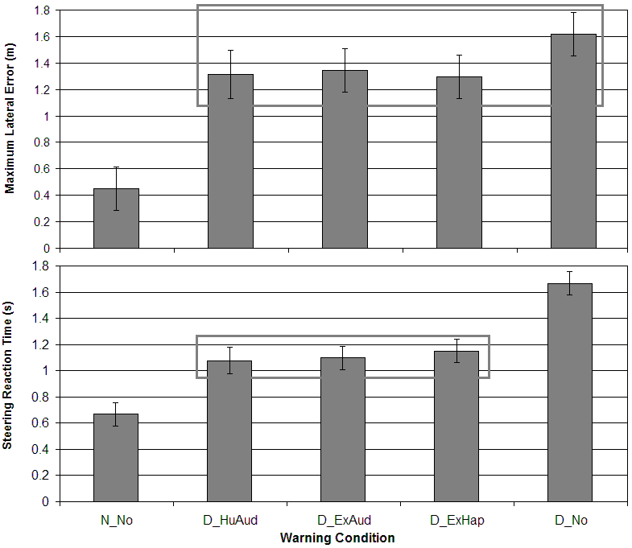
Figure 9.11. Steering Reaction Time (s) and Maximum Lateral Error (m) as a function of the single non-distracted-driver Warning Condition N_No (No Warning), and the four distracted-driver Warning Conditions D_HuAud (HUD icon plus Auditory), D_ExAud (Exogenous display plus Auditory), D_ExHap (Exogenous display plus Haptic), and D_No (No Warning). The boxes around the conditions represent groups that were not statistically different (p > 0.05) in LSD pairwise comparisons.

The SRT measure was more sensitive than the MLE measure, revealing pairwise-comparison differences not only between the distracted and non-distracted conditions (all statistically-significant at the p < 0.005 level), but also within the distracted drivers between each of the warned conditions and the condition in which the driver was not warned (all at the p < 0.001 level). The differences between the three warned conditions did not approach statistical significance (all with p-values greater than 0.5).

9.4.3 Experiment 4 Discussion
This experiment provided some support for both hypotheses related to LDW alerts being relatively self-explanatory: that training was unnecessary and that HMI would have little effect on the driver’s response to the alerts (within reason). This finding does not necessarily that HMI is completely irrelevant, because the HMI alternatives that were used represent a relatively narrow range of stimuli. Each of the three alternatives attempted to simulate rumble strips with either an auditory or haptic stimulus. At the extreme, it is likely that an ineffective HMI could be designed. However, at least within the relatively narrow set of HMI candidates tested in this experiment, the three tested candidates were equally effective. As a result, the SAVE-IT program is relatively unconstrained to select from these alternatives. Due to the apparent acceptance of the auditory and haptic stimuli used in the RDCW FOT program, the SAVE-IT program selected alerting stimuli that included both auditory and haptic stimuli, with the one exception that the auditory stimulus provided directionality. By providing the auditory and haptic stimuli in synchronization with each other, such that each was pulsed at 4-Hz, the stimuli produced a more compelling simulation of rumble strips, which seemed more like a single multi-modal stimulus than two separate stimuli. In addition to the auditory and haptic stimuli, the exogenous display was presented, however, in order to keep the visual stimulus brief, the exogenous LDW visual stimulus was not synchronized with the auditory and haptic stimuli and flashed 3 times at 5 Hz (like the FCW exogenous display). This combination of stimuli was subjectively evaluated on real roadways within the Task 11 (Data Fusion) task.

The swiftness of driver responses to the lateral disturbance supports the hypothesis that visually-attentive drivers do not benefit from a LDW system. As predicted by the conceptual diagram in Figure 9.3, in the absence of a “contributing factor” (such as visual distraction), the precipitating event (the lateral disturbance) was counteracted so quickly that most participants did not even realize that it had occurred. The average maximum lateral error for attentive drivers was less than 0.5 m. This immediate and effective response from attentive and alert drivers leaves little room for improvement and supports the alert-suppression strategy for LDW. Although in a real system, the alerts might also adapt to the driver’s state of drowsiness or impairment, these driver states are beyond the scope of the SAVE-IT program. Thus visual distraction provides the only input as to whether alerts are suppressed. Although the case for LDW was relatively clear, further experiments were needed to determine the most effective adaptation for FCW systems. Experiment 5 was designed to fulfill this research need.

9.5. Experiment 5: FCW ADAPTATION DOWN SELECTION

In Phase I, an experiment was conducted to investigate the different FCW adaptation candidates in a repeated-measures experiment. However, because of the multiple imminent-braking events and the resulting elevation of expectency, the safety benefit or cost of the different alternatives was difficult to quantify. In Phase II, an experiment was designed to investigate the different adaptation candidates for FCW using a between-subjects methodology. This required that one set of drivers experienced one half of the adaptation (positive) and another set of drivers experience the other half (negative). Although the between-subjects methodology is less sensitive, it avoids exposing each driver to multiple imminent events. Instead, each driver is surprised only once with the lead-vehicle-braking event and only across subjects can the pattern of results be understood.

To create a set of conditions that could be informative about the Differential Stimuli (suppressing the auditory component of the alert when the driver is attentive) and the Alert Suppression (suppressing the entire alert when the driver is attentive) candidates, Driver Distraction (distracted vs. non-distracted) was factorially crossed with Warning (Visual-plus-tone, Visual only, and no warning). Because Experiment 3 supported the use of the exogenous display and because the car-horn seemed to raise issues that might be tangential to the goals of the SAVE-IT program, the exogenous display and ACAS FOT tones were used to span the visual and auditory modalities. Table 9.7 displays the 2 x 3 factorial combination of conditions and describes how the different cells in this matrix represent the behavior of the different adaptation strategies.

Table 9.7. Between-subject Adaptation Matrix for Experiment 5.
Distraction | No Warning | Visual only | Visual-plus-tone
Distracted Drivers | No FCW system  D0 | Not using auditory even for distracted drivers  D1 | Non-adaptive  Differential Stimuli  Alert Suppression  D2
Non-Distracted Drivers | Alert Suppression  N0 | Differential Stimuli  N1 | Non-adaptive  N2

Whereas Cell D2 represents the system behavior of both a non-adaptive system and the Differential Stimuli and Alert Suppression adaptations for the distracted drivers, the three adaptation strategies behave differently for the non-distracted drivers and span Cells N0, N1, and N2. Cell D1 is designed to help answer the questions of whether suppressing the auditory tone only during non-distracted episodes is a beneficial negative adaptation or whether the auditory tone just never provides any benefit. Likewise, Cell D0 is designed to help answer whether suppressing the alert is useful only when the driver is not distracted, or whether the alerts should always be suppressed regardless of the driver state. To examine the behavior of these different adaptations across different driving conditions, this 2 x 3 matrix was also factorially crossed with two Headway conditions (1-s vs. 2-s time headways), creating a set of twelve conditions. For the 2-s headway conditions, the distracted-driver conditions in Table 9.7 (Cells D0, D1 and D2) are identical to that of Experiment 3 and have already been collected.

The twelve conditions that resulted from the factorial crossing of 2 (Distraction) x 3 (Warning) x 2 (Headway) provided an evaluation of two the negative adaptation candidates (Differential Stimuli and Alert Suppression) in comparison with a non-adaptive system. However, the two major positive adaptation candidates were not represented in this set (Differential Location and Differential Timing). To satisfy the need for testing these two adaptation candidates, three additional conditions were added to allow for t-test comparisons. Two conditions were added to evaluate the positive side (earlier alerts) of the Differential Timing adaptation.

The braking events that were developed in Experiment 3 and used in Experiment 5 did not provide much room for earlier warnings, because the 2-s headway required that if the alert was issued 0.5 s after the lead-vehicle-braking event, the alert would only provide the driver with approximately a 1.5-s reaction time. For this reason, a less extreme event was simulated to allow a 2.5-s reaction time. To achieve this, the lead vehicle had to brake at a rate of 3.7 m/s² rather than 5 m/s². If the FCW algorithm assumed that the host driver would brake at 5 m/s², an alert that was presented 0.5 s after the 3.7 m/s² braking event would correspond to an assumed 2.5-s brake-reaction time. By using this reduced braking rate, more room was provided for an earlier warning. To compare this early warning to a more nominal warning, another condition was added that used the 3.7-m/s² braking rate, except with the alert onset delayed by 1.5 s rather than 0.5 s. The t-test between these two conditions would thus reveal the benefit of warning distracted drivers earlier.

To evaluate the Differential Location adaptation, one condition was added. This condition was identical to Cell 1 (exogenous-plus-tone) with a 2-s headway and 5-m/s² lead-vehicle-braking rate, except that the FCW icon that was used in Experiment 3 was simultaneously displayed on the center-console area. This icon filled the entire center-console visual space of 7.5 H x 4.5 V inches and flashed at a rate of 4 Hz. Comparing this condition to the same condition without the console-icon allowed the evaluation of whether this addition benefited distracted drivers.

9.5.1 Experiment 5 Method
Participants
One hundred and fifty employees at Delphi Electronics and Safety Systems in Kokomo, Indiana, participated in the study and were recruited, screened, and paid using the same protocol established in Experiment 3. Ten participants were randomly assigned to each of the fifteen conditions. As mentioned above, three of the conditions in this experiment overlapped with Experiment 3 and include the same data set.

Apparatus
In all aspects, except those pertaining to the warning systems, the apparatus was identical to that of Experiment 3, except that the center-console was programmed to display the FCW icon for the Differential Location add-on condition.

Design
The design included the 2 (Distraction) x 3 (Warning) x 2 (Headway) between-subject factorial crossing of conditions and also three add-on conditions that were designed to provide t-test comparisons. These add-on conditions included the following:

- Early Warning (2DE): The drivers were visually distracted and received the visual-plus-tone stimuli 0.5 s after the lead vehicle began braking at a rate of 3.7-m/s² at a 2-s headway, simulating an algorithm that assumes a 2.5-s brake-reaction time.
- Nominal Warning (2DN): The drivers were visually distracted and received the visual-plus-tone stimuli 1.5 s after the lead vehicle began braking at a rate of 3.7-m/s² at a 2-s headway, simulating an algorithm that assumes a 1.5-s brake-reaction time.
- Console-icon (2DC): The drivers were visually distracted and received a console-icon in addition to the visual-plus-tone stimuli 0.5 s after the lead vehicle began braking at a rate of 5-m/s² at a 2-s headway. This condition was added to provide a comparison to the Cell D1 in Table 9.7 for the 2-s headway condition to evaluate the potential benefit of the Differential Location adaptation.

Due to the redundancy revealed in Experiment 3 of the large set of dependent measures a smaller set of measures was analyzed and included the following five measures (defined in Section 9.3.1):

Response-Time Measures:
- Accelerator Release Time (ART)
- Brake Reaction Time (BRT)
- Half Brake Time (HBT)
Threat-Severity Measures:
- Minimum Time-to-collision (TTC)
- Collision Velocity (CV)

Procedure
Other than the addition of the 1-s headway conditions and the three add-on conditions, the procedure was identical to that of Experiment 3. The distance between host and lead vehicles was controlled in the same manner as Experiment 3 just prior to the braking event for both the 1- and 2-s headway conditions.

9.5.2 Experiment 5 Results
Table 9.8 displays the results of the 2 x 3 x 2 MANOVA, presenting the degrees of freedom, F-values, and levels of significance across the five dependent measures, that included Accelerator Release Time (ART), Brake Reaction Time (BRT), Half-brake Time (HBT), Minimum Time-to-collision (TTC), and Collision Velocity (CV). The table is shaded to highlight the significant effects, and it appears to support the Experiment 3 finding that ART is one of the more sensitive measures. Whereas main effects were prevalent across the dependent measures for Distraction, Warning, and Headway, the two-way interactions in most cases did not reach significance. Although the Distraction x Warning interaction was statistically-significant for ART and CV, it only approached statistical significance for BRT and TTC. Similarly, the Warning x Headway interaction reached statistical significance only for the Accelerator Release Time variable. All five dependent measures suggest that Distraction and Headway do not interact. The three-way interaction of Distraction x Warning x Headway only approached statistical significance for the most sensitive measure (ART).

Table 9.8. MANOVA Table for Experiment 5: Distraction (D) x Warning (W) x Headway (H)
Measure | df | ART | BRT | HBT | TTC | CV
Distraction (D) | 1,115 | 47.59**** | 37.23**** | 12.91**** | 8.26*** | 18.30****
Warning (W) | 2,115 | 10.02**** | 5.43** | 9.16**** | 3.93* | 9.54****
Headway (H) | 1,115 | 26.45**** | 71.48**** | 88.89**** | 7.58** | 1.66
D x W | 2,115 | 6.43*** | 2.87 (p = 0.06) | 1.13 | 2.61 (p = 0.08) | 8.93****
D x H | 1,115 | 0.06 | 0.06 | 0.07 | 0.63 | 0.19
W x H | 2,115 | 4.67* | 2.11 | 0.32 | 0.05 | 2.01
D x W x H | 2,115 | 2.98 (p = 0.06) | 1.34 | 0.80 | 0.63 | 0.27
Table presents F-values, and displays p-values where approaching statistical significance (0.05 < p < 0.10)
* p < 0.05, ** p < 0.01, *** p < 0.005, **** p < 0.001 (Significant effects are shown in larger font and are shaded)

Table 9.9 displays the means and standard errors for the fifteen conditions (1D0, 1D1, 1D2, 2D0, 2D1, 2D2, 1N0, 1N1, 1N2, 2N0, 2N1 and 2N2) and the three add on conditions (2DE, 2DN, and 2DC). The three-way interaction for ART that approached statistical significance (p = 0.06) is displayed in Figure 9.12, and suggests that the only case in which warnings were effective was for distracted drivers in the 2-s Headway, wherein warnings were extremely effective. The effect of warning was more prevalent in the 2-s cases, and in the 2-s cases, where the nature of the warning effect appeared to vary between distracted and non-distracted drivers. Whereas pairwise comparisons revealed statistically significant differences between the different types of warnings in the 2-s Headway conditions, there were no statistically significant differences between different warnings in the 1-s Headway condition for either distracted or non-distracted drivers (ART: p > 0.1). Within the 2-s Headway condition, the warning effect produced the expected pattern of results for the distracted drivers, where the visual-plus-tone condition was responded to earlier than the visual-only condition (ART: 2D1 < 2D2, p = 0.02) and both of these conditions were responded to earlier than the no-warning (ART: 2D2 < 2D0 and 2D1 < 2D0, p < 0.01). For the non-distracted drivers in the 2-s Headway condition, the unwarned drivers responded as quickly as the warned drivers (ART: 2N2 ~ 2N0 and 2N1 ~ 2N0, p > 0.25). Pairwise comparisons revealed that the only difference that was statistically significant (2N) was that between Visual-plus-tone and Visual-only (ART: 2N2 < 2N1, p = 0.03). The greater effectiveness of warnings at the 2-s Headway was reflected in the statistically significant Warning x Headway interaction.

Table 9.9. Means and Standard Errors for the Fifteen Conditions
Headway / Distraction | Warning |  | ART | BRT | HBT | TTC | CV | Col. / N
1-s  Distracted | Visual-plus-tone | 1D2 | 1.44  (0.17) | 1.85  (0.16) | 2.13  (0.18) | 1.45  (0.51) | 0.83  (1.32) | 1/8  13%
1-s  Distracted | Visual- only | 1D1 | 1.57  (0.15) | 2.05  (0.15) | 2.48  (0.16) | 0.65  (0.46) | 3.04  (1.18) | 6/10  60%
1-s  Distracted | No Warning | 1D0 | 1.76  (0.15) | 2.18  (0.15) | 2.60  (0.16) | 0.25  (0.46) | 6.35  (1.18) | 8/10  80%
2-s  Distracted | Visual-plus-tone | 2D2 | 1.36  (0.16) | 2.34  (0.15) | 2.87  (0.17) | 2.73  (0.48) | 1.40  (1.25) | 2/9  22%
2-s  Distracted | Visual- only | 2D1 | 1.89  (0.15) | 2.52  (0.15) | 3.13  (0.16) | 1.93  (0.46) | 2.52  (1.18) | 3/10  30%
2-s  Distracted | No Warning | 2D0 | 2.77  (0.15) | 3.21  (0.15) | 3.67  (0.16) | 0.56  (0.46) | 9.89  (1.18) | 7/10  70%
1-s  Not-Distracted | Visual-plus-tone | 1N2 | 0.93  (0.15) | 1.53  (0.15) | 1.93  (0.16) | 1.59  (0.46) | 1.62  (1.18) | 3/10  30%
1-s  Not-Distracted | Visual- only | 1N1 | 0.90  (0.15) | 1.39  (0.15) | 1.90  (0.16) | 2.12  (0.46) | 0.48  (1.18) | 1/10  10%
1-s  Not-Distracted | No Warning | 1N0 | 0.95  (0.16) | 1.45  (0.15) | 2.25  (0.17) | 1.61  (0.46) | 0.09  (1.25) | 1/9  11%
2-s  Not-Distracted | Visual-plus-tone | 2N2 | 1.19  (0.15) | 2.02  (0.15) | 2.80  (0.16) | 2.53  (0.46) | 0.93  (1.18) | 1/10  10%
2-s  Not-Distracted | Visual- only | 2N1 | 1.67  (0.15) | 2.33  (0.15) | 2.91  (0.16) | 2.19  (0.46) | 0.78  (1.18) | 1/10  20%
2-s  Not-Distracted | No Warning | 2N0 | 1.44  (0.15) | 2.32  (0.15) | 3.12  (0.16) | 2.18  (0.48) | 2.27  (1.18) | 2/10  10%
2-s Distracted | Early  (lead braking 3.72 m/s²) | 2DE | 1.51  (0.22) | 2.26  (0.22) | 3.24  (0.29) | 3.10  (0.75) | 0.00  (0.00) | 0/9  0%
2-s Distracted | Nominal  (lead braking 3.72 m/s²) | 2DN | 1.98  (0.15) | 3.11  (0.17) | 4.06  (0.19) | 1.93  (0.39) | 0.97  (0.67) | 2/10  20%
2-s Distracted | Console icon with  Visual-plus-tone | 2DC | 1.51  (0.15) | 2.23  (0.15) | 2.93  (0.17) | 2.45  (0.49) | 1.31  (1.18) | 2/10  20%

Although the reaction times are not highly indicative of an effect in the 1-s distracted-driver (1D) conditions, the differences between Visual-plus-tone and non-warned began to emerge in the later measures. For example, the difference between warned and unwarned HBTs approached statistical significance (1D2 < 1D0, p = 0.06; 1D1 < 1D0, p = 0.06) and the CV warning effect reached statistical significance (1D1 < 1D0, p < 0.05; 1D2 < 1D0, p < 0.01). The difference between the number of collisions further implies that warning distracted drivers at short headways can produce a benefit, with drivers warned by the Visual-plus-tone stimulus (1D2) crashing 13 % of the time compared with unwarned drivers (1D0) crashing 80 % of the time, χ²(1) = 13.05, p < 0.01.

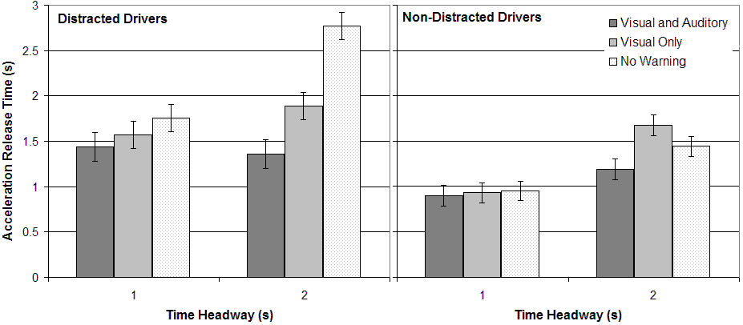

Visual-plus-tone
Visual only
No Warning

Figure 9.12. The three-way interaction (Headway x Distraction x Warning) that approached statistical significance for Accelerator Release Times (s).

Figure 9.13 displays the Warning x Distraction interaction across the ART, BRT, TTC, and CV measures. This interaction reached statistical significance for ART, F(2,115) = 6.43, p < 0.01, and CV, F(2,115) = 8.93, p < 0.01, and approached statistical significance for BRT, F(2,115) = 2.87, p = 0.06, and TTC, F(2,115) = 2.61, p = 0.08. The pattern of the warnings having little effect on non-distracted drivers and a large effect on distracted drivers appears to be consistent across the dependent measures. This trend supports the general philosophy of negative adaptation (suppressing or softening warnings when a driver is attentive). At least in the scenario that was simulated here, when the drivers were attentive, warnings failed to show any signs of providing a benefit. Thus, this experiment suggests that neither the Differential Stimuli (suppressing auditory) or Alert Suppression adaptations are likily to compromise the safety of an FCW system. This figure also suggests that the visual-plus-tone warning was able to negate the effect of distraction.

The main effect of distraction was evident across all dependent measures, with distracted drivers responding more slowly and consequently being exposed to greater risk. Whereas 47 % of distracted drivers crashed, only 15 % of the drivers who were not distracted crashed. The main effect of Headway was also evident across most of the measures, with drivers at shorter headways reacting more quickly. The faster reaction times at shorter headways compensated for the more threatening initial situation, ultimately leading to little difference in CV or collision percentage (35 % of drivers crashed in the 1-s condition and 27 % of drivers crashed in the 2-s condition). The 1-s Headway did, however, translate to higher TTCs than the 2-s Headway.

The main effect of Warning was consistent across dependent measures, however, ART was the only measure to reveal a significant difference between Visual-plus-tone in comparison to Visual-only (p < 0.05). Both warnings were significantly different from the no-warning condition across all dependent measures (p < 0.05), except for TTC where the difference between Visual-only and no warning approached statistical significance (p = 0.08). The Visual-plus-tone condition was significantly different from no warning (p < 0.01).

The add-on conditions with the –3.72 m/s² braking event (2DE and 2DN) were created to examine the benefit of providing distracted drivers with earlier warnings. The means and standard errors of these conditions were displayed in Table 9.9, and one-tailed t-tests revealed that the earlier warning led to shorter reaction times for ART, t(17) = 1.82, p = 0.04, BRT, t(17) = 3.15, p < 0.01, and HBT, t(17) = 2.43, p = 0.01. The 1-s earlier warning translated into a 850-msec earlier BRT. The TTC, t(17) = 1.43, p = 0.09, and CV, t(17) = 1.37, p = 0.09, measures approached statistical significance. The differences observed in the reaction time measures provide support for the use of earlier warnings for distracted drivers in the Differential Timing Strategy. However, the Differential Location adaptation did not appear to be promising. The differences between the condition with the console addition (2DC) in comparison to the Visual-plus-tone (2D2) were relatively small, and although no results reached statistical significance, in many cases the differences went in the direction of a degradation of effectiveness.

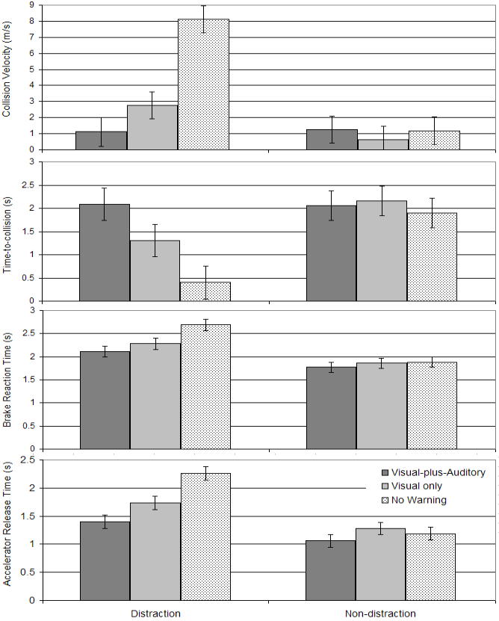
Figure 9.13. The two-way interaction (Distraction x Warning) across dependent measures (Accelerator Release Time, Brake Reaction Time, Time-to-collision, and Collision Velocity).

9.5.3 Experiment 5 Discussion
This experiment provided support for three out of four of the adaptation strategies. Whereas the data suggest that neither of the negative adaptations (Differential Stimuli or Alert Suppression) are likely to compromise safety and that the positive side of the Differential Timing strategy (earlier warnings) could provide a safety benefit, these data did not support the Differential Alert Location strategy. The experimental conditions provided the most likely scenario for the console stimuli to provide a benefit, because the drivers were highly distracted by material in the precise location of the additional warning stimulus, and yet it still did not provide a benefit. This lack of benefit might be anticipated from Figure 9.6 which predicts that icons add an additional stage before the driver responds to the warning. Based on this finding, the Differential Location adaptation was removed from further consideration and was not considered in the on-road testing of the Data Fusion (Task 11) task. The three other candidates were investigated further. It should also be noted that whereas the Differential Timing adaptation is a positive adaptation (designed to provide a safety benefit during driver distraction), the Differential Stimuli and Alert suppression adaptations that were tested in this experiment are negative adaptations (designed to improve driver acceptance during attentive driving). For this reason, they are not mutually exclusive and could potentially be combined. Furthermore, the negative side of Differential Timing (later rather than nominal alerts) that was not tested in this experiment, could also be used and becomes increasingly like an Alert Suppression adaptation as the timing is pushed further back, making an alert increasingly unlikely. An adaptation strategy could potentially include multiple manipulations from these candidates, even within the positive or negative side. For example, an alert could be both later and without an auditory stimulus when the driver is attentive.

This experiment demonstrated that suppressing the entire warning compromised safety no more than just suppressing the auditory warning. To evaluate the overall effectiveness of these two candidates, the affects on acceptance need to be considered. The philosophy behind this research was to separate the evaluation of the impact on safety from the evaluation of acceptance. Whereas safety was ideally investigated in this tightly-controlled between-subject driving simulator paradigm, acceptance required on-road testing. This on-road testing counterpart, necessary for the final selection of adaptation for the Evaluation task (Task 14), was transferred to the Data Fusion (Task 11) task.

9.6. CONCLUSIONS

The effectiveness of the different adaptation strategies were evaluated in a series of between-subject driving simulator experiments and the subjective evaluation was transferred to Task 11b (Data Fusion of Safety Warning Countermeasures), where acceptance could be studied on real roadways. In order to examine the benefit of providing visual or auditory FCW stimuli while a driver is not distracted, a between-subjects design was used that factorially crossed the three display alternatives (visual-plus-tone, visual-only and no warning) with the presence of visual distraction. This design was used to provide some data about the potential safety cost of the suppression and auditory-suppression strategies that attempt to increase driver acceptance. The result suggested that neither strategy of suppressing FCW completely (Alert Suppression) or suppressing the auditory component of the FCW stimulus (Differential Stimuli) were likely to compromise safety. The selection of one over the other requires further consideration from a driver-acceptance standpoint. The goal of these two negative adaptations is to improve acceptance without compromising safety, and the research conducted under this task only addresses the latter issue. The selection of the preferred negative adaptation method might also consider other types of driver degradation, such as driver impairment or drowsiness.

The CAMP workload metrics project (Angell, Anflick, Austria, Kochhar, Tijerina, Biever, Diptiman, Hogsett, & Kiger, 2006) data suggested that auditory-vocal tasks can actually lead to a reduction in the standard deviation of lane position (SDLP), supporting the Task 9b (Phase I Safety Warning Countermeasures) conclusion that cognitive distraction does not degrade lane keeping. The case for LDW may therefore be quite clear cut: in the absence of either visual distraction or driver drowsiness, if the vehicle is departing the lane, the driver is likely to be already aware of it. When a driver is already aware of the lane departure, even if it is unintentional, they still unlikely to benefit from the warning.

The extent to which FCW alerts may assist drivers who are cognitively distracted may be more uncertain. Many studies have demonstrated that cognitive distraction can have a relatively small yet detectable effect on driver reaction times to a lead-vehicle conflict (Horrey & Wickens, 2006). Reyes and Lee (2004) examined whether an auditory-vocal task increased driver reaction times to a lead-vehicle conflict. Although the auditory-vocal task had a small effect on conflicts that could not be anticipated, the effect emerged when the conflict could be anticipated, increasing accelerator release times by as much as 0.6 s. Reyes and Lee proposed that although auditory-vocal tasks had relatively little effect on the control level of driving, these tasks could degrade performance at the tactical level (Task 5: Cognitive Distraction). Whereas cognitively-attentive drivers were receptive to the clues that the conflict was about to occur, responding earlier when the clues were present, cognitively-distracted drivers did not appear to use the clues. Therefore, although cognitive distraction clearly has a smaller effect on a driver’s ability to respond to rear-end conflicts, it is still uncertain whether FCW alerts are completely redundant for situations involving cognitive distraction alone (e.g., talking on a cell phone). In the 100-Car Study data, two out of the fifteen rear-end crashes occurred just after the driver appeared to be “lost in thought” or “daydreaming”. It is difficult to predict whether an FCW system would have been successful in preventing these collisions, but this uncertainty may suggest that even if cognitive distraction cannot easily be measured, perhaps it should still be accounted for. For example, rather than suppressing an FCW alert completely in the absence of visual distraction, perhaps the alert should be softened or delayed. For this reason, a negative adaptation such as Differential Timing or Differential Alert Modalities might be a safer choice than Alert Suppression for FCW, because they may allow for the possibility of providing some benefit for drivers who are severely cognitively distracted or drowsy if such drivers are able to benefit from the warnings. Whereas the total suppression of an alert when the driver is visually-oriented to the forward scene would not provide assistance for driver states other than visual distraction, the other negative adaptations may allow for other driver-states (even if they cannot be detected) that may be interfering with a successful avoidance response.

The positive adaptations of Differential Location and Differential Timing were also evaluated for FCW in Phase II to determine whether these adaptations could improve the safety benefit of conventional warning systems. The Differential Location adaptation attempted to speed up drivers’ response to the warning by displaying the FCW visual icon (redundantly with the exogenous display) in the location of the driver’s distraction (in this case the center console). These data did not support this adaptation method, and even showed a slight increase in accelerator release time that was not statistically significant when the redundant console (1.51 s) was compared to just an exogenous display (1.36 s). The Differential Location adaptation was therefore rejected as an adaptation alternative. Another evaluation compared the responses of distracted drivers for an early FCW alert (0.5 s after the lead vehicle braking event) versus a late FCW alert (1.5 s after the braking event). The brake reaction time results revealed that the earlier warning translated into a significantly earlier response, with drivers who experienced the earlier alert braking 2.3 s after the event compared with the late-alert drivers who began braking 3.1 s after the event. The final selection of adaptation strategies and the human machine interface was reserved for the on-road Task 11b work (Adaptive Safety Warning Countermeasures Data Fusion).

As sensing technologies provide increasingly accurate and sensitive information about the state of the driver, the methods for adaptation will likely evolve to make use of the new information. For example, whereas head-pose provides a coarse indication of visual distraction only, future systems will provide information about where the driver’s eyes are focused. This more fine-grained information will likely support the detection of both cognitive distraction (Reyes & Lee; in preparation) and driver intention (Smith & Zhang, 2004a). Although the price of automotive-grade technology with sufficient resolving power to support the detection of cognitive distraction may currently be excessive, such technology is likely to become increasingly affordable, soon providing adaptive systems with information regarding the driver’s cognitive state (see Reyes & Lee, In preparation). Increased resolving power may also eventually support the detection of driver impairment due to alcohol or other drugs. The adaptation techniques that were developed in this task did not appear to be suitable for cognitive distraction (Smith & Zhang, 2004a), however, more subtle and sophisticated techniques may be developed to make use of this information. One of the challenges of adapting collision warning systems to the driver’s cognitive state may be that whereas the criteria for a driver’s visual orientation might be easily observed and understood, the criteria for more complex phenomena such as the degree to which the driver is mentally engaged in the driving task may be more subjective and less easily understood by the driver. However, even if the driver’s cognitive state is not the subject of the adaptation, the potential for cognitive distraction might still be taken into account by an adaptation that does not completely suppress the warning (e.g., Differential Stimuli adaptation).

The extent to which drivers will accept adaptive collision warnings may also be influenced by how these systems are marketed to the public. Drivers who have an inadequate understanding of the system might perceive the warning behavior as inconsistent when an alert is provided in one instance (when the driver’s head pose is not forward) but not in another (when the driver’s head pose is forward). Such drivers might view this system as failing to provide a safety benefit. If unnecessary alerts do not degrade driver’s trust (Lees & Lee, in preparation), drivers may prefer to witness the system issuing an alert, even when the system may be able to predict that the alert is unnecessary. Drivers who understand the concept of adaptation may prefer a system that provides a subtle alert (e.g., haptic or visual only) when they are attentive rather than one that suppresses the alert completely, because it may continue to reinforce that the system is providing the protection and is accurately detecting the lane change or the lead vehicle braking. The driver’s mental model is thus a crucial factor in determining the acceptance of different adaptation techniques. How an adaptive system is perceived or which type of adaptation is preferred may therefore be dependent on how these systems are marketed or how they are sold on the show-room floor. As adaptive and non-adaptive systems increasingly penetrate the market, they will further reveal the answers to these kinds of questions.

References
Abe, G., & Richardson, J. (2005). The influence of alarm timing on braking response and driver trust in low speed driving. Safety Science, 43(9), 639-654.
Angell, L., Auflick, J., Austria, P.A., Kochhar, D., Tijerina, L., Biever, W., Diptiman, T., Hogsett, J., & Kiger, S. (CAMP) Driver Workload Metrics Project: Final Report. Sponsored by National Highway Traffic Safety Administration, Washington, D.C., November 2006. DOT HS 810 635
Bliss, J., Dunn, M., & Fuller, B. S. (1995). Reversals of the cry-wolf effect: An investigation of two methods to increase alarm response rates. Perceptual and Motor Skills, 80, 1231-1242.
Bliss, J., & Acton, S. A. (2003). Alarm mistrust in automobiles: how collision alarm reliability affects driving. Applied Ergonomics, 34, 499-509.
Brouwer, D. M. & Hoedemaeker, D. M. (Eds.) (2006). Driver support and information systems: Experiments on learning, appropriation and effects of adaptiveness. http://www.aide-eu.org/pdf/aide_d1-2-3.pdf
Campbell, J. L., Carney, C., & Kantowitz, B. H. (1998). Human factors design guidelines for advanced traveler information systems (ATIS) and commercial vehicle operations (CVO) (No. FHWA-RD-98-057). Washington, DC: Federal Highway Administration.
Campbell, B. N., Smith, J. D., & Najm, W. G. (2003). Examination of Crash Contributing Factors Using National Crash Databases. National Highway Transportation Safety Administration Report, Washington DC. DOT HS 809 664.
Dingus, T. A., Klauer, S. G., Neale, V. L., Petersen, A., Lee, S. E., Sudweeks, J., Perez, M. A., Hankey, J., Ramsey, D., Gupta, S., Bucher, C., Doerzaph, Z. R., Jermeland, J., & Knipling, R. R. (2006). The 100-Car Naturalistic Driving Study: Phase II - Results of the 100-Car Field Experiment, NHTSA DTNH22-00-C-07007.
Emery, L. Srinivasan, G., Bezzina, D., LeBlanc, D., Sayer, J., Bogard, S., & Pomerleau, D. (2005). Status report on USDOT project ‘An intelligent vehicle initiative road departure crash warning field operational test.’ (US DOT HS 809 825). Proc. 19th Intl. Technical Conference on the Enhanced Safety of Vehicles, Washington, D.C.
Ervin, R., Sayer, J., LeBlanc, D., Bogard, S., Mefford, M., Hagan, M., Bareket, Z & Winkler, C. (2005). Automotive collision avoidance system (ACAS) field operational test methodology and results. (US DOT HS 809 901). Washington, D.C.: National Highway Traffic Safety Administration.
JCN Newswire (2005). Toyota Enhances Pre-crash Safety System With Driver-monitoring Function. http://www.japancorp.net/Article.Asp?Art_ID=10803
Heinrich, H. W., Petersen, D., & Roos, N. (1980). Industrial Accident Prevention. New York: McGraw-Hill Book Company.
Horrey, J. H., & Wickens, C. D. (2006). Examining the Impact of Cell Phone Conversations on Driving Using Meta-Analytic Techniques. Human Factors, 48(1), 196-205.
Kiefer, R., LeBlanc, D., Palmer, M., Salinger, J., Deering, R., & Shulman, M. (1999). Development and validation of functional definitions and evaluation procedures for collision warning/avoidance systems. Washington D.C.: U.S. Department of Transportation, report no. DOT-HS-808-964.
LeBlanc, D., Sayer, J., Winkler, C., Bogard, S., Devonshire, J. Mefford, M., Hagan, M., Bareket, Z., Goodsell, R., & Gordon, T. (XXXX) Road departure crash warning system (RDCW) field operational test final report. US DOT report, Washington, D.C.
Lee, J. D., Hoffman, J. D., & Hayes, E. (2004). Collision warning design to mitigate driver distraction. In Proceedings of CHI 2004 (pp. 65-72). New York: ACM.
Lee, J. D., McGehee, D. V., Brown, T. L., & Reyes, M. L. (2002). Collision warning timing, driver distraction, and driver response to imminent rear-end collisions in a high fidelity driving simulator. Human Factors, 44, 314-334.
Lee, J. D., & See, K. A. (2004). Trust in technology: Designing for appropriate reliance. Human Factors, 46(1), 50-80.
Lees, M. N. & Lee, J. D. (in preparation). Alarm Context Influences Trust in Collision Warning Systems and Affects How Drivers Respond to Critical and Non-Critical Events.
Lerner, N. Dekker, D., Steinberg, G. & Huey, R. (1996). Inappropriate Alarm Rates and Driver Annoyance (DOT HS 808 532). National Highway Traffic Safety Administration, Washington, DC. .
National Highway Transportation Safety Administration (2005). Automotive Collision Avoidance System Field Operational Test: Final Program Report (No. DOT HS 809 886). Washington, DC: National Highway Traffic Safety Administration.
National Highway Transportation Safety Administration (2006). Traffic Safety Facts.
Reyes, M. L., & Lee, J. D. (2004). The influence of IVIS distractions on tactical and control levels of driving performance. In Proceedings of the 48th Annual Meeting of the Human Factors and Ergonomics Society (Vol. 2, pp. 2369-2373). Santa Monica, CA: Human Factors and Ergonomics Society.
Reyes, M. L., & Lee, J. D. (in preparation). Effects of cognitive load presence and duration on driver eye movements and event detection performance. Transportation Research Part F.
Smith, M. R. H., Bakowski, D. L., & Witt, G. J. (In preparation). Safety Vehicle(s) using adaptive Interface Technology (SAVE-IT) Task 9 Final Report: Safety Warning Countermeasures.
Smith, M. R. H. & Zhang, H. (2004a). Safety Vehicle(s) using adaptive Interface Technology (SAVE-IT) Task 8 Phase I Report: Intent, http://www.volpe.dot.gov/hf/roadway/saveit/docs/dec04/finalrep_8b.pdf
Smith, M. R. H. & Zhang, H. (2004b). Safety Vehicle(s) using adaptive Interface Technology (SAVE-IT) Task 9 Final Report: Safety Warning Countermeasures, http://www.volpe.dot.gov/hf/roadway/saveit/docs/dec04/finalrep_9b.pdf
Subramanian, R. (2006) Motor Vehicle Crashes as a leading cause of death in the United States, 2004, http://www-nrd.nhtsa.dot.gov/pdf/nrd-30/NCSA/RNotes/2006/810568.pdf
Theeuwes, J. (1991). Exogenous and Endogenous Control of Attention - the Effect of Visual Onsets and Offsets. Perception & Psychophysics, 49(1), 83-90.
Wiese, E. E., & Lee, J. D. (In press). Attention grounding: a new approach to IVIS implementation. Theoretical Issues in Ergonomics Science.

Witt, G.J, Zhang, H., & Smith, M. R. H. (2004). Safety Vehicle(s) using adaptive Interface Technology (SAVE-IT): Phase I Progress Report. International Workshop on Progress and Future Directions of Adaptive Driver Assistance Research, Washington DC, 2004. http://www.volpe.dot.gov/hf/roadway/saveit/workshop.html
Zhang, H., Smith, M. R. H., & Witt, G. J. (2006) Identification of Real-Time Diagnostic Measures of Visual Distraction With an Automatic Eye Tracking System, Human Factors, 48(4), 805-822.

In a comparison of steering reaction times for LDW events, the type of human machine interface appeared to make little difference. The exogenous display (1.10 s) and the HUD icon (1.12 s) appeared to be equally effective in decreasing the steering reaction times in response to a lane departure event, compared with no warning (1.67 s).
Driver impairment (such as drowsiness) is currently outside the scope of the SAVE-IT program and so was not considered.
E.g., a lead vehicle braking or the host vehicle drifting out of the lane
This finding may be limited to the particular type of adaptation strategies and cognitive distractions used. Task 5 suggests that cognitive distraction affects drivers in a qualitatively different manner than visual distraction, (degrading the situational awareness rather than the reactive response to a sudden and obvious threat), and may require a more subtle and sophisticated method of adaptation.
The differences did not necessarily reach statistical significance.
The point of origin of the optic flow field corresponding to the direction of where the self-motion is headed (Gibson, 1979).
When there was no auditory stimulus, the exogenous display yielded faster Accelerator Release Times than no visual stimulus (p = 0.014).
When the tonal stimulus was presented, the exogenous display yielded faster Glance Reaction Times than the HUD-icon (p = 0.050) and no visual stimulus (p = 0.004) and the HUD-icon yielded faster Glance Reaction Times than no visual stimulus (p = 0.044).
No pairwise comparisons between visual stimuli within the car-horn condition reached statistical significance at an alpha level of 0.05.
This driver was also the first author of this report.
E.g., alerts caused by overhead out-of-path objects such as signs or peripheral objects such as vehicles in other lanes or cones on the roadside.
Any sooner than 0.5 s after the braking event is likely to be unrealistic given the current sensing technology and the time required to differentiate velocity to provide reliable acceleration data.
This is true if the algorithm assumes that the driver of the host vehicle will brake at the same rate as the lead vehicle, which in this case was -5 m/s².
The greater effectiveness of warnings in the 2-s conditions was revealed in a statistically significant interaction between Headway and Warning for Accelerator Release Time, F(2,115) = 4.67, p = 0.01).

