TestMaster™ Evaluation Report
(Based on the Pilot Program)

Prepared by:

Thomas Huang

Integration and Test
Image Processing System
Science Data Processing Systems - Section 388
Jet Propulsion Laboratory
4800 Oak Grove Drive
Pasadena, CA 91109

and

Teradyne, Inc.
Software and Systems Test
44 Simon Street
Nashua, NH 03060

Jet Propulsion Laboratory Confidential

This document contains Jet Propulsion Laboratory confidential information. Disclosure of the information contained in any portion of this document is not permitted without the express, written consent of a duly authorized representative of the Jet Propulsion Laboratory, Pasadena, CA, USA.
October 16, 1997

Table of Contents

Applicable Documents iv
Jet Propulsion Laboratory’s Documents. iv
Vendor Documents: iv
Introduction 1
Goals 1
Background 2
Pilot Program Approach 2
Current Testing Process: 3
XVD Software 5
Black Box Test Techniques 5
TestMaster Description 6
TestMaster and the Test Process 6
TestMaster Tool 7
XRunner Test Harness 9
VERITAS ViSTA TEST Code Coverage Tool 10
Pilot Generated Test Models 11
XVD Modeling and Test Generation 12
Mars Pathfinder (MPF) Subsystem Modeling and Test Generation 16
Reusable Submodels 18
Pilot Task Evaluation 21
Test Quality Comparison 22
Comparison Summary 23
System Modeling Estimate 23
Basis for the Estimation 23
Labor Hours Analysis 24
Code Coverage 27
TestMaster Tool Observations and Results 27
Conclusions: 29
Glossary: 30
List of Figures
Figure 1, Current Integration and Testing Approach to Software Testing 4
Figure 2, Functional Testing with XRunner and VERITAS ViSTA TEST 6
Figure 3, Functional Testing with VICAR and VERITAS ViSTA TEST 6
Figure 4, TestMaster Elements 7
Figure 5, Model and Programmable Elements 8
Figure 6, Mercury Interactive's XRunner® 10
Figure 7, ViSTA Utilities model 11
Figure 8, Top-level XVD model 13
Figure 9, File menu submodel 13
Figure 10, File Open submodel 14
Figure 11, Edit menu submodel 15
Figure 12, Preference submodel 15
Figure 13, Display preference submodel 16
Figure 14, Top-Level System Test model for MPF 16
Figure 15, MPFNAV function model 17
Figure 16, MCAULEY function model 17
Figure 17, MPFMOS function model 18
Figure 18, Test model used to demonstrate the functionality of Combo_ 19
Figure 19, Documentation for submodel Combo_ 19
Figure 20, Implementation of Combo_ 20
Figure 21, Combo_ integrated into MPFMOS application model 20
Figure 22, Partial MPF image processing subsystem specification model 22
Figure 23, Total Time Spent during Pilot Program and the breakdowns 25

Applicable Documents

Jet Propulsion Laboratory’s Documents.

SPECIFICATIONS:
Identification | Title | Revision/Date
Jet Propulsion Laboratory, Science Data Processing System | XVD User’s Guide | 15-Sep-1997
Jet Propulsion Laboratory, Science Data Processing System | VICAR User’s Guide  Version 3 | Rev B. 14-Oct-1994

Vendor Documents:
Identification | Title | Revision/Date
Teradyne Software & System Test | Using TestMaster™ | Ver. 1.80
Teradyne Software & System Test | Introduction to Modeling With TestMaster™ | Rev. Jul-1997
ISBN 0-471-12094-4 | Black Box Testing Techniques for Functional Testing of Software and Systems | 1995
Mercury Interactive | XRunner® User’s Guide | Ver. 4.0
Mercury Interactive | TSL Reference Guide | Ver. 4.0
VERITAS® Software Corporation | User’s Guide for the VERITAS® ViSTA™ Code Coverage Tools | Ver. 2.0.3

TestMaster is a trademark of Teradyne, Inc., 44 Simon Street, Nashua, New Hampshire 03060
XRunner is a registered trademark of Mercury Interactive Corporation, 470 Potrero Avenue, Sunnyvale, CA 94086
ViSTA is a registered trademark of VERITAS Software Corporation, 1600 Plymouth Street, Mountain View, CA 94043

Introduction
This is an evaluation of the TestMaster automated test generator software developed by Teradyne Software and Systems Test Inc. This evaluation is based on a 30-day pilot program conducted by both the Integration and Test team of the Science Data Processing System at Jet Propulsion Laboratory and Teradyne Software and Systems Test Inc. The object of this pilot program was to evaluate TestMaster’s ability to provide test generation for the science data processing environment at JPL. This environment includes science data interpretation and image data enhancement applications.
TestMaster is a software package that enables test engineers to visually model their applications into state machine-based models. Based on the state machine model, TestMaster will automatically generate test scripts that can be used to test the application-under-test manually or automatically.
The application-under-test (AUT) for this pilot program was XVD. A few of the Mars Pathfinder image processing applications were also selected for system-level testing and also as standard VICAR (Video Image Communication and Retrieval) applications. The specification for the XVD can be found on the World Wide Web at
http://www-mipl.jpl.nasa.gov/GUIHelp_1.4/Xvd/Xvd.html.
An automated execution and verification system developed by Mercury Interactive called XRunner® was used to automatically execute and verify the TestMaster-generated TSL (Test Script Language) scripts for testing XVD. For the VICAR applications, the TCL (Transportable Applications Executive Command Language) scripts can be verified by executing the generated PDF (Proc Definition File) under VICAR environment. A code coverage tool developed by VERITAS® Software Corporation called ViSTA™ Code Coverage was used to measure the code coverage on some of the applications that were implemented with C language. Currently, VERITAS Software Corporation has been converted to CenterLine and its ViSTA Code Coverage Tool has been converted to QC Coverage.

Goals
The primary goal of this pilot program was to evaluate the suitability of TestMaster software within the current testing process and the quality of tests it generates for the science data process environment.
The pilot program’s primary tasks involved designing, generating, and executing tests using TestMaster’s model-based technique. The tests would be constructed to execute under automated test execution systems (XRunner and/or VICAR). The JPL test engineer would construct TestMaster models using the available specifications for XVD and selected VICAR applications.

At the conclusion of this pilot program, we would evaluate the following:
- The effort needed to create preliminary tests.
- The effort needed to generate test suites with varying test coverage.
- The relationship between FRD (Functional Requirement Document) requirements and model elements.
- The quality of manually generated test suites vs. the test suites generated by TestMaster.
- The effort required to update existing models to respond to software changes.

Background
The Integration and Test team of the Science Data Processing System at JPL is currently testing the XVD Software and VICAR applications using manually written and executed test procedures. XVD is a general-purpose graphic viewer program that is used to display data files mainly in VICAR image format. It is a Graphical User Interface (GUI) application that is driven by user interactions. It has many options and user preferences that can be configured by the user interactively.
Although the pilot used XRunner as test harness, many of the science data processing applications are command-line interface oriented. These applications are all operating under VICAR. VICAR is a set of computer programs and procedures designed to facilitate the acquisition, processing and handling of digital image data. It is based on the Transportable Applications Executive (TAE) that was developed for the NASA Goddard Space Flight Center. User interfaces with VICAR by issuing a series of TAE Command Language (TCL) statements. One of the goals of the pilot was to determine the successfulness of modeling VICAR command-line applications.

Pilot Program Approach
The Integration and Test engineer assigned to conduct the pilot program would approach the task as follows:
- Become familiar with black box testing techniques.
- Become familiar with TestMaster.
- Become familiar with the XRunner as a test harness.
- Construct the XVD and VICAR application software models.
- Generate test scripts for XVD functions to execute automatically on the XRunner test harness.
- Generate Proc Definition Files (PDF, file contains TCL commands for command-line interface applications) to execute automatically under VICAR.
- Execute the TestMaster-generated TSL scripts on the XRunner test harness.
- Execute the TestMaster generated PDF under VICAR and measure coverage when possible.
- Compare the effort to design, generate and execute tests using automated testing techniques with that of the current manual testing process.
- Compare the quality and coverage of the tests generated by each method.
Finally, Integration and Testing and Teradyne would jointly author a report on the results of the 30-day pilot program.
Teradyne provided a four-day classroom-training course on the use of TestMaster. The course included lecture, laboratory exercises, and take-home reference materials for the students to keep. The course also provided “hands-on” experience with the tool under instructor supervision.

Current Testing Process:
The current Integration and Test process block diagram is shown below. The testing process conducted by the Integration and Test team can be divided into three phases. (See Figure 1)
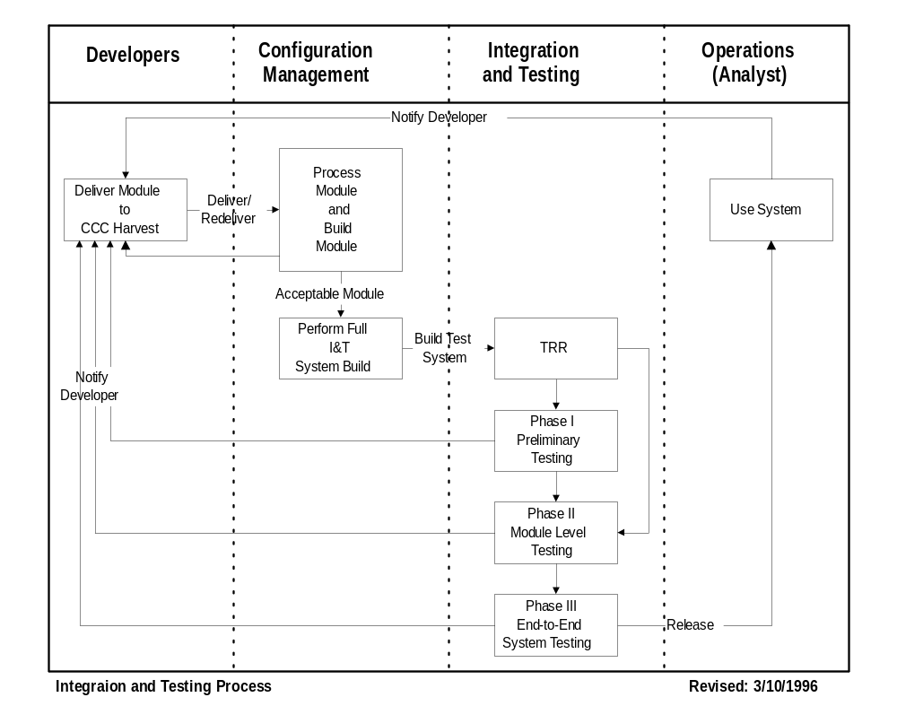
Figure 1, Current Integration and Testing Approach to Software Testing
Phase I (Preliminary Test)
This is the initial approach phase. In this phase, the test engineer performs initial checking of the delivered applications for each subsystem. The test engineer verifies the build status of the software and identifies the changes that were made. If the application is new to the engineers, then the learning process also occurs in this stage.
Phase II (Module Level Test)
In this phase, the test engineer executes the delivered unit tests and generates new test cases to verify the correctness of the module. The test cases are generated manually. The validity and coverage of the tests generated depend on the engineer’s knowledge of the software and his or her testing experience. The amount of test effort is also constrained by the given testing schedule.
Phase III (End-to-End, System Level Test)
In this phase, the test engineer’s focus is on the integration among applications. Since JPL’s science data processing software are driven by data, different methods of data generation and manipulation can affect the sequence of the processing operation that has direct affect on the end products (i.e. images and/or scientific data).

TestMaster Insertion into Process
It is the Integration and Test team’s believe that TestMaster will improve the current testing process by reducing the time spend on Phase II and direct engineer’s focus toward the end-to-end system level testing. Since models built by TestMaster can easily be tailored to generate tests that can quickly verify the changes to the software, the time spend on Phase II can be greatly reduced. By importing models built for Phase II and integrating them together as subsystem, the test engineer will be able to generate models for Phase III with very little effort.

XVD Software
XVD is a Graphic User Interface image viewer. It is mainly designed to view VICAR image files and allows the user to perform various image enhancements. XVD is an application saturated with configurable user preferences and image manipulation options. It provides the user with information on each pixel of the image and a histogram on color distribution. The primary functions of XVD are its zoom capability and its rich stretch algorithm functions. Both of these functions enable scientists to surface any hidden information within the digital image.

Black Box Test Techniques
The TestMaster tool presupposes a Black-box testing strategy.
Testing strategies are either structural or behavioral in nature. Structural testing is also called “glass-box” or “white box” testing. Behavioral or functional testing is called “black-box” testing.
Testers perform Glass-box testing by having complete access to the system-under-test’s design. In the case of a software program, this approach allows the tester to ensure that every source code statement and every branch of a conditional check executes correctly.
Black-box testing, is based upon the functional, performance, and interface requirements of the system-under-test. Knowledge of the internal workings of the system is not needed and is even avoided. This approach encourages the tester to concentrate on ensuring all of the requirements of the system are met. Tests are constructed without being influenced by the details of the system implementation.
Often, a hybrid test strategy occurs, with unit level testing performed using the “white-box” approach and higher system level testing performed using the “black-box” approach.
Teradyne provided Black-Box Testing: Techniques for Functional Testing of Software and Systems by Boris Beizer, John Wiley & Sons, 1995 as an introduction to black-box testing as part of the course material during TestMaster training.

TestMaster Description
TestMaster is a software tool developed by Teradyne Software & Systems Test. It is an automatic test script generator designed to test software and hardware systems using the black-box approach to testing.

TestMaster and the Test Process
TestMaster creates test scripts for automated or manual test execution. It does not address test execution and validation. Test execution and validation are performed by the XRunner and VICAR execution environments for this pilot program. The execution and validation aspects of the testing process still require a significant amount of manual effort and training. The effort is expended primarily in executing the appropriate test steps and validating that the system has responded correctly to the stimulus. This is a repetitive process. Executing the steps and interpreting the system response also require training and experience with the system.
TestMaster focuses on Test Generation, which is prior to test execution. The figure below shows a Block Diagram of the test process used in the pilot. (See Figure 2 and Figure 3)

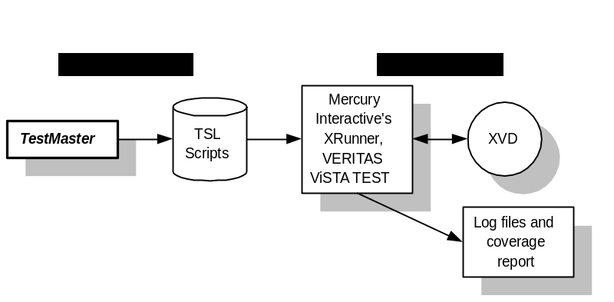

Figure 2, Functional Testing with XRunner and VERITAS ViSTA TEST

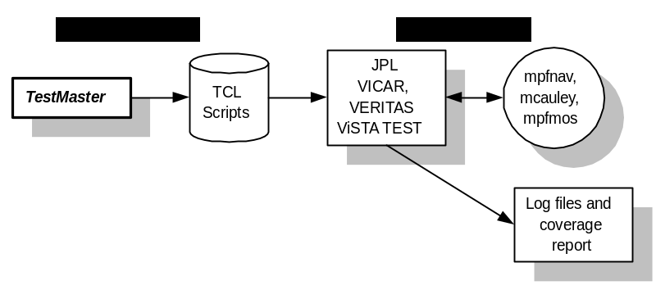
Figure 3, Functional Testing with VICAR and VERITAS ViSTA TEST

TestMaster Tool
The tool is possible by the development of fourth generation, modern visually programmed testing tools that provides both a human and machine readable model of the system-under-test. Using this class of tool, the test engineers are encouraged to:
- Operate at a higher level of abstraction (only the system’s behavior is relevant).
- Focus on the test goals and strategy.
- Delegate the generation of the actual test scripts to the automated tool.
TestMaster runs on a variety of UNIX-based workstations. It is comprised of three major elements: a graphical editing tool (Model Editor), a test program generator (Path Generator) and a Model Debugger. (See Figure 4)
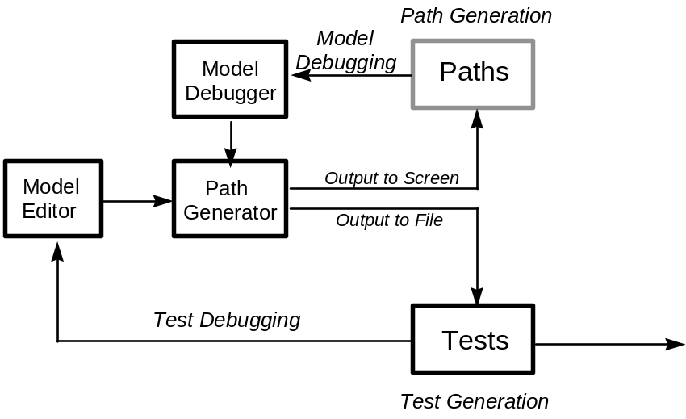
Figure 4, TestMaster Elements

TestMaster is both a tool and a methodology. The software tool supports the Test Engineer’s application of the methodology. The methodology first requires the construction of a behavioral model of the system-under-test. Testers construct this model using TestMaster’s graphical editing tools while referring to the specification (in this case the XVD specification and VICAR software specifications) of the system-under-test. When a valid model of the system exists, TestMaster’s path generator executes to generate a suite of test scripts in the language of the target-automated tester (i.e. test harness).
TestMaster models are hierarchies of Extended Finite State Machines (EFSM). An ESFM is an extension of the classic state machine notation used in engineering design. Like classic state machines, ESFMs are constructed from States, Transitions and Events. In addition, they include several extensions for the behavioral modeling environment. The use of EFSMs solves the basic problems with using classic state machines for model-based engineering problem solving.
The first of these problems is state explosion. State explosion is the tendency for models of complex systems to become very large. Large models contain a lot of states and transitions. This makes them unmanageable (i.e. difficult to understand and edit). EFSMs solve this problem by embedding historical context into the models through an EFSM feature called a Predicate.
In addition, hierarchies of state machines allow the engineer to create state machines within state machines. This technique of layering allows construction of complex models that are built-up from simple state machine models.
A Predicate is a Boolean condition that must be true in order for a state transition to be a legal path between states in the behavioral model. The predicate checks the context of a model, unlike a traditional state machine that has no historical context. Predicate information is typically an integral part of the model specification for the system-under-test. Predicates are a component of EFSM transitions. For example, an image file must be open before any kind of zooming and stretching can be performed.
A second problem with state machine-based model test generation is it tends to generate far too many tests for practical use. Large numbers of trivial tests and unwanted permutations of previous tests can result that are uneconomical to execute on even a highly automated test execution environment. TestMaster overcomes this problem with the EFSM Constraint feature.
A constraint is a control condition embedded in a state transition to guide the path generator. A constraint is not a predicate, because it is not part of the system-under-test’s specification. Constraints provide the model builder with a convenient way to limit the number of tests being generated for execution on the test harness or performed manually. Using constraints, tests that are not interesting to the tester can be “filtered” out of the test suite. Constraints are a component of EFSM transitions. (See Figure 5)
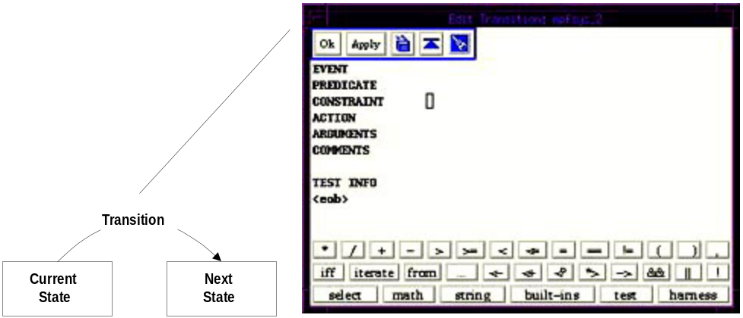

Figure 5, Model and Programmable Elements
TestMaster produces test scripts by embedding manual or automated script code statements into the model. These statements or “snippets” are embedded into the model’s transitions. The model builder embeds the statement or command required for the test harness to drive the system-under-test from the current state to the next state or verify correctness of a subsequent action. Because the model is behavioral, the paths though the model’s logic will contain the valid executable test statements needed to drive the system-under-test under all circumstances and scenarios. When model construction is finished, the model serves as an input to TestMaster’s Test Generator. The Test Generator concatenates the statements in the model’s transitions into executable test scripts.

The Path Generator is a software engine that generates a suite of test scripts in the test language choice (automated or manual). The engine can generate a range of test suites for the system-under-test varying in degrees of test coverage. For example, the test engineer may select transition cover (basic degree of coverage) or full cover (most comprehensive degree of coverage) on a model by model basis.
When the Path Generator is set to transition cover it will find the minimum number of tests required to make sure that each modeled transition and path is traversed at least once. This is equivalent to all transitions in the behavioral model being included in the test suite in at least one test. In contrast, full cover generates tests for all transitions, to all states, in all contexts - a set of tests that represent every possible path and permutation of paths through the model.
A range of options exists between transition and full coverage. The test engineer can control the Path Generator to select the range of test coverage desired. The range between transition and full cover is referred to as hybrid coverage. In addition, “filter” capabilities exist to only cause the generation of tests that meet user defined criteria. For example, a test engineer may elect to create a test suite containing only tests exercising newly added functions to the system-under-test.
These features ensure the user can generate tailored test suites. A tailored suite would have the maximum economic value within the available test execution time and resource budget. The practical result is that the user can generate tests for specific purposes, such as: regression testing, overnight build testing, bug detection, etc..
The test engineer does not have to wait to complete a model of the system-under-test before generating useful test scripts. Partially complete models can generate useful tests. In this regard, TestMaster supports an incremental and continuous improvement process of model building.

XRunner Test Harness
XRunner is an automated testing tool for X Windows applications. It offers user the capability to create adaptable and reusable test scripts that can verify the functionality of the application-under-test. It enables the user to create tests by recording how the user interacts with the application. Every point and click applied to the GUI application is recorded in a test script that is in C-like Test Script Language (TSL). The tester can als enhance the generated test script by manual programming with TSL. (See Figure 6)
XRunner operates in two modes for test recording:
Context Sensitive mode records user actions and interactions in terms of GUI objects. The physical location of the object on screen is not important. The TSL script generated will describe the object selected and action performed. In order for XRunner to operate under this mode, the tester must first generate a GUI Map through XRunner’s Learn feature. Since the GUI Map is stored separately from the test scripts, changes to the application’s user interface only requires the GUI Map to be updated. The Integration and Testing team was unable to configure XRunner to operated properly under the Context Sensitive mode, therefore automated verification of the test scripts generated from pilot was not performed.
Analog Sensitive mode records every mouse clicks, keyboard inputs, and the exact coordinates traveled by the mouse. The mode is generally being used where the exact mouse coordinates are important to the application-under-test, such as drawing applications. Since different workstations may configure their display devices differently, the TSL script generated under this mode may not be portable.
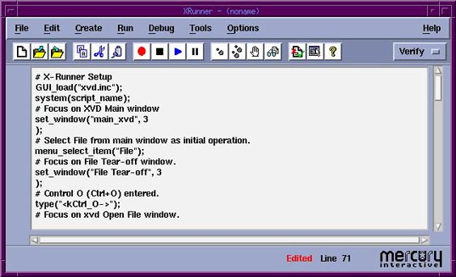
Figure 6, Mercury Interactive’s XRunner.

VERITAS ViSTA TEST Code Coverage Tool
ViSTA TEST is a code coverage measurement tool. Any C or C++ application can use this tool to determine what code fragments has and has not been exercised. This enables the software developer and test engineer to release software with greater confidence. Code that has been specially compiled with the coverage compiler will report each item as it is exercised by the test suite. Reports generated by ViSTA TEST will report the measurements of functional call entry/exit coverage, basic block coverage, code segment coverage, test coverage partitioning, path coverage, error-seeding, interface coverage, simulation, and exception coverage (for C++). Complexity of the software is the base for measurement of coverage. ViSTA TEST supports several static metrics for measuring Cyclomatic Complexity, Essential Complexity, Halstead’s Software Science, and CK Metrics. (See Figure 7)
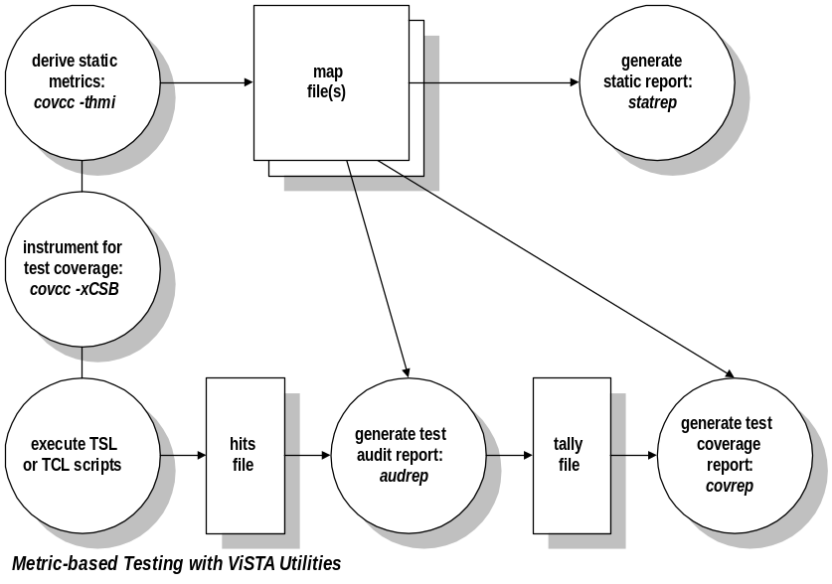
Figure 7, ViSTA Utilities model

Pilot Generated Test Models
In order to appreciate the modeling strategy applied during the pilot, it is useful to revisit the nature of unit level testing as compared to systems level testing. A unit typically encompasses a single system function. Developer typically performs unit test before the unit is being delivered. It is also being performed by test engineer during the first two phases of software testing process. In addition, new system functions are added at the unit level, binding unit test to regression testing. It is advisable to test exhaustively at the unit level. This can be a practical strategy because when the unit is considered in isolation, the number of tests required for an exhaustive test, while large, is still manageable.
On the other hand, it is rarely possible to even consider exhaustive testing at the system or subsystem level (Phase III). The reason is that the (sub)system is made up of numerous “units”. The number of tests required for exhaustive system coverage grows exponentially to numbers that will exceed the ability of any automated tester or test engineer to apply in a reasonable amount of time. Since system test combines together many system functions to form a test scenario, the test objective is to verify that the units interact properly in the system as a whole, but not to exhaustively test each unit that makes up the system.
The model strategy used for this pilot was based on the desire to have “dual-use” models: one use being unit testing to test individual system functions and the other system testing to test related functions. The unit testing required building a model that could generate all possible test cases in order to support the potential for exhaustive test coverage of a single function. This same model, however, had to meet the needs of system testing: the other dual use requirement. During the course of test generation for system testing it is necessary that this same model provide a more limited number of test paths. Limiting the number of scenario paths is important for the reasons discussed above.
In the pilot, XVD is viewed as a “mega-unit” that is composed large number of complex units. Therefore, the pilot approached XVD as a unit not a system. System level testing was demonstrated through the modeling of several Mars Pathfinder (MPF) applications. The modules selected for the demonstration were MPFNAV, MCAULEY, and MPFMOS. The modeling style used to model the System level testing was achieved through four steps.
- Identify the top-level software calling sequences and requirements.
- View each unit as a submodel of the system.
- Design and construct each submodel with respect to the system model. Unit testing was also being performed during this step.
- Integrate the submodels to produce the complete system model designed from the first step. As mentioned earlier, the number of test generated for system level coverage may grow exponentially. Therefore, fine-tuning of the system model is necessary.

XVD Modeling and Test Generation
The modeling for XVD employed a hierarchical modeling strategy, where the submodel was defined by each encapsulating window of the application. Since XVD is a GUI application, modeling of user events is necessary to produce the correct TSL script. This has greatly increased the complexity of the model. The pilot has produced a partially complete model of XVD. It successfully generated test cases for the File_Menu and Edit_Menu. Stubs were used to simulate other yet to be defined submodels.
The top-level view of the application contains four primary objects. These are the items on the menu bar. When there is no image being displayed, the only interaction a user can generate through the items on the menu bar. The Setup and Cleanup submodels are defined for initiation and termination of XRunner and XVD. (See Figure 8)
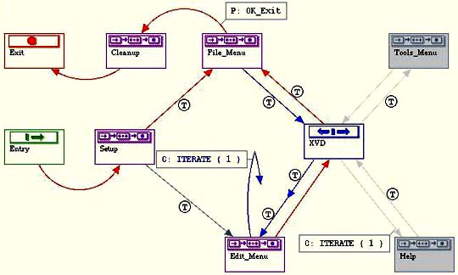
Figure 8, Top-level XVD model
The File_Menu submodel contains only two selections: Open and Exit. However, user can generate several events under this menu. The pull-down menu has Tear-Off capability and it can be driven by accelerated keyboard entries. The pilot has fine-turned the user-generated events by placing emphasis on the mouse clicks. (See Figure 9)
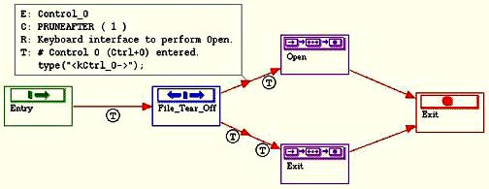
Figure 9, File menu submodel
The Open_Menu submodel is defined by a standard Motif file-selection Widget. The objects in this window can be grouped into three submodels: Set_Filter, Set_Directory, and Set_File. The Filter selection box allows the user to filter only the type of file he or she wishes to see in the file-selection box (e.g. *.img, earth.*). The Directory selection box allows the user to select a directory through mouse clicks. The File selection box lists out all available files within a given directory with respect to the input filter. Since this is a GUI application, user-triggered events can be in any combination. A good example of this is the ability to change the directory when the file cannot be located in the current directory. Various transitions were added to model the possible user-triggered events. Fine-tuning of the model is required to avoid infinite loops. Each of the submodels defines the complex user inputs events generated through mouse and keyboard interactions. (See Figure 10)
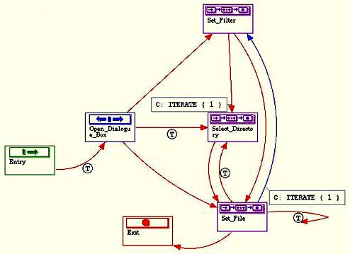
Figure 10, File open submodel
The submodel Edit_Menu defines the three primary objects where user interactions would occur. Like the File_Menu submodel, users can generate several events under this menu other than just using the mouse and pointing to one of the three primary objects. The pull-down menu can be tear-off and triggered by accelerated keyboard entries. Fine-tuning of the submodel is required to properly simulate the common user interactions. The Preferences selection allows the user to interactively configure the appearance of XVD. Data Range allows the user to set the color distribution of the image. Undo is to reverse the previous action. (See Figure 11)
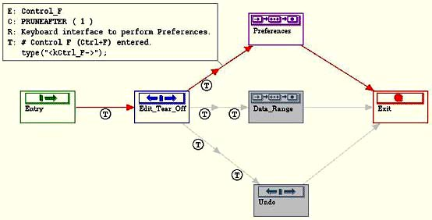
Figure 11, Edit menu submodel
The Preferences submodel defines all possible user events in selecting the preferences of the application. The main focus of this submodel is the Display_Preferences, which defines the possible user selection on the appearance of the XVD application window. To fine-tune this submodel, a COMBINATION function is invoked to make sure all possible combinations of user events will be covered. (See Figure 12 and Figure 13)
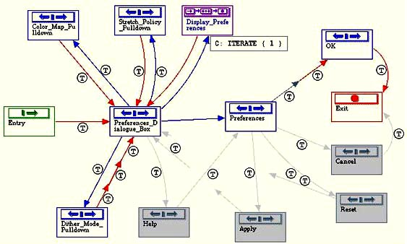
Figure 12, Preferences submodel

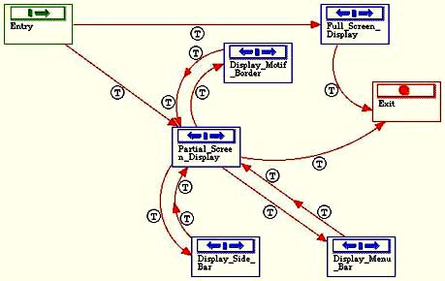
Figure 13, Display preference submodel

Mars Pathfinder (MPF) Subsystem Modeling and Test Generation
Modeling of Mars Pathfinder image-processing subsystem is performed by following the four-step process described earlier. The modules involved in this subsystem include MPFNAV, MCAULEY, and MPFMOS. To derive the top-model system model, the model engineer needs to first determine the calling sequence for the modules, and define the relations between the modules. (See Figure 14)
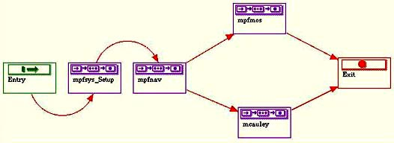
Figure 14, Top-Level System Test model for MPF.
Models where derived by grouping of program parameters. Instead of treating them as parameters, the model engineer treated the submodels as processing entities. Since these modules were all designed for MPF image processing, they shared some common input parameters. Therefore, many of the submodels can be reused among them. One of the observations through the pilot program was reusability of common models. If we treat submodels as subroutines, we can achieve reusability of submodels by adapting the same disciplines as software development. (See Figure 15, Figure 16, and Figure 17)
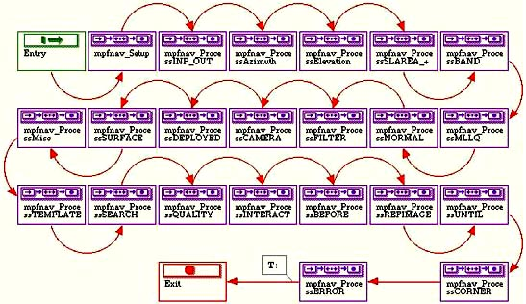
Figure 15, MPFNAV functional model
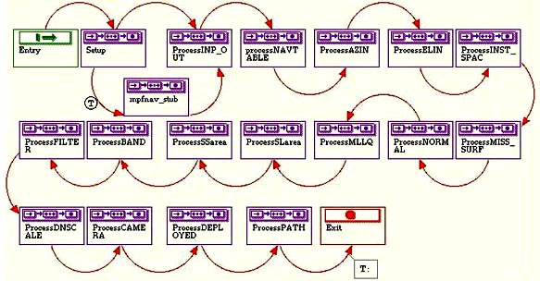
Figure 16, MCAULEY functional model
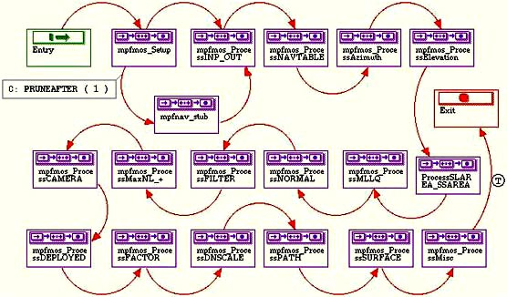
Figure 17, MPFMOS function model

Reusable Submodels
One of the major discoveries by the model engineer through modeling VICAR command-line applications was the concept of reusable submodels. As mentioned earlier, there are common parameters among image processing applications. Re-modeling of identical submodels between applications can by quite time consuming and inefficient. The model engineer developed generic submodels that can be easily configured and interfaced into application models.
An example of reusable submodels was the generic model to generate values for parameters such as SIZE, SLAREA, and SSAREA. The SIZE parameter expects a list of four arguments: starting line, starting sample, number of line, and number of sample. The parameter SLAREA (starting line area) and SSAREA (starting sample area) are lists that expect a variable number of arguments. The size of the list depends on the number of input images. These parameters are different, but they have their similarities. They all have the same format that is a list of numbers separated by commas and enclosed within parentheses.
The packaged generic submodels derived by the pilot have similar components as an image processing subroutine’s .COM file. It has a top-level test model to demonstrate the functionality of the generic submodel. (See Figure 18)
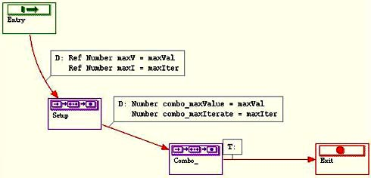
Figure 18, Test model used to demonstrate the functionality of Combo_
Each submodel has help documentation that describes the interfaces and purpose of the submodel. (See Figure 19)
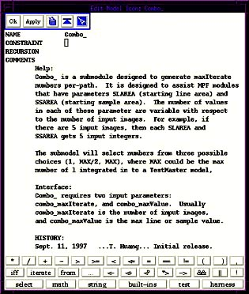
Figure 19, Documentation for submodel Combo_
The Combo_ submodel was used to generate combinations of numbers for parameters SIZE, SLAREA, and SSAREA. It expects two arguments: combo_maxValue and combo_maxIterate. When integrating this submodel into the application model, the engineer assigns a maximum sample or line value to combo_maxValue and assigns the number of images to combo_maxIterate. For the SIZE parameter, the engineer assigns 4 to combo_maxIterate. Submodels within an application or system model have unique naming requirements. The underscore in the submodel name “Combo_” is used to avoid name collision with other existing submodels within the application or system model. (See Figure 20)
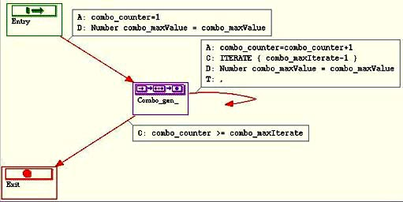
Figure 20, Implementation of Combo_
The submodel Combo_ was integrated into the MPF application models to assist in generation of SLAREA and SSAREA. It was also used to generate MLLQ and NORMAL with minor modifications in the number sequence to be generated. In the application model for MPFMOS, the subroutine was renamed to mpfmos_SLAREA and mpfmos_SSAREA to reflect the function of the submodel. (See Figure 21)
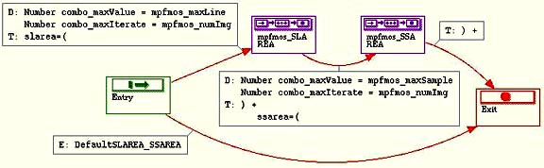
Figure 21, Combo_ integrated into MPFMOS application model.
The submodels can be stored as a TAR file in a common access area in Integration and Test, rather than as a packaged .COM file.

Pilot Task Evaluation
Initially, the stated goals for evaluating TestMaster included a complete model of the XVD and demonstrate the testing sequence under XRunner. This was too ambitious a goal for a 30-day pilot program. It is a time consuming and complex task to model every user event for XVD due to the complexity of the application. The biggest obstacle was not learning TestMaster, it was correctly configuring XRunner to operate properly under the current science data processing environment. However, the generation of the MPF System Test model was a success.
Due to the limitation of XRunner has placed over this pilot program, only a partial XVD model was generated. It was decided that proper modeling of the File_Menu and Edit_Menu would be enough to prove the suitability of TestMaster for generating TSL test scripts. The model that resulted establishes the infrastructure for testing the entire software, while at the moment only testing selective objects. The remaining objects can be added-on incrementally to make the model a fully functioning representation of XVD. The TSL scripts generated by TestMaster were required to execute under the Context Sensitive mode of XRunner, which is currently not operational. Another limitation of XRunner has placed over this pilot program was its failure to learn the GUI window objects, which is required to generate the GUI Map file for Context Sensitive execution. However, the correctness of the model can be verified by hand to ensure the proper generation sequence.
The modeling of MPF Subsystem model was a success. The three selected candidates were properly modeled and were all tested with Transition Coverage. Several software failures were discovered during the execution of the generated test scripts. Constraining the models was necessary to sort-out redundant test cases and improves test generation time. The efforts required to integrate the submodels were very minimal.
During our modeling activity, we discovered the specification for the software did not provide enough detail to accurately model some functions and objects of the software. It became necessary to consult with the software systems engineer to clarify specific functions before they could be modeled. This observation suggests that the specification alone may not always provide an unambiguous requirement specification for the subsystem developers.
Since TestMaster uses EFSM’s to model the system for testing, it is possible that in addition to generating “black box” tests, it could also be used to actually define the software requirements specifications. This would have the added benefit of reducing the number of system defects caused by incomplete and/or conflicting specifications. The TestMaster models could also be used in other contexts that require specifications. (See Figure 22)
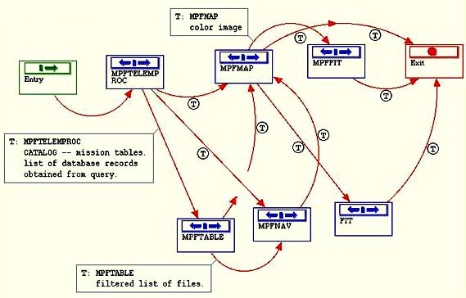
Figure 22, Partial MPF image processing subsystem specification model.
The layered modeling approach, as discussed in the previous section, is a compromise between the conflicting goals of a totally exhaustive test and a carefully controlled scenario for validating a subsystem. As noted below in the TestMaster tools observations section, if the tool had the ability to associate different constraint sets with the same ESFM diagrams, it would further reduce the effort needed to generate models to perform both scenario and exhaustive testing.
The use of a model-based testing strategy allows the test engineer to easily create new scenarios without being knowledgeable of the automated test language and the underlying tester implementation. The model becomes the knowledge base for this information. However, adding or changing functionality of a model requires that the test engineer be knowledgeable of the underlying tester’s capabilities.
The tool is capable of generating thousands of tests for validating the subsystem under test. The challenging part of TestMaster is in applying constraints to the models. Constraints are needed to reduce the number of tests to as few as possible giving the largest amount of coverage, and being executable within the given time and budget limitations.

Test Quality Comparison
A review of the tests generated by TestMaster models shows that it produced comparable coverage to the current, manually created tests. The pilot model generated much more tests.
At the time of the pilot program, there was no complete subsystem test for the Mars Pathfinder imaging applications. The number of tests generated manually was limited and was not sufficient. The quality of the tests generated by TestMaster for the subsystem test revealed the limitations of manual test generation. One of the advantages of using TestMaster is the reduction in manual labor for the test engineer. PDF and TSL scripts were generated and can be executed under test harness without any manual modifications. The coverage of the tests generated was desirable.
The TestMaster test suite detected a few failures in the MPF system-under-test. The specifications for MPFNAV, MCAULEY, and MPFMOS stated the applications could handle images taken by all cameras. However, these applications fail to handle any of the images taken by the Pathfinder Rover. A great portion of the code was not covered due to these failures, because there are three cameras onboard of the Rover. There are software packages developed specifically for the Rover images. If these applications were designed only to handle Lander’s images, then the code fragments need to be removed and the specifications of the applications need to be modified. Other problems found involved the SLAREA and SSAREA parameters. Different combinations of valid size values can trigger Abnormal Process Termination of MCAULEY.
In addition, the TestMaster model produced 140+ tests in Hybrid, and 5000+ tests in Full coverage schemes for each of the MPF applications. Hybrid and Full Coverage tests are not part of this comparison.

Comparison Summary
There were huge increases in test coverage on the tests generated with TestMaster compared to tests generated manually.
The TestMaster tests contained more test steps per test than the existing suite. The automatically generated tests included some trivial test steps, which were determined to be outside of the normal use pattern for the function. The Teradyne engineer says that a more rigorous constraining of the MPF models would eliminate test steps outside of the normal use pattern. However, these steps are allowed by the specification and are relevant to the function’s test.
Finally, the tests generated with TestMaster covered a wider range of executions. The time spent on model construction can vary from a few hours to one day of test engineer’s time for a typical VICAR application. Tests generated with Transition Coverage were sufficient and adequately exercise all functionality of a given application.

System Modeling Estimate
In order to make a fair estimate as to the time required to complete the modeling process for XVD and MPF subsystem, it is necessary to take a closer look at where the time was spent on the pilot program.

Basis for the Estimation
The amount of time it takes to complete the modeling process depends on many different factors. A list of the most important factors is shown below.
- Knowledge of the test harness.
- Resource availability.
- Model reusability.
- Knowledge of the system under test by the model engineer.
- Completeness of the Specification.
- Function/Feature complexity.
- Skill of the modeling engineer(s).
- Learning curve.
One of the limiting factors for the pilot program was the configuration of the test harness. Since XRunner’s Learn feature was not operational under the Science Data Processing environment, the model engineer was unable to identify the correct logical names to many of the window objects to XVD. Even though the flow of events generated by TestMaster has correctly simulated most of the user interactions, the logical names embedded in the output TSL script need to be updated after XRunner has been properly configured.
Modeling software with EFSMs through specifications is a new paradigm to the Integration and Test team. Just as there is more than one way to implement a given algorithm, there is more than one way to model a piece of software with EFSMs. Disciplines in modeling must be adept to improve the reusability and maintenance of the model. Models generated by the model engineer were being modified numerous times, because of the engineer constantly learning new ways to improve the efficiency and maintainability of the system models.
In order for the models to effectively reflect the behavior of the application-under-test, the modeling engineer must have working knowledge of the application-under-test. The Integration and Test team has long history of testing GUI systems and VICAR software. Therefore, the model engineer was able to begin the pilot with only learning TestMaster and learning to configure XRunner. It was obvious to the modeling engineer that lack of documentation of the system-under-test will present real challenges to the modeling process. The consistency of the documentation is also a huge factor in the correctness of the final model product.
The learning curve was not a huge factor, due to the model engineer’s experience with the systems-under-test. Learning to use TestMaster was achieved through the in-class session. Learning to configure XRunner presented a real challenge to the pilot, which was not resolved at the end of the pilot program. Learning to model with EFSMs was a new experience to the Integration and Test team. The engineer’s modeling skills were improved significantly at the end of the pilot program.

Labor Hours Analysis
The hours spent on the pilot program are shown in the figure below:
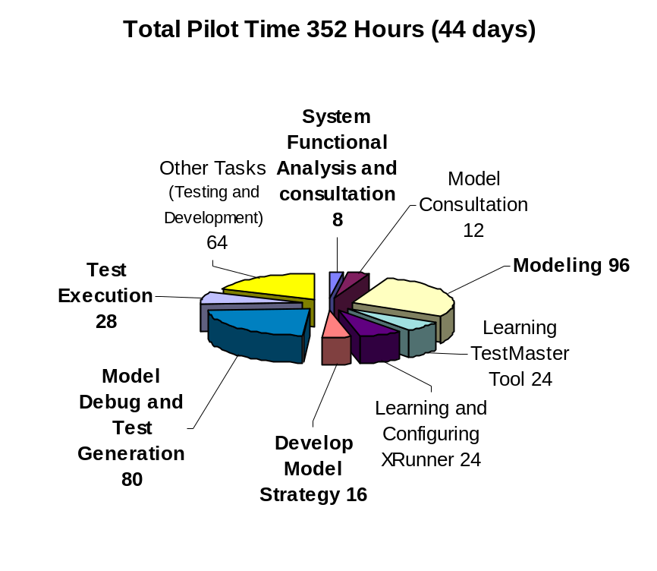
Figure 23, Total Time Spent during Pilot Program and the breakdowns.

TestMaster vs. Manual Test Generation
It should be obvious that once the model is built, the time for test generation is minimal. Adapting to TestMaster will require a paradigm shift within the Integration and Testing team, because modeling with EFSM is a new concept to the team. Therefore, it was the model engineer’s belief that there will not be a significant improvement in test time during the initial implementation of TestMaster. The time it takes learning TestMaster, modeling with ESFM, and developing subsystem models may even slow down the testing process during initial implementation. However, the time for future test generation will improve substantially after the models have been built. Since most software maintenance will only involve adding new capabilities or correction of documented failures, modifications to the existing models will require very little effort. A 5-year projection was made at the end of the pilot program to compare the time difference after implementing TestMaster.

 |  | Test with Test Master  (Hour) | Traditional Way  (Hours)
 | System Function Analysis | 8 | 8
 | Develop Model Strategy | 16 | 0
 | Modeling | 96 | 0
 | Model Debug and Test Generation | 80 | 370
 | Test Execution | 28 | 50
 | Total Time for initial implementation | 228 | 428
 | Additional maintenance and new case generation over 5 years | Two deliveries/year  It will take 10 hours to learn about the new changes and modify existing model.  A total of 20 hours | Two deliveries/year  It will take 50 hours to learn about the new changes and manually generate test cases.  A total of 100 hours
 | In 5 years | 100 | 500
 | Total | 328 | 928

Cases Generated
There were two sets of cases generated for each model, Transition and Full Coverage. However, only the Transition Coverage test cases were executed during this pilot program. The main focus of the model engineer was not just to increase number of test cases for the Application-Under-Test, but to review the quality of the test cases to ensure all parameters or user-triggered-events were covered.
 | Application/System Under Test | Transition Coverage | Full Coverage
 | XVD | 22 | 1687
 | MPFNAV | 9 | 5000+
 | MCAULEY | 23 | 5000+
 | MPFMOS | 13 | 5000+
 | MPF system test | 21 | 5000+

Code Coverage
One of the goals of the pilot was to measure the code coverage of the tests generated by TestMaster. Some of the generated Transition Coverage test cases were measured against the traditional unit tests. While 100% code coverage is always ideal for test engineers, a long history of revisions and maintenance to the testing applications, and existing problems of the applications have placed limits on the code coverage outputs.
As mentioned earlier, several software failures were discovered in some of the MPF software. These failures have prevented coverage on some code fragments of the applications. Another limitation was “dead codes”. A long history of code modifications, such as changes in calling sequences in existing subroutines, have prevented some code fragments to be covered. Changes to the application’s PDF can generate obsolete parameters in the applications. Removing a parameter from the application’s PDF, but failure to remove the code fragments that are triggered by the parameter from the application source can do this.
Code coverage was measured with ViSTA TEST coverage tool. Each set of tests for a given application was measured through its Call Coverage, Exit Coverage, Implicit Exit Coverage, Basic Block Coverage, and Segment Coverage. There was an average of 30% increase in code coverage for Transition Coverage. Full coverage test cases were also generated, but they were not executed. The limitations on available resources (machine, disk space, and time) have prevented the pilot to measure the coverage on Full Coverage tests.

TestMaster Tool Observations and Results
The pilot program was executed using TestMaster version 1.80. Our overall impression of the tool is that it is suitable for the Science Data Processing environment. The quality of the generated tests is directly proportional to the quality of models constructed. The modeling time varies with respect to the application under test. It is also dependent on the goal of the model engineer. If the model was constructed to be “disposable”, that is, no model reuse was intended, then modeling can be done in a matter of a few hours. If reuse and future expansions are expected, then more detail planning and design are required. In the case of system-level testing, the model engineer has taken the second approach. It is the model engineer’s belief that software-engineering concepts should be applied in all model constructions.
The model engineer provided Teradyne with several suggestions for improvements on TestMaster. Some of the suggestions have already been implemented in the next release of the software. These suggestions include:
Reference to Global Variable:
This was a bug discovered during the pilot. A global variable was referenced in a submodel, which was used as a loop-control-variable. The submodel was not able to retrieve the global variable, and the submodel entered an infinite loop. The Teradyne engineer has submitted a bug report to the TestMaster development. The changes should be reflected in the next point-release.
Submodel Renaming:
When a submodel is renamed through right mouse click on the submodel icon, TestMaster creates a new submodel with the new name and discards all contents of the old submodel. The work-around to this problem was to rename the submodel through the main application window. The Teradyne engineer has submitted a change request to TestMaster development. The changes should be reflected in the next release.
Debug and Replay Capabilities:
While there is a debugger in the current version of TestMaster, it has provided little assistance in locating problems within the model. For complex models, it is very easy to introduce contradicting conditions and infinite loops to the model. TestMaster offers a replay feature that can replay any generated path, but these paths are “bug free” paths which offers no assistance in locating the infinite loop problems.
Example of the problem:
A complex model was constructed and the engineer began to execute the Path Generator. The Path Generator generated n cases and it entered an infinite loop when trying to generate the n+1 path. If n is a small number and the model is relatively simple, the debugger may be used to replay the generation process step-by-step to locate the problem. However, it would be a very time consuming process when n is large and/or the model is very complex. The replay feature can only replay any of the n paths that were generated, but the engineer’s interest is on the n+1 path.
It is the model engineer’s strong recommendation to Teradyne to introduce a Replay UpTo feature to the Debugger. In the above example, the engineer can tell the Debugger to run the Path Generator to generate up to the n paths (i.e. the Path Generator will have all the preconditions up to the n^{th} path in memory) and the real debugging process can begin at n+1 path.
User Interface:
To start a TestMaster session, the user must supply a model name at the command-line. TestMaster does not have an Open feature in its File menu. It is the model engineer’s recommendation to the TestMaster development to implement an Open feature to the software.

Conclusions:
The effort needed to generate software models:
Modeling software with EFSM is a task with several requirements. The model engineer must have working knowledge of the application-under-test and/or the system-under-test. The ability to reflect the behavior of the application-under-test with EFSM is required. Boris Beizer’s book on Block-Box Testing supplied by Teradyne was a wonderful reference on modeling with EFSM. As in software engineering, future reuse is a key factor in model construction. When a model is intended to be reused and integrating to future system tests, a higher level of abstraction is required to ensure ease of integration and configuration. Once the model is constructed, the effort required for future integration and configuration will be minimal. Of course, this is dependent upon the quality of model constructed.
The effort needed to generate different levels of coverage:
This requires very little effort to the engineer. TestMaster has features that can generate various levels of tests. Model constraining is required to generate an effective set of tests, therefore model constraining also affect the number of output tests.
The effort required to change generated scripts:
For standard command-line VICAR applications, TestMaster can be configured to generate a complete PDF without any retrofitting. For TSL scripts, a LEX script was provided by Teradyne to extract generated cases into small files. In both cases, the effort required to change scripts was minimal.
Overall Observation:
TestMaster can provide higher quality tests over the current manual test generation process. It is a paradigm shift to the Integration and Test team by modeling software with EFSMs. Test generation with EFSMs has definite advantage over current test generation process, because it can generate all possible combination and permutation of tests.
The concept of reuse can greatly reduce the modeling time, since there are many common parameters among image processing applications. Construction of application model can be easily achieved by integrating existing generic submodels together. Another advantage TestMaster offers is the verification of software specification. The pilot has already found several inconsistencies in the system-under-test through modeling.

Glossary:
Black-box testing - A testing method in which the internal working of the system is not know or even avoided. Testing’s solely based upon stimulus and response.
Constraint - A user-defined control embedded into a TestMaster model that guides the path generator. It is not a part of the system specification, only a control of the tests being generated.
Domain Knowledge - An understanding of the system under test. A knowledge of how the features and functions of the system are supposed to behave.
Executable test script - A full test script with a test sequence from beginning to end, not just a small portion or step in the test sequence.
Exhaustive testing - Testing every possible combination and permutation of the model of the system under test. Testing every possible input to verify every possible output.
Extended Finite State Machine (EFSM) - A graphical representation of all of the different possible states a system can be in and how it gets from one state to another. Extended finite state machines differ from standard state machines by the use of predicates and constraints.
Full Coverage - Taking every possible path through a TestMaster model.
Function - A single element of the system under test. A small part of the system that has a specific purpose.
Functional Model - A model that represents only one function of the specification.
Functional Test - A test to prove basic functionality of a specific function or feature having a very narrow range.
Hybrid Coverage - A user defined level of test coverage between full and transition coverage. In TestMaster, this is achieved by setting some submodels to full and others to transition cover.
Mode Model - A model that represents the working environment of the system under test.
Negative case testing - When invalid input data is applied to see if the system will properly “trap” the error and handle it.
Positive case testing - When valid input is applied to verify a positive or predetermined outcome.
Predicate - A condition that must be met in order to take a transition to another state in a EFSM. This is usually a condition that is defined in the specifications or a physical condition of the system under test that is not defined in the code.
Requirement - A single statement that the system must obey.
Snippet - A piece of embedded code in a TestMaster model which will execute the step need to take the transition it is embedded in.
System-Under-Test (SUT) - the hardware or software application which is the object of testing.
TAE (Transportable Applications Executive) - It is the base of VICAR that was developed for the NASA Goddard Space Flight Center.
Test execution - Performing the test or tests on the system. This could be done manually or automatically.
Test Generation - Developing or generating the tests that need to be executed on the system under test.
Transition Coverage - The tests generated by taking several paths to cover each transition in the model at lest once.
TSL (Test Script Language) – A scripting language used by XRunner to describe all mouse and keyboard interactions. A test engineer can use this language to customize specialized test cases.
ViSTA TEST - A code coverage measurement tool developed by VERITAS Software Corporation. Any C or C++ application can use this tool to determine what code fragments have and have not been covered.
VICAR (Video Image Communication and Retrieval) - A set of computer programs and procedures designed to facilitate the acquisition, processing, and handling of digital image data.
XRunner - An automated testing tool for X Windows applications developed by Mercury Interactive. It offers user the capability to create adaptable and reusable test scripts that can verify the functionality of the application-under-test.
XVD - A Graphic User Interface image viewer. It is mainly designed to view VICAR image files and allows user to perform various image enhancements.

