Junior Ranger Program
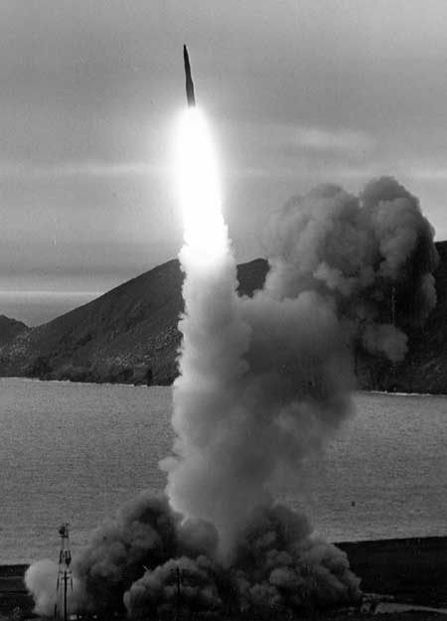
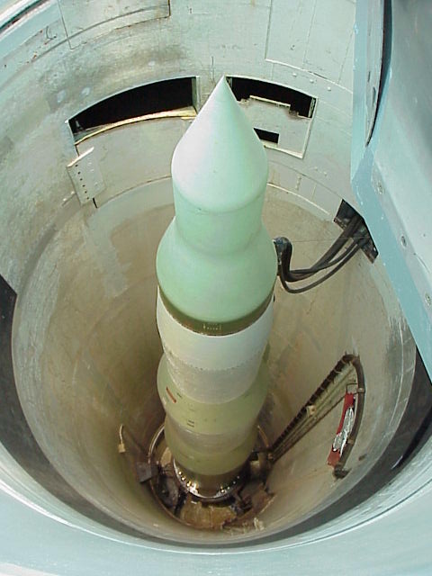
Hey Kids!!
YOU CAN BE A
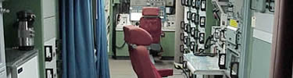
JUNIOR RANGER!

Welcome to the Minuteman Missile National Historic Site Junior Ranger Page! We are glad you were able to visit this site today. We hope that by taking part in this Junior Ranger program, you will develop an appreciation for one of the nation’s newest National Park areas.

A NOTE TO PARENTS OR GUARDIANS:
This web-based Junior Ranger program deals with concepts and realities that some children may not be comfortable with or may be beyond their understanding. It was designed for children between the ages of 10 and 14 to help them learn about Minuteman Missile National Historic Site and the National Park Service, and also to have some fun! We need your assistance to accomplish this goal. We encourage you to help and interact with your child, but let her or him do as much of the work as possible. The activities need to be printed in order to complete them, but it is not necessary to print them in color. You only need to print the pages of the activities your child chooses to complete. If more space is needed to complete an activity they may continue on the back of the sheet. It is our hope that the activities on this website will help you and your child so that you might better enjoy a future visit to Minuteman Missile National Historic Site and other National Park Service sites.
CHECKLIST FOR JUNIOR WEB RANGER REQUIREMENTS:
- Visit the Minuteman Missile National Historic Site web page: www.nps.gov/mimi
- Everyone must complete Activity Number 1. If you are less than 10 years of age, complete 3 of the remaining 11 activities. If you are between the ages of 10 and 14, complete 5 of the remaining 11 activities. If you are older than 14 years of age, complete 7 of the remaining activities.
- Upon completion of your Junior Ranger activities you may mail them to Minuteman Missile NHS, 21280 SD Highway 240, Philip, SD 57567.
- Please be patient. In a few weeks you will receive your Junior Ranger Badge and a certificate that you can display so everyone will know you are a Junior Ranger at Minuteman Missile National Historic Site.

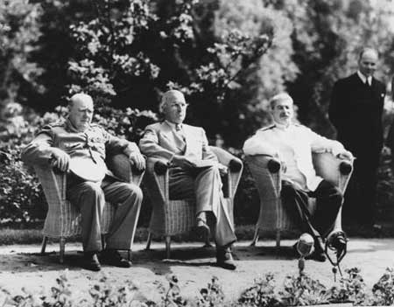
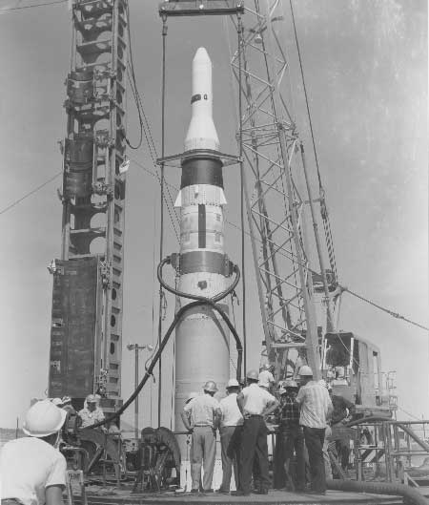

British Prime Minister Winston Churchill,
United States President Harry S. Truman,
and Soviet Premier Joseph Stalin meeting
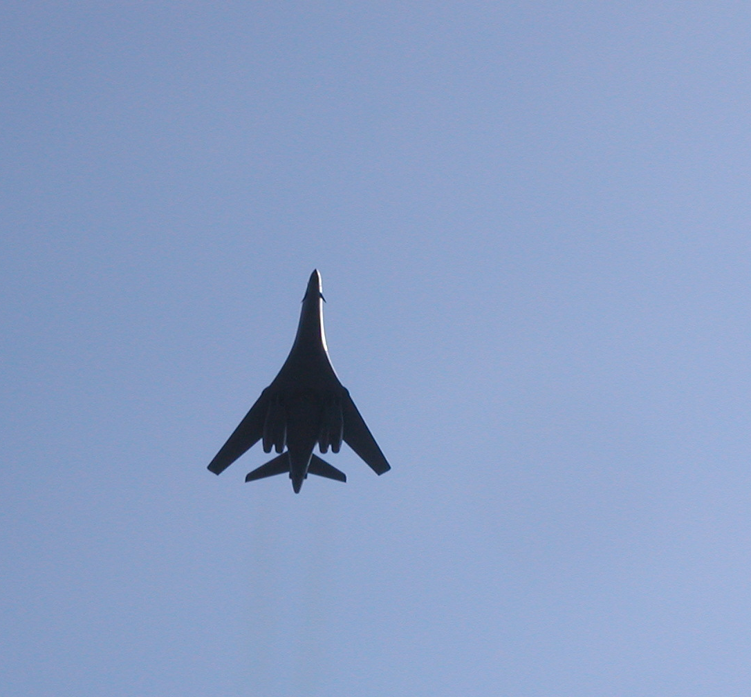
at the Potsdam Conference, August 1945.

Full-scale test of Minuteman I
missile, Edwards Air Force Base,
California, 1960.

B-1 bomber flyover at the
ceremony transferring the
Minuteman Missile site from
the US Air Force to the NPS on
September 27, 2002.
Activity Number 1:
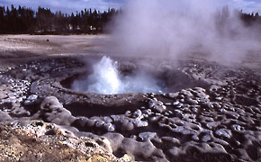

The National Park Service cares for special places saved by the American people so that all may experience our heritage.
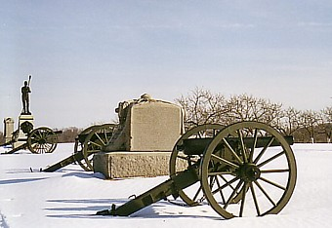
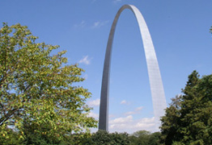
Minuteman Missile National Historic Site (NHS), the 379th National Park Service unit, is one of the nation's newest national parks. Although the resources protected at this site relate directly to the Minuteman Missile program, the site's story will include the larger issues of the Cold War era.

Some other National Park areas that tell a military story include Cowpens National Battlefield (NB), Minute Man National Historic Park (NHP), Fort Point NHS, Petersburg NB, Tupelo NB, Pecos NHP, Eisenhower NHS, and War in the Pacific NHP.


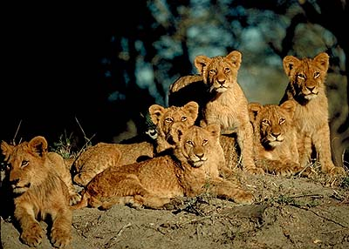
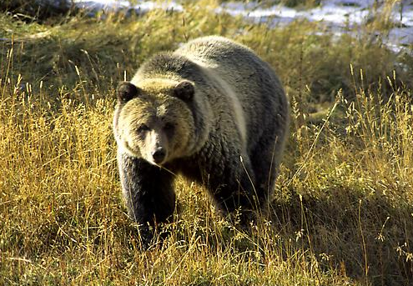
The National Park concept has been described as "America's best idea." Many countries around the world look to the United States as a leader in park and protected area management. National Parks exist worldwide in over 120 countries. Among them are Tierra del Fuego (Argentina), Norfolk Island (Australia), Zhangjiajie (China), Volcan Irazu (Costa Rica), Gros Morne (Canada), Plitvice Lakes (Croatia), Lake Nakuru (Kenya), and Sagarmatha (Nepal).

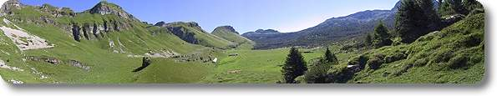
You may access information on international parks at: http://www.nps.gov/oia/around/index.htm

Have you visited any National Park Service sites? ______ If so, name one. _____________________________________________________

Have you completed any other Junior Ranger programs? _______ If so, at which National Park Service site? _____________________________

Activity Number 2:

The Cold War is the term used to describe the shifting struggle for power and influence between the Western powers and the Communist bloc after World War II ended in 1945. This confrontation between the United States and the Soviet Union is a typical example of the differences between a capitalist democracy and a communist world. The conflict that arose between these two powers was the reason for the development of new weapons systems, including the Minuteman II missile.

A Communist state is one ruled by a single political party. Communism is a system of political and economic organization in which property is owned by the community or government and all citizens share in the common wealth according to their needs.

A capitalist system is an economic system based on private ownership, in which money can be made through investment of capital and employment of labor with little government control – the idea of free enterprise.


This flag is the flag of the former Soviet Union. The red color was for communism. The hammer was the symbol of the industrial workers and the sickle represented the peasants. The gold star represented unity and contained five points (one for each class in communist society: workers, peasants, scholars, youths, and soldiers).


The flag of the United States of America consists of thirteen horizontal stripes, seven red alternating with six white. The stripes represent the original 13 colonies; the stars represent the 50 states of the Union. The colors of the flag are symbolic as well: red symbolizes hardiness and valor, white symbolizes purity and innocence, and blue represents vigilance, perseverance and justice.

Activity Number 2 continued:

Imagine you are the President of a new country. Design your country’s flag to represent what is important to you and explain the colors and symbols that you used.

_____________________________________________________________
__________________________________________________________________________________________________________________________
_____________________________________________________________
__________________________________________________________________________________________________________________________


Flags from around the world:

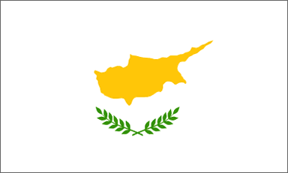

Afghanistan
Cyprus Italy




New Mexico (United States) Liechtenstein Micronesia
Activity Number 3:

The United States had developed an atomic bomb during World War II. After using this very powerful new weapon to end the war, the United States presented a plan to the United Nations to share their knowledge of the atomic bomb with the world. This plan was rejected by the Soviet Union. They had spies that had already learned of the secrets of the atomic bomb and they did not want to share these secrets with potential enemies.

Imagine you’re at a birthday party on a hot August day. The really cool parents hosting the party organize two teams for a water balloon fight. You have a great secret plan for quickly filling water balloons.

Would you share this secret with your teammates if you knew the teams would be changed later in the day? _____ Why or why not.
_________________________________________________________________________________________________________________________________________________________________________________________________________________________________________________________________________

Would you tell your friends on the other team? _____ Why or why not.
_________________________________________________________________________________________________________________________________________________________________________________________________________________________________________________________________________

What if you didn’t share the secret with your teammates and one member of the other team learned of your secret plan. Would you now share it with your teammates? ______ Why or why not. _____________________
_________________________________________________________________________________________________________________________________________________________________________________________________________________________________________________________________________

Activity Number 4:

Although the Atlas and Titan missile systems were operational by the early 1960s, the Air Force actively sought to develop another intercontinental ballistic missile (ICBM) – one that would be more cost-effective, smaller, and easier to build and operate. This push for improved technology was largely driven by the desire to surpass the perceived advanced Soviet Union missile technology and overcome what seemed to be a growing “missile gap”.

The Minuteman missile was designed to be an efficient, reliable weapon that could be mass-produced, stand unattended for long periods, be operated and maintained by small crews, stored and launched from underground silos, and automatically monitored for condition and combat readiness. It formed the land-based portion of what was known as the nuclear “triad” – nuclear weapons that could be launched from land, sea, or the air.

In the early 1960s the Air Force chose South Dakota as one of the locations to base the Minuteman missiles. Minuteman Missile National Historic Site lies in a part of South Dakota west of the Missouri River known as the Western plains. The settlement of this area is tied to agriculture, focusing on raising livestock and ranching. In order to place the launch control facilities and missile silos in the area, the government had to purchase land from hundreds of property owners. Four to six acres were needed for missile silo construction sites, but many more thousands of miles of land, only 16 ½ feet wide were needed for burying underground cables.
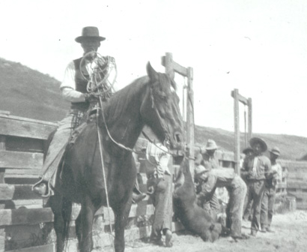
Imagine that you were a rancher in South Dakota who raised cattle on your 2,500 acre ranch. The government came to you and asked to buy six acres from you for a missile silo site. Would you sell your property to the government? ____ Why or why not. _____________________________________ __________________________________________________________________________________________________________

Would it change your mind if you could not decide where on your land the six acres would be? _____ Why or why not. _____________________
__________________________________________________________________________________________________________

What if the government wanted to run a cable through your property – not above ground, but buried four to eight feet below ground. Would you allow the government to do this? _____ Why or why not. ________________
__________________________________________________________________________________________________________
Activity Number 5:

The construction of the Launch Facilities (LF) and the Launch Control Facilities (LCF) were huge projects supervised by the Peter Kiewit Sons Company of Omaha, Nebraska. The cost to build the 150 LFs and 15 LCFs in South Dakota in 1961 was about $56 million.

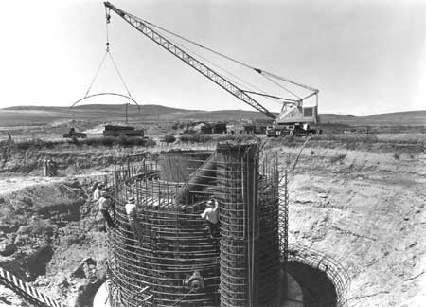
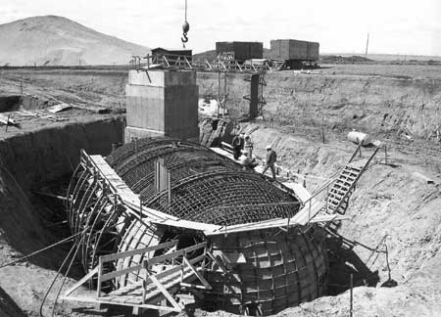
The first step in constructing the LFs was the excavation and grading at each site using a bulldozer and clam shovel to create a large hole that they then dug down to a depth of approximately thirty-five feet. A second crew moved in and proceeded to dig the shaft for the silo using a large auger. The shaft was a circular hole with a diameter approximately fifteen to eighteen feet and extended over eighty feet below the ground. The next task involved a third crew that poured a concrete plate in the bottom of the shaft. After this crew secured the bottom of the hole, steel contractors lowered a twenty-five-ton, sixty-two-foot prefabricated steel liner into position. Contractors then poured concrete around the exterior of the steel liner, forming a twelve-inch-thick wall. Additional crews constructed a lower equipment room around the silo and a support building adjacent to the silo, both of reinforced concrete and below ground level. All of this required a great deal of coordination from all of the crews involved. In addition, the LCFs and Launch Control Centers (LCC) had to be constructed and all of the missile silos connected to the LCCs with underground cable.

The project began on September 11, 1961 and was finished by November 1, 1963 – only two years and seven weeks later.

Imagine that you were building a snow fort in your backyard for a snowball fight. Consider location, size of the fort, protection from the weather, and any other details. On the back of this sheet draw a sketch of your snow fort and tell what you would consider in the location and type of fort you would build. _____________________________________________________
______________________________________________________________________________________________________________________________________________________________________________________________________________________________________________________________________________________________________________________________
Activity Number 6:

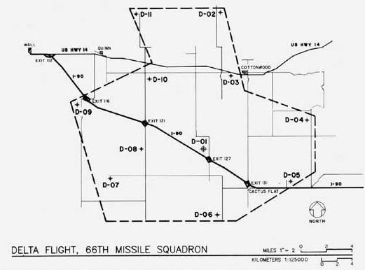
The Minuteman was the first missile system designed so that the crew members did not have to be at the missile site in order to launch it. The launch control facility was connected to the missile silos by a series of underground cables. With earlier missile systems, crew members had to live underground near the missiles in order to launch them, which was not very safe. Those earlier missiles were clustered together so they could be operated by one crew, a system that was less expensive, but more vulnerable to attack.

At the right is the arrangement of the launch control facility (D-01) and the dispersed ten missile silos of Delta Flight, 66th Missile Squadron.

Imagine that your teacher is organizing a game of tag for the class. The teacher wants the game to last for a long time. Would the game last longer in a room the size of your classroom, where the players would be clustered, or out on the playground, where they’d be dispersed? __________ Why? _______________________________________________________________________________________________________________________________________________________________
If you were “it”, would you rather play on the playground or inside? _____ Why? ________________________________________________
__________________________________________________________________________________________________________

If you were not “it”, where would the game be best to play? __________ Why? _________________________________________________
_______________________________________________________________________________________________________________________________________________________________
Activity Number 7:


During the American Revolutionary War, the minutemen were a military group made up of American Colonists who could be called upon at anytime to fight. These colonists were called the minutemen because they were prepared to fight "at a minute’s notice". The minutemen were "volunteers" who provided their own muskets and rifles. They had no real uniforms and sometimes didn't even have enough money to buy food. Still, the minutemen and their fellow soldiers in the regular army managed to defeat the British – one of the best professional armies in the world.

During the Cold War, the Minuteman Missile system that was designed had two new ideas that gave it a long practical service life: a solid rocket booster and a digital flight computer. The solid rocket booster made the Minuteman faster and safer to launch than other intercontinental ballistic missiles, which used liquid fuels. In less than five minutes from their time of notification, the missiliers could have completed their mission of launching a Minuteman II missile.

A name is how a person or thing is known. For example, “His name is Jefferson Smith” or, “The name of that town is Castle Rock.” Names usually help us to understand the thing they define or honor past events.

How do you think the Minuteman II Missile got its name “minuteman”? __________________________________________________________________________________________________________
_______________________________________________________________________________________________________________________________________________________________

How did your favorite pet get its name?* _____________________________________________________
____________________________________________________________________________________________________________________________________________________________________________________________________________________
* It doesn’t have to be your pet, it could be a friend’s or one in a book or movie.

Activity Number 8:
How fast can a snail go at top speed? Snails have been measured at speeds of up to 31 inches per minute (78 centimeters per minute).
How fast can a Bald Eagle fly at top speed? The average migratory flight speed is approximately 31 miles per hour (50 kilometers per hour).
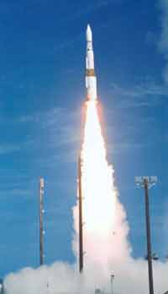
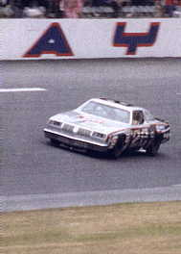
How fast can a NASCAR driver go?
The Daytona 500 speed record for a race is an average of 177.602 mph (284 kph), by Buddy Baker in 1980.
How fast can an airplane fly?
The top speed of a Boeing 737 airliner is 577 mph (923 kph).
How fast can a Minuteman II missile fly?
The top speed of the Minuteman II missile is approximately 15,000 mph (24,000 kph).

A modern long-range military rocket, which is also similar to the kind used to send a spacecraft to the Moon, is made of materials which must be light in weight but tremendously strong and able to withstand very high temperatures without bending, burning, or melting. The fuel that is burned in the rocket, called propellant, must produce enormous power and the system that guides it must ensure that it will reach its target however great the distance.
On a map, try to determine how far you could get from your hometown in one hour if:
You were an eagle. _______________________________________
You were a NASCAR driver*. _______________________________
You were on a Boeing 737 airliner. ____________________________
You were shooting off a Minuteman II Missile. ___________________

* - remember, this is just imagining – do not drive 177 mph unless you are on a closed track!
Activity Number 9:
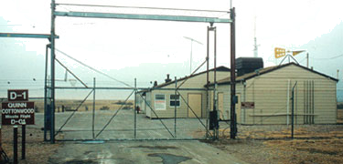
There were many jobs available at the Launch Control Facility (LCF) – facility manager, flight security controller, security alert team, cook, and missile combat crew. All of these Air Force personnel were stationed at Ellsworth Air Force Base near Rapid City, South Dakota and had to drive to the LCF for their tour of duty. The tours of duty varied over the years. All topside personnel, while on an alert tour, but off-duty, would spend time playing games, working out, resting, and relaxing.

The facility manager was on duty for a three-day alert tour. The facility managers were responsible for managing the facility and supervising the topside crew. His or her job also included everything from acting weatherman, mechanic, and innkeeper to groundskeeper. The facility manager was the only LCF personnel assigned a single room.

The flight security controller was also on duty for a three-day alert tour. Since someone had to be on duty in the security control room at all times, each of the three days was split into twelve hour shifts. From the security control room they monitored the LCF grounds, checked identification of visitors, and supervised the security alert team.

The security alert team members checked the LCF site, responded to any security breaches, and escorted maintenance teams to the missile silos. In addition to security duties, the security alert team members assisted the facility manager in housekeeping duties.
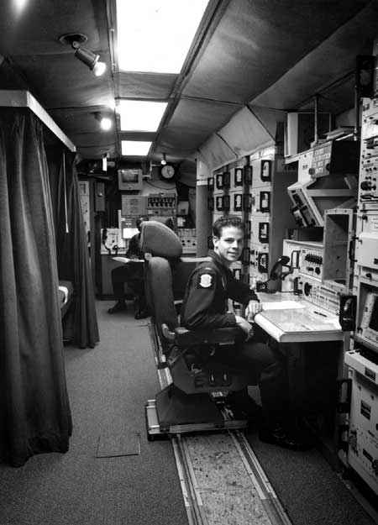
One cook was scheduled for each three-day alert tour. The cook was required to prepare requested meals for the personnel and visitors to the LCF. The cook was responsible for serving four meals a day – breakfast, lunch, dinner, and a midnight meal. In addition, the cook assisted the facility manager in responding to emergencies and in housekeeping duties.

The missile combat crew tour of duty was twenty-four hours. They worked from the Launch Control Center (LCC), located in a capsule below ground. Their most important responsibility was constant vigilance and preparation to launch the ten missiles under their control. The LCC included a sleeping compartment where one crew member could rest while his or her partner would remain at the console. This position was only assigned to Air Force officers.
Activity Number 9 continued:


Uncle Sam wants YOU!

Imagine that you want to apply for a job at the Launch Control Facility. Please fill out the application below:

- Job applied for: _____________________________________
- What do you think would be good about this job? ______________
_________________________________________________
_________________________________________________
_________________________________________________
- What do you think you’d dislike about it? ___________________
_________________________________________________
_________________________________________________
_________________________________________________
- Skills that you have that would make you good for the job: _________________________________________________
____________________________________________________________________________________________________________________________________________________________________________________________________
5. Why should you be hired for the job: ______________________
_____________________________________________________________________________________________________________________________________________________________________________________________________________________________________________________
Activity Number 10:
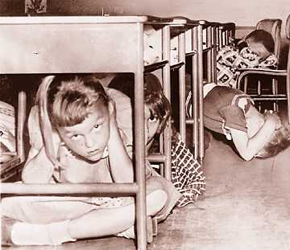
Today, in some American schools, students are learning how to recognize a special warning tone on the school wide intercom. When it sounds, they rise from their desks and the teacher locks the door with a special key. The shades are drawn, the lights switched off. The students huddle against the interior wall, so they are not visible from the classroom door. They must be quiet. This is in case a problem has arisen inside their school. The drill is slightly different in some elementary schools. Lights are kept on. Teachers keep a special bag by their doors, equipped with storybooks and candies and other items to keep students calm and busy during the drill.
This may remind some people of the “duck and cover” drills of the 1950s. Many teachers at that time were instructed to practice the "duck and cover" air raid drill with their classes. In this drill, the students would drop to the floor and put their heads between their knees with their backs to the windows or take cover under their desks. Teachers were instructed to have their students "duck and cover" at the sight of a sudden bright flash.

Talk to someone that you know who remembers the “duck and cover” drills of the 1950s. Ask them to tell you how they were conducted, what they thought about the drills, and what emotions they felt. ______________
______________________________________________________________________________________________________________________________________________________________________________________________________________________________________________________________________________________________________________________________

What safety precautions do you practice in your home? ______________
______________________________________________________________________________________________________________________________________________________________________________________________________________________________________________________________________________________________________________________________
Activity Number 11:

There were many people worldwide that left their influence during the Cold War period.

Select one person from the following list of people and find out what influence they had during the Cold War. Using the back of this sheet, write a poem, song, or brief story about the person you chose. (The poem doesn’t have to rhyme if you don’t want it to.)

Dr. Helen Caldicott Jimmy Carter

Nadia Comaneci Mike Eruzione

Daniel James, Jr. John le Carré

George McGovern Paul Robeson

Andrei Sakharov Edward Teller

Margaret Thatcher Lech Walesa

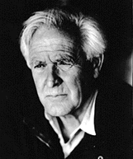

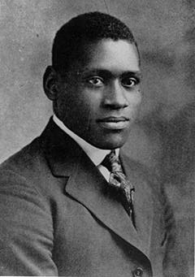

Paul Robeson Margaret Thatcher John le Carré

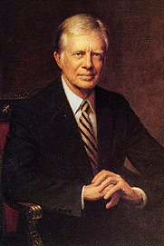
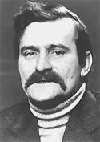

Lech Walesa Jimmy Carter
Activity Number 12:

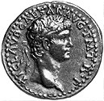
Shown below are eight quotes taken from some famous and some not-so-famous people:

“He who wants peace must prepare for war.” – Claudius (10 BC – 54 AD)

“Choose your friends carefully. Your enemies will choose you.” - Yassir Arafat (1929 - present)

“There are only two forces in the world, the sword and the spirit. In the long run the sword will always be conquered by the spirit.” - Napoleon Bonaparte (1769 – 1821)
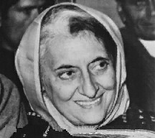
“You can't shake hands with a clenched fist.” - Indira Gandhi (1917 – 1984)

“Indeed, I think that people want peace so much that one of these days governments had better get out of the way and let them have it.” - Dwight D. Eisenhower (1890 – 1969)
"Victory goes to the player who makes the next-to-last mistake."

“Victory goes to the player who makes the next-to-last mistake.” - Savielly Grigorievitch Tartakower (1887 – 1956)

“You got to be careful if you don't know where you're going, because you might not get there.” - Yogi Berra (1925 – present)

“It is my principle that the will of the majority should always prevail.” - Thomas Jefferson (1743 – 1826)

Circle one quote that you agree with or that you think is the best one. Tell why you selected that quote and what it means to you. ____________________________________________________________________________________________________________________________________________________________________________________________________________________
_____________________________________________________

Do you think these quotes have a different meaning if they were said long ago? _____ Why or why not. _______________________________
_______________________________________________________________________________________________________________________________________________________________
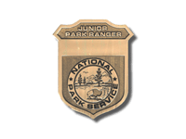
Excellent work, Junior Ranger!

We just need a little information from you so that we can send you your Junior Ranger patch and certificate. Feel free to tell us more about the program on the back of this sheet if you would like.
How would you like your name to appear on your Minuteman Missile Junior Ranger certificate? (Please print in your best handwriting!)
________________________________________________
What address would you like your certificate and patch mailed to?
Street Address: _________________________________________________
City, State, Zip Code: ____________________________________________
What is your age? Less than 10 ____ from 10 to 14 ____ from 15 to 25 ____

from 26 to 62 ____ over 62 ____

Where did you do the Minuteman Missile Junior Ranger program?
At home ____ at school ____ somewhere else (where?) _______________
How did you learn about the program? __________________________________
Which activities did you like best in this Junior Ranger program? Why?
____________________________________________________________________
____________________________________________________________________
Which activities did you like least? Why?
____________________________________________________________________
____________________________________________________________________
Was the program too hard? _____ Too easy? _____ Just right? _____

