 |  |  | PROPOSAL COVER PAGE  (Date Nov 16, 2004) |  |  |  |  |  |  |  |  |  |  | NRA: NNH04ZYS008N  Proposal Number:  MAP/04-0000-0110  (Above assigned by SYS-EYFUS)
Name of Submitting Institution: |  |  |  |  |  |  |  | Bay Area Environmental Research Institute |  |  |  | Congressional District: |  |  |  |  |  | 12
Proposal Title: | An Innovative Data Assimilation Technique for Assimilating  Satellite Radiances Into a Global Aerosol Model
Certification of Compliance with Applicable Executive Orders and US Code
By submitting the proposal identified in this Cover Sheet/Proposal Summary in response to this Research Announcement, the Authorizing Official of the proposing institution (or the individual proposer if there is no proposing institution) as identified below:
- certifies that the statements made in this proposal are true and complete to the best of his/her knowledge;
- agrees to accept the obligations to comply with NASA award terms and conditions if an award is made as a result of this proposal; and
- confirms compliance with all provisions, rules, and stipulations set forth in the two Certifications contained in this NRA [namely, (i) Assurance of Compliance with the NASA Regulations Pursuant to Nondiscrimination in Federally Assisted Programs, and (ii) Certifications, Disclosures, And Assurances Regarding Lobbying and Debarment & Suspension].
Willful provision of false information in this proposal and/or its supporting documents, or in reports required under an ensuing award, is a criminal offense (U.S. Code, Title 18, Section 1001).
NASA PROCEDURE FOR HANDLING PROPOSALS
This proposal shall be used and disclosed for evaluation purposes only, and a copy of this Government notice shall be applied to any reproduction or abstract thereof. Any authorized restrictive notices that the submitter places on this proposal shall also be strictly complied with. Disclosure of this proposal for any reason outside the Government evaluation purposes shall be made only to the extent authorized by the Government.
 |  |  |  | Principal Investigator Name: |  |  |  |  | Robert Bergstrom
 |  |  |  | Organization: |  |  |  |  | Bay Area Environmental Research Institute
 |  |  |  | Mailing Address: |  |  |  |  | 560 Third St. West
 |  |  |  | City, State Zip: |  |  |  |  | Sonoma CA 95476
 |  |  |  | Telephone Number: |  |  |  |  | (707) 938-9387
 |  |  |  | Fax Number: |  |  |  |  | (707) 938-3984
 |  |  |  | Email Address: |  |  |  |  | bergstrom@baeri.org
 |  |  |  | Principal Investigator Signature:
 |  |  |  |  |  |  |  |  | Date:
Authorized Institutional  Official Name: |  |  |  |  | Marion Williams  Executive Director |  |  |  |  |  |  |  | R. Stephen Hipskind,  Acting Division Chief
Organization: |  |  |  |  | Bay Area Environmental Research Institute |  |  |  |  |  |  |  | NASA Ames Research Center
Department |  |  |  |  |  |  |  |  |  |  |  |  | Earth Science Division
Mailing Address |  |  |  |  | 560 Third St. West |  |  |  |  |  |  |  | MS 245-5
City, State Zip: |  |  |  |  | Sonoma CA 95476 |  |  |  |  |  |  |  | Moffett Field, CA, 94035-1000
Telephone Number: |  |  |  |  | (707) 938-9387 |  |  |  |  |  |  |  | (650) 604-5076
Fax Number: |  |  |  |  | (707) 938-3984 |  |  |  |  |  |  |  | (650) 604-3625
Email Address: |  |  |  |  | williams@baeri.org |  |  |  |  |  |  |  | Steve.Hipskind@nasa.gov
Authorized Institutional Official Signature: |  |  |  |  | Date: |  |  |  |  |  |  |  | Date:
Co-Investigators/Collaborators:
Name |  | Telephone |  |  |  | Email |  |  |  |  | Institution |  |  |  |  | Address
Howard Houben Co-I |  | (650) 604-3381 |  |  |  | houben@humbabe@arc.nasa.gov |  |  |  |  | BAERI |  |  |  |  | Moffett Field, CA 94035
Bob Chatfield Co-I |  | (650) 604-3386 |  |  |  | jlivingston@mail.arc.nasa.gov |  |  |  |  | NASA Ames |  |  |  |  | Moffett Field, CA 94035
Phil Russell Co-I |  | (805) 658-2637 |  |  |  | jredemann@mail.arc.nasa.gov |  |  |  |  | NASA Ames |  |  |  |  | Moffett Field, CA 94035
Hong Guan Co-I |  | (650) 604-3903 |  |  |  | guan@clio.arc.nasa.gov |  |  |  |  | BAERI |  |  |  |  | Moffett Field, CA 94035
Phil Rasch Col |  | (303) 497-1368 |  |  |  | pjr@ucar.edu |  |  |  |  | Nat’l. Center for Atmos. Res. |  |  |  |  | Boulder, CO 80305
Sundar Christopher Col |  | (256) 961-7872 |  |  |  | sundar@nsstc.uah.edu |  |  |  |  | Univ. of AL, Huntsville |  |  |  |  | Huntsville, AL 35806
Tami Bond Col |  | (217) 244-5277 |  |  |  | yark@uiuc.edu |  |  |  |  | Univ. of IL, Urb.-Champ |  |  |  |  | Urbana, IL 61801
Budget: |  |  |  |  |  |  | BAER |  |  | NASA Ames |  |  |  |  |  |  | Total
Year 1 (April 2005-March 2006):
Year 2 (April 2006-March 2007):
Year 3 (April 2007-March 2008):
Total:
Table of Contents

COVER PAGES i-iii
Abstract/Executive Summary 1
- Background and Rationale 2
  - The NCAR MATCH/CAM aerosol model 3
  - Radiative Transfer Model 4
  - Obervations of Satellite Aerosols 4
  - Application of Data Assimilation to Aerosol Effects in Climate Modeling 7
- Detailed Description of Proposed Work 10
  - Run the ACE Asia case (April 2001) with the MATCH model 10
  - Adapt the radiative transfer code to match the GMS-5 sensor 13
  - Develop the data assimilation algorithms 15
  - Apply the assimilation scheme to the numerical simulation and
compare the results to other data 16
  - Assimilate data from other satellites 16
  - Other test cases – SAFARI 2000, PRIDE, INDOEX, INTEX 17
- Summary of Planned Activities by Year 17
- References 18
- Management Plan 21
- Current Support 22
- Budget 23
- Vitae 24
- Letters from Collaborators 31

Abstract/Executive Summary

We propose to apply an innovative data assimilation approach to satellite radiance data for input into a global aerosol model. The goal is to improve the assessment of aerosol effects on atmospheric radiation and climate through more accurate evaluations of aerosol sources and better constrained modeling of aerosol transport and evolution. Data assimilation has been used by several previous investigators to input satellite measurements of aerosol optical depth into aerosol numerical models. We will instead directly assimilate radiance data, enabling us to work simultaneously with many different satellites and other data sets in a more consistent fashion. Major advances in numerical weather prediction have followed the use of satellite radiance data (rather than retrievals) to constrain dynamical fields. We can expect similar advances in the understanding of aerosols and aerosol processes if this approach is applied to aerosol modeling. The required data assimilation calculations will also be more efficient when the primary assimilation variable is the same as the primary observational variable. This allows the application of four-dimensional variational techniques that combine observations from different times to fully constrain the aerosol model parameters, eliminating many a priori assumptions about the physical properties of those aerosols. A similar approach has been used on a routine basis to assimilate radiances from the Martian Global Surveyor into a Martian General Circulation Model.
We have assembled an experienced research team that has expertise in all aspects of the proposed research: numerical aerosol modeling, atmospheric chemistry, radiative transfer and data assimilation. We propose to use the NCAR Model for Atmospheric Transport and CHemistry (MATCH) aerosol model as our aerosol numerical model. This model contains complete aerosol simulation capabilities and routines for data assimilation (of AOD) that we can adapt for our purposes. We will use a previously developed radiative transfer model that has been used to analyze moderate resolution (10 nm) radiometer data as our forward model to predict the radiances from the aerosol concentrations given by the aerosol model. Our initial test area and time frame will be the ACE Asia region of April 2001. We propose to start by using the geostationary GMS-5 satellite data as it has better time resolution than the polar orbiting satellites. The East Asian aerosol is of great current interest and has been the subject of a number of studies. The aerosol in this region is extremely complex as it results from windblown dust, urban pollution, biomass burning and sea salt. After establishing our methodology we will use other polar-orbiting satellite data (MODIS, SeaWiFS, TOMS) that contain more spectral information to improve our simulations. We will attempt to focus on source areas to attempt to get more information about the sources of the Asian aerosol. We will also investigate other test experiments (SAFARI, PRIDE, INDOEX,INTEX) that include examples of biomass burning aerosols, desert dust or urban pollution.
We are proposing a three-year study. The tasks for the first year will be to develop the specific numerical tools needed, acquire the satellite data and sources and meteorological data for the aerosol model. The second year will be to run the ACE Asia case with data assimilation and compare to observational data. The third year will be to expand our methods to other satellites and other test areas.
If this proposal is selected for funding, we will participate in the GMI Science Team meetings and make our assimilation techniques available to the community. This technique has application to other remote sensing problems such as CO and other atmospheric gases.
- Background and Rationale

Climate modeling plays a crucial role in the assessment of the potential climate changes due to anthropogenic emissions. One of the most fundamental and pressing issues in climate change research is the effect of atmospheric aerosols. The Intergovernmental Panel on Climate Change (IPCC, 1994 and 2001) has identified aerosol radiative forcing as a major uncertainty in the global radiative energy budget.
The difficulty of predicting aerosol effects by climate models stems from the variability (in both amount and properties) of the atmospheric aerosol. Previous studies of the climatic effect of atmospheric aerosol have restricted the aerosol properties to a fixed set of "typical" values or aerosol models. This has limited the applicability of the results.
The advent of satellite and surface data has created the opportunity of using this data to improve estimates of the aerosol effects. A major thrust of NASA's Earth Science Strategic Plan is the inclusion of satellite data into climate models. Merging data with predictions from a numerical model is characterized by the term "data assimilation." In recent years there is a large body of research that has been created by developing and using techniques of data assimilation. For example, major improvements in weather forecasting have resulted from the use of satellite data into weather prediction models (Kalnay, 2003).
Several investigators have used data assimilation into their numerical aerosol model (Collins et al 2002,2003; Filmore et al 2004; Yue et al 2003; Wang et al 2004). These investigators used derived aerosol optical depths (AOD) from the satellite measurements. We propose to extend their work by using satellite radiance values to assimilate into a global aerosol model. We will use the NCAR MATCH model as the global aerosol model, the visible channel of the geostationary satellite GMS-5 as the initial satellite measurements and the ACE Asia region as the initial test area. Once the numerical assimilation technique is established we will expand the research to include other satellite data and other areas.
We expect to gain in three ways from our direct assimilation of radiance data. First, data from all satellites are treated in the same way and are easily combined to increase the data’s influence on the modeling results. Second, the (transformed) Kalman filer that mediates between model predictions and observations is readily computed when the observational quantity is the same as the primary assimilation variable, allowing for optimal model increments at little computational cost. Third, this computational saving makes four-dimensional assimilation a real possibility, allowing the data to constrain the model source terms and aerosol evolutions.
This proposed work responds to the new Climate Global Modeling Initiative part of the Modeling NRA. If successful this assimilation technique will be made available to the scientific community, particularly the GMI project scientists. We will participate in GMI meetings to facilitate this technology transfer.

  - The NCAR MATCH/CAM aerosol model

The Model for Atmospheric Transport and CHemistry (MATCH) (Rasch et al., 1997) is a chemical transport model forced with meteorological fields from an external source. The aerosol species included in the model are sulfate, soil dust, black carbon and organic carbon, and sea salt. The model has been used in simulations of the aerosol during the INDOEX program (Collins et al 2002) and the ACE Asia program. The NCAR investigators have also used the model to input the aerosol optical depth results from MODIS and AVHRR (Collins et al 2003, Filmore et al 2003).
As discussed by Collins et al (2002), the aerosol species in the current MATCH aerosol model of sulfate, soil dust, black and organic carbon are computed from prognostic equations including surface sources, wet and dry deposition, and transport by resolved and subgrid-scale motion. The vertical profile of sea salt is computed from the 10 m wind speed. The dust is resolved in 4 size bins and each bin is represented by a lognormal distribution. The other aerosols are represented by a single mass-mixing ratio for each species. Currently the aerosols are assumed to be externally mixed.
The formulation of the sulfur cycle is described in the works of Barth et al. (2000) and Rasch et al. (2000). The emissions inventory for SO2 is from Smith et al. (2001). The sources for mineral dust are based upon the approach of Tegen and Fung (1994) with modifications to the soil mobilization to improve agreement with the TOMS absorptive-aerosol index from Herman et al. (1997). The emissions of carbonaceous aerosols include contributions from biomass burning (Liousse et al., 1997), fossil fuel burning (Penner et al., 1993), and a source of natural organic aerosols resulting from terpene emissions (Collins et al 2002). The carbon emissions will be updated with the recent work of Bond et al (2004). As discussed below it is likely that the satellite data will yield information about the aerosol sources.
The model is integrated using meteorological fields from either the NCAR/NCEP reanalysis or aviation data (Collins et al 2002). The data is stored on a Gaussian T62 grid with 28 sigma levels at 6-hourly intervals. At the equator, the horizontal resolution is 209 km. The fields are temporally interpolated to each model time step.

  - Radiative Transfer Model

A radiative transfer calculation is needed to predict the radiance that is seen by the satellite from the predicted aerosol concentration fields. In previous studies (Bergstrom et al 2003, 2004a) Dr. Bergstrom developed a numerical radiative transfer model specifically for analysis of medium resolution (10 nm) solar radiometer data. We propose to adapt this radiative transfer code to predict top of the atmosphere radiances that would be seen by a number of satellite instruments.
A description of the model is contained in Bergstrom et al (2003, 2004a). The major features of the model include the K-distribution method for O₂,O₃,CO₂, and H₂O absorption coefficients, the multiple scattering code DISORT, and a high resolution representation of the solar spectrum. The inputs are the vertical profiles of the gases, aerosol and clouds; as well as the spectral scattering and absorption properties of the aerosols and clouds, the spectral surface reflectance and the solar and azimuthal angles.
The K-distribution technique has been discussed a number of times and is an effective method for treating the line absorption of atmospheric gases. The significance of the K- distribution technique is that it also allows for the accurate inclusion of scattering and absorption of gases and aerosols at a saving of several orders of magnitude computational effort compared to a line-by-line calculation.
The line-by-line code LBLRTM is be used to compute the gas absorption coefficients at a high resolution (typically 0.001 cm-1). For each band and temperature and pressure combination the coefficients are then sorted in cumulative probability space. Sixteen Gaussian quadrature points are typically used to compute a number of absorption coefficients. The resulting values are interpolated (linear in temperature and logarithmically in pressure). The H2O/CO2 and H2O/O2 overlap was included. This requires defining the ratio of the overlapping gas amounts as an additional variable and then an interpolation in that ratio. Since both the solar source function and the gaseous absorption coefficients have a fine structure at a resolution of 0.001 cm⁻¹ to integrate over a spectral interval, the pairing of absorption coefficient and solar source function must be maintained. The same requirement holds for the instrument filter function.
A major concern in building a radiative transfer code for a numerical model is speed. Generally, radiative transfer codes take a significant amount of time compared to the dynamics. This has led to a large number of approximate techniques and codes that endeavor to compute the radiant fluxes or radiances with a minimum amount of time. For example, the Joint Center for Satellite Data Assimilation is funding an effort to develop a Community Radiative Transfer Model (CRTM). This model will be used to assimilate cloud radiances into numerical weather prediction models. We will follow the development of this code to see if there are techniques that will be applicable to our research.

  - Satellite Observations of Aerosols

Satellite sensors of aerosols [Kaufman et al., 2002; Ramanathan et al., 2002] are essential to developing an accurate description of their global distribution and variability. Originally, aerosol effects were detected by satellite instruments (e.g., AVHRR, UARS and TOMS), which were not explicitly designed for aerosol work. Spaceborne aerosol sensors launched in the past few years—such as MODIS, MISR, POLDER and OMI — have made the study of tropospheric aerosols from space more quantitative than was possible with their predecessors.
The methodology for determining the aerosol effects from a satellite remote measurement is the solution of the radiative transfer equation. The radiance observed by a satellite at wavelength λ and angles μ,φ can be simply written as

I(μ_{s}, μ_{o},φ_{o}) = μ _{o} I_{s}*R [μ_{s}, μ _{o}, φ_{o},ω, τ, P(Θ),brdf(μ₁, μ₂)] (1)

where I_{s} is the solar intensity, R is the reflectance function, brdf is the bidirectional reflection function of the surface, ω is the albedo for single scattering, τ is the optical depth and P(Θ) is the scattering distribution function. The reflectance function is determined by solving the radiative transfer equation.
The reflectance function depends upon the scattering and absorption properties of the aerosols in the particular area viewed by the satellite instrument. Given the variability of the atmospheric aerosol, these absorption and scattering properties can not be known a priori. By measuring only the satellite radiance the three unknowns (ω, τ, P(Θ)) can not be uniquely determined. Therefore investigators have been forced to develop "typical" aerosol models to use for the values of aerosol absorption (originally assumed to be zero) and scattering distribution function (usually assumed to be that of spherical particles with some size distribution). The reflectance function is then computed and tabulated. For a given satellite radiance and set of angles the closest value in the table is used estimate the aerosol optical depth.
With the advent of multi-spectral instruments (SeaWiFS, MODIS, MISR) more information about the aerosols can be inferred. The TOMS group has shown that their data can be used to detect the existence of absorbing particles (Torres et al 1998). Both Higurashi and Nakajima (2003) and Hsu et al (2004) have used SeaWiFS data to differentiate between four different types of aerosols. The MODIS team routinely publishes information about particle sizes. New advances such as the work of Hsu et al (2004) that differentiates between absorbing dust particles from different regions will undoubtedly occur as the scientific community gets more experience with the satellite data.
We propose to work with the following satellite data sets:

Instrument | Satellite | solar wavelengths
S-VISSR | GMS-5 | 500 - 800 nm; one band
MODIS | Terra, Aqua | 420 - 940 nm; 15 bands
SeaWiFS | OrbView-2 | 412 - 1050 nm; 9 bands
TOMS(OMI) | Nimbus-7 | 312 - 360 nm; 6 bands
AVHRR | NOAA-7, -9, -11, -14 | 580 - 1100 nm; two bands
MISR | Terra | 446 - 830 nm; 4 bands
Since our initial test area is the ACE Asia region, we propose to use the visible channel aboard the geo-stationary GMS-5 satellite following Wang et al (2002). As discussed below, this data set, while having only one visible wavelength channel with somewhat broad spectral sensitivity, has the advantage of better spatial and temporal coverage than the polar orbiting satellites.
We will use the radiances measured by the satellite sensor to assimilate into the numerical model for two reasons. First, we want to avoid the inconsistency of having two aerosol models - one for the satellite retrieval and one for the aerosol numerical model (as discussed by Collins 2002). Secondly, as set out below, there are computational advantages to having the assimilated variable be the actual measurement.
We have already downloaded the GMS-5 data for April 2001. We will need to determine the occurrence of clouds (Wang et al 2002) and can use the infrared channels of GMS-5 to accomplish this.
Once we have the assimilation tools developed we will extend the research to other satellites. The Ames Sunphotometer group has considerable experience and expertise in working with satellite data. Co-I Dr. Russell, who leads the group, brings to the proposed study this familiarity with the satellite data and its relation to a variety of measurements, in situ and remote, made within the atmosphere. Table 1 shows the large number of validation experiments and resulting publications carried out by Dr. Russell's group.

Table 1. Validation of satellite derived spectral AOD published by the Ames Sunphotomer Group
Sensor | Campaign | Region | Surface | Period | Publication
AVHRR | TARFOX | US East Coast | Ocean | July 1996 | Veefkind et al., 1999
AVHRR | ACE 2 | Canary Islands | Ocean | June/July 1997 | Durkee et al., 2000  Livingston et al., 2000  Schmid et al., 2000
ATSR-2 | TARFOX | US East Coast | Ocean | July 1996 | Veefkind et al., 1999
ATSR-2 | SAFARI 2000 | Namibian Coast | Ocean | September 2000 | Schmid et al., 2003b
GMS-5 | ACE-Asia | Eastern Asia | Ocean | April 2001 | Wang et al, 2003b
GOES-8 | PRIDE | Puerto Rico | Ocean | June/July 2000 | Livingston et al., 2003  Wang et al., 2003a
MAS | TARFOX | US East Coast | Ocean | July 1996 | Tanré et al. 1999
MISR | SAFARI-2000 | Southern Africa | Ocean & Land | September 2000 | Schmid et al., 2003b
MISR | ACE-Asia | Eastern Asia | Ocean | April 2001 | Kahn et al., 2004
MISR | CLAMS | US East Coast | Ocean | July/Aug. 2001 | Redemann et al., 2004
MODIS | PRIDE | Puerto Rico | Ocean | June/July 2000 | Livingston et al., 2003  Levy et al., 2003
MODIS | SAFARI-2000 | Southern Africa | Ocean & Land | September 2000 | Schmid et al., 2003b
MODIS | CLAMS | US East Coast | Ocean | July/August 2001 | Levy et al., 2004  Redemann et al., 2004
MODIS | ACE-Asia | Eastern Asia | Ocean | April 2001 | Chu et al., 2004
MODIS | EVE | US CA Coast | Ocean | April 2004 | Redemann et al., in prep.
POAM | SOLVE-2 | Arctic | Ocean & Land | Jan/Feb 2003 | Russell et al., in prep.
SAGE 3 | SOLVE-2 | Arctic | Ocean & Land | Jan/Feb 2003 | Russell et al., in prep.
SeaWiFS | ACE-Asia | Eastern Asia | Ocean | April 2001 | Hsu et al., 2002
TOMS | PRIDE | Puerto Rico | Ocean | June/July 2000 | Livingston et al., 2003
TOMS | SAFARI-2000 | Southern Africa | Land | September 2000 | Schmid et al., 2003b

  - Application of Data Assimilation to Aerosol Effects in Climate Modeling

Data assimilation combines a forecast model and observations to produce an analysis of the state of the atmosphere that is consistent with both the governing equations of the model and the data (Ghil and Malanotte-Rizzoli, 1991). This analysis can be thought of as a weighted average of the model predicted state and the measured state (Talagrand, 1997). Determining the optimal average requires that both the model forecast errors and the observational errors be known. The latter can clearly be inferred from the statistical properties of the data themselves. Model errors are another matter. While there are a number of approaches to determining forecast errors for well-tested terrestrial numerical weather prediction models (e.g., by making ensemble forecasts -- on the assumption that the range of variability in those forecasts brackets the true variability in the atmosphere -- or from fore-knowledge of the intrinsic co-variability in the atmosphere, usually associated with physical space assimilation (Daley and Barker, 2001; Kalnay, 2003), such methods are not appropriate for aerosol retrievals about which we know much less. An alternative approach is to use the formalism of the model forecast error covariance matrix to impose additional constraints on an otherwise underdetermined problem (e.g., to enforce a balance condition that controls gravity waves in a dynamical assimilation or to predetermine the particle size distribution in an aerosol retrieval (Cosme et al., 2004).
However, at least for research purposes, it is preferable to minimize such a priori assumptions. We therefore adopt a data assimilation method that has been developed for planetary science applications -- where there is minimal advance knowledge about the properties of the system being measured. By choosing the primary assimilation variable to be the observed quantity (i.e., satellite radiances), it is possible to estimate both the instrumental and forecast errors from the data themselves. This approach also leads to a major reduction in the computational requirements of the data assimilation.
Data assimilation is usually divided into two possible approaches: sequential or variational. Both solve the same optimization problem (which is in fact the same problem solved by all data retrievals). The differences arise from the relative importance of prior knowledge (the background state) and the new data in determining the analysis solution.
Operationally, given:
- a predictive model M (in this case the MATCH model which includes the physics of atmospheric aerosol transport and chemistry) which has computed a future state b with forecast error covariance matrix B;
- an observation operator H (in our case, the k-distribution radiance forward model) that transforms from the model variables to observable quantities;
- a set of observations y (here the GMS-5 satellite data), with observational error covariance matrix R;
we seek a new model state x (i.e., a three-dimensional distribution of aerosol properties) that minimizes the cost function

J = 1/2 (x - b)^{T} B⁻¹ (x - b) + 1/2 (HMx - y)^{T} R⁻¹ (HMx - y). (2)

After some manipulation, it can be shown that the solution is

x = b + K (y - HMb), (3)

where the Kalman filter K is defined by

K = BM^{T}H^{T} [R + HMBM^{T}H^{T}] ⁻¹. (4)

Thus, the theory of data assimilation is straightforward, but as discussed above it requires knowledge of the forecast error covariance matrix B. Furthermore, this large matrix must be propagated in time by

B <-- MBM^{T},

to retain the optimality of the solution. This last calculation is beyond the capabilities of numerical weather prediction centers to this day. Therefore, they must estimate B by other means. While those methods have shown some success in dynamic meteorology, we do not yet have enough experience to be sure the same approaches will work for aerosol assimilations.
For example, the current MATCH model performs a three-dimensional assimilation of AOD (Collins et al 2002, 2003, Filmore et al 2004). The observations are incorporated only at the time of observation, so M in the above relations is the identity operator. H is a spatial interpolator from the model grid to the point of observation. It is assumed that separate observations by nadir-viewing satellites are independent, so B is diagonal (and is computed based on assumed correlation lengths).
In order to avoid these restrictive assumptions, we propose to use observation space assimilation (Houben, 2003), whereby the principal variable to be fit is not x, but HMx (i.e., the satellite radiances, in the case of our global aerosol observations). The sequential assimilation scheme then becomes

HMx = (I - HMK) HMb + HMKy, (5)

where

HMK = HMBM^{T}H^{T} [R + HMBM^{T}H^{T}] ⁻¹

and

I - HMK = R [R + HMBM^{T}H^{T}] ⁻¹.

So the fitted variable (HMx) is clearly a weighted average of the prediction (HMb) and the observation y. And the weighting factors are estimated from the data themselves as (Courtier, 1997; Menard et al., 2000)

R = <(<y>-y)(<y>-y)^{T}> (6)

and

[R + HMBM^{T}H^{T}] = <(y-HMb)(y-HMb)^{T}>. (7)

It is important to note that the resulting efficient estimate of HMBM^{T}H^{T}or HBH^{T} that comes from this formulation is only available when the primary assimilation variable is the same as the observed variable.
If, in addition, adjoints of the radiative transfer model H and the aerosol transport model M are available, we can use variational techniques to invert HMx and derive x. This solution gives all the advantages of four-dimensional variational assimilation in that information measured at a given time can propagate forward and backward in time to improve the knowledge of the state. Furthermore, data can be accumulated over a long enough assimilation window to assure that the solution x is overdetermined.
The adjoint of the radiative transfer model is straightforward. In fact, adjoint methods can easily be used to solve atmospheric radiation problems (Box et al., 1988). The adjointing of the aerosol transport and chemistry model will be more complicated and constructing it will be an important part of the effort under this proposal. However, even in the absence of this code, the solution determines an analysis increment that can be used to sequentially update the model state in much the same way as is currently done.
Co-I Dr. Houben has used the proposed technique to assimilate Thermal Emission Spectrometer data (infrared radiances) from the Mars Global Surveyor spacecraft into a Martian general circulation model. More than 10,000 spectra per day are assimilated and used to determine approximately 10,000 initial atmospheric state variables. The radiation code is a two-stream model with multiple scattering for the emission from the 15 micron band of CO₂. When the model state is propagated forward in time from these initial conditions using the general circulation model, the observed data are reproduced with a high degree of precision (See Figure 1). The assimilation is validated by comparing model results with independent observations of temperature and surface pressure (such as those derived by radio occultation measurements).

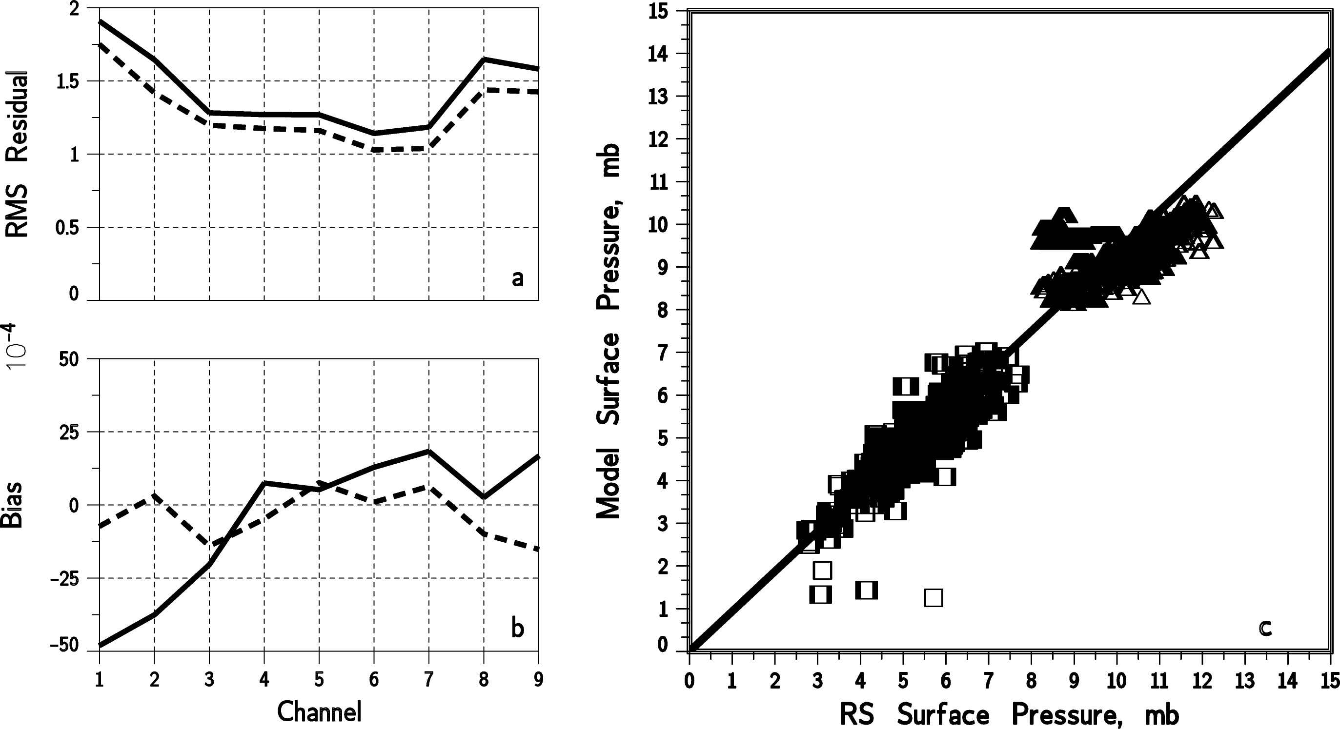

Figure 1 (a) Root-mean-square residuals as a function of Thermal Emission Spectrometer channel for the direct assimilation of some 1,000,000 infrared spectra over 80 Mars days, in units of erg/cm²/s/sr/wavenumber. Average observed radiances are on the order of 50 in these units. Results are improved somewhat (dashed curve) when the global average surface pressure of the assimilated state is increased by 16% over the precalculated model value (black curve). (b) Biases (in the same units) are small (black curve) and can be further diminished by rescaling the K-distribution coefficients used in the radiative forward model with adjustments on the order of 1% (dashed curve). This is equivalent to making a small adjustment in the channel center wavenumbers, a reasonable recalibration of the instrument. (c) Model surface pressure compared to independent radio occultation values for two occultation seasons (approximately 1000 ingress and egress occultations). Consistent with the results in (a), observed northern hemisphere surface pressures (black line and points) exceed the ab initio model values by 12%.

- Detailed description of Proposed Work

We are proposing to develop the numerical tools and test our methodology on the problem of understanding and predicting the aerosols in the East Asian region. There are several reasons for selecting this region. First, the aerosol has been the subject of a number of field programs and our group has a good set of observational data (Bergstrom et al 2004a). Second, the area is of increasing interest since the aerosol is thought to be impacting US air quality (Van Curren, 2003). Third the aerosol is particularly difficult since it consists of intermixed layers of dust, biomass burning and urban air pollution (Huebert et al 2003).
The Aerosol Characterization Experiment Asia (ACE Asia) intensive field program was carried out during April-May 2001 (Huebert et al, 2003). Its purpose was to investigate the outflow of aerosols from East Asia during the spring months with particular emphasis on mineral dust outbreaks and on air pollution transport. The ACE Asia intensive program consisted of measurements made aboard two aircraft (the Twin Otter and C130), a NOAA ship the Ron Brown, ground stations at Gosan and various locations in Japan and in conjunction with several satellite sensors (SeaWiFS, MODIS, MISER, AVHRR). The study was also coordinated with the APEX program and the TRACE-P study.
The initial results of the study have been described in a number of papers (JGR special section 2003) that discuss various aspects of the aerosols measured during ACE Asia. (Huebert et al 2003.) The study observed aerosols from pollution sources, biomass burning and mineral dust from the inland Chinese deserts. Of particular interest were several outbreaks of mineral dust (22 March, 6-11 April and 23 April).
One of the most important findings of ACE Asia is that the aerosols of the coast of East Asia are often mixtures of both mineral dust and pollution particles. This combination of particle types is highly variable and makes attribution of the aerosol absorption, for example, very difficult. Bergstrom et al (2004a) investigated the spectral absorption properties of the ACE Asian aerosol and found that there was a range of possible absorption due to dust and black carbon combinations.

  - Run the ACE Asia case (April 2001) with the MATCH model

We have obtained the MATCH code and with the help of Phil Rasch and Dani Bundy of NCAR and have it running on the NASA Ames Research Center Advanced Supercomputing (NAS) computer. Our initial testing shows that running it with NCEP aviation data at T62 takes about 30 min wall time for every day of simulation. At present we are running an ACE Asia base simulation with the NCEP Aviation meteorological inputs for the time period of March 12 to May 9, 2001.
One of the unique computational capabilities of the Ames Research Center is the new Columbia supercomputer. This machine is specifically designed for input of satellite data into numerical models. While the current computers that we are using are sufficient for the present, we will request Columbia computer time at a later date.
The aerosol optical depth results from the MATCH simulation for April 12, 2001 with no assimilation are shown in Figures 2 and 3. April 12, 2001 is chosen since it has been extensively studied (Bergstrom 2004a) and the aerosol plume contains both black carbon and mineral dust. The optical depth results show the aerosol plume containing dust and urban pollution extending fro the mainland northward over the Pacific Ocean.

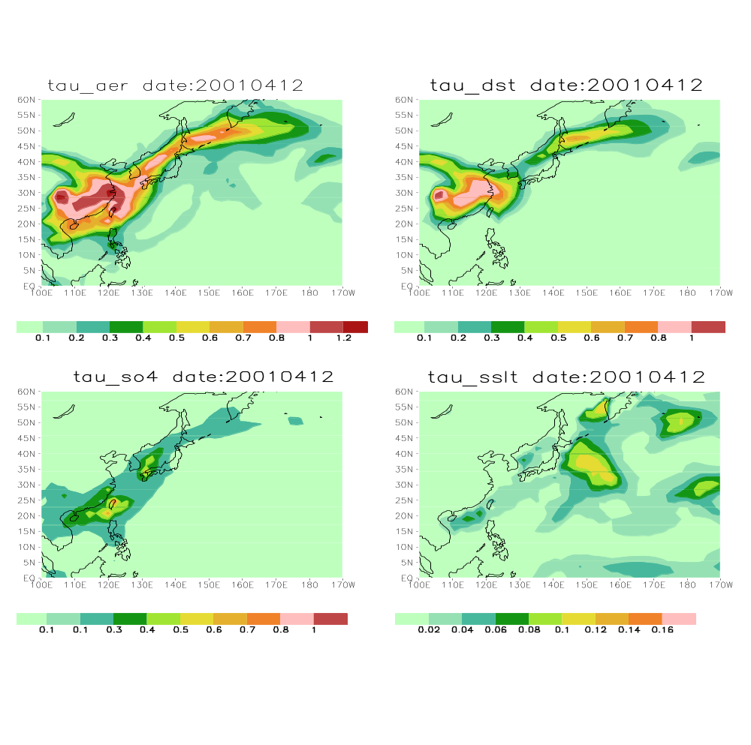

Figure 2. The aerosol optical depth at 550 nm for (a) total aerosol - upper left; (b) dust - upper right; ( c) sulfate - lower left and (d) sea salt - lower right.

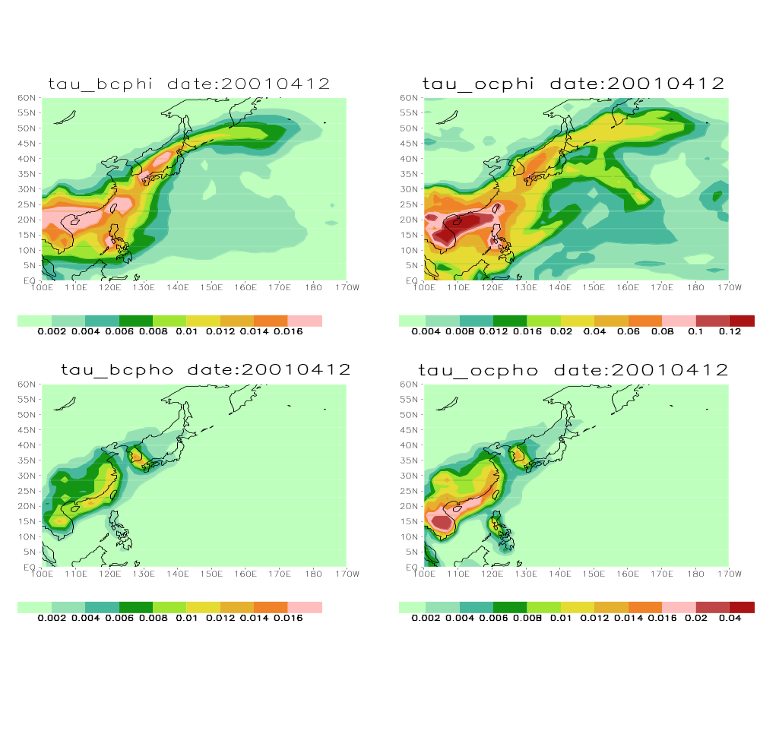

Figure 3. The aerosol optical depth at 500 nm for (a) black carbon hydrophylic - upper left; (b) organic carbon hydrophlic - upper right; ( c) black carbon hydrophobic - lower left and (d) organic carbon hydrphobic - lower right.

These simulation results can be compared to the total aerosol optical depth results for a previous MATCH run, Figure 4, on the NCAR computer with AVHRR data assimilation (Bergstrom et al 2004b - these results were supplied by Bill Collins and David Filmore of NCAR).

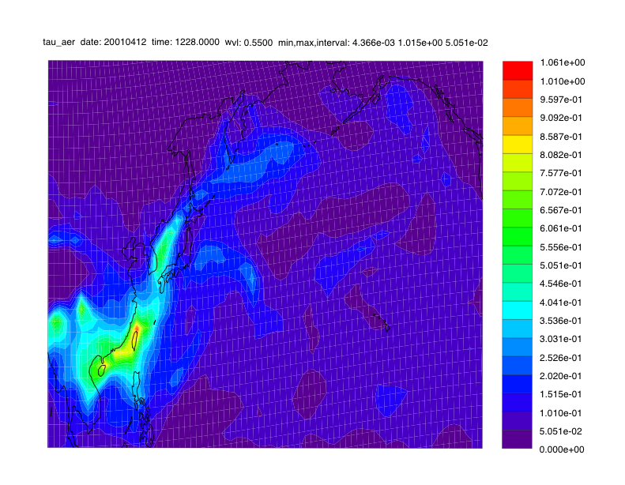

Figure 4 Total aerosol optical depth at 550 nm for April 12, 2001 with AVHRR aerosol optical depth product assimilated.

As seen the aerosol optical depth pattern is quite similar since the only difference (aside from the color scheme) is the use of the AVHRR assimilation in the earlier run. However the optical depth of the unassimilated run is larger than the assimilated run. The assimilated run appears to be in better agreement with the in situ data (Bergstrom, 2004a).

  - Adapt the radiative transfer code to match the GMS-5 sensor

The spectral response of the GMS-5 visible sensor is shown in Figure 5. We will tailor the bands of the radiative transfer model to match the GMS-5 instrument response. We will break up the spectral region into several bands to correctly account for H2O and CO2 in the region.
We will also modify the code to calculate radiances instead of fluxes. This entails an expansion in a Fourier series for the azimuthal angle (Chandrasekar, 1960).
To obtain aerosol information over land the surface reflectance must also be known. Originally, the aerosol retrievals were only over water since the reflectance

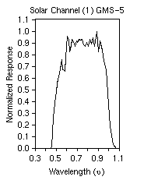

Figure 5 Spectral response of the GMS-5 channel 1 instrument.
of water is a relatively well-known small value. More recent work by the MODIS group has shown that the surface reflectance can be known well enough to permit some retrievals over land.
Wang et al. (2002) were been able to compute AOD's at 670 nm for the ACE Asia case. (See Fig 7 below). We will use their suggested calibration values to convert the GMS-5 data to radiance units of w/m2-str. We can use the GMS-5 IR channels to help discriminate clouds and the ratio to look for dust (Durkee et al 2000).
There is a great deal known about the aerosol properties that were observed during the ACE Asia (and APEX and TRACE-P) program. We can use this information to describe the initial aerosol properties that are used by the model.
The ACE Asia dust particles are non- spherical. The effects of non-sphericity on satellite remote sensing are have been studied, but no consensus has emerged as to how to treat such particles. We will attempt to use non-spherical phase functions in the model.
As mentioned above, we will try to make the radiation code as computationally efficient as possible. This means using as few K coefficients and number of streams as possible.
We have plotted the data from the GMS-5 visible channel for April 12, 2001 in Figure 6. The importance of clouds is quite apparent in the Figure 6. Both Professor Christopher and Dr. Higurashi have extensive experience with cloud screening techniques. This will be an important part of this research.
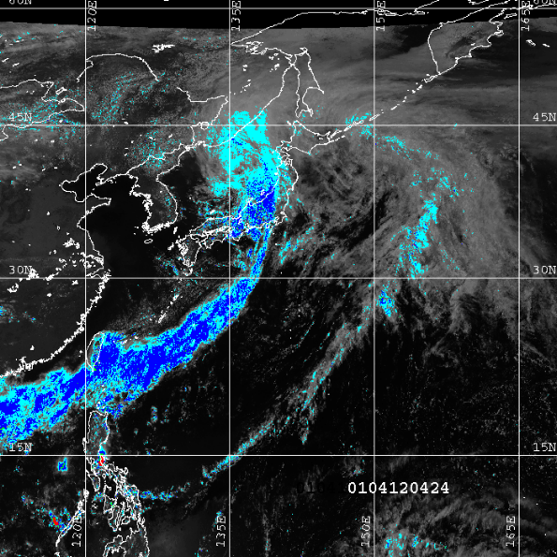

Figure 6. The GMS-5 channel 1 reflectance data for April 12, 2001..

The results of an optical depth retrieval from this GMS-5 data from Christopher (2004) is shown below In Figure 7. The figure is from the research described in Wang et al 2002.

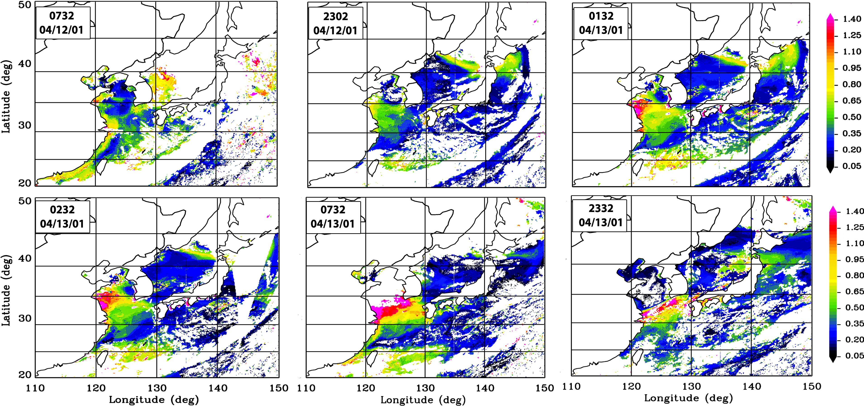

Figure 7 - The total aerosol optical depth at 670 nm derived from the GMS-5 channel 1 data from Christopher (2004).

  - Develop the data assimilation algorithms

The techniques that we are developing are general and can be applied to any modeling effort. Specifically, the code for assimilating satellite radiance data is a special treatment of radiative transfer that only needs to reproduce the observations at specific times and places. The observables are usually outgoing radiances in a few spectral bands. This code is much easier to generate (and less demanding of resources) and easier to use than a full radiative transfer model that is required to compute radiative forcing for all times and places in a general circulation model. Ultimately, it would be desirable for instrument teams to provide forward models for their observations, which could then be adjointed by standard techniques (see below).
The production and use of adjoints for data assimilation is now well understood (Talagrand 1997, Courtier, P., and O. Talagrand, 1990). In general, we are solving the problem Hx=y, where y is the data and x is the model state and H is the model. Even if the model is linear and H is a matrix, it may not be invertible (because it's not square, for example). On the other hand, the problem H^{T}Hx = H^{T}y is always invertible. However, it is too large and complicated to write out explicitly. Instead, we can use a technique like conjugate gradients (Press et al 1992) to solve the problem as long as we know H and HH^{T} implicitly. (Knowing H and HH^{T} implicitly means given a vector b, we can calculate Hb and/or HH^{T}b as the case may be). To produce H^{T} from a linearized version of H, we can also go line by line in the code and convert the algebraic operations (additions and multiplications) to their adjoints. This is extremely laborious, but straightforward. In fact, this is how we computed the adjoint of the radiative transfer model for the Mars TES data discussed above.
While constructing the adjoint of the radiative transfer code is relatively easy (Box et al. 1988), the advection code is not simple. There are some reported techniques to adjointing semi-Lagrangian transport codes (Tanguay, M., and S. Polavarapu, 1999, Polacarapu et al 1996), it is not guaranteed that the techniques will work with the MATCH mode, which can use methods other than semi-Langrangian transport. Even though the advection equation is also linear, the techniques used to assure positive definitiveness and mass conversation may not be so simple.
We will compute the adjoint of the radiative transfer model during the first year and the transport model over the first two years. Even with just the radiative transfer adjoint, we can do 3-d assimilation (like the MATCH model now does for optical depth), only with a better handle on the aerosol properties and combining different observations. When we have got the transport code done, we will add the 4th dimension -- time.

  - Apply the assimilation scheme to the numerical simulation and compare the results to other data.

Once we have the adjoints, applying them to the simulation will be relatively straightforward. As set out above, we will use the data to estimate the best fit of the variables. We will update the model with the most recent carbon inventory (Bond et al 2004).
We can compare the results of the simulations with a variety of in situ data. For example. The AERONET network has continuous record that has been used to compare against numerical simulations and satellite retrievals. Also, the ground based sites of the APEX and ACE Asia campaigns have data available that we can compare against.
There are also many experiments we can perform with regard to the ACE Asia aerosol. We can focus on particular source regions where the aerosol should be dominated by a particular type of aerosol such as biomass burning, urban air pollution or mineral dust. In an interesting paper (van der Werf et al, 2004), investigators evaluated the contribution of fires from different continents to variability in these greenhouse gases using satellite-based estimates of fire activity, biogeochemical modeling, and an inverse analysis of atmospheric CO anomalies. We will attempt a similar type of analysis to obtain information about the sources of the Asian aerosol. Co-I Dr. Chatfield has a great deal of experience in this field.
We can investigate the Asian dust transport. Chin et al (2003) found that it was necessary to explicitly lift the dust out of the boundary layer to get the proper amount of dust transport across the Pacific. In general, proper description of dust sources have been a difficult task for numerical models (Grini et al, 2004).

  - Assimilate data from other satellites

As set out in Table 1 above, we will work with other satellite data. We will have to go through the same procedure as discussed above to adapt the radiative transfer model to the satellite sensor. The multi-channel satellite data of SeaWiFS and MODIS will be particularly interesting. One of the advantages of our assimilation techniques is that we can work with multiple satellite data set in a consistent manner.
Dr. Akiko Higurashi derived results for the optical depth during ACE Asia from the SeaWiFS data (Bergstrom et al 2004a). Dr. Higurashi has agreed to work with us as a collaborator on using her four-channel technique. She is now working with both SeaWiFS and MODIS data.

  - Other test cases - SAFARI 2000, PRIDE, INDOEX, INTEX

There are a number of interesting field experiments that should we will investigate.
SAFARI 2000 observed a significant amount of biomass burning mixed in with other aerosols (Schmid et al 2002), well-defined industrial emissions from the High Veld and intermittent moderate dust events. Dr.’s Chatfield, Russell and Bergstrom have experience with the SAFARI 2000 data as has Professor Christopher. Southern Africa provides simpler case with far more data than the mixed aerosol flowing into the Equatorial Atlantic from West Africa during its burning season. We will use the Global Observations of Forest and Land Cover Dynamics (GOFC/GOLD) effort as guidance for regionalization of emissions (Prins et al 2004), making a critical usage of MODIS fire products as the GOFC assessment continues (Justice et al., 2002). We expect that higher resolution regional emissions for approximately 5-month burning season will be used. Our colleagues at the University of Witwatersrand (Profs. Luanne Otter and Stuart Piketh) have supplied Southern African related datasets developed since the main SAFARI-2000 publications, and will advise us on rational approaches to industrial and biomass burning emissions. A SAFARI-2000 biomass burning emissions estimate led by Robert Scholes may still be expected.
Dr.'s Chatfield and Guan have a small project to make forward-model studies of the transport of biomass burning emission around Southern Africa and mechanisms of escape to the free troposphere [Chatfield et al., 2002]. As the adjoint model is developed and applied to the ACE-Asia region, they will also work to understand and perhaps improve the meteorology of emissions lofting and the formation of various “rivers of smoke” (Schmid et al, 2002, and references). A wide variety of new information regarding properties and timing of smoke emissions (Reid et al., 2004, Korontzi et al., 2004) will be recognized for this regional application. The large database of observations for SAFARI-2000 will ensure that our ultimate assimilation efforts have a proper independent test. (SAFARI-2000 data disks and U. of Washinton aircraft dataset http://cargsun2.atmos.washington.edu/sys/research/safari/)
The PRIDE experiment has provided much information about the impact of the African Dust plume. Professor Christopher and Jun Wang have recently completed a study where they assimilated satellite data into an interactive meso-scale model (Wang et al 2004). We will explore our assimilation technique for the PRIDE experiment.
There are a number of other important field experiments where we can test our technique (e.g. INDOEX, INTEX). The only limitation is time and money.

- Summary of Planned Activities by year

  - Year One:

a. Adapt the radiative transfer model to the GMS-5 sensor
b. Compute the adjoint of the radiative transfer model
c. Set up the ACE Asia runs
d. Do the data assimilation on the runs with only the radiative transfer model
e. Work on the adjoint of the transport and chemistry model
f. Direct simulation of during emissions for SAFARI 2000

3.2 Year Two:

a. Compare results with ground and in situ ACE Asia data
b. Convert radiation code to work with MODIS and SeaWiFS data
c. continue developing the adjoint of the transport and chemistry model
c. Run simulations with three satellites
d. compare the results with the data
e. Comparison and reporting of direct simulations for SAFARI 2000

3.3 Year Three

a. Finish developing the adjoint for the transport and chemistry module
a. Start data assimilation simulations for SAFARI
b. Start data assimilation simulations for PRIDE

4. References

Barth, M. C., P. J. Rasch, J. T. Kiehl, C. M. Benkovitz, and S. E. Schwartz, Sulfur chemistry in the National Center for Atmospheric Research Community Climate Model: Description, evaluation, features and sensitivity to aqueous chemistry, J. Geophys. Res., 105, 1387– 1415, 2000.
Bergstrom, R. W., P. Pilewskie, B. Schmid, and P. B. Russell, Estimates of the spectral aerosol single scattering albedo and aerosol radiative effects during SAFARI 2000, J. Geophys. Res., 108(D13), 8474, doi:10.1029/2002JD002435, 2003.
Bergstrom, R.W., P. Pilewskie, J. Pommier, M. Rabbette, P. B. Russell, B. Schmid, J. Redemann, A. Higurashi, T. Nakajima, and P. K. Quinn, Spectral absorption of solar radiation by aerosols during ACE-Asia, J. Geophys. Res., Vol. 109, D19S15, doi:10.1029/2003JD004467, 2004a.
Bergstrom, R.W, Pilewskie, P. , Russell, P. B., Ramirez, S. and T. C. Bond, Effect of the Variability of the Absorption Properties of Light Absorbing Carbon (LAC) Particles on Direct Radiative Forcing, IGAC Confernce, New Zealand September, 2004b.
Blanchard, D. C., and A. H. Woodcock, Production, concentration, and vertical distribution of the sea salt aerosol, Ann. N. Y. Acad. Sci., 338, 330– 347, 1980.
Bond, T.C. D. G. Streets, K. F. Yarber, S. M. Nelson, J.-H. Woo, and Z. Klimont, A technology-based global inventory of black and organic carbon emissions from combustion J. Geophys. Res., Vol. 109, D14203, doi:10.1029/2003JD003697, 2004.
Box, M. A., S. A. W. Gerstl, and C. Simmer, Application of the adjoint formulation to the calculation of atmospheric radiative effects, Beitr. Phys. Atmosph., 61,303-311 1988.
Chin, M., P. Ginoux, R. Lucchesi, B. Huebert, R. Weber, T. Anderson, S. Masonis, B. Blomquist, A. Bandy, and D. Thornton, A global aerosol model forecast for the ACE-Asia field experiment, J. Geophys. Res., 108(D23), 8654, doi:10.1029/2003JD003642, 2003.
Chu, D. A., L. A. Remer, Y. J. Kaufman, B. Schmid, J. Redemann, K. Knobelspiesse, J.-D. Chern, R. Li, F. Chang, J. Livingston, P. Russell, Characterization of aerosol properties by MODIS during ACE-Asia experiment, J. Geophys. Res., submitted, 2004.
Chylek et al, Aerosol radiative forcing and the accuracy of satellite aerosol optical depth retrieval, J. Geophys. Res. 108, doi:10.1029/2003JD004044 ,2003.
Christopher, S., Satellite Remote Sensing of East (ACE)-Asia Aerosols from Geostationary GMS-5 Imager, figure displayed on website, http://www.atmos.uah.edu/%7Esundar/Research/ace-asia.htm,fromWang et al 2002 below, 2004
Collins, W. D., P. J. Rasch, B. E. Eaton, D. W. Fillmore, J. T. Kiehl,C. T Beck, C. S. Zender, Simulation of aerosol distributions and radiative forcing for INDOEX: Regional climate impacts, J. Geophys. Res., Vol. 107, No. D19, 8028, doi:10.1029/2000JD000032, 2002.
Collins et al, Global Aerosol Modeling for Climate Studies Using Assimilation of EOS Satellite Observations, 2002 and 2003 Progress reports, Grant NASA (W-19942), 2003
Cosme, E., R. Menard, and M. O'Neill, First experiments in assimilation of ODIS reflectances in an aerosol model, Eos Trans. AGU, 85(17), Jt. Assem. Suppl., Abstract A53C-06, 2004.
Courtier, P. Dual formulation of four-dimensional variational assimilation, Quart. J. Roy. Meteor. Soc., 123, 2449-2461, 1997.
Courtier, P., and O. Talagrand, Variational assimilation of meteorological observations with the direct and adjoint shallow-water equations. Tellus 42A, 531-549, 1990.
Daley, R., and E. Barker, NAVDAS Source Book, NRL Publication RL/PU/7530-01-441, 161pp., 2001.
Durkee, P. A., K. E. Nielsen, P. J. Smith, P. B. Russell, B. Schmid, J. M. Livingston, B. N. Holben, D. R. Collins, R. C. Flagan, J. H. Seinfeld, K. J. Noone, E. Öström, S. Gassó, D. A. Hegg, L. M. Russell, T. S. Bates, and P. K. Quinn. Regional aerosol properties from satellite observations: ACE-1, TARFOX and ACE-2 results. Tellus, B 52, 484-497, 2000.
Fillmore, D.W., W.D. Collins and A.J. Conley, Aerosol direct radiative forcing - estimates from a global aerosol analysis with MODIS assimilation. American Geophysical Union Fall Meeting, Dec. 8-12, 2003, San Francisco, California. EOS Trans. AGU , vol. 84 (no.46), p. F67, 2003:
Ghil, M., and P. Malanotte-Rizzoli, Data assimilation in meteorology and oceanography, Adv. Geophys., 33, 141-246, 1991.
Grini, A., G. Myhre, C. S. Zender, I. S.A. Isaksen, Model simulations of dust sources and transport in the global atmosphere. Effects of soil erodibility and wind speed variability, J. Geophys. Res., in press 2004.
Herman, J. R., P. K. Bhartia, O. Torres, C. Hsu, C. Seftor, and E. Celarier, Global distributions of UV-absorbing aerosols from Nimbus 7/TOMS data, J. Geophys. Res., 102, 16,911 – 16,922, 1997.
Higurashi, A., and T. Nakajima, Detection of aerosol types over the East China Sea near Japan from four-channel satellite data, Geophys. Res. Lett., 29(17), 1836, doi:10.1029/2002GL015357, 2002.
Houben, H., Planetary meteorology by onboard data assimilation, Roger Daley Memorial Symposium, Montreal, Canada, 2003.
Houben, H., and C. L. Weeks, Mars Global Surveyor meteorology by sequential data assimilation, Bull. A. A. S., 35, 936, 2003.
Hsu, N. C., Tsay, S, Herman, J Holben, B, Comparisons of satellite retrieval of aerosol properties from SeaWiFS and TOMS to the AERONET measurements, EOS Trans. AGU, 82 (47), Spring Meet. Suppl., Abstract A51B-03, 2002.
Hsu, N.C., S.C. Tsay, M.D. King, and Jay R. Herman, IEEE Trans. Geoscience Remote Sensing, Vol. 42, no. 3, 557 Aerosol Properties Over Bright-Reflecting Source Regions, 2004,
Huebert, B. J., T. Bates, P. B. Russell, G. Shi, Y. J. Kim, K. Kawamura, G. Carmichael, and T. Nakajima, An overview of ACE-Asia: Strategies for quantifying the relationships between Asian aerosols and their climatic impacts, J. Geophys. Res., 108(D23), 8633, doi:10.1029/2003JD003550, 2003.
Intergovernmental Panel on Climate Change (IPCC), Climate Change, 1994: Radiative Forcing of Climate Change and an Evaluation of IPCC IS92 Emission Scenarios, 339 pp., Cambridge Univ. Press, New York, 1995.
Intergovernmental Panel on Climate Change (IPCC), Climate Change 2001: The Scientific Basis, 881 pp., Cambridge Univ. Press, New York, 2001.
Kahn R.A., et al., Environmental Snapshots for Satellite Multi-Angle Aerosol Retrieval Validation During the ACE-Asia Field Campaign J. Geophys. Res., accepted 2004.
Kalnay, E., Atmospheric Modeling, Data Assimilation and Predictability, Cambridge U. Press, 341pp., 2003.
Kaufman, Y., D. Tanré, and O. Boucher, A satellite view of aerosols in the climate system, Nature, 419, 215-223, 2002.
King, M. D., Y. J. Kaufman, D. Tanré, and T. Nakajima, “Remote sensing of tropospheric aerosols from space: Past, present, and future,” Bull. Amer. Meteorol. Soc., vol. 80, pp. 2229–2259, 1999.
Lamarque, J.-F., B. Khattatov, J. Gille, and G. Brasseur, Assimilation of Measurement of Air Pollution from Space (MAPS) CO in a global three dimensional model, J. Geophys. Res., 104, 26,209– 26,218, 1999.
Le Marshall, J., F. Weng, S. Lord, L.-P. Riishojgaard and P. Phoebus, Joint Center for Satellite Data Assimilation, NOAA Science Center, Camp Springs, MD Presented at AMS meeting, 2004.
Levelt, P. F., B. V. Khattatov, J. C. Gille, G. P. Brasseur, X. X. Tie, and J. Waters, Assimilation of the MLS ozone measurements in the global three-dimensional chemistry-transport model ROSE, Geophys. Res. Lett., 25, 4493– 4496, 1998.
Levy, R.C., L.A. Remer, J.V. Martins, Y.J. Kaufman, A. Plana-Fattori, J. Redemann, B. Wenny, Evaluation of the MODIS aerosol retrievals over ocean and land during CLAMS, J. Atmos. Sci., special issue on CLAMS, accepted, 2004.
Liousse, C., F. Dulac, H. Cachier, and D. Tanre, Remote sensing of carbonaceous aerosol production by African savanna biomass burning, J. Geophys. Res., 102, 5895 -5911, 1997.
Livingston, J. M., V. Kapustin, B. Schmid, P. B. Russell, P. K. Quinn, T. S. Bates, P. A. Durkee, P. J. Smith, V. Freudenthaler, D. S. Covert, S. Gassó, D. A. Hegg, D. R. Collins, R. C. Flagan, J. H. Seinfeld, V. Vitale, and C. Tomasi, Shipboard sunphotometer measurements of aerosol optical depth spectra and columnar water vapor during ACE 2 and comparison to selected land, ship, aircraft, and satellite measurements. Tellus, B 52, 594-619, 2000.
Livingston, J. M., et al., Airborne sunphotometer measurements of aerosol optical depth and columnar water vapor during the Puerto Rico Dust Experiment, and comparison with land, aircraft, and satellite measurements, J. Geophys. Res., 108 (D19), 8588, doi:10.1029/2002JD002520, 2003.
Lorenc, A. C., Analysis methods for numerical weather prediction, Q. J. R. Meteorol. Soc., 112, 1177–1194, 1986.
Menard, R., S. E. Cohn, L.-P. Chang, and P. M. Lyster, Stratospheric assimilation of chemical tracer observations using a Kalman filter, part I, Formulation, Mon. Wea. Rev., 128, 2654-2671, 2000.
Michalsky, J. et al, Rotating shadowband radiometer development and analysis of spectral shortwave data, ARM Science team meeting, 1999.
Penner, J. E., H. Eddleman, and T. Novakov, Towards the development of a global inventory for black carbon emissions, Atmos. Environ., 27, 1277– 1295, 1993.
Polavarapu, S., M. Tanguay, R. Menard, and A. Staniforth, The tangent linear model for semi-Lagrangian schemes. Tellus 48A, 74-95, 1996.
Press, W.H., S.A. Teukolsky, W.T. Vettering and B.Flannery, Numerical Recipes, 2nd Ed., Cambridge Press, (1992)
Prins et al., * Report on the Joint GOFC/GOLD Fire and CEOS LPV Working Group Workshop on Global Geostationary Fire Monitoring Applications. EUMETSAT, Darmstadt, Germany, 23 – 25 March 2004
Ramanathan, V., T. S. Bates, J. E. Hansen, D. J. Jacob, Y. J. Kaufman, J. E. Penner, M. J. Prather, S. E. Schwartz, and J. H. Seinfeld, National Aerosol-Climate Interactions Program (NACIP), A National Research Imperative, White Paper, http://www-NACIP/ucsd.edu
Rasch, P. J., M. C. Barth, J. T. Kiehl, S. E. Schwartz, and C. M. Benkovitz, A description of the global sulfur cycle and its controlling processes in the National Center for Atmospheric Research Community Climate Model, Version 3, J. Geophys. Res., 105, 1367–1385, 2000.
Rasch, P. J., N. M. Mahowald and B. E. Eaton, Representations of transport, convection and the hydrologic cycle in chemical transport models: Implications for the modeling of short lived and soluble species, J. Geophys. Res, 102, 28127-28138, 1997:
Redemann, J., S. Masonis, B. Schmid, T. Anderson, P. Russell, J. Livingston, O. Dubovik, A. Clarke, Clear-column closure studies of aerosols and water vapor aboard the NCAR C-130 in ACE-Asia, 2001, J. Geophys. Res. 108(D23), 8655, doi:10.1029/2003JD003442, 2003.
Redemann, J., B. Schmid, J. A. Eilers, R.A. Kahn, R. C. Levy, P. B. Russell, J. M. Livingston, P. V. Hobbs, W. L. Smith Jr., B. N. Holben, Suborbital measurements of spectral aerosol optical depth and its variability at sub-satellite grid scales in support of CLAMS, 2001, J. Atmos. Sci., special issue on CLAMS, accepted 3/29, 2004.
Schmid, B., J. M. Livingston, P. B. Russell, P. A. Durkee, H. H. Jonsson, D. R. Collins, R. C. Flagan, J. H. Seinfeld, S. Gassó, D. A. Hegg, E. Öström, K. J. Noone, E. J. Welton, K. J. Voss, H. R. Gordon, P. Formenti, and M. O. Andreae, Clear sky closure studies of lower tropospheric aerosol and water vapor during ACE 2 using airborne sunphotometer, airborne in-situ, space-borne, and ground-based measurements, Tellus, B 52, 568-593, 2000.
Schmid B., J. Redemann, P. B. Russell, P. V. Hobbs, D. L. Hlavka, M. J. McGill, B. N. Holben, E. J. Welton, J. Campbell, O. Torres, R. A. Kahn, D. J. Diner, M. C. Helmlinger, D. A. Chu, C. Robles Gonzalez, and G. de Leeuw, Coordinated airborne, spaceborne, and ground-based measurements of massive, thick aerosol layers during the dry season in Southern Africa, J. Geophys. Res, 108, doi:10.1029/2002JD002297, 2003b.
Smith, S. J., H. Pitcher, and T. M. L. Wigley, Global and regional anthropogenic sulfur dioxide emissions, Global Biogeochem. Cycles, 29,99– 119, 2001.
Talagrand, O., Assimilation of observations, an introduction, J. Meteor. Soc. Japan, 75, 191-209, 1997.
Tanguay, M., and S. Polavarapu, The adjoint of the semi-Lagrangian treatment of the passive tracer equation. Mon. Wea. Rev. 127, 551-564, 1999.
Tegen, I., and I. Fung, Modeling of mineral dust in the atmosphere: Sources, transport, and optical thickness, J. Geophys. Res., 99, 22,897– 22,914, 1994.
Tanré, D., Remer, L. A., Kaufman, Y. J.; Mattoo, S.; Hobbs, P. V.; Livingston, J. M.; Russell, P. B.; Smirnov, A. Retrieval of aerosol optical thickness and size distribution over ocean from the MODIS airborne simulator during TARFOX. J. Geophys. Res. 104 (D2) 2261-2278, 1999.
Torres, O., P.K. Bhartia, J.R. Herman, Z. Ahmad and J. Gleason, Derivation of aerosol properties from satellite measurements of backscattered ultraviolet radiation, Theoretical Basis, J. Geophys. Res.,103, 17099-17110, 1998.
VanCuren, R.A., Asian aerosols in North America: Extracting the chemical composition and mass concentration of the Asian continental aerosol plume from long-term aerosol records in the western United States, J. Geophys. Res,108 doi:10.1029/2003JD003459, 2003
Veefkind J. P., G. de Leeuw, P. A. Durkee, P. B. Russell, P. V. Hobbs, and J. M. Livingston, Aerosol optical depth retrieval using ATSR-2 and AVHRR data during TARFOX, J. Geophys. Res., 104, 2253-2260, 1999.
Wang J., S. A. Christopher, J. S. Reid, H. Maring, D. Savoie, B. N. Holben, J. M. Livingston, P. B. Russell, and Shi-Keng Yang. GOES-8 Retrieval of Dust Aerosol Optical Thickness over the Atlantic Ocean during PRIDE. J. Geophys. Res., 108, doi:10.1029/2002JD002494, 2003a
Wang, J., S.A. Christopher, F. Brechtel, J. Kim, B. Schmid, J. Redemann, P.B. Russell, P. Quinn, and B.N. Holben, Geostationary Satellite Retrievals of Aerosol Optical Thickness during ACE-Asia, J. Geophys. Res., 108, doi:10.1029/2003JD003580, 2003b.
Wang, J., U.S. Nair, and S.A. Christopher. GOES 8 aerosol optical thickness assimilation in a mesoscale 2 model: Online integration of aerosol radiative effects, , J. Geophys. Res., 108, doi:10.1029/2004JD004827, 2004
Yu, H, R. E. Dickinson, M. Chin ,Y. J. K.aufman ,B. N. Holben,V. Geogdzhayev and M. I. Mishchenko, Annual cycle of global distributions of aerosol optical depth from integration of MODIS retrievals and GOCART model simulations, J. Geophys. Res., 108, doi:10.1029/2002JD002717, 2003.

5. Management Plan

5.1 Roles of Co-PIs and Co-I’s
Drs. Robert Bergstrom and Howard Houben will be the Co-Principal Investigators. They will be responsible for the overall scientific direction, project management, administration, and communications with NASA HQ. They will further be responsible for completing the work on time and within budget. Dr. Bergstrom will be also responsible for the radiative transfer modeling since he has developed the radiative transfer code. Dr. Houben will be responsible for the data assimilation numerical tools since he has performed similar
Dr. Robert Chatfield, Philip Russell and Hong Guan (Co-Investigators) will assist the PIs in the proposed activities. Dr. Chatfield who is a member of the GMI science team will coordinate the efforts with the GMI project. He is a respected expert in atmospheric chemistry modeling and has extensive experience in biomass aerosol and gases transport. Dr. Chatfield’s expertise and contacts will be particularly useful in evaluating the SAFARI simulations. Dr. Russell brings an extensive familiarity with the satellite data and its relation to a variety of measurements, in situ and remote, made within the atmosphere. Dr. Guan has been running global circulation simulations at the Canadian Weather Service and at NASA Ames for many years. She is also an expert in cloud modeling and her experience will be useful in cloud screening and attempts to determine the aerosol indirect effect. She will be in charge of running the numerical simulations.

5.2 Role of Collaborators

We are extremely fortunate that we have obtained offers of assistance from Dr.'s Phil Rasch, Akiko Higurashi and Professors Tami Bond and Sundar Christopher. Dr. Rasch is one of the authors of the MATCH code and is currently in charge of the Community Atmospheric Model (CAM). He has already given us valuable assistance in acquiring and setting up the MATCH model. Professor Bond is one of the foremost experts in carbonaceous aerosols and has recently published a detailed inventory. She has graciously agreed to provide this inventory to us. Professor Christopher leads one of the most active groups in remote sensing and has worked with the GMS-5 data to determine aerosol optical depth over the ACE Asia region. He has offered to give us the benefit of his expertise in the processing of the GMS-5 data. Dr. Higurashi has pioneered the development of the 4-channel retrieval from satellite data that distinguishes between four different types of aerosols. She will help us with the adaptation of her technique into our assimilation method.

The emails from Dr.'s Rasch and Higurashi and Professors Bond and Christopher expressing their interest in this project are attached.

6. Current Support

CURRENT SUPPORT OF Co-PI (Robert Bergstrom)
Short Title | Agency/Task No.  Total award | Duration / WY for PI
Quantification of aerosol radiative effects by integrated analysis of airborne measurements, satellite retrievals, and radiative transfer models | NOAA, OGP, Aerosol-Climate Interactions Program.  $000k/yr (Co-I; P.B. Russell PI) | 3/2003-2/2006  0.2 WY
Satellite-Sunphotometer Studies of Aerosol-Chemistry-Climate Coupling | NASA EOS-IDS  $000k/yr (Co-I; P.B. Russell PI) | 4/2003-3/2006  0.35 WY

CURRENT SUPPORT OF Co-PI (Howard Houben)
Short Title | Agency/Task No.  Total award | Duration / WY for PI
Tidal Dissipation in Giant Planets Point of Contact: Dr. Denis Bogan | NASA Planetary Atmospheres  $00.0k/yr (PI) | 1/2002-12/2004  0.2 WY
Validation of Mars Global Surveyor Meteorology Point of Contact: Dr. Herbert Frey | NASA Mars Data Analysis Program  $00.0k/yr (PI) | 6/2002-5/2005  0.2 WY

7. Budget

BUDGET INFORMATION DELETED

Travel

TRAVEL BUDGET INFORMATION DELETED

8. Vitae

Dr. Robert W. Bergstrom

B.S., Mechanical Engineering, Oregon State University (1968). M.S. and Ph.D., Mechanical Engineering, Purdue University (1969 and 1972). J.D., Law, Stanford University (1983). Member of the California Bar (1983-present).

Post-Doctoral fellow, Mainz University, Germany (1972-1973). National Research Associate, NASA Ames Research Center (1974-1977) . Senior Scientist, Systems Application Inc. in San Rafael CA (1997 – 1980). Associate, Law Firm of McCutchen, Doyle, Brown and Enersen, San Francisco (1983-1984). Assistant Regional Counsel, U.S. EPA, Region IX, San Francisco, (1984-1992).

Founder of the Bay Area Environmental Research Institute, San Francisco, CA (1992). Currently, Director of Research overseeing 30 employees. Principal Investigator on a several Cooperative Agreements with NASA Ames Research Center.

Selected Relevant Publications

Bergstrom, R.W., P. Pilewskie, J. Pommier, M. Rabbette, P. B. Russell, B. Schmid, J. Redemann, A. Higurashi, T. Nakajima, and P. K. Quinn, Spectral absorption of solar radiation by aerosols during ACE-Asia, J. Geophys. Res., Vol. 109, D19S15, doi:10.1029/2003JD004467, (2004)
Bergstrom, R.W., P. Pilewskie, B. Schmid, P.B. Russell, "Comparision of Measured and Predicted Aerosol Radiative Effects during SAFARI 2000," ,J. Geophys. Res.,doi:1029/2002JD002435, (2003).
Bergstrom, R.W., P.B. Russell, P. Hignett, "The Wavelength dependence of black carbon particles: Predictions and Results fro the TARFOX experiment and Implications for the Aerosol Single Scattering Albedo," J. Atmos. Sci., 59, 567-577, (2002).
Pilewskie, P. et al. (including R.W. Bergstrom), "The Discrepancy between measured and modeled downwelling solar irradiance at the ground: Dependence on water vapor." Geophys. Res. Lett., 25, 137-14, (2000).
Bergstrom, R.W. and P.B. Russell, "Estimation of aerosol radiative effects over the mid-latitude North Atlantic region from satellite and in situ measurements," Geophys. Res. Lett., 26, 1731-1734, (1999).
Sokolik, I., O.B. Toon and R.W. Bergstrom, “Modeling the Radiative Characteristics of Airborne Mineral Aerosols at Infrared Wavelengths,” J. Geophys. Res., 103, 8813-8826, (1998).
Pilewskie, P. et al. (including R.W. Bergstrom), " Observations of the spectral distribution of solar irradiance at the ground During SUCCESS,” Geophys. Res. Lett., 25, 1141-1144, 1998.
Russell, P.B. S. Kinne and R.W. Bergstrom: “Aerosol climate effects: Local radiative forcing and column closure experiments,” J. Geophys. Res. 102, 9397, (1997)
Kinne, S. et al (including R.W. Bergstrom), "Cirrus Cloud Radiative and Microphysical Properties from Ground Observations during FIRE ‘91," J. Atmos. Sci., 54, 2320 (1997).

Dr. Howard Houben

Cornell University, Ithaca, New York, 1972-1978. Ph.D. in Astronomy, August 1978.
City College of New York, New York, New York, 1967-1971. B.S. in Phyysics, June 1971.

Bay Area Environmental Research Institute
Principal Investigator, beginning May 2002

Space Physics Research Institute
Research Scientist, May 1990 to April 2002

Mycol, Incorporated, Sunnyvale, California
Research Scientist, September 1980 to April 1990

National Research Council (Tenure at NASA-Ames Research Center)
NRC Resident Research Associate, September 1978 to September 1980

Selected Relevant Publications:

Houben, H., and C.L. Weeks, 2003. Mars Global Surveyor meteorology by sequential data assimilation, Bull. A. A. S., 35, 936.
Houben, H., 2003. Planetary meteorology by onboard data assimilation, Roger Daley Memorial Symposium, Montreal, Canada.
Houben, H., and R.W. Bergstrom, 2001. Meteorology for the Mars Global Surveyor mapping year based on Thermal Emission Spectrometer data assimilation, EOS Trans. AGU, 47, Fall Meeting Supplement, Abstract P32E-08.
Houben, H., 1999. Assimilation of Mars Global Surveyor meteorological data, Adv. Spa. Res., 23, 1899-1902.
Houben, H., 1999. The Martian diurnal water cycle, Adv. Spa. Res., 23, 1587-1590.
Houben, H., R.M. Haberle, R.E. Young, and A.P. Zent, 1997. Evolution of the Martian water cycle, Adv. Spa. Res., 19, 1233-1236.
Houben, H., R.M. Haberle, R.E. Young, and A.P. Zent, 1997. Modeling the Martian seasonal water cycle. J. Geophys. Res. 102, 9069-9083.
Haberle, R.M., H. Houben, J.R. Barnes, and R.E. Young, 1997. A simplified three-dimensional model for Martian climate studies. J. Geophys. Res. 102, 9051-9067.
Hamill, P., H. Houben, R. Young, R. Turco, and J. Zhao, 1996.; Microphysical processes affecting the Pinatubo volcanic plume, in The Mount Pinatubo Eruption Effects on the Atmosphere and Climate, G. Fiocco, D. Fua, and G. Visconti, eds., NATO ASI Series, Vol. I42, Springer-Verlag, Berlin, pp. 49-59.
Young, R.E., H. Houben, and O.B. Toon, 1994. Radiatively forced dispersion of the Mt. Pinatubo volcanic cloud and induced temperature perturbations in the stratosphere during the first few months following the eruption. Geophys. Res. Lett. 21, 369-372.

Dr. Robert B. Chatfield
MS 245-5 NASA Ames Research Center
Moffett Field, CA 94035
650-604-5490; FAX: 650-604-3625; chatfield@clio.arc.nasa.gov ftp://science.arc.nasa.gov/pub/chatfield/pub

Colorado State University | Ph.D. | 1982 | Atmospheric Science
University of Washington | M.S. | 1976 | Atmospheric Sciences
Rice University | B.A. | 1969 | Math (Chemical Physics)
Dissertation: Remote tropospheric SO2: Cloud transport of reactive sulfur emissions, with Paul J. Crutzen, Nobel Prize winner, at the Max-Planck -Institut für Chemie

Professional Experience

NASA Ames Research Center (1990-2004) Researcher, Atmospheric Chemist
Leader of a small research group. Focus: the study of source, chemical, and transport processes where they clearly require improvement in global simulations. Basic technique: reconcile detailed, situation-specific studies of emissions and observed chemical composition (from aircraft and satellites), and deposition, and so to check the closure of chemical and particulate budgets. We use advanced statistical techniques and the NCAR Finite Volume version of Community Atmospheric Model, and our own flexible, 0-,1-,2-, or 3-dimensional models for synoptic-to-global transport and transformation for idealized or highly experiment-specific analyses. We are collaborating with other centers including Goddard Space Flight Center, University of São Paulo, University of Virginia, University of North Carolina, Harvard, and others. Strong connections with those studying land use, biomass burning, surface deposition of trace species, and gaseous emissions from soils, plants, and combustion, as they compose the great global biogeochemical cycles.

National Center for Atmospheric Research, Atmospheric Chemistry Division
PostDoctoral fellow and Research Scientist, 1984–1990; work on transport parameterizations, oxidant chemistry, and field observations.

Contributions

Publications break significant new and tend establish new paths of research. Here are some contributions that have had a significant impact on this field:

-remote tropospheric O3 sondes values interpreted [1977]; Demonstrating transport of Indian Ocean Brown Cloud ozone pollution to the remote Atlantic [2003].
-conceived, analyzed and wrote a universally cited paper on a major biogenic emission, isoprene, Zimmerman et al. [1978].
-showed that cumulonimbus clouds had extraordinary effects on the global upper troposphere. The role of (CH3)2S a source of new aerosol there is now a commonplace.
-demonstrated the importance of clouds in moving radical reservoirs like the peroxides which determine tropospheric cleaning power (OH radicals and O3 buildup) [1984].
-demonstrated and estimated a simple “two-stream” model of planetary boundary layer transport that has become a standard for models that can easily treat atmospheric chemistry and physics [1987]
-demonstrated a fundamental limitation in the simulation of the atmospheric chemistry of tropospheric ozone while also providing an origin for high smog ozone over the Equatorial Atlantic [1990]. Presented wavelet analysis pointing to a separate role for lightning [2002].
-demonstrated a fundamental anomaly in the reactive nitrogen chemistry of the background troposphere, possibly implying “re-NOx-ification” [1995]
-gave a quantitative mechanistic explanation for the “Great African Plume” and the “Subtropical Global Plume” describing the pollution of the Atlantic and global tropics from biomass burning [1988, 2000].
-provided provocative evidence that aircraft NOx plays an environmentally significant role in the troposphere above 6 km, and other sources have limited effects [1999].

Honors, Science Teams, Scientific Societies

– Science Teams: NASA Global Modeling Initiative, Global Tropospheric Experiment,
EOS Interdisciplinary Science
– NASA Professional Development Program at NASA Headquarters, 2000–2001.
– American Geophysical Union
– Annual Invited Lecturer at U.C. Berkeley.

Selected publications. See web page for recent papers in PDF and recent presentations.

Chatfield, R., H. Guan, A.M. Thompson, and H. Smit, Mechanisms for the Intraseasonal Variability of the Tropospheric Ozone during the Indian Winter Monsoon, submitted to Atmospheric Environ., 2004.
Chatfield, R.B., H. Guan, A.M. Thompson, J.Witte, Convective Lofting Links Indian Ocean Air Pollution to Paradoxical South Atlantic Ozone Maxima, Geophys. Res. Lett., 31, L06103, doi:10.1029/2003GL018866, 2004.
Chatfield R. B., Z. Guo, G. W. Sachse, D. R. Blake, and N. J. Blake, The subtropical global plume in the Pacific Exploratory Mission-Tropics A (PEM-Tropics A), PEM-Tropics B, and the Global Atmospheric Sampling Program (GASP): How tropical emissions affect the remote Pacific, J. Geophys. Res., 107 (D16), doi:10.1029/2001JD000497, 2002.
Folkins, I., and R.B. Chatfield, Impact of acetone on ozone production and OH in the upper troposphere at high NOx, J. Geophys. Res., 105,11,585–11,599, 2000
Chatfield, R.B., “Atmospheric Composition and Structure”and “Atmospheric Motions and the Greenhouse Effect,” Earth System Science: Processes and Issues, ed., G. Ernst, Cambridge University Press, 2000.
Chatfield, R.B., J.A. Vastano, L. Li, G.W. Sachse, and V.S. Connors, The Great African Plume from biomass burning: A three-dimensional study of Trace-A carbon monoxide, J. Geophysical Res., 103, 28,059-28,077, 1998.
Chatfield, R.B., J.A. Vastano, H.B. Singh, and G.W. Sachse, A generalized model of how fire emissions and chemistry produce African / oceanic plumes (O3, CO, PAN, smoke) seen in Trace-A, J. Geophysical Res, 101, 24,279–24,306, 1996.
Chatfield, R.B., Anomalous HNO3/NOx ratio of remote tropospheric air: Conversion of nitric acid to formic acid and NOx?, Geophys. Res. Lett., 21, 2705–2708, 1994.
Chatfield, R.B., Ephemeral Biogenic emissions and the earth's radiative and oxidative environment, in Scientists on Gaia, MIT Press, ed. Stephen Schneider, 1991
Chatfield, R.B., and A. C. Delany, Convection links biomass burning to increased tropical ozone: However, models will tend to overpredict O3, J. Geophysical Res, 95, 18473–18488, 1990.
Chatfield, R.B., and P. J. Crutzen, Are there interactions of iodine and sulfur species in marine air photochemistry?, J. Geophysical Res, 95, 22319–22341, 1990.
Ferek, R.J., R.B. Chatfield, and M.O. Andreae, Vertical distribution of dimethylsulfide in the marine atmosphere: implications for the atmospheric sulfur cycle, Nature, 320, 514–516, 1986.
Chatfield, R.B. and P.J. Crutzen, Sulfur dioxide in remote oceanic air: Cloud transport of reactive precursors, J. Geophys. Res., 89, 7111–7132, 1984.
Zimmerman, P.R., R.B. Chatfield, J. Fishman, P.J. Crutzen, and P.L. Hanst, Estimates of the production of CO and H2 from the oxidation of hydrocarbon emissions from vegetation, Geophys. Res. Lett., 5, 679–682, 1978.

Dr. Philip B. Russell

Ph.D. and M.S., Physics, Stanford University (1971 and 1967, Atomic Energy Commission Fellow). M.S., Management, Stanford University (1990, NASA Sloan Fellow). B.A., Physics, Wesleyan University (1965, Magna cum Laude; Highest Honors).

Chief, Atmospheric Experiments Branch (1982-89), Acting Chief, Earth System Science
Division (1988-89), Chief, Atmospheric Chemistry and Dynamics Branch (1989-95), Research Scientist (1995-present), NASA Ames Research Center.

Physicist to Senior Physicist, Atmospheric Science Center, SRI International (1972-82).

Postdoctoral Appointee, National Center for Atmospheric Research (1971-72, at University of Chicago and NCAR).

NASA Ames Honor Award (2002, for excellence in scientific research). NASA Ames
Associate Fellow (1995, for excellence in atmospheric science). NASA Space Act Award (1989, for invention of Airborne Autotracking Sunphotometer). NASA Exceptional Service Medal (1988, for managing Stratosphere-Troposphere Exchange Project). Member, Phi Beta Kappa and Sigma Xi.

Currently, Member, Science Teams for NASA’s Earth Observing System Inter-Disciplinary Science (EOS-IDS) and Solar Occultation Satellites (SOSST).

Previously, Mission Scientist for Jetstream 31 aircraft in the 2004 INTEX and ITCT
projects. Mission Scientist for ACE-Asia C-130 flights addressing aerosol-radiation interactions. Co-coordinator for the CLEARCOLUMN component of IGAC’s Second Aerosol Characterization Experiment (ACE-2). Coordinator for IGAC’s Tropospheric Aerosol Radiative Forcing Observational Experiment (TARFOX). Member, Science Teams for SAGE II and SAGE III (satellite sensors of stratospheric aerosols, ozone, nitrogen dioxide, and water vapor). Member, Science Team for the Asian Pacific Regional Aerosol Characterization Experiment (ACE-Asia) of the International Global Atmospheric Chemistry (IGAC) Project.

Previously, Editor-in-Chief (1994-95) and Editor (1993, 1996), Geophysical Research Letters. Chair, American Meteorological Society Committee on Laser Atmospheric Studies (1979-82). Member, AMS Committee on Radiation Energy (1979-81). Member, National Research Council Committee on Army Basic Research (1979-81).

Previously, Project Scientist, Small High-Altitude Science Aircraft (SHASA) Project to
develop the Perseus A Remotely Piloted Aircraft (RPA, 1992-94). Member, NASA Red Team on Remote Sensing and Environmental Monitoring of Planet Earth (1992-3). Leader, NASA Ames Earth Science Advanced Aircraft (ESAA) Team (1990-94).

Patent, "Airborne Tracking Sunphotometer Apparatus and System" (U.S. Pat. No. 4,710,618, awarded 1987)

Over 114 peer-reviewed publications. Selected publications relevant to this NRA are included in section 5 of this proposal.

Dr. Hong Guan

1995 Ph.D. In Department of Atmospheric and Oceanic Sciences, McGill University, Montreal, Quebec, Canada
1989 M.Sc. In Institute of Atmospheric Physics, Academia Sincia, Beijing, China
1984 B.S. In Nanjing Institute of Meteorology, Nanjing, China

Professional Experiences

NASA Ames Research Center (BAERI),USA
May,2002-Present, Senior Scientist
In charge of running large numerical models and publishing the results, supercomputer has been
intensively used in the recent years. In charge of analysis of SSFR data for cirrus clouds in CRYSTAL-
FACE
Cloud Physics Research Division, Meteorology Service of Canada, Canada
a) 2001-2002, Research Scientist
b) 1996-2001, Contract Scientist
Studied the warm frontal precipitation structures with different scales (synoptic scale, mesoscale, and
cloud scale) using Canadian MC2 model. Test and compare various convective (Kuo, Frisch-Chappell,
Kain-Fritsch) and condensation (Sundqvist, Mixed-phase, Hsie, and Kong-Yau) parameterization
schemes. Simulated the stratus clouds and their radiation property observed in the RACE with high
resolution, test the sensitivity of the cloud on longwave and shortwave radiation, and explore cloud-
radiation interaction. Improve radiative transfer model in CMC.Assess the accuracy of GEM forecast
meteorological and cloud fields through extensive test cases. Test and compare various cloud and aircraft
icing forecast algorithms in CMC using in-situ aircraft observations.

Department of Atmospheric and Oceanic Sciences, McGill University, Montreal, Quebec, Canada
1989-1995, Ph.D Candidate (Oct. 1992-Oct. 1993 maternity leave)
Develop a three-dimensional longwave radiative transfer model and calculate
longwave radiative cooling rates in cumulus and stratiform clouds. Validate radiative
transfer model with LOTRAN 6. Explore the effects of cloud top inhomogeneity on
radiative cooling rates.
Study the interaction between longwave radiation and a cumulus cloud using an
interactive radiation-cloud dynamics model.

Institute of Atmospheric Physics, Academia Sinica
1987-1989, M.Sc. research
Develop a scheme to retrieve the vertical distribution of stratospheric aerosols using
the radiance observations during twilight periods and Monte Carlo simulations.

Beijing Meteorological Bureau, Beijing, China
1984-1986, Assistant engineer in Radar Meteorology Div.
Operational radar observation, analysis and forecast.

Honors and Awards

B.Sc. (2nd place among 33 students) in the Department of Atmospheric Physics, Nanjing
Institute of Meteorology (1984).
M.Sc. Received three annual graduate awards at Academia Sinica (1986-1989).
Ph.D. Research Assistantship and Fellowship in Department of Atmospheric and Oceanic
Sciences, McGill University, Montreal, Canada (1989-1995).
Canadian NSERC Post Doc. Scholarship. (1997)
Group Achievement Award Crystal-Face Science Team (2002)

Journal Publications

R. B. Chatfield, H. Guan, A. M. Thompson, H. Smit, 2004: Mechanisms for the intraseasonal variability of the tropospheric ozone during the Indian Winter Monsoon. Submitted to J.G.R.
R. B. Chatfield, H. Guan, A. M. Thompson, J.Witte, 2004: Convective Lofting Links Indian Ocean Air Pollution to Paradoxical South Atlantic Ozone Maxima, Geophys. Res. Lett., 31.
Manfred Wendisch, Peter Pilewskie, Evelyn Jakel, Sebastian Schmidt, John Pommier, Steve Howard, Haflidi H. Jonsson, Hong Guan, Marc Schroder and Bernhard Mayer, 2004: Airborne measurements of areal apectral surface albedo over different sea and land surfaces. J.G.R., 109,D08203, doi:10.1029/2003JD004392.
Guan, H., S. G. Cober, G. A. Isaac, and A. Méthot, 2003: Validation of four cloud forecast schemes with in-situ aircraft measurements. Wea. Forecasting, 17, 1226-1235.
Guan, H., S. G. Cober, and G. A. Isaac, 2001: Verification of supercooled water forecasts with in-situ aircraft measurements. Wea. Forecasting. 16,145-155.
Guan, H., A. Tremblay, G. A. Isaac, K. B. Strawbridge and Catharine M. Banic, 2000:
Numerical simulations of stratus clouds and their sensitivity to radiation ¾ A RACE
case study, J. Appl. Meteor., 39, 1881-1893 .
Szeto, K. K. and H. Guan, 2000: Coarse-grid and cloud-resolving simulations of a midlatitude cyclonic cloud system: Implications for the parameterization of layer clouds in GCMs. J. Climate., 13, 1972-1978.
Szeto, K. K., A. Tremblay, H. Guan, D. R. Hudark, R. E. Stewart, and Z. Cao, 1999: On the dynamics of freezing rain storms over eastern Canada. J. Atmos. Sci., 56, 1261-1281.
Guan, H., M. K. Yau, and R. Davies, 1997: The effects of longwave radiation in a small
cumulus cloud, J. Atmos. Sci., 55, 2201-2214.
Guan, H., R. Davies, and M. K. Yau, 1995: Longwave radiative cooling rates in axially
symmetric clouds, J. Geophys. Res., 100, 3213-3220.
Guan, H., D. Lu, and B. Wu, 1992: Retrieval of the profile of stratospheric aerosols from the intensity of skylight during twilight periods, Scientia Atmospheric Sinica, 16, 216-227.
Ye, Z., and H. Guan, 1986: A numerical study of evolution of the nocturnal urban boundary layer. Scientia Atmospheric Sinica, 10, 78-88.

9. Letters from Collaborators

From: yark@uiuc.edu
Subject: NASA proposal
Date: November 7, 2004 12:22:09 PM PST
To: bergstrom@baeri.org

Dear Dr. Bergstrom:

I acknowledge that I am identified by name as a collaborator on your proposal entitled "Quantification of aerosol radiative effects by data assimilation of satellite radiance measurements into a global aerosol model." This proposal will be submitted by the Bay Area Environmental Research Institute to the NASA Research Announcement NNH04ZYS008N entitled "Modeling, analysis, and prediction including contributions from climate variability and change focus area." As stated in the proposal, I intend to provide you with data sets of our global black and organic carbon inventories, including current-year updates as they become available.

Best regards,

Tami Bond

____________________________________________________________
Assistant Professor yark@uiuc.edu
Dept. of Civil & Environmental Engineering ofc 217-244-5277
University of Illinois at Urbana-Champaign fax 217-333-6968
Newmark Civil Engineering Laboratory, MC-250
205 N. Mathews Ave.
Urbana, IL 61801

From: pjr@ucar.edu
Subject: Letter of commitment
Date: November 12, 2004 8:32:39 AM PST
To: bergstrom@baeri.org
Reply-To: pjr@ucar.edu

Hi Bob,

This email indicates my interest in participating in your project
entitled 'Quantification of aerosol radiative effects by data
assimilation of satellite measurements into a global aerosol model',
as a collaborator and advisor. We have already provided the MATCH
assimilation program to you and I am happy to continue on the project,
by providing further advice on the model, and sharing our experience with
modeling and assimilating aerosols for this project.

Regards

Phil

--
Phil Rasch, Climate Modeling Section, National Center for Atmospheric Research
Mail --> P.O. Box 3000, Boulder CO 80307
Shipping --> 1850 Table Mesa Dr, Boulder, CO 80305
email: pjr@ucar.edu, Web: http://www.cgd.ucar.edu/cms/pjr Phone: 303-497-1368, FAX: 303-497-1324

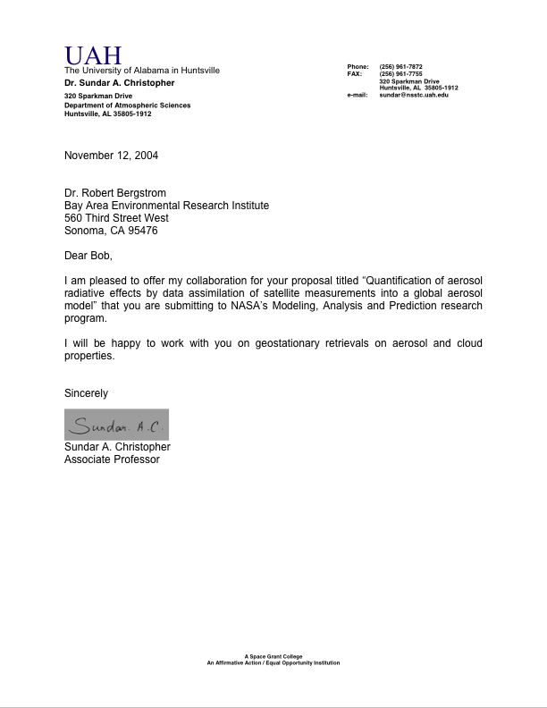

From: hakiko@nies.go.jp
Subject: Re: NASA Proposal
Date: November 14, 2004 6:27:42 PM PST
To: bergstrom@baeri.org

Dear Dr. Bergstrom,

Thank you for your email.

Yes, I will accept your offer of participation. I'm very glad you're involving my work.

I'm trying to apply the 4-channel algorithm on global scale. Therefore global segmented data with latitudinal and longitudinal resolution of 0.25 degrees are processing for MODIS and SeaWiFS data now.

Thank you.

Sincerely,

Akiko

--
Akiko Higurashi
Atmospheric Environment Division
National Institute for Environmental Studies
16-2 Onogawa, Tsukuba, Ibaraki 305-8506, Japan
Phone: +81-29-850-2423, Fax: +81-29-850-2960
E-mail: hakiko@nies.go.jp

The NRA states as the goals of the new Climate Global Modeling Initiative: (a) Incorporation and evaluation of state-of-the-art algorithms and inclusion of new surface, in situ and satellite remote sensing data into the GMI model with the goal of understanding their relative importance in determining simulated atmospheric composition. High priority will be given to studies incorporating new satellite-based meteorological fields, wet scavenging processes, emission of source gases, boundary layer processes, microphysical processes, chemical mechanisms and numerical approaches. Research efforts towards off-line incorporation of GCM processes such as convective parameterizations, hydrological cycle and aerosol-cloud interactions are also encouraged. (b) Evaluation of GMI simulation results with available surface, in situ and satellite remote sensing data. Priority will be given to studies utilizing available and forthcoming measurements from satellite instruments and aircraft platforms. (c) Studies of the impact of anthropogenic activity and climate change on atmospheric composition at both regional and global scales, incorporating the coupling between the stratosphere and the troposphere incorporating satellite observations. (d) Studies of the radiative impact of atmospheric composition as simulated by the GMI model. Priority will be given to efforts that include coordination with climate models and interactive chemistry-climate research.
The NCAR scientists are currently merging the MATCH model capability with the newly released CCSM and CAM models. At present, the CAM model does not have the capability to carry the aerosol model. In the near future all simulations will be run with the CAM model. For the work discussed here, the MATCH model is sufficient. Using data assimilation to derive the aerosol indirect effect will require an interactive model such as the new CAM model.
The MATCH model is one of the models participating in the AEROCOM comparison. There are fifteen such models of which five are US models - information on AEROCOM is available at http://nansen.ipsl.jussieu.fr/AEROCOM/aerocomhome.html.
In data assimilation terminology, the radiative transfer model is termed a forward model
For description of satellite remote sensing of aerosols see King et al 1999 and Kaufman et al 2002.
While the single scattering albedo and optical depth are each one number the function P(Θ) requires more one number to characterize it. Usually, the scattering distribution function is assumed to be the represented by a lognormal distribution of spherical particles of mode radius, r_{o}.
Not all bands can be used for aerosol detection; the H2O bands prevent retrieval in certain solar spectral regions (King, et al 1999; Bergstrom et al 2002). There are also slight differences in wavelengths for TOMS and AVHRR for different spacecraft.
Ultimately, we will be able to compute cloud radiances with these techniques. However, that effort is beyond the scope of work presented here.
While straightforward, use of the adjoint in atmospheric radiative transfer is actually not particularly common. Only in a few cases (Michalsky et al 1999) has the adjoint method been used.

