

Strategic Human
Capital Management:
Revised Human Capital Plan
FY 2008 – FY 2009

U.S. Department of Housing and Urban Development
March 2008



Strategic Human
Capital Management:
Revised Human Capital Plan
FY 2008 – FY 2009

Office of Administration

TABLE OF CONTENTS
A MESSAGE FROM THE HUD CHCO…………….…………………............………............................……… | 4
INTRODUCTION……………………………………………………………...……....………………….…….…. | 5
Human Capital Goals……………………………………………………..……..….….…………………...  Human Capital Vision…………………………………………………….….………………………………  Human Capital Values…………………………………………………..……….....…….………………….. | 5  6  6
SIGNIFICANT ACCOMPLISHMENTS……….……………...……………….…………………….................... | 6
HUD Organizational Structure……………………………………………..…………….…….……...……  Other Accomplishments………………………………………………………………….…....………..…… | 6  8
STRATEGIC ALIGNMENT…………………………………………….……………………..……..................... | 10
Linkage to Departmental Strategic Plan………………………………...…….……………………….……  Linkage to Annual Performance Plan……………………………………...….……….…...….....................  Linkage to Departmental Budget……………………………………….………………….…......................  Figure 1: HUD Strategic Framework……..…………………………………...…………….….………..…  Figure 2: Integrated Human Capital Planning at HUD…………………………...….………………….… | 10  11  11  12  13
INSTITUTIONALIZED WORKFORCE PLANNING…………......................................................................... | 14
Figure 3: OPM Workforce Planning Model……………………..…...............…….……………………..…  Figure 4: HUD Workforce Planning Process……….……………….………………………..……………..  Figure 5: Mission Critical Occupations for Targeted Skill Gap Closure…………………………………… | 14  15  16
WORKFORCE PLANNING: THE DEPARTMENTAL FOCUS FY 2008—FY 2009………………………... | 17
Figure 6: Workforce Analyses Indicators for Mission Critical Occupations…………………...………...…  Workforce Diversity…………………………………………………………………………..………………  Figure 7: HUD Workforce Diversity Profile…………………………………………………………………  Mission Critical Positions……………………………………………………………………………………  Figure 8: Mission Critical Positions Distribution of Employees by Pay Level/Program Office….................  Retirement Eligible Employees…………………………………………………………………….................  Figure 9: Mission Critical Positions, Retirement Eligible Employees……………………………................  Departmental Workforce Planning Strategies For FY2008—FY2009…………………………….................  Figure 10: Staffing Analysis Chart…………………………………………………………………………..  Figure 11: Skill Assessment Chart…………………………………………………………………………... | 17  18  19  20  20  21  22  23  24  25
NEW HUMAN CAPITAL STRATEGIC OBJECTIVES….……………….…………………………................ | 26
Goal 1: Mission-Focused Agency…………………………….……………...…………..………..................  Goal 2: High-Quality Workforce……………………………………….……………………..……………...  Goal 3: Effective Succession Planning………………………………….…...…………………..................... | 27  29  30
ALIGNMENT WITH THE HCAAF…………………..…………….…………………………………................. | 31
Figure 12: Human Capital Goals And Objectives Aligned By HCAAF Dimension……………...………… | 32
ROLES AND RESPONSIBILITIES…..……………………………………...………..….………………............ | 34
Senior Management…………………………………………………….…..……………….….….................  Human Resource Management………………………………………….……...………….…………………  Program and Support Offices…………………………………………….......................…..……………….. | 34  34  34
HUMAN CAPITAL ACCOUNTABILITY……………………......………...……...……………...…….............. | 34
HUMAN CAPITAL PROGRAM POLICY REFERENCES  AND DEPARTMENTAL GUIDANCE…..……………………………………...................................................... | 35
FY 2008 MEMBERSHIP ROSTER HUD EXECUTIVE STEERING  COMMITTEE FOR HUMAN CAPITAL MANAGEMENT…..………………………………………....…….. | 38

A MESSAGE FROM
THE HUD CHIEF HUMAN CAPITAL OFFICER (CHCO)

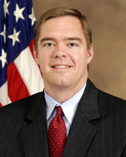

Keith A. Nelson

As the CHCO for the Department of Housing and Urban Development (HUD) my energies, and the energies of my staff, are focused on strengthening human capital management within the Department to help put the program offices in the best position to fulfill HUD’s mission to increase homeownership, support community development and increase access to affordable housing free from discrimination. In building on the successes we have experienced and the lessons we have learned in implementing the strategies identified in our original human capital plan, Strategic Human Capital Management: Planning for the Future of HUD and our Employees FY 2003 – FY 2008, we are now moving forward with the development of a new strategic human capital plan which will guide human capital management within HUD for the next two fiscal years. Starting in Fiscal Year (FY) 2003, HUD has begun a systematic approach to strengthening human capital management within the Department. We have strengthened our workforce planning processes, aligning our limited resources with the mission of the organizations. We have improved our hiring process, greatly reducing the amount of time needed to bring in new talent. We have bolstered our training programs to ensure that mission critical skill gaps are identified and addressed. We have institutionalized succession planning and implemented proven succession planning programs to ensure a smooth generational transition within the workforce; and we have strengthened our performance management systems to hold employees accountable for achieving results and then rewarding them and recognizing them when those results are achieved.

The new strategic human capital plan further engages all program offices in the management of their most important resources, their employees. The objectives and targets identified in this plan outline a strategy the Department can follow to achieve its human capital goals. By leveraging more extensive use of new automated processes, such as eRecruit and the new Learning Management System, program areas will become more adept at dealing with sudden changes in resources and program requirements. The plan also incorporates the Department’s new Accountability System which will enable senior management to more accurately determine our success in the area of human capital management. It also establishes a more data driven process for making human capital decisions in the future.

As the HUD CHCO, I fully endorse this plan and look forward to working with all key stakeholders as we move toward creating a more efficient HUD through the effective management of our human capital.
Keith A. Nelson
Assistant Secretary for Administration

INTRODUCTION

In our original human capital plan entitled Strategic Human Capital Management: Planning for the Future of HUD and Our Employees FY 2003 – FY 2008, we wrote that “At HUD, we value our employees.” Now, five years later, we still do!

We also still clearly recognize that our employees are the critical component in fulfilling HUD’s mission to increase homeownership, support community development, and increase access to affordable housing free from discrimination. Our employees continue to believe in our mission, have a strong commitment and sense of purpose in their work, and are enthusiastic about working at HUD.

In response to a new President’s Management Agenda (PMA) initiative, the Executive Steering Committee for Human Capital Management (Committee), which was formed to develop our original plan, was tasked with developing an update. The Committee is still chaired by the Assistant Secretary for Administration who is also the CHCO and comprised of senior officials from major program offices throughout HUD. Within this Plan, the Committee identifies new strategies, objectives, baselines, and targets to continue our progress toward improving human capital at HUD over the next two years.

Human Capital Goals

The Committee developed this document entitled, “Strategic Human Capital Management: Revised Human Capital Plan, FY 2008 – FY 2009” (Plan). We believe this Plan continues our commitment to sustaining a culture of high performance and while increasing our human capital investment.
The Plan also reflects lessons learned from our previous four years of experience in human capital. From one of these lessons learned, we actively sought to make this Plan be more strategically aligned, disciplined, and measurable.

Ultimately, the Plan relies upon our original three strategic goals for human capital, which are as follows:

- Mission-focused agency
- High-quality workforce
- Effective succession planning

Mission Focused Agency

To become a mission-focused agency, our employees and our work will be aligned to increase homeownership, support community development, and increase access to affordable housing free from discrimination.

High-Quality Workforce

To maintain a high quality workforce, we will recruit, develop, manage and retain our diverse workforce. This means our employees must have the knowledge, skills, and abilities they need to do their jobs; they are empowered to do their jobs; and, they are rewarded and held accountable for their performance.

Effective Succession Planning

It is critical to implement effective succession planning. We must ensure retiring employees are succeeded by qualified employees who are prepared to continue quality service and program delivery; and that the technical knowledge of those departing is captured, documented, and institutionalized.

Human Capital Vision

The Committee created a statement to capture HUD’s strategic vision for human capital. This vision statement serves as the standard against which all related initiatives will be judged.

HUD’s STRATEGIC VISION FOR
HUMAN CAPITAL

Our employees are mission-focused, diverse, highly qualified, and well prepared to fulfill the Department’s goals and objectives.

Human Capital Values

The Committee retained the same common set of values of the original plan that we, as a Department, will always strive to meet. These 12 values will guide each of us as we work to support our Agency’s mission. These values are what make HUD and our employees unique. The human capital values capture the essence of HUD’s relationship with employees and partners, what has driven success in the past, and will enable us to meet challenges in the future. This value set has been a guide for the Committee to develop specific goals and objectives.

HUD’s HUMAN CAPITAL VALUES

- High performance and quality work
- Diversity and differences make HUD stronger
- Empowerment
- Pervasive customer orientation
- Innovation in problem solving, and continual improvement in all we do
- Effective communication, teamwork, and cooperation at all levels
- Feedback from employees
- Continuous learning
- High ethical and moral behavior
- Respect for others
- A pleasant, safe, and supportive work environment
- Balance between work and family

SIGNIFICANT ACCOMPLISHMENTS

HUD Organizational Structure

Within the framework of the PMA, and through the implementation of the original five-year Strategic Human Capital Plan, the Department has been working to strengthen internal management and streamline business processes to become more efficient in delivering services to the public. HUD faced many challenges as it worked to align its resources to the strategic goals of the Secretary. Using the standards for success from the Human Capital Assessment and Accountability Framework (HCAAF) and the Proud-to-Be as a framework, HUD addressed many of the issues it faced and transformed the Department into an efficient organization with human capital programs in place to foster a culture of achievement.
Over the past decade, HUD has significantly improved the effectiveness of its program delivery and results, through an improved organization and alignment of its operations and staff resources, increased automation of business processes, and more efficient use of a reduced workforce. In 1994, HUD was the only cabinet-level agency to be placed on the Government Accountability Office’s (GAO) high-risk program watch list in its entirety; GAO attributed HUD’s unique distinction to an ineffective organizational structure, resource management deficiencies, and systemic weaknesses that precluded HUD from effectively mitigating high-risks in any of its core program areas. In addition, budget cuts have reduced HUD’s workforce from its 1994 level of 12,748 to the 2008 level of 9,262. To address GAO’s high-risk agency issues, and the reduction of its workforce, HUD has undergone a number of organizational, functional and systemic changes to more efficiently and effectively deliver its programs with available resource levels.

HUD has instituted a number of on-going systemic processes for assuring that it continually assesses opportunities to more efficiently and effectively organize and utilize its workforce in pursuit of the Department’s mission. In FY 2006, HUD established an “Optimal Organization Strategy” that sought to streamline administrative processes across the Department to free-up more of HUD’s reduced workforce for core program operating needs. Under that strategy, HUD is currently piloting the use of service level agreements by a central service provider in the Office of Administration / Office of Human Resource (OHR) functions as a means of streamlining processes, improving performance, and reducing the shadow support staff in program client organizations. Other “Optimal Organization” efforts initiated this year include Business Process Re-engineering studies in the areas of correspondence control/processing, Internet web site management, and the Salaries & Expenses (S&E) budget formulation and execution function.

The organizational, functional and systemic changes initiated in 1996 have reduced HUD’s S&E FTE staffing level from 10,542 to 8,400 resulting in an estimated $246M in annual cost avoidance or efficiency savings in HUD’s S&E Fund in FY 2007, alone. In January 2007, GAO noted the Department’s improvement in the management of the Rental Housing Assistance and Single Family Housing Mortgage Insurance Programs, prompting the removal of all HUD Programs off its “High Risk List.” This marked the first time since 1994 that there were no HUD programs on the list, which GAO’s Comptroller General, David Walker, described as “an historic achievement.” Unquestionably, the organizational changes implemented by the Department over the past decade have had a significant impact on the elimination of material weaknesses and high risk program designations identified by Congress, the Office of Inspector General and the GAO. HUD’s actions during this period not only improved the management of high risk programs, but completed the agency’s major plans for restructuring.

Now the program Assistant Secretaries have flexibility to make changes in their organizations to maintain effective program management and service delivery. (Reorganizations or realignments at the division level or higher are submitted for Congressional review and approval.) HUD program managers are well-pleased with the progress made in analyzing the structure against requirements to maintain effective program delivery and customer services, Department-wide.

With institutionalized workforce planning, each program Assistant Secretary can focus on mission critical program requirements and document their mission critical resource needs in their Strategic Staffing Plans. Through recurring employee skills assessments, they are identifying and setting targets to close mission critical skill gaps. They use their GS-14/15 Reduction Plans and the Quarterly Hiring Plans to address mission critical staffing needs. They also use the full spectrum of succession planning tools and resources to preserve and secure talented individuals for future program operations.

Other Accomplishments

Currently, HUD enjoys “Yellow” status and “Green” Progress on the PMA Human Capital Scorecard. We received that score in June 2004 because of our many accomplishments during the first two years of our original human capital plan. For this Plan, we will only highlight significant accomplishments and milestones because a separate document—the annual Human Capital Management Report (HCMR)—is the primary means for reporting in detail, HUD’s entire spectrum of human capital accomplishments.

Major Human Capital

Accomplishments & Milestones at HUD

FY03 – FY07

March 2003
- HUD released: Strategic Human Capital Management: Planning for the Future of HUD and Our Employees FY 2003 – FY 2008

September 2003
- Contracted with Logistics Management Institute (LMI) to begin developing workforce analysis plans for the four core program offices at HUD: Housing, CPD, PIH, and FHEO

February 2004
- HUD released: Strategic Human Capital Management Implementation Plan: Planning for the Future of HUD and Our Employees FY 2003 – FY 2008

March 2004
- HUD releases: Human Capital Accountability System Plan

May 2004
- HUD launched the Emerging Leaders Program with 30 candidates

June 2004
- HUD achieved “Yellow” status on the PMA for human capital

July 2004
- HUD contracted with Human Technologies to develop Integrated Competency Models for mission critical occupations in the four major program offices

September 2004
- LMI released all final workforce plans for Housing, CPD, PIH, FHEO, and a Departmental Workforce Plan Report

Major Human Capital

Accomplishments & Milestones at HUD

FY03 – FY07
(Continued)

October 2004
- HUD developed a multi-level performance appraisal program for non-SES managers and supervisors

December 2004
- HUD releases: Workforce Planning at HUD: A Departmental Implementation and Action Plan for Program Offices , which further supported LMI’s workforce plans and set action items and milestones for the Department

January 2005
- HUD established Workforce Analysis Planning Committees (WAPCs) in each of the four major program offices to implement LMI’s recommendations

March 2005
- HUD release preliminary succession planning guidance: “Success Planning: Steps to Success” which made use of OPM’s managerial competencies to establish leadership talent pools.

April 2005
- HUD launched the HUD Integrated Human Resources and Training System (HIHRTS) which eliminated 17 legacy systems and provided real-time data

June 2005
- The first class of the PIH/CPD Leadership Development Program graduates

July 2005
- HUD set targets to close mission critical skill gaps in the four core business program offices

September 2005
- HUD established an executive team to develop a human capital vision with strategic alignment of resources for future challenges

Major Human Capital

Accomplishments & Milestones at HUD

FY03 – FY07
(Continued)

December 2005
- OHR completed the OPM Self Assessment of HUD’s performance management systems

March 2006
- HUD developed the framework for a Human Resources Management Internal Audit Program, as required by OPM
- The HUD CIO developed action plans to close critical IT skills gaps

April 2006
- HUD launched the “Beta Site” which was a test pilot for implementing S.M.A.R.T. (Specific, Measurable, Attainable, Relevant, Time-bound) standards; the “test” program offices were ADMIN and CPD

June 2006
- HUD Training Services (MEO) wins its A-76 Competitive Sourcing competition with the private sector

August 2006
- The Beta Site expands to 5 additional offices: FHEO, GNMA, HHLHC, OCFO, and OCPO
- HUD changes Beta Site name to “ePerformance” to capture the addition of a new automated performance management system in HIHRTS
- HUD Secretary released memo to all employees: “HUD Training Strategy,” which addressed the loss of intellectual capital and training/career development concerns and required actions

October 2006
- OPM’s Accountability Review Panel approved HUD’s human capital accountability system which was updated to include an internal audit program and activity schedule

February 2007
- HUD conducts its first internal accountability audit of OHR operations in Headquarters, with OPM participation

Major Human Capital

Accomplishments & Milestones at HUD

FY03 – FY07
(Continued)

March 2007
- HUD completed the OPM PAAT for both the Employee Performance Planning and
Evaluation System (EPPES) and Performance Accountability and Communication System (PACS) and received a passing score

June 2007
- HUD conducts an accountability review of OHR operations in ASC 3, Denver, Colorado

August 2007
- HUD submits the “Green Book” to OPM which documents HUD’s accomplishments for achieving “Green” status on the Human Capital Scorecard
- HUD contracts with FPMI to conduct S.M.A.R.T. standards training for the final roll out of ePerformance to the remaining program offices in the Department

September 2007
- HUD provided evidence of operating with Career Patterns
- Developed strategy for implementing the Annual Employee Survey (AES)

December 2007
- Developed Gap Analysis Report and Improvement Plan for the Acquisition occupation
- Submitted the annual HCMR (re: Accountability) to OPM, and updated the Accountability Plan
- Set new performance management competency targets
- Completed the roll out of ePerformance for a results-oriented performance culture, Department-wide
- Is on track to revalidate all checkmarks against the new Proud-to-Be V standards

STRATEGIC ALIGNMENT

This Plan links to the HUD Strategic Plan and the Annual Performance Plan (APP) and it aligns with those objectives and outcomes to further promote and support the Department’s overall mission, vision, and values. It also links human capital initiatives to the Department’s annual budget. This level of attention to human capital planning over the next two years will help HUD manage human capital and workforce planning initiatives in order to present our intentions for action and results to Congress, other stakeholders, and the public at large. Through these efforts, we will also be able to illustrate the link between human capital and the Administration’s policy and management objectives. Furthermore, we have strong, cascading leadership participation to keep this alignment in place.

Linkage to Departmental Strategic Plan

HUD’s FY 2003 – FY 2008 Strategic Plan was a six-year plan as provided by OMB Circular A-11, Section 211.3 which incorporates all three of the human capital goals developed in this Plan. Objective EM.1: “Rebuild HUD’s human capital and further diversify its workforce” and Objective EM.5: “Improve internal communications and employee involvement” bear on human capital issues. Additionally, several of this Plan’s objectives correspond with the Departmental goal of Embracing High Standards of Ethics, Management, and Accountability. Human capital’s prominent role in the Departmental Strategic Plan shows the level of concern senior management has for this issue, and is indicative of HUD’s commitment.

Figure 1 on page 12 illustrates HUD’s Strategic Framework which includes strategic goals and objectives that summarize the Department’s aims. This strategic framework includes three programmatic strategic goals and three cross-cutting strategic goals. Programmatic goals reflect the program areas where HUD’s efforts benefit families and communities. Cross-cutting goals reflect HUD priorities with a wide cross-cutting impact that affect each of HUD’s program areas. Under each goal are the key strategic objectives that HUD will use to guide its performance.

Linkage to Annual Performance Plan

This Plan will be evaluated annually for inclusion in HUD’s APP. The APP will serve as one of several implementation mechanisms for this Plan. Performance will be measured through reporting requirements consistent with the APP process.

Linkage to the Departmental Budget

At HUD, human capital is a top priority. We ensure our human capital programs and initiatives are integrated with our annual budget process and given priority consideration for funding. Figure 2 on page 13 illustrates how human capital planning is integrated into our:

- Agency Budget
- Strategic Plan
- Annual Performance Plan
- Program Office Management Plans
- Revised Human Capital Plan

Figure 1:
HUD Strategic Framework
HUD Mission: Increase homeownership, support community development, and increase access to affordable housing free from discrimination.
HUD
STRATEGIC GOALS

PROGRAMMATIC GOALS
Increase homeownership opportunities | Promote decent affordable housing | Strengthen communities
- Expand national homeownership opportunities.  - Increase minority homeownership.  - Make the home buying process less complicated and less expensive.  - Fight practices that permit predatory lending.  - Help HUD-assisted renters become homeowners.  - Keep existing homeowners from losing their homes. | - Expand access to affordable rental housing.  - Improve the physical quality and management accountability of public and assisted housing.  - Increase housing opportunities for the elderly and persons with disabilities.  - Help HUD-assisted renters make progress toward self-sufficiency. | - Provide capital and resources to improve economic conditions in distressed communities.  - Help organizations access the resources they need to make their communities more livable.  - End chronic homelessness and move homeless families and individuals to permanent housing.  - Mitigate housing conditions that threaten health.
CROSSCUTTING GOALS
Ensure equal opportunity in housing
- Resolve discrimination complaints on a timely basis.
- Promote public awareness of Fair Housing laws.
- Improve housing accessibility for persons with disabilities.
Embrace high standards of ethics, management and accountability
- Rebuild HUD’s human capital and further diversify its workforce.
- Improve HUD’s management, internal controls and systems and resolve audit issues.
- Improve accountability, service delivery and customer service of HUD and its partners.
- Ensure program compliance.
- Improve internal communications and employee involvement.
Promote participation of faith-based and community organizations
- Reduce regulatory barriers to participation by faith-based and community organizations.
- Conduct outreach to inform potential partners of HUD opportunities.
- Expand technical assistance resources deployed to faith-based and community organizations.
- Encourage partnerships between faith-based/community organizations and HUD’s traditional grantees.

Figure 2:
Strategic Human Capital Management Plan

HUD MISSION
Goal 1
Mission-Focused Agency
Goal 2
Quality Workforce
Goal 3
Effective Succession Planning
Strategic Alignment
Results-Oriented Performance Culture
Talent
Leadership and Knowledge Management
Accountability
Mission Critical Recruitment
SMART Standards Training
Human Capital Assessment and Accountability Framework (HCAAF)

ePerformance System
HUD Fellows
Program
Student Loan Repayment Program
HUD Training Strategy
Internal Accountability Audits
Examples of
Funded Human Capital Outputs
Program Office Budgets
HUD Strategic Plan
Annual Performance Plan
Program Office Management Plans
Workforce Estimation and Allocation Processes
Integrated Human Capital Planning at HUD

Agency
Budget

INSTITUTIONALIZED WORKFORCE PLANNING

Comprehensive workforce planning was first launched in 2004, when the Department completed a strategic workforce analysis in the four core business program offices. The resulting products included individual workforce plans for each of the four offices and a Departmental Strategic Workforce Analysis Report that was submitted to the Deputy Secretary. This effort was led by staff in the Office of Administration, OHR with contracted technical assistance. The strategic analysis was accomplished with senior managers at high levels within the core organizations under review, to capitalize on their visions and management plans for the future of the organization, i.e., strategic direction; forthcoming challenges from new legislation or new program assignments; plans for enhanced service delivery, and customer support. When completed, the analyses identified many serious issues confronting the agency, in light of the aging workforce and the increasing probabilities of great losses of talented resources to retirement. Important management data regarding anticipated or projected mission critical competency gaps and full-time equivalent (FTE) gaps in staffing over a five year period was documented to facilitate both workforce and succession planning for the future.

In the following two years, workforce planning was institutionalized. Other organizations joined the core business program offices in the next phases of the workforce planning effort, which was patterned after the Office of Personnel Management (OPM) Workforce Planning Model; see Figure 3. HUD program offices were required to develop their own workforce plans to meet their workload and staffing challenges. Administration staffs throughout the Department remained readily available, providing technical guidance and assistance, but the program managers, responsible for carrying out the organization’s mission, now and into the future, were tasked and expected to conduct the workforce analyses and develop plans to keep the right people, with the right skills, in the right place for their future mission and service delivery requirements.

Figure 3:

OPM Workforce Planning Model

Support for workforce planning has always come from the top down. In fact, the Deputy Secretary appointed an experienced HUD Executive to lead a Workforce Planning Taskforce to jumpstart the program offices through a systematic process to examine the following: current state analysis of human resources, including an employee skills analysis and retirement projections; future workload projections; organizational structure; future workload projections; FTE allocations; grade levels; mission critical staffing needs and any remaining human capital concerns. This effort, by comparison to OPM’s Workforce Planning Model, involves the processes outlined in Figure 4 on page 15.

Figure 4:

HUD Workforce Planning Process

STEP 5
- Annual Human Capital Management Report
- Accountability Audits
- Performance Accountability Report
- Quarterly Human Capital Scorecard Evaluations
- Quarterly Training Completion Reports
- Annual Training Results and Impact Report
- FHCS and AES
- Performance Appraisals
.
STEP 1
- President’s Management Agenda
- HUD Strategic Goals and Annual Performance Goals
- HUD Human Capital Management (GAO)
- Program Specific Management Plan Goals

STEP 4
- HIHRTS
- Targeted recruitment outreach
- Increased intern hiring
- Hiring Flexibilities
- Recruitment and retention incentives
- VERA Authority
- Targeted VSIP Authority
- Focus on GS-14/15 position management
- Improved delegated examining
- Streamlined hiring timelines
- Career Patterns
- Category Rating
- HUD Virtual University
- Supervisory accountability for employee training
- Approval of training requests linked to employee ITAPS
- Reorganizations and realignments

STEP 3
- Program Office Workforce Plans
- Departmental Training Strategy
- Program Office Training Action Plans
- Individual Training Action Plans
- Departmental Succession Plan
- Program Office Succession Plans
- Workforce Estimation and Allocation Process
- Program Office Staffing Plans
- Quarterly Hiring Plans
- Strategic Recruitment Plans
- Senior Management Approval Process
- HUD Fellows Program
- Results-oriented performance management and S.M.A.R.T. Standards
- Business Process Reengineering
- Technology solutions
- Competitive Sourcing opportunities
STEP 2
- Identification of mission critical positions and mission critical competencies
- All employee skills assessment
- Identification of mission critical competency gaps
- Examine retirement eligibility and 3-year projections
- Determine potential FTE gaps
- Set targets to close skill gaps
- Include management and leadership bench strength gaps
- Identify leadership talent pools
HUD
HUD’s Workforce Planning Taskforce was successful because it engaged all program offices in the effort and fostered the transition to recurring independent workforce analyses. Each step requires a myriad of activities. For example, when program offices are developing their annual workforce plans, they give consideration to the following: competency requirements and skill gaps; workforce size needs; retirement eligibility; length of service and diversity; grade levels and performance expectations for various occupations; customer service demands; and employee-friendly workplace concerns. Also important are concerns pertaining to training and professional development; maintaining good supervisors and strong management leadership; and effective performance management at all levels. Our thinking is that one size may not fit all, so, each organization head has the flexibility to apply the workforce planning steps, evaluate the results, and develop individual plans, processes, and targets to address the organization’s needs. While the support organizations like OHR, Training Services, Office of the Chief Financial Officer, Office of the Chief Information Officer, and the Office of Departmental Equal Employment Opportunity (ODEEO) must undertake the same workforce analyses and planning for their workforce, they are dually-tasked to interface closely with all program areas to provide technical assistance and strategic planning support as needed.

As the agency moves forward, continuous workforce planning remains an integral part of our human capital management program. We will follow OPM’s guidelines and continue in the government-wide focus to address skill gaps in human resources, information technology, acquisition and management. Positions within the Department that are involved in this effort and the mission critical program occupations that have been targeted for skill gap reduction are recorded in the chart below. See Figure 5. Our new human capital strategies for FY 2008 — FY 2009, discussed later in this Plan, include several activities with expected outcomes that are predicated on effective workforce planning. The Committee will continue to monitor and report to the Deputy Secretary on the progress of workforce planning within the Department.

Figure 5:
Mission Critical Occupations for Targeted Skill Gap Closure

Program Office | Mission Critical Positions
Community Planning and Development | CPD Representative, GS-301
Community Planning and Development | CPD Specialist, GS-301
Community Planning and Development | Environmental Protection Specialist,  GS-301
Community Planning and Development | HOPWA Program Specialist, GS-301
Community Planning and Development | Special Needs Assistance Specialist,  GS-301
Public and Indian Housing | Public Housing Revitalization Specialist, GS-1101
Public and Indian Housing | Financial Analyst, GS-1160
Public and Indian Housing | ONAP Grants Evaluation Specialist,  GS-1101
Public and Indian Housing | ONAP Grants Management Specialist, GS-1101
Housing | Project Manager, GS-1101
Housing | Asset Manager, GS-1101
Housing | Financial Analyst, GS-1160
Housing | Affordable Housing Specialist, GS-1160
Fair Housing and Equal Opportunity | Equal Opportunity Specialist, GS-360
Fair Housing and Equal Opportunity | Program/Management Analyst, GS-343
Office of Human Resources | Human Resource Specialist, GS-201
Chief Information Officer | Information Technology Specialist,  GS-2210
Chief Procurement Officer | Contract Specialist, GS-1102
Chief Procurement Officer | Procurement Analysts, GS-1102

WORKFORCE PLANNING:
THE DEPARTMENTAL FOCUS FY 2008—FY 2009

HUD Management remains concerned about the potential attrition losses due to the high retirement eligibility within the workforce. Although approximately 60 percent of employees may be eligible to retire, we recognize that not all employees retire when they become eligible. For this reason, the Department will focus on the impact of human capital losses in the core business program offices and within these offices we will focus our workforce planning around those same mission critical
Figure 6:
Workforce Analyses Indicators for Mission Critical Occupations

occupations listed previously in Figure 5. These are also the same occupations identified in our Staffing Analysis Chart and Skill Assessment Chart as reflected later in Figures 10 (page 24) and 11 (page 25) respectively. This approach keeps our workforce and succession planning, skill gap closure, and strategic recruitment all integrated and concentrated in those core business occupations that have been declared as mission critical for the Department’s future operations and service delivery.

Program Office | Mission Critical  Positions | Total  Employees  In Job Series  (As of 1/19/08) | Average  Grade  Program Office | Average  Age  Program Office | Retirement  Eligibility  Program Office |  | Total  Supervisors  In Job  Series
 |  |  |  |  | Now | Early | Total  Supervisors  In Job  Series
Community  Planning and  Development | CPD Representative, GS-301 | 535 | 12 | 51 | 125 | 113 | 120
Public and  Indian Housing | Public Housing  Revitalization Specialist,  GS-1101 | 751 | 13 | 51 | 169 | 189 | 116
Public and  Indian Housing | Financial Analyst, GS-1160 | 166 | 12 | 52 | 47 | 50 | 1
Housing | Project Manager, GS-1101 | 1915 | 12 | 52 | 462 | 468 | 345
Housing | Financial Analyst, GS-1160 | 7 | 12 | 44 | 1 | 3 | 0
Fair Housing  and Equal  Opportunity | Equal Opportunity Specialist, GS-360 | 405 | 12 | 52 | 103 | 85 | 84
Fair Housing  and Equal  Opportunity | Program Management Analyst, GS-343 | 51 | 13 | 49 | 17 | 9 | 2
Office of Human  Resources | Human Resource Specialist, GS-201 | 128 | 12 | 49 | 23 | 47 | 27
Office of The  Chief  Information  Officer | Information Technology  Specialist, GS-2210 | 210 | 13 | 50 | 37 | 48 | 39
Office of The Chief  Procurement  Officer | Contract Specialist, GS-1102 | 89 | 13 | 47 | 8 | 24 | 20

The above data in Figure 6 indicates that in every occupation, high numbers of employees are retirement eligible. In most cases, the average grade for the occupations is at the GS-12 level. As we plan for the future, we need to make sure we build leadership talent pools with training opportunities for the seasoned mid-level employees, who may not yet be seriously contemplating retirement. They will need both career advancement and retention incentives to keep them in the Agency for a long time so that HUD can benefit from their knowledge and experience. Similarly, we need to continue to promote mentoring and knowledge transfer from employees at this level to new hires, particularly interns, just entering the Federal service or just beginning tours of duty with the Department.

“Nurturing and leveraging the expertise and initiative of knowledge workers, and finding ways to engage them in knowledge creation and sharing, are critical to the multiplication of talent.”

–Accenture/Outlook, The Journal of High-Performance Business ,Vol. XIX, No. 3, September 2007, p.21

Workforce Diversity

The data in Figure 7 on page 19 provides a brief workforce diversity profile for the Department for FY 2007. The Department’s executive leadership and managers recognize that diversity is a cornerstone of America’s strength. In this regard, HUD is committed to ensuring equality of opportunity in all facets of employment, fully in accordance with equal employment laws and the civil service merit principles. As a result of this commitment, HUD has consistently maintained a diverse workforce that is representative of the face of America from coast to coast. Under this Plan, the Department will continue its efforts to assure full and fair consideration to all persons seeking HUD services through our mission. We will also assure full and fair consideration to all Federal employees and individuals with disabilities, not only in the hiring, placement, and advancement but also in the training and retention of current employees. OHR staff will continue working with the ODEEO to foster communications with program managers on workforce diversity and to support staff planning, recruitment, and outreach necessary to sustain a well-diverse and capable workforce for the Department’s future.

Figure 7:
HUD Workforce Diversity Profile

GRADE | AF | AM | BF | BM | HF | HM | NAF | NAM | WF | WM | Total
01-04 | 0 | 0 | 16 | 2 | 1 | 0 | 2 | 0 | 6 | 2 | 29
05-08 | 23 | 8 | 370 | 74 | 63 | 15 | 15 | 4 | 236 | 49 | 857
09-12 | 89 | 38 | 981 | 248 | 155 | 53 | 33 | 10 | 728 | 435 | 2770
13-15 | 105 | 112 | 1144 | 511 | 147 | 141 | 17 | 20 | 1130 | 1413 | 4740
EX | 0 | 0 | 2 | 1 | 0 | 1 | 0 | 0 | 0 | 2 | 6
SES | 3 | 1 | 20 | 12 | 3 | 2 | 0 | 1 | 14 | 40 | 96
Total | 220 | 159 | 2533 | 848 | 369 | 212 | 67 | 35 | 2114 | 1941 | 8498
% of  Total Workforce | 2.59% | 1.87% | 29.81% | 9.98% | 4.34% | 2.49% | 0.79% | 0.41% | 24.88% | 22.84%
Legend:

AF | Asian Female |  | HF | Hispanic Female |  | NAM | Native American Male
AM | Asian Male |  | HM | Hispanic Male |  | WF | White Female
BF | Black Female |  | NAF | Native American Female |  | WM | White Male
BM | Black Male

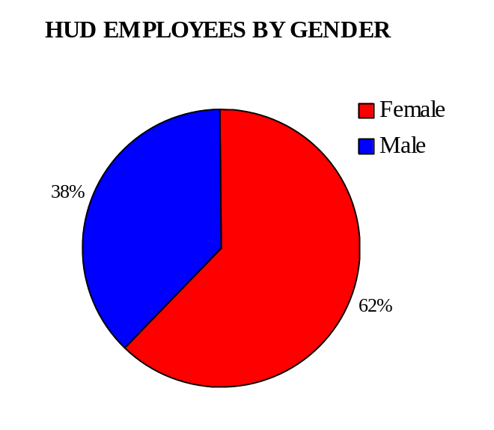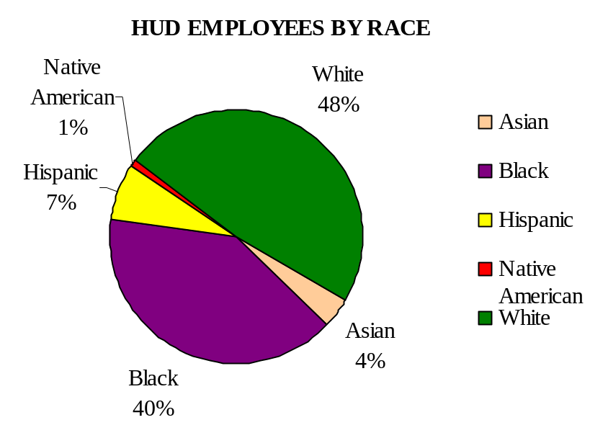

Mission Critical Positions

The data in the following bar charts of Figure 8 indicates a very poor pipeline of internal candidates at the GS-5/7 entry levels to fulfill the demand for seasoned journeyman level positions in our mission critical occupations. Therefore, this data confirms our decision to increase hiring under the new HUD Fellows program---i.e., generate a pipeline with intern hires and train these new hires for mission critical positions--is indeed a wise one. In addition, we must continue our efforts to build our talent from within. Using technology to enhance our capabilities for conducting and documenting employee skills assessments, providing access to expanded training opportunities through the HUD Virtual University are two steps that will have far-reaching impact on employee development for HUD’s future.

Figure 8:
Mission Critical Positions,
Distribution of Employees by
Pay Level / Program Office

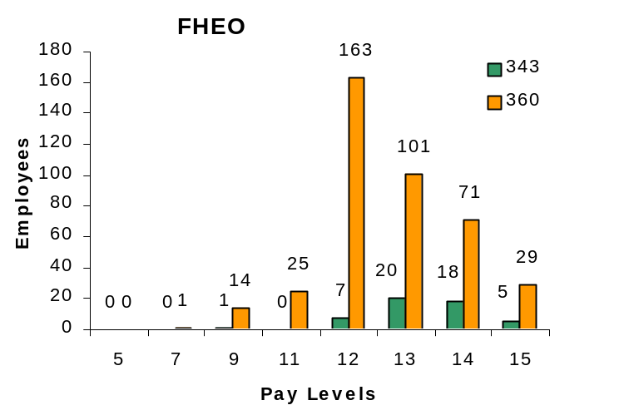

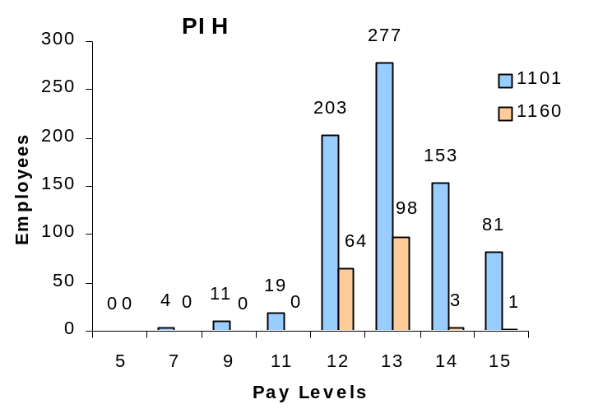

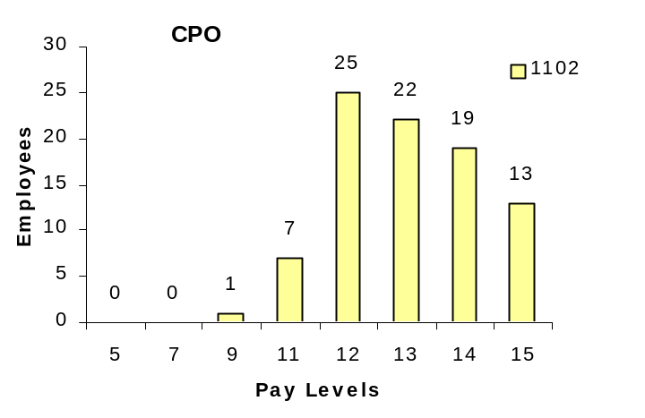

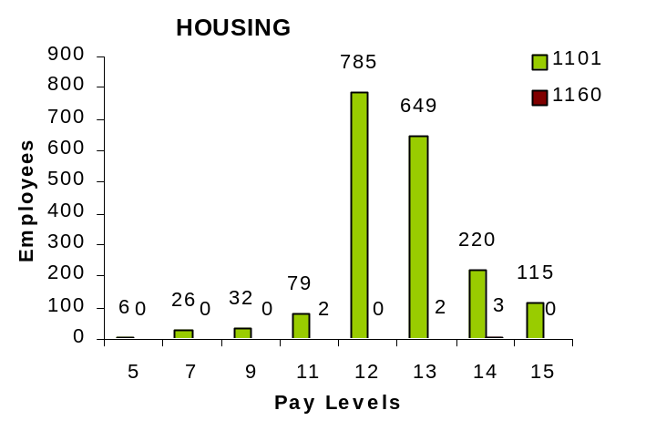

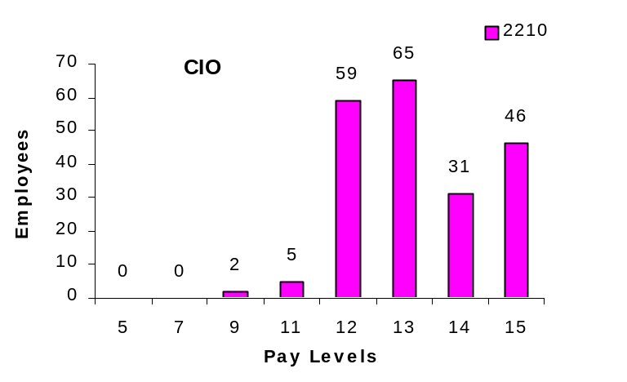

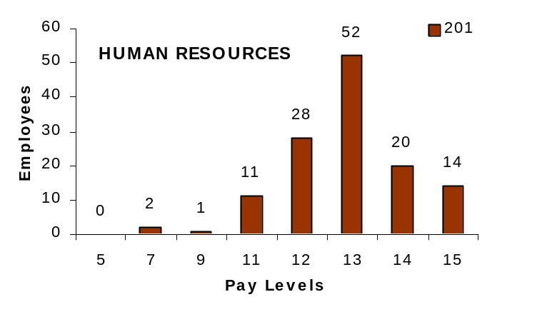

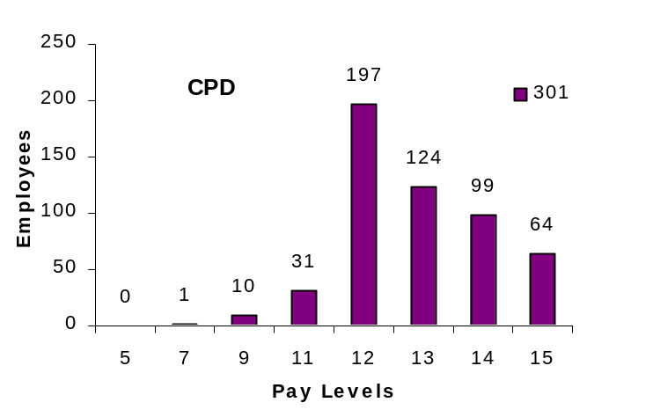

“In the global competition for talent, some companies may view the endgame as a matter of adding the right individuals. But the key to winning on talent is multiplication, not addition. Companies that build this critical capability will generate superior effort, creativity, and results from their workforces.”

–Accenture/Outlook, The Journal of High-Performance Business ,Vol. XIX, No. 3, September 2007, p.18

Retirement Eligible Employees

Our workforce is still aging. Despite massive staffing efforts, the Department’s talent base in mission critical occupations will continue to dwindle as more staff reaches the threshold of either optional or early retirement eligibility. The pie charts in Figure 9 on pages 22 and 23 indicate that HUD’s workforce and succession planning must have a wider scope than just ensuring leadership continuity. It must be multi-faceted and far-reaching in terms of the types of positions and the training and developmental programs include. In planning for the Department’s future, we must implement strategies to embrace as the most essential component of tapping and expanding the potential of existing staff for more challenging responsibilities in their current occupations, as well as in other positions within the Department at various grade levels. To that end, we must also look at the work environment offered here at HUD. Is it truly an employee-friendly workplace? What can we do to make our employees want to stay and work longer? Perhaps a closer look at the concerns raised by employees in the Federal Human Capital Survey (FHCS) and the AES may shed more light on other measures to pursue to support the retention of our qualified staffs. In addition, we must keep up our progress with reducing the hiring timelines and new marketing steps under the Career Patterns initiative to maintain a competitive edge for attracting candidates for the HUD team.
Figure 8:

Mission Critical Positions
Retirement Eligible Employees

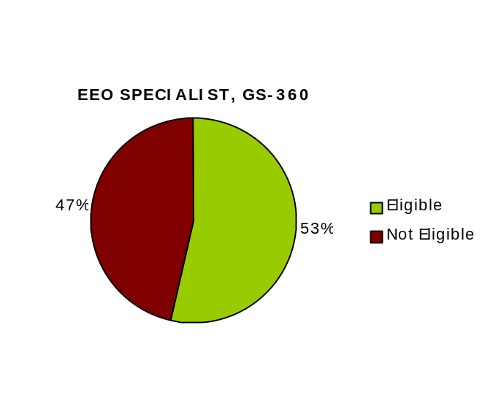
Figure 9:
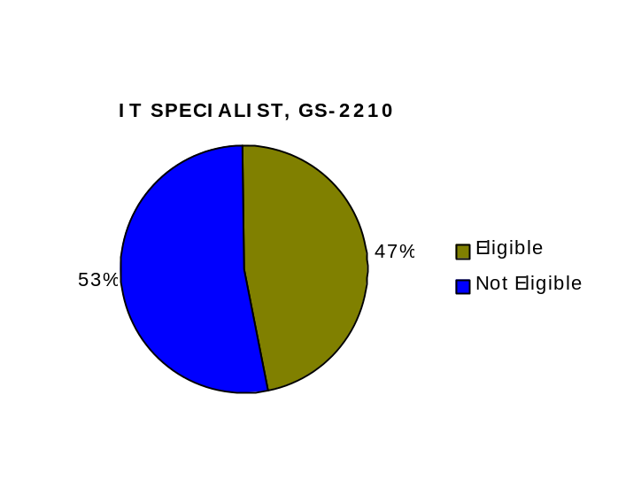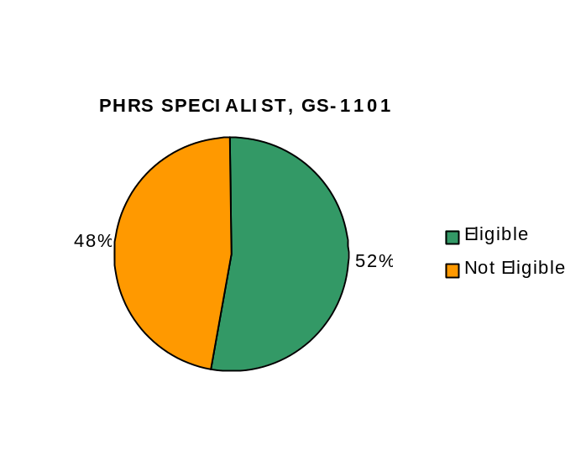Mission Critical Positions,
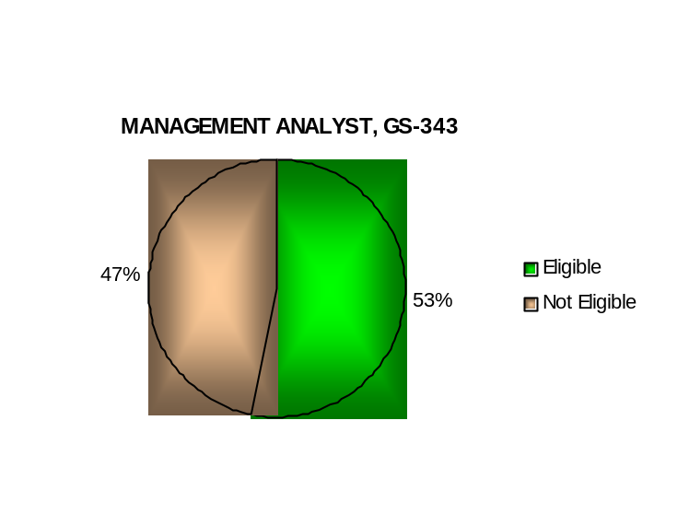
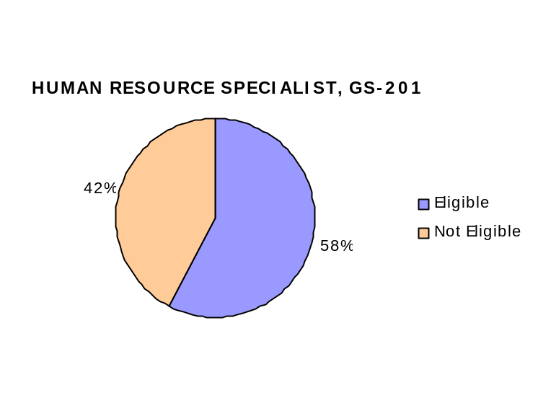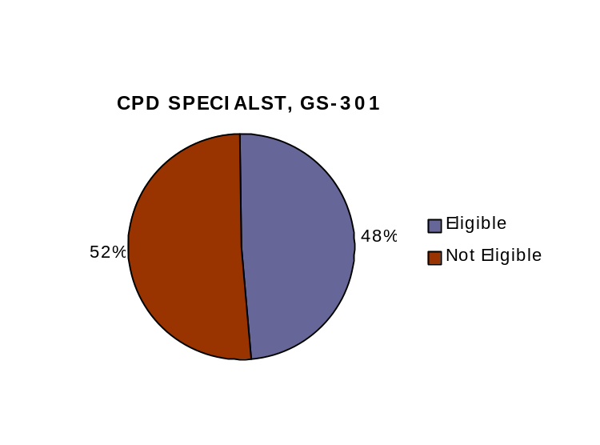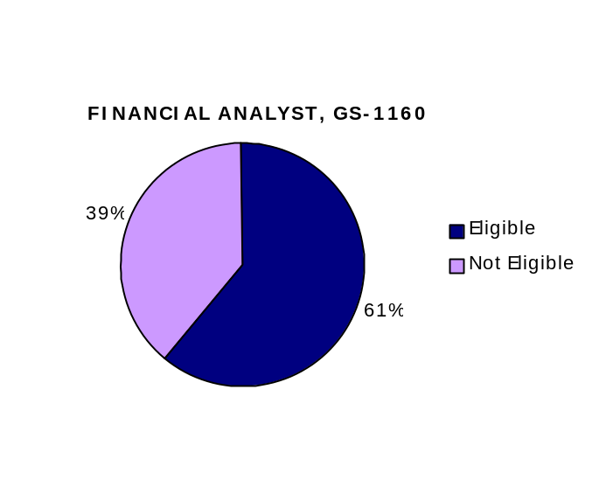 Retirement Eligible Employees

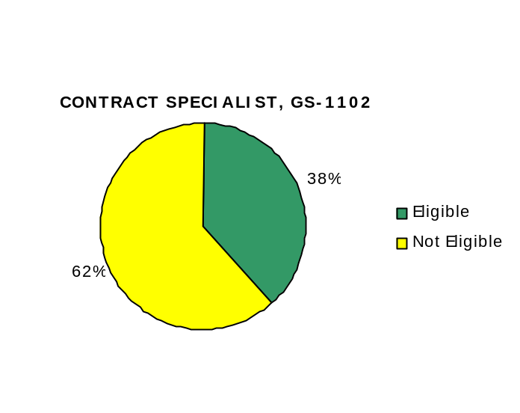

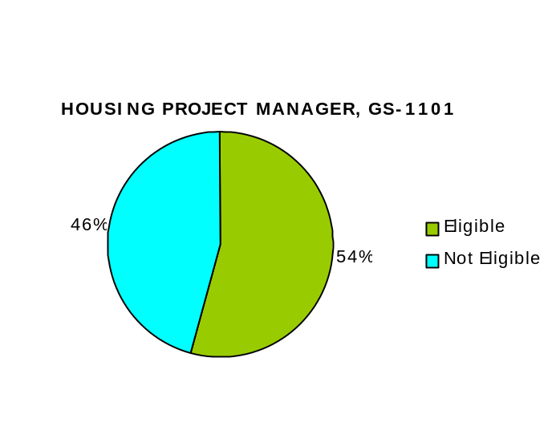

Departmental Workforce Planning Strategies for FY2008—FY2009

The foregoing workforce analysis indicators have yielded the following Departmental workforce planning strategies:

- Focus external recruitment on filling mission critical positions and closing skill gaps in mission critical occupations; meet targets established in Staffing Analysis Chart, page 24
- Meet competency gap reduction targets for mission critical technical competencies; meet targets established in Skill Assessment Chart, page 25
- Continue to reduce general skills competency gaps
- Institutionalize employee skill assessments through the implementation of an automated competency management process
- Implement improved recruitment strategies, including career patterns, to increase the number of well-qualified candidates
- Modernize the recruitment process with USA Staffing and an online applications process through USA Jobs, to make applying for HUD vacancies easier and more applicant-friendly. This will also eliminate paper and issues of untimely filing
- Establish individual Program Succession Plans for the core business offices, to give them the responsibility and flexibility to manage internal succession planning, following the guidance in the Departmental Succession Plan
- Continue the use of Strategic Staffing Plans from the program offices, to highlight and monitor mission critical positions
- Use Quarterly Hiring Plans to monitor and manage recruitment and avoid peak staffing workloads
- Develop a Departmental Strategic Recruitment Plan to identify highly qualified talent pools and sustain workforce diversity
- Centralize the hiring and initial placement of intern hires under the new HUD Fellows Program
- Restructure the Emerging Leaders Program to a competitive training program
- Seize opportunities to fill executive level vacancies from eligible graduates of the Senior Executive Service (SES) Candidate Development Program

Figure 10:
Staffing Analysis Chart
(OPM Mission Critical Resource Chart)
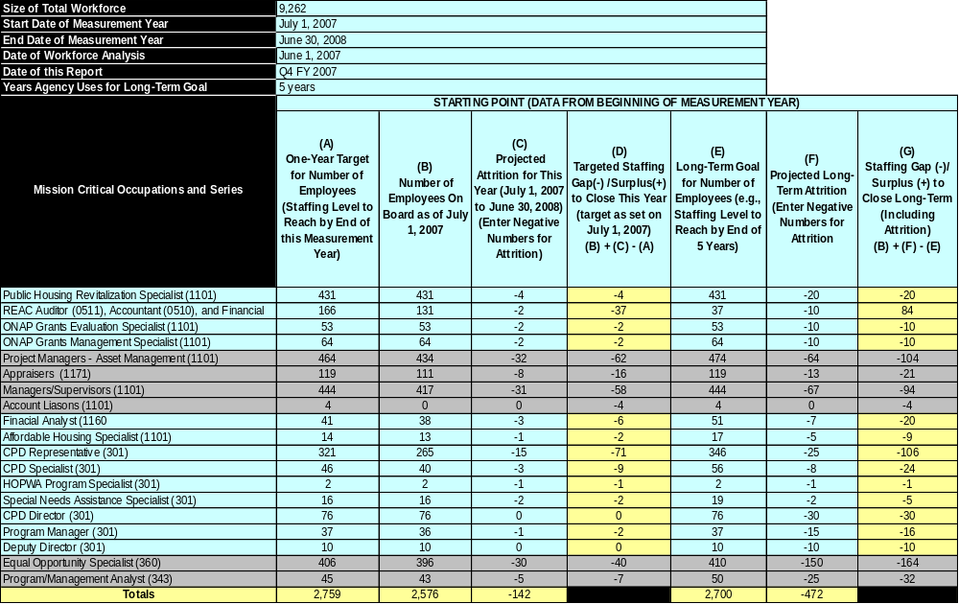

Figure 11:

Skill Assessment Chart

(OPM Mission Critical Competency Profile Chart)

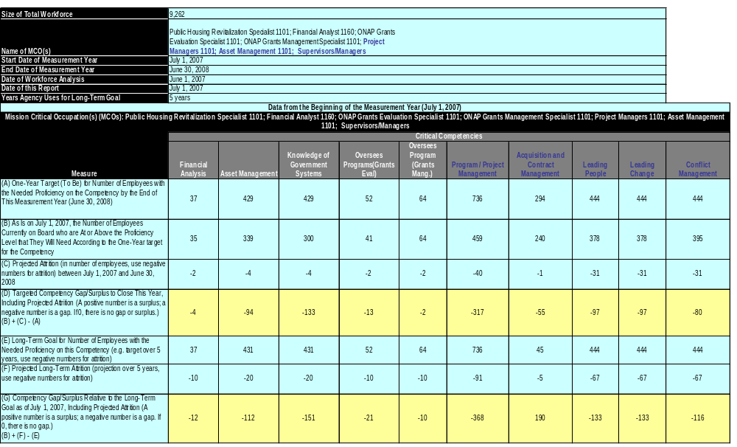

NEW HUMAN CAPITAL STRATEGIC OBJECTIVES

Our original human capital plan helped us set in place a wide variety of programs, initiatives, activities, and tools to address issues related to our three human capital goals: mission-focused agency, high-quality workforce, and effective succession planning. Now, with this Plan, we have developed new strategic objectives that will help us fine-tune our previous work while institutionalizing human capital at HUD.

These new strategic objectives beginning on the following page are based on feedback from our customers and stakeholders as well as Proud-to-Be V initiatives, the PMA, and other HUD-specific human capital policies. With the benefit of hindsight and lessons learned, we believe this Plan contains strategies to help us accomplish the following overarching PMA objectives: reduce the distance between citizens and decision-makers; increase the performance of employees who provide services to citizens; make better use of existing flexibilities for acquiring and developing talent and leadership; and attract and retain the right people, in the right places, and at the right time.

This two-year Plan, like the original plan before it, seeks to ensure that:

- HUD’s organizational structure is optimized through continuous workforce planning
- Succession strategies are in place to provide a continuously updated talent pool
- Performance appraisal plans for all managers and staff ensure accountability for results and are linked to the goals and objectives of HUD’s mission
- Hiring strategies are in place to address workforce diversity
- Skills gaps are assessed and corrected
- Human capital management accountability systems are in place to support effective management of HUD’s human capital

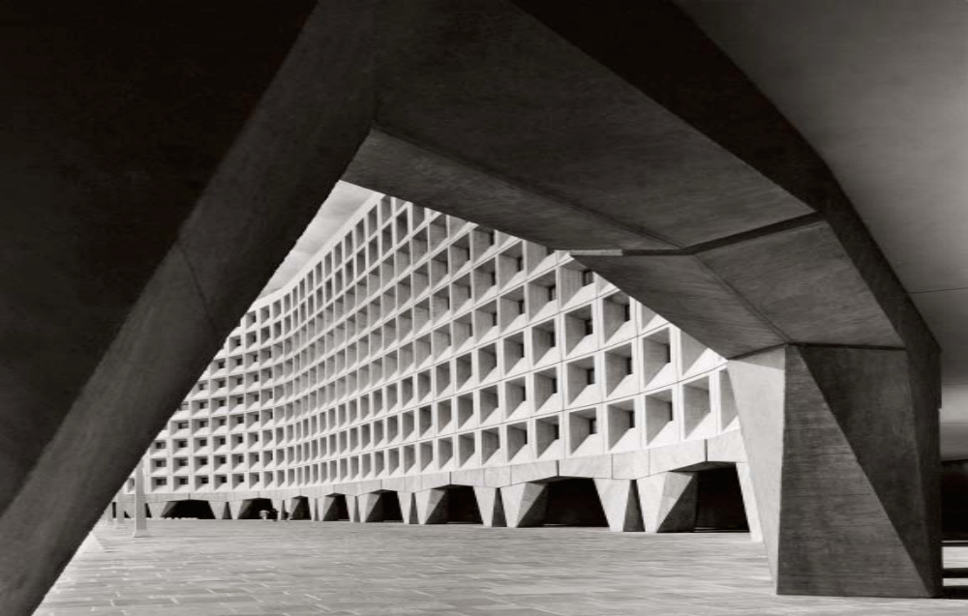
NEW

HUMAN CAPITAL

STRATEGIC OBJECTIVES

FY2008 – FY2009





Human Capital Goal 1:
Mission-Focused Agency

Objective 1: Program Offices continue engaging in workforce planning activities to identify the workforce needed to meet future challenges. Program Offices will submit individual workforce plans to the Committee. Plans will include:

- The strategic direction for their program office and each office/division within that office (Strategic Staffing Plan)

- An analysis of their current workforce identifying staffing projections and potential FTE gaps in mission critical occupations. (Quarterly Hiring Plan)

- Potential operating improvements through the merger of similar functions, competitive sourcing, or the elimination of non-critical functions and the strategic re-assignment of FTE (GS-14 / 15 Reduction Plan)

- An analysis of their current workforce identifying current competency levels and existing skill gaps, as well as future competency levels and potential gaps (Program Training Action Plan)

- Retention strategies for keeping skilled employees currently on board; an analysis of retirement eligible statistics; projections for retirements in mission critical occupations; strategies for managing potential FTE and competency gaps due to retirement (Succession Plan)

FY08 Target: 4 Core Program Offices plus 3 additional Program Offices submit their Workforce Plans

FY09 Target: Remaining Program Offices submit their Workforce Plans

Baseline: 4 Core Program Offices

Objective 2: OHR modernizes the recruitment process to make applying for HUD vacancies easier and more applicant-friendly

FY08 Target: 25% of all advertised vacancies are processed through USA Staffing

FY09 Target: 70% of all advertised vacancies are processed through USA Staffing

Baseline: HUD Fellows Program vacancies

Objective 3: Program Office Staffing Plans align with organizational priorities and goals

FY08 Target: 40% of all new hires are in mission critical occupations

FY09 Target: 75% of all new hires are in mission critical occupations

Baseline: New, no baseline

Objective 4: Employee performance plans are strategically aligned and support program office goals and priorities

FY08 Target: Positive Employee responses to FHCS/AES Question; “I know how my work relates to the agency’s goals and priorities” increases by 3% from the FY06 baseline

FY09 Target: Positive Employee responses to FHCS/AES Question; “I know how my work relates to the agency’s goals and priorities” increases by 7% from the FY06 baseline

Baseline: 82.7% (FY06 FHCS)

Objective 5: Employee performance ratings are aligned with organizational performance

FY08 Target: Employee performance is adequately aligned with organizational performance based on the scoring of sections 9 and 15 of OPM’s Performance Appraisal Assessment Tool (PAAT). Agency receives a score of 10 for the EPPES PAAT and a score of 9 for the PACS PAAT.

FY09 Target: Employee performance is adequately aligned with organizational performance based on the scoring of sections 9 and 15 of OPM’s PAAT. Agency receives a score of 12 for the EPPES PAAT and a score of 12 for the PACS PAAT.

Baseline: EPPES FY07 Score is 9; PACS FY07 Score is 6

Objective 6: Organizational goals and priorities are communicated down to the lowest level

FY08 Target: Positive Employee responses to FHCS/AES Question; “Managers communicate the goals and priorities of the organization” increases by 10% from the FY06 baseline

FY09 Target: Positive Employee responses to FHCS/AES Question; “Managers communicate the goals and priorities of the organization” increases by 15% from the FY06 baseline

Baseline: 60.4% (FY06 FHCS)

Objective 7: Effective communication across program areas and between Headquarters and the Field Offices

FY09 Target: Internal accountability audits confirm better communication between program areas and HQ and the Field, as reflected through focus group sessions with a cross section of Field employees

Baseline: 2 audits in FY07 showing high concern with communication

Human Capital Goal 2:
High-Quality Workforce

Objective 1: OHR implements improved recruitment strategies to increase the number of well-qualified candidates

FY08 Target: Positive responses to CHCO Management Satisfaction Survey Question “How satisfied are you with the quality of applicants” increases by 5% from the FY07 baseline

FY09 Target: Positive responses to CHCO Management Satisfaction Survey Question “How satisfied are you with the quality of applicants” increases by 10% from the FY07 baseline

Baseline: 78.5% (FY06 FHCS)

Objective 2: Competency gap reduction targets for mission critical technical competencies are identified and met

FY08 Target: The Department meets its APP goal of a 50% reduction in technical competency gaps

FY09 Target: The Department exceeds its FY08 APP goal by an additional 10% or meets its FY09 APP goal

Baseline: 83% (FY07 Performance and Accountability Report)

Objective 3: Institutionalize employee skill assessments through the implementation of an automated competency management process

FY08 Target: The Learning Management System is implemented

FY09 Target: 40% of the HUD workforce completes a competency self assessment

Baseline: New, no baseline

Objective 4: Continue to reduce general skills competency gaps

FY08 Target: Deliver training to close skill gaps by 25% of the top 3 general competencies in the FY08 Departmental Training Action Plan (DTAP)

FY09 Target: Deliver training to close skill gaps by 25% of the top 3 general competencies in the FY09 DTAP

Baseline: Top 3 DTAP general competencies: Customer Service (946 employees), Acquisition Management (200 employees), and Problem Solving (601 employees)

Human Capital Goal 3:
Effective Succession Planning

Objective 1: Continue succession planning programs; i.e. SES Candidate Development Program, Emerging Leaders Program, HUD Fellows Program

FY08 Target: Graduate a class of Emerging Leaders

FY09 Target: Graduate a class SES Candidate Development Program

Baseline: 1 Emerging Leaders class and 1 SES Candidate Development class in FY06

Objective 2: Fill vacant SES positions through re-assignment of current HUD SES or through placement of HUD graduates of the SES Candidate Development Program

FY08 Target: 30% of all vacant SES positions are filled through re-assignment of current HUD SES or through placement of HUD graduates of the SES Candidate Development Program

FY09 Target: 50% of all vacant SES positions are filled through re-assignment of current HUD SES or through placement of HUD graduates of the SES Candidate Development Program

Baseline: New, no baseline

Objective 3: Fill vacant manager / supervisory positions through re-assignment of qualified GS-13/14/15 employees, and graduates of the Emerging Leaders Program

FY08 Target: 10% of all vacant manager/supervisory positions are filled through re-assignment of qualified GS-13/14/15 employees, or through placement of HUD graduates of the Emerging Leaders Program

FY09 Target: 20% of all vacant manager/supervisory positions are filled through re-assignment of qualified GS-13/14/15 employees, or through placement of HUD graduates of the Emerging Leaders Program

Baseline: New, no baseline

Objective 4: Capture institutional knowledge

FY08 Target: Positive Employee responses to FHCS; “Employees in my work unit share job knowledge with each other” increase by 10% from the FY 06 baseline

FY09 Target: Positive Employee responses to FHCS/AES Question; “Employees in my work unit share job knowledge with each other” increase by 15% in from the FY 06 baseline

Baseline: 69.7% (FY06 FHCS)

ALIGNMENT WITH THE HCAAF
Strategic Staffing Plan, Program Office Training Action Plan, Individual Training Action Plan
Career Patterns, Departmental Succession Plan
Quarterly Hiring Plan, GS-14/15 Reduction Plan

OPM has provided all Federal agencies with excellent guidance on what elements are necessary for a human capital strategic plan to succeed. Through collaboration with several Federal agencies and large private corporations, OPM developed the HCAAF. The HCAAF is an invaluable model and measurement tool, which incorporates the Human Capital Standards for Success and provides additional information to assist agencies with their human capital transformation efforts. The HCAAF looks at how well a Federal agency can deploy the skills, communications, leadership and teamwork that are required and provides specific goals and measures to assess progress.

This Plan was developed with full consideration of OPM guidance in the HCAAF. HUD’s three human capital goals, with the supporting objectives and strategies, are very well-linked to the criteria of the HCAAF. This linkage and alignment is illustrated in Figure 12 on page 32. The targets established are intended to further demonstrate the Department’s efforts to comply with the HCAAF requirements.

Figure 12:

Human Capital Goals and Objectives Aligned by HCAAF Dimension
Employee performance ratings are aligned with organizational performance
Employee performance plans are strategically aligned and support program office goals and priorities
Organizational goals and priorities are communicated down to the lowest level
Effective communication across program areas and between Headquarters and the Field Offices
Human Capital Assessment and Accountability Framework (HCAAF)

Talent Management
(HC Goal 2)
Strategic Alignment
(HC Goal 1)

OHR modernizes the recruitment process to make applying for HUD vacancies easier and more applicant-friendly

Program Offices continue engaging in workforce planning activities to identify the workforce needed to meet future challenges

OHR implements improved recruitment strategies to increase the number of well qualified candidates

Competency gap reduction targets for mission critical technical competencies are identified and met are identified and met
Program Office Staffing Plans align with organizational priorities and goals

Results-Oriented Performance Culture
(HC Goal 2)
Leadership & Knowledge Management
(HC Goal 3)
Accountability
(All HC Goals)

Continue succession planning programs; i.e. SES Candidate Development Program, Emerging Leaders Program, HUD Fellows Program

Fill vacant SES positions through re-assignment of current HUD SES or through placement of HUD graduates of the SES Candidate Development Program

Fill vacant manager/supervisory positions through re-assignment of qualified GS 13/14/15 employees, and graduates of the Emerging Leaders Program
Institutionalize employee skill assessments through the implementation of an automated competency management process

Continue to reduce general skills competency gaps
Capture institutional knowledge

HUD Human Capital Goals

Goal 1: Mission-Focused Agency

Goal 2: High-Quality Workforce

Goal 3: Effective Succession Planning


Staffing Plans
HUD
Succession Plan
Departmental
Training Strategy
Leadership
Talent Pools
HUD Fellows
Program
Strategic
Recruitment
Quarterly
Hiring Plans
Employee Skills
Assessments
Mission Critical
Skill Gap Closure
Accountability
Audits
S.M.A.R.T.
Standards
Workforce Estimation
and Allocation Processes
ITAPS & PTAPS
Hiring
Flexibilities
Recruitment
and Retention
Incentives
Mentoring
Workforce
Planning
FHCS
AES
CAREER
PATTERNS
Performance Management
Accountability
Human Capital
Management

33
ROLES AND RESPONSIBILITIES

To successfully implement this Plan, everyone, from the Secretary to front-line employees, must be committed to the Plan and its goals. Senior leadership will need to communicate their commitment to human capital and achieving the human capital goals. In addition, they must provide support by incorporating human capital into their performance plans and ensuring resources are allocated to the efforts. The Office of Administration will take the lead facilitating coordination and collaboration among program offices, developing and implementing a communication strategy, and managing the accountability system.

Senior Management is responsible for:

- Developing and communicating HUD’s Departmental goals
- Identifying and eliminating barriers to success
- Achieving the desired results
- Committing to an integrated, Agency-wide, approach to human capital management
- Holding management accountable for results

Human Resource Management is responsible for:

- Developing and communicating specific policies to support human capital strategies
- Communicating with Headquarters and Field organizations in a timely manner
- Providing appropriate guidance and support to Field organizations implementing strategies
- Reporting progress against performance measures in the Department’s APP and Management Plan
- Supporting planning and resource requirements processes with the Field
- Providing appropriate measures of results timely
- Achieving the desired results
- Identifying and eliminating barriers to success
- Promoting general understanding of this Plan and its implications for all employees

Program and Support Offices are responsible for:

- Understanding this Plan
- Providing needed data and information in a timely manner
- Planning for implementation of this Plan at the local level by identifying enablers, barriers and resource requirements
- Communicating the Plan and its benefits to employees in your organization
- Involving employees in the planning and implementation process
- Identifying and eliminating barriers to success
- Providing appropriate measures of results timely
- Achieving the desired results

HUMAN CAPITAL ACCOUNTABILITY

This Plan will set the direction for human capital management within the Department for the next two fiscal years. Capitalizing on our existing Human Capital Programs such as, the HUD Fellows Program, Emerging Leaders Program, Strategic Recruitment and Staffing Programs and our performance management program, program offices will continue to make progress on achieving the Department’s three human capital goals through implementing the objectives identified in this Plan. Working with each stakeholder, the Office of Administration will be monitoring the progress made in meeting the established targets. Senior management will be informed of results being achieved through quarterly reports provided to the Committee allowing them to make critical decisions to strengthen human capital management within the Department.

As part of the Department’s Accountability Program, progress made in achieving the targets established in the Plan will be evaluated on an annual basis. Using the quarterly reports provided to the Committee, and the targets established in the Plan, HUD will be able to determine the impact of its human capital programs and objectives. The results will be shared with the Committee and senior management through the submission of the annual Human Capital Management Report, (HCMR), developed under the direction of the CHCO. The HCMR will document all achievements made in human capital management during the previous year using data collected from each of the program offices. The data will paint a clear picture of the areas where targets were met or exceeded as well as areas where different strategies may be needed. The data presented in the HCMR will be used to identify best practices and help drive improvement in areas where the Department might have fallen short of established targets. Utilizing the HCMR to report on achievements made in meeting the targets established in this Plan will strengthen human capital accountability within HUD and establish a process for making human capital decisions in the future.

HUMAN CAPITAL PROGRAM POLICY REFERENCES AND DEPARTMENTAL GUIDANCE

Human Capital

Policies:

- John W. Cox, Chief Financial Officer, memorandum to Principal Staff, all Regional Directors, Subject: Detailed Memorandum for Development of Budget Estimates for Fiscal Years 2009 – 2013
- Keith A. Nelson, Assistant Secretary for Administration, memorandum to Principal Staff, Subject: Interim Policy – HUD Fellows Program; March 29, 2007
- Keith A. Nelson, Assistant Secretary for Administration, memorandum to Principal Staff, Subject: HUD Fellows Program; March 22, 2007
- Roy A. Bernardi, Deputy Secretary, memorandum to Principal Staff, Subject: Implementation of Workforce Plan; April 5, 2005
- Vickers B. Meadows, Assistant Secretary for Administration, memorandum to Assistant Secretary for Housing, CPD, PIH, GDAS for FHEO, OGC, and GNMA, Subject: HUD Executive Steering Committee for Human Capital Management; May 3, 2002

Guidebooks, Handbooks and Plans:

- Succession Management Plan, Fiscal Year 2006-2009; September, 2006

Performance Management System

Policies:

- Keith A. Nelson, Assistant Secretary for Administration, memorandum to The Deputy Secretary, Subject: ACTION – Memorandum for HUD Supervisors and Managers on the ePerformance Roll Out Final Phase; July 31, 2007
- Roy A. Bernardi, Deputy Secretary, memorandum to Principal Staff, Subject: Performance Management Accountability for Managers and Supervisors; June 5, 2007
- Keith A. Nelson, Assistant Secretary for Administration, memorandum to SES Members and Admin. Officers, Subject: ACTION – Revision to Fiscal Year 2007 Senior Executive Service Performance Plans. Developing Results-Oriented Performance Objectives; May 31, 2007
- Keith A. Nelson, Assistant Secretary for Administration, memorandum to The Deputy Secretary, Subject: ACTION – Implementation of a Mandatory Critical Element; May 25, 2007
- Keith A. Nelson, Assistant Secretary for Administration, memorandum to Principal Staff, Subject: Interim Policy – HUD Performance Management. HUD Performance Management Interim Policy Guide; May 24, 2007
- Roy A. Bernardi, Deputy Secretary, memorandum Principal Staff: Subject: ePerformance Roll Out; December 5, 2006

Guidebooks, Handbooks, and Plans:

- Performance Management: An Information Guidebook for HUD Employees; September, 2006

Strategic Staffing/Recruitment Programs

Policies:

- Emmett I. Aldrich, Acting Director, OHR, memorandum to All Human Resources Division Directors, Subject: GS-14/15 Reduction Plan; May 17, 2007
- Keith A. Nelson, Assistant Secretary for Administration, memorandum to The Deputy Director, Subject: ACTION-Reduction of GS-14 & GS-15 Positions Action Plan; April 5, 2007
- Keith A. Nelson, Assistant Secretary for Administration, memorandum to Principal Staff, Subject: Fiscal Year 2007 Hiring Control Procedures Revision. Fiscal Year 2007 Hiring Control Procedures attached; April 5, 2007
- Keith A. Nelson, Assistant Secretary for Administration, memorandum to Principal Staff, Subject: Fiscal Year 2007 Hiring Control Procedures. Hiring Controls Guidance and Procedures for Fiscal Year 2007; December 19, 2006
- Keith A. Nelson, Assistant Secretary for Administration, memorandum to Principal Staff, Subject: Fiscal Year 2007 Strategic Recruitment Plan; December 19, 2006
- Keith A. Nelson, Assistant Secretary for Administration, memorandum to Principal Staff, Subject: Revised Hiring Control Procedures; February 14, 2006
- Vickers B. Meadows, Assistant Secretary for Administration, memorandum to Principal Staff, Subject: New Internal Hiring Control Procedures; January 28, 2005

Guidebooks, Handbooks and Plans:

- HUD Fellows Recruitment and Retention Plan; August, 2007
- Guide to Position Management and Delayering; July, 2005
- Handbook on Job Analysis/Crediting Plan Development; May, 2003
- Implementation Guidelines for Above the Minimum Rated Based on Superior Qualification; May, 2003

Training Programs

Policies:

- Roy A. Bernardi, Deputy Secretary, memorandum to The Secretary, Subject: INFORMATION – HUD Training Results, FY07 Q1; March 2, 2007
- Keith A. Nelson, Assistant Secretary for Administration, memorandum to All Employees, Subject: HUD Training Strategy Details; September 6, 2006
- Alphonso Jackson, HUD Secretary, memorandum to All Employees, Subject: HUD Training Strategy August 30, 2006

Human Capital Accountability Program

Letter:

- Linda M. Springer, Director, OPM, OPM Letter to Keith A. Nelson, re: OPM approval of HUD Human Capital Accountability System; October 27, 2006

Policies:

- HUD Human Capital Accountability System Policy, rev. December 2007
- Fiscal Year 2007 HUD Human Capital Management Report; December 2007

FY 2008 Membership Roster
HUD Executive Steering Committee for Human Capital Management

Keith A. Nelson
Assistant Secretary for Administration,
HUD Chief Human Capital Officer

Barbara J. Edwards  Deputy Assistant Secretary for  Human Resource Management,  Deputy Chief Human Capital Officer |  | Dawn Luepke  General Deputy Assistant Secretary,  Office of Administration
Sharman R. Lancefield  Associate Deputy Assistant Secretary for Human Resource Management,  Acting Director, OHR |  | Paula O. Blunt  General Deputy Assistant Secretary,  Office of Public and Indian Housing
Linda Bradford-Washington  Director, Office of Departmental  Equal Employment Opportunity |  | James M. Martin  Deputy Chief Financial Officer,  Office of the Chief Financial Officer
Cheryl L. Ziegler  General Deputy Assistant Secretary,  Office of Fair Housing/Equal Opportunity |  | Craig T. Clemmensen  Deputy Assistant Secretary Housing  Operations, Office of Housing
John W. Cox  Chief Financial Officer,  Office of the Chief Financial Officer |  | Joseph Neurauter  Chief Procurement Officer,  Office of the Chief Procurement Officer
Frank L. Davis  General Deputy Assistant Secretary,  Office of Housing |  | Karen A. Newton  Deputy Assistant Secretary,  Office of Fair Housing/Equal Opportunity
Cheryl Owens  Senior Vice President,  Government National Mortgage Association |  | Darlene F. Williams  Assistant Secretary,  Office of Policy Development  and Research
Jean Lin Pao  General Deputy Assistant Secretary,  Office of Policy Development and Research |  | Bob Young  Acting Assistant Deputy Secretary for  Field Policy and Management
Marcella Belt  Chief Executive Officer,  Office of The Secretary |  | Michael F. Hill  Senior Advisor, Office of the Deputy Secretary
William H. Eargle  Deputy Assistant Secretary for Operations, Office of Community Planning and Development |  | Inez G. Banks-Dubose  Director,  Office of Departmental Operations and Coordination
Michael C. Flynn  General Deputy General Counsel  of General Counsel |  | Sinthea M. Kelly  Administrative Officer, Director, Administration, Office Management / Human Resources Division, Office of General Counsel
Lynn B. Newkirk  Administrative Officer, Director, Management/  Administrative Services Division,  Office of Policy Development and Research |  | William Johnson  Director, Office of Training Services,  Office of Administration
Angela M. Wilmer  Administrative Officer,  Office of Field Policy and Management |  | George K. Dickey  Director, Office of Planning, Resource Management / Administrative Services, Office of Public and Indian Housing
Linda S. Grant  Administrative Officer, Director, Management Division, Office of Community Planning and Development |  | Matt Ammon  Deputy Director, Office of Healthy Homes/Lead Hazard Control
Jacqueline W. Roundtree  Departmental Operations Officer,  Office of Departmental Operations and Coordination |  | Marianne C. DeConti  Administrative Officer,  Office of The Secretary

Pamela F. Taylor  Director Human Capital Management Staff, Office of Human Resources, Office of Administration |  | John F. Walsh  Program Specialist Human Capital Management Staff, Office of Human Resources, Office of Administration

