Unit 1:
Floods and Floodplain Management

In this unit

Unit 1 lays the groundwork for the course by explaining:
- The more common types of floods and floodplains,
- How floods affect floodplain development,
- The strategies and tools for floodplain management, and
- Basic terms used throughout the course.
Contents
Introduction 1-4
A. Floods and Floodplains 1-5
Riverine Flooding 1-6
Overbank flooding 1-7
Flash flooding 1-8
Riverine erosion 1-8
Coastal flooding 1-9
Coastal storms 1-9
Coastal erosion 1-10
Tsunamis 1-11
Lake flooding 1-11
Shallow Flooding 1-11
Sheet flow 1-11
Ponding 1-12
Urban drainage 1-12
Special Flood Hazards 1-12
Closed basin lakes 1-13
Uncertain flow paths 1-13
Dam breaks 1-14
Ice jams 1-15
Mudflow 1-16
Natural and beneficial floodplain functions 1-16
Natural flood and erosion control 1-17
Biologic resources and functions 1-17
Societal resources and functions 1-17
Learning Check #1 1-19
B. Floodplain Development 1-20
Floodplain development dynamics 1-20
Riverine floodplains 1-20
Watersheds 1-21
Coasts 1-22
Flood damage 1-23
Hydrodynamic forces 1-23
Debris impact 1-25
Hydrostatic forces 1-26
Soaking 1-26
Sediment and contaminants 1-27
Safety and health hazards 1-28
C. Floodplain Management 1-29
Evolution 1-29
The Unified National Program for Floodplain Management 1-30
Strategies and tools 1-31
Floodplain Management Strategies 1-31
Strategy 1: Modify human susceptibility to flood damage 1-31
Strategy 2: Modify the impact of flooding 1-32
Strategy 3: Modify flooding itself 1-32
Strategy 4: Preserve and restore natural resources 1-33
Learning Check #2 1-34
Unit Learning Exercise 1-35
Answers to the learning checks 1-36
Learning check #1 1-36
Learning check #2 1-37
Unit Learning Exercise 1-39

Introduction
Throughout time, floods have altered the floodplain landscape. These areas are continuously shaped by the forces of water—either eroded or built up through deposit of sediment. More recently, the landscape has been altered by human development, affecting both the immediate floodplain and events downstream.
Historically, people have been attracted to bodies of water as places for living, industry, commerce and recreation. During the early settlement of the United States, locations near water provided necessary access to transportation, a water supply and water power. In addition, these areas had fertile soils, making them prime agricultural lands.
This pattern of development continued as communities grew. In recent decades, development along waterways and shorelines has been spurred by the aesthetic and recreational value of these sites.
The result has been an increasing level of damage and destruction wrought by the natural forces of flooding on human development. It is probable that you are taking this course because your community has experienced some of this. You, yourself, or someone you know may have suffered through a flood and a long, painful and expensive repair and recovery process.
The purpose of this course is to familiarize you with how this problem can be curbed through proper management of how your floodplains are developed. Communities that guide development following the standards of the National Flood Insurance Program have seen the results – their new buildings and neighborhoods have had less damage and suffering from flooding.
To start this course, we need an orientation into the natural processes of flooding. That is the focus of Section A. Many terms are introduced in this section, such as watershed and coastal erosion, that are used throughout the course.
Next, we review of the other part of the equation – human development in the path of that flooding. The final section in this unit discusses the Federal government’s overall floodplain management effort and the other strategies and tools that help prevent and reduce flood damage.

A. Floods and Floodplains
Floods are part of the Earth’s natural hydrologic cycle.
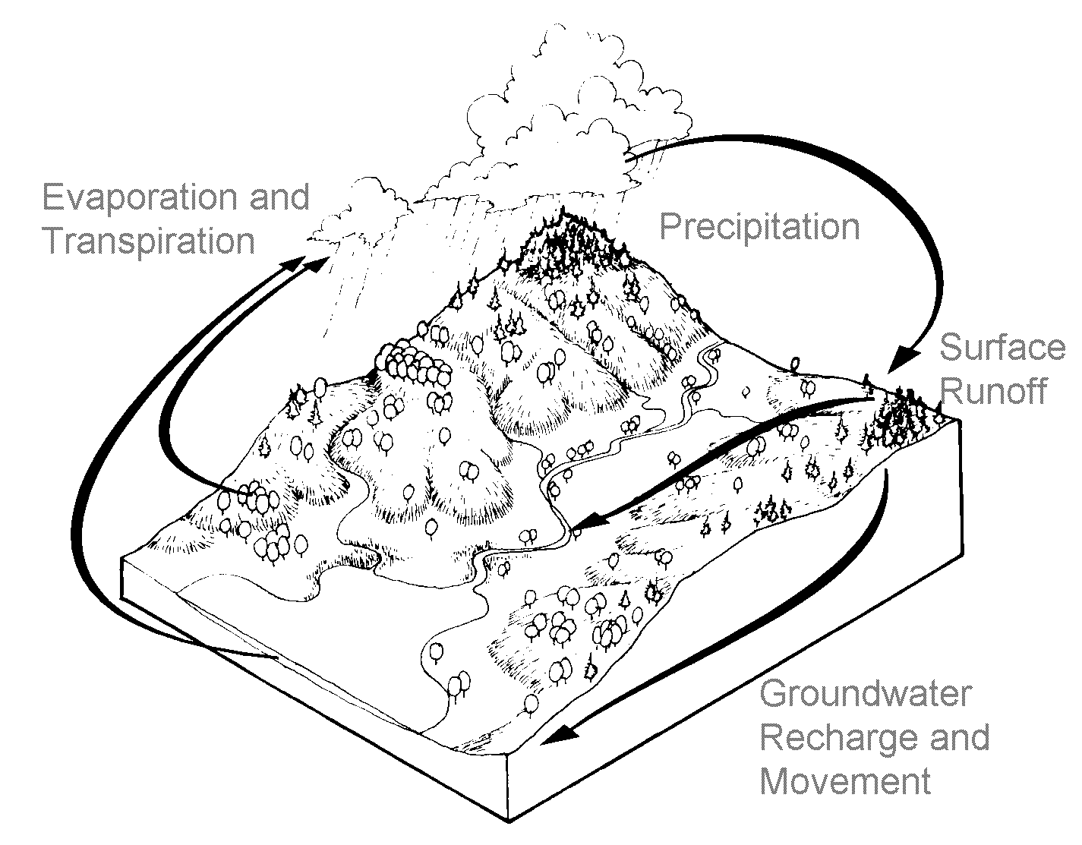
The cycle circulates water throughout the environment (Figure 1-1). This process maintains an overall balance between water in the air, on the surface and in the ground.

Figure 1-1. The Hydrologic cycle

Sometimes the hydrologic cycle gets outs of balance, sending more water to an area than it can normally handle.
The result is a flood.
A flood inundates a floodplain. There are different types of floodplains and they are based on they type of flooding that forms them.
Most floods fall into one of three major categories:
- Riverine flooding
- Coastal flooding
- Shallow flooding

Riverine Flooding
A watershed is an area that drains into a lake, stream or other body of water. Other names for it are basin or catchment area.
Watersheds vary in size. Larger ones can be divided into sub-watersheds.
Figure 1-2 shows a watershed and some of the key terms. The boundary of a watershed is a ridge or divide. Water from rain and snowmelt are collected by the smaller channels (tributaries) which send the water to larger ones and eventually to the lowest body of water in the watershed (main channel).
Channels are defined features on the ground that carry water through and out of a watershed. They may be called rivers, creeks, streams or ditches. They can be wet all the time or dry most of the time.
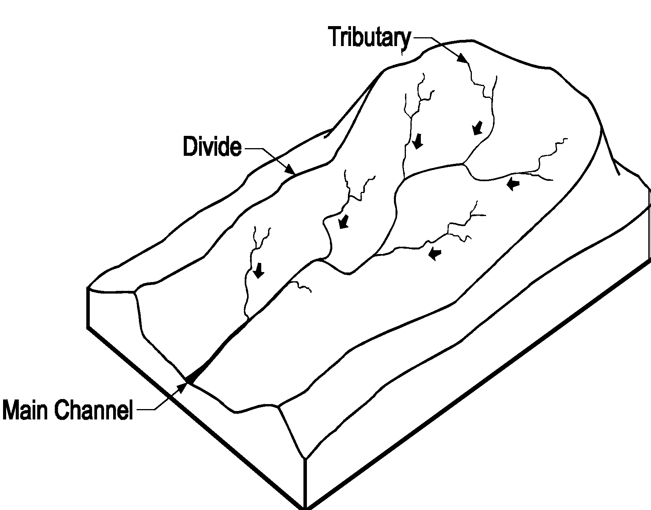When a channel receives too much water, the excess flows over its banks and into the adjacent floodplain. Flooding that occurs along a channel is called riverine flooding.

Figure 1-2. Riverine Watershed and Floodplain

What happens in a watershed will affect events and conditions downstream. Terrain helps determine the dynamics of riverine flooding. In relatively flat areas, shallow, slow-moving floodwater may cover the land for days or even weeks.
In hilly and mountainous areas, a flood may come scant minutes after a heavy rain. Such a flash flood gives short notice and moves so fast that it is particularly dangerous to people and property in its path.

Overbank flooding
The most common type of flooding in the United States is called overbank flooding (Figure 1-3).
Overbank flooding occurs when downstream channels receive more rain or snowmelt from their watershed than normal, or a channel is blocked by an ice jam or debris. For either reason, excess water overloads the channels and flows out onto the floodplain.
Overbank flooding varies with the watershed’s size and terrain. One measure of a flood is the speed of its moving water, which is called velocity. Velocity is measured in feet per second.
Hilly and mountainous areas have faster moving water, so velocity can pose a serious hazard. In flat areas, the flood may move slowly, making its velocity less of a hazard.
Terrain may affect how much warning people have that a flood is building. Conditions on a river that drains a large watershed may warn of a pending flood hours or even days before actual flooding. On the other hand, streams in hilly areas may give no warning that a flash flood is about to strike.
Flood depths vary, as do flood durations. Generally, the larger the river, the deeper the flood and the longer it will last. However, in hilly or mountainous areas with narrow valleys, flooding can be very deep in small watersheds.
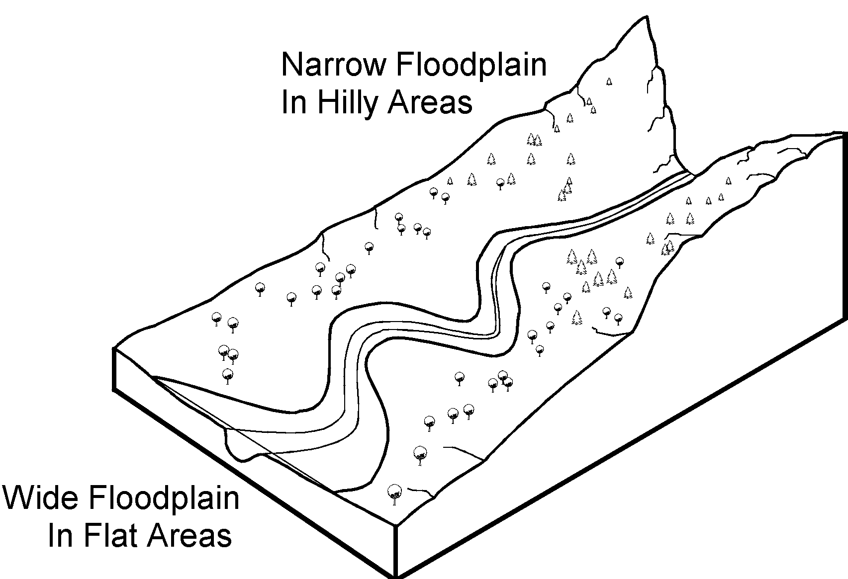
Depending on the size of the river and terrain of its floodplain, flooding can last for days and cover wide areas.

Figure 1-3. Riverine floodplain

Flash flooding
A severe storm that drops much rainfall in a short time can generate a flash flood. All flash floods strike quickly and end swiftly.
While flash floods occur in all fifty states, areas with steep slopes and narrow stream valleys are particularly vulnerable, as are the banks of small tributary streams. In hilly areas, the high-velocity flows and short warning time make flash floods hazardous and very destructive.
In urban areas, flash flooding can occur where impervious surfaces, gutters and storm sewers speed runoff. Flash floods also can be caused by dam failure, the release of ice-jam flooding, or collapse of debris dams.
Flash floods rank first as the cause of flood-related deaths in the United States. In the 1970s, four flash floods in a five-year period killed 570 people. Death tolls associated with the 1993 Mississippi River flood or hurricanes are in another category because such events build over several days, giving people enough time to evacuate safely.
- In 1972, 118 people died along Buffalo Creek in West Virginia when an embankment made of coal refuse washed out, destroying 546 houses and damaging as many more.
- Weeks later, 236 people died when heavy rain and a dam failure inundated the area near Rapid City, South Dakota. Property damage exceeded $100 million.
- In 1976, heavy rains spawned floods in Colorado’s Big Thompson Canyon, killing 139 people.
- The next year, 77 people died in Johnstown, Pennsylvania, when heavy rain overwhelmed a dam, causing $200 million in damage.

Riverine erosion
River channels change as water moves downstream, acting on the channel banks and on the channel bottom (the thalweg). This force is made more potent during a flood, when the river’s velocity increases.
Several features along a river are affected by this flow of water in different ways. A meander is a curve in a channel. On the outside of a meander, the banks are subject to erosion as the water scours against them (Figure 1-4). On the other hand, areas on the inside of meanders receive deposits of sand and sediment transferred from the eroded sites.
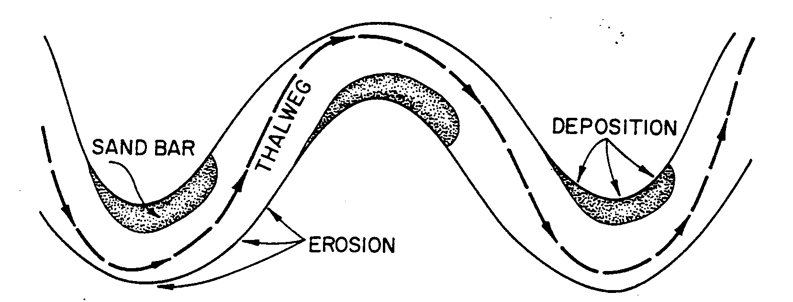
Figure 1- 4. Erosion changes the shape of channels

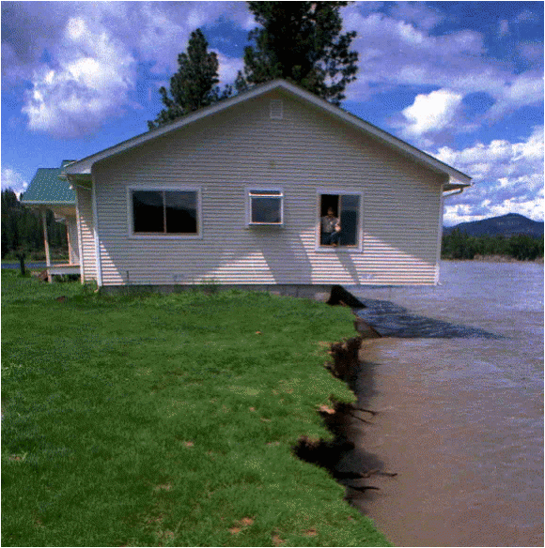Properties on the outside of curves face a double threat of inundation and undercutting from riverine erosion during floods (Figure 1- 5).
In addition, meanders do not stay in the same place—they migrate slowly downstream and across the floodplain, reworking the shape of the channel within the floodplain.

Figure 1-5. Riverine erosion
can undercut structures

Coastal flooding
Development along the coasts of the oceans, the Gulf of Mexico, and large lakes can be exposed to two types of flood problems not found in riverine areas: coastal storms and coastal erosion. The Pacific and Caribbean coasts face a third hazard: tsunamis.

Coastal storms
Hurricanes and severe storms cause most coastal flooding. These include “Nor’easters,” which are severe storms on the Atlantic coast with winds out of the northeast.
Persistent high wind and changes in air pressure push water toward the shore, causing a storm surge which can raise the level of a large body of water by several feet. Waves can be highly destructive as they move inland, battering structures in their path.
On open coasts, the magnitude of a flood varies with the tides. An increase in the level of the ocean during high tide will flood larger areas than a storm that strikes during low tide.
Major coastal storms can significantly change the shape of shoreline landforms, making sandy coastal floodplains particularly unstable places for development.
Wind and waves shape sand dunes, bluffs and barrier islands. Because these landforms provide natural buffers from the effects of a storm, their preservation is important to the protection of inland development.

Coastal erosion
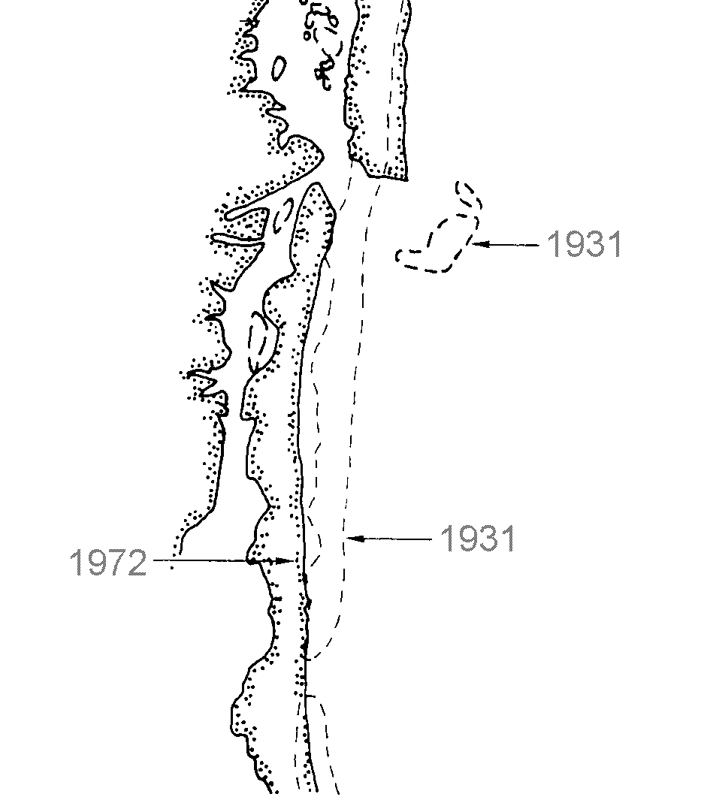
Long-term coastal erosion is another natural process that shapes shorelines. It is a complex process that involves natural and human-induced factors. The natural factors include sand sources, sand size and density, changes in water level, and the effects of waves, currents, tides and wind. These factors determine whether a shoreline will recede or accrete.
Human activity—such as construction of groins or seawalls, the dredging of channels and placement of sandbags—also can contribute to coastal erosion by altering the natural systems that transport sand.

Figure 1-6. This area of the Maryland shore shows how erosion can move or remove entire islands over a period as short as 40 years.

Tsunamis
Another hazard along the coast is a tsunami, a large wave often called a “tidal wave” even though tides and tsunamis are not related. Caused by an underwater earthquake or volcano, a tsunami is a pressure wave that can raise water levels as much as 15 feet.
In the open ocean, a tsunami’s wave may be only a few feet high. Because the wave’s energy extends from the surface to the bottom, that energy is compressed as the wave approaches shallow water, creating higher, more life-threatening waves (Figure 1-7).
Tsunamis usually occur in the Pacific Ocean, but they have caused floods in the Caribbean. Because they can happen on a clear day and are not related to storms, they can catch many people unawares.
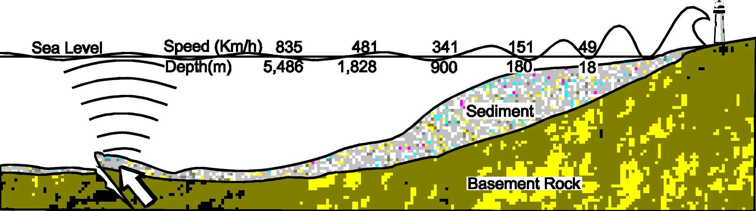
Figure 1- 7. Tsunami waves increase in shallower water.

Lake flooding
Lake shores can flood in ways similar to ocean coasts. Along the Great Lakes, severe storms can produce waves and cause shoreline erosion. FEMA is starting to map Great Lakes flooding with the same techniques it uses for ocean coastal flooding.

Shallow Flooding
Shallow flooding occurs in flat areas where a lack of channels means water cannot drain away easily. Shallow flood problems fall into three categories: sheet flow, ponding and urban drainage.

Sheet flow
Where there are inadequate or no defined channels, floodwater spreads out over a large area at a somewhat uniform depth in what’s called sheet flow.
Sheet flows occur after an intense or prolonged rainfall during which the rain cannot soak into the ground. During sheet flow, the floodwaters move downhill and cover a wide area.

Ponding
In some flat areas, runoff collects in depressions and cannot drain out, creating a ponding effect. Ponding floodwaters do not move or flow away. Floodwaters will remain in the temporary ponds until they infiltrate into the soil, evaporate or are pumped out.
Ponding is especially a problem in glaciated areas, where glaciers carved out depressions; in areas where caves and sinkholes are common, and in other areas where man-made features, such as roads and railroad embankments, have blocked outlets.

Urban drainage
An urban drainage system comprises the ditches, storm sewers, retention ponds and other facilities constructed to store runoff or carry it to a receiving stream, lake or the ocean. Other man-made features in such a system include yards and swales that collect runoff and direct it to the sewers and ditches.
When most of these systems were built, they were typically designed to handle the amount of water expected during a 10-year storm. Larger storms overload them, and the resulting backed-up sewers and overloaded ditches produce shallow flooding.
Another urban drainage problem occurs in the areas protected by levees. Being in floodplains, they are flat and don’t drain naturally, especially when a levee blocks the flow to the river.
To drain these areas, channels have been built and pumps installed to mechanically move the water past the levee. Often, these man-made systems do not have the capacity to handle heavy rains or intense storms.

Special Flood Hazards
The flooding types described so far are the more common types found in the United States. There are many special local situations in which flooding or flood-related problems do not fit the national norm.
This section discusses five of those special flood hazards:
- Closed basin lakes
- Uncertain flow paths.
- Dam breaks.
- Ice jams.
- Mudflows.
Closed basin lakes
There are two types of closed basin lake:
- Lakes with no outlets, like the Great Salt Lake, Utah, Devil’s Lake, North Dakota, and the Salton Sea, California; and
- Lakes with inadequate, regulated or elevated outlets, such as the Great Lakes and many glacial lakes.
Seasonal increases in rainfall cause a closed basin lake’s level to rise faster than it can drain. As a result, they are subject to large fluctuations in water surface elevation. Floodwaters in closed basin lakes may stay up for weeks, months or even years.
The long periods of high water make closed basin lake flooding particularly problematic. Properties may not be heavily damaged, but they are unusable for long periods because they are surrounded by—or under—water. Buildings are isolated and septic fields are unusable. Properties are exposed to waves (and sometimes ice) that add to the hazard.

Uncertain flow paths
The section on riverine erosion explained that stream channels change their locations gradually or only after very large and rare floods. However, in some areas of the country, every flood may change channels.
For example, in mountainous areas, high-velocity floodwater picks up sediment and rock. At the base of the valley where the slope flattens out, the floodwater decreases in speed and spreads out, as in a sheet flow, dropping sediment and rock over a fan-shaped area called an alluvial fan.
Figure 1-8 shows how an alluvial fan can have numerous channels. During the next flood, the channels may be in different locations.
Alluvial fan flooding is more common in the mountainous western states, where there is less ground cover and more opportunity for erosion.
Alluvial fan floods are not as predictable as riverine floods—one never knows where the floodwaters will spread out across the fan. Thus, they pose three hazards:
- Velocity of floodwaters and the debris they carry.
- Sediment and debris deposited by the floodwaters.
- The potential for the channel to move across the fan during the flood.
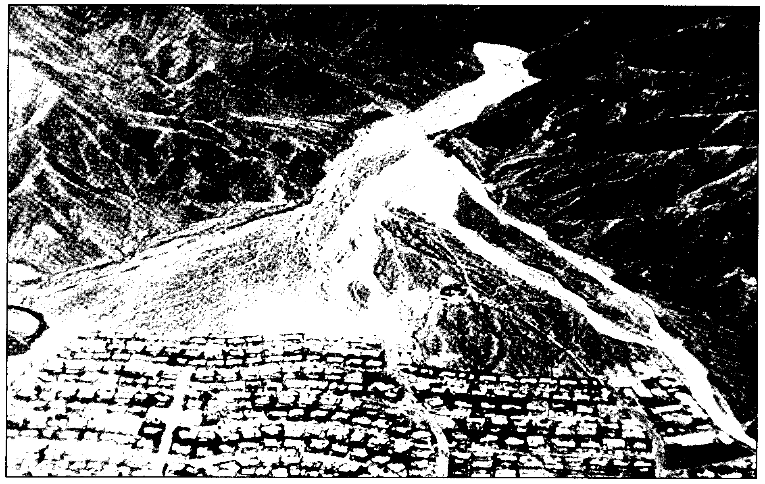
Figure 1-8. This alluvial fan flood caused over $7 million in damage and one death

The arid west is subject to another type of flooding that features uncertain flow paths, known as movable bed streams.
When a high-velocity flood runs through an area with sand or loose soil, the erosion and sedimentation can occur so fast that the stream channel can be lowered, filled in or relocated through processes known as degradation, aggradation and migration. In some cases, these processes may occur simultaneously, or one process may occur in one flood and another process in a later event.

Dam breaks
A break in a dam can produce an extremely dangerous flood situation because of the high velocities and large volumes of water released by such a break. Sometimes they can occur with little or no warning on clear days when people are not expecting rain, much less a flood.
Breaching often occurs within hours after the first visible signs of dam failure, leaving little or no time for evacuation. (As noted in the earlier section on flash flooding, three of the four top killer floods in the 1970s were related to the failure of a dam or dam-like structure.)
Dam breaks occur for one of three reasons:
- The foundation fails due to seepage, settling or earthquake.
- The design, construction, materials or operation were deficient.
- Flooding exceeds the capacity of the dam’s spillway.
Proper design can prevent dam breaks. While dam safety programs can ensure that new dams are properly designed, there are still many private or locally built dams that were poorly designed and maintained.

Ice jams
Ice jam flooding generally occurs when warm weather and rain break up frozen rivers or any time there is a rapid cycle of freezing and thawing.
The broken ice floats downriver until it is blocked by an obstruction such as a bridge or shallow area (Figure 1-9). An ice dam forms, blocking the channel and causing flooding upstream.

Figure 1-9. Likely Ice Jam Areas

Ice jams present three hazards:
- Sudden flooding of areas upstream from the jam, often on clear days with little or no warning.
- Movement of ice chunks (floes) that can push over trees and crush buildings (see Figure 1-18).
- Sudden flooding of areas downstream when an ice jam breaks. The impact is similar to a dam break, damaging or destroying buildings and structures.

Mudflow
A mudflow is a type of landslide that occurs when runoff saturates the ground. Soil that is dry during dry weather turns into a liquid solution that slides downhill. They typically cause more damage than clear-water flooding due to the combination of debris and sediment, and the force of the debris-filled water.
FEMA officially defines a “mudslide (i.e. mudflow)” as “a condition where there is a river, flow or inundation of liquid mud down a hillside usually as a result of a dual condition of loss of brush cover, and the subsequent accumulation of water on the ground preceded by a period of unusually heavy or sustained rain.”
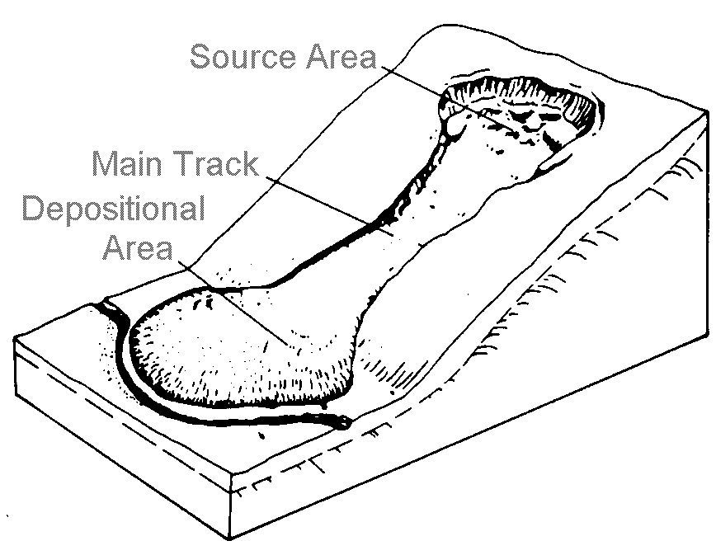
FEMA does not map or have any management or regulatory standards for “mudslides (i.e. mudflows).” What many people view as mudfloods are technically landslides and are not addressed by the NFIP.

Figure 1-10. Mudflows are caused by saturated soil

Natural and beneficial floodplain functions
Floodplain lands and adjacent waters combine to form a complex, dynamic physical and biological system found nowhere else. When portions of floodplains are preserved in their natural state, or restored to it, they provide many benefits to both human and natural systems.
Some are static conditions—such as providing aesthetic pleasure—and some are active processes, such as reducing the number and severity of floods, helping handle stormwater runoff and minimizing non-point water pollution. For example, by allowing floodwater to slow down, sediments settle out, thus maintaining water quality. The natural vegetation filters out impurities and uses excess nutrients.
Such natural processes cost far less money than it would take to build facilities to correct flood, stormwater, water quality and other community problems.
Natural resources of floodplains fall into three categories: water resources, living resources and societal resources. The following sections describe each category’s natural and beneficial functions.

Natural flood and erosion control
Over the years, floodplains develop their own ways to handle flooding and erosion with natural features that provide floodwater storage and conveyance, reduce flood velocities and flood peaks, and curb sedimentation.
Natural controls on flooding and erosion help to maintain water quality by filtering nutrients and impurities from runoff, processing organic wastes and moderating temperature fluctuations.
These natural controls also contribute to recharging groundwater by promoting infiltration and refreshing aquifers, and by reducing the frequency and duration of low surface flows.

Biologic resources and functions
Floodplains enhance biological productivity by supporting a high rate of plant growth. This helps to maintain biodiversity and the integrity of ecosystems.
Floodplains also provide excellent habitats for fish and wildlife by serving as breeding and feeding grounds. They also create and enhance waterfowl habitats, and help to protect habitats for rare and endangered species.

Societal resources and functions
People benefit from floodplains through the food they provide, the recreational opportunities they afford and the scientific knowledge gained in studying them.
Wild and cultivated products are harvested in floodplains, which are enhanced agricultural land made rich by sediment deposits. They provide open space, which may be used to restore and enhance forest lands, or for recreational opportunities or simple enjoyment of their aesthetic beauty.
Floodplains provide areas for scientific study and outdoor education. They contain cultural resources such as historic or archaeological sites, and thus provide opportunities for environmental and other kinds of studies.

These natural resources and functions can increase a community’s overall quality of life, a role that often has been undervalued. By transforming stream and river floodplains from problem areas into value-added assets, the community can improve its quality of life.
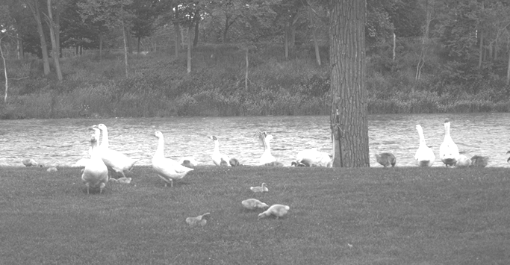
Parks, bike paths, open spaces, wildlife conservation areas and aesthetic features are important to citizens. Assets like these make the community more appealing to potential employers, investors, residents, property owners and tourists.


Figure 1-11 Floodplains offer recreation and aesthetic benefits.

 Learning Check #1
- This unit describes a number of types of floods. Which types occur in your community?

- What are the three most common types of flooding?

- Which type of flooding has accounted for the most flood-related deaths in recent history?

- What is a “meander?”

- What’s the major cause of coastal flooding?

- What causes a tsunami?

- List the five types of special flood hazards covered in this course. Does your community have any of these?

- List at least three benefits that floodplains, in a relatively undisturbed condition, actually contribute or could contribute to your community.

B. Floodplain Development
Throughout time, floods have altered the floodplain landscape. These areas are continuously shaped by the forces of water—either eroded or built up through deposit of sediment. More recently, the landscape has been altered by human development, affecting both the immediate floodplain and events downstream.
Historically, people have been attracted to bodies of water as places for living, industry, commerce and recreation. During the early settlement of the United States, locations near water provided necessary access to transportation, a water supply and water power. In addition, these areas had fertile soils, making them prime agricultural lands.
This pattern of development continued as communities grew. In recent decades, development along waterways and shorelines has been spurred by the aesthetic and recreational value of these sites.
Because floodplains have attracted people and industry, a substantial portion of this country’s development is now subject to flooding. Floodplains account for only seven percent of the nation’s total land area. However, they contain a tremendous amount property value. It is estimated that there are 8 – 12 million homes in our floodplains.
Two problems result from floodplain development:
- Development alters the floodplain and the dynamics of flooding.
- Buildings and infrastructure are damaged by periodic flooding.

Floodplain development dynamics
Human development can have an adverse impact on floods and floodplains. Three types of problems are reviewed here.

Riverine floodplains
The most obvious impact of development on riverine flooding comes with moving or altering channels or constructing bridges and culverts with small openings. Construction and regrading of the floodplain can obstruct or divert water to other areas. Levees and dikes are the best known examples of this, but even small construction projects have an impact (Figure 1-12).
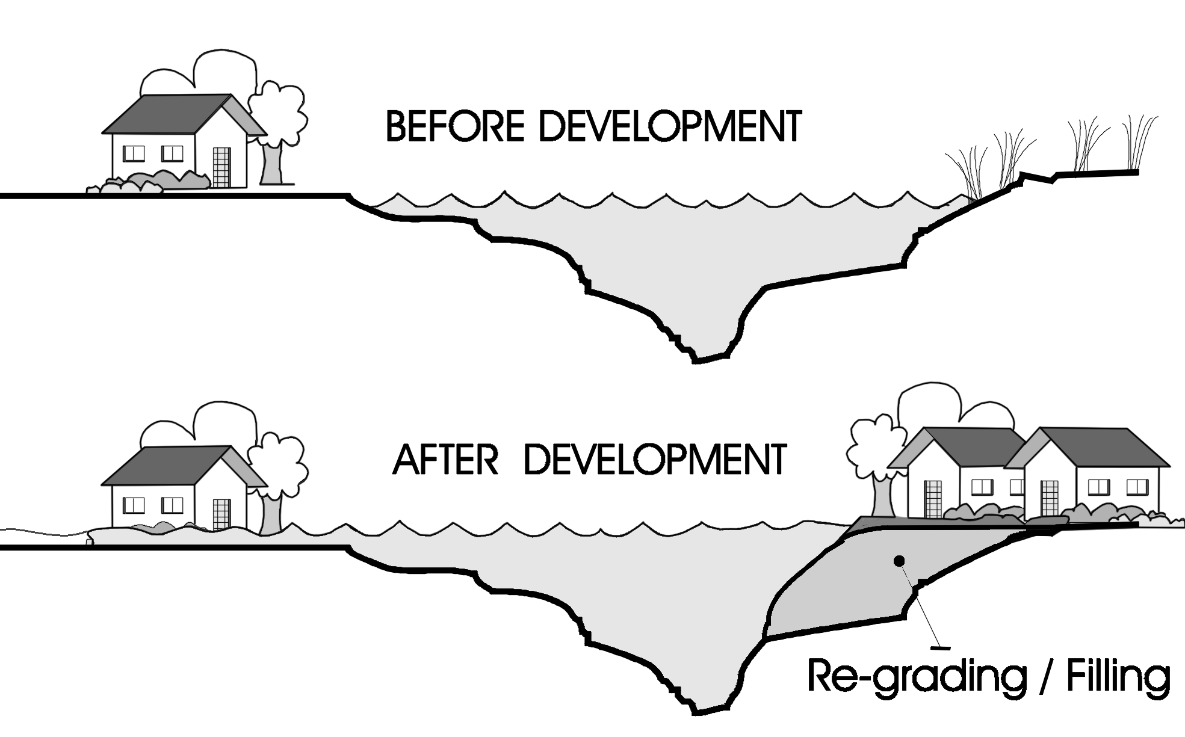
Filling obstructs flood flows, backing up floodwaters onto upstream and adjacent properties. It also reduces the floodplain’s ability to store excess water, sending more water downstream and causing floods to rise to higher levels. This also increases floodwater velocity.
Figure 1-12. Effects of development on a riverine floodplain

Watersheds
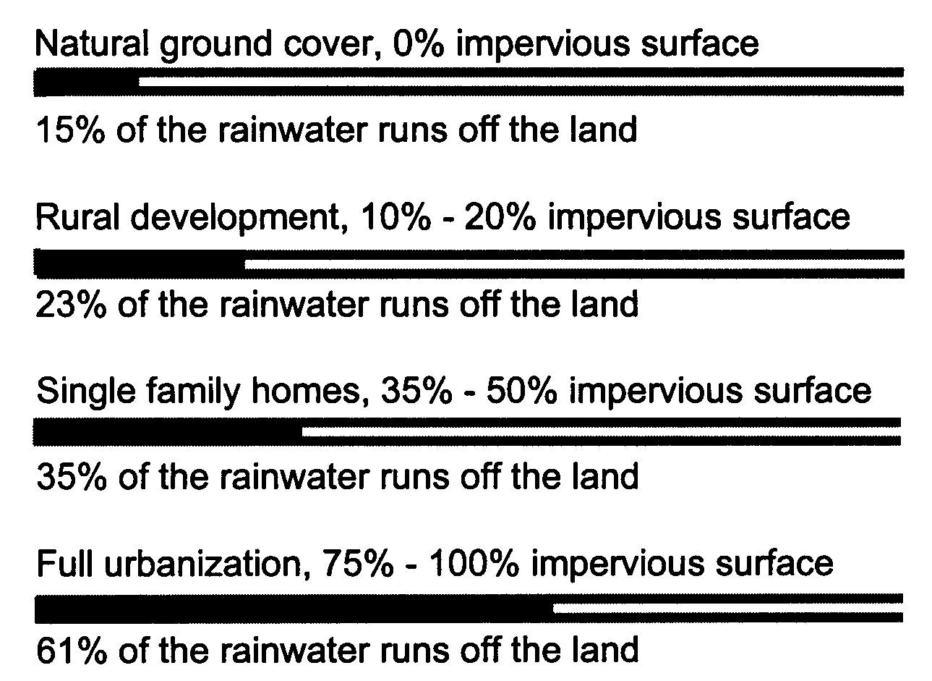
Development in riverine watersheds affects the runoff of stormwater and snowmelt. Buildings and parking lots replace the natural vegetation which used to absorb water. When rain falls in a natural setting, as much as ninety percent of it will infiltrate the ground; in an urbanized area, as much as ninety percent of it will run off (Figure 1-13).
Figure 1-13. Effects of development on
stormwater runoff. (Data for Northeastern Illinois)

Urban features alter flood dynamics as well. Storm sewers and more efficient ditches that come with urban drainage systems speed flood flows. The result of urbanization is that there is more runoff in the watershed and it moves faster, increasing flooding downstream. Thus, a 10-year storm may produce the runoff equivalent of a 25-year storm, overloading the man-made drainage system.
Urbanization also changes the timing of flows along the tributaries. If one subwatershed develops faster than another, the flood will leave sooner than it used to, possibly arriving at the main channel at the same time as the peak arrives from another tributary, causing increased flooding downstream.

Coasts
Coastal development similarly affects the dynamics of coastal flooding. Removing the sand from beaches and dunes removes the natural barrier built up by flood forces over the years and exposes inland areas to increased risk of flooding.
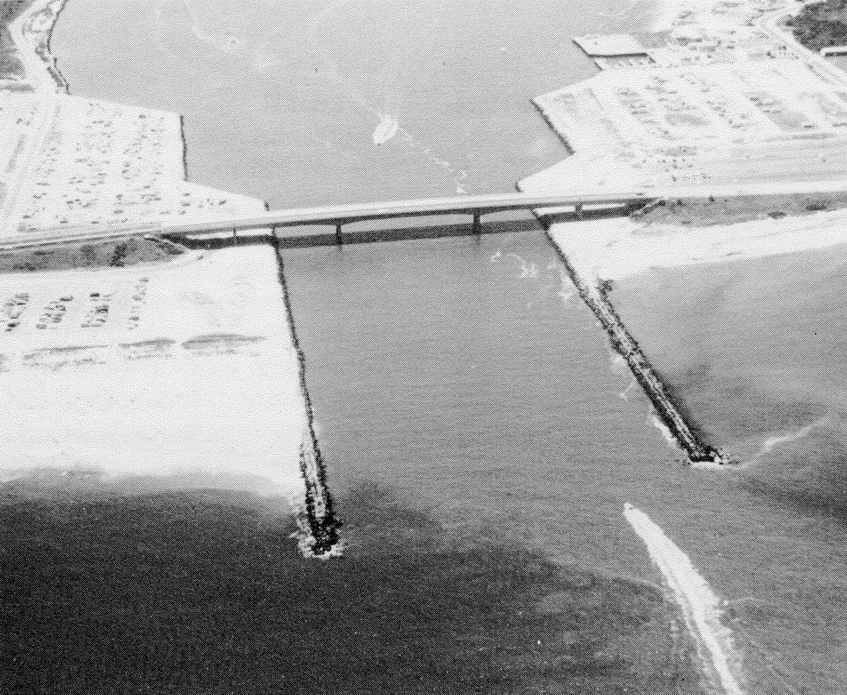
Coastal erosion is affected by construction of navigation channels, breakwaters, and jetties, and mining of sand. Often construction of barriers, seawalls, or even sandbag walls to protect buildings from flooding or erosion has an adverse affect on properties at the end of the walls where erosion is accelerated.

Figure 1-14. Jetties to protect a navigation inlet affect
sand accumulation and erosion.

Flood damage
Floodplains are home to nearly 10 million households. In an average year, floods kill 150 people and cause over $3 billion in property damage. Nationally, average annual flood losses continue to increase.
Floods can hurt or kill people, and damage property, in several ways. Knowing the impact of a potential hazard—and guarding against it—is integral to administering a floodplain management program.
As a floodplain management administrator, you need to be knowledgeable about the five main causes of flood damage:
- Hydrodynamic forces
- Debris impact
- Hydrostatic forces
- Soaking
- Sediment and contaminants

Hydrodynamic forces
Moving water creates a hydrodynamic force which can damage a building’s walls in three ways (see Figure 1-15):
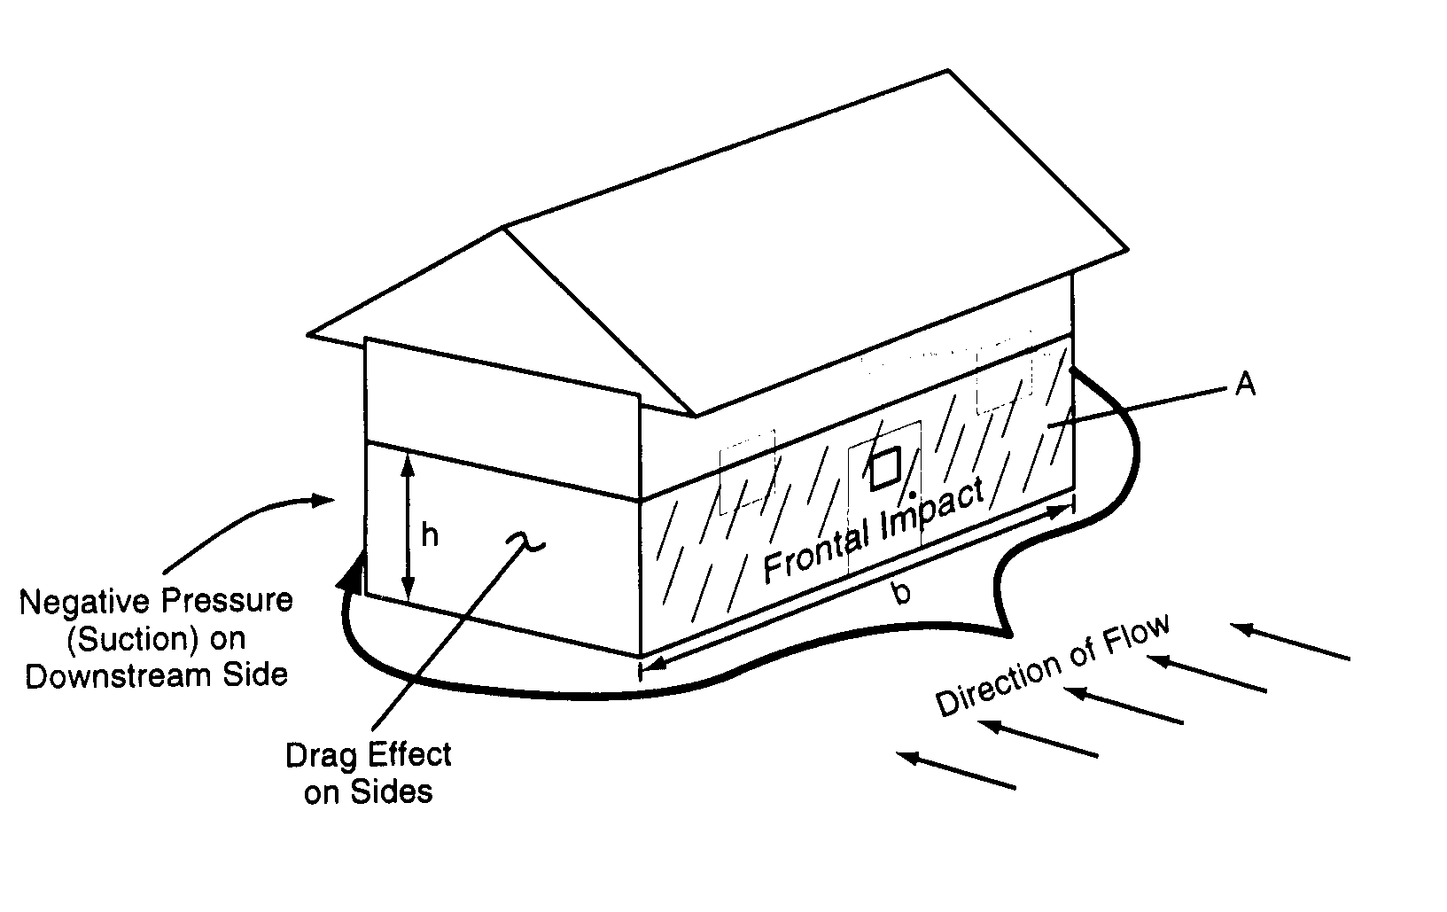
- Frontal impact, as water strikes the structure.
- Drag effect, as water runs along the sides of a structure.
- Eddies or negative pressures, created as water passes the downstream side.

Figure 1-15. Hydrodynamic forces on a building.

The speed of moving water is called velocity, a force that is measured in feet per second. The faster water moves, the more pressure it puts on a structure and the more it will erode stream banks and scour the earth around a building’s foundation.
Floodwaters moving faster than 5 feet per second comprise a high-velocity flood, requiring special design considerations for buildings, roads, bridges and other manmade structures in its path.
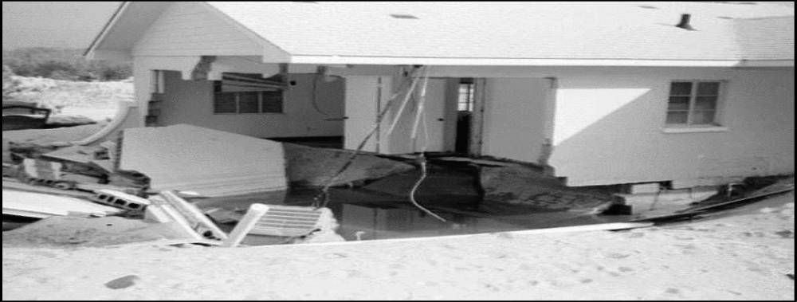

Figure 1-16. Beaches are particularly susceptible to
undermining of foundations due to velocity flows.

While velocity is one factor in determining the potential harm of a flood, the total impact of moving water is related to the depth of the flooding. Studies have shown that deep water and low velocities can cause as much damage as shallow water and high velocities.
People are more susceptible to damage than buildings: Studies have shown that it doesn’t take much depth or velocity to knock a person over. Thus, no areas with moving floodwater can be considered safe for walking (Figure 1-17).
A car will float in only two feet of moving water, which is one reason floods kill more people trapped in vehicles than anywhere else. Often victims put themselves in perilous situations by ignoring warnings about travel or mistakenly thinking that a washed-out bridge is still open.

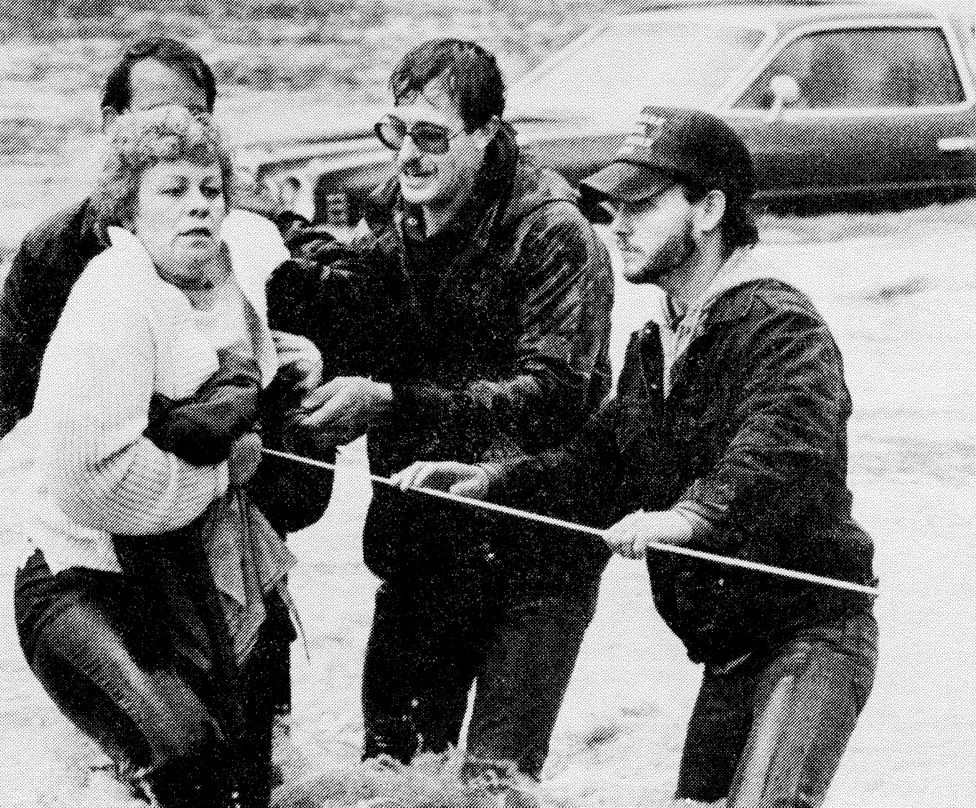

Figure 1-17. Even shallow floodwaters can stop cars
and wash people off their feet

Debris impact
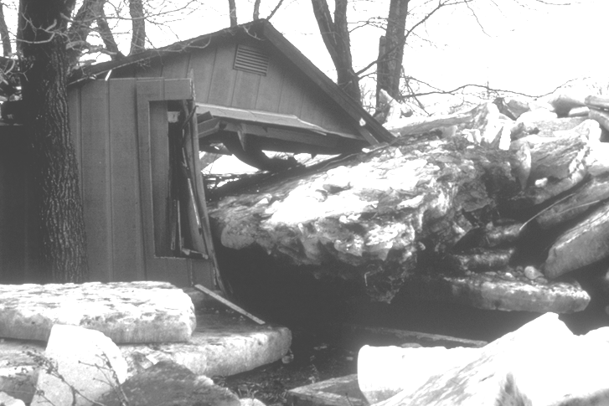
Debris also increases the hazard posed by moving water. Floodwaters can and will pick up anything that will float—logs, lumber, ice, even propane tanks and vehicles (Figure 1-18). Moving water will also drag or roll objects that don’t float. All of this debris acts as battering rams that can knock holes in walls.

Figure 1-18. Ice floes and other large items of debris can crush a house

Hydrostatic forces
The weight of standing water puts hydrostatic pressure on a structure. The deeper the water, the more it weighs and the greater the hydrostatic pressure.
Because water is fluid, it exerts the same amount of pressure sideways (lateral pressure) as it does downward. As water gets deeper, it exerts more lateral pressure than shallow water.
Most walls are not built to withstand lateral pressure. Studies and tests have shown that the lateral force presented by three feet of standing water can be enough to collapse the walls of a typical frame house.
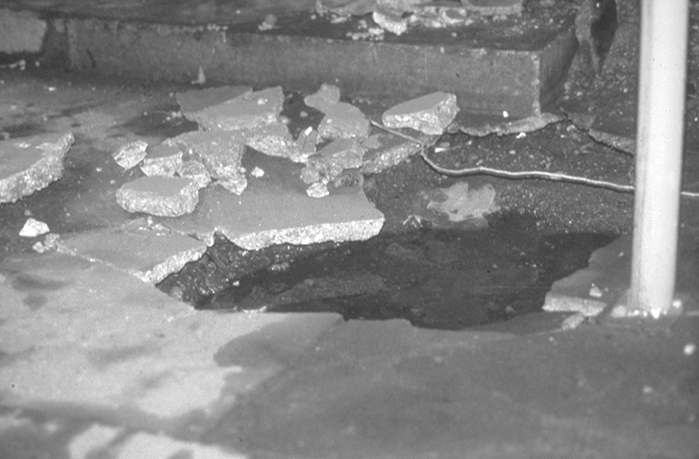
Basement walls and floors are particularly susceptible to damage by hydrostatic pressure. Not only is the water deeper, a basement is subjected to the combined weight of water and saturated earth. Water in the ground underneath a flooded building will seek its own level – resulting in uplift forces that can break a concrete basement floor (Figure 1-19).

Figure 1-19. This basement floor broke from hydrostatic pressure

Soaking
When soaked, many materials change their composition or shape.
Wet wood will swell, and if it is dried too fast it will crack, split or warp. Plywood can come apart. Gypsum wallboard will fall apart if it is bumped before it dries out. The longer these materials are wet, the more moisture they will absorb.
Soaking can cause extensive damage to household goods. Wooden furniture may get so badly warped that it can't be used. Other furnishings, such as upholstery, carpeting, mattresses and books, usually are not worth drying out and restoring. Electrical appliances and gasoline engines won't work safely until they are professionally dried and cleaned.

Sediment and contaminants
Many materials, including wood and fiberglass or cellulose insulation, absorb floodwater and its sediment. Even if allowed to dry out, the materials will still hold the sediment, salt and contaminants brought by the flood. Simply letting a flooded house dry out will not render it clean—and it certainly will not be as healthy a place as it was before the flood.
Few floods, especially those that strike inland, have clear floodwater, and so they leave a mess made of natural and man-made debris. Stormwater, snowmelt and river water pick up whatever was on the ground, such as soil, road oil, and farm and lawn chemicals. If a wastewater treatment plant upstream was inundated, the floodwaters will likely include untreated sewage.
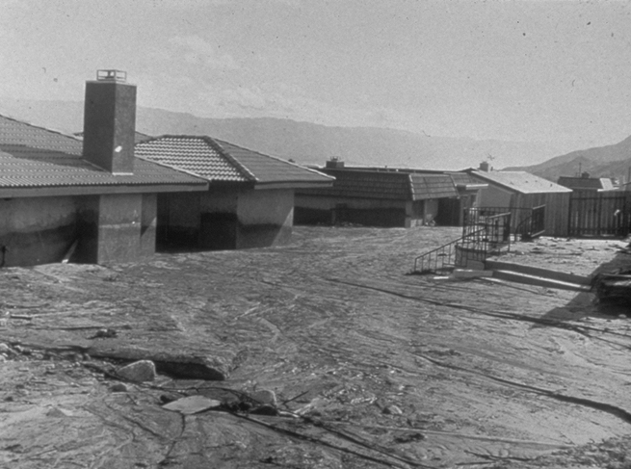
Especially in the arid west and coastal areas, flooding can leave large amounts of sand, sediment and debris (Figure 1-20) that require major cleanup efforts. After the water recedes or evaporates, these sediments are left on and in a building, and its contents.

Figure 1-20. Debris flows can completely

fill a house with sediment

Safety and health hazards
Floods pose a variety of hazards as they build, crest and subside. At different points in the life of a flood, people are displaced, damage occurs and finally a cleanup can begin. Disruption of normal public utilities and the presence of flood debris and damage can produce safety and health hazards.
When utilities are damaged, hazards arise. Electrocution is the second most frequent cause of flood deaths, claiming lives in a flooded area that is carrying a live current created when electrical components short. Floods also can damage gas lines, floors and stairs, creating secondary hazards such gas leaks and unsafe structures. If the water system loses pressure, a boil order may be issued to protect people and animals from contaminated water.
Fire can be a result of too much water: floods can break gas lines, extinguish pilot lights, and short circuit electrical wiring – causing conditions ripe for a fire. Fire equipment may not be able reach a burning building during high water.
Floods bring and leave health hazards in the form of animal carcasses, garbage and ponds that can become breeding grounds for germs and mosquitoes. Any flooded items that come in close contact with people must be thrown out, including such things as food, cosmetics, medicines, stuffed animals and baby toys. Clothes and dishes need to be washed thoroughly.
Mold, mildew and bacteria grow in damp, flooded areas. One health hazard occurs when heating ducts in a forced-air system are not properly cleaned following inundation. When the furnace or air conditioner is turned on, the sediments left in the ducts are circulated throughout the building and breathed in by the occupants.
Flooding, especially repetitive flooding, takes a toll on people's mental health. Stress comes from facing the loss of time, money, property and personal possessions such as heirlooms. This is aggravated by fatigue during cleanup and anxiety over lost income, health risks and damage to irreplaceable items.
Children and the elderly are especially susceptible to stress from the disruption of their daily routines.
C. Floodplain Management
The strategies and tools available to prevent problems and protect people and development from flooding have been developed over many years. A short history of U.S. policy on floodplain management will help explain their evolution.

Evolution
The federal government got involved in floodplain management in the 1800s, when it had an interest in maintaining the navigability of rivers to facilitate interstate commerce. The great Mississippi River flood of 1927 led the federal government to become a major player in flood control.
As defined by the Flood Control Acts of 1928 and 1936, the role of government agencies was to build massive flood control structures to control the great rivers, protect coastal areas and prevent flash flooding. The 1936 act alone authorized construction of some 250 projects for both flood control and relief work.
Until the 1960’s, such structural flood control projects were seen as the primary way to reduce flood losses. Public policy emphasized that flood losses could be curbed by controlling floodwater with structures, such as dams, levees and floodwalls. But people began to question the effectiveness of this single solution. Disaster relief expenses were going up, making all taxpayers pay more to provide relief to those with property in floodplains. Studies during the 1960s concluded that flood losses were increasing, in spite of the number of flood control structures that had been built.
One of the main reasons structural flood control projects failed to reduce flood losses was that people continued to build in floodplains. In response, federal, state and local agencies began to develop policies and programs with a “non-structural” emphasis, ones that did not prescribe projects to control or redirect the path of floods. Since the 1960s, floodplain management has evolved from heavy reliance on flood control, or structural measures, to one using a combination of many tools.
The creation of the National Flood Insurance Program in 1968 was a landmark step in this evolution. The NFIP:
- Established an insurance program as an alternative to disaster relief.
- Distributed responsibility for floodplain management to all levels of government and the private sector.
- Set a national standard for regulating new development in floodplains.
- Began a comprehensive floodplain mapping program.
Also during the 1960s and 1970s, interest increased in protecting and restoring the environment, including the natural resources and functions of floodplains. Coordinating flood-loss reduction programs with environmental protection and watershed management programs has since become a major goal of federal, state and local programs.
As a result of this evolution, we no longer depend solely on structural projects to control floodwater. U.S. floodplain policies are now multi-purpose and result in a mix of solutions to suit many situations. Consequently, administrators like you have several non-structural flood protection measures at their disposal. They include:
- Regulations to prohibit development in high-hazard areas.
- Building codes requiring flood-resistant construction for new buildings in floodprone areas.
- Acquisition and relocation of buildings in high hazard areas.
- Modifying or retrofitting existing buildings.
- Installing flood warning systems.
- Controlling stormwater runoff.
- Providing self-help advice to property owners.

The Unified National Program for Floodplain Management
To coordinate the efforts of the many government programs that can affect flooding or floodplain development, Congress created the Unified National Program for Floodplain Management under the National Flood Insurance Act of 1968.
The Unified National Program sets forth a conceptual framework for coordinating the floodplain management efforts of federal, state and local agencies as well as private parties.
The program is coordinated by a Federal Interagency Floodplain Management Task Force made up of federal agencies that are involved in flooding, or with development that can be affected by flooding.
The Task Force defines “floodplain management” as “a decision-making process that aims to achieve the wise use of the nation’s floodplains.” “Wise use” means both reduced flood losses and protection of the natural resources and functions of floodplains.
Where floodplain development is permitted, floodplain management results in development and construction measures that minimize the risk to life and property from floods and the risk to the floodplain’s natural functions posed by human development.

Strategies and tools
The Task Force has identified four floodplain management strategies for reducing the human economic losses from flooding as well as minimizing the losses of natural and beneficial floodplain resources. Each strategy is supported by an array of tools which are summarized in the rest of this section.
Many of the tools can be used in more than one strategy.
In most cases, a combination of these tools is needed to reduce risks and protect natural resources and functions. Because floodplain management is a process, there is no one “best” set of tools or one single “wise use” of the floodplain.
The important message from this definition of floodplain management is to consider all the options and account for both the hazard and the natural values before developing or implementing any action that will change the floodplain.

Floodplain Management Strategies

Strategy 1: Modify human susceptibility to flood damage
Reduce disruption by avoiding hazardous, uneconomic or unwise use of floodplains.
Tools include:
- Regulating floodplain use by using zoning codes to steer development away from hazardous areas or natural areas deserving preservation, establishing rules for developing subdivisions, and rigorously following building, health and sanitary codes.
- Establishing development and redevelopment policies on the design and location of public services, utilities and critical facilities.
- Acquiring land in a floodplain in order to preserve open space and permanently relocate buildings.
- Elevating or floodproofing new buildings and retrofitting existing ones.
- Preparing people and property for flooding through forecasting, warning systems and emergency plans.
- Restoring and preserving the natural resources and functions of floodplains.

Strategy 2: Modify the impact of flooding
Assist individuals and communities to prepare for, respond to and recover from a flood.
Tools include:
- Providing information and education to assist self-help and protection measures.
- Following flood emergency measures during a flood to protect people and property.
- Reducing the financial impact of flooding through disaster assistance, flood insurance and tax adjustments.
- Preparing post-flood recovery plans and programs to help people rebuild and implement mitigation measures to protect against future floods

Strategy 3: Modify flooding itself

Develop projects that control floodwater.
Tools include:
- Building dams and reservoirs that store excess water upstream from developed areas.
- Building dikes, levees and floodwalls to keep water away from developed areas.
- Altering channels to make them more efficient, so overbank flooding will be less frequent.
- Diverting high flows around developed areas.
- Treating land to hold as much rain as possible where it falls, so it can infiltrate the soil instead of running off.
- Storing excess runoff with on-site detention measures.
- Protecting inland development with shoreline protection measures that account for the natural movement of shoreline features.
- Controlling runoff from areas under development outside the floodplain.

Strategy 4: Preserve and restore natural resources
Renew the vitality and purpose of floodplains by reestablishing and maintaining floodplain environments in their natural state.
Tools include:
- Floodplain, wetlands and coastal barrier resources or land use regulations, such as zoning, can be used to steer development away from sensitive or natural areas.
- Development and redevelopment policies on the design and location of public services, utilities and critical facilities.
- Land acquisition; open space preservation; permanent relocation of buildings; restoration of floodplains and wetlands, and preservation of natural functions and habitats.
- Information and education to make people aware of natural floodplain resources and functions and how to protect them.
- Tax adjustments to provide a financial initiative for preserving lands or restoring lands to their natural state.
- Beach nourishment and dune building to protect inland development by maintaining the natural flood protection features.
Learning Check #2
- What two problems result from floodplain development?

- What does watershed development do to flooding?

- What is one of the problems with constructing seawalls to protect buildings from flooding or erosion?

- What are the five main causes of flood damage?

- Standing water as little as feet deep can collapse the walls of a frame house.

- What are some of the safety and health hazards that accompany floods?

- Prior to the 1960’s what was the primary way to reduce flood losses?

- What is the Unified National Program for Floodplain Management’s definition of “floodplain management?”

- What are the two primary goals of floodplain management?

 Unit Learning Exercise
- What areas are conducive to flash flooding?

- Is erosion only a threat in coastal areas?

- What is “ponding?”

- Are plants and animals the only beneficiaries of the “natural and beneficial functions” of floodplains?

- What does filling in a floodplain do?

- Does moving sand and sand dunes affect flooding?

- Hydrodynamic forces are caused by ______________ water and hydrostatic forces are caused by ______________ water.

- List three materials or household items that are particularly susceptible to flood damage by soaking.

- What are examples of non-structural flood protection measures?

- What are the Unified National Program for Floodplain Management’s four main floodplain management strategies?

Answers to the learning checks
Learning check #1
- This unit describes a number of types of floods. Which types occur in your community?
Depends on the community
- What are the three most common types of flooding?
Riverine, coastal, shallow
- Which type of flooding has accounted for the most flood-related deaths in recent history?
Flash flooding.
- What is a “meander?”
It’s a curve or turn in a river channel.
- What’s the major cause of coastal flooding?
Storm surge.
- What causes a tsunami?
Underwater earthquakes or volcanoes.
- List the five types of special flood hazards covered in this course. Does your community have any of these?
- Closed basin lakes
- Uncertain flow paths
- Dam breaks
- Ice jams
- Mudflows
If your community has one or more of these hazards, you should become familiar with their natural processes and the appropriate regulatory measures discussed in Unit 6.
- List at least three benefits that floodplains, in a relatively undisturbed condition, actually contribute or could contribute to your community.
Although this depends on the community, there are a large number of benefits they could potentially provide.
Learning check #2
- What two problems result from floodplain development?
- Development alters the floodplain and the dynamics of flooding.
- Buildings and infrastructure are damaged by periodic flooding.
- What does watershed development do to flooding?
The increase in impervious surface results in increased runoff and higher flood levels.
- What is one of the problems with constructing seawalls to protect buildings from flooding or erosion?
It can accelerate erosion on properties at the end of the wall.
- What are the five main causes of flood damage?
- Hydrodynamic forces
- Debris impact
- Hydrostatic forces
- Soaking
- Sediment and contaminants
- Standing water as little as feet deep can collapse the walls of a frame house.
Three feet
- What are some of the safety and health hazards that accompany floods?
- Disruption of public utilities
- Electrocution
- Contamination of water supplies
- Fire
- Animal carcasses, garbage and ponds that can become breeding grounds for germs and mosquitoes.
- Mold, mildew and bacteria that grow in damp, flooded areas
- Contaminated air from dirty heating ducts
- Stress and mental health problems.
- Prior to the 1960’s what was the primary way to reduce flood losses?
Structural flood control projects
- What is the Unified National Program for Floodplain Management’s definition of “floodplain management?”
“A decision-making process that aims to achieve the wise use of the nation’s floodplains.”
- What are the two primary goals of floodplain management?
- To reduce the loss of life, disruption, and damage caused by floods
- To preserve and restore the natural resources and functions of floodplains
Unit Learning Exercise
- What areas are conducive to flash flooding?
- Hilly areas with steep slopes and narrow valleys
- Urban areas with large amounts of impervious surfaces and storm sewers
- Areas downstream of dams or subject to ice jams
- Is erosion only a threat in coastal areas?
No. Riverine erosion can move stream channels and undercut structures.
- What is “ponding?”
Where stormwater runoff collects in depressions and cannot drain out.
- Are plants and animals the only beneficiaries of the “natural and beneficial functions” of floodplains?
No. People benefit from floodplains through the food they provide, the recreational opportunities they afford and the scientific knowledge gained in studying them. Floodplains also recharge groundwater supplies and their filtering actions help improve water quality.
- What does filling in a floodplain do?
Filling reduces the floodplain’s ability to store excess water, sending more water downstream and causing floods to rise to higher levels.
- Does moving sand and sand dunes affect flooding?
Yes, it may remove a natural barrier that protects inland properties.
- Hydrodynamic forces are caused by ______________ water and hydrostatic forces are caused by ______________ water.
Moving, standing
- List three materials or household items that are particularly susceptible to flood damage by soaking.
- Wood
- Gypsum wallboard
- Furniture and upholstery
- Carpeting
- Mattresses
- Books
- Electrical appliances
- Gasoline engines
- What are examples of non-structural flood protection measures?
- Regulations to prohibit development in high-hazard areas.
- Building codes requiring flood-resistant construction for new buildings in floodprone areas.
- Acquisition and relocation of buildings in high hazard areas.
- Modifying or retrofitting existing buildings.
- Installing flood warning systems.
- Controlling stormwater runoff.
- Providing self-help advice to property owners.
- What are the Unified National Program for Floodplain Management’s four main floodplain management strategies?
- Modify human susceptibility to flood damage
- Modify the impact of flooding
- Modify flooding itself
- Preserve and restore natural resources

