A Summary of the Design, Development, and Testing of Photomultiplier Tubes and Base Electronics for the BTeV Experiment

A Report for the BTeV Experimental Group and a Tutorial for the Phototube Initiate

May 31, 2001

Tim Brennan
Teacher Fellow, 2000-2001
Fermi National Accelerator Laboratory
Introduction

This account of photomultiplier tubes, base electronics, and testing is intended to be a summary of the work I have done for Fermilab’s BTeV experiment over the past several months. It is written to serve many purposes.
One purpose is somewhat self-indulgent; this document serves as a self-assessment of my level of understanding of this project. Though I have a background in electrical engineering, my knowledge of photomultiplier tubes was negligible and my experience in particle physics was none. I struggled mightily with many aspects of this project and the act of summarizing the results has clarified many, though not all, of my misunderstandings.
Another reason for creating this document is to account for the state of the project as I leave it. From the beginning of this Fellowship, it was unclear which project(s) might demand my attention, how deeply I might get involved with any given project, and whether I might “dabble” in a variety of projects. Looking back on the year, it seems clear that the opportunity to understand photomultiplier tubes, design base electronics, test the combinations of tubes and bases, and report on the results has filled out the calendar in a meaningful way. Though I do not consider myself to be an expert at any one of the tasks mentioned, I do feel as though I’ve developed, in a broad-based way, a greater personal understanding regarding the detection of light in particle collision experiments. Clearly, though I may be leaving, the development of tubes and bases will continue. For the benefit of the person who next takes up the task of advancing this project, I write what I hope to be a valuable review of this year’s efforts.
This document exists for yet another reason. I have learned throughout this year that there are many people, even some deeply involved with particle physics, for whom the topic of photomultipliers is something of a mystery. For some folks, their experience with photomultiplier tubes is something of a distant memory; for others, there has never been such an experience. Many rely on the expertise of a few, placing their trust in an industry and technology that are well developed. Photomultiplier tubes, for some, exist as “black boxes” - they are used without being completely understood. Though I make no claim to complete understanding myself and though this is obviously not the definitive document regarding photomultiplier tubes, it is my sincere wish that my work and this summary may act as a “primer” of sorts. For those who truly are experts in this field, I imagine this document to be of little benefit. What I hope for, with those readers, is that I have addressed the topic in such a way as to have committed no egregious errors.
Acknowledgments

As this is my final exercise before leaving, it seems like an appropriate time and place to give thanks. I would like to thank Harry Cheung for his mentoring throughout the year, providing me with everything from technical insights to test equipment to tours of experimental halls. Thanks also to Joel Butler, one of the BTeV spokespersons, for taking me on as a Fellow and for finding time for the occasional chat about life within and without the physics community. Thank you to Bob Jones and his wonderfully capable technical team, for providing me with first-class technical support; I’m sure Bob will not miss my frequent requests for “just one more” electronics assembly. I wish to give special thanks to Jeff Appel for his invaluable support, guidance, and friendship, particularly through some difficult moments. Elliott McCrory has also provided guidance and valuable insight into the workings of Fermilab; though we met late in the year, his impact on my Fellowship was significant, uplifting, and inspirational.
This has been a very challenging year for me, personally and professionally. To Tom Jordan, Liz Quigg, Spencer Pasero, Marge Bardeen, and all of the folks in Fermilab’s Education Office, I offer much praise and endless thanks. Without your vision of how an educator can participate in the world of high-energy physics, and without your faith in the ways that that world can positively influence the classroom, my year would have been far less valuable. Without your friendship, my year would have been far less enjoyable. I encourage you all – if I haven’t left you drained – to shepherd the next Teacher Fellow as you have shepherded me.
Finally, I can never thank my wife, Beth, sufficiently for her boundless faith in me, and her endless support of me. To get here, from Vermont, together, she left a job that she loved, with no assurance that it would be there upon our return. To go back, she will again leave a job - and some newly found friends and colleagues - that she loves, with no assurance that we will return to Illinois. Her sacrifices have been difficult ones; her insistence in making them, on my behalf, has been astonishing. I hope that in my lifetime I may, somehow, give back to her all she has given me. I believe it was Linus Pauling who, when asked why, after a lifetime filled with scientific successes, he continued to work on important scientific and social issues with a diligence unnecessary for a “retired” person, responded, “I want my wife to be proud of me.” With a partner like Beth, I can think of no greater creed by which to live. I look forward to our continued adventures together.
Photomultiplier Tube Theory of Operation

A photomultiplier tube (PMT) is a device that creates an electric charge in proportion to the amount of light energy that it receives. The charge is typically integrated throughout some critical time period and is taken as a measure of the input light energy. The operation of the PMT is critically dependent upon an important physical phenomenon: the photoelectric effect.
As the name suggests, the photoelectric effect involves both photons (particles of light) and electrons (particles of matter). Under the right conditions, a metallic plate will release electrons when struck by a single photon. The number of electrons liberated depends, in some special ways, upon both the intensity and the frequency of the light wave. Curiously, if the frequency of the light source drops below a critical, “cut-off” frequency, no electrons will be liberated, no matter how intense the light source. This frequency is a function of the metal used - each metal has a different cut-off frequency that depends upon the binding energy between that atom’s nucleus and its orbiting electrons. Hence the frequency of the light acts as a switch; the flow of electrons can be interrupted by allowing the frequency of the light to drop below the cutoff. Once above the cutoff frequency, the number of liberated electrons increases with the intensity of the light source. The relationship is essentially a linear one, at a given frequency.
If no electrons are emitted below the cutoff frequency – no matter how intense the light wave – then thinking of light as a wave cannot be completely correct. How, then, does one explain the mechanism of the photoelectric effect? One can visualize this effect by thinking of quantized particles of light – which Einstein dubbed “photons” – colliding with the surface atoms of the metals and liberating electrons via collisions. The greater the intensity is, the greater the number of incident photons and, hence, the greater the number of liberated electrons.
But that’s only part of the story. Each photon has an energy that depends upon its frequency. If the frequency of an individual photon is too low, its energy will be insufficient to the task of liberating the electrons, which are bound to the atom by electromagnetic forces. Indeed, rather than speaking of “collisions,” physicists would say that an electron “absorbs” the energy of the incident photon and, if the absorbed energy was great enough to overcome the binding electromagnetic force, the electron will be freed. While it is possible for multiple low-energy photons to “collide” with an electron virtually simultaneously, thereby contributing a total energy capable of releasing the electron from the bounds of the nucleus, in practice, this is rare. Therefore, the number of electrons liberated by light of the “wrong” frequency is, to a first approximation, zero.
So, assuming the incident photons are energetic enough, where do these liberated electrons go? If the metal is inside a photomultiplier tube, then the electrons are released from an initial metal plate (the photocathode) into an electric field. The field is set up in such a way as to accelerate the electrons toward a second metal plate where, upon colliding with the plate, more electrons are liberated. The incoming electrons have such great velocity (and, therefore, kinetic energy) that each one can liberate 3-4 more electrons. A third plate, held at a voltage that is higher still than the second, will replicate the process. This can continue for as many stages as is practical (typically 6-12) with the same kind of yield at each stage. A tremendous multiplicative factor can be achieved in this manner; a ten stage PMT with a gain of 3 electrons per stage will have a gain of 3¹⁰ or roughly 60,000. Thus, in this example, for every electron liberated at the photocathode, 60,000 will arrive at the last stage (the anode).
There are many types of PMT construction techniques. Each technique optimizes one or more of the following variables that are important to the PMT user: cost, electron collection efficiency, size, gain, response time, and linearity (Philips, page 1-14). In general, one can say that a prerequisite of the geometry of the successive plates (dynodes) is that electrons liberated from one plate should be physically directed toward the next plate. In other words, though an electric field will be used to accelerate the electrons from one dynode to the next, there should be no physical barriers in the electrons’ path. Clearly, a wide variety of strategies will achieve this goal; some of these are shown below (figure from Philips, page 1-15):

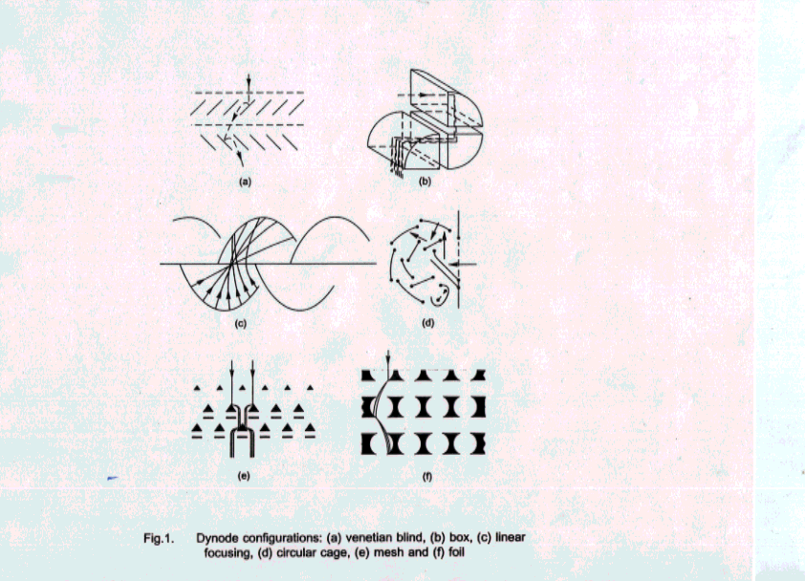

The voltages at each dynode need to be both large enough to effectively collect the liberated electrons and stable enough to create known, reliable electric fields. In addition, the first stage and the last stage(s) need to be particularly efficient in order to maximize the efficiency of the PMT.
The first stage of the PMT is the photocathode to first dynode. The voltage between these two plates needs to be great enough so that any electrons emitted by the cathode can be efficiently swept up by the first dynode. Interestingly, the effect of this voltage is negligible as long as it remains above a certain threshold, typically on the order of tens of volts. When the voltage is greater than this threshold, the cathode acts like a current source; the number of electrons is proportional to the incident flux of photons (Philips, page 1-11). Typically, the first dynode-to-cathode voltage is set at 2-3 times the nominal voltage difference between the dynode stages.
The dynode-to-dynode voltage level has a great impact on the overall gain of the PMT. Indeed, it is the usual way in which a particular gain is achieved. There are two physical effects that determine the gain. Some liberated electrons do not make it, for one reason or another, to the next stage. The percentage of previously emitted electrons that strike the next dynode is called the collection efficiency, l. On the other hand, there is a multiplying effect; a single electron can liberate more than one electron at a given dynode. This is called the secondary emission coefficient, s. Each of these effects is an increasing function of dynode voltage. In fact, the relationship between l, s, and V, the interdynode voltage, is:

l * s = k * V ª (Philips, page 1-12)

where k = constant of proportionality that varies with PMT
a = an exponent with a value between .65 and .75

The product of these two effects (l and s) can be called the gain (g_{i}) for a given stage of the PMT. The overall gain of the PMT is simply the product of the individual stage gains. In the simplest arrangement, all of the interdynode voltages are equivalent and all of the gains are equivalent, as well. For an n-stage PMT, the overall gain would be:
(g)^{n} = (k * Vª)^{n}
g ^{n} = k^{n} * V^{an}
g ^{n} = k’ * V ^{(.7n)} (allowing a = .7, k^{n} to be replaced by k’)

Here it is now plain to see that the gain is proportional to an exponential function of the interdynode voltage. The exact exponent depends upon the number of stages - in the final equation above, if one assumes that a is approximately .7, then a ten stage tube will result in an exponent of, roughly, 7.
Finally, when considering the interdynode voltages, one needs to carefully consider the last one or two stages. These are the stages that must provide the greatest number of electrons; any performance variations that are functions of current will be most apparent here. There are, at least, two separate issues to consider.
First, if the dynode voltages are created by a resistor divider circuit (shown below, Figure 2, Philips, page 1-3), it is important to make the maximum dynode current a small portion of the overall resistor string current. If the dynode current does become an appreciable percentage of the string current, then the voltage at the dynodes will drop by an amount equal to the resistor-dynode current product and the gain of that stage will drop as well. Typically, the resistors are chosen such that the string current is 10-100x the maximum dynode current. In addition, capacitors are placed across the dynodes to supply the dynode charge while keeping the dynode voltage relatively fixed. One attendant problem with these solutions is this: the resistors will dissipate heat according to I²R and this heat can cause fluctuations in tube and scintillator performance, particularly in the case where many PMTs and, perhaps more importantly, many scintillators are expected to operate in close proximity to one another. Additionally, the storage capacitors can be prohibitively large and expensive. For these reasons and others, Kerns has advocated the use of a transistorized base. More will be said about this later.

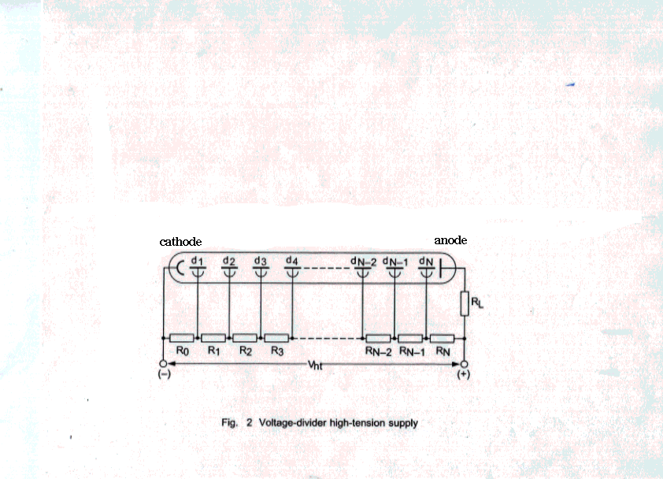

The other issue to consider is the space charge effect. When electrons are liberated from a dynode, they will not all leave at once, nor will they all have the same kinetic energy. A group of electrons, therefore, will spread out in space and arrive at the next dynode at different times. The electrons, of course, are negatively charged and will create an electric field in opposition to the electric field that is set up by the (positive) voltage between the two dynodes in question. In small numbers the electric field created by the earliest arriving electrons will create only a modest oppositional field. The late arriving electrons will have enough kinetic energy to easily overcome such opposition. But, in larger numbers, the earliest arriving electrons can create an opposing field large enough to inhibit the late arriving electrons. This “space charge effect” can prevent the PMT from operating as a linear instrument; the gain of the PMT at the uppermost levels of input light energy may be diminished when compared to the gain at the lower input levels. The likeliest locations for this space charge effect are in the final few stages of the PMT where the number of electrons is greatest. One simple way to address this effect is to increase the voltages at the last few stages; the resulting increase in the electrons’ kinetic energy is often adequate for overcoming the oppositional field. This additional field strength, however, also diminishes the useful lifetime of the tube; the final few plates will wear down more quickly due to the additional interactions of photons and electrons.

Electronics Design

My primary responsibility throughout this design and test project has been to design a ten-stage (and later a six-stage) base electronics package that was to provide the proper voltages to the dynodes, couple the resulting signal out to an integrator, and create as linear a response as possible to a wide range of input light energy. In addition to these universal requirements of a base, there were several other key design goals, driven by specific BTeV needs:

- low heat dissipation
- small volume
- AC coupling of anode signal

Each goal was met with a different design choice. In order to dissipate as little heat as possible, I chose to use a transistorized base, a la Kerns. To keep the package small, we created a long, narrow printed circuit board, populated with (mostly) surface mount electronics. AC coupling was achieved, naturally, through the use of a capacitor, though the value of that capacitor had to be chosen carefully within the tradeoff of circuit performance versus size. Each of these choices is considered below. In addition, the topic of linearity is of such primary importance that it will be considered in greater depth, in the testing section.

Low Heat Dissipation

The use of transistors in a base allows one to accomplish two simultaneous, and somewhat competing, goals that would not be possible to attain with the traditional, resistive, base. The two goals are to maintain dynode voltages that do not vary with appreciable dynode current and to provide that additional current while dissipating as little heat as possible within the base. It will be instructive to look at the resistive base strategy to see why these goals are difficult within that model.
As stated earlier, in order to keep the dynode voltages from varying during the time when current is supplied to those dynodes, a large standing current is required in the resistive string. If that current is large, then the meager, additional current to be supplied to the dynodes will create a small, hopefully tolerable, additional drop in voltage across the resistors. If the additional voltage drop is objectionable, one would increase the standing current by dropping the resistive values accordingly. One proceeds in this manner until the dynode current is a small enough fraction of the resistor current. The large standing current through the resistors, of course, creates additional heat according to I²R. It was our desire to keep that heat to a minimum since our tubes and bases would ultimately be placed in assemblies that number in the thousands, and the scintillator performance (to say nothing of the tube and base performance) is well known to vary with temperature.
A transistorized base, however, can provide the fixed voltages necessary for the dynodes while simultaneously providing both large dynode currents and low heat dissipation. To see why, one must consider the operation of the transistor: current that flows into the base of the transistor is amplified – by a gain factor that has a guaranteed minimum value for any given transistor model – into current that flows from the collector to the emitter (see Figure 3a below). While that current amplification is occurring, the base-emitter voltage is fixed at approximately one diode drop, or roughly .5 volts. In practice, the base of the transistor is connected to the junction of two resistors, the values for which have been chosen so that they create an appropriate dynode voltage (see Figure 3b below). The emitter is connected to the dynode. Its voltage is just .5 volts lower than that junction, a negligible drop considering the usual levels of voltage associated with dynodes. The transistors are cascaded together with the emitter of one transistor being connected to the collector of the next one. The dynode currents flow through the collector-emitter junctions and only a small portion of that current is necessary to flow into the bases. Since it is only the small base currents, and not the dynode currents, that flow through the resistor string, the resistor values themselves can be much larger, the standing current can be much lower, and the overall heat dissipation drops according to I²R.

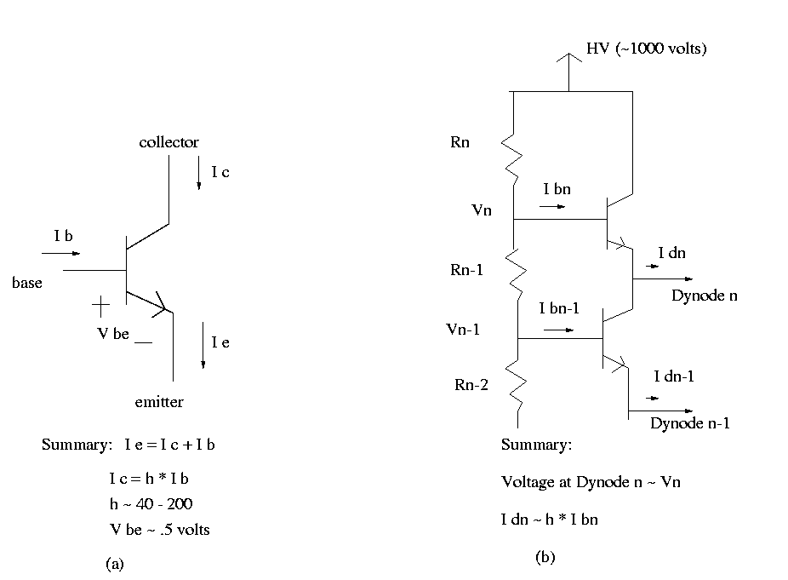
Figure 3 (a) Typical transistor characteristics and (b) Transistors used to supply dynode current and voltages

Of course, during the supply time for the dynodes, the dynode current does heat up the transistors by the same amount that that current would have heated the resistors. But the duty cycle of that supply is typically very low and the overall heat dissipation of the circuit can be approximated, to a first degree, by looking at the “no load” condition. Indeed, it is under this assumption that the dissipative woes of the resistive base are perhaps most clearly seen. For a resistive base, the resistor values are chosen to be low so that, in the rare case that dynode current needs to be supplied, the additional voltage drop is negligible. At all other times, the resistors simply heat up their environment.
A short series of calculations can demonstrate the advantage of the transistorized base. Let’s assume a 1000-volt supply and a need to provide a maximum of 1 mA of dynode current. In a resistive base, we would choose our resistors so that the 1 mA dynode current was, at most, 1/10th of the standing current through the resistors. Such a choice would force a standing current of, at least, 10 mA. The power dissipated in the resistive string can be calculated according to VI, where V is the overall high voltage supply. This circuit would dissipate, at all times, (1000 V * 10 mA) or 10 watts.
In a similar, transistorized base, with the same assumptions, we could choose resistors that were much larger. To choose correctly, we need to understand the additional current flowing through the resistors during dynode supply time. If we assume a very modest gain of 40 in our transistors, then the additional resistor current would equal the base current which would be, at most, 1 mA/40, or .025 mA. The resistors would then be chosen to create 10x this amount of standing current. The power dissipation would then be (1000 V * .25 mA), or .25 watts. The decrease in power dissipation is, of course, a factor of 40. Choosing transistors with greater gains will result in greater power savings.

Small Volume

Previous negotiations with the Hamamatsu organization led to the selection of a PMT with a one-inch diameter. Though we wished for the PMT and base to take up as little space as possible, there was a degree of freedom in the length of the assembly. So, though the cross-section of the assembly was restricted to a one-inch diameter, the base electronics could be as long as necessary. The electronics fit comfortably on a 3.00-inch board. This length, when combined with a “seating” height above a socket and the thickness of an end cap, created an overall length of 3.41 inches.
I followed the lead of a previous experiment in choosing a housing appropriate for the base electronics. The KTeV group had created a tube that covered the electronics and was secured by screws that passed through the tube and terminated into a metallic end. I modified the KTeV drawings and selected materials that were appropriate for the BTeV base. One important difference between the KTeV and BTeV housing tubes was that the BTeV housing needed to be made of a non-conductive material. PVC piping of the right diameter turned out to be an inexpensive and easily worked source; ten feet of one-inch (outside) diameter PVC pipe costs about $3.00 and would yield approximately 30 housings! The end cap needed to be metallic and easily worked. I chose a standard grade of aluminum (6061-T6); this is the same choice made by the KTeV group. Mechanical drawings for each of these pieces are shown below.
One additional note about heating: if necessary, holes could be drilled in the housing to allow for heat to naturally dissipate away from the electronics. We considered doing this as a standard; to date, though, there is little evidence showing a need for such ventilation.

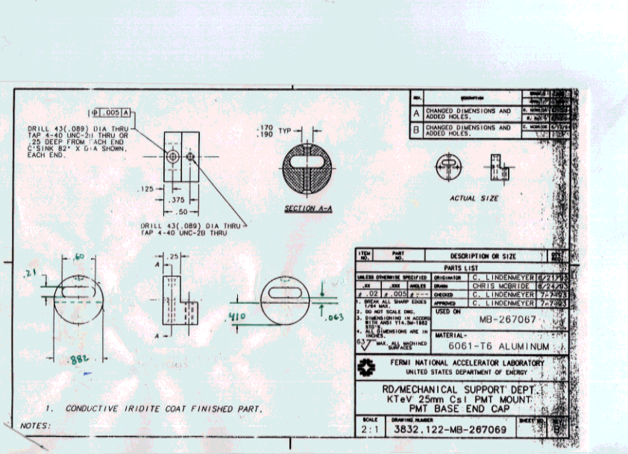

Figure 4. End Cap for Base Electronics Assembly

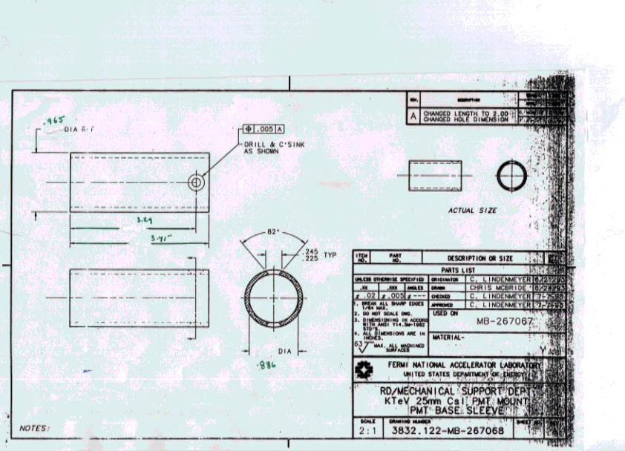

Figure 5. Housing for Base Electronics Assembly

AC Coupling

The output of a PMT is available at the anode. For the BTeV project, it had been previously decided that a positive power supply would be used. (For a summary of the tradeoffs between positive and negative supplies, see Appendix C.) This meant the anode would be held at some high voltage, typically 1000 volts and such a large voltage cannot be passed onto the integrating electronics; capacitors are used to block the DC voltage while passing along the AC portion of the signal.
Though any capacitor will block the DC voltage, one must choose the right capacitor to pass along the AC portion with minimal distortion. The output section of the base is a simple high-pass filter, or a differentiator. The voltage across the, standard, 50-ohm output resistor is approximated by:

Vo(t) ~ 50*C * dVc/dt (Horowitz and Hill, page 22)

I ran spreadsheet simulations of this output based on an estimated input current that is represented below in Figure 6. This particular signal would create an integrated output of approximately 200 pC, which seemed, at the time, to be a reasonable design maximum. Examination of the various output signals (Figures 7a-7c) reveals important information. As the size of the capacitor grows, the maximum output approaches the IR product of, roughly, 4 mA and 50 ohms, or 200 millivolts. In addition, the shape of the output signal approaches the shape of the input signal. Finally, increasing capacitance generates smaller and smaller overshoot voltages on the back end of the signal. If there were no other considerations, the choice for the largest available capacitor would be clear. Capacitor size, however, grows with the product of capacitance and voltage. The coupling capacitor, in this application, would be expected to withstand a minimum of 1500 volts and general engineering safeguards would push that choice to 2000 or even 3000 volts. As the capacitance value increases toward the microfarad range, the size of the capacitor becomes prohibitively large, given the volume constraints considered earlier. Indeed, locating standard inventory capacitors with a 3000-volt rating and a .022 uF value became problematic; I eventually settled for two .01 uf capacitors in parallel. The performance of these parallel capacitors is closely modeled by Figure 7b.
Clearly, from a signal point of view, it would be desirable to get larger valued capacitors; the limited volume prevents that choice for now. It may be true that surface mount capacitors with 3000-volt ratings and large capacitor values will become available for future use. Alternately, this coupling capacitor would be unnecessary in a scenario where the anode was grounded but still positive with respect to the cathode, that is, with a negative power supply.

Figure 6. The Estimated Input Current into the AC coupling capacitor

Figure 7a. Voltage Output with .0022 uF capacitor

Figure 7b. Voltage Output with a .022 uF capacitor

Figure 7c. Voltage Output with .22 uF capacitor

Having selected the capacitors and analyzed the stages that would benefit from having transistors, I designed the circuit in Figure 8. Later, I will refer to two versions of this design: the uniform voltage and the tapered voltage design. In the uniform voltage design, resistors R9, R10, and R11 all have values of 560 Kohms, resulting in a uniform voltage distribution from dynode 1 through dynode 10 and the anode. In the tapered version, R9 is a 1.1 Mohm and R10 and R11 are both 1.8 Mohm resistors. The resulting voltage distribution is “tapered” in that the voltage difference between dynodes 9 and 10 is roughly twice that of the previous stages whereas the final two stages have voltage differences that are three times the earlier stages. The tapered base helps to eliminate the space charge effect mentioned earlier.

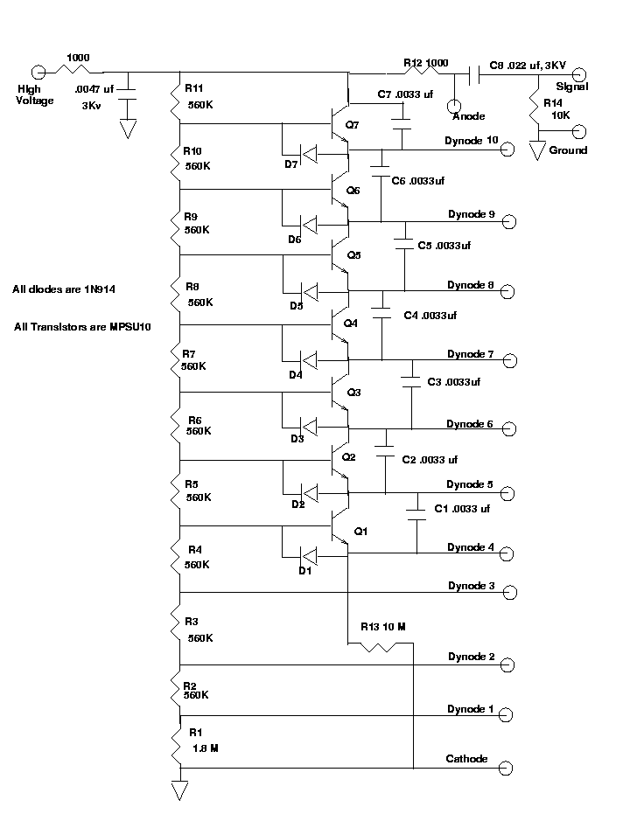

Figure 8. Ten Stage Base Schematic

Test Setup

A critical function of the PMT/base combination is that it should deliver a linear output in response to changes in input light energy. In order to test these bases and tubes for linearity, I used a testing station originally developed for the KTeV program. A block diagram is show below; the station currently resides in the front room of Lab 5.

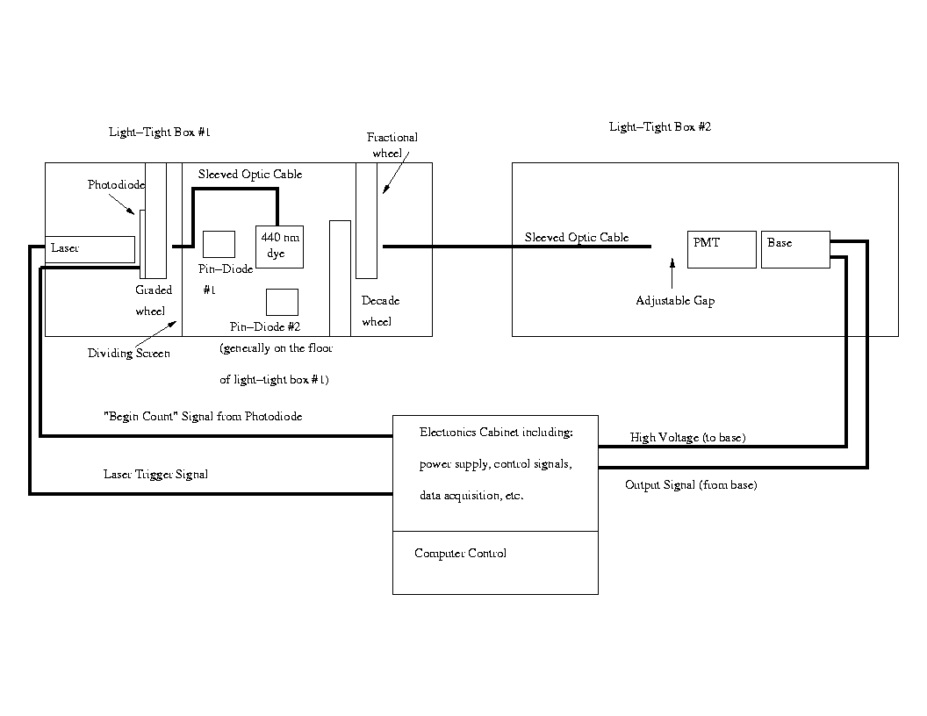
Figure 9. The PMT Linearity Test Station

There were two critical software utilities that provided me with control over the test station. One, called “calibf,” allowed me to choose start (opaque) and end (transparent) positions of the graded wheel. Before running any linearity test, I would invoke calibf in order to set the graded wheel to its start position. In addition, after major changes occurred in the test station – or after power outages or interruptions that forced a resetting of the electronics – I would run the calibf routine in order to recalibrate the start and end positions.
The other critical routine is called “burrfera” after two of the types of analog to digital converters used in the collection of data. Though burrfera grants the user an abundance of test strategies, I used only three.
Choosing “1” from the burrfera menu would begin a linearity test. During the test, the graded wheel would slowly advance from opaque to transparent allowing greater input light energy to get to the photocathode of the PMT. The program would record digitized versions of two measurements of the input light energy (from two pin-diodes placed near the fluorescing dye solution in the laser/wheel box) and a digitized, integrated measurement of the output signal. These data were stored in a file entitled “pmt.out” and were subsequently saved with encoded names at the end of any worthwhile test.
Choosing “4” from the burrfera menu would allow the operator the opportunity to select different filter wheels. These wheels effectively set the maximum amount of light that was to be passed onto the photocathode. An opportune time to select these filters was at the end of each linearity test. At that time, the graded wheel was positioned at the transparent position; selecting the new filter wheels and checking the response of the PMT/base to this amount of light allowed the operator the chance to see if, at the maximum input, the output was still in the measurement range of the analog-to-digital converter (ADC). The filter wheels could be chosen in such a way as to maximize the output signal from the PMT/base without saturating the ADC associated with that signal. The ADC associated with the output, by the way, was a LeCroy 2249W converter with a maximum count of roughly 2000. Each count was the equivalent of .25 pC. allowing a linearity test of up to ~ 500 pC.
To implement the selection of the filter wheels, an operator would need the ability to fire the laser a small number of times without altering the graded wheel position. Such an ability could be attained by choosing “12” from the burrfera menu. Generally, I opted for 10 pedestal readings followed by 20 output readings, choices I could make in response to program prompts. Over the course of the 20 readings, I checked the output counts to see if they were near the top of the range of the ADC. In general, I accepted any settings that created maximum outputs of 1600-1700 counts, though I had no absolute standard by which I made my selection. Once I was satisfied with the filter wheel selections, I would leave the burrfera routine, reset the graded wheel to the start position (through calibf as described above), and return to burrfera to begin a new linearity test.

General Testing Comments

The goal for any PMT and base is to produce a linear output in response to light energy input. At this test station, the input light energy to the PMT could be manipulated in any number of ways. The graded wheel, of course, provided a mechanism for attenuating the fixed output of the laser from essentially zero to some, pre-determined, maximum level. The filter wheels helped to establish what that maximum level would be, for any given test. The amount of light into the PMT itself could be altered by adjusting the position of the fiber optic cable with respect to the PMT photocathode window. Similarly, the fiber optic cable could be moved to different distances at other points in the station; variations in those distances would enhance or diminish the ability of the cable to pick up light. All of these techniques were required, at one time or another, to force the output of the PMT/base into a range that corresponded to the full-scale range of the 2249W analog-to-digital converter. Whenever possible, I tried to create a test whereby the output of the PMT/base corresponded to at least 1700 counts at maximum light input to the PMT.
The measurement of the input light was actually done well “upstream” from the PMT window. Indeed, the “input” to the PMT was measured by pin-diodes stationed near the fluorescing dye through which the laser light was directed. The dye fluoresced at 440 nm, a wavelength typical for testing PMTs. The pin-diodes, in turn, were chosen for their sensitivity to light at this wavelength and for their linear response to light. Previous work, completed by the KTeV experimental group, had verified that these pin-diodes could be used as reliable, linear, detectors of light energy.
Though the pin-diodes were quite linear in their response to light, it was not unusual for the output of the pin-diodes to drift significantly throughout a day of testing. This “drift” was likely the result of laser light variations (with temperature?) since an increase in the measured input light (at the pin-diodes) was accompanied by an actual increase in the PMT/base output. In addition to this laser drift, variations in the level of the dye, variations in the positions of the pin-diodes with respect to the dye, and the occasional use of filters over the inputs of the pin-diodes all, at one time or another, altered the amount of light entering the pin-diodes. All in all, the magnitude of the signal at the pin-diodes varied, from test to test, in some dramatic ways. Therefore, as you will notice, the x-axis scales in the test results section will vary by large factors. The effect of all this is that, when comparing one test with another, there is no absolute meaning to the x-axis numbers. Fortunately, the scale of the x-axis has no bearing on the judgment of linearity.
What is crucial to the judgment of linearity, however, is the y-axis scale. In any given test, I wanted to know two things, both of which depended absolutely on the y-axis values. First, how linear was the output response? Second, at what y-axis value did the output become unacceptably non-linear?

Evaluation Methods

In order to address the two questions above, I needed some evaluation tools. I used four Fortran programs, written by Harry Cheung, to accomplish several intermediate goals:
- read in the data from the data files,
- subtract the pedestals (the non-zero number of counts, for each analog-to-digital converter, in response to zero input) from the data,
- bin the data into histograms,
- generate error bars and means for each data bin, and
- generate an output file to be used by a statistical package.

The statistical package – called the Physics Analysis Workstation, or PAW – allowed me to find best-fit lines (or functions) for all or any portion of my data set. In addition, PAW would generate a measure of the “goodness of fit,” something that is worth elaborating upon.
The “goodness of fit” can be evaluated via a statistical method known as a “chi squared” test. In general, this test allows one to evaluate the statistical significance of the connection between any two columns of data. It is frequently – though not exclusively, as we shall see – used to evaluate how likely a data set is to have been generated by chance. For example, if one rolled a six-sided die 3000 times and collected 515 “ones,” 498 “twos”, etc., the chi-squared test would generate a number that would allow one to evaluate the likelihood that the die was a fair one. A low chi-square number would indicate that the actual results matched the expected results. The larger the chi-square number, the greater the deviation is from an expected result. In practice, one would calculate the chi-square number and determine, via a table or computer program, the probability that the particular results, say, with the die, could occur by chance.
Though Adler (page 227) and Moore (page 606) use an alternate, and less widely applicable definition, I used the mathematical definition of the chi-squared test as given by Bevington (page 67):

Χ² = Σ (observed data – expected data)²
variance of data

= Σ (observed data – expected data)²
(standard deviation)²

Before evaluating this expression, the data need to be processed. The data are first adjusted for pedestal offsets, and then binned. In any given x-bin there will be some number of y-values. From those y-values, one computes a mean and a variance. The means from each of the bins are used to perform a least-squares regression analysis, which yields a best-fit line. It is this best-fit line that provides the “expected” value in the chi-squared computation; for any given x-value there is a corresponding “fitted” y-value. The “observed data” are mean values of y for each x-bin. Each difference is squared and divided by the variance for that bin. The sum is over the number of x-bins.
A fitted function that matches the data set well will produce differences between the bin means and the fitted values that are approximately equal to the standard deviation of the bin (see Appendix A for justification). Each term should contribute, on average, a value that is close to 1. The sum, therefore, should be – again, for functions that fit the data set well – roughly equal to the number of terms, or bins. The best best fits will have ratios of Χ² to the number of terms that are approximately equal to 1. Larger ratios are indications of poorer fits; one may always fit a “best” line but that doesn’t mean the data is truly linear.
In each of the graphs that follow, one may notice a “chi2/ndf” number in the upper right hand corner. This is essentially the ratio – the “reduced chi-squared” number (Bevington, pg. 195) – that is discussed above. The “ndf” is the “number of degrees or freedom,” a number that is smaller than the number of bins by two since there are two constraints placed upon a linear fit function (a slope and an intercept). This number is valid for the region of the graph for which a linear fit has been established. That region can be seen in each graph; it is the region for which the function is drawn.
Using this “chi2/ndf” as a metric, I attempted to establish, for any given base and tube under test, the answers to the two questions that motivated this section: how linear is the output response? and, at what y-axis value does the output become unacceptably non-linear?

The graphs shown in Figures 10 a, b, and c show the results of a ten-stage base and tube under a variety of conditions. In each case, I used a single tube: a Hamamatsu ten-stage tube, model number 5800. A “uniform” base is one in which the interdynode voltages are all equivalent, save for the cathode-to-first stage which is typically three times larger than the subsequent stages. A “tapered” base follows a different pattern. It is the same as the uniform base until the final three stages which are, respectively, two times, three times, and three times greater than the earlier stages. It is apparent that the tapered base is more effective at creating a linear performance than the uniform base. Indeed, one may suppose that the larger interdynode voltages of the final three stages provide greater kinetic energies to the incoming electrons, allowing those electrons to overcome the oppositional field created by the space charge effect. A direct comparison of the tapered and uniform bases at 900 volts (Figures 10a and 10b) shows that the tapered base is respectably linear through a range of about 1500 counts (roughly 375 pC.); this is an increase of about 50% greater range than the uniform base. This range is extended even further when the high voltage is reduced to 700 volts; Figure 10c shows a linear response up to nearly 1800 counts or 450 pC. In order to get approximately 400 pC of output charge at both 700 and 900 volts, I manipulated the light – by adjusting the final gap between the light fiber and the PMT window - such that the input was much greater at 700 volts than at 900. I don’t have a satisfying explanation for the difference in performance though it seems reasonable to question the response of the cathode as a function of reception area; are its responses to inputs over narrow and wide areas equivalent?
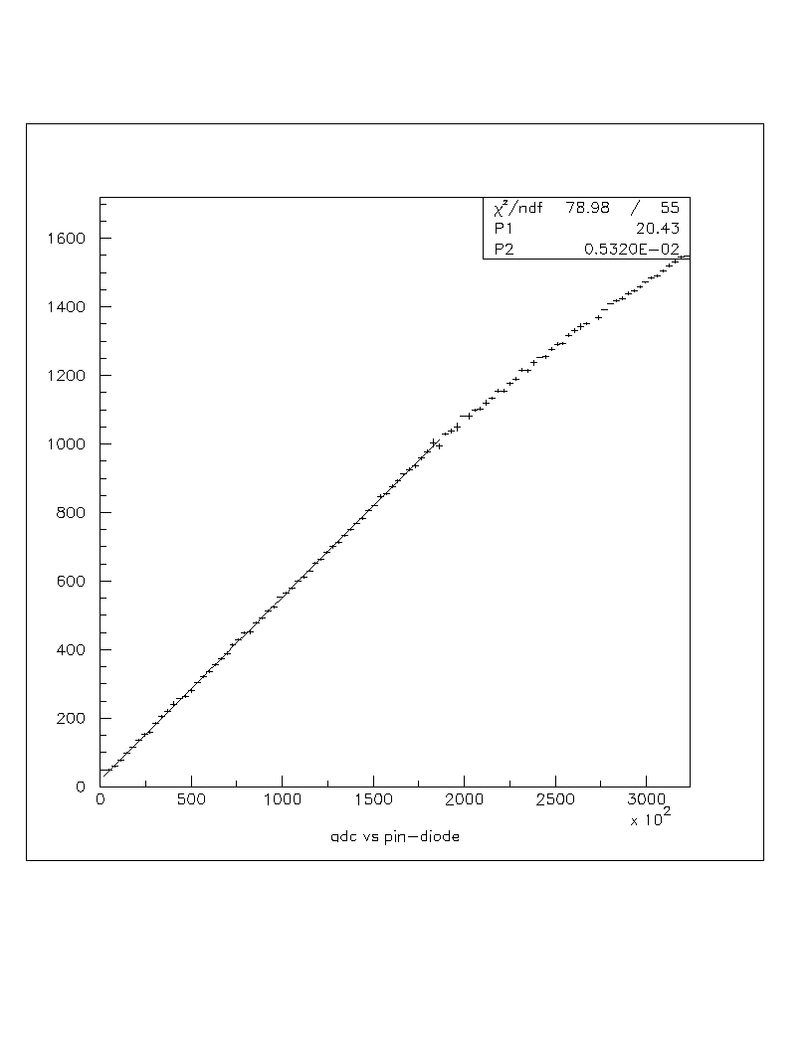
Figure 10a. Uniform ten-stage base at 900 volts
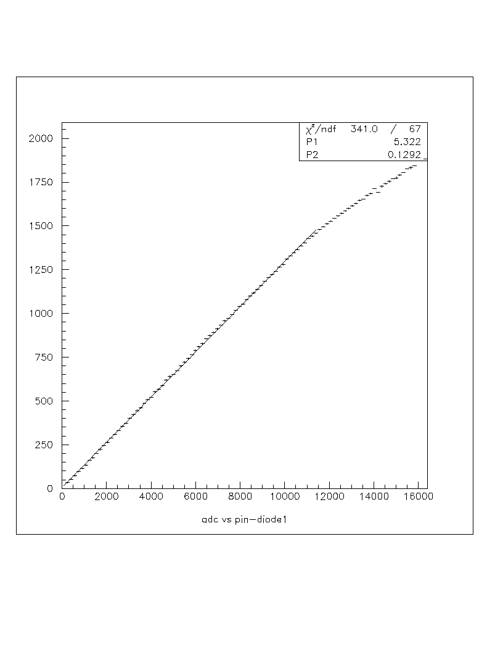
Figure 10b. Tapered ten-stage base at 900 volts

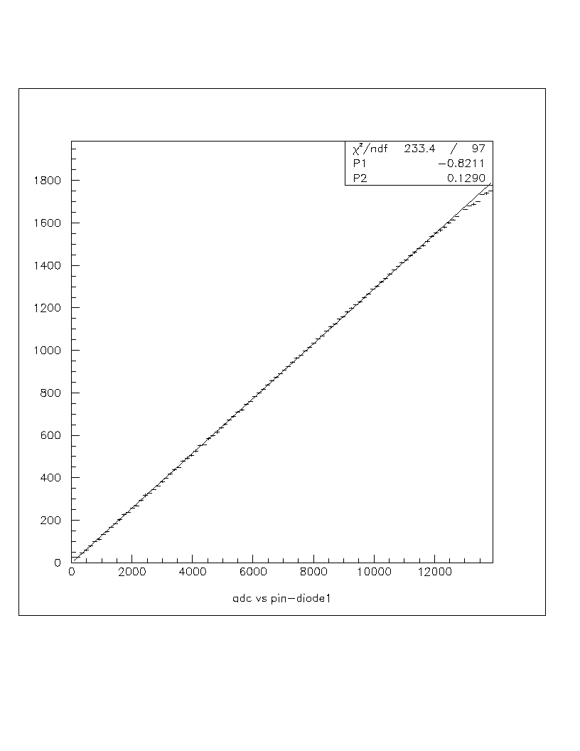

Figure 10c. Tapered ten-stage base at 700 volts

Ultimately, the BTeV experimenters would like to use a six-stage base for their photo-detectors. Several different manufacturers have responded with prototype, six-stage, bases. The results of some of these tests will be discussed here. Results of all of my tests are available at a Fermilab website; see Appendix B for information regarding those files. The first set of figures (Figure 11a and Figure 11b) feature Hamamatsu six-stage bases, model number 5380. All bases for the six-stage Hamamatsu tubes are tapered. Figure 11a shows the performance of tube #CA0119 at 900 volts. It is very linear within the first 1000 counts (250 pC.) with a tendency to “roll off” somewhere above 1200 counts. Figure 11b is similar; it is tube #ZL0093 under the same conditions. The tendency to become non-linear is somewhat more pronounced with this tube. Figure 11c is the CA0119 tube again, this time at 800 volts. Finally, each of the tubes was subjected to 1000-volt (or greater) conditions, as shown in Figures 11d and 11e. It appears, as with the ten-stage tubes and bases, that performance is enhanced at lower voltages.

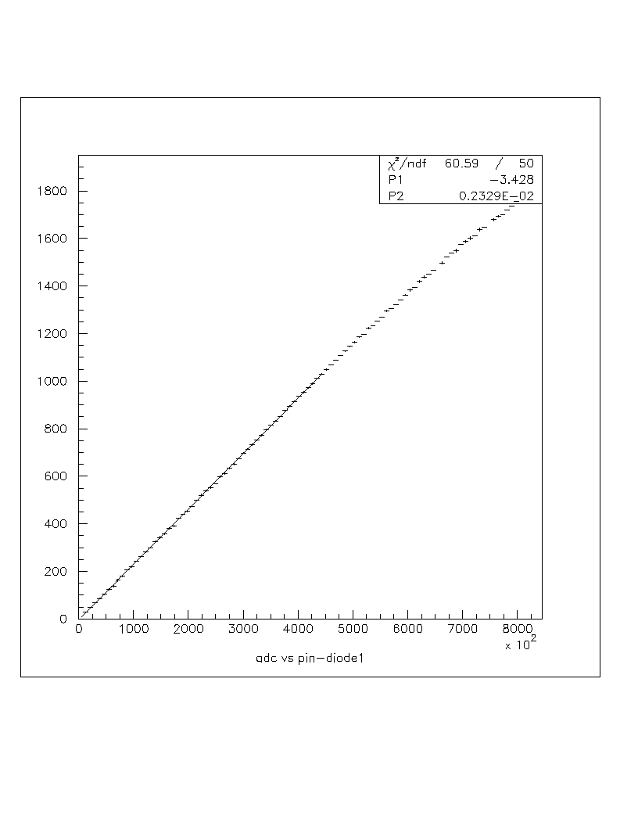

Figure 11a. Six-stage base at 900 volts (Tube s/n CA0119)

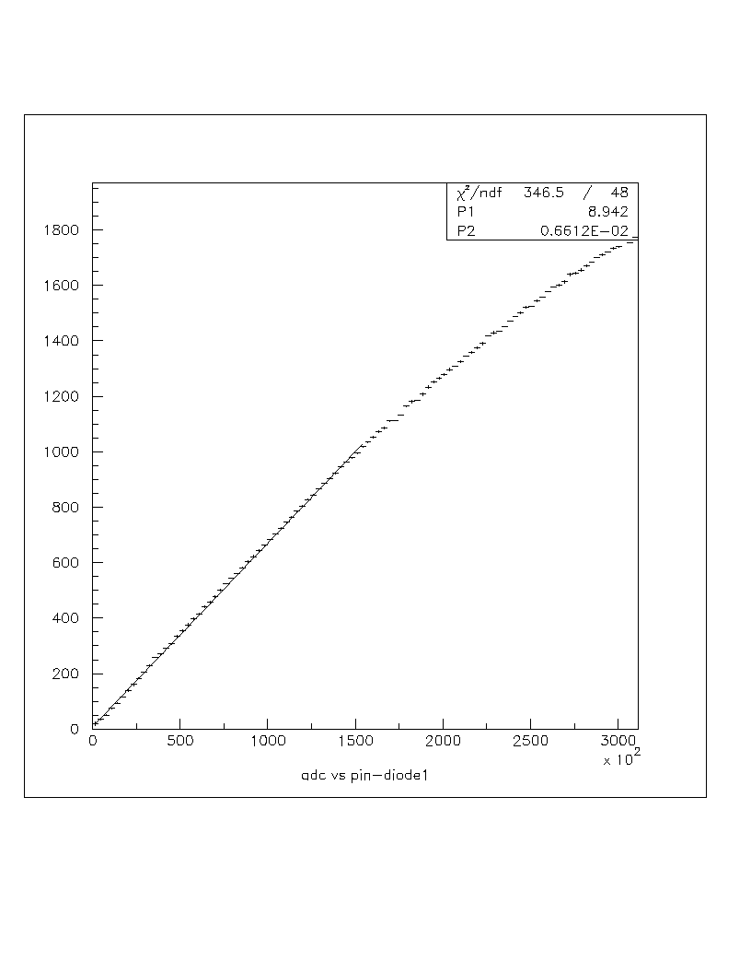
Figure 11b. Six-stage base at 900 volts (Tube s/n ZL0093)

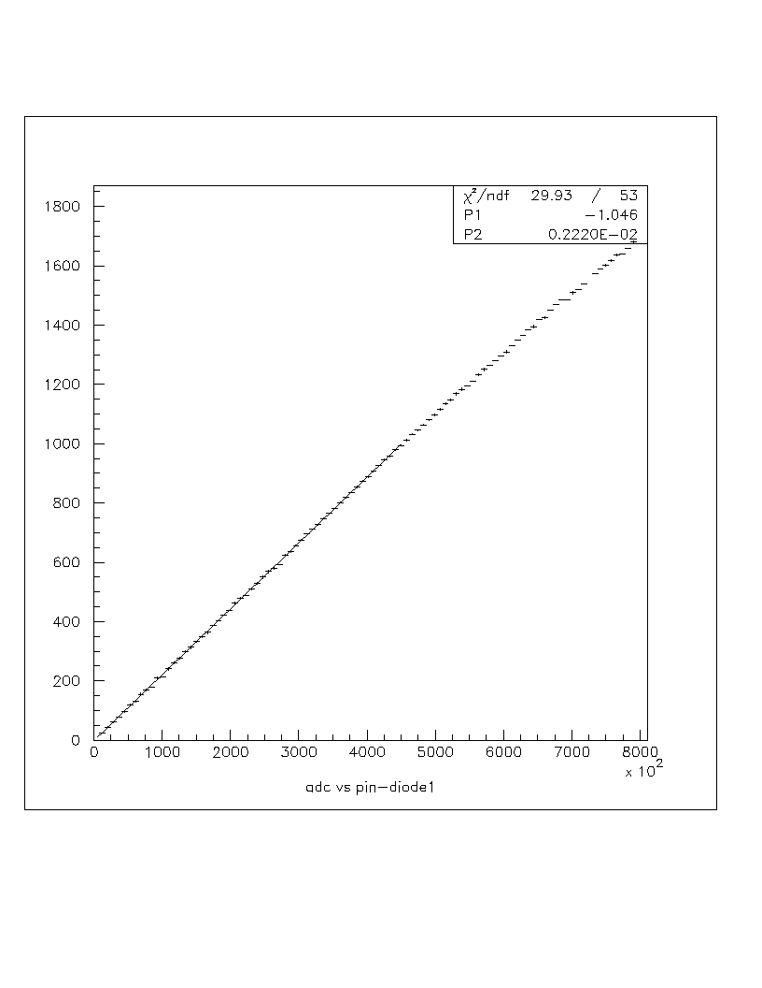

Figure 11c. Six-stage base at 800 volts (Tube s/n CA0119)

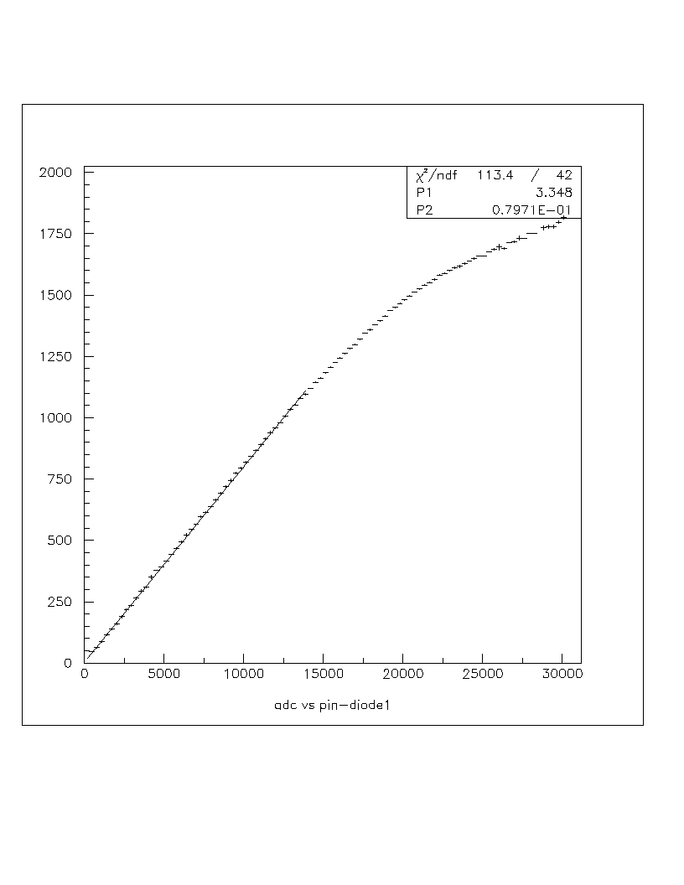
Figure 11d. Six-stage base at 1000 volts (Tube s/n ZL0093)

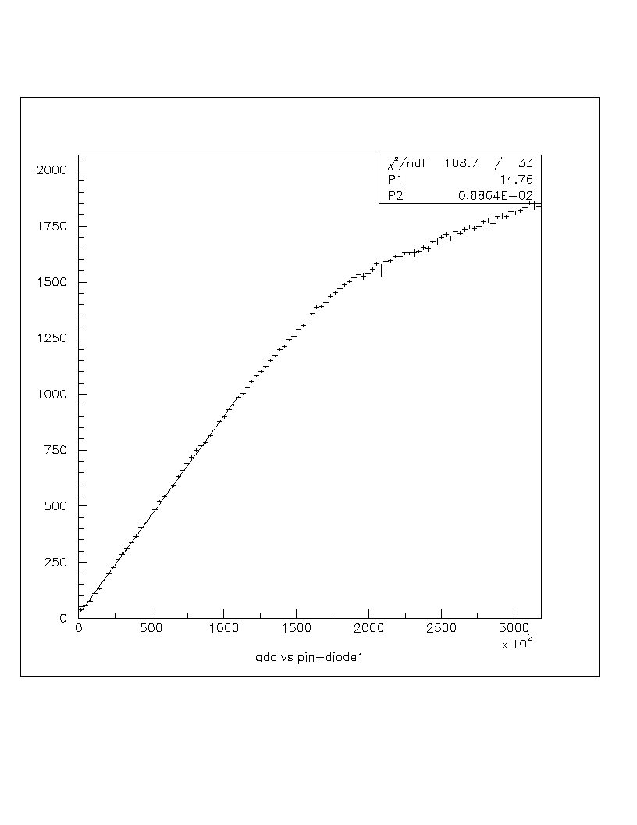

Figure 11e. Six-stage base at 1100 volts (Tube s/n CA0119)

ETI and Photonis also submitted prototype six-stage tubes. The ETI tubes were tested with uniform and tapered bases; the Photonis tube was tested only with a tapered base that followed their suggested voltage schedule. Some of the results are shown here; all of the results are, again, available at a Fermilab website.
Some results of the ETI tests are shown below. Figures 12a and 12b show the performance of ETI tube # 103, with a uniform base. Counter to the Hamamatsu results, it appears that the six-stage ETI tubes perform better at higher voltages; the linear region at 1000 volts is roughly twice as large as the linear region at 800 volts.
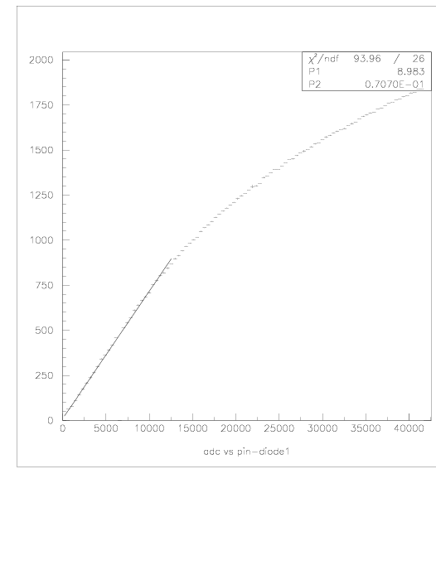
Figure 12a. ETI six-stage tube (s/n 103), with uniform base, at 800 volts

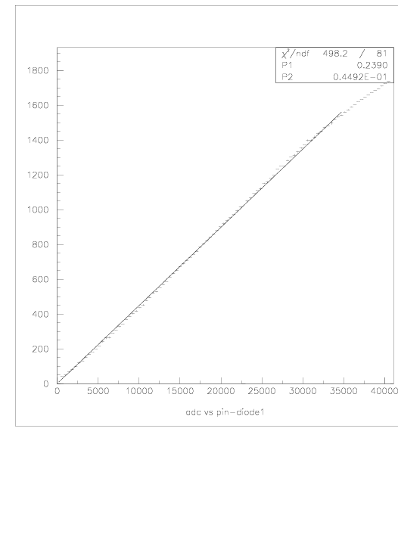
Figure 12b. ETI six-stage tube (s/n 103), with uniform base, at 1000 volts

In Figures 13a and 13b, one can see the results of using a tapered base with an ETI tube. While there is some improvement with an increased high voltage, the performance with the tapered base is poor when compared to the uniform base results in Figure 12. It is also possible that tube # 106 is inferior to tube #103; these are prototypes from ETI, not standardized products with a mature history.

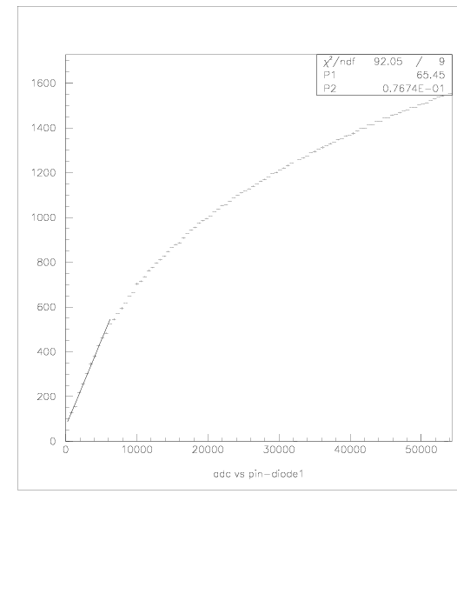
Figure 13a. ETI six-stage tube (s/n 106), with a tapered base, at 900 volts

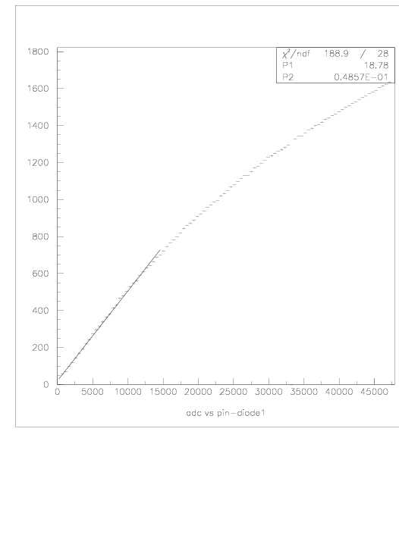
Figure 13b. ETI six-stage tube (s/n 106), with tapered base, at 1200 volts
The results from the tests of the Photonis six-stage tube are shown in Figures 14a and 14b. In each of these tests, one may notice a pronounced “s” shape to the data. There is no single, satisfactory, linear region, though the effect seems less pronounced at the lower voltage.

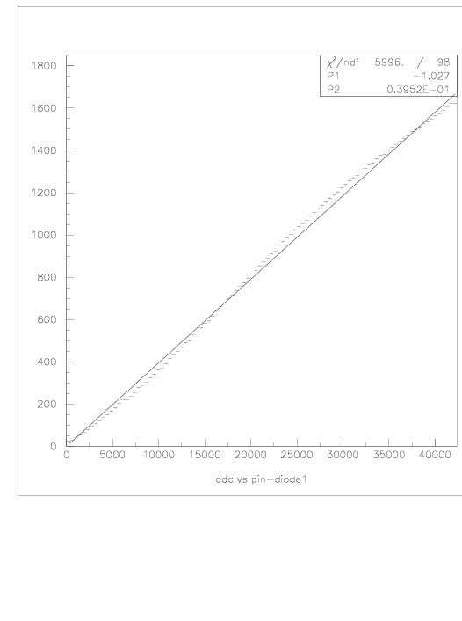
Figure 14a. Photonis, six-stage tube, at 600 volts

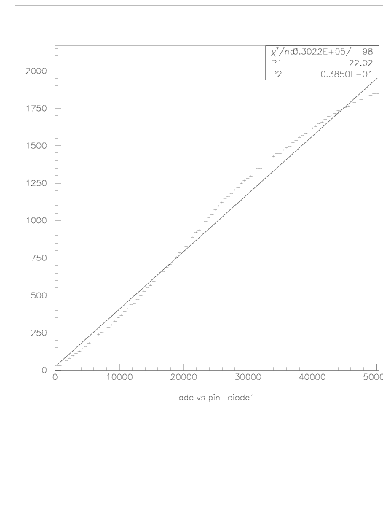
Figure 14b. Photonis, six-stage tube, at 1100 volts
APPENDIX A

The variance is defined as the square of the standard deviation. Since the standard deviation is a measure of the average difference between the mean and the data points, then the non-squared values of the numerator and denominator, in Bevington’s chi-square formula, should, on average, be approximately equivalent. That is,

< (observed data – expected data) > ~ (variance) ^{.5}

or

< (observed data – expected data) > ~ standard deviation

where < . . . > indicates the expected value of a term.

Since the numerator and denominator terms are roughly equivalent, then the contribution from each data point, to the chi-square sum, should be about 1. Of course, squaring each term will accentuate differences from unity. Nevertheless, for “well-fitted” functions, the chi-square sum should be roughly equal to the number of terms in the sum.

APPENDIX B

Summary of Directories

The following is a summary of the various directories found at http://home.fnal.gov/~tbren/. I have been testing various PMT base electronics under a variety of conditions and the directories have been created to sort the tests in some meaningful way. Since the titles of the directories contain limited information, this document is meant to describe the contents of each directory.

NEGBASES – These are files for two types of negative supply base electronics. As a check on performance I looked at an older, purely resistive base that had been used at Fermilab. As you can see in the files labeled “neg*.*” the performance of these bases is outstanding. They are very linear throughout the entire output range (0 to ~ 1600 counts or, equivalently, 0 to 400 pC.). I also tested a transistorized base that used a negative supply (anode grounded, cathode at – HV). Though it’s clearly not as linear as the purely resistive base, the advantage of a transistorized base is lower heat dissipation.

PROTOSIX – Though I do provide more information below, these tests should be considered faulty; I had interpreted the manufacturer’s data sheet incorrectly and had the incorrect voltage schedule built into the base. Please see the “NEWSIX” files below for data with correctly built, six-stage bases.

These are the files for some six-stage prototype tubes and bases. There are three sub-categories: six*.*, sixc*.*, and sixp*.* The six*.* files are the files for the six-stage base as originally designed. The sixc*.* files are the same base but with larger output capacitors across the final two stages (up to .022 uf from the original .0033 uf). The sixp*.* files are for that same base (with the larger caps) but with the distance between the PMT and the light cable increased. Since the gain of the six-stage base was reduced from that of the 10-stage base, I had originally placed the PMT very close to the light cable, in an effort to create a large output signal (up to 1600 counts). Upon reflection, I thought perhaps that the light might be striking a very limited area of the photocathode and that there might be some non-linearity associated with that situation. The distance was increased by 2-3 cm in each trial, as voltage levels were increased.

In all three of these sub-categories, the voltage level is encoded into the name of the file. For example, sixc1000.* would indicate that that file was data taken with the enhanced capacitor unit, run at 1000 volts.

NEWSIX – These are the files that contain the data for the correctly built, six-stage base. There are three main sub-directories: “c19” contains the data taken with Hamamatsu tube #CA0119, “z93” contains the data taken with Hamamatsu tube #ZL0093, and “scattertests” contain the data for six consecutive tests taken with the CA0119 tube, to see if there were any short-term, drift-like anomalies with the tube/base.

In each sub-directory, the voltage is encoded into the filename as before. Occasionally, the final number in such a scenario may be a “1” or a “2” indicating that the test was the first or second test, respectively, done at that voltage that day. File “c19100.gif” should have been saved as “c191100.gif.” I will try to rename the file soon.

The C19 tube seems to be much more linear than the Z93 tube. Each tube was tested with the same base.

TENSTAGE – These are files for the 10-stage PMT/base combination. Again the high voltage is implied by the file name, as described above. These files were generated using unit #18 and show how the linearity is affected by changes in HV.

There are two broad categories of tests in this directory: “tap*.*” and “ten*.*” The “tap” files are data taken with a tapered base, where the voltage in the final three stages was set to 2x, 3x, and 3x the nominal interdynode voltage. The “ten” files are earlier data; the interdynode voltages were uniform. Unit #18 was used in each case.

The tapered base tests show a much-extended linear region, compared with the uniform base tests.

UNIT18 – These files show the performance of unit #18 over time. Encoded in the file names are the dates of tests. On March 1, the unit demonstrated adequate linearity. By April 4th, however, there appeared a remarkable bending in the “line.” I noticed a difference in the x-axis measurement and adjusted my test set-up to reset the x-axis full-scale reading to be less than 50,000 counts. The result was the picture seen in the April 5th picture, one that reflects the performance of March 1st.
The meaning of all this is still not clear, though there is a suspicion that adjustments to the dye level (see the test station figure in body of the paper) throughout the month of March were misguided; at times the laser light was not directed through the dye at all, at other times it was directed through the meniscus. When I committed myself to directing the laser light directly through the body of the dye, I was not able to recreate the “remarkable bending” mentioned above. This is true whether the x-axis readings were limited to < 20,000 counts or allowed to be > 300,000 counts, variations that were created by moving the pin-diode’s location or filtering the input to the pin-diode with a thin foil. I have not tried to recreate the failure mode, though it may be worth exploring for greater insights.

UNIT22 – This is a set of files that was generated to share with the our collaborators in Protvino, Russia while they were running their beam tests with the bases developed here at Fermilab. They represent the typical performance of the bases at the beginning of March.

UNIT24 – This set of files is the same as “UNIT22” above, though with a different unit (#24).

ETITUBES – These are files taken with two different six-stage tubes sent to Fermilab by the British company, ETI. Again, the voltage levels are encoded into the file name. There are two other codes as well: a 3 or a 6 in the name will indicate tube #103 or #106, respectively, while a “u” or “t” in the fail name will indicate if the base follows a “uniform” or a “tapered” schedule, respectively. The pinout for the ETI tubes is different from the Hamamatsu tubes; the bases, therefore, are not interchangeable. Therefore, two distinct bases were built to test the ETI tubes.

PHOTONISTUBE – A French company, Photonis, also provide Fermilab with a prototype six-stage base. Again, its pinout is different from both the ETI and Hamamatsu tubes. And, again, the voltage level is encoded into the file name.

APPENDIX C

Choosing between positive and negative high voltage supplies requires a consideration of the tradeoffs involved.
A positive supply allows the cathode to be grounded. The potential difference between the cathode and the chassis, including the window, then is essentially zero. Phototubes operated with positive supplies, therefore, do not have to be insulated from one another or from other, grounded, instruments that may be nearby. Furthermore, the long-term advantages of a grounded cathode are significant; a large potential difference between the cathode and the glass window can result in long-term degradation of, and possible damage to, the window itself. Positively supplied tubes also provide enhanced “dark current” performance. That is, the number of electrons that would flow under “no light” conditions is smaller for positively supplied tubes than for negatively supplied ones.
The cost for these advantages is borne by the coupling capacitor, and borne in a number of ways. The capacitor, which essentially averages the signal that passes through it, may provide a small, positive, overshoot voltage on the back end of the signal pulse. At high data rates, this overshoot may introduce errors into the integration scheme; the “counting” of the electrons will not begin at zero in these cases. To minimize this possibility, the value of the capacitor should be as large as possible, as one can see from the diagrams in Figures 7a, b, and c. When one combines this need with the need to withstand at least 1000 volts (and quite possibly twice this voltage), the size of the capacitor grows quickly. Its size may outgrow the volume constraints placed upon the base by other, geometric, considerations. The cost of the capacitor also rises with capacitance value and voltage rating. Indeed, capacitor manufacturers may not stock the ideal capacitor for these unusual needs; the cost of a specially ordered capacitor may be quite a burden.
And so it is that one might be tempted to eliminate this capacitor by adopting a negative high voltage supply. In this case, the anode would be grounded and the cathode would be held at some large, negative voltage. Of course, the precautions mentioned in the previous paragraph would then be necessary. One would have to characterize the dark current performance more rigorously. In addition, the shielding of the phototube becomes a more difficult chore; not only does one need to shield the tube magnetically, but electrically, as well. In addition, one would need to track the performance of the tubes over time; the degradation to the window caused by potential differences may require replacing tubes.
The polarity choice, then, must be made with these issues in mind.

REFERENCES

Henry L. Adler and Edward B. Roessler, “Introduction to Probability and Statistics,” W. H. Freeman and Company, 1972.

Philip R. Bevington, “Data Reduction and Error Analysis for the Physical Sciences,” McGraw-Hill, Inc., Second Edition, 1992.

Paul Horowitz and Winfield Hill, “The Art of Electronics,” Cambridge University Press, 1982.

C.R. Kerns, “A High-Rate Phototube Base,” Fermilab Technical Note, TM-640, January 22, 1976.

David S. Moore and George P. McCabe, “Introduction to the Practice of Statistics,” W. H. Freeman and Company, 1993.

“Photomultiplier Tubes, Principles and Applications,” Philips Technical Manual.

