Tropical Cyclone Report
Hurricane Gordon
(AL072006)
10-20 September 2006

Eric S. Blake
National Hurricane Center
14 November 2006

Gordon was a category 3 hurricane (on the Saffir-Simpson Hurricane Scale) that affected the Azores as a hurricane, causing minimal damage. As an extratropical system it brought heavy rains and high winds to parts of western Europe, causing substantial power outages and at least five injuries.

- Synoptic History

Gordon formed from a tropical wave that left the west coast of Africa on 1 September. This wave was initially well-organized with an associated low along the wave axis and some convection. However, vertical wind shear from an upper-level trough east of tropical storm Florence hindered any development. This synoptic situation remained nearly the same for about a week, as the wave progressed westward without significant organization. By 9 September, the upper trough associated with Florence had moved far enough away from the wave to cause a decrease in shear. Convection increased around the low overnight and, at 1800 UTC 10 September, it is estimated that a tropical depression formed, centered about 470 n mi east-northeast of the Leeward Islands. The “best track” chart of the tropical cyclone’s path is given in Fig. 1, with the wind and pressure histories shown in Figs. 2 and 3, respectively. The best track positions and intensities are listed in Table 1.

Initially, moderate shear from the upper trough allowed for only a modest intensification of the depression, and the system became a tropical storm on 11 September at 1200 UTC. Gordon continued moving toward the west-northwest, then slowed as it turned toward the northwest on 12 September, heading into a weakness in the subtropical ridge left behind Florence. The upper trough that had been hindering Gordon’s development weakened and moved to the southwest, causing shear to abate over the tropical cyclone. The storm turned toward the north and intensified into a hurricane, forming a large ragged eye early on 13 September. Gordon then rapidly intensified, with convection in the eyewall deepening and the eye becoming better-defined. The cyclone strengthened 50 kt in the 30 h period from 1800 UTC 12 September until 0000 UTC 14 September, when it reached a peak intensity of 105 kt while centered about 500 n mi east-southeast of Bermuda. It maintained its peak intensity for about 24 h, during which time the eye of the hurricane shrunk a little but the cloud tops in the eyewall warmed a bit.

Gordon turned toward the northeast and accelerated somewhat on 14 September, but an upper trough that had been steering the system bypassed the hurricane late that day. As a result, middle-tropospheric ridging rebuilt to the north of the tropical cyclone and Gordon’s motion ground to a halt by midday on 15 September, about 575 n mi east-southeast of Bermuda. Vertical wind shear increased somewhat and the cyclone weakened, barely maintaining hurricane-strength on 16 September as it drifted northwestward. The leisurely motion during this time also caused increased upwelling of cooler water beneath the hurricane, contributing to a weakening of the deep convection associated with the tropical cyclone. Early on 17 September, a building high to the east of Gordon finally restarted the hurricane’s motion to the northeast at about 5 to 10 kt.

Gordon acccelerated to the northeast on 18 September, and turned to the east-northeast later that day around the strengthening subtropical high. Vertical wind shear relaxed during this time and convection redeveloped around the eye. The cyclone reached a second peak intensity of 90 kt on 19 September at 0600 UTC about 420 n mi west-southwest of the Azores, despite the storm moving over relatively cool waters of about 25°C. Below normal upper-tropospheric temperatures in the subtropical Atlantic Ocean were at least partially responsible for allowing the hurricane to get stronger than typically occurring over cool waters. Gordon was moving quickly eastward between 25 and 30 kt at this time between a large trough over the North Atlantic Ocean and the subtropical ridge. The tropical cyclone finally started weakening later on 19 September as a combination of lower sea-surface temperatures and increasing wind shear took its toll. The hurricane moved a little south of due east overnight on 20 September, allowing its radius of maximum winds to stay south of the Azores. Gordon’s center went between the islands of São Miguel and Santa Maria in the Azores at about 0900 UTC 20 September, bringing hurricane-force wind gusts to Santa Maria. Later that day, Gordon began interacting with a cold front and weakened, and the system became extratropical at 0000 UTC 21 September about 240 n mi west of the west coast of Portugal.

The extratropical phase of Gordon was rather eventful as it retained the majority of its strength from its tropical phase, maintaining winds of 55 kt or greater for almost two days after transitioning from a tropical cyclone. Gordon continued moving quickly to the northeast and was driven northward at almost 50 kt on 21 September around a larger middle-latitude extratropical low that captured the storm. Gordon remained distinct from the larger system, and brought heavy rain and high winds to Spain, England and Ireland, with winds gusts of hurricane-force recorded. An interaction with the middle-latitude system produced another deepening period and QuikSCAT indicated that Gordon’s extratropical remnant briefly regained sustained winds of hurricane-force early on 22 September. Surface analyses show that the post-Gordon cyclone became the dominant low pressure area and made a large cyclonic loop while slowly weakening over the far northeastern Atlantic Ocean. The system completed the loop just south of Ireland on 24 September and the low dissipated between Ireland and England later that day.

- Meteorological Statistics

Observations in Gordon (Figs. 2 and 3) include satellite-based Dvorak technique intensity estimates from the Tropical Analysis and Forecast Branch (TAFB), the Satellite Analysis Branch (SAB) and the U. S. Air Force Weather Agency (AFWA), as well as flight-level observations from flights of the 53rd Weather Reconnaissance Squadron of the U. S. Air Force Reserve Command. Microwave satellite imagery from NOAA polar-orbiting satellites, the NASA Tropical Rainfall Measuring Mission (TRMM), the NASA QuikScat, and Defense Meteorological Satellite Program (DMSP) satellites were also useful in tracking Gordon. The peak intensity of 105 kt in Gordon is based on objective Dvorak T-numbers, which suggested the storm was a little stronger than subjective T-numbers alone would imply. Figure 4 shows Gordon as it was rapidly intensifying a few hours before reaching its peak intensity.

Ship reports of winds of tropical storm force associated with Gordon are given in Table 2, and selected surface observations from land stations and data buoys are given in Table 3. A peak wind gust of 71 kt was recorded in the Azores as Gordon passed. During the extratropical portion of Gordon, a wind gust of 99 kt was recorded on the northwest coast of Spain at an elevated location. The British Broadcasting Corporation (BBC) reported that wind gusts to 70 kt were measured in southwestern England, but no exact location was given.

- Casualty and Damage Statistics

There were no reports of casualties associated with Gordon as a tropical cyclone. The BBC reported only minor damage in the Azores, consisting of mostly fallen trees and power outages. However, after Gordon became an extratropical low, four injuries due to falling debris from high wind were reported in Spain. Power was also reported out for 100,000 customers after the storm in Spain. The strong extratropical Gordon brought high winds and rain that affected practice rounds at the Ryder Cup golf tournament in Ireland. About 126,000 homes were without power after the storm in Northern Ireland and one injury was reported. No monetary damage figures are available.

- Forecast and Warning Critique

The timing of the genesis of Gordon was not particularly well-anticipated, although the system that eventually became Gordon was mentioned in the Tropical Weather Outlook products for 5 days prior to genesis. It was initially thought that the system could become a tropical depression in the eastern Atlantic Ocean, but a depression did not form. On 10 September, the possibility that the wave that eventually became Gordon could become a depression was only mentioned about six hours before the first advisory was issued.

A verification of official and guidance model track forecasts is given in Table 4. Average official track errors for Gordon were 28, 54, 86, 129, 227, 332, and 361 n mi for the 12, 24, 36, 48, 72, 96, and 120 h forecasts, respectively. The number of forecasts ranged from 38 at 12 h to 19 at 120 h. These errors are comparable to the average long-term official track errors (Table 4) through about 36 hours, and are larger than the long-term averages from 48-120 h. Perhaps it is not surprising that the track errors were large, in view of the fact that CLP5 errors were also unusually large. There were some good individual model performances. The GFDI model had low errors until 48 h, while the NGPI had a good performance beyond 48 h. The UKMI struggled with this system, having an average error of 611 n mi at 5 days.

Average official intensity errors were 7, 11, 15, 17, 23, 21, and 21 kt for the 12, 24, 36, 48, 72, 96, and 120 h forecasts, respectively. For comparison, the average long-term official intensity errors are 6, 10, 12, 14, 18, 20, and 22 kt, respectively. The official forecast errors were generally a little worse than average for Gordon (Table 5). There was also a substantial low bias in the official forecast for Gordon, especially at 48 h and beyond where the bias was 17 kt or greater. The re-intensification of Gordon at higher-latitudes was not anticipated and this contributed to the low bias. The SHIPS model also had a similar intensity bias. On the other hand, the GFDI model had extremely low errors and biases. In fact, at 96 and 120 h, the errors of the GFDI were about half that of the official forecast.

Table 6 lists the tropical cyclone watches/warnings advisories that were issued for Gordon. At first, a tropical storm watch was issued for the Azores due to the expectation that the hurricane would weaken before reaching the Islands. However the watch was upgraded to a hurricane warning 6 h later as the Gordon continued to intensify. Tropical storm conditions began affecting the Azores about 33 h after the watch was issued and about 27 h after the hurricane warning was issued. No sustained hurricane-force winds were reported, with QuikSCAT suggesting that these winds stayed just south of Santa Maria Island.

Table 1. Best track for Hurricane Gordon, 10-20 September 2006.

Date/Time  (UTC) | Latitude  (°N) | Longitude  (°W) | Pressure  (mb) | Wind Speed  (kt) | Stage
10 / 1800 | 20.2 | 53.8 | 1012 | 25 | tropical depression
11 / 0000 | 20.3 | 54.5 | 1011 | 30 | "
11 / 0600 | 20.6 | 55.3 | 1010 | 30 | "
11 / 1200 | 20.9 | 56.3 | 1008 | 35 | tropical storm
11 / 1800 | 21.4 | 57.1 | 1005 | 40 | "
12 / 0000 | 21.8 | 57.6 | 1003 | 50 | "
12 / 0600 | 22.3 | 58.0 | 1000 | 50 | "
12 / 1200 | 22.8 | 58.2 | 998 | 50 | "
12 / 1800 | 23.4 | 58.2 | 994 | 55 | "
13 / 0000 | 24.0 | 58.1 | 987 | 65 | hurricane
13 / 0600 | 24.7 | 58.0 | 984 | 70 | "
13 / 1200 | 25.6 | 57.9 | 980 | 80 | "
13 / 1800 | 26.5 | 57.7 | 965 | 95 | "
14 / 0000 | 27.3 | 57.4 | 955 | 105 | "
14 / 0600 | 28.2 | 56.8 | 956 | 105 | "
14 / 1200 | 29.1 | 56.2 | 956 | 105 | "
14 / 1800 | 29.8 | 55.4 | 958 | 105 | "
15 / 0000 | 30.3 | 54.6 | 960 | 100 | "
15 / 0600 | 30.8 | 53.8 | 965 | 95 | "
15 / 1200 | 31.1 | 53.5 | 973 | 85 | "
15 / 1800 | 31.1 | 53.5 | 976 | 80 | "
16 / 0000 | 31.1 | 53.5 | 980 | 75 | "
16 / 0600 | 31.2 | 53.6 | 983 | 70 | "
16 / 1200 | 31.3 | 53.8 | 987 | 65 | "
16 / 1800 | 31.5 | 53.9 | 987 | 65 | "
17 / 0000 | 31.9 | 53.8 | 987 | 65 | "
17 / 0600 | 32.4 | 53.7 | 987 | 65 | "
17 / 1200 | 33.3 | 53.3 | 983 | 70 | "
17 / 1800 | 34.1 | 52.9 | 983 | 70 | "
18 / 0000 | 35.0 | 52.1 | 981 | 75 | "
18 / 0600 | 36.1 | 50.6 | 979 | 75 | "
18 / 1200 | 36.9 | 48.7 | 976 | 80 | "
18 / 1800 | 37.5 | 46.3 | 972 | 85 | "
19 / 0000 | 38.0 | 43.3 | 972 | 85 | "
19 / 0600 | 38.1 | 40.2 | 970 | 90 | "
19 / 1200 | 38.0 | 37.0 | 977 | 80 | "
19 / 1800 | 37.8 | 33.5 | 979 | 75 | "
20 / 0000 | 37.7 | 29.9 | 980 | 70 | "
20 / 0600 | 37.6 | 26.1 | 980 | 70 | "
20 / 1200 | 37.8 | 22.6 | 983 | 65 | "
20 / 1800 | 38.5 | 18.5 | 983 | 65 | "
21 / 0000 | 40.1 | 14.0 | 984 | 60 | extratropical
21 / 0600 | 43.8 | 10.4 | 986 | 55 | "
21 / 1200 | 48.5 | 9.0 | 982 | 55 | "
21 / 1800 | 52.5 | 9.5 | 978 | 55 | "
22 / 0000 | 54.5 | 10.5 | 975 | 60 | "
22 / 0600 | 57.0 | 14.0 | 974 | 65 | "
22 / 1200 | 56.5 | 18.5 | 976 | 55 | "
22 / 1800 | 56.0 | 19.5 | 980 | 45 | "
23 / 0000 | 54.5 | 20.0 | 982 | 45 | "
23 / 0600 | 52.5 | 20.0 | 986 | 40 | "
23 / 1200 | 50.7 | 17.7 | 993 | 35 | "
23 / 1800 | 49.0 | 14.5 | 994 | 35 | "
24 / 0000 | 48.0 | 10.0 | 995 | 30 | "
24 / 0600 | 48.5 | 8.5 | 996 | 30 | "
24 / 1200 | 49.0 | 8.0 | 998 | 30 | "
24 / 1800 | 50.5 | 7.5 | 1001 | 25 | "
25 / 0000 |  |  |  |  | dissipated
14 / 0000 | 27.3 | 57.4 | 955 | 105 | minimum pressure

Table 2. Selected ship reports with winds of at least 34 kt for Hurricane Gordon, 10-20 September 2006 .

Date/Time (UTC) | Ship call sign | Latitude  (°N) | Longitude  (°W) | Wind  dir/speed (kt) | Pressure  (mb)
16 / 1600 | DGNB | 29.7 | 52.1 | 180 / 37 | 1014.4
16 / 1700 | DGNB | 29.6 | 52.4 | 200 / 37 | 1014.0
16 / 1800 | DGNB | 29.6 | 52.7 | 200 / 37 | 1013.0
16 / 1900 | DGNB | 29.5 | 53.0 | 210 / 35 | 1012.6
20 / 0000 | 4XFV | 35.4 | 29.4 | 160 / 38 | 1013.0
20 / 0600 | ZCIH7 | 34.7 | 30.4 | 290 / 37 | 1013.1
20 / 0600 | DEDM | 35.6 | 27.5 | 260 / 51 | 1008.0
20 / 1200 | V2RE | 35.4 | 22.4 | 230 / 41 | 1006.5
20 / 1200 | VRZN9 | 35.4 | 21.8 | 210 / 39 | 1008.0
20 / 1800 | V2RE | 35.9 | 22.0 | 280 / 41 | 1008.5
20 / 1800 | A8GX4 | 35.9 | 21.0 | 270 / 41 | 1006.0

Table 3. Selected surface observations for Hurricane Gordon, 10-20 September 2006. Selected observations from the extratropical portion of the cyclone from Spain and England are also included.

Location | Minimum Sea Level Pressure |  | Maximum Surface  Wind Speed |  |  | Storm surge  (ft)^{c} | Storm  tide  (ft)^{d} | Total  rain  (in)
Location | Date/  time  (UTC) | Press.  (mb) | Date/  time  (UTC)ª | Sustained  (kt)^{b} | Gust  (kt) | Storm surge  (ft)^{c} | Storm  tide  (ft)^{d} | Total  rain  (in)
Azores
Santa Maria (LPAZ) | 20/0800 | 990.9 | 20/0800 | 49 | 71
Ponta Delgada | 20/0700 | 991.9 | 20/0800 | 25 | 44
Spain
Punta Candieira |  |  | 21/???? |  | 99
Fisterra |  |  | 21/???? |  | 89
Cabo Vilán |  |  | 21/???? |  | 82
Ferrol |  |  | 21/???? |  | 64
A Coruña | 21/0644 | 988.0 | 21/0644 | 37 | 62
Santiago |  |  | 21/???? |  | 54
Vigo |  |  | 21/???? |  | 46
England
St. Mary’s Airport, Scilly Island |  |  | 21/???? |  | 60

ª Date/time is for sustained wind when both sustained and gust are listed.
^{b} Wind averaging periods is 10 min.
^{c} Storm surge is water height above normal astronomical tide level.
^{d} Storm tide is water height above National Geodetic Vertical Datum (1929 mean sea level).

Table 4. Preliminary track forecast evaluation (heterogeneous sample) for Hurricane Gordon, 10-20 September 2006. Forecast errors (n mi) are followed by the number of forecasts in parentheses. Errors smaller than the NHC official forecast are shown in bold-face type. Verification includes the depression stage, but does not include the extratropical stage.

Forecast Technique | Forecast Period (h)
Forecast Technique | 12 | 24 | 36 | 48 | 72 | 96 | 120
CLP5 | 52 (39) | 127 (37) | 217 (35) | 315 (33) | 475 (29) | 514 (25) | 450 (21)
GFNI | 28 (34) | 57 (32) | 85 (30) | 121 (28) | 225 (24) | 297 (20) | 363 (15)
GFDI | 23 (37) | 36 (35) | 56 (33) | 99 (31) | 228 (27) | 382 (23) | 525 (17)
GFSI | 33 (35) | 48 (33) | 71 (33) | 104 (30) | 203 (24) | 304 (18) | 364 (10)
AEMI | 40 (36) | 65 (35) | 93 (33) | 147 (29) | 301 (24) | 391 (19) | 563 (15)
NGPI | 32 (34) | 60 (32) | 86 (30) | 119 (28) | 207 (24) | 215 (20) | 223 (16)
UKMI | 52 (35) | 96 (33) | 136 (31) | 198 (29) | 403 (21) | 553 (19) | 611 (16)
A98E | 41 (38) | 69 (36) | 111 (35) | 166 (33) | 264 (29) | 322 (25) | 351 (21)
A9UK | 42 (17) | 84 (16) | 134 (16) | 201 (16) | 300 (14)
BAMD | 37 (38) | 66 (36) | 113 (35) | 169 (33) | 312 (29) | 431 (25) | 485 (21)
BAMM | 31 (38) | 54 (36) | 85 (35) | 129 (33) | 224 (29) | 315 (25) | 379 (21)
BAMS | 41 (38) | 75 (36) | 106 (35) | 143 (33) | 211 (29) | 297 (25) | 298 (21)
CONU | 28 (37) | 49 (35) | 74 (33) | 114 (30) | 203 (25) | 299 (21) | 368 (16)
GUNA | 28 (32) | 49 (30) | 75 (30) | 110 (28) | 238 (19) | 306 (15) | 392 ( 9)
FSSE | 24 (35) | 47 (33) | 72 (31) | 114 (29) | 259 (25) | 356 (21) | 396 (16)
OFCL | 28 (38) | 54 (36) | 86 (34) | 129 (32) | 227 (27) | 332 (21) | 361 (19)
NHC Official  (2001-2005) mean) | 37 (1930) | 65 (1743) | 91 (1569) | 118 (1410) | 171 (1138) | 231 (913) | 303 (742)

Table 5. Preliminary intensity forecast evaluation (heterogeneous sample) for Hurricane Gordon, 10-20 September 2006. Forecast errors (kt) are followed by the number of forecasts in parentheses. Errors smaller than the NHC official forecast are shown in bold-face type. Verification includes the depression stage, but does not include the extratropical stage.

Forecast Technique | Forecast Period (h)
Forecast Technique | 12 | 24 | 36 | 48 | 72 | 96 | 120
SHF5 | 7.2 (39) | 11.4 (37) | 14.8 (35) | 17.6 (33) | 20.6 (29) | 19.7 (25) | 10.7 (21)
GFDI | 5.9 (37) | 9.0 (35) | 12.2 (33) | 15.7 (31) | 13.6 (27) | 10.4 (23) | 10.4 (17)
SHIP | 5.6 (35) | 8.8 (33) | 12.9 (32) | 17.5 (30) | 24.6 (29) | 26.4 (25) | 27.5 (21)
DSHP | 5.6 (35) | 8.8 (33) | 12.9 (32) | 17.5 (30) | 24.6 (29) | 26.4 (25) | 27.5 (21)
FSSE | 5.6 (35) | 8.3 (33) | 10.8 (31) | 14.4 (29) | 18.4 (25) | 23.0 (21) | 31.3 (16)
ICON | 5.4 (32) | 7.8 (31) | 10.0 (30) | 13.1 (28) | 15.7 (27) | 16.6 (23) | 19.9 (17)
OFCL | 6.8 (38) | 10.7 (36) | 14.7 (34) | 17.2 (32) | 22.6 (27) | 21.4 (21) | 21.1 (19)
NHC Official  (2001-2005 mean) | 6.3 (1930) | 9.8 (1743) | 12.1 (1569) | 14.3 (1410) | 18.4 (1138) | 19.8 (913) | 21.8 (742)

Table 6. Watch and warning summary for Hurricane Gordon, 10-20 September 2006.

Date/Time (UTC) | Action | Location
18/2100 | Tropical Storm Watch issued | The Azores
19/0300 | Tropical Storm Watch changed to Hurricane Warning | The Azores
20/0000 | Hurricane Warning discontinued | The Western Azores Islands of Corvo and Flores
20/0600 | Hurricane Warning discontinued | The Central Azores
20/1200 | Hurricane Warning discontinued | The Eastern Azores

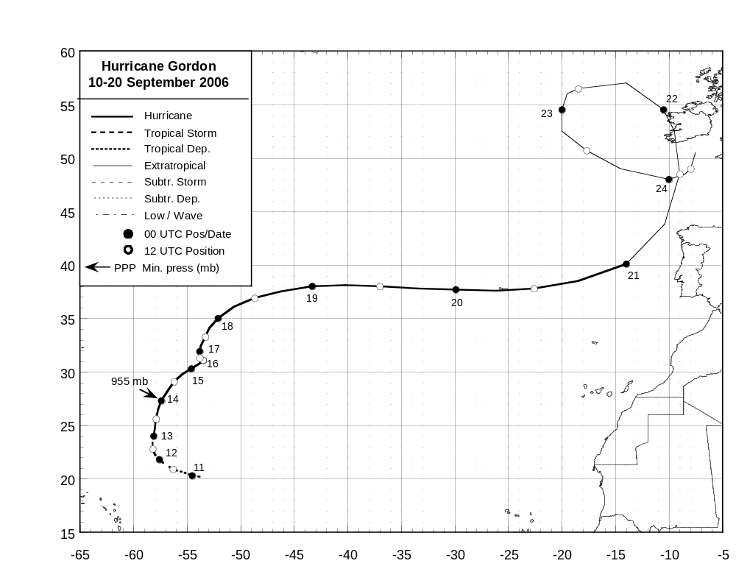

Figure 1. Best track positions for Hurricane Gordon, 10-20 September 2006. Track during the extratropical stage is based on analyses from the NOAA Ocean Prediction Center.
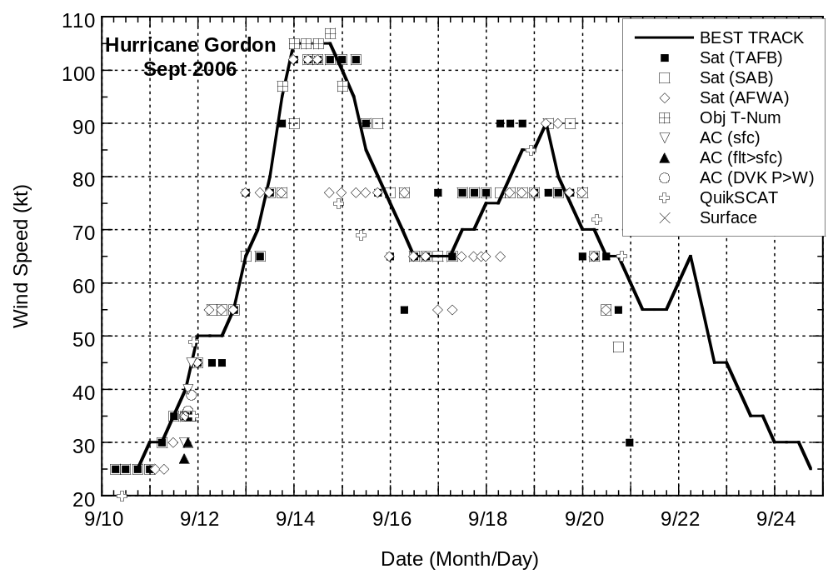
Figure 2. Selected wind observations and best track maximum sustained surface wind speed curve for Hurricane Gordon, 10-20 September 2006. Aircraft observations have been adjusted for elevation using 90%, 80%, and 80% reduction factors for observations from 700 mb, 850 mb, and 1500 ft, respectively. Objective Dvorak estimates represent linear averages over a three-hour period centered on the nominal observation time. Estimates during the extratropical stage are based on analyses from the NOAA Ocean Prediction Center and QuikSCAT data.

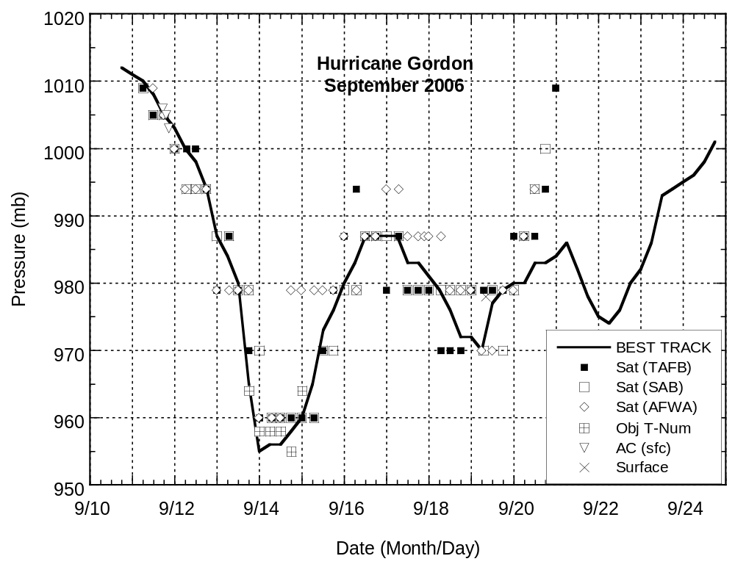
Figure 3. Selected pressure observations and best track minimum central pressure curve for Hurricane Gordon, 10-20 September 2006. Objective Dvorak estimates represent linear averages over a three-hour period centered on the nominal observation time. Estimates during the extratropical stage are based primarily on analyses from the NOAA Ocean Prediction Center.
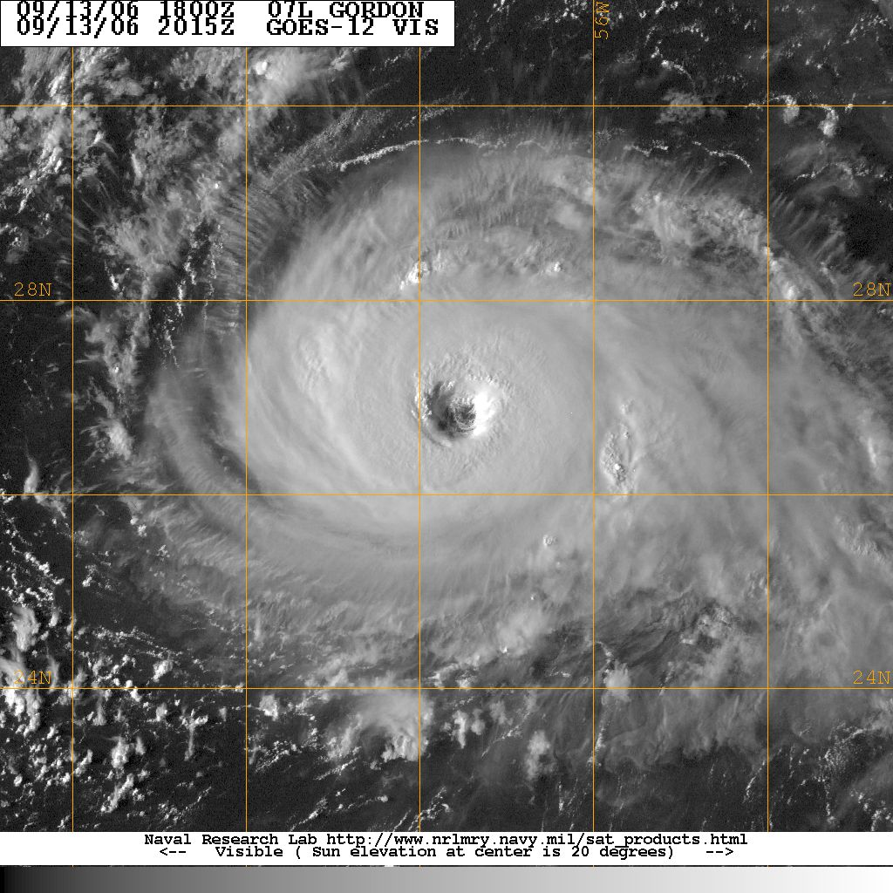
Figure 4. Visible satellite image from GOES-12 at 2015 UTC 13 September, showing Gordon approaching peak intensity. Image courtesy of the Naval Research Laboratory, Monterey, CA.

