NACP West Coast Cruise

R/V Wecoma, W0705A
11 May – 14 June 2007
Newport, OR – San Diego, CA USA
Chief Scientists: Richard A. Feely and Christopher L. Sabine
NOAA Pacific Marine Environmental Laboratory
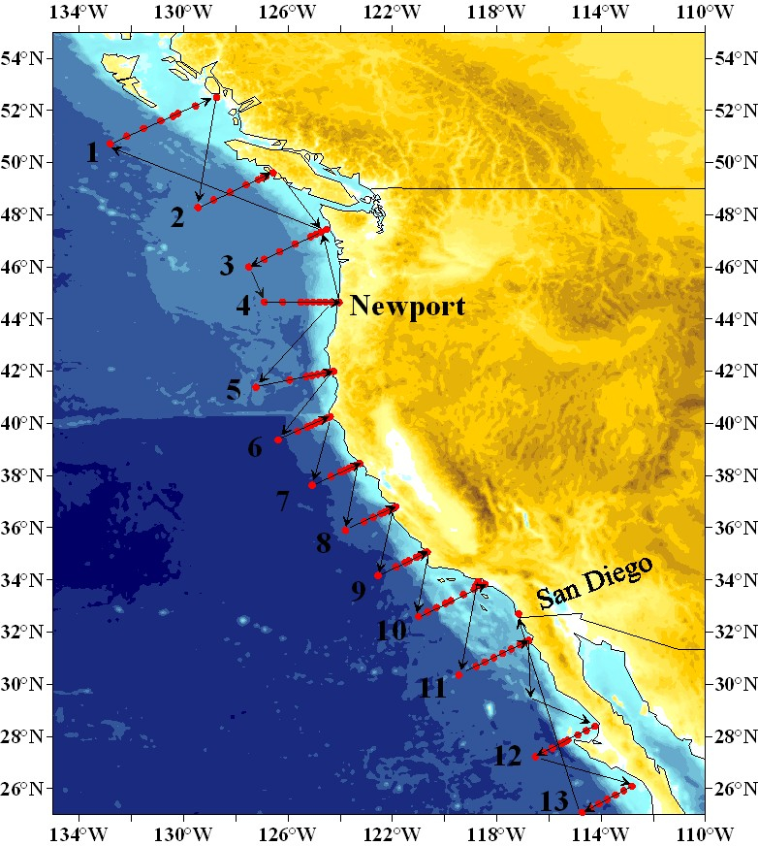
Figure 1. Station locations for the North American Carbon Program West Coast Cruise W0705A on the R/V Wecoma. The numbers indicate the transect lines from north to south.

Cruise Report
14 June 2007
Table of Contents

1.0 Summary….………………………………………………………………...2

2.0 Introduction………………………………………………………………...2

3.0 Description of Measurements from Vertical Profiles……………………3
3.1 CTD/Hydrographic Measurements Program……………………………………3
3.2 Salinity Measurements…………………………………………………………..16
3.3 Oxygen Measurements……………………………………………………….….17
3.4 Nutrient Measurements……...………………………………….........................18
3.5 DIC Measurements………………………...……………………………………19
3.6 TA Measurements…..……….…………………………………………………..20
3.7 Oxygen Isotopes and O₂/Ar gas ratio sampling ……..…………………………21
3.8 Dissolved Organic Carbon…….……….………………………………………..22
3.9 Colored Organic Matter (CDOM)………………………………………..……..22
3.10 Particulate Organic Carbon (POC), Particulate Organic
Nitrogen (PON), Biogenic Silica and chlorophyll (chl).………………………..22
3.11 Phytoplankton Counts…………….…………………………………………….23

4.0 Underway Measurements……………………...…………………………23
4.1 OSU Underway DIC/pCO₂/TSG/O₂ and bio-optics system.……………...………..23

5.0 Other Measurements……..…………………...……………….…………24
5.1 Floats …….……………………………………………………………………........24

6.0 Preliminary Results for Mexican Waters………………………………………………24

6.0 Acknowledgements……………………………………………….………25

7.0 References…………………………………………………………………25

1.0 Summary
The R/V Wecoma completed the first North American Carbon Program (NACP) West Coast Cruise from Queen Charlotte Sound in western Canada in the north to Cabo San Lazaro, Baja California, Mexico in the south. The cruise was designed to complete a series of 13 transects approximately orthogonal to the Pacific Coast (Figure 1). Full water column CTD/rosette stations were occupied at 111 specified locations along the transects. A total of 16 scientists from PMEL/AOML and other government agencies and universities participated on the 33-day cruise which departed from the Oregon State University Marine Facility in Newport, Oregon on 11 May, and arrived on schedule in San Diego, California on 14 June. Water samples were collected from the 24-bottle rosette at each station and analyzed for salinity, oxygen, nutrients, dissolved inorganic carbon, total alkalinity, dissolved organic matter, colored dissolved organic matter, particulate organic carbon, Particulate silica, and chlorophyll. Argo floats were deployed at 4 locations. Near-surface measurements of seawater and atmospheric pCO_{2,} and bio-optical properties were also made along the cruise track. No major problems were encountered on the cruise and all major cruise objectives were achieved.

2.0 Introduction
In support of the interagency North American Carbon Program (NACP) of the Climate Cycle Science Program (CCSP), NOAA conducted the NACP West Coast Cruise (Figure 1) along the Pacific west coast to study carbon cycle processes in the coastal zone over a wide range of oceanographic, atmospheric, and biogeochemical conditions. The coastal ocean plays a critical role in the North American carbon cycle and global carbon dynamics. It is a conduit for transport of terrestrial material from the land to the open ocean and its specific biological productivity is on average about three times larger than the average open-ocean values. It is also the region where the majority of the interior ocean interacts with the bottom boundary, leading to enhancements of many chemical, biological and physical processes in mid-water regions of the ocean. The coastal regions have large air-sea fluxes both into and out of the ocean. To date, the net magnitude and direction of the flux still have large uncertainties. Globally, net CO₂ fluxes as large as 1 Pg C/year, or about 60% of the oceanic uptake, have been hypothesized for this region of the oceans. The large flux is due, in part, from the coastal pump hypothesis in which the coastal margin sink is enhanced by net offshore carbon transport. The uncertainty in coastal ocean flux would be reduced with comprehensive measurements of CO₂ and related controlling parameters and yields significant improvements in the understanding of carbon sources and sinks on the continental shelf. The major goal of the cruise was to identify the sources and sinks of CO₂ in the U.S. coastal regime, along with their magnitudes, scales of variability, and controls on CO₂ fluxes. The coastal zone must be well quantified regarding carbon sources and sinks in order to make reasonable projections of future atmospheric CO₂ levels.

To address this problem, the PMEL/AOML Marine CO₂ Program has initiated a coastal carbon studies component to the U.S. North American Carbon Program to apply a variety of approaches for studying the carbon cycle (e.g. survey cruises, underway surface observations, and moorings) in the coastal region to study the invasion and transport of anthropogenic CO₂ and other tracers in coastal ocean waters. This program is designed to establish baseline observational fields for carbon system parameters, provide comparative data for observations from other projects, and develop a set of hydrographic transects of full water column measurements to be re-occupied over time for studies of inter-annual changes in physical, chemical and biological characteristics of the coastal ocean.

This NACP West Coast cruise aboard the R/V Wecoma, was the first of what is planned to be a biennial sequence of observations and studies of carbon in the dynamic coastal ocean region above/adjacent to the continental shelf along the west coast of the North American continent. Data from this cruise will provide a robust observational framework to monitor long-term trends on inter-annual timescales, and determine the temporal variability of the inorganic carbon system and its relationship to biological and physical processes in the coastal ocean and their capacity to withstand the onset of ocean acidification.

Table 1. Cruise Participants of the NACP West Coast Cruise

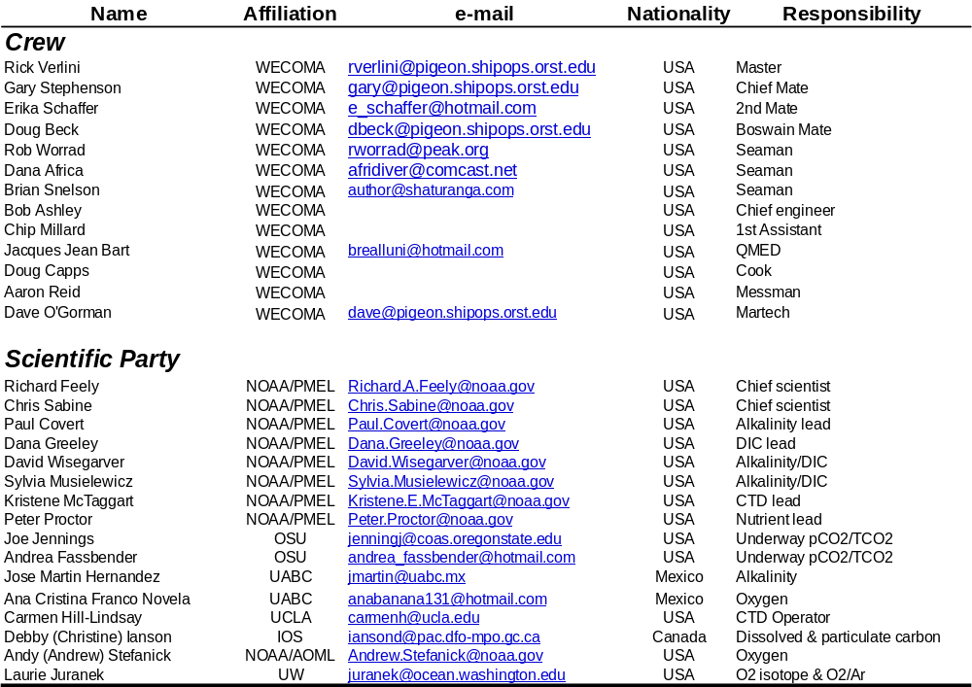
The Wecoma W0705A cruise was supported by the NOAA Global Carbon Cycle (GCC) program. Sixteen scientists representing 5 universities and 3 government research laboratories participated on the cruise (Table 1) covering the western North American continental shelf region from Queen Charlotte Sound in western Canada in the north to Cabo San Lazaro, Baja California, Mexico in the south. The R/V Wecoma departed Newport, OR on 11 May 2007. The ship proceeded north to the first station at 51°1.08’N, 132°50.72’W. The cruise completed a series of 13 transects approximately orthogonal to the Pacific Coast (Figure 1). Full water column CTD/rosette stations were occupied at specified locations along each of the transects. Twenty-four 12L and 10L Niskin-type bottles were used to collect water samples from throughout the water column at each station. Each Niskin-type bottle was sub-sampled on deck for a variety of analyses. A total of 111 stations were occupied on the cruise (Table 2). In addition, underway measurements of salinity, temperature, dissolved oxygen, pCO₂ (air and water), total carbon, fluorescence, light transmittance, and colored dissolved organic matter fluorescence. As part of the Argo program, floats were deployed at about 4 locations usually upon departure from a station. The cruise ended in San Diego, CA on 14 June, 2007.

3.0 Description of Measurements from Vertical Profiles

3.1 CTD/Hydrographic Measurements Program
The basic CTD/hydrographic measurements consisted of salinity, dissolved oxygen and nutrient measurements made from water samples taken on a 24-bottle CTD/rosette casts, plus pressure, temperature, salinity, dissolved oxygen, transmissometer and fluorometer from CTD profiles. A total of 111 stations were conducted on this cruise, usually to within 10-20m of the bottom (Table 2). Figure 1 shows the sample locations of the discrete water samples. No major problems were encountered during the operation.

3.1.1 Water Sampling Package
All but four CTD/O₂ profiles were collected using Sea-Bird instrumentation mounted vertically in a 24-position stainless steel frame, 12L and 12 10L Niskin-type Bullister bottles, and 400 lbs lead weights. Sea-Bird instruments included 24-position carousel s/n 471; 9plus CTD s/n 315; primary 3plus temperature sensor s/n 03P-4569 (stations 1-34) and 03P-4335 (stations 35-111); primary 4C conductivity sensor s/n 04-3157 (stations 1-34) and 04-2887 (stations 35-111); secondary 3plus temperature sensor s/n 03P-4341 and secondary 4C conductivity sensor s/n 04-3068; and oxygen s/n 43-0313 (stations 1-34) and 43-0315 (stations 35-111). An altimeter, load cell, and pinger were also mounted on the underwater package, as well as an OSU-supplied WET Labs fluorometer and transmissometer. Both optical sensors were removed from the package after severe corrosion at the CTD connector was found after station 38. The rosette system was suspended from a UNOLS-standard three-conductor (0.322”) electro-mechanical sea cable using the R/V Wecoma’s aft winch. The CTD was mounted vertically in an SBE CTD frame attached to a plate welded in the center of the rosette frame, under the pylon. The SBE4 conductivity and SBE3plus temperature sensors and their respective pumps were mounted vertically as recommended by SBE. Pump exhausts were attached to inside corners of the CTD cage and directed downward. The transmissometer was mounted horizontally and the fluorometer vertically. The altimeter was mounted on the inside of the bottom frame ring.

Table 2. NACP West Coast Cruise rosette station locations

Station Latitude Longitude Date GMT Depth¹ Wire Out² Pmax³
____________________________________________________________________________________________________________________
11 50 43.1N 132 49.1W 14-May-07 812 2944 2947 1120
21 51 01.0N 132 10.5W 14-May-07 1412 2756 2712 2753
31 51 18.4N 131 32.1W 14-May-07 2000 2358 2313 2346
41 51 36.0N 130 52.6W 15-May-07 136 2028 1990 2018
51 51 42.5N 130 38.0W 15-May-07 504 928 901 908
61 51 49.8N 130 22.3W 15-May-07 823 238 226 228
71 52 01.0N 129 58.2W 15-May-07 1202 133 118 121
81 52 14.0N 129 27.0W 15-May-07 1548 170 153 155
91 48 16.5N 129 27.2W 16-May-07 1558 2633 2594 2634
101 48 34.2N 128 50.4W 16-May-07 2148 2042 2021 2049
111 48 51.5N 128 13.4W 17-May-07 310 2494 2451 2488
121 49 06.3N 127 41.8W 17-May-07 849 2579 2495 2525
131 49 21.9N 127 06.0W 17-May-07 1602 157 142 143
141 49 26.1N 126 58.2W 17-May-07 1749 129 114 117

151 49 28.5N 126 50.6W 17-May-07 1946 88 70 72
161 49 32.0N 126 42.0W 17-May-07 2120 52 38 41
171 46 00.0N 127 30.0W 19-May-07 2351 2811 2770 2813
181 46 17.4N 126 55.0W 19-May-07 1654 2745 2700 2740
191 46 35.1N 126 19.4W 19-May-07 1023 2677 2638 2676
201 46 52.3N 125 43.6W 19-May-07 432 1905 1863 1887
211 47 09.4N 125 07.5W 18-May-07 2330 1141 1127 1138
221 47 15.2N 124 55.4W 18-May-07 2102 582 543 550
231 47 20.2N 124 44.2W 18-May-07 1554 131 117 119
241 47 25.1N 124 33.7W 18-May-07 1747 55 40 40
251 44 39.0N 124 09.6W 21-May-07 2333 53 40 42
261 44 39.0N 124 20.1W 22-May-07 100 84 73 76
271 44 39.0N 124 34.0W 21-May-07 1354 170 155 159
281 44 39.0N 124 48.1W 21-May-07 1042 391 375 380
291 44 39.0N 125 02.1W 21-May-07 736 1151 1125 1136
301 44 39.1N 125 16.2W 21-May-07 340 2233 2194 2224
311 44 39.0N 125 30.2W 20-May-07 2303 2880 2840 2883
321 44 39.1N 126 12.3W 20-May-07 1656 2884 2844 2888
331 44 39.0N 126 54.4W 20-May-07 1101 2906 2869 2911
341 41 23.1N 127 09.5W 22-May-07 2139 2530 2534 2505
351 41 39.4N 125 56.4W 23-May-07 812 2981 2905 2951
361 41 47.4N 125 17.5W 23-May-07 1604 3117 3055 3101
371 41 50.1N 125 04.5W 23-May-07 2123 1277 1254 1267
381 41 52.4N 124 51.5W 24-May-07 52 792 767 773
391 41 55.2N 124 38.6W 24-May-07 353 601 580 585
401 41 57.5N 124 29.0W 24-May-07 637 110 94 97
411 41 59.6N 124 21.0W 24-May-07 834 52 39 41
421 40 15.4N 124 23.2W 26-May-07 1410 57 42 44
425 40 14.0N 124 26.8W 26-May-07 1235 123 108 110
431 40 10.4N 124 34.4W 26-May-07 930 668 651 656
441 40 05.5N 124 46.0W 26-May-07 543 1055 1032 1045
451 40 00.5N 124 57.2W 26-May-07 200 1412 1383 1397
461 39 55.6N 125 07.0W 25-May-07 2217 1976 1925 1947
471 39 51.6N 125 16.0W 25-May-07 1615 3013 3018
481 39 41.6N 125 38.3W 25-May-07 900 3569 3496 3551
491 39 21.6N 126 23.2W 25-May-07 141 4094 4016 4084
501 37 38.0N 125 04.4W 27-May-07 605 4171 4128 4201
511 37 58.0N 124 21.1W 27-May-07 1432 3859 3827 3891
521 38 08.2N 123 58.8W 27-May-07 2010 3605 405 431
531 38 12.0N 123 50.3W 29-May-07 538 3197 3197 3213
541 38 16.0N 123 41.4W 29-May-07 129 1549 1526 1544
551 38 20.0N 123 32.5W 28-May-07 2146 271 257 262
561 38 24.0N 123 24.0W 28-May-07 1935 129 117 119
571 38 28.0N 123 15.2W 28-May-07 1805 70 57 59
581 35 54.0N 123 48.1W 29-May-07 2041 3853 3820 3884
591 36 14.0N 123 05.3W 30-May-07 401 3465 3435 3488
601 36 24.1N 122 44.1W 30-May-07 918 3063 3016 3060
611 36 32.0N 122 26.6W 30-May-07 1411 2355 2327 2357
621 36 36.0N 122 18.3W 31-May-07 841 2723 2687 261
631 36 40.0N 122 09.5W 31-May-07 424 1145 1125 1299
641 36 44.0N 122 01.1W 31-May-07 32 1314 1286 1136
651 36 48.0N 121 52.3W 30-May-07 2133 262 259 2723
661 34 10.1N 122 33.2W 1-Jun-07 16 3916 3844 3906
671 34 30.1N 121 51.4W 1-Jun-07 802 3778 3742 3800
681 34 40.1N 121 30.4W 1-Jun-07 1442 1274 1248 1265
691 34 44.1N 121 22.2W 1-Jun-07 1729 590 573 577
701 34 52.1N 121 05.3W 1-Jun-07 2153 530 522 520
711 34 56.1N 120 57.1W 2-Jun-07 44 330 315 319

721 35 00.2N 120 48.5W 2-Jun-07 319 106 93 94
731 35 02.1N 120 44.3W 2-Jun-07 559 58 46 48
741 35 03.5N 120 41.5W 2-Jun-07 730 36 22 24
751 32 36.2N 120 59.5W 3-Jun-07 16 3801 3767 3828
761 32 46.2N 120 39.2W 3-Jun-07 624 3809 3782 3843
771 32 56.1N 120 18.4W 3-Jun-07 1255 795 773 780
781 33 06.1N 119 58.2W 3-Jun-07 1803 1098 1077 1089
791 33 12.1N 119 45.6W 3-Jun-07 2244 675 659 666
801 33 26.2N 119 17.1W 4-Jun-07 454 1558 1567 1585
811 33 38.2N 118 52.2W 4-Jun-07 1147 897 875 884
821 33 46.7N 118 34.9W 4-Jun-07 1554 769 743 750
831 33 50.2N 118 27.3W 4-Jun-07 1904 81 73 70
841 33 56.0N 118 43.2W 4-Jun-07 2245 492 478 482
851 33 47.1N 118 51.1W 5-Jun-07 221 908 890 896
861 30 21.1N 119 27.3W 5-Jun-07 2205 3850 3804 3865
871 30 41.1N 118 47.3W 6-Jun-07 458 2808 2574 2608
881 30 51.1N 118 27.2W 6-Jun-07 1112 2372 2334 2361
891 31 01.1N 118 07.2W 6-Jun-07 1731 1751 1714 1735
901 31 11.1N 117 47.2W 6-Jun-07 2324 1733 1726 1745
911 31 21.1N 117 27.1W 7-Jun-07 525 1906 1876 1901
921 31 31.2N 117 06.5W 7-Jun-07 1053 1233 1219 1231
931 31 37.1N 116 54.4W 7-Jun-07 1607 1146 1125 1136
941 31 41.1N 116 46.4W 7-Jun-07 1950 406 391 396
951 28 23.2N 114 14.0W 8-Jun-07 1643 54 42 44
961 28 13.2N 114 34.2W 8-Jun-07 1903 97 85 87
971 28 03.2N 114 53.5W 8-Jun-07 2230 82 74 75
981 27 51.2N 115 17.1W 9-Jun-07 345 101 90 92
991 27 47.2N 115 24.6W 9-Jun-07 641 297 292 295
1001 27 43.2N 115 32.5W 9-Jun-07 1021 2301 2245 2272
1011 27 33.2N 115 52.1W 9-Jun-07 1652 3779 3723 3780
1021 27 23.2N 116 11.3W 9-Jun-07 2347 3681 3681 3738
1031 27 13.2N 116 31.0W 10-Jun-07 726 3747 992 998
1041 26 05.1N 112 49.0W 11-Jun-07 153 87 75 78
1051 25 55.1N 113 08.2W 11-Jun-07 439 194 181 184
1061 25 45.0N 113 27.4W 11-Jun-07 847 873 850 857
1071 25 35.1N 113 46.5W 11-Jun-07 1425 2998 2961 3001
1081 25 25.1N 114 05.6W 11-Jun-07 2106 3287 3264 3310
1091 25 15.1N 114 24.6W 12-Jun-07 333 3521 107 109
1092 25 15.1N 114 24.6W 12-Jun-07 542 3519 2968 3000
1101 25 05.1N 114 43.7W 12-Jun-07 924 3735 108 101
1102 25 05.1N 114 43.7W 12-Jun-07 1121 3707 2970 2195
1111 24 55.2N 115 02.8W 12-Jun-07 1421 3927 109 110
1112 24 55.1N 115 02.7W 12-Jun-07 1625 3927 2969 3000
__________________________________________________________________________
¹Depth [m] is uncorrected bottom depth from shipboard Knudsen echosounder
²Wire out [m] of winch cable at maximum pressure
³Maximum pressure [db] of CTD package

The deck watch prepared the rosette 10-15 minutes prior to each cast. The bottles were cocked and all valves, vents and lanyards were checked for proper orientation. The CTD was powered up about 10 minutes prior to station. Once stopped on station, the data acquisition system in the computer lab was started when directed by the deck watch leader. The rosette was unstrapped from its tiedown location on deck. The pinger was activated and syringes were removed from the CTD intake ports. The winch operator was directed by the deck watch leader to raise the package, the A-frame and rosette were extended outboard and the package quickly lowered into the water. The package was lowered to at least 10 meters and held there for 1 minute after the sensor pumps had turned on. The winch operator was then directed to bring the package back to the surface (0 winch wireout) and to begin the descent. At most stations the CTD rosette was lowered to within 10-20 meters of the bottom (Table 2) depending on weather conditions and bottom slope, using both the pinger and altimeter to determine the height above bottom. During the upcast the winch operator was directed to stop the winch at each bottle trip depth. The CTD console operator waited 30 seconds before tripping a bottle to insure the package wake had dissipated and the bottles were flushed, then an additional 10 seconds after bottle closure to insure that stable CTD comparison data had been acquired. Once a bottle had been closed, the console operator directed the winch operator to bring in the package to the next bottle stop. Standard sampling depths were used throughout the cruise (Figure 1). Recovering the package at the end of the deployment was essentially the reverse of launching, with the additional use of poles and snap-hooks to attach tag lines. The rosette was secured on deck under the block for sampling. The bottles and rosette were examined before samples were taken, and anything unusual noted on the sample log.

Each bottle on the rosette had a unique serial number. This bottle identification was maintained independently of the bottle position on the rosette, which was used for sample identification. No bottles were replaced on this cruise, but various parts of bottles were occasionally changed or repaired. Routine CTD maintenance included soaking the conductivity and DO sensors in dilute Triton-X solution between casts to maintain sensor stability by eliminating any accumulating biofilms. Rosette maintenance was performed on a regular basis. O-rings were changed and lanyards repaired as necessary. Bottle maintenance was performed each day to insure proper closure and sealing. Valves were inspected for leaks and repaired or replaced as needed.

3.1.2 Underwater Electronics Packages
The ship’s CTD/rosette package was employed for stations 103, 109, 110, and 111 while the aft winch was under repair. Similar Sea-Bird instrumentation, including a horizontally mounted 9plus CTD s/n 256 and vertically mounted sensors, was housed in a 12-position stainless steel frame with 12 10-liter Niskin bottles and Sea-Bird 12-position carousel s/n 89. The sensors included primary temperature s/n 03-0997, primary conductivity s/n 04-1018, oxygen s/n 43-0387, secondary temperature s/n 03-1008, and secondary conductivity s/n 04-0670. Due to time restraints, this was a 1000 m profile instead of a deep cast.

Data were acquired at full 24 Hz resolution using a 0.322” three-wire conducting cable on the aft winch. Data were telemetered through the ship’s Sea-Bird 11plus V2 deck unit s/n 11P6193-0252 onto the ship's dedicated PC using Sea-Bird Seasave Win32 version 5.37m acquisition software. The pumps were primed for 1 minute at a depth of 10 m before starting the profile near the surface. The altimeter and pinger were used to determine the height above the bottom. At each bottle depth, the console operator waited 30 seconds before closing a bottle to ensure the package wake had dissipated and the bottles were flushed, and 10 seconds after bottle closure to ensure that stable CTD comparison data had been acquired. CTD sensors were flushed and stored with a dilute Triton-X solution between casts to maintain sensor stability by reducing biofouling. Near real-time digital data were backed up onto a networked PMEL laptop. No real-time data were lost.

At station 1, profile data were truncated at 1121dbar owing to a bad primary conductivity cable that caused both pumps to shut off. At station 34, the package hit bottom and the primary TCO sensor suite had to be replaced. Profile data were truncated at 2507 dbar. At station 47, the package hit bottom and resulted in several kinks in the sea cable. Eighty-seven meters of cable was cut off before it was reterminated. Deep station 52 was aborted at 420 dbar owing to bad weather.

Table 3a. NACP West Coast Cruise PMEL underwater electronics

Sensor | Serial Number | Calibration Date | Calibration Facility
SBE 32 24-position carousel | 3232696-0471 | n/a | n/a
SBE 9plus CTD | 09P8431-0315 | n/a | n/a
Paroscientific Digiquartz Pressure Sensor | 53960 | January 22, 2007 | Sea-Bird Electronics
SBE 3plus Temperature Sensor | 03P-4569 (primary, stations 1-34) | April 24, 2007 | Sea-Bird Electronics
SBE 3plus Temperature Sensor | 03P-4335 (primary, stations 35-111) | April 24, 2007 | Sea-Bird Electronics
SBE 3plus Temperature Sensor | 03P-4341 (secondary, all stations) | April 25, 2007 | Sea-Bird Electronics
SBE 4C Conductivity Sensor | 04-3157 (primary, stations 1-34) | April 25, 2007 | Sea-Bird Electronics
SBE 4C Conductivity Sensor | 04-2887 (primary, stations 35-111) | April 25, 2007 | Sea-Bird Electronics
SBE 4C Conductivity Sensor | 04-3068 (secondary, all stations | April 25, 2007 | Sea-Bird Electronics
SBE 43 Oxygen Sensor | 43-0313 (stations 1-34) | April 20, 2007 | Sea-Bird Electronics
SBE 43 Oxygen Sensor | 43-0315 (stations 35-111) | May 4, 2007 | Sea-Bird Electronics
WET Labs Fluorometer | FLRTD-425 | November 10, 2005 | WET Labs
WET Labs Transmissometer | CST-590DR | January 22, 2007 | WET Labs
Benthos 916 Altimeter | 1035, 1034 | n/a | n/a
Metrox Load Cell | 8756 | n/a | n/a
Benthos Pinger | 1006, 1134 | n/a | n/a

Table 3b. NACP West Coast Cruise OSU underwater electronics

Sensor | Serial Number | Calibration Date | Calibration Facility
SBE 32 12-position carousel | 3212395-0089 | n/a | n/a
SBE 9plus CTD | 09P0000-0256 | n/a | n/a
Paroscientific Digiquartz Pressure Sensor | 50130 | February 26, 2007 | Sea-Bird Electronics
SBE 3 Temperature Sensor | 03-0997 | November 16, 2006 | Sea-Bird Electronics
SBE 3 Temperature Sensor | 03-1008 | November 16, 2006 | Sea-Bird Electronics
SBE 4 Conductivity Sensor | 04-1018 | November 17, 2006 | Sea-Bird Electronics
SBE 4C Conductivity Sensor | 04-0670 | November 17, 2006 | Sea-Bird Electronics
SBE 43 Oxygen Sensor | 43-0387 | January 3, 2007 | Sea-Bird Electronics
Benthos PSA-916D Altimeter | 1021 | n/a | n/a

3.1.3 Navigation and Bathymetry Data Acquisition
Navigation data were acquired at 1-second intervals from the ship's P-Code GPS receiver by a Linux system that provided a web-page with continuous updates to the ship’s position and to the arrival times for upcoming stations throughout the cruise. Bathymetric data were collected using the Ship's 12khz Knudsen echosounder system. These data were logged using the R/V Wecoma’s DAS system. Interruptions to the acquisition of the bathymetric data occurred when the Knudsen system was switched to receive the frequency of the pinger to track the distance between the CTD rosette package and the bottom.

3.1.4 CTD Data Acquisition and Rosette Operation

The CTD data acquisition system consisted of an SBE-11plus (V2) deck unit and a networked generic PC workstation running Windows XP. SBE SeaSave software was used for data acquisition and to close bottles on the rosette. CTD deployments were initiated by the console watch after the ship had stopped on station. The watch maintained a console operations log containing a description of each deployment, a record of every attempt to close a bottle and any pertinent comments. Once the deck watch had deployed the rosette, the winch operator would lower it to 10 meters. The CTD sensor pumps were configured with a 60 second startup delay, and were usually on by this time. The console operator checked the CTD data for proper sensor operation, waited an additional 60 seconds for sensors to stabilize, then instructed the winch operator to bring the package to the surface, pause for 10 seconds, and descend to a target depth (wire-out). The profiling rate was no more than 30m/min to 50m, no more than 45m/min to 200m and no more than 50m/min deeper than 200m varying with sea cable tension and the sea state.

The console watch monitored the progress of the deployment and quality of the CTD data through interactive graphics and operational displays. Additionally, the watch created a sample log for the deployment which would be later used to record the correspondence between rosette bottles and analytical samples taken. The altimeter channel, CTD pressure, wire-out, pinger and bathymetric depth were all monitored to determine the distance of the package from the bottom, usually allowing a safe approach to within 10 meters. Bottles were closed on the up cast by operating an on-screen control. Bottles were tripped 30 seconds after stopping at the trip location to allow the rosette wake to dissipate and the bottles to flush. The winch operator was instructed to proceed to the next bottle stop 10 seconds after closing bottles to insure that stable CTD data were associated with the trip. After the last bottle was closed, the console operator directed the deck watch to bring the rosette on deck. Once out of the water, the console operator terminated the data acquisition, turned off the deck unit and assisted with rosette sampling.

3.1.5 CTD/O₂ Data Processing
The reduction of profile data began with a standard suite of processing modules (process.bat) using Sea-Bird Data Processing Win32 version 5.37e software in the following order:

1. DATCNV converts raw data into engineering units and creates a .ROS bottle file. Both down and up casts were processed for scan, elapsed time(s), pressure, t0, t1, c0, c1, and oxygen voltage. Optical sensor data were converted to voltages but not carried further through the processing stream. MARKSCAN was used to skip over scans acquired on deck and while priming the system under water. MARKSCAN values were entered at the DATCNV menu prompt.

2. ALIGNCTD aligns temperature, conductivity, and oxygen measurements in time relative to pressure to ensure that derived parameters are made using measurements from the same parcel of water. Both conductivities are automatically advanced in the V2 deck unit by 0.073 seconds. No additional alignment was necessary for primary conductivity sensors s/n 3157 and 2887. An additional alignment of .020 seconds was made to secondary conductivity sensor s/n 3068 for a net advance of .093 seconds. It was not necessary to align temperature or oxygen.

3. BOTTLESUM averages burst data over an 8-second interval (+/- 4 seconds of the confirm bit) and derives both primary and secondary salinity, primary potential temperature (θ), primary potential density anomaly (σ_{θ}), and oxygen (in μmol/kg).

4. WILDEDIT makes two passes through the data in 100 scan bins. The first pass flags points greater than 2 standard deviations; the second pass removes points greater than 20 standard deviations from the mean with the flagged points excluded. Data were kept within 100 of the mean (i.e. all data).

5. FILTER applies a low pass filter to pressure with a time constant of 0.15 seconds. In order to produce zero phase (no time shift) the filter is first run forward through the file and then run backwards through the file.

6. CELLTM uses a recursive filter to remove conductivity cell thermal mass effects from measured conductivity. In areas with steep temperature gradients the thermal mass correction is on the order of 0.005 PSS-78. In other areas the correction is negligible. The value used for the thermal anomaly amplitude (α) was 0.03. The value used for the thermal anomaly time constant (β⁻¹) was 7.0 s.

7. LOOPEDIT removes scans associated with pressure slowdowns and reversals. If the CTD velocity is less than 0.25 m s⁻¹ or the pressure is not greater than the previous maximum scan, the scan is omitted.

8. BINAVG averages the data into 1-dbar bins. Each bin is centered on an integer pressure value, e.g. the 1-dbar bin averages scans where pressure is between 0.5 dbar and 1.5 dbar. There is no surface bin. The number of points averaged in each bin is included in the data file.

9. DERIVE uses 1-dbar averaged pressure, temperature, and conductivity to compute primary and secondary salinity.

10. TRANS converts the binary data file to ASCII format.

Package slowdowns and reversals owing to ship roll can move mixed water in tow to in front of the CTD sensors and create artificial density inversions and other artifacts. In addition to Seasoft module LOOPEDIT, MATLAB program deloop.m computes values of density locally referenced between every 1 dbar of pressure to compute the square of the buoyancy frequency, N², and linearly interpolates temperature, conductivity, and oxygen voltage over those records where N² is less than or equal to -1 × 10⁻⁵ s⁻². Twelve profiles failed this criteria in the top 10 meters. These data were retained by program delooppost.m and flagged as questionable in the final WOCE formatted files.Program calctd.m reads the delooped data files and applies final calibrations to primary temperature and conductivity, and computes salinity and calibrated oxygen. Program cnv_eps.f computes ITS-90 temperature, potential temperature (θ), density anomalies σ_{t} and σ_{θ}, and dynamic height; creates WOCE quality flags, and converts the ASCII calibrated data files into NetCDF format for PMEL’s database. Program wocelst.f converts the ASCII calibrated data files into ASCII WOCE format for submission to the WHPO.

3.1.6 CTD Shipboard Calibration Procedures
CTD 09P8431-0315 was used for all casts (Table 3). The CTD was deployed with all sensors and pumps aligned vertically, as recommended by SBE. The primary temperature and conductivity sensors (T1 & C1) were used for all reported CTD data. In-situ salinity and dissolved O2 check samples collected during each cast were used to calibrate the conductivity and dissolved O2 sensors.
3.1.7 CTD Pressure
Pressure calibrations for the CTD instrument used during this cruise were pre-cruise. No additional adjustments were applied. On deck pressure readings prior to each cast were examined and remained within 0.5 dbar of calibration.
3.1.8 CTD Temperature
In addition to a viscous heating correction of -0.0006 °C, a linearly interpolated temperature sensor drift correction using pre and post-cruise calibration data for the midpoint of the cruise will be determined. Viscous and drift corrections are applied to profile data using program calctd.m, and to burst data using calclo.m.

3.1.9 CTD Conductivity
Seasoft module BOTTLESUM creates a sample file for each cast. These files were appended using program sbecal1.f. Program addsal.f matched sample salinities flagged as good to CTD salinities by station/sample number. Primary sensors s/n 3157 and 2887 were selected for calibration. For s/n 3157, program calcos0.m produced the best results for an overall linear fit of sample data from stations 1-34:

number of points used: 71
total number of points: 88
% of points used in fit: 80.68
fit standard deviation : 0.002516
fit bias: 0.032562618
fit slope: 0.99893265

For s/n 2887, program calcop1.m produced the best results for a station-dependent linear fit with a pressure term of two groups of sample data, 35-46 and 47-111 respectively:

Group: 35-46
number of points used: 1797
total number of points : 2057
% of points used in fit: 87.36
fit standard deviation : 0.001389
fit bias: -0.00093990233
fit slope: 0.99997966

Group: 47-111
number of points used: 1797
total number of points: 2057
% of points used in fit: 87.36
fit standard deviation : 0.001389
fit bias : -0.00093990233
fit slope: 0.99997966

For s/n 1018, program calcos0.m produced the best results for an overall linear fit of sample data from stations 103 and 109-111:

number of points used: 8
total number of points: 8
% of points used in fit: 100
fit standard deviation: 0.002184
fit bias: 0.006008887
fit slope: 0.99990618

Conductivity calibrations were applied to profile data using program calctd.m, and to burst data using calclo.m.

Primary sensor CTD - bottle conductivity differences plotted against station number (Figure 2) and pressure (Figure 3) are used to allow a visual assessment of the success of the fit.

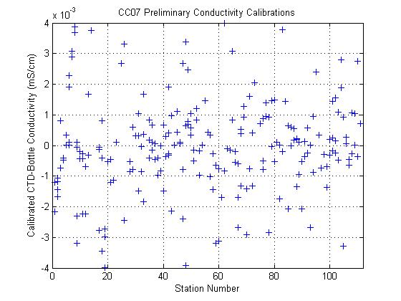
Figure 2. Calibrated CTD conductivity - bottle conductivity versus station number.

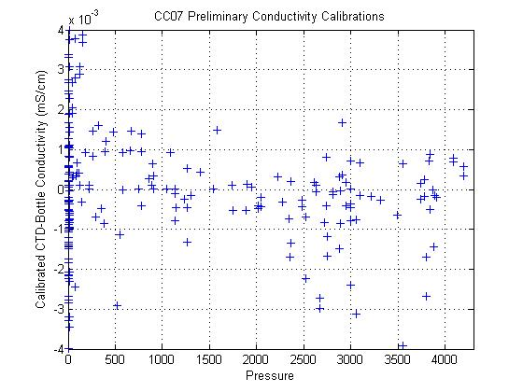
Figure 3. Calibrated CTD conductivity – bottle conductivity versus pressure.

3.1.10 CTD Oxygen Calibration
Program addoxy.f matched bottle sample oxygen values flagged as good (2 or 6) to CTD oxygen values by station/sample number. Because of sensor hysteresis, programs match_sg_n_313.m (stations 1-34) and match_sg_n_315.m (stations 35-111) were used to match up-cast oxygen data to downcast oxygen data by potential density anomalies referenced to the closest 1000-m interval. A least-squares station-dependent fit was determined for groups of stations using program run_oxygen_cal_1.m:

Station Slope Range Bias Lag Tcor Pcor Points Used StdDev
1- 4 0.3309-0.3399 -0.4972 3.0197 0.0029 0.0001 100 98.0% 0.4481
5-20 0.3511-0.3645 -0.5119 3.1121 0.0023 0.0001 528 90.5% 0.7684
21-22 0.3731-0.3731 -0.5271 3.7915 0.0016 0.0001 68 88.2% 0.6854
23-43 0.3620-0.3693 -0.5059 3.3016 0.0023 0.0001 628 89.6% 0.8648
44-66 0.3756-0.3820 -0.5145 7.3144 0.0017 0.0001 783 89.8% 0.8288
67-67 0.3612-0.3612 -0.4606 3.7839 0.0102 0.0002 29 96.6% 0.6001
68-84 0.4244-0.4359 -0.4600 6.7851 -0.0056 0.0001 524 82.1% 0.7518

Oxygen calibration coefficients were applied to profile data using program calctd.m, and to burst data using calclo.m.

Primary sensor CTD - bottle oxygen differences plotted against station number (Figure 4) and pressure (Figure 5) are used to allow a visual assessment of the success of the fits.

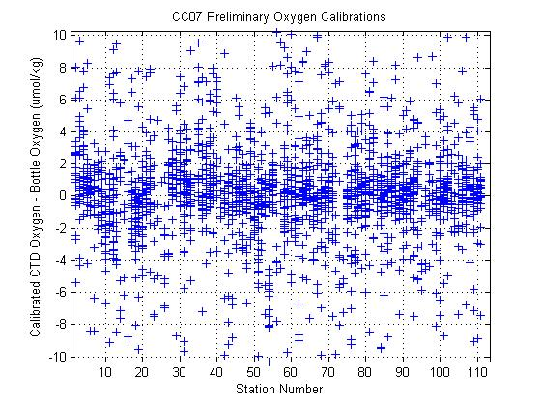
Figure 4. Calibrated CTD oxygen - bottle oxygen versus station number.

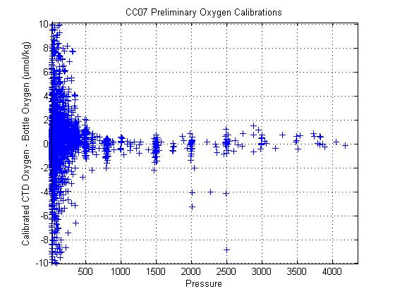
Figure 5. Calibrated CTD oxygen – bottle oxygen versus pressure.

Dissolved O₂ concentration is calculated via the equation:

O₂(ml/l) = [c1*Oc+c2]*fsat(S,T,P)*e**(c3*Pl+c4*Tf+c5*Ts+c6*dOc/dt) (1)

where:
O₂(ml/l) = Dissolved O₂ concentration in ml/l;
Oc = Sensor current (µamps);
fsat(S,T,P) = O₂ saturation concentration at S,T,P (ml/l);
S = Salinity at O₂ response-time;
T = Temperature at O₂ response-time (°C);
P = Pressure at O₂ response-time (decibars);
Pl = Low-pass filtered pressure (decibars);
Tf = Fast low-pass filtered temperature (°C);
Ts = Slow low-pass filtered temperature (°C);
dOc/dt = Sensor current gradient (µamps/secs);
dT = low-pass filtered thermal gradient (Tf - Ts).

3.1.11 Bottle Sampling
At the end of each rosette deployment water samples were drawn from the bottles in the following order:
o O₂
o Ar and O₂ isotopes
o Dissolved Inorganic Carbon (DIC)
o Total Alkalinity
o Dissolved Organic Carbon (DOC)
o Total Organic Carbon
o CDOM
o Chlorophyll
o Salinity
o Nutrients
o Particulate Organic Carbon
o Particulate Si
o Stained Paticulate Matter

The correspondence between individual sample containers and the rosette bottle position (1-24) from which the sample was drawn was recorded on the sample log for the cast. This log also included any comments or anomalous conditions noted about the rosette and bottles. One member of the sampling team was designated the sample cop, whose sole responsibility was to maintain this log and insure that sampling progressed in the proper drawing order.

Normal sampling practice included opening the drain valve and then the air vent on the bottle, indicating an air leak if water escaped. This observation together with other diagnostic comments (e.g., “lanyard caught in lid,” “valve left open”) that might later prove useful in determining sample integrity were routinely noted on the sample log. Drawing oxygen samples also involved taking the sample draw temperature from the bottle. The temperature was noted on the sample log and was sometimes useful in determining leaking or mis-tripped bottles.

Once individual samples had been drawn and properly prepared, they were distributed for analysis. Oxygen, nutrient and salinity analyses were performed on computer-assisted (PC) analytical equipment networked to the data processing computer for centralized data management.

3.1.11 Bottle Data Processing
Water samples collected and properties analyzed shipboard were managed centrally in a Excel data base and processed in Ocean DataView. The sample logs was entered into the database once sampling was completed. Quality flags associated with sampled properties were set to indicate that the property had been sampled, and sample container identifications were noted where applicable (e.g., oxygen flask number). Analytical results were provided on a regular basis by the various analytical groups and incorporated into the database. Various consistency checks and detailed examination of the data continued throughout the cruise.

3.2 Salinity Measurements
Sample salinity measurements were made using Guildline 8400B Autosal salinometer s/n 68807 located in a container lab on the upper deck aft. Two samples were collected from each cast, one from the surface mixed layer and one from the deepest Niskin. Samples were collected in 200 ml Kimax high-alumina borosilicate bottles, sealed with custom clear plastic inserts and Nalgene caps, and externally rinsed with fresh water to reduce salt contamination. Salinity samples were allowed to equilibrate in an open tray on the counter next to the Autosal for a minimum of eight hours. A batch of measurements, sorted by depth in descending order, was performed at the end of each transect, roughly every third day of the cruise. A total of 260 sample salinity measurements were made during this cruise, including 40 duplicates.

The Autosal bath temperature was set to 21C. An air conditioner was mounted in the van to regulate temperature around 19-20C. Fluctuations were monitored using a wall-mounted thermometer. A logging thermometer recorded ambient temperature in1-minute increments during a run, which usually remained stable to within 1C. Power to the Autosal was conditioned through a UPS to reduce noise in the readings. An Ocean Scientific Instruments interface box connected the Autosal to a laptop with ACI2003 software installed.

After initiating the software program, a bottle of standard seawater (batch P145) was used to determine an offset correction to be applied to the following measurements. Each water sample was flushed through the Autosal’s conductivity cell 3-5 times before taking the first reading. After waiting five seconds, ten seconds of 4 Hz data (40 values) were averaged for a conductivity ratio. Three corrected conductivity ratios were averaged and one salinity value was calculated for each water sample. After all samples were analyzed, a second bottle of standard seawater was run and may be used post-cruise to determine a drift correction during the run. A dilute solution of Triton-X surfactant was flushed through the cell at the end of each session, followed by 400 ml is distilled water. Distilled water remained in the cell between uses.

3.3 Oxygen Measurements

Samples were drawn from Niskin bottles into calibrated 125 ml iodine titration flasks using Tygon tubing with a silicone adaptor that fit over the petcock to avoid contamination of DOC samples. Bottles were rinsed three times and filled from the bottom, overflowing three volumes while taking care not to entrain any bubbles. The draw temperature was taken using a digital thermometer with a flexible thermistor probe that was inserted into the flask while the sample was being drawn during the overflow period. These temperatures were used to calculate µmol kg⁻¹ concentrations, and a diagnostic check of bottle integrity. One-ml of MnCl₂ and one-ml of NaOH/NaI were added immediately after drawing the sample was concluded using a Repipetor, the flasks were then stoppered and shaken well about 20 times. DIW was added to the neck of each flask to create a water seal. The flasks were stored in the lab in plastic totes at room temperature for 6-7 hours before analysis. Twenty-four samples plus two duplicates were drawn from each station except the shallow costal stations where only ten to fifteen samples were drawn with one to two duplicates. Total number of samples collected was 2419 with a test cast of 10 samples; total number of samples flagged after initial shipboard reduction of quality control: Questionable (QC=6 ): Bad (QC=11 ): Not reported (QC=5 ).

Dissolved oxygen analyses were performed with a MBARI-designed automated oxygen titrator using photometric end-point detection based on the absorption of 365 nm wavelength ultra-violet light. The titration of the samples and the data logging were controlled by a 386 PC running the
Oxygen program written by Gernot Friedrich. The titrations were preformed in a climate controlled lab van at 18.5°C-20°C. Thiosulfate was dispensed by a Dosimat 665 fitted with a 5.0 ml buret. The whole-bottle titration technique of Carpenter (1965) with modifications by Culberson et al. (1991) was used, but with more dilute solution of thiosulfate (10 g L⁻¹). Replicate 10 ml iodate standards were run every 36 hours. The reagent blank determined as the difference between V2 and V1, the volumes of thiosulfate required to titrate 1 ml aliquots of the iodate standard was determined at the beginning of the cruise. This method was found during pre-cruise testing to produce a more reproducible blank value than the value determined as the intercept of a standard curve. Periodic spot checks of the thiosulfate was done between standards along with checks of the blank measurement to insure its initial quality. The molarity of the thiosulfate titrant was determined as given in Dickson (1994).

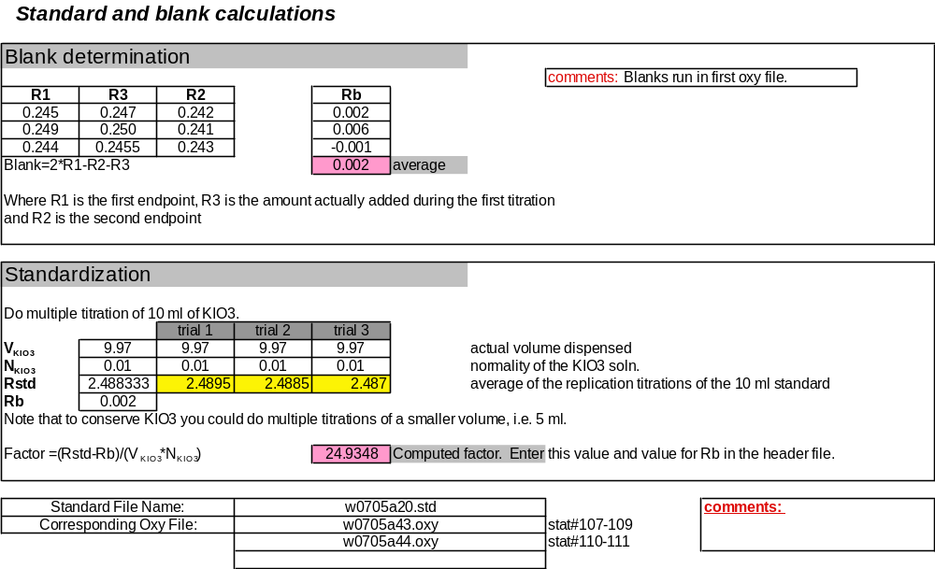

3.4 Nutrient Measurements
Nutrient samples were collected from the Niskin bottles in acid washed 25-ml linear polyethylene bottles after three complete seawater rinses and analyzed within 1 hour of sample collection Nutrients were analyzed with a continuous flow analyzer (CFA) using the protocols for the WOCE hydrographic program as set forth in the manual by L.I. Gordon, et al (2000). ~2350 samples were taken at discrete depths and analyzed for phosphate (PO₄), nitrate (NO₃) plus nitrite (NO₂)--(N+N), nitrite and silicic acid (Sil). The A and B standards for PO4, NO₃ and Sil for the cruise were prepared in the laboratory at PMEL. An A standard for NO₂ was prepared weekly. Working standards were prepared at sea for each run of the CFA. Output from the detectors was recorded as peak heights of the analog voltage signal using a VI program on a laptop computer and converted to μM/L using an Excel spreadsheet. A refractive index analysis was run every other day and a linearity test of the detectors was run weekly.

3.4.1 Nitrate and Nitrite
Nitrite was determined by diazotizing with sulfanilamide and coupling with N-1 naphthyl ethylenediamine dihydrochloride to form an azo dye. The color produced is measured at 540 nm (Zhang et al., 1997). Samples for nitrate analysis were passed through a home made cadmium column (Zhang et al., 2000), which reduced nitrate to nitrite and the resulting nitrite concentration was then determined as described above. Nitrate concentrations were determined from the difference of nitrate + nitrite and nitrite.

3.4.2 Phosphate
Phosphate in the samples was determined by reacting with molybdenum (VI) and antimony (III) in an acidic medium to form an antimonyphosphomolybdate complex a temperature of 55°C. This complex was subsequently reduced with hydrazine to form a blue complex and the absorbance was measured at 815 nm (Zhang et al., 2001).

3.4.3 Silicic Acid
Silicic acid in the sample was analyzed by reacting the aliquote with molybdate in a acidic solution to form molybdosilicic acid. The molybdosilicic acid was then reduced by SnCl₂ to form molybdenum blue (Gordon et al., 1995). The absorbance of the molybdenum blue was measured at 660 nm.

3.4.4 Calibration and Standards
Stock standard solutions were prepared by dissolving high purity standard materials (KNO₃, NaNO₂, KH₂PO₄ and Na₂SiF₆ ) in deionized water. Working standards were freshly made at each station by diluting the stock solutions in low nutrient seawater. The low nutrient seawater used for the preparation of working standards, determination of blank, and wash between samples was filtered seawater obtained from low-nutrient Pacific surface waters. Standardizations were performed prior to each sample run with working standard solutions. Replicates were usually collected at the deepest Niskin bottle from each cast. The relative standard deviation from the results of these replicate samples was used to estimate the overall precision obtained by the sampling and analytical procedures. The precisions of these samples were 0.04 µmol/kg for nitrate, 0.01 µmol/kg for phosphate and 0.1 µmol/kg for silicic acid.

3.5 DIC Measurements
The DIC analytical instrumentation was set up in a seagoing container modified for use as a shipboard laboratory. The analysis was done by coulometry with two analytical systems (PMEL-1 and PMEL-2) used simultaneously on the cruise. Each system consisted of a 5011 coulometer (UIC, Inc.) coupled with a system designed to improve upon the original SOMMA (Single Operator Multiparameter Metabolic Analyzer) inlet system. The original SOMMA was developed by Ken Johnson (Johnson et al., 1985,1987,1993; Johnson, 1992; Wilke et al., 1993) of Brookhaven National Laboratory (BNL). In the coulometric analysis of DIC, all carbonate species are converted to CO₂ (gas) by addition of excess hydrogen to the seawater sample, and the evolved CO₂ gas is carried into the titration cell of the coulometer, where it reacts quantitatively with a proprietary reagent based on ethanolamine to generate hydrogen ions. These are subsequently titrated with coulometrically generated hydroxide. CO₂ is thus measured by integrating the total change required to balance the reaction.

For this NACP West Coast Cruise, our primary standards (Certified Reference Materials (CRMs supplied by Dr. A. Dickson of Scripps Institution of Oceanography (SIO). The CRM accuracy is determined shoreside manometrically. The CRMS were run approximately every 24 samples on each analytical system. We also re-used (or re-analyzed) these standards as a “secondary standard” – these were also analyzed approximately every 24 samples – though offset from the primary standard. On this cruise, the overall accuracy and precision for the primary CRMs on both instruments combined was 0.54 ± 1.5 µmol/kg (n=87, as of June 4). Preliminary DIC data reported to the database have not yet been completely corrected to the Batch 79 CRM value, but a more careful quality assurance to be completed shoreside will have final data corrected to the secondary standard on a per instrument basis.

Samples were drawn from the Niskin-type bottles into cleaned, precombusted 300-mL Pyrex bottles using Tygon tubing with silicone ends. Bottles were rinsed twice and filled from the bottom, overflowing half a volume and taking care not to entrain any bubbles. The tube was pinched off and withdrawn, creating a 6-mL headspace, and 0.18 mL of 50% saturated HgCl₂ solution was added as a preservative. The sample bottles were sealed with glass stoppers lightly covered with Apiezon-L grease, and were stored at room temperature for a maximum of 5 hours prior to analysis. Over 2000 samples were analyzed for discrete DIC; full profiles were completed on every station after some initial instrument adjustment during line number 1. Replicate samples were typically taken from the two bottom depths out of the Niskin-type bottles. The replicate samples were interspersed throughout the station analysis for quality assurance of the integrity of the coulometer cell solutions. No systematic differences between the replicates were observed.

3.6 TA Measurements
Seawater total alkalinity (TA) was measured by acidimetric titration. The specific method used was based upon the open cell method described by Dickson et al (2003). This method involves first acidifying the sample to reduce the sample pH to less than 3.6 followed by bubbling CO₂-free air through the sample to facilitate removal of the CO₂ evolved by the acid addition. After removal of the carbonate species from solution, the titration proceeds until a pH of less than 3.0 is attained. Titration progress is monitored by measuring the electromotive force (E) of a combination glass-reference electrode. The electromotive force is directly related to solution pH via the Nernst Equation
[H⁺] = k exp(E/RTF⁻¹) = exp(E – E⁰/RTF⁻¹), (Eq. 1)
where E⁰ is the electrode reference potential, R is the universal gas constant, T is the solution temperature, and F is the Faraday constant. A non-linear least squares method is used to fit the titration data to an equation that takes into account the various acid-base equilibria in solution during the titration. The two adjustable parameters in this fit equation are A_{T} and E⁰.

Samples were drawn from the Niskin-type bottles into cleaned, amber, 250 mL borosilicate glass bottles using Tygon tubing with silicone ends. Bottles were rinsed twice and filled from the bottom, overflowing half a volume and taking care not to entrain any bubbles. The sample tube was closed off and withdrawn from the sample bottle, creating a 5 mL headspace. Samples were preserved by poisoning with 0.18 mL of a 50% saturated HgCl₂ solution. Sample bottles were sealed with glass stoppers lightly coated with Apiezon-L grease, and were stored at room temperature (21-25 °C) for a maximum of 12 hours prior to analysis.

Titrations were carried out in water-jacketed, 250 mL beakers. The beakers were kept at 24.0 ± 0.2 °C with water from a constant temperature bath. Prior to analysis, samples were placed in the water bath to bring them to the same temperature as the reaction beakers. Seawater samples were dispensed into the water-jacketed beaker using a fixed volume (108.30 +/ 0.03 mL) glass syringe. A Metrohm Dosimat 765 was used to deliver acid to the sample beaker in increments of 0.040 mL. The acid titrant used was 0.1 mol kg⁻¹ HCl prepared in 0.6 mol kg⁻¹ NaCl background to approximate the ionic strength of seawater (0.7 mol kg⁻¹). Three batches of titrant were used over the course of the cruise: PMEL 050607-1, PMEL 050607-2, and PMEL 050607-3. Acid concentrations determined from laboratory preparation are 0.09923, 0.10031, and 0.10002 mol kg⁻¹, respectively.Titration pH was monitored with a Radiometer (model PHC 2002-8) combination pH glass-reference electrode. Electrode E was measured using a National Instruments high-precision data acquisition card (NI-4351). This same data acquisition card was used to provide the 100 mA excitation current and record the resistance of the Pt RTDs used to monitor sample, titrant, and reaction temperatures. Pt RTDs were calibrated to +/- 0.01 °C. Degassing air was flowed through a Drierite column and then an Ascarite column prior to bubbling through the sample to remove all water and CO₂ from the gas stream.Instrument control and data acquisition was with custom software developed at NOAA/PMEL using the National Instruments LabView programming environment. Over the course of the cruise we analyzed over 2,500 samples, including duplicate samples and certified reference materials (CRMs). Typical titrations were completed in 10 - 14 minutes and required 20 - 24 acid additions to reach a pH of 3.0. Analytical accuracy was assessed by periodic analysis of CRMs (Batch 79: supplied by Dr. A. Dickson of Scripps Institution of Oceanography; http://andrew.ucsd.edu/co2qc/) throughout the cruise. References were analyzed approximately every 24 samples. Deviation from the certified reference alkalinity (2262.31 umol/kg) varied between acid batches, but was never greater than 5.0 umol/kg. Analytical precision over the course of the cruise, calculated as the standard deviation of all CRM analyses, was +/- 2.0 umol/kg. The electrode reference potential, E⁰, was monitored over the course of the cruise to assess electrode condition and stability. With the exception of a step in E⁰ near the beginning of the cruise, coinciding with a change in reaction temperature from 20 to 24 °C, E⁰ increased steadily and in a linear fashion from 0.380 to 0.383.

3.7 Oxygen Isotope and O₂/Ar gas ratio sampling
Samples for dissolved oxygen isotopes and O₂/Ar gas ratios were collected from a near-surface (10-15m) Niskin at all stations except station 85. At 20 stations an additional 1-2 samples were collected in the upper 100m below the mixed layer. Roughly, these additional subsurface samples were taken at one inshore (shelf) station and one offshore station on each line. Samples were collected in 500 ml pre-evacuated glass sampling bottles equipped with Louwers™ high vacuum single o-ring valves. Each bottle had been pre-poisoned with mercuric chloride during flask preparation. Great care was taken to prevent atmospheric contamination of the sample during collection by filling the flask sidearm with water, tapping all air bubbles free, then slowly opening the o-ring to the flask while maintaining a water lock between the atmosphere and the o-ring. Roughly 250 ml of sample was collected in each 500 ml flask, allowing half the flask volume for dissolved gases to exsolve into the headspace.

Samples will be returned to the University of Washington stable isotope laboratory for analysis of ¹⁸O/¹⁶O, ¹⁷O/¹⁶O, and O₂/Ar by a Thermo-Finnigan isotope ratio mass spectrometer after cryogenic separation of water vapor and CO₂ and chromatographic separation of N₂ from the O₂ and Ar in the collected gas mixture. Seventy-five determinations of the ¹⁸O/¹⁶O and ¹⁷O/¹⁶O ratio relative to an internal reference standard will be used to compute ¹⁷Δ, which is defined as
¹⁷Δ=10⁶ [ln(δ¹⁷O/1000 -1) – 0.518*ln(δ¹⁸O/1000 -1)],
where δ¹⁷O = 10³[(¹⁷O/¹⁶O)sample/(¹⁷O/¹⁶O)standard -1] and δ¹⁸O is defined analogously. Final ¹⁷Δ values will be reported relative to air based on air standards analyzed each day with samples. The O₂/Ar ratio will also be determined on each sample by a separate determination of mass peaks 32 and 40. The ratio will then be reported relative to the O₂/Ar ratio expected at solubility equilibrium using the O₂ and Ar solubility relationships of Garcia and Gordon (1992) and Hamme and Emerson (2004).

The ¹⁷Δ of dissolved O₂ will yield an estimate of in situ gross primary productivity following Luz and Barkan (2000), while the dissolved O₂/Ar gas ratio will yield an estimate of net biological O₂ production (e.g., Craig and Hayward, 1987; Emerson et al., 1997). These data will be used to determine the spatial variability of gross and net organic carbon production and export along the west coast during the upwelling season and help to constrain the influence of biological activities on the west coast inorganic carbon budget.

3.8 Dissolved Organic Carbon
DOC samples were collected using two slightly different sampling protocols for different laboratories (Craig Carlson, University of California Santa Barbara, UCSB, and Debby Ianson, Institute of Ocean Sciences, IOS). Approximately 1250 samples were collected for the UCSB lab and 200 samples for the IOS lab (including some TOC samples). Vertical profiles from surface to 2000m (or depth of water column) were sampled at all lines and all stations (with the exception of two nearshore locations). Samples can easily be contaminated so great care was taken when sampling. Nitrile gloves (not latex) were worn and only silicon tubing was used for all samples drawn from the rosette. Samples were filtered in line from the Niskin bottles using a nominal 0.7 µm pore size glass fibre filter (GFF) into 60 ml high density polyethylene bottles (UCSB) or a 0.2 µm Teflon filter into 40 ml glass vials with Teflon caps (IOS). TOC samples were collected directly from the Niskin bottles (no filtering). DOC samples below 250 m going to the UCSB lab were not filtered. All samples were frozen immediately after collection. The 0.7 um filters were discarded and new filters used for each cast. The filter cartridges were acid rinsed between each cast. The 0.2 µm filter was acid rinsed between each line and flushed with 1 l of seawater before sampling at each station.

All analysis will occur at the respective labs. For analysis the sample is thawed and acidified, sparged with oxygen to remove inorganic carbon. The organic carbon is combusted and converted to carbon dioxide which is measured by a non-dispersive infrared detector.

3.9 Colored Dissolved Organic Matter (CDOM)
CDOM samples were collected using the 0.2 µm Teflon filter (same filter and procedure as the DOC samples above) into a 125 ml amber glass bottle and refrigerated immediately. Surface samples were collected at 4-5 stations on each line including the 3 profile stations per line (described below, section 3.10). At these 3 stations 3 depths were sampled; surface, mixed layer and below the mixed layer. Approximately 150 samples were collected. Analysis will be completed at IOS by Sophia Johannessen using a dual beam spectrophotometer.

3.10 Particulate Organic Carbon (POC), Particulate Organic Nitrogen (PON), Biogenic Silica and chlorophyll a (chl)

At 3 stations per line vertical profiles of POC, PON, BSi and chl were sampled. The stations were chosen to be representative of the shelf, shelf break and immediately offshore. For POC, PON and BSi 4 depths were sampled; 5m, middle of surface mixed layer (ML), base of ML and one depth well below the ML (usually 175m). Chl was sampled at the upper 3 depths, but not below the ML. Chl was also sampled at 5m at an additional station on each line.

The collection of POC, PON, BSi and chl samples from the rosette is similar. A volume of water (0.5 l for chl; 2 l for POC and PON; 2 1 for BSi) was collected from the rosette and filtered immediately after collection onboard in the wet lab using a filtration manifold and a low pressure vacuum pump. Note that POC and PON are measured from the same filter. Polycarbonate filters (0.6 µm) were used for BSi samples and GFF (0.7 µm) filters were used for POC, PON and also chl. The filters were frozen immediately after filtering to await analysis.

The BSi samples will be analyzed at the University of Victoria (UVic) by Diana Varela's lab. These filters will be dried at 60 °C, transferred to a 15-ml centrifuge tubes where the BSi is dissolved with NaOH at 95 °C for 1 hour. Dissolved Si will then be measured spectophotometrically. Chl and phaeopigments will be analyzed fluorometrically (also in the Varela lab at UVic). POC and PON will be analyzed at the University of California, Davis Stable Isotope Facility. Filters will be dried at 60 °C and prepared for mass spectrometric analysis.

3.11 Phytoplankton Counts
Samples for phytoplankton species composition were collected at one station per line, above the shelf and in the surface. Seawater was collected and fixed (cells are killed, preserved and stained) with a Lugols solution. Aliquots of the sample will be counted using an inverted microscope.

4.0 Underway Measurements

4.1 OSU Underway DIC/pCO₂/TSG/O₂, bio-optics system

An integrated suite of underway surface measurements was attempted using the ship’s uncontaminated seawater supply, flowing at > 20 liters per minute. Approximately 8 liters per minute were diverted to flow sequentially through a 'bio-optics' sensor suite, consisting of a SeaBird Electronics (SBE) SBE45 Thermosalinograph, an SBE43 dissolved oxygen sensor, and WetLabs transmissometer, chlorophyll fluorometer, and CDOM fluorometer sensors. Continuous pCO₂ determinations were made by equilibrating at about 200 – 400 ml/min of this seawater stream with marine air using a miniature version of the microporous membrane contactor as described in Hales, Chipman, and Takahashi, 2004. A stream of air flowing counter to the liquid stream equilibrated with the seawater, and then passed through a LI- COR LI-840 dual-channel NDIR analyzer, where the CO₂ and water vapor content of the carrier gas were analyzed at a frequency of 1 Hz. Accuracy was ensured by regular analyses of standard gases of known CO₂ mixing ratio. Precision of the LI-840 is reported by LI-COR to be about 2 ppm, however our high sampling rate and subsequent data reduction improves this statistic. Repeat analyses of standard gases shows that polynomial data-smoothing at ca 10-second resolution reduces the analytical precision to <1 ppm.

Continuous underway measurement of DIC was accomplished by passing an acidified subsample of the surface seawater through a second microporous membrane contactor where it is stripped of CO₂ by CO₂-free air which is then analyzed by a LiCor 6262 infrared analyzer. The method is essentially that described in Bandstra, Hales, and Takahashi, 2006. The DIC measurements were calibrated by both CO₂ standard gases and liquid sodium bicarbonate standards prepared in artificial seawater. Discrete subsamples of the liquid bicarbonate standards were analyzed by coulometry on board the ship by NOAA personnel.

Unprecedented problems with the interface between the data collection and control system and the pCO₂ analytical hardware plagued the pCO₂ system. These problems manifested themselves as data-transmission dropouts, connectivity issues, valve mis-alignment, and mass flow controller (MFC) inaccuracy. Trouble-shooting at sea by PMEL's Paul Covert appeared to isolate the problems to a USB hub that was used to merge the signals from several instruments. The hub was bypassed, with the result that the MFC was no longer actively controlled, and the SBE45 TSG was no longer logging data. These issues were overcome by manually setting the MFC, and verifying that the TSG and the Wecoma's underway TSG system were supplying essentially identical readings. The system ran in this mode after 31 May. Unfortunately, the MFC issues arose again, even when the MFC was operating independently of the other components. Joe Jennings and Paul Covert discovered that the MFC would operate properly with a set point of 60 ml/min. This was double the desired flow rate, and required that we verify the extent of equilibration. Joe Jennings ran tests with high and low standard gases and found that the carrier gas was 92% equilibrated at that flow rate, as opposed to the >99.5% at 30 ml/ min. This correction will be made in the post-cruise data processing. The problem also raises the suspicion that the MFC was the source of the earlier issues, as the system -wide problems were absent when the MFC was isolated, and the MFC problems continued.

5.0 Other Measurements

5.1 ARGO Floats
As part of the ARGO program, ARGO floats were deployed upon departure from each of 4 stations. Each deployment required 30 minutes of startup time to unpack, inspect, and test the float. All floats passed their self-check routines and were launched successfully. Immediately following deployment, an email was sent to Dr. Greg Johnson of PMEL to report the exact time and position of the float. Return emails from Dr. Johnson confirmed that all floats were working properly.

6.0 Preliminary Results for Mexican Waters

The California Current System (CCS) extends along the coasts of California, USA and Baja California, Mexico. Along Mexico’s coast the most intense upwelling events occur in spring and early summer. For this region there are no historical measurements of inorganic carbon. Most of what is known about the dynamics of the CCS has been built from the CalCOFI program, which began sampling in 1949. Coastal Baja California was included in the spatial and temporal coverage of the original CalCOFI grid, but at a reduced sampling grid, including only southern California, was established in 1985, with the sampling of Mexican waters ending in 1984 (Hewitt, 1988). In particular, the coastal ocean off Baja California is important because it is the southern end of the CCS and also because it is the transitional region between the mid-latitudes and the tropics along the eastern boundary of the North Pacific (Durazo and Baumgartner, 2002). Recognizing the need for more complete spatial coverage, a multi-institutional monitoring program supported by the Mexican government was initiated off Baja California (25–31°N) in October 1997. These surveys follow the original CalCOFI grid in Mexican waters and were scheduled to coincide as closely as possible with the CalCOFI cruises in central and southern California. Thus, a regular program of oceanographic observations called IMECOCAL (Investigaciones Mexicanas de la Corriente de California) now exists in Mexican waters to provide the coverage needed to match the scale of observation to the scale of variability in the CCS (Durazo and Baumgartner, 2002). However, it was not until 2006 when measurements of CO₂ system parameters (pH, DIC and TA) were included as a part of this program. These measurements are especially significant as they will form the spatial and seasonal baseline of CO₂ system chemistry in this region of the North Pacific West coast. In addition, the concern about the long-term fate of anthropogenic CO₂ in the atmosphere will permit to examine the fundamental processes controlling the distributions of DIC and TA onto the continental shelf of the coastal off Baja California.

During the NACP West Coast cruise, three lines were included along Mexico’s coast: one located between the California Bight; a second located in Pta. Eugenia, where several studies identify this area as the transition between CC (California Current) and subtropical waters; and the third located in San Lazaro Bay, where subtropical waters are predominant. As was reported in the NACP West Coast Cruise Week 4 Report, evidence for upwelling of corrosive “ocean acidified” water onto the North American west coast continental shelf was observed. The extent of the ocean acidification impacted is between 50º and 32ºN. The ocean acidification appears to be also occurring on the continental shelf off Ensenada Baja California, but deeper in comparison with the observed on higher latitudes probably as a result of less intense upwelling events. In this region, the upwelling occurred offshore with pCO₂ in near surface depths (~20m) at about 700 µatm. Corrosive waters with pH<7.775 were upwelled from depths of approximately 100-150 m in the offshore region and were observed about 30m from the surface. Furthermore, both calcite and aragonite saturation horizons were deeper than the northern lines but very similar to the conditions observed off San Luis Obispo and Los Angeles (LA). However, the aragonite and calcite saturation horizons were deeper by 30m and 50m, respectively, off Ensenada than off LA. The first line in Mexico supports the idea that upwelling processes transport corrosive water onto the continental shelf in this region. These results also represent the first evidence that in Mexico the continental shelf is being seasonally impacted by ocean acidification.

6.0 Acknowledgements. The scientific party of the NACP West Coast Cruise W0705A would like to express sincere thanks to Captain Rick Verlini and all of the crew of the R/V Wecoma for their outstanding work in support of our cruise despite some very difficult weather conditions in the North Pacific Ocean.

7.0 References
Bandstra, L., B. Hales, and T. Takahashi (2005): High-frequency measurements of total CO₂:
Method development and first oceanographic observations, Marine Chemistry, 100, 24-
38.
Brown, N. L. and G.K. Morrison. 1978. WHOI/Brown conductivity, temperature and depth microprofiler, Technical Report No. 78-23, Woods Hole Oceanographic Institution.
Carpenter J. H. (1965) The Chesapeake Bay Institute technique for the Winkler dissolved oxygen method. Limnol. Oceanogr. 10, 141-143.
Chipman, D.W., J. Marra, and T. Takahashi, 1993. Primary production at 47°N and 20°W in the North Atlantic Ocean: A comparison between the ¹⁴C incubation method and mixed layer carbon budget observations. Deep-Sea Res., II, v. 40, pp. 151-169.
Craig, H., and T.L. Hayward (1987), Oxygen supersaturation in the ocean: biological vs. physical contributions, Science, 235, 199-202.
Culberson C.H., and Huang S (1987). Automated amperometric oxygen titration. Deep-Sea Res. 34, 875-880.
Culberson, C. H., Knapp, G., Stalcup, M., Williams, R. T., and Zemlyak, F., Aug. 1991. A comparison of methods for the determination of dissolved oxygen in seawater, Report WHPO 91-2, WOCE Hydrographic Programme Office.
Dickson, A. G. (1994). "Determination of dissolved oxygen in seawater by Winkler titration."
WHP Operations and Methods.
Dickson, AG., J.D Afghan, and G.C. Anderson (2003): Reference materials for oceanic CO₂
analysis: a method for the certification of total alkalinity. Mar. Chem., 80, 185-197.
DOE Handbook, 1996. SOP 7: Determination of the pH of seawater using the indicator dye m-cresol purple. In Handbook of Methods for the Analysis of the Various Parameters of the Carbon Dioxide System in Sea Water, eds Andrew G. Dickson and Catherine Goyet.
Durazo R. and T.R. Baumgartner (2002). Evolution of oceanographic conditions off Baja
California:1997–1999. Progress in Oceanography 54, 7–31
Emerson, S., P. Quay, D. Karl, C. Winn, L. Tupas, and M. Landry (1997), Experimental
determination of the organic carbon flux from open-ocean surface waters, Nature, 389,
951-954.
Garcia, H.E., and L.I. Gordon (1992), Oxygen solubility in seawater: better fitting equations, Limnol. Oceanogr., 37, 1307-1312.
Gordon, L.I., Joe C. Jennings, Jr., Andrew A. Ross, and James M. Krest. 1995. A suggested protocol for continuous flow automated analysis of seawater nutrients (Phosphate, Nitrate, Nitrite and Silicic Acid) in the WOCE Hydrographic Program and the Joint Global Ocean Fluxes Study. OSU Coll. of Oc. Descr. Chem. Oc. Grp. Tech. Rpt. 93-1.
Hamme, R., and S.E. Emerson (2004), The solubility of neon, nitrogen and argon in distilled water and seawater, Deep Sea Res., Part I, 51, 1517-1528.
Hewitt, R. P. (1988). Historical review of the oceanographic approach to fisheries research.
CalCOFI Reports, 29, 27–41.
Johnson, K.M., A.E. King, and J. McN. Sieburth. 1985 Coulometric DIC analyses for marine studies: An introduction. Mar. Chem., 16, 61–82.
Johnson, K.M., P.J. Williams, L. Brandstrom, and J. McN. Sieburth. 1987. Coulometric total carbon analysis for marine studies: Automation and calibration. Mar. Chem., 21, 117–133.
Johnson, K.M. 1992. Operator’s manual: Single operator multiparameter metabolic analyzer (SOMMA) for total carbon dioxide (CT) with coulometric detection. Brookhaven National Laboratory, Brookhaven, N.Y., 70 pp.
Johnson, K.M., K.D. Wills, D.B. Butler, W.K. Johnson, and C.S. Wong. 1993. Coulometric total carbon dioxide analysis for marine studies: Maximizing the performance of an automated continuous gas extraction system and coulometric detector. Mar. Chem., 44, 167–189.
Joyce, T., ed. and Corry, C., ed., May 1994, Rev. 2. Requirements for WOCE Hydrographic Programme Data Reporting, Report WHPO 90-1, WOCE Report No. 67/91, 52-55, WOCE Hydrographic Programme Office, Woods Hole, MA, USA. UNPUBLISHED MANUSCRIPT.
Luz, B. and E. Barkan (2000), Assessment of oceanic productivity with the triple-isotope composition of dissolved oxygen, Science, 288, 2028-2031.
Millard, R. C., Jr., 1982. CTD calibration and data processing techniques at WHOI using the practical salinity scale, Proc. Int. STD Conference and Workshop, p. 19, Mar. Tech. Soc., La Jolla, Ca.
Owens, W. B. and Millard, R. C., Jr., 1985. A new algorithm for CTD oxygen calibration, Journ. of Am. Meteorological Soc., 15, p. 621.
Prinn, R. G., Weiss, R.F., Fraser, P.J., Simmonds, P.G., Cunnold, D.M., Alyea, F.N., O'Doherty, S., Salameh, P., Miller, B.R., Huang, J., Wang, R.H.J., Hartley, D.E., Harth, C., Steele, L.P., Sturrock, G., Midgley, P.M., McCulloch, A., 2000. A history of chemically and radiatively important gases in air deduced from ALE/GAGE/AGAGE. Journal of Geophysical Research, 105, 17,751-17,792.
Peng, T.-H., Takahashi, T., Broecker, W. S., and Olafsson, J., 1987. Seasonal variability of carbon dioxide, nutrients and oxygen in the northern North Atlantic surface water: observations and a model. Tellus, v. 39B, p. 439-458.
UNESCO, 1981. Background papers and supporting data on the Practical Salinity Scale, 1978, UNESCO Technical Papers in Marine Science, No. 37, p. 144.
Wilke, R.J., D.W.R. Wallace, and K.M. Johnson. 1993. Water-based gravimetric method for the determination of gas loop volume. Anal. Chem. 65, 2403–2406.
Zhang, J-Z., Fischer C., and Ortner, P. B., 2000. Comparison of open tubular cadmium reactor and packed cadmium column in automated gas-segmented continuous flow nitrate analysis. International Journal of Environmental Analytical Chemistry, 76(2):99-113.
Zhang, J-Z., Ortner P. B., and Fischer, C., 1997. Determination of nitrite and nitrate in estuarine and coastal waters by gas segmented continuous flow colorimetric analysis. EPA's manual, Methods for the determination of Chemical Substances in Marine and Estuarine Environmental Matrices - 2 nd Edition. EPA/600/R- 97/072.
Zhang, J.-Z., C. Fischer and P. B. Ortner, 2001. Continuous flow analysis of phosphate in natural waters using hydrazine as a reductant. International Journal of Environmental Analytical Chemistry, 80(1), 61-73.

