2.0 MANAGEMENT ALTERNATIVES

Action 1. Measures to revise the red snapper rebuilding plan and end overfishing of red snapper by 2009 or 2010.

On March 12, 2007, the United States District Court for the Southern District of Texas, Houston Division, issued a ruling on legal challenges to the current red snapper rebuilding plan contained in Amendment 22 to the Reef Fish FMP. The Court ruled the rebuilding plan in Amendment 22 had less than a 50 percent chance of rebuilding red snapper by 2032 and, therefore, required a new rebuilding plan be established within 9 months of the ruling (i.e., December 12, 2007). However, the Council had already initiated Joint Amendment 27/14 to further reduce harvest and bycatch of red snapper and to maintain the rebuilding trajectory approved in Amendment 22 based on the findings of SEDAR 7 (2005) that indicated red snapper were undergoing overfishing and the stock was still overfished.

The following alternatives describe four red snapper rebuilding plans and management measures associated with each rebuilding plan to constrain recreational harvest within the allocated quota. With the exception of quota reductions, no measures are proposed to further constrain commercial harvest because the commercial fishery operates under an IFQ program; quota shares are reduced proportionally based on the number of shares a fisherman possesses at the time of the quota reduction. Recreational management measures necessary to achieve various TACs are summarized for each alternative. The length of the recreational fishing season specified for each alternative is based on allowing captain and crew to retain bag limits of red snapper while under charter. If captain and crew are prohibited from retaining bag limits of red snapper (see Action 3) then the length of the recreational fishing season will be longer (see Table 2.1).

Reductions in TAC for each of the alternatives in this action are based on baseline levels of directed red snapper fishery landings and fishing effort during 2001-03 and assume no post-hurricane reductions in fishing effort/landings. Table 2.1 summarizes the length of the fishing season for each of the alternatives in Action 1 if a 10 or 25 percent reduction in post-hurricane fishing effort/landings is assumed and the captain and crew red snapper bag limit is set to zero (Preferred Alternative 2 in Action 3). Similar reductions in commercial red snapper landings are not assumed because the fishery is operating under an IFQ program as of January 1, 2007.

Alternative 1. No Action – Do not revise the rebuilding plan approved in Amendment 22 to the Reef Fish Fishery Management Plan. Maintain a constant 9.12 MP TAC until 2032; the commercial quota would remain at 4.65 MP and the recreational quota would remain at 4.47 MP. Review and adjust the rebuilding plan and directed fishery management measures, as necessary, based on periodic stock assessments and Magnuson-Act mandates (e.g., annual catch limits). The 16-inch minimum size limit, 4-fish bag limit, and recreational fishing season from April 21 through October 31 (194 days).

Alternative 2. Revise the red snapper rebuilding plan in Reef Fish Amendment 22 by reducing TAC to 7.0 MP between 2008 and 2032; the commercial quota would be 3.57 MP and the recreational quota would be 3.43 MP. Review and adjust the rebuilding plan and directed fishery management measures, as necessary, based on periodic stock assessments. Management measures to achieve the 3.43 MP recreational quota would be:

Option a. 4-fish bag limit, 16-inch minimum size limit, and:
Suboption i. May 15 – September 30 recreational fishing season (139 days).
Suboption ii. Gulfwide weekend openings. Recreational fishing season May 15 – August 31 plus 8 consecutive weekends after August 31 (125 days).
Suboption iii. Texas weekend openings. In the EEZ off Texas, recreational fishing season May 15 – August 31 plus 8 consecutive weekends after August 31 (125 days). In the rest of the EEZ, May 15 – September 30 recreational fishing season with no weekend openings (139 days).
Suboption iv. Western Gulf weekend openings. In the EEZ west of the Mississippi River, May 15 – August 31 recreational fishing season plus 8 consecutive weekend openings after August 31 (125 days). In the EEZ east of the Mississippi River, May 15 – September 30 recreational fishing season with no weekend openings (139 days).

Option b. 3-fish bag limit and:
Suboption i. 16-inch minimum size limit and May 15 – October 15 recreational fishing season (154 days).
Suboption ii. 15-inch minimum size limit and June 1 – October 15 recreational fishing season (137 days).

Option c. 2-fish bag limit and:
Suboption i. 15-inch minimum size limit and May 15 – October 15 recreational fishing season (154 days).
Suboption ii. 13-inch minimum size limit and May 15 – September 15 recreational fishing season (124 days).
Suboption iii. 15-inch minimum size limit and Gulfwide weekend openings. Recreational fishing season May 15 – August 31 plus 12 weekend openings after August 31 (133 days).
Suboption iv. 15-inch minimum size limit and Texas weekend openings. In the EEZ off Texas, May 15 – August 31 recreational fishing season plus 12 consecutive weekends after August 31 (133 days). In the rest of the EEZ, May 15 – October 15 fishing season with no weekend openings (154 days).
Suboption v. 15-inch minimum size limit and western Gulf weekend openings. In the EEZ west of the Mississippi River, May 15 – August 31 recreational fishing season plus 12 consecutive weekend openings after August 31 (133 days). In the EEZ east of the Mississippi River, May 15 – October 15 recreational fishing season with no weekend openings (154 days).

Preferred Alternative 3. Revise the red snapper rebuilding plan in Reef Fish Amendment 22 by reducing TAC to 5.0 MP between 2008 and 2010; the commercial quota would be 2.55 MP, and the recreational quota would be 2.45 MP. After 2010, TAC would correspond to the level of catch associated with fishing at rate that produces MSY (proxy = 26 percent SPR). Review and adjust the rebuilding plan and directed fishery management measures, as necessary, based on periodic stock assessments. Management measures to achieve the 2.45 MP recreational quota would be:

Preferred Option a. 2-fish bag limit, 16-inch minimum size limit, and:
Preferred Suboption i. June 1 – September 15 recreational fishing season (107 days).
Suboption ii. May 1 - July 31 recreational fishing season (92 days)

Option b. 2-fish bag limit, 16-inch minimum size limit and:
Suboption i. May 15 – August 15 recreational fishing season (92 days)
Suboption ii. Gulfwide weekend openings. July 1 – July 31 recreational fishing season plus 6 weekends immediately prior to July 1 and 7 weekends immediately after July 31 (57 days).
Suboption iii. Texas weekend openings. In the EEZ off Texas, July 1 – July 31 recreational fishing season plus 6 weekends immediately prior to July 1 and 7 weekends immediately after July 31 (57 days). In the rest of the EEZ, May 15 – August 15 recreational fishing season with no weekend openings (92 days).
Suboption iv. Western Gulf weekend openings. In the EEZ west of the Mississippi River, July 1 – July 31 recreational fishing season plus 6 weekends immediately prior to July 1 and 7 weekends immediately after July 31 (57 days). In the rest of the EEZ, May 15 - August 15 recreational fishing season with no weekend openings (92 days).

Option c. 2-fish bag limit, 15-inch minimum size limit and May 15 – August 10 recreational fishing season (88 days).

Option d. 2-fish bag limit, 14-inch minimum size limit and:
Suboption i. May 15 – July 31 recreational fishing season (77 days).
Suboption ii. June 1 – August 15 recreational fishing season (76 days).
Suboption iii. May 1 – July 9 recreational fishing season (71 days).

Option e. 2-fish bag limit, 13-inch minimum size limit and June 1 – July 31 recreational fishing season (61 days).

Option f. 1 fish bag limit, 14-inch minimum size limit and:
Suboption i. June 1 – September 30 recreational fishing season (122 days).
Suboption ii. May 1 – August 10 recreational fishing season (102 days).

Option g. 1 fish bag limit, 16-inch minimum size limit, and:
Suboption i. May 15 – October 15 recreational fishing season (154 days).
Suboption ii. May 1 – September 15 recreational fishing season (138 days).

Alternative 4. Revise the red snapper rebuilding plan in Reef Fish Amendment 22 by reducing TAC to 3.0 MP between 2008 and 2010; the commercial quota would be 1.53 MP, and the recreational quota would be 1.47 MP. After 2010, TAC would correspond to the level of catch associated with fishing at rate that produces MSY (proxy = 26 percent SPR). Review and adjust the rebuilding plan and directed fishery management measures, as necessary, based on periodic stock assessments. Management measures to achieve the 1.47 MP recreational quota would be:

Option a. 2-fish bag limit, 16-inch minimum size limit, and
Suboption i. August 1 – September 15 recreational fishing season (46 days).
Suboption ii. Gulfwide weekend openings. August 1 – August 31 recreational fishing season plus 2 weekends immediately prior to August 1 and 2 weekends immediately after August 31 (39 days).
Suboption iii. Texas weekend openings. In the EEZ off Texas, August 1 – August 31 recreational fishing season plus 2 weekends immediately prior to August 1 and 2 weekends immediately after August 31 (39 days). In the rest of the EEZ, August 1 – September 15 recreational fishing season with no weekend openings (46 days).
Suboption iv. Western Gulf weekend openings. In the EEZ west of the Mississippi River, August 1 – August 31 recreational fishing season plus 2 weekends immediately prior to August 1 and 2 weekends immediately after August 31 (39 days). In the rest of the EEZ, August 1 – September 15 recreational fishing season with no weekend openings (46 days).

Option b. 2-fish bag limit, 15-inch minimum size limit, and August 1 – September 8 recreational fishing season (39 days).

Option c. 2-fish bag limit, 14-inch minimum size limit, and August 1 – September 4 recreational fishing season (35 days).

Option d. 2-fish bag limit, 13-inch minimum size limit, and August 1 – August 31 recreational fishing season (31 days).

Table 2.1. Length of the recreational red snapper fishing season for alternatives in Action 1 if captain and crew are allowed or are prohibited from retaining bag limits of red snapper while under charter (see Action 2; Note: the change in fishing season length for various alternatives in some cases exceed 3-7 days. This is because closed seasons summarized in Action 1 were analyzed in 15-day increments and reductions in harvest for some alternatives are slightly greater than necessary to meet specified TACs. As a result, when alternatives in Action 1 are combined with a zero captain and crew bag limit, the season can be extended in some instances longer than 3-7 days).
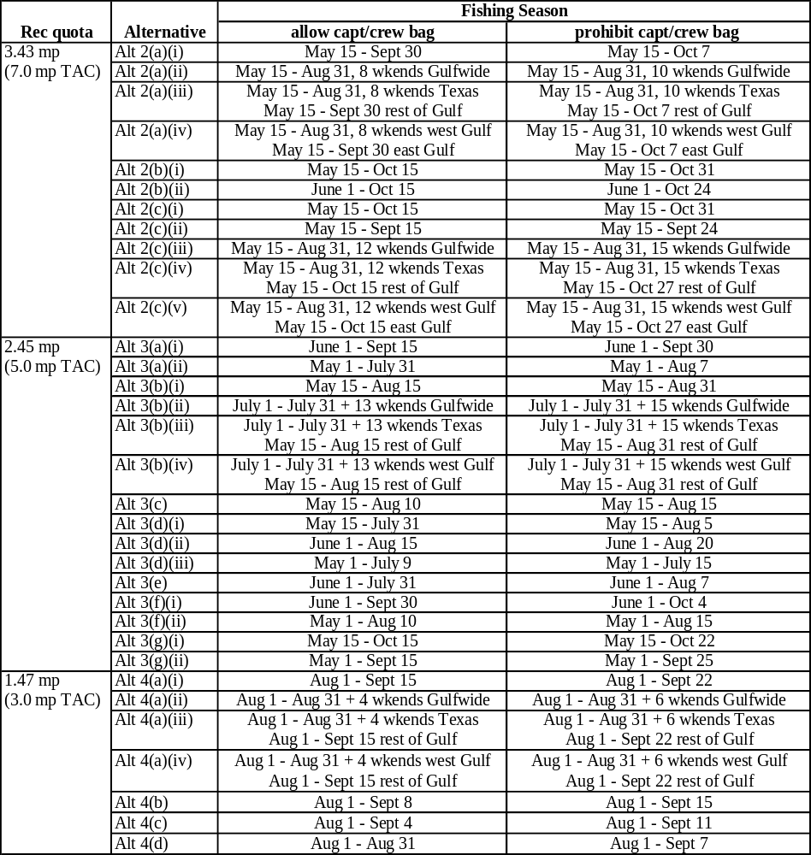

Red Snapper Allocation

Since 1990, the red snapper fishery has been managed under an overall TAC, which is allocated between the commercial (51 percent) and recreational (49 percent) sectors. This allocation was established in Amendment 1 to the Reef Fish FMP and is based on average commercial and recreational landings during 1979-1987 (GMFMC 1989). All of the rebuilding plans and alternatives in Action 1 continue to allocate the TAC and quotas based on this allocation ratio, resulting in equal proportion reductions to the commercial and recreational quotas.

2008 Commercial Quota

Interim regulations published on April 2, 2007, reduced the red snapper TAC from 9.12 MP to 6.5 MP through September 29, 2007. This temporary reduction in TAC will expire after that time unless extended on an interim basis for another 186 days. The Council intends to further reduce the red snapper TAC in 2008 to end overfishing and rebuild the red snapper stock in compliance with the red snapper rebuilding plan. The Council's preferred red snapper TAC for 2008 is 5.0 MP (Action 1; Alternative 3). The Council is requesting NMFS implement this TAC adjustment for the 2008 fishing year on or before January 1, 2008, to ensure the amount of red snapper allocation issued to the commercial red snapper IFQ fishery does not exceed the commercial quota defined by the Council's preferred TAC for 2008 (51% of 5.0 MP, or 2.55 MP). If NMFS is unable to publish a final rule on or prior to December 1, 2007, to implement this TAC adjustment for the 2008 fishing year, then the Council requests NMFS issue only 2.55 MP of red snapper allocation to the commercial red snapper IFQ fishery at the start of the 2008 fishing season. This will reduce the likelihood that NMFS would be required to retract red snapper allocation from the commercial red snapper IFQ fishery during the 2008 fishing year.

ABC and TAC

Allowable biological catch (ABC) refers to a range of catches for a species or species group that will produce the desired biological results given a set of biological stock parameters and management targets. Historically, the Council’s Reef Fish Stock Assessment Panel recommended ABC levels for red snapper. However, with the implementation of the Southeast Data, Assessment, and Review (SEDAR) process, the SEDAR panel now is tasked with reviewing the adequacy and appropriateness of management benchmarks. During review of the red snapper stock assessment, the SEDAR panel indicated it was not possible to specify an ABC for red snapper without guidance from the Council on the level of assumed shrimp bycatch reduction (SEDAR 7 2005).

Total allowable catch (TAC) is a level of catch that is set by managers at or below the maximum ABC. The level of TAC is selected after considering the biological, ecological and socioeconomic implications of catch levels within the ABC range. The level of risk (i.e., failure to attain management targets without a future reduction in TAC being needed) should also be considered. In general, TACs set near the upper end of the ABC range carry a greater risk of not ending overfishing and rebuilding the red snapper stock than TACs set at a lower catch level.

The current 9.12 MP TAC has been in effect since 1996. Amendment 22 to the Reef Fish FMP (GMFMC 2004a) revised the rebuilding plan for red snapper based on the results of the 1999 stock assessment (Schirripa and Legault 1999). The revised rebuilding plan maintained the initial TAC at 9.12 MP and set management targets to end overfishing by 2009 or 2010 and rebuild the stock to B_{msy} by 2032. The Council specified in Amendment 22 (GMFMC 2004a) that the rebuilding plan would be reviewed and revised, as necessary, after periodic stock assessments.

The 2005 stock assessment indicates all TACs under consideration, even the no action 9.12 MP, will allow spawning biomass to increase over the short term. However, TACs greater than 7 MP will not end overfishing in the timeframe specified by the rebuilding plan (Thompson 2005). The following discussion focuses on the effects of various rebuilding plans and TACs that would end overfishing by 2009 or 2010 and rebuild red snapper to B_{msy} by 2032, in accordance with the Council’s currently approved rebuilding plan (GMFMC 2004a). The level TAC can be set at over the next three years is dependent on numerous factors, including the amount shrimp trawl bycatch mortality, directed fishery bycatch and closed season bycatch can be reduced. In general, the greater the reduction in closed season, directed fishery, and shrimp trawl dead discards, the higher directed TAC can be set.

The maximum ABC for red snapper that would end overfishing within the timeframe set by the Council’s rebuilding plan is 7 MP. However, a 7 MP TAC would require all sources of fishing mortality (i.e., directed fishery, closed season bycatch, and shrimp trawl bycatch) be reduced by 74 percent in order to end overfishing (Thompson 2005). Based on management measures considered in this amendment and revised rebuilding plans developed by the SEFSC (Chester 2007; SERO 2007), bycatch is unlikely to be reduced across all sources by 74 percent; especially closed season discards (Chester 2007, SERO 2007, Crabtree 2006). Therefore, if TAC is set at 7 MP and all sources of fishing mortality are not reduced by 74 percent, overfishing would continue beyond 2009 or 2010. This would result in slower than expected rebuilding progress and require implementation of additional measures to end overfishing. Beginning in July 2009, the reauthorized Magnuson-Stevens Act will require the Council to immediately end overfishing if it has not already done so.

Rebuilding Plans

The Council considered three alternative rebuilding plans in addition to no action (Alternative 1). The red snapper rebuilding plan is being revised in accordance with a March 12, 2007, District Court order, which requires the Secretary of Commerce to establish a new red snapper rebuilding plan within 9 months of the Court ruling. The revised rebuilding plan must ensure that there is at least a 50 percent probability of ending overfishing and rebuilding red snapper to the biomass at MSY. In revising the red snapper rebuilding plan, the Council is not considering changes to the timeframe for ending overfishing or rebuilding the stock. As specified in Amendment 22 to the Reef Fish FMP, overfishing must end between 2009 and 2010 and the stock must be rebuilt to B_{msy} by 2032 (GMFMC 2004a).

Table 2.2 summarizes red snapper rebuilding plans for each of the alternatives in Action 1. Two types of rebuilding strategies were considered during SEDAR 7 (2005): 1) a ‘linked’ rebuilding strategy, which requires proportional reductions in fishing mortality across all sources (i.e., directed fishery, closed season bycatch, and shrimp trawl bycatch) and 2) a ‘delinked’ rebuilding strategy, which allows disproportional reductions in fishing mortality across all sources. Under a ‘delinked’ rebuilding strategy, decisions are made by fishery managers regarding the extent to which bycatch can be practically reduced by available management tools (e.g., circle hooks, dehooking devices, lower size limits, etc.). Under a ‘linked’ rebuilding strategy, reductions in fishing mortality, including bycatch, are assumed to be achievable, even if they cannot practically be achieved with available management tools. Alternatives 1 (9.12 MP TAC) and 2 (7 MP TAC) are based on ‘linked’ rebuilding strategies, whereas Preferred Alternatives 3 and Alternative 4 are based on ‘delinked’ rebuilding strategies. In addition to the rebuilding plans considered herein, the Council reviewed and considered a myriad of other rebuilding plans, which are summarized in Thompson (2005), Crabtree (2006), and Chester (2007). The success of each of these TACs and rebuilding strategies in ending overfishing and rebuilding red snapper is contingent, in large part, on how much bycatch can be practically reduced.

Figure 2.1 and Table 2.2 compare TACs and estimated discards resulting from two ‘linked’ rebuilding plans (Alternatives 1 and 2) and two ‘delinked’ rebuilding plans (Alternatives 3 and 4). In general, the ‘linked’ strategy results in faster stock recovery, but requires much greater reductions in closed season bycatch and shrimp trawl discards over the long-term. Because higher TACs are allowed under a ‘linked’ rebuilding strategy, more open season directed fishery discards are estimated to occur when compared with the preferred ‘delinked’ rebuilding plan (Preferred Alternative 3). Over the long-term, closed season and shrimp trawl discards must be maintained at levels lower than those assumed under ‘delinked’ rebuilding strategies in order to rebuild the stock to 26 percent SPR (proxy for B_{msy}). If bycatch can be successfully reduced to levels necessary under the ‘linked’ rebuilding plans (Alternatives 1 and 2), stock recovery (B/B_{msy} > 1.0) would be much faster and occur well in advance of the 2032 rebuilding deadline. However, based on rebuilding projections conducted by the SEFSC in January through March 2007 (Chester 2007; SERO 2006) and bycatch management alternatives considered in this amendment (i.e., lower size limits, gear restrictions, etc.), it is impractical to assume bycatch can be reduced to the extent required in Alternatives 1 and 2 in order to end overfishing and rebuild the stock. Because sufficient bycatch reduction cannot be achieved to satisfy the assumptions of the ‘linked’ rebuilding strategies, maintaining TAC at 9.12 MP or setting TAC at 7 MP would not end overfishing by 2009 or 2010 (SERO 2007 in reference to Crabtree 2006) as required by the Magnuson-Stevens Act and as specified by approved red snapper rebuilding plan. Even if realistic assumptions are made about reductions in bycatch (i.e., ‘delinked’ rebuilding strategies), TACs no greater than 5 to 5.5 MP could be implemented from 2008 through 2010 to end overfishing (Table 2.3).

‘Delinked’ rebuilding strategies require lower TACs over the short-term, because the rebuilding plan does not assume closed season bycatch and/or shrimp trawl bycatch are reduced to the extent estimated under a ‘linked’ rebuilding strategy. Rebuilding plans summarized in Alternatives 3 and 4 make reasonable assumptions about how much bycatch can be practically reduced. In general, the more shrimp trawl bycatch and/or closed season bycatch allowed, the lower TAC must be set. Additionally, the higher TAC is set, the greater the number of open season discards estimated to occur. The rebuilding plan summarized in Preferred Alternative 3 assumes fishing mortality on red snapper resulting from shrimp trawl bycatch will be reduced by 74 percent beginning in 2007, while Alternative 4 assumes fishing mortality on red snapper from shrimp trawl bycatch will be reduced by 50 percent. Actions 6 and 7 in this amendment summarize measures proposed to cap shrimp effort and restrict effort if this cap is exceeded. Alternatives 3 and 4 also assume fishing mortality will be reduced during the closed season by 10 percent owing to implementation of the commercial red snapper IFQ system and the requirement to use circle hooks for the harvest of all reef fish (see Action 5). Directed fishery bycatch is associated with the preferred minimum size limits selected in Actions 1 and 4; i.e., directed fishery bycatch was assumed to correspond to the bycatch resulting from a 13-inch commercial minimum size limit and 16-inch recreational minimum size limit.

In addition to the alternatives described above, several other red snapper rebuilding projections were conducted by the SEFSC in January through March 2007 (Chester 2007; SERO 2007); these projections did not assume fishing mortality could reduced proportionally across all sources - they are ‘delinked’ rebuilding strategies. Rather, the projections include reasonable assumptions about how much bycatch can be reduced in various fisheries and during the closed season. Because closed season bycatch cannot be sufficiently reduced as required by a ‘linked’ rebuilding strategy, all projections indicate TAC would have to be set much lower than 7 MP in order to end overfishing by 2009 or 2010 (SERO 2007 in reference to Crabtree 2006). Table 2.3 summarizes the results of these projections. Projection runs 1 and 7 in Table 2.3 correspond to rebuilding plans summarized for Preferred Alternative 3 and Alternative 4, respectively. All other projection runs summarized in Table 2.3 represent additional information the Council was presented with while selecting the range of alternatives to revise the red snapper rebuilding plan.

All rebuilding projections summarized in Table 2.3 include updated directed fishery landings and shrimp effort through 2005, end overfishing by 2009 or 2010, depending on the level TAC is set at over the next two to three years (2008-2009 or 2008-2010), and rebuild the red snapper stock to the Council’s rebuilding goal (26 percent SPR, which is a proxy for B_{msy}) by 2032.

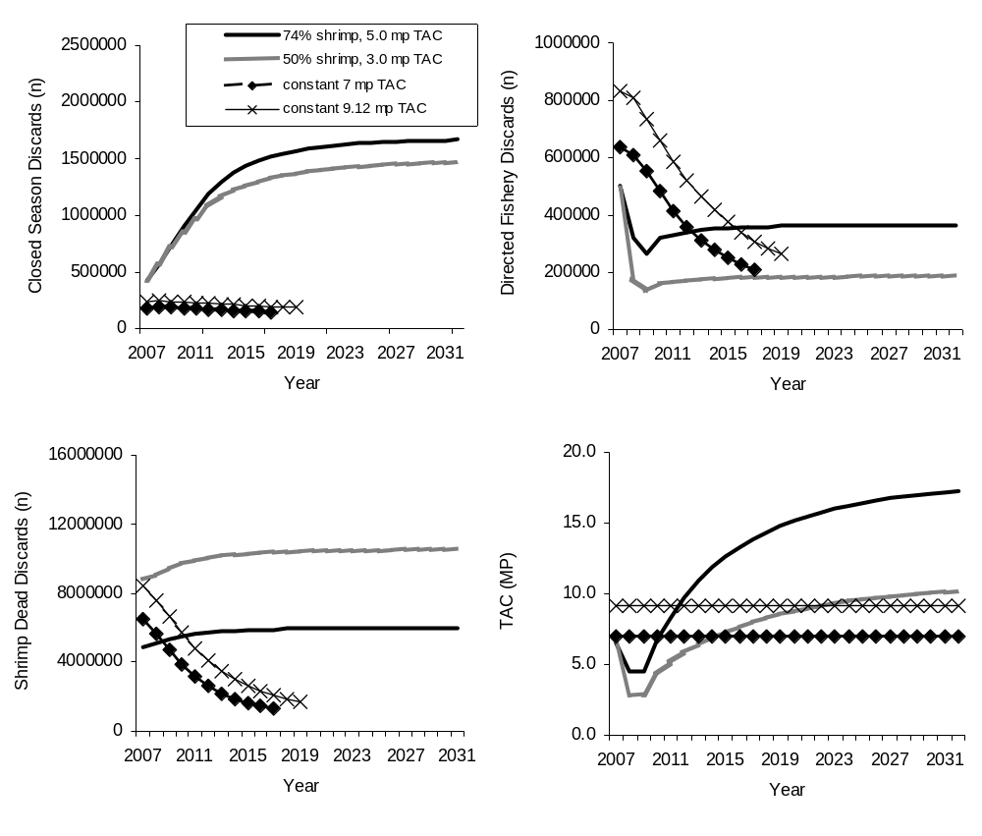
Figure 2.1. Estimated red snapper TAC (mp) and directed fishery discards (numbers), closed season discards, and shrimp trawl discards for four rebuilding strategies: 1) delinked’ 74 percent shrimp, 5.0 MP TAC (same as projection run #1 in Table 2.3, 2) ‘delinked’ 50 percent shrimp, 3.0 MP TAC (same as projection run #7 in Table 2.3), 3) ‘linked’ 7 MP constant TAC, and 4) ‘linked’ 9.12 MP constant TAC.

The following inputs and assumptions were used for the projections summarized in Table 2.3:

- Directed fishery landings in 2006 were set equal to directed fishery landings in 2005;
- Shrimp fishing mortality in 2006 was set at 60 percent less than the 2001-2003 baseline shrimp fishing mortality rate;
- After 2006, the shrimp fishing mortality rate was either capped at 50 or 74 percent of the 2001-03 baseline shrimp fishing mortality rate;
- TAC for the directed fishery was set at 6.5 million pounds (mp) in 2007;
- Commercial directed fishery discards correspond to those estimated under a 13-inch minimum size limit;
- Recreational directed fishery discards correspond to those estimated under either a 14-inch or 16-inch minimum size limit;
- The fishing mortality rate associated with closed season discards was set 10 percent less than the 2001-2003 baseline fishing mortality rate owing to implementation of the IFQ program;
- The release mortality rate for recreational discards during both the open and closed season was reduced by 0, 5, or 10 percent owing to circle hooks, venting tools, and dehooking devices; and,
- TAC in 2008-2009 or 2008-2010 corresponds to the level of catch necessary to end overfishing and was contingent on the level at which shrimp effort was capped (see #3 above). After 2009 or 2010, TAC was increased at a constant rate to rebuild the stock to 26 percent SPR by 2032.

If the Council requires circle hooks, venting tools, and dehooking devices (see Action 5) and these gears result in small reductions in recreational release mortality rates then TACs could be increased by an additional 100,000 to 150,000 pounds, regardless of the minimum size limit selected or any additional reductions in bycatch associated with circle hooks and other gears. Reducing the recreational minimum size limit from 16 to 14 inches total length would allow TAC to increase by 100,000 to 160,000 pounds over the short-term (next 2-3 years). Over the long-term (through 2032), lower size limits would result in slightly lower TACs than higher size limits.

Maximum sustainable yields range from 10.2 to 17.8 MP for the projection runs summarized in Table 2.3, and are largely contingent on the amount shrimp fishing mortality is reduced (i.e., greater reductions in shrimp fishing mortality result in greater MSY). Similarly, the more closed season bycatch can be reduced, the greater MSY.

Table 2.2 Yield and spawning potential streams for proposed red snapper rebuilding plans.
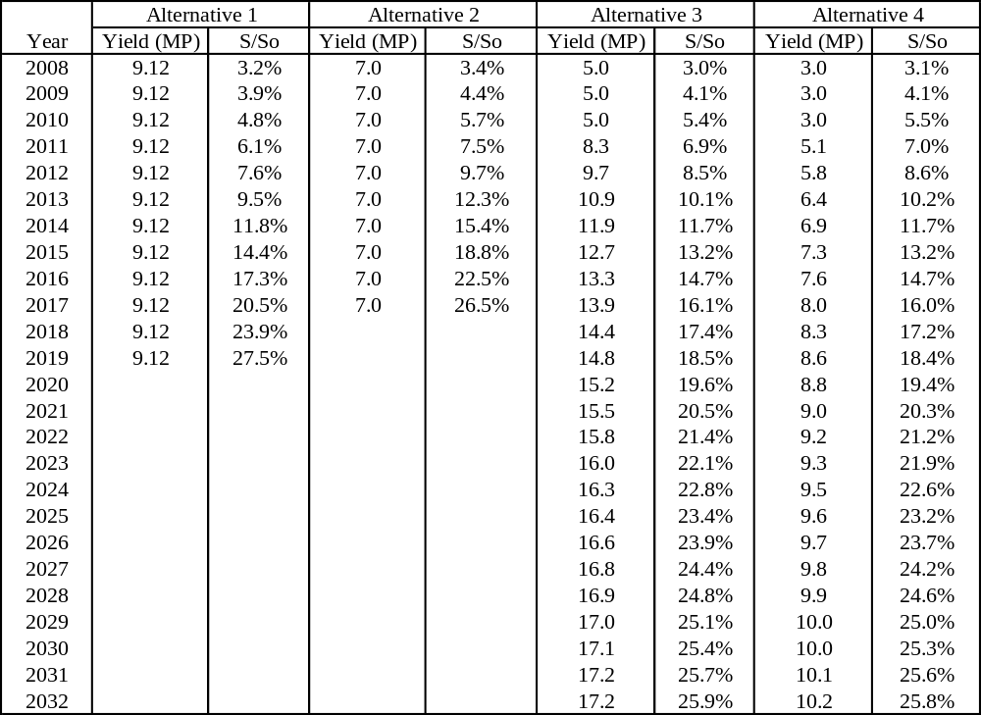

Table 2.3. Summary of total allowable red snapper catches ending overfishing by 2009 or 2010 and the estimated maximum sustainable yield for various red snapper rebuilding scenarios. Projection runs 8-18 (highlighted in gray) were interpolated from projection runs 1-7.

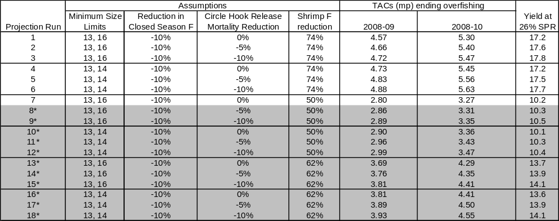

Discussion: As described in the purpose and need for this amendment, reductions in red snapper directed fishing mortality and bycatch mortality are needed for the stock to rebuild. Action 1 examines changes to the TAC, commercial quota, recreational quota, and various recreational management measures. Section 5.1 examines the effects of the various Action 1 alternatives relative to each other within the physical, biological/ecological, socioeconomic, and administrative environments. Important factors to this discussion include:

- The Council’s red snapper rebuilding plan specifies overfishing will end by 2009 or 2010 and red snapper will be rebuilt to B_{MSY} by 2032 (GMFMC 2004a). No revisions to these timeframes are proposed in this amendment.
- Recovery of red snapper in the western Gulf is more sensitive to reductions in shrimp trawl bycatch (and to a lesser extent commercial fishing mortality), whereas recovery of red snapper in the eastern Gulf is more sensitive to reductions in recreational fishing mortality and bycatch.
- A 74 percent reduction in total red snapper fishing mortality (both the directed and shrimp trawl fisheries) from baseline levels (2001-03) is required to end overfishing of red snapper by 2010.
- The maximum ABC that would end overfishing of red snapper by 2009 or 2010 is 7 MP. In order to end overfishing under a 7 MP TAC, fishing mortality across all sources, including closed season bycatch, must be reduced by 74 percent.
- Preferred bycatch reduction management alternatives discussed in this amendment are not expected to reduce closed season bycatch to the extent necessary to end overfishing under a 7 MP TAC.
- Red snapper rebuilding plans summarized in Table 2.3, which incorporate reasonable assumptions about bycatch reduction based on available management tools, indicate TACs ranging from 5 to 5.5 MP are necessary to end overfishing in accordance with the Council’s rebuilding plan.
- The more bycatch is reduced, the higher TAC can be set.
- Smaller recreational minimum size limits reduce the number of red snapper discarded dead, but increase landings and catch rates. To compensate for increases in recreational landings resulting from lower minimum size limits, more restrictive bag limits and closed seasons must be imposed to constrain landings within specified recreational quota levels.
- Reducing the recreational minimum size limit from 16 to 15, 14, or 13 inches slows stock recovery over the long-term, although changes in spawning potential and the rate of stock recovery are very small for recreational size limits ranging from 13 to 15 inches TL (Figure 4.2.1). The more the recreational size limit is reduced the slower the stock recovers in the long-term. Eliminating the minimum size limit would greatly slow stock recovery (see Figure 4.2.1).
- In the short-term (next 5-10 years), lower recreational minimum size limits would allow slightly higher TACs, although differences in recovery relative to no action are negligible. These results are consistent with Porch (2005), who indicated stock recovery would be slightly faster for 13-15 inch minimum size limits over the short-term, but slightly slower over the long-term (through 2032). Lowering the minimum size limit is expected to result in a slightly lower TAC over the long-term than if a higher minimum size limit is maintained.
- Adverse economic impacts increase as TACs are reduced. Higher bag limits and longer open seasons, result in lower adverse economic impacts than shorter open seasons and lower bag limits. Anglers generally prefer reducing the red snapper bag limit to reducing the length of the fishing season, unless the bag limit becomes too restrictive.
- Impacts to the administrative environment increase with higher TACs and/or greater assumptions about the success of bycatch reduction measures. TACs greater than those summarized in Table 2.3 are unlikely to end overfishing and therefore additional management actions may be needed in the future to end overfishing. Fishing seasons that include weekend openings and weekday closing are complicated and likely to reduce regulatory compliance. Implementing different regulations in the eastern versus western Gulf would require a line of demarcation, which causes some enforcement problems and angler confusion near the line.
- Impacts to the physical environment are expected to be small since most fishing occurs on artificial structures and the primary gear used is hook-and-line.

Comparison of Physical, Biological, and Ecological Consequences

The 2005 red snapper stock assessment (SEDAR 7 2005) continues to indicate red snapper are undergoing overfishing and overfished. Red snapper fishing mortality rates are too high in both the directed and shrimp fisheries (SEDAR 7 2005). In comparison to previous assessments, the directed fishery now contributes to a greater portion of fishing mortality than previously thought because of higher juvenile natural mortality rates (age-0 and age-1) and higher directed fishery release mortality rates of regulatory discards. Shrimp trawl bycatch of red snapper still remains a significant source of mortality in the western Gulf and actions are being considered in this amendment to further reduce shrimp trawl bycatch of red snapper (see Actions 6 and 7).

Action 1 considers four rebuilding plans for red snapper. Constant TACs are being considered for at least the next three years (2008-2010) and are intended to end overfishing in the directed fishery. NMFS implemented a temporary rule for the 2007-fishing season that establishes a 6.5 MP TAC. All TACs under consideration, even the no action 9.12 MP, will allow spawning biomass to increase. However TACs greater than 7.0 MP will not end overfishing by 2009 or 2010, and TACs greater than 5-5.5 MP are not expected to end overfishing between 2009 and 2010 because adequate reductions in bycatch would not be achieved.

Alternative 1 (no action) would maintain the current rebuilding plan and hold TAC constant at 9.12 MP until 2032 (Table 2.2). This TAC would result in no changes to the commercial quota or recreational management regulations over the short- or long-term. The rebuilding plan associated with a constant 9.12 MP TAC assumes shrimp trawl, directed fishery, and closed season discards would decline throughout the timeframe of the rebuilding plan. However, based on rebuilding projections conducted by the SEFSC in January through March 2007 (Chester 2007; SERO 2007) and management alternatives under consideration in this amendment, bycatch is projected to actually increase as the stock rebuilds. Although a 9.12 MP TAC would result in some stock recovery, it would not reduce recreational dead discards and would continue to allow overfishing after 2009 or 2010. Over the long-term, maintaining TAC at 9.12 MP would result in faster than expected stock recovery when compared to the Council’s rebuilding benchmark (F_{MSY} = F_{26%SPR}); however, stock recovery would only be faster if reductions in bycatch summarized in Figure 2.1 are achieved. Based on management measures considered in this amendment and revised rebuilding plans developed by the SEFSC (Table 2.3), bycatch is unlikely to be reduced across all sources to the levels summarized in Figure 2.1. Of the four alternatives considered in Action 1, Alternative 1 would reduce fishing mortality the least, has the lowest probability of ending overfishing over the next three years, and would result in no additional recreational management measures to reduce the number of red snapper discarded dead. Preliminary information from the SEFSC indicates the rebuilding plan under Alternative 1 has less than a 50 percent chance of ending overfishing by 2010 unless shrimp and closed season discard rates are reduced by substantially more than 74 percent. Alternative 1 has a greater than 50 percent chance of allowing rebuilding by 2032 if shrimp and closed season discard rates are both reduced by 74 percent or more relative to 2001-2003 levels. Because fishing mortality across all sources, including closed season bycatch, will not likely be reduced by this amount the probability of ending overfishing will be less than 50 percent.

Alternative 2 would revise the red snapper rebuilding plan and reduce the TAC to 7 MP and hold it constant until 2032 (Table 2.2). Relative to Preferred Alternative 3, TAC would not increase over time as the stock rebuilds. By 2011, TAC for the preferred rebuilding plan (Preferred Alternative 3, Table 2.2) would exceed the constant 7 MP TAC for Alternative 2 and would remain well above the 7 MP TAC throughout the remainder of the rebuilding plan. This TAC is the maximum ABC that could be taken from the red snapper stock to end overfishing within the timeframe specified by the Council’s rebuilding plan. The commercial quota would be 3.57 MP and the recreational quota would be 3.43 MP. Alternative 2 would only end overfishing of red snapper in 2009 or 2010 if all sources of mortality can be reduced proportionally by 74 percent. Based on projections conducted by the SEFSC in January through March 2007 (Chester 2007; SERO 2007), bycatch is unlikely to be reduced to levels necessary to end overfishing under a 7 MP TAC (Chester 2007; SERO 2007 in reference to Crabtree 2006); therefore, lower TACs are needed. Over the long-term, Alternative 2 would result in faster than expected stock recovery when compared to the Council’s rebuilding benchmark (F_{MSY} = F_{26%SPR}); however, stock recovery would only be faster if reductions in bycatch summarized in Figure 2.1 are achieved. Rebuilding over the next three years would be expected to occur at a slower rate when compared to the Council’s rebuilding benchmark (F_{MSY} = F_{26%SPR}). Alternative 2 would reduce fishing mortality more in 2008 than Alternative 1, but less than Alternatives 3 and 4. Over the long-term, Alternative 2 has a greater probability of ending overfishing than Alternative 1, but a lower probability than Preferred Alternative 3 and Alternative 4. Preliminary information from the SEFSC indicates the rebuilding plan under Alternative 2 has a slightly greater than 50 percent chance of ending overfishing by 2010 if shrimp and closed season discard rates are reduced by 74 percent or more. Alternative 2 has a greater than 50 percent chance of allowing rebuilding by 2032 if shrimp and closed season discard rates are both reduced by 74 percent or more relative to 2001-2003 levels. Because fishing mortality across all sources, including closed season bycatch, will not likely be reduced by this amount the probability of ending overfishing will be less than 50 percent.

Alternative 2 includes 11 options and/or suboptions. Options and sub-options for Alternative 2 include various bag limit, size limit, and open season combinations. Sub-options under Option 2(a) would maintain the four fish bag limit and 16-inch size limit, but would reduce the length of the open season to 125-139 days. Suboptions 2(a)(ii) – 2(a)(iv) would establish 8 weekend openings either Gulf-wide, in the western Gulf, or off Texas, following a core fishing season. Sub-options under Option 2(b) would reduce the bag limit to three fish, maintain the 16-inch minimum size limit or reduce it to 15-inches, and reduce the length of the open season to 137-154 days. Suboptions under Option 2(c) would reduce the bag limit to two fish, reduce the minimum size limit to either 13 or 15-inches TL, and reduce the length of the open season to 124-154 days. Suboptions 2(c)(iii) – 2(c)(v) would establish 12 consecutive weekend openings either Gulf-wide, in the western Gulf, or off Texas, following a core fishing season. All management measures included in Options 2(a), 2(b), and 2(c) are estimated to achieve at least a 23 percent reduction in harvest.

Preferred Alternative 3 would revise the red snapper rebuilding plan and reduce the TAC to 5 MP from 2008 through 2010 (Table 2.2). After 2010, TAC would be increased consistent with a fishing mortality rate that produces MSY. The commercial quota would be 2.55 MP and the recreational quota would be 2.45 MP. Preferred Alternative 3 would end overfishing between 2009 and 2010, consistent with the Council’s rebuilding plan (Chester 2007). Preferred Alternative 3 would permit the Gulf-wide red snapper stock to attain the expected F_{26%SPR} biomass trajectory by 2009 or 2010. Preferred Alternative 3 would require shrimp trawl fishing mortality be reduced by 74 percent and closed season red snapper fishing mortality be reduced by a minimum of 10 percent. Directed fishery bycatch is associated with the preferred minimum size limits selected in Actions 1 and 4 (i.e., directed fishery bycatch was assumed to correspond to the bycatch resulting from a 13-inch commercial minimum size limit and 16-inch recreational minimum size limit). Over both the short- and long-term, Alternative 3 has a higher probability of ending overfishing than Alternatives 1 and 2. The probability of Preferred Alternative 3 ending overfishing would be similar to the probability of Alternative 4 ending overfishing if the Council selects a 50 percent reduction in shrimp fishing mortality in conjunction with Alternative 4; however, Alternative 4 (3 MP TAC) has a greater probability of ending overfishing if the Council selects shrimp trawl fishing mortality reductions greater than 50 percent. When fully rebuilt, MSY would be 17.2 MP (Table 2.1.3). Preliminary information from the SEFSC indicates the preferred rebuilding plan has at least a 50 percent probability of end overfishing and rebuilding the stock to B_{msy}. Because TAC is 0.3 MP lower than the maximum TAC allowed over the next three years (Table 2.3, projection run #1) and the rebuilding plan does not take into account reductions in release mortality resulting from circle hooks, the probability of ending overfishing is estimated to be higher than 50 percent. Additionally, adjusting the rebuilding plan after subsequent stock assessments will increase the probability of successfully rebuilding red snapper.

Preferred Alternative 3 includes 15 options and/or suboptions. Options and sub-options for Preferred Alternative 3 include various bag limit, size limit, and open season combinations. All options for Preferred Alternative 3 would reduce the bag limit to either one or two fish. Preferred Option 3(a)(i) would maintain the 16-inch size limit and reduce the length of the open season to 107 days. Option 3(a)(ii) would maintain the 16-inch size limit and start the fishing season on May 1, which would allow for a 92-day fishing season. Option 3(b) would maintain the 16-inch size limit and reduce the length of the open season to 57-92 days. Suboption 3(b)(i) would establish a May 15 – August 15 fishing season Gulfwide. Suboptions 3(b)(ii-iv) would allow harvest only on weekends before and after a core July fishing season. This would result in the shortest fishing season because a majority of red snapper are landed by recreational anglers on weekends (SERO 2006d). Six consecutive weekend openings prior to July 1 and 7 consecutive weekend openings after July 31 would extend the fishing season from mid-May to late September. Option 3(c) would reduce the minimum size limit to 15-inches TL and establish an 88-day fishing season. Option 3(d) would reduce the minimum size limit to 14-inches TL and Suboptions 3(d)(i-iii) would reduce the length of the open season to 71-77 days. Option 3(e) would reduce the minimum size limit to 13 inches TL and establish a 61-day fishing season. Option 3(f) would reduce the bag limit to one and the minimum size limit to 14-inches TL, and Suboptions 3(f)(i-ii) would reduce the length of the fishing season to 102-122 days. Option 3(f) would reduce the bag limit to one and maintain the 16-inch TL minimum size limit. Suboptions 3(f)(i-ii) would reduce the length of the fishing season to 138-154 days. All management measures included in Options 3(a-g) are estimated to achieve at least a 45 percent reduction in harvest and therefore would benefit red snapper stock recovery.

Alternative 4 would revise the red snapper rebuilding plan and reduce the TAC to 3 MP from 2008 to 2010 (Table 2.2). After 2010, TAC would be increased consistent with a fishing mortality rate that produces MSY. The commercial quota would be 1.53 MP and the recreational quota would be 1.47 MP. Alternative 4 would end overfishing between 2009 and 2010, consistent with the Council’s rebuilding plan (Chester 2007). Alternative 4 would permit the Gulf-wide red snapper stock to attain the expected F_{26%SPR} biomass trajectory by 2009 or 2010. Alternative 4 would require shrimp trawl fishing mortality be reduced by a minimum of 50 percent and closed season red snapper fishing mortality be reduced by a minimum of 10 percent. Directed fishery bycatch is associated with the preferred minimum size limits selected in Actions 1 and 4 (i.e., directed fishery bycatch was assumed to correspond to the bycatch resulting from a 13-inch commercial minimum size limit and 16-inch recreational minimum size limit). Over both the short- and long-term, Alternative 4 has the highest probability of ending overfishing of any of the alternatives if the Council selects a 74 percent shrimp trawl fishing mortality goal. Relative to Preferred Alternative 3, Alternative 4 would have a similar probability of ending overfishing if the Council selects a 50 percent shrimp trawl fishing mortality reduction goal. Preliminary information from the SEFSC indicates the proposed rebuilding plan has at least a 50 percent probability of end overfishing and rebuilding the stock to B_{msy}. Because TAC is 0.27 MP lower than the maximum TAC allowed over the next three years (Table 2.3, projection run #7) and the rebuilding plan does not take into account reductions in release mortality resulting from circle hooks, the probability of ending overfishing is estimated to be higher than 50 percent. Additionally, adjusting the rebuilding plan after subsequent stock assessments will increase the probability of successfully rebuilding red snapper.

Alternative 4 includes 7 options and/or suboptions. Options and sub-options for Alternative 4 include various bag limit, size limit, and open season combinations. All options for Alternative 4 would reduce the bag limit to two fish. Option 4(a) would maintain the 16-inch size limit and reduce the length of the open season to 39-46 days. Suboption 3(b)(i) would establish an August 1 – September 15 fishing season Gulfwide. Suboptions 4(a)(ii-iv) would allow harvest only on weekends before and after a core August fishing season. This would result in the shortest fishing season because recreational anglers land a majority of red snapper on weekends (SERO 2006d). Two consecutive weekend openings prior to August 1 and 2 consecutive weekend openings after August 31 would extend the fishing season from mid-July to mid-September. Option 4(b) would reduce the minimum size limit to 15-inches TL and establish a 39-day fishing season. Option 4(c) would reduce the minimum size limit to 14-inches TL and establish a 35-day fishing season. Option 4(d) would reduce the minimum size limit to 13 inches TL and establish a 31-day fishing season. All management measures included in Options 4(a-d) are estimated to achieve at least a 67 percent reduction in harvest and therefore would benefit red snapper stock recovery.

In general, sub-options with lower size limits will reduce dead discards the most, but will lower yield-per-recruit and result in slightly slower stock recovery over the long-term. The current 16-inch minimum size limit represents the greatest source of regulatory discards by the recreational fishery. To compensate for the increase in landings and fishing mortality associated with lower size limits, additional management measures are necessary to maintain landings within the specified recreational quota. These additional management measures will partly diminish the benefits of lowering the size limit, because they increase dead discards and shorten the open season when size limits would be effective. Lower bag limits and higher size limits allow for longer fishing seasons. Establishing weekend openings after a core season reduces the number of allowable days for fishing because effort is higher and more red snapper are landed on weekends.

Porch (2005) evaluated various minimum size limits for red snapper and found the 16-inch recreational minimum size limit resulted in the fastest recovery for the stock over the long-term, although size limits as low as 13-inches TL were found to only slightly slow stock recovery over the long-term (see Figure 4.2.1). Over the short-term, lowering the minimum size limit may slightly speed up stock recovery, allowing for higher TACs at lower minimum sizes. Based on recreational minimum size limits ranging from 6 to 16 inches TL, YPR analyses indicate 16 inches maximizes YPR assuming current fishing selectivities and discard mortality rates (Figure 2.2). In the western Gulf, where recreational release mortality rates are higher (40 vs. 15 percent), there was little difference in YPR (SERO 2006b).
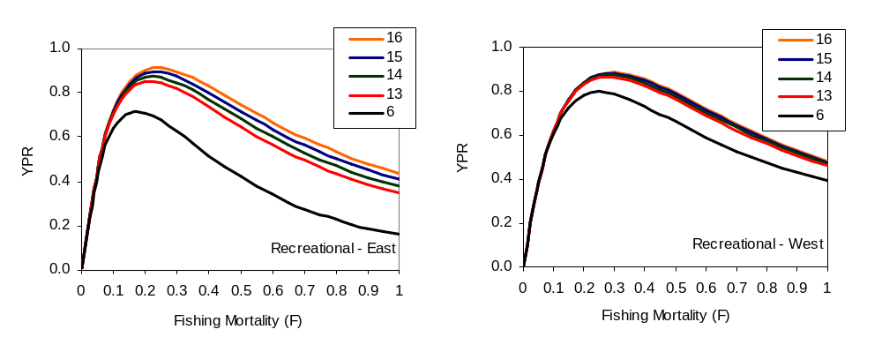
Figure 2.2. Yield-per-recruit for various recreational minimum size limits by region. YPR is based on selectivities from the 2005 stock assessment and assumed released mortality rates of 15 and 40 percent for the eastern and western Gulf, respectively.

As discussed above, the probability of Alternatives 1 through 4 ending overfishing and rebuilding the red snapper stock is contingent on whether or not fishing mortality (including bycatch mortality) can be adequately reduced. Numerous alternatives to reduce bycatch are considered in this amendment, or were considered, but eliminated from further consideration (see Appendix A). None of the proposed bycatch reduction measures summarized in Actions 1, 4, and 5 are expected to reduce bycatch to levels necessary under a ‘linked’ rebuilding strategy. Because closed season and directed dead discards cannot be sufficiently reduced to target bycatch reduction levels, Alternatives 1 (9.12 MP TAC) and Alternative 2 (7 MP TAC) would not end overfishing. TACs proposed in Preferred Alternative 3 and Alternative 4 assume bycatch in the directed fishery and during the closed season would only be partially reduced due to the implementation of the commercial IFQ program, gear requirements, and a lower commercial minimum size limit. Both Preferred Alternative 3 (5 MP TAC) and Alternative 4 (3 MP TAC) would end overfishing, as long as the assumptions above are met and shrimp trawl fishing mortality is reduced by 74 percent. A lesser reduction in shrimp fishing mortality (50 percent) in combination with Alternative 4 would also end overfishing.

Alternatives 2-4 are all expected to have some negative impacts on other reef fish species due to effort shifting. Impacts on other species would be greatest for alternatives with lower TACs and shorter red snapper fishing seasons. Species likely to be impacted the most include: vermilion snapper, gray triggerfish, and gag, which all co-occur with red snapper. Currently, vermilion snapper is not overfished and is not undergoing overfishing and both gag and gray triggerfish are experiencing overfishing.

Alternatives 1-4 are not expected to significantly effect the physical environment since most fishing for red snapper occurs over artificial structures and the primary gear used is hook-and-line. Impacts to the physical environment are largely associated with reductions in fishing effort. The lower TAC is set and the more restrictive management measures are set, the more effort will likely be reduced, thereby benefiting the physical environment through less gear-habitat interactions. Alternative 1 is expected to have the greatest impacts on the physical environment, followed by Alternatives 2, 3, and 4, respectively.

Action 2. Post-hurricane reduction in directed fishery effort assumed for Action 1 TAC alternatives.

Alternative 1. Do not take into consideration any potential post-hurricane reductions in directed fishery effort and landings when evaluating alternative TACs and management measures in Action 1.

Alternative 2. Assume a 25-percent reduction in post-hurricane fishing effort and landings when evaluating alternative TACs and management measures in Action 1.

Alternative 3. Assume a 10-percent reduction in post-hurricane fishing effort and landings when evaluating alternative TACs and management measures in Action 1.

Discussion: The 2005 hurricane season was the busiest and costliest on record. There were 28 named storms, including 15 hurricanes, four of which reached category 5 strength. Along the Gulf coast from the Florida Panhandle to Texas, where red snapper primarily are caught, five named storms (Tropical Storm Arlene and Hurricanes Cindy, Dennis, Katrina, and Rita) made landfall. Hurricanes Katrina (landfall August 29, 2005) and Rita (landfall September 24, 2005) were the most devastating of these storms, impacting an area stretching from eastern Texas to western Alabama and resulting in significant physical and economic damage to coastal communities. Direct losses to the fishing industry and businesses supporting fishing activities included: loss of vessels, loss of revenue due to cancelled fishing trips, and destruction of marinas and other fishery infrastructure (Walker et al. 2006).

Because of the social, economic, and physical impacts resulting from last year’s hurricane season, the Council approved a motion at their June 2006 meeting to consider a 25-percent reduction in fishing effort and landings (Alternative 2) when analyzing recreational management measures in Action 1. At the March 2007 Council meeting, the Council also approved a motion to consider a 10-percent reduction in fishing effort and landings (Alternative 3) when analyzing recreational management measures in Action 1. Similar reductions in effort are not assumed for the commercial fishery since an IFQ program was implemented in 2007 and the only change to management measures being considered in Action 1 is a lower quota. The Council is considering a smaller minimum commercial size limit in Action 4. Although this alternative will likely increase the rate of harvest, allowing the quota to be met faster, IFQ shareholders would be restricted to harvesting only their share of the commercial quota specified in Action 1. The IFQ will also allow commercial fishermen impacted by last year’s storms the opportunity to sell or lease their shares to other fishermen who may have a greater likelihood of using the shares.

Preliminary MRFSS effort estimates for 2006 indicate charter trips in federal waters of the exclusive economic zone (EEZ) were up 9 percent relative to the 2001-03 average effort level and up 3 percent relative to 2002-2005 average effort level. In contrast, private trips in the EEZ during 2006 were down 15 percent relative to the 2001-03 average effort level and 17 percent relative to the 2002-05 average effort level. For all areas fished (state and federal waters), charter trips in 2006 were up by 13 percent relative to the 2001-03 average effort level and 11 percent relative to the 2002-05 average effort level, whereas private trips were up 2 percent relative to 2001-03 average effort level and down 2 percent relative to 2002-05 average effort level.

Preliminary 2006 MRFSS red snapper landings in numbers of fish were 2 percent less than average MRFSS red snapper landings during 2001-03 and 4 percent less than average MRFSS red snapper landings during 2002-2005. In terms of pounds landed, the weight of MRFSS red snapper landings was 19 to 20 percent less than 2001-03 and 2002-05 average landings levels. On average, the weight of each red snapper landed in 2006 was less than the average weight of each red snapper landed during the prior four to five years.

Alternative 1 would maintain the status quo baseline for fishing effort (2001-03). No reductions in fishing effort would be assumed and the Council would need to select one of the management alternatives summarized in Action 1 for reducing red snapper harvest. This alternative would have the same impacts on the physical environment as those described in Action 1. Reductions in fishing effort will result in less gear (hook-and-line, anchors, spears) interactions with habitat, resulting in minor benefits to the physical environment. Alternative 1 would be the most precautionary management approach for selecting management measures in Action 1. Assuming no change in fishing effort occurs, impacts to the biological environment would be the same as those described for various management alternatives in Action 1. However, if reductions in fishing effort occur, but are not accounted for when analyzing management measures in Action 1, there would be an increased likelihood necessary reductions in fishing mortality would be achieved. Not accounting for reductions in fishing effort that may occur would also potentially allow for faster than expected rebuilding progress, thereby ending overfishing sooner than expected. Alternative 1 would have no effect on the administrative environment. Management alternatives summarized in Action 1 are expected to reduce recreational landings to levels that approximate the annual quota, potentially requiring no in-season management changes and allowing the recreational fishery to operate under a fixed season length.

Alternative 1, which would use baseline effort levels in the evaluation of management measures considered under Action 1, does not affect previously estimated changes in net fishing effort and in economic values. Conclusions derived from the previous comparative evaluation of economic impacts associated with the different management scenarios considered in Action 1 still apply.

Alternatives 2 and 3 would assume a 25-percent and 10-percent reduction in fishing effort and landings, respectively, when analyzing management measures in Action 1 for reducing red snapper fishing mortality. NOAA Fisheries Service, in developing interim regulations for 2007, assumed a 10 percent reduction in landings would occur from hurricane impacts. As described above, preliminary landings and fishing effort information indicate some declines have occurred since Hurricane Katrina. However, the magnitude of reductions varies by fishing sector and it is unknown how long post-hurricane reductions in landings and fishing effort may continue into the future. Table 2.4 summarizes the length of the recreational fishing season if the Council assumes either a 10 or 25-percent reduction in landings/fishing effort and prohibits captain and crew from retaining bag limits of red snapper (see Action 3).

If a 10 percent or 25-percent reduction in effort/landings does occur, then benefits to the physical environment would occur regardless of any changes to management measures. Benefits to the physical environment would largely be due to lower fishing effort and less gear interactions with habitat. However, because most red snapper are harvested with hook-and-line gear and the recreational red snapper fishery accounts for only a small fraction of the overall reef fish fishery harvest, any benefits are expected to be small. If a 10 percent or 25-percent reduction in fishing effort occurs in the short-term (next few years), benefits to the biological environment would include decreases in landings and discards. If these decreases in landings and discards allow target reductions in fishing mortality to be achieved, then rebuilding progress would continue to be made, allowing overfishing to end consistent with the timeframe specified in the rebuilding plan. If however, the reduction in effort is less than 10 percent or 25-percent, or diminishes overtime, then negative impacts to the biological environment would occur. Negative direct impacts would include landings and discards exceeding levels needed to rebuild the red snapper fishery, which would result in quota overages. Alternatives 2 and 3 are not expected to greatly affect the administrative environment if in fact specified percent reductions in fishing effort occur. However, if reductions in effort and landings are less than 10 or 25-percent or diminish over time, then the Regional Administrator would be required to close the recreational fishery once the quota is projected to be met (Sec. 407(d) M-SFCMA). This would result in negative effects to the administrative environment by requiring additional staff time to monitor the quota and issue quota closure notices.

Alternative 1, which would assume historic baseline effort levels in the evaluation of management measures considered under Action 1, does affect previously estimated changes in net fishing effort and in economic values. Though it could potentially establish stricter than required management measures thereby limiting short term economic benefits, Alternative 1 would be consistent with a precautionary approach to management. Alternative 2, which assumes a 25-percent reduction in post-hurricane fishing effort, may establish management measures that could jeopardize the rebuilding of the resource and significantly delay its recovery. While it would potentially increase short- term benefits derived from the fishery, it could impose sizeable long term adverse economic benefits. Alternative 3, which assumes a 10-percent reduction in post-hurricane fishing effort may also establish management measures that could jeopardize the rebuilding of the resource and significantly delay its recovery. However, the effects on rebuilding and time of recovery would be less than that of Alternative 2.

Alternative 1 does not consider any potential reduction in effort and landings. By not assuming any reduction, the season should not have to close early because the TAC was met sooner than expected. By not considering any possible reductions, there is a greater chance the TAC will not be met during the year.

Alternative 2 assumes a 25 percent reduction in fishing effort and landings. If there is not a 25 percent reduction, the TAC may be met sooner requiring an early closure of the fishery. If effort and landings have indeed been reduced by 25 percent then fishermen would benefit from a longer fishing season.

Alternative 3 assumes a 10 percent reduction in fishing effort and landings. If there is not a 10 percent reduction, the TAC may be met sooner requiring an early closure of the fishery. If effort and landings have indeed been reduced by 10 percent then fishermen would benefit from a longer fishing season.

Table 2.4. Length of the recreational red snapper fishing season for Alternatives 2-4 in Action 1 if captain and crew are prohibited from retaining bag limits of red snapper while under charter (see Action 3) and either a 10 or 25 percent post-hurricane reduction in landings/effort is assumed (Action 2). (Note: the table does not include season lengths for alternatives in Action 1 that have weekend openings and weekday closings).
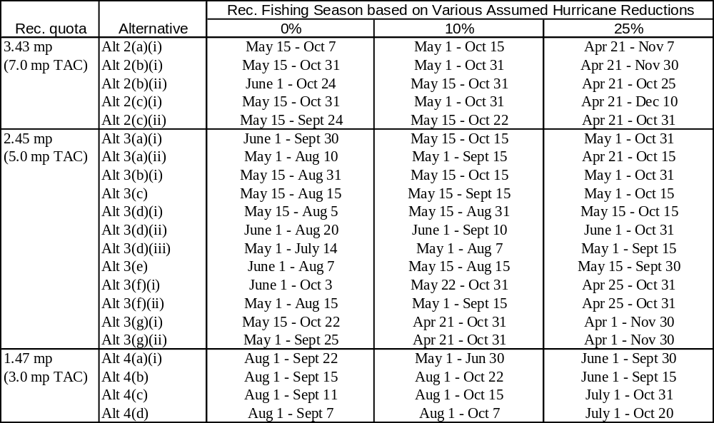

Action 3. Establish separate bag limit restrictions for the captain and crew of for-hire vessels

Alternative 1. No action – The captain(s) and crew of a for-hire vessel may retain the same daily bag limit of red snapper as allowed for each passenger.

Preferred Alternative 2. The red snapper bag limit for captain(s) and crew of for-hire vessels is zero.

Comparison of Physical, Biological, and Ecological Consequences

Alternative 1 would allow captains and crew to continue to retain recreational bag limits of red snapper while under charter. It is estimated captain and crew on for-hire vessels account for approximately 2 percent of the annual red snapper harvest, which is equivalent to an additional 3-7 fishing days (SERO 2006a). If the red snapper bag limit is reduced (see Action 1), captain and crew could and potentially would supplement the catch of their clients and negate some of the reductions expected from a lower daily bag limit. Continuing to allow captain and crew to retain a daily bag limit of red snapper may increase the potential harvest by recreational for-hire anglers and prevent necessary reductions in harvest from being achieved. The amount of fish they catch adds to the TAC and reduces the amount of fish for non-working, recreational fishermen. If the captain and crew keep a share, the number of days in the fishing season is shortened to meet the TAC.

Alternative 1 is not expected to result in any additional impacts to the physical environment caused by gear interactions. No impacts to the administrative environment are expected since regulations would not change and there would be no additional burden on enforcement. Because reductions in TAC will be achieved through management measures considered in Action 1 (or a combination of alternatives in Action 1 and Alternative 2 below), Alternative 1 will not directly affect progress made toward rebuilding red snapper. However, because the primary objective of setting the captain and crew bag limit to zero would be to extend the fishing season, Alternative 1 may increase closed season discards because a longer closed season would be necessary to achieve reductions in landings.

Preferred Alternative 2 would reduce the captain and crew bag limit to zero, which would reduce red snapper landings by approximately 2 percent and allow the fishing season to be extended. Table 2.1.1 shows the length of the fishing season for various alternatives in Action 1 if the captain and crew bag limit is set to zero. If the red snapper bag limit is reduced (see Action 1), Preferred Alternative 2 increases the likelihood reductions from lower red snapper bag limits are achieved, because captain and crew would no longer be able to supplement the catch of their clients. Preferred Alternative 2 would also increase consistency among regulations and make them more equitable among user groups. NMFS recently implemented Amendment 18A to the Reef Fish FMP, which prohibits commercial fishermen from retaining bag limits of reef fish while possessing commercial quantities of reef fish. Also, a regulatory amendment to the Reef Fish FMP was recently implemented in summer 2006 that prohibited captain and crew from retaining bag limits of grouper while under charter.

Preferred Alternative 2 is expected to result in benefits to the physical environment through reduced effort and less gear interactions with habitat. However, because for-hire captain and crew harvest represents a small fraction of the overall reef fish fishery, any benefits to the physical environment are expected to be immeasurably small. Reductions in landings resulting from a zero captain and crew bag limit in combination with management alternatives considered in Action 1 will directly benefit the biological environment by reducing red snapper mortality rates in the directed fishery. Closed season discards will also be slightly reduced because the season would be extended by a few additional days (see Table 2. 1).

Comparison of Socioeconomic and Administrative Consequences

Alternative 1 would maintain the status quo and continue to allow for-hire captains and crew to keep a bag limit while conducting a for-hire trip. The additional harvest from this source of mortality, however, would be expected to require more severe restrictions on the general angling public in order to accomplish required harvest reductions and fishery recovery goals. Preferred Alternative 2 would eliminate this source of mortality, and be expected to allow more liberal restrictions for the fishery as a whole, and increase the likelihood of achieving recovery goals. Although captains and crew would be expected to experience a more restrictive household food budget, although not quantified, the benefits associated with less restrictive measures for anglers and greater success associated with meeting recovery goals are expected to exceed these costs. Neither alternative is expected to greatly effect the administrative environment, because bag limits are routinely used to restrict harvest and similar regulations exist for other reef fish species.

In the social environment, Alternative 1 would benefit captain and crew because they could continue to keep the bag limit. The amount of fish they catch adds to the TAC and reduces the amount of fish available for non-working, recreational fishermen. If the captain and crew keep a share, the number of days in a fishing season is shortened to meet the TAC. Preferred Alternative 2 would prevent the captain and crew from keeping red snapper. Captain and crew will not be able to supplement their food budget with fish they can keep under current rules. The amount of fish the captain and crew kept previously will be available to non-working, recreational fishermen. The fishing season can be open a few days longer without the captain and crew keeping a share. Preferred Alternative 2 may have negative impacts for captain and crew because they can no longer keep fish and it may make it harder for captains to retain crewmembers who may consider fishing and keeping red snapper one of the benefits of the job.

Action 4. Reduce the red snapper minimum size limit in the commercial fishery

Alternative 1. No action. Maintain the 15-inch TL commercial minimum size limit for red snapper.

Preferred Alternative 2. Reduce the minimum size limit in the commercial red snapper fishery to 13 inches TL.

Alternative 3. Eliminate the commercial red snapper minimum size limit

Discussion: As described in the purpose and need for this amendment, reductions in red snapper bycatch (regulatory discards) are needed in all sectors of the red snapper fishery for the stock to recover over the long term and to reduce overfishing in the short term. Action 4 examines changing minimum size limits for the commercial fishery as a method to reduce discards in the directed red snapper fishery. Section 5.4 examines the effects of the various Action 4 alternatives relative to each other within the physical, biological/ecological, socioeconomic, and administrative environments. Important factors to this discussion include:

- Discards in the commercial red snapper fishery are highest for vessels using bandit gear (84 percent), followed by handline (15 percent) and longline (1 percent) (Poffenberger and McCarthy, 2004).
- Logbook data indicates all reported discarded red snapper were regulatory discards (Poffenberger and McCarthy, 2004).
- Red snapper discarded during open seasons (likely undersized) were numerically greater (SEDAR 7, 2005) but overall weighed less than fish discarded during the closed seasons (undersized- and legal-sized fish).
- One study (Wilson et al., 2004) found over half of undersized red snapper released during the open period were 13 inches or greater (61 percent), and 86 percent were 12 inches or greater.
- Porch (2005) estimated the number of regulatory discards based on size would decrease by 42 percent if the commercial size limit were reduced to 13 inches, and by 61 percent if reduced to 12 inches.
- Based on the range of size limits analyzed (12- to 15-inches total length), analyses suggest YPR is maximized for the western Gulf at 12 inches assuming an 82 percent discard mortality rate, while YPR is maximized at 15 inches for the eastern Gulf assuming a 71 percent discard mortality rate (although the difference in YPR between 12 and 15 inches is negligible) (SERO, 2006b).
- Most of the commercial catch occurs in the western Gulf (SEDAR 7, 2005).
- Stock recovery occurs at a slightly faster rate if the minimum size is reduced (Porch 2005).
- Economic consequences of reducing the minimum size limit must consider the level of TAC established in Action 1.

Alternative 1 (no action) would not reduce discard rates in the commercial red snapper fishery. Some reductions will occur through Reef Fish Amendment 26, which has established an IFQ program beginning January 1, 2007. This program allocates IFQ shares to individual fishermen and allows fishermen to fish their shares when they want. Thus, regulatory discards associated with closed seasons would cease. Some discards would still occur from the 15-inch minimum size limit and from fishermen targeting reef fish after using all of their annual allocation of IFQ shares.

Preferred Alternative 2 sets the size limit at 13 inches TL. Wilson et al. (2004) and Porch (2005) examined the size distribution of undersized red snapper caught by the commercial fishery. Their estimates of the number of fish caught between 13 and 15 inches was between 62 and 41 percent, respectively. Thus selecting this alternative would reduce the number of discards from the current 15-inch minimum size limit.

Alternative 3 eliminates the minimum size limit for red snapper. Porch (2005) indicated red snapper less than 12 inches were not considered marketable and would unlikely be retained by the commercial fishery. Wilson et al. (2004) estimated 14 percent of undersized fish measured from commercial catches at sea were less than 12 inches. Thus, this measure would not completely eliminate discards, although the number of discards would be less than Preferred Alternative 2. Porch (2005) and Wilson et al. (2004) estimated the number of commercially caught red snapper between 12 and 15 inches was 61 percent and 86 percent, respectively.

Effects of these alternatives on the physical environment should be minimal (see Section 5.3.1). Impacts result from gear interacting with bottom structure. Hook-and-line and longline gear, the predominate gear types of the fishery, minimally interact with the bottom compared to other gears such as trawls and traps. Effects from gear are related to fishing effort, thus alternatives reducing effort would have less of an impact on the physical environment. Alternatives 2 and 3 would be more favorable to the physical environment than Alternative 1 because they would allow fishermen to keep more fish and should result in an overall decrease in fishing effort.

Alternative 3 (no size limit) would be most beneficial to the biological environment because stock rebuilding would occur more quickly than the current 15-inch size limit. Porch (2005) reported the current 15-inch size limit contributes little towards stock rebuilding. This is because benefits derived from harvesting a larger fish are nullified by the high discard mortality rates associated with the commercial fishery. In a comparison between a 15-inch and 12-inch minimum size with recreational harvest parameters held constant, stock recovery occurred faster at the smaller size limit. Porch (2005) did not examine the effects of a commercial 13-inch size limit (Preferred Alternative 2) under similar recreational conditions; however, the effects should be intermediate to Alternatives 1 and 3.

Reducing the commercial red snapper size limit from the current 15-inch minimum is expected to result in increased economic benefits to the fishery and associated industries. These benefits are expected to accrue to increased operational efficiency of commercial vessels and to a potential price premium for smaller fish. This expectation holds regardless of the TAC. In the short term, Alternative 3 is expected to result in slightly greater economic benefits than Preferred Alternative 2. However, perceptions of inequity between no commercial minimum size limit (Alternative 3) and the current minimum size limit in the recreational sector (16 inches) may result in unquantifiable future adverse economic impacts that erode the benefits attributable to increased commercial vessel efficiency. Thus, overall, the economic benefits of Preferred Alternative 2 are expected to exceed those of Alternative 3. For the preferred TAC (5.0 MP, Preferred Alternative 3) and minimum size combination (13 inches, Preferred Alternative 2), the commercial fishery is projected to consist of 22-52 vessels and generate approximately $14.5 million in net revenue. These net revenues are approximately 0.08 percent greater than under the status quo minimum size limit.

Alternative 1 maintains the 15-inch TL minimum size limit and would not have any short-term effects on the social environment. Preferred Alternative 2 would reduce the minimum size limit to 13-inches TL. This would allow fishermen to keep more of the fish they catch and would reduce bycatch of fish that are too small to be kept now. Preferred Alternative 2 may lead to commercial fishermen filling their IFQ shares more quickly, which could impact the fishermen and communities dependent on the fishery. Alternative 3 would eliminate the commercial red snapper minimum size limit and would reduce the waste of fish that are now less than 15 inches. Commercial fishermen will benefit from being able to keep all of the fish they catch, making the fishery more efficient by requiring less time fishing, and less expenditure on fuel and bait. Overall, Preferred Alternative 2 would benefit the participants in the fishery, while reducing potential user conflicts associated with the entire elimination of the minimum size limit

Alternatives 2 and 3 would result in some minor adjustments to the Reef Fish FMP and fall within the scope and capacity of the current management system and are not expected to significantly affect the administrative environment. Because Alternative 3 would eliminate the commercial minimum size limit, one less regulation would need to be enforced, reducing the administrative burden on red snapper management and enforcement.

Action 5. Modify fishing gear restrictions

Alternative 1. No action. Do not implement further fishing gear modifications to reduce bycatch in the directed red snapper fishery.

Preferred Alternative 2. Require the use of non-stainless steel circle hooks when using natural baits, and require the use of venting tools and dehooking devices when participating in one of the following EEZ fisheries:

Option a. Commercial red snapper fishery
Option b. Recreational red snapper fishery
Option c. Both commercial and recreational red snapper fisheries
Preferred Option d. All commercial and recreational reef fish fisheries

Alternative 3. Require a minimum hook size when participating in one of the following EEZ fisheries:

Option a. Commercial red snapper fishery
Option b. Recreational red snapper fishery
Option c. Both commercial and recreational red snapper fisheries
Option d. All commercial and/or recreational reef fish fisheries

The minimum required hook size would be:

Suboption i. A hook with an outside diameter of at least 2.5 cm and a hook point to shank (gap) measurement of no more than 1.0 cm.

Suboption ii. A hook with an outside diameter of at least 2.8 cm and a hook point to shank (gap) measurement of 1.1 cm.

Suboption iii. A hook with an outside diameter of at least 3.3 cm and a hook point to shank (gap) measurement of 1.2 cm.

Suboption iv. A hook with an outside diameter of at least 3.7 cm and a hook point to shank (gap) measurement of 1.4 cm.

Discussion: Section 5.5 examines the effects of the various Action 5 alternatives relative to each other within the physical, biological/ecological, socioeconomic, and administrative environments. Factors considered in this discussion include:

- For many species, circle hooks reduce hooking mortality rates more than J-style hooks (Cooke and Suski 2004).
- Reduction in release mortality associated with the use of circle hooks results primarily from the tendency of circle hooks to jaw-hook fish (Cooke and Suski 2004).
- Some studies indicate catch rates and mean length at capture for red snapper are greater for circle hooks compared to J-hooks (Sullivan et al. 1999; Henwood et al. 2006); however, Powers and Shipp (personal communication.), found similar mean length at capture, but lower catch rates for red snapper caught with circle hooks compared to J-hooks.
- More red snapper caught with rod-and-reel gear die from hook mortality caused by J-hooks than all other causes combined, including depth, stress, and handling (Burns et al. 2002). Additionally, Burns (personal communication.) has shown tag return rates for red snapper caught on circle hooks to be greater than J-hooks.
- Preliminary data suggest that venting increases survival in red snapper caught in deep water (Burns and Porch, personal communication).
- Ease of hook removal is a major contributor to release survival (Cooke and Suski 2004).
- Venting, when properly executed, increases survival of released fish.
- Large hooks in general result in some size selectivity towards larger fish; however, they do hook smaller fish as well (Cooke and Suski 2004).
- There is no industry standardization of hook size.

Alternative 1 (no action) would not require any additional gear or gear modifications for the directed red snapper fishery or reef fish fishery to reduce bycatch or bycatch mortality. Anecdotal information suggests circle hook use is common in the commercial fishery and some sectors of the recreational fishery. Dehooking devices are required in the commercial and for-hire fisheries through Amendment 18A; however, this requirement is aimed at protected species, such as sea turtles. The extent these sectors would also use dehookers to assist in releasing fish is unknown. Selecting various gears to reduce bycatch should provide long-term benefits to the stock.

Preferred Alternative 2, Preferred Option d would require the use of circle hooks, venting tools, and dehooking devices when harvesting reef fish from the EEZ. Cooke and Suski (2004) reviewed studies on circle hook effectiveness to determine the usefulness of circle hooks for fisheries management. Overall, they found mortality rates were lower for circle hooks than J-style hooks. Hooking depth, anatomical hooking location, amount of bleeding, and ease of hook removal were identified as major contributors to mortality. These factors were thought to be reduced by the use of circle hooks. Circle hooks typically hook fish around the maxilla for red snapper (SEDAR 7, 2005), and are less likely to be swallowed. Burns (personal communication) has shown that tag return rates for fish caught on circle hooks are greater than fish caught on J-hooks (8.6 percent return vs. 7.97 percent, respectively) suggesting greater survival.

Testimony provided to the Council indicates commercial red snapper fishermen primarily use circle hooks already, therefore requiring these hooks only in this fishery (Preferred Alternative 2, Option a) would do little to reduce discard mortality by the directed fishery. Requiring their possession in the recreational fishery (Preferred Alternative 2, Option b) would reduce discard mortality for some sectors where circle hooks are not typically used. Requiring the possession of circle hooks in both the recreational and commercial red snapper fisheries (Preferred Alternative 2, Option c), or the entire reef fish fishery (Preferred Alternative 2, Preferred Option d), would further decrease discard mortality of red snapper and/or other reef fish species. This would be particularly important over the long term during red snapper closed seasons when all caught red snapper are released.

Preferred Alternative 2 would also require the use of venting tools when harvesting red snapper from the EEZ. Venting, when properly executed, increases survival of released fish. Preliminary data from a 15-year study conducted at Mote Marine Lab (Burns and Porch, personal communication) suggests that venting increases survival in red snapper caught in deep water. A venting tool can be any hollow, sharpened instrument that allows gases to escape. Ice picks and knives are not suitable because simply puncturing the fish is undesirable and can result in mortal injury (Florida Sea Grant 2005). The Sea Grant/Novak Venting Tool designed and developed by Florida Sea Grant in cooperation with Mote Marine Laboratory, can be purchased from Aquatic Release Conservation, Inc. Alternatively, a venting tool can be created out of a hypodermic needle syringe with the plunger removed, or by cementing a 16-gauge needle into a hollow wooden dowel (Florida Sea Grant 2005) (Figure 2.3).

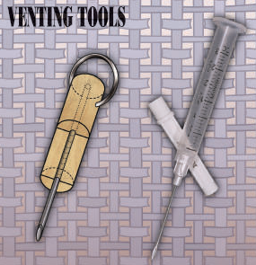
Figure 2.3. Two examples of venting tools described by Florida Sea Grant (2005).

To properly vent a fish with an expanded swimbladder, protocols developed by Florida Sea Grant (2005) have the fisherman holding the fish gently but firmly on its side and inserting the venting tool at a 45-degree angle approximately one to two inches from the base of the pectoral fin (Figure 2.4.). The tool should be inserted deep enough to release the gases, which, when done properly, is accompanied by an audible sound of gas escaping with a noticeable deflation of the body cavity. For fish extremely bloated, gentle pressure on the fish’s abdomen, using the hand holding the fish, aids deflation (Florida Sea Grant 2005).

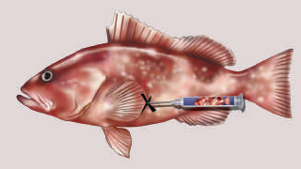
Figure 2.4. Anatomical location for inserting a venting tool into a fish with an over expanded swimbladder (Florida Sea Grant, 2005).

A third requirement of Preferred Alternative 2 would be dehooking devices. Dehooking devices are any device intended to remove a hook embedded in a fish in order to release the fish with minimum damage. Several devices may be used to remove hooks depending on the depth and location of hooking (Figure 2.5). Cooke and Suski (2004) identified ease of hook removal as a major contributor to mortality; therefore, the use of dehookers to remove hooks and lines would likely reduce serious injury and post-release mortality of targeted species, and other incidentally caught species.
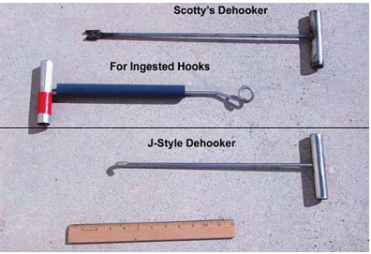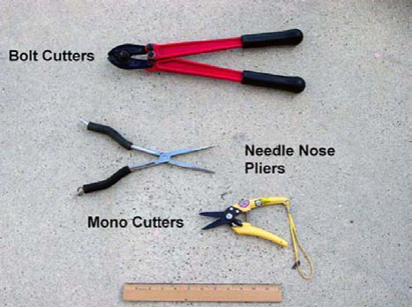
Figure 2.5. Some examples of dehooking devices that can be used to remove fishing hooks. The type of dehooking device used depends on hooking location and depth.

Options a-c in Alternative 3 specify a minimum hook size to be used in the directed red snapper fishery, while Alternative 3, Option d expands the requirement to all reef fish fisheries. Specifications for hook size are given under the various sub-options instead of traditional manufacturers’ sizing to eliminate confusion caused by the discrepancies found between manufacturers’ hook sizes. As seen in Table 2.5, there is a wide discrepancy between manufacturers’ hook sizes in relation to the outside diameter and hook point to shank measurements.

Cooke and Suski’s (2004) review found large hooks in general result in some size selectivity towards larger fish; however, they do hook smaller fish as well. Specifically for red snapper, Gledhill and Driggers ( 2006), found the mean length at capture was greater when caught with circle hooks (Mustad 15/0) compared to J-hooks. They also found a significant difference in fish length between circle hook sizes (Mustad 11/0 versus Mustad 15/0), with larger hooks catching larger fish. Thus selecting a minimum hook size could possibly reduce the number of undersized fish discarded. Suboption iv would require the largest minimum hook size, and therefore is expected to reduce discards the most relative to the other suboptions.

Table 2.5. Manufacturer hook size and outside diameter and hook point to shank measurements.

Manufacturer hook size | Hook Style | Outside diameter (cm) | Hook point to shank (cm)
Owner - 2/0 | Circle | 2.25 | 1.05
Owner - 3/0 | Circle | 2.5 | 1.15
Owner - 4/0 | Circle | 2.6 | 1.3
Owner - 5/0 | Circle | 2.95 | 1.5
Owner - 7/0 | Circle | 2.8 | 1.65
Owner - 8/0 | Circle | 2.95 | 1.9
Owner - 9/0 | Circle | 3.2 | 2
Eagle Claw - 2/0 | Circle | 1.8 | 1
Eagle Claw - 3/0 | Circle | 2.05 | 1.2
Eagle Claw - 4/0 | Circle | 2.3 | 1.4
Eagle Claw - 5/0 | Circle | 2.55 | 1.45
Gamakatsu - 2/0 | Circle | 1.95 | 1.2
Gamakatsu - 3/0 | Circle | 2.05 | 1.4
Gamakatsu - 4/0 | Circle | 2.2 | 1.5
Gamakatsu - 5/0 | Circle | 2.4 | 1.6
Mustad - 10/0 | Circle | 2.5 | 1
Mustad - 11/0 | Circle | 2.8 | 1.1
Mustad - 12/0 | Circle | 3.3 | 1.2
Mustad - 13/0 | Circle | 3.7 | 1.4

The intended effects of the gear modifications in Preferred Alternative 2 and Alternative 3 are to reduce bycatch and discard mortality, which would be expected to decrease effort in the fishery, thereby benefiting the physical environment compared to Alternative 1. Preferred Alternative 2 is expected to benefit the physical environment because circle hooks snag the bottom less often due to their design. Alternative 3 would require a minimum hook size while fishing for red snapper and/or reef fish. Specifying a minimum hook size reduces the capture of undersized fish, but would not greatly benefit the physical environment unless the size of the hook increases or decreases interactions with bottom habitat.

Though anecdotal evidence suggests circle hook use is widespread in the commercial sector, and increasing in popularity in the recreational sector, it appears mandatory use of circle hooks in all fisheries would benefit the biological environment of red snapper by reducing acute and long-term mortality caused by J-hook usage. Also, it is believed that venting, when properly executed, could increase survival of released fish. The use of venting tools may also reduce predation on red snapper and other bycatch species. The use of dehooking devices to remove hooks and lines would likely reduce serious injury and post-release mortality of sea turtles, marine mammals, targeted species, and other incidentally caught species. Larger hooks result in some size selectivity towards larger fish, which would reduce the number of fish discarded as regulatory discards and would allow for a quicker stock recovery time. Thus, Preferred Alternative 2 and Alternative 3 are both expected to be more beneficial to the red snapper stock than the current regulations for gear requirements.

Alternative 1 would not impose any additional gear requirements or restrictions on either the red snapper or reef fish fisheries and would not, therefore result in any direct or indirect short-term economic impacts to participants in the directed fisheries or associated businesses. The gear requirements and restrictions considered by Preferred Alternative 2 and Alternative 3 have the intended purpose of reducing bycatch and bycatch mortality, with attendant gains in long-term stock conditions and economic benefits. Each alternative comes with attendant costs, through new gear purchases, though such costs are not expected to be substantial.

Continued mortality associated with the absence of gear modifications would be expected, however, to result in slower recovery and more restrictive harvest allowances than would otherwise be possible, with attendant loss in economic benefits. Continuation of the status quo through Council action would, therefore, be expected to delay rebuilding, where applicable, and reduce allowable harvests and associated economic benefits to the directed fisheries and associated businesses. From the long-term perspective, the expected impacts of the hook specification, dehooking gear, and venting gear alternatives are largely indistinguishable when considered for application to a specific fishery. However, the expected benefits of potentially applying the requirements to all reef fish fisheries (Preferred Alternative 2, Preferred Option d and Alternative 3, Option d are expected to exceed the benefits when compared with such requirements being applied only to the red snapper fishery or a sector thereof (Options 2(a-c) and Options 3(a-c)).

Alternative 1 would not have any direct or indirect effects on the social environment in the short run because it maintains the status quo. Preferred Alternative 2 and Alternative 3 require the use of certain gear for the red snapper and reef fish fisheries that will help to protect and preserve the species. Although fishermen will be required to purchase new hooks, venting tools and dehooking devices, this action will have minimal impacts on the fishermen and fishing communities while allowing the fishery to be rebuilt.

All alternatives would require adjustments to the Reef Fish FMP, which fall within the scope and capacity of the current management system. Alternative 1 would continue current gear requirements while Preferred Alternative 2 and Alternative 3 would modify these requirements. Defining and enforcing these requirements would increase the administrative burden of red snapper and/or reef fish management.

Action 6. Establish a Target Reduction Goal for Juvenile Red Snapper Mortality in the Shrimp Fishery of the northern and western Gulf of Mexico

Alternative 1: No Action - do not establish a target reduction goal for the shrimp fishery of the northern and western Gulf of Mexico

Alternative 2: Establish a target reduction of shrimp trawl bycatch mortality on red snapper 50 percent less than the benchmark years of 2001-2003.

Alternative 3: Establish a target reduction of shrimp trawl bycatch mortality on red snapper 60 percent less than the benchmark years of 2001-2003.

Preferred Alternative 4: Establish a target reduction of red snapper shrimp trawl bycatch mortality on red snapper 74 percent less than the benchmark years of 2001-2003.

Alternative 5: Establish a target reduction of red snapper shrimp trawl bycatch mortality on red snapper 74 percent less than the benchmark years of 2001-2003 and then adjust it to the appropriate percent as determined by the red snapper stock assessment updates.

Discussion: The 2005 assessment for red snapper indicated a need for a 74 percent reduction in shrimp trawl bycatch mortality, beginning in 2007, compared to levels of effort and mortality experienced during the 2001-2003 period to end overfishing between 2009 and 2010. Fishing mortality during the 2001-2003 time period was estimated at 0.617 for the western Gulf of Mexico, and that includes the contributions attributable to BRDs; therefore fishing mortality needs to be reduced to 0.160 (Figures 2.5 and 4.1.4). The most commonly used BRD, the Fisheye positioned greater than 10.5 feet from the codend tie-off, was expected to reduce mortality by 44 percent from the mortality level during the 1984-1989 time period. In previous red snapper assessments, this magnitude of bycatch reduction was expected to be sufficient for the stock to rebuild, assuming it was achieved from 1998 onward. However, recent evaluations of the Fisheye BRD indicate it is reducing F by only approximately 11 percent. Given that the target level of reduction from BRDs was not achieved, even greater reductions are now required. Based on a new BRD certification criterion to be established in 2007, new and more effective BRDs will be certified for use in the fishery. The BRDs most likely to be used by the industry reduce mortality on juvenile red snapper by greater than 20 percent (Table 2.6); therefore, the new BRDs should reduce mortality from shrimp trawls by at least an additional 10 percent over the contribution of the current industry standard, the Fisheye. However, BRDs by themselves, will not meet the new reduction needs to achieve rebuilding of the red snapper stock. Consequently, a target reduction goal and measures to achieve this goal need to be established.

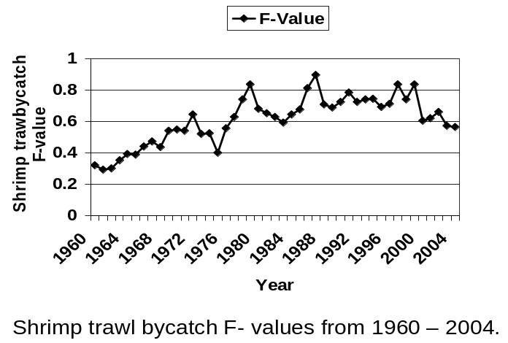
Figure 2.5. Shrimp Trawl Bycatch F-values (Red Snapper)

Table 2.6. Performance and Average Price of Bycatch Reduction Devices Tested in the Gulf of Mexico
BRD TYPE | REDUCTION CRITERION |  |  | Shrimp Loss  (Percent) | Average Price  per Unit
BRD TYPE | Percentage Reduction  in Red Snapper  (Ages 0 - 1) Mortality | Percentage Reduction  in CPUE on Red Snapper  (Ages 0 – 1) | Percentage Reduction in Total Finfish Bycatch (by weight) | Shrimp Loss  (Percent) | Average Price  per Unit
Fisheye Legal  8.5’-10.5’ | 26.6  (5.5 - 47.8) | 26.6  (5.5 - 47.5) | 22.8  (18.0- 27.5) | 6.3  (4.0- 8.7) | $45
Fisheye Legal 10.6’-12.5’ | 10.8  (-1.3 - 22.9) | 8.8  (1.1 – 16.5) | 13.5  (11.1– 15.9) | 1.6  (-0.4-3.6) | $45
Fisheye – All | 9.4  (3.3 - 15.5) | 6.2  (0.1 - 12.2) | 17.0  (16.1- 17.9) | 1.2  (0.4- 2.1) | $45
Jones Davis | 52  ( * * ) | 40.0  (30.0–50.0) | 58.0  (53.0 –63.0) | 4.0  (0.0 –9.0) | $425
Modified Jones Davis | 30.6  (25.6 -35.7) | 24.1  (18.6 -29.6) | 33.1  (30.3 –36.0) | 3.2  (1.4 -4.9) | $200
Extended Funnel | 25.1  (11.8 –38.4) | 17.4  (6.5 – 28.2) | 26.6  (21.7 -31.6) | 2.2  (-1.7-6.0) | $350
Source: Dan Foster, NMFS – 95% confidence interval in parentheses;
** based on Goodyear model: confidence interval not available.

The following summary discussion is based on several factors discussed elsewhere in this document:

- Shrimp fishing effort has a strong correlation to the levels of red snapper mortality attributable to the shrimp fishery (Figure 2.6 and Table 2.7), and is a more appropriate tool to manage red snapper mortality than bycatch quotas or restrictions on the number of federal shrimp vessel permits (see Figure 4.1.3).

- Juvenile red snapper are more common in the 10-30 fathom depth strata (Section 3.2.1).

- Shrimp fishing effort in 2005 in areas where red snapper are abundant was reduced by 50 to 60 percent from the baseline 2001-2003 period (Figure 3.2.1.3 and Table 2.7).

- The number of vessels participating in the offshore shrimp fishery is expected to continue declining until at least 2012, and has been further reduced by the impacts of Hurricanes Katrina and Rita (Section 3.2).

The effort declines illustrated in Tables 3.2.1 and 3.2.2 are anticipated to continue given the current economic environment, but they may not be permanent. To that end, Alternative 1 (No action) may not ensure consistent reductions in bycatch mortality on juvenile red snapper in the shrimp fishery over the time of the current rebuilding program. In addition, as noted above, although reducing bycatch mortality on juvenile red snapper through the use of BRDs is a practical action, it does not appear (Table 2.6) that current technology will have the potential, in the near future, to develop BRDs that meet the overall reduction goals. Therefore, the Council is considering additional measures to reduce bycatch in the shrimp fishery, recognizing additional bycatch mortality reduction may continue to occur from continued effort reductions.

In developing alternatives for an interim rule to begin reducing fishing mortality from the directed red snapper and shrimp fisheries, NMFS established a target reduction goal of 50 percent for the shrimp fishery. This target was based on initial estimates of fishing mortality on juvenile red snapper attributable to shrimp effort in areas where red snapper are abundant (Figure 3.2.1.3). Initial estimates suggested effort was down by 58 percent in these areas, which translated to a 52 percent reduction in fishing mortality on juvenile red snapper. Alternative 2 in this amendment would maintain the target established in the interim rule. It does not meet the 74 percent target mortality reduction level recommended by the 2005 red snapper stock assessment to end overfishing between 2009 and 2010, and it would likely result in TAC for red snapper having to be set at approximately 2.8 MP for 2008 and 2009. Nevertheless, a 50 percent reduction target would allow the industry some additional flexibility in achieving OY, as it is currently defined for the fishery.

Figure 2.6. Juvenile Red Snapper F vs. Shrimp Effort in the 10-30 Fathoms in the Gulf of Mexico.

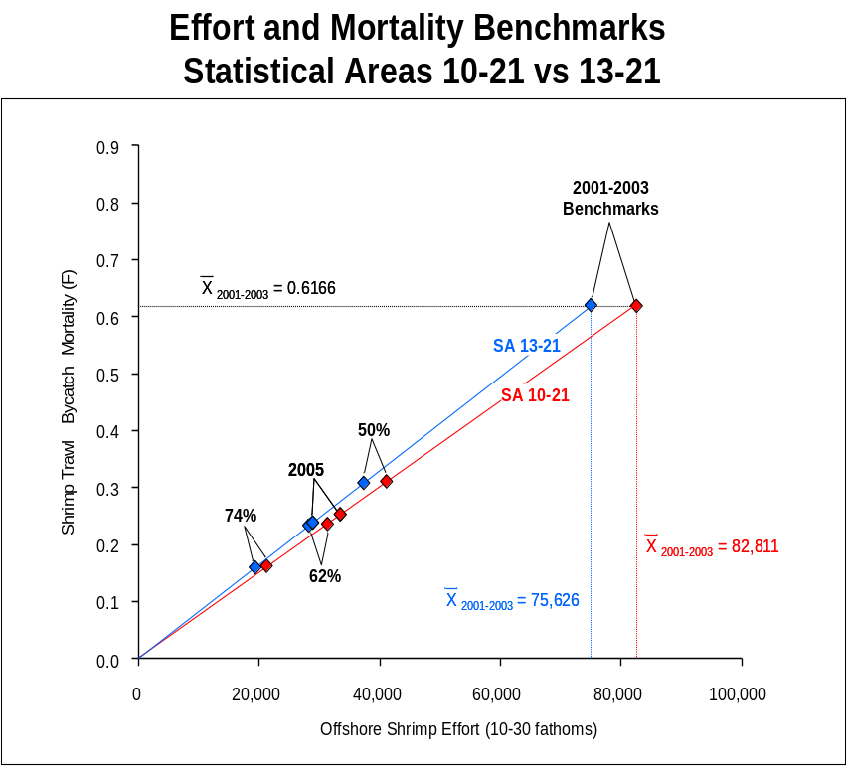

Subsequent analyses of 2005 shrimp effort data revised the reduction estimates (Table 2.7), suggesting effort and fishing mortality was reduced by approximately 60 percent from the benchmark 2001-2003 period. In addition, as noted in Section 3.2, effort is expected to continue declining in the near future. For example, of the 1,800 shrimp trawl vessels active during 2005, the U.S. Coast Guard has documented that nearly 150 of those vessels were either damaged or stranded. Assuming equal effort among vessels, this would equate to a 5-10 percent reduction in effort from the 2005 level attributed to attrition in the fishery. Preliminary estimates of effort in 2006 support these assumptions. Data for the first two trimesters of 2006 suggest total effort in the western Gulf may be down by an additional 10 percent, and effort in the 10 to 30 fathom area of the western Gulf may be down by as much as 35 percent from the levels of effort documented for 2005 (Nance, personal communication). Assuming these preliminary estimates hold true, F in 2007 would be approximately 74-75 percent below the 2001-2003 average.

Table 2.7. Juvenile Red Snapper F vs. Shrimp Effort in the 10-30 Fathoms in the Western Gulf of Mexico
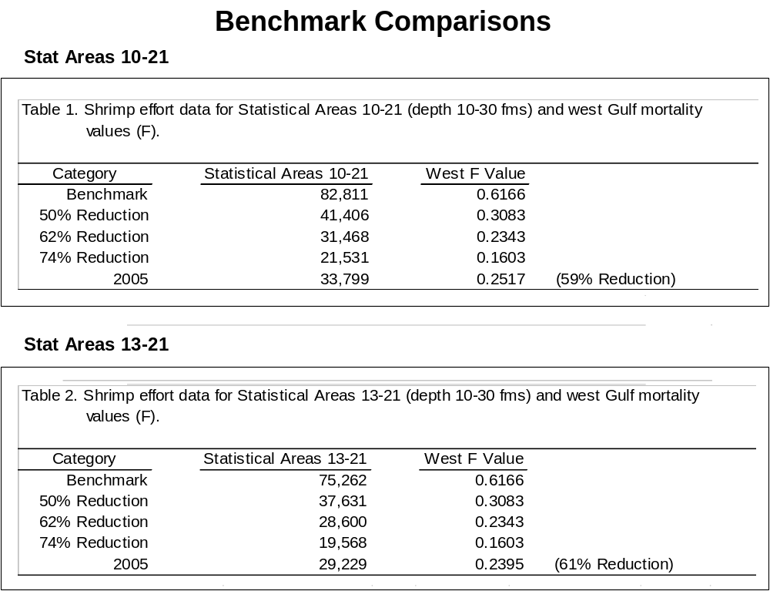

Alternative 3 would establish a target mortality reduction of 60 percent from the benchmark years; this reduction level reflects the level of effort reductions associated with 2005, and in the near future, it is expected that fishing mortality will remain below this level. As previously stated, the revised BRD criterion is expected to further reduce bycatch mortality by an additional 10 percent. Furthermore, The Council also expects effort and participation in the fishery to continue to decline due to potential reductions in permits from the implementation of the shrimp vessel permit moratorium and the current external economic factors. As mentioned above, in the discussion for Alternative 2, early estimates of 2006 shrimp effort support the expectation of continuing declines. These declines are detailed in the Regulatory Impact Review section, and are anticipated to continue at least through 2012. As discussed in Action 8, NMFS annually would develop effort estimates, and either the Council or NMFS would then consider management actions to keep shrimp effort below the selected threshold, if needed.

Preferred Alternative 4, as well as Alternative 5, would establish a target aligned with the recommended 74 percent reduction in red snapper fishing mortality from the benchmark years of 2001-2003. As noted in the discussion for Alternative 2, the fishery is likely to meet a 74 percent reduction in the 10-30 fathom depth strata of the western Gulf of Mexico, based on preliminary effort estimates for 2006, along with anticipated benefits of improved BRDs in 2007 or 2008. Nevertheless, although limited expansion of the fishery is anticipated in the near future, actions may be needed in the future to maintain these reductions in effort in areas where red snapper are abundant, such as those identified in Action 7. As noted below, this reduction in effort, which only affects the ability of the fishery to utilize a portion of the shrimp grounds for a limited time frame during the year, should not preclude the fishery the opportunity to achieve OY, as currently defined, on a continuing basis.

There would be no direct biological impacts from setting a target reduction goal for red snapper bycatch mortality in the Gulf shrimp fishery. This is an administrative action that would allow managers to monitor a specific portion of the total shrimp effort in the northern and western Gulf that has a direct impact on juvenile red snapper. If the target effort level is being exceeded to the point where managers determine further actions are needed, there would be indirect effects only in the sense that this action would serve as the basis for future actions. Any biological impacts would result from options presented in Action 8. Such impacts would be identified and discussed in a regulatory amendment or in supporting documents for action delegated to the RA, depending on the Council’s choice of a preferred option.

Alternative 3, Preferred Alternative 4, and Alternative 5 could result in a long-term restriction of effort in the mid-shelf regions of the western Gulf of Mexico, compared to the baseline 2001-2003 period, or the documented level of effort in 2005. The fishery in the 20-50 fm depth zone is primarily for brown shrimp. Because of economic issues facing the shrimp fishery today, brown shrimp landings are below the Council’s designation of OY. However, these proposed effort restrictions in the mid-shelf region should not prevent the fishery from achieving OY as it is currently defined. It would not preclude the fishery from targeting brown shrimp in waters deeper than 30 fathoms, or inshore of 10 fathoms. And depending on the length of any time-area closure, such as proposed in Action 7, the areas in the mid-shelf area would also be open probably most of the year.

Since this is an administrative action, none of the alternatives would be expected to result in any direct adverse economic or social impacts in the short-term or long-term. Alternatives 1, 2, and 3 would also not be expected to result in any indirect short-term adverse economic and social impacts. Alternative 1 would not establish a benchmark on which to base subsequent effort control. Current effort reductions are believed to be within the benchmarks that would be established by Alternatives 2 and 3 and, hence, no additional restriction on the shrimp fishery would be required at this time. However, increases in or changes in the spatial distribution of effort in the shrimp fishery could require future effort restrictions under Alternatives 2 and 3, particularly if these changes increase effort in areas where juvenile red snapper are abundant. Thus, Alternatives 2 and 3 could indirectly cause adverse economic and social impacts in the long-term. Whether and to what extent these restrictions mirror those considered under Action 7 cannot be determined at this time. But, if so, the discussion for Action 7 provides a range of potential impacts. Due to shrimpers exiting the fishery and the damage caused by the hurricanes of 2005, as partially reflected by preliminary effort data for 2006, it is also possible that the target established by Preferred Alternative 4 and Alternative 5 will be achieved in 2007 and thus no additional restrictions on the shrimp fishery would be required in 2008. However, if the bycatch target is not achieved, measures may be required in the future which could impact fishermen and communities that depend on the fishery. Thus, Preferred Alternative 4 and Alternative 5 could potentially result in indirect adverse economic and social impacts due to the effort restrictions that would need to be placed on the fishery, the range of which is described under Action 7. The need for future actions will be assessed in reports based on the preferred alternatives selected in Action 7 and Action 8.

Action 7. Consider establishing shrimp fishing restrictions to reduce effort to achieve a fishing mortality reduction target for juvenile red snapper in the northern and western Gulf of Mexico established in Action 6

Alternative 1. No action – do not consider establish fishing restrictions for the Gulf shrimp fishery

Preferred Alternative 2: Establish if necessary a seasonal closure beginning on the same start date as the closure of the EEZ off Texas in the 10 to 30-fathom zone of selected areas within statistical zones 10-21 in the Gulf of Mexico. The need for the closure and its extent and duration will be determined based on the annual evaluation of the level of shrimp effort and associated red snapper mortality, taking into consideration mortality reductions associated with improved BRDs and other gear improvements. Any closure would be implemented in accordance with the framework outlined in Action 8.

Alternative 3: Establish if necessary a seasonal closure within the January 1 through April 30 timeframe in the 10 to 30-fathom zone of selected areas within statistical zones 10-21 in the Gulf of Mexico. The need for the closure and its extent and duration will be determined based on the annual evaluation of the level of shrimp effort and associated red snapper mortality, taking into consideration mortality reductions associated with improved BRDs and other gear improvements. Any closure would be implemented in accordance with the framework outlined in Action 8.

Alternative 4: Establish if necessary a seasonal closure within the October 1 through November 30 timeframe in the 10 to 30-fathom zone of selected areas within statistical zones 10-21 in the Gulf of Mexico. The need for the closure and its extent and duration will be determined based on the annual evaluation of the level of shrimp effort and associated red snapper mortality, taking into consideration mortality reductions associated with improved BRDs and other gear improvements. Any closure would be implemented in accordance with the framework outlined in Action 8.

Discussion: The same four factors bulleted at the beginning of the discussion section for Action 6 apply to Action 7. The statistical zones referred to in the Alternatives are illustrated in Figure 2.7.

Figure 2.7. Diagram of the various statistical zones across the Gulf of Mexico, used for record keeping purposes in regard to fishery landings.
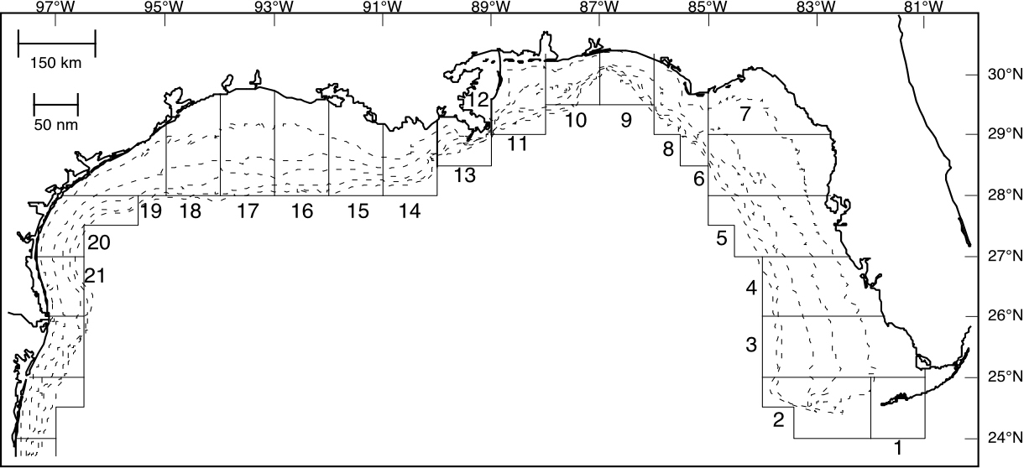

Because of the relatively high bycatch of juvenile red snapper in the shrimp trawl fishery, managers have, on several occasions, considered alternatives to minimize such bycatch through area and seasonal closures. It should be noted that the Council rejected broad time-area closures and bycatch reduction options for the shrimp fishery in Amendment 1 to the Reef Fish FMP in 1990, and again in Amendment 9 to the Shrimp FMP in 1998 and again in Amendment 10 to the Shrimp FMP in 2004. Any seasonal closure intended to reduce the catch of juvenile red snapper would have to assume a consistent and proportional relationship across years for shrimp effort, shrimp and red snapper distribution, and juvenile red snapper recruitment. In addition, to be effective the seasonal or area closure must include the time period just prior to the migration of these juvenile red snapper from shrimp grounds to areas of greater relief.

More importantly, depending on the amount of effort allowed, there could be a change in the fishing behavior of the shrimp fleet and a redistribution of effort around a closed area. Shrimp effort could be expected to move to state and nearshore federal waters if a closure as with Preferred Alternative 2 and Alternatives 3 and 4 is implemented. This is particularly true off Louisiana and northeast Texas where white shrimp (that occur closer to shore) are dominant in the fall and early winter months, after the high brown shrimp effort period of July and August. Finally, the impacts of Hurricanes Katrina and Rita may have reduced effort due to vessel damage and loss to the extent that any reasonable cap on effort to control the level of bycatch may not be reached, and a closure may not be needed, or it could be reduced in scope.

As noted above, any season or area closure must provide the ability for the affected size/age class of red snapper to escape the shrimp fishery. Closed areas would be most effective if they are large (for enforceability and to effectively address the broad distribution of red snapper in the northern and western Gulf) because juvenile red snapper are associated with the shrimp grounds for 14 months or longer. The geographic scope of the closure would also need to include documented areas where juvenile red snapper are found to be consistently abundant across years. As discussed in detail in Sections 3.2 and 4.1, recent evaluations of catch and bycatch data (Gallaway et al. 1998; Gallaway et al. 1999) indicate substantial portions of the total juvenile red snapper bycatch occurs in shrimp trawls fished in the mid-shelf depth zones of the northern and western Gulf of Mexico (west of Cape San Blas, Florida). Juvenile red snapper occur infrequently inside of 10 fathoms (Branstetter 1997; Gallaway et al. 1998). Gallaway et al (1998, 1999) found the greatest densities of juvenile red snapper catches occurred in the areas between 10 and 25 fathoms. Therefore, the Council is not considering closures in the entire EEZ of the northern and western Gulf.
Alternative 1 (No Action) would not provide for the establishment of a time/area closure and would allow the shrimp fishery to continue, with the only anticipated reductions in red snapper mortality being associated with any further declines in effort because of external factors. While these declines are anticipated, they are not assured; at least, not in the long term. If fishing effort and bycatch mortality levels in 2007 do not meet the 74 percent reduction target (Action 6, Preferred Alternative 4 and Alternative 5) or if effort increases in the future and exceeds the target, the choice of Alternative 1 would not provide the Council with an immediate means to address the issue. Additional action, through a plan amendment or other action by NMFS (interim rule or emergency action) would be needed to return fishing effort and thus bycatch mortality to the threshold level.

Preferred Alternative 2 would provide for a potential closure in the northern and western Gulf (Statistical Subzones 10-21) within the 10-30 fathom zone in conjunction with the beginning of the Texas Closure, which closes the entire EEZ off Texas from typically May 15 to July 15. This depth range is where red snapper are known to be most abundant and the area that contains the most suitable juvenile red snapper habitat (see Figures 3.2.1.1 and 3.2.1.2). It is important to emphasize that while the starting date of the potential closure considered under this alternative is set to coincide with the beginning of the Texas closure, no ending date is specified. In other terms, this alternative could potentially result in a short closure, i.e., a few days or result in a closure lasting up to a full year. Similarly, within the 10-21 statistical zones, the scope of the closure could be limited to a few statistical zones or cover the entire area (from Mobile Bay to Brownsville).

Assuming the area closure coincided with the Texas Closure (ca. 60 days), it would provide approximately a 17.5 percent reduction in effort in the 10-30 fathom zone from Mobile Bay to Brownsville (Table 2.7). As noted under the discussions for Alternative 3 for Action 6, effort in 2006 for the 10-30 fathom depth range may be 35 percent less than it was in 2005. If so, fishing mortality reductions may be meeting the target reduction goal of 74 percent, and a closure associated with the beginning of the Texas Closure might be of very limited duration or areal scope.

The potential seasonal closure considered under Preferred Alternative 2 would encompass the beginning of the time red snapper reach biological age 1, attain a size of approximately 120-150 mm, and begin emigrating off the shrimp grounds to areas of high relief (see Figures 4, 5, and 6 in Gallaway and Cole 1999). While the overall abundance and catch rate of red snapper are not particularly high during the Texas closure, almost all the red snapper caught are age 1 fish. A closure during this time period would allow a large number of them to migrate off the shrimp grounds to their sub-adult habitats. The age 0 fish on the grounds at this time are very small because spawning occurs in the Spring, and small (ca. 50 mm) juvenile red snapper are just beginning to settle on the shrimp grounds at this time. This new age class is not as vulnerable to trawl gear, being of a size where they can pass through the webbing of the net. Recent analyses by NMFS suggests as many as 65 percent of small Age-0 red snapper may pass through standard sized (1-7/8”) mesh bags used by the fishery.

Shrimp trawl mortality in the 10 to 30 fathom depth zone has a significant linear relationship with annual fishing effort in 10 to 30 fathoms (Figure 2.6). The 2005 red snapper stock assessment considered the mouth of the Mississippi River as a dividing line to separate the Gulf of Mexico into a western and eastern zone. Approximately 11 percent of the total effort expended in the 10-30 fathom zone in statistical subzones 10-21 (Mobile Bay to Brownsville) comes from statistical subzones 10-12 (east of the Mississippi River), and primarily from statistical subzone 11. While this fishing effort is substantial, the impact of a 10-30 fathom closure in this area on juvenile red snapper mortality is low (Figure 3.4.1.2); recreational fishing mortality is the dominating impact in this eastern area. Reductions in effort and in shrimp trawl mortality in the western Gulf (statistical subzones 13-21) would provide the vast majority of the potential benefits of a closure because reductions in effort are commensurate with reductions in fishing mortality (Figure 3.4.1.2).

Closures established under the provisions of Preferred Alternative 2 could alleviate fishing mortality problems stemming from shifts in fishing effort to Louisiana mid-shelf regions during the Texas Closure each year. In past years, substantial amounts of effort have been redirected to the Louisiana shelf area (Table 2.8). A closure of the mid-shelf area off Louisiana beginning with the start of the Texas Closure could provide the potential to reduce red snapper mortality from direct reductions in effort (Table 2.7.2) in the areas where red snapper are abundant. The alternative would not prohibit all shrimping off Louisiana; substantial portions of the shelf are inshore of the 10-fathom contour and are fished during this time period, and substantial effort occurs seaward of the 30-fathom contour as well (Gallaway et al. 1999). Thus, none of the proposed closures should preclude the fishery from achieving OY as it is currently defined.

Table 2.8. Nominal effort (24-hr days fished) by sub-region in the 10-30 fathom depth zone of the Gulf of Mexico for 2005 compared to average annual effort for the benchmark 2001-2003 period.

2001-2003 | Stat Zones | Jan - Apr | May - Aug | Sept - Oct | Annual
Florida | 1 - 9 | 8,542 | 5,722 | 4,409 | 18,673
FL-AL-MS | 10 – 12 | 603 | 3,150 | 2,515 | 6,268
Louisiana | 13 – 17 | 3,117 | 25,342 | 5,948 | 34,407
Texas | 18 – 21 | 6,201 | 15,680 | 17,938 | 39,820
2005
Florida | 1 - 9 | 7,356 | 4,055 | 3,494 | 14,905
FL-AL-MS | 10 – 12 | 799 | 2,864 | 917 | 4,580
Louisiana | 13 – 17 | 1,641 | 10,489 | 1,282 | 13,412
Texas | 18 – 21 | 1,028 | 7,889 | 6,900 | 15,817

Table 2.9. Percent of total shrimp effort for 2003-2005 per month in the 10 to 30 fathom depth zone for Statistical Zones 10-21 (Mobile Bay to Texas), 10-12 (east of the Mississippi River), and 13-21 (west of the Mississippi River).

MONTH | Area 10-21 | Area  10-12 | Area 13-21
January | 3.4 | 10.9 | 2.3
February | 3.6 | 3.1 | 3.7
March | 2.0 | 1.5 | 2.1
April | 1.4 | 0.7 | 1.5
May | 4.5 | 4.1 | 4.6
June | 9.4 | 12.1 | 9.1
July | 12.0 | 11.5 | 12.1
August | 25.6 | 11.0 | 27.7
September | 11.6 | 16.0 | 11.0
October | 10.1 | 12.3 | 9.8
November | 8.0 | 5.8 | 8.3
December | 8.4 | 10.9 | 8.0

Alternative 3 would provide for a potential closure in the northern and western Gulf of Mexico within the 10-30 fathom zone during January through April of the year. This is a time period when limited shrimp effort occurs in the Gulf of Mexico (Table 2.9). While this alternative brackets potential closures between January 1 and April 30, it neither provides a definite starting date nor indicates a specific ending date. As in Preferred Alternative 2, the scope of potential closures could include a limited number of statistical zones or cover the entire northern and western Gulf. Assuming a complete four-month closure for the entire area (Statistical Zones 10-21) would approximate a 10.4 percent reduction in effort in the 10-30 fathom zone where juvenile red snapper are more abundant.

Biological impacts resulting from Alternative 3 would be primarily determined by the timing of the proposed closure. As noted in the introductory discussion for Action 7, an area-season closure needs to ensure the target species has the ability to disperse from the area before the closure ends. In the case of a winter trimester closure, the majority of the red snapper on the shrimp grounds at this time are biologically age-0 (age 1 as of January 1 for stock assessment purposes), and at a size less than 120 mm in length. A closure during this period would reduce fishing mortality on these individuals, but the fish would still be on the shrimp grounds when the closure ends, May 1. Individuals off Texas would again be protected with the May 15 start of the Texas Closure, but individuals off Alabama, Mississippi, and Louisiana would be susceptible to potentially intensified fishing effort, particularly concentrated off Louisiana during June (Table 2.8).

On the positive side, shrimp trawls have a distinct size selectivity. Trawls are towed at approximately 3 knots; fish greater than 150 mm in length can swim faster than 3 knots and have a greater opportunity to successfully avoid the trawls. By June, when this effort shift to Louisiana waters would occur, many of the fish would be approaching this size. But, with an intensified trawling effort during May through July, particularly off Louisiana, increased numbers of surviving juveniles would be susceptible to capture.

Alternative 4 would provide for a potential closure in the northern and western Gulf of Mexico within the 10-30 fathom zone between October and November. This is the time period when heavy shrimp activity occurs in this region as brown shrimp complete their offshore migrations. As with Alternative 3, Alternative 4 does not specify starting and ending dates but provides a set time interval for a potential closure. Assuming the entire area was closed for the two-month period, it would approximate an 18 percent reduction in shrimp trawl effort in the 10-30 fathom depth zone of the northern and western Gulf of Mexico. The primary difference between Preferred Alternative 2 and Alternative 4 is the timing of the closure. The potential biological benefits of a closure as with Preferred Alternative 2 and Alternative 4 are similar. Preferred Alternative 2 focuses on the early phase of the time period when Age 1 red snapper are emigrating off the shrimp grounds, and attaining a size to avoid capture, whereas Alternative 4 focuses on the late phase of the emigration period. Plus, Alternative 4 potentially would provide protection for the next age class, which has begun to dominate the overall bycatch by this time. However, the benefits of increasing the survival of age 0 fish during the fall, while they remain on the shrimp grounds for another 9 months, may not be substantial, primarily due to the high natural mortality rate on age 0 fish.

Seasonal closures during peak shrimping periods, such as provided for under Preferred Alternative 2 and Alternative 4, could cause some relocation of effort by the shrimp fleet. Fishermen would not be allowed to fish in the closed offshore waters, and some could opt for fishing in shallower waters inshore of the closure area. Travel to areas offshore of the closed area would be costly under current fuel prices. Branstetter (1997) and NMFS (1998) have documented that finfish bycatch levels are higher in nearshore waters (inshore of 10-15 fathoms) than for offshore areas. Branstetter (1997) noted finfish to shrimp ratios (in biomass) were 7.6:1 off Louisiana inshore of 10 fathoms compared to 3.3:1 offshore of 10 fathoms. Similarly, off Texas, finfish to shrimp biomass ratios were 4:1 for waters inshore of 10 fathoms, and 3.3:1 offshore of 10 fathoms. Therefore, shifts in effort to nearshore waters during a closure would increase the overall bycatch of finfish, assuming there is no reduction in overall effort for the closure period. This issue may be ameliorated to some extent in that many of the common nearshore fishes can be excluded at relatively high rates from the use of BRDs.

Alternative 1 would not be expected to result in any direct adverse economic and social impacts since no effort restrictions would be imposed on the shrimp fishery. However, if status quo effort reductions in the fishery are not sufficient to achieve target goals, continuation of this alternative may result in more severe future restrictions, resulting in potentially greater adverse economic impacts than the adoption of effort restrictions at this time. Each of the alternatives that could enact effort controls would be expected to result in greater adverse economic impacts in the future relative to Alternative 1. Among these alternatives, Alternative 3 would be expected to result in the least adverse economic impacts on the shrimp fishery, affecting fewer vessels, fewer pounds of shrimp, and less shrimp revenues. Ranking of Preferred Alternative 2 and alternative 4 is less clear. However, since Preferred Alternative 2 would be expected to potentially result in more firms exiting the industry than Alternative 4, the adverse economic impacts associated with Preferred Alternative 2 would be expected to exceed those of Alternative 4. Longer term benefits derived from expected improvements to the red snapper stock are expected to outweigh these adverse impacts. Preferred Alternative 2, which is expected to have the largest impact on red snapper mortality reduction, is expected to result in greater long-term benefits. Greater positive impacts associated with Preferred Alternative 2 are attributable to the specified starting date of a potential closure, which would coincide with the movement of age 1 snapper from shrimp grounds to larger structures.

Action 8. Establish a framework procedure to adjust shrimp fishing effort in the northern and western Gulf of Mexico

Alternative 1. No action – do not establish a framework.

Preferred Alternative 2. Establish a framework procedure to adjust the effort target and closed season for the shrimp fishery in the Gulf of Mexico within the scope of the preferred alternatives identified in Actions 6 and 7.

Option a. The SEFSC will provide an annual report to the Council on the previous year’s assessment of shrimp effort for the 10- to 30-fathom area in the Gulf (statistical subzones 10-21). The Council may recommend the area and duration of a closure for the subsequent year.

Preferred Option b. The SEFSC will conduct an annual assessment of the previous year’s shrimp effort for the 10- to 30-fathom area in the Gulf (Statistical Subzones 10-21) and determine the area and duration of a closure and report this to the Regional Administrator for administrative action in the subsequent year.

Option c. A shrimp effort assessment team of scientists, appointed by the Council, will provide an annual report to the Council on the previous year’s assessment of shrimp effort for the 10- to 30-fathom area in the Gulf (statistical subzones 10-21). The Council may recommend the area and duration of a closure for the subsequent year.

Discussion: Preferred Alternative 4 in Action 6 in combination with Preferred Alternative 2 in Actions 7 and 8 establish a target red snapper mortality reduction, as well as a time/area closure and procedure that would provide managers with the ability to address future changes in the shrimp fishery of the Gulf of Mexico through potential closures in specified areas to reduce shrimping effort and thus bycatch mortality on juvenile red snapper in a timely manner. The purpose of such closures would be to maintain an effort control on the shrimp fishery and thus maintain a level of bycatch reduction that allows the red snapper stock to rebuild in compliance with the rebuilding plan and end overfishing between 2009 and 2010.

The information regarding the level of effort for a given calendar year would not be available for analysis until some time in the middle of the following year. For example, information regarding 2007 would be available during the end of the first semester in 2008. Thus, there would be limited time to take effective action during 2008. Any action would be implemented during the 2009 fishing year. In effect, future actions will be in response to conditions experienced two years prior. The SEFSC report, and its recommendations, should take this time lag into consideration, given the current economic uncertainties surrounding the shrimp fishery. It is difficult to determine what the current (2007) status of the fishery is or what it will be in the near future; however the number of participants and the associated effort and bycatch are expected to continue to decline through at least 2012 due to economic factors related to competition with imports and high operating expenses (Travis and Griffin 2004). Should this decline be realized in subsequent years, there may not be a need to establish additional closures as with Action 7, Preferred Alternative 2. On the other hand, if the preferred target of a 74 percent reduction in bycatch mortality from the 2001-2003 baseline average is not being achieved at the time that this action is implemented or if in the future, the economic climate improves or other factors cause an increase in effort such that the target is no longer being achieved, Preferred Alternative 2 provides a mechanism for implementing closures based on the criteria established in Action 7, Preferred Alternative 2. Under Option a or Preferred Option b of Preferred Alternative 2, the SEFSC would conduct analyses of effort in Statistical Subzones 10-21 and develop an annual report of effort and bycatch mortality relative to the target 74 percent reduction. With Option a, the report would be provided to the Council for its review and consideration of regulatory actions to implement a closure conforming with the guidelines established by Action 7, Preferred Alternative 2, if needed, in the following year. Preferred Option b would assign authority to the RA of the SERO, NMFS to determine the area and duration of a closure, if needed, for the coming year within the guidelines established by Action 7, Preferred Alternative 2. Under Option c the Council would appoint a Shrimp Effort Assessment Team (SEAT) of scientists that would review the SEFSC’s analyses of effort and develop a report to the Council. The Council in turn would review the SEAT report and determine the need for and the location/duration of any closure in conformance with the guidelines established by Action 7, Preferred Alternative 2.

If a closure is determined to be needed, Preferred Option b would provide the most expedient means of implementation in that the SEFSC’s report would be submitted to the RA who in turn would implement the closure through a similar procedure as has been used to implement the Texas Closure in the past. Option c would provide the least expedient means of implementing a closure in that the SEFSC’s report would have to be reviewed by the SEAT and then the Council before regulatory action could be initiated. Preferred Option b would provide a middle of the road approach with regard to the expediency of implementing a closure.

Alternative 1 would not establish a framework procedure to potentially implement additional closures within the guidelines established by Action 7, Preferred Alternative 2. Not establishing a framework action would render the preferred alternatives in Action 6 and Action 7 moot because there would be no other means of implementing a closure other than a separate amendment, or an emergency or interim rule action by the RA. This action could benefit the shrimp fishermen in that they would be able to continue to shrimp without the potential for further restrictions, at least in the short term. On the other hand, if there is no framework procedure to quickly adjust effort to meet the bycatch reduction target in the future, there may be a higher mortality on juvenile red snapper, and it may be more difficult to end overfishing and continue to rebuild the red snapper stock in accordance with the established rebuilding plan. This would be detrimental to the recreational and commercial red snapper fishery and the people who depend on it since there may be a need for further reduction on the directed red snapper fishermen. It could also impact fishermen and fishing communities that depend on the shrimp fishery if this lack of action results in the need for further reductions in the future to reduce the amount of bycatch of juvenile red snapper.

Action 8 is an administrative action. Hence, no direct short-term or long-term adverse economic impacts would be expected to result from either Alternative 1 or Preferred Alternative 2. The adoption of a framework procedure for addressing effort in the shrimp fishery would generally be expected to facilitate faster corrective action, reducing both the cost of action and pace at which benefits for the action would be received. Thus, Preferred Alternative 2 would be expected to result in greater indirect economic benefits than Alternative 1. Impacts to the administrative environment would occur as a result of the SEFSC’s analysis of effort and the development of the appropriate reports to support the potential actions as contemplated by Option a, Preferred Option b, or Option c. Economic and social impacts would result from the determination of the area and duration of a closure, if needed, based on the guidelines established by Action 7, Preferred Alternative 2 and would be evaluated in the appropriate analyses based on the Council’s choice of Option a, Preferred Option b, or Option c.

