splitbeard bluestem
Andropogon ternarius Michx.
Plant Symbol = ANTE2

Contributed by: USDA NRCS Louisiana State Office, National Plant Data Center, & the Grazing Land Conservation Initiative-South Central Region
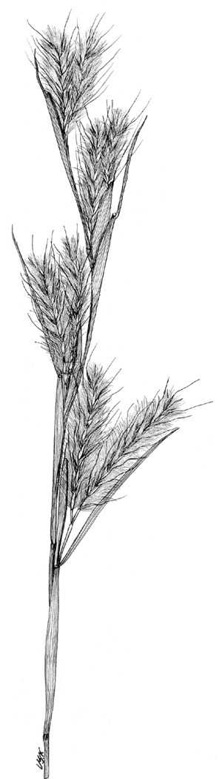
Grass Images
@ Texas A&M University

Alternative Names
Splitbeard beardgrass, paintbrush bluestem, silver bluestem, silvery beardgrass, and feather bluestem.

Uses
Livestock: Splitbeard bluestem is grazed readily by cattle in the spring shortly after growth starts. However, it is seldom abundant enough for forage for cattle. If it is the principal winter forage, the cattle should be fed a protein supplement.

Ornamental Landscaping: Splitbeard bluestem is used as an ornament in landscapes and in flower arrangements because of its fluffy, cottony, or silvery appearing seed heads scattered over the length of each stem. To some people, the grass evokes images of shooting fireworks.

Wildlife: Splitbeard bluestem benefits wildlife. Several species of birds and mammals eat the seeds and use the plants for cover. The white-tailed deer and rabbits also browse the plant.

Erosion Control: Splitbeard bluestem provides erosion control on slopes in poor or sandy soils.

Habitat Restoration: Due to its relatively high seedling vigor, splitbeard has great potential as a native nurse crop for slower establishing native species such as wiregrass (Aristida beyrichiana).

Conservation Practices: Splitbeard bluestem, because of its growth habit, potentially has application when established with certain conservation practices; however, conservation practice standards vary by state. For localized information, consult your local NRCS Field Office. NRCS practices include the following: 327-Conservation Cover; 342-Critical Area Planting; 386-Field Border; 390-Riparian Herbaceous Cover; 393-Filter Strip; 512-Pasture and Hay Planting; 550-Range Planting; 560-Access Road; 562-Recreation Area Improvement; 643-Restoration and Management of Declining Habitats; 644-Wetland Wildlife Habitat Management; 647-Early Successional Habitat Development/Management; 656-Constructed Wetland; 657-Wetland Restoration; 658-Wetland Creation; 659-Wetland Enhancement.

Status
Consult the PLANTS Web site and your State Department of Natural Resources for this plant’s current status, such as, state noxious status and wetland indicator values.

Description
General: Grass Family (Poaceae). It is a native, warm-season, herbaceous, perennial bunch grass that begins its growth in April. The culms are up to 5 feet tall, slender, and erect. The purple sheaths are covered with hair, especially during early plant growth. The upper part of the plant is rounded and the lower part is slightly flattened and keeled. The blade is ⅛ to ¼ inch wide, 10 to 16 inches long, usually hairy, and curly at maturity. The ligule is small and membranous. The inflorescence has three to six pairs of racemes about 2 inches long with a small tuft of hair at the base. The spikelets are long and hairy. The sessile spikelet is ¼ inch long with a twisted and bent awn that is up to 1 inch long. The pedicillate spikelet is absent or rudimentary. The pedicel is flattened, densely white pubescent, and shorter than the sessile spikelet. After the seed disperses, a tuft of silver hair remains, which suggests the common name, paintbrush bluestem.

Distribution
Splitbeard bluestem is composed of two varieties, A. ternarius var. ternarius and A. ternarius var. cabanisii. A. ternarius var. ternarius is found in fields, ditches, and open woods throughout the southeastern United States, while A. ternarius var. cabanisii is restricted to Florida. For current distribution, consult the Plant Profile for this species on the PLANTS Web site.

Establishment
Adaptation: The USDA Hardiness Zones for splitbeard bluestem is 6 to 10. It grows best on well-drained, coarse to medium textured, fertile soil in full sun. However, it can grow in a wide variety of soil conditions and exposures, including light shade and coastal conditions.

Splitbeard bluestem is propagated from seeds or by plant division. The white seeds are produced from early to mid-fall when the clumps reach a basal diameter of 1¼ inches or more. For division, the plants are reproduced from buds at the base of the culms. However, of the two propagation methods, it is best to plant splitbeard bluestem by seed.

The seeds should be planted in late winter as a dormant seeding or when daily temperatures average in the low 60’s. Broadcast the seed and culti-pack, if the right field conditions exist. The seeding rate should be 10 to 12 pure live seed pounds/acre. The seeds should be planted to a depth of ¼ to ¾ inch. If the right field conditions do not exist or intensive seedbed preparation is undesirable, then disk the site and leave the surface as rough as possible. Do not attempt to create a smooth uniform appearance for the seedbed. Broadcast the seed and leave it undisturbed. When seeding under minimal seedbed preparation, increase the seeding rate by 50%.

It is not recommended to mix splitbeard bluestem seeds with cool season grass seeds. In parts of the United States where cool season grasses dominate, the warm season grasses can be taken over because they develop slower than the cool season grasses. It is also recommended that seed should not be moved more than 300 miles north, 100 miles east or west, or 200 miles south of its point of origin.
If division is the desirable way to propagate, then the plants should be placed at 12 inch-centers because the rate of spread is slow.

Management
Splitbeard bluestem does not require fertilizers as the plants can grow in low fertility areas. Overgrazing and frequent haying of splitbeard bluestem will cause this species to decline. If splitbeard bluestem becomes weedy, then burning or mowing is recommended. However annual burning followed by grazing tends to eliminate this grass. Check with the local extension service for recommended herbicides. Splitbeard bluestem has no known pests or problems.

Cultivars, Improved and Selected Materials (and area of origin)
NRCS Plants Materials Program Brooksville Plant Materials Center, Brooksville, FL, has released a source identified splitbeard germplasm called Ft. Cooper. This germplasm was collected in Ft. Cooper State Park in Citrus County Florida. The Ft. Cooper material has been shown to consistently produce relatively large quantities of seed with up to 90% germination rates. In addition to Ft. Cooper, common seed and container plants are readily available from a number of growers, wholesalers, and retailers of native seed.

References
Hitchcock, A.S. 1950. Manual of the grasses of the United States. USDA Miscellaneous Publication No 200. Agricultural Research Administration, Washington, D.C. Pp. 760-761.

Leithead, H.L, L.L. Yarlett, & T.N. Shiflet. February 1971. 100 native forage grasses in 11 southern states. USDA SCS Agriculture Handbook No. 389, Washington, D.C. 216p.

Pfaff, S., M.A. Gonter, and C. Maura. 2002. Florida Native Seed Production Manual. USDA-NRCS, Gainesville, FL. <http://www.plant-materials.nrcs.usda.gov/pubs/flpmcpuflsdprod.pdf>.

Texas A&M University. 1997. Grass images: Andropogon ternarius. Bioinformatics Working Group, College Station, Texas. <http://www.csdl.tamu.edu/FLORA/taesgrass/4374900t.jpg>.

USDA, NRCS. 2003. The PLANTS database. <http://plants.usda.gov>. 001106. National Plant Data Center, Baton Rouge, Louisiana.

Yarlett, L.L. 1996. Common grass of Florida and the Southeast. The Florida Native Plant Society, Spring Hill, FL.

Prepared By

Selena Dawn Newman, USDA, NRCS, Louisiana Plant Materials Program

Maraya Gates, Formerly USDA, NRCS, National Plant Data Center

Edited 17jan01 jsp; 10feb03ahv; 24may06jsp; 16July08mjw

For more information about this and other plants, please contact your local NRCS field office or Conservation District, and visit the PLANTS Web site<http://plants.usda.gov> or the Plant Materials Program Web site <http://Plant-Materials.nrcs.usda.gov>

The U.S. Department of Agriculture (USDA) prohibits discrimination in all its programs and activities on the basis of race, color, national origin, sex, religion, age, disability, political beliefs, sexual orientation, and marital or family status. (Not all prohibited bases apply to all programs.) Persons with disabilities who require alternative means for communication of program information (Braille, large print, audiotape, etc.) should contact USDA's TARGET Center at 202-720-2600 (voice and TDD).
To file a complaint of discrimination write USDA, Director, Office of Civil Rights, Room 326-W, Whitten Building, 14th and Independence Avenue, SW, Washington, DC 20250-9410 or call 202-720-5964 (voice or TDD). USDA is an equal opportunity provider and employer.
Read about Civil Rights at the Natural Resources Conservation Service.

