REGION 15: MIAMI-FT. LAUDERDALE-MIAMI BEACH, FL CBSA

I. Geographic Boundaries, Political Jurisdictions, and Infrastructure

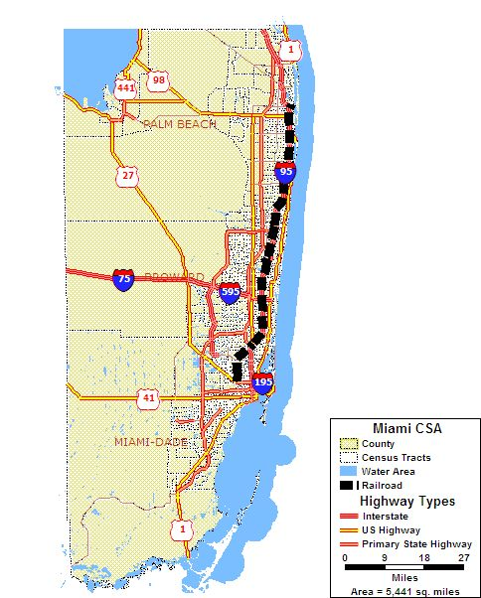

Map 15.1: Miami-Ft. Lauderdale-Miami Beach, FL CBSA Major Highways and Fixed Guideway System

The Miami-Ft. Lauderdale-Miami Beach, FL CBSA includes Miami-Dade, Broward and Palm Beach Counties and is located in the southeastern section of Florida. Palm Beach County is bordered by Martin County to the north, Glades County on the northwest corner and to the west by Hendry County. A large portion of Palm Beach County is also bordered by Lake Okeechobee to the northwest, which is otherwise known as the Lake Region. Broward County is in the middle of Miami-Dade and Palm Beach Counties and also borders Hendry County to the northwest and Collier County to the west. Miami-Dade County is at the southernmost part of Florida and borders Collier County to the northwest and Monroe County on the southwest. Miami-Dade County also borders two national parks, the Biscayne National Park to the east in the Biscayne Bay and the western third of Miami-Dade County in the Everglades National Park.

The CBSA’s population was 5,007,564 according to the 2000 census, which includes 2,253,362 for Miami-Dade County, 1,623,018 for Broward County, and 1,131,184 for Palm Beach County. The 2000 census population of Florida was 15,982,378. Miami-Dade County covers a total of 1,983 square miles, Broward, which covers 1,224 square miles and Palm Beach is 2,234 for a total of 5,441 square miles for the entire CBSA. Fixed guideway rail transit service is provided by the Miami-Dade Transit Agency (Metrorail) and the South Florida Regional Transportation Authority (Tri Rail).

The Miami-Ft. Lauderdale-Miami Beach, FL CBSA is on the coast of the Atlantic Ocean and has a strong potential for hurricanes, flooding and other natural disasters because of its location. The area has a fairly mild climate and the weather is often sunny and hot, which is moderated by cool ocean breezes. The climate is also quite humid, especially in the summer, and there are occasional heavy rains. The Miami-Ft. Lauderdale-Miami Beach, FL CBSA is also at a high risk of hurricanes, which usually occur from June to November.

II. Agencies Operating in the Miami-Ft. Lauderdale-Miami Beach, FL CBSA

Agency | Jurisdictions Served | Population  Served | Operating Budget | Staff  Size
Florida DOT | Miami Dade County, Broward County | Miami Dade County: 2,253,362 Broward County: 1,623,018 | $7 billion | 7,450
Miami-Dade MPO | Miami Dade County | Miami Dade County: 2,253,362 | $5,447,973 | 22 voting members, 13 commissioners
Broward County MPO | Broward County | Broward County: 1,623,018 | (a) | (a)
Miami-Dade Transit Agency | Miami-Hialeah Urbanized Area | 1.8 million | $457,859,915 | Approximately 4,000
Broward County Mass Transit Division (BCT) | Miami Urbanized Area | 1,623,018 | $119,761,387 | (a)
Palm Tran | Palm Beach County | Palm Beach County: 1,131,184 | (a) | (a)
Tri Rail | Palm Beach, Broward and Miami-Dade Counties | Miami Dade County: 2,253,362 Broward County: 1,623,018  Palm Beach County: 1,131,184 | (a) | (a)

(a) = Not Available

Table 15.1: Miami-Ft. Lauderdale-Miami Beach, FL CBSA Transportation Agencies

III. Transit Service Area: Fixed Guideway and Bus Service Area

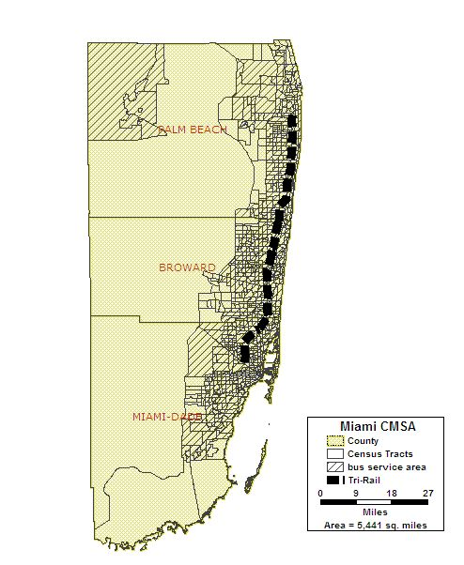

Map 15.2: Miami-Ft. Lauderdale-Miami Beach, FL CBSA Fixed Guideway and Bus Transit Service Area

Miami – Dade Transit Agency (MDT): Miami-Dade Transit, a county department of more than 4,000 employees, is the largest transit agency in the state of Florida and provides more than 50 percent of the trips taken on public transit in the state. The MDT transportation system consists of four major components: Metrobus, a 24-hour service consisting of over 100 routes; Metrorail, an elevated 22-mile service connecting downtown Miami, the Omni area, and Brickell; Metromover, a 4.4-mile elevated people mover that serves the downtown central business district of Miami; and STS paratransit, a service for people with disabilities and senior citizens. Metrobus routes cover more than 35-million miles annually, including limited service to Broward and Monroe counties. In 2004, MDT's Metrobus, Metrorail, and Metromover transported more than 96 million passengers.
Metrorail offers connections to Broward and Palm Beach counties via Tri-Rail, South Florida's tri-county commuter train. Metromover connects with Metrorail and serves downtown Miami, the Omni area, and Brickell, while STS provides mobility for people with disabilities and senior citizens unable to board regular transit vehicles. Currently, Miami-Dade Transit records over 326,000 daily (weekday) boardings on this unified system.
Broward County Mass Transit Division (BCT): Broward County Transit is a system of buses that serve approximately 410 square miles in Broward County, Florida. The fleet consists of 284 fixed route buses and 75 community buses and paratransit, which serve a total of 41 routes on weekdays. BCT operates buses from approximately 5 a.m. until 12:30 a.m. and connect to the Palm Beach and Miami-Dade systems and Tri-Rail. BCT's fixed route service makes 37.4 million annual passenger trips and travels 13.4 million service miles a year.
Palm Tran: Palm Tran runs seven days a week (excluding holidays) serving more than 3,500 bus stops. Palm Tran provides more that seven million rides a year. Timed-Transfer points allow for easy movement from the north/south main routes to the east/west routes. All Palm Tran buses are equipped with wheelchair ramps and automatic stop announcement systems. For safety and security, buses are equipped with surveillance cameras. Palm Tran also runs a paratransit service, connection, which is a shared ride, door-to-door service for the elderly, those who are disadvantaged and those with disabilities. Connection service runs seven days a week, averaging over 3,200 trips each weekday; with 55% of our riders being seniors. Trips are provided by local transportation providers on approximately 218 routes per day; performing approximately 2,369 hours of service and 32,000 miles of service per day.
South Florida Regional Transportation Authority (Tri Rail): Tri Rail is a regional rail system that serves three counties in south Florida, which include Palm Beach, Broward and Miami-Dade Counties. The Tri Rail system consists of 22 stations, traversing from just north of the Palm Beach Airport in Palm Beach County, through Ft. Lauderdale and the Ft. Lauderdale Airport, to the Miami-Dade Airport in Miami-Dade County. Tri Rail also connects to the metro rail in Miami Beach, which also has 22 stops. The hours of operation are generally from approximately 5 a.m. to 11 p.m.

IV. Number and Proportion of Minority, Below Poverty and Limited English Proficient Populations in Relation to the Transit Service Area

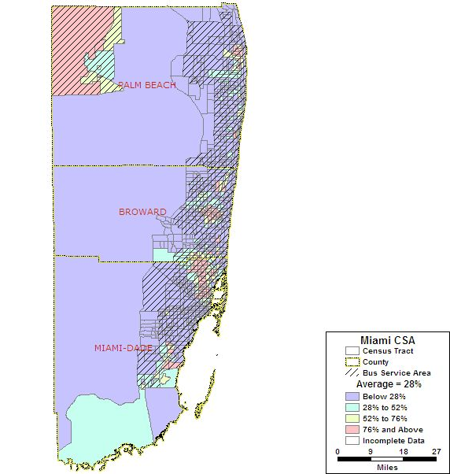
Area of Detail A
Area of Detail B
Area of Detail C

Map 15.3: Miami-Ft. Lauderdale-Miami Beach, FL CBSA Minority Population

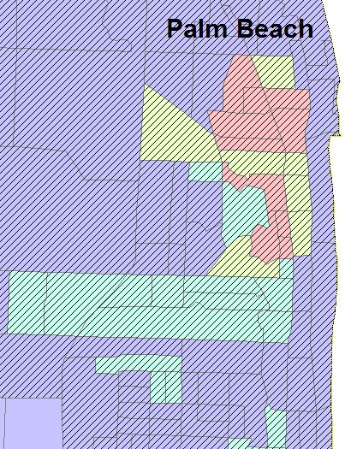
Map 15.3.A: Palm Beach Minority Population

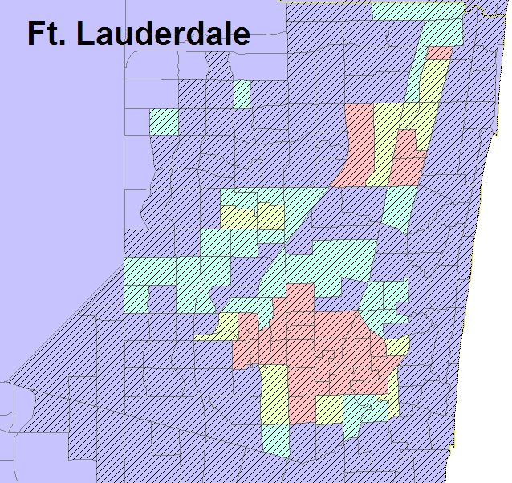
Map 15.3.B: Ft. Lauderdale Minority Population

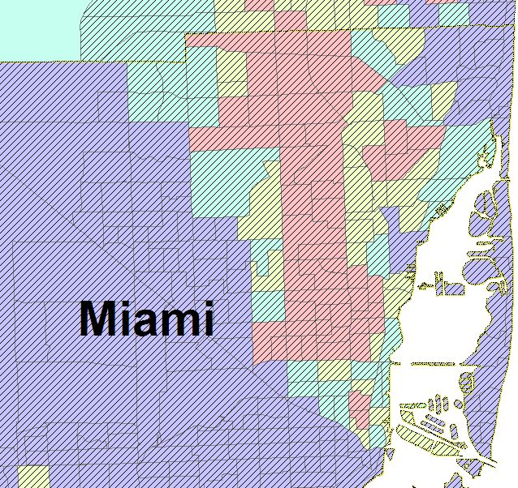
Map 15.3.C: Miami Minority Population

Total Number of Census Tracts in CBSA 891
Total Population of CBSA 5,007,564
Total Minority Population residing in CBSA 1,397,512
Regional Average of Minority Population in the CBSA 28%
Number (%) of Census Tracts with above average minority population 284 (32%)
Total Minority Population in the above average census tracts 963,740

Based on U.S. 2000 Census Data, the average minority population for the Miami-Ft. Lauderdale-Miami Beach, FL CBSA is 28 percent, or 1,397,512 out of 5,077,564 in the entire population. Census tracts located in downtown Miami, Ft. Lauderdale, Palm Beach and the Palm Beach lake region of the CBSA show the highest concentrations of minority population.

There are 284 census tracts, or 32 percent, with above average minority population. Almost all of the census tracts with an above average minority population fall within the bus service area. Only four census tracts that have an above average minority population do not fall within the bus service area. One of the census tracts is on the furthest southwest point and two are in the southeast portion of Miami-Dade County. The fourth census tract is on the southern portion of Broward County, bordering both Miami-Dade County and the Everglades. These four census tracts consist of 37,113, or only 0.7 percent of the entire population.

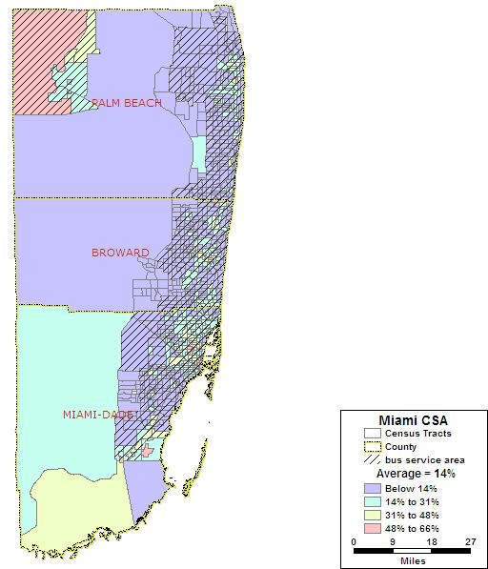
Area of Detail A
Area of Detail B
Area of Detail C

Map 15.4: Miami-Ft. Lauderdale-Miami Beach, FL CBSA Below Poverty Population

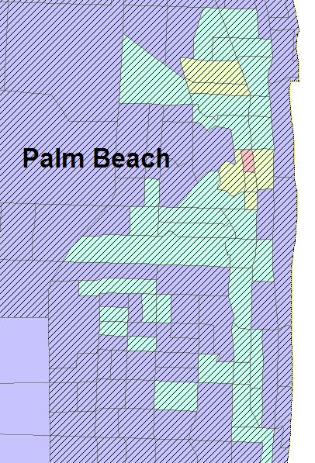
Map 15.4.A: Palm Beach Below Poverty Population

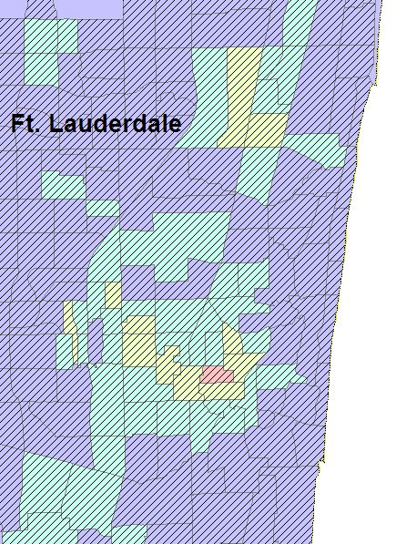
Map 15.4.B: Ft. Lauderdale Poverty Population
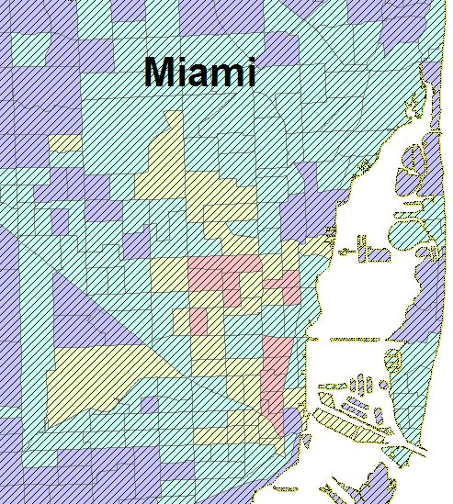
Map 15.4.C: Miami Below Poverty Population

Total Number of Census Tracts in CBSA 891
Total Population of CBSA 5,007,564
Total Below Poverty Population residing in CBSA 692,014
Regional Average of Below Poverty Population in the CBSA 14%
Number (%) of Census Tracts with above average Below Poverty pop. 330 (37%)
Total Below Poverty Population in the above average census tracts 463,216

The U.S. 2000 Census Data shows that 14 percent or 692,014 of the total population in the Miami-Ft. Lauderdale-Miami Beach, FL CBSA is below the poverty level. Approximately 37 percent, or 330 out of the 891 census tracts, have a below poverty population that exceeds the regional average; this includes 463,216 persons. Seventeen census tracts or approximately two percent falls into the highest range of concentration of poverty in the CBSA.

The majority of the census tracts with an above average below poverty population are within the bus service area. There are a total of six census tracts with higher than average below poverty populations. One is a rather large census tract in the northwest portion of Miami-Dade County, two smaller tracts are in the central part of the county and two are in the southeast portion of the county (much of these census tracts are in the Everglades). Also, there is one large census tract in the southeast portion of Palm Beach County, inland from the coast and to the west of the bus service area that has an above average below poverty population and does not have access to public transit. These six tracts account for less than one percent of the CBSA’s total population. The minority and below poverty maps are very similar in that the concentrations of these populations are found in the larger cities in all three counties and in the lake region in Palm Beach County.

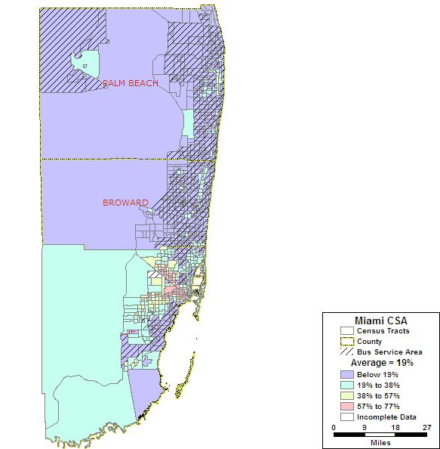
Area of Detail A
Area of Detail B
Area of Detail C

Map 15.5: Miami-Ft. Lauderdale-Miami Beach, FL CBSA Limited English Proficient Population

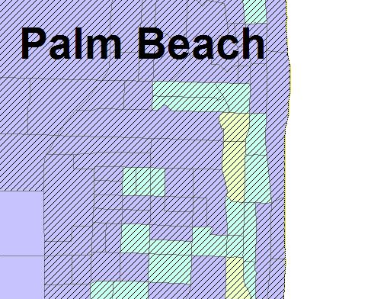
Map 15.5.A: Palm Beach LEP Population

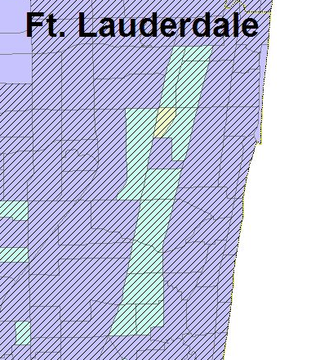
Map 15.5.B: Ft.Lauderdale LEP Population
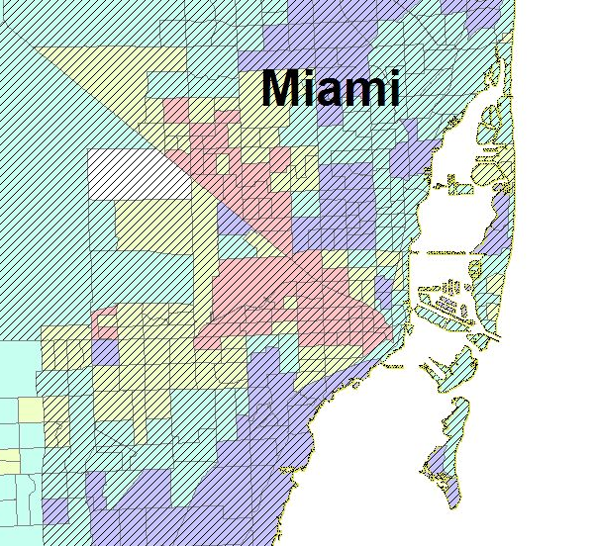
Map 15.5.A: Miami LEP Population

Total Number of Census Tracts in CBSA 891
Total Population of CBSA 5,007,564
Total Population 5 years and older of CBSA 4,695,898
Total LEP Population* residing in CBSA 1,008,963
Regional Average of LEP Population* in the CBSA 19%
Number ( %) of Census Tracts with above average LEP population* 321 (36%)
Total LEP Population* in the above average census tracts 757,653

* LEP includes those 5 years of age and older

The limited English proficient (LEP) population in the Miami-Ft. Lauderdale-Miami Beach, FL CBSA is 19 percent, or 1,008,963 of the total CBSA population. Approximately 36 percent, or 321 out of the 891 census tracts, have a LEP population that exceeds the regional average. This includes 757,653 persons. Fifty census tracts or approximately six percent fall into the highest range of concentration of LEP in the CBSA.

The LEP map differs from both the minority and poverty maps in that the high concentrations of LEP are found outside both the large cities and the bus service area. Twenty census tracts, accounting for 3.6 percent (178,913 persons) of the total CBSA population, are located beyond the bus transit service area. Another major difference is that there is only one census tract in the lake region of Palm Beach County that has an above average LEP population, unlike the minority and poverty maps, which show that the majority of census tracts in this region have a population that is above the regional average. The entire western border of the Miami-Dade County has an LEP population above the regional average and there are also high concentrations of LEP populations in the area to the west of downtown Miami.

Note: As shown on the legend, there are some census tracts that have incomplete data. This is due to the fact that the Maptitude data does not have information for the LEP populations, most likely because these census tracts are within the Everglades or other landmarks that do not have data available. The same situation applies to the zero car households data that are displayed in the following map.

V. Number and Proportion of Zero Car Households: Greater than the Regional Average

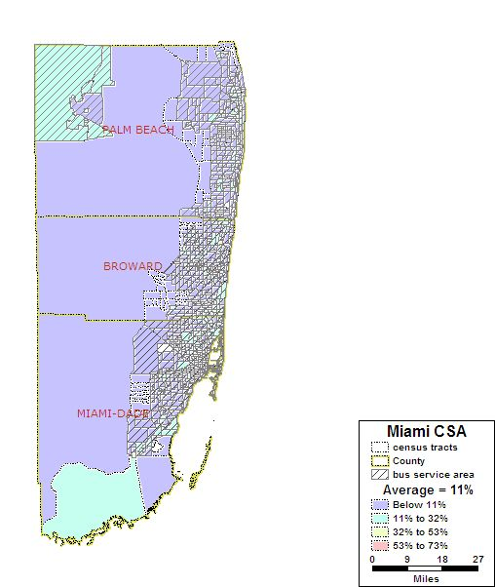
Area of Detail A
Area of Detail B
Area of Detail C

Map 15.6: Miami-Ft. Lauderdale-Miami Beach, FL CBSA Zero Car Households

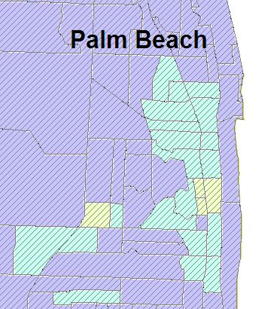
Map 15.6.A: Palm Beach Zero Car Households

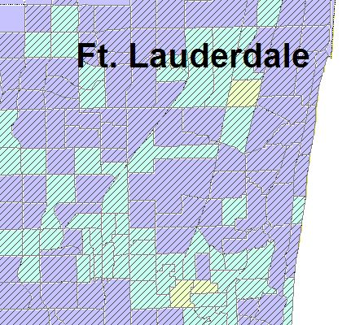
Map 15.6.B: Ft. Lauderdale Zero Car Households
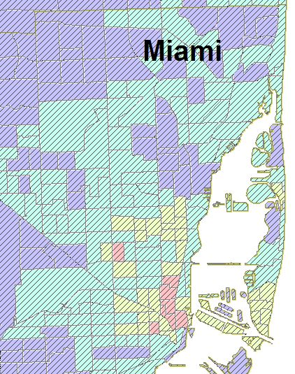
Map 15.6.B: Miami Zero Car Households

Total Number of Census Tracts in CBSA 891
Total Households in CBSA 1,905,394
Total Zero Car Households in CBSA 210,173
Regional Average of Zero Car Households in the CBSA 11%
Number (%) of Census Tracts with above average Zero Car Households 305 (34%)
Total Zero Car Households in the above average census tracts 145,768

The Miami-Ft. Lauderdale-Miami Beach, FL CBSA has a total of 1,905,394 households. A total of 210,173 are households without vehicles (approximately 11 percent). There are 305 census tracts, or 34 percent, with an above average number of households without vehicles.

Only three of the census tracts with an above average zero car population are not within the bus service area. These tracts account for less than one percent (21,099 persons) of the CBSA’s total population. Both of these census tracts are located in Miami-Dade County, one located on the southernmost tip and the other, which is located centrally. The zero car household population has the lowest percentage of all of the factors for the Miami-Ft. Lauderdale-Miami Beach, FL CBSA.

VI. Number and Proportion of Minority Population with Overlay of Below Poverty Population

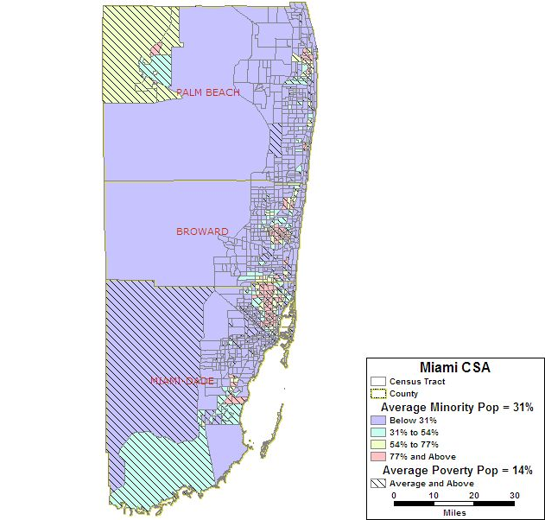
Area of Detail A
Area of Detail B
Area of Detail C

Map 15.7 Miami-Ft. Lauderdale-Miami Beach, FL CBSA Minority Population with an Overlay of Below Poverty Population
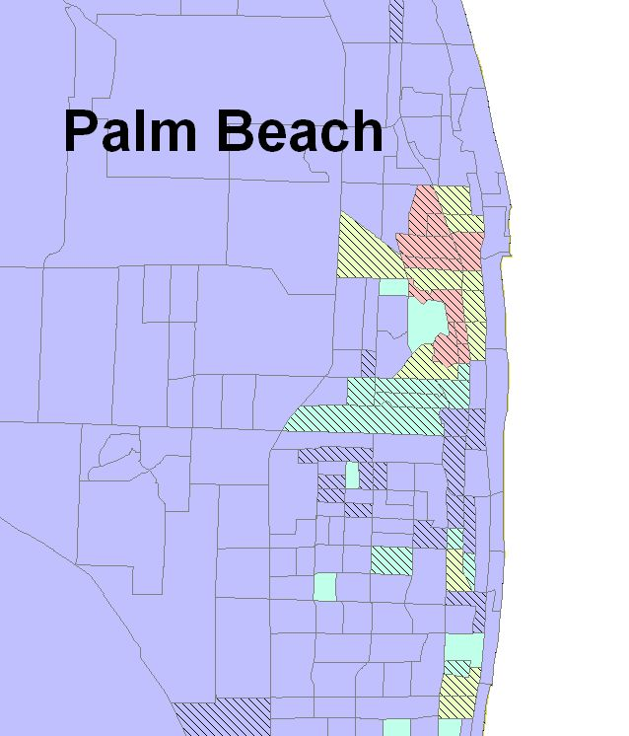
Map 15.7.A: Palm Beach Minority Population with an Overlay of Below Poverty Population

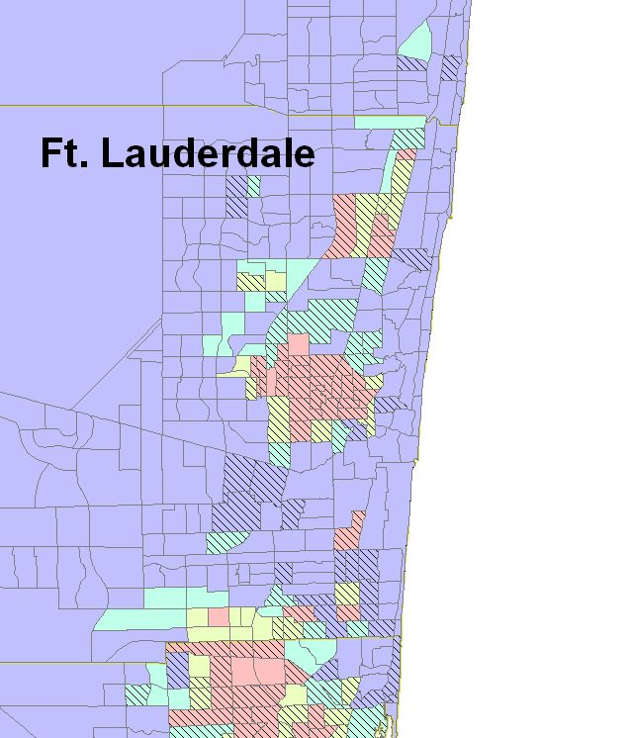
Map 15.7.B: Ft. Lauderdale Minority Population with an Overlay of Below Poverty Population

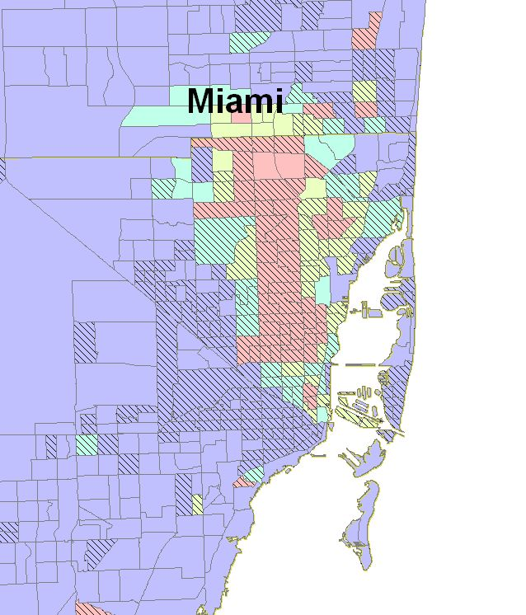
Map 15.7.C: Miami Minority Population with an Overlay of Below Poverty Population

As shown in Maps 15.7, 15.7A, 15.7B, and 15.7C, there is a very strong correspondence between the minority population and below poverty population in the Miami-Ft. Lauderdale-Miami Beach, FL CBSA. There are 82 census tracts that have both an above average minority and below poverty population. The combined total population of these 82 census tracts is 375,212. In the Lake Region, downtown Miami, Ft. Lauderdale and Palm Beach metro areas, there is a high concentration of both below poverty and minority population.
VII. Number and Proportion of Minority Population with Overlays of Below Poverty Population and Zero Car Households

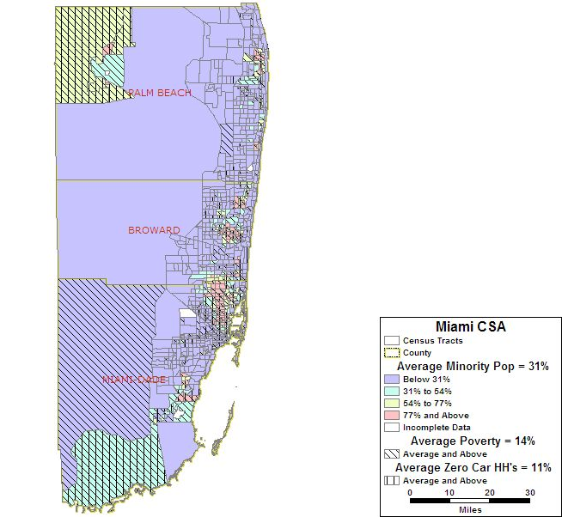
Area of Detail A
Area of Detail B
Area of Detail C
Map 15.8: Miami-Ft. Lauderdale-Miami Beach, FL CBSA Minority Population with Overlays of Below Poverty Population and Zero Car Households

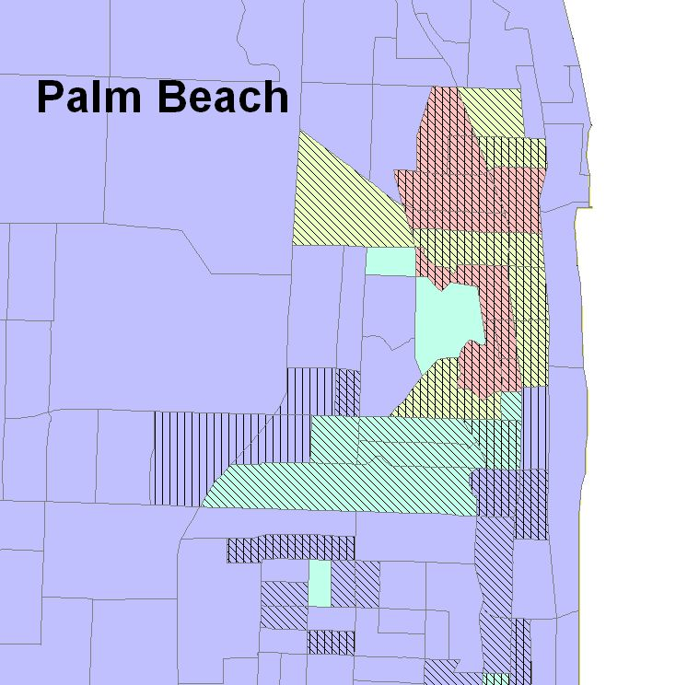
Map 15.8A: Palm Beach Minority Population with Overlays of Below Poverty Population and Zero Car Households

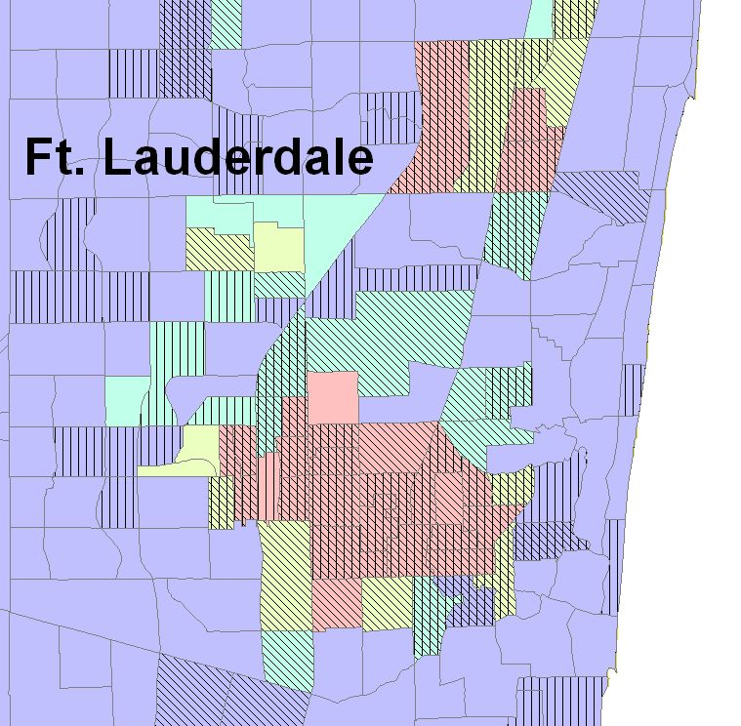
Map 15.8A: Ft. Lauderdale Minority Population with Overlays of Below Poverty Population and Zero Car Households

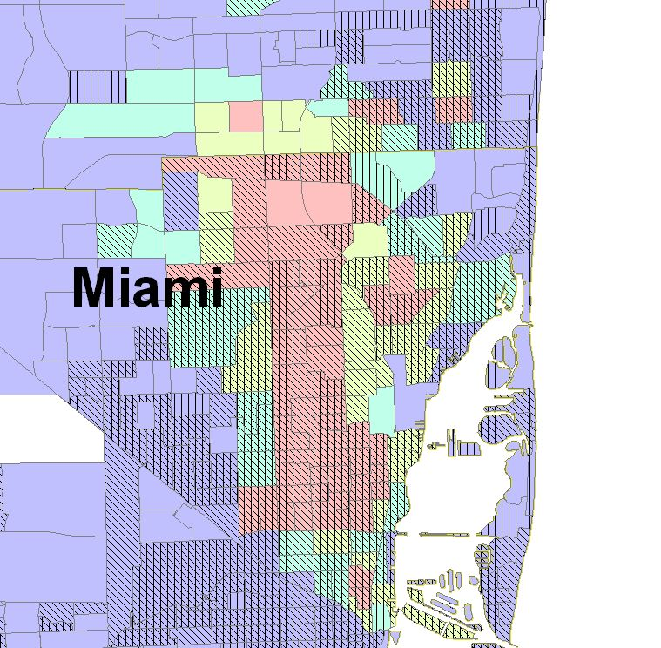
Map 15.8A: Miami Minority Population with Overlays of Below Poverty Population and Zero Car Households

As shown in Map 15.8, 15.8A, 15.8B, and 15.8C, there is a strong correlation between the minority population and below poverty population, but there is an even stronger connection between below poverty and zero car households in the Miami-Ft. Lauderdale-Miami Beach, FL CBSA. There are 149 census tracts, with a total population of 763,803 that have both an above average minority population, below poverty population and zero car households. The census tracts that have concentrations of minority, below poverty and zero car households are mostly found in the downtown Miami, Ft. Lauderdale and Palm Beach areas and are within the bus service area. Outside of the larger metro areas and bus service area, there are very few counties that have high concentrations of coincident minority, below poverty populations and zero car households.

VIII. Correlation Among Minority Population, Below Poverty Population, LEP Population and Zero Car Households

 | Minority | Below Poverty | LEP | Zero Car HH
Minority | 1
Below Poverty | 0.66 | 1
LEP | 0.16 | 0.50 | 1
Zero Car HH | 0.22 | 0.63 | 0.29 | 1

Table 15.2: Miami-Ft. Lauderdale-Miami Beach, FL CBSA Correlation Coefficients

Based on the coefficients highlighted in the table above, there is a strong relationship between minority and below poverty populations (0.66) and below poverty and zero car households (0.63) in the Miami-Ft. Lauderdale-Miami Beach, FL CBSA. All other categories are under a 0.50 range, and LEP and minority have the weakest connection with a 0.16 correlation.

IX. Natural Disasters

Event | Date | Location | Human Impact | Financial Impact
Rip Currents | 07/17/1996 | Ft. Lauderdale | 1 injured / 1 death | $0
Rip Currents | 12/20/1998 | Pompano Beach | 2 injured / 1 death | $0
Rip Currents | 04/12/2002 | Ft. Lauderdale | 6 injured / 1 death | $0
Rip Currents | 08/31/2003 | Deerfield Beach | 1 injured / 1 death | $0
Rip Currents | 05/13/2004 | Lauderdale by the Sea | 2 injured / 1 death | $0
Tornado | 01/15/1991 | Ft. Lauderdale | 1 injury / 0 deaths | $2.5 million
Tornado | 02/02/1998 | Miramar | 0 injuries / 0 deaths | $30 million
Flash Flood | 06/08/1999 | East Portion | 0 injuries / 0 deaths | $1 million
Flash Flood | 10/15/1999 | East Portion | 0 injuries / 0 deaths | $45 million
Flash Flood | 05/27/2003 | Ft. Lauderdale | 0 injuries / 0 deaths | $1 million
Hurricane Andrew | 08/1992 | Miami / Ft. Lauderdale | 15 deaths | $26 billion
Tropical Storm Jerry | 08/23/1995 | Miami/Ft. Lauderdale/Palm Beach | 0 injured/  0 deaths | $4.6 million
Hurricane Erin | 08/02/1995 | Miami/Ft. Lauderdale/Palm Beach | 1 injured/  6 deaths | $3.0 million
Hurricane Floyd | 09/14/1999 | Miami/Ft. Lauderdale/Palm Beach | 0 injured/  0 deaths | $67.7 million
Hurricane Irene | 10/14/1999 | Miami/Ft. Lauderdale/Palm Beach | 4 injured/  0 deaths | $327.8 million
Hurricane Frances | 09/04/2004 | Miami/Ft. Lauderdale/Palm Beach | 0 injured/  5 death | $5.6 billion
Hurricane Jeanne | 09/24/2004 | Ft. Lauderdale/Palm Beach | 0 injured/  1 deaths | $840.2 million
Hurricane Wilma | 10/23/2005 | Miami/Ft. Lauderdale/Palm Beach | 6 injured/ 5 deaths | $10.2 billion
(a) = Not Available

Table 15.3: 20-Year History of Natural Disasters in the Miami-Ft. Lauderdale-Miami Beach, FL CBSA (Source: FEMA and NOAA National Climatic Data Center)

The Miami-Ft. Lauderdale-Miami Beach CBSA has been most prone to hurricanes, strong winds and floods, as shown from the log of natural disasters in the area since 1985. The Miami-Ft. Lauderdale-Miami Beach CBSA is also prone to frequent rip currents along the Atlantic coast. Rip currents are powerful, channeled currents of water that flow away from the shoreline. Persons caught in these rip currents frequently panic and drown trying to escape the current and swim back to shore. Table 15.3 outlines the natural disasters that have occurred in the Miami-Ft. Lauderdale-Miami Beach CBSA between 1985-2005. The United States Geological Survey does not rate the state of Florida as having a Moderate, High, or Very High Risk of earthquakes.

X. Man-Made Disasters

There have been several airline disasters in the area:

- May 11, 1996 – ValuJet Flight 592, a DC-9, crashed in the Everglades, Florida, due to a fire in its cargo hold. All 110 passengers and crew perished.
- July 6, 1996 – Delta Air Lines Flight 1288, crashed during the takeoff from Pensacola, Florida. The left engine of an MD-88 sustained an uncontained failure, causing pieces of the engine to penetrate the cabin, killing 2 of the 137 passengers.
- November 20, 2000 – An American Airlines Airbus A300 took off from Miami, Florida and turned back to land the plane after the cabin pressure could not be maintained at 16,000 ft. Upon landing, the aircraft failed to depressurize and a door exploded open killing a flight attendant.
- December 7, 2005 – A passenger disembarking American Airlines Flight 924, a Boeing 757, in Miami, Florida was shot and killed by an air marshal when the marshal believed he heard the man say he had a bomb.
- December 19, 2005 – Chalk's Ocean Airways Flight 101, a Grumman Mallard, crashed off the coast of Miami Beach, Florida, killing all 20 on board.

There was one rail disaster, as follows.
- March 17, 1993 – near Fort Lauderdale, Florida, United States: An Amtrak passenger train struck a gasoline tanker truck that had stopped on a grade crossing, causing the tanker to explode. Six people (including the truck driver) were killed and 12 injured.

The 2005 data from the U.S. Department of Transportation on Hazardous Material Safety shows the state of Florida accounted for four percent of the hazardous materials incidents and 29 percent of related deaths for the year.

