
In cooperation with the Texas Water Development Board
Geologic and Hydrogeologic Information for a Geodatabase for the Brazos River Alluvium Aquifer, Bosque County to Fort Bend County, Texas
By Sachin D. Shah and Natalie A. Houston

Open-File Report 2007–1031, version 3
U.S. Department of the Interior
U.S. Geological Survey

U.S. Department of the Interior
DIRK KEMPTHORNE, Secretary
U.S. Geological Survey
Mark D. Myers, Director
U.S. Geological Survey, Reston, Virginia: 2007
For product and ordering information:
World Wide Web: http://www.usgs.gov/pubprod
Telephone: 1-888-ASK-USGS
For more information on the USGS—the Federal source for science about the Earth
its natural and living resources, natural hazards, and the environment:
World Wide Web: http://www.usgs.gov
Telephone: 1-888-ASK-USGS
Suggested citation:
Shah, S.D., and Houston, N.A., 2007, Geologic and hydrogeologic information for a geodatabase for the Brazos River alluvium aquifer, Bosque County to Fort Bend County, Texas: U.S. Geological Survey Open-File Report 2007–1031 [version 3], 10 p.

Any use of trade, product, or firm names is for descriptive purposes only and does not imply
endorsement by the U.S. Government.
Although this report is in the public domain, permission must be secured from the individual
copyright owners to reproduce any copyrighted material contained within this report.

Contents
Abstract 1
Introduction 1
Purpose and Scope 3
Acknowledgments 3
Geologic and Hydrogeologic Setting 3
Geodatabase 3
Methodology 5
Data Compilation 5
Data Input 6
Data Quality 9
Metadata 9
References 9

Figures
1. Brazos River alluvium aquifer study area, Bosque County to Fort Bend County, Texas, showing
1/2- by 1/2-mile grid used to facilitate uniform data distribution 2
2. Well-numbering system for the Texas Water Development Board Ground Water Data System 8

Tables
1. Lithology and water-yielding characteristics of the major geologic units of the Brazos River alluvium aquifer study area, Bosque County to Fort Bend County, Texas. 4
2. Sources of data compiled and entered into the geodatabase of geologic and hydrogeologic
information, Bosque County to Fort Bend County, Texas . 6
3. Description and definition of data compiled and entered into the geodatabase of geologic and hydrogeologic information, Bosque County to Fort Bend County, Texas . 7

Datums
Vertical coordinate information is referenced to North American Vertical Datum of 1988 (NAVD 88).

Horizontal coordinate information is referenced to North American Datum of 1983 (NAD 83).
Geologic and Hydrogeologic Information for a Geodatabase of the Brazos River Alluvium Aquifer, Bosque County to Fort Bend County, Texas
By Sachin D. Shah and Natalie A. Houston

Abstract
During July–October 2006, the U.S. Geological Survey (USGS), in cooperation with the Texas Water Development Board (TWDB), developed geologic and hydrogeologic information for a geodatabase for use in development of a Groundwater Availability Model (GAM) of the Brazos River alluvium aquifer along the Brazos River from Bosque County to Fort Bend County, Texas. The report provides geologic and hydrogeologic information for a study area that encompasses the Brazos River alluvium aquifer, a 1/2-mile-wide lateral buffer surrounding the aquifer, and the rocks immediately underlying the aquifer. The geodatabase involves use of a thematic approach to create layers of feature data using a geographic information system. Feature classes represent the various types of data that are keyed to spatial location and related to one another within the geodatabase. The 1/2-mile-wide buffer surrounding the aquifer was applied to include data from wells constructed primarily in alluvium but outside the boundary of the Brazos River alluvium aquifer. A 1/2- by 1/2-mile grid was generated on the study area to facilitate uniform distribution of data for eventual input into the GAM. Data were compiled primarily from drillers’ and borehole geophysical logs from government agencies and universities, hydrogeologic sections and maps from published reports, and agency files. The geodatabase contains 525 points with geologic data and 280 points with hydrogeologic data.

Introduction
During July–October 2006, the U.S. Geological Survey (USGS), in cooperation with the Texas Water Development Board (TWDB), developed geologic and hydrogeologic information for a geodatabase for use in development of a Groundwater Availability Model (GAM) (Texas Water Development Board, 2006a) for the Brazos River alluvium aquifer. The geologic and hydrogeologic information pertains to a study area (fig. 1) that encompasses the Brazos River alluvium aquifer (the area of occurrence of which comprises parts of Bosque, Hill, McLennan, Falls, Grimes, Brazos, Burleson, Robertson, Milam, Washington, Waller, Austin, and Fort Bend Counties), a 1/2-mile-wide lateral buffer surrounding the aquifer, and the rocks immediately underlying the aquifer. The information, in geodatabase format (Zeiler, 1999), includes altitudes of the top and base of the aquifer and hydrogeologic properties such as hydraulic conductivity, specific capacity, and transmissivity. The geodatabase does not include data for every part of the study area; it is limited to selected digital and hard-copy data from published reports, the TWDB, Texas Commission on Environmental Quality (TCEQ), various universities, and ground-water conservation districts (table 2).
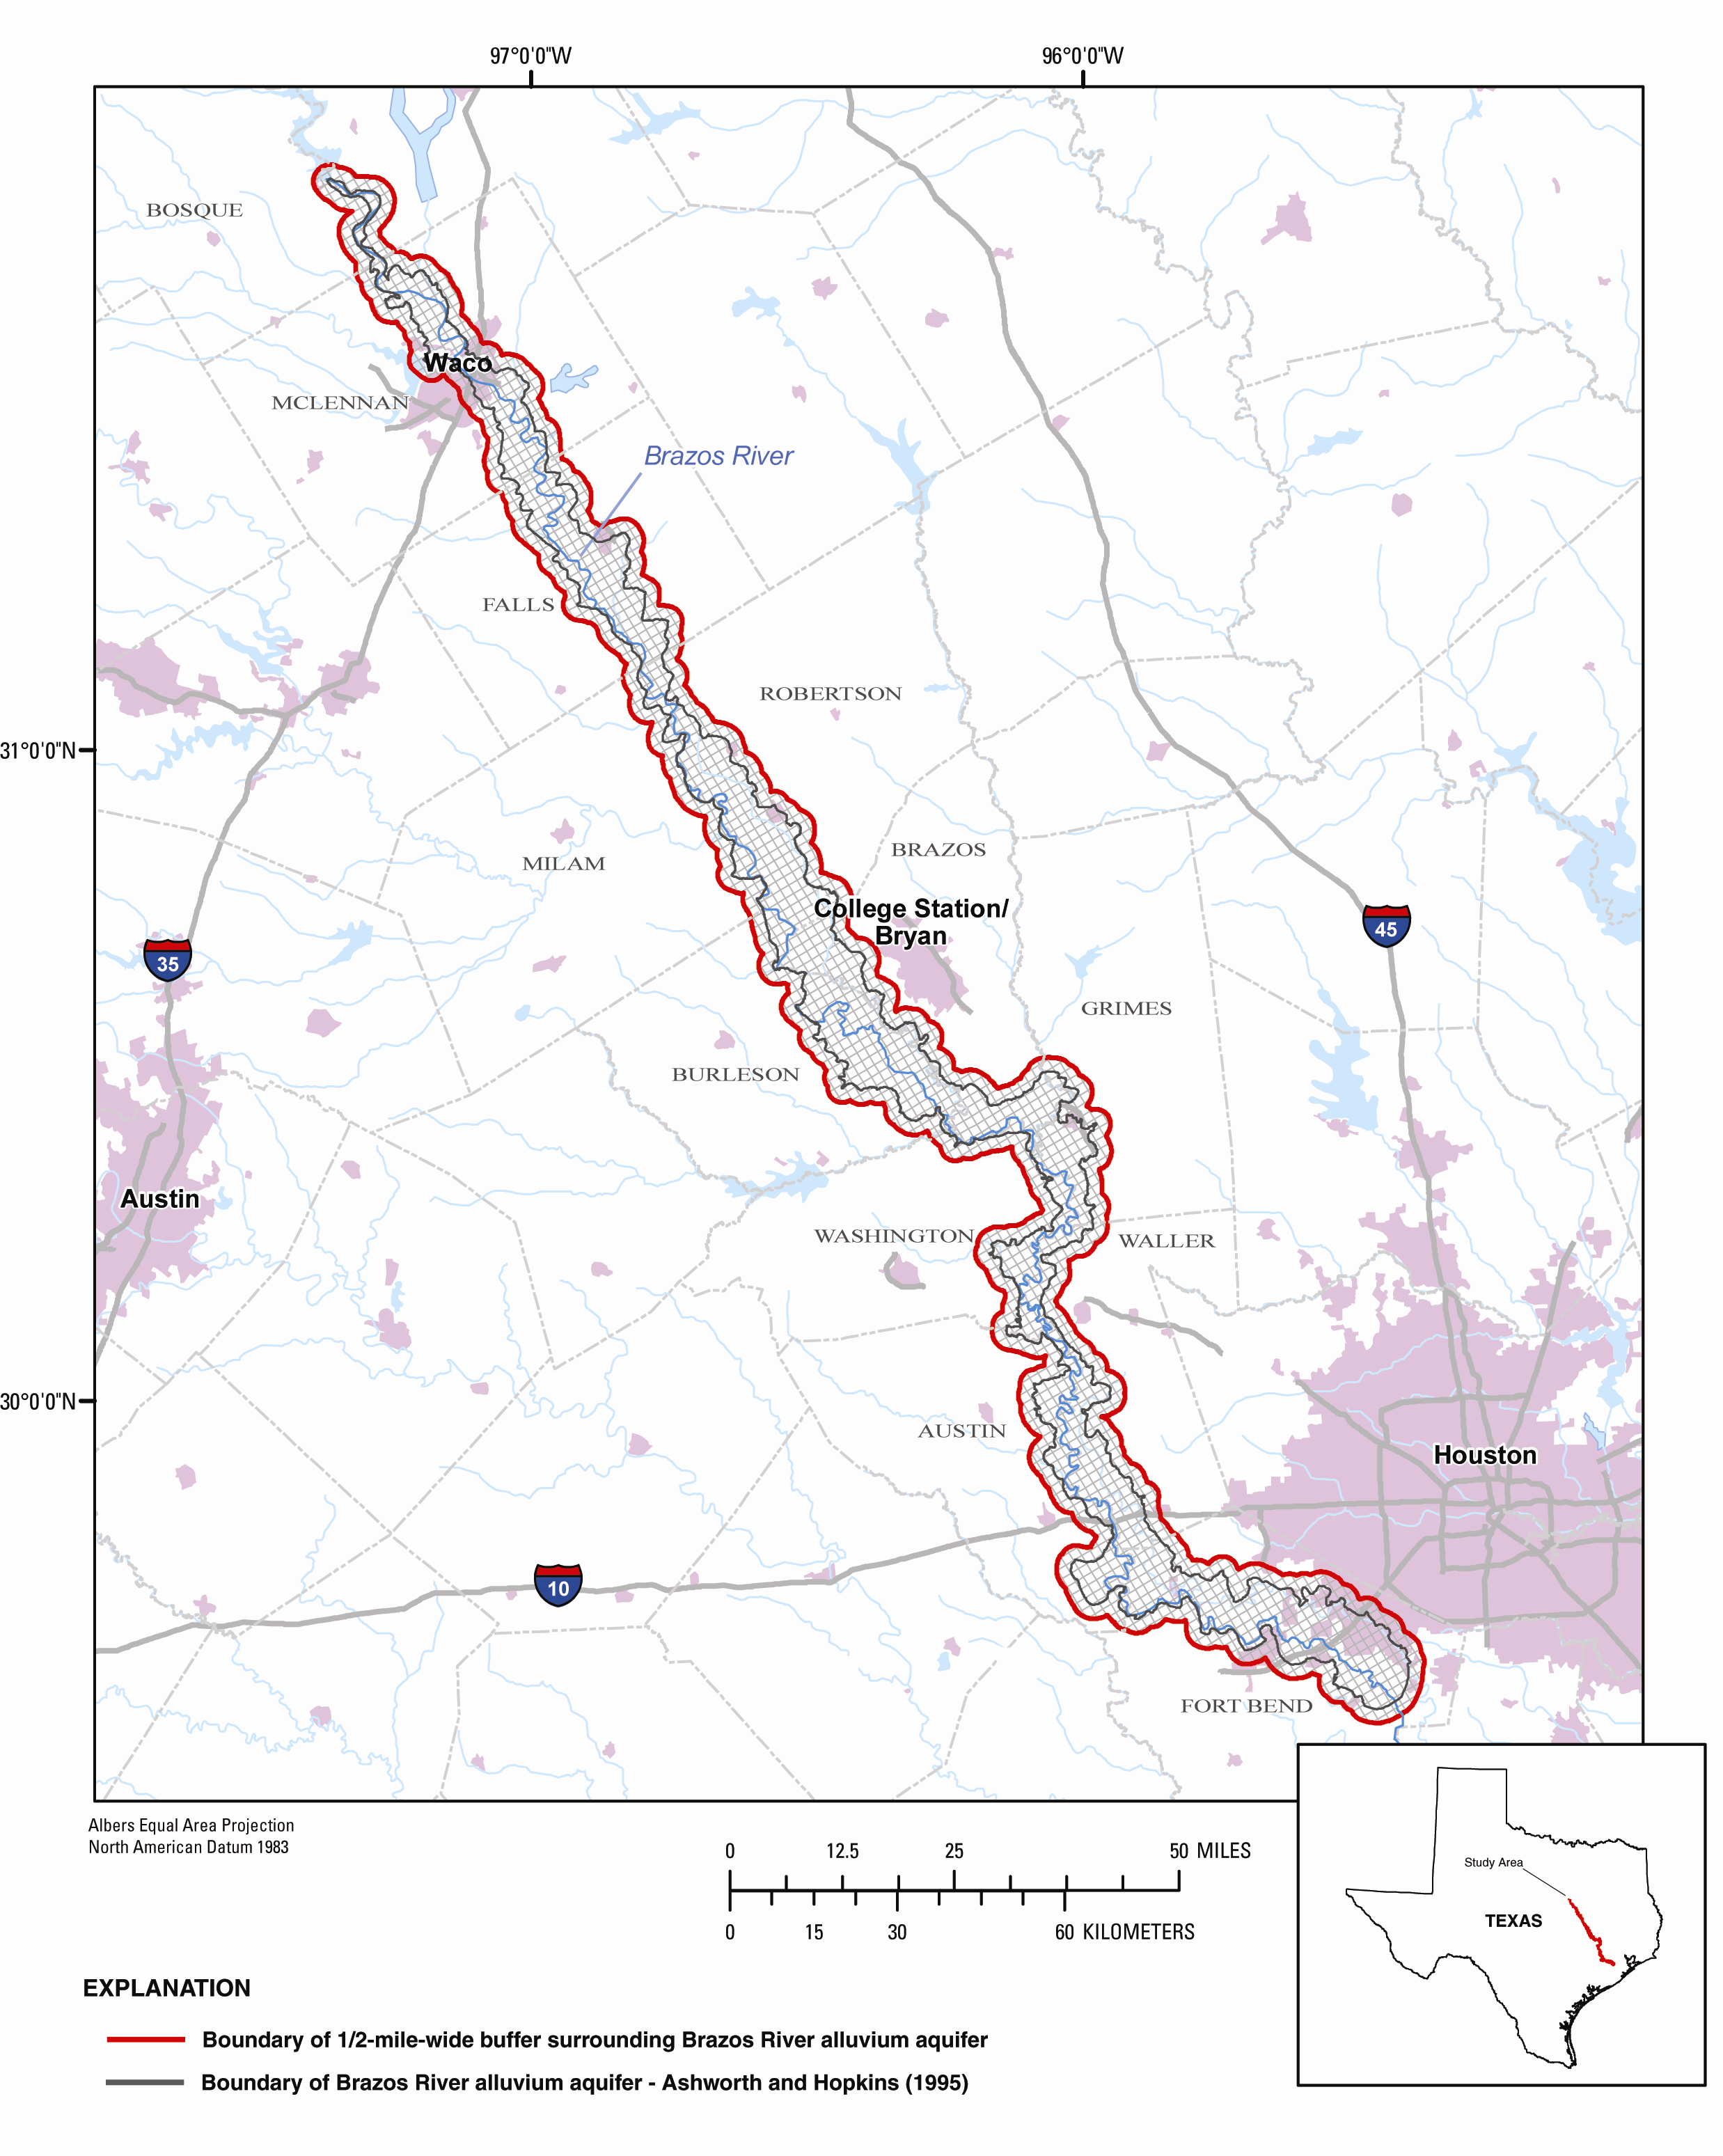
Figure 1. Brazos River alluvium aquifer study area, Bosque County to Fort Bend County, Texas, showing 1/2- by 1/2-mile grid used to facilitate uniform data distribution.

Purpose and Scope
The purpose of this report is to provide information for a geodatabase for use in development of a Brazos River alluvium aquifer GAM. The information is in the GAM Source Data Geodatabase format (Texas Water Development Board, 2006b). After a brief description of the geology and hydrogeology of the study area, the characteristics and function of the geodatabase are described and then the methodology used to create the geologic and hydrogeologic components of the geodatabase.

Acknowledgments
The authors thank Dr. Joe Yelderman, Baylor University Department of Geology, for providing valuable data on the Brazos River alluvium for McLennan County. The authors also thank Dr. Clyde Munster, Department of Biological and Agricultural Engineering, Texas A&M University, for site access and Brazos River alluvium information for Burleson County.

Geologic and Hydrogeologic Setting
The Brazos River alluvium aquifer is defined by the TWDB as a minor aquifer (Ashworth and Hopkins, 1995). The aquifer comprises Quaternary-age, unconsolidated clay, silt, sand, and gravel deposited by flooding of the Brazos River, and Pleistocene-age fluvial terrace deposits. The 1/2-mile-wide buffer surrounding the aquifer primarily comprises Pleistocene-age fluvial terrace deposits. The rocks immediately underlying the aquifer compose numerous sedimentary geologic units of Tertiary and Cretaceous age. The thickness of the Brazos River alluvium aquifer exceeds 80 feet in some isolated, downstream areas but averages about 45 to 50 feet throughout its extent (Cronin and Wilson, 1967). The geologic units immediately beneath the aquifer primarily are composed of sand and clay and the thickness of the units varies substantially (table 1).
According to HDR Engineering, Inc. (2001), water in the alluvial aquifer occurs under water-table conditions and primarily is used for irrigation. The water table slopes toward the Brazos River, indicating that the Brazos is gaining water from the aquifer. Recharge to the aquifer occurs primarily through direct rainfall on the aquifer and subsequent downward leakage to the saturated zone. Discharge from the aquifer primarily occurs through evapotranspiration and withdrawals from wells.

Geodatabase
A geodatabase is a spatially enabled database that contains spatial information; it is an extension of tabular data that allows users to correlate tabular data with physical and spatial components. With a geodatabase, geographically referenced data can be manipulated using a geographic information system (GIS) to produce maps, interactive queries, and various types of spatial analyses. A geodatabase provides a framework and an interactive tool to aid in understanding subsurface structure. The geodatabase developed for the GAM is an Environmental Systems Research Institute (ESRI) ArcGIS personal geodatabase. ArcGIS personal geodatabases are stored as Microsoft Access files (Zeiler, 1999). The geodatabase can be used to interpret the thickness of the Brazos River alluvium aquifer on the basis of aquifer top and base altitudes and to associate hydrogeologic properties such as hydraulic conductivity and specific capacity with point locations in the study area.
Table 1. Lithology and water-yielding characteristics of the major geologic units of the Brazos River alluvium aquifer study area, Bosque County to Fort Bend County, Texas (modified from Cronin and Wilson, 1967).
System | Series | Geologic  unit | Maximum  thickness  (feet) | Lithology | Water-yielding  characteristics
Quaternary | Holocene | Alluvium | 82 | Fine to coarse sand, gravel, silt, and clay | Yields small to large quantities of fresh water mostly to irrigation wells along the Brazos River.
Quaternary | Pleistocene | Fluvial terrace deposits | 70 | Fine to coarse sand, gravel, silt, and clay | Yields small to large quantities of fresh water mostly to wells for rural-domestic and livestock use and some irrigation wells.
Tertiary | Miocene | Catahoula Sandstone | 460 | Clay and sand | Yields small quantities of water to wells in the outcrop for rural-domestic and livestock use.
Tertiary | Eocene | Jackson Group | 1,480 | Shale, volcanic ash, sand, and clay | Yields small quantities of water to wells in the outcrop for rural-domestic and livestock use.
Tertiary | Eocene | Yegua Formation | 1,150 | Fine to medium sand, silt, clay, and gypsum and lignite | Yields small quantities of water to wells for public supply, domestic, livestock, and irrigation use
Tertiary | Eocene | Cook Mountain Formation | 550 | Clay, small amount of sand, sandstone, limestone, glauconite, and gypsum | Yields small quantities of water to wells that tap the Spiller Sand Member
Tertiary | Eocene | Sparta Sand | 290 | Fine to medium sand with some clay, and sandy clay | Yields small to large quantities of water to wells in and downdip from the outcrop
Tertiary | Eocene | Weches Formation | 130 | Iron-bearing glauconitic clay and sand | Yields small quantities of water to wells in the outcrop for rural-domestic and livestock use.
Tertiary | Eocene | Queen City Sand | 540 | Massive to thin-bedded, fine to medium sand, clay, and some lenses of conglomerate containing iron | Yields small quantities of water to wells in and several miles downdip from the outcrop
Tertiary | Eocene | Reklaw Formation | 430 | Glauconitic sand and silt in the lower part of the formation; clay and thin beds of sandstone in the upper part | Capable of yielding small quantities of water to wells.
Tertiary | Eocene | Carrizo Sand | 250 | Fine to coarse, cross-bedded sand and some thin beds of sandstone and clay | Yields small quantities of water mostly to public-supply wells.
Tertiary | Eocene | Wilcox Group | 3,900 | Fine to coarse sand and sandstone, sandy clay, clay, and shale, with some lenses of limestone and lignite | Yields water to public-supply, irrigation, domestic, and livestock wells. Most water is produced from the Simsboro Formation.
Tertiary | Paleocene | Midway Group | 900 | Glaucontic sand, silt, calcareous clay, and limestone | Yields small to moderate quantities of water chiefly from limestone lentils.
Table 1. Lithology and water-yielding characteristics of the major geologic units of the Brazos River alluvium aquifer study area, Bosque County to Fort Bend County, Texas (modified from Cronin and Wilson, 1967)—Continued.
Cretaceous | Gulfian | Navarro Group | 200 | Sandy marl and clay, glauconitic; fine sand in places lime cemented | Locally yields small quantities of fresh to moderately saline water to wells.
Cretaceous | Gulfian | Taylor Marl | 1,110 | Marl, sandy marl, chalky limestone, and calcareous sandstone. | Locally yields small quantities of fresh to moderately saline water to wells.
Cretaceous | Gulfian | Austin Chalk | 600 | Chalky and marly limestone and limey shale. | Locally yields small quantities of fresh to moderately saline water to wells.
Cretaceous | Gulfian | Eagle Ford Shale | 200 | Shale, thinly bedded sandstone and limestone. | Locally yields small quantities of fresh to moderately saline water to wells.
Cretaceous | Gulfian | Woodbine Formation | 185 | Cross-bedded ferruginous sandstone, shale, clay, sandy clay, lignite, and gypsiferous clay. | Locally yields small quantities of fresh to moderately saline water to wells.
Cretaceous | Comanchean | Washita Group | 580 | Fossiliferrous limestone and marl; some shale, clay, sand, and shells. | Yields small to large quantities of water to public-supply, domestic, and livestock wells and springs.
Cretaceous | Comanchean | Fredericksburg Group | 580 | Fossiliferrous limestone and marl; some shale, clay, sand, and shells. | Yields small to large quantities of water to public-supply, domestic, and livestock wells.

A geodatabase involves use of a thematic approach to create spatial layers of data called feature classes in a GIS. Feature classes represent the various types of data that are keyed to spatial location and related to one another within the geodatabase. Point feature classes typically represent wells in the study area. The various types of data are separated into relational tables in the geodatabase on the basis of how they interact and correspond with the spatial feature class. These relational tables represent a collection of features and the relations between them. The goal is to provide accurate representations of the spatial extent and properties of the Brazos River alluvium aquifer using the geologic and hydrogeologic data that have been compiled in the GAM geodatabase format.

Methodology
A ground-water model requires a large amount of information about the aquifer. Initial steps in developing a ground-water model are obtaining and preparing for use detailed information on the structure and properties of the hydrogeologic units, specifically geologic and hydrogeologic data. The Brazos River alluvium aquifer is the single hydrogeologic unit that is the focus of the Brazos River alluvium aquifer GAM. Compiling data, entering data into the geodatabase, ensuring data quality, and documenting the associated metadata are the primary steps involved.

Data Compilation
Geologic and hydrogeologic data were organized and incorporated into the geodatabase. The 1/2-mile-wide buffer surrounding the aquifer (fig. 1) was applied to include data from wells constructed primarily in alluvium but outside the boundary of the Brazos River alluvium aquifer delineated by Ashworth and Hopkins (1995). A 1/2- by 1/2-mile grid was generated on the study area to facilitate uniform distribution of data for eventual input into the GAM. Data were compiled primarily from drillers’ and borehole geophysical logs from government agencies and universities, hydrogeologic sections and maps from published reports, and agency files (table 2). Drillers’ and geophysical logs were used to obtain lithology and altitudes of the top and base of the Brazos River alluvium aquifer. Data gaps exist in parts of the study area; for example, at some sites, drillers did not describe the lithology and thickness of the alluvium as separate and distinct from the underlying unit where the two showed similar lithologic characteristics, thus precluding identification of the base of the aquifer at those sites. Data gaps also exist in areas where the alluvium is too thin to yield adequate amounts of water and therefore contains no wells.
Table 2. Sources of data compiled and entered into the geodatabase of geologic and hydrogeologic information, Bosque County to Fort Bend County, Texas.
Data source | Supplying entity or report
Drillers' logs | Texas Commission on Environmental Quality - Public Drinking Water Division
 | Texas Water Development Board - Water Information Integration Dissemination System
 | Texas A&M University Department of Geology
 | Baylor University Department of Geology
 | U.S. Geological Survey Brazos River alluvium archives
 | Fort Bend Subsidence District
 | Post Oak Savannah Groundwater Conservation District
Geophysical logs | University of Texas Bureau of Economic Geology
 | Texas Commission on Environmental Quality Surface Casing Division
Hydrogeologic sections and maps | Cronin and Wilson (1967)
 | Cronin and Follet (1963)
 | Baker and others (1974)
 | Follet (1974)
 | Naftel and others (1976)
 | Sandeen (1972)
 | Turner (1950)
 | Wesselman (1972)
 | Wilson (1967)
Files | U.S. Geological Survey Brazos River alluvium archives

Data Input
Digital data were imported and hard-copy data were entered manually into the geodatabase according to the TWDB GAM geodatabase scheme. Because the scope of geodatabase development was limited to geologic and hydrogeologic data, only feature classes and tables containing geologic and hydrogeologic attributes were populated. Spatial and lithologic data from drillers’ and geophysical logs were input into the GeoLocations and WellLogs feature classes, respectively. Related data were populated in corresponding tables. The feature classes and tables that were populated in the geodatabase are listed in table 3. Drillers’ logs of wells are recorded at the time of drilling and are subsequently assigned a State well number by the Texas Water Development Board. The well-numbering system of this report (fig. 2) is that of the TWDB Ground Water Data System (GWDS) (Nordstrom and Quincy, 1999). Wells not in the GWDS were numbered using a modified State well number called the key well number, as described in TWDB GAM technical memo 06–01 (Texas Water Development Board, 2006b). The key well number retains the locational aspect of a State well number—that is, wells sited in increasingly smaller quadrangles.
Table 3. Description and definition of data compiled and entered into the geodatabase of geologic and hydrogeologic information, Bosque County to Fort Bend County, Texas.
Dataset | Data type | Feature class  or table name | Definition
Geology | Point feature class | GeoLocations | Spatial locations of points with elevations of the top and bottom of the Brazos River alluvium.
Geology | Table | GEOL_CrossSections | Non-spatial lithologic information collected from cross-sections used in Cronin and Wilson (1967). Data includes well ID, top and base elevations of the alluvium.
Geology | Table | GEOL_Data | Non-spatial lithologic information collected from drillers' logs. Data includes well ID, top and base elevation of the alluvium.
Geophysics | Point feature class | WellLogs | Spatial locations of wells with borehole geophysical logs in which the base of the Brazos River alluvium can be determined.
Geophysics | Table | GEOL_WellLogData | Non-spatial location information from the geophysical logs used to obtain the base of the Brazos River alluvium. The types of geophysical logs collected are included for each well.
SubSurfaceHydro | Point feature class | Wells | Spatial locations of wells with hydrologic property information in the Brazos River alluvium such as hydraulic conductivity, specific capacity, and transmissivity
SubSurfaceHydro | Table | SUBHYD_Conductivity | Non-spatial data that have hydraulic conductivity information.
SubSurfaceHydro | Table | SUBHYD_SpecificCapacity | Non-spatial data that have specific capacity information.
SubSurfaceHydro | Table | SUBHYD_Transmissivity | Non-spatial data that have transmissivity information.

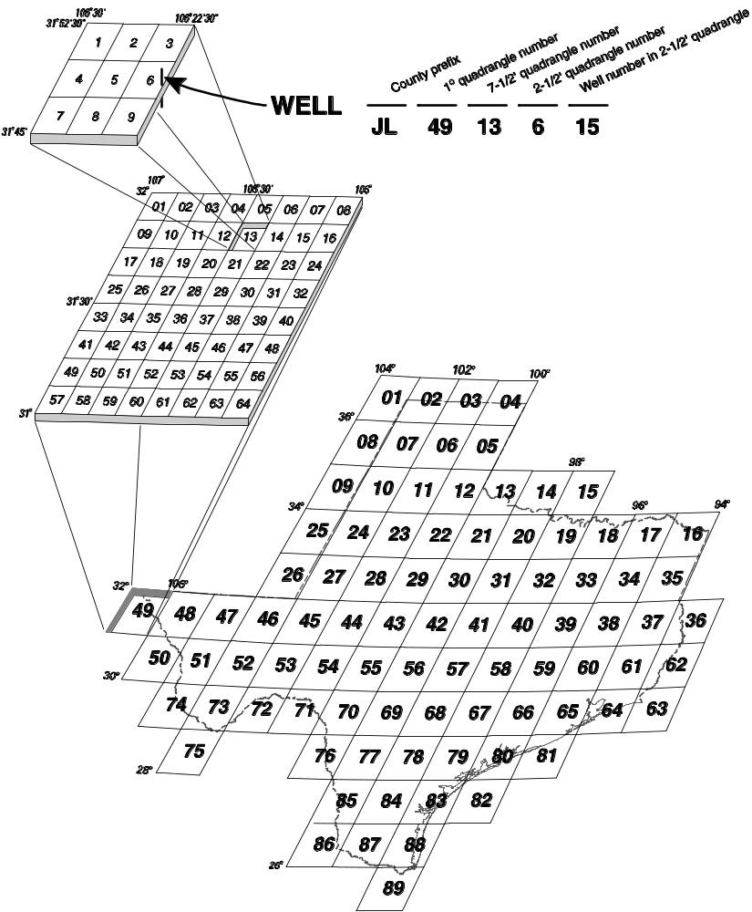
Figure 2. Well-numbering system for the Texas Water Development Board Ground Water Data System (Nordstrom and Quincy, 1999).

Data Quality
Quality-assurance techniques were applied to ensure the quality of the data entered into the geodatabase. Digital elevation models (DEM) were used to improve the accuracy of land-surface altitudes. To remove duplicate data sites, database queries and GIS proximity analyses were used to match duplicate records. After removal of duplicate sites, 525 points with geologic data and 280 points with hydrogeologic data populated the final geodatabase.

Metadata
Metadata that comply with Federal Geographic Data Committee standards were created for each spatial component. The metadata record documents the basic characteristics of the data or information resource in the study area. Metadata components include information such as the title, abstract, and publication date of source documents; geographic elements such as geographic extent and projection information; and database elements such as attribute label definitions and attribute domain values.

References
Ashworth, J.B., and Hopkins, Jamie, 1995, Aquifers of Texas: Texas Water Development Board Report 345, 69 p.
Baker, E.T., Jr., Follet, C.R., McAdoo, G.D., and Bonnet, C.W., 1974, Ground-water resources of Grimes County, Texas: Texas Water Development Board Report 186, 109 p.
Cronin, J.G., and Follett, C.R., 1963, Reconnaissance investigation of the ground-water resources of the Brazos River Basin, Texas: Texas Water Commission Bulletin 6310, 152 p.
Cronin J.G., and Wilson, C.A., 1967, Ground water in the floodplain alluvium of the Brazos River, Whitney Dam to vicinity of Richmond, Texas: Texas Water Development Board Report 41,
206 p.
Follett, C.R., 1974, Ground-water resources of Brazos and Burleson Counties, Texas: Texas Water Development Board Report 185, 194 p.
HDR Engineering, Inc., 2001, Brazos River alluvium groundwater model and conjunctive use analysis: HDR Engineering, Inc., File Copy 2002–0152, 27 p.
Naftel, W.L., Vaught, Kenneth, and Flemming Bobbie, 1976, Records of wells, drillers’ logs, water-level measurements, and chemical analyses of ground water in Brazoria, Fort Bend, and Waller Counties, Texas, 1966–74: Texas Water Development Board Report 201, 90 p.
Nordstrom, P.L., and Quincy, Roger, 1999, UM-50 ground-water data system data dictionary: Texas Water Development Board, 99 p.
Sandeen, W.L., 1972, Ground-water resources of Washington County, Texas: Texas Water Development Board Report 162, 103 p.
Texas Water Development Board, 2006a, Groundwater availability modeling (GAM): Accessed November 1, 2006, at http://www.twdb.state.tx.us/gam/
Texas Water Development Board, 2006b, Groundwater availability modeling (GAM), GAM documents, technical memos, GAM technical memo 06–01: Accessed November 1, 2006, at http://www.twdb.state.tx.us/gam/GAM_documents/GAM_Memo_06-01.pdf
Turner, S.F., 1950, Milam County, Texas: Texas Board of Water Engineers Report, 50 p.
Wesselman, J.B., 1972, Ground-water resources of Fort Bend County, Texas: Texas Water Development Board Report 155, 179 p.
Wilson, C.A., 1967, Ground-water resources of Austin and Waller Counties, Texas: Texas Water Development Board Report 68, 201 p.
Zeiler, Michael, 1999, Modeling our world—The ESRI guide to geodatabase design: Redlands, Calif., Environmental Systems Research Institute Press, 10 p.

