IBEX Project Data Management Plan

June 2007

SwRI® Project 11343

Document No. 11343-PDMP-01
Revision 1
Contract NNG05EC85C

Prepared by:

N. Schwadron and M. Reno

IBEX Project Data Management Plan

SwRI Project 11343

Document No. 11343-PDMP-01

Contract NNG05EC85C

Prepared by: Chelle Reno 12 September 2006

Approved by: /s/ Chelle Reno Date: 9/12/06
Chelle Reno, ISOC Lead, SwRI

Approved by:  Date: 9/12/06
Nathan Schwadron, Co-Investigator, BU

Approved by: /s/ John Scherrer Date: 9/12/06
John Scherrer, Project Manager, SwRI

Approved by: /s/ David McComas Date: 9/12/06
David McComas, Principal Investigator

Approved by: /s/ Larry McCullough Date: 9/12/06
L. D. McCullough, SwRI Project CM

1. Introduction 1
1.1 Purpose and Scope 1
1.2 PDMP Development, Maintenance, and Management Responsibility 1
1.3 Reference Documents 1
2. Project Overview 1
2.1 Science Objectives 2
2.2 Data Acquisition and Access Overview 2
2.3 Summary of Mission Operations 3
3. Science Instrumentation 5
3.1 IBEX-Hi and IBEX-Lo Sensor Performance and Characteristics 5
4. IBEX End-to-End Data Flow 6
4.1 Overview 6
4.2 Science and the Mission Operations Center 9
4.3 Data Products and Access Overview 10
4.3.1 IBEX Data Management 10
4.3.2 IBEX Raw Spacecraft Data 10
4.3.3 Level 0 Data 10
4.3.4 Level 1 Data 11
4.3.5 Level 2 Data 11
4.3.6 Higher Level Data Products 11
4.3.7 Attitude, Orbit, Magnetospheric Structure Products 12
4.3.8 Ancillary Science Data Products 13
4.4 Archiving Functions 13
4.4.1 Overview of the Archiving Functions 13
4.4.2 ISOC Data Archive 13
4.4.3 Distributed Archive Design 13
4.4.4 Generation of the Distributed Archive 14
4.4.5 Validation of the Archive 15
4.4.6 Final Packaging and Delivery of the Distributed Archive to the NSSDC 15
4.4.7 Archival Data Volume 15
4.5 Data Access at the ISOC, SPDF and NSSDC 16
5. Data Rights and Rules for Data Use 16
6. References 17
AppendiX A – Acronym List 18

1. Introduction
This document describes the Project Data Management Plan (PDMP) for the Interstellar Boundary Explorer (IBEX) mission. The IBEX PDMP is designed to be consistent with the IBEX Project Level Requirements and Mission Definition Requirements Agreement documents.

Purpose and Scope
This data management plan describes the generation and delivery of IBEX science data products, institutional responsibilities for data analysis, and the transfer of archival data products to the Space Physics Data Center (SPDF) and the National Space Science Data Center (NSSDC). Covered in this plan are:
- Introduction
- Project Overview
- Science Instrumentation
- IBEX End-to-End Data Flow
- Data Rights and Rules for Data Use
- References

It is important to note that the IBEX mission supports single data telemetry downlinks during each orbit. There is also an uplink/downlink capability over the entire orbit at 2 kbps for spacecraft emergencies and events; the management of data from the spacecraft to the IBEX Science Operations Center (ISOC) is not covered here and is the responsibility of the Mission Operations Center (MOC) at Orbital Sciences Corporation (Orbital) in Dulles, VA.

1.2 PDMP Development, Maintenance, and Management Responsibility
The IBEX Principal Investigator (PI), Dr. David McComas at Southwest Research Institute, and Co-Investigator (CoI), Dr. Nathan Schwadron (ISOC Lead) at Boston University, and Michelle Reno (Mission Operation Manager), are responsible for the development, maintenance, and management of the PDMP throughout the IBEX mission. Data handling and data distribution tasks are the responsibility of SwRI personnel, while data analysis tools and capabilities are developed at SwRI, LANL, and LMATC. The IBEX PDMP is modified and updated as required in accordance with the IBEX Configuration Management Plan.

Reference Documents
Document # | Document Name
Appendix SMEX-10 | IBEX Project-Level Requirements
11343-MDRA-01 | IBEX Mission Definition Requirements Agreement
S924-PP3100 | IBEX Concept of Operations
11343-SOPS-01 | IBEX Science Operations Center Specification
EM 11343-032 | IBEX Science Data Acquisition and Telemetry

2. Project Overview
IBEX will provide the first global views of the Sun’s interstellar boundaries, unveiling the physics of the heliosphere’s interstellar interaction, providing a deeper understanding of the heliosphere and thereby astrospheres throughout the galaxy and creating the opportunity to make even greater unanticipated discoveries. IBEX will be launched on June 15, 2008, achieve baseline measurements by 2010 near solar minimum, and extended measurements nearer solar maximum when there will be increased solar activity, 2010-2012.

Science Objectives
The IBEX objective is to discover the global interaction between the solar wind and the interstellar medium by imaging interstellar interactions and interstellar boundaries at the edge of our heliosphere via detection of energetic neutral atoms (ENAs). IBEX achieves its sole objective by answering four fundamental science questions:
- Question I: What are the global strength and structure of the termination shock?
- Question II: How are energetic protons accelerated at the termination shock?
- Question III: What are the global properties of the solar wind flow beyond the termination shock and in the heliotail?
- Question IV: How does the interstellar flow interact with the heliosphere beyond the heliopause?
ENA imaging on several precursor missions and IMAGE (Imager for Magnetopause-to-Aurora Global Exploration) has revealed the global dynamics of Earth’s magnetosphere and providing rudimentary measurements of heliospheric neutral atoms. By carrying much more sensitive ENA cameras beyond the region of intense magnetospheric emissions and backgrounds, IBEX globally images ENAs from the outer heliosphere for the first time.

Because so little is known about the interstellar interaction, its exploration requires a broadly scoped science strategy. IBEX achieves its objective through three levels of exploration. At the Discovery Level, simple raw IBEX images, energy spectra, and fluxes directly reveal the fundamental properties of the interstellar interaction. At the Exploration Level, the combination of IBEX data products with simple physics-based calculations, theory and limited 2D and 3D modeling explore the underlying properties and variations of the interaction. Finally, at the Understanding Level, iterative analysis of the IBEX data, in concert with increasingly refined 3D models of the heliosphere expose the detailed nature of the interstellar interaction.

Data Acquisition and Access Overview
The IBEX mission operates with sensors in their baseline operational modes. The first ENA observations of the interstellar boundaries will be available within ~month after launch, with the first complete global images produced ~6 months later, and the full statistics images after 2 years of observation. In addition, a complete set of interstellar oxygen and helium flux distributions will be generated each year.

The IBEX Level 0 data are available to the IBEX science team 24 hours after downlink via the IBEX data site. Level 0 data are processed into Level 1 data and are made available to the IBEX science team 72 hours after downlink. Level 2 data products are generated 1 month after each all-sky view is obtained (each 6 months) and are also forwarded to the NSSDC and made available through the ISOC web site.

Summary of Mission Operations
The IBEX mission summary is shown in Table 2.1. Launch is from Kwajalein (Marshall Island). The final orbit is achieved using the Pegasus XL launch vehicle, a STAR-27 Solid Rocket Motor for initial orbit insertion and a Hydrazine Propulsion System (HPS) for apogee and perigee raising burns and routine orbit maintenance. The nominal initial apogee altitude is 40-50 R_{E}, which keeps the spacecraft above the Earth’s magnetosphere over the majority of the mission and maximizes sensor-viewing time. The initial perigee altitude of 7000 km is outside the inner radiation belt, reducing the total radiation dose seen by IBEX subsystems. Because the final orbit is highly elliptical, it is subject to long-term perturbations due to solar and lunar gravity effects.
Orbit Description | Initial inclination: 11˚  Initial apogee: 50 R_{E}  Initial perigee: 7000 km  Initial period: 8.2 days
Launch Date | 15 June 2008  (however, launch windows exist each month)
Launch Vehicle | Pegasus XL
Nominal Mission Duration | 2 years
Extended Mission Life | At least 4 years
Spacecraft Dry Mass  (Spacecraft Bus + Payload) | ~79 kg
Spin Rate | 4 rpm
Attitude Control Accuracy | 2.5°
On-Board Data Storage Capacity | 145.25 MB
Table 2.1 IBEX Mission Summary

 | HASO | LAHO | Repointing Maneuver | Units
Hi | 95 | 0 | 0 | bps
Lo | 124 | 0 | 0 | bps
CEU HK | 32 | 32 | 32 | bps
S/C HK | 35.2 | 33 | 1132.1 | bps
Ancillary | 48.4 | 0 | 0 | bps
Total bps | 334.6 | 65 | 1164.1 | bps
Time in Mode | 655740.7 | 37704.7 | 300 | s
Total Data per mode | 219410.84 | 2450.8 | 349.23 | kbits
Total Data Collected per Orbit |  |  | 222210.87 | kbits
 |  |  | 27.78 | MB
CCSDS Overhead Factor |  |  | 12.80%
Data Downlinked per Orbit |  |  | 250653.87 | kbits
 |  |  | 31.33 | MB
Table 2.2 IBEX Data Acquisition Summary

The spacecraft is spin stabilized at 4 rpm, with the spin axis nominally pointed at the Sun. The IBEX sensors (7°x7° single pixel ENA sensors) are mounted pointing radially outward, perpendicular to the spin axis. During each spacecraft rotation, the sensors view a 360°x7° band, a great circle of the sky that passes through the North and South heliospheric poles. Each orbit, the spin-axis points toward the sun at apogee, and is repointed to realign with the orbit-averaged Sun vector when the spacecraft is near perigee. With nominally 7° FWHM FOVs the great circles completely sweep the sky every 6 months.

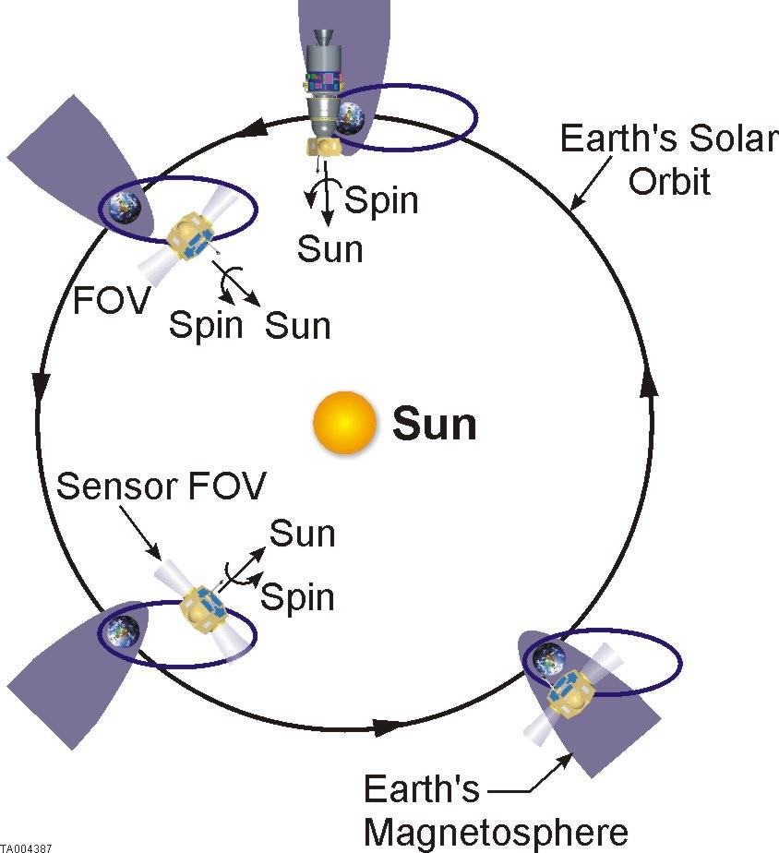
Figure 2.1 IBEX Orbit Progression
The IBEX orbit progression over 1 year is shown in Figure 2.1. During most seasons, this orbit places the spacecraft outside the magnetosphere for the vast majority of time. Modeling of the viewing from this orbit shows that unobstructed lines of sight completely sample the celestial sphere with a minimum duty/cycle in the direction from apogee to Earth and a maximum duty/cycle over the poles (see Figure 2.2).

The IBEX mission has an ~8-day orbit, ~11 hours of which are spent below 10 R_{E}. IBEX Nominal Operations is split into High Altitude Science Operations (HASO) above 10 R_{E} and Low Altitude Housekeeping Operations (LAHO) below 10 R_{E}. There will be two (TBR) ground passes near perigee. One will be used to download data collected in the previous orbit, re-downlink any data from other orbits that was missed or corrupted, upload commands for the next two orbits and perform routine maintenance activities such as resetting the spacecraft bus clock. The other perigee pass is exclusively for ranging (TBR). There will also be a brief ground pass once at apogee to assess spacecraft state of health and for ranging.

For the nominal mission, IBEX is launched on June 15, 2008. First detection of heliospheric ENAs is expected to occur in July of 2008. The nominal mission concludes after two years of observations, and will have the capability to be extended for at least two additional years.

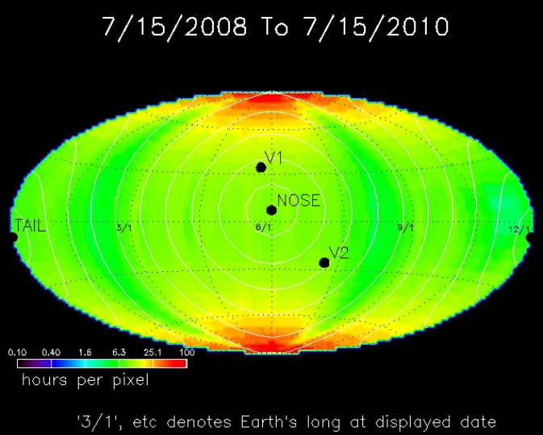

Figure 2.2 The sample time per pixel for IBEX-Hi over the first two years of observation
(excludes view through the magnetosphere)

Science Instrumentation
The IBEX mission payload consists of two single-pixel nominally 7°x7° FWHM sensors that measure ENAs (IBEX-Hi and IBEX-Lo). Both sensors are straightforward extensions of previous instruments (IMAGE-HENA, MENA, LENA; ACE/SEPICA) and incorporate heritage subsystems. IBEX-Lo is optimized to measure 0.01-2 keV oxygen and hydrogen, and IBEX-Hi is optimized to measure 0.3- 6 keV hydrogen. To accomplish Science Question IV, IBEX-Lo also has a higher resolution mode that accumulates higher resolution angular distributions over the limited region of the sky containing the interstellar neutral oxygen arrival direction. Both IBEX sensors are optimized for high geometric factors and angular resolutions.

IBEX-Hi and IBEX-Lo Sensor Performance and Characteristics
The IBEX-Hi and –Lo sensors are designed and optimized (1) for high geometric factors and high background suppression to image the faint ENA sources from the outer heliosphere, (2) for high angular resolutions to provide well-resolved images, and (3) to span the full energy range from 0.01 to 6 keV, which requires two separate sensors. The sensor energy ranges are plotted with a sample ENA spectrum in Figure 3.1, illustrating the populations measured in various energy ranges. Note that the overlapping energy coverage provides additional counts for more accurate images and redundancy.

The IBEX-Lo and Hi sensors are very similar, although the conversion process for ENA detection is different. Both IBEX-Lo and IBEX-Hi employ similar subsystems to reject incident ions, collimate the field-of-view, convert ENAs to negative ions (IBEX-Lo: charge-conversion surface) or positive ions (IBEX-Hi: charge stripping foil), measure the ionized ENA energy using toroidal (bundt-pan type) electrostatic analyzers (ESAs), and detect the ionized ENAs. Note that after ENA conversion, the sensors are essentially standard charged particle detection space instruments.

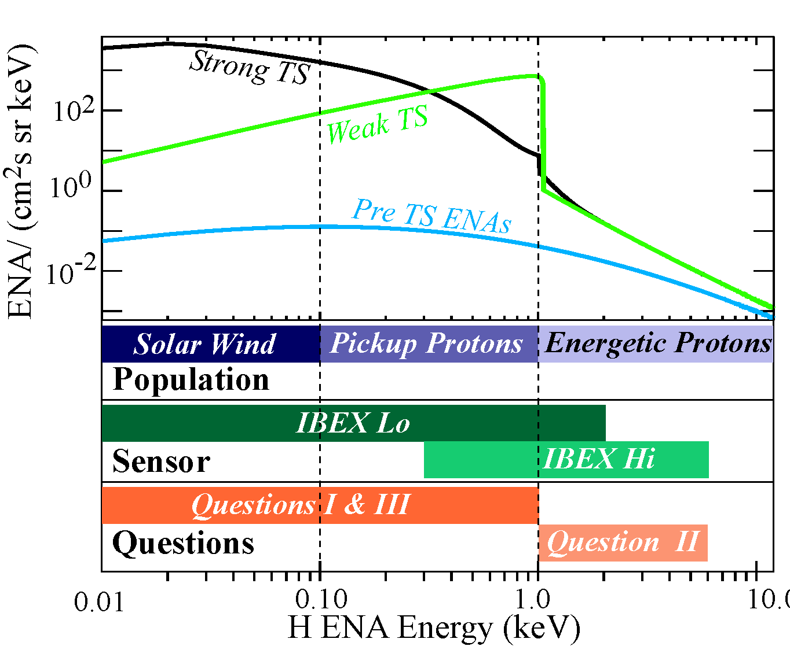

Figure 3.1. IBEX HENA energy distributions are used to discover the global properties of the proton populations of the inner heliosheath. Shown here are predicted ENA energy distributions near the nose of the heliosphere for a strong (black curve) and weak (green curve) TS [Gruntman et al., 2001]. These curves are for a nominal, slow (1 keV) solar wind. The blue curve shows the predicted ENA flux due to energetic protons inside the TS. Energetic ENA distributions >1 keV (black and green curves) are the accelerated energetic protons of the inner heliosheath, also based on observed distributions that have been projected out beyond the TS.

4. IBEX End-to-End Data Flow
The IBEX mission maintains a series of World Wide Web (WWW) pages that provide the latest information about all aspects of IBEX, including accessibility to IBEX data, sensor health and status, spacecraft attitude and ephemeris, and selected model runs to aid interpretation.

Overview
During nominal operations downloaded data are received at the Universal Space Network (USN) stations and forwarded to the MOC at Orbital in Dulles, VA. MOC flight operators will monitor real-time state of health information during contact with the spacecraft. ISOC operators will have the capability to remotely monitor this state of health information in near-real time using Virtual Network Computing (VNC) software to control an analyst MAESTRO workstation in the MOC. One orbit’s worth of IBEX data is typically ~31 MB. After the pass is completed, raw science data, spacecraft housekeeping telemetry and ancillary telemetry (quaternions) are forwarded to the ISOC via secure ftp. This raw data is at the CCSDS level, and has had all encoding and VCDU headers removed.
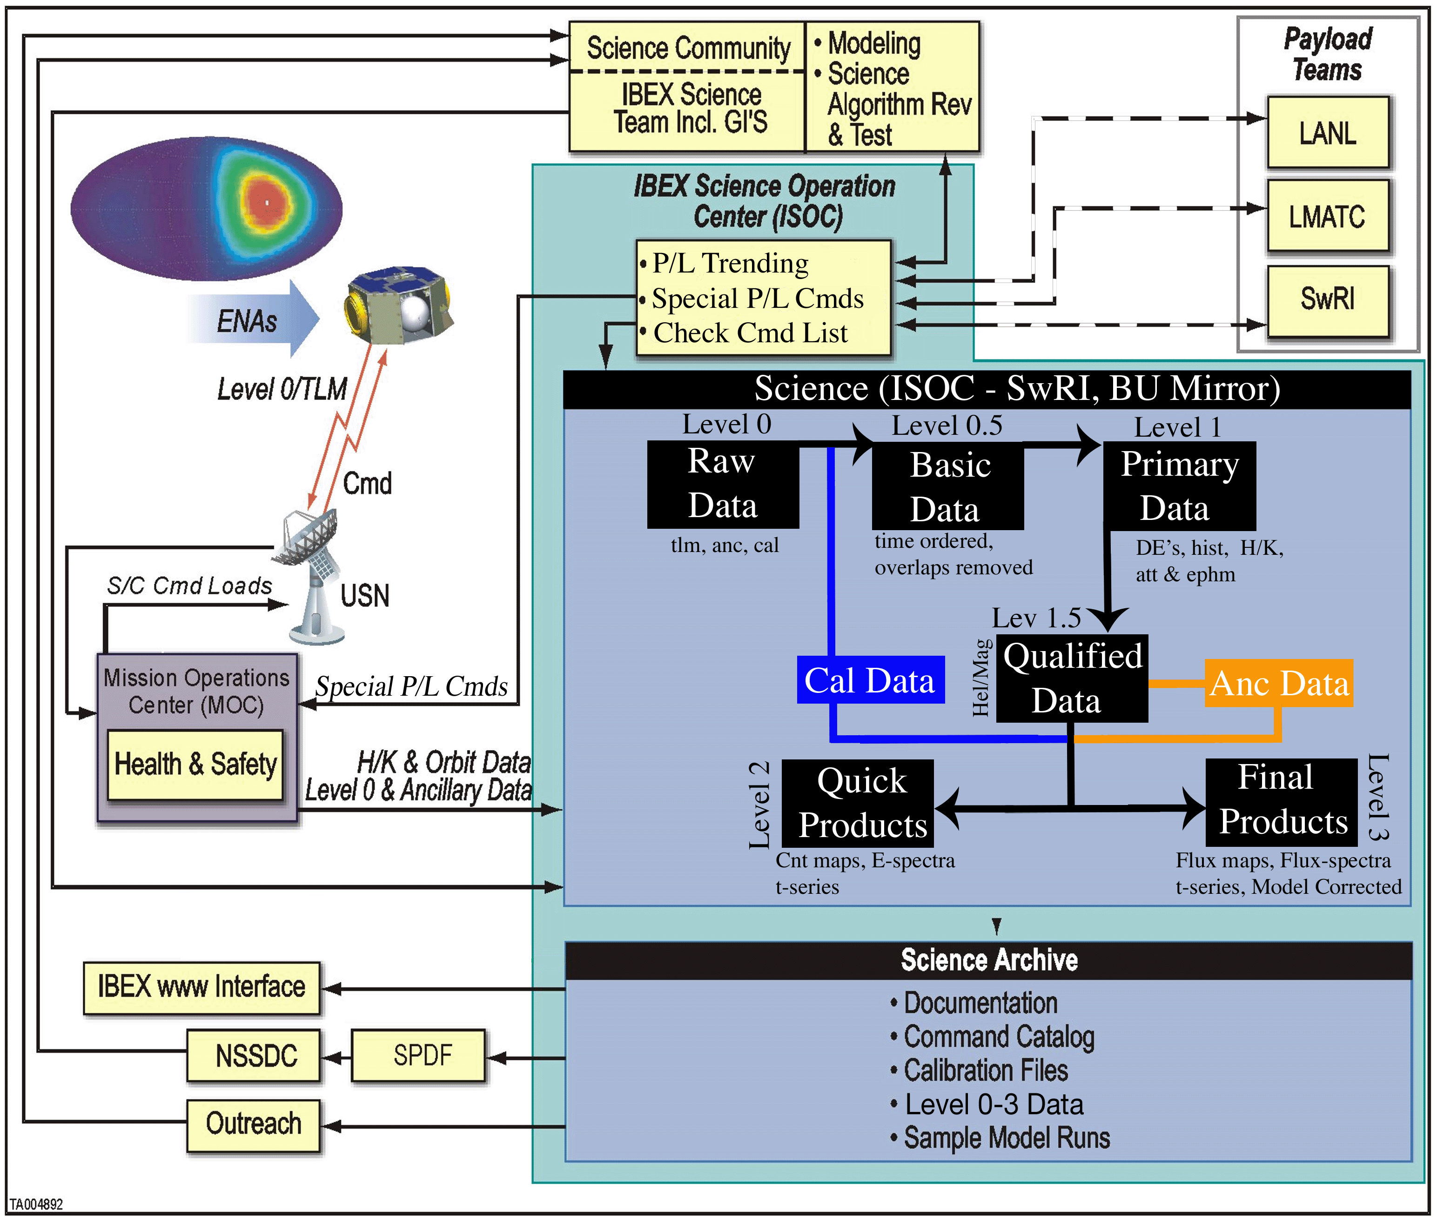
Fig. 4.1 The IBEX Data System

Level 0 data is the raw telemetry. This Level 0 data then has the telemetry framing information removed, the data is ordered in time, redundant data is removed, and sequence gaps and corrupted data are noted for downlink on the following pass. This cleaned basic data (Level 0.5) consists only of information stored directly on the spacecraft. Level 0.5 data is processed into the primary data (Level 1), which includes not only information stored on the spacecraft, but also derived fields such as spin phase and look direction. Spacecraft attitude and ephemeris data are correlated with each coincident event timestamp, energy, and species. Primary data are run through a series of filters based on look direction, count rate, background level, and coincidence type. The filters are used to qualify the data in terms of the magnetospheric source, the heliospheric source, background, and other potential foreground sources (planets, comets, etc). The qualification can be modified at any stage to produce different quality tags for the direct events histogram bins. Data is only tagged for qualification, and never removed permanently. The qualification scheme is then used to produce count maps for the quick products (Level 2). The final products (Level 3) will combine the qualified data with calibrated geometric factors to produce flux maps. The flux maps will also include model-dependent corrections for ENA loss through ionizaton (photo-ionization and charge-exchange), and map distortion due to the bending of ENA propagation paths caused by solar radiation pressure and gravity. There will be an important process of vetting qualified data in the production of quick and final products with the science team. These vetting activities will be managed through science working team meetings and will be closely tracked by the PI and the Science Operations Manager.

Resulting data products will be made available weekly to the IBEX Science Team via the IBEX data site maintained in the ISOC. Validated Level 0, 1, 2 and 3 data products will be made available to the greater science community and the public one month after each all-sky image is obtained (every 6 months). A bulk data delivery of Level 0, 1, 2 and 3 data products will be made to the SPDF one month after each all-sky image is collected for active archiving. The SPDF will then forward the definitive IBEX data to the NSSDC for permanent archiving and public distribution. See Figure 4.1 for a graphical description of the ISOC data system.

The ISOC also monitors and trends the IBEX payload, supports Quick Look Analysis (QLA), and provides custom quality assurance routines. The science team examines all processed data. A data distribution to the IBEX sensor leads and other select Co-Is occurs every 2 weeks and consists of calibrated products, processing logs, and quality assurance results. This ensures rapid feedback and identification of problems.

The payload operations are handled primarily through the MOC. Variable parameters are set in look-up tables, which are called by macros. Each orbit, the ISOC receives an Orbit Events file from MOC, checks the file and provides a Command Authorization Report (CAR). For orbits where special science maintenance operations are desired, the ISOC generates a Science Tasking File that details the needed operations (these may include Pressure Measurement and Gain Testing among others). If no special operations are needed, integrated command load is generated by the MPS software in the MOC. The ISOC then receives a record of the``as-delivered'' uplink. These will also be stored in the Science Archive with the Level 0 telemetry.

Twice a year for IBEX-Lo, interstellar oxygen and helium fluxes (0.01-0.5 keV) are determined vs. velocity direction and time-of-year to 2° post-processed accuracy. These interstellar oxygen viewing periods require a special mode of operation that obey the following general rules:
- they do not occur in the first 6 months of science acquisition
- they are restricted to ± 30° from ecliptic (when the Lo sensor is directed generally toward the heliospheric nose and facing the oncoming interstellar flow of neutrals)
- during the Fall special viewing period (Day-of-yr 255-290), the Lo sensor
  - uses both high (3.5º FWHM) and low (7º FWHM) resolution sectors of the collimator for interstellar neutral observing
  - Focus on Energy bins 2-3 (31 eV)
- during the Spring special viewing period (Day-of-yr 10-60), the Lo sensor
  - rejects particles from low-resolution sectors (with a suppression voltage)
  - for 9 of 10 spins, uses a single energy channel near 430 eV for O sensing
  - for every 10-th spin, looks at Energy bin 1 to identify any possible He counts

Science and the Mission Operations Center
The IBEX spacecraft is operated from the MOC located at Orbital in Dulles, VA. The Mission Operations Manager (MOM, Michelle Reno) manages the MOC and performs all mission operations including execution of the consolidated science data plan provided weekly by the ISOC. The MOC performs command management, health and safety monitoring and mission planning.

The ISOC supports the IBEX Science Team (IST) processing and analysis of science data, performs additional health and safety checks, generates payload commands, and checks integrated spacecraft command lists. The ISOC provides easy access to all data required by the IBEX Science Team and the MOC. The ISOC accepts and processes telemetry, command history, and navigation data through Levels 2 and 3, creating Experiment Data Records (EDRs), calibration files, the telemetry archive, and the IBEX data products. For Qualified data, segregation between magnetospheric and heliospheric ENAs is accomplished with the help of a magnetospheric structure model that is also maintained and archived by the ISOC. While not a formal part of the IBEX investigation, the ISOC also maintains and archives Level 2 and 3 magnetospheric ENA data products. The ISOC coordinates with the MOC to collect science sequence priorities from the Science Teams, and coordinates with the MOC and the Orbital navigation team to maintain the orbital model datasets. Finally, the ISOC aids in the use of IBEX data products to iteratively define, revise and refine 3D models of the heliosphere. Selected model data and predicted ENA distributions useful for interpretation are also maintained and archived by the ISOC as higher level data products. The ISOC archives with the SPDF the Level 0, 1, and 2 data including EDRs, attitude history and ephemeris, and magnetospheric structure data.

The IBEX Science Team is responsible for calibration data and sensor specific algorithms used in the Level 1, 2 and 3 processing. The IBEX Science Team will also generate science priorities for in-flight tests, with the science sequence planning coordinated by the ISOC

Data Products and Access Overview
This section will discuss all the IBEX data products, how and where they are generated, and how and when they will be accessible. The detailed descriptions of data types and their use in creating the various levels of data products is detailed by the Software Design Document (written and maintained by Geoff Crew, the ISOC Software Lead) and summarized in Table 4.1. The foundation for the IBEX data is detailed in Table 4.2.

Table 4.1: IBEX Data Products
Level | Archived | Name | Description
0.0 | yes | Raw Data | Telemetry (CCSDS packets) and other basic inputs including raw calibration data (if delivered to ISOC)
0.5 | no | Basic Data | Raw Data reorganized into time order with overlaps and redundancy removed
1.0 | yes | Primary Data | Direct Events, Event Histograms, Sensor and S/C Housekeeping, S/C Attitude and Ephemeris, etc. unpacked and augmented
1.5 | no | Qualified Data | A subset of Primary Data, qualified for heliospheric (or conversely magnetospheric) analysis
2.0 | yes | Quick Products | Basic high level data products: sky maps of counts, energy-count spectra, count rate time series, based on selection, but not modeling
3.0 | yes | Final Products | Science data products: ENA flux maps, spectra, instrument and science model-dependent assessments
n/a | yes | Calibration Data | Individual sensor calibrations, S/C geometry, etc.
n/a | no | Ancillary Data | Other useful data, typically data products from other missions

Table 4.2: Foundation for IBEX data products
Data type | Description | Cadence | Use | Packing | Compression
Hi Direct Events (DE’s) | ENAs: Energy Step, Arrival Time (spin-phase), Coin Type (16) | Up to ~800 events in 3 min (over 1 energy sweep) | - Global Heliosphere Maps | List sorted by spin, coin type, timetag | Full 12-bit timestamp
Hi Histograms  (16 different coin- type histograms) | Number of Counts per Bin | Partition into two sets: one at 24 min (8 energy sweeps), one at 12 min (4 energy sweeps) | - Global Heliosphere Maps;  - Magnetosphere imaging | Number of events in each of the 60 bins | 16 -> 8 bit compression (linear/sqrt scheme)
Lo Direct Events (DE’s) | ENAs: Energy Step, TOF0, TOF1, TOF2, Arrival Time (spin-phase) | Up to ~800 events in 4 min (over 1 energy sweep) | - Global Heliosphere Maps;  - O, He Neutral measurements | List sorted by spin, event-type (mode, absent bit), timetag | Full 12-bit timestamp
Lo Histograms  (21 histogram types) | Number of Counts per Bin (60° bins, and 6° bins) | 16 minute | - Global Heliosphere Maps;  - Magnetosphere imaging | Number of events in each of the bins | 16 -> 8 bit compression (linear/sqrt scheme)
Backgound Monitor (Channel D) | Number of Counts per Bin (6° bins) | 3 minute | - Basic proxy for EP B/G | Number of events in each of the 60 bins | 12-> 8 bit compression
Star Sensor | Counts in 720 1/2 degree bins | 3 minutes | - Accurate pointing (aligned with Lo) | Number of events in each of the 720 bins | 12->8 bit compression (after subtraction of dark current)

IBEX Data Management
IBEX data management is accomplished using a dedicated IBEX database. This system provides flexible storage and searching capabilities. The IBEX database is accessed through a front-end user WI. The WI is used for browsing data, and for transfer of data from SwRI (or the BU mirror) to IBEX Science Team members, the greater science community and the public. For archival purposes, the baseline data format is ascii, which is a standard format that can be read on many computer platforms using many types of software. The ascii format is also used for data transfers from the ISOC to the SPDF.

The IBEX State-of-health archive is a MySQL database located in the ISOC. It is a parallel database system and has data tables for each data and telemetry application identification (APID) stored on the spacecraft, as well as a table for orbit parameters and one for spin phase and look direction derived from quaternion data. The IBEX database has a WI that allows the user to query the IBEX database for collected data.

The Web Interface to the science repository is now underdevelopment. We anticipate the ability to load a series of screens that show count histograms over a user-specified timeframe, energy histograms over a specific region of the sky, plots that show the IBEX viewing and orbit geometry including the magnetosphere, and a series of other capabilities for viewing IBEX count and flux maps.

The ISOC contains a primary and a backup IBEX database which are automatically synced once a week. These databases are backed up through SwRI Division 15 standard IT operations at least weekly, and also stored on tapes that are kept in a separate facility. In addition there will be a mirror IBEX database at Boston University which will automatically be synced weekly.

The ISOC servers at SwRI and the mirror at BU will include three primary computers:
- High-security Firewalled ISOC computer which contains the base telemetry and archived science products;
- Normal security firewalled RAID system and computer for web interface and software processing contained outside the high-security firewall
- Normal security firewalled computer is used to monitor network, logging, communications

Raw Data (Level 0)
Level 0 data files consist of a timestamped set of coincident events, singles rates, and histograms from each sensor. Level 0 data files are simply raw spacecraft data. Therefore, all Level 0 data are direct images of what is stored on board the IBEX central electronic unit (CEU) within its solid state recorder (SSR). A detailed description of data and telemetry stored on the SSR can be found in EM 11343-032 IBEX Science Data Acquisition and Telemetry. A detailed description of SSR management can be found in the IBEX Concept of Operations.

Once at SwRI, Level 0 data will be quickly incorporated into the ISOC database and posted on the IBEX Science Team data page within 24 hours of each perigee pass. In addition, Level 0 quaternion and housekeeping data is ingested into the ISOC database.

Basic Data (Level 0.5)
Level 0.5 data consists essentially of a time-ordered, cleaned (redundancy removed) set of Level 0 data with telemetry framing information removed. The level 0.5 data forms the basis for all higher level products. We do not specifically archie level 0.5 data, since the level 0 data can be quickly processed to generate Basic Data. In terms of software and data reliability and longevity, it is essential to maintain both the science software archive that generates Basic Data, and the Raw Data from which it is generated. Both the science software archive and Raw data are stored in the behind the high security firewall and copied outside to the normal security firewall for processing to higher data levels.

Primary Data (Level 1)
Primary data files are a time-tagged set of direct events, singles rates, histograms from each sensor, attitude data, ephemeris data, star sensor data and background detector. There will be eight primary data files generated per orbit; one direct event and one histogram file for each sensor (four files), an attitude file, an ephemeris file, a background detector file, and a star sensor file. Time stamps are used to correlate energy step, sensor pointing, spin phase, ion background level, and star sensor information. ENAs are tagged according to their velocity direction in the coordinate systems detailed in the IBEX Related Coordinate System Technical Memo.

Level 1 data files will be incorporated into the ISOC database and posted on the IBEX Science Team data page within 72 hours of each perigee pass.

Qualified Data (Level 1.5)

A magnetospheric structure model and counting rate structure (much higher counting rates in histogram bins where the sensors are directed at the magnetosphere) are used to qualify data in terms of heliospheric and magnetospheric sources. There will also be time-periods when high backgrounds contaminate the ENA signal. Quality flags will be used to tag these data as potential background. High background periods are identified with both the background sensor that is mounted with the Hi sensor, and through analysis of ancillary data (e.g., ACE, GOES, Wind, and STEREO data when they are available). H-ENA energy distributions are generated over the full energy range (0.01-6 keV) in each sky pixel (6°x6°). While histograms are necessarily pixelated due to the binning procedure (60 bins per rotation, see Table 4.2), direct events are available to the 0.5° post-processed spin accuracy. Twice a year for IBEX-Lo, interstellar oxygen and helium fluxes (0.01-0.5 keV) are determined vs. velocity direction and time-of-year to 2° post-processed accuracy. The species separation required for identification of oxygen and helium will also be processed using quality flags.

Quick Products (Level 2)

Quick products consist of sky maps of counts, counts vs energy in each sky pixel, and time series of counts. The quick data products make use of the Qualified Data (the quality flags) for selection, but do not require further modeling or inclusion of calibration data for sensor geometric factors. In principle direct event lists can be used to construct ENA maps down to a 0.5° resolution (post-procesed). However, the quality of such maps will depend inherently on counting statistics. It is anticipated that high quality maps can be determined to 6°x6° resolution. These maps will be provided for each of the Hi and Lo energy channels. The ISOC web-interface will provide functionality to combine energy channels, and bin according to specific time-periods, although specific usage and functionality is still being defined. Level 2 products will be made available to the SPDF and NSSDC approximately 1 month after each all-sky image is obtained (approximately 7 months after data acquisition).

The software algorithms for Level 2 (and level 3) production are provided by sensor teams and are integrated into the ISOC data production pipeline prior to launch. The software and associated documentation for the Level 2 data are archived both at the ISOC and at the SPDF and NSSDC. The ISOC also maintains and archives data concerning magnetospheric structure models used for segregation, and spacecraft attitude and ephemeris. Also accessible is any analysis or visualization software used to create images, generate or validate data. Database downloads can be performed in ASCII (text), and Postscript (PS) for plots generated by the WI software.

Final Products (Level 3) and Higher Level Products
Level 3 data products consist of H-ENA All-sky flux maps (0.01-6 keV in 12 energy steps at 6°x6° and 18°x18° resolution) and interstellar oxygen and helium angular distributions (0.01-0.5 keV). These flux maps are built up from Level 2 data products. H-ENA All-sky flux maps are completed 1 month after each 6-month all-sky image is obtained. Interstellar oxygen and helium angular distributions are generated for both the fall and spring viewing periods.

A Quicklook version of each of these Level 3 data products is generated by the ISOC and posted on the ISOC data site throughout the mission. Validated Level 3 data products are made available to the greater science community and the public via the ISOC data site one month after each all-sky view is collected. A package of validated Level 0, 1, 2 and 3 data will be sent to the SPDF for active archiving one month after each all-sky view is collected. The SPDF will forward this data to the NSSDC for permanent archiving.

Final data products are generated using the Qualified Data for heliospheric (or magnetospheric) ENAs, and calibration data for the relevant sensor geometric factors. In addition, ENA flux maps are corrected for abberation, gravitational effects causing the ENA paths to bend around the Sun’s focus (radiation pressure is also significant for hydrogen atoms, and acts in the opposite sense to gravity), and ENA loss due to ionization. Therefore, the Final Products introduce both significant calibration-dependent effects, and model-dependent effects. As such, the Final Products will have to be vetted carefully with the science team at science working team meetings and through interactions with the sensor teams.

Level 3 data products are used extensively to infer properties of the interstellar interaction. As discussed previously, these data products are studied at three levels. At the higher levels of exploration and understanding, Level 3 data products are studied and interpreted based on simple physics-based calculations and 3D heliospheric models. As such, there is a set of higher level data products associated with physics–based calculations and modeling. At this level, IBEX interacts with the full science team including guest investigators, members of the heliospheric community outside the team, and everyone who contributes to the more detailed analysis and interpretation. Selected calculations and model results are packaged by the ISOC into higher level data products archived at the ISOC, the SPDF, the NSSDC, and maintained on the IBEX web site. These data products include both direct outputs from calculations and models, including global heliospheric structures and dynamics, and associated simulated ENA images, energy distributions and interstellar oxygen and helium angular and velocity distributions. This multi-pronged approach for data analysis, modeling and interpretation ensures a process of thorough investigation open to the scientific community and the public.

Although not a formal part of the IBEX mission, magnetospheric ENA data are derived as a by-product of the IBEX investigation. These data will likely lead to the elucidation and discovery of a broad range of magnetospheric phenomena. As such, segregated magnetospheric ENA data are also maintained by the ISOC. Since the Qualified ENA events are also tagged according to equatorial coordinates, it is straightforward to generate ENA maps of the magnetosphere. These Level 2 and 3 magnetospheric data products are useful not only for magnetospheric science, but also for understanding potential sources of background in heliospheric ENA maps, and for assuring that magnetospheric segregation was performed properly.

The Level 2 and Level 3 data products, documentation, and analysis software developed to create Level 2 data are accessible through the IBEX WI and forwarded to the NSSDC through the SPDF for long-term archiving.

Attitude, Orbit, Magnetospheric Structure Products
An orbit attitude history file is produced by the ISOC. This file contains the attitude quaternions as determined by the spacecraft on-board star tracker. Orbit determination is performed by the Orbital mission planning system and retrieved via secure ftp by the ISOC, where it is converted into an orbit file containing spacecraft position and velocity vectors. These data are also made available through the IBEX WI and delivered to the SPDF and NSSDC for long-term archiving and distribution.

Qualifying data based on the magnetospheric and heliospheric sources of ENAs requires a structural model of the magnetosphere. Multiple, best-available magnetospheric structure models are used for ENA segregation. These structure models are stored and archived. As updated and improved structure models become available, they will be incorporated into data analysis and used to revise Qualified Data. These models and associated data are incorporated into the IBEX database, made available through the IBEX WI, and forwarded to the SPDF and NSSDC for long-term archiving.

Star-sensor Data Products
The foundation for star-sensor, as detailed in Table 4.2, is a count rate (after subtraction of a dark current) in 720 bins each 0.5° wide. The star-sensor is aligned with Lo and provides a means for the high accuracy pointing (0.1° post-processed) for measuring the average Oxygen velocity direction. The star-sensor historgrams will be correlated with UV star maps to derive pointing information. As a basic-product the 720 binned star-sensor histograms accumulated over 3 minute intervals will be archived, and made available to the science team and public as a part of the Level 1 data products.

Background Monitor Data Products
The background monitor (Channel D) also produces stand-alone data products that will be archived as a part of the Level 1 Primary data. The background detector produces a count rate 5° bins over a 3 minute interval. The background monitor is aligned with the Hi sensor and ~180° off from the Lo sensor. Therefore, the background detector histogram bins are most easily correlated with the Hi measurements. With proper spin-phase (or time offset) adjustment, these data can also be correlated with the Lo measurements. The background monitor produces a 72 bin histogram accumulated over 3 minute intervals. This histogram will be a part of the Primary level 1 data.

Ancillary Science Data Products
The IBEX database includes ancillary mission data from ACE, SoHO, NOAA-GOES and other relevant missions for cross-referencing and broad heliospheric and magnetospheric research. The list of ancillary science data products will evolve with usage and suggestions by users of the IBEX database. Ancillary science data are stored for periods of time covered by the IBEX mission, and shall be acquired and updated periodically by enabling automated routines to check for availability of updated data on various remote servers.

Calibration Data Products
Calibration data plays a central role in the science analysis. Calibration data are used to determine precise sensor alignment (key to Primary Data); energy widths, shapes and centers; sensor geometric factors, sputtering yields, etc. These calaibration data products will be an important part of the archived data.

Archiving Functions

Overview of the Archiving Functions
The IBEX archive contains science data products from each of the sensors, orbit and attitude data,

ancillary science data, magnetospheric structure models and data, selected heliospheric model results and associated simulated IBEX data. In addition, the archive contains software and sufficient documentation of the data, software, sensors and mission to enable future scientists to understand and use the archive. The data archive at the ISOC is maintained through the IBEX database. In addition, there is a Distributed Archive that is designed, generated, validated, packaged and distributed by the ISOC.

ISOC Data Archive
The ISOC is responsible for data distribution to IBEX team members and for making the data available to the scientific community and to the public. We anticipate that most data distribution will take place through web access to the IBEX database.

All data are archived at SwRI as soon as possible after processing and validation. This time frame ranges from hours to months depending on the complexity of the specific data product. Data archiving includes both raw, validated data and histograms, and direct event lists (Level-0, and -1). Higher-level data products are also archived, including heliospheric and magnetospheric Level-1, -2 data products, and Level-3 data products.

Distributed Archive Design
The dataset to be packaged and distributed from the IBEX project is expected to be ~ 15 GB in size. The Distributed Archive is delivered to the NSSDC using a physical medium such as CDs and/or DVDs, as appropriate. The data are ordered first by time, then by sensor, and further divided by type of data. Data are tagged according to energy, species, and velocity direction in solar ecliptic coordinates, GSE, and GSM. Data are also segregated according to their qualification tags. Figure 4.2 illustrates the structure of a typical volume of the archive. Data types and volumes for each sensor and archive component and for the total archive are shown in Table 4.1. Final arrangement of the archive down to the file level is specified prior to launch, and described in Software Interface Specification (SIS) documents. Ancillary data products are not formally a part of the Distributed Archive, but are available through the IBEX WI to the IBEX database.

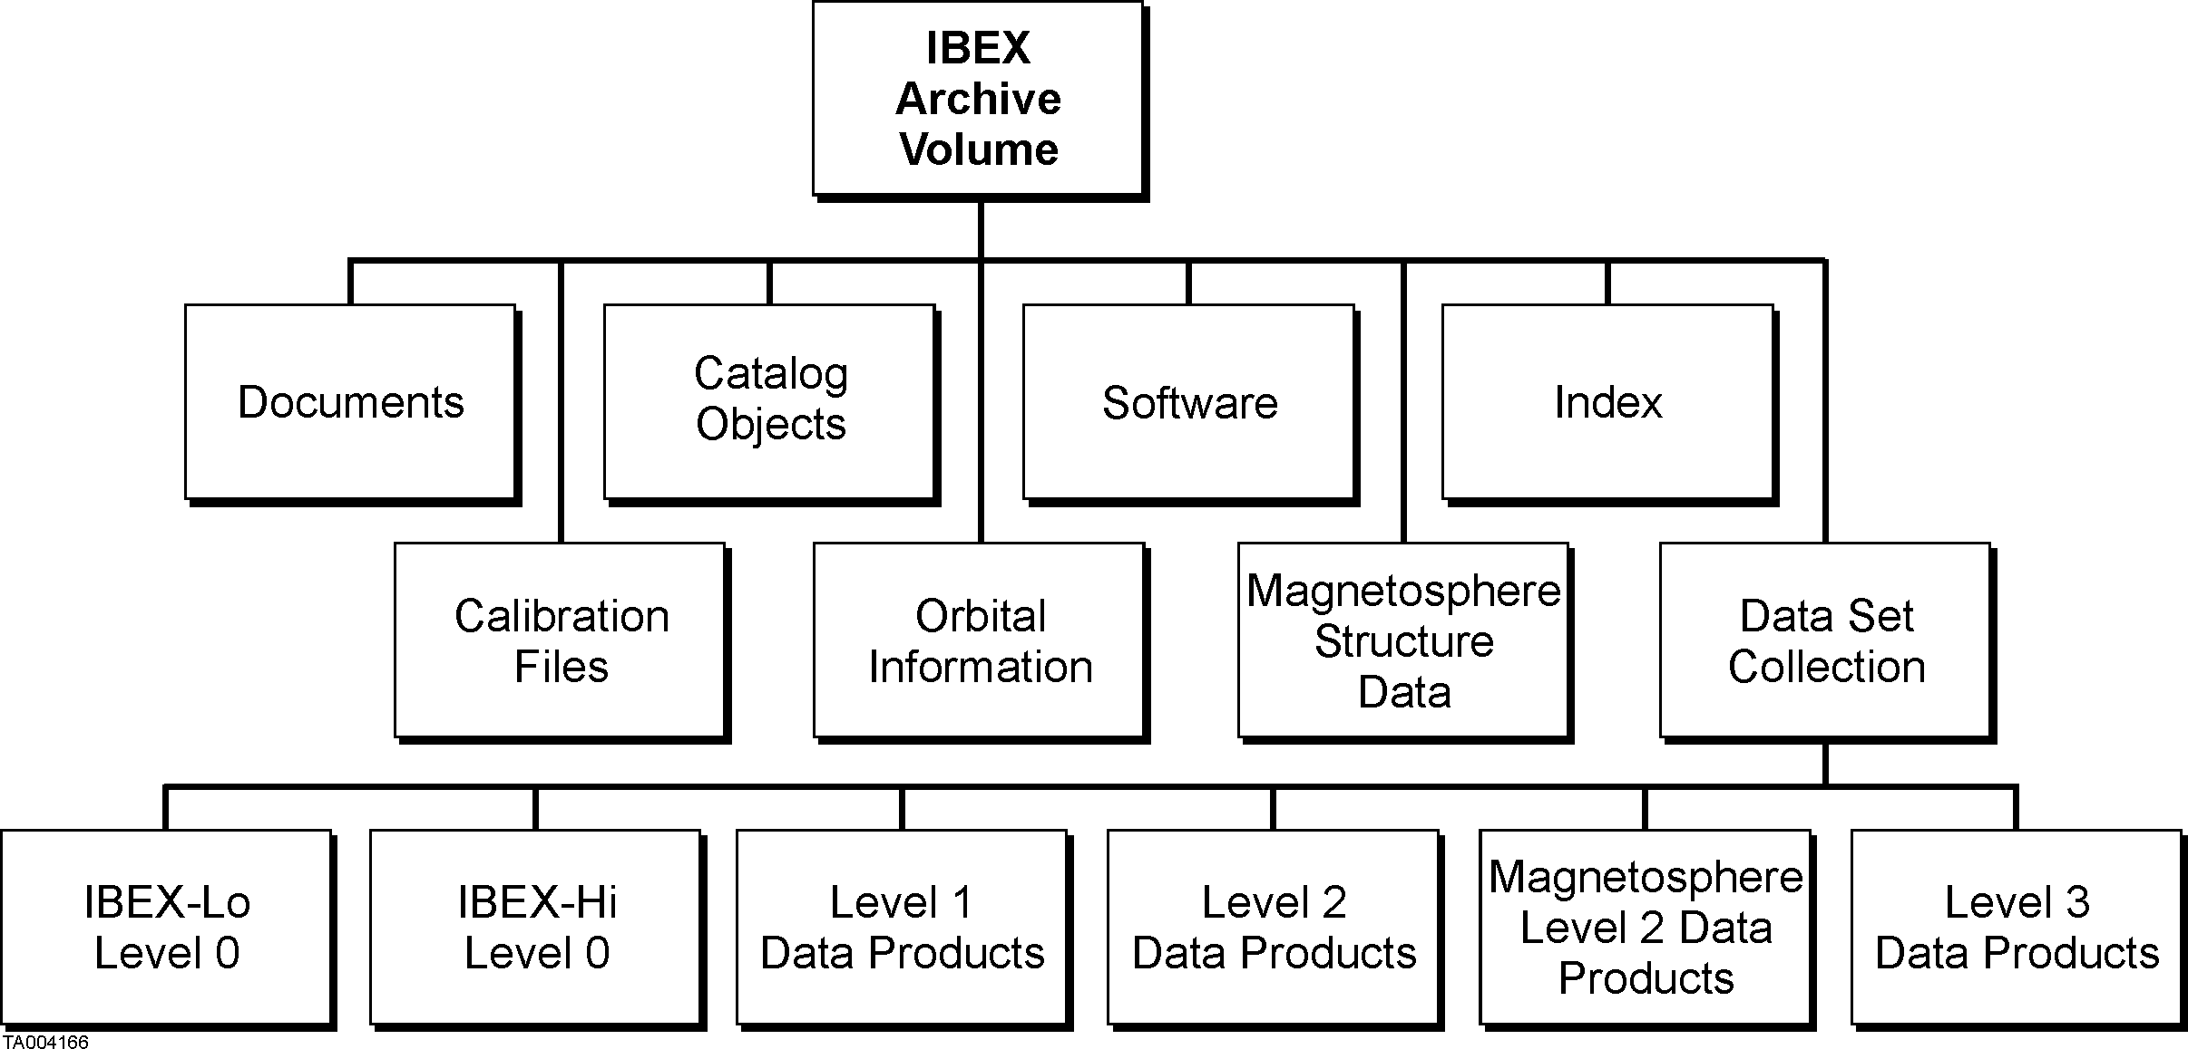
Figure 4.2: General structure of a typical volume of the Distributed Archive

Generation of the Distributed Archive
Science data products are generated in CDF and ASCII format. Each data file (data table or image file) is accompanied by a “label”, which is a detached header file describing the content and structure of the accompanying data file. Orbit and attitude data necessary for interpretation and production of Level-1 and 2 products (e.g., spacecraft ephemeris, attitude records, command histories, and spacecraft housekeeping files) are also provided as archive components. The source code of all software to be provided with the archive is collected and documented. In addition, files documenting the archive components are prepared by ISOC. All information necessary to use the data is included in the archive.

“Catalog objects” are files that document the mission, spacecraft, sensors, and data products. The catalog objects take the form of templates filled out with prescribed mission-specific information. Required catalog objects are the “mission template”, describing the IBEX mission as a whole, the “sensor host template” describing the spacecraft, two sensor templates, and templates for each data set. These templates contain information needed to document the archive and enable future scientists to make correct use of the data.

Validation of the Archive
The IBEX Science Team in consultation with the SPDF and the NSSDC carries out validation of data content, adequacy of documentation, and adherence to archiving standards for both the ISOC archive and the Distributed Archive. The review process may result in “liens”, actions recommended to correct the archive. All liens must be resolved by the dataset providers: the ISOC for Level 1 data, and the IBEX Science Team for Level 2 data products, calibration data and calibration algorithms. Once liens are cleared, the ISOC conducts a final validation prior to packaging and delivery of the Distributed Archive.
Archive Component | Data Type
DOCUMENTS | Text files serving as documentation for the archive
CATALOG OBJECTS | These objects (templates) document the mission, spacecraft, sensors, and data sets
SOFTWARE | Software to be included with the archive
CALIBRATION FILES | Calibrations may also be included within individual data sets
ORBIT AND ATTITUDE INFORMATION | Data necessary to describe the observing geometry and orbital position
MAGNETOSPHERIC STRUCURE DATA | Data necessary to infer structure of magnetosphere or segregation between magnetospheric and heliospheric ENAs
IBEX-Lo Primary Data | Time-tagged Direct Events, Singles Rates, and Histograms
IBEX-Hi Primary Data | Time-tagged Direct Events, Singles Rates, and Histograms
Quick data | Count maps
Quick data | H-ENA Energy-count rate distributions (0.01-6 keV) vs. velocity direction (for details see Table E5). Data is segregated between magnetospheric and heliospheric ENAs.  O, He fluxes (0.01-0.5 keV) vs. velocity direction and time-of-year
Final data | H-ENA All-sky Flux Maps in 12 energy steps (0.05-6 keV).  O, He in-ecliptic flux maps vs. velocity direction
Higher Level data | Selected heliospheric model results, and simulated IBEX ENA and interstellar O and He data
Magnetospheric Level 3 data | H ENA maps of the magnetosphere (0.05-6 keV)
Table 4.1: Distributed Archive Components

Final Packaging and Delivery of the Distributed Archive to the NSSDC
The first delivery of data occurs within ~7 months after sensor turn-on. Validated Level 0, 1, 2 and 3 deliveries take place four times in the mission. Archival delivery is made to the SPDF and the NSSDC, selected IBEX investigators and participating scientists on a physical medium such as CD-ROMs and/or DVDs. Higher level data is packaged with the archive. The final data delivery incorporates the entire archive, including earlier data deliveries.

The CD-ROMs/DVDs produced in the ISOC conform to the ISO 9660 standard, which defines both the physical and logical format of the CD-ROM/DVD. This approach ensures that most CD-ROM/DVD drives on most platforms will be able to read these disks.

Archival Data Volume
The estimated volume of data acquired over the baseline 2-year mission (based on average data rates per orbit and an 8-day orbit) are shown in Table 4.2. The attitude/orbit data and magnetospheric structure volume is approximately ~2 GB total, and Level-3 data volume is ~15 GB. Based on these estimates the total IBEX Spacecraft data volume to be archived at the NSSDC are approximately 20 GB over the baseline 2-year mission.

Sensor | Level-0 (GB) | Level-1 (GB) | Level-2 (GB) | Level-3  (GB) | Attitude/Orbit/  Magnetospheric Structure Data | Level-3
IBEX-Lo | 0.91 | 1.8 | 1.8 | 1.8
IBEX-Hi | 0.70 | 1.4 | 1.4 | 1.4
CEU | 0.23 | N/A | N/A | N/A
Spacecraft | 0.60 | 0.21 | 0.21 | 0.21
Total | 2.44 | 3.41 | 3.41 | 3.41 | ~2 GB | ~15 GB
Table 4.2 Estimated Volume of Mission Data and Data Products

Data Access at the ISOC, SPDF and NSSDC
The ISOC develops and maintains a science archive. The archive is updated continuously as new data become available. Ancillary mission data from ACE, SoHO, NOAA-GOESand other relevant missions are included for cross-referencing. A Web Interface to the IBEX science archive makes data retrieval, searching, and cross-referencing functions widely available to the IBEX team, scientific community and public.

NSSDC is currently making almost all newly-archived data available online, and is in the process of migrating old offline data to online. In addition, the NSSDC operates an interactive system, CDAWeb, which provides browse graphical display of user-selected parameters from multiple data sets. CDAWeb is available at http://cdaweb.gsfc.nasa.gov/cdaweb and supports:
(1) graphical browse display or ASCII listing of user-selected parameters for user-selected time intervals;
(2) downloading of user-selected parameters in ASCII; and
(3) downloading of data in PS format

The SPDF and the NSSDC is responsible for conversion of IBEX ascii data containing all needed information for display and download through CDAWeb. The SPDF, the NSSDC and ISOC work together to define proper structures of the IBEX ascii data.

IBEX will be a part of the Virtual Heliospheric Observatory (VHO), a new concept that allows users to interact with data that is stored at locations other than the SPDF CDAWeb. VHO is basically a search tool that will not house any actual data. To enable IBEX in the VHO, the ISOC plans to submit metadata to the SPDF identifying where various data products are retrievable.

IBEX will also be a part of the Virtual Cosmic Ray Observatory (ViCRO) now under development by John Cooper (GSFC). IBEX ENA observations will constitute a low energy portion of the Cosmic Ray data. As a part of ViCRO, IBEX observations will be naturally placed in context with Voyager osbervations of the heliosheath, and will contribute to the great heliospheric observatory.

5. Data Rights and Rules for Data Use
The IBEX data are open to all scientists and the public. There are no proprietary periods associated with any of the IBEX data products. All IBEX data (including Level 0) are archived at theSPDF, the NSSDC and at the ISOC.

6. References
Funsten, H.O., D.J. McComas, and M. A. Gruntman, Energetic neutral atom imaging of the outer heliosphere-LIC interaction region, in The Outer Heliospere: The Next Frontiers, COSPAR Colloquia Series, Vol. 11, edited by K. Scherer, H. Fichtner, H.-J. Fahr, and E. Marsch, pp. 237-244, pergamon, New York, 2001.
Gruntman, M., E. C. Roelof, D. G. Mitchell, H. J. Fahr, H. O. Funsten, and D. J. McComas, Energetic neutral atom imaging of the heliospheric boundary region, J. Geophys. Res., 106, 15767-15,781, 2001.
Witte, M., M. Banaszkiewicz, and H. Rosenbauer, Recent results on the parameters of the interstellar helium from the Ulysses/Gas experiment, Space Sci. Rev., 78, 289-296, 1996.

AppendiX A – Acronym List

ACE - Advanced Composition Explorer
CDF - Common Data Format
CEU - Combined Electronics Unit
CoI - Co-Investigator
CCSDS - Consultative Committee for Space Data Systems
CVD - Chemical Vapor Depositions
DVD - Digital Versatile Disk
EDRs - Experiment Data Records
ENAs - Energetic Neutral Atoms
ESA - European Space Agency
ESAs - Electrostatic Analyzers
FOV - Field of View
FTP - File Transfer Protocol
GB - Gigabytes
HASO - High Altitude Science Operations
HDF - Hierarchical Data Format
H-ENA - Hydrogen Energetic Neutral Atom
HENA - High-Energy Neutral Atom Imager
IBEX - Interstellar Boundary Explorer
IMAGE - Imager for Magnetopause-to-Aurora Global Exploration
ISOC - IBEX Science Operations Center
ISTP - International Solar Terrestrial Physics
LAHO - Low Altitude Housekeeping Operations
LANL - Los Alamos National Laboratory
LENA - Low-Energy Neutral Atom Imager
LMATC - Lockheed Martin Advanced Technology Center
MENA - Medium-Energy Neutral Atom Imager
MCP - Multi-Channel Plate
MOC - Mission Operations Center
MOM - Mission Operations Manager
IST - IBEX Science Team
NAI - Neutral Atom Imager
NASA - National Aeronautics and Space Administration
NSSDC - National Space Science Data Center
PI - Principal Investigator
PDMP - Project Data Management Plan
QLA - Quick Look Analysis
SMEX - Small Explorer mission
SEPICA - Solar Energetic Particle Ionic Charge Analyzer
SPDF - Space Physics Data Facility
SSR - Solid State Recorder
SwRI - Southwest Research Institute
TOF - Time of Flight
TS - Termination Shock
TWINS - Two Wide-Angle Imaging Neutral-Atom Spectrometers
UV - Ultraviolet
VCDU - Virtual Channel Data Unit
WI - Web Interface
WWW - World Wide Web

