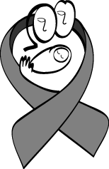

Module 1 Introduction to HIV/AIDS

 Total Time: 120 minutes

SESSION 1 Scope of the HIV/AIDS Pandemic
Activity/Method | Resources Needed | Time
Exercise 1.1 Hope exercise: group discussion | Summary of information on local/national/regional epidemiology of HIV/AIDS  If available, HIV prevalence among women at local prenatal clinics. | 30 minutes

SESSION 2 Natural History and Transmission of HIV
Activity/Method | Resources Needed | Time
Exercise 1.2 HIV 1, 2, 3 Knowledge interactive game | Prizes, such as sweets or condoms (optional), for the winning team | 90 minutes

Also have available the following:
- Overheads or PowerPoint slides for this Module (in Presentation Booklet)
- Overhead or LCD projector, extra extension cord/lead
- Flipchart or whiteboard and markers or blackboard and chalk
- Pencil or pen for each participant

Relevant Policies for Inclusion in National Curriculum
Session 1
- Brief summary of local/national/regional epidemiology of HIV
- If available, a graph illustrating HIV prevalence among pregnant women at antenatal clinics (a local variation on Figure 1.2)

SESSION 1 Scope of the HIV/AIDS Pandemic

 | Advance Preparation
 | For the Hope Exercise (Exercise 1.1), prepare a list of positive responses to HIV in your area.

Total Session Time: 30 minutes

Begin by reviewing the module objectives listed below.

 | Trainer Instructions  Slides 1 and 2

After completing the module, the participant will be able to:
  - Describe the global and local impact of the epidemic.
  - Answer basic questions about HIV/AIDS in women, children, and families.
  - Discuss the natural history of HIV infection.
  - Present information about HIV transmission.

Discuss the scope of the global HIV/AIDS pandemic.

Trainer Instructions
Slides 3, 4 and 5
 | Make These Points
  - More than 90% of people living with HIV/AIDS (PLWHA) are in the developing world.
  - 95% of all HIV-related deaths have been in the developing world, largely among young adults.

Figure 1.1 Worldwide epidemiology of HIV/AIDS

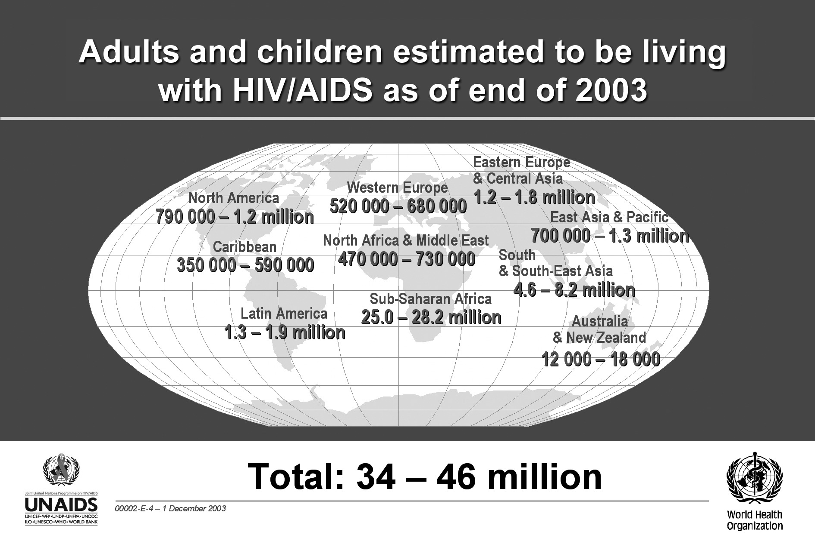

Trainer Instructions
Explain the effects of HIV/AIDS on children.

HIV in children, 2003
UNAIDS estimates that at the end of 2003:
  - 40 million people worldwide were living with HIV/AIDS
  - 2.5 million people with HIV/AIDS were children younger than 15 years old
  - 90% of the children living with HIV/AIDS were from sub-Saharan Africa
  - 700,000 children worldwide were newly infected in 2003
  - 500,000 child deaths are estimated to have occurred from HIV/AIDS during 2003

Make These Points
  - Emphasise the number of new infections using the most recently available data.
New infections, 2003
According to UNAIDS, about 14,000 new infections occurred each day in 2003. Of these new infections
  - About 6,000 each day were among persons 15 to 24 years old
  - Almost 2,000 each day were in children younger than 15 years old
  - Most of the infections in children younger than 15 years old occurred through mother-to-child transmission (MTCT) of HIV.

Trainer Instructions
Briefly highlight the regional HIV/AIDS data as detailed in Table 1.1. This table also appears in the Participant Manual, so you need not discuss the information in detail.

Table 1.1 Regional HIV/AIDS statistics and features, through 2003
Region | Adults and Children Living with HIV/AIDS | Adults and Children Newly Infected with HIV | Adult Prevalence*  (%) | Adult and Child Deaths Due to AIDS
Sub-Saharan Africa | 25.0–28.2 million | 3.0–3.4 million | 7.5–8.5 | 2.2–2.4 million
North Africa and Middle East | 470,000–730,000 | 43,000–67,000 | 0.2–0.4 | 35,000–50,000
South and South-East Asia | 4.6–8.2 million | 610,000–1.1million | 0.4–0.8 | 330,000–590,000
East Asia and Pacific | 700,000–1.3 million | 150,000–270,000 | 0.1–0.1 | 32,000–58,000
Latin America | 1.3–1.9 million | 120,000–180,000 | 0.5–0.7 | 49,000–70,000
Caribbean | 350,000–590,000 | 45,000–80,000 | 1.9–3.1 | 30,000–50,000
Eastern Europe and Central Asia | 1.2–1.8 million | 180,000–280,000 | 0.5–0.9 | 23,000–37,000
Western Europe | 520,000–680,000 | 30,000–40,000 | 0.3–0.3 | 2,600–3,400
North America | 790,000–1.2 million | 36,000–54,000 | 0.5–0.7 | 12,000–18,000
Australia and New Zealand | 12,000–18,000 | 700–1,000 | 0.1–0.1 | <100
Total | 40 million  (34–46 million) | 5 million  (4.2–5.8 million) | 1.1  (0.9–1.3) | 3 million  (2.5–3.5 million)
* Percentage of adults age 15 to 49 years living with HIV/AIDS in 2003, using 2003 population data
The ranges in this table are based on the best available information. These ranges are more precise than in previous years, and work is under way to further improve the precision of the estimates to be published in mid-2004.

Trainer Instructions
Explain that to estimate HIV prevalence in the general population, researchers often measure HIV prevalence in antenatal clinics.

Figure 1.2 below is a good example of the results of a prevalence study among pregnant women, which shows the extent of the South African epidemic.

Figure 1.2 HIV prevalence: pregnant women in South Africa, 1991–2002

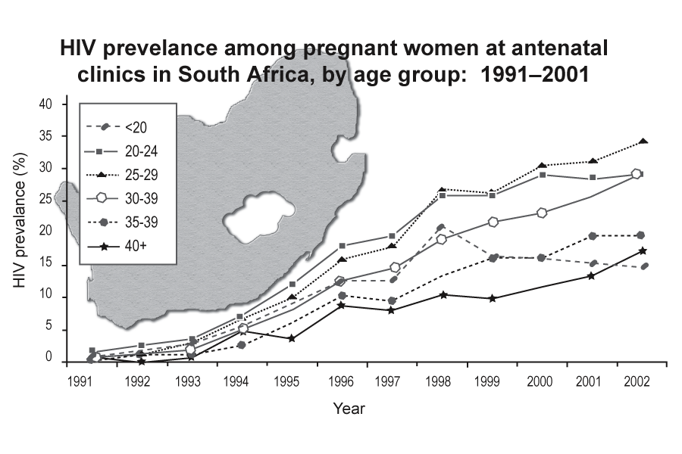

Most of these estimates are based on surveillance systems that focus on pregnant women who attend selected antenatal clinics. This method assumes that HIV prevalence among pregnant women is a good approximation of prevalence among the adult population (aged 15–49 years). A direct comparison of HIV prevalence among pregnant women at antenatal clinics and the adult population in the same community in a number of African communities has provided evidence for this method of estimating HIV prevalence.

Trainer Instructions
Slide 6
Explain that the impacts of HIV occur at all levels of society from the individual to the family, community and country level. The social and economic consequences are far reaching.

Make These Points
- HIV/AIDS affects every region of the world.
- Millions of people are infected with HIV or live in families affected by HIV.
- The number of new infections continues to grow.
- The HIV/AIDS pandemic contributes to:
    - Childhood malnutrition
    - Shortened life span with illness and suffering
    - Economic loss, personal and countrywide
    - Weakened family system

Trainer Instructions
Begin a group discussion about some of the pandemic's global outcomes, based on the following information:

Global impact of HIV
The global impact of the HIV/AIDS pandemic is especially severe in resource-constrained settings and results in the following:
  - Negative impact on countries’ economic development
  - Overwhelmed healthcare systems
  - Decreasing life expectancy in many countries
  - Deteriorating child survival rates
  - Increasing number of orphans

Effects of the HIV/AIDS pandemic on individuals include the following:
  - Illness and suffering
  - Shortened life span
  - Loss of work and income
  - Death of family members, grief, poverty, and despair
  - Barriers to health care related to stigma and discrimination
  - Deteriorating child health and survival
  - Weakened integrity and support structure of the family unit

Trainer Instructions
Slides 7, 8 and 9
Slides 7, 8 and 9 feature national epidemiologic data; review this data with participants. Invite the participants to share individual and family outcomes they have witnessed related to the HIV pandemic.

Trainer Instructions
Lead an interactive discussion based on Exercise 1.1.
Exercise 1.1 Hope exercise: group discussion
Purpose | To begin the PMTCT training with a feeling of hope and optimism despite the devastation left by decades of HIV.
Duration | 20 minutes
Introduction | Explain to participants that this activity is intended to introduce hope and optimism about the response to HIV/AIDS.
Activities | Ask participants to share their ideas about positive responses to the HIV/AIDS pandemic. Record their responses on the flipchart or board. Typical responses include:  - Groups in the community that have never worked together before have connected with each other to address HIV/AIDS.  - Global community has allocated increased funding for healthcare systems in the developing world, especially HIV/AIDS care systems.  - The Ministry of Health in many countries has become a stronger advocate for the healthcare needs of people in all sectors of society.  - Global community has become more attentive to TB because of its connection to HIV.  - There is increased awareness of safer sex practices that protect people from other STIs and HIV.  If no one identifies PMTCT as a positive response, ask what the participants know about preventing transmission from mothers to babies.
Debriefing | Summarise the session by noting the following points:  - Much of the progress in HIV treatment and care in developed nations relates to HIV-positive people living longer, healthier lives.  - Fewer infants are infected from their mothers.  - Participants can be part of the progress in PMTCT.  - Even though HIV has brought devastation, it also has brought positive responses such as bringing together many different kinds of people to fight for a common goal.  - This PMTCT course begins on a note of hope.

Make These Points
  - Despite the devastation caused by HIV, there are reasons to be hopeful and optimistic.

Trainer Instructions
Slides 10, 11 and 12
Use this part of the session to present an overview of HIV infection and AIDS. For some participants, this may be a review.

Discuss the definitions of HIV and AIDS and highlight the differences. Allow time to respond to questions.

Overview of HIV and AIDS

 | Refer to Pocket Guide.

Definitions of HIV and AIDS
HIV stands for human immunodeficiency virus, the virus that causes AIDS.
H: Human
I: Immunodeficiency
V: Virus
  - HIV breaks down the body's defence against infection and disease—the body's immune system—by infecting specific white blood cells, leading to a weakened immune system.
  - When the immune system becomes weak or compromised, the body loses its protection against illness.
  - As time passes, the immune system is unable to fight the HIV infection and the person may develop serious and deadly diseases, including other infections and some types of cancer.
When a person is infected with HIV, the person is known as “HIV-infected.”
“HIV-positive” is when person who is HIV-infected has tested positive for HIV.

AIDS is an acronym for acquired immunodeficiency syndrome and refers to the most advanced stage of HIV infection.

A: Acquired, (not inherited) to differentiate from a genetic or inherited condition that causes immune dysfunction
I: Immuno-, because it attacks the immune system and increases susceptibility to infection
D: Deficiency of certain white blood cells in the immune system
S: Syndrome, meaning a group of symptoms or illnesses that result from the HIV infection

Make These Points
  - Emphasise the differences between HIV and AIDS.

Differences between HIV, HIV infection, and AIDS
  - HIV is the virus that causes infection.
  - The person who is HIV-infected may have no signs of illness but can still infect others.
  - Most people who are HIV-infected will develop AIDS after a period of time, which may be several months to more than 15 years.
  - AIDS is a group of serious illnesses and opportunistic infections that develop after being infected with HIV for a long period of time.
  - A diagnosis of AIDS is based on specific clinical criteria and laboratory test results.

(See Appendix 1-A for information about the World Health Organization (WHO) staging systems for HIV infection and Disease and Appendix 1-B for the U.S. Centers for Disease Control and Prevention (CDC) AIDS Surveillance Case Definitions.)

Trainer Instructions
Slides 13 and 14
Discuss HIV-1 and HIV-2, highlighting the similarities and differences between them.

Types of HIV
HIV-1 and HIV-2 are types of HIV. Both types are transmitted the same way, and both are associated with similar opportunistic infections and AIDS. HIV-1 is more common worldwide. HIV-2 is found predominantly in West Africa, Angola, and Mozambique.

Differences between HIV-1 and HIV-2
HIV-2 is less easily transmitted than is HIV-1, and it is less pathogenic, meaning that the period between initial infection and illness is longer. In some areas, a person may be infected with both HIV-1 and HIV-2. While HIV-2 can be transmitted from an infected mother to her child, this appears to be rare (0% to 5% transmission rate in breastfed infants in the absence of any interventions).

A discussion of preventing mother-to-child-transmission (PMTCT) from women who are infected with HIV-2 to their infants is included in Module 2, Overview of HIV Prevention in Mothers, Infants, and Young Children, Appendix 2-A. Women who are infected with both HIV-1 and HIV-2 should follow all PMTCT recommendations for HIV-1-infected women.

Make These Points
  - Emphasise the differences between HIV-1 and HIV-2 and be sure that participants understand the information.
SESSION 2 Natural History and Transmission of HIV

Advance Preparation
Review Exercise 1.2 HIV 1, 2, 3 Knowledge interactive game: although a few easy questions and a few difficult ones help to make the game fun, re-write any questions that are inappropriate for participants.
Before the session, draw on flipchart paper in the front of the room (or on a blackboard or whiteboard) one circle for each team. Each circle should be approximately 30 cm to 60 cm in diameter so that people in the back of the room can see it clearly. Divide each circle into sixths.
Optional: Purchase sweets or condoms to be used for prizes for Exercise 1.2.

Total Session Time: 90 minutes

Trainer Instructions
Slides 15, 16 and 17
Review the basic information about the natural history of HIV infection using Figure 1.3.
Explain the "Natural Course of HIV Disease" graph, and describe the presentation of HIV at each stage of infection.

Make These Points
  - Emphasise that HIV is transmitted during each stage and that many people do not know that they are infected until they become symptomatic.
  - Examine the relation of viral load and increased risk of transmitting infection.

Trainer Instructions
Slide 18
Discuss CD4 count and viral load highlighting the relationship between them.

Make These Points
  - CD4 count and viral load are difficult concepts. Spend adequate time on them and ask participants for feedback to verify that they understand both concepts.
  - Explain that although CD4 and viral load are both indicators of disease progression, they measure different things—one measures the amount of suppression of the immune system and the other measures the amount of virus in the blood.
  - Participants may find it confusing that a low CD4 count is a bad sign and a low viral load is a good sign. Take the time to clarify these measures to be sure the participants understand the concepts clearly.
  - Emphasise that high maternal viral load increases the risk of mother-to-child transmission of HIV.

Background information on CD4 count and viral load

Figure 1.3 Characteristic viral load and CD4 changes over time in HIV/AIDS
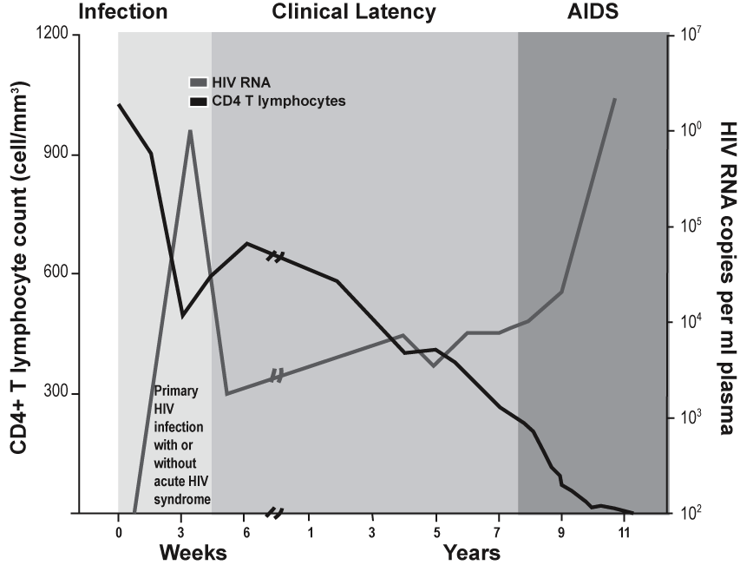

The CD4 count and viral load are two measures of the progression of HIV. When HIV actively multiplies, it infects and kills CD4 T cells—a specific type of white blood cell—that are the immune system's key infection fighters. The effects of HIV are measured by the decline in the number of CD4 cells.

The CD4 count is the number of CD4 cells in the blood and reflects the state of the immune system. The normal count in a healthy adult is between 600 and 1,200 cells/mm³. When the CD4 count of an adult falls below 200 cells/mm³, the risk of opportunistic and serious infection is high.

Viral load is the amount of HIV virus in the blood. It can be measured by the HIV ribonucleic acid polymerase chain reaction blood test (HIV-RNA PCR). The test is used as a marker of response to antiretroviral (ARV) treatment.

The viral load is very high shortly after primary HIV infection. It falls steeply when the body develops antibodies and rises again after a number of years as the CD4 count drops. High viral load leads to higher transmission risk. Most often, after a number of years, high viral load is also a sign of more severe disease as people develop AIDS (Figure 1.3).
Natural history (or course) of HIV infection
Seroconversion

People infected with HIV usually develop antibodies 4 to 6 weeks after being infected, but it may take as long as 3 months for antibodies to develop. The period of time between when a person is infected with HIV and when the antibody test result is positive is called the "window period."

Unlike for most diseases, having antibodies for HIV does not indicate protection but indicates infection.

When a recently infected person develops antibodies that can be measured using a laboratory test, seroconversion is occurring. Some people may experience a glandular illness (fever, rash, joint pains, and enlarged lymph nodes) at the time of seroconversion.

HIV testing detects antibodies or antigens associated with HIV in whole blood, saliva, or urine.

A person whose blood test results show HIV infection is said to be seropositive or
HIV-positive.

A person whose blood test results do not show HIV infection is said to be seronegative or HIV-negative.

A person who tests HIV-negative but who has engaged in behaviour within the past 3 months that places him or her at risk for HIV should be tested again in 3 months.

Asymptomatic HIV infection
A person who is HIV-infected but looks and feels healthy is asymptomatic. None of the physical signs or symptoms that indicate HIV infection are present.
Whether they have symptoms or not, people who are HIV-positive can still pass the virus to others.

The duration of the asymptomatic phase varies greatly from person to person. Some adults may develop symptoms of HIV as quickly as a few months after primary infection; others may take as long as 15 years or more to develop symptoms.

For children infected with HIV through MTCT, during pregnancy, labour and delivery, and breastfeeding, the asymptomatic phase is shorter. A few infants who are HIV-positive will become ill within the first weeks of life. Most children start to develop symptoms before they are 2 years old; a few remain well for several years.

Symptomatic HIV infection
A person who has developed physical signs of HIV and reports symptoms related to HIV is symptomatic.

The immune system weakens and CD4 count decreases during this phase.

The progression of HIV depends on the type of virus and specific host characteristics including general health, nutritional, and immune status.

AIDS
Almost all people who are HIV-positive will ultimately develop HIV-related disease and AIDS, the end stage of HIV infection. As HIV infection progresses, the CD4 count continues to decrease and the infected person becomes susceptible to opportunistic infections.

An opportunistic infection is an illness caused by a germ that might not cause illness in a healthy person, but will cause illness in a person who has a weakened immune system. For example, co-infection with tuberculosis (TB) is very common in people infected with HIV.

People living with advanced HIV infection suffer from opportunistic infections of the lung, brain, eyes, and other organs. Other common opportunistic infections in persons diagnosed with AIDS are pneumocystis carinii pneumonia (PCP); cryptosporidiosis; histoplasmosis; other parasitic, viral and fungal infections; and some types of cancers, such as Kaposi's sarcoma.

ARV treatment and prophylaxis and treatment of opportunistic infections help preserve the CD4 cells, lower viral load, and prolong the time it takes for HIV to progress to the symptomatic phase and, ultimately, to AIDS.

Trainer Instructions
Slides 19, 20, 21, and 22
Discuss and reinforce the concept of HIV disease progression.
Make These Points
  - Point out that the transition from the stages of asymptomatic to symptomatic to AIDS occurs when CD4 counts decrease and immune function deteriorates.
  - Note that HIV infects many organ systems and causes a range of symptoms and opportunistic infections.
  - Emphasise the role of high viral load and low CD4 counts in the development of clinical symptoms.

Trainer Instructions

Review the staging systems for HIV and their purpose so that the participants are familiar with these topics.
Take a few moments to go over the tables in Appendix 1-A with the participants.

Make These Points
  - Tell the participants that staging systems continue to be modified as we learn more about the disease.

Staging systems for HIV
Staging systems for HIV can:
  - Contribute to the care of individuals who are HIV-infected
  - Provide a framework for follow-up and management
  - Help define prognosis and guide patient counselling
  - Be used to help evaluate new treatments

World Health Organization (WHO) staging system for HIV
The WHO staging system groups HIV progression into four clinically relevant stages—Stages I to IV—that correspond to the natural history of HIV. (See Appendix 1-A.)

The staging system for HIV infection in children is scheduled to be revised by WHO in consultation with paediatric experts in 2004. In the interim, using the WHO staging system can help define parameters for initiating treatment in resource-constrained settings.

However, adapting the staging system at the country level may be appropriate.

U.S. Centers for Disease Control and Prevention (CDC) surveillance case definition
The CDC AIDS Surveillance Case Definitions include clinical and immunologic categories. (See Appendix 1-B.) This system uses a combination of symptoms and
CD4 count levels to establish criteria for AIDS.

Trainer Instructions
Slide 23
Review the natural history summary slide slowly and carefully and take the opportunity to invite additional questions.

Trainer Instructions
Slides 24, 25 and 26
Discuss transmission of HIV.

Make These Points
  - The main source of HIV transmission is unprotected sex with a partner who is
HIV-positive.
  - Myths and misinformation regarding the transmission of HIV infection exist and require clarification.
  - Condoms used consistently and correctly prevent HIV and other sexually transmitted infections (STIs).
  - Effective PMTCT programmes reduce the risk of perinatal transmission of HIV.

Routes of HIV transmission
HIV can be transmitted through blood, sexual contact, or injection drug use, and from mother-to-child (also known as perinatal or vertical transmission).

The most common route of HIV transmission is through sexual contact, especially heterosexual intercourse.

Blood-to-blood transmission
  - Transfusion with HIV-infected blood
  - Direct contact with HIV-infected blood

Sexual contact
  - Unprotected sexual intercourse (vaginal, oral, or anal)
  - Direct contact with HIV-infected body fluids such as semen, cervical and vaginal secretions

Women of childbearing age are at particular risk for acquiring HIV. The main behaviour that places them at risk is unprotected sex with an infected male partner.

Drug use
  - Injection of drugs with needles or syringes contaminated with HIV

Perinatal transmission (MTCT)
  - From mothers who are HIV-positive to their infants during pregnancy, labour, delivery, and breastfeeding

HIV cannot be transmitted by:
- Coughing or sneezing
- Insect bites
- Touching or hugging
- Kissing
- Public baths/pools
- Public toilets
- Shaking hands
- Working or going to school with a person who is HIV-infected
- Telephones
- Water or food
- Sharing cups, glasses, plates, or other utensils

Public health strategies to prevent HIV infection
Blood-to-blood transmission
  - Screen all blood and blood products for HIV.
  - Follow universal precautions which include:
    - Use of protective equipment
    - Safe use and disposal of sharps
    - Sterilisation of equipment
    - Safe disposal of contaminated waste products
Sexual contact
  - Promote abstinence or being faithful to one uninfected partner.
  - Provide instruction on the consistent and correct use of barrier methods.
- Male or female condoms for vaginal intercourse
- Non-lubricated condoms for oral intercourse on a male
- Dental dams, plastic wrap, or latex panties for oral intercourse on a female
- Condoms for anal intercourse
  - Prevent, identify, and provide early treatment for sexually transmitted infections (STIs).
  - Provide access to HIV testing and counselling.
Condoms provide protection from HIV transmission as well as other sexually transmitted infections (STIs) when used correctly and consistently.
Drug use
  - Educate about the risks of infection through drug use with contaminated needles and syringes.
  - Provide referral for treatment of drug dependence.

Drug use in any form may increase the risk of HIV infection by limiting judgment and facilitating engagement in risky behaviours. Even occasional use of alcohol, marijuana, and other “recreational” drugs may increase risk of HIV infection.
Perinatal transmission from HIV-positive mothers
  - Provide ARV treatment when indicated and available.
  - Provide ARV prophylaxis during labour and delivery.
  - Provide ARV prophylaxis to the infant.
  - Offer elective caesarean section when safe and feasible.
  - Follow safer delivery practices.
  - Provide linkages to treatment, care, and social support for mothers and families with HIV infection.
  - Provide infant-feeding counselling.

(Module 2, Overview of HIV Prevention in Mothers, Infants, and Young Children contains detailed information on a comprehensive PMTCT approach.)

Trainer Instructions
Slides 27 and 28
Summarise key points for Module 1.

Module 1: Key Points

  - HIV is a global pandemic.
  - The number of people living with HIV worldwide continues to increase.
  - The HIV epidemic is especially severe in many resource-constrained countries.
  - HIV is a virus that destroys the immune system, leading to opportunistic infections.
  - The progression from initial infection with HIV to end-stage AIDS varies from person to person and can take more than 15 years.
  - The most common route of HIV transmission worldwide is heterosexual transmission.
  - Women of childbearing age are at particular risk for acquiring HIV. The main behaviour that places them at risk is unprotected sex with an infected male partner.
  - Pregnant women who are HIV-infected are at risk of passing HIV infection to their newborn.
  - Risk of HIV transmission from mother-to-child can be greatly reduced through effective PMTCT programmes.

Trainer Instructions

Close the module by facilitating Exercise 1.2, the HIV 1, 2, 3 Knowledge Game. Your copy of the game (pages 1-22 to 1-29) includes the answers in the column on the right.

The participant copy of the HIV 1, 2, 3 Knowledge Game is on pages 1-13 of the Participant Manual.

Exercise 1.2 HIV 1, 2, 3 Knowledge interactive game
Purpose | To present basic and advanced HIV/AIDS information in an easy and enjoyable way while allowing participants an opportunity to demonstrate what they know. This game also gives the participants a chance to get to know each other.
Duration | 60 minutes
Introduction | Set up round tables that will accommodate 4–6 participants at each table. Divide the group into two to four teams of equal size, depending on the size of the group and the amount of time you have. The more teams there are, the longer the game will take.  Distribute the groups somewhat evenly by discipline, so that each group has the same number of nurses, doctors, and so on. Number the teams 1, 2, 3, and 4 and ask the participants to sit with their teams.  Start the exercise by explaining that the objective is to be the first team to complete the circle. Each team can fill in one-sixth of the circle each time the team gets a correct answer in six of the following seven categories:  - HIV/AIDS transmission  - Prevention  - Infant feeding  - Testing  - Mother-to-child transmission  - Linkages to treatment, care, and support  - Prevention in healthcare settings  Distribute one question sheet to each participant. Use the Wild Card category only in the event of a tie.
Activities | Give the participants 15–20 minutes to answer the questions working together in their teams.  Remind the teams to record their answers on the question sheet.  Suggest that they keep the answers simple and not linger on any one question.  To begin play, the first team chooses a category and a question, then reads the question aloud and gives the answer. The team has 10 seconds to answer.  If correct, the team colours in one-sixth of its circle and records next to the circle the name of the category from which the question came.  A team may only answer one question per category.  If incorrect, the next team gets to answer that question or another question of its choosing.  Once a question has been answered correctly, no other team may use it.  The facilitator should clarify any misconceptions that may have surfaced during the discussion once the question is correctly answered.  The next team takes a turn.  The first team to fill its circle by colouring in all six pieces (representing six correct answers in six different categories) is the winner and receives the prize.
Debriefing | Point out that each participant knows more than they think they know and that by working together, they are able to respond correctly to many of the HIV/AIDS questions in the Knowledge Game.

Answers to Exercise 1.2 HIV 1, 2, 3 Knowledge Game
Category 1: HIV/AIDS Transmission
Question | Answer
List at least three ways in which HIV infection is transmitted. | - Unprotected sex with an infected person  - From an infected mother to her infant before birth, during birth, or during breastfeeding  - Blood transfusion in countries in which blood is not routinely screened  - Blood-to-blood transmission, including any of the following:  - Injection drug use or  - Accidental exposure to needles or sharps in a health care setting—razors, scalpel blades, lancets, or scissors—that were used by a person who was HIV-infected and not cleaned
Name the two types of HIV. | HIV-1 and HIV-2
What body fluids contain high concentrations of HIV? | - Blood  - Semen  - Vaginal secretions  - Breastmilk
What is the major route of HIV transmission worldwide? | Unprotected heterosexual sex
What specific part of the human body does HIV attack and what does  this cause? | HIV infects the immune system, specifically the CD4 cells. Over time, the weakened immune system has a progressively more difficult time fighting infections.

Category 2: Prevention
Question | Answer
What are the  ABCs of prevention  (on an individual level)? | A. Abstain from sex completely.  B. Be faithful to one partner who is uninfected.  C. Use a new condom properly each time you have sexual intercourse.  Note: There is also a “D”. Do not use drugs and do not share injection equipment.
Universal precautions are a set of practices designed to protect health workers and patients from infection. Name at least four interventions that are universal precautions. | - Wash hands after any direct contact with patients.  - Do not recap needles, whenever possible.  - Dispose of needles (hypodermic and suture) and sharps (scalpel blades, lancets, razors and scissors) safely, putting them into puncture- and leak-proof safety boxes.  - Wear gloves to prevent contact with body fluids, broken skin and mucous membranes.  - Wear a mask, eye protection, and gown (and sometimes a plastic apron) if blood or other body fluids might splash.  - Cover cuts and abrasions with a waterproof dressing.  - Promptly and carefully clean up spills of blood and other body fluids.  - Use a safe system for hospital waste collection and disposal.
Category 3: Infant Feeding

Question | Answer
Exclusive breastfeeding is defined by WHO as giving an infant only breastmilk (including expressed breastmilk), with the exception of ____________________  (Fill in the blank). | Drops or syrups consisting of vitamins, mineral supplements, or medicines
List two reasons why cup feeding is preferred over bottle feeding when the mother chooses replacement foods (rather than breastfeeding). | - Cups are safer because they are easier to clean with soap and water than bottles.  - Cups are less likely than bottles to be carried around for a long time, giving bacteria the opportunity to multiply.  - Cup feeding requires the mother or other caregiver to hold and have more contact with the infant, providing more psychosocial stimulation than bottle-feeding.  - Cup feeding is better than feeding with a cup and spoon because spoon feeding takes longer and the mother may stop before the infant has had enough.
At what age does WHO recommend starting a child on complementary foods (food in addition to milk)? | 6 months
Name two reasons why a woman may choose to breastfeed rather than give a breastmilk substitute to her infant. | - To avoid stigma  - To avoid inadvertently disclosing her HIV status  - To accommodate family pressure  - To maintain denial of her HIV status  - To manage finances if she cannot afford a breastmilk substitute (or if one is not available)  - To comfort the infant in an easy way  - To compensate for a feeling that she is missing out on something

Category 4: Testing

Question | Answer
What is specifically measured when an HIV screening test is done? | HIV antibodies  Note: In some settings infants who are HIV-exposed may be “screened” using antigen tests.
With regard to HIV testing, what does the "window period" mean? | This is the period between the initial infection and the time when the HIV test can detect the antibodies the body has generated in reaction to HIV. People infected with HIV usually develop antibodies 4 to 6 weeks after being infected, but it may take as long as 3 months for antibodies to develop.
Name two advantages of the HIV rapid screening test (compared with the traditional ELISA test). | - The result is ready on the same day, so a woman does not need to leave the clinic and then return for the results.  - Rapid tests are cost-effective because they do not need special laboratory equipment and can be conducted in the clinic setting.  - There is less potential for specimen mix-up  and loss.  - Providers do not have to spend time tracking down test results weeks after the test was done.  - Pregnant women with positive HIV test results can immediately receive information on treatment for themselves and interventions to protect their infants from mother-to-child HIV transmission.

Category 5: Mother-to-Child Transmission

Question | Answer
If 100 women who were HIV-infected gave birth to 100 infants, how many of the infants would typically become infected during pregnancy? | During pregnancy 5–10  During labour and delivery About 15  During breastfeeding 5–15  Total 25–40
If 100 women who were HIV-infected gave birth to 100 infants, how many of the infants would typically become infected delivery?
If 100 women who were HIV-positive gave birth to 100 infants, how many of these infants would typically become infected during breastfeeding?
Name two maternal factors that may increase the risk of HIV transmission during pregnancy. | - New HIV infection during pregnancy  - Viral, bacterial, and parasitic placental infection  (especially malaria)  - Maternal malnutrition  - STIs  - Advanced HIV or late-stage AIDS
Name two factors that may increase the risk of HIV transmission during breastfeeding. | - New maternal HIV infection during breastfeeding  - Duration of breastfeeding  - Mixed feeding (breastmilk along with replacement feeding such as foods and fluids other than breastmilk)  - Breast abscesses, nipple fissures (cracked nipples),  and mastitis  - Advanced HIV or AIDS in the mother  - Maternal malnutrition  - Oral disease in the infant, such as thrush and mouth sores

Category 6: Linkages to Treatment, Care, and Support

Question | Answer
Name at least two activities that should be included in the 6-week postnatal visit for the woman who is  HIV-infected. | - Assessment of healing, which includes:  - Wound healing  - Uterine involution  - Cessation of postnatal bleeding  - Infant feeding support  - Family planning and contraception  - Supporting the mother's choice of contraception  - Discussing importance of safer sex to prevent other  STIs and the further spread of HIV  - Providing advice about early treatment of STI
Name one test that will tell you if an infant who is HIV-infected. | An HIV antibody test (typically ELISA or one of the rapid HIV tests), done at 18 months of age or older  An HIV antigen test, such as the DNA polymerase chain reaction (PCR) test, done beginning in the first month of life (Note: Definitive diagnosis requires 2 positive antigen tests done at least a month apart.)
Name one symptom associated with HIV infection in the infant or child. | - Low weight and/or growth failure  - Pneumonia, including PCP  - Oral candidiasis (thrush)  - Lymphadenopathy  - Diarrhoea  - TB

Category 7: Prevention in Healthcare Settings

Question | Answer
Name one disinfectant that is capable of inactivating HIV. | - Soap and water  - 10% chlorine bleach solution  - 70% alcohol  - Hydrogen peroxide
If a healthcare worker accidentally got stuck with a needle that had previously been used on a patient with HIV (and not cleaned), what would be the chance that he or she would become HIV-infected?  - 1%  - 5%  C. 3%  D. 20% | The risk of HIV transmission in situations in which the skin is punctured by a needle stick or other sharp is less than 1%. The risk of HIV transmission from exposure to infected fluids or tissues is believed to be lower than from exposure to infected blood.
What are two things that you can do when attending to a patient in obstetrics to reduce risk of occupational exposure to HIV? | - Cover broken skin or open wounds with watertight dressings.  - Wear gloves when expecting exposure to blood or body fluids.  - Wear an impermeable plastic apron for the birth.  - Pass all sharp instruments on to a receiver, rather than hand-to-hand.  - Use long cuffed gloves for manual removal of a placenta.  - Modify surgical practice to use needle holders and avoid using your fingers in needle placement.  - When available, wear an eye shield for operating, assisting a cesarean section, and suturing episiotomies.  - If blood splashes on skin, immediately wash the area with soap and water. If blood splashes in the eye, wash the eye with water only.  - Dispose of solid waste, such as blood-soaked dressings or placentas, safely and according to local procedures.

Category 8: Wild Card

Question | Answer
AIDS is the ________ (choose number) cause  of death in Africa?  A. Number 1  B. Number 2  C. Number 3  D. Number 4 | A. Number 1
The HIV/AIDS pandemic is growing fastest in what regions of the world? | Eastern Europe and Central Asia
In sub-Saharan Africa, women represent what percentage of all people living with HIV/AIDS?  A. 78%  B. 72%  C. 58%  D. 48% | C. 58%
What is the difference between stigma and discrimination? | Stigma refers to attitudes and thoughts.  Discrimination is a behaviour based on stigmatising attitudes and thoughts.
What is the difference between monitoring and evaluation? | Monitoring is concerned primarily with describing the costs of an intervention, for example, the number of staff, hours worked, schedules, and costs.  Evaluation relates to the benefits, such as how the project's objectives were realised (eg what percentage of ANC women were tested for HIV? What percentage of women who are HIV-infected received NVP? Was there a reduction in the number of infants who were HIV-infected?).

APPENDIX 1-A WHO staging systems for HIV infection and disease in adults, adolescents, and children

WHO staging system for HIV infection and disease in adults

Clinical stage I
- Asymptomatic
- Generalised lymphadenopathy
Performance Scale 1: asymptomatic, normal activity
Clinical Stage II
- Weight loss of less than 10% of body weight
- Minor mucocutaneous manifestations (seborrhoeic dermatitis, prurigo, fungal nail infections, recurrent oral ulcerations, angular cheilitis)
- Herpes zoster within the last 5 years
- Recurrent upper respiratory tract infections (e.g., bacterial sinusitis)
And/or Performance Scale 2: symptomatic, normal activity
Clinical Stage III
- Weight loss of more than 10% of body weight
- Unexplained chronic diarrhoea lasting for more than 1 month
- Unexplained prolonged fever (intermittent or constant) lasting for more than 1 month
- Oral candidiasis (thrush)
- Oral hairy leukoplakia
- Pulmonary tuberculosis
- Severe bacterial infections (e.g., pneumonia, pyomyositis)
And/or Performance Scale 3: bedridden less than 50% of the day during the past month
Clinical Stage IV
- HIV wasting syndromeª  - Pneumocystis carinii pneumonia  - Toxoplasmosis of the brain  - Cryptosporidiosis with diarrhoea lasting more than 1 month  - Cryptococcosis, extrapulmonary  - Cytomegalovirus (CMV) disease of an organ other than liver, spleen or lymph node (e.g., retinitis)  - Herpes simplex virus (HSV) infection, mucocutaneous (lasting for more than 1 month), or visceral  - Progressive multifocal leukoencephalopathy (PML)  - Any disseminated endemic mycosis | - Candidiasis of the oesophagus, trachea, bronchi  - Atypical mycobacteriosis, disseminated or pulmonary  - Non-typhoid salmonella septicaemia  - Extrapulmonary tuberculosis  - Lymphoma  - Kaposi's sarcoma (KS)  - HIV encephalopathy^{b}
And/or Performance Scale 4: bedridden more than 50% of the day during the last month
ª HIV wasting syndrome: weight loss of more than 10% body weight, plus either unexplained chronic diarrhoea (lasting longer than 1 month) or chronic weakness and unexplained prolonged fever (lasting longer than 1 month)
^{b} HIV encephalopathy: clinical findings of disabling cognitive and/or motor dysfunction interfering with activities of daily living progressing over weeks to months, in the absence of a concurrent illness or condition other than HIV infection that could explain the findings
Source: World Health Organization (WHO). 2004. Scaling up antiretroviral therapy in resource-limited settings: Treatment guidelines for a public health approach, 2003 Revision, Appendix D: WHO staging system for HIV infection and disease in adults and adolescents, p. 42

APPENDIX 1-A WHO staging systems for HIV infection and disease in adults, adolescents, and children (continued)
WHO staging system for HIV infection and disease in children

Clinical Stage I
  - Asymptomatic
  - Generalised lymphadenopathy
Clinical Stage II
  - Chronic diarrhoea lasting more than 30 days in the absence of known etiology
  - Severe persistent or recurrent candidiasis outside the neonatal period
  - Weight loss or failure to thrive in the absence of known etiology
  - Persistent fever lasting longer than 30 days in the absence of known etiology
  - Recurrent severe bacterial infections other than septicaemia or meningitis (eg, osteomyelitis, bacterial (non-TB) pneumonia, abscesses)
Clinical Stage III
  - AIDS-defining opportunistic infections
  - Severe failure to thrive (wasting) in the absence of known etiology ª
  - Progressive encephalopathy
  - Malignancy
  - Recurrent septicaemia or meningitis
ª Persistent weight loss of more than 10% of baseline or less than 5th percentile on weight for height chart on 2 consecutive measurements more than 1 month apart in the absence of another etiology or concurrent illness.
Source: World Health Organization (WHO). 2004. Scaling up antiretroviral therapy in resource-limited settings: Treatment guidelines for a public health approach, 2003 Revision, Appendix E: WHO staging system for HIV infection and disease in children, p. 44

APPENDIX 1-B CDC AIDS surveillance case definitions for
adolescents, adults, and children
I. CDC AIDS surveillance case definition for adolescents and adults

Clinical Categories

CD4 Cell Categories | A | B | C*
mm³ (%) | Asymptomatic, PGL, or Acute HIV Infection | Symptomatic**  (not A or C) | AIDS Indicator Condition (1987)
1 >500/mm³  (>29%) | A1 | B1 | C1
2 200–499/mm³  (14–28%) | A2 | B2 | C2
3 <200/mm³  (<14%) | A3 | B3 | C3
* All patients in categories A3, B3 and C1-3 are defined as having AIDS, based on the presence of an AIDS-indicator condition (see the following table) and/or a CD4 cell count of less than 200/mm³.
** Symptomatic conditions not included in Category C that are: a) attributed to HIV infection or indicative of a defect in cell-mediated immunity or b) considered to have a clinical course or management that is complicated by HIV infection. Examples of B conditions include but are not limited to bacillary angiomatosis; thrush; vulvovaginal candidiasis that is persistent, frequent or poorly responsive to therapy; cervical dysplasia (moderate or severe); cervical carcinoma in situ; constitutional symptoms such as fever (38.5º C) or diarrhoea lasting longer than 1 month; oral hairy leukoplakia; herpes zoster involving two episodes or more than 1 dermatome; idiopathic thrombocytopoenic purpura (ITP); listeriosis; pelvic inflammatory disease (PID) (especially if complicated by a tubo-ovarian abscess); and peripheral neuropathy.
Source: U.S. Centers for Disease Control and Prevention. 1992. 1993 Revised classification system for HIV infection and expanded surveillance case definition for AIDS among adolescents and adults. MMWR 41(RR-17) http://www.cdc.gov/mmwr/preview/mmwrhtml/00018179.htm

II. CDC AIDS case surveillance definition for infants and children
CDC immunologic categories based on age-specific CD4 counts and percent of total lymphocytes
Immunologic category | <12 mos | 1–5 yrs | 6–12 yrs
 | mm³ (%) | mm³ (%) | mm³ (%)
Category 1: No evidence of suppression | > 1,500 (> 25) | >1,000 (> 25) | > 500 (> 25)
Category 2: Evidence of moderate suppression | 750–1,499 (15–24) | 500–999 (15–24) | 200–499 (15–24)
Category 3: Severe suppression | < 750 (<15) | < 500 (<15) | < 200 (<15)

APPENDIX 1-B CDC AIDS surveillance case definitions for adolescents, adults, and children (continued)

Clinical categories for children with HIV
CATEGORY N: NOT SYMPTOMATIC
Children who have no signs or symptoms considered to be the result of HIV infection or who have only one of the conditions listed in Category A.

CATEGORY A: MILDLY SYMPTOMATIC
Children with two or more of the conditions listed below but none of the conditions listed in Categories B and C.

- Lymphadenopathy (> 0.5 cm at more than two sites; bilateral = one site)
- Hepatomegaly
- Splenomegaly
- Dermatitis
- Parotitis
- Recurrent or persistent upper respiratory infection, sinusitis, or otitis media
CATEGORY B: MODERATELY SYMPTOMATIC
Children who have symptomatic conditions other than those listed for Category A or C that are attributed to HIV infection.
Examples of conditions in clinical Category B include but are not limited to:
- Anemia (<8 gm/dL), neutropenia (<1,000/mm³), or thrombocytopenia (<100,000/mm³) persisting > 30 days
- Bacterial meningitis, pneumonia, or sepsis (single episode)
- Candidiasis, oropharyngeal (thrush), persisting (>2 months) in children >6 months of age
- Cardiomyopathy
- Cytomegalovirus infection, with onset before 1 month of age
- Diarrhea, recurrent or chronic
- Hepatitis
- Herpes simplex virus (HSV) stomatitis, recurrent (more than two episodes within 1 year)
- HSV bronchitis, pneumonitis, or esophagitis with onset before 1 month of age
- Herpes zoster (shingles) involving at least two distinct episodes or more than one dermatome
- Leiomyosarcoma
- Lymphoid interstitial pneumonia (LIP) or pulmonary lymphoid hyperplasia complex
- Nephropathy
- Nocardiosis
- Persistent fever (lasting >1 month)
- Toxoplasmosis, onset before 1 month of age
- Varicella, disseminated (complicated chickenpox)
- Leiomyosarcoma
- Lymphoid interstitial pneumonia (LIP) or pulmonary lymphoid hyperplasia complex
- Nephropathy
- Nocardiosis
- Persistent fever (lasting >1 month)
- Toxoplasmosis, onset before 1 month of age
- Varicella, disseminated (complicated chickenpox)
CATEGORY C: SEVERELY SYMPTOMATIC
Conditions included in clinical Category C for children infected with human immunodeficiency virus (HIV)

- Serious bacterial infections, multiple or recurrent (i.e., any combination of at least two culture-confirmed infections within a 2-year period), of the following types: septicemia, pneumonia, meningitis, bone or joint infection, or abscess of an internal organ or body cavity (excluding otitis media, superficial skin or mucosal abscesses, and indwelling catheter-related infections)
- Candidiasis, esophageal or pulmonary (bronchi, trachea, lungs)
- Coccidioidomycosis, disseminated (at site other than or in addition to lungs or cervical or hilar lymph nodes)
- Cryptococcosis, extrapulmonary
- Cryptosporidiosis or isosporiasis with diarrhea persisting >1 month
- Cytomegalovirus disease with onset of symptoms at age >1 month (at a site other than liver, spleen, or lymph nodes)
- Encephalopathy (at least one of the following progressive findings present for at least 2 months in the absence of a concurrent illness other than HIV infection that could explain the findings): a) failure to attain or loss of developmental milestones or loss of intellectual ability, verified by standard developmental scale or neuropsychological tests; b) impaired brain growth or acquired microcephaly demonstrated by head circumference measurements or brain atrophy demonstrated by computerized tomography or magnetic resonance imaging (serial imaging is required for children <2 years of age); c) acquired symmetric motor deficit manifested by two or more of the following: paresis, pathologic reflexes, ataxia, or gait disturbance
- Herpes simplex virus infection causing a mucocutaneous ulcer that persists for >1 month; or bronchitis, pneumonitis, or esophagitis for any duration affecting a child >1 month of age
- Histoplasmosis, disseminated (at a site other than or in addition to lungs or cervical or hilar lymph nodes)
- Kaposi’s sarcoma
- Lymphoma, primary, in brain
- Lymphoma, small, noncleaved cell (Burkett’s), or immunoblastic or large cell lymphoma of B-cell or unknown immunologic phenotype
- Mycobacterium tuberculosis, disseminated or extrapulmonary
- Mycobacterium, other species or unidentified species, disseminated (at a site other than or in addition to lungs, skin, or cervical or hilar lymph nodes)
- Mycobacterium avium complex or Mycobacterium kansasii, disseminated (at site other than or in addition to lungs, skin, or cervical or hilar lymph nodes)
- Pneumocystis carinii pneumonia
- Progressive multifocal leukoencephalopathy
- Salmonella (nontyphoid) septicemia, recurrent
- Toxoplasmosis of the brain with onset at >1 month of age
- Wasting syndrome in the absence of a concurrent illness other than HIV infection that could explain the following findings: a) persistent weight loss >10% of baseline OR b) downward crossing of at least two of the following percentile lines on the weight-for-age chart (e.g., 95th, 75th, 50th, 25th, 5th) in a child > 1 year of age OR c) <5th percentile on weight-for-height chart on two consecutive measurements, >=30 days apart PLUS a) chronic diarrhea (i.e., at least two loose stools per day for >30 days) OR b) documented fever (for > 30 days, intermittent or constant)

Adapted from: US Centers for Disease Control and Prevention. 1994. Revised classification system for human immunodeficiency virus infection in children less than 13 years of age. MMWR (RR–22).

