
National Aeronautics and
Space Administration

John C. Stennis Space Center
SSC, Mississippi 39529

Decision Support Tools Evaluation Report
For HAZUS-MH® Hurricane Model, Version 1.0

Earth Science Applications Directorate HAZUS-MH® DST Evaluation Team
John C. Stennis Space Center, Mississippi

Acknowledgments
This work was supported by the NASA Earth Science Applications Directorate under contract number NAS 13-650 at the John C. Stennis Space Center, Mississippi.

Table of Contents
Abstract vi
1.0 Introduction 1
1.1 Role of NASA in National Application DST Development 1
1.2 Introduction to HAZUS-MH Hurricane Model 3
2.0 Overview of HAZUS-MH Loss Estimation Tool 3
3.0 Detailed Description of HAZUS-MH Hurricane Model 6
3.1 Capabilities of the Software 6
3.2 Functional Components of the Hurricane Model 7
3.2.1 Modes of Analysis for Hurricane Wind Risk Assessment 8
3.2.2 Geospatial Databases Used in Hurricane Model 9
3.3 Models Resident to HAZUS-MH Hurricane Model 9
3.3.1 Hurricane Hazard Model 10
3.3.2 Terrain Model 10
3.3.3 Wind Load Model 13
3.3.4 Windborne Debris Models 14
3.3.5 Building Damage Model 14
3.3.6 Building Loss Model 15
4.0 Possible NASA Remote Sensing Inputs to DSTs 16
5.0 Identified NASA Technology Gaps in Meeting Remote Sensing Needs of DSTs 20
6.0 Conclusions and Recommendations 22
7.0 References 26
Appendix A. Surface Roughness Length A-1
Appendix B. Glossary B-1
Appendix C. Acronym and Abbreviation List C-1
Appendix D. Disaster Management Roadmap D-1
Appendix E. HAZUS DSS One Page Summary E-1
Appendix F. Relevant Earth Observing Missions and Sensors F-1
F.1. Aqua F-3
F.2. Landsat 7 F-5
F.3. Terra F-7
F.4. ASTER F-9
F.5. ETM+ F-11
F.6. MODIS F-13
F.7. SRTM F-15
Appendix G. Additional Sources of HAZUS-Relevant Information G-1
Appendix H. HAZUS Inventory GIS Databases H-1

Tables
Table 1. Parameter/data versus data level. 7
Table 2. NLCD Land Use/Land Cover versus look-up table of Z₀. 13
Table 3. NASA-related geospatial data available with potential for Z₀ estimation studies. 17
Table 4. NASA-related remote sensing models and assets with potential for contributing to the HAZUS-MH Hurricane Model DST parameters other than Z₀. 20
Table F-1. Partial list of the Earth observing missions and sensors relevant to HAZUS. F-1

Figures
Figure 1. Applications framework and the role of ESA systems engineering. 2
Figure 2. HAZUS-MH Hurricane Model DST output using data from Hurricane Bertha over North Carolina. 5
Figure 3. HAZUS-MH Hurricane Model flowchart. 8
Figure 4. Model inputs for HAZUS-MH Hurricane Model. 10
Figure 5. Peak gust velocity as a function of Z₀. 11
Figure 6. Total loss versus peak gust velocity as a function of terrain-based Z₀. The magenta line in the graph was included to provide a point of reference. 12
Figure 7. Examples of house models within wind tunnels. 14
Figure 8. A flux tower with a sonic anemometer deployed at the top. 19
Figure 9. Potential role of Stennis Space Center assets for improving HAZUS-MH. 24
Figure H-1. Summary of Inventory Databases listed in Appendix D of the HAZUS99 SR2 User Manual (FEMA, 2000b). H-1

Abstract
This report provides an evaluation of the Hazards United States – Multi Hazard (HAZUS-MH) Hurricane Model, due for Preview release in the last quarter of FY2003. This decision support tool (DST) software provides emergency managers with a new, computer-aided means to model and mitigate for hurricane hazard risks, plus gives a method for estimating damage and loss to buildings and infrastructure. The Preview Hurricane Model contains an impressive level of functionality, though much more capability will be developed between now and the final release scheduled for 2006. The relatively nascent state of this DST provides a timely opportunity for contributions of NASA remote sensing solutions towards some of the needs of the envisioned full capability wind model for loss estimation. This evaluation discusses apparent data needs for the DST, assesses how NASA may be able to contribute remote sensing solutions, plus reviews apparent technology and knowledge gaps for addressing needs of the DST. It appears that NASA mission data has good potential for providing necessary geospatial data for improving the HAZUS-MH Hurricane Model. In particular, NASA remote sensing technologies have good potential to provide crucial data for mapping land cover and for modeling aerodynamic surface roughness of different targeted surface cover types. Aerodynamic surface roughness is a critically important parameter for estimating building damage and loss due to severe winds. A research proposal submitted to NASA Headquarters in FY2003 is discussed to quantify the ability of NASA remote sensing data for providing needed data for improving the DST, using NASA ESE technologies and working with the Federal Emergency Management Agency (FEMA), National Institute of Building Sciences (NIBS), and Applied Research Associates (ARA).

Introduction
This report discusses an evaluation of the potential use of NASA data products and technologies for enhancing the Hazards U.S – Multi-Hazard (HAZUS-MH®) Hurricane Wind software for use in hurricane hazard risk assessment. The report initially provides background information on NASA’s role in improving decision support tools (DSTs) of national priority. The report then gives a general overview of HAZUS-MH software, followed by a detailed description of this DST’s Hurricane Model. The subsequent sections identify possible NASA data inputs to the HAZUS-MH Hurricane Model and NASA technology gaps in meeting HAZUS-MH Hurricane Wind DST needs. The report follows with sections on conclusions and recommendations.

Role of NASA in National Application DST Development
In April 2002, the National Aeronautics and Space Administration (NASA) redefined its mission as follows:
To understand and protect our home planet
To explore the universe and search for life
To inspire the next generation of explorers
…as only NASA can.
Earth system science, the first element of the NASA mission, includes understanding the Earth’s system and its response to natural and human-induced changes, investing in technologies, and collaborating with others to improve the quality of life and to create a more secure world. Accordingly, the mission of NASA’s Earth Science Enterprise (ESE) is as follows:
To develop a scientific understanding of the Earth system and its response to natural and human-induced changes to enable improved prediction of climate, weather, and natural hazards for present and future generations.
This mission is intended to increase our knowledge of the Earth as a system of interactive processes. To accomplish this mission, the ESE has established a science goal to “observe, understand, and model the Earth system to learn how it is changing, and the consequences for life on Earth” (NASA, 2001). ESE missions and research seek to answer questions related to the Earth’s variability, the forces acting on it, the Earth’s response, the resulting consequences, and improved predictions.
An important aspect of the Earth Science Enterprise is to ensure that results of ESE research and technology produce positive impacts for the citizens of the world. Consistent with the ESE mission, the Earth Science Enterprise Applications Program mission is as follows:
Expand and accelerate the realization of societal and economic benefits from Earth science, information, and technology.
The ESE Applications Program contributes to the NASA vision by enabling individuals and organizations in the public and private sectors to routinely deliver and use Earth science information that saves lives, that improves the quality of life, and that saves resources through improved decision making. The success of the ESE Applications Program is based on the degree to which it has evaluated, verified and validated, and benchmarked the capacity of ESE results to serve national applications through improved decision-support solutions.
The Applications Division of NASA’s Earth Science Enterprise has defined 12 National Applications that are the highest priority national needs and opportunities (NASA, 2002a,b). The Applications Division at NASA Headquarters (HQ) has also identified decision support systems (DSSs) and DSTs for the National Applications. The goal of the program is to enhance the National Application DSSs with NASA observations from remote sensing systems and predictions from computational models.
The Earth Science Applications (ESA) Directorate at the NASA John C. Stennis Space Center (SSC) in Mississippi provides cross-cutting systems engineering support for the National Applications. The mission of ESA is
To optimize benefits from NASA’s Earth science investments through systems engineering to advance decision support tools that serve the nation.
Through systems engineering, ESA systematically assimilates results of ESE missions, models, and technologies into DSSs and DSTs to affect policies and societal impacts. The Applications Division framework for accomplishing its mission and the role of SSC/ESA are depicted in Figure 1.
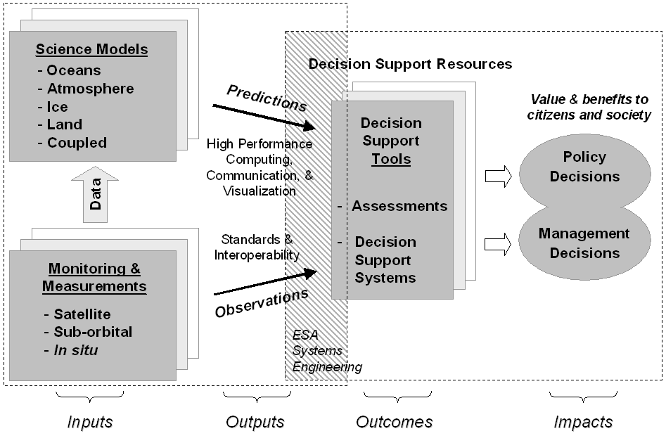
Figure 1. Applications framework and the role of ESA systems engineering.

Introduction to HAZUS-MH Hurricane Model
One of the 12 National Applications, Disaster Management, includes the management of natural disasters due to severe winds, flooding, earthquakes, and other factors. NASA recently selected the HAZUS-MH software as a DST candidate for improvement using NASA remote sensing assets and computer-aided modeling capabilities. HAZUS-MH software enables use of geospatial data and geographic information system (GIS) technology to assess the risk level of properties and communities to damage and loss from multiple hazards, such as earthquakes, flooding, and wind. Initially, NASA will work the Hurricane Wind Model aspect of the HAZUS-MH software.
The HAZUS-MH Hurricane Wind Model has direct relevance to the Disaster Management National Application. Ward and Main (1998) report that more than half of the U.S. population resides in coastal areas, which compose only about 1/4 of the land area. Boyd et al. (2002) indicate that coastal areas contained nearly 3/4 of the Federally recognized natural disasters occurring from 1992–1997. Applied Research Associates, Inc., (ARA) et al. (2003) report that on average, two hurricanes breach portions of the U.S. coastline each year. Herbert et al. (1996) estimate that, after adjusting for inflation, hurricanes in the United States alone caused an annual average loss of $1.6 billion for the period 1950–1989, $2.2 billion over 1950–1995, and $6.2 billion over 1989–1995. In fact, hurricanes signify the costliest natural disasters in the United States (Pielke and Landsea, 1998). Coastal human population and related infrastructure has quadrupled over the past 30 years, according to the National Science and Technology Council (NSTC) (2003). Insured coastal property values have grown dramatically with increases of 100 to 250% from 1980 through 1993 and more since then (Ross and Lott, 2000; Insurance Institute for Property Loss Reduction and Insurance Research Council, 1995). The development and utilization of the HAZUS-MH Hurricane Model will help save lives, will help people living in coastal areas to prepare for hurricane hazards, and will help emergency managers and the planning community to mitigate hurricane risk (Bausch, 2003; Lavelle et al., 2003; FEMA, 2003b).
The HAZUS-MH Hurricane Model could benefit many other National Applications identified by NASA, most specifically coastal management, ecological forecasting, homeland security, public health, and water management. The U.S. Atlantic and Gulf Coasts contain large, growing human populations. These low-lying regions are vulnerable to negative impacts from hurricanes and severe storms. Hurricanes can radically alter fisheries, cause significant coastal erosion, and cause flooding and an influx of toxins into affected waterways. For example, in 1996 Hurricane Fran caused a tremendous amount of illegal sewage discharges (Mallin et al., 1997), whereas Hurricane Andrew resulted in massive erosion of barrier islands in southeastern Louisiana (Guntenspergen, 1998). Hurricanes also pose threats to homeland security, with respect to both offshore and terrestrial security. The HAZUS-MH Hurricane Model may help in regard to other National Applications, such as agricultural efficiency, aviation, energy management, and carbon management. Hurricanes can raise havoc with agricultural areas, disrupt electricity, delay air travel, and cause extensive damage to vegetation.

Overview of HAZUS-MH Loss Estimation Tool
The HAZUS-MH Loss Estimation Tool is a GIS-based decision support system tool developed by the U.S. Federal Government for natural hazards loss estimation. Several publications give general descriptions of the HAZUS-MH software, including Schauer et al. (2002), Bausch (2003), Lavelle et al. (2003), and Srinivasan (2003). The Federal Emergency Management Agency (FEMA) oversees HAZUS-MH activities at large, whereas the National Institute for Building Sciences (NIBS) manages this tool’s development and implementation for use by the Federal, State, and Municipal emergency management community. FEMA initially released HAZUS in 1999 as HAZUS-99 SR2, then primarily a tool for earthquake disaster risk assessment.
More recently, HAZUS has been expanded to accommodate multi-hazard loss estimation and consequently renamed to HAZUS-MH. The Federal Government has developed HAZUS-MH as a GIS-based planning tool for emergency managers to address a fundamental question: As earthquakes, hurricanes, and floods continue to occur, how can we plan to minimize damage and loss of life from these natural events to ensure that natural hazards do not become large-scale, catastrophic natural disasters? This software provides a means to convey risk to the public so that communities can be informed and motivated to respond appropriately through better hazard planning, preparation, mitigation, and response. The HAZUS-MH software is designed to be easy and quick to use, given a familiarity with the software.
The main modules of HAZUS-MH pertain to earthquakes, wind, and flood hazard risk assessment. The literature on HAZUS-MH contains some ambiguity regarding what is considered a module and what is considered a model. In this report, “module” denotes only the major software components of HAZUS-MH: the Wind, Flood, and Earthquake Modules. The most recent version of HAZUS-MH includes the new module for assessment of coastal flooding in addition to the preexisting earthquake module. The third module on wind hazards to assess risk of property loss and damage from hurricane winds will soon be available to HAZUS users.
Lavelle et al. (2003) refer to the HAZUS-MH Hurricane Module as the “Preview” Hurricane Model, scheduled for release in fall of 2003. A full-capability Hurricane model is tentatively scheduled for release in 2006. The additional capabilities will include ability to estimate risk of property damage and loss from hurricane wind, storm surge, waves, and flooding damage. HAZUS-MH is also being expanded to address other forms of wind hazards, including tornados, extra-tropical storms, hail storms, and thunderstorms. The accommodation of additional wind hazards is scheduled to be available in 2006.
Each hazard-specific module includes a basic functionality common to all HAZUS natural hazards loss estimation software, plus additional functionality unique to the particular hazard (e.g., Hurricane Wind). Each HAZUS-MH module (earthquake, wind, flood) allows the user to map, assess, and display geospatial data pertaining to a specific natural hazard to assess and mitigate hazard risk. HAZUS-MH also enables estimation of physical damage to buildings, critical facilities, and other infrastructure. In addition, each hazard-specific module gives estimates of economic loss (e.g., lost jobs, business interruption, repair costs, construction costs) and social impacts (e.g., identifying requirements for shelters and medical aid). HAZUS-MH allows end users (1) to assess hazard vulnerability to identify areas requiring additional planning consideration; (2) to assess pre-disaster preparedness and readiness; (3) to compute potential losses from assorted hazard events, such as pre-event, near real-time, and post-event reporting scenarios; (4) to determine resource allocation needed for most effective response and recovery; and (5) to prioritize implementation of mitigation measures required to reduce/mitigate future losses.
The HAZUS-MH Hurricane Model in “Preview” form will allow users to model hurricane winds and to assess impacts (Figure 2). The model will also compute basic estimates of potential damage to residential, commercial, and industrial buildings. In addition, it will estimate direct economic losses. However, the Preview version of the model will not estimate indirect economic losses and impacts to lifelines. These additional capabilities will be available in the full-capability version of the software.
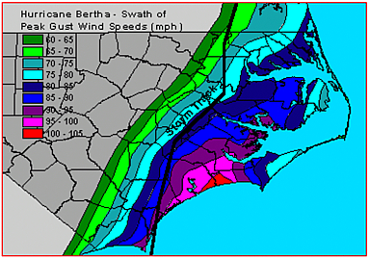
Figure 2. HAZUS-MH Hurricane Model DST output using data from Hurricane Bertha over North Carolina.
HAZUS-MH runs on PCs in conjunction with GIS software made by the Environmental Systems Research Institute (ESRI). Under ESRI’s ArcView and ArcGIS, the HAZUS-MH Flood Module requires use of ESRI’s Spatial Analyst Extension software. According to FEMA, the earthquake and hurricane (winds) HAZUS-MH modules do not require this extension (FEMA, 2003a, 2003c). However, running the hurricane wind and flood models together will require the Spatial Analyst Extension.
HAZUS-MH makes use of nationwide geospatial databases and employs national standardized loss estimation and risk assessment methodology. The use of GIS enables geospatial relationships to be computed and assessed within and between map layers and enables hazard risk scenarios to be more effectively modeled and communicated. The geospatial databases used by HAZUS-MH employ many GIS coverages: (1) demographics, (2) building stock, (3) essential facilities, (4) transportation, (5) utilities, and (6) high potential loss facilities. These databases are non-proprietary and are easily customized. The use of national standardized loss estimation and risk assessment methodology came about through engineering analysis in conjunction with hazard-specific oversight committees consisting of expert practitioners and academic professionals. This methodology is also non-proprietary and has been well documented by FEMA (2003b), Lavelle et al. (2003), and others.
HAZUS-MH can be applied to multiple scales of observation, including regional, community, neighborhood, and individual site (i.e., building lot) assessment. However, individual site assessment requires additional data entry from the end user. The software is highly flexible with respect to data entry and can accept three levels of input: Level 1 – nationwide data provided with the software, Level 2 – data developed and input directly by end users, and Level 3 – data developed by experts for input into the system.
The HAZUS-MH Hurricane Model constitutes an improvement over existing loss estimation models in that it employs a wind hazard-load-damage-loss framework (Bausch, 2003; Lavelle et al., 2003; FEMA, 2003b). This DST initially applied to areas along the Atlantic and Gulf coasts, where the majority of United States hurricane threats tend to occur. The software has been recently expanded to include the Hawaiian Islands (FEMA, 2003a). The model will address wind pressure, windborne debris, surge and waves, atmospheric pressure change, duration/fatigue, and rain. Upgrades to the HAZUS-MH Hurricane Model will be made to aid future assessment of mitigation, benefit-cost, and building code issues.
HAZUS-MH has a large and varied group of potential end users: (1) emergency managers, (2) community planners, (3) building officials, (4) federal agencies, (5) policy makers, (6) public works/utilities, (7) engineers and scientists, (8) insurers, (9) academic institutions, (10) software developers, and (11) GIS consultants. ARA et al. (2003) estimated the total HAZUS-MH user base to be over 1700 prior to the 2003 release of the Hurricane and Flood modules and expect this user base to grow to over 9000 end users when these two modules come on line. In addition, HAZUS User Groups now exist in several states and/or regions of the country. These user groups hold meetings and maintain Web sites to exchange information on applications of the HAZUS-MH software (see http://www.fema.gov/hazus/us_main.shtm for additional information).
A sizeable and diverse team including the following members oversees software development: (1) FEMA Mitigation Directorate; (2) NIBS, which is in charge of project management; (3) expert committees that provide technical and expert oversight; and (4) leading firms in loss estimation (e.g., ARA, Inc.) that are in charge of technical and software development, pilot studies, and model calibration/validation. The expert oversight committees consist of several Federal agencies, many universities, some state agencies, and multiple consulting firms. In addition, FEMA is providing software training and education, plus technical support in the use of the HAZUS-MH.

Detailed Description of HAZUS-MH Hurricane Model
HAZUS technical information was found in several documents, including conference papers by Lavelle et al. (2003) and Schauer et al. (2003), a draft pre-release technical manual by FEMA (2003b), and journal papers regarding components of the HAZUS-MH Hurricane Model. Vickery et al. (2000a, 2000b) and Vickery and Twisdale (1995a, 1995b) address modeling and prediction of hurricane wind fields and simulation of hurricane risks. In addition, a preliminary course manual by FEMA (2003b) provided up-to-date information on the software.

Capabilities of the Software
Lavelle et al. (2003) report that the HAZUS-MH Hurricane Model employs a unique wind hazard-load-damage-loss framework considered to be a significant improvement over pre-existing loss estimation models. According to Bausch (2003) and FEMA (2003b), the HAZUS-MH Hurricane Model features the following:
- A building classification system that depends on the characteristics of the building envelope and building frame.
- The capability to compute damages based on building classes and the effects of progressive failure from wind-induced rain damage.
- The capability to compute damage to building contents and interior.
- The capability to estimate tree blow down and structure debris quantities.
- Loss estimates that will include direct and indirect economic loss, shelter requirements, and casualties.
FEMA (2003b) summarizes additional information regarding the data used in the Hurricane Model and the user data input requirements as shown in Table 1. While all data parameters can be addressed with Level 1 data resident to the software, improved results can be obtained by user-supplied data input for the following parameters: (1) wind model, (2) building inventory; (3) terrain, and (4) shelter requirements. Level 1 data is nationally available geospatial data, using national standards for geoprocessing such data. For HAZUS99 software (a precursor to HAZUS-MH), Level 1 data includes 43 map coverages organized under the following headings: (1) General Building Stock (2 coverages), (2) Essential Facilities (3 coverages), (3) High Potential Loss Facilities (3 coverages), (4) Transportation System (16 coverages), and (5) Utility System (19 coverages). The origin of Level 1 data depends on the thematic map coverage as summarized in Appendix H (FEMA, 2002b). Sources for Level 1 data include map coverages from the U.S. Census Bureau, the American Heart Association Database, FEMA, National Dams Inspection Program, U.S. Census TIGER files, National Bridge Inventory, Applied Technology Council ATC-13 and ATC-25 databases, and the Environmental Protection Agency. Level 1 data enables regional studies (e.g., county and state levels), whereas the user-supplied Level 2 and the expert-supplied Level 3 data regard more site-specific assessment (e.g., census block and property levels).

Table 1. Parameter/data versus data level.
Parameter/Data | Level 1 (Default Data) | Level 2 (User-Supplied Data) | Level 3 (Advanced Data)
Wind Model | Default Probabilistic | User-Defined Scenario
Building Inventory | Default | User-Supplied
Facilities and Building Classes | Residential Commercial  Industrial Essential  Facilities
Utility, Transportation, and High Potential Loss Facilities | Display/Edit Locations Only – No Damage or Loss Estimates
Terrain | Default |  | Expert-Supplied
Loss Functions | Default
Damage Functions | Default
Shelter Requirements | Default | User-Supplied Parameters
Debris | Default
Source: FEMA, 2003b
The “Preview” Hurricane Model has recently been delivered to FEMA for distribution.

Functional Components of the Hurricane Model
The FEMA (2003b) flowchart of the HAZUS-MH Wind Model (Figure 3) depicts current and future components of the Hurricane Model in terms of six functional components: (1) Hazard Type, (2) Modes of Analysis, (3) Reference Geospatial Databases, (4) Hazard Effects, (5) Physical Damage Estimation, and (6) Loss Estimation.
As of 2003, hurricane winds will be the only wind hazard applicable to HAZUS-MH, although future versions will also allow other wind hazards, such as extratropical storms, thunderstorms, tornados, and hail storms. Extratropical storms are former tropical storms traveling through temperate latitudes. To begin using the HAZUS-MH software, the user must select the region of interest prior to performing risk assessment analysis with the software (FEMA, 2003c).

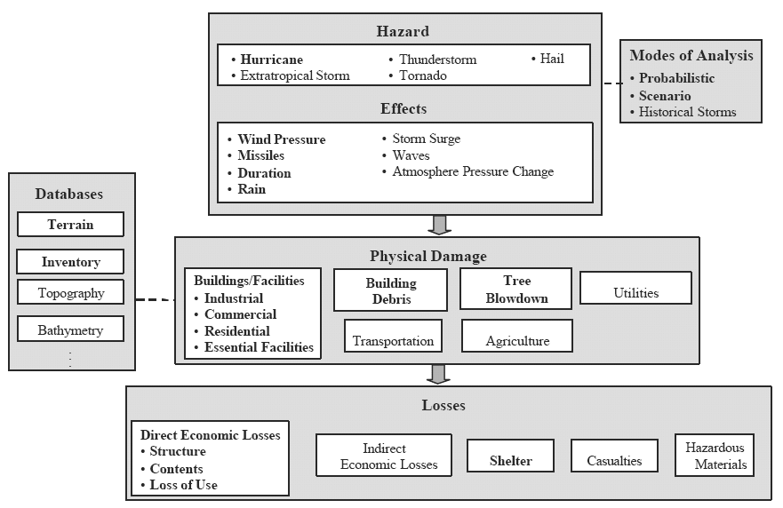
Bold text indicates currently enabled features; regular text indicates future, non-enabled features
Source: FEMA, 2003b
Figure 3. HAZUS-MH Hurricane Model flowchart.

Modes of Analysis for Hurricane Wind Risk Assessment
The HAZUS-MH Hurricane Model will allow users to implement all three modes of analysis: probabilistic, scenario, and historical storm. The addition of the historical storm mode is subsequent to the release of the FEMA (2003b) draft technical manual on the software.
The probabilistic mode of hurricane risk analysis employs a 100,000-year storm simulation dataset to estimate annualized loss for 7 return periods of 10, 20, 50, 100, 200, 500, and 1000 years. In doing so, the software also enables users to view GIS-based predictive maps (i.e., geospatial models) of peak wind fields for each return period. In addition, users can compute summary descriptive and tabular reports for estimated damage and loss for each probabilistic run. The probabilistic mode can be used to estimate how many years will pass before a hurricane of magnitude X occurs for a given area based on the storm simulation data. For example, this mode of analysis can be used to estimate how many years will pass before a Hurricane Andrew returns to southern Florida.
The scenario mode of hurricane risk analysis requires user inputs regarding specific storm scenarios. For example, this mode can be used to estimate damage and loss on a per-scenario basis, given user-supplied historic or simulated information on storm track data points in regard to geolocation, intensity, and time period between data points.
The historic mode of hurricane risk analysis allows end users to estimate loss and damage in relation to historic storms frequenting a specified region of interest. HAZUS software developers added the historical storm mode subsequent to the release of the software’s draft technical manual (2003ba).

Geospatial Databases Used in Hurricane Model
The software includes a large volume of resident GIS-readable databases, including physiographic data relating to terrain (i.e., land cover), topography, and inventory data pertaining to buildings and other infrastructural features. These datasets include national data on building structures and hazards as well as TIGER census data. The most recent version of the Hurricane Model now also takes topography into account.
Much of the geospatial data resident in the software concerns so-called inventory data pertaining to buildings and other infrastructure (FEMA, 2003c). Inventory data is often common to all hazards, although some such data is hazard specific. Generic inventory data is included with the software for use as default Level 1 data (Table 1): (1) general building types and occupancies, (2) lifelines, (3) replacement costs, and (4) demographics. Hazard-specific inventory data pertains to specific building types, elevation, and building configurations. For all primary HAZUS-MH modules, buildings are categorized according to five structural classes (wood, steel, concrete, masonry, and manufactured housing) and seven major occupancy classes (residential, commercial, industrial, agricultural, religion/nonprofit, government, and education). Specific to the hurricane model, the building classification scheme consists of 39 specific building types (e.g., wood, multi-unit housing, one story) and up to 9 building characteristics per building type (e.g., roof shape, roof cover type, and roof wall attachment type). In all, the Hurricane Model contains a building classification consisting of 1,884 building classes. General inventory data on buildings is also referred to in the literature as building stock data (FEMA, 2003b).
HAZUS-MH includes some utility software for user value-added geospatial database development, especially with respect to building inventory data. In particular, the software includes (1) the Inventory Collection and Survey Tool (INCAST), and (2) the Building Inventory Tool (BIT). These software utilities can be used for producing Level 2 datasets (Table 1).

Models Resident to HAZUS-MH Hurricane Model
Lavelle et al. (2003) discusses the HAZUS-MH Hurricane Model in terms of six input models: (1) hurricane hazards, (2) terrain, (3) wind pressure, (4) windborne debris, (5) physical damage estimation, and (6) building loss estimation (Figure 4). These six input models collectively enable the Hurricane Model software to estimate building damage and loss from hurricanes occurring along the Atlantic and Gulf coasts and the Hawaiian Islands. The remainder of this section provides an overview of these six input models for the HAZUS-MH Hurricane Model based on Lavelle et al. (2003) and FEMA (2003a,b).

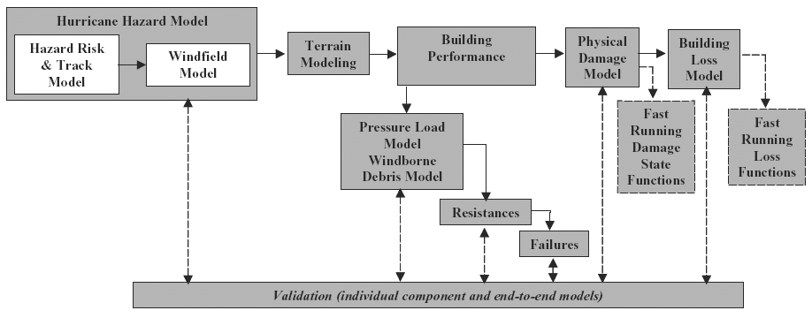
Source: Lavelle et al., 2003
Figure 4. Model inputs for HAZUS-MH Hurricane Model.

Hurricane Hazard Model
The Hurricane Hazard Model consists of a hazard risk and track model as well as a windfield model that enable hurricanes to be simulated by modeling the full hurricane track. In doing so, the model estimates central pressure as a function of sea surface temperature, allowing for updates of storm heading, speed, etc. at a user-specified time interval (e.g., 6 hours). The coupling of the hurricane track and windfield models enables computational estimates of hurricane wind speed at any location in the vicinity of coastlines. The model allows for statistical analysis with respect to multiple landfalls, bypassing storms, and hurricane storm characterization. It also enables modeling effects of rainfall entering damaged buildings. In-depth documentation on the hurricane track model can be found in Vickery et al. (2000b). Vickery et al. (2000a) provides a detailed account of the wind field model. Powell et al. (2003) have developed an approach to modeling the windfield at landfall for the State of Florida, comparable to that described by Vickery et al. (2000a,b).

Terrain Model
Experts associated with HAZUS-MH software development regard terrain models of surface roughness to be a crucial input for effective estimation of wind effects and of damage and loss to buildings and facilities. Ground surface roughness length is denoted as Z₀ and is a function of feature height and density distributions of features on the ground. Figure 5 illustrates the impact of Z₀ on the magnitude of peak gust wind speed as a function of height above the ground. The x-axis in this chart is actually dimensionless, showing the velocity profiles as being normalized by the velocity measured at 10-meter height in open terrain (Z₀=0.03). Note that the second lowest curve (Z₀=0.03) passes through 1.0 at a height of 10 m. The higher Z₀ values equate to rougher surface length values (e.g., heterogeneous urban and uneven canopy forest surfaces). The peak gust velocity is lowered for rough surfaces (higher Z₀ values). Rougher ground surfaces lower wind speeds on the ground, even while the upper level wind speeds stay constant. See Appendix A for additional description on equations used for estimating Z₀.

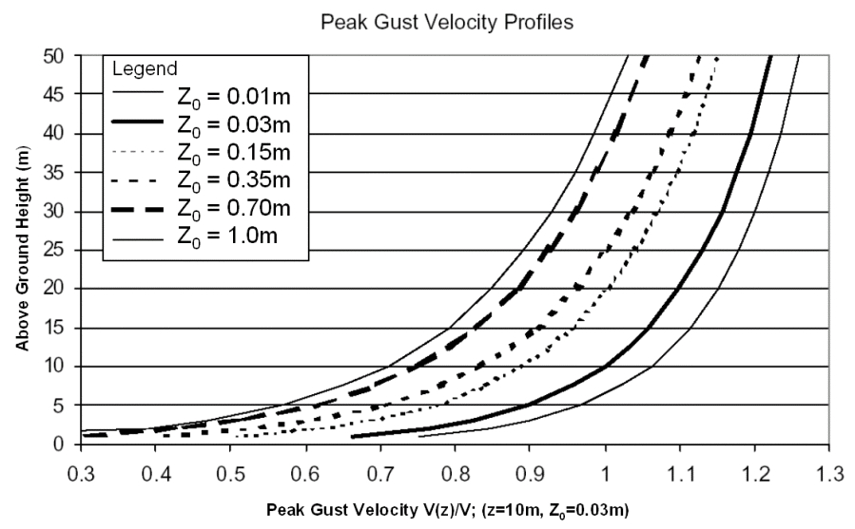
Source: FEMA, 2003b
Figure 5. Peak gust velocity as a function of Z₀.
Because of lowered surface roughness characteristics, hurricane winds pose a greater risk of damage and loss to housing in open areas than to housing in wooded areas (Figure 6). For example, Lavelle et al. (2003) report that one- or two-storied buildings within forested areas receive half the wind loads experienced by the same housing in open areas. By default, the HAZUS-MH Hurricane software models the terrain for general building stock as being a uniform value across a census tract.
The HAZUS-MH Hurricane model does currently not include a means for directly estimating surface roughness over regions applicable to the software. Instead, it employs an alternative approach: using land cover maps and lookup tables for assigning an average roughness on a land cover type basis. For all areas except Florida, the software uses land cover map data from the National Land Cover Database (NLCD) that originated from Landsat (Table 2). In doing so, wind engineering experts on the HAZUS software development team assign land-cover-specific surface roughness length based on in-situ measurements weighted by expert consensus. Table 2 indicates that some in-situ measurements of land cover types (e.g., low intensity residential) took place in many more subregions of the country than others (evergreen forest). In some cases, particularly over residential areas, aerial photograph analyses were performed in the process of assigning surface roughness length to land cover types. Validation of the NLCD data for use in HAZUS-MH hurricane software applications revealed two types of errors: (1) misclassification error in regard to certain land cover (e.g., residential areas), and (2) locational errors of as much as 120 meters (FEMA, 2003b).
Areas in Florida make use of Florida land cover map data from the Land Use Land Cover (LULC) databases maintained by the five Florida Water Management Districts (FEMA, 2003a,b,c). The Florida LULC database is used because it more discretely defines forested areas in terms of average height and density than the NLCD data. The software allows expert users to input terrain data needed (e.g., land cover/land use) for computing surface roughness length.

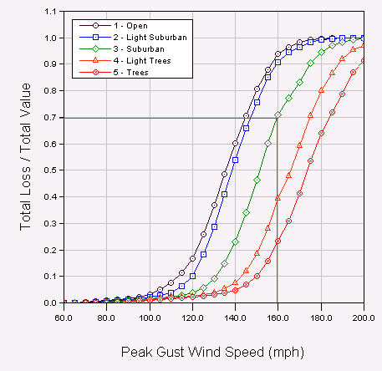
Source: FEMA, 2003b
Figure 6. Total loss versus peak gust velocity as a function of terrain-based Z₀. The magenta line in the graph was included to provide a point of reference.

Table 2. NLCD Land Use/Land Cover versus look-up table of Z₀.
MRLC-NLCD Land Cover Classification and Numerical Coding | Land Surface Roughness Length,  z0 (m) |  |  |  |  | Number of Sub-Regions Used
MRLC-NLCD Land Cover Classification and Numerical Coding | Used | Avg. | COV | Max. | Min. | Number of Sub-Regions Used
Water
11 Open Water | 0.010 | 0.013 | 0.612 | 0.030 | 0.010 | 6
12 Perennial Ice/Snow | 0.012 |  |  |  |  | 0
Developed
21 Low Intensity Residential | 0.350 | 0.307 | 0.496 | 0.600 | 0.010 | 51
22 High Intensity Residential | 0.600 | 0.401 | 0.498 | 0.800 | 0.080 | 39
23 Commercial/Industrial/ Transportation | 0.350 | 0.265 | 0.605 | 0.600 | 0.030 | 28
Barren
31 Bare Rock/Sand/Clay | 0.200 | 0.300 |  |  |  | 1
32 Quarries/Strip Mines/Gravel Pits | 0.400 |  |  |  |  | 0
33 Transitional | 0.400 | 0.400 | 0.661 | 0.600 | 0.100 | 3
Forested Upland
41 Deciduous Forest | 0.600 |  |  |  |  | 0
42 Evergreen Forest | 0.600 | 0.500 |  |  |  | 1
43 Mixed Forest | 0.600 |  |  |  |  | 0
Shrubland
51 Shrubland | 0.060 | 0.040 |  |  |  | 1
Non-natural Woody
61 Orchards/Vineyards/Other | 0.210 | 0.213 | 0.777 | 0.400 | 0.050 | 4
Herbaceous Upland
71 Grasslands/Herbaceous | 0.150 | 0.193 | 0.662 | 0.300 | 0.050 | 4
Herbaceous Planted/Cultivated
81 Pasture/Hay | 0.150 | 0.160 | 1.301 | 0.400 | 0.030 | 3
82 Row Crops | 0.100 | 0.100 | 0.913 | 0.300 | 0.030 | 8
83 Small Grains | 0.030 |  |  |  | 0
84 Fallow | 0.030 |  |  |  | 0
85 Urban/Recreational Grasses | 0.150 | 0.155 | 0.514 | 0.250 | 0.030 | 6
Wetlands
91 Woody Wetlands | 0.300 | 0.545 | 0.594 | 1.100 | 0.300 | 10
92 Emergent Herbaceous Wetlands | 0.030 | 0.188 | 0.959 | 0.600 | 0.050 | 10
Source: FEMA, 2003b

Wind Load Model
According to Lavelle et al. (2003), the wind-loading model is an empirical model for estimating directionally dependent wind-induced pressures subjected to building exteriors during windstorms. This model employs pressure coefficient data from several boundary-layer wind tunnel tests that measured wind pressures on model buildings (Figure 7). The model also utilizes directional pressure coefficient information from British and Australian wind codes. Pressure coefficient models have been developed for several types of buildings as a function of number of stories and roof type (FEMA 2003a,b). Windstorms exert both positive and negative wind-induced pressure on buildings, which can lead to structural damage and even failure. Positive wind-induced pressure refers to pressure exerted externally onto a building, whereas negative pressure denotes pressure exerted internally from the building outward toward the building’s exterior. The model also considers adjacency effects regarding how the juxtaposition of buildings influences wind loads. For example, adjacent buildings can reduce the negative pressures on roofs and walls of low buildings by about 25% but do not affect positive pressures acting on walls of such buildings (Lavelle et al., 2003; FEMA, 2003b).

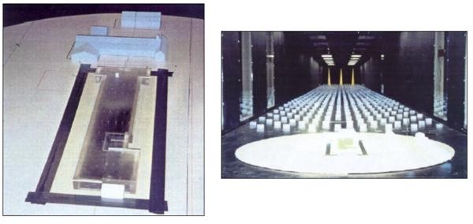
Source: FEMA, 2003b
Figure 7. Examples of house models within wind tunnels.

Windborne Debris Models
Windborne debris can cause or lead to building structural breaches and building failures during high wind events, such as hurricanes. The physically based building damage model requires reasonable estimates of windborne debris loads as an input. The HAZUS-MH Hurricane Model employs two types of windborne debris models: one estimates debris missile impacts from residential areas and one models debris impacts from rooftop gravel, most commonly associated with commercial land use zones. Lavelle et al. (2003) describes the residential debris model as a first principles model for estimating hurricane debris impact probabilities, impact momenta, and impact energy. The windborne debris model for rooftop gravel was specifically developed for use in HAZUS-MH in conjunction with commercial areas, where rooftop gravel missiles can inflict significant damage to adjacent buildings. Researchers used wind tunnels and residential model simulation to characterize the likelihood of missile impacts from windborne debris due to shingles, wood, and sheathing (FEMA, 2003a). Twisdale et al (2000a,b) and FEMA (2003b) provide more detailed description on the development of the wind debris models for use in the HAZUS-MH hurricane model.

Building Damage Model
This damage model estimates damage to several building components, including windows, doors, wall cladding, roof cladding, and roof cover. This model is also used to predict failure of glazing from wind debris impacts, wall failure from wind pressure for brick and wood frame walls, wall/roof frame connection failure for wood and steel wood frames, and foundation failure due to multiple earth movement processes for manufactured housing. The Building Damage Model is important to the building loss module, because loss estimates are based on estimations of physical damage and repair costs.
The model inputs include nationally available regional building inventory data and storm characteristics data. Calculation of storm characteristics data depends on how the user sets up the region and analysis mode (e.g., historic, probabilistic, or scenario). Damage estimation is based on comparing building loads to resistances. The software enables computation of loads by spatially integrating estimated pressure coefficients at each point on a grid corresponding to the building surface. The resistance for each failure mechanism per building component is defined by a probability function used to sample resistances for a given storm scenario. Damage is estimated in an accumulative manner as the storm passes through the region of interest by incorporating wind speed and direction at 15-minute time intervals over the storm duration. The wind speed and direction can be user specified in the scenario analysis mode via the software user interface. As discussed earlier, the software also allows users to enhance the building stock data loaded with the software. Each time interval includes comparison of wind building loads and resistances to predict physical damage. The software concurrently estimates the number of missiles (e.g., flying 2x4s) impacting building walls to predict glazing damage and damage to wall finish.
The Building Damage Model also estimates the number and size of wall breaches due to failed windows, doors, and wall cladding. If additional breaching occurs between time steps, the software re-computes internal and external building pressure parameters to compare loads versus resistances and to estimate additional building damage.
Building Damage Model validation compares of hurricane observations to simulated damage test scenarios, involving full reproductions of wind speed and direction time histories in conjunction with the hurricane wind field model described earlier. According to Lavelle et al. (2003) and FEMA (2003a), case studies include those on damage to roof cover, roof sheathing, and windows. Simulations from HAZUS-MH Hurricane Model analyses were compared to observed data from Hurricanes Andrew, Erin, and Fran.

Building Loss Model
The Building Loss Model provides estimates of economic losses to buildings, content and/or inventory losses, and costs associated with the loss of use of the building. As with the Building Damage Model, inputs include nationally available regional building inventory data and storm characteristics data. Calculation of storm characteristics data depends on how the user sets up the region and analysis mode (e.g., historic, probabilistic, or scenario). The outputs of the model include estimates of building loss, contents loss, loss of use, business inventory loss, relocation expense, loss of income, rental income, wage income, output loss, and economic loss (FEMA, 2003a). The software computes building losses using a combination of explicit and implicit costing techniques in conjunction with estimates of physical damage to the building. Explicit costing includes estimated replacement costs to exterior building components, such as windows, doors, sheathing, and roof cover. The software employs replacement thresholds to determine if the degree of physical damage and loss is sufficient to warrant complete replacement. Implicit costing pertains to estimates of water volume entering failed openings in the building and the resulting impacts to interior housing components (e.g., electrical system) and contents. Implicit costing employs empirical functions based on engineering judgment and insurance company loss data. The software provides different loss estimation capabilities and methodologies for different building types (e.g., residential, manufactured homes, and commercial buildings). The implicit functions relate the interior damage cost estimation to building exterior damage estimation. The contents loss model also employs an explicit and implicit costing approach. In addition to exterior and interior loss estimation, the software also enables prediction of the amount of time required to reconstruct a house. Additional information on the Building Loss Model is available in FEMA (2003a), the technical manual for the HAZUS-MH Hurricane Model.

Possible NASA Remote Sensing Inputs to DSTs
The current version of the HAZUS-MH Hurricane Model focuses on wind-related risk assessment. Eventually, however, this model will also include risk assessment of hurricane damage due to storm surge, waves, tides, and flooding. In effect, the eventual DST will enable a more integrated, complete assessment of hurricane risk. NASA remote sensing technologies may provide essential inputs needed to hasten and refine the development of these additional capabilities. NASA remote sensing technologies and related modeling software may also help improve certain facets of the current hurricane wind risk assessment capability.
One of the main information needs of the current HAZUS-MH Hurricane Model is for improved estimates of surface roughness length, Z₀. In fact, based on scenario analyses with HAZUS-MH Hurricane Model software, the roughest surface terrain types (i.e., land cover/land use types) can equate to a 50% reduction in total projected loss (see Figure 6 and FEMA, 2003b). Developing residential areas with some forest cover can greatly lower the risk of direct hurricane wind damage in coastal areas and may therefore save a great deal of money (FEMA, 2003b). However, it should be noted that coastal suburban areas with forest cover could be at risk to indirect wind damage from tree blow down.
As discussed previously, the HAZUS-MH Hurricane Model currently employs land cover maps with Z₀ look-up tables. Such land cover maps are derived from Landsat data. However, the land cover data used can be out of date, as many United States coastal areas experience significant growth and related land cover change (NSTC, 2003). Land cover maps are not a direct measure of surface roughness length but are more an approximation in which experts have used combined knowledge, data, and simulations to assign an average roughness value to a given land cover. The accuracy of the Z₀ average values assigned to land cover types is directly related to the accuracy of the land cover classification and to the amount of within-class variation in surface roughness. A more direct means of determining Z₀ is to apply statistical regression techniques to remote sensing data using anemometer data in a reference capacity. This technique can be used alone or as supporting information to improve Z₀ values derived from another technique.
Predictive maps of surface roughness length may be computed using a variety of data sources: (1) anemometer data, (2) land cover maps from multispectral remote sensing imagery in conjunction with Z₀ look-up tables, (3) digital elevation models, (4) textural information from remote sensing data (e.g., synthetic aperture radar (SAR) backscatter data and high resolution electro-optical imagery), (5) geospatial surface resistance models computed from multispectral reflectance vegetation indices and thermal imagery (e.g., through NASA’s Moderate Resolution Imaging Spectroradiometer (MODIS) data), (6) stereoscopic high-resolution remote sensing imagery (e.g., aerial photography), and (7) thermal remote sensing data often included with multispectral electro-optical data. NASA has a wealth of remote sensing technology from a variety of platforms that may be of value in improving surface roughness estimates of the HAZUS-MH Hurricane Model. Table 3 reflects an initial investigation of remote sensing data that could address land cover classification and digital elevation model (DEM) requirements for the computation of surface roughness coefficients. These data range in spatial and spectral resolution from coarse to fine, reflecting a variety of inputs to be tested in a modeling environment. One aspect of the partnership between NASA and FEMA will be to test these data and to determine the model’s sensitivity to changing spatial and spectral resolutions.

Table 3. NASA-related geospatial data available with potential for Z₀ estimation studies.
Remote Sensing Data/Model
NASA-Related Data Source | NASA-Related Data Products
Flux Tower Anemometer Data
FLUXNET Ecological and Atmospheric Monitoring Sites | See http://daac.ornl.gov/FLUXNET/
NASA Remote Sensing V&V Sites | e.g., NASA Stennis Space Center
Multispectral Reflectance Data
MODIS Reflectance Data | MOD09A1 – 8-Day Mean Surface Reflectance at 250 or 500 m
MISR Reflectance Data | Level 1B2 – Georectified Radiance
ASTER Reflectance Data | AST_07 – L2 Surface Reflectance VNIR/SWR
Landsat Reflectance Data | SDP Landsat TM, ETM Products
IKONOS Reflectance Data | SDP Products – Select Sites
QuickBird Reflectance Data | SDP Products – Select Sites
DEM Data
SRTM DEM Data | 30 m SRTM DEM data – see http://srtm.usgs.gov/
Airborne LIDAR Altimetry DEM Data from NASA | Airborne Topographic Mapper (ATM) 5 m DEM data
Airborne LIDAR Altimetry Commercial DEM Data | SDP Products – Select Sites
ASTER DEM Data | AST14DEM ASTER DEM
Airborne Interferometric Synthetic Aperture Radar (InSAR) Commercial DEM Data | SDP Products – Select Sites
RS Textural Data
MODIS Reflectance Data | MOD09A1 – 8-Day Mean Surface Reflectance at 250 or 500 m
ASTER Reflectance Data | AST_07 – L2 Surface Reflectance VNIR/SWR
Landsat Reflectance Data | SDP Landsat TM, ETM Products
IKONOS Reflectance Data | SDP Products – Select Sites
QuickBird Reflectance Data | SDP Products – Select Sites
SRTM C-Band SAR Data | See http://srtm.usgs.gov/
Evapotranspiration/Surface Resistance
MODIS Evapotranspiration/Surface Resistance Data | MYD16A2 – 8-Day Mean L4 Global 1 km
Stereoscopic Reflectance Data
ASTER VNR Reflectance Data | AST_07 – L2 Surface Reflectance VNIR/SWR
NASA RS Data Archives | Aerial Photography
Thermal Data
MODIS Thermal Data | MOD11A2 – MODIS Land Surface Temperature/Emissivity 8-Day L3 Global 1 km
ASTER Thermal Data | AST_09T – ASTER On-Demand L2 Surface Radiance TIR
Landsat Thermal Data | SDP Landsat TM, ETM Products
As indicated in Table 3, anemometer data from FluxNet and from NASA remote sensing verification and validation (V&V) sites could be useful as reference data in evaluating and refining surface roughness estimates. Using the land cover mapping approach, MODIS, Multi-angle Imaging SpectroRadiometer (MISR), and Advanced Spaceborne Thermal Emission and Reflection Radiometer (ASTER) data can be used to generate land cover maps as input for estimating surface roughness. At this time, utility of the land cover classification derived from such sensor data is unknown in regard to HAZUS requirements for estimating property damage and loss. Other approaches also may be useful to evaluate. For example, ASTER data acquired in stereo mode can be used to develop digital elevation models. NASA airborne LIDAR altimetry has already been acquired along much of the U.S. Atlantic and Gulf coast. This data and the data collection capability it represents could be used to improve estimates of Z₀ for the most critical areas. Other NASA DEM data could be used as well, such as the 30 meter DEM data from the Shuttle Radar Topography Mission (SRTM). The SRTM also produced C-band SAR backscatter imagery that may also be used for characterizing surface roughness, which may be worth evaluating for use in rain-prone regions where electro-optical imagery can be difficult to collect. Textural data from other remote sensing data types are also available for evaluation in regards to Z₀ estimation.
The relationships between evapotranspiration, thermal measurements, and surface roughness are not immediately obvious. However, some associations between heat flux, aerial resistance to the flow of sensible heat, and surface roughness seem to exist and should be explored (see Appendix A). Preliminary research shows (at least at the equation level) that there may be some usable relationship between r_{a} and z₀—but how can r_{a} be “measured” with NASA satellites? From a phenomenological point of view, one can perceive that changes in leaf structure in a crop or forest canopy will impact wind speed profiles associated with z₀. The thermal and evapotranspiration products available from Aqua/MODIS and ASTER may, therefore, be useful in inferring information about vegetation vigor and hence, surface roughness. It should be noted, though, that this an area will require research before it can be integrated into operational models such as HAZUS.
ARA et al. (2003) discuss how NASA remote sensing technology and models could address information needs for upcoming components of the HAZUS-MH Hurricane Model. In particular, ARA et al. (2003) propose to integrate the NOAA/NASA WAVEWATCH III deep-water wave model into the HAZUS-MH Hurricane model to provide a risk estimation tool by integrating results from models for storm surge, tides, wind, and wave activity. ARA et al. (2003) also proposes to assess NASA remote sensing assets for improving DEM information for low-lying coastal areas. The default DEM data for the HAZUS-MH flood model is the 30-meter National Elevation Dataset. This resolution is less than desirable for assessing hurricane-related flooding risk of coastal communities and also poses limitations to horizontal and positional accuracies. With its suite of satellites, NASA may have the capability to develop improved DEMs. By demonstrating relevant technologies, no matter what the resolution, NASA may provide FEMA an alternative approach to the development of improved DEM data products.
In addition to the need for improved Z₀ estimation, other inputs to the HAZUS-MH Hurricane DST wind model may be improved with NASA remote sensing mission data (Table 4). For example, the HAZUS-MH Hurricane wind model employs information on sea surface temperature, hurricane track, and rainfall intensity (FEMA, 2003b) that can be derived from and possibly improved with NASA remote sensing data. NOAA provides historic storm data used in the HAZUS-MH software, and the NASA Aqua satellite includes three sensors able to compute sea-surface temperature: MODIS (Brown et al., 2002), the Advanced Microwave Scanning Radiometer (AMSR-E), and the Tropical Rainfall Measuring Mission's (TRMM) sensors (NASA, 2003). Tentatively available in 2007, the Global Precipitation Mission sensors represent another means for estimating sea surface temperature and a follow-up to AMSR and TRMM. Such data may provide improved sea-surface temperature estimation inputs to HAZUS-MH during hurricanes for forecasting or for comparison with historic storm data. The Aqua satellite's AMSR-E and the TRMM, in addition to the Global Precipitation Measurement (GPM) Microwave Imager, all offer the advantage of detecting sea surface temperatures through clouds (NASA, 2003). Other NASA remote sensing assets available for sea surface temperature studies include ASTER and Landsat thermal data, although these data types may be problematic because atmospheric correction and/or signal-to-noise resolution requirements.
The HAZUS-MH Hurricane Model also computes hurricane rainfall intensity estimates, which may be improved and validated with the NASA TRMM and GPM sensors, at least for areas within ground coverage of the sensor. In addition, QuikSCAT and SeaWinds sensors are used to estimate wind intensity and direction for hurricanes and may help to improve hurricane-tracking information within the HAZUS-MH Hurricane Model. NASA’s Jason-1 satellite altimeter collects data on sea surface height, a critical measure of ocean energy available to developing hurricanes. The hurricane boundary layer model of the HAZUS-MH Hurricane Model incorporates sea surface roughness and the sea-air temperature difference at the estimated surface level (FEMA, 2003a), so Jason-1 could be an effective contributor to HAZUS-MH as well.
NASA has maintained sites for remote sensing V&V that could be useful for aiding surface roughness studies. An appropriate V&V site for the HAZUS-MH study of surface roughness will include a highly developed spatial and geodetic target range, a wealth of current remote sensing datasets over the site, and a variety of weather instrumentation that is frequently used in characterizing spaceborne and airborne remote sensing assets (Pagnutti et al., 2002). Other required capabilities include flux towers containing weather monitoring instrumentation, including anemometers to measure wind speed (ARA et al., 2003). A typical flux tower is shown in Figure 8.

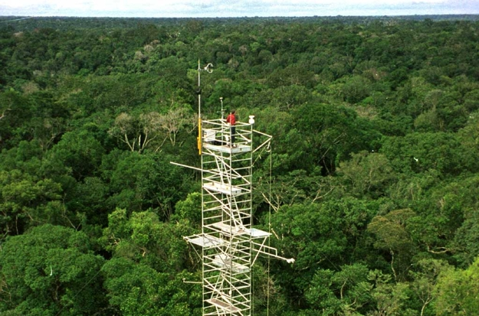
Photo Credit: Alessandro Carioca de Araújo
Source: CarboEurope Web site at http://www.bgc-jena.mpg.de/public/carboeur/archive/foto.html
Figure 8. A flux tower with a sonic anemometer deployed at the top.

Table 4. NASA-related remote sensing models and assets with potential for contributing to the HAZUS-MH Hurricane Model DST parameters other than Z₀.
HAZUS-MH Hurricane Model Parameter
NASA-Related Data Source | NASA-Related Data Products
Elevation Data For Flood Assessment
Airborne NASA LIDAR Altimetry DEM Data | Airborne Topographic Mapper (ATM) 5 m DEM data
Airborne Commercial LIDAR Altimetry DEM Data | NASA RS Data Archives - SDP Products – Select Sites
Airborne Commercial and NASA InSAR DEM Data | NASA RS Data Archives - Select Sites - Some SDP Data
Airborne Photogrammetric DEM Data | NASA RS Data Archives - Select Sites
ASTER DEM Data | AST14DEM ASTER DEM
SRTM InSAR DEM Data | See http://srtm.usgs.gov/
IKONOS DEM data | NASA RS Data Archives - SDP Products – Select Sites
Sea Surface Temperature
MODIS data | MYD28L2 - Sea Surface Temperature - 5-Min L2 Swath 1km
AMSR-E Data | AMSR-E/Aqua L2B Global Swath Ocean Products – includes SST at 56 km
TRMM Sensor Data | See http://www.gsfc.nasa.gov/topstory/2003/0909hurricane.html
GPM Microwave Imager Data | Dual-Frequency Precipitation Radar products
 | GMI Microwave Radiometer products
 | See http://gpm.gsfc.nasa.gov/index.html
ASTER Thermal Radiance Data | AST_09T – ASTER On-Demand L2 Surface Radiance TIR – 90 m
Landsat Thermal Data | L7WRS2_L1 Level 1 WRS Scene – 60 m
Rainfall Amount/Intensity
TRMM Sensor Data | See http://trmm.gsfc.nasa.gov/data_dir/ProductStatus.html
GPM Microwave Imager Data | Dual-Frequency Precipitation Radar products
 | GMI Microwave Radiometer products
 | See http://gpm.gsfc.nasa.gov/index.html
Wind
QuikSCAT Data | Level 3 Daily, Gridded Ocean Wind Vectors
SeaWinds Data | See http://winds.jpl.nasa.gov/
Sea Surface Height
Jason-1 Altimeter Data | See http://topex-www.jpl.nasa.gov/mission/jason-fact-sheet.html

Identified NASA Technology Gaps in Meeting Remote Sensing Needs of DSTs
Assessing technology gaps is difficult, given the information gaps regarding requirements for estimating Z₀. Additional information is needed to determine spatial, temporal, radiometric, and geometric requirements of remote sensing data needed to compute estimates of Z₀. More research is needed to determine whether Landsat data is best suited for computing surface roughness, albeit indirectly via land cover maps. The current method for assigning terrestrial surface cover roughness is rather arbitrary and could be refined with further study, perhaps using a modified or completely different approach than the land cover method currently used by the software. Alternative approaches will require further study as suggested in the proposal by ARA et al. (2003). Land cover maps from moderate spatial resolution sensors (e.g., Landsat ETM+) may be sufficient for use with refined Z₀ look-up tables to enable improved HAZUS-MH hurricane risk assessment. Coarse spatial resolution from MODIS may well be adequate or finer resolution ASTER imagery may be best for residential areas and other sites of high concern. When going from open to higher land cover, wind gusts may have to travel across 500–1000 meters of obstructing contiguous land cover to impose a mitigating effect on the wind speed (personal communication, Frank Lavelle, ARA). The spatial resolution requirements and the information extraction approach for deriving Z₀ are both in need of further study. Another unresolved issue is how to validate Z_{0.} All of these questions must be addressed before any integration of NASA remote sensing data can occur. A systems engineering approach must be employed to determine remote sensing data resolution requirements for mapping land covers of interest to HAZUS-MH software developers and end users. Systematic investigation of alternate approaches for deriving Z₀ values must also be performed. Once data and algorithm requirements are identified, technology gaps in up-to-date data availability may need to be addressed. For example, the current method of computing surface roughness from Landsat 7 land cover maps may pose a technology gap given the current degraded state of the sensor and the lack of scheduled replacement.
NASA technology gaps may also exist for other HAZUS information needs potentially addressable with NASA remote sensing assets (e.g., sea surface temperature, storm rainfall intensity and amount, storm direction, and sea surface roughness. These information needs regard storm characterization data that include stringent temporal data collection requirements compared to land cover mapping. Therefore, one technology gap regards the lifespan of identified sensors and the need for long-term timely data availability. Some sensors, such as SeaWinds and MODIS/Aqua, will remain operational for several more years, whereas others may soon be out of operation (e.g., TRMM). ADEOS SeaWinds, launched in December 2002, is scheduled to operate for 5 years. Aqua/MODIS, launched in May 2002, should be in operation for 6 years, providing sea surface temperature as one of the products. On the other hand, TRMM was launched in 1997 with an expected life span of 3 years. TRMM still collects data, but will TRMM survive long enough for its successor, GPM, to be launched as scheduled in fall 2007?
Difficulty integrating NASA data into HAZUS may also exist. To use NASA remote sensing data directly for HAZUS information needs would require significant programming resources, beyond what is being planned for current HAZUS software development.
Another potential technology gap concerns the research nature of many NASA remote sensing missions and related data products. For example, much of the high-resolution airborne DEM data available in NASA data archives was acquired for experimental purposes. This data is highly suitable for use in technical feasibility tests of such data for a given application (e.g., proof of concept studies) but is not usually available in quantities that permit operational use. Data collected by the NASA Airborne Topographic Mapper (ATM) LIDAR system presents another example. While a fair amount of ATM DEM data has been collected along the Atlantic and Gulf Coasts, these areas constitute thin strips of land along the shoreline. More inland coverage might be required for operational use.
Additional technology gaps may exist because of data quality issues. For example, SRTM DEM data can have data gaps in the otherwise contiguous DEM surfaces because of incoherence and interference effects. Such errors can be land-cover specific, so additional testing may be needed to assess the technical feasibility of SRTM data for use in HAZUS applications and study area landscapes. SRTM data is an attractive choice for providing DEM products operationally because of its broad available coverage and because it provides information on the elevation of the uppermost terrestrial surface.

Conclusions and Recommendations
This report documents an evaluation of the HAZUS-MH Hurricane Model, using relevant previously published papers, reports, research proposals, technical manuals, presentations, course materials and some hands on experience with the software. In addition, the evaluation included attending a short course on using the software for hurricane risk assessment.
FEMA, NIBS, and others, including multiple consulting firms, have developed the HAZUS-MH Hurricane Model into a GIS-based DST for hurricane risk assessment. The most recent version of the software showed impressive capabilities for aiding emergency managers in assessing risk, and in developing and implementing strategies for mitigating risk from hurricanes.
A review of the literature indicated several publications with information on the capability of this DST. Although limited, the hands-on experience with the software aided the evaluation, although additional software testing is recommended should NASA commit to aiding development of this DST. The relatively nascent state of the Hurricane Model for HAZUS-MH represents an opportunity for NASA to make a significant contribution to the development and performance of this DST.
The evaluation revealed that use of NASA remote sensing and modeling technologies have potential for improving the hurricane model and especially for improving estimates of surface roughness, a critical factor for estimating building damage and loss from hurricane winds. Further research should be conducted into the feasibility of using NASA remote sensing data for mapping surface roughness length to improve the current capability of HAZUS-MH for hurricane risk assessment.
It appears to be technically feasible that NASA remote sensing assets can aid improvement of surface roughness estimates. However, more research is needed to assess more fully the potential of NASA remote sensing for satisfying this DST information requirement. Fortunately, NASA’s remote sensing application V&V capability is well suited for aiding such a study. In particular, NASA’s remote sensing instrumentation capability and preexisting data archive (e.g., at Stennis Space Center) will be invaluable for assessing remote sensing data resolution requirements for providing improved surface roughness estimates.
The study identified several NASA sensors and sensor data products with potential for improving surface roughness estimates and identified multiple methods for computing surface roughness length with remotely sensed data. Research is also needed into which method is most appropriate and into whether alternative methods can be identified to improve estimates of Z₀. Even if the land cover method is the best option, more research is needed to resolve spatial, spectral, temporal, and radiometric resolution requirements for the input remote sensing data. More research is needed to determine if coarse resolution remote sensing (e.g., MODIS 250 to 1 km reflectance data) can be used or if a finer spatial resolution (e.g., ASTER 15 meter reflectance data) than 30 meter Landsat data would be beneficial. Additional research is also needed to determine the benefits of improving land cover classification scheme specificity. For example, FEMA (2003b) reported that forest height and density information is important for refining Z₀ estimates and for assessing risk of hurricane wind damage and loss. Other methods and data types (e.g., LIDAR altimetry) offer high potential for improving forest height and density estimates. A combination of surface roughness measurement and land cover mapping may be needed to improve risk estimates of hurricane wind damage and loss. Consequently, the DST evaluation team recommends that NASA work with FEMA, NIBS, and ARA to conduct system engineering studies, sensitivity analyses, and V&V on use of remote sensing for improving Z₀ estimates used in the HAZUS-MH Hurricane Model DST.
A NASA verification and validation study related to surface roughness should include an evaluation and verification NASA land cover and DEM data sources through comparisons against actual surface roughness measurements derived from in situ anemometers and against other remote sensing data sources. Figure 9 illustrates how NASA ESA remote sensing assets may be used in a systematic V&V study of Z₀ estimation, utilizing Stennis Space Center as a demonstration site.
The anemometer method offers the best means to collect in situ data for characterizing Z₀ of various land cover types common to the coastal United States. However, employing this method in a weather station scenario is expensive, and deploying this method over the vast region of the United States coastline under consideration by HAZUS-MH Hurricane Model is impractical. In addition, existing anemometers have often been placed in ways that are problematic for extracting land-cover-specific Z₀ data without encountering adjacency affects from other land cover. For example, these devices are sometimes deployed on airport buildings adjacent to a mix of open areas and other buildings, which makes it difficult to collect land-cover-specific information on Z₀. A more appropriate method would be to instrument a flux tower with anemometers at various heights, starting at ground level, and to locate the tower well within a homogeneous land cover, thus enabling land-cover-specific characterization of the wind profile. Because Z₀ is typically measured at 10 meters above the ground for land cover surface roughness studies, anemometers would also be deployed above the 10-meter mark to characterize the wind profile more fully. The atmospheric and ecological research community often utilizes flux towers in this manner.
The Stennis Space Center includes a highly developed V&V target range, a wealth of current remote sensing datasets over the site, and a variety of weather instrumentation that is frequently used in characterizing spaceborne and airborne remote sensing assets (Pagnutti et al., 2002). This capability will soon include two flux towers containing weather monitoring instrumentation (ARA et al., 2003). One of the towers will be 30 meters high and will include 6 separate cup anemometers arranged vertically on the tower, similar to the flux tower shown in Figure 8. The tower will be 10 meters high and mobile; it will include a cup and a sonic anemometer, each located in a different spot vertically on the tower. At least one anemometer per tower will be located at 10 meters above the ground, the preferred distance for measuring Z₀. Initially, the towers will be deployed in open grassy land cover sufficiently large to contain adequate fetch. The patch size of such sitings is still being studied. The Environmental Protection Agency (2002) recommends that the patch width be 10 times the height of the nearest obstruction. Determination of a minimum patch size requirement is an issue in need of further research and is still being actively pursued. It is also conceivable that the tower locations may be moved to characterize surface roughness of different land cover types.

SSC Total
Station &
GPS
LIDAR
IFSAR
Aerial
Photogrammetry
LIDAR Range
Survey
GIS Data
High Spatial Resolution
Commercial Data
USGS
Landcover
EOS MODIS,
ASTER, L7
SSC Flux
Tower
Anemometer
Measurements
Aerodynamic
Surface
Roughness
Landcover
Surface Roughness
Landcover Model
Surface Roughness
DEM Model
DEM
Surface
Roughness
Estimate
HAZUS
Windloss
V&V of surface
roughness derived
from remote
sensing data

V&V
DSS V&V: HAZUS-MH Wind Model
Figure 9. Potential role of Stennis Space Center assets for improving HAZUS-MH.

NASA also has laboratory facilities for remote sensing instrumentation characterization, DST studies, and mapping application validation. For example, Stennis Space Center includes a V&V laboratory for characterizing field deployable remote sensing instruments and in-house software, such as the Application Research Toolbox (ART) for quantitative analysis of remote sensing data requirements for any of a number of DST application evaluation needs (Zanoni et al., 2002).
NASA’s remote sensing data archive can also be of great value in developing improved estimates of Z₀. This archive includes diverse high-resolution DEM data ranging from LIDAR altimetry, InSAR, and traditional aerial photogrammetry. The archive also comprises an equally diverse assortment of high to moderate resolution electro-optical remote sensing data acquired from spaceborne and airborne platforms. For example, a variety of remote sensing and related DEM data depicts Stennis Space Center, which includes estuarine coastal habitat adjacent to the Pearl River. A great deal of the SDP commercial imagery was acquired over Stennis Space Center, including Space Imaging IKONOS multispectral data, DigitalGlobe QuickBird multispectral data, Intermap STAR-3i DEM and X-band SAR data, Positive Systems ADAR multispectral data, and 3001 LIDAR altimetry data. Such data could be used with anemometer and with other in-situ data to develop land cover maps for use in developing and validating improved HAZUS-MS surface roughness estimation techniques.
In performing a V&V study of HAZUS-MH improved surface roughness, it is further recommended that the following questions be addressed more fully:
- Regarding wind models that enjoy the widest application:
  - What are the most significant criteria (i.e., parameters)?
  - Of these criteria, which ones can be derived from remote sensing?
  - Of the criteria that can be derived from remote sensing, can any be derived from ESE data? (This assumes knowledge of scale for the model and its application method.)
- How is the measure of surface roughness length, Z₀, used in the DST?
  - How significant is this variable to the DST compared with other required variables?
  - How accurate can Z₀ be calculated directly from remote sensing data? What is the validity of Z₀ estimates using different methods and data sources? What is the sensitivity of Z₀ as an input to models used by the DST?
  - What is the sensitivity of scale with respect to effective estimation of Z₀ values? For potentially useful, cost-effective remote sensing techniques, what are the optimal spatial, spectral, radiometric, geometric, temporal, and signal-to-noise resolution requirements?
  - How do land cover classes affect variation in surface winds? How do different land cover types relate to a surface wind field? Do current standard land cover classification schemes permit complete and/or effective understanding of community risk from wind?
  - How does land cover height affect variation in surface winds? For a given land cover type, how does intra-patch heterogeneity affect surface wind variation? How does adjacent land cover affect surface wind variation? What is the benefit of improved elevation maps for improved estimates of Z₀ values?
- How useful will high-resolution DEM data be compared to NED DEM data for other functions of the HAZUS-MH Hurricane Model? How useful will high resolution DEM data be for estimating hurricane risk from flooding, storm surge, and high tides?
Based on the proposed work by ARA et al. (2003), the DST owner, FEMA, has considerable interest in working with NASA to improve surface roughness estimates, thus improving the HAZUS-MH Hurricane Model’s capabilities. Improving these capabilities could increase the potential of this powerful DST for helping emergency managers to mitigate hurricane hazards effectively and to save human lives.

References
Applied Research Associates, Inc., National Institute of Building Sciences, and Federal Emergency Management Agency, 2003. Research to Develop Advanced Severe Storm Coastal Risk Assessment Methodology Using NASA’s WAVEWATCH III and Remote Sensing Technology. Unsolicited proposal, submitted to NASA April 23, 2003, 34 pp.
Bausch, D., 2003. HAZUS: FEMA’s GIS-Based risk assessment tool. Proceedings of the Geospatial Information & Technology Association’s 7th Annual Conference and Exhibition: A Geospatial Odyssey, http://gisdevelopment.net/proceedings/gita/2003/disman/dism09.shtml, accessed September 22, 2003.
Boyd, K., R. Hervey, and J. Stradtner, 2002. Assessing the vulnerability of the Mississippi Gulf Coast to coastal storms using an on-line GIS-based coastal risk atlas. Proceedings of the OCEANS 2002 MTS/IEEE Conference and Exhibition, October 29–31, 2002, Biloxi, MS, pp. 1234–1240; also http://www.ncddc.noaa.gov/cra/Papers/vuln_paper, accessed September 22, 2003.
Brown, O.B., R.H. Evans, P.J. Minnett, E.J. Kearns, and K. Kilpatrick, 2002. Sea surface temperature measured by the MODerate Resolution Imaging Spectroradiometer (MODIS). EOS Investigators Working Group Meeting, November 18-20, 2002, Ellicott City, MD, http://modis-ocean.gsfc.nasa.gov/refs/Brown.IWG.11.18.02.ppt, accessed September 29, 2003.
Environmental Protection Agency, 2002. Meteorological Monitoring Guidance for Regulatory Modeling Applications. Section 3.2.1.1 Probe placement. EPA-454/R-99-005, United States Environmental Protection Agency, Office of Air and Radiation, Office of Air Quality Planning and Standards, Research Triangle Park, NC, http://www.epa.gov/scram001/guidance/met/mmgrma.pdf , accessed September 27, 2003.
Federal Emergency Management Agency, 2003a. Advanced Hazards in the U.S. (HAZUS) Multi-Hazard for Hurricane (Pilot). FEMA National Emergency Training Center, Emergency Management Institute, Emmitsburg, MD.
Federal Emergency Management Agency, 2003b. Multihazard Loss Estimation Methodology Hurricane Model – HAZUS-MH® (Draft). FEMA Emergency Preparedness and Response Directorate, Mitigation Division, under contract with National Institute of Building Sciences, Washington, DC, CD-ROM, 592 pp.
Federal Emergency Management Agency, 2003c. Multihazard Loss Estimation Methodology Hurricane Model – HAZUS-MH® User Manual (Draft). FEMA Emergency Preparedness and Response Directorate, Mitigation Division, under contract with National Institute of Building Sciences, Washington, DC, CD-ROM, 221 pp.
Federal Emergency Management Agency, 2002a. HAZUS®99 Service Release 2 User Manual. ArcView Version. http://www.fema.gov/hazus/pdf/dl_sr2av.pdf, accessed September 29, 2003.
Federal Emergency Management Agency, 2002b. HAZUS®99 Service Release 2 User Manual: Appendices. ArcView Version. http://www.fema.gov/hazus/pdf/dl_sr2ap.pdf, accessed September 29, 2003.
Guntenspergen, G., 1998. The impact of Hurricane Andrew on Louisiana's coastal landscape. Status and Trends of the Nation's Biological Resources, U.S. Department of the Interior, U.S. Geological Survey Biological Resources Division, Reston, VA, 2:20–22; also http://biology.usgs.gov/s+t/SNT/noframe/np104.htm, accessed September 22, 2003.
Herbert, P.J., J.D. Jarrell, and M. Mayfield, 1996. The Deadliest, Costliest, and Most Intense United States Hurricanes of this Century (And Other Frequently Requested Hurricane Facts). NOAA Technical Memorandum NWS NHC-31 (February), Coral Gables, FL.
Insurance Institute for Property Loss Reduction and Insurance Research Council, 1995. Coastal Exposure and Community Protection: Hurricane Andrew's Legacy. Boston, MA.
Lavelle, F., P. Vickery, B. Shauer, L. Twisdale, and E. Laatsch, 2003. The HAZUS-MH hurricane model. Proceedings of the Eleventh International Conference on Wind Engineering, June 2-5, 2003, Lubbock, TX (Wind Science and Engineering Research Center, Texas Tech University), http://129.118.105.4:9000/paperListing/viewPaper.aspx?ID=343, accessed September 22, 2003.
Mallin, M.A., M.H. Posey, M.L. Moser, G.C. Shank, M.R. McIver, T.D. Alphin, S.H. Ensign, and J.F. Merritt, 1997. Environmental Assessment of the Lower Cape Fear River System, 1996-1997. Center for Marine Science Research Report No. 97-01, University of North Carolina at Wilmington, http://www.uncwil.edu/cmsr/aquaticecology/lcfrp/WQ%20Reports/96-97/Report.htm, accessed September 22, 2003.
National Aeronautics and Space Administration, 2001. Exploring Our Home Planet: Earth Science Enterprise Strategic Plan. NASA Earth Science Enterprise, http://www.earth.nasa.gov/visions/stratplan/ese_strategic_plan.pdf, accessed September 3, 2003.
National Aeronautics and Space Administration, 2002a. Earth Science Enterprise Applications Strategy for 2002-2012. NASA Earth Science Enterprise, http://www.earth.nasa.gov/visions/appstrat2002.pdf, accessed August 6, 2003.
National Aeronautics and Space Administration, 2002b. Earth Science REASoN - Research, Education and Applications Solutions Network: A Distributed Network of Data and Information Providers For Earth Science Enterprise Science, Applications and Education. NASA Cooperative Agreement Notice, CAN-02-OES-01, Appendix F, http://research.hq.nasa.gov/code_y/nra/current/CAN-02-OES-01/can-02-oes-01.pdf, accessed August 6, 2003.
National Aeronautics and Space Administration, 2003. NASA Satellites Extract Ingredients in Hurricane Recipe to Improve Forecasts. Top Story, Goddard Space Flight Center, September 10, 2003, http://www.gsfc.nasa.gov/topstory/2003/0909hurricane.html, accessed September 29, 2003.
National Science and Technology Council, 2003. Reducing Disaster Vulnerability Through Science and Technology: Interim Report. NSTC Committee on the Environment and Natural Resources, Subcommittee on Disaster Reduction, July 2003, 42 pp., http://www.ostp.gov/NSTC/html/SDR_Report_ReducingDisasterVulnerability2003.pdf, accessed September 22, 2003.
Pagnutti, M., K. Holekamp, R. Ryan, S. Blonski, R. Sellers, B. Davis, and V. Zanoni, 2002. Measurement sets and sites commonly used for characterization. Proceedings of the ISPRS Commission I Mid-Term Symposium 2002: Integrated Remote Sensing at the Global, Regional and Local Scale, November 10–15, 2002, Denver, CO, IAPRS Vol. XXXIV, Part 1.
Pielke, R.A., and C. W. Landsea, 1998. Normalized hurricane damages in the United States: 1925–95. Weather and Forecasting, 13:621–631.
Powell, M., G. Soukup, N. Morisseau-Leroy, C. Landsea, S. Cocke, L. Axe, and S. Gulati, 2003. State of Florida hurricane loss projection model: Atmospheric science component. Proceedings of the Eleventh International Conference on Wind Engineering, June 2-5, 2003, Lubbock, TX (Wind Science and Engineering Research Center, Texas Tech University), http://www.aoml.noaa.gov/hrd/project2003/powsof.pdf, accessed September 22, 2003.
Ross, T., and N. Lott, 2000. A Climatology of Recent Extreme Weather and Climate Events. U.S. Department of Commerce, NOAA/NESDIS, National Climatic Data Center Technical Report 2000-02, Asheville, NC, http://lwf.ncdc.noaa.gov/oa/reports/billion/new-paper2x.PDF, accessed September 22, 2003.
Schauer, B., E. Laatsch, J. Minor, P. Vickery, and F. Lavelle, 2002. The HAZUS hurricane model and its use in mitigation. Proceedings of 2002 National Hurricane Conference, April 2002, Orlando, FL, 34 pp., http://www.fema.gov/hazus/zip/dl_hurpres.zip, accessed September 22, 2003.
Srinivasan, D., 2003. Battling hazards with a brand new tool. Planning Magazine, February, pp. 10–13; also http://www.fema.gov/hazus/pdf/dl_plan.pdf, accessed September 22, 2003.
Twisdale, L.A., P.J. Vickery, J.X. Lin, and A.C. Steckley, 2000a. Analysis of hurricane windborne debris impact risk for residential structures: Part I. Draft to be submitted to ASCE Journal of Structural Engineering.
Twisdale, L.A., P.J. Vickery, J.X. Lin, and A.C. Steckley, 2000b. Analysis of hurricane windborne debris impact risk for residential structures: Part I. Draft to be submitted to ASCE Journal of Structural Engineering.
Vickery P.J., P.F. Skerlj, A.C. Steckley, and L.A. Twisdale, 2000a. A hurricane wind field and gust factor models for use in hurricane simulations. Journal of Structural Engineering, 126(10):1203–1221.
Vickery, P.J., P.F. Skerlj, and L.A. Twisdale, 2000b. Simulation of hurricane risk in the U.S. using an empirical storm track model technique. Journal of Structural Engineering, 126(10):1222–1237.
Vickery, P.J., and Twisdale, L.A., 1995a. Prediction of hurricane wind speeds in the United States. Journal of Structural Engineering, 121(11):1691–1699.
Vickery, P.J., and Twisdale, L.A., 1995b. Wind-field and filling models for hurricane wind-speed predictions. Journal of Structural Engineering, 121(11):1700–1709.
Ward, S., and C. Main, 1998. Population at risk from natural hazards. NOAA’s State of the Coast Report, National Oceanic and Atmospheric Administration, Silver Spring, MD, http://oceanservice.noaa.gov/websites/retiredsites/sotc_pdf/PAR.PDF, accessed September 22, 2003.
Zanoni, V., B. Davis, R. Ryan, G. Gasser, and S. Blonski, 2002. Remote sensing requirements development: A simulation-based approach. Proceedings of the ISPRS Commission I Mid-Term Symposium 2002: Integrated Remote Sensing at the Global, Regional and Local Scale, November 10–15, 2002, Denver, CO, IAPRS Vol. XXXIV, Part 1.

This page intentionally blank

Surface Roughness Length
One aspect of integrating NASA-developed technology into hurricane modeling is the direct estimation of aerodynamic surface roughness (Z₀) using NASA remote sensing data. The surface of the Earth interacts with the floor of the planetary boundary layer because of its manmade and natural irregularities. These irregularities cause surface roughness to exist on two levels: the microscopic level, dealing with surface interaction of particles (e.g., airflow over different textures of leaf surfaces), and the macroscopic level, dealing with surface areas of larger objects (e.g., airflow around trees and buildings).
A sonic anemometer determines instantaneous wind speed and direction (velocity) by measuring the degree to which wind affects the speed of sound waves traveling between a pair of transducers. Anemometers located on meteorological towers can obtain wind speed vertical profile observations. Wind speed in the vertical profile tends to approach zero close to the Earth’s surface and to increase with height. The surface height where wind speed comes closest to zero is known as the surface roughness length, Z₀. Where surface irregularities are small (smooth surface), the wind speed will come closest to zero near the surface; where surface irregularities are large (e.g., buildings, trees, terrain) minimum wind speed will occur farther from the surface. Typical values of Z₀ range from several millimeters for bare soil to a few tens of centimeters for growth-covered surfaces. Once Z₀ is determined for a wind direction, this parameter will not change with wind speed, atmospheric stability, or surface stress.
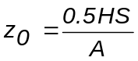The most commonly accepted formula for estimating surface roughness length is from Lettau (1969)
where H is average vertical extent, or average height (cm) within the area; S is the silhouette area (cm²) of the average obstacle, or total projected frontal area of the obstacles; and A is the surface area (cm²). This equation has been demonstrated as valid for total area sizes A up to and including the mesoscale (10⁹ m²). This equation should be used only when the area of obstacles is of sufficient distance in the upwind direction of the measuring anemometer tower.
Even when anemometer matching and calibration properly eliminate instrumental errors, the estimation of surface roughness with the help of measured wind-profile data is not without problems. In addition to Z₀, the determination of a so-called “zero-plane displacement” is required. Ideally, Z₀ is an unchanging surface characteristic of the tower site, while the zero-plane displacement is “the corrective height increment between the mathematically defined zero level of a numerical model of the wind profile and the arbitrary datum level from which the observer has measured anemometer heights” (Lettau, 1969). The zero-plane displacement is the altitude above which the wind profile is again described by a similarity equation. Z₀ should be positive and unchanging with respect to vertical tower positions, whereas the zero-plane displacement should vary by exactly the height increment that the tower assembly was moved, either up or down.

Another formula used for estimating Z₀ using anemometer data takes advantage of wind profile data. 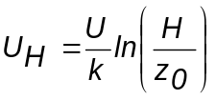The adiabatic wind speed vertical profile is described in the following logarithmic law:
where U_{H} is the average wind speed at a height H, k is the von Karman constant (k = 0.4), and U is the friction velocity. This formula should be not used when obstacles are spaced very close together (i.e., dense forests or urban buildings). In such cases, the zero-plane displacement height is again required.
Past a definite lower threshold level of area density, the statistical action of roughness elements breaks down and the individual airflow around each obstacle must be considered separately. The statistical notion of the roughness parameter, as well as visual range, would become unacceptable if the cross sections of the obscuring elements are significantly wider than that of the open air spaces between them.
The relationships between evapotranspiration, thermal measurements, and surface roughness are not immediately obvious. However, some literature indicates apparent associations between heat flux, aerial resistance (a.k.a. aerodynamic resistance) to the flow of sensible heat, and surface roughness that should be explored. For example, Rosenberg et al. (1983) show a relationship between aerial resistance r_{a} and z₀

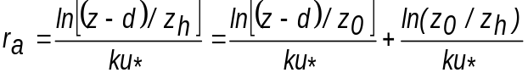
where k is the von Karman constant, z_{h} is a parameter for heat transfer that is analogous to the roughness parameter z₀ for the momentum transfer, d is the zero plane displacement (assumed to be the same for heat as for momentum transfer), and u* is the friction velocity. Generally defined, surface resistance is a function of surface roughness and is indirectly proportional to wind speed. Consequently, zones of high surface roughness have a low aerodynamic surface resistance. Surface resistance regards the resistance of surface to the transfer of water vapor. Aerodynamic resistance is often used to model the heat and water transfer near the surface and represents the effect of surface roughness on the transfer. Within the context of the Penman-Monteith model for evapotranspiration, surface resistance regards the vegetative influence on the model (i.e., the transpiration).
Monteith and Unsworth (1990) report empirical relationships between r_{a} and z₀ based on correlations using dimensionless groups derived from engineering experiments discussed in the literature. These discussions show, at least at the equation level, the occurrence of a potentially usable mathematical relationship between r_{a} and z₀. The question remains as to how can r_{a} be “measured” with NASA satellites, although one option to explore appears to be the Aqua/MODIS product, MOD 16. This product contains 1-km resolution geospatial estimates of surface resistance and evapotranspiration produced from 8-day average MODIS thermal (MOD 11) and reflectance (MOD 13) data products (NASA, 2003). From a phenomenological point of view, one can perceive leaf-structure changes in a crop or forest canopy will impact wind speed profiles associated with z₀. The thermal and evapotranspiration products available from Aqua/MODIS and from ASTER may therefore be useful in inferring information about surface resistance and vegetation vigor; hence, surface roughness. It should be noted, though, that this technique will require more research compared to other approaches before it could possibly be integrated into operational models such as HAZUS.

This page intentionally blank

Glossary
Adjacency effects – In terms of remote sensing, the change in the spectral response (i.e., digital number) of a pixel caused by the atmospheric scattering of radiance of adjacent pixels, which are located outside the pixel in question’s field of view. In terms of surface roughness versus land cover type, the ability of adjacent land cover to influence surface roughness length at a given location.
Anemometer – instrument used to measure wind speed, usually either from the rotation of wind-driven cups or from wind pressure through a tube pointed into the wind.
Central pressure – the estimated minimum barometric pressure in the eye (approximate center) of a hurricane.
Digital elevation model (DEM) – a representation of the topography of the Earth in digital format; that is, by coordinates and numerical descriptions of altitude.
Electro-optical imagery – imagery derived from a device that detects radiation by utilizing the influence of light in forming an electrical signal.
Explicit costs – costs entailing actual monetary transactions; e.g., cost of repairing or replacing damaged structures or structural elements.
Geospatial data – information that identifies the geographic location and characteristics of natural or constructed features and boundaries on the earth. This information may be derived from, among other things, remote sensing, mapping, and surveying technologies. Statistical data may be included in this definition at the discretion of the collecting agency.
Geographic information system (GIS) – a system for archiving, retrieving, and manipulating data that has been stored and indexed according to the geographic coordinates of its elements. The system generally can utilize a variety of data types, such as imagery, maps, tables, etc.
Historical storm mode – HAZUS mode that uses historical storm records as a method of exploiting current and past motion and intensity trends to project future storm positions and intensities.
Hurricane – severe tropical storms whose winds exceed 74 mph. Hurricanes originate over the tropical and subtropical North Atlantic and North Pacific oceans, where there is high humidity and light wind.
Impact energy – the amount of energy required to fracture a material upon impact. The HAZUS-MH Hurricane Model uses impact energy calculations in its two Windborne Debris Models.
Impact momenta – the force with which objects collide. The HAZUS-MH Hurricane Model uses impact momenta calculations in its two Windborne Debris Models.
Implicit costs – costs not entailing actual monetary transactions but having negative financial impacts; e.g., loss of business while repairing or replacing damaged structures or structural elements, property value depreciation caused by flooding.
Light detection and ranging (LIDAR) – LIDAR is in many ways analogous to radar (radiation detection and ranging). LIDAR systems use optical laser light (instead of microwave radiation) for atmospheric monitoring, tracking, detection of speed, altitude, direction, and range. Remote sensing personnel often use LIDAR interchangeably with LADAR (laser detection and ranging). LIDAR is an active system that requires both a transmitter (laser) to send a signal and a receiver to measure the time delay, intensity, phase shift, and spectral change in the return signal.
Loss estimation – a projection of the damage likely to occur as the result of various natural disasters, such as earthquakes, floods, and hurricanes.
Physiographic data – geographic data that deals with the exterior physical features and changes of the Earth.
Probabilistic mode – HAZUS mathematical mode of analysis in which the behavior of one or more of the variables is either completely or partially subject to probability laws.
Synthetic aperture radar (SAR) backscatter – SAR is a coherent radar system that generates high-resolution remote sensing imagery. Signal processing uses magnitude and phase of the received signals over successive pulses from elements of a synthetic aperture to create an image. "Backscatter" is the portion of the outgoing radar signal that the target redirects directly back towards the radar antenna.
Scenario mode – HAZUS quantitative mode used to simulate a possible disaster situation.
Sea surface temperature – the temperature of the layer of seawater (approximately 0.5 m deep) nearest the atmosphere.
Stereoscopy – the science or art dealing with three-dimensional effects and the methods by which these effects are produced.
Surface roughness length – wind speed in the vertical profile tends to approach zero close to the Earth’s surface and to increase with height. The surface height where wind speed comes closest to zero is known as the surface roughness length, Z₀.
Topography – the technique of graphically representing the exact physical features of a place or region on a map; the physical features of a place or region.
Wind loading – the amount of resistance to wind caused by a structure or fitting.

Acronym and Abbreviation List
AMSR-E Advanced Microwave Scanning Radiometer
ARA Applied Research Associates
ART Application Research Toolbox
ASTER Advanced Spaceborne Thermal Emission and Reflection Radiometer
BIT Building Inventory Tool
DEM Digital Elevation Model
DSS Decision Support System
DST Decision Support Tool
EPEDAT Early Post-Earthquake Damage Assessment Tool
ESA Earth Science Applications
ESE Earth Science Enterprise
ETM+ Enhanced Thematic Mapper Plus
FEMA Federal Emergency Management Agency
GIS Geographic Information System
GPM Global Precipitation Measurement
GPS Global Positioning System
HAZUS-MH Hazards U.S. – Multi-Hazard
HQ Headquarters
INCAST Inventory Collection and Survey Tool
InSAR Interferometric Synthetic Aperture Radar
LIDAR Light Detection And Ranging
LULC Land Use Land Cover
MISR Multi-angle Imaging SpectroRadiometer
MMI Modified Mercalli Intensity
MODIS Moderate Resolution Imaging Spectroradiometer
NASA National Aeronautics and Space Administration
NIBS National Institute for Building Sciences
NLCD National Land Cover Database
NSTC National Science and Technology Council
PC Personal Computer
QuikSCAT Quick Scatterometer
SAR Synthetic Aperture Radar
SCIGN Southern California Integrated GPS Network
SDP Scientific Data Purchase
SLOSH Sea, Lake, and Overland Surges from Hurricanes
SRTM Shuttle Radar Topography Mission
TRMM Tropical Rainfall Measuring Mission
V&V Verification and Validation

Disaster Management Roadmap
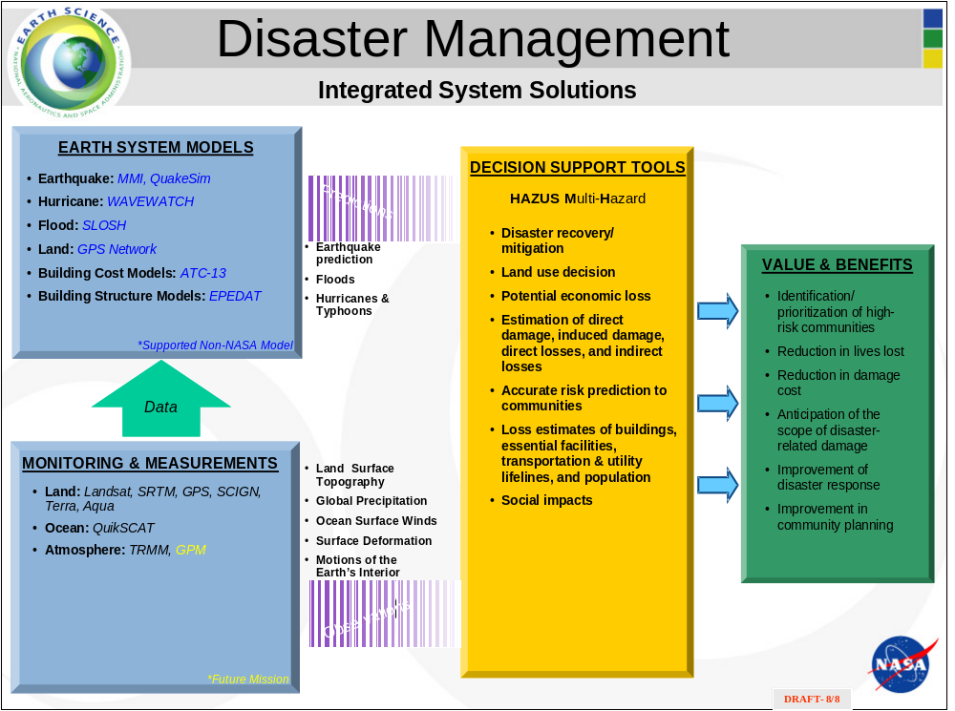

This page intentionally blank

HAZUS DSS One Page Summary
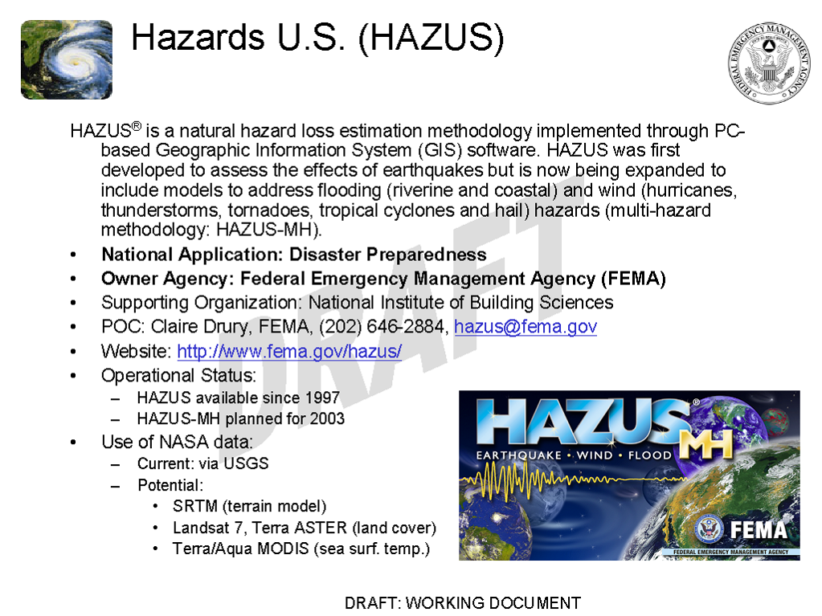
This page intentionally blank

Relevant Earth Observing Missions and Sensors

Table F-. Partial list of the Earth observing missions and sensors relevant to HAZUS.
Platform/Mission | Sensor | Product | Comments
Aqua | MODIS | Land, ocean, and atmospheric processes | Operational
Terra | MODIS | Land, ocean, and atmospheric processes, | Operational
Terra | ASTER | Land surface temperature, elevation | Operational
Landsat 7 | ETM+ | Land cover change, vegetation type | Degraded Operation
Shuttle | SRTM | Digital Elevation | Data collected during 11-day mission in February 2000

Additional information about Aqua, Landsat 7, Terra, ASTER, ETM+, MODIS, and SRTM are provided in the following pages.

This page intentionally blank

Aqua
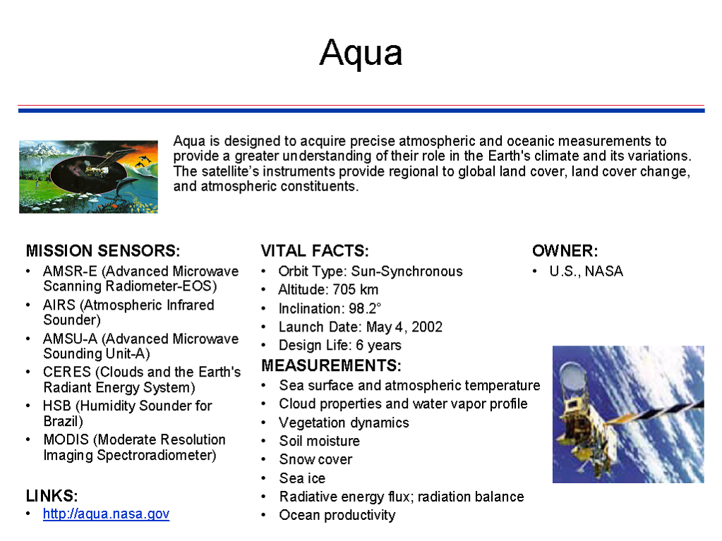

This page intentionally blank

Landsat 7
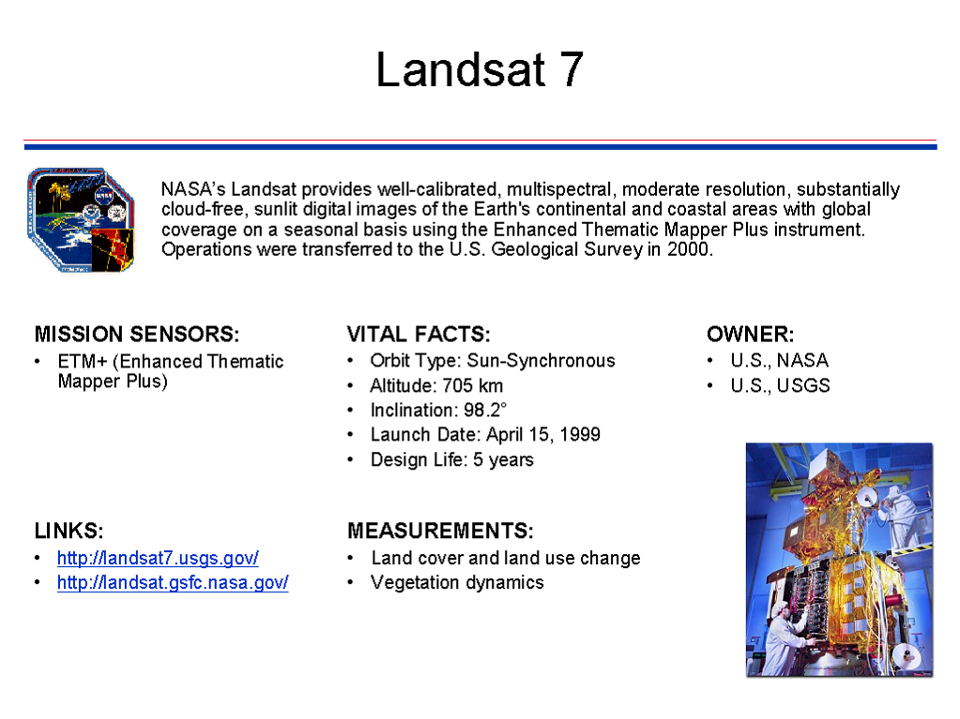

This page intentionally blank

Terra
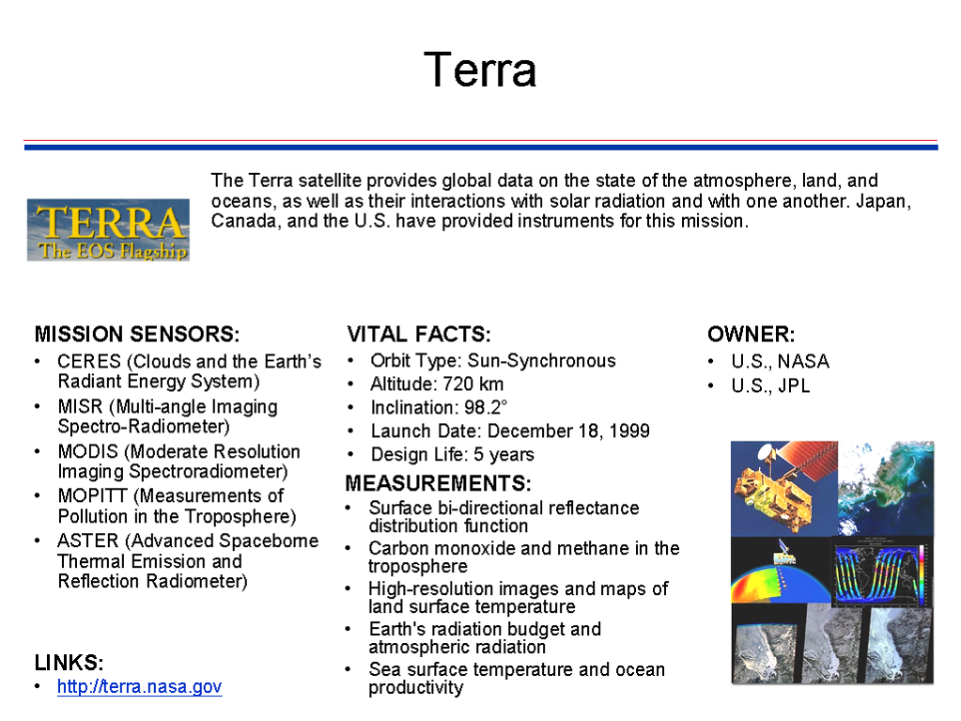

This page intentionally blank

ASTER
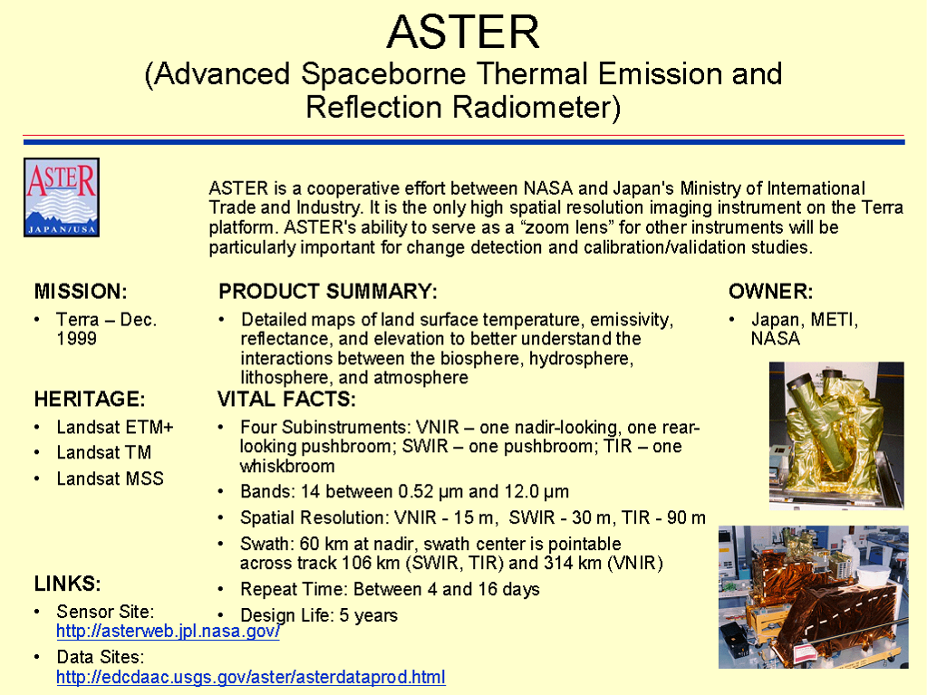

This page intentionally blank

ETM+
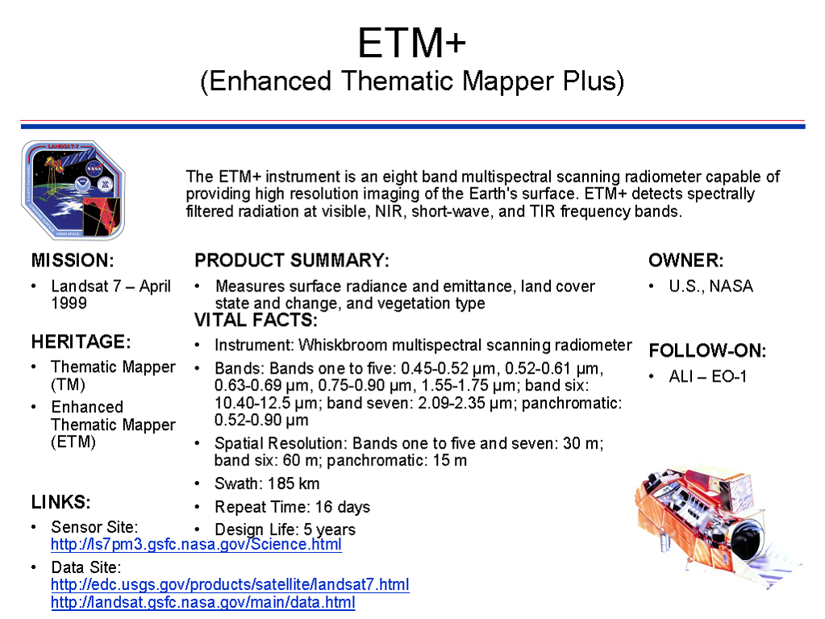

This page intentionally blank

MODIS
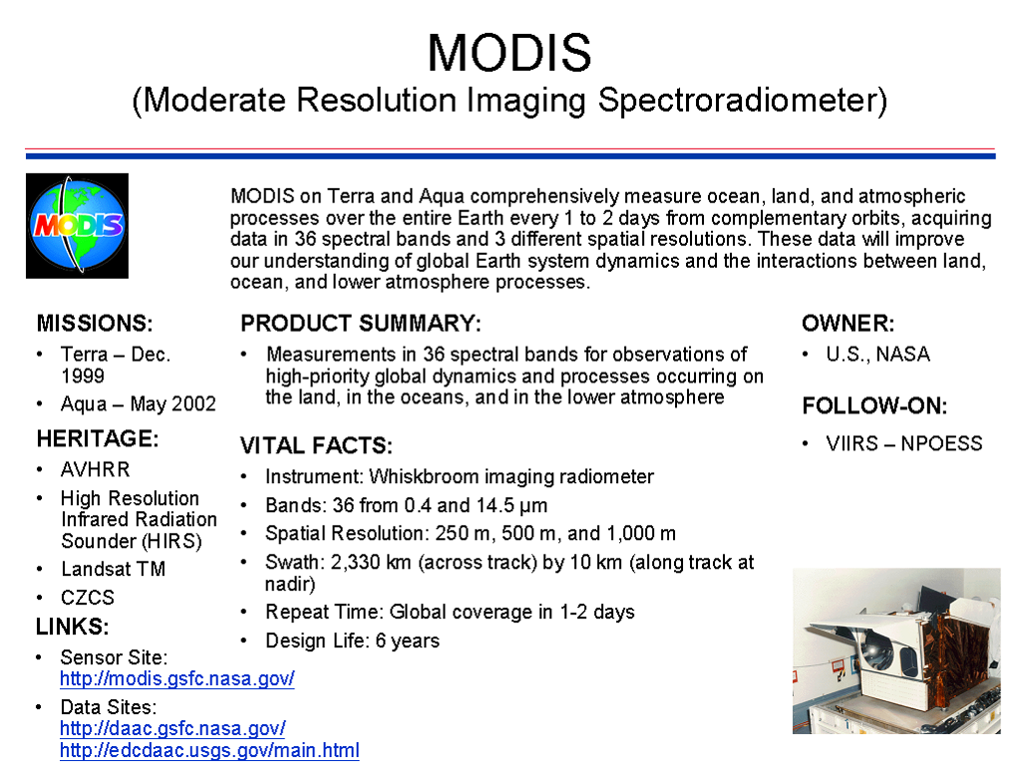

This page intentionally blank

SRTM
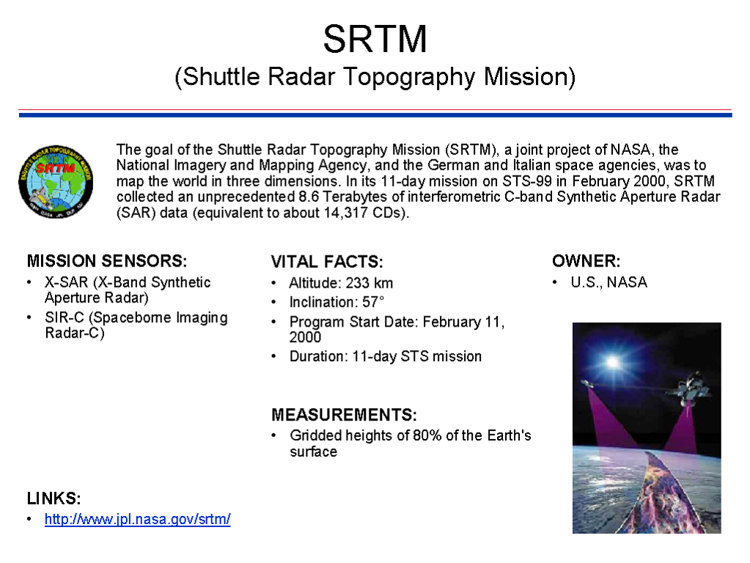
This page intentionally blank

Additional Sources of HAZUS-Relevant Information
Arnfield, A.J., 2003. Two decades of urban climate research: A review of turbulence, exchanges of energy and water, and the urban heat island. International Journal of Climatology, 23:1–26; also http://www.environmental-center.com/magazine/wiley/0899-8418/pdf1.pdf, accessed September 22, 2003.
Bernard, J.C., L.L. Wendell, and V.R. Morris, 1998. Optimal filtering of AC output anemometers. Journal of Atmospheric and Oceanic Technology, 15:1261–1271.
Carl, D.M., T.C. Tarbell, and H.A. Panofsky, 1973. Profiles of wind and temperature from towers over homogeneous terrain. Journal of Atmospheric Sciences, 30:788–794.
Grimmond, C.S.B., and T.R. Oke, 1999. Aerodynamic properties of urban areas derived from analysis of surface form. Journal of Applied Meteorology, 38:1262–1292.
Henjes, K., P.K. Taylor, and M.J. Yelland, 1999. Effect of pulse averaging on sonic anemometer spectra. Journal of Atmospheric and Oceanic Technology, 16(1):181–187.
Holtslag, A.A.M., 1984. Estimates of diabetic wind speed profiles from near-surface weather observations. Boundary-Layer Meteorology, 29:225–250.
Kaplan, J., and M. DeMaria, 1995. A simple empirical model for predicting the decay of tropical cyclone winds after landfall. Journal of Applied Meteorology, 34(11):2499–2512; also http://shadi.aoml.noaa.gov/cgi-bin/w3-msql/refs/search_pubaoml1.html?author=kaplan&initial=j (abstract), accessed September 22, 2003.
Lavelle, F.M., P.J. Vickery, and L.A. Twisdale, 2003. Hurricane Mitigation Cost/Benefit Analysis for Hawaii. Proceedings of the Eleventh International Conference on Wind Engineering, June 2-5, 2003, Lubbock, TX (Wind Science and Engineering Research Center, Texas Tech University), http://129.118.105.4:9000/paperListing/viewDetails.aspx?ID=375, accessed October 16, 2003.
Lettau, H., 1969. Note on aerodynamic roughness-parameter estimation on the basis of roughness-element description. Journal of Applied Meteorology, 8:828–832.
Martano, P., 2000. Estimation of surface roughness length and displacement height for single-level sonic anemometer data. Journal of Applied Meteorology, 39:708–715.
Mason, P.J., 1988. The formation of areally-averaged roughness lengths. Quarterly Journal of the Royal Meteorological Society, 114:399-420.
McVehil, G.E., 1964. Wind and temperature profiles near the ground in stable stratification. Quarterly Journal of the Royal Meteorological Society, 90:136–146.
Monteith, J.L., and M.H. Unsworth, 1990. Principles of Environmental Physics. 2nd ed., London: Edward Arnold, 291 p.
NASA, 2003. EOS Data Products Handbook. Volume 2 (C.L. Parkinson and R.L. Greenstone, editors), NASA GSFC, Greenbelt, MD, http://eospso.gsfc.nasa.gov/ftp_docs/data_products_vol2.pdf, accessed October 22, 2003.
Opadeyi, J., 2002. Incorporating technology into disaster preparedness and management operations: Mechanisms for the practical application of scientific and technical solutions. United Nations Development Programme Caribbean Regional Seminar on the Use of Information Technology in Comprehensive Disaster Management, May 29-31, 2002, Ocho Rios, Jamaica, http://www.cdera.org/pdfs/meetings/itconf2002/Opadeyi's%20paper.pdf, accessed September 22, 2003.
Penman, H.L., 1948. Natural evaporation from open water, bare soil and grass. Proceedings, Royal Society of London, Series A, 193:120-145.
Pielke, R.A., R. Avissar, M. Raupach, A.J. Dolman, X. Zeng, A.S. Denning, 1998. Interactions between the atmosphere and terrestrial ecosystems: Influence on weather and climate. Global Change Biology, 4:461–475.
Rosenberg, N.J., B.L. Blad, and S.B. Verma, 1983. Microclimate: The Biological Environment. 2nd edition, New York: John Wiley & Sons 495 p.
Sadeh, W.Z., J.E. Cermak, and T. Kawatani, 1971. Flow over high roughness elements. Boundary-Layer Meteorology, 1:321–344.
Simiu, E., 1973. Logarithmic profiles and design wind speeds. ASCE Journal of the Engineering Mechanics Division, 99(5):1073–1083.
Simiu, E., and R.H. Scanlan, 1996. Wind Effects on Structures: Fundamental and Applications to Design. 3rd Edition, New York: John Wiley & Sons, 704 p.
Sozzi, R., M. Favaron, and T. Georgiadis, 1998. Method for estimation of surface roughness and similarity function of wind speed vertical profile. Journal of Applied Meteorology, 37:461–469.
Tennekes, H., 1973. The logarithmic wind profile. Journal of Atmospheric Sciences, 30:234–238.
Thuillier, R.H., and U.O. Lappe, 1964. Wind and temperature profile characteristics from observations on a 1400 ft tower. Journal of Applied Meteorology, 3:299–306.
Tombrou, M., and D. Founda, 1998. Wind profile diagnosis from surface routine meteorological data over a coastal area. Boundary-Layer Meteorology, 87: 217–231.

HAZUS Inventory GIS Databases

Source: FEMA, 2000b, Appendix D
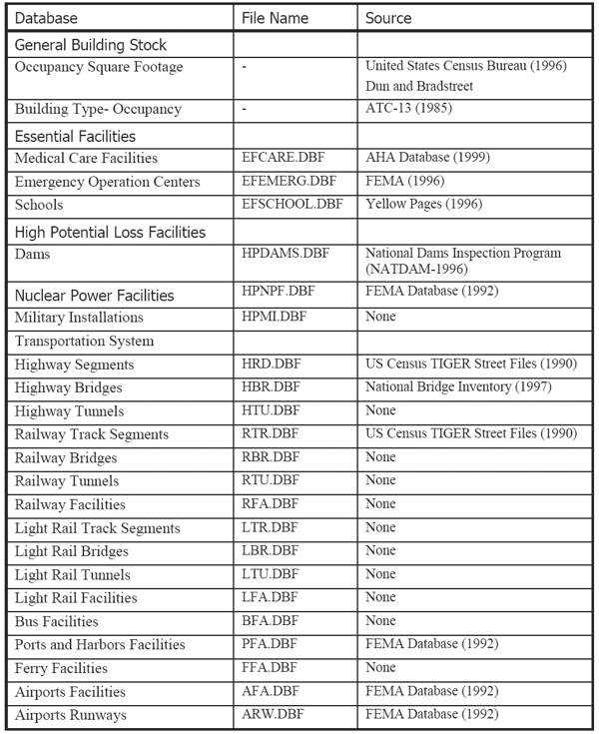
Figure H-. Summary of Inventory Databases listed in Appendix D of the HAZUS99 SR2 User Manual (FEMA, 2000b).

Source: FEMA, 2000b, Appendix D
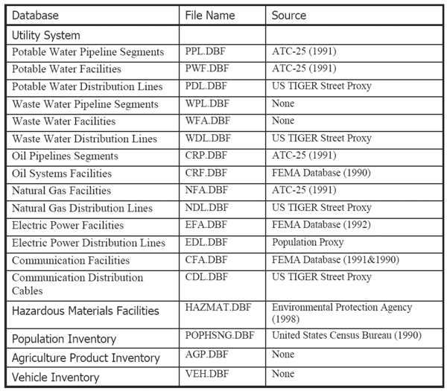
Figure H-, continued.

