Prevention of
Mother-to-Child
Transmission of HIV

Generic Training Package
Pocket Guide

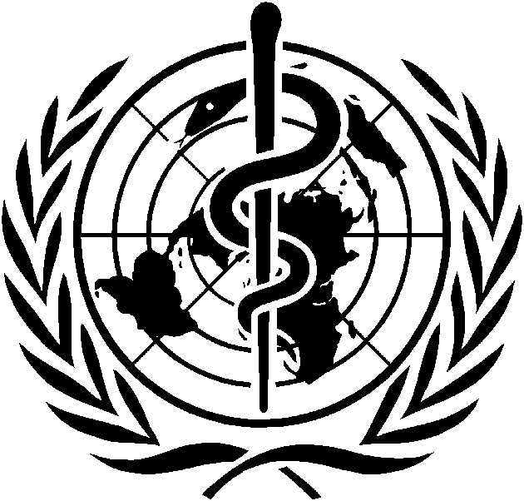  WORLD HEALTH ORGANIZATION | 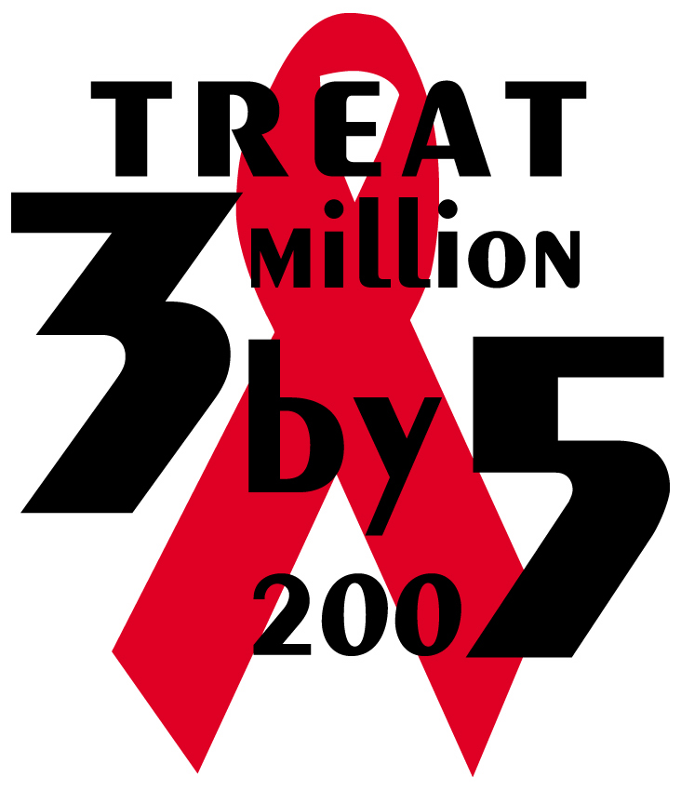 | 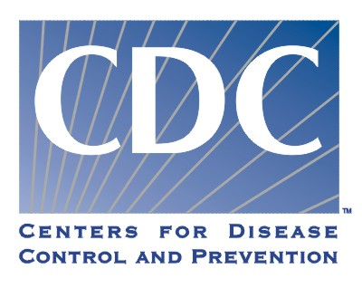

WHO Library Cataloguing-in-Publication Data

World Health Organization.
Prevention of mother-to-child transmission of HIV generic training package: pocket guide.

9 modules in 1 v.
1.Acquired immunodeficiency syndrome - therapy 2.HIV infections - therapy 3.Disease transmission, Vertical - prevention and control 4.Breast feeding - adverse effects 5.Manuals I.Title.

ISBN 92 4 159201 X (NLM classification: WC 503.2)

© World Health Organization 2004
All rights reserved. Publications of the World Health Organization can be obtained from Marketing and Dissemination, World Health Organization, 20 Avenue Appia, 1211 Geneva 27, Switzerland (tel: +41 22 791 2476; fax: +41 22 791 4857; email: bookorders@who.int). Requests for permission to reproduce or translate WHO publications—whether for sale or for noncommercial distribution—should be addressed to Publications, at the above address (fax: +41 22 791 4806; email: permissions@who.int).
The designations employed and the presentation of the material in this publication do not imply the expression of any opinion whatsoever on the part of the World Health Organization concerning the legal status of any country, territory, city or area or of its authorities, or concerning the delimitation of its frontiers or boundaries. Dotted lines on maps represent approximate border lines for which there may not yet be full agreement.
The mention of specific companies or of certain manufacturers’ products does not imply that they are endorsed or recommended by the World Health Organization in preference to others of a similar nature that are not mentioned. Errors and omissions excepted, the names of proprietary products are distinguished by initial capital letters.
The World Health Organization does not warrant that the information contained in this publication is complete and correct and shall not be liable for any damages incurred as a result of its use.

The WHO/CDC Prevention of Mother-to-Child Transmission of HIV Generic Training Package is a comprehensive approach to the training of healthcare workers. The other components in this package are
- Training Programme and Course Director Guide
- Participant Manual
- Trainer Manual
- Presentation Booklet
- Wall Charts
- CD-ROM containing MS® Word and Adobe Acrobat® (PDF) files for each programme component

Table of Contents

Introduction iii
Overview of HIV/AIDS 1
WHO Staging System for HIV Infection and Disease in Adults and Adolescents 3
WHO Staging System for HIV Infection and Disease in Children 5
CDC AIDS Surveillance Case Definition for Adolescents and Adults 6
CDC Classification System for Infants and Children 7
Stigma, Discrimination, and International Human Rights 12
Strategies to Reduce Stigma and Discrimination in PMTCT Programmes 13
PMTCT Overview 14
PMTCT Strategies 16
Antiretroviral Treatment for Pregnant Women 17
Antiretroviral Prophylaxis for PMTCT 24
Antenatal Care of Women Who Are HIV-Infected and Women of Unknown HIV Status 29
Management of Labour and Delivery in Women Who Are HIV-Infected and Women of Unknown HIV Status 31
Postpartum Care of Women Who Are HIV-Infected and Women of Unknown HIV Status 32
Immediate Newborn Care of Infants Who Are
HIV-Exposed 33
Infant-Feeding Recommendations 34
Infant-Feeding Options for Mothers Who Are
HIV-Infected 35
Infant-Feeding Counselling and Support 42
Breastfeeding Education 45
Breast Care While Breastfeeding 46
Cup Feeding 47
Feeding 6–24 Months 48
HIV Testing and Counselling Services 50
Types of HIV Tests 53
Diagnostic Testing of Infants and Young Children Exposed to HIV 56
Counsellor Skills 58
Pre-Test Group Information 59
Counselling Couples 60
Post-Test Counselling Sessions 61
Testing and Counselling in Labour and Delivery 62
Postpartum Care of the Mother Who Is HIV-Infected 63
Linkages with Local Treatment, Care, and Support Services 64
Prevention and Treatment of Opportunistic Infections 65
Pneumocystis Carinii Pneumonia (PCP) Prophylaxis for Adults 66
Prevention, Screening, and Treatment of Mycobacterium Tuberculosis (TB) 67
Treatment of Symptoms and Palliative Care 68
Treatment, Care, and Support of the Infant Who Is
HIV-Exposed 69
Pneumocystis Carinii Pneumonia (PCP) Prophylaxis for Infants 71
WHO Immunisation Recommendations 72
Care of the Infant with Documented HIV Infection 73
WHO Recommendations for Initiating ARV Treatment in Infants and Young Children 74
Creating a Safe Work Environment 75
Risk Reduction in the Obstetric Setting 77
Managing Occupational Exposure to HIV 78
Burnout Syndrome in Healthcare Workers 81
PMTCT Programme Monitoring 83

Introduction

Prevention of mother-to-child transmission of HIV (PMTCT) refers to a comprehensive, family-centred spectrum of clinical and supportive services—provided in conjunction with public health initiatives—to prevent the transmission of HIV from a woman to her infant. PMTCT programmes recognise the importance of knowing one’s HIV status and keeping parents-to-be HIV-negative. Testing and counselling in antenatal clinics and maternities allows for early identification of HIV infection. These settings serve as a gateway to comprehensive PMTCT services, including ARV treatment and prophylaxis, safer delivery practices, and safer infant-feeding practices for mothers who are HIV-exposed and their infants, who are also HIV-exposed.

Based on the clinical content of the Participant Manual of the WHO/CDC Prevention of Mother-to-Child Transmission Generic Training Package, this Pocket Guide is a reference tool for healthcare workers. It provides clear and concise evidence-based guidance, reflecting the most current WHO recommendations on the delivery of treatment, care, and support services to mothers and families at risk of or infected with HIV in resource-constrained settings.

For a complete list of resources used to prepare the Generic Training Package, please refer to the Participant Manual or Trainer Manual, “Glossary and Resources” sections.
Overview of HIV/AIDS

HIV stands for human immunodeficiency virus, the virus that causes AIDS
H: Human
I: Immunodeficiency
V: Virus

- HIV weakens the immune system—the body's defence against infection and disease
- As the immune system weakens, the body loses its protection against illness, including infections and certain types of cancer

- HIV-infected refers to someone who has become infected.
- HIV-positive refers to an HIV-infected person who has tested positive for HIV.

AIDS stands for acquired immunodeficiency syndrome and refers to the most advanced stage of HIV infection
A: Acquired – not inherited
I: Immuno – attacks the immune system
D: Deficiency – by destroying certain white blood cells
S: Syndrome – a group of symptoms or illnesses that occur as a result of the HIV infection

Types of HIV: HIV-1 and HIV-2
- HIV-1 is the most common.
- Both have the same routes of transmission and are associated with similar opportunistic infections and AIDS.
- HIV-2 is less easily transmitted than HIV-1, and the period between initial infection and illness is longer.
- Mother-to-child transmission of HIV-2 is rare.

HIV is transmitted by:
- Sexual contact, such as unprotected vaginal, anal or oral sex
- Injection drug use
- From a mother who is HIV-infected to her child during pregnancy, childbirth, labour and delivery, and breastfeeding

The most common route of HIV transmission is through sexual contact, especially heterosexual intercourse.

HIV is NOT transmitted by:
- Coughing or sneezing
- Being bitten by an insect
- Touching or hugging
- Kissing
- Going to a public bath/pool
- Using a public toilet
- Shaking hands
- Working or going to school with a person who is HIV-infected
- Using telephones
- Drinking water or preparing or eating food
- Sharing cups, glasses, plates, or other utensils
WHO Staging System for HIV Infection and Disease in Adults and Adolescents
Clinical Stage I
- Asymptomatic
- Generalised lymphadenopathy
Performance Scale 1: asymptomatic, normal activity
Clinical Stage II
- Weight loss of less than 10% of body weight
- Minor mucocutaneous manifestations (seborrhoeic dermatitis, prurigo, fungal nail infections, recurrent oral ulcerations, angular cheilitis)
- Herpes zoster within the last 5 years
- Recurrent upper respiratory tract infections (ie, bacterial sinusitis)
And/or Performance Scale 2: symptomatic, normal activity
Clinical Stage III
- Weight loss of more than 10% of body weight
- Unexplained chronic diarrhoea lasting for more than 1 month
- Unexplained prolonged fever (intermittent or constant) lasting for more than 1 month
- Oral candidiasis (thrush)
- Oral hairy leukoplakia
- Pulmonary tuberculosis
- Severe bacterial infections (ie, pneumonia, pyomyositis)
And/or Performance Scale 3: bedridden less than 50% of the day during the past month
WHO Staging System for HIV Infection and Disease in Adults and Adolescents
(continued)
Clinical Stage IV
- HIV wasting syndromeª
- Pneumocystis carinii pneumonia
- Toxoplasmosis of the brain
- Cryptosporidiosis with diarrhoea lasting more than 1 month
- Cryptococcosis, extrapulmonary
- Cytomegalovirus (CMV) disease of an organ other than liver, spleen or lymph node (eg, retinitis)
- Herpes simplex virus (HSV) infection, mucocutaneous (lasting for more than 1 month) or visceral
- Progressive multifocal leukoencephalopathy (PML)
- Any disseminated endemic mycosis
- Candidiasis of the oesophagus, trachea, bronchi
- Atypical mycobacteriosis, disseminated or pulmonary
- Non-typhoid salmonella septicaemia
- Extrapulmonary tuberculosis
- Lymphoma
- Kaposi's sarcoma (KS)
- HIV encephalopathy^{b}
And/or Performance Scale 4: bedridden more than 50% of the day during the last month
ª HIV wasting syndrome: Weight loss of more than 10% of body weight, plus either unexplained chronic diarrhoea (lasting longer than 1 month) or chronic weakness and unexplained prolonged fever (lasting longer than 1 month).
^{b} HIV encephalopathy: clinical findings of disabling cognitive and/or motor dysfunction interfering with activities of daily living progressing over weeks to months, in the absence of a concurrent illness or condition, other than HIV infection, that could explain the findings.
WHO Staging System for HIV Infection and Disease in Children
Clinical Stage I
- Asymptomatic
- Generalised lymphadenopathy
Clinical Stage II
- Chronic diarrhoea lasting more than 30 days duration in the absence of known etiology
- Severe persistent or recurrent candidiasis outside the neonatal period
- Weight loss or failure to thrive in the absence of known etiology
- Persistent fever lasting longer than 30 days duration in the absence of known etiology
- Recurrent severe bacterial infections other than septicaemia or meningitis (eg, osteomyelitis, bacterial (non-TB) pneumonia, abscesses)
Clinical Stage III
- AIDS-defining opportunistic infections
- Severe failure to thrive (wasting) in the absence of known etiologyª
- Progressive encephalopathy
- Malignancy
- Recurrent septicaemia or meningitis
ª Persistent weight loss >10% if baseline or less than 5th percentile on weight for height chart on 2 consecutive measurements more than one month apart in the absence of another etiology or concurrent illness.

CDC AIDS Surveillance Case Definition for Adolescents and Adults
Clinical Categories

CD4 Cell Categories | A | B | C*
mm³ (%) | Asymptomatic, PGL or Acute HIV Infection | Symptomatic†  (not A or C) | AIDS Indicator Condition (1987)
1: >500/mm³  (>29%) | A1 | B1 | C1
2: 200–499/mm³  (14–28%) | A2 | B2 | C2
3: <200/mm³  (<14%) | A3 | B3 | C3
* All patients in categories A3, B3 and C1-3 are defined as having AIDS, based on the presence of an AIDS-indicator condition (see the following table) and/or a CD4 cell count of less than 200/mm³.
† Symptomatic conditions not included in Category C that are: a) attributed to HIV infection or indicative of a defect in cell-mediated immunity or b) considered to have a clinical course or management that is complicated by HIV infection. Examples of B conditions include but are not limited to bacillary angiomatosis; thrush; vulvovaginal candidiasis that is persistent, frequent or poorly responsive to therapy; cervical dysplasia (moderate or severe); cervical carcinoma in situ; constitutional symptoms such as fever (38.5º C) or diarrhoea lasting longer than 1 month; oral hairy leukoplakia; herpes zoster involving two episodes or more than 1 dermatome; idiopathic thrombocytopenic purpura (ITP); listeriosis; pelvic inflammatory disease (PID) (especially if complicated by a tubo-ovarian abscess); and peripheral neuropathy.
CDC Classification System for Infants and Children

Immunologic categories based on age-specific CD4 counts and percent of total lymphocytes
Immunologic  category | <12 mos | 1–5 yrs | 6–12 yrs
 | uL (%) | uL (%) | uL (%)
1: No evidence of suppression | > 1,500 (> 25) | > 1,000 (> 25) | > 500 (> 25)
2: Evidence of moderate suppression | 750–1,499 (15–24) | 500–999 (15–24) | 200–499 (15–24)
3: Severe suppression | < 750 (<15) | < 500 (<15) | < 200 (<15)
Clinical categories for children with HIV infection
CATEGORY N: NOT SYMPTOMATIC
Children who have no signs or symptoms considered to be the result of HIV infection or who have only one of the conditions listed in Category A.
CATEGORY A: MILDLY SYMPTOMATIC
Children with two or more of the conditions listed below but none of the conditions listed in Categories B and C.
- Lymphadenopathy (> 0.5 cm at more than two sites; bilateral = one site)
- Hepatomegaly
- Splenomegaly
- Dermatitis
- Parotitis
- Recurrent or persistent upper respiratory infection, sinusitis, or otitis media
CDC Classification System for Infants and Children (continued)
CATEGORY B: MODERATELY SYMPTOMATIC
Children who have symptomatic conditions other than those listed for Category A or C that are attributed to HIV infection. Examples of conditions in clinical Category B include but are not limited to:
Anemia (<8 gm/dL), neutropenia (<1,000/mm³), or thrombocytopenia (<100,000/mm³) persisting > 30 days
- Bacterial meningitis, pneumonia, or sepsis (single episode)
- Candidiasis, oropharyngeal (thrush), persisting (>2 months) in children >6 months of age
- Cardiomyopathy
- Cytomegalovirus infection, with onset before 1 month of age
- Diarrhea, recurrent or chronic
- Hepatitis
- Herpes simplex virus (HSV) stomatitis, recurrent (more than two episodes within 1 year)
- HSV bronchitis, pneumonitis, or esophagitis with onset before 1 month of age
- Herpes zoster (shingles) involving at least two distinct episodes or more than one dermatome
- Leiomyosarcoma
- Lymphoid interstitial pneumonia (LIP) or pulmonary lymphoid hyperplasia complex
- Nephropathy
- Nocardiosis
- Persistent fever (lasting >1 month)
- Toxoplasmosis, onset before 1 month of age
- Varicella, disseminated (complicated chickenpox)

CDC Classification System for Infants and Children (continued)
CATEGORY C: SEVERELY SYMPTOMATIC
Serious bacterial infections, multiple or recurrent (ie, any combination of at least two culture-confirmed infections within a 2-year period), of the following types: septicemia, pneumonia, meningitis, bone or joint infection, or abscess of an internal organ or body cavity (excluding otitis media, superficial skin or mucosal abscesses, and indwelling catheter-related infections)
- Candidiasis, esophageal or pulmonary (bronchi, trachea, lungs)
- Coccidioidomycosis, disseminated (at site other than or in addition to lungs or cervical or hilar lymph nodes)
- Cryptococcosis, extrapulmonary
- Cryptosporidiosis or isosporiasis with diarrhea persisting >1 month
- Cytomegalovirus disease with onset of symptoms at age >1 month (at a site other than liver, spleen, or lymph nodes)
- Encephalopathy (at least one of the following progressive findings present for at least 2 months in the absence of a concurrent illness other than HIV infection that could explain the findings): a) failure to attain or loss of developmental milestones or loss of intellectual ability, verified by standard developmental scale or neuropsychological tests; b) impaired brain growth or acquired microcephaly demonstrated by head circumference measurements or brain atrophy demonstrated by computerised tomography or magnetic resonance imaging (serial imaging is required for children <2
CDC Classification System for Infants and Children (continued)
years of age); c) acquired symmetric motor deficit manifested by two or more of the following: paresis, pathologic reflexes, ataxia, or gait disturbance
- Herpes simplex virus infection causing a mucocutaneous ulcer that persists for >1 month; or bronchitis, pneumonitis, or esophagitis for any duration affecting a child >1 month of age
- Histoplasmosis, disseminated (at a site other than or in addition to lungs or cervical or hilar lymph nodes)
- Kaposi’s sarcoma
- Lymphoma, primary, in brain
- Lymphoma, small, noncleaved cell (Burkett’s), or immunoblastic or large cell lymphoma of B-cell or unknown immunologic phenotype
- Mycobacterium tuberculosis, disseminated or extrapulmonary
- Mycobacterium, other species or unidentified species, disseminated (at a site other than or in addition to lungs, skin, or cervical or hilar lymph nodes)
- Mycobacterium avium complex or Mycobacterium kansasii, disseminated (at site other than or in addition to lungs, skin, or cervical or hilar lymph nodes)
- Pneumocystis carinii pneumonia
- Progressive multifocal leukoencephalopathy
- Salmonella (nontyphoid) septicemia, recurrent
- Toxoplasmosis of the brain with onset at >1 month of age
CDC Classification System for Infants and Children (continued)

- Wasting syndrome in the absence of a concurrent illness other than HIV infection that could explain the following findings:
a) persistent weight loss >10% of baseline OR
b) downward crossing of at least two of the following percentile lines on the weight-for-age chart (eg, 95th, 75th, 50th, 25th, 5th) in a child > 1 year of age OR
c) <5th percentile on weight-for-height chart on two consecutive measurements, >30 days apart PLUS a) chronic diarrhoea (ie, at least two loose stools per day for >30 days) OR
b) documented fever (for >30 days, intermittent or constant)
Stigma, Discrimination, and International Human Rights
Stigma refers to unfavourable attitudes and beliefs directed toward someone or something.

HIV/AIDS-related stigma is directed toward people living with HIV/AIDS (PLWHA) or those perceived to be infected, as well as their loved ones, close associates, social groups, and communities.

HIV/AIDS-related stigma is the single greatest challenge to slowing the spread of the disease.

Discrimination is the treatment of an individual or group with partiality or prejudice. Discrimination is often defined in terms of human rights and entitlements and may impact healthcare, employment, the legal system, social welfare, and reproductive and family life.
Stigma versus Discrimination
Stigmatisation reflects an attitude, but discrimination is an act or behaviour.
Discrimination is a way of expressing, either on purpose or inadvertently, stigmatising thoughts.

"Discrimination on the basis of HIV/AIDS status, actual or presumed, is prohibited by existing human rights standards.”
—UN Commission on Human Rights
Strategies to Reduce Stigma and Discrimination in PMTCT Programmes
There are many ways that healthcare workers can help reduce the stigma and discrimination that PLWHA experience.
- Integrate PMTCT interventions into antenatal care services for all women.
- Include partners/spouses in all aspects of PMTCT services.
- Offer group or individual education sessions that emphasise the role that partners play in transmission and reducing stigma towards women.
- Educate and train healthcare providers to understand rights of PLWHA and their families.
- Use universal precautions with all patients regardless of assumed or established HIV status.
- Safeguard patient confidentiality.
- Encourage PMTCT staff to serve as role models.
- Facilitate peer and community support for PLWHA.
- Advocate for women’s rights.
PMTCT Overview
Mother-to-child transmission (MTCT) of HIV infection is the vertical transmission of HIV from a mother who is HIV-infected to her infant. MTCT is the main transmission route for HIV infection in infants and children.

Programmes for the prevention of MTCT (PMTCT) can reduce MTCT and link women who are
HIV-infected, their children and their families to treatment, care, and support. PMTCT programmes are comprehensive and follow national protocols and policies.

PMTCT core interventions
- HIV testing and counselling
- Antiretrovirals
- Safer delivery practices
- Safer infant-feeding practices
Partner involvement in PMTCT
- Both partners need to be aware of the importance of safer sex throughout pregnancy and breastfeeding
- Both partners are tested and counselled for HIV
- Both partners are aware of and provided with PMTCT interventions

The use of the term mother-to-child transmission of HIV attaches no blame or stigma to the woman who gives birth to a child who is HIV-infected. Rather, it reinforces the fact that both mothers and fathers have an impact on the transmission of HIV to the infant.
MTCT risk factors during pregnancy
- High maternal viral load (new or advanced HIV/AIDS)
- Viral, bacterial, and parasitic placental infection (especially malaria)
- Sexually transmitted infections
- Maternal malnutrition (indirectly)

MTCT risk factors during labour and delivery
- High maternal viral load (new or advanced HIV/AIDS)
- Rupture of membranes for more than 4 hours before labour begins
- Invasive delivery procedures
- First infant in a multiple birth
- Chorioamnionitis (inflammation of the membranes covering the foetus)

MTCT risk factors during breastfeeding
- High maternal viral load (new or advanced HIV/AIDS)
- Duration of breastfeeding
- Early mixed feeding of infant (breastmilk with replacement feeding)
- Breast abscesses/inflammation or cracked nipples
- Maternal malnutrition
- Infant oral disease (eg, thrush or mouth sores)

PMTCT Strategies
Prevention of primary HIV infection
- Promote safer, responsible sexual practices.
- Provide access to condoms.
- Provide early diagnosis and treatment of sexually transmitted infections (STIs).
- Make HIV testing and counselling widely available.
- Provide suitable counselling for HIV-negative women.

Prevention of unintended pregnancies among women who are HIV-infected
- Provide effective family planning.
- Promote access to safe and effective contraception.
- Promote safer sex practices.

Prevention of MTCT
- Provide HIV testing and counselling.
- Provide antiretroviral prophylaxis and treatment.
- Promote safer delivery practices.
- Educate and support in safer infant-feeding practices.

Providing treatment, care and support to women who are HIV-infected, their infants, and their families
- Provide HIV-related treatment, care, and support services for women.
- Provide early diagnosis, care and support to the infant and child who are HIV-infected.
- Promote linkages to community-based services for comprehensive family care.
Antiretroviral Treatment for
Pregnant Women
Antiretroviral (ARV) drugs decrease viral replication and viral load in the mother and protect the infant against HIV exposure. ARV drugs effectively treat maternal HIV infection and prevent MTCT.

Treatment is not to be confused with prophylaxis.
Definitions
ARV treatment – Long-term use of antiretroviral drugs to treat the mother’s HIV/ AIDS and prevent PMTCT
ARV prophylaxis – Short-term use of antiretroviral drugs to reduce HIV transmission from mother to infant

ARV treatment during pregnancy, when indicated, will improve the health of the woman and decrease the risk of transmission of HIV to the infant and is recommended in the following situations:
If CD4 testing is available, it is recommended to document baseline CD4 counts and to offer ARV to patients with:
- WHO Stage IV disease, irrespective of CD4 cell count
- WHO Stage III disease (including but not restricted to HIV wasting, chronic diarrhoea of unknown aetiology, prolonged fever of unknown aetiology, pulmonary TB, recurrent invasive bacterial infections, or recurrent or persistent mucosal candidiasis); with consideration of using CD4 cell counts of less than 350/mm³ to assist decision-makingª
- WHO Stage I or II disease with CD4 cell counts of 200/mm³ or lower3 ^{b}

2

If CD4 testing is unavailable, it is recommended to offer ARV to patients with:
- WHO Stage IV disease, irrespective of total lymphocyte count
- WHO Stage III disease (including but not restricted to wasting, chronic diarrhoea of unknown aetiology, prolonged fever of unknown aetiology, pulmonary TB, recurrent invasive bacterial infections or recurrent/ persistent mucosal candidiasis), irrespective of total lymphocyte count^{c}
- WHO Stage II disease with a total lymphocyte count of less than or equal to 1,200/mm3^{d}

ª CD4 count advisable to assist with determining need for immediate therapy. For example, pulmonary TB can occur at any CD4 level, and other conditions can be mimicked by non-HIV aetiologies (eg, chronic diarrhoea, prolonged fever).
^{b} The precise CD4 count above 200/mm³ at which ARV treatment should start has not been established.
^{c} The recommendation to start ART in all patients with stage III disease, without reference to total lymphocyte counts reflects consensus of expert opinion. It took into account the need of a practical recommendation that allows clinical services and TB programmes in severely constrained settings to offer access to ART to their patients. As some adults and adolescents with stage III disease will be presenting with CD4 counts above 200, some of them will receive antiretroviral treatment before the CD4 less than 200 threshold is reached. However, if CD4 counts cannot be determined, starting ART earlier in these patients was not considered problematic.
^{d} A total lymphocyte count of less than or equal to 1200/mm³ can be substituted for the CD4 count when the latter is unavailable and HIV-related symptoms exist. It is not useful in the asymptomatic patient. Thus, in the absence of CD4 cell testing, asymptomatic patients who are HIV-infected (WHO Stage I) should not be treated because there is currently no other reliable marker in severely resource-constrained settings.
When treatment is indicated for pregnant women ARVs should be started as soon as possible. Sometimes treatment is delayed until after the first trimester. However, when a woman is severely ill, the benefits of treatment outweigh any potential risks to the foetus.

Pregnant women receiving ARV therapy require ongoing care and monitoring within the local HIV/AIDS programme. When co-infection with TB exists, additional drug therapy and clinical management are required to minimise side effects.

The table on the following pages discusses antiretroviral treatment recommendations for women of childbearing age and pregnant women with HIV infection. Conduct clinical and laboratory monitoring as outlined in WHO treatment guidelines.

Clinical situations and recommendations for the use of antiretroviral drugs in pregnant women and women of child-bearing potential in resource-constrained settings
Clinical Situation | Recommendation
A: HIV-infected women with indications for initiating ARV treatment¹ who may become pregnant | First-line regimens: ZDV + 3TC + NVP or d4T + 3TC + NVP  Efavirenz (EFV) should be avoided in women of childbearing age, unless effective contraception can be assured. Exclude pregnancy before starting treatment with EFV.
B: HIV-infected women receiving ARV treatment who become pregnant | Women  - Continue the current ARV regimen² unless it contains EFV. If it does, substitution with a NVP or a PI should be considered if in the 1st trimester.  - Continue the same ARV regimen during the intrapartum period and after delivery.  Infants  - If born to women receiving either 1st or 2nd-line ARV regimens: 1-week ZDV OR single-dose NVP OR 1-week ZDV and single dose NVP.
C: HIV-infected pregnant women with indications for ARV treatment¹ | Women  - Follow the treatment guidelines as for non-pregnant adults except that EFV should not be given in the 1st trimester.  - First line regimens: ZDV + 3TC + NVP or d4T + 3TC + NVP  - Consider delaying therapy until after the 1st trimester, although in severely ill women the benefits of early therapy clearly outweigh the potential risks.  Infants  - 1-week ZDV OR single-dose NVP OR 1-week ZDV and single-dose NVP.
Clinical situations and recommendations for the use of antiretroviral drugs in pregnant women and women of child-bearing potential in resource-constrained settings (continued)
Clinical Situation | Recommendation
D: HIV-infected pregnant women without indications for ARV treatment¹ | First-choice regimen: ZDV and NVP  Women  - ZDV starting at 28 weeks or as soon as possible thereafter. Continue ZDV at the same dose in labour. In addition, women should receive single-dose NVP at the onset of labour.  Infants  - Single-dose NVP and 1-week ZDV³  Alternative regimen: NVP only  Women  - Single-dose NVP  Infants  - Single-dose NVP  Alternative regimen: ZDV only  Women  - ZDV starting at 28 weeks or as soon as possible thereafter. Continue in labour.  Infants  - 1-week ZDV³  Alternative regimen: ZDV + 3TC  Women  - ZDV + 3TC starting at 36 weeks or as soon as possible thereafter. Continue in labour and for 1 week postpartum.  Infants  - 1-week ZDV + 3TC
E: HIV-infected pregnant women with indications for starting ARV treatment¹ but treatment is not yet available | Follow the recommendations in Situation D, but preferably use the most efficacious regimen that is available and feasible.
Clinical situations and recommendations for the use of antiretroviral drugs in pregnant women and women of
child-bearing potential in resource-constrained settings
(continued)

Clinical Situation | Recommendation
F: HIV-infected pregnant women with active tuberculosis | - If ARV treatment is initiated, consider⁴: (ZDV or d4T) + 3TC + SQV/r.  - If treatment is initiated in the 3rd trimester (ZDV or d4T) + 3TC +EFV can be considered.  - If ARV treatment is not initiated, follow the recommendations in Situation D.
G: Pregnant women of unknown HIV status at the time of labour or women in labour known to be HIV-infected who have not received ARV drugs before labour | If there is time, offer HIV testing and counselling to women of unknown status and if positive, initiate intrapartum ARV prophylaxis.  Women  - Single-dose NVP. If in advanced labour do not give the dose but follow the recommendations in Situation H  Infants  - Single-dose NVP  Women  - ZDV + 3TC in labour and 1-week ZDV + 3TC postpartum  Infants  - 1-week ZDV+3TC  If there is insufficient time for HIV testing and counselling during labour, then offer testing and counselling as soon as possible postpartum. Follow the recommendations in Situation H for women testing positive postpartum.
H: Infants born to HIV-infected women who have not received any ARV drugs | Infants  - Single-dose NVP as soon as possible after birth and 1-week ZDV  If the regimen is started more than 2 days after birth, it is unlikely to be effective.
Clinical situations and recommendations for the use of antiretroviral drugs in pregnant women and women of
child-bearing potential in resource-constrained settings
(continued)

¹ WHO recommendations for initiating ARV treatment in HIV-infected adolescents and adults. If CD4 testing is available it is recommended to offer ARV treatment to patients with: WHO Stage IV disease irrespective of CD4 cell count, WHO Stage III disease with consideration of using CD4 cell counts less than 350 10⁶ cells/L to assist decision-making and WHO Stage I and II disease in the presence of a CD4 cell count less than 200 10⁶ cells/L. If CD4 testing is unavailable, it is recommended to offer ARV treatment to patients with WHO Stage III and IV disease irrespective of total lymphocyte count or WHO Stage II disease with a total lymphocyte count less than 1200 10⁶ cells/L.
² Conduct clinical and laboratory monitoring as outlined in the 2003 revised WHO treatment guidelines.
³ Continuing the infant on ZDV for four to six weeks can be considered if the woman received antepartum ARV drugs for less than four weeks.
⁴ ABC can be used in place of SQV/r; however, experience with ABC during pregnancy is limited. In the rifampicin-free continuation phase of tuberculosis treatment, an NVP-containing ARV regimen can be initiated.
Antiretroviral Prophylaxis for PMTCT

Women who do not need treatment, or do not have access to treatment, should be offered prophylaxis to prevent MTCT in accordance with national protocols.

The first choice prophylaxis regimen is zidovudine (ZDV) starting at 28 weeks or as soon as possible thereafter, with single dose nevirapine (NVP) at the onset of labour for the mother and single dose NVP plus one week of ZDV to the infant.

Several other prophylactic regimens are also recommended for PMTCT. See the following two pages for alternate recommendations. All regimens are administered by mouth. Paediatric formulations are needed for all infant regimens. Efforts must be made to monitor for side effects and support maternal infant adherence.

HIV-related treatment, care, and support must be provided during the antenatal and postpartum periods. All infants who are HIV-exposed should be followed-up for diagnosis of HIV and opportunistic infections and receive treatment, care, and support.
Antiretroviral prophylaxis regimens to prevent MTCT

HIV-related treatment, care and support must be provided during the antenatal and postpartum periods. All HIV-exposed infants should be followed-up for diagnosis of HIV, prophylaxis of opportunistic infection, and treatment, care and support.
All regimens are administered by mouth. Paediatric formulations are needed for all infant regimens. Efforts must be made to monitor for side effects and support maternal infant adherence.

Course | Antenatal | Intrapartum | Postpartum | Postnatal
Zidovudine  ZDV and nevirapine (NVP) | Mother:  ZDV 300 mg twice a day starting at 28 weeks or as soon as possible thereafter | Mother:  ZDV 300 mg at onset of labour and every 3 hours until delivery and single-dose NVP 200 mg at onset of labour | None | Infant:  NVP 2mg/kg oral suspension immediately after birth and ZDV 4 mg/kg twice a day for 7 days
 |  | OR  ZDV 600 mg at onset of labour |  | OR  NVP 2 mg/kg oral suspension immediately after birth
ZDV | Mother:  ZDV 300 mg twice a day starting at 28 weeks or as soon as possible thereafter | Mother:  ZDV 600 mg at onset of labour  OR  ZDV 300 mg at onset of labour and every 3 hours until delivery | None | Infant:  ZDV 4 mg/kg twice a day for 7 days  OR  ZDV 2 mg/kg  4 times a day for  7 days

Antiretroviral prophylaxis regimens to prevent MTCT (continued)
COURSE |  | Antenatal |  |  | Intrapartum |  |  | Postpartum |  | Postnatal
ZDV and NVP for infant  (when mother has received no ARV prophylaxis) |  |  | None |  |  | None |  |  | None |  |  |  | Infant:  NVP 2 mg/kg oral suspension immediately after birth and ZDV  4 mg/kg, twice a day for 7 days. When ZDV oral suspension not available, NVP  2 mg/kg as soon as possible after delivery and a dose of NVP 72 hours after birth
NVP | None |  |  | Mother:  Single-dose NVP 200 mg at onset of labour |  |  | None |  |  |  | Infant:  NVP 2 mg/kg oral suspension immediately after birth
ZDV and lamivudine (3TC) | Mother:  ZDV 300 mg and 3TC 150 mg twice a day starting at 28 weeks or as soon as possible thereafter |  |  | Mother:  ZDV 300 mg every 3 hours until delivery and 3TC 150 mg every 12 hours until delivery |  |  | Mother:  ZDV 300 mg and 3TC 150 mg twice a day for  7 days |  |  |  | Infant:  ZDV 4 mg/kg and 3TC 2 mg/kg twice a day for 7 days
ZDV and 3TC |  | None |  |  | Mother:  ZDV 600 mg and 3TC 150 mg at onset of labour followed by ZDV 300 mg every  3 hours and 3TC  150 mg every 12 hours until delivery |  |  | Mother:  ZDV 300 mg and 3TC 150 mg twice a day for  7 days |  |  |  | Infant:  ZDV 4 mg/kg and 3TC 2 mg/kg twice a day for 7 days

Antiretroviral prophylaxis regimens to prevent MTCT (continued)
COURSE | Antenatal | Intrapartum | Postpartum | Postnatal
ZDV + 3TC + saquinavir (SQV/r) *  (This regimen can be considered for MTCT prophylaxis in women not needing  ARV therapy) | Mother:  ZDV 300 mg, 3TC 150 mg and SQV/r  1000 mg/100 mg twice a day starting at 36 weeks or as soon as possible thereafter | Mother:  Continue antenatal dosing schedule | None |  | Infant:  NVP 2 mg/kg oral suspension immediately after birth  OR  ZDV 4 mg/kg twice a day for 7 days  OR  NVP 2 mg/kg oral suspension immediately after birth and ZDV 4 mg/kg twice a day for 7 days

Antiretroviral prophylaxis regimens to prevent MTCT (continued)
COURSE | Antenatal | Intrapartum | Postpartum | Postnatal
ZDV or stavudine (d4T) +  3TC + NVP⁺  (When used for treatment in pregnant women, this regimen also provides MTCT prophylaxis.) | Mother:  ZDV 300 mg and 3TC 150 mg and NVP 200 mg twice a day  OR  d4T 40 mg, 3TC 150 mg and NVP 200 mg twice a day starting at  36 weeks or as soon as possible thereafter | Mother:  Continue antenatal dosing schedule | None | Infant:  NVP 2 mg/kg oral suspension immediately after birth  OR  ZDV 4 mg/kg twice a day for 7 days  OR  NVP 2 mg/kg oral suspension immediately after birth and ZDV 4 mg/kg twice a day for 7 days

* In women who do not require ART, alternative triple-combination regimens for MTCT prophylaxis may be considered. If the woman is in the third trimester of pregnancy, these regimens may include ZDV + 3TC + nelfinavir (NFV) or ZDV + 3TC + efavirenz (EFV).

⁺ In women who require ART, this is the recommended first-line regimen. However, in the third trimester of pregnancy, a regimen consisting of ZDV (or d4T) + 3TC + EFV may be considered.

= First choice regimen

Antenatal Care of Women Who Are
HIV-Infected and Women of Unknown HIV Status
Antenatal care of women who are HIV-infected and women of unknown HIV status includes the following:
- Health information and education
- Education about safer sex practices and HIV
- Safe motherhood including malaria and TB treatment
- HIV testing and counselling
- Partner HIV testing and counselling
- Interventions to reduce the risk of MTCT
- Infant-feeding counselling and support
- Diagnosis and treatment of sexually transmitted infections (STIs)

Offer all women HIV testing as part of
initial ANC counselling.
In some situations, a woman’s HIV status will be unknown. In such circumstances, the woman should
be considered at risk for MTCT, and she should be counselled accordingly during ANC.

HIV-related symptoms
Assess and manage HIV symptoms and recurrent or chronic infections as indicated.

Link to treatment, care, and support services
Link women who are HIV-infected to psychosocial and community support systems to ensure continuity of care.

Prevent and treat opportunistic infections
Preventing opportunistic infections may reduce rates of illness and death among women who are HIV-infected and improve their quality of life.

Typical infections that require screening, prevention and treatment include:
- Tuberculosis (TB)
- Urinary tract infections
- Respiratory infections
- Recurrent vaginal candidiasis
- Malaria

Co-infection with TB is common in PLWHA. Any woman presenting with a cough for two weeks or more should be screened for TB and treated if indicated.

Follow country guidelines and protocols for screening, prevention and treatment of both TB and malaria.
Management of Labour and Delivery in Women Who Are HIV-Infected and Women of Unknown HIV Status
Strategies to reduce risk in women who are HIV-infected
Adherence to standard practices for delivery and to procedures that reduce foetal contact with maternal blood and secretions can reduce the risk of MTCT.
Interventions that reduce MTCT risk in labour and delivery include:
- Antiretroviral treatment and prophylaxis following national protocols
- Universal precautions
- Minimal use of cervical exams
- Avoidance of:
- Prolonged labour
- Routine rupture of membranes
- Unnecessary trauma such as episiotomies and foetal scalp monitoring
- Minimise risk of postnatal haemorrhage
- Safe transfusion practices
Strategies to reduce MTCT risk in women with unknown HIV status
Even when a woman’s HIV status is unknown, there are steps healthcare workers can take to prevent MTCT:
- Offer rapid testing with right to refuse during labour.
- Provide post-test counselling.
- Provide ARV prophylaxis to mother and infant as appropriate.
- In areas of high prevalence, consider single-dose nevirapine for prophylaxis as a last resort when testing is not possible.
Postpartum Care of Women Who Are HIV-Infected and Women of Unknown HIV Status
Postpartum care of women who are
HIV-infected
After delivery, help the mother who is HIV-infected by:
- Continuing routine health care including pap smears and monitoring for vaginal infections
- Monitoring and treatment of opportunistic infections, malaria and TB
- Referring for antiretroviral treatment when indicated
- Providing infant-feeding support
- Monitoring for signs and symptoms of postnatal infection such as:
- Burning with urination
- Fever
- Foul smelling lochia
- Cough, shortness of breath
- Severe lower abdominal tenderness
- Redness, pus or drainage from any incisions
- Family planning

Postpartum care of women with unknown HIV status
Testing and counselling should be available for women with unknown HIV status.
After delivery, knowledge of HIV status can help the mother who is HIV-infected to:
- Choose safer infant-feeding options.
- Initiate ARV prophylaxis for the infant.
- Access HIV treatment and care for herself.

Immediate Newborn Care of Infants Who Are HIV-Exposed
- Maintain universal precautions.
- Clamp cord immediately after birth, avoid milking the cord and cover the cord with gloved hand or gauze before cutting.
- Wipe infant’s mouth and nostrils with gauze when the head is delivered.
- Use suction only when meconium-stained liquid is present. Use either mechanical suction at less than 100 mm Hg pressure or bulb suction, rather than mouth-operated suction.
- Wipe the infant dry with a towel.
- Determine the mother’s feeding choice. If she is using breastmilk substitute, place the infant on her body for skin-to-skin contact. If she is breastfeeding, place the infant on the mother’s breast.
- Administer vitamin K, silver nitrate eye ointment, and Bacille Calmette Guérin (BCG) when indicated by national guidelines.
- Provide antiretroviral prophylaxis according to protocol.
- Encourage routine follow-up for assessment, PCP prophylaxis, HIV testing, and immunisations.
Infant-Feeding Recommendations
For HIV-negative mothers and mothers with unknown HIV status
- Breastfeeding exclusively for the first six months of life.
- Continue breastfeeding for up to 2 years or longer.
- After the infant reaches 6 months of age, introduce foods that provide sufficient nutritional balance and are safe.

Exclusive Breastfeeding
The mother gives her infant only breastmilk except for drops or syrups consisting of vitamins, mineral supplements, or medicines. The exclusively breastfed child receives no food or drink other than breastmilk—not even water.

For mothers with HIV-infection
- Avoid all breastfeeding if replacement feeding is acceptable, feasible, affordable, sustainable, and safe.
- Mothers who are HIV-infected should exclusively breastfeed when replacement feeding is not an option.
- Discontinue breastfeeding as soon as feasible. There is no evidence indicating a specific time for early cessation of breastfeeding—it depends on each mother’s individual situation.
- All mothers who are HIV-positive should receive infant-feeding counselling.
Infant-Feeding Options for Mothers Who are HIV-Infected

An HIV-positive pregnant or newly-delivered woman will have to make a decision among the locally-appropriate options available.

Replacement feeding
Option 1: Commercial infant formula
- Advantages
- Poses no risk of transmitting HIV to the infant
- Is made especially for infants
- Includes most of the nutrients that an infant needs
- Other family members can help feed the infant
- If the mother falls ill, others can feed her infant while she recovers

- Disadvantages
- Does not contain antibodies, which protect infants from infection
- Can be expensive
- Infants are more likely to get diarrhoea and pneumonia
- Continuous, reliable formula supply is required to prevent malnutrition
- Soap for cleaning cups and utensils is required
- Safe preparation requires clean water, boiled vigorously for 1–2 seconds; this also requires fuel.
- Each feeding may need to be made day and night, unless there is access to a refrigerator
- The infant needs to drink from a cup, which may take time to learn
- The mother must stop breastfeeding completely, or the risk of transmitting HIV to her infant will continue
- A mother who does not breastfeed may be questioned about her HIV status

Option 2: Home-modified animal milk
- Advantages
- Presents no risk of HIV transmission
- May be less expensive than commercial formula and more readily available
- May be used when or if commercial formula is not available
- Other family members may help feed the infant
- If the mother falls ill, others can feed her infant while she recovers

- Disadvantages
- Does not contain antibodies, which protect infants from infection
- Does not contain all of the nutrients and micronutrients that infants need, especially in the first 6 months of life
- Must be diluted with clean water (boiled vigorously for 1–2 seconds) and sugar added in the correct amount in accordance with policy
- Each feeding may need to be made day and night, unless there is access to a refrigerator.
- Formulas based on animal milks are more difficult for infants to digest
- Infants are more likely to get diarrhoea and pneumonia and may develop malnutrition.
- Families will need access to a regular supply of animal milk, sugar and multivitamin syrup or powder, fuel for boiling water, soap for cleaning feeding cups, and utensils used in preparing the formula.
- The infant needs to drink from a cup, which may take time to learn
- A mother who does not breastfeed may be questioned about her HIV status
- Formula feeding offers the mother no protection from pregnancy

Home-modified formula of modified animal milk is only suitable when commercial formula is not available. Infants require about 15 litres of modified animal milk formula per month for the first 6 months.

Breastmilk feeding
Option 1: Exclusive breastfeeding
- Advantages
- Easily digestible and gives infants all the nutrition and water that they need for the first 6 months
- Always available and does not need any special preparation
- Protects infants and children from diseases, particularly diarrhoea and pneumonia
- Provides the close contact that deepens the emotional relationship between mother and child
- Compared to mixed feeding, exclusive breastfeeding for the first few months may lower the risk of transmitting HIV
- Disadvantages
- Risk of MTCT continues as infant is exposed to HIV during breastfeeding
- Transmission risk increases if the mother has a breast infection (eg, mastitis) or cracked and bleeding nipples
- Family, friends, and neighbours may pressure mothers to give water, other liquids, or foods to the infant
- Although nearly all mothers have sufficient milk to feed their infants, some are concerned that they do not have enough milk to breastfeed exclusively
- Breastfeeding requires feeding on demand at least 8–10 times per day.
- Working mothers may need to find a strategy to continue to breastfeed exclusively once they return to work, eg, privately expressing milk during the workday and arranging to store milk in a cool place.
- Breastfeeding mothers require an additional 500 kcal/day to support exclusive breastfeeding during the infant’s first 6 months.

Option 2: Exclusive breastfeeding with early cessation
- Advantages
- Early cessation of breastfeeding terminates the infant's exposure to HIV through breastfeeding
- Disadvantages
- Malnourishment or diarrhoea may occur if appropriate breastmilk substitutes are not modified safely when breastfeeding ceases.
- Cup feeding requires caregiver patience and time.
- Infants may become anxious and even dehydrated if breastfeeding cessation is too rapid.
- After six months, a milk source should continue to be given along with other appropriate foods.
- Mothers' breasts may become engorged and infected during the transition period if some milk is not expressed and discarded.
- Mothers are at risk of becoming pregnant if they are sexually active.

Early breastfeeding cessation is not recommended for infants with documented HIV infection.
Option 3: Wet nursing
- Advantages
- Poses no risk of HIV transmission provided the wet nurse is not HIV-infected
- Many advantages of breastfeeding (described previously) also apply

- Disadvantages
- Must be tested and confirmed to be free of HIV infection
- Must protect herself from HIV infection during entire breastfeeding period
- Must be available to breastfeed the infant frequently throughout the day and night, or must express milk to be provided when she is away from the infant
- People might ask mother why someone else is breastfeeding her infant

Additional education and support may be necessary to assist mothers who choose to use wet nurses. For example, mothers and wet nurses should be familiar with techniques for breastmilk expression, use of heat-treated breastmilk, and the option of using breastmilk banks.

Option 4: Expressing and heat-treating breastmilk
- Advantages
- The HIV is killed by heating the milk
- Breastmilk is the perfect food for babies, and most nutrients remain in breastmilk after heating
- Breastmilk is always available.
- Other family members can help feed the baby

- Disadvantages
- Although heat-treated breastmilk does not contain HIV, it may not be as effective as unheated breastmilk in protecting the baby from other diseases, but is still better than formula
- Expressing and heating breastmilk takes time and must be done frequently.
- The baby will need to drink from a cup, and it may take time to learn
- The breastmilk needs to be stored in a cool place and used within an hour of heating
- Families will need clean water and fuel to wash the baby's cup and the container used to store the breastmilk
- People may wonder why the mother is expressing her milk
Infant-Feeding Counselling and Support
Infant-feeding counselling, education, and support can:
- Be provided during antenatal and postnatal care
- Be based on national protocol
- Be based on an individual woman's circumstances as well as her customs and beliefs
- Include education on feeding options
- Provide women with skills needed to feed their infants safely
- Encourage partner or family involvement in infant-feeding decisions
- Support women when they disclose their HIV status to loved ones

Specific infant-feeding counselling skills include:
- Listening and learning
- Building the client’s confidence
- Giving support
- Providing Information
Infant-feeding counselling for women with HIV-infection

Step 1
Explain the risks of MTCT

Step 2
Explain the advantages and disadvantages of different feeding options starting with the mother's initial preference

Step 3
Explore with the mother her home and family situation

Step 5
Demonstrate how to practise the chosen feeding option. Provide take-home flyer.

How to practise replacement feeding

Step 6
- Provide follow-up counselling and support
- Repeat Steps 3-5 if the mother changes her original choice.
Explain when and how to stop breastfeeding early

Step 4
Help the mother choose an appropriate feeding option
How to practise exclusive breastfeeding
How to practise other breastmilk options
Postnatal Visits
- Monitor growth
- Check feeding practices and whether any change is envisaged
- Check for signs of illness
Discuss feeding for infants 6 to 24 months

Using the infant-feeding flow chart
If this is the mother's first infant-feeding
counselling session and…
She is early in her pregnancy:
- Do Steps 1–4.
- Ask her to return in her third trimester to learn how to implement the feeding method (Step 5).
She is late in her pregnancy:
- Do Steps 1–5.
She already has a child and is breastfeeding or mixed feeding:
- Do relevant parts of Steps 1–5.
She already has a child and is using only replacement feeding:
- Do relevant parts of Step 5 and Step 6.
If the mother has already been counselled and chosen a feeding option and…
She is still pregnant or newly delivered, but has not yet been counselled on how to succeed in her selected feeding method:
- Begin with relevant parts of Step 5.
If she already has a child:
- Begin with Step 6.
If this is a follow-up visit…
- Begin with Step 6.

Breastfeeding Education
Breastmilk production and the transfer of milk from breast to infant are dependent on suckling. For suckling to be effective, the infant must be well-attached to the breast.

Help the mother position her infant:
- Make sure she is comfortable and relaxed.
- Position the infant and body straight, facing mother's breast with full body supported and close to mother.
- Show her how to support her breast, with her first finger supporting the breast with her thumb above (but not too close to nipple).
- Explain to her how to help infant attach. She should touch her infant's lips with the nipple; once infant's mouth is opened, move it onto breast.
- Repeat this process, as needed, for proper attachment.

Good breastfeeding technique requires feeding on demand at least 8 times in 24 hours.

Breast Care While Breastfeeding
Preventing and treating mastitis
Good breastfeeding technique minimises nipple fissures and mastitis, which may increase risk of MTCT of HIV.

If nipple fissures or mastitis develops
- Avoid breastfeeding from affected breast.
- Express milk from affected breast to speed recovery and maintain milk supply.
- Treat with a 10–14 day course of antibiotics.
- Use ibuprofen or paracetamol/acetaminophen and apply warm compresses for comfort.
- Resume breastfeeding once affected breast has healed.
- Rest when possible.

Breast engorgement
Can occur in a mother who is not breastfeeding or who suddenly discontinues breastfeeding.

How to relieve breast engorgement
- Support the breasts well (do not bind)
- Apply compresses: warm compresses are comfort producing, cold compresses reduce swelling
- Express enough milk to relieve discomfort
- Relieve the pain with an analgesic such as ibuprofen or paracetamol
- Pharmacological products to reduce the
mother's milk supply are not recommended

Cup Feeding
Cups are easier to clean, take less time than spoon-feeding, and provide more contact between caregiver and infant than bottles.

Feeding bottles are not the preferred option because of the following:
- Increased risk of diarrhoea, dental disease, and ear infections
- Bottles must be sterilised with boiling water
- Decreased stimulation and attention during feedings

How to feed an infant with a cup
- Hold the infant sitting upright or semi-upright on your lap.
- Hold the cup of milk to the infant's lips.
- Tip the cup so that the milk just reaches the infant's lips and it rests lightly on the infant's lower lip.
- The infant will become alert and the mouth and eyes will open.*
- Do not pour the milk into the infant's mouth. Hold the cup to the infant's lips and let the infant take it.
- When the infant has had enough, the mouth will close and no more milk will be taken.
- Measure the infant's intake at each feeding over 24 hours.

*Low-birthweight infants will start to take milk with the tongue. A full-term or older infant will suck the milk, spilling some.
Feeding 6–24 Months
General guidelines:
All infants, including infants who continue to be breastfed, require nutritious foods beginning at about 6 months of age, increasing amounts as the child gets older.

- The infant will continue to need breastmilk or milk in some form. Animal milk requirements after 6 months are about 1–2 cups per day.
- For infants older than 6 months, animal milks do not have to be diluted. However, fresh animal's milk should still be boiled.
- No special preparation is needed for processed, pasteurised, or ultra-heat treated (UHT) milk.
- Increase the number of feedings as the child gets older. The number of feedings depends on the energy density of the local foods and the usual amounts consumed at each feeding. When no milk is available, the diet should include other animal-source foods and/or enriched foods.
- Energy requirements are higher for unhealthy infants because of the metabolic effects of infections. Energy requirements also are higher for infants who are severely malnourished and undergoing nutritional rehabilitation.

Type, frequency, and amounts of complementary foods required by age

Age | Texture | Frequency | Amount at each meal*
6 months | Soft porridge; well-mashed vegetable, meat, or fruit | 2 times a day plus frequent milk feeds | 2–3 tablespoons
7–8 months | Mashed foods | 3 times a day plus frequent milk feeds | 2/3 cup⁺
9–11 months | Finely chopped or mashed foods, and foods that baby can pick up | 3 meals plus 1 snack between meals plus milk feeds | 2/3 cup⁺
12–24 months | Family foods, chopped or mashed if necessary | 3 meals plus 2 snacks between meals plus milk feeds | 1 full cup⁺
If baby is not breastfed, give in addition: 1–2 cups of milk per day, and 1–2 extra meals per day.
* This chart should be adapted to the local context, using local utensils to show the amount.
⁺ One cup = 250 ml

HIV Testing and Counselling Services
- Serve as entry point to comprehensive HIV/AIDS treatment, care, and support
- Identify and take steps to reduce behaviours that increase the risk of HIV infection or transmission
- Need to be available to all women of childbearing age, particularly those who are pregnant and their male partners

Two approaches to HIV testing in the ANC/labour and delivery settings:

Opt-In
- Client receives information about HIV and testing
- Client consents to or refuses the HIV test
- Requires an oral or written consent

Opt-Out
- HIV testing is part of standard package of care.
- Client receives information about HIV testing.
- Client may refuse testing but is not specifically asked to consent to the HIV test.

The opt-out strategy is recommended for HIV testing and counselling in the ANC setting.
Definition
HIV Testing: a process that determines if a person
is infected with HIV

HIV Counselling: a confidential dialogue between client and healthcare provider to examine risks of acquiring or transmitting HIV infection

Three guiding principles
1. Confidentiality
- Ensures that information shared between client and healthcare provider is kept private
- Informs client that information disclosed to other healthcare providers is only done on a “need-to-know” basis
- Provides safe and secure storage of medical records

2. Informed consent
Process that provides clear, accurate information about HIV testing to clients by:
- Clarifying the purpose and benefits of services
- Ensuring an understanding of the testing and counselling process
- Respecting the client’s testing decision

3. Post-test support and services
The result of HIV testing should always be offered in person. Along with the result, appropriate post-test information, counselling or referral should be offered.

Testing process
Determines the presence of HIV-related antibodies or antigens

Basic steps in testing process
- Sample is obtained. Most often, a blood sample is taken from a person's fingertip or arm.
- Sample is processed. This can be done on site—for example, at the ANC clinic for rapid tests—or in a laboratory.
- Healthcare worker obtains results.
- Healthcare worker provides results to the client during post-test counselling.
Types of HIV Tests
Virologic testing or assays
Antigen tests detect the presence of HIV in blood.
- p24 antigen test measures one of the proteins found in HIV.
- PCR (polymerase chain reaction) detects HIV DNA or RNA
- DNA PCR detects the presence of the virus in the blood and is used for diagnosis of the infant less then 18 months
- RNA PCR detects and measures the amount of virus in blood (viral load)

Antibody tests
- Enzyme-linked immunosorbent assay (ELISA)
- Western blot test
- Rapid HIV test

Window period and antibody testing
Although HIV antibody tests are very sensitive;
there is a "window period." This is the period of time between the onset of infection with HIV and the appearance of detectable antibodies to the virus.
The window period lasts for 4 to 6 weeks but occasionally up to 3 months after HIV exposure. Persons at high risk who initially test negative
should be retested 3 months after exposure to confirm results.

ELISA
- ELISA is used to identify antibodies to HIV in blood, urine, or saliva.
- Blood sample is taken by needle from a vein in the arm.
- Tests are done in batches of 40–90 specimens.
- Sample must be sent to a laboratory for processing.
- Results may take several days or weeks.
- Test is sensitive to temperature, and reagents require refrigeration.

Rapid tests
- Highly accurate when done correctly
- Requires whole blood sample (often finger prick is sufficient)
- Sampling does not require special equipment or refrigeration
- Can be done on a single sample
- Results usually ready within 30 minutes
- Clinic staff can do testing
Rapid HIV testing algorithm
(Serial testing)
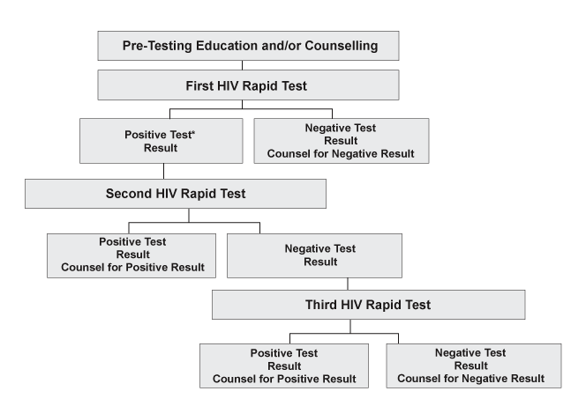

*In the context of labour in a MTCT-prevention setting, it is advised to give a single dose of nevirapine on the basis of a positive rapid test. This should then be confirmed after delivery.
Diagnostic Testing of Infants and Young Children Exposed to HIV

Because ARV treatment/prophylaxis reduces but does not eliminate MTCT, programmes must include follow-up care and HIV diagnostics for infants of mothers who are HIV-infected.

HIV diagnosis in children 18 months and older with HIV antibody tests in resource-constrained settings
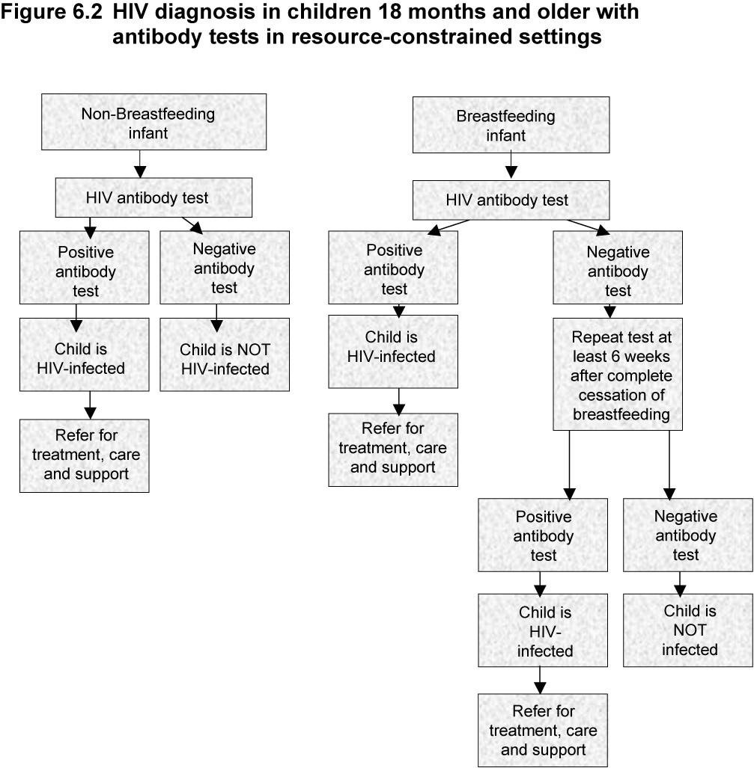
HIV diagnosis in infants and young children less than 18 months with viral assay in resource-constrained settings
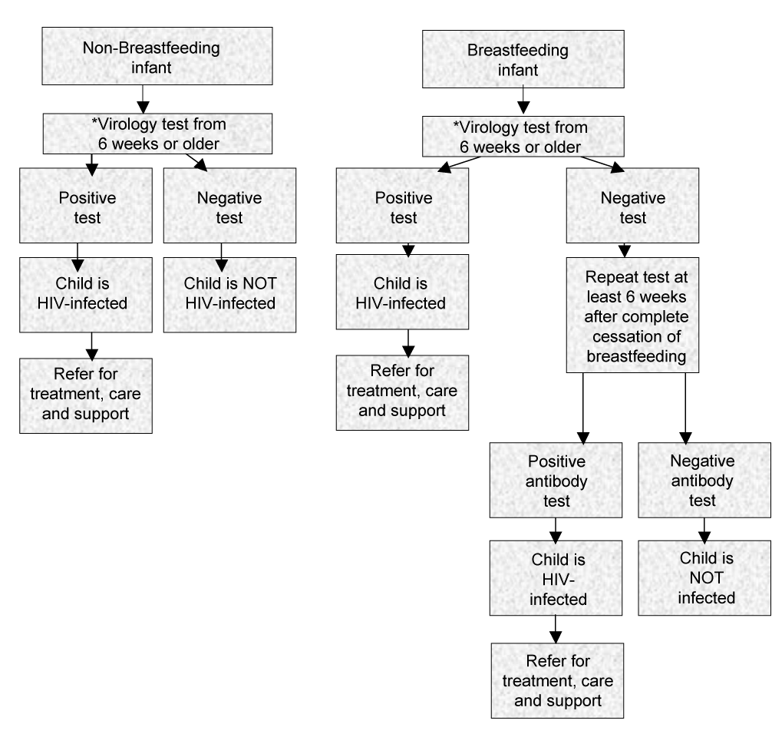

*Recommended virologic tests include HIV DNA PCR and HIV RNA PCR assays
Counsellor Skills
Empathising—understanding how the client feels without being judgmental
Active listening—paying attention to the client's verbal and physical cues indicating feelings or concerns
Open questioning and probing—asking questions beginning with “how,” “what,” or “why,” that prompt detailed answers
Focusing—helping the client remain focused on the goals of the session
Correcting inaccurate information—sensitively correcting myths and false information

The key to a promoting a positive counsellor/client relationship is mutual respect and complete confidentiality.

Pre-Test: Group Information
Adapt the scope and depth of information to the group's knowledge. Use client-friendly teaching methods and answer questions. Reinforce behaviour change efforts including safer sex practices. Include a discussion of:
- HIV and AIDS overview
- STIs and HIV
- MTCT and its prevention
- HIV testing process
- Benefits and risks of HIV testing
- Confidentiality
- Implications of both positive and negative test results
- Identification of supportive HIV services
- Family planning
- Individual counselling and risk assessment
- Testing and counselling for couples

Recognise when an individual needs to be referred for individual counselling and facilitate that referral.

Counselling Couples

Considerations when working with couples
- Establish a relationship with both partners.
- Check each person's understanding of HIV/AIDS.
- Avoid letting one partner dominate the conversation.
- Verify willingness to have the test done.
- Explain the process of testing and the results:
- How do they want to receive the results?
- What kind of support can they give each other?
- Explore benefits and risks of knowing their status, as individuals and as a couple.
- Encourage them to discuss what it will mean if they do not get the same result (discordant test results).
- Explore who else might be affected by the HIV test result.

Post-Test Counselling Sessions
The post-test counselling session for both the
HIV-positive and HIV-negative woman has several goals:
- Provide the woman with her HIV test result.
- Help her understand the meaning of the result.
- Provide support, information, and referral.
- Encourage risk-reducing behaviour.
- Encourage disclosure and partner testing.

For the HIV-negative woman
Provide information to prevent future HIV infection and about the high risk of transmission to infant if newly infected during pregnancy or breastfeeding.

For the HIV-positive woman
- Discuss immediate concerns.
- Discuss disclosure and partner testing.
- Encourage women to attend subsequent ANC visits and stress the importance of delivery in a PMTCT facility.

Guide to post-test counselling
- Establish her readiness to receive the result.
- Give the result simply, clearly, in a neutral tone.
- Allow her time to consider the result.
- Use open-ended questions and make sure she understands the result.
- Identify her major concerns.
- Encourage partner participation or provide referrals.
- Provide contact information for health centre.
Testing and Counselling in
Labour and Delivery
Women with unknown HIV status
Some women present at the time of labour without having received antenatal care or HIV testing. Consider rapid testing and ARV prophylaxis to prevent MTCT per national policies.

Postpartum testing and counselling
- Establishes HIV status and provides direction for ARV prophylaxis for the infant
- Provides direction and support for infant feeding
- Provides an opportunity for education about the increased risk of infection
- Establishes linkages for ongoing treatment, care, and support within the community
Postpartum Care of the Mother Who Is HIV-Infected
Healthcare workers can ensure that women are either visited at home after delivery or encouraged to return to a health centre for postpartum appointments.

Women who give birth at home need to be evaluated 1 week after the birth and again at 6 weeks.

Goals of postpartum care include:
- Assessment of healing
- Infant-feeding support
- Sexual and reproductive care

Link the mother who is HIV-infected to the following services, either directly or by referral as needed:

- Prevention and treatment of opportunistic infections
- ARV treatment, when indicated and available
- Treatment of symptoms and palliative care
- Nutritional support
- Social and psychosocial support
- Faith-based support
- Home-based care

Women receiving ARV treatment during pregnancy will continue treatment with monitoring and follow-up by the HIV programme. Women diagnosed in pregnancy and not receiving ARVs should be referred to the HIV treatment programme for follow-up care.
Linkages with Local Treatment, Care, and Support Services
Linkages between MCH and HIV services
- MCH services serve as entry points for PMTCT and for the treatment, care, and support of women who are HIV-infected and their infants and families.
- Caring for and treating families affected by HIV is a shared responsibility.
- Infants who are HIV-exposed require close follow-up and care.
- Health promotion, prevention, and treatment of illnesses are part of comprehensive care.
- Specialists in HIV who care for women and children can provide consultation, antiretroviral treatment, and management of HIV.

Linkages for special needs
Comprehensive health care for families living with HIV infection includes linkages to:
- Family planning services
- STIs treatment services
- Malaria and tuberculosis prevention and treatment services
- Substance abuse treatment services
- Nutritional support services

Linkages to community-based AIDS service organisations
Non-governmental organisations (NGOs), faith-based groups, and similar agencies often provide treatment, care, and support services for mothers who are HIV-infected and family members.
Prevention and Treatment of Opportunistic Infections
Infections are a major complication of HIV/AIDS. Preventing opportunistic and other infections will help a woman stay healthier, preserve her immune system and improve her quality of life.

Follow national and WHO guidelines for:
- Prevention and treatment of malaria
Recommend the use of insecticide-treated bed nets to prevent malaria in areas where it is endemic.

- Prevention, screening and treatment of tuberculosis (TB)
An estimated 40% of persons who are
HIV-infected will develop TB in their lifetime. Refer to country protocols regarding prophylaxis, screening, and treatment of TB, particularly in high prevalence areas.

- Immunisations
Recommendations for immunisations should follow national and WHO guidelines for adults who are HIV-infected.

Pneumocystis Carinii Pneumonia (PCP) Prophylaxis for Adults
Category | Recommendation for Adults
Client selection and duration of prophylaxis | - All persons with symptomatic HIV (WHO Stage II, III, IV)  - Asymptomatic individuals with CD4 counts below 500/mm³ or equivalent total lymphocyte count  - Cotrimoxazole should be taken for life or until ARV agents become available and therapy results in restoration of CD4 count of 500/mm³ or greater
Drug regimen | - Recommended dose: cotrimoxazole 960 mg once daily (1 double-strength tablet or 2 single-strength tablets daily)
Preparation | - Most commonly, oral tablet
Adverse events requiring discontinuation and substitution | - Severe cutaneous reaction, such as fixed drug reaction or Stevens-Johnson Syndrome, renal or hepatic insufficiency, severe haematologic toxicity

Prevention, Screening, and Treatment of Mycobacterium Tuberculosis (TB)
National guidance is provided on prevention, screening, treatment and monitoring of TB. With standardised treatment of both active and latent TB, preventive therapy against TB is part of a comprehensive care package for all PLWHA.

TB prophylaxis is recommended for persons who are HIV-infected who test positive for TB infection and in whom active TB has been excluded.
Six to nine months isoniazid (INH) is recommended for preventive treatment of latent TB infection for persons who are HIV-infected living in high prevalence areas where skin testing is not available.

Persons who are HIV-infected and who have active TB should also receive cotrimoxazole preventive therapy for the prevention of secondary bacterial and parasitic infections.

With special consideration of treatment drugs and careful clinical management, women on oral contraceptives, pregnant women and persons who are HIV-infected on antiretroviral therapy can receive simultaneous treatment for TB and HIV.

Treatment of Symptoms and Palliative Care
Early identification and symptom management can relieve discomfort, improve a woman’s quality of life and help her to “live positively.”

Encourage reporting and treatment of the following HIV symptoms:
- Nausea or vomiting
- Fatigue
- Skin problems
- Pain (early intervention is key to effective management)
- Emotional distress

Palliative Care
Patient and family-centred care that:
- Provides access to information and honours a person’s choices
- Optimises quality of life
- Anticipates, prevents and treats suffering
- Addresses physical, emotional, social and spiritual needs

Provide nutritional counselling to:
- Avoid nutrition-related complications
- Reduce bacterial infections
- Improve overall health and immune function
Treatment, Care, and Support of the Infant Who Is HIV-Exposed
Infants born to mothers with HIV or whose HIV status is unknown are at increased risk of illness and failure to thrive, even if they have received antiretroviral prophylaxis.

Regular assessment, early identification of
HIV-related symptoms and HIV testing are key to ensuring proper growth and development—especially during the first two years of life.

Anytime the infant becomes ill or the mother suspects a problem, encourage her to seek health care.

Healthcare visits
- Assess and manage common illnesses.
- Monitor growth and development.
- Identify HIV-related symptoms.
- Provide HIV testing (according to protocols).
- Provide PCP prophylaxis.
- Immunise according to guidelines.
- Treat helminth infections when indicated.
- Screen, prevent, and treat tuberculosis (TB) and malaria.
- Support and counsel on infant feeding, nutrition, and antiretroviral treatment when indicated.

Clinical conditions or signs of HIV infection in a child who is HIV-exposed

Specificity for HIV infection | Signs and conditions
Common in children who are HIV-infected; also seen in ill, uninfected children | - Chronic, recurrent otitis media with discharge  - Persistent or recurrent diarrhoea  - Failure to thrive  - Tuberculosis
Common in children who are HIV-infected; uncommon in uninfected children | Severe bacterial infections, particularly if recurrent  - Persistent or recurrent oral thrush  - Chronic parotitis (often painless)  - Generalised persistent non-inguinal lymphadenopathy in two or more sites  - Hepatosplenomegaly  - Persistent or recurrent fever  - Neurologic dysfunction  - Herpes zoster (shingles), single dermatome  - Persistent generalised dermatitis unresponsive to treatment
Specific to HIV infection | - Pneumocystis carinii pneumonia  - Oesophageal candidiasis  - Lymphoid interstitial pneumonitis  - Herpes zoster (shingles) with multidermatomal involvement  - Kaposi's sarcoma

Pneumocystis Carinii Pneumonia (PCP)
Prophylaxis for Infants
Category | Recommendation for Infants Who Are HIV-Exposed
Client selection and duration of prophylaxis | - Infants who are HIV-exposed, starting at 6 weeks and continuing for at least 6 months, preferably until HIV infection can be ruled out  - Infants who are HIV-infected less than 12 months, regardless of symptoms or CD4 percentage or count  - Infants who are HIV-infected over 12 months, if symptomatic, if AIDS is diagnosed, if CD4 below 15% (when information is available), or prior PCP diagnosis
Drug regimen | TMP 150 mg/m² and SMX 750 mg/m² given once daily
Preparations | Oral suspension: TMP 8 mg/mL and SMX 40 mg/mL  If suspension is unavailable, crushed tablets may be used
Adverse events requiring discontinuation and substitution | Severe cutaneous reaction such as fixed drug reaction or Stevens-Johnson Syndrome, renal or hepatic insufficiency, severe haematologic toxicity

Age of Infant | Vaccine
Birth | BCG*, OPV-0
6 weeks | DPT-1, OPV-1
10 weeks | DPT-2, OPV-2
14 weeks | DPT-3, OPV-3
9 months² | Measles²
Key:
BCG = Bacille Calmette Guérin
OPV = oral polio vaccine
DPT = diphtheria, pertussis, tetanus
¹ Additional immunisations, for yellow fever or other diseases, for example, can be included in national recommendations that account for local disease prevalence.
² An additional, early dose of measles vaccine should be given at age 6 months if the following conditions are met:
- Measles morbidity and mortality before age 9 months represents more than 15% of cases and deaths.
- There is a measles outbreak.
- The infant has a high risk of measles death. This includes infants
- with documented HIV infection,
- living in refugee camps,
- admitted to the hospital, or
- affected by disasters.

* BCG – do not give in low prevalence countries to infants or children who are HIV-infected; in high prevalence countries give to all children except children with symptoms of HIV/AIDS.
WHO Immunisation Recommendations¹
Care of the Infant with
Documented HIV Infection
The suggestion or confirmation of HIV diagnosis in an infant or child is difficult for the parents. Compassion and assurance of confidentiality are needed as parents receive information about available services.

Where ARV treatment is available, providers can:

- Monitor for symptoms of HIV infection
- Determine criteria for treatment of HIV based on WHO and country protocols
- Refer for treatment, care, and social support

WHO Recommendations For Initiating
ARV Treatment In Infants And Young Children
For infants who are seropositive aged under 18 months, WHO recommends the initiation of ARV therapy in the following circumstances:
- The infant has virologically proven infection (using either HIV DNA PCR, HIV RNA assay, or immune-complex dissociated p24 antigen) and has:
- WHO Paediatric Stage III HIV disease (ie, clinical AIDS) irrespective of CD4%; or
- WHO Paediatric Stage II HIV disease, with consideration of using CD4 <20% to assist in decision-making; or
- WHO Paediatric Stage I (ie, asymptomatic) and CD4% <20%. (asymptomatic children, ie, WHO Stage I, should only be treated when there is access to CD4 assays).
If virological tests to confirm HIV infection status are not available but CD4 cell assays are available, WHO recommends that ARV treatment can be initiated in infants who are HIV-seropositive and have WHO Stage II or III disease and a CD4 percentage below 20%. In such cases, HIV antibody testing must be repeated at age 18 months in order to definitively confirm that the children are HIV-infected; ARV therapy should only be continued in infants with confirmed infection.
For children who are HIV-seropositive aged 18 months or older, WHO recommends initiation of ARV therapy in the following circumstances:
- WHO Paediatric Stage III HIV disease (clinical AIDS), irrespective of CD4%; or
- WHO Paediatric Stage II disease, with consideration of using CD4 <15% to assist in decision-making; or
- WHO Paediatric Stage I (asymptomatic) and CD4 <15%.
Breastfed infants are at risk of HIV infection during the entire period of breastfeeding. A negative virological or antibody test at one age does not exclude the possibility of infection occurring subsequently if breastfeeding continues.
Creating a Safe Work Environment
Most HIV transmission to healthcare workers in healthcare settings is the result of skin puncture with contaminated needles or sharps. These injuries occur when sharps are recapped, cleaned, or inappropriately discarded.
Patient-to-patient transmission of HIV infection can be prevented by disinfecting or sterilising equipment and devices used in invasive or percutaneous procedures.

Universal Precautions
A simple set of effective practices designed to protect health workers and patients from infection with a range of pathogens including bloodborne viruses. These practices are used when caring for all patients regardless of diagnosis.
.

Universal precautions include the following
- Wash hands for at least 15 seconds before and after any direct patient contact.
- Disinfect or sterilise contaminated equipment or devices.
- Avoid recapping needles.
- Use needles or scalpel blades on one patient only.

Recommendations for use of
sterile injection equipment
- Use a sterile syringe and needle for each injection and to reconstitute each unit of medication when possible.
- Avoid recapping and other hand manipulations of needles.
- Use a single-handed scoop technique when recapping is absolutely necessary.
- Place used syringes immediately in a sharps container that is puncture- and leak-proof.
- Seal sharps container before completely full—never re-use containers.
- Completely destroy or bury needles and syringes so that people cannot access them and so that groundwater contamination is prevented.

Sharps containers
If plastic or metal containers are unavailable or too costly, use cardboard safety boxes that meet WHO specifications. If cardboard safety boxes are unavailable, many easily available objects can substitute as sharps containers:
- Tin with a lid
- Thick plastic bottle
- Heavy plastic box
- Heavy cardboard box
Risk Reduction in the Obstetric Setting
The potential for exposure to HIV-contaminated blood and body fluids is greatest during labour and delivery.

The following strategies can help reduce risk:
- Cover broken skin or open wounds with watertight dressings.
- Wear suitable gloves, including long cuffed gloves for manual removal of placenta.
- Wear impermeable plastic apron for delivery.
- Modify surgical practice to use needle holders, and use appropriately sized needles for suturing.
- Wear eye shield as needed.
- Wash blood splashes on skin with soap and water; rinse eyes with clear water only.
- Safely dispose of solid waste, including placenta and blood-soaked dressings.

Strategies for resource-constrained settings
Universal Precaution measures are difficult to practise when supplies are low and protective equipment is not available. Use resources cost-effectively by prioritising the purchase and use of supplies.

Minimise contact with blood and body fluids.
Help develop and implement safety procedures that ensure effective patient care without risking personal safety.
Managing Occupational Exposure to HIV
Immediate steps
Any healthcare worker (HCW) accidentally exposed to blood or body fluids must take the following steps:

- Wash wound and exposed skin sites with soap and water.
- Allow any “stick” injury (percutaneous) to bleed or a few seconds before washing.
- Flush exposed mucous membranes with water.
- Immediately inform supervisor of exposure.
- Topical antiseptics may be used.
- Do not apply caustic agents to wound.
- Immediately inform the supervisor, or person in charge, of the exposure type and the action taken.

The supervisor should take the following steps:
- Assess exposure to determine transmission risk
- Inform patient and request permission for HIV testing.
- Request permission from exposed HCW for HIV testing.
- Perform rapid testing on both samples, if available.
- Provide immediate support and information on post-exposure prophylaxis (PEP) to HCW.
- Refer HCW to appropriate physician and counselling.
- Maintain confidentiality of records.

Guidelines for PEP
Early rapid testing of the patient involved in the incident may help determine the need for PEP—and may avert the unnecessary use of ARV drugs, which may have adverse side effects. If necessary, PEP should begin as soon as possible after exposure, ideally within 2 hours.

Staff members who are at risk for occupational exposure to bloodborne pathogens need to be educated about the principles of PEP management during job orientation and on an ongoing basis. Currently there is no single approved PEP regimen; however, dual or triple drug therapy is recommended and believed to be more effective than a single agent.

Drug selection for PEP depends on the following factors:
- Type of injury and transmission device
- Source patient’s HIV viral load and treatment history
- ARV drugs available at the facility

Importance of ARV treatment for post-exposure prophylaxis on-site
Due to the need to start PEP as soon as possible after exposure (ideally, within 2 hours), a minimum of two doses of ARV treatment should be available and accessible at the facility at all times.
ARV treatment should be provided in accordance with national or institutional protocol.

If possible, consulting with a HIV specialist is recommended, particularly when exposure to drug-resistant HIV may have occurred.
It is important that healthcare workers have ready access to at least the first two doses of the ARV PEP regimen as per national guidelines. A minimum treatment of 2 weeks and maximum of 4 weeks is recommended.
Some healthcare workers taking PEP experience adverse symptoms including nausea, malaise, headache, and anorexia. Pregnant workers or women of child-bearing age who may be pregnant may receive PEP, but must avoid efavirenz, which has harmful effects on the foetus. PMTCT programmes should support workers while they are taking PEP and help manage any side effects.
Continue PEP counselling for the exposed healthcare worker for 6 months after the exposure, or until the third negative test result.

For 6 months or until the third negative test, the HCW should:
- Practise safe sex or abstinence
- Avoid breastfeeding
- Not donate blood, plasma, tissue, semen, or organs
Burnout Syndrome in Healthcare Workers
Healthcare workers who provide ongoing care of pregnant women who are HIV-infected, pregnant women of unknown HIV status, and their infants are vulnerable to compassion fatigue or “burnout.” This condition occurs whenever someone finds himself or herself under intense and prolonged work-related stress.

Healthcare workers are particularly susceptible to this condition because of staff shortages, and caring for persons with diseases associated with high mortality, such as AIDS.

Warning signs and symptoms of burnout
- Changes in mood, eating, and sleeping patterns
- Becoming accident-prone
- Unable to make decisions, poor concentration, or forgetfulness
- Sensitivity to criticism
- Elevated blood pressure, palpitations, dry mouth, or upset stomach
- Arguing with colleagues
- Low energy and productivity

Personal strategies to minimise or prevent burnout syndrome:
- Find a support group of peers.
- Find a mentor or someone you can speak with in confidence who will guide and support you.
- Take a refresher course or a new course, or learn a new skill to help you in your work.
- Take breaks during work hours.

Most importantly, healthcare workers should:
- Exercise, eat properly, and get enough rest.
- Make time for themselves and their families.

PMTCT Programme Monitoring
Monitoring is regular tracking of key programme elements to:
- Assess programme performance
- Detect and correct performance problems
- Make more efficient use of PMTCT programme resources

A PMTCT monitoring system includes:
- Clear definitions of indicators – measures
used to describe a situation
- Standard tools, data sources and methodologies
- Clear roles and responsibilities for
staff involved in
- Data collection
- Analyses
- Reporting
- Dissemination
- Data use

Tips for collection of “good data”
- Understand the data to be collected
- Record the data
- Every time
- All of the data
- In the same way every time

For further information, please contact:

World Health Organization
Department of HIV/AIDS
20, Avenue Appia, CH-1211 Geneva 27, Switzerland
E-mail: hiv-aids@who.int
http://www.who.int/hiv/en

ISBN 92 4 159201 X


