Saint-Gaudens National Historic Site
Water Resources Monitoring 2004 Annual Report

Abstract

The data collected in 2004 indicate that the overall water quality and biological integrity of the aquatic ecosystems at the Saint-Gaudens National Historic Site, Cornish, New Hampshire, are in good condition. Data were collected at six permanent water-monitoring stations established in 1997. The following parameters were measured at the six stations on a monthly basis, beginning in May and concluding in November: conductivity, dissolved oxygen, depth, pH, water temperature, and turbidity. Discharge was measured at four stations: 1, 2, 3, and 6. Fecal coliform sampling was conducted at stations 1, 2, 3, and 5 September. A biological assessment was done at stations 1, 2, 3, and 6, in May, August, and November.

Water temperatures were as expected, showing the effects of both seasonal changes in air temperature and water discharge volume. The Blow-Me-Up Brook, located in the well-shaded Ravine, consistently registered the coldest water temperatures.

Throughout the course of the sampling season, the park’s streams and pond exhibited a high capacity for carrying oxygen, which is critical for the survival of aquatic organisms. There was a direct correlation between water temperature and oxygen content: colder water temperatures in the spring and fall resulted in greater oxygen content in the water. In July, the lowest percent saturation and concentration of oxygen were observed; however, these values are well within State of New Hampshire standards for Class A waters, which require a dissolved oxygen content of at least 75% saturation and a minimum of 6 mg/l.

Past and present pH sampling indicates that the park waters maintain a very stable, slightly alkaline, value range. In 2004, the pH levels at the six sampling sites ranged from 7.18 to 8.17.

Turbidity values are highly variable with storm events and stream substrate. The station sited within the pond, where silt accumulates, registered the highest average turbidity.

Dissolved nutrient sampling (ammonium, nitrate and phosphate) was not conducted in 2004.
Stream discharge was greatest in August, while October registered the lowest discharge volume. Precipitation was above average for five of the seven months that sampling was conducted in 2004, following a similar pattern as 2003. For the calendar year, annual precipitation was 3.96 inches below the 100-year average; however, for the sampling season precipitation was 2.02 inches above the 100-year average.

Fecal coliform levels were within the established limits for Class B recreational waters as defined by the State of New Hampshire.

The biological health of the park’s aquatic resources produced an average index value of 15.5 indicating that the streams are in fair (index value 11-16) condition based on the assessment protocols. No samples were in the “poor” category. Abundant water levels provided for plentiful macroinvertebrate habitat, yielding an average SQS index value in the high end of the “fair” category. The average SQS index value in 2003 was 14.08. The streams contain a diversity of benthic macroinvertebrates that are intolerant of pollution.

Introduction

Statement of Problem

Saint-Gaudens National Historic Site (SAGA) is a rural park located approximately 15 miles south of Lebanon in Cornish, New Hampshire. Although water quality monitoring has been conducted at the park in the past, data collection was sporadic (five samples over the ten-year period 1981-1991). Due to the infrequency of sampling, lack of consistency among methods, and lack of water discharge data, it is difficult to evaluate the data or determine any long-term trends pertaining to the water quality of the Blow-Me-Down watershed. In 1997, a permanent monitoring program was established to address the lack of baseline data. The program also aids the park in meeting the reporting requirements of the Government Performance and Results Act, as well as monitoring its “vital signs” in conjunction with the Northeast Temperate Network of the National Park Service Inventory & Monitoring program.

Development in the drainage basins surrounding SAGA is currently limited; however, land use in adjacent areas is changing and it is essential that SAGA generate baseline water resources data and monitors the status of those resources via a long-term monitoring strategy. The strategy includes a suite of useful water quality parameters, in addition to the implementation of the Izaak Walton League of America's Stream Quality Survey (SQS), a rapid bio-assessment technique. This dual, complementary approach allows not only for the characterization of water quality based on pre-set state and federal standards, but also of the actual effects of this water quality on SAGA's surface aquatic ecosystems.

Objectives of Study

Through long-term water quality and biological monitoring activities, the park’s objective is to detect changes in the relative health of the surface stream ecosystems and identify external factors that may be degrading the species distribution and, therefore, the functional integrity of those ecosystems. If and when a case can be suggested for a cause and effect relationship between specific external factors and SAGA water resources, the appropriate local, state, and federal environmental enforcement officials will be notified, and the situation corrected by educating and working with the potentially responsible parties. In addition, other, more focused investigations may be necessary to substantiate the existence of problems beyond the resolution of this program.

Description of Study Site

SAGA encompasses a variety of watershed types from predominantly well-drained, upland terrain to lower elevation streams and associated wetland areas (approx. 300-600 feet altitude range). Two major surface streams, Blow-Me-Down Brook and Blow-Me-Up Brook, begin upstream of the park, flow through the park, and eventually empty directly into the Connecticut River. Blow-Me-Down Brook enters the park on the northwest boundary and meanders through the western side of the park (defining that portion of the park boundary) and into Blow-Me-Down Pond. Blow-Me-Up Brook enters the park on the northeast boundary and joins Blow-Me-Down Brook in the western-central region of the park (where it again is part of the park boundary). Beyond Blow-Me-Down Pond, water exits the park over the historic Blow-Me-Down Dam and flows under New Hampshire Route 12A and into the Connecticut River. Both of these streams have headwaters located adjacent to land uses which may be potentially harmful to the water resources within SAGA (i.e. residential septic systems, limited agriculture, and landscape development). Management concerns include the potential threat posed by the use of road deicing chemicals on nearby roads, as well as erosion and siltation.

The water quality-monitoring program consists of monthly (approximately May – November) sampling at six permanent monitoring stations (Appendix II), all but one station located within the NPS boundary. Due to the climate and resultant hazardous conditions of this region (i.e. ice and high water), it is usually not feasible to conduct monitoring activities from approximately December to March. Also, parameters that cannot be measured in the field are analyzed with the help of in-kind laboratory services from the Cape Cod National Seashore, North Atlantic Coastal Laboratory as well as at a cost basis at a local water laboratory.

Methods

Physical Quality Parameters

The following water quality parameters are measured at all six of the site’s permanent monitoring stations: water temperature, water depth, dissolved oxygen, conductivity, pH, and turbidity. These were measured in the field using a Hydrolab H20® submersible sonde with a Scout II display unit. The instrument is calibrated on a regular basis and checked for accuracy prior to the collection of field data.

Other parameters including nitrogen (NH₄ - ammonia, NO₃ – nitrate) and phosphorus (PO₄ -orthophosphate) are measured colorimetrically using the Cape Cod National Seashore, North Atlantic Coastal Lab’s Lachat autoanalyzer. Park personnel collected water samples, which were filtered through 0.4-micrometer Millipore membranes and preserved, chilled, with 0.4 mL of 2N HCl, prior to analysis. These nutrients were not assessed in 2004. The park is currently awaiting the completion of a Water Resources Scoping Report as a result of a technical assistance request made to the National Park Service Water Resources Division. The report will address the viability of current monitoring protocols. For a number of reasons, nutrient analysis has proven to be problematic since the program began in 1997.

Flow Rate

Stream discharge was measured at stations 1, 2, 3, and 6 using a Marsh-McBirney, Model 2000, electromagnetic flow meter to determine spot flow rates. The total flow was estimated by dividing the stream into equal-width segments using a tape stretched from bank to bank. A velocity measurement was recorded at the center of each segment at 60% of the segment’s depth. The flow volume through the segment was found by multiplying the spot velocity by the cross-sectional area (CSA): the width of the segment multiplied by the depth at the segment’s center. The sum of these segments’ flow was the estimated stream flow, recorded in cubic feet per second (CFS).

Biological Quality Parameters

Fecal coliform levels were assessed once in 2004 at stations 1, 2, 3, and 5. Samples were collected in sterile containers, placed on ice, and transported within six hours to a local laboratory for analysis.

The Izaak Walton League of America’s Stream Quality Survey (SQS) was performed at stations 1, 2, 3, and 6. Water depth is too great to conduct SQS at stations 4 and 5, and the rocky bottom sampling method is inappropriate for the benthic substrate at these locations. This portion of the water quality monitoring program was conducted in order to quantitatively evaluate the distribution and diversity of the benthic macroinvertebrates in the park’s streams. The exact protocol for conducting the SQS is found in the Save Our Streams, Volunteer Trainers Handbook (Izaak Walton League of America, 1994). SQS parameters were updated in 2003 by the IWLA; however, the park continued to use the older standards for the 2004 season for the sake of consistency. Following the completion of the Water Resources Scoping Report, the park will determine whether or not to adopt the revised standards.

The SQS protocols generate a numerical index of aquatic “health” based on the diversity of several groups of taxa and their overall ability to survive in water containing pollution (sensitive, somewhat sensitive, tolerant). Stream health is based on an aggregate “score” for each particular sampling station (<11 poor, 11-16 fair, 17-22 good, >22 excellent). A 1m x 1m kick seine net with 1mm pores is placed in the stream with the lower edge flat against the bottom. An area of streambed approximately 1m² immediately upstream of the net was rubbed by hand, followed by a general dislodging of the sediment to loosen any invertebrates. All those remaining in the net when it is scooped out of the water are identified by general taxa. The “score” increases by finding a representative of a taxon, with pollution-sensitive taxa worth three “points,” moderately sensitive taxa worth two and pollution-tolerant taxa worth one “point.” Additional representatives are not factored into the aggregate score.

Results (See Appendix I for raw data)

Water Temperature

Water temperature levels at the six permanent monitoring stations followed a typical seasonal fluctuation (Appendix III, Chart 1). The coldest temperatures recorded were during the November sampling, with Station 1 registering 3.95 degrees Celsius. The warmest temperature reported was 22.14 degrees, during the July sampling at Station 6. Average temperatures for the six stations generally increased from Station 1 to Station 6. The most notable temperature difference was found in July, when Station 1 was at 15.51 degrees and Station 6 at 22.14 degrees, a temperature differential of 6.63 degrees.

Dissolved Oxygen

Dissolved oxygen (DO) levels varied according to season (Appendix III, Chart 2). The highest levels were found in the spring and fall, while the lowest readings were recorded during the middle of the summer. The maximum was 13.57 mg/l in May (Station 6) and the minimum was 8.43 mg/l in July (Station 6). These levels were consistently high, with greater than 88% saturation in all 42 of the readings.

pH

pH values (Appendix III, Chart 3) at the six sampling station ranged from 7.18 (Station 4, May) to 8.17 (Station 6, November). The average for all samples at all stations was 7.73. The average for a given month ranged from 7.30 in May to 8.04 in November. There was an apparent trend of increasing pH values seasonally from May to November. pH values did not vary significantly between stations.

Conductivity

Conductivity values for the six sampling stations ranged from 0.1172 mS/cm (Station 1, November) to 0.2117 mS/cm (Station 5, July). There are apparent trends associated with the conductivity values, as the values tended to increase seasonally from May to July, and then remained somewhat static for the months of August and September, after which, they decreased. (Appendix III, Chart 4).

Turbidity

The highest turbidity value (Appendix III, Chart 5) for the six sampling stations was recorded at Station 5 (10.0 NTU, June). Station 5 had the highest mean value (6.5 NTU), while Station 1 had the lowest mean value (1.1 NTU). On average, turbidity values increased following the downstream gradient with the exception of Station 6.

Ammonium - NH₄

This parameter was not assessed in 2004.

Nitrate- NO₃

This parameter was not assessed in 2004.

Phosphate- PO₄

This parameter was not assessed in 2004.

Stream Discharge

Water flow through the park varied from month to month (Appendix III, Chart 6), with the trends of greater discharge levels usually associated with the spring thaw and fall rains not readily apparent. Maximum output at Station 6 (below BMD Dam) was 22.336 Cubic Feet per Second (CFS) in August, while flow at the same station was 7.501 CFS in September. Station 1 averaged the lowest discharge at 1.594 CFS, while Stations 2 and 3 were averaged 11.361 and 11.746 CFS, respectively. Station 6 had the greatest average discharge at 14.009 CFS.

SQS Index

The Stream Quality Survey (SQS) index showed an average value of 15.5 for all samples, which at the high end of the “Fair” category. The lowest value identified was 13 at Station 1 in August and Stations 1 and 3 in November. The highest index value was 19 at Station 3 in August. There was no significant difference between months for average sampling values; however, Station 2 yielded the highest average value (16.33), while the lowest average (12.67) was found at Station 1.

Fecal Coliform
One series of samples were collected in September, 2004 (Appendix I). The concentrations of coliform ranged from 9 (Station 1) Colony Forming Units per 100 ml of water (CFU) to 147 (Station 5). The average coliform concentration for the four samples was 89.25 CFU. This figure closely resembles the 2003 average of 88.5 CFU (based on a twelve-sample average).

Discussion

Temperature

Water temperature typically changes in response to seasonal changes in air temperature, which was clearly seen in the SAGA data; with the highest temperatures recorded during the summer sampling. The lowest temperatures were generally recorded at stations 1 and 2. This is consistent with a system where sunlight produces the warm air and water temperatures. A relatively negligible amount of sunlight reaches this portion of the watershed due to the steep topography and abundant canopy cover of the forest and likely accounts for the cooler water temperatures. Another factor influencing water temperature is discharge. The average air temperature was 0.5 degrees warmer in August as compared to July, while the average water temperature for all six stations was 1.37 degrees warmer in July. There is an apparent correlation between water temperature and discharge volume, with temperature decreasing with increased discharge. In August the discharge rate at the time of sampling was almost double that of July.

Dissolved Oxygen

Generally, there is an inverse relationship between dissolved oxygen and water temperature, i.e. colder water has a greater capacity for holding oxygen. This was apparent in the 2004 data, as the least amount of DO was observed in July when water temperature was the highest. A deviation from the intuitive pattern is due to the consistency of DO amounts in a given sampling and the lack of repetitions. The turbulent waters of Blow-Me-Up Brook (Station 1), Blow-Me-Down Brook (Stations Two and Three) and especially the area below the dam (Station 6) would logically have more dissolved oxygen due to aeration. The relative lack of variation may be explained by the Percent Saturation data, as the water was usually near saturation, when extra potential aeration would have little effect. High DO levels signify a non-eutrophic system, which is important for ecological health.
Based on the data collected in between 1997 and 2004, the park meets and exceeds the New Hampshire DO standards for Class A waters: minimum of 6.0 mg/l (based on any single sample)
And a minimum of 75% saturation (based on daily average of all samples).

pH

Fresh water pH values fall somewhere between 6.5 and 8.2, although wide variations can occur. At SAGA, the waters were somewhat alkaline, i.e. above 7.0. The data show no clear trends in the order of the stations’ pH, indicating a lack of change from the water flow downstream, or a constant effect of a local condition such as a patch of basic mineral in the streambed. pH did show an increasing trend across the year, indicating that seasonal change in flow rate and precipitation may be somewhat important to acidity. This change was not statistically significant, and while snowmelt may be acidic, the effects appear to dissipate with time. The Blow-Me-Down watershed appears to be buffered against the acidic precipitation that is threatening much of New England.

Conductivity

Conductivity is a measure of how easily water will conduct an electrical current, which is dependent upon the concentration of dissolved ions (e.g. salinity). The soils in and along Blow-Me-Down Brook contain clay, which will increase conductivity. Conductivity showed a slight seasonal increase that peaked in July, followed by a slight decline in the fall. This is a normal reaction to increases and decreases in water temperature. Much of the relevant variance may be connected to weather events rather than seasons. Addition of ions from runoff, particularly road care on the adjacent highway (NH Route 12-A) would be primarily tied to storms and snowmelt. Conductivity readings may decrease as the system is flushed out. There are no standards for specific conductivity because the levels vary with geology, however, SAGA’s values fall within the low end of the EPA’s range for rivers throughout the United States. Though specific standards for conductivity do not exist, the park measures this parameter in order to look for changes or anomalies over time, as sudden drastic changes may indicate a problem in the watershed.

Turbidity

Turbidity is the measure of suspended solids in a body of water; therefore it is also a relative measure of water clarity. High turbidity may limit the depth to which light can diffuse underwater; thus limiting the maximum depth for photosynthesis. It can also be partially indicative of nutrient-overloading (eutrophication) problems due to excess algal growth. A suspicion of harmful loading would have to be corroborated by other evidence to show that it was not a sustainable level of algae growth or turbidity from non-living material.

Turbidity readings on the HydroLab measuring device were highly variable, often jumping 50% or more between readings while the probe was submerged and immobile. In the past, this variability led to a lack of confidence in the accuracy of the turbidity readings; however, previous investigation using statistical analysis showed that turbidity readings, while appearing to be unreliable, are not problematic. Stations 4 and 5 tend to show the highest values for turbidity for the entire sampling season. This is presumed to be an artifact of the sampling sites, as there is significant sedimentation present at both locations. The impact of the probe on the stream substrate generates enough sediment that the turbidity reading may reflect the impact of the probe, rather than the prevailing value. Repetitions and testing for acceptable variation may increase the confidence level experienced with the probe.

Stream Discharge

Discharge was greatest in August due to the timing of the sampling, as well as the above average rainfall that month. Station 1 on Blow-Me-Up Brook produced, by far, the least volume of water throughout the sampling period. In most instances, the amount of water produced by the Blow-Me-Up and the Blow-Me-Down Brooks was additive and approximated the amounts measured at Stations 3 and 6. Average monthly precipitation for 2004 was 4.00 inches; .29 inches greater than the 110-year average for the same period, i.e. May - November (Appendix III, Chart 7).

SQS Index

The average score for the SQS index was 15.5, which is at the high end of the “Fair” category. Five of the 12 assessments made, scored above 16, which is “Good.” Station 2 averaged “Good” with an index of 17.0. Stations 1, 2, and 3 averaged 12.7, 16.6, and 16.0, respectively. Differences between stations, and season, were not statistically significant, regarding biological assessment.

Although the index values register as “Fair,” they are at the highest end of the category and show an improvement of 1 point over the 2003 average SQS. These scores indicate an apparent lack of pollution in the watershed. The “Pollution Tolerant” organisms, those that would remain in a polluted watershed, were outnumbered by the “Pollution Sensitive” taxa. Additionally, variances in SQS values over the years are generally attributed to changes in water levels, i.e. available macroinvertebrate habitat, not to watershed pollution.

Fecal Coliform

Fecal coliform is indicative of the presence of a bacterium that threatens human health and water usage. It is introduced by wildlife, such as beaver, deer and waterfowl, all of which occur in the park’s watershed. Other common and potentially harmful sources of fecal coliform include agricultural and human waste. Fecal coliform levels for this year were similar to those found in previous years.

Only one round of samples was taken in 2004. Although more would be desirable, the cost of such analysis makes widespread, routine testing prohibitive. The single round of samples taken in November showed variable concentrations of coliform, ranging from 9 Colony Forming Units per 100 mL of water (CFU) at Station 1 (Blow-Me-Up Brook) to 147 CFU at Station 5 (Blow-Me-Down Pond). For comparison, State of New Hampshire Class S surface waters are not to exceed 153 CFU/100ml in any one sample. This standard is based on a one-time sample. All of the 2004 SAGA samples met NH Class A standards. Sampling will continue in order to monitor for the presence of this potentially harmful bacterium, with a minimum goal of sampling at least three times per year.

Recommendations/Future Considerations

- Incorporate any pertinent findings or recommendations of the Saint-Gaudens NHS Water Resources Scoping Report into the water quality monitoring program (report to be completed in 2005).

- Share data with the NPS Northeast Temperate Network, Inventory & Monitoring program.

- Include farm pond property in the water quality monitoring program.

- Maintain the current sampling practices with repetitions for physical parameters measured with the Hydrolab and flow meter. Increasing from one to three repetitions will enhance the validity of data collected. Once one suite of samples has been taken, it is recommended that they be repeated. In most cases, sampling can still be done in one day, though the October and November sampling may require additional time due to weather conditions and amount of daylight. Continuing this sampling will aid in identifying trends and allow for better identification of anomalies.

- Should inappropriately high levels of coliform be detected, expand the frequency of coliform sampling. Additionally, should coliform levels exceed standards for recreational waters, contact the New Hampshire Department of Environmental Services and recommend that they investigate upstream, to determine the source of the coliform. Park staff may want to consider sampling the small stream leading from visitor parking lot. Coliform sampling should coincide with the SQS.

- When practical, continue using school groups to assist with water quality monitoring program especially the SQS. In this manner, the park can provide educational opportunities for local students while, at the same time, continue to further the park mission of preserving and protecting its resources.

- Perform conductivity and pH samples during or at the end of the snowmelt period to determine if there are important shifts in these values. Of particular concern are changes in salinity resulting from road salt runoff (as measured by conductivity) and changes in acidity resulting from possibly acid snow melting (as measured by pH).

- Do special physical-properties samples following storm events. Many of the physical parameters such as turbidity, conductivity, nitrogen levels, temperature, discharge, and DO may be significantly affected by storm events.

- Obtain weather-monitoring equipment in order to correlate on-site weather conditions with water quality parameters.

- Consider including additional major dissolved ions (Cl-, Ca+, Mg++) into the sampling program. Metals are measured under the New Hampshire Department of Environmental Services Volunteer River Assessment Program. Sampling for metals may be costly and require additional effort and funding.

- Consider a statistical comparison with the following parameters: fecal coliform, water temperature, and precipitation.

Bibliography
Environmental Protection Agency. Water Quality Monitoring and Assessment.
Available on-line at: http://www.epa.gov/OWOW/monitoring/

Isaak Walton League. 1994. Save Our Streams, Volunteer Trainers Handbook

National Weather Service Climate Data, National Oceanic and Atmospheric Administration. 2004. Available on-line at: http://lwf.ncdc.noaa.gov/oa/climate/research/cag3/NH.html

National Park Service. 2004. National Park Service Management Policies. Available on-line at: http://www.nps.gov/refdesk/mp/index.html

Roman, Charles T. 1992. Review of Water Quality Sampling in the Blow-Me-Down Watershed from 1982 – 1991
State of New Hampshire. 2000. Surface Water Quality Regulations, Chapter 1700. NH Department of Environmental Services. Available on-line at: http://www.des.state.nh.us/Rules/water.htm

Water Resources Division and Service wide Inventory & Monitoring Program. 2000. Baseline water quality Data Inventory and Analysis, Saint-Gaudens National Historic Site. Technical Report NPS/NRWRD/NRTR-99/242. National Park Service, Washington D.C.

Wilkes University, Center for Environmental Quality, Geo-Environmental Sciences and Engineering
Department, Water Quality Terms Available on-line at: http://www.odak.com/GlossaryofWaterQualityTerms.html

Zubricki, Brendan. 1995. Water Resources Monitoring Study Plan, Saint-Gaudens National Historic Site

Appendix 1: Water Quality Data
 |  | Station 1 - BMU Brook
 |  | Station 2 - BMD Brook (above confluence with BMU)
 |  | Station 3 - BMD Brook (below confluence)
 |  | Station 4 - BMD Brook (Route 12A)
 |  | Station 5 - BMD Pond
 |  | Station 6 - BMD Brook (below dam)
Parameters | Conductivity | Dissolved | Dissolved | Depth | pH | Temp. | Turbidity | Discharge
 | mS/cm | Oxygen | Oxygen | (M) |  | (Celsius) | (NTU) | (CFS)
 |  | (% Satur.) | (mg/l)
5/25/04
Station 1 | 0.1637 | 99.1 | 13.47 | 0.2 | 7.31 | 7.97 | 0.0 | 3.031
Station 2 | 0.1662 | 98.8 | 13.01 | 0.3 | 7.40 | 10.91 | 3.0 | 17.763
Station 3 | 0.1691 | 98.5 | 13.34 | 0.4 | 7.35 | 11.04 | 2.1 | 18.402
Station 4 | 0.1683 | 99.2 | 13.42 | 0.5 | 7.18 | 11.58 | 1.8 | N/A
Station 5 | 0.1659 | 98.3 | 13.39 | 0.5 | 7.22 | 12.02 | 2.0 | N/A
Station 6 | 0.1677 | 98.0 | 13.57 | 0.2 | 7.35 | 12.73 | 1.0 | 20.226
6/22//04
Station 1 | 0.1697 | 90.1 | 10.17 | 0.1 | 7.40 | 12.75 | 1.0 | 0.760
Station 2 | 0.1723 | 92.5 | 9.61 | 0.2 | 7.43 | 15.91 | 2.0 | 15.466
Station 3 | 1.7540 | 90.8 | 9.52 | 0.2 | 7.67 | 16.34 | 4.4 | 11.428
Station 4 | 0.1769 | 94.9 | 9.30 | 0.4 | 7.38 | 17.18 | 7.3 | N/A
Station 5 | 0.1758 | 95.2 | 9.41 | 0.5 | 7.55 | 18.42 | 10.0 | N/A
Station 6 | 0.1771 | 91.9 | 9.07 | 0.2 | 7.49 | 19.01 | 3.3 | 16.963
7/16/04
Station 1 | 0.1962 | 91.1 | 9.15 | 0.1 | 7.36 | 15.51 | 0.0 | 1.176
Station 2 | 0.2013 | 92.4 | 9.02 | 0.2 | 7.64 | 19.81 | 3.0 | 9.527
Station 3 | 0.2104 | 90.9 | 8.91 | 0.2 | 7.55 | 20.05 | 4.2 | 11.170
Station 4 | 0.2089 | 95.5 | 8.92 | 0.5 | 7.81 | 21.23 | 5.1 | N/A
Station 5 | 0.2117 | 88.9 | 8.54 | 0.6 | 7.60 | 21.45 | 7.0 | N/A
Station 6 | 0.2088 | 92.6 | 8.43 | 0.2 | 7.43 | 22.14 | 1.0 | 11.850
8/24/04
Station 1 | 0.1865 | 91.1 | 9.21 | 0.1 | 7.71 | 15.37 | 1.9 | 2.517
Station 2 | 0.1922 | 93.7 | 9.15 | 0.3 | 7.65 | 18.88 | 5.1 | 18.315
Station 3 | 0.1971 | 94.2 | 9.06 | 0.2 | 7.91 | 18.91 | 4.2 | 19.471
Station 4 | 0.1983 | 95.9 | 9.14 | 0.6 | 7.83 | 19.25 | 6.3 | N/A
Station 5 | 0.1962 | 92.6 | 8.87 | 0.5 | 7.77 | 19.61 | 8.1 | N/A
Station 6 | 0.1955 | 93.3 | 8.74 | 0.2 | 7.86 | 19.94 | 2.0 | 22.336
9/16/04
Station 1 | 0.1754 | 90.5 | 9.82 | 0.1 | 7.75 | 12.52 | 1.9 | 1.024
Station 2 | 0.1896 | 94.6 | 9.44 | 0.3 | 7.82 | 15.48 | 2.8 | 5.718
Station 3 | 0.1926 | 94.9 | 9.41 | 0.3 | 7.85 | 15.91 | 1.0 | 6.994
Station 4 | 0.1959 | 93.2 | 9.37 | 0.5 | 8.01 | 16.50 | 3.0 | N/A
Station 5 | 0.1903 | 92.0 | 9.01 | 0.6 | 7.99 | 17.23 | 5.5 | N/A
Station 6 | 0.1985 | 91.1 | 8.95 | 0.2 | 8.03 | 17.38 | 1.0 | 7.501
10/22/04
Station 1 | 0.1460 | 92.1 | 11.98 | 0.2 | 7.75 | 4.76 | 2.9 | 0.761
Station 2 | 0.1492 | 92.8 | 12.04 | 0.4 | 7.89 | 4.81 | 1.8 | 4.752
Station 3 | 0.1521 | 93.9 | 12.15 | 0.3 | 7.95 | 4.90 | 3.1 | 5.185
Station 4 | 0.1507 | 92.9 | 12.00 | 0.6 | 8.16 | 4.89 | 4.4 | N/A
Station 5 | 0.1530 | 92.0 | 11.82 | 0.6 | 8.09 | 4.92 | 5.7 | N/A
Station 6 | 0.1550 | 92.5 | 12.13 | 0.2 | 8.11 | 4.91 | 1.8 | 6.439
11/10/04
Station 1 | 0.1172 | 94.2 | 12.31 | 0.2 | 7.81 | 3.95 | 0.0 | 1.886
Station 2 | 0.1238 | 93.7 | 12.38 | 0.5 | 7.99 | 4.14 | 2.5 | 7.989
Station 3 | 0.1265 | 93.5 | 12.29 | 0.3 | 8.03 | 4.20 | 6.1 | 9.571
Station 4 | 0.1289 | 92.1 | 12.22 | 0.5 | 8.07 | 4.23 | 8.0 | N/A
Station 5 | 0.1303 | 91.4 | 11.95 | 0.5 | 8.14 | 4.25 | 7.2 | N/A
Station 6 | 0.1293 | 92.7 | 12.91 | 0.2 | 8.17 | 4.24 | 3.0 | 12.725

Coliform Samples
9/21/04 | CFU / 100mL
Station 1 |  | 9
Station 2 |  | 18
Station 3 |  | 83
Station 5 |  | 147

Stream Quality Survey Index (SQS)
 | Station1 | Station 2 | Station 3 | Station 6
5/27/04 | 12 | 17 | 17 | 15
8/26/04 | 13 | 18 | 19 | 17
11/03/04 | 13 | 16 | 13 | 16

Appendix II: SAGA Water Quality Monitoring Stations
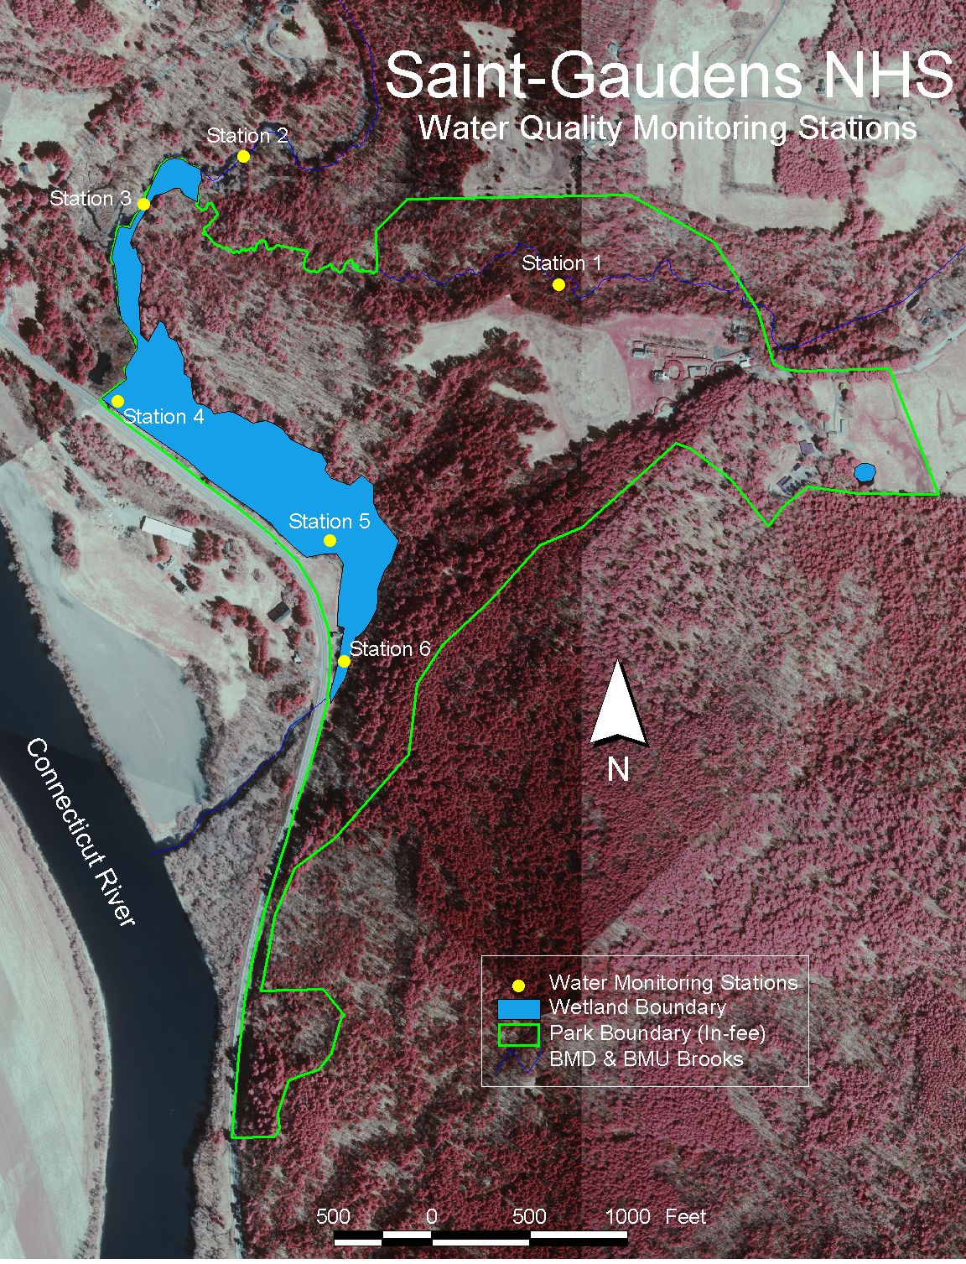

Appendix III: Data Charts

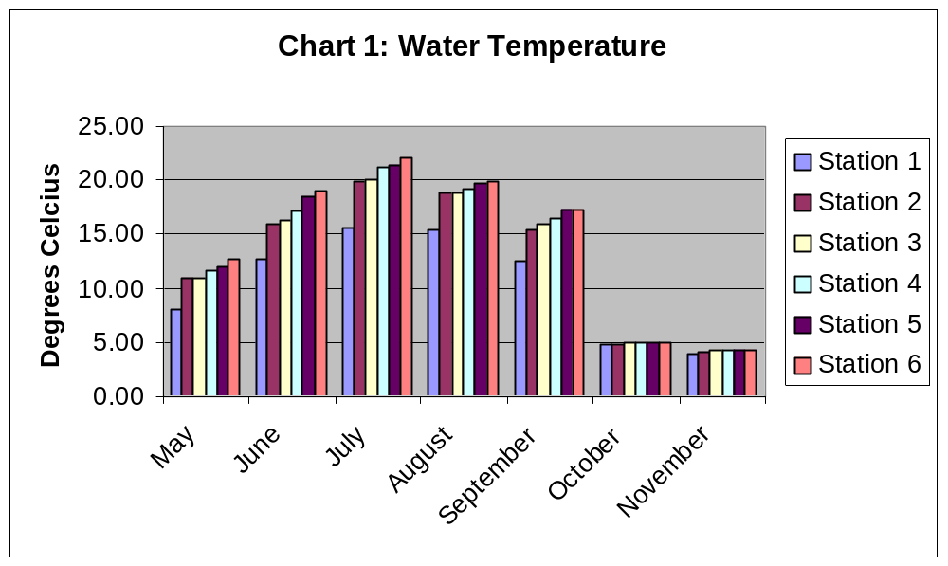

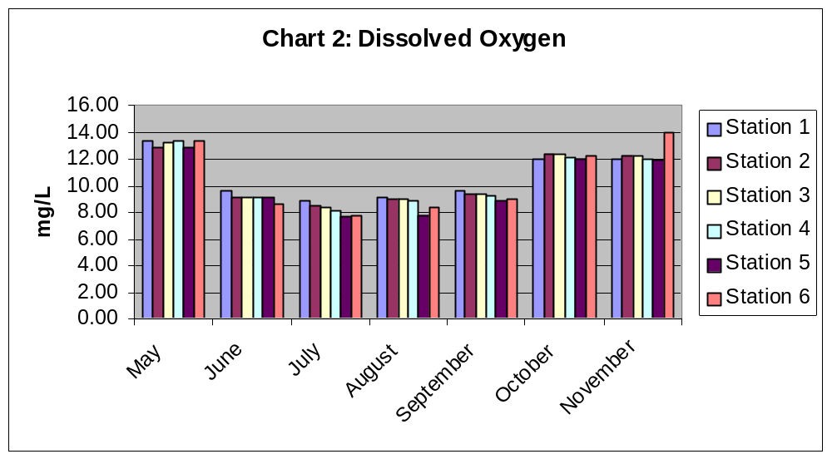

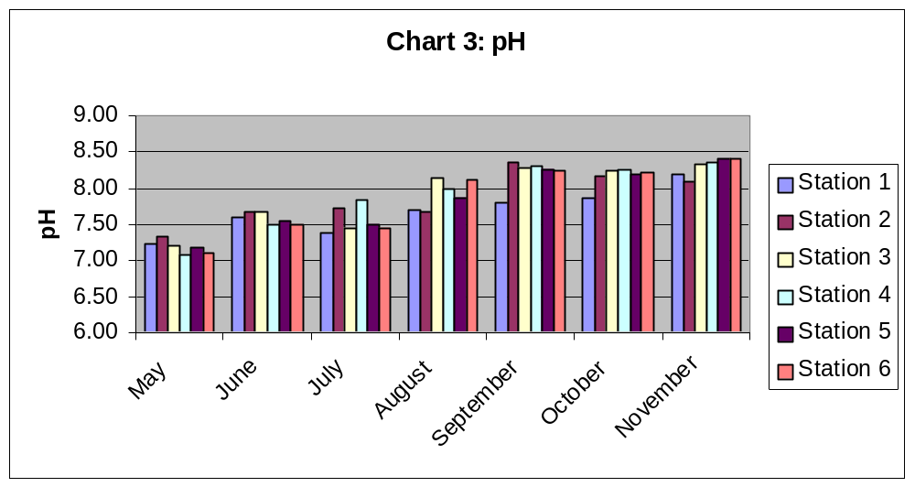

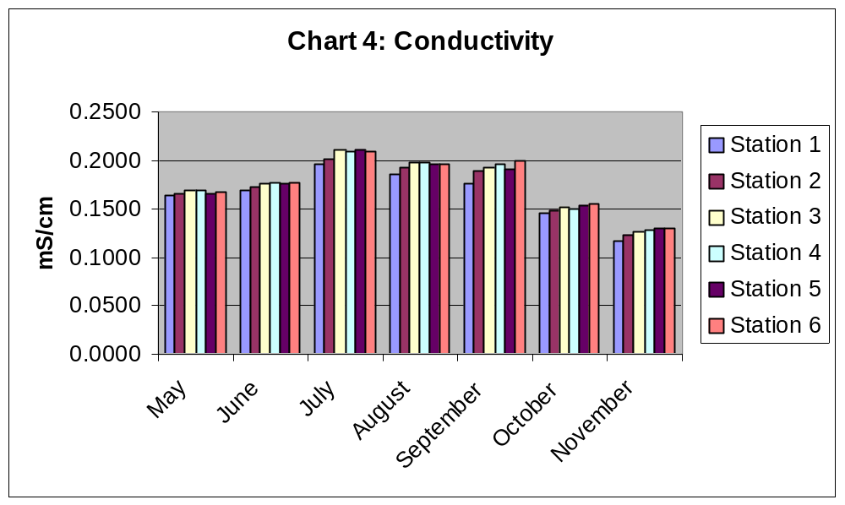

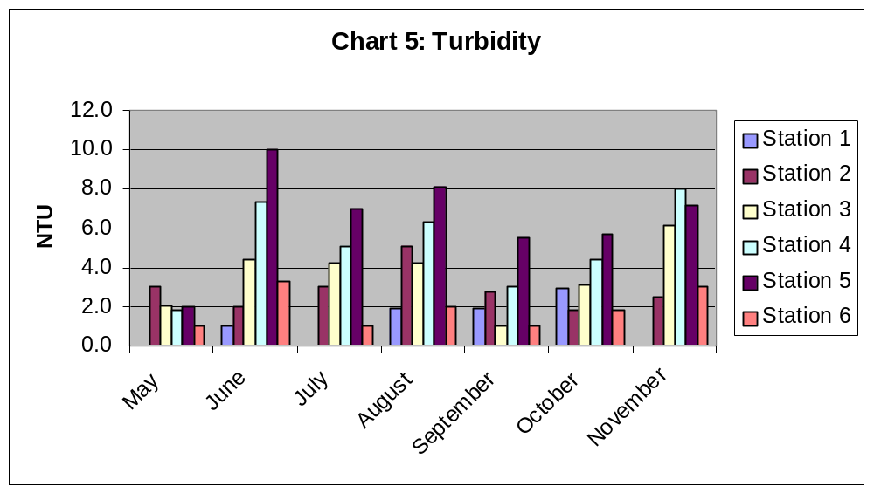

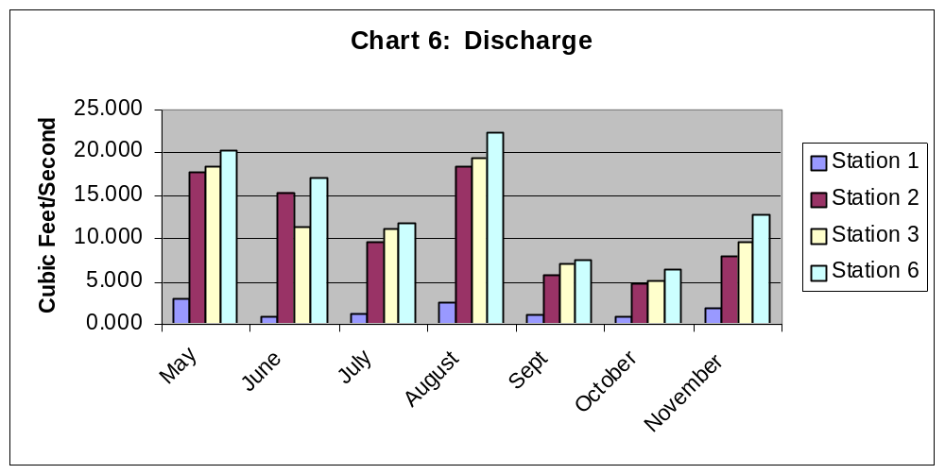

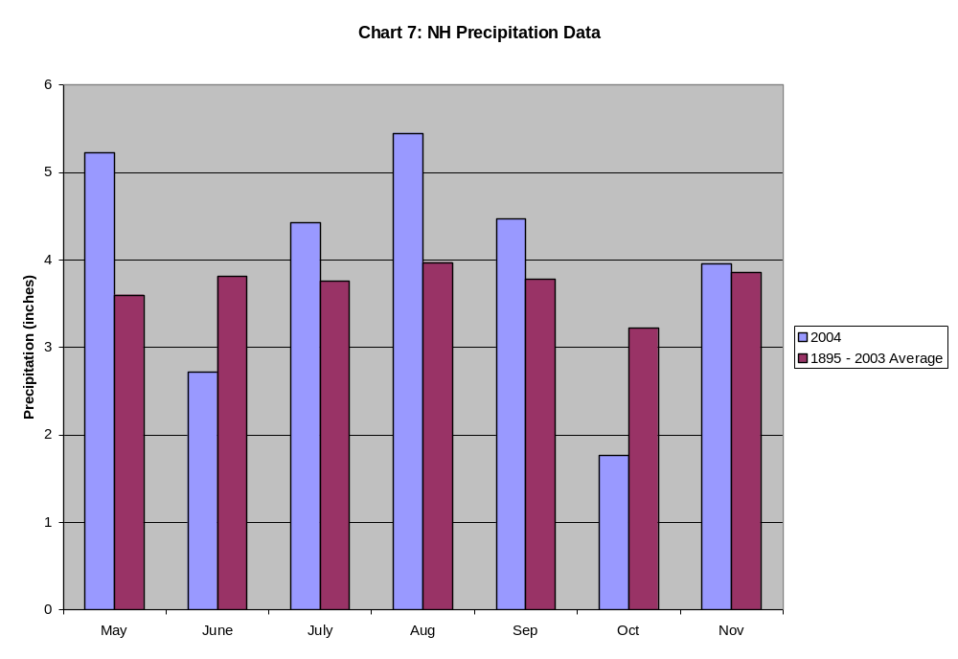

Appendix IV: Glossary

 | Wilkes University  Center for Environmental Quality  GeoEnvironmental Sciences and  Engineering Department  Water Quality Terms

We depend upon water for our very existence. The impact of water quality and quantity issues has never been greater. Yet the terminology used to describe the water we drink, the water we provide to plants and animals, the water stored underground, in lakes, rivers, and oceans, is not well understood by many.

This listing of water-related terms is intended to reduce the potential for misunderstanding presentations made by elected officials, environmental agencies and news reporters. The definitions and associated explanations provide working knowledge of water. Some terminology could be defined differently to describe water supply issues in other locations in the world.

Absorption is the process by which chemical in gaseous, liquid or solid phases are incorporated into and included within another gas, liquid, or solid chemical. For example, sponges absorb water.
Acidity -The base neutralizing capacity of water is known as acidity. Acids contribute to corrosiveness, influence chemical reactions, and chemical/biological processes. Acidity is determined using a titrametric or potentiometric method.
Adsorption is the adherence of gas molecules, ions or solutions to the surface of solids. For example, odors from freezers and refrigerators are adsorbed to baking soda.
Alkalinity: The acid neutralizing capacity of water is known as alkalinity. For surface waters alkalinity has been called "The Protector of the Stream", since the alkalinity of the water rests sudden changes in the pH of the stream associated with the influx of acid deposition, water containing organic acids, groundwater discharges or industrial wastes.
Most surface waters have alkalinity’s < 200 mg CaCO3/L, but in limestone areas the alkalinity’s can be greater than 1000 mg CaCO3/L. In some cases, pristine surface water has very low alkalinities and therefore they would be adversely impacted by acid mine drainage and acid rain. The alkalinity of precipitation can be from 1 to about 10 mg CaCO3/L. Typically the best alkalinity for aquatic life is between 100 and 120 mg CaCO3/L. Alkalinity is determined using a titrametric or potentiometric method.
Ammonia (NH4): There is no MCL established for ammonia. Ammonia is very toxic to fish and aquatic life. Ammonia concentrations of 0.06 mg/L can cause gill damage in fish and 0.2 mg/L is lethal to trout. Concentrations in excess of 0.1 mg/L suggest domestic or agricultural sources of waste.
Conductivity: The theoretical definition of conductivity is the "reciprocal of the resistance of a cube of a substance 1 cm on a side at a specified temperature". Typically the units of measure are microhms/cm (uohms/cm) or microsiemens/cm (uS/cm). Conductivity or specific conductance is a measure of the ability of a fluid to carry a charge, which is directly related to the concentration of dissolved substances. As the total dissolved substances in the water increases, the conductivity of the water also increases. For More information see Total Dissolved Solids.
Diffusion is a process where heat or chemicals are transported in response to differences in chemical concentration or temperature. Movement is from high concentration (or temperature) to low concentration (or temperature). This process could involve liquids, gases and solids.
Discharge area is an area where groundwater moves toward or is delivered to the soil surface. Groundwater can flow into springs, or seeps; contribute baseflow to streams; or provide supplemental water for plant use.
Effluent is the discharge of a contaminant or contaminants with water from animal production or industrial facilities or wastewater treatment plant.
Erosion is the process or series of processes that removes soils, crop residues, and organic matter from the land surface in runoff waters, or by wind. Water droplets begin the erosion process by detaching soil particles. Runoff waters transport the detached particles to local and regional streams or lakes. Soil erosion represents the single largest source of nonpoint pollution in the United States.
Eutrophication is the process of surface water nutrient enrichment causing a water body to fill with aquatic plants and algae. The increase in plant life reduces the oxygen content of the water. Eutrophic lakes often are undesirable for recreation and may not support normal fish populations.
Evapotranspiration (ET) is the process of changing soil water into water vapor through the combination of soil evaporation and plant water use, or transpiration.
Fecal coliform is a portion of the coliform bacteria group originating in the intestinal tract of warm-blooded animals that pass into the environment as feces. Fecal coliform often is used as an indicator of the bacteriological safety of a domestic water supply.
The fecal coliform bacterial densities will be determined using the membrane filtration technique. The MF procedure uses an enriched lactose medium and an incubation temperature of 44.5 + 0.2oC. Fecal coliform is bacteria typically found in the feces of warm-blooded mammals. Fecal coliform colonies produced by the M-FC medium are blue, while non-coliform colonies are pale yellow, gray, or cream color. Since fecal coliform is found in mammalian waste, it is recommended that fecal coliform be absent from potable water.
Groundwater recharge is the process where water enters the soil and eventually reaches the saturated zone. Recharge varies from place to place due to the amount of rainfall, infiltration, and surface vegetation.
Hydrologic cycle describes the constant movement of water above, on, and below the earth's surface. Processes such as precipitation, evaporation, condensation, infiltration and runoff comprise the cycle. Within the cycle, water changes forms in response to the Earth's climatic conditions.
Losing stream (influent stream) is a stream or portion of a stream that discharges water into the groundwater.
Non-point source (NPS) pollution is the source of surface or groundwater pollution originating from diffuse areas without well-defined sources. The most common examples of NPS are chemicals that enter surface water during runoff events from cropland and turf grass, and soil erosion from cultivated cropland and construction sites.
Part-per-million (ppm) is a measure of concentration of a dissolved material in terms of a mass ratio (milligrams per kilogram, mg/kg). One part of a contaminant is present for each million parts of water. For water analysis, parts per million often is presented as a mass per unit volume (milligrams per liter, mg/l). There are one million milligrams of water in one liter.
Permeability is the property of porous materials indicating the ease with which liquids or gases will be transmitted through a soil or other porous material. Permeabilities are not affected by changing the type of liquid.
pH is a numerical measure of the acidity or alkalinity of water. The pH scale ranges from 1 (acidic) to 14 (alkaline). A pH of 7 is neutral. The technical definition of pH is that it is a measure of the activity of the hydrogen ion (H+) and is reported as the reciprocal of the logarithm of the hydrogen ion activity. Therefore, a water with a pH of 7 has 10-7 moles per liter of hydrogen ions, whereas, a pH of 6 is 10-6 moles per liter. The pH scale ranges from 0 to 14.
Phosphate (PO4): There is no MCL for phosphate. In surface waters, phosphate is typically a limiting plant nutrient. The recommend maximum concentration in rivers and streams is a concentration of 0.1 mg/L of total phosphate.
Point source (PS) pollution is the source of surface or groundwater pollution that originates from a well-defined source. Examples include: industrial effluent; large animal containment facilities; city wastewater treatment discharges, or chemical spills. Point sources commonly are associated with pipeline discharges of some type.
Pollutant is any unwanted chemical or change in physical property that renders a water supply unfit for its intended use.
Porosity is the ratio of the volume of open spaces or voids to the total volume of a porous material. For example, a sand and gravel deposit may have 20 percent porosity. Porosity determines the amount of water that can be stored in a saturated formation. A saturated formation 100 feet thick with porosity of 20 percent could store an equivalent water depth of approximately 20 feet.
Potable water supply is a source of water that can be used for human consumption.
Precipitation is the process where water vapor condenses in the atmosphere to form water droplets that fall to the earth as rain, sleet, snow or hail. Nebraska's long-term annual precipitation varies from 16 inches in the west to 34 inches in the southeast. Annual deviations can be greater than 30 percent.
Runoff is precipitation or irrigation water that does not infiltrate but flows over the land surface toward a surface drain, eventually making its way to a river, lake or an ocean.
Spring is the point of natural groundwater discharge to a soil surface, river, or lake.
Turbidity: Turdidity is a measure of the cloudiness or opaqueness of the water and is measured in nephelometric turbidity units (ntu). Nephelometry is the measurement of suspended particles, or cloudiness. The turbidity is influenced by the amount and nature of suspended organic and inorganic material in water. Typically, the higher the concentration of the suspended material the greater the turbidity. The value of 1 ntu is recommend for drinking water, since higher turbidities could cause aesthetic problems or inhibit the ability of a system to disinfect the water. The source of turbidity could be fine sand, silt, and clay (i.e., soil separates); organic material, particles of iron and manganese or other metal oxides, rust from corroding piping, or carbonate precipitates. Turbidity measurements are typically not made on surface water sources - see Total suspended solids.
Watersheds are regional basins drained by or contributing water to a particular point, stream, river, lake or ocean. Watersheds range in size from a few acres to large areas of the country.
Water table is the upper level of a saturated formation where the water is at atmospheric pressure. The water table is the upper surface of an unconfined aquifer.
For More information about the Environmental Quality Center, please contact:
Attn: Mr. Brian Oram, Professional Geologist (PG)
Laboratory Director
Wilkes University
GeoEnvironmental Sciences and Engineering Department
PO Box 111
Wilkes-Barre, PA 18766
1-800-572-4444 ext. 4619
(570) 408-4619

