4.2.12 Target Pile Shielding & Carriages

The target pile is installed in the target hall pit. The pit cross section is illustrated in Figure 4.2-1. The pit elevation view is illustrated in Figure 4.2-2. The pit floor slopes downward from the upstream end to the downstream end of the hall at a theoretical angle of 3.34349° with respect to the LTCSZ (x, y) plane. The pit is 52.5 meters long. The decay pipe protrudes into the pit at the downstream end by about 0.35 meters. The last 4.3 meters of the beam-left pit sidewall at the downstream end is 0.16 meters wider as shown by the dashed line in Figure 4.2-3. This part of the wall is offset to form part of the downstream air labyrinth (with the steel shielding installed). This labyrinth is the passageway that the cooling airflow passes through to exit the target pile and enter the air-cooling equipment located in the target hall. The beam-left pit sidewall stops about 0.5 meters short of the decay pipe shielding concrete. The cooling airflow flows from the passageway mentioned above, through this 0.5-meter opening in the sidewall, and into a plenum located alongside the decay pipe shielding concrete. The cooling airflow turns upward in the plenum and enters the return duct at the top of the decay pipe shielding concrete. The pit walls and floor are concrete and about 1 meter thick.

The major components of the target pile are the steel and concrete shielding, the carriages, and the air-cooling system. The target, baffle, horn 1, horn 2, and beam monitoring instrumentation are installed in the target pile chase.
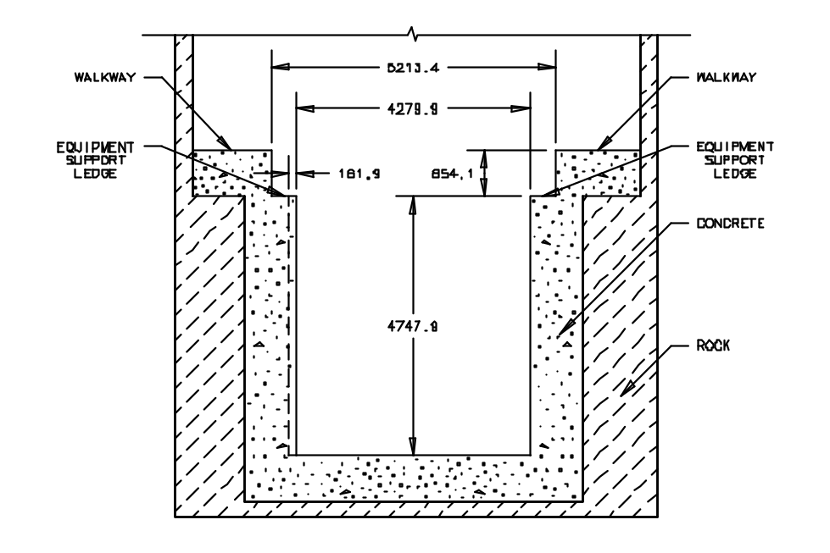
Figure 4.2-35 Target hall pit cross section

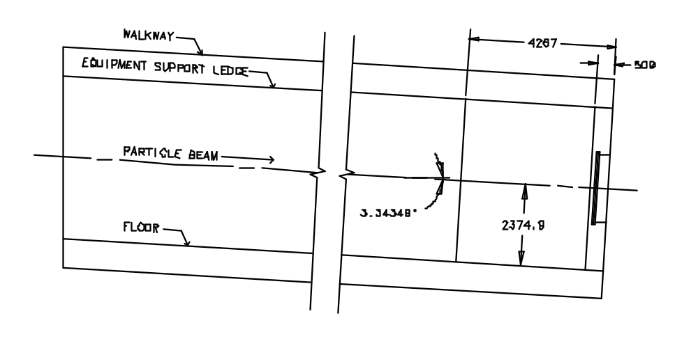
Figure 4.2-36 Target hall pit elevation view

4.2.12.1 Steel and Concrete Shielding

The steel shielding has a rectangular cross section with a central square chase. Beam line components and instrumentation are installed in the chase. The chase also serves as a channel for the cooling airflow. The cross sectional view of the floor and walls of the steel shielding, the concrete pit, and the concrete covers is illustrated in Figure 4.2-37. The floor and walls are primarily built using steel blocks referred to as “Duratek blocks” or “blue blocks”. These steel blocks measure 1.33 meters x 1.33 meters x 0.67 meters. A company named Duratek manufactured the blocks. Most of these blocks have integral lifting handles and are painted blue. The remaining Duratek blocks are painted green and have integral pick points. The steel blocks in every wall layer are stacked in an interlocked fashion like masonry bricks in a house, that is, gaps between blocks in a row are offset from gaps in the rows immediately below and above it. All wall and floor layers are staggered with respect to each other so the gaps between blocks do not line up and form a line-of-sight crack through the target pile. There is always 0.67 meters of steel between an inner layer gap and the outside surface of the pile. Gaps between blocks can be as large as 2.54 centimeters. In addition to the Duratek blocks, steel blocks of various sizes are used at both the upstream and downstream ends of the pile to fill gaps caused by staggering the Duratek block layers. The “top-out rail” is a layer of steel installed on top of both inner wall layers. Its function is to provide a defined surface for supporting T-blocks anywhere along the length of the target pile. The top-out rails are installed at a prescribed elevation. The steel shielding is installed on four grout rails. The grout rails are installed at a prescribed elevation.
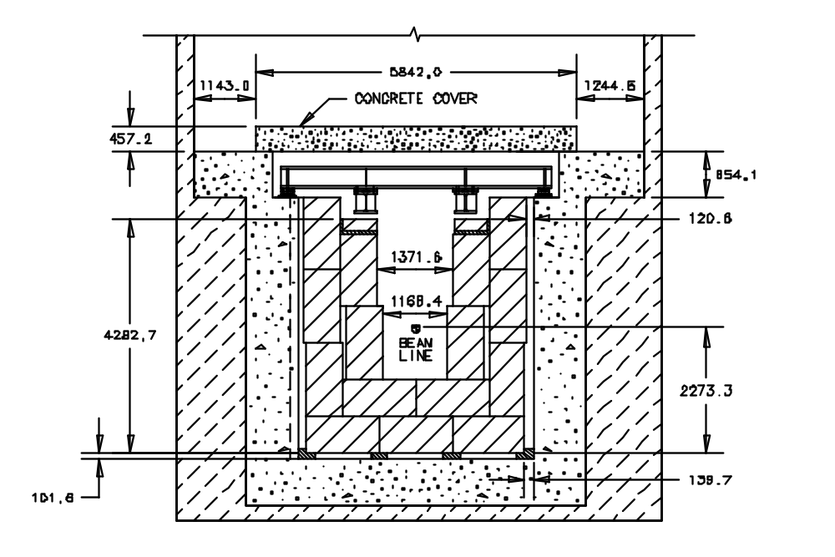
Figure 4.2-38 Steel walls and floor, concrete shielding

Two methods are used to close the top of the shielding block pile. “T-blocks” are used where beam line equipment is installed. A horn 1 module T-block is shown in Figure 4.2-39. Duratek blocks are used in all other areas. Two layers of Duratek blocks are used to close the top of the pile between horn 2 and the downstream air labyrinth, as illustrated in Figure 4.2-40. Three layers are used between horn 1 and horn 2. As shown in the figure, the Duratek blocks sit on the lower blocks in the inner wall. The inner walls are installed with a 0.1 meter offset between the lower and upper rows of blocks to make this support ledge. Additionally, the ledge forms a radiation labyrinth with two 90° bends when the beam component module is installed. These labyrinths attenuate radiation leakage through the gap between the upper row of Duratek blocks in the inner wall and the module.

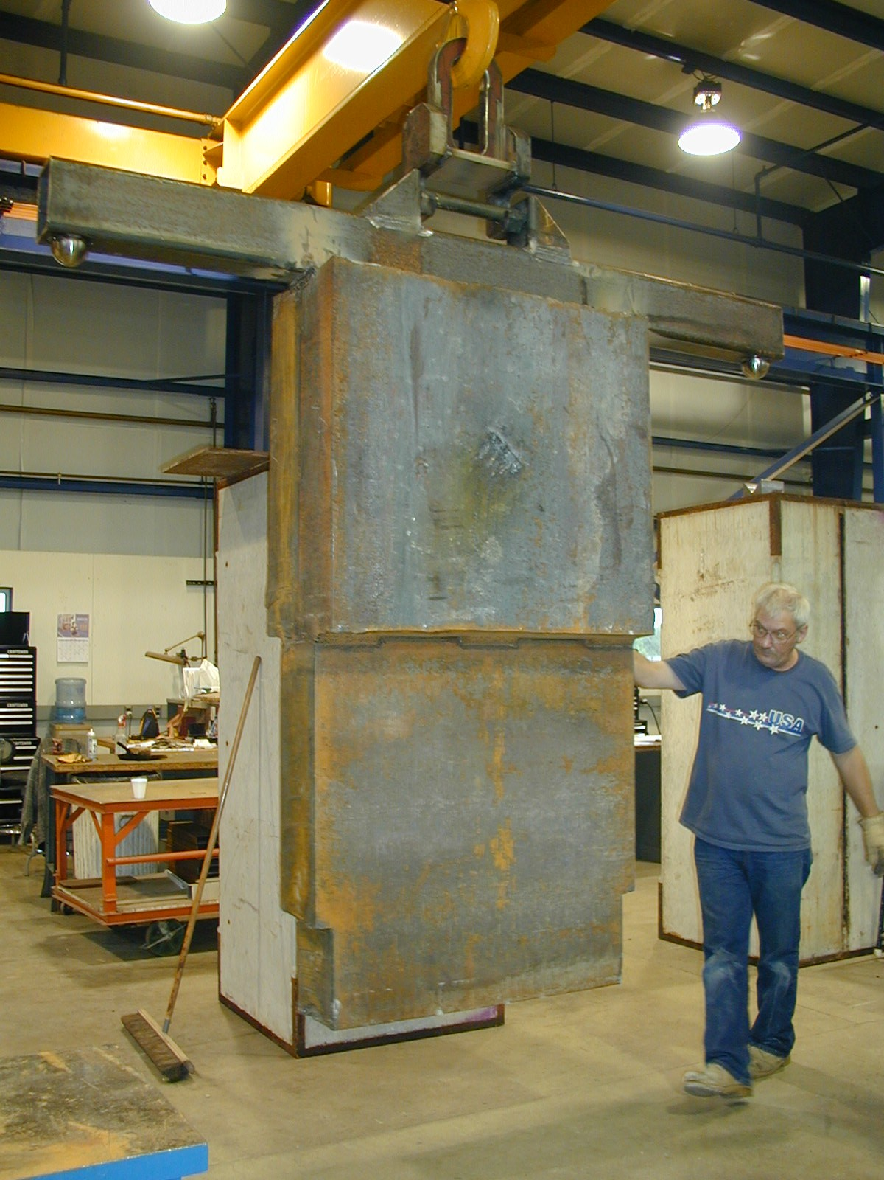

Figure 4.2-41 Horn 1 module T-block

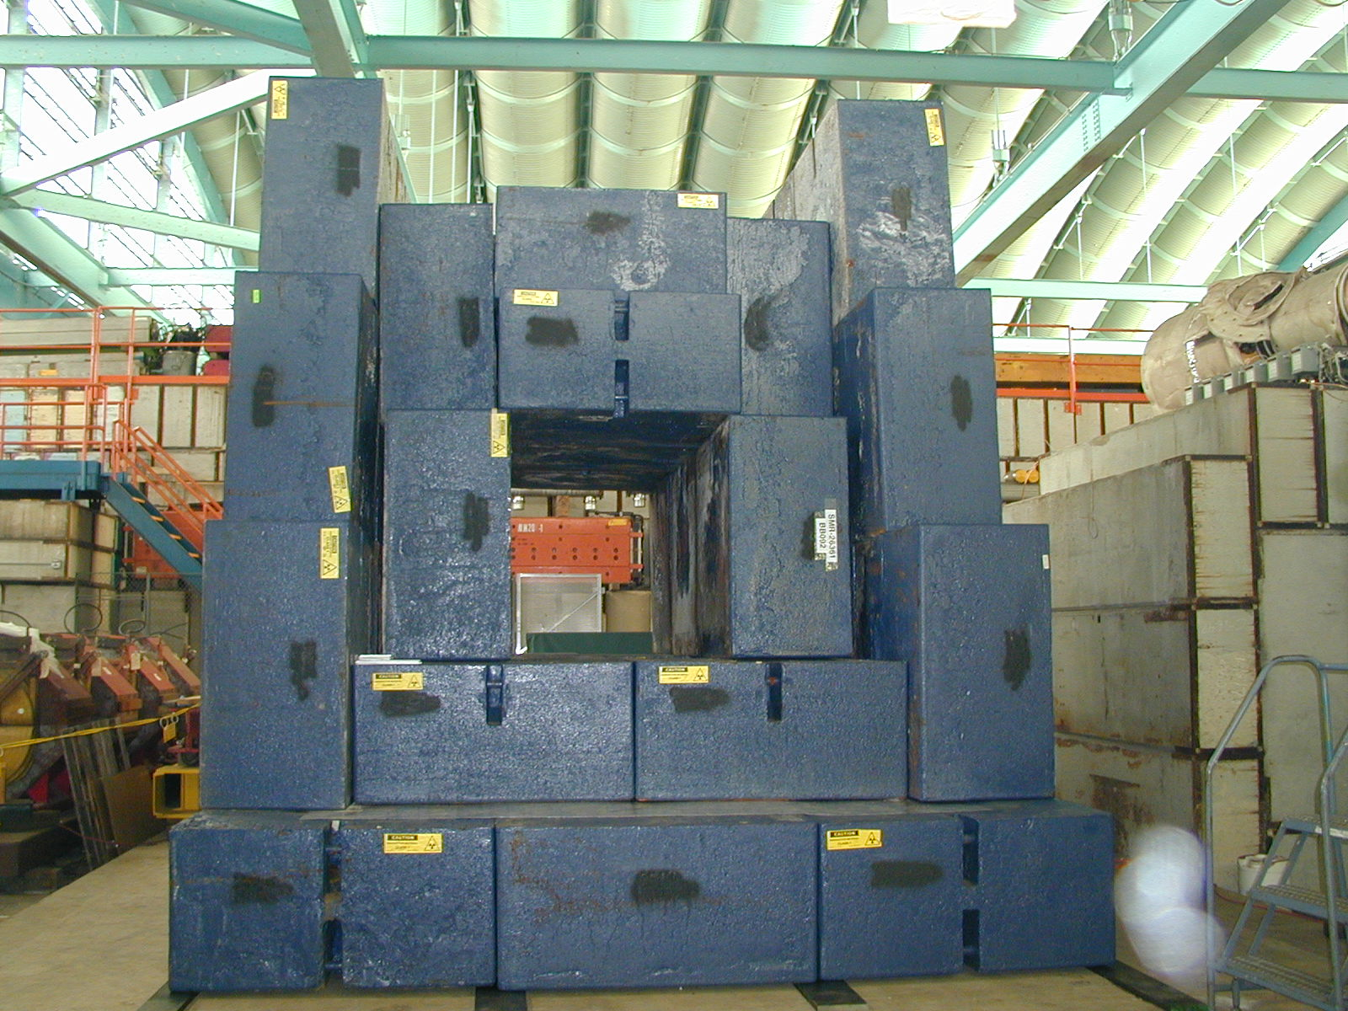

Figure 4.2-42 Steel shielding downstream of horn 2

The steel shielding is completely surrounded by concrete. The pit and decay pipe shielding concrete are discussed above. Concrete covers close off the top of the pit. The covers are steel reinforced concrete beams with dimensions of 0.46 by 0.92 by 5.8 meters. A 1.83-meter thick masonry wall is installed at the upstream end of the pit to shield the pre-target area.

The open space between steel shielding blocks, pit floor, and pit walls form cooling channels for the exterior surface of the pile. The channels are named “bottom” and “side”, respectively. The space between the top of the steel shielding pile and the concrete covers is named the “top” channel. The cooling airflow enters the target pile at the downstream end and flows upstream in the top, bottom and side channels. All of the air exits the bottom and side channels at the upstream end of the pile, turns 180°, and enters the chase. All of the air flowing in the top channel flows vertically downward through clearances between the T-blocks and into the chase. The cooling airflow exits the target pile at the downstream end of the chase.

An aluminum air seal is installed across the opening of the pit just under the concrete covers. The covers hold this air seal down when the air-cooling system pressurizes the target pile. The outer surfaces of both the floor and the walls are wrapped with a thin layer of aluminum sheeting that terminates at the top-out rail. This layer of aluminum is provided to minimize air leakage from the bottom and side channels into the chase through gaps between the Duratek blocks. A grout air seal between the bottom and side channels prevents air leakage from the bottom channels into the side channels. A soft, elastomer seal is provided at the top of each side channel to minimize air leakage into the top channel. Aluminum sheeting is installed over top-closure Duratek blocks and sealed to the top-out rail, as shown in Figure 4.2-43. This is done to minimize the leakage of cooling air from the top channel, through the blocks, and into the chase. An aluminum air seal is installed across the upstream end of the pit. This wall of aluminum sheeting is provided to minimize air leakage into the pre-target area and into the equipment morgue.

An air labyrinth is installed at the downstream end of the target pile. Its purpose is to provide a way for the cooling airflow to exit the target pile and to attenuate radiation leakage out of the airflow path to an acceptable level. The air labyrinth consists of the “grill”, the pit passageways discussed in the paragraph about the Target Hall pit, and the outer ceiling. The grill is a 0.61 meter thick layer of steel at the very downstream end of the hall with eight, 0.23 by 1.91 meter, equally spaced slots through it. The cooling airflow makes a hard 90 turn upward at the downstream end of the chase, flows through the slots, makes a hard 90 beam-left turn upon exiting the grill and flows into the pit passageways. The outer ceiling consists of two 0.23 meter thick layers of steel slabs installed on the pit horn support ledge directly above the air labyrinth grill. It attenuates radiation leakage through the grill into the target hall. The gaps between slabs are staggered so there is no line of sight crack through the outer ceiling. Aluminum sheeting is installed between the two layers to keep the supply airflow, which enters the target pile in the area above the outer ceiling and below the concrete covers, from leaking into the return air flowing in the air labyrinth. The shielding installation drawings are 8875.126-ME-406820 through 406830.

4.2.12.2 Carriages

A carriage is the structural support for a beam line component module. The Horn 1 carriage is shown in Figure 4.2-44. There are three carriages: Horn 1, Horn 2, and Target/Baffle. Horn 1 and Horn 2 carriages are identical. The Target/Baffle carriage is a slightly longer version of the Horn 1/Horn 2 carriage. A carriage consists of two support beams, two cross beams, and four adjustable feet. An adjustable foot is installed at each end of both cross beams. The support beams are parallel to the beam line. The ends of the support beams bolt to the cross beams. The ends of the cross beams sit on the horn support ledge. The carriages are initially installed at prescribed locations and adjusted as necessary to correctly position the beam line component. The vertical shim stack in each support foot is welded in place after this is accomplished. All of the support feet are free to rotate about all three axes. The upstream, beam-right support foot is not allowed to translate. The downstream, beam-right support foot is free to translate only in the longitudinal, i.e., particle beam, direction. The other two support feet are free to translate in both the lateral and longitudinal directions. The installation assembly drawing for the Horn 1 carriage is 8875.126-ME-427286, 8875.126-ME-427287 for the Horn 2 carriage, and 8875.126-ME-427288 for the Target/Baffle carriage.
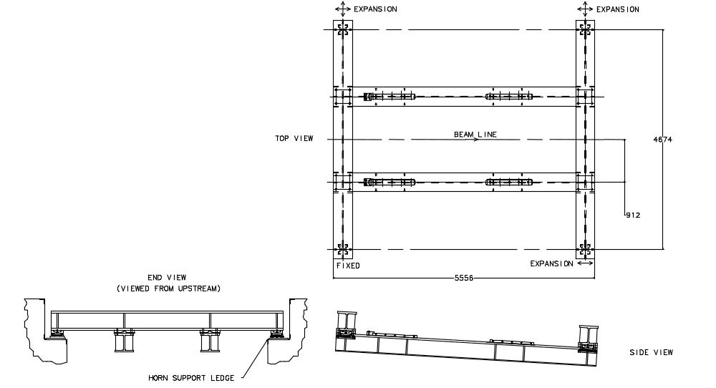

1

Figure 4.2-45 Horn 1 carriage

