

DOE Project Execution Plan

for

Run IIb CDF Detector Project
and
Run IIb D-Zero Detector Project

at

Fermi National Accelerator Laboratory

November 6, 2002

Run IIb CDF and D-Zero Detector Projects
Project Execution Plan

Submitted by Integrated Project Team

_______________________________
Paul R. Philp date
DOE Run II Project Manager
(Federal Project Manager)

Concurred by:

_______________________________
Jane L. Monhart date
Fermi Area Office Manager
(Contracting Officer)

_______________________________
Michael P. Procario date
Run IIb Program Manager

_______________________________
John R. O’Fallon date
High Energy Physics Div. Director

Reviewed by:

_______________________________
Daniel R. Lehman date
Construction Mgmt. Support Div. Director

Approved by:

_______________________________
S. Peter Rosen date
Associate Director, Office of HENP
(Acquisition Executive)
Run IIb CDF and D-Zero Detector Projects
PROJECT EXECUTION PLAN

1. Introduction 1
1.1 Purpose and Context of This Document 1
1.2 Approval and Revision 1
2. Justification of Mission 1
3. Project Description 2
3.1 Scientific Objectives 2
3.2 Technical Goals 2
4. Management Structure and Responsibilities 3
4.1 Division of High Energy Physics 4
4.2 Chicago Operations Office 5
4.3 DOE Run II Project Manager 5
5. Work Breakdown Structure 6
6. Resource Plan 8
7. Project Baselines and Control Levels 9
7.1 Baseline Change Control 10
7.2 Technical Baseline 10
7.3 Cost Baseline 11
7.4 Schedule Baseline 14
8. Project Monitoring and Reporting 15
9. Safety/Hazard Analysis Report 16
9.1 National Environmental Policy Act (NEPA) 16
9.2 Preliminary Safety Analysis Document 16
9.3 Integrated Safety Management 16

1. Introduction

1.1 Purpose and Context of This Document

The Run IIb upgrades of the CDF and D-Zero detectors will provide the necessary capability to make sensitive searches for the Higgs Boson and maximize the physics opportunities in Run IIb. The largest part of the Run IIb projects is to provide the technical components to replace the silicon detectors in the CDF and D-Zero experiments. The projects’ deliverables will be technical components ready to install in the existing CDF and D-Zero detectors. Installation of these components will be handled outside of the Run IIb CDF and D-Zero Detector Projects to decouple the projects’ schedules from Fermilab’s accelerator schedule.

This DOE Project Execution Plan (PEP) for the Run IIb CDF and D-Zero Detector Projects describes the mission need and justification of the projects, their objectives and scopes, the Department of Energy (DOE) management structure, the resource plan, and the environmental, safety, and health (ES&H) requirements. In addition, it establishes the technical, cost, and schedule baselines against which project performance will be measured by the DOE. DOE Baseline Change Control thresholds are also established in this document.

The projects are being carried out by the Universities Research Association, which operates Fermi National Accelerator Laboratory (Fermilab) under contract with DOE. The Run IIb CDF and D-Zero Detector Project Management Plans (PMPs) describe the organization and systems that Fermilab will employ to manage the execution of these projects and report to DOE. The PMPs also establish the more detailed lower-tier milestones against which Fermilab and the DOE Run II Project Manager will measure project performance.

1.2 Approval and Revision

The PEP is approved by the Associate Director, Office of High Energy and Nuclear Physics (SC-20) as a prerequisite of Critical Decision 2, Approval of Performance Baseline.

The Run IIb CDF and D-Zero Detector Project Management Plans are approved by the DOE Run II Project Manager.

2. Justification of Mission

The Fermilab Tevatron provides the highest energy particle beams in the world, enabling unique opportunities for scientific discovery. One such opportunity is the search for the Higgs Boson, which is thought to be responsible for breaking the Electro-Weak symmetry and giving rise to particle masses. Understanding the mechanism for Electro-Weak Symmetry Breaking has been identified as the highest priority of the US High Energy Physics (HEP) program by the HEPAP sub-panel assessing the long-range future of the field. There are strong indications that the Higgs mass is likely to be within the range where CDF and D-Zero experiments are sensitive to it provided the experiments collect sufficient integrated luminosity. The purpose of this acquisition is to provide technical components to upgrade the CDF and D-Zero experiments to enable them to accumulate sufficient integrated luminosity to maximize the chance for discovering the Higgs Boson.

Fermilab will continue to operate at the “Energy Frontier” until the Large Hadron Collider (LHC) at CERN begins operation with a much higher beam energy at the earliest in late FY2007. Thus, the Fermilab Tevatron Collider has a window of opportunity for making a major scientific discovery before handing off the baton to CERN and minimizing the procurement time for the Run IIb upgrades is a significant consideration in the project planning process. Estimates indicate that, due to radiation damage, the current silicon detectors will only be useful up to 4 fb⁻¹, which is expected to occur in FY2005 or FY2006. To maximize the utilization of existing facilities, the detector components provided by the Run IIb upgrades will allow the experiments to operate at high luminosity and meet the laboratory’s goal of acquiring an integrated luminosity of 15 fb⁻¹. Designs will take advantage of advances in radiation resistant electronics to enable the new components to handle 3 to 4 times as much radiation. This is a significant increase above the Run IIa goal of 2 fb⁻¹ and will enable a sensitive search for the Higgs Boson.

3. Project Description

The High Energy Physics program of the DOE Office of Science conducts basic research at Fermi National Accelerator Laboratory (Fermilab) utilizing the Tevatron Collider, which collides protons and antiprotons with center of mass energy of 2 TeV. Two detectors, CDF and D-Zero, observe these collisions. These studies address some of the most fundamental issues in particle physics. In the recently started “Run II” of the Tevatron Collider, it is expected that both detectors have good prospects for making major new discoveries, perhaps including the first observation of the Higgs boson.

3.1 Scientific Objectives

The Run IIb upgrades of the CDF and D-Zero detectors will provide the necessary capability to make sensitive searches for the Higgs Boson and maximize the physics opportunities in Run IIb. The largest part of the Run IIb projects is to provide the technical components to replace the silicon detectors in the CDF and D-Zero experiments. These detectors are capable of identifying short-lived particles, such as b-quarks, that travel a small distance before decaying into other particles. The Higgs Boson is expected to decay into a pair of b-quarks and efficiently detecting them is crucial to the Run IIb goals. The Run IIb CDF Detector Project also includes a central preradiator detector with the capability of improving electron and photon identification, and an upgraded event builder with the capability of increasing the data throughput. The Run IIb D-Zero Detector Project includes upgrades to the Level 1 and Level 2 triggers to improve the selectivity in what data is recorded, and an upgrade to the online computing to provide the necessary computing infrastructure needed for Run IIb.

3.2 Technical Goals

The general technical goals of the Run IIb CDF and D-Zero Detector Projects are presented below. Further details can be found in the Technical Design Reports for each project.

Run IIb CDF Project
- Replacement of inner silicon microstrip tracker with a new, more radiation resistant version capable of improved b-tagging and triggering for physics measurements.
- Upgrade of the central calorimetry, to provide improved time measurement of electromagnetic energy deposition and a replacement for the obsolete central preradiator chambers.
- Replacement of obsolete portions of the data acquisition system that prevent the experiment from collecting data at the rates needed in Run IIb.

Run IIb D-Zero Project

- Replacement of silicon microstrip tracker with a new, more radiation resistant version capable of improved b-tagging and triggering for physics measurements.
- Upgrade of the Level 1 and Level 2 trigger systems to accommodate the higher luminosities from the Tevatron.
- Replacement of obsolete portions of the online and data acquisition systems that would otherwise prevent the experiment from taking data at rates necessary to achieve the physics objectives of Run IIb.

4. Management Structure and Responsibilities

The DOE organization for the Run IIb CDF and D-Zero Detector Projects is shown in Figure 4.1. Each of the major organizational elements is discussed below the figure.

4.1 Office of High Energy and Nuclear Physics

Within the Office of Science, the Office of High Energy and Nuclear Physics has overall DOE responsibility for the development of high energy and nuclear physics. The Associate Director, Office of High Energy and Nuclear Physics will serve as the Acquisition Executive for these projects. The Division of High Energy Physics (DHEP) is the lead program organization for the Run IIb CDF and D-Zero Detector Projects. The prime headquarters point of contact for the project will be the Run IIb Federal Program Manager, a DHEP employee who is appointed by the Director of the DHEP.

The responsibilities of DHEP relating to the projects include the following:
- participates in annual budget process;
- reviews the PEP and substantive changes to it;
- reviews the initial cost, schedule, and technical baselines;
- performs project management reviews on a roughly semiannual basis;
- ensures that funding is provided on a timely basis;
- coordinates project needs within DOE headquarters;
- and coordinates with the DOE Run II Project Manager.

4.2 Chicago Operations Office

The DOE Chicago Operations Office (CH) has the contract management responsibility for DOE’s performance-based management contract with URA. The Fermi Area Office (FAO) is the responsible DOE office on site at Fermilab that administers the contract and provides day-to-day DOE oversight of the laboratory. The FAO Manager has assigned the DOE Run II Project Manager the authority for day-to-day implementation and direction of the project. The FAO Manager will provide the DOE Run II Project Manager with support from FAO staff when appropriate.

4.3 DOE Run II Project Manager

The management responsibility, authority, and accountability for day-to-day execution of the project has been assigned to the DOE Run II Project Manager. The DOE Run II Project Manager is a DOE employee who is appointed by the FAO Manager, subject to the approval of the Director of the DHEP. The DOE Run II Project Manager receives guidance and direction from the DHEP and serves as the principal point of contact for DOE headquarters on issues specific to the project.

Specific responsibilities of the DOE Run II Project Manager are:
- Serves as Integrated Project Team lead in drafting/coordinating the PEP.
- Reviews and approves the Project Management Plans and subsequent revisions.
- Implements procedures for baseline management and control, approves baseline changes at Level 2 and recommends changes or corrective action to baselines above Level 2.
- Maintains close contact with the activities of Fermilab to assure that the goals and schedules are met in a timely and effective manner. Reviews project performance monthly and keeps the DHEP informed of cost, schedule, and technical progress and problems in a timely manner.
- Controls the project contingency funds and authorizes its use within levels established in the Project Execution Plan.
- Coordinates with the FAO Manager regarding approval of subcontract procurement actions performed by Fermilab.
- Oversees the preparation and review of the safety analysis documents.
- Directs the updating of the Project Execution Plans and the Project Management Plans.
- Coordinates updates of the budget.
- Participates in and provide support for the program peer reviews, reviews by oversight committees and validation of the project.
- Submits quarterly reports and other reports on the status of the project for DOE management as required in this Project Execution Plan and applicable DOE requirements.
- Aids in the compliance by the Run IIb CDF and D-Zero Detector Projects with appropriate DOE requirements, and contracting regulations.
- Serves as Integrated Project Team lead in drafting/coordinating the AEP.

5. Work Breakdown Structure (WBS)

The technical description of the Run IIb CDF and D-Zero Detector Projects is presented in Technical Design Reports (TDRs). The TDRs describe the principal components of the detectors and serves as reference for the following descriptions of detector subsystems. Detector subsystems are the basis for defining the high-level WBS of the projects. The WBS for the Run IIb CDF and D-Zero Detector Projects to level 3 are shown in Figures 5.1 and 5.2, respectively. Installation is not included as part of the projects, but will be included in planning. Further details of the WBS for each project are available in the PMPs.

Figure 5.1
CDF WBS Chart
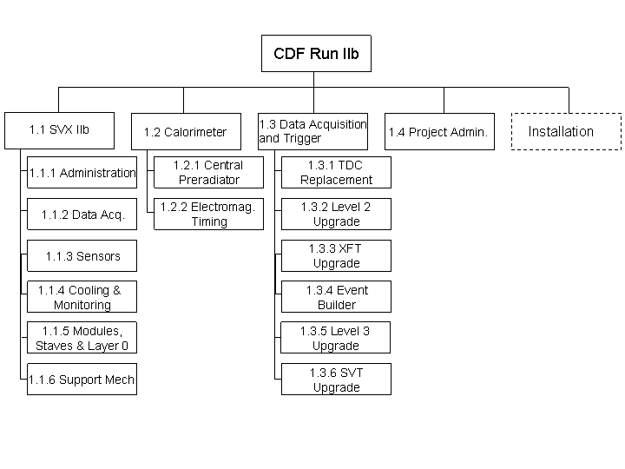
Figure 5.2
D-Zero WBS Chart

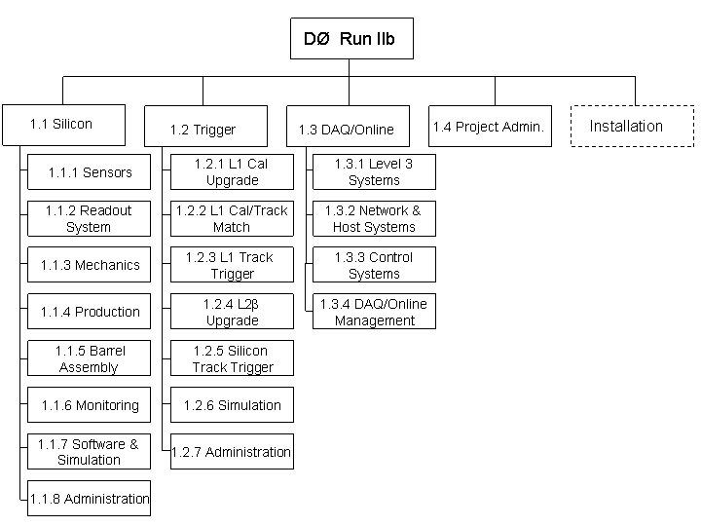

6. Resource Plan

The planned funding for the Run IIb CDF and D-Zero Detector Projects is shown in Table 6.1. The Fermilab and collaboration staffing is presented in the Run IIb CDF and D-Zero PMPs.

Table 6.1
Planned Funding (AY in thousands)
 | FY01 | FY02 | FY03 | FY04 | FY05 | FY06 | Total
Run IIb CDF Detector Project
DOE Equipment | 0 | 3,500 | 3,469 | 8,396 | 8,509 | 1,113 | 24,987
DOE R&D | 0 | 1,670 | 480 | 0 | 0 | 0 | 2,150
Foreign Contributions | 0 | 300 | 1,218 | 1,342 | 10 | 0 | 2,869
U.S. Universities | 0 | 24 | 225 | 103 | 26 | 0 | 377
Total Funding * | 0 | 5,494 | 5,392 | 9,841 | 8,544 | 1,113 | 30,383
Run IIb D-Zero Detector Project
DOE Equipment | 0 | 3,500 | 2,752 | 8,588 | 5,781 | 0 | 20,621
DOE R&D | 0 | 1,499 | 2,380 | 0 | 0 | 0 | 3,880
Foreign Contributions | 0 | 258 | 201 | 90 | 49 | 0 | 599
NSF–MRI silicon | 17 | 1,326 | 495 | 631 | 0 | 0 | 2,469
NSF–MRI trigger | 0 | 0 | 112 | 57 | 430 | 0 | 599
U.S. Universities | 0 | 210 | 141 | 39 | 47 | 0 | 437
Total Funding** | 17 | 6,793 | 6,080 | 9,407 | 6,307 | 0 | 28,604
* Approximately 50 percent of the foreign contributions to CDF will come in the form of contributed goods, i.e., “in kind.” The remaining half will be in the form of cash which will pass through the Fermilab Procurement Department. This portion will be subjected to the same procurement procedures used for DOE funds.
** All foreign contributions are in kind, applied toward the trigger. Both the silicon and trigger Major Research Instrument (MRI) grants from the National Science Foundation are approved, with spending having begun for the silicon MRI. Remaining in kind funds are from US university support of engineering and other technical personnel.

7. Project Baselines and Control Levels

The project baselines and control levels are defined in a hierarchical manner that provides change control authority at the appropriate management level. The highest level of baseline change control authority is defined as Level 0. Changes at Level 0 are approved by the DOE Deputy Secretary. Changes below Level 0 are approved as follows: Level 1—Acquisition Executive (Associate Director, Office of High Energy and Nuclear Physics); Level 2—DOE Run II Project Manager; and Level 3—Fermilab as specified in the Run IIb CDF and D-Zero Detector Project PMPs.

Change control thresholds for the projects are presented in section 7.1. The technical, cost, and schedule baselines and the associated control levels down to Level 2 are given in sections 7.2, 7.3, and 7.4.

The change control levels and procedures at Level 3 and below are addressed in the PMPs.

7.1 Baseline Change Control

Change control thresholds are presented in table 7.1.

Table 7.1
Run IIb CDF and D-Zero Detector Projects
Technical, Schedule, and Cost Baseline Control Levels*

 | Deputy Secretary** (Level 0) | Acquisition Executive (Level 1) | DOE Run II Project Manager (Level 2)
Technical | Decrease in scope to maintain cost. | Changes to scope that affect mission need.
Schedule | Any change to level 0 milestones. | Any change to level 1 milestones. | Any change to level 2 milestones (see PMPs).
Cost | Any increase in TEC. | Any increase in TPC. | Any use of contingency that would take the contingency as percentage of TEC ETC below 35%.
* Changes must be recommended at all applicable lower levels prior to being forwarded to the next higher level for consideration.
** September 19, 2001, memo from Francis S. Blake, subject: Project Management

7.2 Technical Baseline

The technical definition of project completion for the Run IIb CDF and D-Zero Detector Projects are listed in Table 7.2. As stated previously, installation of the technical components into the CDF and D-Zero Detectors is not part of the Run IIb CDF and D-Zero Detector Projects, but will be planned and managed with formal project management techniques.

Table 7.2
CD-4, Project Closeout Definition

Subsystem | Technical Definition of Subproject Completion
Run IIb CDF Detector Project
Silicon Detector | Silicon Detector assembled and tested.
Central Preradiator | Pulse height distribution for each 15° module tested.
Calorimeter timing | All electronic components bench-tested and time distribution on the test wedge tested.
Data Acquisition and Trigger | Level 2 decision crate, track trigger boards, and TDCs bench-tested using simulated inputs inputs to verify they meet design specifications.
Run IIb D-Zero Detector Project
Silicon Detector | Silicon Detector assembled and tested.
Level 1 Trigger | Level 1 Trigger boards assembled and bench-tested using simulated inputs to verify boards meet design specifications.
Level 2 beta | Processors procured and input/output tested for correct beta-to-beta communication in a test crate.
Level 2 Silicon Track Trigger | Silicon Track Trigger boards assembled and bench-tested using simulated inputs to verify boards meet design specifications.

7.3 Cost Baseline

Table 7.3a below presents the cost baselines for the Run IIb CDF and D-Zero Detector Projects. Table 7.3b presents Total Estimated Costs and Total Project Costs at WBS level 1. Baseline costs resulted from bottoms-up cost estimates, and contingency is provided by DOE. In-kind contributions are provided by collaborating institutions. In addition, two NSF MRI grants provide some funding on the Run IIb D-Zero Detector Project.

Table 7.3a
Run IIb CDF and D-Zero Detector Projects
Change Control Level and
Project Cost by WBS Element
($ in Thousands)

Control  Level | WBS  Element | Item | Cost
Run IIb CDF Detector Project
3 | 1.1 | Silicon Detector | 15,214
3 | 1.2 | Calorimeter Upgrades | 1,079
3 | 1.3 | Data Acquisition Upgrades | 4,680
3 | 1.4 | Administration | 1,557
2 |  | Contingency | 7,853
1 |  | TOTAL PROJECT COST | $30,383
Run IIb D-Zero Detector Project
3 | 1.1 | Silicon Detector | 15,986
3 | 1.2 | Trigger Upgrades | 3,276
3 | 1.3 | Online Computing | 1,061
3 | 1.4 | Administration | 1,463
2 |  | Contingency | 6,818
1 |  | TOTAL PROJECT COST | $28,604

Table 7.3b
Run IIb CDF and D-Zero Detector Projects
TEC and TPC Table
($ in Thousands)

Control  Level | Item | Cost
Run IIb CDF Detector Project
0 | DOE Equipment | 24,987
0 | TOTAL ESTIMATED COST | 24,987
3 | DOE R&D | 2,150
3 | Foreign Contributions | 2,869
3 | U.S. Universities | 377
1 | TOTAL PROJECT COST | $30,383
Run IIb D-Zero Detector Project
0 | DOE Equipment | 20,621
0 | TOTAL ESTIMATED COST | 20,621
3 | DOE R&D | 3,880
3 | Foreign Contributions | 599
3 | NSF–MRI silicon | 2,469
3 | NSF–MRI trigger | 599
3 | U.S. Universities | 437
1 | TOTAL PROJECT COST | $28,604

7.4 Schedule Baseline

Table 7.4 below presents the schedule baselines for the Run IIb CDF and D-Zero Detector Projects.

Table 7.4
Run IIb CDF and D-Zero Detector Projects
Controlled Milestones

Level 0 Milestones

Milestone | Description | Baseline Date
0.0 | CD-0: Approve Mission Need | May 2001
0.1 | CD-1: Approve Preliminary Baseline | December 2002
0.2 | CD-2: Approve Performance Baseline | December 2002
0.3 | CD-3: Approve Start of Construction | December 2002
0.4 | CD-4: Approve Project Closeout | November 2006

Level 1 Milestones

Milestone | Description | Baseline Date
Run IIb CDF Detector Project
CDF 1.1 | Silicon Production Modules Available | January 2005
CDF 1.2 | Calorimeter Upgrades Ready for Installation | January 2006
CDF 1.3 | Data Acquisition and Trigger Upgrades Ready for Installation | January 2006
CDF 1.4 | Silicon Outer Detector Completed | February 2006
CDF 1.5 | Silicon Ready for Installation into ISL | May 2006
Run IIb D-Zero Detector Project
D-Zero 1.1 | All Silicon Sensors Delivered and Tested | December 2004
D-Zero 1.2 | Online System Production and Testing Complete | October 2005
D-Zero 1.3 | Silicon Stave Production Complete | December 2005
D-Zero 1.4 | Level 2 Trigger Production and Testing Complete | January 2006
D-Zero 1.5 | Level 1 Trigger Production and Testing Complete | January 2006
D-Zero 1.6 | Silicon Ready to Move to D-Zero Assembly Building | May 2006

8. Project Monitoring and Reporting

The DOE Run II Project Manager will provide quarterly reports on the Run IIb CDF and D-Zero Detector Projects to HQ and monthly updates to the Project Assessment and Reporting System (PARS). Monitoring of the Run IIb CDF and D-Zero Detector Projects will occur through established mechanisms among project participants. Reviews of the projects status will be conducted by the Director of High Energy Physics approximately semiannually. Fermilab will provide formal project monthly reports to the DOE Run II Project Manager. The requirements of the monthly reports will be included in the Run IIb CDF and D-Zero Detector Projects PMPs.

9. Safety/Hazard Analysis Report

9.1 National Environmental Policy Act (NEPA)

The Categorical Exclusions (B3.10) for the Run IIb CDF Detector project and the Run IIb D-Zero Detector projects were approved on September 17 and 30, 2002, respectively.

9.2 Preliminary Safety Assessment Document

The original CDF and D-Zero Detectors were designated as Low Hazard Radiological Facilities and the Safety Envelopes were approved by DOE in November 1994 and November 1995, following submission of the Safety Assessment Documents (SADs). Addendums to the SADs were submitted and approved for the Run IIa Upgrades, and the radiological facility designations remained unchanged. In compliance with the Fermilab ES&H Manual, the Directorate, through the ES&H Section, has determined that a Run IIb addenda to the existing CDF and D-Zero SADs should be prepared. No aspect of the Run IIb CDF and D-Zero Detector Projects will increase the hazards of the experiments for either radiological or conventional hazards. Consequently, a complete reanalysis of the Safety Assessment Documents is not warranted.

9.3 Integrated Safety Management

The Run IIb CDF and D-Zero Detector Projects will be constructed and operated under the Integrated Safety Management (ISM) plan developed by Fermilab in consultation with DOE. The Fermilab ES&H Section, the Fermilab Particle Physics Division, and the project teams work together to assure effective application of the ISM plan. Each project team has committees with specific oversight responsibilities for the advice and ES&H approval process.

