Rainbow Mountain Wilderness
24,997 acres

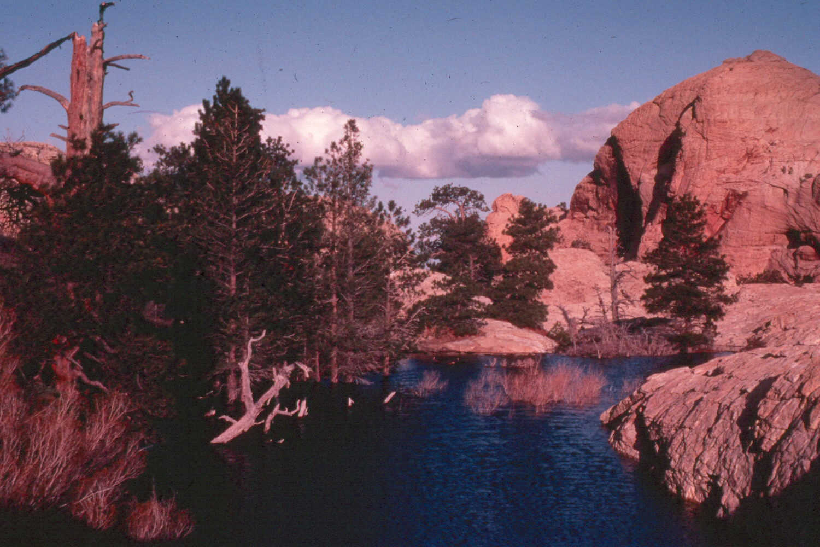

Location Approximately 12 miles west of Las Vegas

Access The east side of the area is easily accessed from the scenic drive at Red Rock Canyon National Conservation Area.

Terrain Vertical red and buff sandstone cliffs, capped by limestone in some areas, are deeply incised by narrow, twisting and heavily vegetated canyons. The area contains one perennial stream. Elevations range from 4,400 feet in the canyon bottoms to 7,000 feet at the top of the escarpment.

Habitat Type Rocky outcrops with pockets of ponderosa pine, pinyon pine and juniper. Willow, ash and hackberry cover canyon bottoms. The area’s unique geology and microclimates support endemic plant communities.

Special Features

• High concentrations of rock art, including petroglyhs and pictographs.

• A variety of unique plant communities. The deep, cool canyons support endemic chain ferns that reach 6 feet high and stands of ponderosa pine that grow at unusually low elevations.

• The cross-bedding of ancient sand dunes and the limestone formations of the Keystone Overthrust are of geologic and paleontological interest.

