Tsunamis: A Historical Perspective

Introduction:

Tsunamis have occurred throughout human history. The explosive eruption of the volcanic Island of Santorini in the Aegean Sea in approximately 1500 B.C.E. generated a tsunami that swept the shores of nearby islands and helped lead to the end of the Minoan culture. Not incidentally, there are some who feel this event was the basis of the myth of Atlantis.

Since the eruption of Santorini, humankind has been afflicted with tsunamis in all oceans and on all inhabited continents. Although the Pacific Ocean is known for numerous tsunamis, significant numbers have occurred in the Mediterranean Sea, the Caribbean Sea, and the area surrounding the Indonesian archipelago. Although less common in the Atlantic Ocean, one of the great natural disasters of European history occurred on November 1, 1755, when a great earthquake with follow-on tsunamis between 15 and 40 feet high devastated much of the Spanish and Portuguese coasts. Lisbon, in particular, experienced catastrophic damage and it is believed that tens of thousands perished as the result of the earthquake and tsunamis.

Although tsunami waves were noted at many Caribbean Islands following the Lisbon earthquake, little notice was made in the British colonies of North America. There was no infrastructure to observe the small water level fluctuations that would have been superimposed upon normal tidal observations from New England to Georgia. It would not be until after the American Revolution that the scientific infrastructure grew up that could observe and analyze such natural phenomena. Ancestor agencies of today’s NOAA were instrumental in developing these capabilities. First among those was the Survey of the Coast, known later as the Coast Survey and then Coast and Geodetic Survey.

The American scientific infrastructure as we know it today had its beginnings with the authorization of a Survey of the Coast during the administration of President Thomas Jefferson in 1807. From small beginnings, this first agency of the Federal Government had grown into a robust organization by the 1850’s conducting survey operations along all coastlines of the growing United States.

Serendipitous Science

Within the instrument shop of the United States Coast Survey, a new technology called a self-registering tide gauge was developed. In 1854 three of these new instruments were shipped to the West Coast of the United States for installation at San Diego, San Francisco, and Astoria. Lieutenant William P. Trowbridge, United States Army, was tasked with installing these gages and assuring their proper operation.

Within six months of the installation of the San Francisco gauge, a major earthquake occurred on December 23, 1854, near the central coast of Japan raising a series of great tsunamis along portions of the Japanese coast. The tsunamis traveled across the Pacific Ocean and were recorded as attenuated waves on the self-registering tide gauges along the western coast. These waves were superimposed upon the regular tidal record as a series of sinusoidal squiggles. The first person to recognize the significance of these squiggles was Lieutenant Trowbridge who wrote to Superintendent Bache in early 1855, “There is every reason to presume that the effect was caused by a sub-marine earthquake.” This was an amazing insight given that recording seismographs were still twenty-five years in the future and that no earthquake or tsunami had ever been remotely sensed by any means up to this time.

Trowbridge’s insight was validated when word of a major earthquake occurring on the coast of Japan on December 23 reached Superintendent Bache. Armed with knowledge of the time of the earthquake, its location, times of arrival of the tsunami waves at both San Francisco and San Diego (from the tide gauge records), and times between crests of the various waves, Superintendent Bache was able to estimate the average depth of the Pacific Ocean. Bache was familiar with the latest basic research published by Sir George Biddell Airy and his treatise on Waves and Tides in the Encyclopaedia Metropolitana in 1849. Airy had mathematically developed theoretical expressions that govern the motion of waves in canals of uniform depth and compiled tables for expressing the relationships between wave length, wave period, wave velocity and depth of water. Bache interpolated the Airy table values using his distance estimates and the tide gauge measurements for the theoretical tsunami wave travel lines between Shimoda, Japan and both San Diego and San Francisco. Using two separate estimates for the times of the disturbance due to the tsunami on the tide gauge curve at San Francisco, Bache estimated the average depth of the Pacific between Shimoda and San Francisco to be 13,380 feet and 15,000 feet. For the line between Shimoda and San Diego, the average depth was estimated to be 12,600 feet. Considering that these were estimates of the average depth of the Pacific Ocean using indirect measurement and theoretical relationships of waves for canals of uniform depth, these numbers agree remarkably well with published values based upon modern measurement technology. Modern day estimates for the average depth for the depth profile from Shimoda to San Francisco are 15,504 feet and 15,221 feet from Shimoda to San Diego. Bache published his estimates at a time when deep sea sounding technology was in its infancy, inaccurate soundings ranging between 30,000 to 50,000 feet were fairly common, and there was great uncertainty concerning the true average depth of the oceans.

Over the ensuing years, Coast Survey and then Coast and Geodetic Survey (as the organization became known after 1878) tide gauges observed many of the great tsunamogenic events of the Indo-Pacific region. In particular, remnants of the great Krakatoa tsunami, caused by the eruption and near-instantaneous destruction of the island of Krakatoa, was observed prior to any notification of this great disaster in the United States. The Coast and Geodetic Survey announced word of a potentially great disaster prior to receiving the particulars via telegraph and news media of the time.

Beginnings of Modern Seismology

In spite of the ability to observe the remnants of great tsunamis on tide records, there was still no infrastructure or mechanism in place to warn of impending tsunamis. The science of seismology was not even in its infancy until late in the Nineteenth Century when three British scientists traveled to Japan to observe and study earthquakes and their attendant phenomena between 1878 and 1883. John Milne invented the first accurate seismograph and with his colleagues, Thomas Gray and James Alfred Ewing, made many contributions to the early development of seismology. Thomas Corwin Mendenhall, a professor of physics and future Superintendent of the Coast and Geodetic Survey, was active in Japan in seismology and geophysics during the same period.

In the United States, weather service field offices had absorbed the task of recording observed (felt) earthquakes almost since the beginning of a national weather network. Initially these reports were anecdotal accounts of observations and subjective measures of intensity and damage. The first account of tsunami damage on United States soil was published in the Monthly Weather Review for October 1878 and reported that on August 29, 1878, an earthquake and accompanying tidal wave destroyed the village of Makuslin on Unalaska Island in the eastern Aleutians.

Although the Weather Service had been tasked with conducting seismological observations, the Coast and Geodetic Survey maintained seismographs at all of its geomagnetic observatories. Because of this, and its related earth science activities of geodesy, oceanography, and gravity studies, the Survey was designated the primary seismological agency of the United States Government in 1925. Over the next twenty years instrumental improvements were made, engineering seismology related to studies of man-made structures evolved within the Survey, and improvements were made in methods of data analysis and dissemination. There was even sufficient information for Captain Nicholas Heck, Chief of the Division of Terrestrial Magnetism and Seismology, to compile a list of over 200 destructive tsunamis that he presented at a meeting of the International Union of Geodesy and Geophysics in 1934. However, although there had been tsunamis in Alaska, Puerto Rico, and the Philippines (a United States territory until 1946) during these years, little notice had been made of them other than locally. This all changed on April 1, 1946.

Genesis of a Tsunami Warning System

On April 1, 1946, an earthquake occurred south of the Aleutian Islands generating tsunami waves that devastated Hilo, Hawaii, a little less than 5 hours later. 159 people were killed in this disaster. This served as a wakeup call for the United States and led directly to the establishment of a tsunami warning system by the Coast and Geodetic Survey. Commander Charles K. Green, an officer in the commissioned service of the Coast and Geodetic Survey, analyzed tidal records associated with the tsunami, computed theoretical travel times for arrival at various locations throughout the Pacific Ocean, and compared these results to the observed travel times as determined on tidal records.

Commander Green noticed that on virtually all marigrams (tidal records) that recorded the tsunami, that there was a small run-up of water level followed by a relatively large withdrawal over an interval of ten to twenty minutes. Larger amplitude waves of similar period would follow this initial indicator. Making use of these facts, Green designed a system that filtered out short period wind waves and other short-period oscillations that could affect water level observations. Longer period waves associated with tsunamis would trigger an alarm when detected.

Commander Green’s invention was but one element of a warning system. The complete warning system that was operational by 1949 included: 1) a network of four Coast and Geodetic Survey seismograph stations coupled with two cooperating stations for rapid earthquake epicenter location determination; 2) a network of tide gauges installed throughout the Pacific Ocean, some of which had Green’s tsunami detection system installed; 3) an improved seismic sea-wave travel time chart for determining probable time of tsunami arrival at various locations; and 4) a high-priority communications system that utilized both civil and military emergency capabilities. This first warning system was devised only for the Hawaiian Islands; but by March 1964, at the time of the great Alaska earthquake, the warning area consisted of the entire Pacific basin from Japan to Chile and from British Columbia to New Zealand.

Epilogue

The Pacific tsunami warning system of today is the direct descendant of that first system built by the Coast and Geodetic Survey. It is fitting that the system is operated by the National Oceanic and Atmospheric Administration, an organization that has many components descended from the former Coast and Geodetic Survey and the Weather Bureau. Today the work of the early scientists and engineers of those agencies serves as the foundation for a tsunami warning system that will become world-wide in the wake of the great Indian Ocean tsunami event that occurred December 26, 2004.

Bibliography:

Bache, A.D. Notice of Earthquake Waves on the Western Coast of the U.S., December 23 and 25, 1854; ocean depth” in Appendix No. 51, Report of the Superintendent of the Coast Survey …. 1855. Pp. 342-346. Available on-line at http://docs.lib.noaa.gov/rescue/cgs/001_pdf/CSC-0004.PDF

Green, Charles K. 1946. “Seismic Sea Wave of April 1, 1946, as Recorded on Tide Gages” in Transactions , American Geophysical Union, Vol. 27, Number IV, August 1946. Pp. 490-500.

Heck, Nicholas H. 1934. “List of Seismic Sea Waves” in Annales de la Commission pour l’Etude des Raz de Maree , International Geodetic and Geophysical Union.

Monthly Weather Review 1878-1925. Numerous mentions of earthquake observations; a few mentions of tsunamogenic events.

Roberts, E. B. 1950. “A Seismic Sea Wave Warning for the Pacific” in The Journal Coast and Geodetic Survey, No. 3. Pp. 74-79.

Sammons, Jack C. 1950. “Destructive Seismic Sea Waves in the Hawaiian Islands” in The Journal Coast and Geodetic Survey, No. 3. Pp. 64-73.

Theberge, Albert E. 2004. “150 Years of Tides on the Western Coast” presented at celebratory dedication of San Francisco Tide Gauge on June 30, 2004. 15 pp. Available on-line at http://tidesandcurrents.noaa.gov/publications/150_years_of_tides.pdf .

Zerbe, W. B. 1948. “A Seismic Sea Wave Detector” in The Journal Coast and Geodetic Survey, No. 1. Pp. 51-55.

Zetler, Bernad D. 1948. “A Seismic Sea Wave Travel Time Chart” in The Journal Coast and Geodetic Survey, No. 1. Pp. 56-58.

Historical Perspective NOAA Library Photos
Figures to Accompany “Tsunamis: A Historical Perspective “

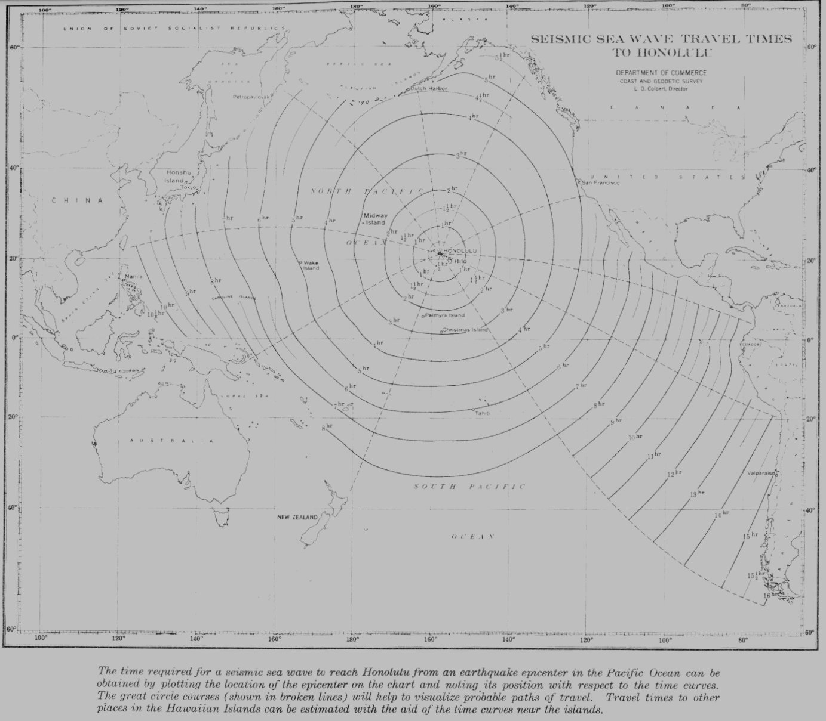

Tsunami Travel Time from earthquake in the Pacific Ocean to Hawaii

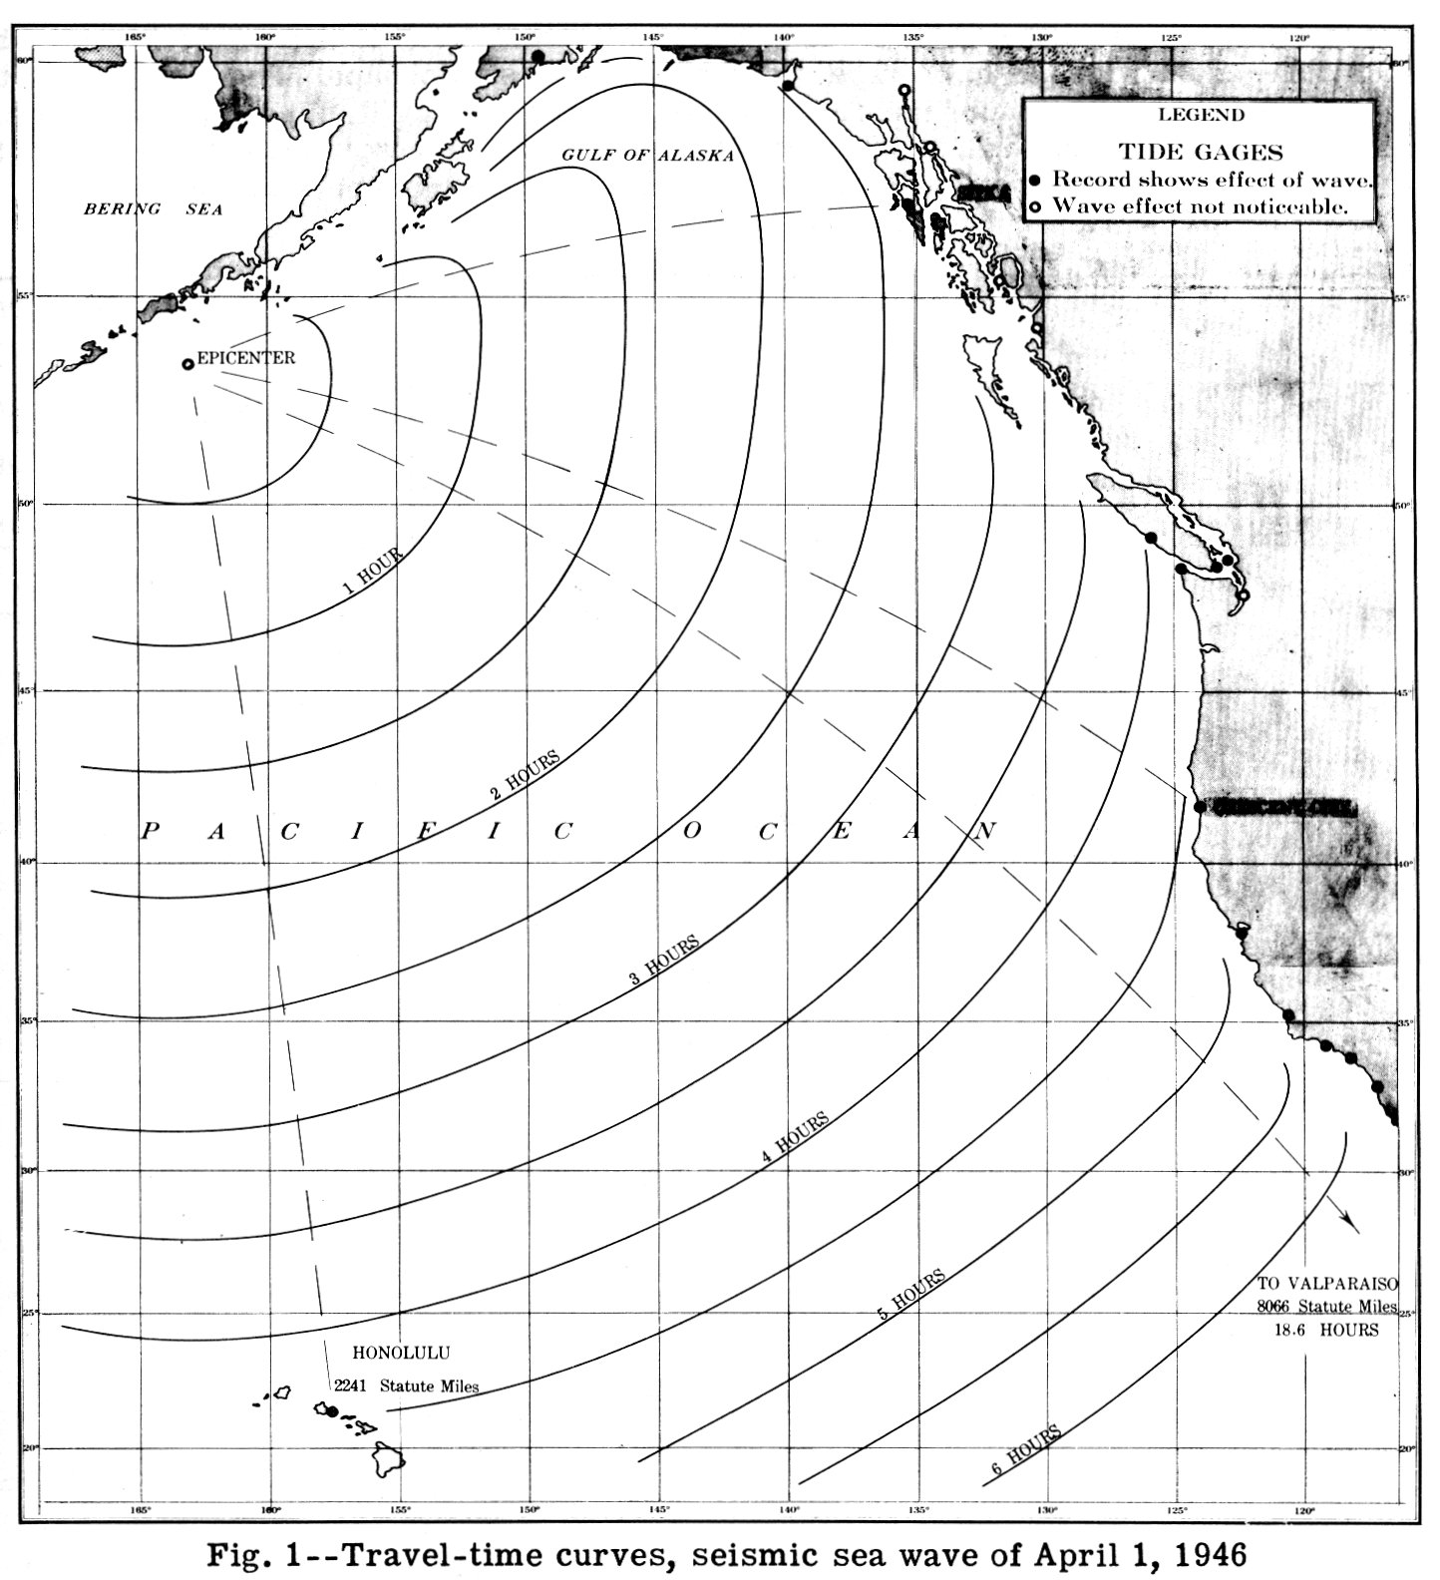

Travel-time curves
Seismic Sea Waves, April 1, 1946, Honolulu

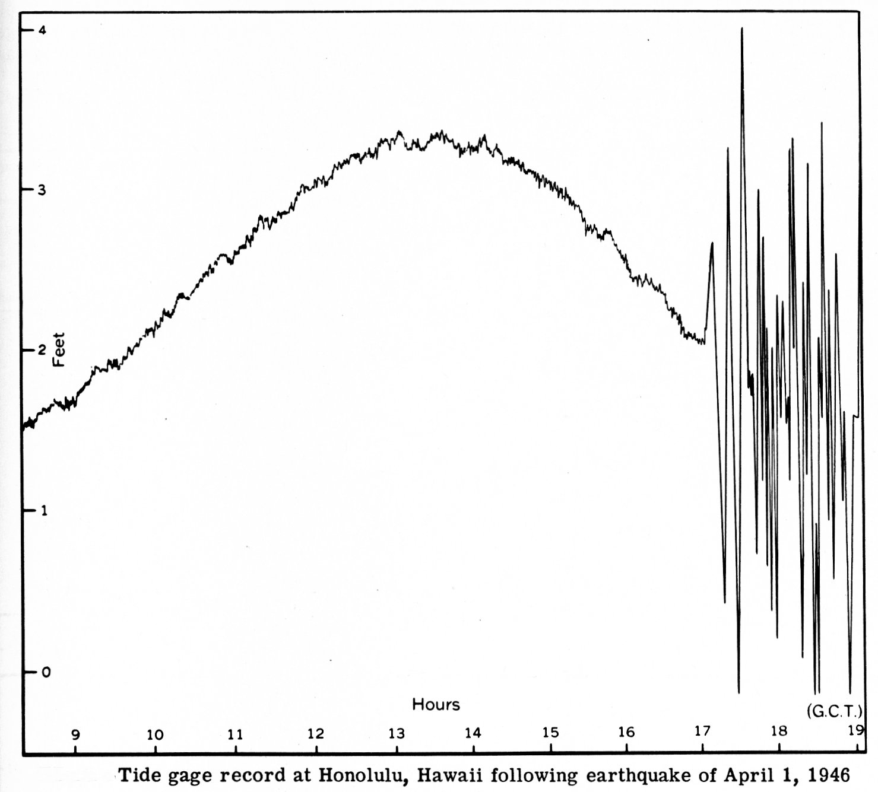

Tide Gauge record at Honolulu, April 1, 1946

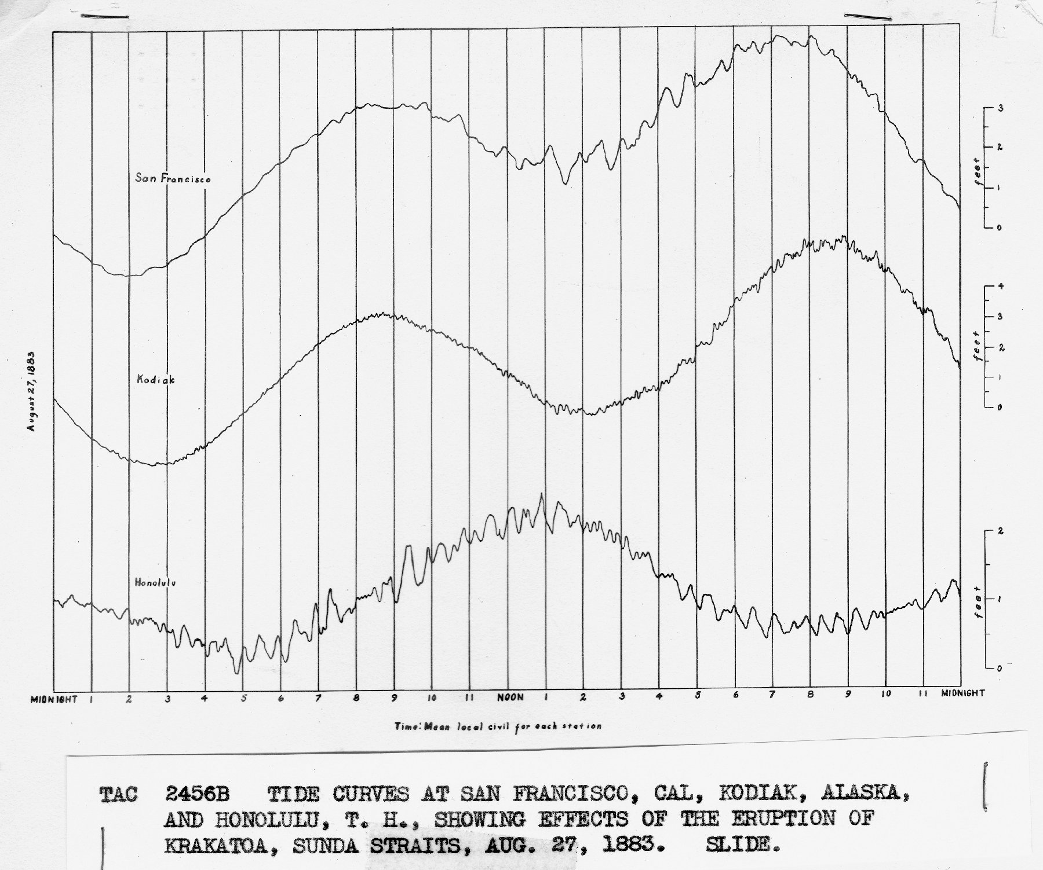

Tide curves at San Francisco, CA, Kodiak, Al, Honolulu, HI showing effects of the eruption of Krakatoa, 1883

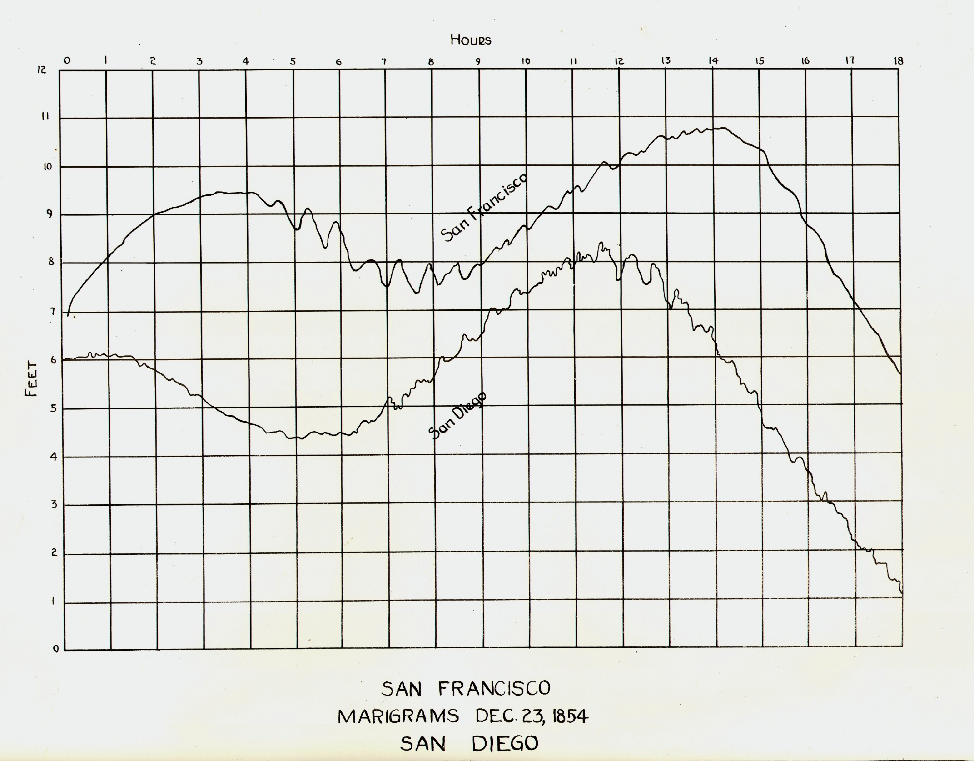

SF tide record 1854
San Francisco
Dec. 23, 1854
Marigram

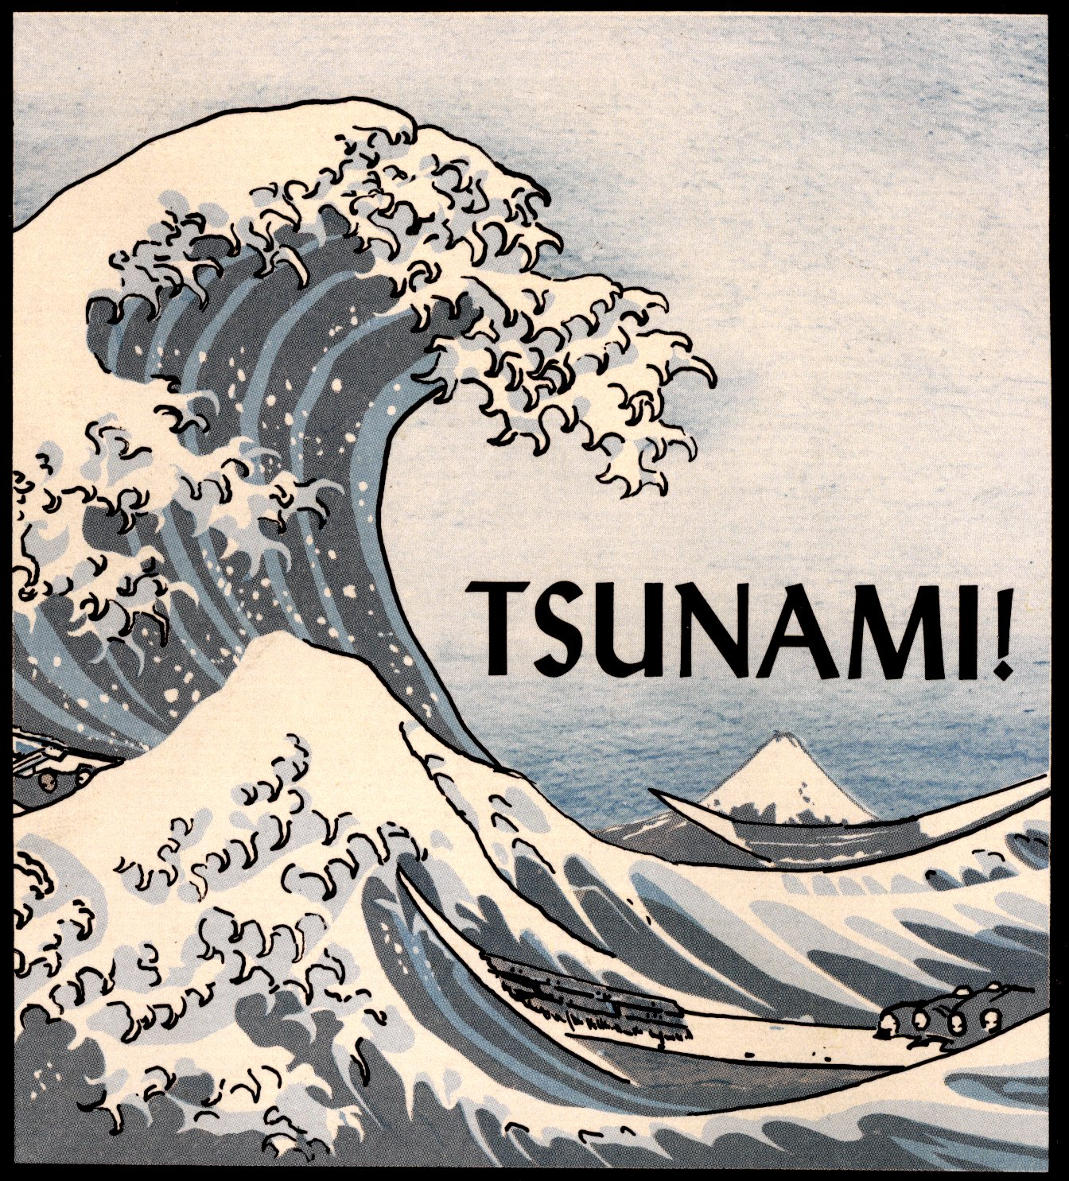

Japanese Wave

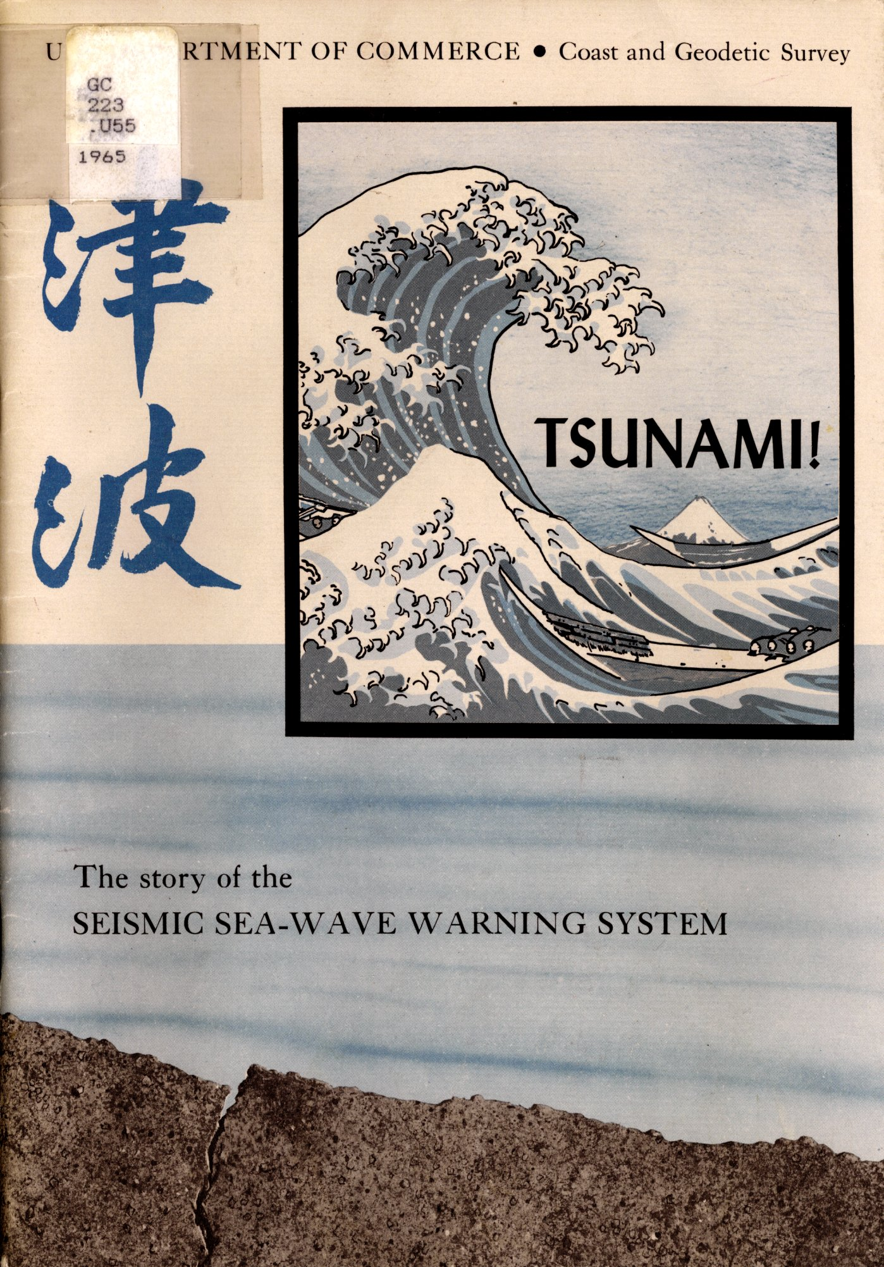

Coast and Geodetic Survey
Japanese Wave first used in 1965
Department of Commerce
The Story of the Seismic Sea-Wave Warning System

