

GEORGE WASHINGTON BIRTHPLACE
NATIONAL MONUMENT

PRESENTS
^{Chesapeake Bay Living Map}
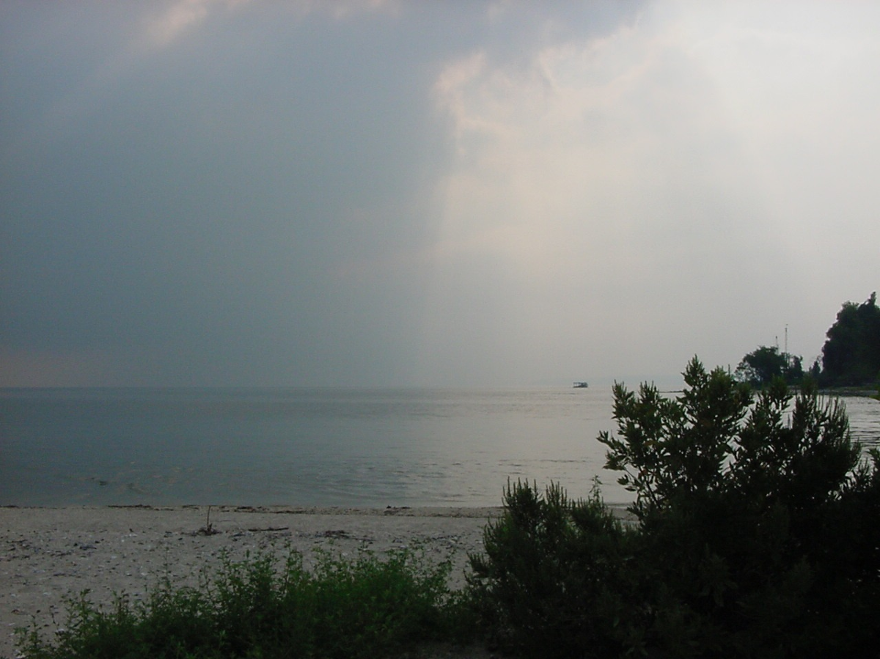

TEACHER GUIDE

GEORGE WASHINGTON BIRTHPLACE
NATIONAL MONUMENT
^{Chesapeake Bay Living Map}
TEACHER GUIDE, FOR GRADES 2 THROUGH 4

VIRGINIA
HISTORY AND SOCIAL SCIENCE STANDARDS OF LEARNING INCLUDED:
- 2.3, 3.5, 3.6
- VS.1, VS.2, VS.3, VS.4, VS.5, VS.6

GEOGRAPHY STANDARDS
- 2.4, 2.5, 2.6

ECONOMICS AND CIVICS STANDARDS
- 2.7, 2.8, 2.9, 2.11, 3.11

SCIENCE
- 2.5, 2.7, 2.8, 3.1, 3.4, 3.5, 3.7, 3.8, 3.9, 3.10, 4.5, 4.8

MARYLAND
SOCIAL STUDIES VOLUNTARY STATE CURRICULUM STANDARDS INCLUDED:
- Grade 2-4: 3.0, 4.0, 5.0, 6.0

SCIENCE
- Grade 2-4: 2.0, 6.0

Dear Teacher,

Thank you for participating in the educational program, “Chesapeake Bay Living Map.” The George Washington Birthplace National Monument developed this special program for 2nd through 4th grade students to meet Virginia and Maryland state requirements for environmental education based entirely on the Virginia Standards Of Learning and the Maryland Voluntary State Curriculum content standards.

The Chesapeake Bay Living Map: An Interpretive Visit to the Land and Waters of Pope’s Creek Plantation is a curriculum-based education program that involves students in hands-on exercises to help them understand how natural resources affect cultural resources. It focuses on causes and effects of population growth, land use changes, and water ecosystem controls, through touch, feel, and experimentation. Using a large-format canvas map, students discover the natural resources of the Bay and its tributaries, through the story of the lands surrounding Popes Creek Plantation, birthplace of George Washington, and the history of the people that worked the land and water. Interpretive props allow students to view, touch, and feel elements of the Chesapeake Bay ecosystem and enhance messages about the protection of this precious resource. They learn that where they live and what they do affects the Bay. Geography, natural history, and the history of the Bay to modern times are emphasized.

The program is available in the school classroom or in the park. In the classroom, the program provides an interactive hands-on learning experience without leaving the school. In the park, students participate in the same activities with the added benefit of experiencing the authentic site through a guided exploration.

The teacher guide provides a variety of exercises to help prepare students for their Living Map experience. The Living Map provides guided hands-on learning, either in the classroom or in the park. The follow-up exercises focus on the students’ critical thinking skills and understanding of the importance of protecting our Chesapeake Bay. George Washington’s views on natural resources are emphasized throughout.

We are proud to offer “The Chesapeake Bay Living Map” to assist teachers in conveying the importance of environmental education in our American Heritage.

George Washington Birthplace National Monument

Table of Contents
Using This Guide and Student Workbook

- The teacher guide and student workbooks are intended to support the Chesapeake Bay Living Map program presented by a ranger visiting your classroom. The teacher guide and workbooks are structured with pre-visit exercises and follow-up activities.

- The pre-visit activities should be completed in order for the students to better comprehend the Living Map program presented by the ranger in your classroom.

- Follow-up activities are included in the workbook to complete the objectives for the Standards of Learning and to allow students to demonstrate their learning.

Preparation
Park Background 5

A Very Goodly Bay 6

Where in the Watershed Are You? 10

A Taste of Progress – Harvesting Resources 14

When George Was Little 15

Survival in the Bay 18

Mapping Your Corner of the Watershed 20

Chesapeake Bay Living Map Crossword 21

Follow-up Activities
Disappearing Wildlife 23

The Great Chesapeake Mall Debate 25

The Poetry of Erosion 30

How Has the Chesapeake Changed 31

Making Reservations for the Classroom Visit with the Chesapeake Bay Living Map

- Please call George Washington Birthplace National Monument, 804-224-1732, x.227, as early as possible and at least a month in advance to make reservations for a ranger to visit your classroom to conduct the Living Map program.

- The classroom visit is a 55-minute program, intended to fit into standard class periods. If you have less time available, please let the ranger know when you make the reservation. The program accommodates up to 35 students.

- Ranger visits to the classroom are normally scheduled for January, February and March, but the park will consider other dates as well.

- Please plan to prepare your students for the ranger’s visit by using the workbook activities.

The Living Map program is normally conducted in the school classroom, however, arrangements can be made to conduct it in the park instead. In that case, make reservations as listed above, specifying you’d like to visit the park for the program. When visiting the park:

- When visiting the park, the program includes the Living Map program, a visit to George Washington’s birthsite and a self-guided hike with provided materials on the park nature trail to explore habitats relevant to concepts covered in the Living Map program.

- Picnic grounds, orientation video, visitor center, bookstore, beach and burial ground areas are also available.

Park Background

Is your mother or father keeping something valuable for you until you are older? Maybe it is your grandfather’s pocket watch that he wanted you to have. It could be your grandmother's necklace or photograph. Your family "safekeeps" this item until you can understand its importance for you and your family. These items tell a story about your family. You will want to keep these "special" family items to pass down to your children.

The National Park Service has the same role your parents do in safekeeping your "special" family items. The National Park Service protects places that have a story to tell about the land, wildlife, or history. These sites are protected because they are “special places” for the people of the United States. The role of the National Park Service has been to protect and preserve (safekeep) these places for the future.

Where George Washington was born is a "special place” for the people of the United States. The birthplace is important because George Washington was the “Father of Our Country.” Visitors have traveled to the birthplace of George Washington since 1815. George Washington Birthplace National Monument became a part of the National Park Service in 1930. Across the United States, almost 400 places that tell a story are in safekeeping by the National Park Service. This means that your children and your children’s children will be able to visit these sites just as you can.

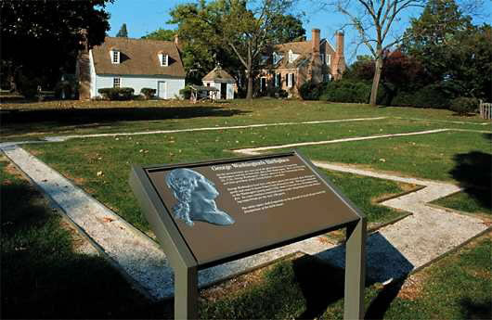
“A Very Goodly Bay”

Water is the key. Water has always played an important role in the settling of America. Early settlers of the Tidewater Virginia area recognized the importance of the waters of this rural land as a food source and as a means of travel.

It was the water and natural resources that Captain John Smith, one of the first English settlers to our land, noted in 1607, “ There is but one entrance by Sea into this Country, and that is at the mouth of a very goodly bay, 18 or 20 myles broad. . . Heaven and earth never agreed better to frame a place for man’s habitation. Here are mountains, hills, plaines, valleyes, rivers, and brookes, all running into a faire Bay, compassed but for the mouth, with fruitful and delightsome land.”

The Chesapeake Bay has many hidden secrets. Fed by hundreds of rivers and creeks into tidal currents, the brackish, or salty, waters of the Bay support more than 2,500 species of plants and animals. Archaeologists have discovered oyster beds here over a thousand years old. The largest is a thirty-acre Native American shell midden, or pile, across Pope’s Creek, off the Potomac River, not far from where George Washington was born.

The wonders of the Bay were not lost on others here at the time of the first English settlers. Native Americans called the vast waters, Chesapeake Bay, “The Great Shellfish Bay.” In the sixteenth century, a Jesuit priest sailed through the Virginia waters and gave them another name, “La Bahia de la Madre de Dios,” the Bay of the Mother of God.

The Bay’s waters are impressive in many aspects. The Chesapeake Bay is North America’s largest estuary. An estuary is a body of water that mixes the waters of the ocean, mountain streams and rivers. It creates a delightful community of fish, clams, oysters, and other sea creatures.

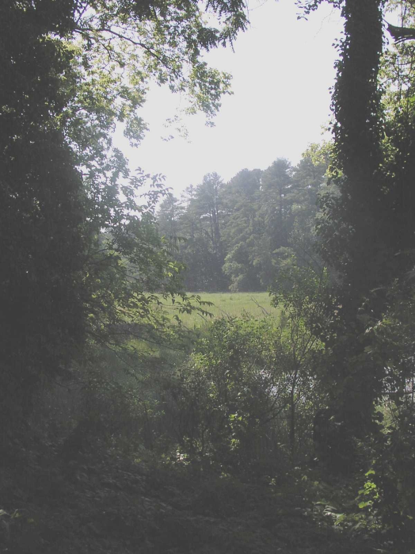
Some of our country’s earliest history as a nation has roots in the fingers of the Bay. The great waters of the Tidewater Virginia region include the James, the York, the Rappahannock, and the Potomac Rivers. The lands called the Northern Neck are bordered by the two most northern rivers, the Potomac and the Rappahannock. This is where our first President, George Washington, was born. Two other presidents, James Madison and James Monroe, also came from the Northern Neck.

It was the water that brought the Washington family to the colony. The first Washington ancestor arrived in Virginia in 1656. The English ship “Seahorse of London” ran aground in the Potomac River during a storm, near Popes Creek. George’s great-grandfather, John Washington, was a second officer. The ship had come to obtain tobacco from Virginia.

John Washington remained in Virginia and married Ann Pope, the daughter of a wealthy landowner living nearby. John Washington, his son Lawrence Washington, and Lawrence’s son, Augustine were all very active planters and civic leaders in Virginia.

In 1718, George’s father, Augustine Washington built a house on Pope’s Creek. His first wife died, but he married his second wife, Mary Ball, in 1730. Their first child, George was born at Popes Creek on February 11, 1732 (the old style calendar date) or on February 22, 1732, according to the new style calendar. George spent his first three years of life at Popes Creek, in a home along the water.

At the time, Virginia was an English colony. Again the water was the key: most of the colonists lived near the rivers, creek, and inlets feeding the Bay. The King appointed the governor and made land grants. Wealth was determined by the amount of land and the number of slaves a person owned. By the early 18th century, about 300 families, including the Washington’s, had become the upper-class that ruled Virginia.

The Washington family was a member of the planter aristocracy. Their position required participation in military and civil affairs of the colony. They served as Vestrymen (a group of men who managed the church’s affairs) and members of the House of Burgess (the lower house of the Virginia legislature).

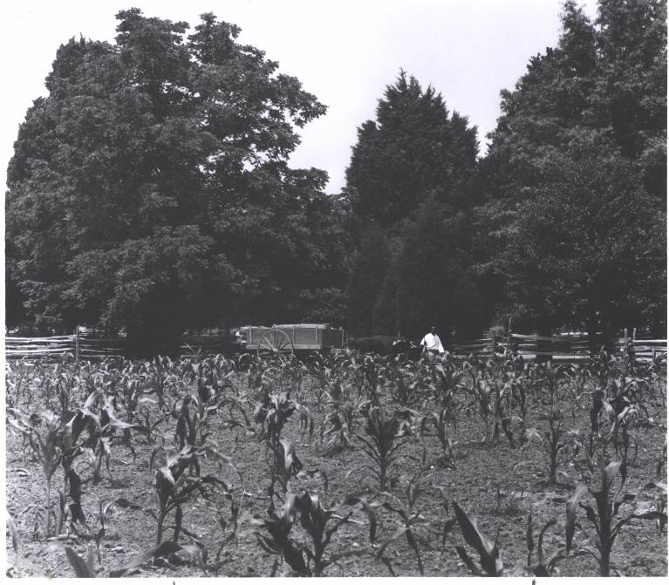
English settlers looked to the fertile land and waters for their food and transportation. They used boats to travel between settlements and plantations. Trade products were shipped by water, too. Tobacco was the main cash crop at the plantations. It was grown to sell for goods the planters needed. Plantation owners filled the holds of merchant ships from England with cured tobacco in exchange for goods such as sugar, fine cloth, dinnerware, spices and wines. Colonists had to wait as much as a year for their ordered goods, but the ships connected them with the sophisticated life of England.

It was the waters of Popes Creek and the Potomac River that the Washingtons used for food and transportation. The waters provided fish, clams, and oysters for the Washington table. Plantations were self-sufficient communities. They had to depend on themselves for the essential items of life: food, clothing, and shelter.

Near the waters, slaves tended a variety of vegetables: corn, carrots, onions, squash, pumpkins, melons, and cabbages. They grew herbs for medicinal use, seasonings, scents, dyes, and to repel bugs from the garden. They grew fruit trees to make pies and jellies. The Washingtons and other colonists raised domestic animals, which they allowed to roam freely, except in the fenced gardens. The Washingtons grew and killed pigs, cattle, sheep, and chickens for meat, eggs, and dairy products for their table.

The Washingtons’ slaves used yoked oxen to pull wagons. They used iron hoes for most of the garden work. Slaves worked the fields and tended the animals from dawn to dusk. Other slaves did chores such as cooking, spinning, carpentry, blacksmithing, and coopering (making barrels). The labor of the workers kept up the plantation. They were the human resources that this way of life depended on. Things like oxen, tools, and blacksmith shop were the capital resources used by the colonists. These scenes were part of large plantations and smaller farms all along the Chesapeake.
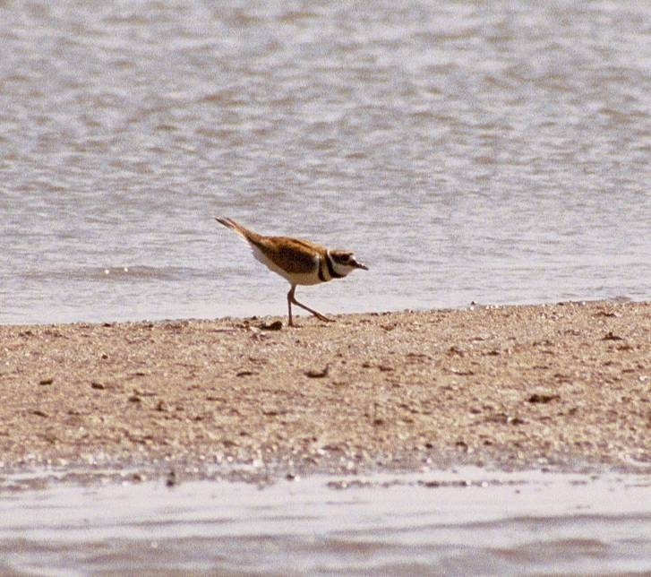
But change was to come to the banks of the Bay. When Europeans first arrived in Virginia, about 90% of the land was covered in trees. Colonists began to cut timber to clear the soil for farming. The main crop was tobacco. It eventually wore out the soil, forcing the farmers to clear more fields or try other crops.

Throughout time, the waters played a key role in the development of the Northern Neck. Timber operations were numerous and portable mills were common. This deforestation during permanently changed the character of the Northern Neck rivers and creeks. The deep channels of water became silted as they swept past bare banks. Commercial upriver areas, such as Leedstown, VA, and Port Tobacco, MD saw their river transport system become useless as it became buried under silt.

In Colonial times, water meant life in many ways. The Potomac and surrounding waters were teeming with life. Fish, oysters and other shellfish were plentiful. Colonists used hooked lines, spears, traps and metal tongs on long poles to catch and kill them for food. Likewise, the forests were lush and filled with wildlife like deer, rabbits, and squirrels that the Washingtons and other colonists also ate. These creatures were all part of the local population of a living community.

It’s always been the water that draws us, like the wildlife, to the Bay. Throughout the years, communities have lived close to the Chesapeake Bay. The pollution and growing development threatens the Bay. Nevertheless, its rich marshes and shallows remain world-class wildlife magnets. The Chespeake is the world’s leading nursery for Blue Crabs. They depend on the grassy shallow water for their early stage development and as a place to hide during shell shedding.

It’s also the waters that are in trouble. The extensive sea grass meadows have shrunk dramatically in recent years, evidence of pollution’s toll on the Chesapeake Bay. Science has determined that excessive nutrients from runoff have damaged the sea grass.

Several problems have combined to create a life-threatening crisis for the Bay: growing populations, sewage discharges, development, and runoff from paving green spaces. The waterways and the land they divide have changed dramatically during each round of development’s ongoing assault. The living things of the Bay share limited resources that are being damaged. The health of the Bay is linked to us all.

Will the waters survive? The Chesapeake Bay we know today is still filling in. The sea is rising about one-tenth of an inch each year. More and more of the land is becoming developed and urban. But the actions we each take can make a difference.

Today, the water is key for groups like the Chesapeake Bay Foundation who assist in the preservation of the Bay and its estuaries. Historic Colonial farms, such as George Washington Birthplace National Monument, recognize the importance of the Bay and its effects on Popes Creek. Through conservation and education, it tells the story of the young man, George Washington, and his lifelong love of the land and its people.

George Washington worked hard to help our country get started. He led the army, supported the idea of having a Constitution, and served as our first President. Because of his efforts, he is known today as “The Father of Our Country.” Yet, he also worked hard to improve his land, take care of the natural resources, and share his ideas so others could improve their environment, too.

The Chesapeake Bay Living Map begins with the Bay area at the time of Washington’s birth. It ends with the continued commitment necessary for future generations to save the Bay and enjoy its beauty and surprises.

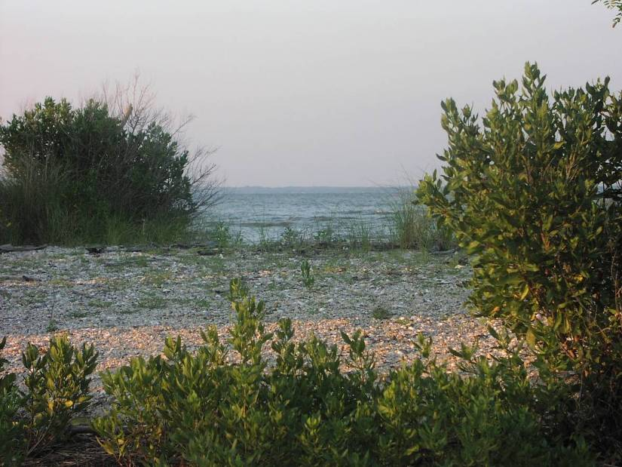

Discussion Question:
Imagine you’re a colonist.
How would the geography (the way the land and waterways are laid out) and the climate affect your choices about where to settle?
Where in the Watershed Are You?

Are you connected to the Chesapeake Bay?

Many of us cross several creeks, rivers, streams and ditches on our way to school every day. Each of these waterways that we cross is part of a network of water channels that empty into larger and larger rivers, and eventually into the Atlantic Ocean.

What’s a watershed?
A watershed is all of the land that is drained by a creek, river, or other waterway. The Chesapeake Bay’s watershed is quite large because it includes the smaller watersheds of all the smaller streams and rivers than drain into it.

Did George Washington know his watershed address?

George Washington knew the Chesapeake Bay and Potomac River well. Beginning with his birthsite on the Pope’s Creek plantation, which is now a national park site, most of his homes were built overlooking the Potomac River or other rivers that are part of the Chesapeake Bay watershed.

Watershed Mapping
The Chesapeake Bay Watershed Maps on following pages show the whole watershed: all the waterways that drain into the Chesapeake Bay.

How many states are at least partly in the Chesapeake Bay Watershed? __6___

Where does all the rain that falls within the watershed end up? ___Atlantic Ocean_

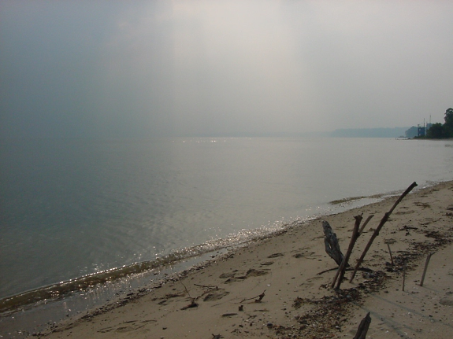
On the first Watershed Map:
Color the Atlantic Ocean and Chesapeake Bay Blue.
Color the Chesapeake Bay watershed Yellow.
Color the parts that are Not in the Chesapeake Bay
watershed, in each state, Green.

Use the second Watershed Map to locate the waterways where George Washington made his homes. For each place where he lived, list the closest river:

Pope’s Creek Plantation: ___Potomac River______

Ferry Farm: _________Rappahannock River____

Mount Vernon: _______Potomac River________

Ships from England kept the colonists connected with the broader world. Trace the best route on the second map from the Atlantic Ocean to Popes Creek Plantation.

George Washington thought that the way to riches was to create canals around the rocky areas in the Potomac River. Then boats could be used to ship goods from the lush Ohio Valley area, down the Potomac to the ports of the Atlantic. He started a canal company that built canals around some of the waterfalls and rapids, such as at Harpers Ferry. What 2 rivers join at Harpers Ferry?

Harpers Ferry: Shenandoah River, Potomac River_________________

What is your watershed address?
- Mark your school’s or town’s location with a star on the map.
- Use the Chesapeake Bay Watershed map, local highway maps, or go to http://topozone.com to fill in the chart below to find your watershed address.

Street Address | Watershed Address
Country | Ocean
State | Major River
County | Large River
Town | Tributary River/Creek
Street | Local River/Creek

Where does the water that you use end up? ____Atlantic Ocean_____________

Is your area of the watershed rural or urban? ___________

What’s the difference between rural and urban areas? May address many concepts: development,

pavement, countryside, farms, work people do, noise levels, amount of wildlife and forest, etc.___

Can pollution where you live get into the Chesapeake Bay? How?

__Pollution from where we live gets in the water stream and travels downstream to

the Bay________________________________________________________

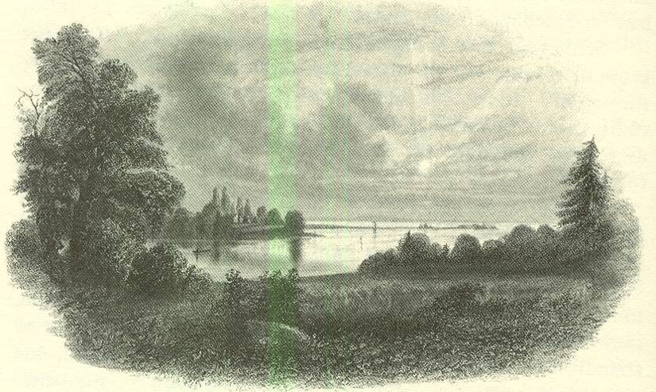

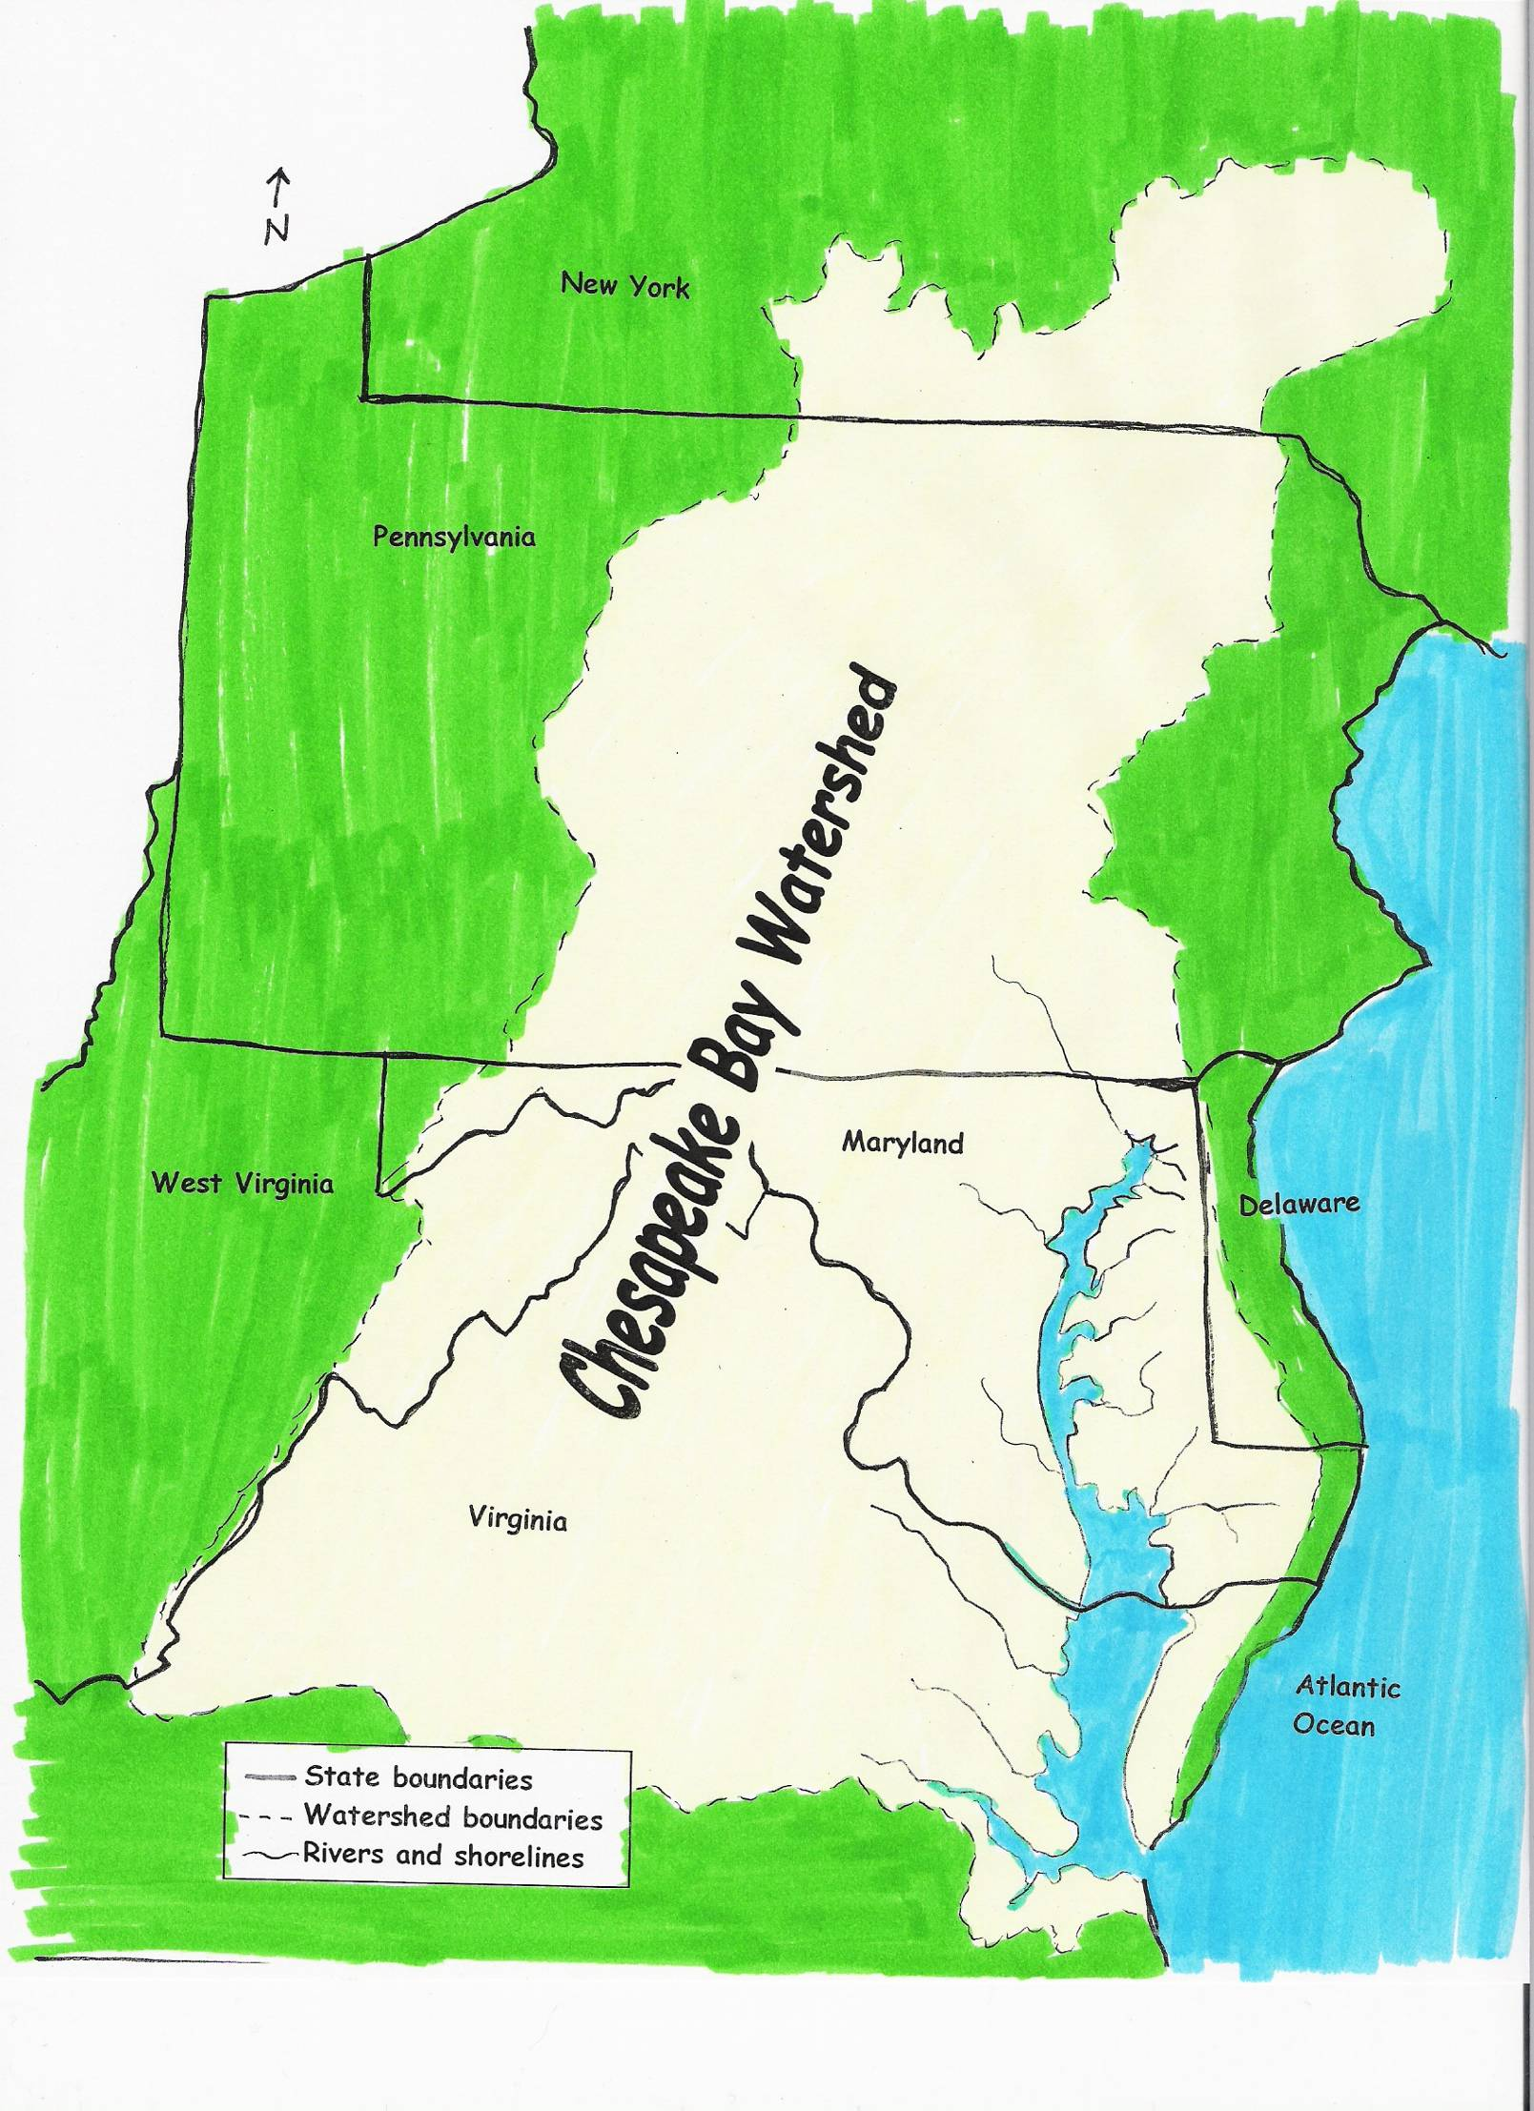
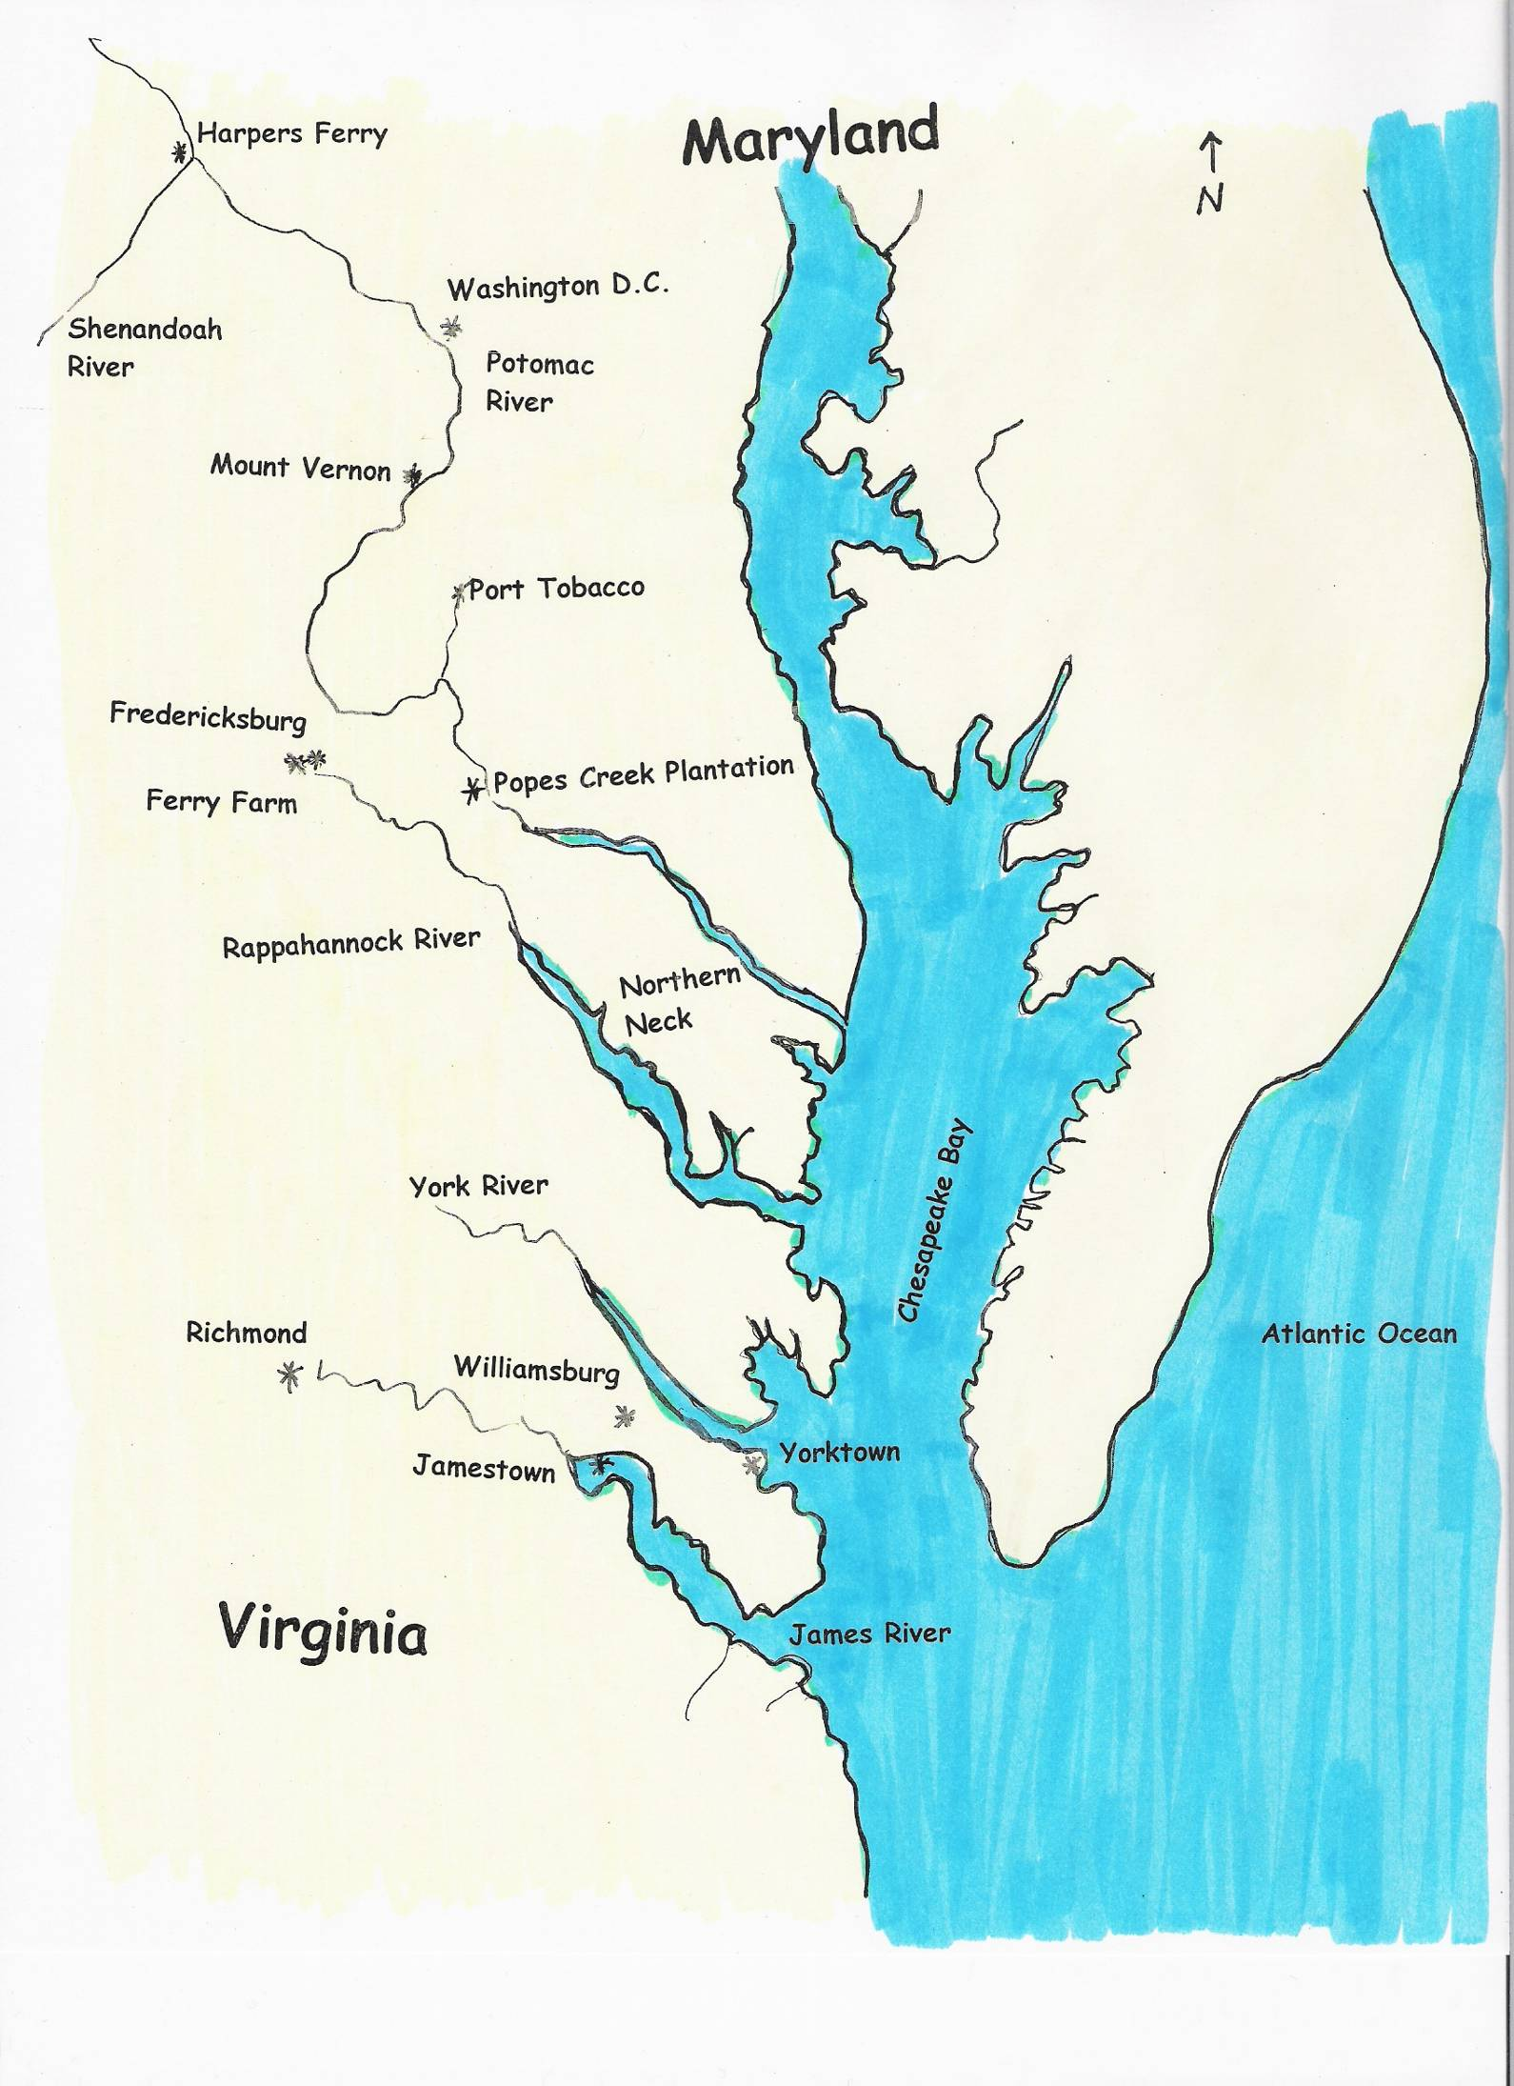
A Taste of Progress - Harvesting Resources
The non-renewable natural resources of our planet are limited. When they are used up, there is no more. Gone forever. Others, like soil, are renewable, but are being used up faster than they can be replaced.

People have always used natural resources. Native Americans, like the Powhatans of the Northern Neck, used natural resources for food, shelter, and transportation. Their technology and tools, and the size of their population was limited. So was their impact on natural resources.

The population and technology growth since then have allowed people to use vast amounts of natural resources, often causing great waste.

George Washington was concerned about waste of natural resources. As an adult, pioneered many ways to conserve soil on his farms. He taught these ideas to as many other plantation owners as he could because he wanted to be an example for wise use of resources.

Materials: 2 one-pound bags of M&M’s (or beans), flimsy paper plates

Gather students around a paper plate heaped up with 1 whole bag of M&Ms.
- Explain: Paper plate represents the Northern Neck of Virginia..
- Candies (or beans) represent all the natural resources on the Northern Neck.
- Ask students what they’d like colors to represent (ie. Brown=soil, green=plants, red=animals)
- Students represent people on the Northern Neck. They’ll gather natural resources using tools
and technology of different time periods.

For each population, discuss:
- Relative size of population, types of tools used in this period to gather resources
- How people lived, survived, traveled, consumer goods available
- How their lifestyle impacted the amount of resources used, and amount of pollution and waste

Native American Population – represented by 2 students (limited people, simple tools, low consumption)
- Representing simple tools, students use index finger & thumb of one hand to gather resources.
- Allow 3 seconds to gather resources.
- When finished return to original positions. Keep their resources in front of them until end.

Colonial Population – 3 students (more people, better tools, more resource consumption)
- Use tips of 3 fingers and a thumb of one hand (NOT entire palm), 3 seconds to gather resources.
- M&Ms fallen off plate are waste from advancing technology (can’t be used, leave on ground)

Current Population – 6 students (even more people, highly advanced tools, high resource consumption)
- Ask students to predict the amount of waste modern technology has on the environment.
- Use one entire hand to gather resources, 3 seconds
- Note the waste, and how much remains of the natural resources.

Discussion - What’s left of the resources for future generations?
- What about the waste? What impact will it have on the availability of resources? On their cost?
- How will the earth look if we continue to lose resources at this rate?
- How can we prevent loss of the remaining resources?
- What about students who didn’t get any M&Ms? (social injustice of resource distribution)
Open the other bag of M&Ms and let students enjoy eating them.
“When George Was Little”

A good homesite then, is a good homesite now. Natural resources and opportunities of the Northern Neck drew colonists like the Washingtons to these shores. Life is different now, but many of the reasons the area was a good homesite for the Washingtons and their neighbors still exist here today.

George Washington was born February 22, 1732 at Pope's Creek Plantation in the colony of Virginia. The plantation was his home for the first 3 1/2 years of his life, and he visited it often as a teenager.

When George was little, the Washingtons were British citizens. They remained so for most of their lives. America would not become a separate country until George helped lead the American Revolution much later in his life.

George and his brothers and sisters played on Pope's Creek's banks and ran through the fields that lined the farm. George loved to ride horses and became a very excellent rider. The plantation was typical for the Tidewater region of Virginia.

The house looked out at the waters and the gardens. The Washington family lived there, waited on by slaves and servants. Outbuildings included the kitchen, a dairy, slave quarters and a smokehouse used to preserve foods.

When George was little, his father found bog iron on one of his plantations. Iron was valuable for making tools, nails, kitchen implements and other metal items needed on plantations. George’s father made good money in the iron making business he set up.

George’s family farmed the land, since there weren’t stores nearby. Forests were cut down to make fields for growing tobacco to sell, and food to eat. Without the trees, much soil ran off into the creeks and rivers.
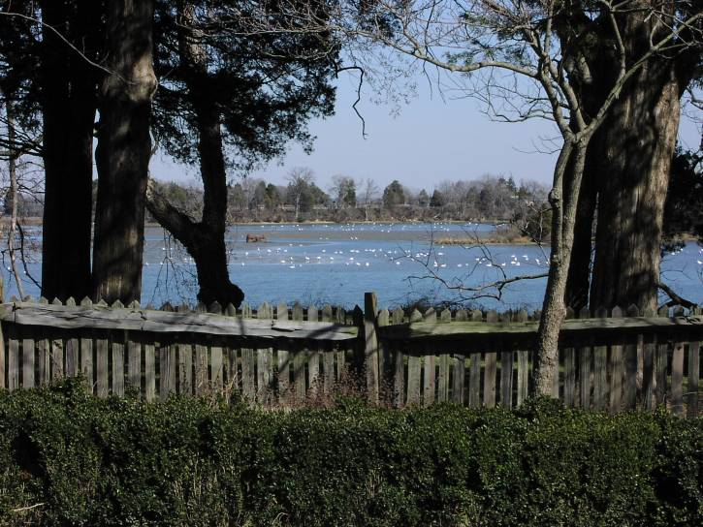
The Washingtons’ slaves harvested fresh vegetables from the garden. They grew herbs such as rosemary, thyme, sage and mints for medicinal use and for food. The orchards provided fresh apples, peaches, and other fruits that the slaves canned and stored for year round use. They also grew corn and wheat.

Some of these plants were not here before the English settlers. The colonists brought them from the Old World, but these new plants crowded out some of the native plants that used to grow here.

When George was little, tobacco was grown as a cash crop. It was grown as the primary product to be sold rather than just used on the plantation. Tobacco wore out the soil, so after a few years, new fields had to be cleared by cutting more trees.

George and his brothers fished in the quite waters of Pope's Creek, catching large and small fish and crabs. Oysters could also be found in the water banks. Many kinds of fish and shellfish were plentiful.

Forests were alive with wildlife such as deer, bear, foxes, rabbits and wild turkeys when George was little. Like other colonists, the Washingtons killed wild animals for meat by hunting them. After several generations, there was less wildlife. Some kinds, like bison, were hunted until there were no more. Others, like beaver, were trapped so that their soft fur could be made into coats and hats, until there were almost no beavers left either.

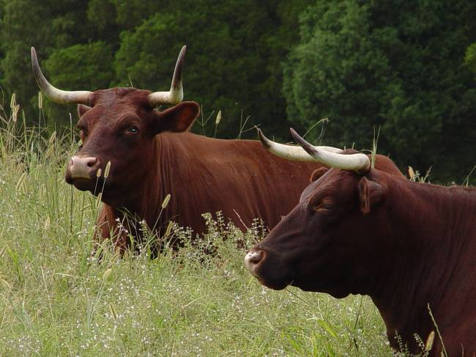
The Washingtons’ slaves used yoked oxen to pull wagons and do the heavy pulling we would use tractors for today. The planter’s family used horses for riding. They ate sheep, cows, chickens, geese and other farm animals. They used sheep, chickens and cows for wool, eggs, and milk.

Farm animals were allowed to roam free, so gardens, buildings, and orchards were usually fenced. Fences were also supposed to keep out predators like foxes, bobcats, and wolves. Colonists wanted to protect the farm animals, so they tried to kill all the predators. All the wolves, cougars and bobcats were killed on the Northern Neck, and they can no longer be found here. This is a piece of our natural environment that is missing.

When George was little, slaves did the plantation’s labor. Slaves lived in the loft over their work buildings or in quarters near the fields. They were provided with clothing and a ration of meal, meat, and molasses. Some were allowed to keep their own gardens and a few chickens to kill for extra food. George owned 11 slaves by the time he was 11 years old.

George and his family lived next to the main highway of their time: the Potomac River. Roads were limited and often in bad condition. The colonists depended upon the water to travel by boat between plantations. George’s family had to wait for the yearly visits of ships from London, whose agents in England filled the family’s orders for refined items, such as sugar, fine cloth, dinnerware, wines, and spices. They paid for these goods with credits from the tobacco.

When George was little, education for plantation owners’ sons often meant going to the College of William and Mary in Virginia. George Washington was hoping to go to college in England like his older half brothers. However, once his father died there was not enough money. Instead, he got a limited education at a private school near home. Education was generally was limited to boys. Girls learned basic skills of reading and writing, but their training centered on domestic chores and fine needlework.

The river brought not only goods, but also news from the outside world, including Williamsburg and England. The pineapple, a rare and valued import, became the sign of hospitality and served as a welcoming sign over Virginia doorways. Guests were encouraged to stay as long as they liked. The Washingtons entertained frequently.

Fond of music and dance, Virginians jigged and reeled until late hours of the night. The Washingtons celebrated Royal birthdays, weddings and funerals when they visited with friends and relatives. They also enjoyed horse racing, hunting, fishing, and bowling.
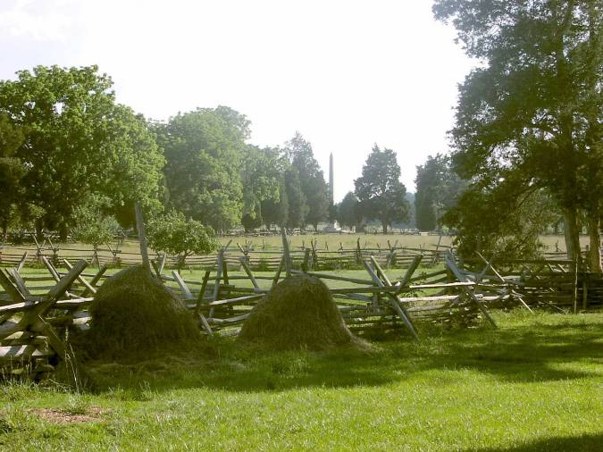
During George's days at Pope's Creek, planters worked long hours to manage the plantations. Slaves worked longer hours. George learned about patience and hard work from his father. When he was 13, George copied 110 rules of behavior. Among them were the need for honesty, modesty and perseverance. He copied rules such as, "Sleep not when other speak," "Wear not your clothes, foul, unript, or dusty," and "think before you speak."

George Washington grew up to be the first President of our country. The Popes Creek plantation was the first place he knew as home. It had many of the things we still value for good homesites: plentiful natural resources, open space, wildlife, water access, family time, opportunities to make a living, connections to neighbors and the outside world.

George was well known for his interest in finding better ways to farm that would protect the land. He shared his ideas with others, hoping everyone could improve their farms. His love for nature, beauty, knowledge, and perseverance followed him all the days of this life.
Survival in the Bay

All plants and animals have ways to help them survive: they are called “adaptations.” Adaptations are changes that help living things survive. Some of them happen right away. Other changes take hundreds and thousands of years.

Behavioral adaptations are things a plant or animal does to help it survive.
George Washington loved to ride horses. The horses run away from danger. Running
away from danger is something horses do to survive, so running is a behavioral adaptation.

Physical adaptations are things a plant or animal has that help it survive.
The Washingtons caught Blue Crabs in the Potomac River and Popes Creek. Blue Crabs have shells that match the colors of sunlight filtering through the seagrass onto the sandy bottom where they live. The color of their shells help them hide from critters that would like to eat them. Their shell color is something Blue Crabs have that helps them survive. It’s a physical adaptation.

On the chart below, write B for behavioral adaptations or P for physical adaptations. Some answers could be both.

Adaptation | Behavioral (B) or  Physical (P)
Tobacco plant turns toward sun to get more light | B
Beavers’ fur keeps them warm | P
Eagle’s feathers help it fly to find food | Both
Loblolly pine tree’s bark protects it from fire | P
Oyster’s shell protects it from being eaten | P
Baby fawns lie still in tall grass so they can’t be seen | B
Lambs call (bleat or baah) for their mother if they get separated | B
Flowers have roots that draw up water from the ground | P
Honey bees do a special dance to tell other bees where the flowers are | B
Canada Geese build a nest of sticks and grass to protect their eggs | B
Foxes fur color helps them blend in to their surroundings | P
Some critters have special adaptations.
Migration is when animals travel long distances at certain seasons of the year, then return in the next season. Animals migrate to follow seasonal food sources and to escape extreme weather, which helps them survive. Migration is something that animals do.

Is migration a behavioral or physical adaptation? _____Behavioral____

List as many animals as you can that migrate. (Hint: birds are animals)

_Waterfowl, Canada Geese, Swans, Ducks, Songbirds, Monarch Butterflies, Blue

Crabs (up and down the Chesapeake Bay), Eels, Salmon, Shad, Herring, Caribou, etc.

The Washingtons and other colonists noticed that many migrating birds and water creatures migrated to the waters of the Bay and rivers surrounding the Northern Neck.
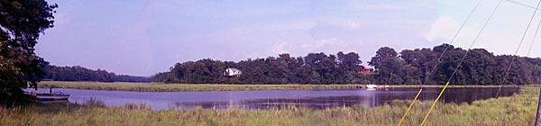
Hibernation is when animals sleep in their den all winter, don’t move around much, lower their body temperature, and don’t eat. This helps them survive the cold winter. Hibernation is something that animals do.
Is hibernation a behavioral or physical adaptation? ___Behavioral_____

List as many animals as you can that hibernate:

_Woodchuck, bats, bears (semi-hibernation, not a true hibernation)____________

_Frogs and turtles (in the mud)_______________________________________

Camouflage is the coloring of some animals’ fur or skin. They are colored just like the habitat where they live. That allows them to hide and blend in with the leaves, plants and soil around them, so they can’t be seen. Camouflage is something animals have.
Is camouflage a behavioral or physical adaptation? ___Physical____

List as many animals as you can that have camouflage:
Snake, turtle, rabbit, raccoon, deer, opossum, - there are many, many with camouflage

__________________________________________________________________
Mapping Your Corner of the Watershed

In the space below, draw a map of your neighborhood. Give your map a title, compass rose, and make a map legend. Include plants, animals and people. Show features of habitats – sources of food, water, shelter and space for animals. Show impacts of people. Mark whether it is rural or urban.
My Neighborhood Map

Teacher: with your students, discuss elements of maps and how these elements help us understand maps (labels, colors, compass rose, and so on).

Student maps may be panorama views (looking out and down), aerial views (looking down), or pictoral views (looking straight ahead at the site). Each student will have different amounts of detail.

Teacher: When students finish their maps, allow them to share with the class. Ask them to make predictions about the quality of their site. (There are no right or wrong answers.)

- Are there any environmental problems or issues relating to your neighborhood?

- How does what happens in your part of the watershed affect the habitats in your neighborhood?

- How does what happens in the habitats in your neighborhood affect the watershed?

- George Washington was interested in protecting the natural resources of his farm. What can you do to help protect the natural resources of your neighborhood?

Chesapeake Bay Living Map Crossword

 |  |  |  |  |  |  |  |  |  |  |  |  |  |  |  |  |  | 1G
 |  |  |  |  |  |  |  |  |  |  |  |  |  |  |  |  |  | E
 |  |  |  |  |  |  |  |  |  |  |  |  |  |  |  |  |  | O
 |  |  |  |  |  |  |  |  |  |  | 2 S |  |  |  |  |  |  | R
 |  | 3 S |  |  |  |  |  |  |  |  | O |  |  |  |  |  |  | G
 |  | C |  | 4 P | O | P | U | L | 5 A | T | I | O | N |  |  |  |  | E
 |  | A |  |  |  |  |  |  | D |  | L |  |  |  |  |  |  | W
6 F | O | R | E | S | T |  |  |  | A |  |  |  | 7 H |  | 8 P |  |  | A
 |  | C |  |  |  |  |  |  | 9 P | R | E | D | A | T | O | R |  | S |  |  |  | 10 P
 |  | 11 I | N | S | T | I | N | C | T |  |  |  | B |  | T |  |  | H |  | 12C |  | R
 |  | T |  |  |  |  |  |  | A |  |  |  | I |  | 13 O | M | N | I | V | O | R | E
 |  | Y |  | 14P | O | W | H | A | T | A | N |  | T |  | M |  |  | N |  | M |  | Y
 |  |  |  |  |  |  |  |  | I |  |  |  | A |  | A |  |  | G |  | P
 |  |  | 15C | A | R | N | I | V | O | R | E |  | T |  | C |  |  | T |  | A
 |  |  |  |  |  |  |  |  | N |  |  |  |  |  |  |  |  | O |  | S
 |  |  |  |  | 16J | A | 17M | E | S | T | O | W | N |  | 18P | L | A | N | T | S
 |  |  |  |  |  |  | A |  |  |  |  |  |  |  |  |  |  |  |  | R
 |  |  |  |  |  |  | R |  |  |  |  |  |  | 19H | E | R | B | I | V | O | R | E
 |  |  |  |  |  |  | S |  |  |  |  |  |  |  |  |  |  |  |  | S
 |  |  |  |  |  |  | H |  |  |  |  |  |  |  |  |  |  |  | 20L | E | G | E | N | D

Crossword Clues

Down Across
1.Father of Our Country 4. All of the animals or plants of one kind
living in an area

2. Provides support and nutrients needed for 6. Example of dry-land environment
plant growth

3. When limited resources require choices 9. Animals that catch other animals for food
about goods and services

5. Ways animals respond to life needs 11. Something animals are born knowing how to do

7. Place where an animal lives 13. Animals that eat both plants and animals

8. River closest to Popes Creek plantation 14. Native American tribes from the Northern
and Mount Vernon Neck area of Virginia

10. Animals that are caught to be eaten by 15. Animals that eat only meat or other animals
other animals

12. Tells you the directions on a map 16. First permanent English settlement in what
would become the American colonies

17. Example of water-related environment 18. Provide homes and food for animals, and keep
soil from washing away

19. Animals that eat only plants

20. Tells you what the symbols on a map mean

Word Bank
Scarcity Jamestown Habitat Powhatan Potomac
Legend Compass Rose Plants Instinct Adaptations
Population Soil Marsh Forest Herbivore
Carnivore Omnivore Predator Prey
George Washington

Post-Visit Activities (After the Living Map Program)

Disappearing Wildlife

Talk with your classmates in small groups about what would happen if we suddenly didn’t have computer games, ipods, dvd’s or cell phones:

How it would change things?

If we lost these things, could we make more?

What are some natural resources that we couldn’t make any more of if they were gone?

Read:
In George Washington’s time, birds were hunted for their eggs and beautiful feathers until there almost weren’t any more of them. Beavers and other wildlife were hunted for their thick soft fur until they were almost gone too.

Today, the Bay’s water has pollution and excess nutrients from lawn and fertilizer runoff. This has greatly shrunk the seagrass meadows where Blue Crabs live.

Make a web organizer with your group to show what would happen if Blue Crabs disappeared from the Chesapeake Bay. Try to think about all the different ways this loss would affect our society and different groups of people. Be ready to share your ideas with the class.

After sharing your web organizer with the class, answer these questions:
Which parts of your web would have the biggest impact on you. Why?

What does our society do to help protect Blue Crabs, underwater plants, and other species
that may be threatened by our lifestyles?

George Washington tried to stop runoff from his farms. He probably didn’t know that this
would help life in the Bay. Could our efforts to solve environmental problems today help people and wildlife of the future in ways we haven’t even thought of yet? Try to think of at least 2 ways.

Teacher: Student booklet has a coloring page here. Students can use other paper or chalkboards to create their own web organizer.

Disappearing Wildlife
Sample Web Organizer
People will depend on other food sources
Other food sources may decline
Your students may have different ideas.

Loss of food for waterfowl and fish
Less seafood for people

Loss of link in food chain
Populations of waterfowl and fish decline
Hotels, small shops and restaurants can’t make a living
No More Blue Crabs

Animals that eat waterfowl and fish eat other critters = stress on other critters
Less tourism

End of commercial crab fishing
Less human interest in water and its health
Loss of vacation memories of finding Blue Crabs
No more teaching younger generation about Blue Crabs = loss of camaraderie
Less seafood restaurants
Loss of a lifestyle
Loss of communities
People move away and developers take over
The Great Chesapeake Mall Debate – Teacher Instructions

Teacher: Student booklet has a coloring page here.

Divide the class into pairs.
Read
- Ask students to read the Great Chesapeake Mall Debate story, or to follow along as you read it.

Townspersons’ Roles
- Assign role of a townspersone to each pair.

- Ask pairs to read their townsperson’s role and viewpoint about the Great Chesapeake Mall. They should think about whether their townsperson would want the mall to be built and why.

- Some students will be assigned the roles of county commissioners, which means listening to the debates, asking questions and voicing opinions.

- Give each pair a chance to explain why their townsperson wants or does not want the mall to be built.

Finding Solutions
- After everyone has had a turn, team pairs up in small groups with townspeople who have similar viewpoints.

- Complete the Great Chesapeake Mall Solutions worksheet in these small groups.

- Groups present solutions to the class.

Voting
- After groups have presented solutions, country commissioners vote on whether to allow the mall.

- Then the rest of students vote on whether each commissioner gets to keep their job as commissioner for the next year.

Discussion Questions
- Follow up with Discussion Questions listed at the end of the activity.

The Great Chesapeake Mall Debate

Development happens more and more. Sometimes we’re told that it’s good for our community, but what about the wildlife, environment, and habitats? Imagine that developers want to build a new mall near along a marsh where you live: The Great Chesapeake Mall.

The marsh drains into a river that empties into the Chesapeake Bay. It provides nesting sites for migratory waterfowl, ospreys, and bald eagles. Canada Geese, Tundra Swans, and ducks use it as a resting place on their long journeys. Fish and shellfish are plentiful. The marsh is the last undeveloped property in your town.

A mall would bring a lot of money and jobs to the town. Many of the jobs however, are part-time, low-paid, and do not provide health insurance. On the other hand, youth crime has increased due to unemployment and lack of recreation opportunities. Tax money from the mall could pay for more roads, development, and schools.

Some townspeople are not happy about the mall idea. Other small stores and shopping centers that have been in the town a long time are afraid competition from the mall will force them out of business. Some workers and the mall owners will make money, but others will lose everything.

Many environmental groups are worried that draining and filling the marsh will destroy habitats for wildlife. Even if another wetland is created a long way from the town, people are worried about what will happen to the local wildlife. They are also worried about how the town and people will suffer without such greenspaces, and how the environment will suffer over time.

Some homeowners are worried that the loss of plants will cause flooding of their property and soil runoff into the river. Others are excited about shopping at such a fancy place.
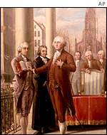
The marsh owner loves the outdoors, kayaking, and bird watching. Her family has owned the marsh for a hundred years. However, she will get a lot of money for selling the land, which she needs. Fishermen have been trespassing and littering in the marsh. Business groups are trying to get her to sell, but other townspeople are fighting to keep the property wild. Then it benefits the whole town.

George Washington was part of the decision making groups that got our country started. The government they set up depends on citizens helping to make the choices in how things are run. Public hearings, county hearings, and voting are still ways you can help decide what will happen in your town.

Townspersons’ Roles

Emily, the person who owns the wetland. She wants to get the most money she can so that she can retire, but loves the wetland and critters that live there.

Kathy, a state biologist dedicated to living things. She worries about the special species that could be destroyed, and the flooding that could happen to homes if the marsh is paved. She kayaks to the marsh every day. She monitors the marsh plants, and shops at community run stores.

Richard, a homeowner who has lived near the marsh for 30 years. He and his cats like the quiet atmosphere. He encourages wildlife in his garden. He thinks it is important to preserve traditional landscapes. He is afraid higher taxes for homeowners caused by the new development will make him lose his home.

Lakeeta, owner of the Great Chesapeake Mall Corporation. Her corporation is very wealthy and her stockholders expect her to make sure it keeps making lots of money for its investors.

LaToya, a city planner from town hall. She likes to plan cities that are neat, with plenty of paved streets, sidewalks, and fancy new buildings. She feels that wetlands are sloppy and in the way.

Samantha, owner of a small store at a nearby shopping center. Local people who live nearby congregate in her store for the sociability and handiness. Her products are not the latest style. She fears that the mall will steal away her customers.

Rose, an unemployed high school student. She’s trying to save for college and hasn’t been able to find a part-time job. She hopes to get a job in a new mall store.

Phil, who loves to shop, shop, shop. He always wears the latest fashion and is known as a trendsetter. He drives a long way to find cool new things to buy.

Maria, the town mayor. She likes to meet the local townspeople, so she eats and shops in the old downtown area. She can’t decide whether the tax income from the new mall would be better than the wetland benefits for the small town.

Virgil, town sheriff. He has seen more crime around the town lately. He is concerned that criminals will use the new mall as another hang-out.

Pastor Juanita likes quiet walks along the marsh. She thinks that malls entice people to spend more than they can afford. She has many parishioners who are saddled with huge credit card debt.

Darren is a fourth-grade history teacher. He loves to take his students for nature walks near the marsh. Important events in the town’s history happened by the marsh. He believes the students enjoy learning more when they get outside and see the real thing.

Rex is a road construction worker. He’s looking forward to the work the mall project will provide. He’ll get a little extra spending money by paving the acres of parking lots.

Dave is the town Parks and Recreation Department director. He’s been expanding after school programs because of the number of kids on the street. His facility is now full, so he’s looking for another site to expand to.

Commissioners
Commissioners each have a particular viewpoint on development and natural resource conservation. They also each want to keep their job, by being reelected to stay in office.

Commissioner William, the Save Our Bay chapter president. He puts together river cleanups at the marsh. He owns land next to the marsh.

Commissioner Diego, just moved back to his old hometown. His great grandmother helped start this town. He’s a model community member and supports many organizations. However, he also is afraid of offending any one group.

Commissioner Linda, is a local businessperson, and president of several civic organizations. She financially supports teens wanting to attend business school. She has reached many of her goals, but still wants very much to be city mayor.

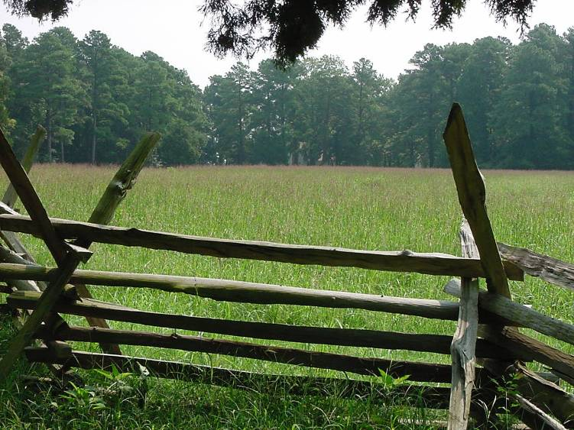

Discussion Questions
1. How do natural resources affect people?

2. How are habitats lost in our watershed?

3. When should the needs of wildlife and the environment be given higher consideration than the wants of people?

Can wildlife or the environment speak
for themselves in county meetings?

4. You were each making choices in the townspersons’ roles. What are the consequences of those
choices?
Are some consequences more important than others?

5. Look at the solutions you came up with. Do you think George Washington would agree or disagree
with them. Why?

Great Chesapeake Mall Solutions worksheet
Answer the following questions with your group.

- What are the basic disagreements and different needs of the townspeople involved in the Great Chesapeake Mall issue?
__________________________________________________________________

__________________________________________________________________

- List area of agreement amongst the townspeople:
____________________________________________________________________

__________________________________________________________________

- Brainstorm solutions with your team. Start your ideas with “What if. . . “
__________________________________________________________________

__________________________________________________________________

- Are there any reasons some of your solutions might not work? What are they?
__________________________________________________________________

__________________________________________________________________

- Will any of the solutions be hard to do? Why?
__________________________________________________________________

__________________________________________________________________

- Which solutions are fair to everyone?
__________________________________________________________________

__________________________________________________________________

Choose a solution: Write your solution and be ready to report it to the class.
__________________________________________________________________

__________________________________________________________________

__________________________________________________________________

__________________________________________________________________

__________________________________________________________________
The Poetry of Erosion
You have learned about how erosion and runoff impact the Chesapeake Bay and its waterways. Use the space below to writ e an acrostic poem about the affects of erosion on life in the Bay.

In acrostic poems, the word you’re writing about is spelled out going down along the left-hand side. Then use each letter of that word to start a new line. Each line can be any length and does not need to rhyme. Here’s an example for the word Hibernate.
Holed up in a warm den
Inside under the deep winter’s snow
Barely moving, the woodchuck sleeps
Even now I wonder, does he dream
Rather than run around and eat,
Not like the fox or weasel or raccoon,
All he does is sleep, and maybe dream
The whole winter long
Ending with spring’s warm entrance.
Now you try. You can write about how erosion and runoff changed the Bay since George Washington was a boy, how different ways of using the land changes the Bay, or what people can do to stop erosion from hurting the Bay.

E ________________________________________________________________________

R ________________________________________________________________________
O________________________________________________________________________
S________________________________________________________________________
I________________________________________________________________________
O________________________________________________________________________
N________________________________________________________________________
Draw a picture to go with your poem:

Try writing acrostic poems for other words, like Extinction, Migrate, or Chesapeake.
How Has the Chesapeake Changed?

With a classmate, talk about this question:

How has the Chesapeake Bay changed since George Washington was a boy?

Think about ideas such as:
  - How people change the Bay
  - What has changed for the living things in and near the Bay
  - Why people protect or don’t protect the Bay

After you have talked about the question and ideas above, present your conclusions to the class. You have several choices for ways to do this. Pick one below, or come up with your own choice.
  - Perform a skit about the question
  - Sing a song about it
  - Write a poem
  - Draw a mural
  - Have a debate with another group

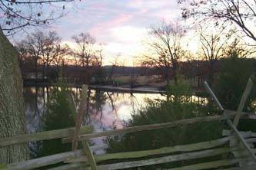

After all pairs have presented their ideas, answer the following questions:
- What are the consequences of the choices we make?
- What solutions would help protect the Bay?
- What can you do to help protect the Bay?

