Module 1: Leadership/Professional Skills

Module Outline

Topic |  | Time Frame
Introduction/Objectives | 20 minutes
Foundation | 35 minutes
Review | 20 minutes
Vision | 60 minutes
Entrepreneurship | 45 minutes
External Awareness | 35 minutes
Strategic Thinking | 35 minutes
Review | 10 minutes
Estimated/Approximate Time for Module Completion | 4 hours

Topic 1 – Introduction/Objectives

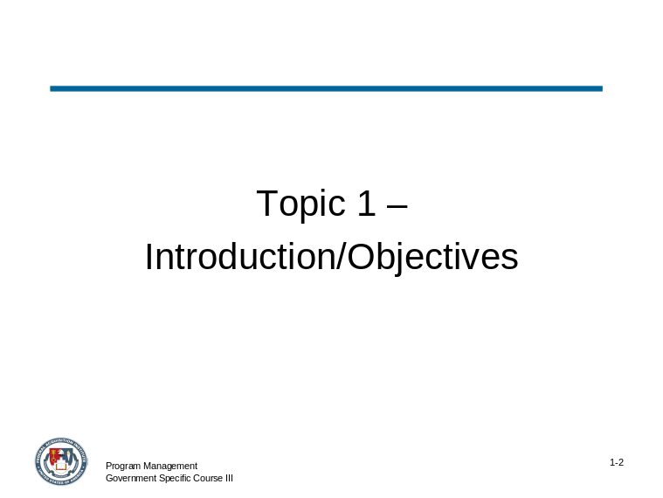 | Slide # 1-2

Topic 1: Introduction/Objectives (continued)

Slide # 1-3

 CONTENT TO BE PRESENTED:
Key Points:
This module will discuss the competencies needed for good leadership. These competencies provide a foundation for effective program manager-related responsibilities and include:
- Vision
- Entrepreneurship
- External Awareness
- Strategic Thinking

Topic 1: Introduction/Objectives (continued)

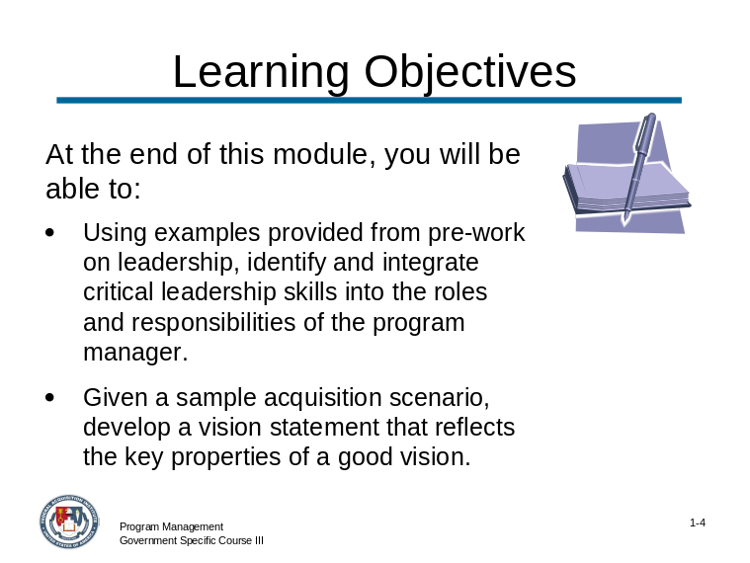 | Slide # 1-4

CONTENT TO BE PRESENTED:
Key Points:
Objectives
At the end of this module, you will be able to:
- Using examples provided from pre-work on leadership, identify and integrate critical leadership skills into the roles and responsibilities of the program manager.
- Given a sample acquisition scenario, develop a vision statement that reflects the key properties of a good vision.
(continued on the next slide)

Topic 1: Introduction/Objectives (continued)

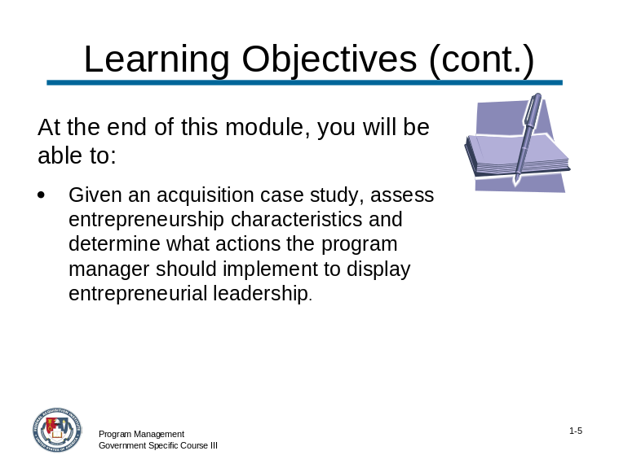 | Slide # 1-5

CONTENT TO BE PRESENTED:
Key Points:
Objectives (continued)
At the end of this module, you will be able to:
- Given an acquisition case study, assess the entrepreneurship characteristics and determine what actions the program manager should implement to display entrepreneurial leadership.

Topic 1: Introduction/Objectives (continued)

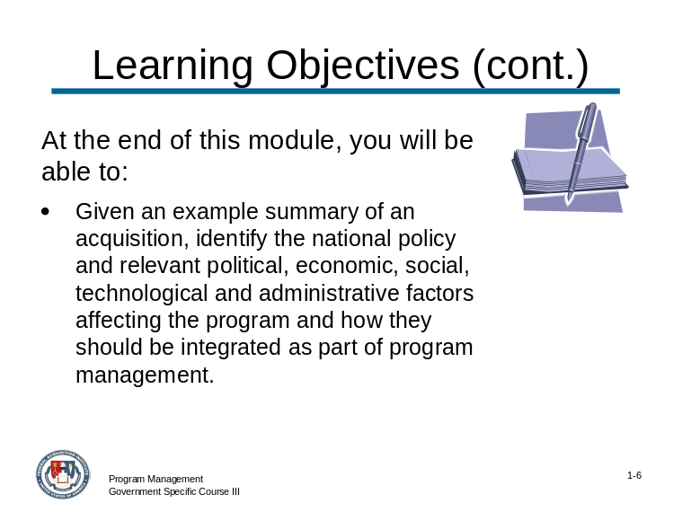 | Slide 1-6

CONTENT TO BE PRESENTED:
Key Points:
Objectives (continued)
At the end of this module, you will be able to:
- Given an example summary of an acquisition, identify the national policy and relevant political, economic, social, technological and administrative factors affecting the program and how they should be integrated as part of program management.
(continued on the next slide)

Topic 1: Introduction/Objectives (continued)

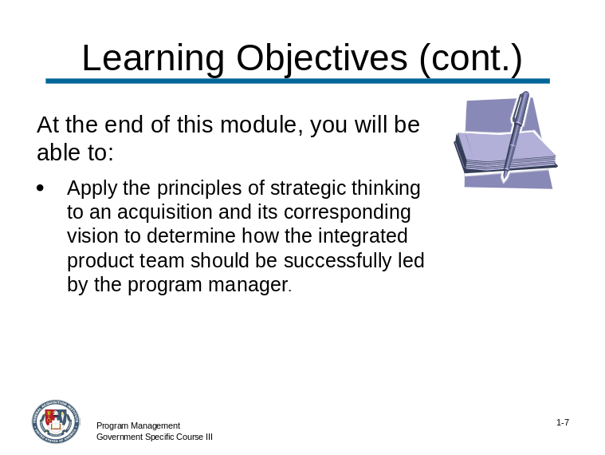 | Slide 1-7

CONTENT TO BE PRESENTED:
Key Points:
Objectives (continued)
At the end of this module, you will be able to:
- Apply the principles of strategic thinking to an acquisition and its corresponding vision to determine how the integrated product team should be successfully led by the program manager.

Topic 1: Introduction/Objectives (continued)

CONTENT TO BE PRESENTED:
Key Points:
Let’s look at an example of a modern day leader who exemplified key leadership skills in the areas of vision, entrepreneurship, external awareness and strategic thinking.

Instructor Notes:
Three examples are given. Make sure to familiarize yourself with each of these leaders.
Select one of the examples to share with the participants and to generate discussion on the key leadership skills presented in this module.
If discussion and class time lends itself to additional examples, discuss one or both of the remaining examples.
The examples and resource/reference information are listed below:
- Robert Bushell
- Project Lessons From The Great Escape (Stalag Luft III) by Mark Kozak-Holland
- Lee Iacocca
- http://www.iacoccafoundation.org/
- http://www.stfrancis.edu/ba/ghkickul/stuwebs/bbios/biograph/leeic.htm
- http://www.bordersstores.com/features/feature.jsp?file=wherehavealltheleadersgone
- Clara Barton
- http://www.nps.gov/clba/
- http://www.lkwdpl.org/wihohio/bart-cla.htm

Topic 1: Introduction/Objectives (continued)

CONTENT TO BE PRESENTED:
Key Points:
Example #1: Roger Bushell: Project Leader for the “Great Escape” from Stalag Luft III in 1944 during World War II.
- Lead large escape project during WWII under extremely difficult and dangerous conditions.
- Plane was shot down and he became a POW who eventually ended up at Stalag Luft III in (then) Sagan, Germany.
- Became known as "Big X" of the camp escape committee and was the mastermind behind the mass escape that occurred on the evening of March 24, 1944
- Roger and his partner Bernard Scheidhauer escaped through a tunnel known as “Harry” along with 74 other men
- Of the 76 men who escaped through "Harry", three men succeeded in escaping while the remaining 73 were all recaptured
- Project involved:
- Planning and building multiple tunnels
- Developing and producing hundreds of disguises and false identifications
- Evading discovery and
- Sending escapees on their way to freedom.
- Prisoners were isolated deep within Germany in “escape-proof” compound under constant surveillance from highly trained guards.
- Leadership involved:
- Organizing and managing an escape committee
- Focusing the efforts of hundreds of prisoners
- Dealing with enormous set backs and risks and
- Motivating under deadly circumstances

Topic 1: Introduction/Objectives (continued)

CONTENT TO BE PRESENTED:
Key Points:
Example #1: Roger Bushell: (continued)
Vision:
- Developed the vision of a project that would provide the prisoners something meaningful to do during their long and uncertain future, something that could serve as an important element in the fight against the Germans.
- His vision was bold almost beyond reason. Considering the hardships of capture and incarceration and the harsh conditions of the prison camp, it is almost unimaginable that the POWs could be organized for a project with the goal of having 200 prisoners escape at the same time.
So why would so many prisoners risk their lives attempting to escape from a prison camp built as “escape proof?” And the vision was not just for one tunnel, it was for three tunnels.
The answer is visionary leadership.
Entrepreneurship:
Bushell’s incredible entrepreneurship was just as bold as his vision for the escape
- Actually able to have a radio receiver built (hidden below a toilet) to listen to the news from the outside world
- Found sources of large quantities of wood to support the tunnel roof and walls (slats from beds)
- Developed undetectable trap doors in the elevated buildings for tunnels access (underneath an operating stove)
- Dispersed the huge quantity of removed sand (POW “penguins” who wore long pockets with drawstrings in their pant legs that were filled with 8 pounds of sand in each leg that would be covertly dispersed while walking outside)
- Produced false documentation (passports, travel papers).

Topic 1: Introduction/Objectives (continued)

CONTENT TO BE PRESENTED:
Key Points:
Example #1: Roger Bushell: (continued)
External Awareness:
- Key the success of The Great Escape was the intense effort Roger undertook to become aware of the environmental situation.
- Located deep within the German borders and cut off from virtually all contact with the outside world Bushell actually built an intelligence gathering organization.
- Learned about:
- Sandy soil that would hamper tunneling, about the escape-proof design of the prison camp (elevated barracks, double perimeter fence, buried microphone sensors, watchtowers)
- Nearby roads and train lines from “Ferrets” (German Army intelligence troops who intermingled with the prisoners)
- Possibilities of exploiting the occasional Red Cross food parcels
Bushell incorporated and used all of these external elements into his escape plan.
Strategic Thinking:
- Built and led a well-organized Escape Committee project management team with one dozen departments
- Leadership style was to meet regularly with his team to solicit their thoughts and ideas about the project as it progressed
- Bushell was a good listener and gave everyone an opportunity to participate. From these discussions, Bushell would form the strategic goals and then challenge his team to do the planning necessary to implement them
- Throughout the project, Bushell did not usually get involved in technical arguments or the day-to-day management; he left that to his department chiefs.

Topic 1: Introduction/Objectives (continued)

CONTENT TO BE PRESENTED:
Key Points:
Example #2: Lee Iacocca: CEO of Chrysler Corporation and active supporter of many charitable and non-profit programs.
- Worked for Ford in the early 1950s, initially as an engineer, then as a sales and marketing executive.
- Was fired from Ford and Chrysler sought him out to help rebuild the failing corporation.
- Requested a loan guarantee from the United States Congress in 1979 with which he was granted to save the demise of Chrysler.
- Some of the greatest contributions from a managerial and motivational perspective Iacocca provide come from his many known quotes:
- “Management is nothing more than motivating other people”.
- ”The speed of the boss is the speed of the team”.

Topic 1: Introduction/Objectives (continued)

CONTENT TO BE PRESENTED:
Key Points:
Example #2: Lee Iacocca: (continued)
Vision:
- Was able to see future needs of his consumers which brought the design of the Ford Mustang and the Lincoln Continental Mark III among others
- Made sure to identify direction and purpose to everyone in the corporation
- Created a set standards of excellence that reflected his high ideals and integrity
- Had the ability to challenge and inspire people to align their energies in a common direction
Entrepreneurship:
- Widely considered one of the most diverse entrepreneurs of the 20th and early 21st centuries
- In 1982, Iacocca became head of the Statue of Liberty-Ellis Island Foundation at the request of Ronald Reagan.
- Has co-authored several books including his auto-biography entitled, “Iacocca: An Autobiography” and “Talking Straight” with Sonny Kleinfield.
- Active supporter of finding a cure for diabetes after the death of his wife from the disease.
- Advocate and the current chairman for the “Nourish the Children” foundation.

Topic 1: Introduction/Objectives (continued)

CONTENT TO BE PRESENTED:
Key Points:
Example #2: Lee Iacocca: (continued)
External Awareness:
- Knowledge of the automotive industry and competitors.
- Utilized outside interests to help save the corporation from certain bankruptcy.
Strategic Thinking:
- Very effective communicator and through communication was able to express his strategy for success
- Developed and defined a list of your values and guiding principles and used these as a reference and guide for decisions.
- Shared his business goals with the organization and actually incorporated these goals in his decisions.

Topic 1: Introduction/Objectives (continued)

CONTENT TO BE PRESENTED:
Key Points:
Example #3: Clara Barton: Pioneer American nurse and humanitarian best remembered for organizing the American Red Cross.
Clara Barton’s vision was to create an organization that would assist in performing disaster relief acts. Her vision began in April 1862 after the First Battle of Bull Run, when Barton established an organization to obtain and distribute supplies to wounded soldiers. Later she would be called “Lady in Charge” of all hospitals by the Union, at the front of the Army of the James.
Her external awareness of the needs for disaster relief was prevalent through her time spent during the war, as well as her time of rest in Europe. While in Europe, she was involved with the International Committee of the Red Cross and its humanitarian efforts.
After returning from Europe in 1870, she inaugurated a movement to gain recognition for the International Committee of the Red Cross by the United States Government. Although the Federal Government showed resistance in her entrepreneurship for this organization due to the belief that disaster relief is only needed during times of war, Barton championed the idea further and created the Red Cross with the added element of assisting any great national disaster.
Her forward and strategic thinking provided her with widespread recognition. Her lectures about her war experiences gave her opportunities to meet other great minds such as Susan B. Anthony and Frederick Douglass.

Topic 1: Introduction/Objectives (continued)

Instructor Notes:
Make sure that the participants understand what will be presented in this module by asking the following question.

Do you have any questions concerning the objectives or the sample leader that was presented?

Topic 2: Foundation - Effective Senior/Expert Level Program Management

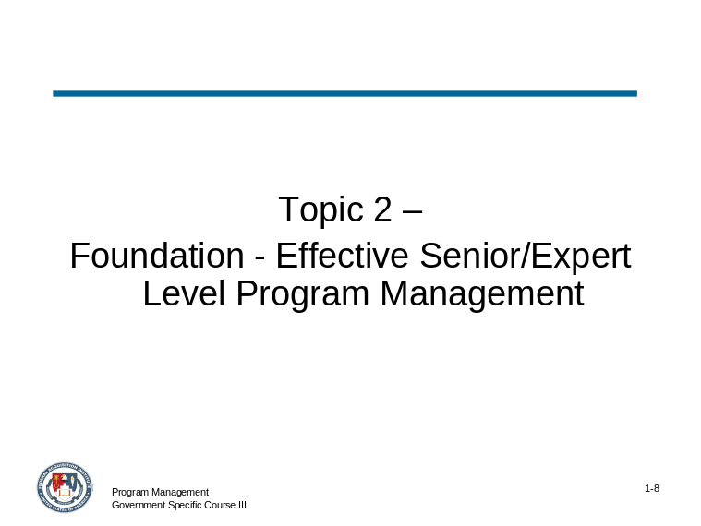 | Slide 1-8

CONTENT TO BE PRESENTED:
Key Points:
- Strong leadership skills are an essential part of effective expert-level program management.
- Program Managers are drawn to leadership – increased need to get things done where formal “powers” are limited.
- With so many projects across organizational lines, program managers seem to always be in a matrix organization with limited control in order to achieve project success
- Leadership is a way of closing that gap

Topic 2: Foundation - Effective Senior/Expert Level Program Management (continued)

CONTENT TO BE PRESENTED:
Key Points:
- Leadership – how do you define it? The skills that a program manager needs and uses are extensive:
Problem-Solving | Conflict Management | Interpersonal Skills
Resilience/Flexibility | Accountability | Communication Skills
Customer Service/Partnering | Developing Others | Team-Building
Political Savvy | * Strategic Thinking | Decisiveness
Creativity/Innovation | * External Awareness | * Vision
* Entrepreneurship | Leveraging Diversity | Influencing/Negotiating

Instructor Notes:
The leadership skills denoted with an asterisk (*) are covered detail as part of this module. The other skills identified as necessary for program management have been discussed as part of prior course content (FAI Government Specific Courses I and II).

Topic 2: Foundation - Effective Senior/Expert Level Program Management (continued)

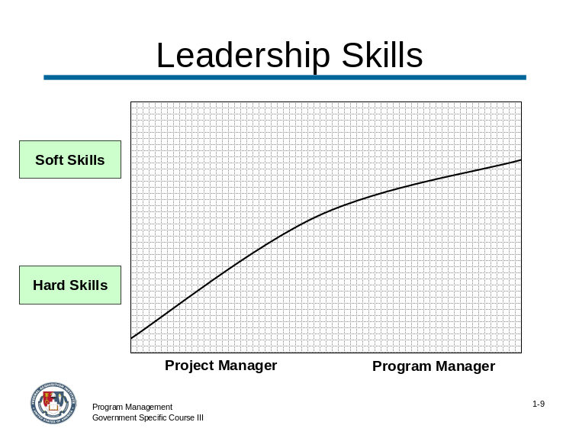 | Slide # 1-9

CONTENT TO BE PRESENTED:
Key Points:
The soft skills of leadership become more important and the hard skills less so as a project manager matures and moves up through program management.
The graph above represents this relationship.

Topic 2: Foundation - Effective Senior/Expert Level Program Management (continued)

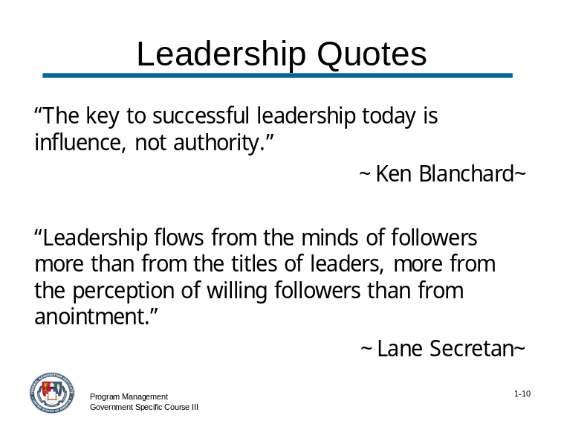 | Slide # 1-10

CONTENT TO BE PRESENTED:
Key Points:
Leadership Quotes:
“The key to successful leadership today is influence, not authority.” ~Ken Blanchard~
“Leadership flows from the minds of followers more than from the titles of leaders, more from the perception of willing followers than from anointment.” ~Lane Secretan~
(continued on the next slide)

Topic 2: Foundation - Effective Senior/Expert Level Program Management (continued)

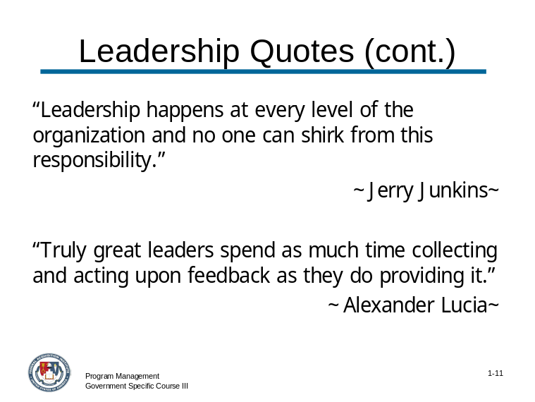 | Slide # 1-11

CONTENT TO BE PRESENTED:
Key Points:
Leadership Quotes: (continued)
“Leadership happens at every level of the organization and no one can shirk from this responsibility.” ~Jerry Junkins~
“Truly great leaders spend as much time collecting and acting upon feedback as they do providing it.” ~Alexander Lucia~

Topic 2: Foundation - Effective Senior/Expert Level Program Management (continued)

CONTENT TO BE PRESENTED:
Key Points:
Senior program managers are required to find innovative and creative ways to employ leadership skills in a meaningful way to drive acquisition programs successfully.
One solution often referred to is “empowerment.” Empowerment serves as the foundation for effective senior/expert level program management.

Instructor Notes:
Ask the following question to define “empowerment” as it relates to this module. Discuss participant responses.

How would you define “empowerment?
Answer:
Webster’s defines empower as “giving official authority or legal power to.” For the purposes of this course, empowerment will be defined as “having the responsibility and authority to take actions and make decisions in pursuit of the organization’s goals.”

Topic 2: Foundation - Effective Senior/Expert Level Program Management (continued)

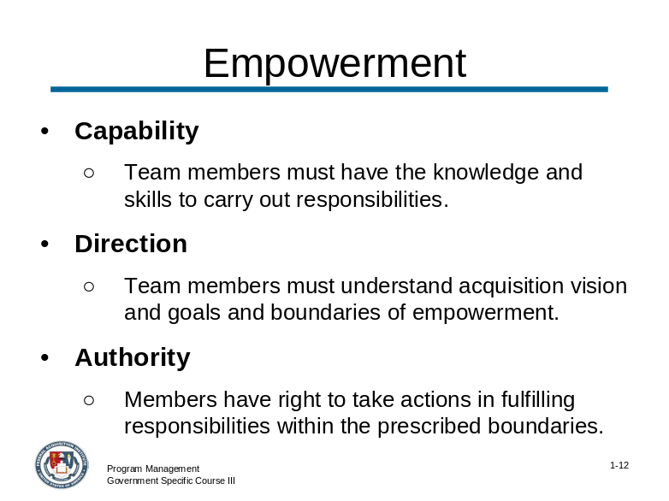 | Slide # 1-12

CONTENT TO BE PRESENTED:
Key Points:
In order to empower acquisition team members as part of an effective leadership strategy, you must first understand what the core components of empowerment include and how they affect your team’s productivity and overall performance.
The core components of empowerment include:
- Capability. Team members must have the knowledge and skills (technical, business, interpersonal, and organizational) to carry out the responsibilities.
- Direction. Team members must understand and be aligned with the acquisition strategy’s vision and goals. They must also know and understand the boundaries of their empowerment.
- Authority. The right to take prescribed actions in fulfilling one's responsibilities within the prescribed boundaries.

Topic 2: Foundation - Effective Senior/Expert Level Program Management (continued)

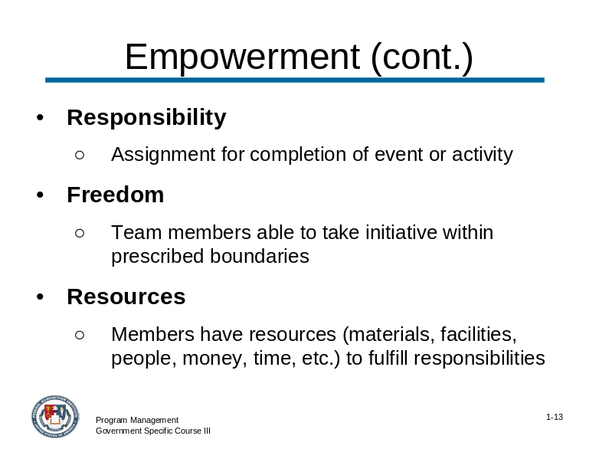 | Slide # 1-13

CONTENT TO BE PRESENTED:
Key Points:
Continuing, some more core components of empowerment include:
- Responsibility. Assignment for completion of a specific event or activity.
- Freedom. Team members must be able to take the initiative within prescribed boundaries in alignment with organizational/team direction to accomplish a task.
- Resources. Team members need the resources (materials, facilities, people, money, time, etc.) to carry out their responsibilities.

Topic 2: Foundation - Effective Senior/Expert Level Program Management (continued)

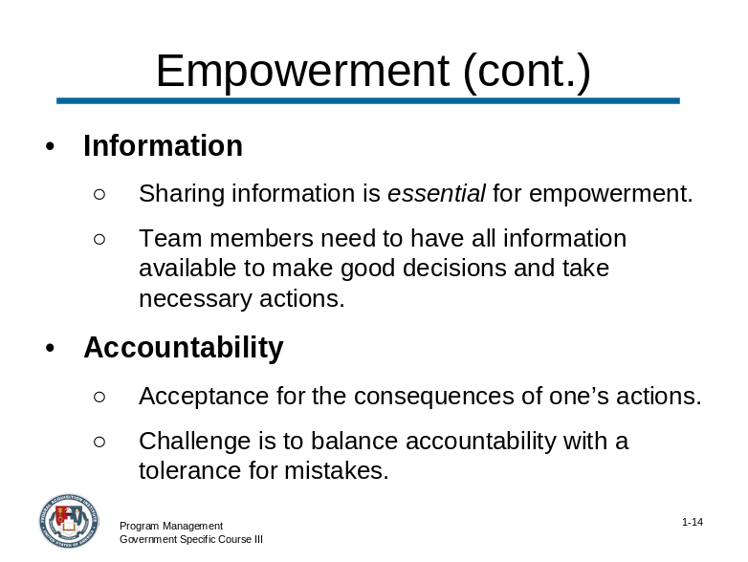 | Slide # 1-14

CONTENT TO BE PRESENTED:
Key Points:
Continuing, more core components of empowerment include:
- Information. Although it could be included under resources, it's important enough to list separately, because sharing information is essential for empowerment. Top levels of management/leadership cannot restrict information; doing so shows a lack of trust and confidence in the team members who need to have all of the information available to make good decisions and take the necessary actions.
- Accountability. Acceptance for the consequences of one’s actions. Management’s challenge is to balance accountability with a tolerance for mistakes.

Topic 2: Foundation - Effective Senior/Expert Level Program Management (continued)

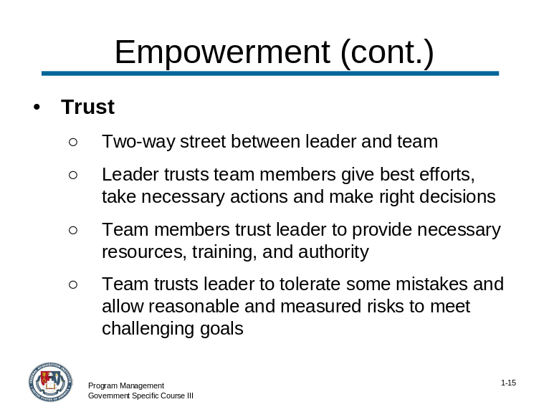 | Slide # 1-15

CONTENT TO BE PRESENTED:
Key Points:
Continuing, more core components of empowerment include:
- Trust. A two-way street between the leader and the team members.
  - Leaders must trust their team members to take the necessary actions and make the right decisions to meet their performance goals and objectives, while remaining within their boundaries and aligned with the organization's vision and mission. Leaders must also trust team members to give their best efforts.
  - Team members must trust the leader to provide the necessary resources, training, and authority so they can perform effectively. They must also trust the leader to have some tolerance for mistakes, allowing them to take reasonable and measured risks to meet challenging goals.

Topic 2: Foundation - Effective Senior/Expert Level Program Management (continued)

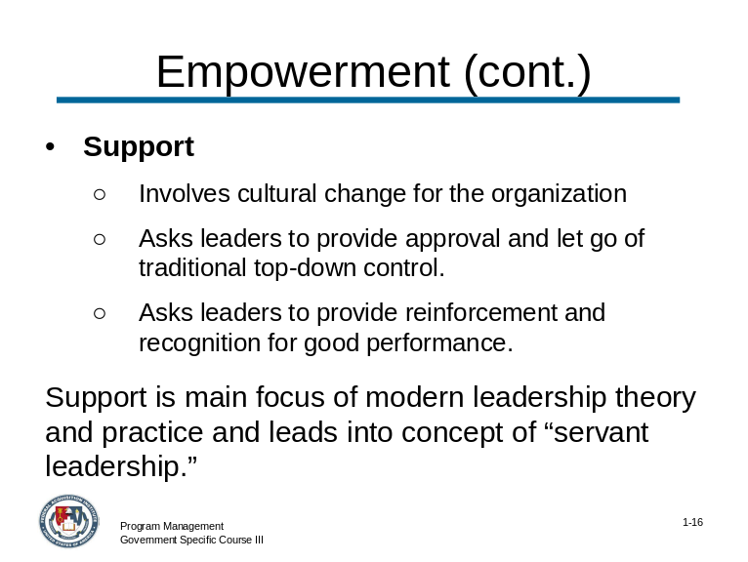 | Slide # 1-16

CONTENT TO BE PRESENTED:
Key Points:
Finally, the last core component of empowerment includes:
- Support. Empowerment involves a cultural change for the organization. Leaders must provide their approval and let go of their traditional top-down control. They also need to provide reinforcement and recognition for good performance.
Support is the main focus of modern day leadership theory and practice. From “support” you can lead to the concept of Servant Leadership.
Let’s discuss Servant Leadership in a little more detail. – it is really about the phrase -- “What can I do to help?”

Topic 2: Foundation - Effective Senior/Expert Level Program Management (continued)

CONTENT TO BE PRESENTED:
Key Points:
- Unlike leadership approaches with a top-down hierarchical style, Servant Leadership instead emphasizes collaboration, trust, empathy, and the ethical use of power.
- At the heart, the individual is a servant first, making the conscious decision to lead in order to better serve others, not to increase their own power.
- The objective is to enhance the growth of individuals in the organization and increase teamwork and personal involvement.

CONTENT TO BE PRESENTED:
Key Points:
The phrase “Servant Leadership” was coined by Robert K. Greenleaf in The Servant as Leader, an essay that he first published in 1970. In that essay, he said:
- "The servant-leader is servant first… It begins with the natural feeling that one wants to serve, to serve first. Then conscious choice brings one to aspire to lead.
- That person is sharply different from one who is leader first, perhaps because of the need to assuage an unusual power drive or to acquire material possessions…
- The leader-first and the servant-first are two extreme types. Between them there are shadings and blends that are part of the infinite variety of human nature."

Topic 2: Foundation - Effective Senior/Expert Level Program Management (continued)

CONTENT TO BE PRESENTED:
Key Points:
"The difference manifests itself in the care taken by the servant-first to make sure that other people’s highest priority needs are being served.
The best test, and difficult to administer, is:
Do those served grow as persons?
Do they, while being served, become healthier, wiser, freer, more autonomous, more likely themselves to become servants?
And, what is the effect on the least privileged in society? Will they benefit or at least not be further deprived?"

CONTENT TO BE PRESENTED:
Key Points:
In your participant guide, there is a link to a short summary of the 10 Principles of Servant Leadership – as defined by Larry Spears, CEO of the Greenleaf Center.

Instructor Notes:
A list of the 10 principles is provided on the next two pages along with the link. Tell the participants that this information is a good resource, review it briefly and then move on.

Topic 2: Foundation - Effective Senior/Expert Level Program Management (continued)

1. Listening
Traditionally, leaders have been valued for their communication and decision making skills. Servant-leaders must reinforce these important skills by making a deep commitment to listening intently to others. Servant-leaders seek to identify and clarify the will of a group. They seek to listen receptively to what is being and said (and not said). Listening also encompasses getting in touch with one's inner voice, and seeking to understand what one's body, spirit, and mind are communicating.
2. Empathy
Servant-leaders strive to understand and empathize with others. People need to be accepted and recognized for their special and unique spirit. One must assume the good intentions of coworkers and not reject them as people, even when forced to reject their behavior or performance.
3. Healing
Learning to heal is a powerful force for transformation and integration. One of the great strengths of servant-leadership is the potential for healing one's self and others. In "The Servant as Leader", Greenleaf writes, "There is something subtle communicated to one who is being served and led if, implicit in the compact between the servant-leader and led is the understanding that the search for wholeness is something that they have."
4. Awareness
General awareness, and especially self-awareness, strengthens the servant-leader. Making a commitment to foster awareness can be scary--one never knows that one may discover! As Greenleaf observed, "Awareness is not a giver of solace - it's just the opposite. It disturbed. They are not seekers of solace. They have their own inner security."
5. Persuasion
Servant-leaders seek to convince others, rather than coerce compliance. This particular element offers one of the clearest distinctions between the traditional authoritarian model and that of servant-leadership. The servant-leader is effective at building consensus within groups.

Topic 2: Foundation - Effective Senior/Expert Level Program Management (continued)

6. Conceptualization
Servant-leaders seek to nurture their abilities to "dream great dreams." The ability to look at a problem (or an organization) from a conceptualizing perspective means that one must think beyond day-to-day realities. Servant-leaders must seek a delicate balance between conceptualization and day-to-day focus.
7. Foresight
Foresight is a characteristic that enables servant-leaders to understand lessons from the past, the realities of the present, and the likely consequence of a decision in the future. It is deeply rooted in the intuitive mind.
8. Stewardship
Robert Greenleaf's view of all institutions was one in which CEO's, staff, directors, and trustees all play significance roles in holding their institutions in trust for the great good of society.
9. Commitment to the Growth of People
Servant-leaders believe that people have an intrinsic value beyond their tangible contributions as workers. As such, Servant-leaders are deeply committed to a personal, professional, and spiritual growth of each and every individual within the organization.
10. Building Community
Servant-leaders are aware that the shift from local communities to large institutions as the primary shaper of human lives has changed our perceptions and caused a sense of loss. Servant-leaders seek to identify a means for building community among those who work within a given institution.

Topic 2: Foundation - Effective Senior/Expert Level Program Management (continued)

CONTENT TO BE PRESENTED:
Key Points:
Let’s talk about the roles and responsibilities of program managers. One of the key responsibilities is the ability to convert a business strategy into new products and services by successfully managing project performing product development.
This responsibility requires program managers to have a broader role than their project manager counterparts, and needs to possess a larger range of skills and competencies.

Three key roles include:
- Managing the “business” of the department/agency
- Leading the project team(s)
- Assuring and sustaining benefits by adjusting the scope and mix of the projects within the program

CONTENT TO BE PRESENTED:
Key Points:
The program manager, in many cases, manages multiple on-going projects that can be interdependent or independent projects.
He/she must emphasize coordination and prioritization of resources across projects, departments and even agencies.
Program managers, in collaboration with other key stakeholders, can be responsible for establishing program goals for cost, for customer support and performance parameters over the life cycle of a program or project(s).

Topic 2: Foundation - Effective Senior/Expert Level Program Management (continued)

CONTENT TO BE PRESENTED:
Key Points:
Some additional functions of a program manager:
- Oversee and direct in conjunction with the project manager, development of business requirements, specifications, and project design and development
- Administer the identification of the technical approach to be used
- Monitor the project requirements including time, risk, and cost

CONTENT TO BE PRESENTED:
Key Points:
Professional Development skills are essential in the role as a program manager. It is rare for a program manager to have the role and be totally qualified to fulfill all aspects of such a broad and encompassing responsibility.

The successful program manager is constantly seeking to learn and broaden his/her experience in order to take on more complex and critical programs.
This module will briefly discuss many leadership skills that can enhance your role as a program manager.
As we are reviewing these skills, please feel free to expand on any of these skills as they may relate to your experience as a program manager.

Topic 2: Foundation - Effective Senior/Expert Level Program Management (continued)

Instructor Notes:
This concludes the topic on the Foundation for Effective Senior/Expert Level Program Management. After addressing any questions the participants may have, inform them that we will be moving on to the next topic: Reviewing Leadership/Professional Skills.

What questions do you have regarding the foundation for effective senior/expert level program management?

Topic 3: Review of Leadership/Professional Skills

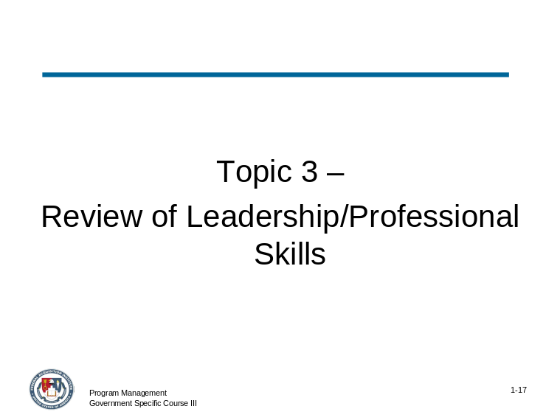 | Slide # 1-17

Instructor Notes:
What follows is a review of key leadership skills. They are organized into “What You Need to Know” segments, which include the most important aspects of each skill.
Because of the length of the module, do not spend too much time on these concepts, but do answer any questions the participants may have regarding them or if there is an interest in one or more skills, spend some time discussing that skill with the participants.

Topic 3: Review of Leadership/Professional Skills (continued)

CONTENT TO BE PRESENTED:
Key Points:
Effectively using empowerment as a leadership strategy for teams requires that you also have a solid command of other leadership and professional skills an effective senior/expert program manager possesses.
What follows is an overview of additional leadership professional skills.

Topic 3: Review of Core Leadership/Professional Skills (continued)

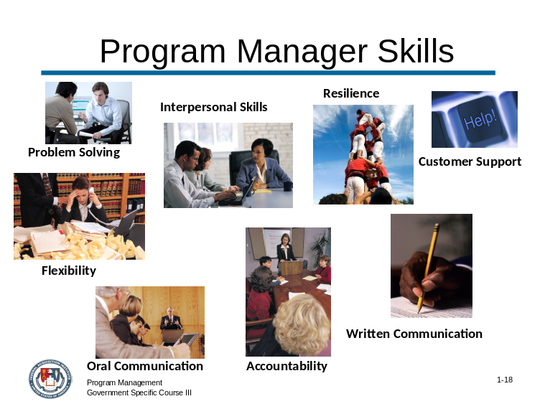 | Slide # 1-18

CONTENT TO BE PRESENTED:
Key Points:
Tell the participants that the information on this slide is from the Project Management Course I.
- Problem Solving is the ability to:
  - Identify and analyze problems.
  - Distinguish between relevant and irrelevant information to make logical decisions.
  - Provide solutions to individual and organizational problems.
- Interpersonal Skills include:
  - Consider and respond appropriately to the needs, feelings, and capabilities of different people in different situations.
  - Be tactful, compassionate and sensitive.
  - Treat others with respect.

Topic 3: Review of Core Leadership/Professional Skills (continued)

Slide # 1-18 (continued)

CONTENT TO BE PRESENTED:
Key Points:
- Resilience means:
  - Dealing effectively with pressure
  - Recovering quickly from setbacks.
  - Maintaining focus and intensity and remaining optimistic and persistent, even under adversity.
- Flexibility means:
  - Being open to change and new information.
  - Adapting behavior and work methods in response to new information, changing conditions, or unexpected obstacles.
  - Adjusting rapidly to new situations warranting attention and resolution.

Topic 3: Review of Core Leadership/Professional Skills (continued)

Slide # 1-18 (continued)

CONTENT TO BE PRESENTED:
Key Points:
- Accountability means that you:
  - Hold yourself and others accountable for rules and responsibilities.
  - Can be relied upon to ensure that projects within areas of specific responsibility are completed in a timely manner and within budget.
  - Monitors and evaluates plans and focuses on results.
- Written Communication skills entail:
  - Expressing facts and ideas in writing in a succinct and organized manner.

Topic 3: Review of Core Leadership/Professional Skills (continued)

Slide # 1-18 (continued)

CONTENT TO BE PRESENTED:
Key Points:
- Customer Service means:
  - Readily readjusting priorities to respond to pressing and changing client demands.
  - Anticipating and meeting the needs of clients.
- Oral Communication skills mean you:
  - Make clear and convincing oral presentations to individuals or groups.
  - Listen effectively and clarify information as needed.
  - Facilitate an open exchange of ideas and foster an atmosphere of open communication.

Topic 3: Review of Core Leadership/Professional Skills (continued)

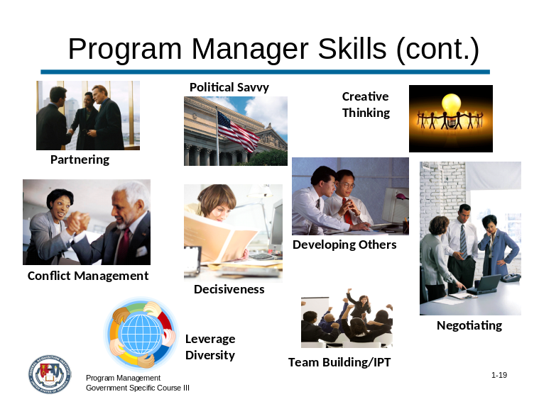 | Slide # 1-19

CONTENT TO BE PRESENTED:
Key Points:
Tell the participants that the information on this side comes from the Program/Project Management Course II.
- Partnering means:
  - Develop networks and builds alliances by collaborating across boundaries.
  - Engage in cross-functional activities.
  - Utilize contacts to build and strengthen internal support bases.

Topic 3: Review of Core Leadership/Professional Skills (continued)

Slide # 1-19 (continued)

CONTENT TO BE PRESENTED:
Key Points:
Tell the participants that the information on this side comes from the Program/Project Management Course II.
- Teambuilding / Integrated Product Team (IPT) occurs when the program manager:
  - Inspires, motivates, and develops leadership in others.
  - Guides others toward goal accomplishments by fostering commitment, team spirit, pride, trust.
  - Consistently develops and sustains cooperative working relationships.
  - Encourages and facilitates cooperation within the agency and customer groups.

Topic 3: Review of Core Leadership/Professional Skills (continued)

Slide # 1-19 (continued)

CONTENT TO BE PRESENTED:
Key Points:
- Conflict Management is the management of conflicts, not the resolution of them. The goal is not for the conflict to be resolved, but instead to be gotten past.
  - Conflict can occur on any department within any agency.
  - Is usually the result of conflicting objectives.
  - The program manager is a “Conflict Manager.”
- “Political savvy” in the workplace represents the totality of skills for successfully navigating the political dynamics of an agency to accomplish one’s goals.
  - Identify the internal and external politics that impact the work of the agency.
  - Approach each problem with a clear perception of agency and political reality.
  - Recognize the impact of alternative courses of action.

Topic 3: Review of Core Leadership/Professional Skills (continued)

Slide # 1-19 (continued)

CONTENT TO BE PRESENTED:
Key Points:
- Decisiveness means that the program manager:
  - Is proactive and achievement oriented, and exercises good judgment by making sound and well-informed decisions, and perceives the implications of decisions.
  - Makes effective and timely decisions, even when data are limited or solutions produce unpleasant consequences.
  - Demonstrates confidence in abilities and decisions - tackles issues in timely way
- Creativity Thinking (Innovation) describes program manager behaviors such as:
  - Develops new insights into situations.
  - Encourages new ideas and innovations.
  - Designs and implements new or cutting edge programs/processes.

Topic 3: Review of Core Leadership/Professional Skills (continued)

Slide # 1-19 (continued)

CONTENT TO BE PRESENTED:
Key Points:
- Developing Others means that the program manager develops the ability of others to perform and contribute to the agency by providing ongoing feedback and by providing opportunities to learn through formal and informal methods.
- The successful program manager can Leverage Diversity by:
  - Recruits, develops, and retains a diverse high quality workforce in an equitable manner.
  - Leads and manages an inclusive workplace that maximizes the talents of each person to achieve sound business results.
  - Respects, understands, values and seeks out individual differences to achieve the vision and mission of the agency.
  - Develops and uses measures and rewards to hold self and others accountable for achieving results that embody the principles of diversity.

Topic 3: Review of Core Leadership/Professional Skills (continued)

Slide # 1-19 (continued)

CONTENT TO BE PRESENTED:
Key Points:
- Finally, the successful program manager demonstrates the ability to Influence / Negotiate by demonstrating the successful actions described below:
  - Persuades others.
  - Builds consensus through give and take.
  - Gains cooperation from others to obtain information and accomplish goals.
  - Facilitates "win-win" situations.

Topic 3: Review of Core Leadership/Professional Skills (continued)

CONTENT TO BE PRESENTED:
Key Points:
The key leadership skills that were just reviewed all contribute to the program manager’s ability to successfully leverage people and business processes involved in an acquisition strategy.
However, there are some additional competencies that a successful program manager in a senior level or an expert role will have mastered.
These competencies incorporate professional skills and combine them with additional, higher-level project management perspectives and concerns to ultimately develop the most effective and positively performing projects and acquisitions.

Topic 3: Review of Core Leadership/Professional Skills (continued)

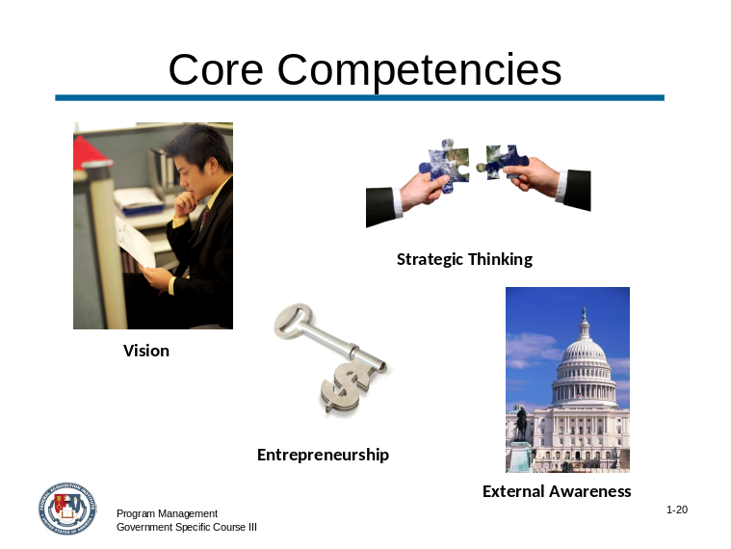 | Slide # 1-20

CONTENT TO BE PRESENTED:
Key Points:
- Strategic Thinking means that, as the program manager, you:
  - Determine objectives, set priorities, and formulate effective strategies.
  - Examine policy issues and strategic planning with a long-term perspective.
  - Anticipate potential threats and seize potential opportunities.
- The program manager with strong External Awareness:
  - Identifies and keeps up-to-date on key national and international policies and economic, political and social trends that affect the agency.
  - Understands near-term and long range plans.
  - Positions his/her program for achievement.

Topic 3: Review of Core Leadership/Professional Skills (continued)

Slide # 1-20 (continued)

CONTENT TO BE PRESENTED:
Key Points:
- Entrepreneurship for the program manager entails:
  - Identifying opportunities to develop and market new products and services within or outside of the agency.
  - Is willing to take risks, initiates actions that involve a deliberate risk to achieve a recognized benefit or advantage.
- Program managers have Vision that consists of:
  - Sharing a dream and direction that other people want to share and follow.
  - Permeating the workplace and is manifested in the actions, beliefs, values and goals of your organization’s leaders
  - Believing in the goals and the mission of the agency.

Topic 3: Review of Core Leadership/Professional Skills (continued)

Instructor Notes:
This concludes the topic on the Review of Core Leadership/Professional Skills. After addressing any questions the participants may have, inform them that we will be moving on to the next topic: Vision.

What questions do you have regarding the review of core leadership/professional skills?

Topic 4: Vision

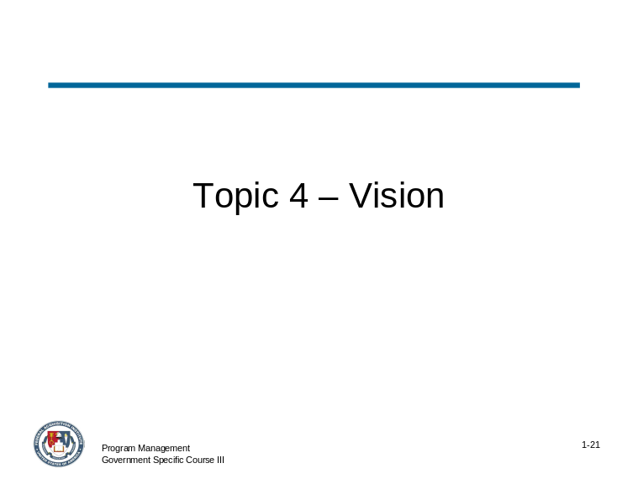 | Slide # 1-21

CONTENT TO BE PRESENTED:
Key Points:
The ability to effectively use the vision competency refers to an individual’s ability to take a long-term view and build a shared vision with others.
Vision acts as a catalyst for organizational change, and when properly communicated can influence others to translate the vision into action.

Topic 4: Vision (continued)

CONTENT TO BE PRESENTED:
Key Points:
The following quote about vision demonstrates its importance as a critical leadership competency.
"The very essence of leadership is that you have to have a vision. It's got to be a vision you articulate clearly and forcefully on every occasion."
Theodore Hesburgh, President of the University of Notre Dame

Topic 4: Vision (continued)

Activity
Activity Purpose:
Conduct a class discussion about how we perceive great leaders’ use of vision to achieve success.
Activity Length: 15-20 minutes
Activity Instructions:
This is an activity for the class as a whole. Ask for two volunteers in the class to share the name of the leader that they felt provides a good role of a leader with a “vision”.
Note: As part of the pre-work, participants were requested to bring to class the name of a leader that they feel exemplifies valuable leadership skills.
Ask the question on the following page to generate a discussion about how the participants perceive great leaders’ use of vision to achieve successes. Use the questions provided below to facilitate a general discussion about how participants perceive the creation and communication of vision as critical to the different leaders’ successes:
- What was this leader’s vision?
- How was this leader’s vision communicated?
- What results did his/her vision achieve?
- How does this relate to your role as a leader with your acquisition teams?
Discuss participant responses, making sure to summarize the discussion into the key points about vision as provided in the answer that follows.

Topic 4: Vision (continued)

Activity (continued)
How would you describe your leader’s vision?
Answer:
There is no “right or wrong” answer for this discussion question. Use the examples of leaders and their visions to help facilitate the key points about the link between effective leadership and the vision competency. An example has been provided below as a reference, too.
The key points about how good leaders use vision include:
- Views problems/issues/challenges as opportunities
- Priority setting
- “Customer” focused (relating “customer” to whomever the leader considers primary in his/her vision)
- Courageous
- Critical and creative thinker
- Tolerance for ambiguity
- Positive attitude towards change
- Committed to innovations in the world, business, etc.

John F. Kennedy did not live to see the achievement of his vision for National Air and Space Administration (NASA), but he set it in motion when he said, "By the end of the decade, we will put a man on the moon." That night, when the moon came out, Americans could all look out the window and imagine.
When it came time to appropriate the enormous funds necessary to accomplish this vision, Congress did not hesitate. Why? Because this vision spoke powerfully to values Americans held dear: America as a pioneer and America as world leader.

Topic 4: Vision (continued)

CONTENT TO BE PRESENTED:
Key Points:
It is important to note that there is a difference between vision as it relates to management and leadership:
- Managerial Vision motivates performance improvement. It is not leadership – it is implementation.
- Visionary Leadership articulates an inspiring picture of what an organization can become in a way that is meaningful to organization members.
  - It points towards a change in direction or difference in “the way it has always been done”, and hence provides leadership.
  - A vision dramatizes new directions that others might not buy into otherwise.

CONTENT TO BE PRESENTED:
Key Points:
Burt Nanus, a well-known expert on the subject of vision, defines it as a realistic, credible, attractive future for an organization.
- Realistic: A vision must be based in reality to be meaningful for an organization. For example, if you are developing a vision for a computer software company that has carved out a small niche in the market developing instructional software and has a 1.5 % share of the computer software market, a vision to overtake Microsoft and dominate the software market is not realistic!
- Credible: A vision must be believable to be relevant. It must be credible to the team members of the organization. If the team members do not find the vision credible, it will not be meaningful or serve a useful purpose. One of the purposes of a vision is to inspire those in the organization to achieve a level of excellence, and to provide purpose and direction for the work of those members.

Topic 4: Vision (continued)

CONTENT TO BE PRESENTED:
Key Points:
- Attractive: If a vision is going to inspire and motivate those in the organization, it must be attractive. People must want to be part of this future that's envisioned for the acquisition.
- Future: A vision is not in the present, it is in the future. A vision is not where you are now; it's where you want to be in the future. If you reach or attain a vision, and it's no longer in the future, but in the present, is it still a vision?
There are key properties that serve as guidelines for creating a realistic, credible, attractive future for an acquisition that can be communicated as part of the teambuilding process.

CONTENT TO BE PRESENTED:
Key Points:
Here are some properties that describe a good vision.
- A good vision is a mental model of a future state. It involves thinking about the future, and modeling possible future states. A vision does not exist in the present however, if it is a good mental model, it shows the way to identify goals and how to plan to achieve them.
- A good vision is idealistic. How can a vision be realistic and idealistic at the same time? One way of reconciling these apparently contradictory properties of a vision is that the vision is realistic enough so that people believe it is achievable, but idealistic enough so that it cannot be achieved without stretching.
  - If it is too easily achievable, it will not set a standard of excellence, nor will it motivate people to want to work toward it.
  - On the other hand, if it is too idealistic, it may be perceived as beyond the reach of those in the organization, and discourage motivation.

Topic 4: Vision (continued)

CONTENT TO BE PRESENTED:
Key Points:
Properties of a good vision: (continued)
- A good vision is appropriate for the acquisition (program) and for the times. A vision must be consistent with the team’s values and culture, and its place in its environment. It must also be realistic.
- A good vision sets standards of excellence and reflects high ideals. Generally, the vision should reflect measurable standards of excellence and a high level of aspiration.
- A good vision clarifies purpose and direction. In defining that "realistic, credible, attractive future for an organization," a vision provides the rationale for both the mission and the goals the team should pursue.
- A good vision inspires enthusiasm and encourages commitment. An inspiring vision can help people in an organization get excited about what they're doing, and increase their commitment to the program goals.

Topic 4: Vision (continued)

CONTENT TO BE PRESENTED:
Key Points:
Properties of a good vision: (continued)
- A good vision is well articulated and easily understood. In order to motivate individuals, and clearly point toward the future, a vision must be articulated so people understand it. Most often, this will be in the form of a vision statement. There are dangers in being too terse, or too long-winded.
  - A vision must be more than a slogan or a "bumper sticker." Slogans such as Ford Motor Company's "Quality Is Job One" are good marketing tools, but the slogan doesn't capture all the essential elements of a vision.
  - On the other hand, a vision made up of a long document that belabors the acquisition philosophy and lays out its strategic plan is too complex to be a vision statement. The key is to strike a balance.

CONTENT TO BE PRESENTED:
Key Points:
Properties of a good vision: (continued)
- A good vision reflects the uniqueness of the team organization, its distinctive competence, what it stands for, and what it is able to achieve. This is where the program manager needs to ask him/herself, "What is it that sets this team apart from others in our area of business?" Focus your vision there.
- A good vision is ambitious. It must not be commonplace and should be truly extraordinary. This property gets back to the idea of a vision that causes people and the team organization to stretch. A good vision pushes the organization to a higher standard of excellence, challenging its members to try and achieve a level of performance they haven't achieved before.

Topic 4: Vision (continued)

Activity
Activity Purpose:
This activity provides participants with an opportunity to apply the key properties of a good vision through the development of a written vision for an acquisition of services.
Activity Length: 25 minutes
Activity Instructions:
- Allow participants 5 minutes to individually read the US West Acquisition Vision Case Study (displayed on the next page). Participants should read the content and create a written vision for the IPT they are leading for this program.
- Ask for volunteers to share their visions for the program with the whole group.
  - Where possible, relate the visions to the key properties of a good vision as described in this topic, e.g., mental model, idealistic,etc.
  - When necessary, discuss vision statements that do not conform to the key properties of a good vision and explain why.
- Continue this process as time allows. If possible, all participants should share their vision for the program with the whole group.
Note: An example of a vision for this program is found in the Key Findings on the page following the case study in this Instructor Guide.

Topic 4: Vision (continued)
US West Acquisition Strategic Thinking Case Study
You are the program manager for the following acquisition of services contract. What would you imagine as the vision for this program, and how would you communicate that vision to your team?
US WEST announced it has been awarded a Metropolitan Area Acquisition (MAA) award from the U.S. General Services Administration's (GSA) Federal Technology Service (FTS) for the cities and surrounding metropolitan area of Minneapolis and St. Paul, Minn. The contract, awarded to US WEST and Winstar Communications, has an estimated value of $160 million.
Under the multi-year contract, US WEST will provide government agencies with standard voice services, including Centrex, Business Line, PBX Access Trunks, Key System Access, Private Line and ISDN services, as well as switched data service and dedicated transmission service offerings at competitive rates to government agencies in Minneapolis and St. Paul.
The MAA program is envisioned to be the government's tool for achieving the immediate benefits, such as price reduction and better services, from the emerging competitive local telecommunications market.
US WEST was awarded the contract after a competitive bid based on several criteria of the MAA Program, including its ability to provide the services and its past history of successful deployments. Winning the MAA contract affords US WEST the opportunity to expand its services for GSA to include new, high-speed services as they become available, bid for other GSA contracts and to potentially offer FTS2001 long distance services nationally.
Through the contract, US WEST will offer new local service prices that will result in substantial cost savings for the government, when compared with standard business rates.

Topic 4: Vision (continued)

Activity (continued)
Answer:
An example of one vision for the IPT is found below. This is not an “absolute” example; participants will develop many variations that can be equally appropriate.
We will manage the services acquisition between the GSA FTS and U S West in a way that results in an immediately noticeable synergy of services for the greater Minneapolis metropolitan area. This synergy will be established through the unprecendented roll out of services to all affected government users in a six month timeframe with no interruption, no loss of functionality, and an immediate and measurable reduction in the cost of services.
The key properties of a good vision that this example illustrates include:
- Mental model of a future state
- Idealistic and realistic
- Standards of excellence
- Establishes purpose and direction
- Encourages commitment
- Well articulated and easily understood
- Inspirational
- Recognizes distinctive competence of the team
- Ambitious
- Achievable

Topic 4: Vision (continued)

CONTENT TO BE PRESENTED:
Key Points:
Understanding the various elements and properties of effective visions for programs is not enough.
Senior level and expert program managers must possess the ability to develop and articulate a vision for the program as part of the overall acquisition strategy.
This ability is part of the larger strategic planning process for the program which also includes elements of entrepreneurship, external awareness and strategic thinking competencies, which will be discussed as part of this module.

Topic 4: Vision (continued)

Instructor Notes:
This concludes the topic on Vision. After addressing any questions the participants may have, inform them that we will be moving on to the next topic: Entrepreneurship.

What questions do you have regarding vision as a leadership skill?

Topic 5: Entrepreneurship

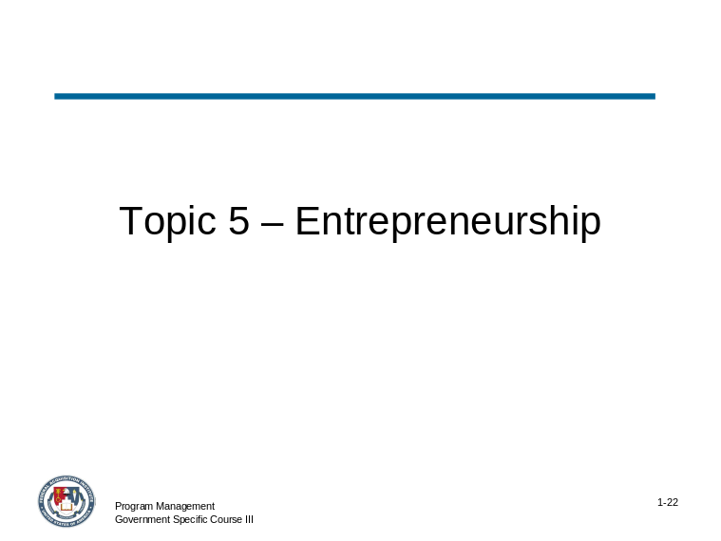 | Slide # 1-22

CONTENT TO BE PRESENTED:
Key Points:
Entrepreneurship positions the team organization for future success by identifying new opportunities, and builds the organization by developing or improving products or services.
Program managers who effectively employ the entrepreneurship competency routinely take calculated risks to accomplish the acquisition strategy objectives.

Topic 5: Entrepreneurship (continued)

CONTENT TO BE PRESENTED:
Key Points:
It is important to consider the term, intrapreneurship, when discussing entrepreneurship. What is intrapreneurship?
- American Heritage Dictionary brought intrapreneurism into the main stream by adding intrapreneur to its dictionary.
- Defined as "a person within a large corporation who takes direct responsibility for turning an idea into a profitable finished product through assertive risk-taking and innovation"
- Can help to find new products and markets for established businesses
- Intrapreneurship is a concept here to stay.

CONTENT TO BE PRESENTED:
Key Points:
Research on entrepreneurship has defined entrepreneurship in two ways: the entrepreneurial organization and entrepreneurial people.
In studying entrepreneurial people and their work flow leadership, Sayles and Stewart (1995) defined entrepreneurship as having three components:
- It is activity that seizes profit and/or improvement opportunities without regard to resources currently controlled.
- It expands existing resources through enhanced learning, synergies, or “bootstrapping.”
- It promotes change and innovation leading to new combinations of resources and new ways of doing business.

Topic 5: Entrepreneurship (continued)

Instructor Notes:
Ask the following question to define “bootstrapping” as it relates to entrepreneurial leadership. Discuss participant responses.

How would you define “bootstrapping?”
Answer:
The term “bootstrapping” refers to the ability of a leader to turn a lack of resources into a competitive advantage.

CONTENT TO BE PRESENTED:
Key Points:
Entrepreneurial people take advantage of opportunities to acquire added value. This definition sees entrepreneurship as a behavioral characteristic of managers and team members in an organization, not as a characteristic of the team itself.
Stevenson, Roberts, and Grousbeck (1989) argued that entrepreneurship is an approach to management. They distinguished between "promoters," individuals whose strategic direction is driven by the perception of opportunity, and "trustees," who are driven by the resources they currently control.
One could argue from this that "promoters" are actually leaders while "trustees" are managers.

Topic 5: Entrepreneurship (continued)

CONTENT TO BE PRESENTED:
Key Points:
In general terms, you can associate entrepreneurs with leadership functions such as providing vision to the development of a new product, service, or organization.
It has been written that entrepreneurial leadership deals with concepts and ideas, and these are often related to problems that are not of an organizational nature (El-Namaki, 1992). Instead, they tend to be individual characteristics or behaviors. These include vision, problem solving, decision-making, risk taking, and strategic initiatives.
Each of those characteristics and behaviors is discussed as they relate to entrepreneurial leadership.

CONTENT TO BE PRESENTED:
Key Points:
Vision
As discussed in the previous topic, a leader’s ability to articulate a vision to his/her team for the acquisition program is an essential competency.
- Role of vision in the strategic management process and the possible relationship between vision and creativity, leadership, and entrepreneurship has been given validation in recent years.
  - Vision is formulated by explicitly identifying a domain for competitive behavior, a set of sources of competitive strength, and a profile for resource capability.
  - Vision implies a capability construct. This capability construct is determined by many factors including managerial vision, competence and capacity, logistic and technological profiles, as well as the financial resource access of the acquisition.
- Good vision is realistic and feasible. It provides a challenge for the whole team organization and mirrors the goals of its constituents.
- Visions fail from fear of mistakes, inability to handle ambiguity, and lack of challenge.

Topic 5: Entrepreneurship (continued)

CONTENT TO BE PRESENTED:
Key Points:
Problem Solving
- Effective leadership must solve, or face, problems quickly and forcefully, regardless of their nature.
  - Task-oriented leadership gets best results with purely technical, fact-based problems.
  - Consideration-oriented leadership copes more effectively with emotional, personal, and interpersonal problems.

CONTENT TO BE PRESENTED:
Key Points:
Decision Making
- Entrepreneurial leaders are more likely to seek assistance from subordinates in solving problems than when making decisions.
- As a general rule, whether leaders are directive or supportive, they know they must make decisions that commit the organization to critical actions.
  - If a leader avoids this responsibility, subordinates will poorly judge him or her and the team will suffer accordingly.

Topic 5: Entrepreneurship (continued)

CONTENT TO BE PRESENTED:
Key Points:
Risk Taking
- Balancing risk is a necessity of entrepreneurial leadership.
- Leaders must weigh the multitudinous factors involved, while understanding that no one can predict the future with certainty. Inability to deal with uncertainty precludes the team organization from achieving its goals.
Strategic Initiatives
- Entrepreneurial leaders must have a vision and a plan for beyond a year or two (dependent upon the acquisition program life cycle) in order to achieve long term success.

CONTENT TO BE PRESENTED:
Key Points:
The general agreement is that a leader influences others toward the attainment of a vision and goals (Zaleznik, 1990; Stoner, 1995).
A successful entrepreneur, likewise, influences those who can help achieve a desired goal or vision relative to the acquisition strategy of a product or service.

Topic 5: Entrepreneurship (continued)

Activity
Activity Purpose:
This activity provides participants with an opportunity to apply entrepreneurship as it relates to leadership.
Activity Length: 15 minutes
Activity Instructions:
- Allow participants 5 minutes to individually read the Warren Buffett Entrepreneurship Scenario (displayed on the next page).
- Participants should read the content and answer the following series of questions about Warren Buffett’s entrepreneurship:
  - Why did Warren start his first business? How do the reasons for a business start up relate to your role as a program manager?
  - How did he finance his start-up? How is the use of other investors’ money similar to managing the funds budgeted for a program?
  - What are the characteristics of the typical entrepreneur, e.g., those of Warren Buffett? Which of these characteristics would be valuable to a program manager, and why?
  - What strategies contribute to the survival and profitability of new businesses over time? How do these survival and profitability strategies compare to those of program management?
- Ask for volunteers to share their responses with the whole group. Note that there are no “right and wrong” answers – these questions are designed to stimulate creative and original thought as it relates to leadership as a program manager and how entrepreneurship tendencies can facilitate a program’s effectiveness.
- Continue this process as time allows.

Warren Buffett Entrepreneurship Scenario
Warren Buffet is the 77 year old CEO of Bershire Hathway, Inc. He is regarded by many to be one of the world’s greatest investors. He is well known for his investing style of “value vesting”. Buffet is a simple, honest man who possesses an intellectual genius in making rapid decisions and is able to decide on major purchases with just a few days of research and analysis.
Buffet’s company consists of variety of businesses that range from utilties to jewelry with half of his profits from insurance companies. His first investment started with $100 of his own money and $105,000 he borrowed from family and friends. Within a year, he was managing five investment partnerships.
“I just read. I read all day. I mean, we put $500 million in PetroChina. All I did was read the annual report.”
Warren Buffet

Topic 5: Entrepreneurship (continued)

Instructor Notes:
This concludes the topic on Entrepreneurship. After addressing any questions the participants may have, inform them that we will be moving on to the next topic: External Awareness.

What questions do you have regarding entrepreneurship as a leadership skill?

Topic 6: External Awareness

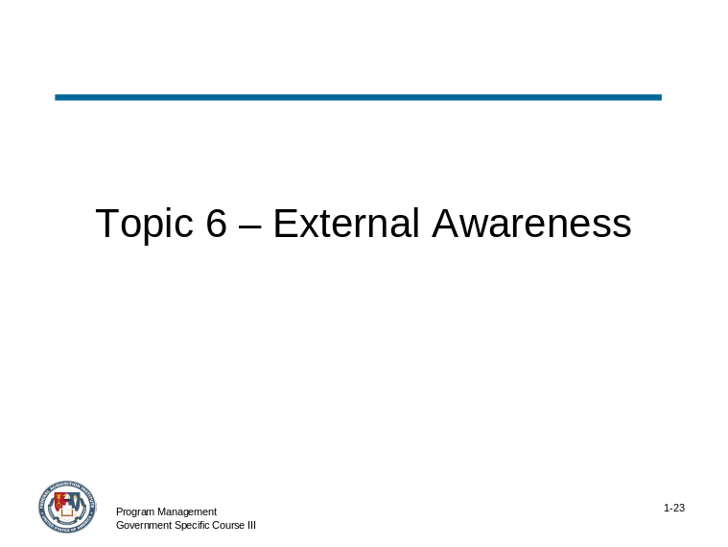 | Slide # 1-23

CONTENT TO BE PRESENTED:
Key Points:
The external awareness competency of expert/senior level program managers is defined as the ability to understand and keep up-to-date on local, national, and international policies and trends that affect the organization and shape stakeholders' views.
An externally aware leader is aware of the organization's impact on the external environment.
External awareness, sometimes referred to as “relational awareness,” also relates to a leader’s ability increase his or her bandwidth in a leadership role on a personal level.
External awareness provides the program manager with an additional competency that contributes toward his/her ability to think strategically about the acquisition.

Topic 6: External Awareness (continued)

Instructor Notes:
Ask the following question to define “bandwidth” as it relates to leadership. Discuss participant responses.

How would you define “bandwidth?”
Answer:
Bandwidth is the capacity a leader and the team members have to get things done. As friction and stress in the working relationships are removed, bandwidth increases.
High bandwidth leadership occurs when everything comes together, and teams are empowered, high performing and relating most effectively.

Topic 6: External Awareness (continued)

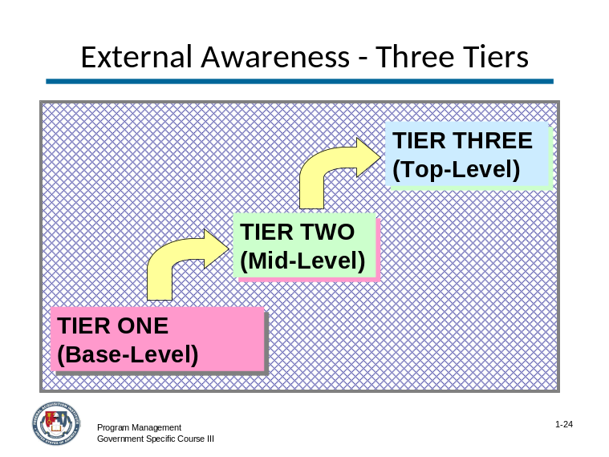 | Slide # 1-24

CONTENT TO BE PRESENTED:
Key Points:
- One leadership challenge is to access a natural real time relational awareness, an awareness of one's personal behavior and others' responses.
- Only when team leaders and members have identified the real nature of their working relationships, including the roles they and others play under stress, can they see how to change their approach, reducing friction and tension.
- Outside the personal relational awareness a leader must be aware of, the primary focus of the external awareness competency for the senior/expert level program manages.
- This focus is the ability to understand near-term and long range goals and determine how to best be positioned to achieve the vision established for the acquisition strategy.
- External awareness can be categorized in three “tiers” that evolve as a leader matures.

Topic 6: External Awareness (continued)

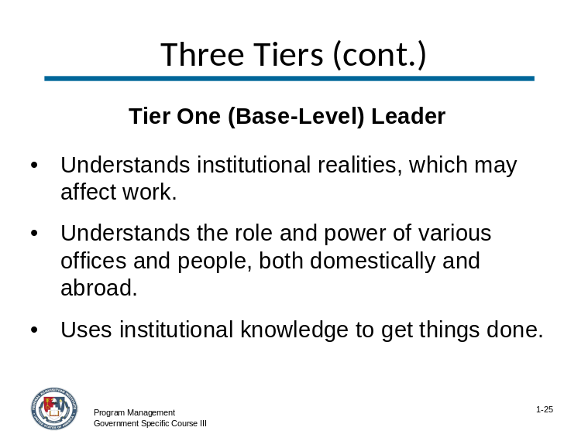 | Slide # 1-25

CONTENT TO BE PRESENTED:
Key Points:
The base or first-level tier can be described as a leader:
- Understands institutional realities, which may affect work.
- Understands the role and power of various offices and people, both domestically and abroad.
- Uses institutional knowledge to get things done.

Topic 6: External Awareness (continued)

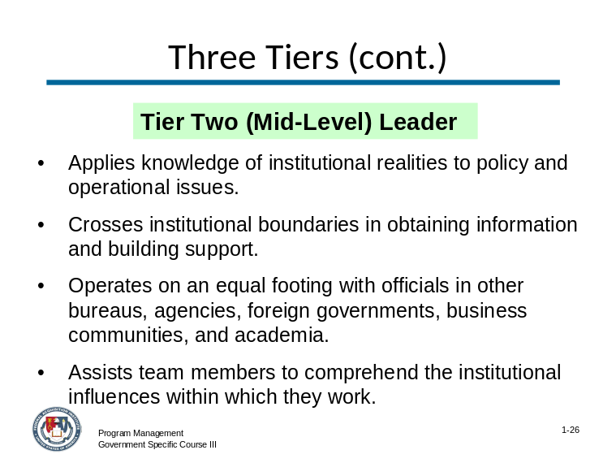 | Slide # 1-26

CONTENT TO BE PRESENTED:
Key Points:
The mid- or second-level tier can be described as a leader:
- Applies knowledge of institutional realities to policy and operational issues.
- Crosses institutional boundaries in obtaining information and building support.
- Operates on an equal footing with officials in other bureaus, agencies, foreign governments, business communities, and academia.
- Assists team members to comprehend the institutional influences within which they work.

Topic 6: External Awareness (continued)

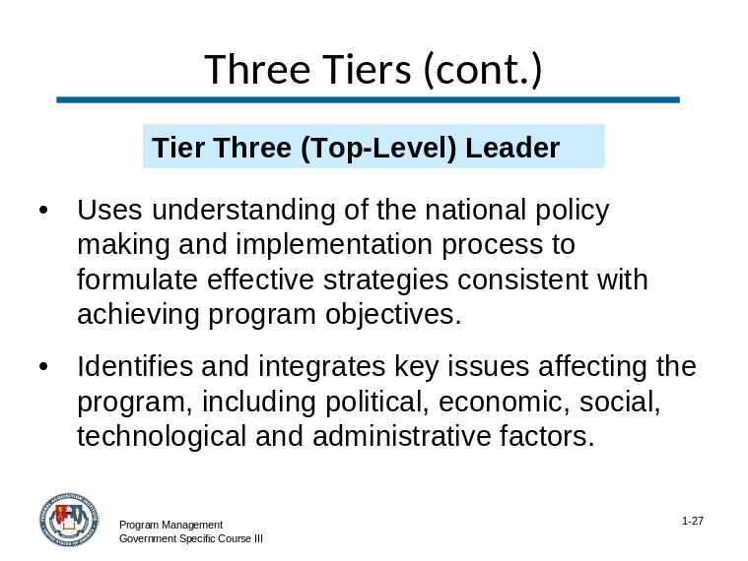 | Slide # 1-27

CONTENT TO BE PRESENTED:
Key Points:
The top or third-level tier can be described as a leader:
- Uses understanding of the national policy making and implementation process to formulate effective strategies consistent with achieving program objectives.
- Identifies and integrates key issues affecting the program, including political, economic, social, technological and administrative factors.

Topic 6: External Awareness (continued)

Activity
Activity Purpose:
This activity provides participants with an opportunity to apply external awareness as it relates to leadership.
Activity Length: 15-20 minutes
Activity Instructions:
(There are two options for an activity. Determine which one works with the participants.)
This is an activity for the class as a whole. Ask for two volunteers in the class to share the name of the leader that they felt provides a good role of a leader who may have utilized “external awareness”, based on the information just presented in this topic.
Note: As part of the pre-work, participants were requested to bring to class the name of a leader that they feel exemplifies valuable leadership skills.
OR
Ask for volunteers from the group to present an example within their own agency or can even be himself/herself on how they apply the skill of external awareness as part of their role as a program manager.
Lead a discussion and try to revert back to the three tiers of external awareness leaders. Ask questions such as:
- Which of the three tiers applies to this leader?
- Can a leader possess all of the characteristics of all of the tiers?
- Has this leader paved “new territory in the area of external awareness?
- What are some of the practices of this leader that shows that he/she uses external awareness effectively as a leader?
- How does external awareness relate to your role as a leader with your acquisition teams?

Topic 6: External Awareness (continued)

Instructor Notes:
This concludes the topic on External Awareness. After addressing any questions the participants may have, inform them that we will be moving on to the next topic: Strategic Thinking.

What questions do you have regarding external awareness as a leadership skill?

Topic 7: Strategic Thinking

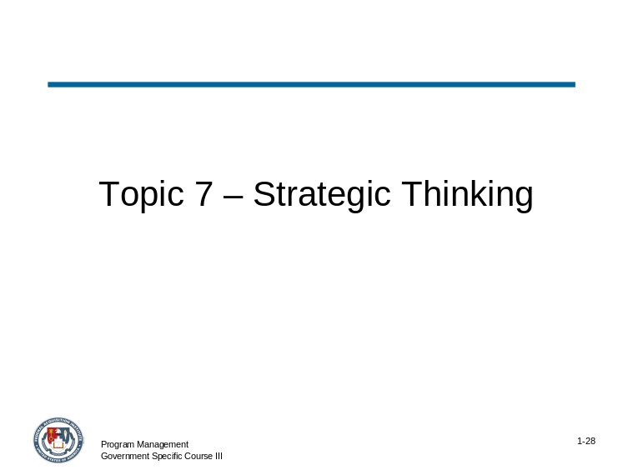 | Slide # 1-28

CONTENT TO BE PRESENTED:
Key Points:
- Word "strategy" is used in a variety of contexts. There are business strategies, coaching strategies, financial strategies, and research strategies.
- Over the past few decades, the concept of strategy increasingly has been applied to organizations such as teams.

Topic 7: Strategic Thinking (continued)

CONTENT TO BE PRESENTED:
Key Points:
- An effective leader develops a strategy based on the team’s mission or goal, a vision of the future, an understanding of the organization's place in that future, and an assessment of the alternatives available to it, given scarce or finite resources.
- Ability to think strategically translates, simply put, into an ability to develop and communicate both a vision for the future and the long-term strategic goals that are necessary to achieve the vision.

CONTENT TO BE PRESENTED:
Key Points:
Strategic Thinking means that, as the program manager, you:
- Formulate effective strategies.
- Examine policy issues and strategic planning with a long-term perspective.
- Determine objectives and set priorities.
- Anticipate potential threats and seize potential opportunities.

Topic 7: Strategic Thinking (continued)

CONTENT TO BE PRESENTED:
Key Points:
What does it mean to employ “Strategic Thinking”?
- Anticipate potential opportunities and obstacles based on past experience, and develop contingency plans for addressing them.
- Ensure that decisions/solutions address the immediate issue while also considering long-term implications.
- Determine the resources or skills that will be needed in the future and take steps to ensure they are available.
- Focus time and energy on anticipating and planning for the future versus “fighting fires.”
- Consider the ways that future changes or developments may impact your projects and take concrete steps to prepare for them.

Topic 7: Strategic Thinking (continued)

CONTENT TO BE PRESENTED:
Key Points:
What are some strategies for developing strong strategic thinking skills?
- Write up and share case-studies following critical situations that you or your team deals with, and encourage your counterparts to do the same.
- Identify potential risks and how best to avoid them through reviewing past project/situation debriefs or case studies.
- Arrange opportunities to observe firsthand the strategies, styles and skills of proven veterans in the agency and apply them to your own situation.
- Proactively address knowledge development needs of your coworkers' as well as yourself.
- Establish ongoing relationships with counterparts in other agencies and share best practices and gain new ideas to apply to within your organization.

Topic 7: Strategic Thinking (continued)

Instructor Notes:
Lead a discussion about the commonalities and differences between “strategic thinking” and “strategic planning”.

What is the difference between a program manager who uses strategic thinking and a program manager who uses strategic planning? Or is there a difference?
Answer:
Review the chart on the following page. Emphasize that this information is just “possible views” and does not neccesarily apply to all program managers.

Topic 7: Strategic Thinking (continued)

Instructor Notes:
A copy of the chart below is included in the Participant Guide so you can reference it for the participants.

CONTENT TO BE PRESENTED:
Key Points:
Concept | Strategic Thinking | Strategic Planning
Vision of the Future | Only shape of the future can be predicted. | A future that is predictable and specifiable in detail.
Strategic Formulating and Implementing | These concepts are interactive rather than sequential and discrete. | The roles of these concepts can be neatly divided.
Program Manager Role in Strategy Making | Involves more project managers who have a voice in strategy-making. | Obtain the needed information from project managers, and then use it to create a plan and, disseminate it to project managers for implementation.

(continued on the following page)

Topic 7: Strategic Thinking (continued)

CONTENT TO BE PRESENTED:
Key Points:
Concept | Strategic Thinking | Strategic Planning
Control | Relies on self-reference –that guides choices on a daily basis in a process that is often difficult to measure and monitor. | Asserts control and hopes agency can measure and monitor important variables both accurately and quickly.
Program Manager Role in Implementation | All managers understand the larger system, the connection between their roles and the functioning of that system, and the interdependence between the various roles that comprise the system. | Project managers need to know their role well but usually only defend their own turf.
Strategy Making | Sees strategy and change as inescapably linked and assumes that finding new strategic options and implementing them successfully is harder and more important than evaluating them. | Challenge of setting strategic direction is primarily analytic.
Process and Outcome | Sees the planning process itself as a critical value-adding element. | Focus is on the creation of the plan as the ultimate objective

Topic 7: Strategic Thinking (continued)

Activity
Activity Purpose:
This activity provides participants with an opportunity to use the vision developed earlier in this module and apply strategic thinking skills to identify how their long-term strategy might impact and influence leadership of their team to achieve the vision goals.
Activity Length: 25 minutes
Activity Instructions:
- Refer participants to the vision created as part of Topic 4: Vision during this module.
- Allow participants five minutes to individually read the US West Acquisition Strategic Thinking Case Study (displayed on the next page). Participants should read the content and identify how strategic thinking affects the information contained in the case study. Have the participants list the impacts.
- For each of the ways that the participant identifies an impact on his/her team, a solution or action that would likely be taken should also be developed.
- Ask for volunteers to share strategic thoughts for the program with the whole group. Note: Key Findings are found on the page following the Case Study, and can be used to help facilitate the discussion on strategic thoughts.
- Continue this process as time allows. If possible, all class participants should share their strategic thinking impacts for the program with the whole group.

Topic 7: Strategic Thinking (continued)

Activity (continued)
US West Acquisition Strategic Thinking Case Study
Imagine you are the program manager for the following acquisition of services contract. What would you envision for this excellence in this program, and how would you communicate it to your team?
US WEST announced it has been awarded a Metropolitan Area Acquisition (MAA) award from the U.S. General Services Administration's (GSA) Federal Technology Service (FTS) for the cities and surrounding metropolitan area of Minneapolis and St. Paul, Minn. The contract, awarded to US WEST and Winstar Communications, has an estimated value of $160 million.
Under the multi-year contract, US WEST will provide government agencies with standard voice services, including Centrex, Business Line, PBX Access Trunks, Key System Access, Private Line and ISDN services, as well as switched data service and dedicated transmission service offerings at competitive rates to government agencies in Minneapolis and St. Paul.
The MAA program is envisioned to be the government's tool for achieving the immediate benefits, such as price reduction and better services, from the emerging competitive local telecommunications market.
US WEST was awarded the contract after a competitive bid based on several criteria of the MAA Program, including its ability to provide the services and its past history of successful deployments. Winning the MAA contract affords US WEST the opportunity to expand its services for GSA to include new, high-speed services as they become available, bid for other GSA contracts and to potentially offer FTS2001 long distance services nationally.
Through the contract, US WEST will offer new local service prices that will result in substantial cost savings for the government, when compared with standard business rates.

Topic 7: Strategic Thinking (continued)

Activity (continued)
Key Findings:
This activity will result in participants determining their own key findings based on their own visions of excellence for the acquisition and their own thoughts on how the vision would be most effectively communicated to the integrated program team.

Instructor Notes:
This concludes the topic on Strategic Thinking. After addressing any questions the participants may have, inform them that we will be moving on to the final topic: Module Review.

What questions do you have regarding strategic thinking as a leadership skill?

Topic 8: Review

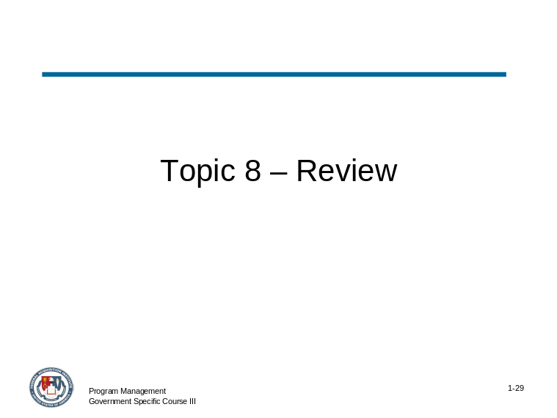 | Slide # 1-29

CONTENT TO BE PRESENTED:
Key Points:
The competencies discussed as part of this module represent skills, knowledge, abilities and traits acquired through experience, training and education within government and the private sector and are cumulative, leading to skilled supervision and seasoned leadership.
These competencies may appear in successive levels to emphasize the process of evolving, developing, and maturing leadership skills.

Topic 8: Review (continued)

CONTENT TO BE PRESENTED:
Key Points:
Let’s review the objectives for this module on Leadership/Professional Skills:
- Using examples provided from pre-work on leadership, identify and integrate critical leadership skills into the roles and responsibilities of the program manager.
- Given a sample acquisition scenario, develop a vision statement that reflects the key properties of a good vision.
- Given an acquisition case study, assess the entrepreneurship characteristics and determine what actions the program manager should implement to display entrepreneurial leadership.
- Given an example summary of an acquisition, identify the national policy and relevant political, economic, social, technological and administrative factors affecting the program and how they should be integrated as part of program management.
- Apply the principles of strategic thinking to an acquisition and its corresponding vision to determine how the integrated product team should be successfully led by the program manager.

Topic 8: Review (continued)

CONTENT TO BE PRESENTED:
Key Points:
- Explain the importance of vision and how it is a crucial skill for program managers.
  - The vision competency refers to an individual’s ability to take a long-term view and build a shared vision with others.
  - The vision acts as a catalyst for organizational change, and when properly communicated can influence others to translate the vision into action.

CONTENT TO BE PRESENTED:
Key Points:
- Present reasons that emphasize the importance of entrepreneurship for a program team.
  - Entrepreneurship positions the team organization for future success by identifying new opportunities, and builds the organization by developing or improving products or services.
  - It is activity that seizes profit and/or improvement opportunities without regard to resources currently controlled.
  - It expands existing resources through enhanced learning, synergies, or “bootstrapping.”
  - It promotes change and innovation leading to new combinations of resources and new ways of doing business.

Topic 8: Review (continued)

CONTENT TO BE PRESENTED:
Key Points:
- Describe the importance of external awareness in program management.
  - External awareness is the ability to understand and keep up-to-date on local, national, and international policies and trends that affect the organization and shape stakeholders' views.
  - An externally aware leader is aware of the organization's impact on the external environment.
  - External awareness, sometimes referred to as “relational awareness,” also relates to a leader’s ability increase his or her bandwidth in a leadership role on a personal level.

CONTENT TO BE PRESENTED:
Key Points:
- Describe how strategic thinking is used to build effective strategies and awareness.
  - An effective leader develops a strategy based on the team’s mission or goal, a vision of the future, an understanding of the organization's place in that future, and an assessment of the alternatives available to it, given scarce or finite resources.

Topic 8: Review (continued)

Instructor Notes:
This concludes Module 1 – Leadership/Professional Skills. Address any questions the participants may have before moving on to Module 2 – Agency Policies and Practices.

What questions do you have about Module 1 – Leadership/Professional Skills?

