Indium:
Supply, Demand & Flat Panel Displays

Brian O’Neill
AIM Specialty Materials
25 Kenney Drive
Cranston, Rhode Island 02920 USA
www.aimsolder.com

Presented at Minor Metals 2004, London, June 2004

Indium Market

Indium is a minor metal that commonly occurs as an impurity in zinc and, to a lesser extent, in tin, lead and copper. The abundance of indium in the earth’s crust is believed to be equivalent to the occurrence of silver, however, the similarities end there. The development of commercial scale silver applications, production, fabrication and recycling spans over centuries. Meanwhile, commercial scale applications of indium began to develop only over the past 2 or 3 decades. During this time the relatively thin supply base and low demand of indium has contributed to significant price instability over the past 20 years. The price instability coupled with relatively small worldwide consumption of indium is the reason why relatively few zinc producers bother to extract indium.

In late 2002 indium prices hit a low of ~ US$60.00/kg. At that point French zinc producer Metaleurop closed their zinc refinery in northern France. As a consequence, the indium circuits at this plant were also closed causing the loss of ~ 60 tons per year of primary indium production. Simultaneously the demand for indium consumed by the LCD industry started to rise rapidly while the more traditional applications for indium continued to grow at more modest growth rates in the range of 5 to 8% per year. These events caused the tightening of indium supply and subsequent steep price increases experienced over the past 16 months. During 2003 the supply of primary indium was impinged further by the closure of several mines in the Nandan region of China. This contributed to a shortage of indium bearing concentrates available to refiners in Asia. The net result of these circumstances was an indium price exceeding US$600.00/Kg.

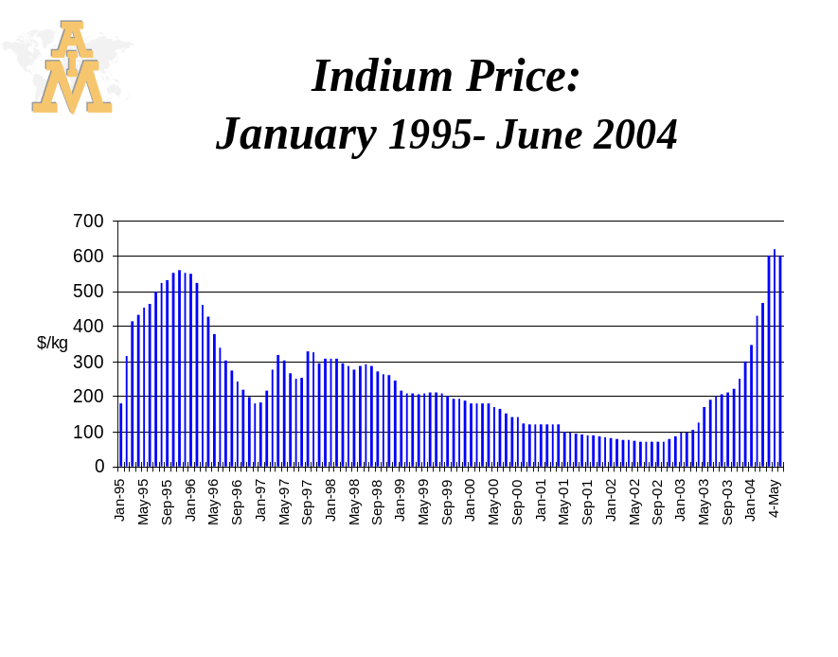
Figure a.

Indium and LCD’s

While indium has many niche applications, flat panel displays have quickly grown to become the primary end user of the world’s indium production. The dominant flat panel display technology is the LCD or liquid crystal display.

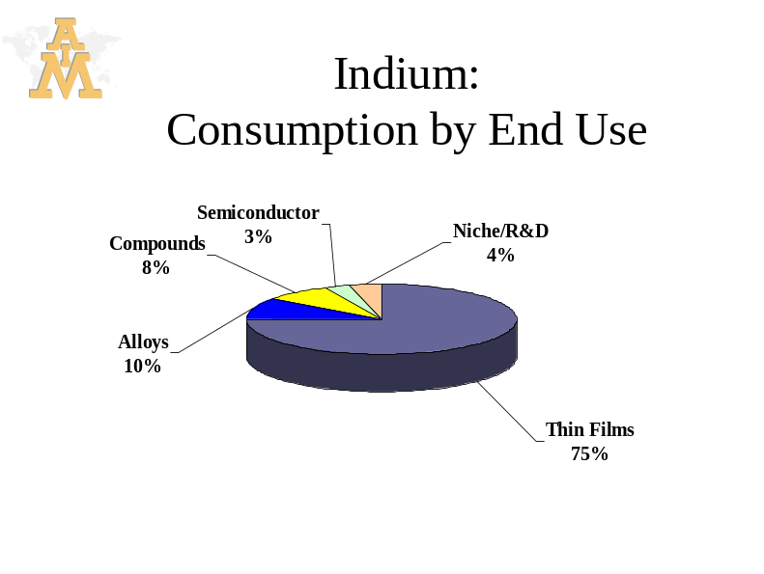
Figure b.

The fabrication of an LCD leverages technologies perfected by the semiconductor industry. Like semiconductor chips, the production of an LCD involves the fabrication of an array of thin film transistors via a series of metal deposition, lithography and etch steps. Unlike silicon chips, a TFT-LCD array must be transparent. Doped indium in the form of indium-tin oxide (ITO) thin films have the unique properties of being optically transparent and electrically conductive. In addition to these physical properties, ITO films have other key attributes, including:

- ITO films are very uniform when applied to glass via physical vapor deposition. Film uniformity is critical to large area LCD’s.

- ITO films etch rapidly & uniformly in the lithography/etch processes used to fabricate LCD’s.

- ITO films are stable and have a very long life in LCD structures

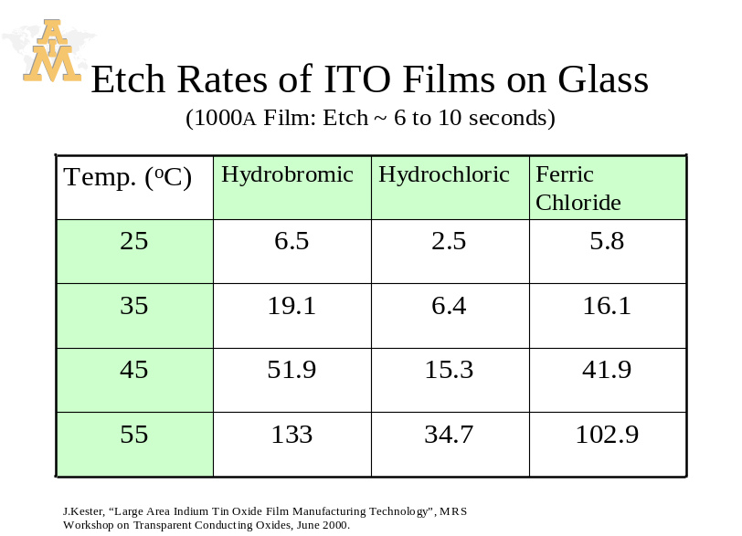
Figure c.

While there are many other metal-oxide transparent conductors which find use in a range of industrial applications, the set of properties critical to LCD’s make indium based thin films uniquely suited to LCD applications. It is not out of the question that some novel material sets could be developed as replacements for ITO, however, this not a likely scenario in the near term. Any change would require significant research/development, life testing, process changes and equipment changes.

COST STRUCTURE OF LCD’s
An LCD is a capital intensive product therefore production yields dominate the cost structure. In 2004 alone LCD makers are expected to invest a record of close to US$10 billion in new LCD fabs^{1.}. Overhead costs are applied to each glass substrate as it passes through the fabrication equipment. The number of good LCD panels yielded per glass substrate has a significant impact on the net cost per panel. This drive to maximize the number of LCD panels per substrate is evident in the investment being made in next generation LCD fabs. Early generations of LCD fabs utilized glass substrates that were ~ 500mm square while current fabs utilize glass that is ~ 1.5 meters x 1.8meters. By 2006 the substrate size will exceed 2 meters.

In terms of the cost structure of an LCD panel, the cost of ITO per panel is insignificant. Even at today’s elevated indium prices, the cost of indium that is applied to a 32” LCD panel would be <US$0.55. Even if indium prices were to double from present levels, the indium cost/panel would be ~US$1.00 on a product that retails for >US$3,000. For reasons detailed earlier it is reliable supply of indium, not cost, that is most important to the LCD fabs.

INDIUM SUPPLY / DEMAND FORECAST

Figure d. is a summary of estimated refinery capacity & actual production vs. forecasted demand. This estimate of the supply-demand balance shows a deficit of supply vs. demand in 2003 with the deficit situation worsening as demand from the LCD sector escalates through 2006. Total indium demand outstrips worldwide primary production capacity in 2004. This estimate assumes the shortage of indium bearing concentrates will persist in China, keeping worldwide primary production at ~ 75% of refinery capacity. Recent news reports indicate the planned addition of ~ 30 tons per year indium refining in Korea. According to reports this new capacity will come on-line sometime in 2005. It remains to be seen whether this new production capacity will absorb indium bearing concentrates that are already being recovered at existing refineries, therefore it is difficult to estimate the impact of this project at this time.

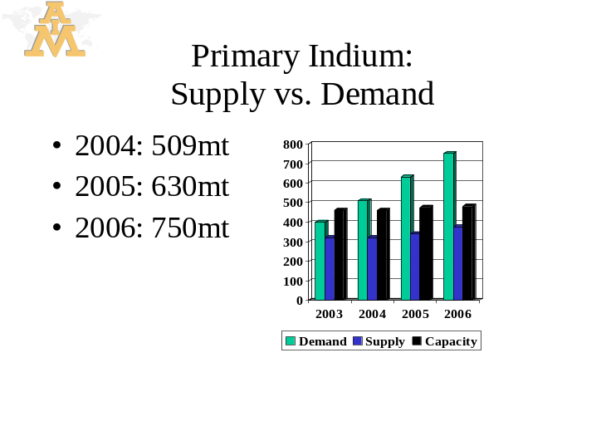
Figure d.

At present the deficit balance of indium that is required is being supplied via recycling of scrap ITO targets. As noted in figure b, indium based thin films now account for ~ 75% of world indium demand. The bulk of these films are produced via physical vapor deposition, a process commonly referred to as sputtering. This process uses indium in the form of ceramic ITO sputtering targets. While this process is well suited to the high rate production of uniform ITO thin films, it is very inefficient in terms of sputter target utilization. While target utilization rates vary, as little as 15% of a given target is actually deposited on the substrate being coated. The balance of the ITO resides as scrap streams in the form of spent targets, ITO films on the coating chamber walls and ITO bearing solutions generated by the etch processes at LCD fabs.

Demand / Price Instability

From 1999 through 2002 indium prices steadily eroded due to increasing indium production from China coupled with inconsistent demand from the LCD sector. The inconsistent demand was driven by the boom & bust cycle of the LCD business through the late 1990’s into the early 2000’s. During this time the largest applications for LCD panels were notebook computers and cell phones therefore ITO demand was tied to the replacement cycle of these products. As this situation persisted, indium availability continued to climb while prices sank, leaving little incentive to invest in ITO recycling or new primary production capacity. In late 2002 and 2003 the market dynamics shifted on several fronts:

On the demand side the cost reductions afforded by next generation LCD fabs were opening new markets for LCD panels: desktop monitors and LCD-TV’s. The present market saturation of LCD-TV’s vs. CRT’s is less than 5%, allowing for many years of strong growth in LCD demand. Simultaneously, the traditional LCD markets were entering a strong replacement cycle: IT spending was on the increase while notebook computers with wireless internet capability were entering the market. Meanwhile, next generation mobile phones with attractive new features (camera phones, wireless internet, PDA functions) were pushing the replacement cycle for handsets. These developments fueled high growth in indium demand.

On the supply side, the loss of Metaleurop’s production coupled with the mining problems in China lead to a drop in primary indium production available to the market. Compounding the problem was the lack of investment in ITO target recycling. Until late 2002, indium had become a commodity with constant downward price pressure, providing little incentive for investment in recycling activities. As indium supply tightened and prices spiked there was renewed interest and investment in recycling. The supply chain now recognizes that the recycling of scrap ITO is a critical component of indium supply and will allow indium to remain viable to both the LCD market and the more traditional uses of indium.

SUMMARY

Indium’s primary end use, the LCD, has entered a period of long term growth. No longer tied to one end market, the LCD industry is expected to achieve annual growth rates exceeding 30% over the next 3 years. LCD-TV’s have captured just 5% of the market for televisions. As 6th & 7th generation LCD fabs reach capacity we can expect LCD-TV prices to decrease significantly, boosting demand dramatically. This will provide steady and significant growth in the demand for indium. Meanwhile, non-LCD related applications for indium will continue to grow at ~ 5% per year.

Improvements in the speed & efficiency of ITO recycling coupled with primary indium production will provide sufficient indium for all applications & will eventually bring about price stability.

References:
^{1.} Wall Street Journal, 5/27/04, “I Want My Flat TV.Now”, E. Ramstad
Figures a, b, d: AIM market research
figure c: J.Kester, “Large Area Indium Tin Oxide Film Manufacturing Technology”, MRS Workshop on Transparent Conducting Oxides, June 2000.

