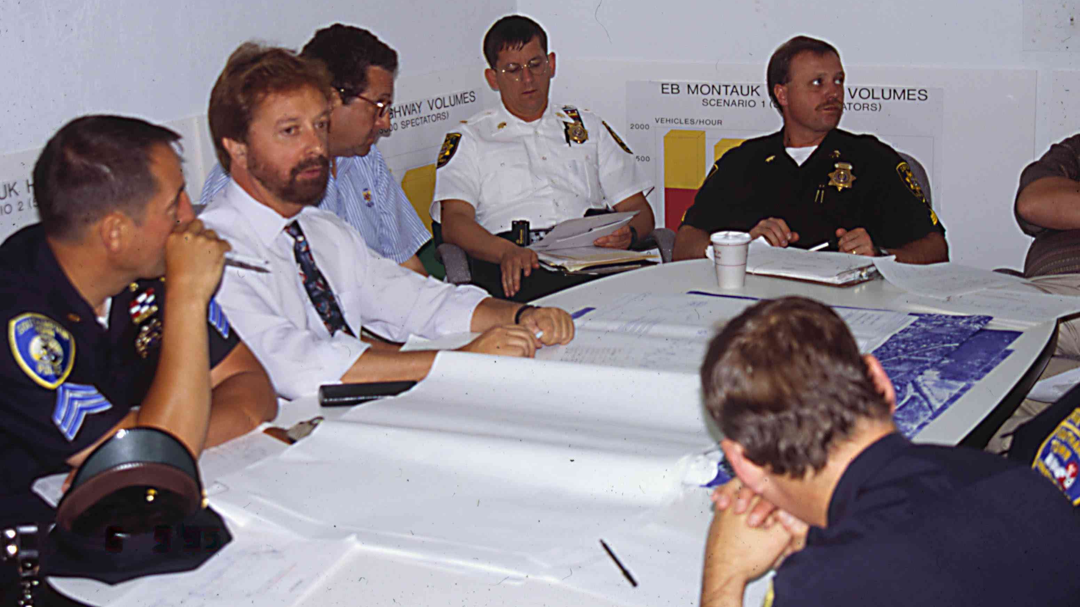
CHAPTER FIVE
EVENT OPERATIONS PLANNING
Figure 5-1
Event Planning Team Meeting





PURPOSE

This chapter presents advance planning and stakeholder coordination activities conducted for a specific planned special event. It represents the first of three successive chapters on the event operations planning phase. The primary, interrelated products of the event operations planning phase include: (1) feasibility study, (2) traffic management plan, and (3) travel demand management initiatives. This chapter describes initial planning activities, summarizes feasibility study analysis steps specific to a planned special event, and highlights external factors

affecting the scope of event impact on transportation system operations.

Practitioners can use this chapter as a tool to: (1) establish an event operations planning framework for guiding stakeholder activities throughout the phase, (2) assist in deciding whether to grant or deny preliminary approval to schedule a proposed planned special event based on predicted transportation system impacts and (3) determine traffic and parking demand, roadway capacity deficiencies, and unplanned scenarios that define that scope of traffic management plan required (Chapter 6) in addition to the need for developing travel demand management initiatives (Chapter 7).
INTRODUCTION
This chapter helps practitioners to hit the ground running on advance planning for a specific planned special event. Compared to Chapters 6 and 7 which detail strategies and tactics for mitigating the impact of planned special events on transportation system operations, this chapter emphasizes, with supporting example case studies, the importance of facilitating a planning structure, stakeholder coordination, and comprehensive event assessment in generating event planning phase products that completely and accurately guide operations activities on the day-of-event.

A section on initial planning activities describes input data requirements for analyzing the event impact and discusses scenarios linked to particular events that may require the development of a contingency plan(s). The section lists transportation system performance objectives, and associated facility-specific measures of effectiveness (MOEs), that satisfy the customer service requirements of event patrons and other road user classes. It presents an event operations planning schedule and lists various products of the event operations planning phase. The section concludes by examining situations necessitating public involvement, summarizing the feasibility study and traffic management plan review process, and identifying successful policies and agreements for managing and operating a planned special event.

The event feasibility study section presents travel forecast process strategies and considerations for estimating modal split, event-generated traffic demand, and vehicle occupancy factors. It reviews techniques for identifying a market area and directional distribution of event-generated traffic. The section reviews methodologies for identifying and evaluating the sufficiency of available venue parking supply based on event parking demand and existing conditions. It specifies traffic demand analysis and roadway capacity analysis strategies, including the application of various traffic modeling and capacity analysis tools. To provide a lead-in to the following two chapters on event operations planning, the section describes a toolbox of mitigation strategies for adjusting event traffic generation levels as well as increasing transportation system capacity.

This chapter concludes with an examination of external factors that may create considerable impact on transportation system operations if ignored. A feasibility study may not account for issues such as available resources, weather, concurrent road construction activities, and concurrent planned special events. These factors must be accounted for early in the advance planning process as well as in traffic management plans prepared for a planned special event. For example, given a particular recurring event, event patrons and non-attendee transportation system users may realize satisfactory system operations during one event occurrence, then experience an unacceptable level of service during the next event occurrence. Such incidents occur when stakeholders do not account for various external factors, through scenario-based response plans, early in the event traffic management plan development process.

INITIAL PLANNING
ACTIVITIES

Overview

This section examines key planning initiatives and special considerations in order to help guide the user through the first steps of the event operations planning phase. The event operations planning phase begins with stakeholders establishing a planning framework and schedule. The framework includes forming an event planning team, creating agreements, identifying performance goals and objectives, and deciding on mitigation assessment and approval protocol.

Special considerations evolve from reviewing the event operations characteristics of a particular special event (e.g., risk assessment) in addition to past successes and lessons learned. These considerations weigh heavy on traffic management plan requirements, and stakeholders must address issues affecting community residents and businesses through public outreach efforts early in the planning phase in order to ensure proper mitigation and non-conflict with traffic management plan specifications.

Stakeholder Roles and
Coordination

The event planning team handles tasks associated with event-specific operations planning and traffic management plan implementation. Table 5-1 lists the primary responsibilities of the event planning team under the event operations planning phase. The event planning team consists of a diverse group of stakeholders with either event operations or community interest as their primary concern. The success of the event planning team depends on achieving strong coordination among participating team stakeholders.

Table 5-1
Event Planning Team Responsibilities
During the Event Operations Planning Phase

RESPONSIBILITY
- Perform feasibility study.
- Develop traffic management plan.
- Evaluate travel demand management initiatives.
Event Planning Team Establishment

An event planning team forms as a result of either: (1) coordination among traffic operations agencies, transit agencies, law enforcement agencies, and event organizers that represent the core event planning team stakeholders or (2) designation by a committee on special events within a regional transportation management organization, such as a traffic incident management program.

- The former typically describes event planning teams formed in response to local planned special events affecting few jurisdictions, such as events occurring in rural or urban areas.
- The latter may occur in metropolitan areas where planned special events happen frequently, thus warranting an on-call event planning team.

A regional transportation committee on special events features stakeholders that have achieved interagency coordination through past, cooperative travel management efforts.

- Stakeholder representatives have firsthand knowledge of the roles, resources, and capabilities of each committee participant.
- Stakeholders commonly include traffic operations agencies, law enforcement, transit agencies, event organizers or venue operators, and the media.
- Committees in metropolitan areas may create task forces for specific planned special event venues or recurring planned special events (e.g., annual fairs, fireworks displays, parades, etc.). The committee or task force generally meets and performs event operations planning tasks on an as-needed basis. The group may also convene regularly (e.g., weekly, monthly, or quarterly) to review program planning efforts for future planned special events.

Prior to initiating the event operations planning process, the core event planning team should adopt a mission, or purpose, and solicit buy-in from public agency stakeholders, the community, and other event support stakeholders. In identifying pertinent jurisdictions, the event planning team may consider contacting stakeholders within a certain distance (e.g., five miles) of the event venue. The event planning team can obtain buy-in from community interest stakeholders more easily when a core group of stakeholders already exists, including public agencies. Elected officials and the public can serve as advocates for the event planning team; therefore, participation from these stakeholders should occur early in the event operations planning phase.

Table 5-2 indicates the typical function of each participating stakeholder in generating the primary products of the event operations planning phase. A list of stakeholders is referenced to the three products produced: (1) feasibility study, (2) traffic management plan, and (3) travel demand management. Stakeholders contribute data, communicate needs, and/or furnish resources. Often, certain agencies promote initiatives developed by the event planning team, such as travel demand management strategies.

Table 5-2
Stakeholder Participation in Event Operations Planning
STAKEHOLDER | PRODUCTS OF THE EVENT PLANNING TEAM
STAKEHOLDER | Feasibility Study |  |  | Traffic  Management Plan |  |  | Travel Demand Management
STAKEHOLDER | Input | Develop | Review | Input | Develop | Review | Input | Develop | Review | Promote
Traffic Operations Agency | • | • | • | • | • | • | • | • | • | •
Law Enforcement |  |  |  | • | • | •
Event Organizer | • |  |  | • | • |  |  | • |  | •
Fire and EMS |  |  |  | • | • | •
Elected Official |  |  | • | • |  | • |  |  | • | •
Transit Agency | • |  |  | • | • |  | • | • |  | •
Public |  |  | • | • |  | • | • |  | •
Private Transportation Consultant |  | • |  | • | • |  | • | •
Private Traffic  Control Contractor |  |  |  | •
Media |  |  |  |  |  |  |  |  |  | •
Office on Special Events |  |  | • |  |  | •
Emergency  Management Agency |  |  |  | • |  | •
Regional  Organization |  |  | • |  |  | • | • | • | • | •

Interagency Coordination

In establishing an event planning team, the core stakeholders must develop a working trust with each other. This trust results when stakeholders realize that a planned special event necessitates the same relationships cultivated in daily traffic and incident management.

A joint operations policy or other memoranda of understanding strengthens the cooperative bond among core stakeholders. These agreements identify common goals and responsibilities of the partnering agencies.

Consensus among stakeholders builds interagency coordination and an understanding of each agency’s responsibility. Key elements to consider include:

- Participating stakeholders must recognize that the motivations of individual agencies may differ from the event planning team’s concerns as a result of their day-to-day responsibilities.
- Although the event planning team does not have authority over individual stakeholders, the planning team must realize that possible conflicts may exist between the team’s objectives and a stakeholder’s primary responsibility. Understanding this is key to overcoming such a problem; yet, the team can foster a cooperative spirit among stakeholders by emphasizing that participants own a part of the event planning team’s common goals. In turn, team goals and objectives create incentives for individual stakeholders.
- Stakeholders must remain focused on the goals and objectives of the event planning team in order to effectively support and contribute in the event operations planning process. This includes concentrating on tasks that can be successfully accomplished collectively.

Common barriers to the event planning team’s progress include resource constraints and jurisdictional barriers.

- Resource or funding constraints surface when stakeholders assign a lower priority to the planned special event. In satisfying individual and team goals, stakeholders may have to make temporary project and program sacrifices, in terms of personnel and equipment reassignment, to provide adequate benefits to the event operations planning effort.
- Jurisdictional barriers arise when two or more stakeholders are unclear on their duties and responsibilities. Do not allow participating agencies to feel left out. At the time of buy-in, the event planning team must indicate which stakeholders are required on an as-needed basis. The team must have the ability to communicate effectively with stakeholders having a peripheral involvement in the overall planning effort.

Risk Assessment

Based on the type and purpose of a planned special event, there exists potential scenarios where event patron or non-attendee behavior may cause overcrowded conditions in the vicinity of an event venue and/or create unplanned road closures. The event planning team must assess the nature of a proposed event and determine the need to incorporate special contingency plans in response to potentially dangerous situations that will interfere with the planned travel management on the day-of-event.

Table 5-3 lists four notable event-oriented risk scenarios associated with some planned special events. This section further

Table 5-3
Summary of Event-Oriented Risk Scenarios
EVENT-ORIENTED RISK | EXAMPLE SCENARIO
Demonstration or protest | - Any event that is political in nature or invokes social concern.  - Political conventions and parades
Ticketless event patrons  causing overcrowding | - Sold-out sports championship games  - Sold-out concerts involving select performers
Fan celebration | - Response to city or school sports team winning a championship.
Event patron violence | - Motorcycle rally violence between patrons and/or participants.

describes these scenarios and highlights example case studies that illustrate resulting impacts on advance planning and/or day-of-event operations. Chapter 6 provides detailed guidance on contingency planning in addition to the development of specific strategies (e.g., alternate route plans) needed to effectively respond to certain unplanned scenarios.

Demonstration or Protest

Certain political or socially controversial planned special events may provoke a demonstration or protest. Those attending the demonstration represent non-attendees, and the event planning team often has little or no advance information regarding the demonstration’s specific location and time of occurrence. The event planning team should obtain access to relevant law enforcement intelligence reports regarding potential demonstrations to develop an effective travel management contingency plan. The threat of an unplanned road closure should prompt the event planning team to consider developing an alternate route contingency plan detailing the personnel and equipment resources necessary to effect an immediate diversion of traffic.

Appendix B contains a contingency diversion routing plan prepared in response to the potential for demonstrations during the 2000 Republican National Convention in Philadelphia, PA.

Overcrowding

The occurrence of sports championship games or major concerts at venues having a defined sell-out capacity may attract ticketless event patrons not accounted for in event travel forecasts and impact mitigation strategies. Events such as the Super Bowl or National Collegiate Athletic Association (NCAA) Final Four cause an increase in area visitors beyond the actual event participants and patrons. Sold-out music festivals may attract persons wanting to tailgate in venue parking areas despite not having a ticket.

For instance, event planners originally anticipated 200,000 people to attend a two-day Grateful Dead reunion concert at a 35,000 seat amphitheater in rural East Troy, WI, located approximately 30 miles southeast of Milwaukee. The Walworth County Highway Committee initially denied the event organizer a permit to hold the two concerts. After the event organizer unveiled a comprehensive security and traffic management plan that included using advance checkpoints to turn away any vehicle that contained a ticketless occupant, county executives overturned their decision and issued a permit.⁽¹⁾ Appendix B contains a list of restrictions imposed by the event organizer and event planning team to prevent ticketless event patrons from gaining access to the venue parking areas.

Fan Celebration

Another severe impact risk associated with sports championship games involves fan celebrations that occur when a city sports team wins a championship at home. In this case, the traffic management team charged with managing travel during event egress must also mitigate traffic impacts caused by non-attendees converging on the venue site and unruly fans disrupting traffic and pedestrian flow.

For instance, the Detroit Red Wings won the 2002 Stanley Cup in Detroit. Operating from past experience, the Michigan State Police began closing portions of Interstate 75 and the Lodge Freeway (State Route 10) leading to downtown Detroit and the event venue. This contingency plan went into effect at the start of the final period of play with Detroit leading the championship clinching game.⁽²⁾ Contingency plan details were even posted in advance on Red Wings’ fan websites. Located approximately 16 miles north of the event venue, Royal Oak police and city officials maintained road closure contingency plans to accommodate the thousands of fans that went to the popular clubs and bars to celebrate the home team win.⁽³⁾

Event Patron Violence

An outbreak of violence among event patrons warrants special security precautions to contain and capture potential suspects. Law enforcement may initiate a road closure as a first response to discourage people from entering and leaving the region where the violence took place.

During the 2002 Laughlin, NV River Run motorcycle rally, attended by tens of thousands of motorcycle enthusiasts, a multiple homicide occurred after a clash between rival motorcycle gangs. In an effort to capture the homicide suspects, Nevada officials closed all highways and arterials serving Laughlin, including Nevada State Route 163 at the Nevada/Arizona border as shown in Figure 5-2. Trucks traveling U.S. 93, a North American Free Trade Agreement (NAFTA) designated trucking corridor, traverse State Route 163 because of prohibitions on crossing the Hoover Dam. Law enforcement maintained the road closures for a few hours.⁽⁴⁾ A possible traffic management contingency plan prepared in advance of the described security incident would specify a regional alternate route plan coupled with regional traveler information.
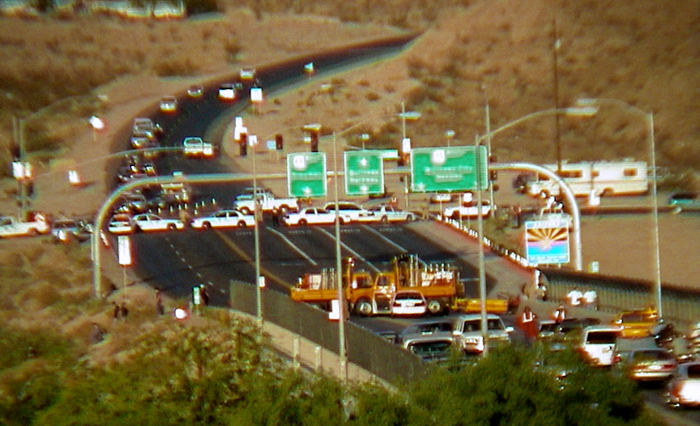
Figure 5-2
Nevada State Route 168 Closure During Motorcycle Rally (Photo courtesy of the Laughlin Free Press)

Performance Goals and Objectives

The goals of managing travel for planned special events include achieving predictability, ensuring safety, and maximizing efficiency. Table 5-4 states performance objectives, for the previously defined classes of transportation system users, applicable to satisfying the overall goal of operations efficiency and safety. In meeting these performance objectives, the event planning team must target the goal of achieving predictability during the event operations planning phase. Table 5-5 presents common, easy-to-measure measures of effectiveness for assessing the performance

Table 5-4
Transportation System Operations Performance Objectives for Planned Special Events
USER CLASS | PERFORMANCE OBJECTIVE
Event patron | - Minimize travel delay to/from the event.  - Minimize conflicts between pedestrians and vehicles.  - Minimize travel safety hazards.  - Minimize impact of traffic incidents.  - Disseminate accurate, timely, and consistent traveler information.  - Increase automation of traffic control.  - Maximize site access service flow rates.
Non-attendee road user | - Minimize travel delay on major thoroughfares, freeways and major arterials.  - Minimize impact on commuter and trucker travel time reliability.  - Maintain required parking and access for local residents and businesses.  - Maintain unimpeded access for emergency vehicles.
Transit user | - Maintain scheduled travel times.  - Minimize transit bus dwell times.  - Maintain required transit station parking for non-attendee transit users.

objectives that describe traffic operations. The event planning team should consider field studies to quantify existing MOEs at key roadways and intersections to calibrate capacity analysis software and computer simulation models applied during traffic management plan development. The identified MOEs represent day-of-event performance evaluation data, useful for: (1) making real-time adjustments to the traffic management plan on the day-of-event, (2) conducting a post-event evaluation of transportation system performance, and (3) referencing during advance planning for future event occurrences.

NCHRP Synthesis 311, Performance Measures of Operational Effectiveness for Highway Segments and Systems, reports on the state-of-the-practice of using performance measures for the monitoring and operational management of highway segments and systems.⁽⁵⁾ It assesses the relative strengths and weaknesses of various performance measures. Based on a survey of current agency practice, the synthesis reports that performance measures associated with planned special event management are similar to traffic and incident management, but may also include performance measures related to clearance times (e.g., time for vehicles to clear a venue site area) and parking management measures.

Table 5-5
Measures of Effectiveness for Assessing Performance Objectives
LOCATION | MEASURE OF  EFFECTIVENESS
Venue  parking areas | - Occupancy and turnover rate  - Arrival and departure service rate  - Time to clear parking lots
Intersections | - Vehicle delay  - Queue length
Freeways and  streets | - Travel time and delay  - Traffic volume to capacity ratio  - Traffic speed  - Number and location of crashes and other incidents  - Traffic incident clearance time

Planning Schedule and Deliverables

Two deliverables, produced by the event planning team during the event operations planning phase, include the feasibility study and the traffic management plan, designed to mitigate impacts identified in the feasibility study. Travel demand management represents a key component of the overall process when forecasted traffic demand levels approach or exceed available roadway capacity.

The previous chapter outlined a detailed special event permit process and identified advance planning deadlines applicable to the event organizer. In turn, Figure 5-3 illustrates a high-level event operations planning schedule for an event planning stakeholder group. The figure lists advance planning activities and potential stakeholder meetings and public hearings in a timeline relative to the planning deliverables. The schedule indicates other stakeholder planning initiatives, such as the development of a specialized transit plan to reduce event traffic demand.

The event planning team should:

- Obtain a completed special event permit application and commence work on the event feasibility study no later than 60 days prior to the event.
- Start developing the event traffic management plan and obtain all initial public input and recommendations no later than 30 days before the event.
- Set aside the final 14 days prior to the event for implementation activities in addition to event information dissemination.

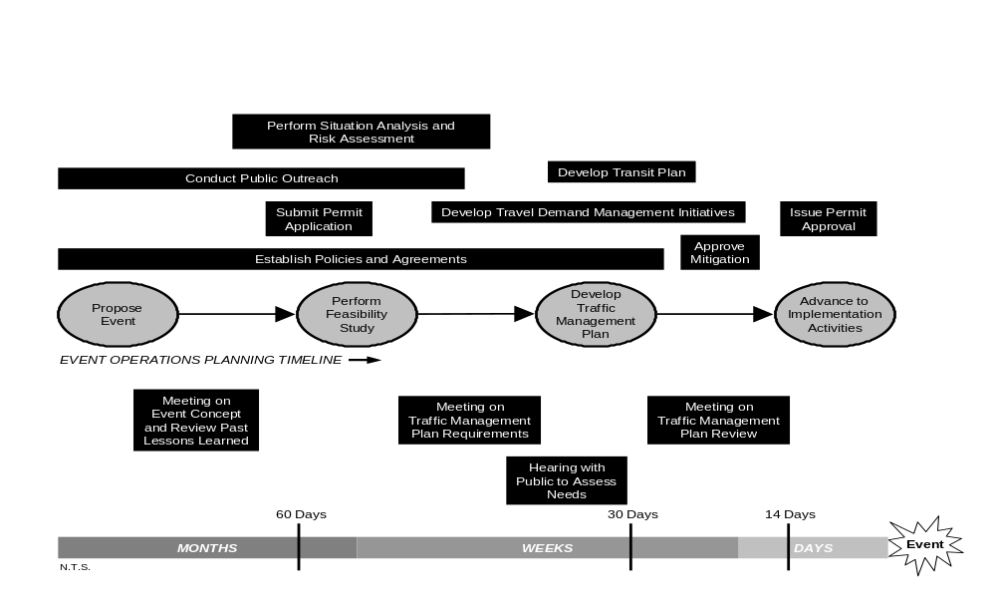
Figure 5-3
Event Operations Planning Schedule

The planning schedule provides a generic timeline, recognizing that actual event operations planning schedules vary considerably. For instance, some major, roving planned special events, such as the U.S. Golf Open, require an event operations planning phase spanning more than one year.

Public Outreach

Planned special events that may impact adjacent neighborhoods and businesses usually require public involvement to address related concerns. The public represents individual residents, businesses, and associated community groups. Public outreach activities initiated early in the event operations planning phase can reveal important issues that local residents and businesses may have. Soliciting these concerns through public involvement, and addressing the issues in the planning process, can improve relations and day-of-event operations.

Street use events or other planned special events that take place at venues located adjacent to residential and/or commercial districts may significantly impact non-attendee mobility and community quality of life. Specific neighborhood impact issues include heavy traffic demand on local streets and event patron use of available local on-street parking. These issues arise because, in some instances, event patrons may find on-street parking in residential neighborhoods and business districts affords more convenient ingress and egress. In addition, illegal parking fines may not exceed, or significantly exceed, the fee charged at designated venue parking areas.

Initiation of public outreach efforts includes stakeholders, such as a traffic operations agency or law enforcement, holding initial
and regular meetings with community groups and local elected officials. At these meetings, the event planning team should present the scope of the event in enough detail to solicit quality input and buy-in from public stakeholders. Concerns revealed in this process should be addressed, and feasible solutions presented, so that the public stakeholders feel assured that impacts will be mitigated to their satisfaction.

The event planning team and public stakeholders should identify potential problems prior to the development of the traffic management plan. These problems can be identified by first understanding the event scope with consideration given to current neighborhood traffic and parking restrictions, traffic management plans deployed during past planned special events, and identified problems experienced during past events. With this information, the public stakeholders can make informed decisions and provide valuable input to the event planning team.

Example Case Studies

Innovative strategies developed by the cities of Seattle and Chicago to minimize neighborhood traffic and parking impacts during discrete/recurring events at a permanent venue are highlighted in three case studies summarized below. It should be recognized that an event planning team can implement these strategies on a temporary basis for less frequent continuous events and street use events.

Case Study One: University of Washington. Due to the construction of a new football stadium, the Seattle Seahawks moved their scheduled 2000 and 2001 home games to the University of Washington’s Husky Stadium. Recognizing the Seahawks represented a

new and different stadium user with unique characteristics, the City of Seattle required development of a Seahawk Football Transportation Management Program.⁽⁶⁾

Key strategies included:

- The City of Seattle DOT, Seahawks organization, University of Washington, neighboring residents, and other City of Seattle officials conducted formal meetings prior to and during the Seahawks football season to listen to community concerns, report on operations, develop plan modifications, and review performance goal achievement.
- A hotline was established for local residents to voice concerns and to communicate day-of-event observations.
- Stakeholders responded by developing carpool parking pricing incentives and establishing new restricted parking zones (RPZ) in residential neighborhoods adjacent to Husky Stadium.
- The number of parking enforcement officers assigned to patrol the RPZs on the day-of-event increased from 6 to 13, and the Seattle Municipal Court approved an RPZ violation fine increase from $28 to $44 (although a $71 fine was initially proposed).
- Table 5-6 notes specific performance goals established by the event planning team to evaluate roadway system performance objectives for the 2000 Seattle Seahawks football season.

Case Study Two: Safeco Field in Seattle, WA. Safeco Field, home to baseball’s Seattle Mariners, was constructed in 1999 and borders three neighborhoods. Recognizing the residential and business needs of these neighborhoods, the City of Seattle developed an Inaugural Season Transportation Management Program (TMP) for events at the stadium venue.⁽⁷⁾

Key strategies included:

- Participating stakeholders set the following TMP goal: The primary goal, first and foremost, is reducing the number of vehicles, drive-alone and otherwise, associated with game attendance, thereby deflecting the traffic and parking impacts from the adjacent destination neighborhoods and the regional transportation system as a whole. The goals, which are stepped according to the kinds of and anticipated attendance, are expressed in vehicles per thousand attendees.
- The Mariners organization, City staff, and the public formed the event planning team charged with developing the TMP.

Table 5-6
Seahawk Football Transportation Management Program Goals and Objectives⁽⁶⁾
GOAL | MEASURE | MEASURED PERFORMANCE | GOAL MET?
Travel reduction | No more than 195 cars/1000 attendees | 182 cars/1000 attendees | Yes
Travel time | Within 5% of Husky game travel times | -0.1% to 4.7% different than for Husky games | Yes
Duration of post-game traffic | Equal to or less than after Husky games | 35 minutes less | Yes

- The stakeholders focused on meeting numerous performance-based traffic demand mitigation requirements, varying by type of event and attendance levels, set by the Seattle City Council upon issuing a stadium master use permit.
- First year operation performance goals for Mariner’s baseball games ranged from 330 (sell-out) to 345 vehicles per 1000 attendees. The permit specified third year operation and beyond performance goals ranging from 275 (sell-out) to 325 vehicles per 1000 attendees.
- A top priority for the TMP concerned deflecting special event parking impacts on the surrounding neighborhoods to the Seattle Central Business District.
- Table 5-7 lists specific measures considered by City officials to minimize on-street parking by event patrons in adjacent neighborhoods.

Case Study Three: U.S. Cellular Field in Chicago, IL. The City of Chicago DOT maintains a Resident Parking Permit Program to preserve legal on-street parking for residents of neighborhoods surrounding U.S. Cellular Field during all Chicago White Sox baseball games.⁽⁸⁾

Key elements of the Resident Parking Permit Program include:

- For residents living within the program area, the City issues one resident parking permit per registered vehicle in addition to one guest permit per resident.

Table 5-7
Measures Considered in Developing a Neighborhood Parking Management Plan
for Seattle’s Safeco Field⁽⁷⁾

PARKING MANAGEMENT OPTION
- Extend parking meter enforcement hours (until at least 10 p.m. and on Sundays).
- Replace existing meters with smart meters (programmable by season, allowing extended hours during baseball season, for instance).
- Impose time limits on parking after 6 p.m. with signs (rather than extend meter hours, place 2 hour limits on metered spaces after 6 p.m. and on Sundays).
- Impose time limits on parking after 6 p.m. with meter hoods.
- Enforce parking restrictions 7 days per week (8 a.m. to 6 p.m. on Sundays).
- Add new parking meters.
- Reduce parking meter duration limits (change some 2 hour meters to 1 hour or less).
- Replace 4 hour and unrestricted spaces with 2-hour spaces.
- Refine role of City’s enforcement officers (add community/public relations function).
- Assess higher fines for parking infractions in the ballpark neighborhoods.
- Increase enforcement (additional parking enforcement officers on game days; multiple ticketing).
- Create residential parking zones.
- Increase number and/or size of loading zones.
- Create business parking zones.
- Discontinue access restrictions that temporarily remove on-street parking (before and after events).
- Discontinue parking prohibitions for stadium access (before, during, and after events).
- Parking space delineation in non-metered areas.

- The City also makes available guest parking permits for area businesses and churches to allow customers and congregation members to park in legal on-street parking spaces and gain access to off-street business/church parking within the program area.
- Figure 5-4 shows a sign enforcing the Resident Parking Permit Program.
- The City has a similar permit program in place for neighborhoods surrounding Wrigley Field, home to baseball’s Chicago Cubs.

Figure 5-4
Chicago Resident Permit Parking Program Enforcement

Stakeholder Review of Planning Products

The previous chapter summarized various criteria for planned special event permit approval. However, as indicated in Figure 5-3, the event operations planning phase includes intermediate and final review periods for the event feasibility study and traffic management plan.

Stakeholder review concentrates on the identification and proposed mitigation of event travel impacts. Effective and rapid stakeholder review of event operations planning products requires: (1) an annotated planning timeline, (2) a review process, and (3) performance standards.

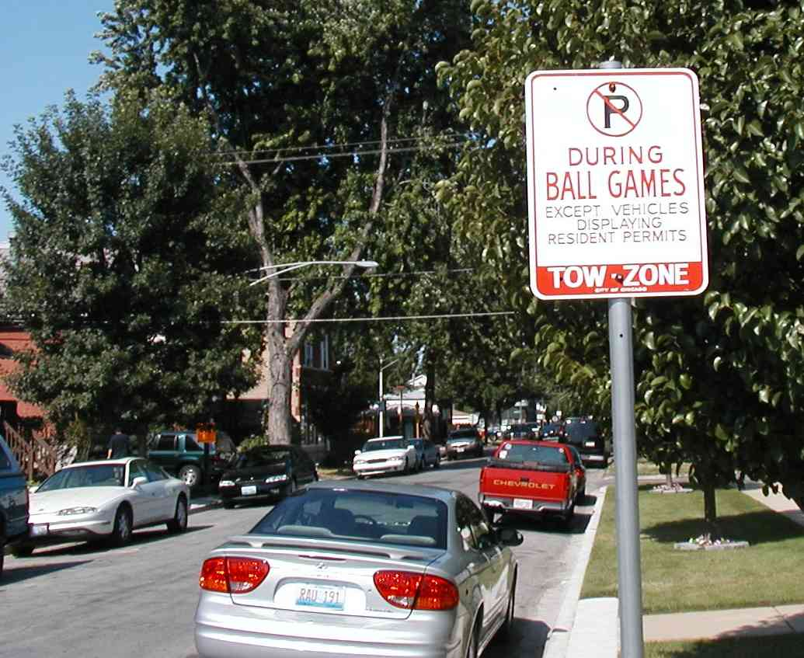
Annotated Planning Timeline

In cases where an event planning team collectively develops a feasibility study, traffic management plan, and associated mitigation strategies, an annotated planning timeline proves effective for monitoring team progress.

The Wisconsin DOT found such a tool useful for tracking specific traffic management planning and infrastructure deployment activities required to prepare for the opening of Miller Park in Milwaukee. The agency maintained a responsibility matrix listing each action item, the stakeholder responsible, the due date, and the present deployment status. An event planning team should establish an annotated planning timeline early in the event operations planning phase and use the tool to guide subsequent team meeting agendas as stakeholders develop event impact mitigation strategies and tactics.

Review Process

Adopting a formal review process reduces unnecessary delay in producing event operations planning deliverables required to stage a planned special event. Key aspects to be considered include:

- The review process should feature the oversight team monitoring and reviewing plans developed by the event planning team.
- The oversight team typically consists of mid-to-upper level representatives of transportation agencies and law enforcement in addition to elected officials and ranking officials of other public agencies.
- A regional organization may assume the duties of an oversight team.
- Under a formal review process, an event planning team may seek oversight team approval of a feasibility study scope or conceptual traffic management plan prior to commencing work on the final deliverable. Both stakeholder groups interact again to review feasibility study results and final traffic management operations plans.
- Some jurisdictions have a champion charged with resolving institutional and operations issues affecting travel management for planned special events. These champions have the position to mitigate issues hampering the event operations planning process. Therefore, they should administer the review process.
- Jurisdictions should have an alternate official ready to replace the current champion should that person resign from present duty.

Performance Standards

This chapter included a review of various transportation system operations performance objectives and associated measures of effectiveness that stakeholders may use to monitor system performance on the day-of-event and, in turn, evaluate travel management efforts. During the event operations planning phase, stakeholders must set and agree to performance standards used to assess traffic impact mitigation proposals. These performance standards typically represent level of service (LOS) measures applicable to freeway and street segments, freeway junctions, and roadway intersections. Stakeholders assigned to develop mitigation strategies or review planned special event impacts on traffic should reference jurisdiction Traffic Impact Study guidelines defining accepted LOS thresholds. The LOS thresholds likely vary by roadway classification. In urban and metropolitan areas, jurisdictions may deem an LOS D, describing high-density stable flow, acceptable for freeways, arterials, and major intersections. Similarly, an LOS C, describing stable flow, may represent the allowable threshold for local streets and intersections. Small urban and rural areas may have more stringent requirements. Jurisdictions may relax their performance standards and allow LOS E operation, describing unstable capacity flow, on major roadway facilities for infrequent planned special events.

Policies and Agreements

The establishment of special policies and agreements to support planning and day-of-event management of planned special events facilitates efficient stakeholder collaboration and defines important event support stakeholder services that may be incorporated into a traffic management plan for a particular planned special event. These initiatives improve interagency relationships, clarify decision-making responsibilities and expectations, and secure on-call services and agency actions. For instance, a particular policy or agreement may intuitively support a contingency response plan to mitigate unanticipated congestion delay on the day-of-event. Stakeholders may develop policies and agreements specific to a particular planned special event or for all planned special events in a region. Because of the potential significant time to develop and approve a particular policy or agreement, stakeholders should establish these initiatives early in the event operations planning phase or during the program planning phase.

Table 5-8 summarizes four types of policies and agreements involving stakeholders responsible for event operations planning and/or day-of-event operations.

Interagency Agreement

Interagency agreements include a joint operations policy, memorandum of understanding, or mutual-aid agreement between two or more stakeholders. Table 5-9 lists components of interagency agreements. Appendix C contains an Illinois and Washington State joint operations policy, between state DOT and state police, that covers special event planning.^{(9,10)} Stakeholders may also strike an interagency agreement, during the event operations planning phase, applicable to a specific planned special event.

Standard Street Use Event Routes

The development and use of standard street use event routes reduces the level and complexity of event operations planning tasks and overall planning time. In establishing such standard routes for parades and/or street races, stakeholders simplify planning tasks, thus creating a more efficient event operations planning process. The routes specify appropriate event starting and ending points coupled with staging areas for participant assembly and disbanding.

Use of a standard street use event route offers the following advantages:

- Allows reuse of traffic management and operations plans, with minor modifications as necessary.
- Realizes a cost savings for stakeholders.
- Allows for the development of standard signs, specific to the event route and associated alternate routes for background traffic, that may be reused for future street use events.
- Allows event patrons and non-attendee road users to become familiar with traffic patterns during recurring street use events, thus minimizing potential traffic problems on the day-of-event.

Toll Facility Congestion Policy

Suspension of toll collections on turnpikes and other toll facilities during periods of heavy congestion represents a new policy concept aimed at reducing congestion and the occurrence of traffic incidents at toll plazas. A toll facility congestion policy represents a congestion mitigation strategy applicable to planned special events. Both West Virginia and Maryland have experience with this policy:

Table 5-8
Summary of Policies and Agreements Applicable to Managing Planned Special Events
ITEM | EXAMPLE APPLICATION
Interagency agreement | - Joint operations policy between stakeholders that establishes a shared role regarding event operations planning and day-of-event travel management.  - Memorandum of understanding defining stakeholder roles and responsibilities.  - Mutual-aid agreement facilitating resource sharing and/or reimbursement for services.
Standard street use event routes | - Routes established under the program planning phase for recurring street use events such as parades and races.
Toll facility congestion policy | - Suspension of tolls during periods of heavy congestion.
Public-private towing agreement | - On-call towing and recovery services during a special event.

Table 5-9
Components of Interagency Agreements

COMPONENT
- Advance planning duties and responsibilities
- Day-of-event duties and responsibilities
- Organization
- Resource sharing
- Funding reimbursement mechanisms

- A West Virginia Turnpike policy, enacted in December 2002, allows Turnpike officials to open toll plazas for 15 minutes any time vehicle queues extend at least three miles upstream of the plaza. After the 15-minute period ends, officials can determine whether the queue dispersed or if another 15-minute period is required. Under normal operations, Turnpike officials estimate that a vehicle joining a three-mile queue takes approximately 15 minutes to pass through a toll plaza. Officials noted 15 minor crashes occurred on the Sunday after Thanksgiving in 2002, the Turnpike’s busiest day of the year.⁽¹¹⁾
- State legislators in Maryland debated a proposed bill in 2003 to create a similar policy for the Chesapeake Bay Bridge.⁽¹²⁾ The bill specifies suspending tolls if a traffic queue extends more than five miles upstream of the toll plaza and is moving at less than 30 miles per hour. The increasing deployment of electronic tolling may obviate the need for these strategies in the future.

Public-Private Towing Agreement

Private towing companies perform a specific functional activity in traffic incident management, that is, removal of disabled or wrecked vehicles, spilled cargo, and debris from an incident site. Law enforcement and traffic operations agencies alike have recognized the indispensable role private towing companies have in effecting incident removal and restoring the affected road section back to normal operation. Public agencies commonly enter into agreements with one or more commercial towing companies to secure on-call traffic incident clearance services, or at a minimum, the agencies maintain a contact list of local private towing companies.

Traffic incident management represents a key consideration in event operations planning. Event planning team stakeholders may establish event-specific public-private towing agreements to secure on-site towing and recovery services. For instance, the City of Cincinnati has established, under the City rules and regulations for police rotation wreckers, a special event tow category.⁽¹³⁾ The City defines a special event tow as “when tow operator remains with police officer for a specified period of time towing or moving vehicles as need arises.” The City regulation specifies a special event tow rate of $20.00 per tow or $35.00 per hour, whichever is greater.

FEASIBILITY STUDY

Overview

The structure and approach of a planned special event feasibility study resembles a Traffic Impact Study required for planned developments, as illustrated in Figure 5-5. The figure shows the sequential steps in preparing a feasibility study for a planned special event.

Table 5-10 provides an overview of the first five feasibility study components. The accuracy of one analysis influences that of another. Achieving predictability, a goal of managing travel for planned special events, represents the focus of a feasibility study effort.

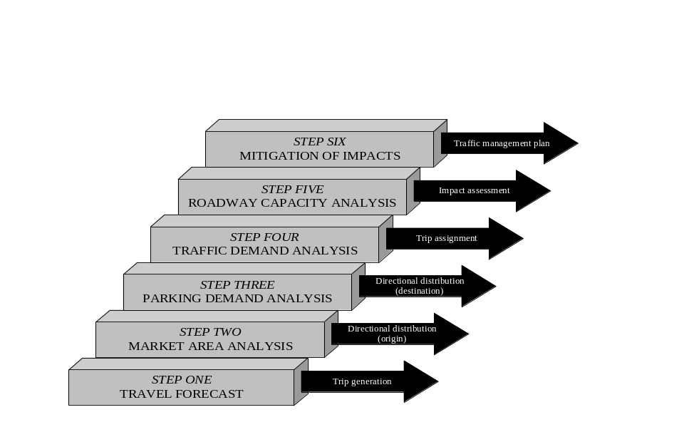

Figure 5-5
Feasibility Study Analysis Steps

Table 5-10
Feasibility Study Analysis Summary
COMPONENT | ANALYSIS | RESULT | APPLICATION
Travel forecast | - Modal split | - Number of trips by mode of travel | - Input into parking demand analysis.  - Input into traffic demand analysis.
Travel forecast | - Event traffic generation | - Number of vehicle trips by personal automobile
Travel forecast | - Traffic arrival rate | - Number of trips per unit of time
Market area analysis | - Event trip origin | - Geographic location of event trip origins and percent split | - Input into traffic demand analysis.
Parking demand analysis | - Background parking occupancy | - Number of non-attendee vehicles per parking area and unit of time | - Input into event parking occupancy.
Parking demand analysis | - Event parking demand | - Number of event-generated vehicles per parking area and unit of time | - Input into traffic demand analysis.
Traffic demand analysis | - Background traffic flow | - Background traffic demand rate, adjusted for event-required road closures | - Input into roadway capacity analysis.
Traffic demand analysis | - Event traffic assignment | - Event traffic demand rate per assigned route | - Input into roadway capacity analysis.
Roadway capacity analysis | - Section and point capacity | - Identification of capacity constraints and level of service | - Input into traffic management plan.  - Input into travel demand management assessment.
Roadway capacity analysis | - Network operations | - Identification of bottleneck locations and saturation flow rates

The feasibility study gauges the impact a proposed event has on traffic and parking operations in the vicinity of the venue. It determines if a particular planned special event will cause travel problems, where and when the problems will occur, and the magnitude of each identified problem using various MOEs. Initially, the study is conducted without roadway capacity improvements or initiatives to reduce travel demand. Once the feasibility study identifies event travel problems, practitioners can take steps to mitigate transportation system deficiencies. These results define the scope of the traffic management plan required to successfully manage travel for a planned special event.

Data Requirements

Feasibility study input data requirements reflect measures of the three core factors that determine the impact of the event: travel demand, road/site capacity, and event operation. Table 5-11 summarizes various types of input data to consider in a feasibility study. This includes transportation system infrastructure, background traffic, and area data and information. With the assistance of other event planning team stakeholders most data types are accessible.

Travel demand data is used to develop the event travel forecast and to determine the event area of impact. Background traffic data describes the scope of available roadway and parking capacity for event patron traffic. Information regarding the venue area assists in identifying possible event patron trip origins. For example, a venue located in a downtown area may attract a significant number of patrons arriving from work, thus possibly reducing the number of transit or vehicular trips generated. Events having a regional or greater scope may involve a significant number of patrons staying at area hotels. To increase travel forecast accuracy and meet the goal of achieving predictability, practitioners should research appropriate historical data.

The identification and quantification of site and transportation system capacity involves performing a full inventory of the transportation system infrastructure serving the event venue. This includes obtaining data on roadway geometrics and associated regulations (e.g., speed limits and travel restrictions). An inventory of freeway facilities should include the capacity of such freeway components as ramp junctions and weaving sections. In addition, street traffic control devices and signal timing plans must be identified and saturation flow rates determined.

Event operation characteristics impact both travel demand and available capacity. The knowledge of certain event logistics, combined with available historical data, can help predict the rate of event patron arrivals and departures over time. Practitioners, in tandem with the event organizer, must also identify the scope of road closures and parking area needed just to stage the event (e.g., parade/race route, hospitality areas, etc.). This does not include the roadway capacity and parking needed to accommodate event patron traffic.

Travel Forecast

Travel forecast analysis involves estimating: (1) modal split, (2) event traffic generation, and (3) traffic arrival rate. Event planning team stakeholders that typically collaborate on this analysis include a traffic operations agency, traffic engineering consultant, transit agency, and event organizer. The event organizer supplies key input data regarding event operation. The transit agency assists

Table 5-11
Feasibility Study Data Requirements
FACTOR | INPUT DATA | DESCRIPTION
Travel Demand | - Event patron traffic | - Daily attendance  - Event patron demographics (e.g., advance/season ticket holder place of residence or zip code)  - Admission (general/reserved seating and free/cost)  - Venue attendance capacity  - Acceptable walking times (e.g., to determine available parking areas and percent walking trips)
Travel Demand | - Background traffic | - Hourly traffic volumes  - Existing parking occupancy  - Vehicle classification
Travel Demand | - Venue area | - Employment centers in venue vicinity (e.g., number of jobs)  - Hotels in venue vicinity
Travel Demand | - Historical data (similar events) | - Attendance (e.g., trip generation rate)  - Hourly traffic volumes  - Parking demand (e.g., parking demand rate)  - Vehicle occupancy  - Hourly/sub-hourly event patron arrival and departure distribution  - Modal spilt  - Patron survey (e.g., demographics and travel)
Road/Site Capacity | - Roadway facilities | - Existing, areawide roadway network  - Freeway and arterial corridors  - Local street facilities connecting corridors and the venue site  - Location and capacity of site access points  - Pedestrian (e.g., sidewalks and crossings) and bicycle accommodation  - Geometrics, regulations, and lane assignments  - Traffic control devices and traffic signal programming data  - Toll plazas (freeway or bridge/tunnel) in venue vicinity
Road/Site Capacity | - Parking availability | - Location and capacity of site access points  - Location and capacity of off-street venue parking areas (free and paid)  - Location and capacity of permitted on-street parking areas  - Location and capacity of overflow parking areas
Road/Site Capacity | - Transit availability | - Number and location of transit stations serving venue (e.g., public transportation – bus and rail)  - Scope of transit services at identified stations (e.g., schedule and capacity)  - Origin and scope of established express and charter bus service to venue (e.g., scheduled bus service from park and ride lots for special events only)  - Base transit spilt (e.g., without incentive or promotion)
Event  Operation | - Event logistics | - Venue location  - Event hours of operation  - Site opening and closing times  - Participant accommodation (e.g., arrive by bus, stay at hotel near venue, etc.)  - Event personnel and volunteer travel demand
Event  Operation | - Site | - Required road closures to stage event
Event  Operation | - Parking | - Number of parking spaces lost in order to stage event (e.g., parking for event participants, hospitality tents, etc.)

in estimating modal split. The traffic operations agency or traffic engineering consultant performs the analysis, and either stakeholder may research historical traffic and parking data or maintain a data archive related to operations for similar planned special events.

Modal Split

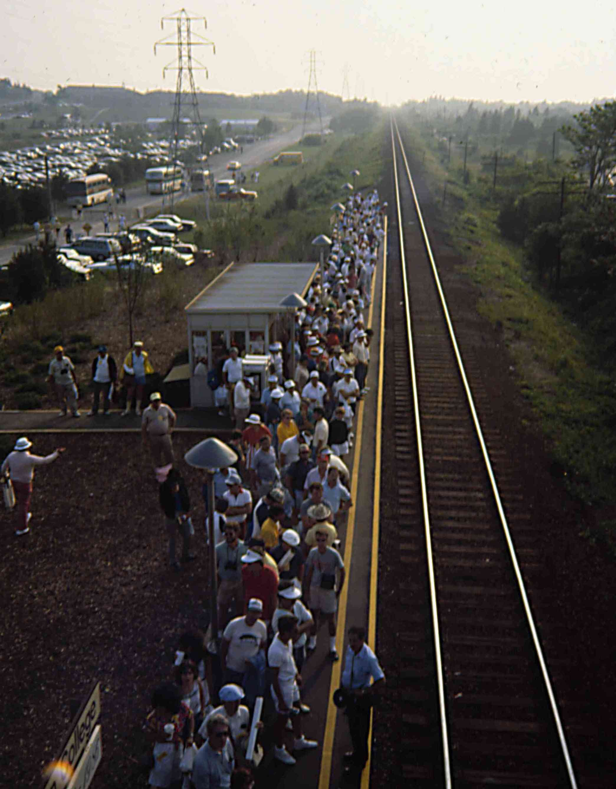
Under the scope of a feasibility study, modal split concerns identifying the existing modes of travel event patrons will use to access the event venue site. Common travel modes include personal automobile, public transit, and walking. Public transit refers to scheduled bus transit or commuter rail. Transit agencies may assist in determining a base transit split, without service incentives or promotion, for patrons traveling to/from the event.

Illustrated in Figure 5-6, some patrons of the 1986 and 1995 U.S. Golf Open in rural Southampton, NY found the Long Island Rail Road commuter rail service an efficient and convenient mode of travel to/from Shinnecock Hills Country Club. To assure consideration of appropriate roadway mitigation, transportation operations planners analyzed a range of modal split percentages in the feasibility study to account for various scenarios. Commuter rail or other people mover systems exist in several metropolitan areas across the Nation and usually provide regular service to city stadium and arena venues. Transit availability includes scheduled express and charter bus service operating from other cities, suburban park and ride lots, and city neighborhoods.

Table 5-12 lists surveyed modal splits for discrete/recurring events at a permanent venue in San Francisco, New York, and San Diego. The baseball stadium venues in San Francisco and New York, located within a metropolitan area, have excellent scheduled transit service, including commuter rail. Stadiums located in suburban areas, such as Qualcomm Stadium in San Diego, and rural areas generally have a high percentage of automobile trips.

Travel time, travel convenience, parking accessibility and cost weighs significantly on an event patron’s decision to drive or utilize an alternate mode of travel. This likely represents another contributor to the high transit split in the San Francisco example, where Pacific Bell Park resides adjacent to the downtown area. Other modes of travel include bicycle and taxi.

Figure 5-6
Commuter Rail Modal Split

Walking trips deserve consideration in modal split estimates for planned special events occurring at downtown venues. Practitioners must consider the proximity of

Table 5-12
Example Modal Split for Discrete/Recurring Events at a Permanent Venue
EVENT | ATTENDANCE | MODE OF TRAVEL
EVENT | ATTENDANCE | AUTO | TRANSIT | WALKING | OTHER
San Francisco Giants weekday baseball game – August 2000⁽¹⁴⁾ | 38,000 – 41,000  (capacity 41,000) | 48% | 41% | 8% | 3%
San Francisco Giants weeknight baseball game – August 2000⁽¹⁴⁾ | 38,000 – 41,000  (capacity 41,000) | 50% | 37% | 7% | 6%
San Francisco Giants weekend baseball game – August 2000⁽¹⁴⁾ | 38,000 – 41,000  (capacity 41,000) | 58% | 34% | 5% | 4%
New York Mets weeknight baseball game –  June 1997⁽¹⁵⁾ | 18,000  (capacity 56,500) | 59% | 41% | -- | --
San Diego Padres weekday baseball game – April/May 1998⁽¹⁶⁾ | Unknown | 85% | 12% | -- | 3%
San Diego Padres  weeknight baseball game – April/May 1998⁽¹⁶⁾ | Unknown | 95% | 5% | -- | --
San Diego Padres weekend evening baseball game – April/May 1998⁽¹⁶⁾ | Unknown | 85% | 12% | -- | 3%

employment centers, residential developments, and hotels to a planned special event venue before dismissing walking as a viable travel mode. Venues located on university campuses typically draw a measurable percentage of walking trips. Surveys for college football games have reported as many as 10 to 25 percent of event patrons arriving by foot.⁽¹⁷⁾

Practitioners can best obtain measured data on planned special event modal split through conducting a survey of event patrons. Appendix D contains an Internet-based event patron evaluation survey for those attending the 2003 Fair Saint Louis festival. In addition to querying event patrons on mode of travel, obtaining origin location information (e.g., zip code) assists event planning team stakeholders configure transit schedules or express and charter bus services for future similar events.
Event Traffic Generation

Unlike other traffic generators such as commercial developments, planned special event practitioners typically have advance knowledge of event attendance and, in turn, can develop traffic generation estimates via vehicle occupancy factors. On the other hand, traffic generation rates, based on event traffic volume or parking occupancy data, may not be appropriate for transfer and application from one special event to another. Too many variables exist with regard to event category, event logistics, event popularity, weather, and parking characteristics. Event operations and other external variables affect any application of historical data to future events.

Table 5-13 outlines a two-step process for forecasting event traffic generation. Input data includes a modal split estimate since

Table 5-13
Traffic Generation Forecast Process
COMPONENT | DETAIL
Input data | - Daily attendance | - Percent automobile trips | - Vehicle occupancy factor
Method | Step 1. (Daily Attendance) x (Percent Automobile Trips) = Person Trips Via Automobile  Step 2. (Person Trips) / (Vehicle Occupancy Factor) = Vehicle Trips
Result | - Number of vehicle trips by personal automobile both to and from the event

the traffic generation forecast aims to estimate the number of event-generated trips by personal automobile. In the absence of a daily attendance estimate, practitioners can use percentage of venue capacity as a base. However, many continuous events or street use events do not have a pre-specified venue capacity. Continuous events, such as fairs and festivals, often run for two or more days. Attendance generally fluctuates greatly from day to day, with Saturday operations yielding the highest daily attendance. A study of two-day (Saturday/Sunday) festivals in West Virginia indicated 58 percent of the total festival attendance was on Saturday.⁽¹⁸⁾ The same study noted the following total event attendance distribution for three-day festivals: 20 percent on Friday, 50 percent on Saturday, and 30 percent on Sunday. It should be recognized that daily attendance reflects scheduled headline entertainment or other main festival events.

Vehicle occupancy factors can serve as the basis for estimating event-generated traffic. Table 5-14 lists average vehicle occupancy factors for select discrete/recurring events at a permanent venue and continuous events. A discrete/recurring event at a permanent venue that occurs on the weekend will likely have a higher vehicle occupancy factor due to families and groups of tailgaters. A vehicle occupancy factor of 2.5 persons per vehicle represents a common assumption, however for forecasting purposes, practitioners should consider a range of factors from 2.2 to 2.8 depending on local conditions.⁽¹⁵⁾
Traffic Arrival and Departure Rate

In order to estimate peak traffic volumes generated by an event, practitioners must estimate the time and scope of peak traffic flow during event ingress and egress. Traffic arrival and departure rate indicates the peak period (e.g., hour or 15 minute) of event-generated traffic. The rate is used to determine the following key parameters for input into the traffic demand analysis: (1) peak period time and (2) percent of total event-generated traffic within the peak period. Event operation characteristics that influence traffic arrival and departure rates include:

- Event time and duration – e.g., specific start time, abrupt end time, continuous operation.
- Event time of occurrence – e.g., day/night, weekday/weekend.
- Audience accommodation – e.g., reserved seating, general admission.
- Event type – e.g., sports/concert, fair/festival, parade/race.

This section focuses on estimating the traffic arrival rate. The temporal share of event patron arrivals vary considerably by event type and requires prediction by practitioners. Traffic arriving to an event can potentially cause greater impacts to background traffic mobility than event departure traffic. This is attributed to arrival traffic typically traveling from high-capacity roadway facilities (e.g., freeways and arterials) to low-capacity facilities (e.g., venue access roads). Roadway

Table 5-14
Example Planned Special Event Vehicle Occupancy Factors
EVENT | ATTENDANCE | AVERAGE VEHICLE OCCUPANCY

Discrete/Recurring Event at a Permanent Venue
San Francisco Giants baseball games –  August 2000⁽¹⁴⁾ | 38,000 – 41,000  (capacity 41,000) | 2.8 persons per automobile
Anaheim Angels weeknight baseball game – July 1997⁽¹⁵⁾ | 18,197  (capacity 37,000) | 2.6 persons per automobile
Cleveland Indians Saturday baseball game – July 1997⁽¹⁵⁾ | 43,070  (capacity 43,368) | 2.64 persons per automobile
New York Mets weeknight baseball game – June 1997⁽¹⁵⁾ | 18,000  (capacity 56,500) | 2.31 persons per automobile
San Diego Padres weekday baseball game – April/May 1998⁽¹⁶⁾ | Unknown | 2.3 persons per automobile
San Diego Padres weeknight baseball game – April/May 1998⁽¹⁶⁾ | Unknown | 2.5 persons per automobile
San Diego Padres weekend evening  baseball game – April/May 1998⁽¹⁶⁾ | Unknown | 3.0-3.1 persons per automobile
Denver Broncos football games – 1998/2001⁽¹⁹⁾ | 76,000 | 3.0 persons per automobile on-site;  2.3 persons per automobile off-site

Continuous Event
1997 Stonewall Jackson Heritage Arts & Crafts Jubilee - West Virginia⁽¹⁸⁾ | 45,000 to 50,000  (four-day total) | 2.46 persons per automobile
1997 West Virginia Honey Festival⁽¹⁸⁾ | 6,000  (two-day total) | 2.15 persons per automobile
1997 West Virginia Wine & Jazz  Festival⁽¹⁸⁾ | 3,500  (two-day total) | 2.42 persons per automobile
22nd Mountain Heritage Arts & Crafts Festival – West Virginia⁽¹⁸⁾ | 25,000  (three-day total) | 2.30 persons per automobile

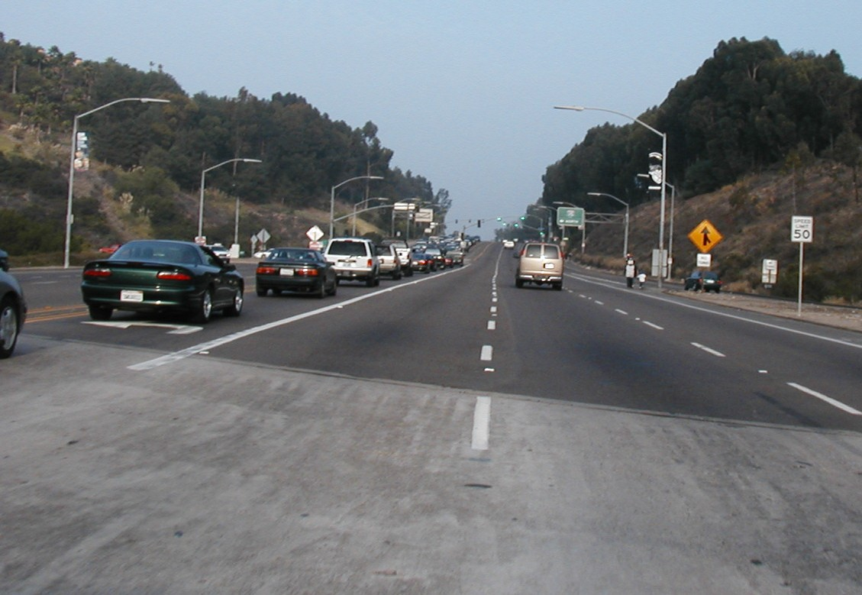
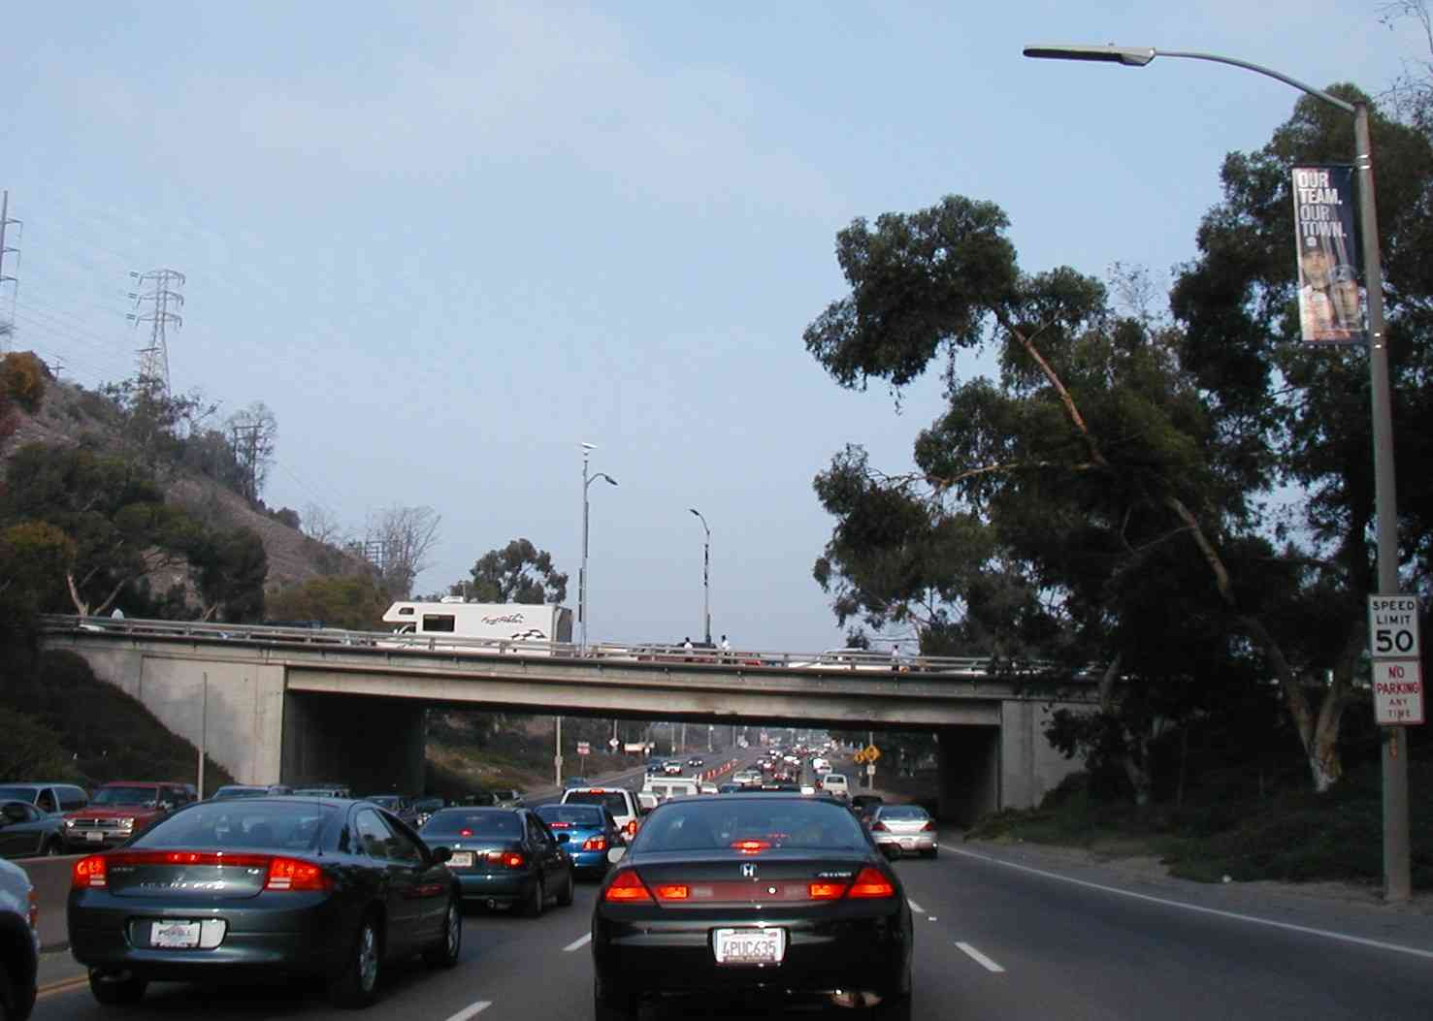
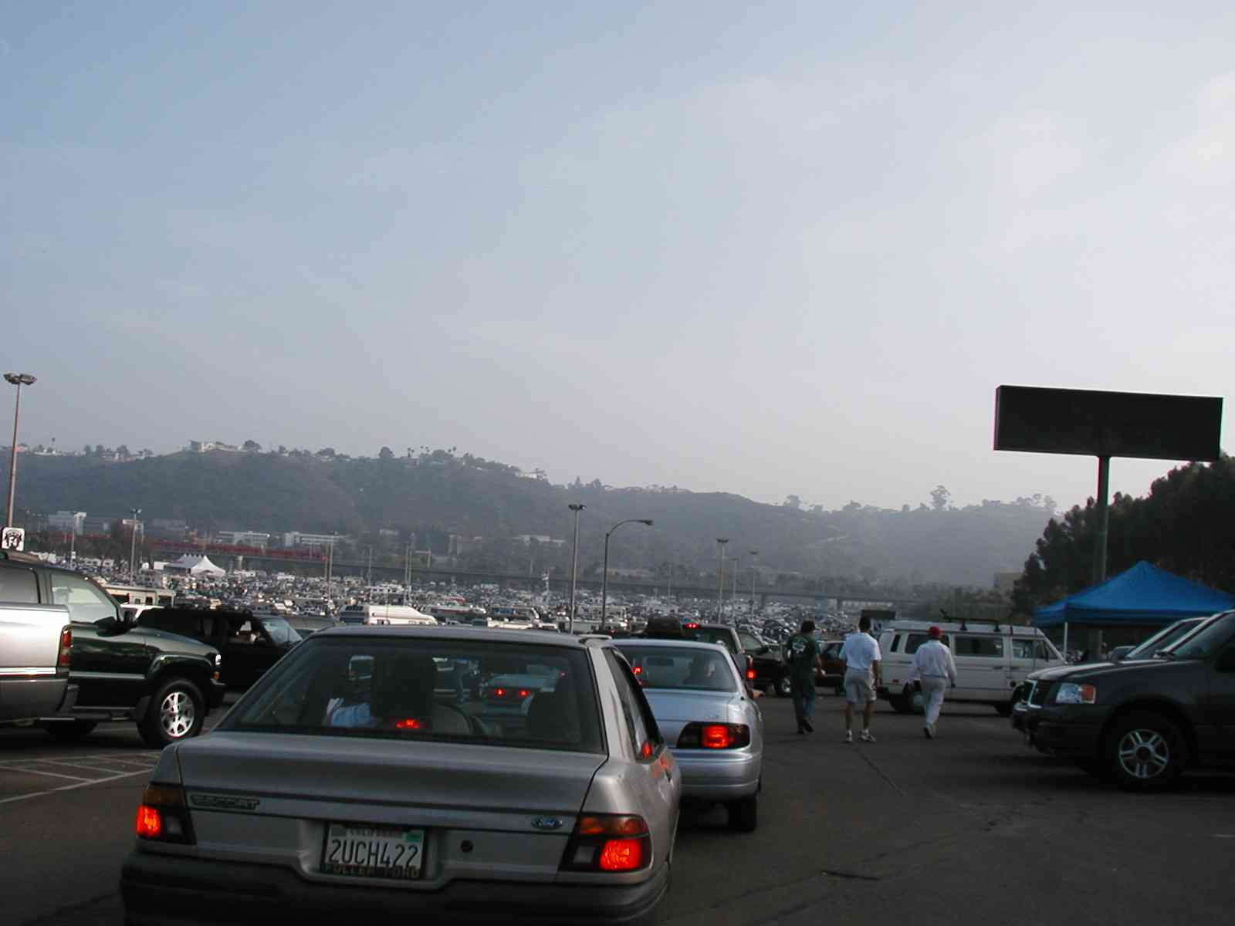

congestion that occurs during event ingress may create queue spillbacks to freeways and major streets, thus impacting background traffic.

Drivers departing an event venue site generally have little or no choice of exit routes. Roadway capacity constraints include freeway entrance ramps and turning movements to arterials and other major collector roadways. Departing traffic queues are usually constrained to the venue access roadway and
spillback into the parking areas. Figure 5-7 shows traffic operations, following a football game at Qualcomm Stadium in San Diego, CA, at: (1) a freeway entrance ramp, (2) a venue access road upstream of a freeway, and (3) an on-site venue parking area.

Figure 5-7

Event Patron Departure from a Discrete/Recurring Event at a Permanent Venue

Table 5-15 indicates traffic arrival rates and time of peak arrival for select discrete/recurring events at a permanent venue and continuous events. Time of arrival depends on audience accommodation (e.g., general admission or reserved seating) and/or the nature of pre-event activities. Such activities include tailgating or practices. Figure 5-8 illustrates NASCAR pre-race preparations that attract a significant number of event patrons well before the event start.

As illustrated in Table 5-15, the traffic arrival rate for sporting games and concerts peaks within one hour of the event start. Due to high traffic arrival concentration, practitioners may consider estimating a peak 15-minute traffic arrival rate and associated peak hour factor for roadway capacity analysis. With regard to continuous events, peak traffic arrival rate generally occurs
immediately prior to the event start. Since event patrons do not place a high priority on meeting a continuous event start time, the concentration of continuous event arrivals is relatively low compared to other event categories. The peak level of event-generated traffic demand may occur during the middle of a continuous event operating period when both event arrival and departure traffic traverse the roadway system as patrons come and go from the event.

Practitioners may use event patron travel surveys in addition to historical event-generated traffic volume and/or parking occupancy counts to estimate the traffic arrival rate and peak time of occurrence. It should be noted that weather conditions, particularly for continuous events and street use events, may significantly skew data. Thus, practitioners must exercise great care when developing future event estimates from historical data.

Table 5-15
Example Planned Special Event Traffic Arrival Rate Characteristics
EVENT | ATTENDANCE | EVENT START | SITE OPEN | PEAK TRAFFIC FLOW OCCURRENCE

Discrete/Recurring Event at a Permanent Venue
2001 NASCAR Kansas 400⁽²⁰⁾ | 100,000+ | 12:00 P.M. | 6:00 A.M. | 8:00 A.M.
Anaheim Angels weeknight  baseball game – July 1997⁽¹⁵⁾ | 18,197  (capacity 37,000) | Evening | 2+ hours before first pitch | 1 hour before first pitch (82% of arrivals – 29% peak 15 minutes)
Cleveland Indians Saturday  baseball game – July 1997⁽¹⁵⁾ | 43,070  (capacity 43,368) | Afternoon | 2+ hours before first pitch | 1 hour before first pitch (67% of arrivals – 19% peak 15 minutes)
New York Mets weeknight  baseball game – June 1997⁽¹⁵⁾ | 18,000  (capacity 56,500) | Evening | 2+ hours before first pitch | 1 hour before first pitch (62% of arrivals – 16% peak 15 minutes)

Continuous Event
Louisiana World Exposition in New Orleans – weekday August 1984⁽²¹⁾ | 35,700 | 10:00 A.M. | -- | 31% of event patrons arrived by 11:00 A.M.
Louisiana World Exposition in New Orleans – Saturday in August 1984⁽²¹⁾ | Unknown | 10:00 A.M. | -- | 29% of event patrons arrived by 11:00 A.M.

Figure 5-8
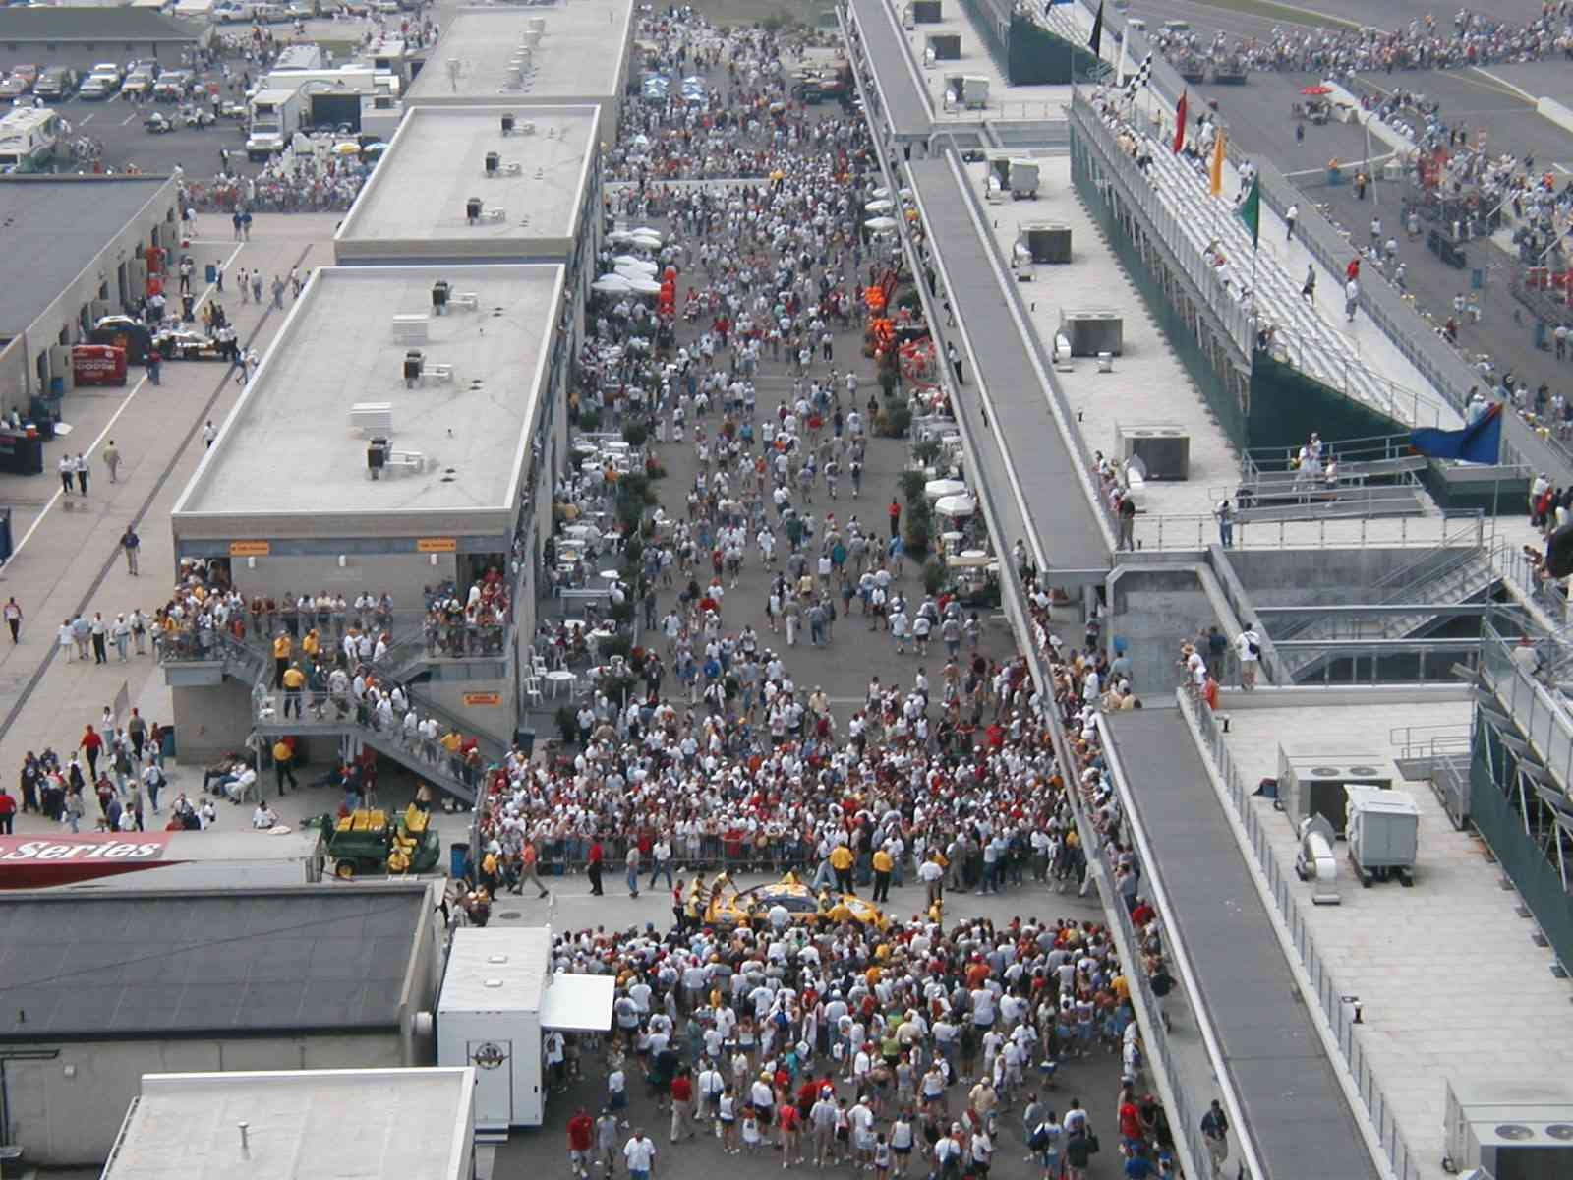
Pre-Event Activity

Market Area Analysis

A market area analysis identifies the origin and destination of trips to and from a planned special event. The analysis focuses on developing a regional directional distribution of event patron trips to/from an event site via personal automobile. The site refers to the collective parking areas serving the venue. A regional directional distribution specifies: (1) the freeway and arterial corridors serving the venue site and (2) the percent split and volume of event-generated automobile trips traversing each corridor. Appendix E contains a regional directional distribution prepared for the NASCAR Kansas 400 race.⁽²⁰⁾

Table 5-16 summarizes three analysis methods used to define a planned special event market area.

Travel Time and Distance Analysis

Practitioners can apply a travel time analysis or distance analysis to estimate the market area for any planned special event. Continuous events or street use events that do
not offer advance ticket sales typically require a market analysis based on travel time or distance and referencing area population distribution.

Figure 5-9 illustrates an example travel time analysis for a downtown Chicago lakefront fireworks display. A geographic information system or other mapping software tool can create travel time zones, as shown in the figure, based on user-defined thresholds. Multiple travel time zones allow users to perform a weighted analysis of population distribution. Practitioners should categorize area population within each travel time zone by zip code or, for a 15 minute threshold or less, by census tract. Most geographic information systems and computer mapping tools generate spreadsheets identifying all spatial population categories within each travel time zone. Using the spreadsheet, practitioners can assign a freeway or arterial corridor, serving the event venue site, to each defined population category. The population distribution among roadway system corridors constitutes the regional directional distribution for the planned special event. Practitioners can also incorporate Census socioeconomic data into an analysis as necessary.

The described travel time analysis methodology applies to a distance analysis as well. Instead of travel time thresholds, users define distance thresholds. Practitioners should exercise care in developing a planned special event market area by travel time or absolute distance to the event venue site:

- In the case of continuous events or street use events, the market area must incorporate only the community or region the event is staged for.

Table 5-16
Market Area Analysis Methods
METHOD | DESCRIPTION
Travel time analysis | - Determine population distribution within travel time threshold of event venue.
Distance analysis | - Determine population distribution within distance radius of event venue.
Origin location analysis | - Determine weighted distribution of known origins by place or zip code.

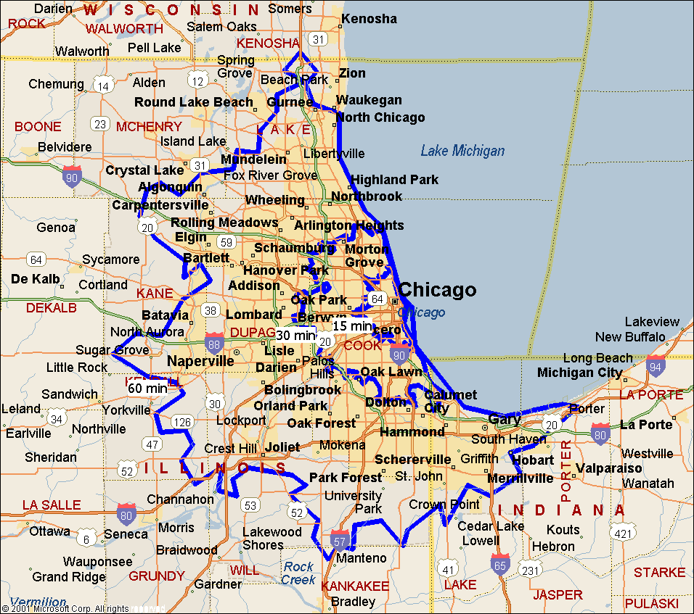

Figure 5-9
Example Travel Time Analysis

- Discrete/recurring events at a permanent venue, such as professional/major college sporting events or major concerts, warrant an expanded market area.
- A travel time or distance analysis for these events should not reflect a sensitivity to travel time or distance at the city/suburb level. In other words, an event patron located in a city suburb typically does not factor travel time into a decision to attend a professional or major college sporting event at a downtown venue.

Origin Location Analysis

An origin location analysis represents the most accurate method for developing an event-specific regional directional distribution. This analysis utilizes a statistically significant database of event patron travel origins. Input data includes advance or season ticket holder place of residence (e.g., place or zip code) or place of trip origin obtained through a past/similar event travel survey. An event economic impact study also indicates the cities or regions patrons will arrive from. A discrete/recurring event at a permanent venue requires ticket sales, and event organizers initiate ticket sales weeks and even months in advance of the event. But, event organizers or ticket sales companies may consider customer information confidential or proprietary.

An event patron travel survey (see Appendix D) proves effective in determining the exact origin of a patron trip to a planned special event. For instance, weekday events may attract a significant percentage of non-home-based trips as event patrons arrive from work. A survey of patrons attending weeknight baseball games at Pacific Bell Park in San Francisco indicates 28 percent of patrons come from work.⁽¹⁴⁾ An event patron travel survey captures this critical information. Event patron departures from the event venue site typically involve home as a destination.

Practitioners performing an origin location analysis determine a geographical distribution of event patron origins. In turn, this distribution defines the freeway and arterial corridors that event patrons will use to access the event venue site in addition to a traffic distribution. An origin location analysis applies to all planned special events.

Parking Demand Analysis

A parking demand analysis functions to determine the amount of required parking for event patrons in the vicinity of the event venue. A parking occupancy study drives the overall analysis and determination of event parking areas. This study indicates the level of parking spaces occupied, relative to lot capacity, at intermittent time intervals. It also specifies an estimate of peak parking demand, a figure particularly useful for managing continuous events where parking space turnover occurs throughout the event day.

Figure 5-10 presents a parking demand analysis process used to determine the adequacy of event venue (on-site) parking and the identification of appropriate off-site parking areas. The flowchart denotes an analysis conducted for a one-time interval. Practitioners should perform an iterative parking demand analysis, over hourly time periods as necessary, if considering parking areas characterized by high background parking turnover.

Examination of on-site parking areas must account for spaces lost to the event sponsors, bus staging, limousine and taxi staging, media parking, event employee parking, and event participant parking. Net parking supply incorporates event staging needs and any background traffic that can legally use the parking area during event hours of operation. In order to conceptually measure parking supply within a non-striped area, assume 150 cars per acre as a rule of thumb.⁽²²⁾ The travel forecast analysis yields an estimate of parking demand by quantifying the anticipated number of event-generated automobile trips. Aside from continuous events, practitioners should perform a parking demand analysis that accounts for maximum event-generated parking demand.

In evaluating parking supply versus demand, consider as a rule of thumb that 90 to 95 percent lot occupancy represents a full parking area.⁽²³⁾ This especially applies under scenarios where event patrons must self-park. When a parking area reaches a near-capacity occupancy level, drivers experience difficulty locating an empty parking space and must circulate through the lot again or seek another parking area. Continuous events and street use events often utilize self-park areas.

Overflow parking areas comprise both on-street parking and public/private off-street parking areas, located off-site but in the immediate vicinity of the event venue. Figure 5-11 shows a designated off-street parking area, as noted by a light post banner, for the Summerfest music festival in downtown Milwaukee, WI. Identification of off-site parking areas depends on walking distance to the event venue. For example, a 15-minute walking time threshold allows consideration of off-street parking areas within 3,600 feet of an event venue, assuming a pedestrian walking speed of 4 feet per second. Parking areas located further from the venue would require a continuous shuttle service.

Table 5-17 shows a parking occupancy summary for a regional/multi-venue event in downtown Denver, CO. The spreadsheet format conveniently organizes and presents occupancy estimates by time of day and day of week. A parking demand analysis for a regional/multi-venue event presents special challenges. Practitioners must determine the hourly parking requirements for each facility separately. Parking areas in this case function under shared parking operation, servicing variable demand rates from different planned special events over the course of a day.

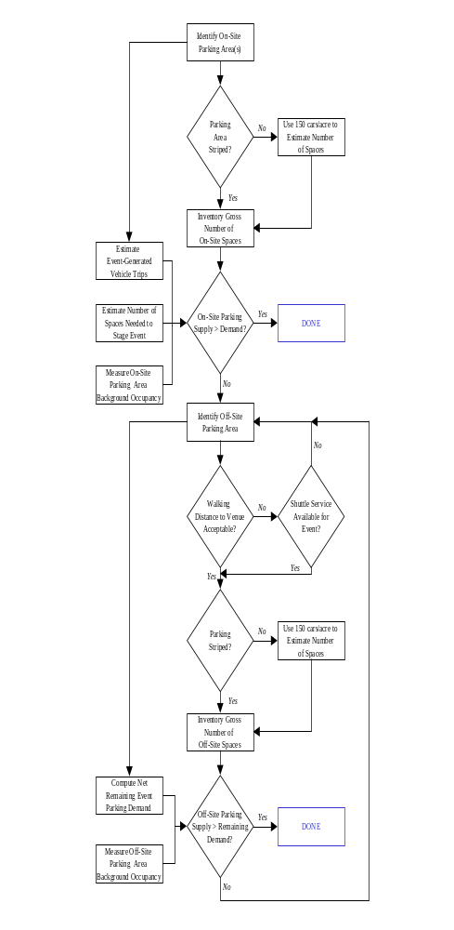

Figure 5-10
Parking Demand Analysis Process

Figure 5-11
Designated Event Off-Site Parking Area

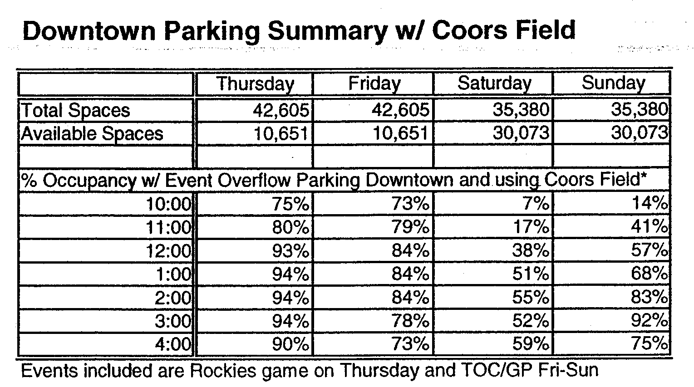

Table 5-17
Example Event Parking Occupancy
Summary⁽²³⁾

Traffic Demand Analysis

A traffic demand analysis determines: (1) a local area directional distribution and (2) the overall assignment of event-generated traffic. This analysis references results obtained through the travel forecast, market area analysis, and parking demand analysis.

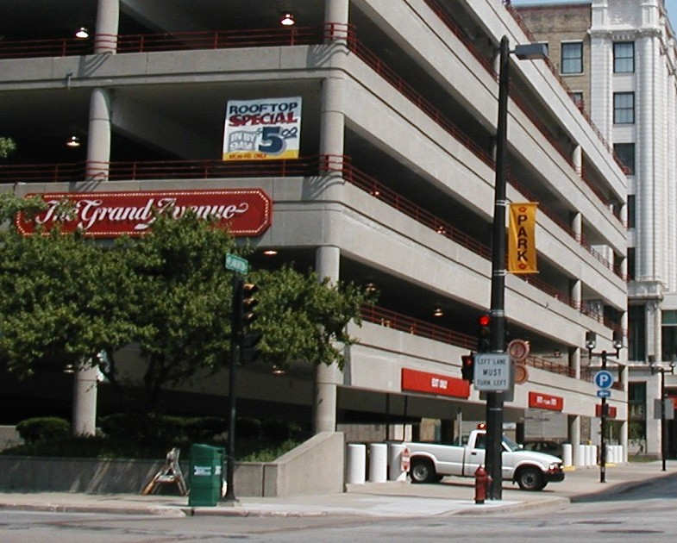

The local area directional distribution indicates freeway ramps and intersections, including turning movements, traversed by event-generated traffic arriving to or departing from a planned special event. The regional directional distribution, as determined in the market area analysis, quantifies the percentage of event patron trips (e.g., origins) by regional freeway and arterial corridor, and the planned special event parking areas, as determined in the parking demand analysis, represent sink nodes or location of trip destination. Traffic assignment includes event-generated automobile traffic, express buses, charter buses, limousines, and other vehicles transporting event patrons, participants, and event employees. Practitioners performing traffic demand analyses should possess a personal knowledge of the roadway system surrounding an event venue in addition to existing traffic conditions.

A parking demand analysis assesses event parking sufficiency. The analysis does not define local traffic patterns to/from individual parking areas. Practitioners, instead, must gauge the utility associated with drivers choosing individual parking areas. The key components comprising this utility include driving time, parking cost, and walking time.⁽²⁴⁾ The attractiveness of each lot varies by freeway or arterial corridor serving the event site, yet event patrons will accept a moderate increase in overall driving/walking time in exchange for a substantial parking cost savings. The event planning team and traffic management team must recognize such driver behavior and formulate the appropriate traffic flow routes and develop traffic management strategies to manage site access and circulation effectively. Figure 5-12 illustrates one strategy, instituting on-street parking restrictions on the day-of-event. Pre-trip and en-route traveler information also influences driver choice regarding parking selection.
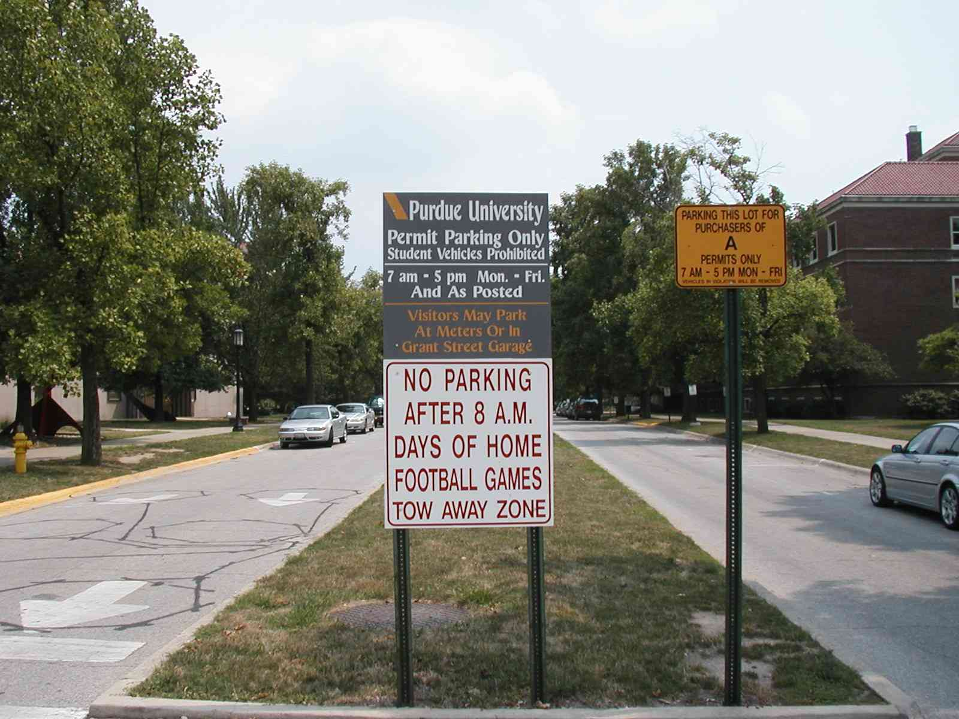
Figure 5-12
Local Area Planned Special Event Parking Restriction

Traffic demand analysis includes developing composite background and event-generated traffic projections for all roadway system facilities serving the event venue. Composite traffic volumes expressed as an hourly (or sub-hourly) rate meet roadway capacity analysis input requirements. These rates identify the peak hour capacity analysis periods during event patron arrival and/or departure. Practitioners must adjust background traffic volumes to account for displaced and diverted traffic due to road closures required to stage the planned special event. These road closures alter traffic patterns to/from commercial trip generators, residential areas, and places of worship. Displaced background traffic assignment involves identifying the shortest path alternate route that has excess capacity.

As a preliminary step to assess the need to perform a detailed roadway capacity analysis, draw a circular screen line (e.g., 0.5 to 1 mile radius) around the event venue site. Note each roadway segment intercepted by the screen line, and estimate the segment’s capacity in each direction of travel. Create a chart of hourly composite traffic volumes for each identified segment, and assess capacity deficiencies in both directions of travel. Figure 5-13 shows a preliminary road segment capacity analysis conducted as part of a feasibility study for a regional/multi-venue event in Denver, CO.
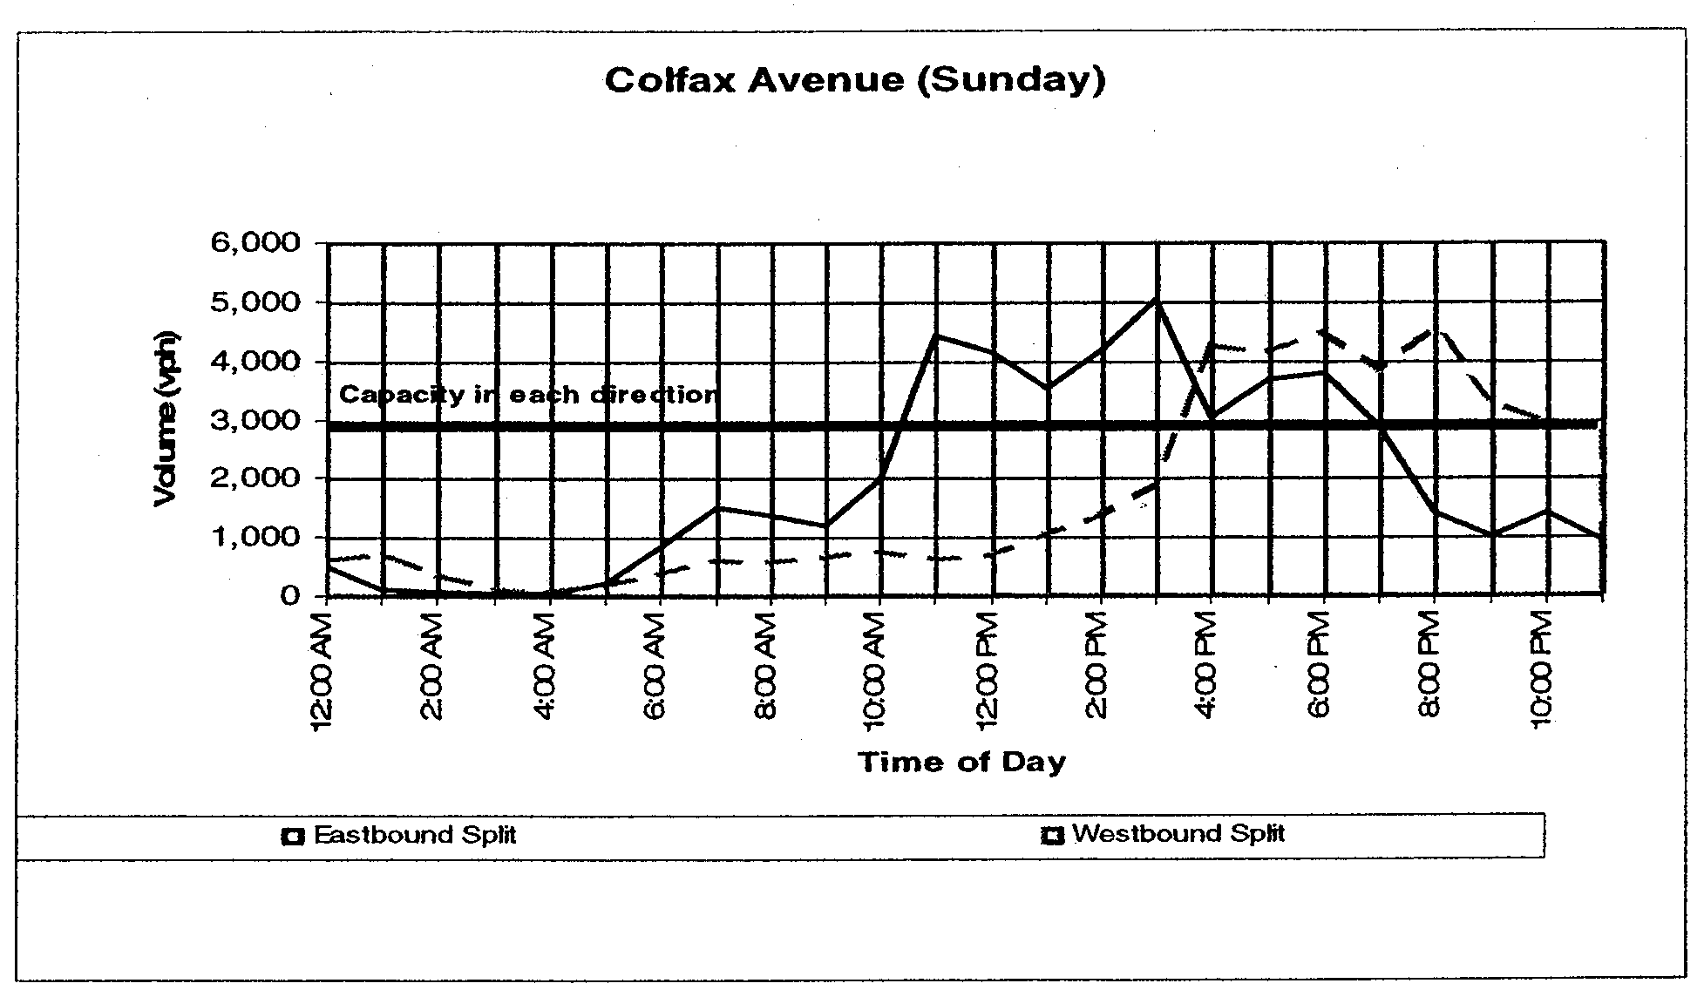
Figure 5-13
Example Preliminary Road Segment
Capacity Analysis⁽²³⁾

Roadway Capacity Analysis

A roadway capacity analysis uses traffic demand analysis results to measure the impact of a proposed planned special event on roadway system operations. At the feasibility study level, a roadway capacity analysis references existing roadway facility operations and capacity (e.g., no reverse flow operation or other capacity enhancements). The analysis assumes pedestrian access management strategies will minimize pedestrian/vehicular conflicts, and parking area access points provide sufficient service flow rates through proper design. Regardless of capacity analysis outcome, pedestrian accommodation and parking management represent key considerations in a planned special event traffic management plan.

Roadway capacity analysis involves freeway segments, freeway junctions such as ramps and weaving areas, street segments, signalized intersections, and unsignalized intersections. To evaluate these facilities, practitioners can employ one of two approaches: (1) analyze section and point capacity or (2) analyze network operations.

- The first approach pertains to applying Highway Capacity Manual (HCM) recommended capacity analysis methodologies to discrete locations in the study area. Practitioners determine roadway sections, freeway junctions, or intersections for analysis, then apply an appropriate HCM methodology to identify movement capacity constraints and measure operations level of service.
- The latter approach concerns utilizing a computer traffic simulation model to identify bottleneck locations, or hot spots, and associated saturation flow rates. Practitioners scope the size and detail of the simulation model network, and the model works to reveal operational deficiencies.

Computer traffic simulation models provide seamless analysis of traffic operations across a network of roadway segments and intersections. This proves particularly useful in analyzing a corridor of closely spaced traffic signals where signal coordination and vehicle spillback from adjacent intersections sharply impact traffic operations. Numerous macroscopic and microscopic simulation models exist, including the CORSIM microscopic computer traffic simulation model developed and supported by FHWA. CORSIM can interface component freeway (FRESIM) and arterial (NETSIM) simulation models. For example, it has the capability of showing a freeway entrance ramp bottleneck and the resulting queue spillback on adjacent streets (or vice versa). As shown in Figure 5-14, CORSIM also affords practitioners and event planning team stakeholders the opportunity to view an animation of simulated traffic operations.
Figure 5-14
CORSIM Simulation Animation

Mitigation of Impacts

Mitigating anticipated planned special event impacts on travel represents the ultimate goal of conducting a feasibility study. The mitigation of congestion and potential safety impacts identified through a feasibility study requires development of a traffic management plan and complementing travel demand management strategies. In turn, practitioners can utilize the tools and techniques used to determine feasibility study results in order to evaluate various mitigation strategies and determine if the selected strategies adequately mitigate identified transportation system deficiencies.

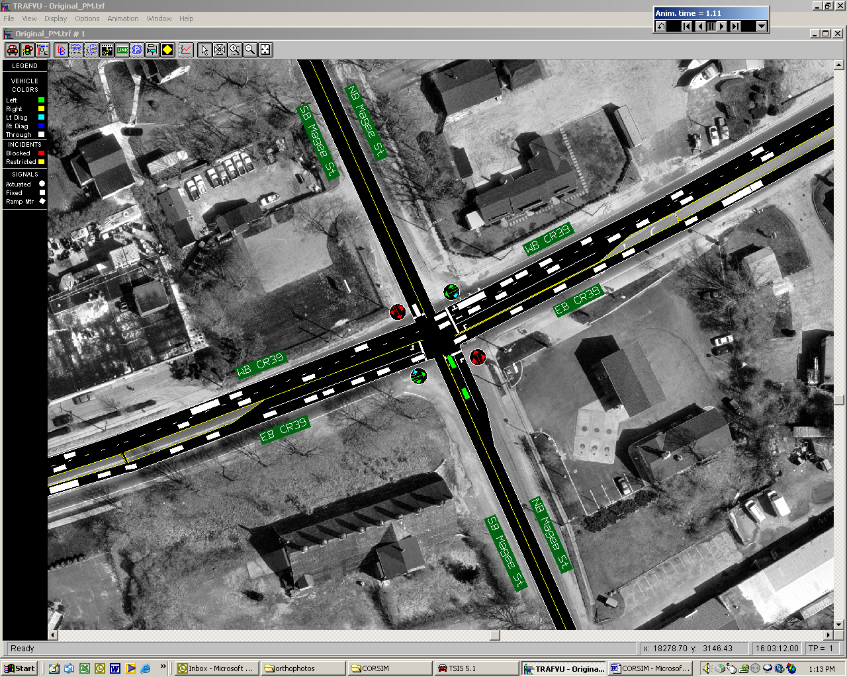
Table 5-18 lists numerous tools for mitigating planned special event impacts on local roadway and regional transportation system operations. In meeting the overall travel management goal of achieving efficiency, these tools target utilizing the excess capacity of the roadway system, parking facilities, and transit. Through travel demand management, event planning team stakeholders develop attractive incentives and use innovative communication mechanisms to influence event patron decision-making and, ultimately, traffic demand. Chapters 6 and 7
Table 5-18
Tools for Mitigating Planned Special Event Impacts on Transportation System Operations
CATEGORY | EXAMPLE TOOLS

Traffic Control and Capacity Improvements
Freeway traffic control | - Ramp closures or additional capacity  - Alternate routes  - Ramp metering
Street traffic control | - Lane control  - Alternative lane operations  - Road closures  - On-street parking restrictions  - Trailblazer signing  - Parking management systems
Intersection traffic control | - Access and turn restrictions  - Advance signing to improve traffic circulation  - Traffic signal timing and coordination
Traffic incident management | - Service patrols  - Tow truck staging  - Advance congestion warning signs  - Portable lighting

Traffic Management
Traffic surveillance | - Closed-circuit television systems  - Field observation  - Aerial observation  - Media reports  - Portable traffic management systems
En-route traveler information | - Changeable message signs  - Highway advisory radio  - Media  - Static signing  - Destination signing

Travel Demand Management
Transit incentives | - Public transit service expansion  - Express bus service from park and ride lots  - Charter bus service
High occupancy vehicle incentives | - Preferred parking  - Reduced parking cost
Event patron incentives | - Pre-event and post-event activities
Bicyclist accommodation | - Bicycle routes and available parking/lock-up
Local travel demand management | - Background traffic diversion  - Truck diversion
Pre-trip traveler information | - Internet  - Telephone information systems  - Public information campaign  - Event and venue transportation guide  - Media

detail impact mitigation strategies and tactics.

EXTERNAL FACTORS AFFECTING SCOPE OF EVENT IMPACT

Overview

This chapter summarizes event operations planning and impact analysis activities that address the core factors affecting planned special event severity. That is, travel demand, road/site capacity, and event operation. A number of secondary factors warrant consideration in the event operations phase, including:

- Available resources
- Weather
- Concurrent roadway construction
- Concurrent planned special events

These factors can greatly influence the level of impact a planned special event has on transportation system operations. By gaining an understanding of the special challenges that these external factors present, the event planning team can develop appropriate contingency response plans, using the tools and strategies presented in Chapters 6 and 7, to mitigate infrequent but high-impact scenarios.

An assessment of the level of impact that an external factor has on travel during a particular planned special event involves the consideration of the following components:

- Duration – temporal impact (e.g., when does the external factor impact operations and for how long?).
- Extent – spatial impact or scope of area
affected (e.g., does the external factor impact a particular corridor or the entire region?)
- Intensity – volume of impact (e.g., how severe is the impact?)

Practitioners should express the impact of an external factor in terms of how it affects travel demand, road/site capacity, and personnel/equipment resource quantities. Feasibility study input data can reflect adjustments made due to certain anticipated external factors, or practitioners can rerun parking and roadway capacity analyses to account for a new unexpected factor (e.g., occurrence of emergency road construction). In turn, revised results may warrant adjustments to the event traffic management plan.

Available Resources

Available resources refer to the quantity and experience of personnel and equipment available to plan and conduct day-of-event travel management operations. Besides the size of a planned special event, the level of required resources depend on time/place of occurrence, other planned special events, and equipment status.

A special factor that may place significant strain on available resources involves the occurrence of planned special events at a venue under reconstruction. Shown in Figure 5-15, venue reconstruction places additional demand on the amount of traffic management team personnel and equipment resources needed to manage events hosted by the venue during its reconstruction. Stakeholder response to on-site parking restrictions include redevelopment of traffic management plans to accommodate parking demand, pedestrian access, and traffic flow in the immediate vicinity of the venue.

Figure 5-15
Stadium Reconstruction

Figure 5-16 presents a site and pedestrian accommodation plan for 2002 Green Bay Packers games during Lambeau Field renovation. Appendix F contains contingency parking and pedestrian accommodation plans for event patrons traveling to Lambeau Field.

Weather

Weather conditions affect travel demand, road/site capacity, or both. For example, in winter, snow banks in permanent venue parking areas reduce the number of on-site parking spaces required for an event sell-out. Rain can create significant problems for unpaved parking areas and access roads. A one-day rain event totaling approximately 0.70 inches during the 2002 U.S. Golf Open forced the traffic management team to close all unpaved parking areas adjacent to the golf course. Figure 5-17 displays a traffic advisory service television announcement issued to indicate contingency parking arrangements that used paved lots.

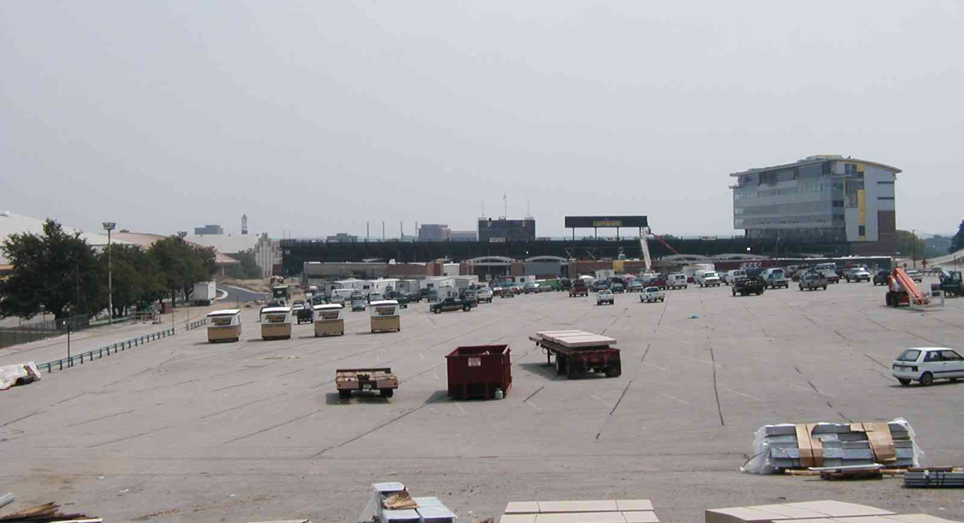
With regard to travel demand, weather conditions have a significant impact on attendance (e.g., increased attendance or reduced attendance) and/or the rate of arrivals and departures at some special events. For instance, event patrons will attend an event at a domed stadium on a rainy day, but patrons
will bypass arriving at the venue early to tailgate, thus concentrating patron arrivals.

Concurrent Road Construction and Planned Special Events

The occurrence of planned events, including road construction and other planned special events, create a range of impacts affecting different traffic management plan components. On a regional level, the characteristics (e.g., increased traffic demand, road/lane closures) of concurrent planned events reduce available capacity in roadway corridors serving a particular planned special event, thus affecting traffic flow patterns. Local impacts include reduced parking supply, in the event of other area planned special events, and restricted traffic circulation.

The identification of concurrent planned events requires interagency communication at the local, county, and state level. Figure 5-18 illustrates an example of a local department of public works (DPW) inventory, accessible through the DPW website, of active local road construction and other planned special events within the jurisdiction.

Key considerations include:

- With regard to planning for a specific planned special event, the event planning team should identify road construction activities in all jurisdictions within a certain travel time or distance radius, equivalent to the event market area, of the event venue. Appendix G contains a local stakeholder outreach letter pre pared by the Wisconsin DOT to identify local road construction in the vicinity of Miller Park and scheduled during the 2002 All-Star baseball game.
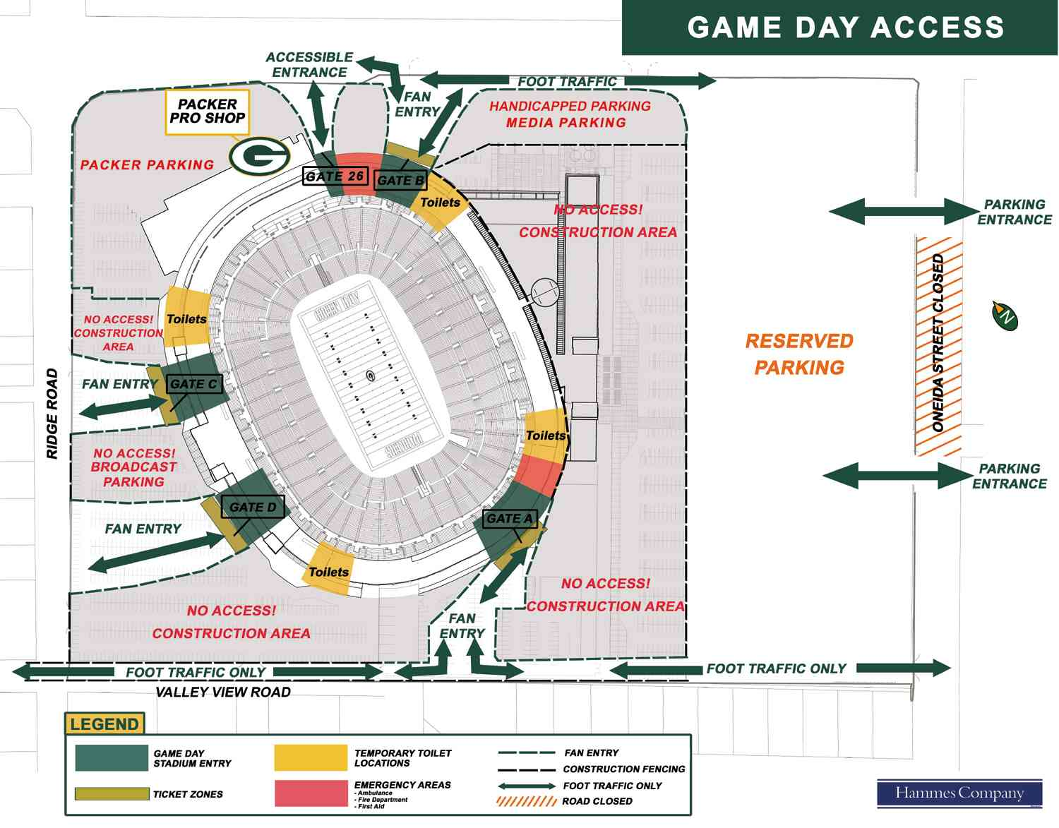
Figure 5-16
Site and Pedestrian Accommodation Plan for Stadium Reconstruction

Figure 5-17
Contingency Parking Plan for Weather
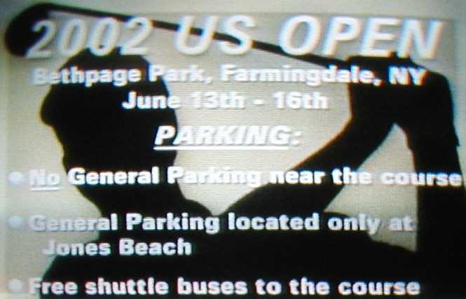
- The event planning team must also interact with area venue operators and determine a timeline of planned special events in the region, particularly those affecting the transportation system serving the subject planned special event.
- Recognizing the regional impacts (e.g., county and multi-county) of major planned special events, the event planning team should obtain information, including attendance estimates, on planned special events occurring in other metropolitan areas and areas with large venues within a certain radius (e.g., 50 or 100 miles). Highway corridors traversing one jurisdiction can realize a significant

Figure 5-18
Internet Summary of Road Construction and Planned Special Events (Graphic courtesy of the City of Milwaukee DPW.)

increase in background traffic during typical off-peak periods as a result of traffic generated by major events occurring in other jurisdictions.

External Factor Monitoring and

Assessment

The event planning team should maintain, and continually update, a spreadsheet matrix or map of inter-jurisdictional roadway construction and planned special events occurring over some defined period of time. For example, Appendix G contains a Wisconsin DOT summary of local and state road construction coupled with major planned special events occurring in the Milwaukee metropolitan area over Summer 2002. Identification of concurrent planned events allows stakeholders to merge transportation planning and operations efforts and consider revising road construction schedules.

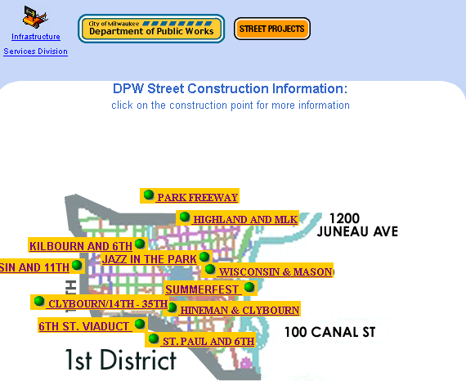
On a broader scale, a regional committee on planned special events monitors planned events across a metropolitan area through regular meetings with traffic operations agencies, law enforcement, community officials, event organizers, and other agencies. The committee facilitates communication and coordination between specific event planning and operation task forces to ensure optimal application of personnel and equipment resources. The Traffic Incident Management Enhancement (TIME) program in southeastern Wisconsin maintains such a committee. As highlighted in Chapter 2, the TIME special event committee proposed development of a traffic management planning tool designed to evaluate the severity level of any planned special event proposed in the greater Milwaukee metropolitan area. Table 5-19 lists specific external factors, and associated criteria, accounted for in the draft planning tool.

REFERENCES

- Held, T., “Dead Family Reunion in East Troy Is a Go,” Milwaukee Journal-Sentinel, June 28, 2002.

- Schmitt, B., “State Troopers Close Roads into Downtown Detroit,” Detroit Free Press, June 13, 2002.

- Laitner, B., “Royal Oak Preparing to Handle Crowds of Red Wings Fans,” Detroit Free Press, June 13, 2002.

- “Hundreds questioned in Nevada Casino Deaths,” CNN.com, April 28, 2002.

- Shaw, T., Performance Measures of Operational Effectiveness for Highway Segments and Systems, NCHRP Synthesis 311, Transportation Research Board, National Research Council, Washington D.C., 2003, 59 pp.

Table 5-19
External Factors Considered in the Wisconsin TIME Program
Special Event Planning Tool⁽²⁵⁾
QUESTION | INCREASING EVENT IMPACT
QUESTION | CRITERIA

What is the effect of construction on traffic?
Is there a construction project on any of the corridors leading to or away from the special event venue? | Not applicable | Some impact | Moderate impact | Considerable impact | Severe impact
Are there any lane closures?

What effect does the event scheduling have on traffic?
Is the event scheduled to begin or end during a peak  period? | Not applicable | Some impact | Moderate impact | Considerable impact | Severe impact
Is there more than one event beginning or ending at the same time?
What are the weather conditions?
Is there a forecast for severe weather before, during, or after the special event that might affect traffic? | Clear | Mild | Moderate | Severe-summer | Severe- winter

Are all human resources available?
Is the event scheduled to begin and end during normal working hours? | Yes | Most | Some | Few | None
Are key individuals available if needed?

Is all equipment available?
Are all facilities available? | Yes | Most | Some | Little | None
Is communication equipment working?
Is all traffic control equipment available?

- Markley, D.D., N.L. Conrad, and G.S. Rutherford, “Serving the University of Washington’s Husky Stadium,” Preprint No. 00113, Prepared for the 2001 ITE Annual Meeting and Exhibit, Institute of Transportation Engineers, Chicago, Illinois, August 19--22, 2002.

- Rankin, E.A., “A Home Run or Out in Left Field? Transportation Management for the New Seattle Mariner’s Baseball Park,” Prepared for the ITE 1998 Annual Meeting and Exhibit, Institute of Transportation Engineers, Toronto, Ontario, Canada, 1998.

- “2003 U.S. Cellular Field Resident Permit Parking Program”, Chicago Department of Transportation, Chicago, Illinois, [Online]. Available: http://www.ci.chi.il.us/Transportation/Sox/. [2003, April 25].

- Joint Operational Policy Statement, Illinois Department of Transportation and Illinois State Police, February 1999.

- A Joint Operations Policy Statement, Washington State Patrol and Washington State Department of Transportation, Washington, February 2002.

- Wrenn, D., “Turnpike Letting Drivers Go Free in Heavy Traffic,” Charleston Daily Mail, December 4, 2002.

- Townsend, E., “Freshman Delegate Wants Bridge Tolls Stopped in Backups,” The Star Democrat, February 10, 2003.

- “Wrecker and Towing Rules and Regulations for Police Rotation Wreckers,” City of Cincinnati Municipal Code Section 869.21.

- Robbins, G., A. Felder, and W.E. Hurrell, “San Francisco’s New Downtown Ballpark: A Home Run for Public Transit,” Preprint No. 00111, Prepared for the 2001 ITE Annual Meeting and Exhibit, Institute of Transportation Engineers, Chicago, Il., August 19--22, 2001.

- Grava, S. and F. Nangle, “Get Me to the Ball Game on Time – Access Time Patterns at Baseball Stadia,” Preprint No. 00395, Prepared for the 2000 Annual Meeting of the Transportation Research Board, National Research Council, Washington, D.C., January 9--13, 2000.

- Peterson, M., D.M. Marum, and A. Moran, “Mode of Access for the New Downtown San Diego Ballpark,” Prepared for the ITE 2000 Annual Meeting and Exhibit, Institute of Transportation Engineers, San Diego, Ca., 2000.

- Traffic Considerations for Special Events, Institute of Transportation Engineers, Washington, D.C., 1976, 44 pp.

- Montag, D.A., Trip Generation Rates and Characteristics for Theme-Oriented Fairs and Festivals, West Virginia University, Morgantown, West Virginia, May 1998.

- Parking and Traffic Management Plans for Investco Field at Mile High, Prepared for the City and County of Denver by Turner/HNTB, June 2002.

- Volz, M.A. and B.J. Nicholson, “Kansas Speedway Event Management Using ITS,” n.d.

- Womble, J.E., “A Transportation and Tourism Profile of Visitors to the 1984 Louisiana World Exposition in New Orleans,” ITE Journal, Vol. 55, No. 4, April 1985, pp. 49--53.

- Boggs, R., “Challenges in Supporting Planned Special Events in Your Community,” Presented at the Institute of Transportation Engineers 2003 Technical Conference and Exhibit Program,” Fort Lauderdale, Florida, March 23—26, 2003.

- Shell Grand Prix of Denver – Parking and Traffic Management Plan, Prepared for the Grand Prix of Denver by URS Corporation, August 2002, 33 pp.

- Sattayhatewa, P. and R.L. Smith, “Development of Parking Choice Models for Special Events,” Presented at the 82nd Annual Meeting of the Transportation Research Board, Washington, D.C., January 12-16, 2003.

- Silverson, S., Wisconsin Department of Transportation – District 2, Personal Communication, February 18, 2003.

