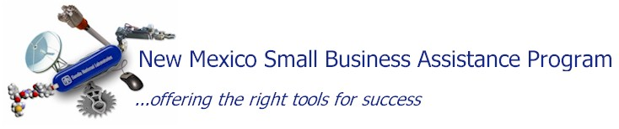
NM Small Business Assistance program enables Sandia National Laboratories to provide technical and certain types of business assistance to New Mexico’s small businesses to help retain and expand current business and technology opportunities.

Enhancing the state’s economy by helping small companies
- Sandia’s assistance is rendered at no cost to the small business
- Assistance can help New Mexico small business owners resolve short-term technology problems or business issues
- A “small business” is generally defined as employing 500 employees or less.

How It Works
- For businesses in Bernalillo County, Sandia’s services are capped at $5,000
- For businesses outside Bernalillo County, Sandia’s services are capped at $10,000 (to enhance rural economic development).

Everyone in New Mexico Benefits
State of New Mexico:
- Lower unemployment
- Higher tax revenues
- Stronger business base
- More robust economy, especially in rural areas

Sandia Laboratories:
- Stimulates research projects
- Reinforces a commitment to New Mexico
- Helps transfer technology & expertise to private sector
Small Businesses:
- Jobs created or retained
- Sales opportunities
- Improved processes
- Avoided costs

Qualify Without “Red Tape”
To qualify, small businesses must certify that Sandia’s assistance is not available at reasonable cost through private sources. That’s it!

Contact Sandia National Labs for Assistance
For more information, visit our web site at:
www.sandia.gov/smallbusinessprograms - click on “ New Mexico Small Business Assistance”

Or call/e-mail us at: Phone: 1- 800-765-1678
E-mail: sbpadmin@sandia.gov

Many Small Business Can Partner
Manufacturing:
- Developing robust manufacturing processes
- Designing & fabricating unique production equipment
- Mentoring manufacturers to better compete for procurement contracts
Retail:
- Developing improved packaging
- Training/mentoring to increase supplier contracts
Oil and Gas:
- Offering high-performance computer modeling
- Improving drilling technologies to lower exploration costs and risks
Agriculture:
- Reducing food spoilage with advanced technologies
- Improving farming efficiencies with supercomputer modeling
- Reducing production costs with robotics
Water:
- Planning and understanding water usage
- Improving water-supply reliability
- Assisting in desalinization
Energy:
- Advising on cost-effective power generation
- Providing alternative energy in remote locations
- Creating environmentally friendly power systems
Critical Infrastructures:
- Maintaining safe & reliable infrastructures using technology and expertise
- Improving infrastructure (electric grids, transportation, telecommunications…)
Information Technology and Software:
- Improving product design
- Assisting with computer simulation
- Designing & developing secure network technologies
Service Businesses:
- Mentoring, training & assisting service businesses to improve procurement contracts

 |  | YES, my company is a NM small business (less than 500 employees)
 |  | YES, I have a NM Tax Identification Number
Company |  |  |  |  | Website:
Contact Name |  |  |  | Title:
Address |  |  | City & County |  | State | Zip
Phone |  |  | FAX |  | E-mail
I heard about NMSB Program from:
Type of Assistance Needed: (if additional space is required, please add an addendum and be as specific as possible) To explore technical capabilities, please refer to our website www.sandia.gov

Complete & Return to: (505) 284-9551

