Location: |  | Date:
Module: |  | Reviewed by:

- Give definitions for the following:
  - Friction Loss -
  - Head Pressure -
  - Nozzle Pressure -
  - Cavitation -

- What is atmospheric pressure at sea level? _________

- Parallel pumping is used to:
  - Increase pressure
  - Increase volume
  - All of the above

- Series pumping is used to:
  - Increase pressure
  - Increase volume
  - None of the above

- Stage pumping is used to:
  - Increase pressure
  - Increase volume
  - None of the above

- Complete the following friction loss calculations. Use the Incident Response Pocket Guide as a reference. Show all work in the space provided.
  - You are pumping a 1½-inch hose lay 500 feet long with a 3/8 inch tip. What is the PP? Compute and write your answer below.

NP=
±H=
+FL=
+A=
PP=

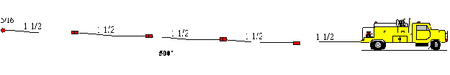

  - You are pumping to a hose lay with the first lateral at 1500 feet. You have another 100 feet of 1½-inch hose to another lateral. Both laterals have 3/8 inch tips. What is the PP?

NP=
±H=
+FL=
+A=
PP=

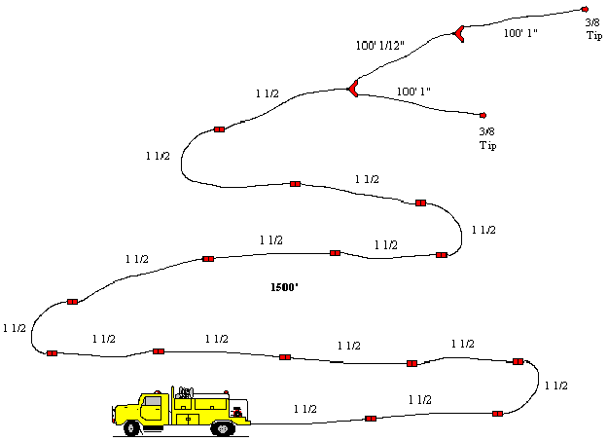

  - You are pumping to a 1½-inch hose lay with the first lateral at 900 feet. You have another 100 feet of 1½-inch hose to another lateral. Both laterals have 3/8 inch tips and are 180 feet above the pump.

NP=
±H=
+FL=
+A=
PP=

