00188.41-01
NAS2-98005 RTO-41
Technical Research in Advanced Air Transportation Technologies

Detailed Description for CE6
En route Trajectory Negotiation

G. J. Couluris

November 2000

Prepared For:
NASA Ames Research Center
Moffett Field, CA 94035-1000

Prepared By: Seagull Technology, Inc.
Los Gatos, CA 95032-2547



Preface
This report is the first version of a detailed description for the Distributed Air/Ground Traffic Management (DAG-TM) Concept Element (CE) 6, En Route Trajectory Negotiation. The ideas presented here are preliminary and require additional work.
NASA is soliciting review of this report and welcomes comments. Comments should be sent to:
Del Weathers, Manager, AATT ATM Concept Definition Sub-element, NASA Ames Research Center – dweathers@mail.arc.nasa.gov
Steve Green, Manager, AATT En Route Systems and Operations Sub-element, NASA Ames Research Center – sgreen@mail.arc.nasa.gov

Contents

1. Introduction 7
1.1 Background 7
1.2 Objectives 8
1.3 Scope 8
2. Problem Description 9
2.1 Problem 9
2.2 Solution 9
2.3 Potential Benefits 10
3. Approach 12
3.1 Overview 12
3.2 Operational Integration 13
3.3 Technical Integration 14
4. Operational Requirements 16
5. Operational Environment 17
5.1 Airspace Structure And Constraints 17
5.2 Traffic Mix and Equipage 17
5.3 CNS Infrastructure 17
5.4 ATM Environment 17
6. Operational Characteristics 19
6.1 ATSP Operations 19
6.1.1 TFM Constraints 19
6.1.2 Potential Conflicts 20
6.1.3 User Request for Trajectory Change 22
6.1.4 Trajectory Prediction and Assessment 22
6.1.5 Trajectory Negotiation 25
6.2 FD Operations 29
6.3 AOC Operations 29
7. NAS Functional Impacts 30
7.1 Functional Requirements 30
7.1.1 Communications 30
7.1.2 Navigation 31
7.1.3 Surveillance 32
7.1.4 Automation 32
7.1.5 Weather 32
7.1.6 Traffic Management 32
7.2 Functional Design 33
8. User/Operator Roles and Responsibilities 35
8.1 ATSP Roles and Responsibilities 35
8.2 Pilot Roles and Responsibilities 35
8.3 Dispatcher Roles and Responsibilities 35
9. Operator Modes and Scenarios 36
9.1 Normal or Nominal Mode 36
9.2 Off-Nominal Mode Scenarios 37
9.3 Failure Mode Scenarios 38
10. Operational Processes/Operational Sequence Diagrams 39
11. Benefits 40
12. Issues and Key Decisions 42
Appendix A. Operational Requirements Table 46
Appendix B. Automated Resolution Advisories 50
References 54

Figures

Figure 6-1 En Route TFM Constraint Propagation 20
Figure 6-2 Multi-Sector Potential Conflict Situations 21
Figure 6-3. Avoidable Interruptions 24
Figure 6-4. Application of an Uplinked Waypoint Constraint 25
Figure 6-5. User-preferred routes 26
Figure 6-6. Re-routes to form spacing trail. 26
Figure 6-7. Spacing with minimum deviation. 27
Figure 6-8. Path-independent spacing. 27
Figure 7-1. CE-6 Functional Design Diagram 33
Figure 10-1 CE-6 Operational Sequence Overview 39

En route Trajectory Negotiation
For
User-preferred Separation Assurance and Local TFM Conformance

Introduction

Background
The Distributed Air/Ground Traffic Management (DAG-TM) concept describes potential modes of operation within the Free Flight concept defined by the RTCA Task Force 3. The goal of DAG-TM is to enhance user flexibility and efficiency and increase system capacity, without adversely affecting system safety or restricting user accessibility to the National Airspace System (NAS).
To explore the DAG-TM concept, the AATT Project formed a DAG-TM Team, which met during 1999 and developed a Concept Definition.ref.1 This document defined 15 DAG-TM “concept elements”, covering air traffic management (ATM) operations in all phases of flight. The defined phases were:
- Gate-to-Gate (information access and exchange)
- Pre-Flight Planning
- Surface Departure
- Terminal Departure
- En Route
- Terminal Arrival
- Terminal Approach
- Surface Arrival
In 2000, the AATT Project selected an initial set of four concept elements (CEs) to pursue further concept exploration (research) activities.
CE-5: En Route Free Maneuvering
CE-6: En Route Trajectory Negotiation
CE-7: En Route: Collaboration for Mitigating Local TFM Constraints due to Weather, SUA, and Complexity
CE-11: Terminal Arrival: Self-Spacing for Merging and In-Trail Separation
In May 2000, a DAG-TM Workshop was held at the NASA Ames Research Center to explain to industry the AATT Project’s activities and plans for the concept. The workshop focus was on the four initial CEs being developed. Under Task Order 41, a contractor team consisting of System Resources Corporation and Seagull Technology is preparing detailed descriptions of each of the four selected CEs. This document is a detailed description of objectives and operational concepts for CE-6, En Route Trajectory Negotiation.

Objectives
This detailed description has the following objectives:
- It provides technical transfer and sharing of information within the NASA research community. It is intended to capture the current thinking of NASA researchers concerning the future ATM environments and capabilities that may be created by this concept.
- It is a guide for a planned program of research in this concept through 2004.
- It is consistent with AATT objectives as described in the AATT Air Traffic Management Operations Concept (ATM/OPSCON).

Scope
The description of CE-6 is intended to provide enough detail to form a basis for further research into the concept. It is not, however, a research plan. The research plan is a separate document being developed by NASA which describes how the concepts presented here will be investigated, and how statements presented here as hypotheses will be tested.
The detailed description has a focus of operational and system requirements, and deliberately avoids design information to the extent possible. Specifications are omitted from this document, since capabilities to support the CE-6 concept should evolve as a result of the research to be conducted. To avoid confusion with widely discussed tools such as automatic dependent surveillance (ADS), ADS-Broadcast (ADS-B) or controller-pilot data link communication (CPDLC) whose specifications are being developed or discussed, this description uses general terms to describe the capabilities necessary to support this concept.

Problem Description
The following problem, solution and benefits descriptions for CE-6 are extracted from the DAG-TM Concept Definition.ref.1 These descriptions address air traffic service provider (ATSP) problems in fully accommodating user preferences as determined by aircraft flight deck (FD) and aeronautical operational control (AOC) trajectory assessments and plans.

Problem
(a) ATSP often responds to potential traffic separation conflicts by issuing trajectory deviations that are excessive or not preferred by users.
In the current air traffic control (ATC) system, trajectory prediction uncertainty leads to excessive ATC deviations for separation assurance. Due to workload limitations, controllers often compensate for this uncertainty (which may be equivalent to or greater than the minimum separation standard) by adding large separation buffers for conflict detection and resolution (CD&R). Although these buffers reduce the rate of missed alerts, some aircraft experience unnecessary deviations from their preferred trajectories due to the unnecessary “resolution” of false alarms (i.e., predicted “conflicts” that would not have materialized had the aircraft continued along their original trajectories). In those cases where a potential conflict really does exist, the buffers lead to conservative resolution maneuvers that result in excessive deviations from the original trajectory. Moreover, the nature of the resolution (change in route, altitude or speed) may not be user-preferred. Due to a lack of adequate traffic, weather, and airspace restriction information (and displays), and also to a lack of conflict resolution tools on the flight deck, current procedures generally do not permit the user to effectively influence controller decisions on conflict resolution.
(b) ATSP often cannot accommodate the user’s (FD or AOC) trajectory preferences for conformance with local traffic flow management (TFM) constraints.
The dynamic nature of both aircraft operations and NAS operational constraints often result in a need to change a 4-D trajectory plan while the aircraft is en route. Currently, the user (FD or AOC) is required to submit their request for a trajectory change to the ATSP for approval. During flow-rate constrained operations, the ATSP is rarely able to consider user preferences for conformance. Additionally, a lack of accurate information on local traffic and/or active local TFM constraints (bad weather, SUA, airspace congestion, arrival metering/spacing) can result in the FD or AOC requesting an unacceptable trajectory. The ATSP is forced to plan and implement clearances that meet separation and local TFM constraints, but may not meet user preferences. Further negotiation between the ATSP and FD can adversely impact voice-communication channels and increase ATSP and FD workload.

Solution
(a) Reduce unnecessary and/or excessive ATSP-issued route deviations for traffic separation by enhancing ATSP trajectory prediction capability through user-supplied data on key flight parameters.
The user (FD and/or AOC) will provide information via data link on key parameters such as aircraft weight, trajectory intent (route, altitude, speed profile), local winds/temperature aloft, and navigational performance. The provision of this information will not adversely affect FD and/or AOC workload, and will be automated. An ATSP-based decision support tool (DST) will use this data to improve its trajectory predictions, resulting in improved CD&R performance. This improvement will: (1) Reduce the number of unnecessary conflict resolution maneuvers by decreasing the conflict prediction false-alarm rate; and, (2) Reduce the extent of excessive trajectory deviations for conflict resolution by decreasing the uncertainty in future positions of the aircraft.
Appropriately equipped users will be able to submit their preferences for resolving conflicts. These preferences may include (but are not limited to): a specified 4D trajectory; a specified route, and/or altitude and/or speed profile; or, preferred degree(s)-of-freedom (route, altitude, speed) for conflict resolution. The trajectory negotiation process may involve single-flight collaboration between the ATSP and an individual user, or multiple-flight collaborations between the ATSP and multiple users for determining a balanced set of deviations among a “gaggle” (group) of flights. Following the selection of a conflict-resolution plan, the ATSP then transmits (via data link) the conflict-free trajectory solutions to the appropriately-equipped aircraft for execution (thereby further reducing trajectory uncertainty and subsequent conflict false-alarm and missed-detection rates). It is emphasized that the ATSP retains full responsibility for separation assurance.
(b) Facilitate trajectory change requests for en route aircraft by providing the user (FD and/or AOC) the capability to formulate a conflict-free user-preferred trajectory that conforms to any active local-TFM constraints.
By making use of information on local traffic and TFM constraints, the user is able to formulate intelligent trajectory change requests that are likely to be acceptable to the ATSP and therefore less workload-intensive for the ATSP to evaluate and coordinate. Using data link, the AOC transmits relevant information on airline preferences/constraints to the FD. The flight crew use a FD-based trajectory planning decision support tool to compute a conflict-free user-preferred trajectory that conforms to any active local TFM constraints (bad weather, SUA, airspace congestion, arrival metering/spacing). The FD transmits the desired trajectory to the ATSP via data link. The ATSP uses their decision support tool to review the request, and in most cases, finds the request acceptable and issues a clearance for the new trajectory. If the request is not acceptable, the ATSP denies the request and may use their decision support tool to formulate an alternative clearance or provide additional information on ATSP requirements/constraints. It is emphasized that the ATSP retains full responsibility for separation assurance.

Potential Benefits
- Reduction in excessive deviations for separation assurance, due to improved CD&R capabilities of ATSP-based decision support tools, enabled by user-supplied data on key flight parameters.
- Reduction in non-preferred deviations for separation assurance, due to user-ATSP collaboration for conflict resolution maneuvers.
- Increased ATSP accommodation of user requests for trajectory changes, due to the user’s ability to intelligently formulate trajectory change requests that conform to local traffic and TFM constraints.
- Reduced ATSP workload, due to improved CD&R capabilities (enabled by user-supplied data) for separation assurance, and intelligent user requests for trajectory changes that conform to local traffic and TFM constraints

Approach

CE-6 operates in en route airspace to increase system flexibility and user preference accommodation through use of ATSP-user trajectory negotiation, augmented by advanced airborne and ground-based decision support automation. The two problems solved by CE-6 address complementary situations that require:
- resolution of potential conflicts due to violations of aircraft minimum separation rules
- conformance with local TFM constraints
Situation “a” is the case in which trajectory negotiation is used to resolve potential aircraft conflicts in the absence of local TFM constraints. Situation “b” is the case in which trajectory negotiation is used to provide conformance with TFM constraints, but this conformance must also satisfy aircraft minimum separation requirements. Both situations may occur simultaneously, or situation “a” may occur in isolation from the other.
The approach taken by CE-6 is to implement the general capability to resolve simultaneous potential violations of aircraft separation and local TFM constraints. CE-6 is designed to provide all the functions, processes, procedures and facilities to implement the general solution to the union of both situations. CE-6 enables the resolution of isolated potential aircraft conflicts as a sub-capability in which trajectory negotiation is simplified by the exclusion of TFM constraint factors.

Overview
CE-6 provides an ATSP focus for implementing en route trajectory negotiation within the framework of distributed decision-making between ATS users and providers. ATSP retains full responsibility for separation assurance, but users are integrated into the solution processes. Users are able to exercise initiatives and participate in the en route traffic management decision-making processes pertaining to the prevention of violations to aircraft separation and local TFM constraints. CE-6 provides the mechanisms for dynamically incorporating user-determined trajectory data and preferences into the assessment and the resolution or avoidance of potential violations. These mechanisms include processes for exchanging information, identifying and evaluating complex traffic situations, and determining and implementing solutions.
The trajectory negotiation process implemented in CE-6 identifies, reviews and resolves traffic management situations requiring corrective or approval action with respect to potential violations of aircraft separation and local TFM constraints. This process emphasizes the use of continual updates of flight and atmospheric information together with advanced decision support tools to support high-fidelity trajectory prediction and situation assessment and real-time collaboration between users and ATSP. This approach: enables the ATSP, FD and AOC operations to accurately assess situations and formulate resolution options; affords ATSP the opportunity to present information to users describing traffic situation and trajectory constraints; affords users the opportunity to present self-optimization preferences for ATSP consideration; and promotes the application of resolutions that are sensitive to user preferences. The resulting ATSP flexibility in determining airspace use allows aircraft to fly efficient trajectories based on the changing traffic and atmospheric conditions.
For effective trajectory negotiation, CE-6 requires development of advanced ATSP, FD and AOC automation, and their operational and technical integration based on advanced communications capabilities and human-centered pilot and controller pilot procedures and technologies. These functions must be properly structured and integrated to enable users and ATSP to evaluate traffic situations accurately and determine and implement optimal courses of action. The operational integration focuses on the establishment of human-centered processes and interfaces for using the computer-derived information cooperatively among ATSP, FD and AOC to make the best use of trajectory negotiation. The technical integration focuses on derivation, transmission and compilation of valid flight data for use by computerized systems to evaluate and predict actual trajectories, identify and examine constraints and generate trajectory alternatives with high accuracy.

Operational Integration
CE-6 implements trajectory negotiation by providing ATSP and users with the means for exchanging potential conflict, TFM constraint and trajectory information to improve their situation assessment and planning processes. User-provided data enable ATSP automation to predict and evaluate trajectories accurately, and AOC-provided data enable users to determine appropriate trajectory preferences:
- AOC provides user flight operations and aircraft performance descriptors to ATSP, and FD provides updates of trajectory status, intent, preference and atmospheric measurements to ATSP. This information is integrated into the ATSP surveillance, flight data and associated computational processes to enhance decision support tool performance.
- ATSP provides the users with atmospheric forecasts and local TFM constraints such as required time of arrival (RTA), altitude, speed or spacing restrictions, route restrictions due to special use airspace, weather or sector traffic congestion, and airport acceptance rates and delays.
- ATSP provides users with information describing potential violations of aircraft separation and TFM constraints, and may provide information describing ATSP-generated trajectory resolution alternatives or restrictions applicable to user-generated resolutions.
These data exchange and trajectory evaluation exercises enable ATSP and users to determine and negotiate clearances that provide efficient resolutions of potential violations of aircraft separation and TFM constraints or permit efficient trajectory changes in response to user requests.
The CE-6 operation employs a human-centered operational design that leverages the advanced capabilities of the automation, pilot and controller computer-human interface (CHI), and communication, navigation and surveillance (CNS) functions available in the DAG environment. A key component of these functions is improved trajectory prediction and assessment, which enables extended probing along the projected trajectory to perform aircraft CD&R and TFM constraint infraction detection and resolution. A theoretically perfect CE-6 trajectory prediction and assessment function would support resolution of all potential violations along the entire trajectory prior to each aircraft’s entry into en route airspace. The theoretical limit of en route probing would be the implementation of user and ATSP-negotiated, violation-free 4-dimensional flight plans, which would eliminate potential conflicts while satisfying any local TFM constraints. Delays and diversions from the negotiated flight plan would be precluded in this theoretically perfect operation.
In the realistic environment of CE-6, trajectory prediction and assessment is not perfect and its accuracy diminishes with longer look-ahead. However, trajectory analysis in the DAG environment would be superior to that of current operations, and CE-6 trajectory accuracy would support reliable aircraft CD&R and local TFM constraint probing well beyond the scope defined by current sector sizing practices. Hence, CE-6 implements trajectory negotiation for airspace that currently would be a multi-sector environment such that ATSP evaluates aircraft separation and local TFM requirements over an extended downstream look-ahead span. Trajectory negotiation is used to establish a reliable violation-free plan for the effective range of the aircraft CD&R and TFM constraint probe. Notionally, ATSP monitors the flight along a previously negotiated trajectory and would not intervene except when or until a violation is projected.
This control-by-exception operation is based on a trajectory-centric, rather than sector-centric, concept for distributing separation assurance responsibility. Theoretically, a trajectory-orientated ATSP operation might be established without sectorization in a futuristic environment. However, for planning purposes based on practical considerations, CE-6 is assumed to operate in a sector structure similar to that currently employed. In this operation, the probe examines aircraft separation and local TFM constraints in the multi-sector airspace that includes the current and downstream sectors. Negotiation is used to agree on a violation-free trajectory plan for this extended range, alleviating requirements for subsequent downstream intervention.
The CE-6 controller and pilot operating procedures and associated CHI are designed to support trajectory negotiation and dissemination of constraint information for single and multi-sector coverage. ATSP data entry and display, decision support tool and communication systems are structured to facilitate detection and assessment of potential violations and their resolution through ATSP-user negotiation and inter-controller coordination. The CHI allows for the handling of a range of complex potential violation or constraint conformance situations. The aircraft involved in a potential violation may be in the same sector as each other at the time of negotiation or in different sectors, and the location of the potential violation may be the sector containing one or more of the subject aircraft or a downstream sector. Trajectory constraint specifications may pertain to a single reference fix and control parameter, or a sequence of fixes and combinations of parameters defining crossing time, spacing, speed, altitude or other traffic management requirements.
Controllers are provided with capabilities to define a trajectory solution or solution options, and to test, evaluate, bound, accept, adjust or reject trajectory options generated by ATSP automation tools and user-generated trajectory change requests. Pilots are provided with capabilities to assess, bound, accept, or reject FD or AOC-generated trajectory change requests and ATSP-generated trajectory resolutions. Dispatchers have analogous capabilities. Controllers, pilots and dispatchers are able to respond to each other’s trajectory plans as part of the process of achieving consensus.

Technical Integration
The CE-6 operation is enabled by advanced ATSP, FD and AOC automation coupled with advanced CNS technology. These technologies provide the mechanisms for reliably determining and describing the attributes, state and intent of aircraft and the air traffic system, accurately evaluating aircraft separation and TFM constraint factors, correctly determining trajectory options and preferences, and effectively performing trajectory negotiation. A critical technical integration component is an air-ground and ground-ground data link system which enables the efficient exchange of data among ATSP, FD and AOC.
Automation tools are used in CE-6 to assist controllers, pilots and dispatchers in conducting aircraft separation and local TFM constraint conformance tasks. These automation tools perform trajectory prediction and assessment calculations using highly-accurate information describing aircraft operating characteristics, traffic, TFM constrains, and atmospheric conditions. Data link enables the automatic exchange of calibration data describing aircraft and system attributes, and facilitates exchange of trajectory negotiation data between ATSP and users.
Calibration information are transmitted between ATSP and user computer operations using automated data link capabilities. These messages contain information used by ATSP, FD and AOC automation to perform high-fidelity modelings of trajectories, traffic situations and atmospheric conditions. Calibration data describe flight operations and aircraft performance factors, aircraft state and trajectory intent, and atmospheric measurements and forecasts.
Negotiation transactions between controllers, pilots or dispatchers include trajectory preference and preference interrogation, trajectory change request, trajectory constraint, trajectory trial plan and clearance, and acceptance and rejection messages.
ATSP decision support tools and surveillance functions are critical CE-6 components. Trajectory prediction and assessment automation functions assimilate calibration and appropriate negotiation data, evaluate aircraft separation and local TFM constraint conformance factors, generate and assess trial plan options where necessary, and provide controller interface capabilities for conducting trajectory negotiation with users. ATSP automation also processes and transmits atmospheric forecasts by data link. The ATSP surveillance system provides traffic situation data. User-derived aircraft status and intent data is fused with ATSP radar track data to provide the surveillance accuracy required for reliable trajectory prediction and assessment computations.
Flight deck avionics systems are integrated into the CE-6 operation. Aircraft flight management systems (FMSs) process calibration and negotiation data. Advanced FMS units generate aircraft status, trajectory intent and atmospheric measurement information for air-ground down linking. FMSs also generate trajectory preference and restriction data, and provide pilot interface capabilities for conducting trajectory negotiation with ATSP. The accuracy of the status and intent data and the capability to maintain trajectory clearance conformance depend on the performance levels of the navigation and guidance systems onboard aircraft.
AOCs generate flight plan and operations data that are used in ATSP and FMS trajectory prediction and assessment computations. AOC decision support tools provide dispatcher interface capabilities for conducting trajectory negotiation with ATSP by ground-ground data link and with pilots by air-ground data link.

Operational Requirements
This section contains a description of the Operational Needs Statements (ONS) which apply to CE-6. These ONS have been created to support the development and ongoing revision of the AATT ATM/OPSCON.
See Appendix A for the operational requirements, presented as a table. CE-6, Trajectory Negotiation, applies to two different service areas as defined in the AATT ATM/OPSCON. The table lists the ONS addressed by CE-6 first in the Separation Assurance service area and then in the Traffic Management – Synchronization service area.

Operational Environment

This section describes the assumptions behind development of the concept description for en route trajectory negotiation, conditions under which this concept applies, and the applicable operational environments. The section describes airspace structure and constraints, traffic mix and equipage, CNS infrastructure, and ATM environment

Airspace Structure And Constraints
CE-6 is applicable to departure, cruise and arrival phases of flight in the domestic en route operational domain, and is extensible to oceanic and terminal area domains. The airspace is sectorized within Center and TRACON jurisdictions. A route structure with named waypoints exists, but this system is not essential to the CE-6 concept. Hemispherical altitude rules and step-climb procedures exist, but these are not essential to CE-6.

Traffic Mix and Equipage
CE-6 is applicable to commercial, general aviation and military aircraft equipped to participate in trajectory negotiation. Essential avionics include accurate navigation performance, advanced FMS, and data link capabilities.

CNS Infrastructure
Data link communication integrates ATSP, FD and AOC operations. Air-ground data link provides two-way communication between FD and ATSP and between FD and AOC. Addressable and broadcast air-ground communications are employed. Ground-ground data link provides two-way communication between ATSP and AOC. Air-ground voice communications continue to be used, but are replaced to the extent appropriate by data link.
The Global Positioning System (GPS) is certified for en route navigation, but not necessarily as sole means. Advanced FMS units support data link-based trajectory negotiation transactions between ATSP and FD.
FMS-derived aircraft state and intent data is downlinked to ATSP and fused with secondary surveillance radar (SSR) data to provide accurate trajectory and situation assessment information.

ATM Environment
An overview of CE-6 en route trajectory negotiation operational environment is presented in the following paragraphs in comparison to that of the current system baseline.
Baseline ATM Environment -- The baseline represents current operations in which air-ground voice communication is used for trajectory negotiation between controllers and pilots. Information required by ATM automation functions is obtained from static databases (e.g., nominal aircraft performance parameters and procedures data), flight plan (e.g., intent data), and radar surveillance (e.g., aircraft state data) sources. Controllers manually perform trajectory prediction and assessment based on radar and flight plan data to determine aircraft separation and local TFM constraint conformance resolution actions. Controllers use computer message entry and display devices to interface with the radar and flight data processing systems and, where implemented, Center-TRACON Automation System (CTAS) operations.
CE-6 ATM Environment -- CE-6 introduces automated exchange of trajectory-specific aircraft data in an integrated ATSP, FMS, AOC operation. CE-6 capabilities transmit air-ground data link messages between FMS and ATM computer systems and ground-ground data link messages between ATM and AOC systems. FD provides ATSP systems with selected aircraft state, intent, and atmospheric measurement data. AOC provide ATSP systems with selected flight plan and preference, aircraft performance, and operating procedure data. ATM provides FD and AOC systems with atmospheric forecast data.
CE-6 calibration message transactions are automated data exchanges of technical parameters specifying trajectory status and intent and atmospheric characteristics. The calibration data link messages are generated by FMS units and ATSP and AOC automation systems. CE-6 negotiation message transactions are controller and pilot data link communications associated with trajectory clearances, maneuvers, constraints and change requests.
The data link-based integration of ATSP, FD and AOC operations enable improved performance of decisions support tools and other automation functions associated with the CE-6. The ATM automation processes and displays more accurate aircraft state data, such as heading and speed, to improve controller situational awareness. However, a key function of the CE-6 data exchange is the provision of aircraft-derived data to improve trajectory modeling accuracy in advanced ATM decision support tools. The data link-provided aircraft state data describing FMS-determined current position and velocity vector and extensive downstream intent data significantly improves trajectory determination and prediction solutions and trial plan and clearance conformance assessments relative to calculations based only on radar and flight plan data. Trajectory calculation accuracy also is improved by incorporating atmospheric model updates based on the downlinked wind and temperature measurements, rather than more static atmospheric modeling. User-derived aircraft weight, top of climb, top of descent, climb and descent profile, and threshold crossing speed information provided and updated for each flight enable more accurate determinations of transition trajectories than those based on static tabular data describing nominal profiles. ATSP is better able to predict trajectories and control inter-aircraft positioning, enabling reductions in excess spacing buffering. The overall result of improved trajectory modeling is more effective potential conflict detection and resolution, sequencing and scheduling, trajectory conformance assessment, and clearance advisory generation by ATM decision support tools. These capabilities enable ATSP to accurately manage trajectories, and facilitate trajectory negotiation between ATSP and FD.
FD and AOC decision support systems and are able to take advantage of the ATSP-generated wind and weather forecasts to update flight planning and flight following factors, and make more-timely determinations of trajectory change requirements. The ATSP-disseminated atmospheric parameters enable calibration of a common ATSP, FD and AOC weather database, reducing instances of inconsistent trajectory assessments between ATSP, FD and AOC systems.

Operational Characteristics

CE-6 En Route Trajectory Negotiation is an evolving operational concept that has been the subject of various research and development activities,ref.1-55 many of which are ongoing. The concept description presented in this document is based on the research conducted to date, and is developed through direct adoption, application or logical extension of the previous findings. The CE-6 description draws heavily from the previous research reports. This description is offered as a basis for further development of the concept, providing topics for future research to prove their operational, technical and economic feasibility or to identify and develop design improvements and alternatives. The CE-6 concept given herein is subject to further examination, analysis and testing to fully mature the En Route Trajectory Negotiation concept.
This CE-6 DAG-based concept assumes trajectory negotiation is conducted primarily between ATSP and FD using air-ground data link, with AOC participating by exchanging information with ATSP by ground-ground data link and by providing FD with flight plan preference updates by air-ground data link. ATSP and FD are the primary trajectory negotiation agents for CE-6, and AOC provides critical support to these agents.
CE-6 implements ATSP, FD and AOC capabilities needed to conduct effective trajectory negotiation. These trajectory negotiation-enabling capabilities are those used to generate and assemble trajectory-relevant data at ATSP, FD or AOC sources, to exchange and process these data, and to provide automation support for controller and pilot decision-making and dispatcher operations. Automation tools provide trajectory analysis and planning and CHI functions used for controller and pilot negotiation of conflict-free clearances in conformance with local TFM constraints. The integration of these operational processes and interfaces are described in the following paragraphs with respect to ATSP, FD and AOC CE-6 functions. Technical integration is addressed in the next section of this document.

ATSP Operations
The CE-6 concept integrates controller, pilot and dispatcher roles and responsibilities, operating procedures, supporting automation and CNS technologies to enable trajectory negotiation while maintaining or enhancing safety. This concept is based on the capability of performing effective, accurate, extended-range trajectory planning unconstrained by sector boundaries to identify and accommodate user preferences and aircraft separation and local TFM constraints. For the ATSP operation, CE-6 introduces multi-sector trajectory processing in which sector team operations are coupled rather than being predominantly focused on airspace internal to their individual sectors. Sector teams work cooperatively to develop trajectories clearances that conform to aircraft separation and TFM constraints in multi-sector airspace so that downstream sector teams subsequently have less need to perform trajectory intervention.

TFM Constraints
Figure 6-1 provides a perspective on the CE-6’s fit into broader TFM operations. Figure 6-1 illustrates a case in which aircraft bound to Chicago O’Hare International Airport (ORD) are subject to delay due to airport capacity overload. The delay is systematically propagated upstream through a series of organized flow constraints which result in dynamic local TFM constraints on ORD-bound aircraft exiting Denver Center (ZDV). The constraints may be miles-in-trail spacing-based or time-based metering requirements. TFM constraints may include altitude, speed and other procedural restrictions. The constraints are applicable at specific reference fixes or jointly applicable at the Denver Center’s outbound boundary regardless of crossing point and altitude. These local TFM constraints are further propagated within Denver Center as metering and procedural restrictions applicable at individual sector boundaries are or within sectors.

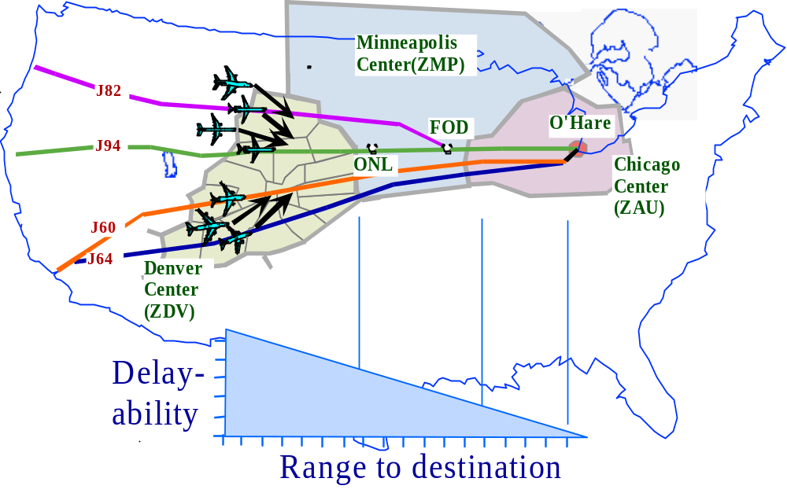
Source: ref. 26,29
Figure 6-1 En Route TFM Constraint Propagation

The ORD-bound flights depicted in Figure 6-1 generally are in cruise or climb mode in Denver or Minneapolis Center airspace, and negotiations focus on completing climb profiles if appropriate and defining and establishing downstream cruise trajectories. But, as these aircraft approach ORD, such as when flying through Chicago Center airspace, the CE-6 operation also considers descent requirements pertinent to terminal area traffic operations in examining downstream aircraft separation and TFM constraints. These trajectory negotiation processes require integration with arrival and departure sequencing and spacing automation.
Each sector team responsible for TFM constraint conformance conducts trajectory negotiation with aircraft in its airspace. The constraints are applicable at reference points within the sector or at downstream points. Trajectory negotiation for downstream constraint conformance takes into account traffic factors along the multi-sector trajectory.

Potential Conflicts
Potential violations of aircraft separation requirements exist concurrently with local TFM constraints or in isolation if flow management is not in effect. In either case, the location of potential conflicts in multi-sector airspace addressed by CE-6 are analogous to those illustrated in Figure 6-2.ref.35,44 The CE-6 multi-sector scope is not restricted to adjacent sectors as shown in Figure 6-2, but this four-sector configuration illustrates potential conflict-airspace combinations relevant to trajectory negotiation. These potential conflicts in general include aircraft crossing, merging and overtaking situations for climb, cruise and descent modes.

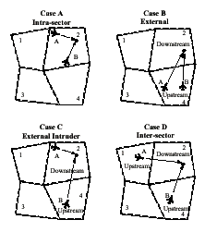
Source: ref.35,44
Figure 6-2 Multi-Sector Potential Conflict Situations
The intrasector and external potential conflicts (Cases A and B in Figure 6-2) are situations in which each aircraft conduct trajectory negotiation with the same sector team. The ATSP negotiation process in the intrasector situation (Case A) is within the jurisdiction of that sector team. But in the external situation (Case B) where the potential conflict point is in a downstream sector, the negotiation process accounts for the separation assurance responsibilities of both sector teams.
The external intruder and intersector potential conflicts (Cases B and C) are situations in which each aircraft conduct trajectory negotiation with different sector teams. The negotiation process is conducted in accordance with the jurisdictional responsibilities of both sector teams.

User Request for Trajectory Change
Trajectory negotiation also is invoked in response to a user request to change the trajectory, normally based on flight plan optimization. The request generates an ATSP examination of the requested trajectory for TFM constraints such as those depicted in Figure 6-1 and potential conflicts such as those depicted in Figure 6-2. The negotiation is conducted between the aircraft and its current controlling sector team, and could involve consideration of downstream sector jurisdictional responsibilities.

Trajectory Prediction and Assessment
ATSP automation in conjunction with data link provides capabilities to identify trajectory options that satisfy TFM constrains without violating aircraft separation requirements, identify and resolve potential conflicts with and without TFM constraints, and respond to user-generated trajectory change requests. CE-6 incorporates user preferences into the resolution process, advises users of TFM constraints, and facilitates trajectory negotiation.
CE-6 automation implements computational processes to predict trajectories and assess aircraft separation and TFM constraints. Accurate trajectory analysis is essential to CE-6, and is supported by comprehensive data exchange between ATSP and users and advanced aircraft dynamics modeling.
Data Exchange – CE-6 exchanges calibration data between ATSP and users using data link. Calibration data provide a dynamically-updated, common set of flight operations, aircraft state, intent and performance, and atmospheric information for processing by FMS units and ATSP and AOC automation. These capabilities are important to the accuracy and compatibility of computational algorithms used for trajectory prediction, enabling high-fidelity FMS and decision support tool performance. The calibration data also are used to enhance the information displayed to controllers, supporting situation awareness.
The calibration data enable improved trajectory prediction accuracy in advanced ATSP decision support tools relative to pre-CE-6 operations. Aircraft state data describing FMS-determined current position and velocity vector and extensive downstream intent data significantly improve trajectory determination and prediction solutions and flight trajectory and clearance conformance assessments relative to calculations based only on radar and flight plan data. Trajectory calculation accuracy also is improved by incorporating atmospheric model updates based on the downlinked wind and temperature measurements, rather than more static atmospheric modeling. Aircraft weight data and the top of climb, top of descent, climb and descent profile, and threshold crossing speed information provided and updated for each flight by AOC systems enable more accurate determinations of transition trajectories than those based on static tabular data describing nominal profiles. The overall result of improved trajectory modeling is more effective potential conflict detection and resolution, sequencing and scheduling, trajectory conformance assessment, and clearance advisory generation by ATM decision support tools.
Aircraft Trajectory Dynamics Modeling – Previous researchref.30 has identified aircraft dynamics modeling requirements for 4D-trajectory predictions:
The approach used is to integrate the point-mass model kinetic equations of motion based on first principles. This models the three translational dimensions and the primary rotational dimension (“roll”). Instead of simplifying the equations of motion to represent average dynamics, all the primary kinetic and kinematic terms are preserved (Thrust-minus-Drag, Weight, acceleration, and wind gradient) to ensure that the predicted dynamics are able to match reality under the wide variety of operational conditions. Extensive field testing has been conducted to validate the accuracy of this approach.ref.31,32,54
For reasons of traffic growth (requiring less uncertainty to squeeze out extra capacity) and integration with FMS, this approach reduces errors related to second-order dynamics. This approach may be “tuned” for greater 4D accuracy by simply improving the input data. Lateral paths are modeled as a series of straight segments and curved-path turns. The turns are defined to be compatible with FMS lateral-navigation standards which defines waypoints as “fly-by” or “fly-over.” The curved-path is predicted as a function of predicted ground speed in the turn (based on predicted airspeed and winds aloft) and bank angle/acceleration (defined in the performance model database as a function of altitude and phase of flight). The vertical profile models performance [(T-D/)W], speed schedule, altitude (non-standard atmosphere) and wind gradient. Corrections are provide for non-standard atmospheres (non-standard temperature), non-standard altimeter settings, and variations in weight if accurate weight data are available.
This trajectory-integration process also accounts directly for the thrust and drag models of each aircraft type thus allowing the model to be tuned to each flight’s performance envelope if the specific configuration is provided (via flight plan or data link communications). More importantly, the approach models the affect of speed profile and wind gradient on the vertical rate, both of which have a substantial impact relative to the other factors. The model predicts the speed profile based on its speed advisories for flow-rate conformance (just the situation when it is most important to model the vertical profile accurately). If flow rate constraints are not in effect, the model uses its estimate of the current speed profile and/or preferred-speed database for future flight segments.
Note 4D trajectory-prediction accuracy has an impact on airspace capacity. In order to achieve an acceptable conflict-probe time horizon and missed-alert rate, “buffers” must be added to trajectory predictions to mitigate the impact of prediction uncertainties. One method is to add a “conformance bounds” around the baseline trajectory prediction. This approach is an effective means for reducing missed alerts, but the penalty involves a loss of airspace to support the buffer, and a greater rate of false alarms. This is particularly relevant for traffic situations (such as arrival metering) where many flights must be compressed to spacings that are on the order of the minimum requirements for separation. As 4D trajectory-prediction-accuracy performance improves, the need for conformance bounds (buffers) is reduced.
Aircraft Separation and TFM Constraint Assessment Probe – ATSP automation operates a potential conflict and TFM constraint probe along a projected trajectory. This trajectory may be that corresponding to the currently predicted flight path, a user requested change, or an alternative flight path. The probe generates alerts of potential violations. The probe’s look-ahead range is based on concerns of preventing missed alerts and limiting false alarms, and is determined by the accuracy of the trajectory prediction model. The probes application should avert the worst case scenario depicted in Figure 6-3 in which the resolution of false alarm leads to a missed alert.
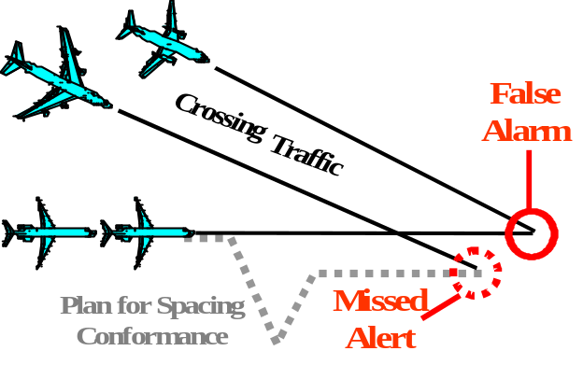
Source: ref. 26,30
Figure 6-3. Avoidable Interruptions
CE-6 uses the probe in an algorithmic process that generates mutual resolution of aircraft separation and TFM constraints. Based on previous research,ref.30 the process is one that first resolves the TFM constraints and then uses this solution as a boundary condition for the potential conflict solutions. This inner-outer loop calculation approach is effective when flow-rate conformance accuracy is small compared to the separation requirement. Accuracy of this magnitude is required for CE-6 trajectory prediction and the corollary capability to deliver aircraft to a fix according to plan.
Trajectory projections beyond Center boundaries require special consideration. Each Center’s data processing system has limited information for traffic in adjacent Centers’ airspace, and automated prediction and assessment of trajectories across Center boundaries are subject to inaccuracy. Except where TFM constraint conformance at these boundaries is sufficient to accommodate inter-Center traffic, special information exchange and coordination of potential conflicts for aircraft approaching Center boundaries is warranted.
TFM Constraint and Related Data Dissemination – ATSP automation compiles and distributes TFM constraints, meteorological and traffic data to users by data link to enable users to generated acceptable trajectory change requests in the CE-6 concept. Data describing airspace and airport congestion, meteorological forecast, severe weather, SUA, and flow rate constraints is voluminous, and would be used by AOC automation to determine flight plan and schedule preferences and constraints. These data are transmitted to the aircraft for use in aligning specific trajectory change requests with dynamic local TFM constraints, subject to potential conflict resolution.
Local TFM constraint and meteorological data transmitted to FD by ATSP would need to be compatible with FMS processing capabilities. These data are succinct specifications of metering and procedural restrictions and wind and temperature forecasts along the predicted trajectory. Figure 6-4 illustrates an example of an FMS determining a preferred descent profile in response to an altitude restriction, enabling negotiation of the top of descent location.
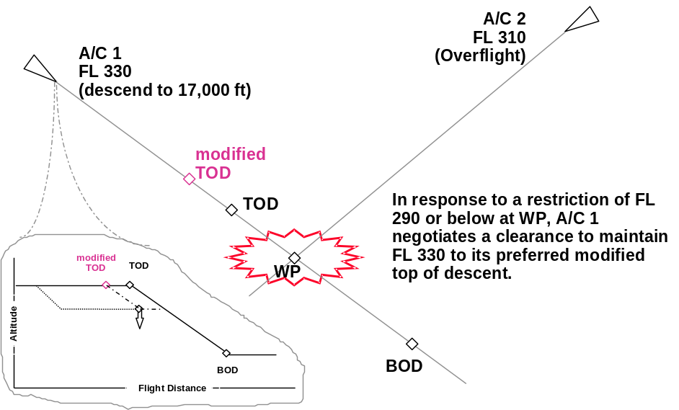
Source: NASA
Figure 6-4. Application of an Uplinked Waypoint Constraint
To further support FMS assessment of potential trajectory changes, ATSP also may provide TFM constraints and meteorological data for reference points along logical alternative trajectories. In all likelihood, RTAs or RTA ranges would be required rather than miles-in-trial spacing unless the FD is capable of processing and integrating trajectory data for other traffic into the TFM constraint information to determine spacing fit. These data requirements further accentuate the need for accurate and efficient trajectory modeling by ATSP automation.

Trajectory Negotiation
ATSP automation generates trajectory amendment advisories for controllers responding to potential conflict and TMA constraint violations and trajectory change requests, and provides the CHI functions necessary for trajectory negotiation with FD.
Aircraft Separation and TFM Constraint Conformance -- Advisories generated by CE-6 decision support tools describe route speed, heading or altitude change maneuvers and spacing, time, speed, altitude crossing constraints at reference fixes along projected trajectories. The advisories are based on analysis of extended trajectories, enabling sector teams to perform conformance planning for multiple flights over multi-sector airspace. Previous researchref.26 provides an illustration of the capabilities of CE-6 relative to current operations in resolving complex traffic situations:
Three flights in Figure 6-5 are initially on user-preferred eastbound routes. The circles indicate the relative sequence of the un-delayed flights when the first flight crosses the boundary. The natural order of arrival at the boundary is B, C, and A. Consider the situation where the downstream center (ARTCC 2) imposes an miles-in-trial spacing restriction at the boundary. Without automation assistance, it would be difficult for sector controllers to visualize and space their flights relative to flights in other sectors that are orthogonal to the flow. Referring to Figure 6-5, the controller in Sector 2 would have difficulty in spacing aircraft B relative to A or C. To overcome this problem, traffic management coordinators re-route aircraft A and C (see Figure 6-6) to form a stream that can be visualized and controlled by Sectors 2 and 5 controllers. Depending on the natural distribution of flight paths, these re-route actions add a significant flight cost penalty. Once streams are formed, spacing adjustments typically involve vectors. Although speed control can help fine-tune spacing under current procedures, it is often too little to establish spacing because of performance mismatches and limited range within a sector (for speed changes to take effect). In-trail flows also reduce the opportunity for faster aircraft to pass slower ones when the faster aircraft would naturally arrive first at the spacing-reference fix. Once spacing is established within a stream, additional deviations may result from conflicts with crossing traffic.
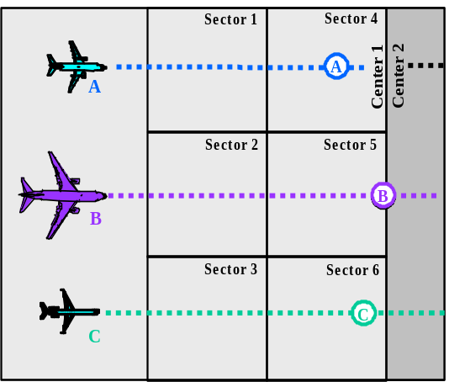
Source: ref.26
Figure 6-5. User-preferred routes

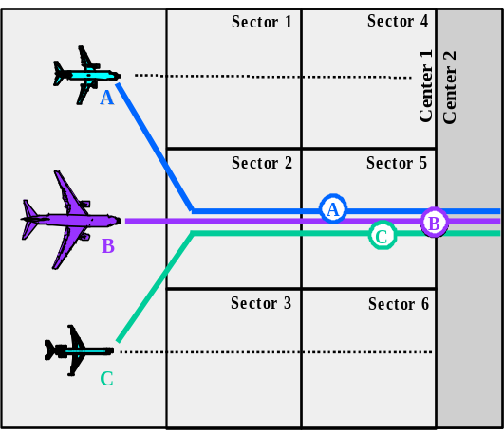
Source: ref.26
Figure 6-6. Re-routes to form spacing trail.
Application of the CE-6 trajectory-prediction and probing capability associated provides solutions that are more sensitive user-preferences. Figure 6-7 illustrates the resulting situation, assuming that the downstream receiving facility will still require an in-trail stream at the hand off. As long as the tools and procedures result in conformance prior to the spacing-reference fix, each of the cross-stream sectors may work their flights independently and thus delay the merge until the spacing-reference fix.
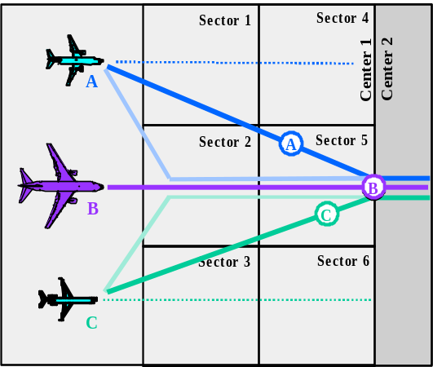
Source: ref.26
Figure 6-7. Spacing with minimum deviation.
Additional benefit could be achieved if the downstream receiving facility relaxed the requirement for an in-trail flow at the hand off. At the theoretical extreme, the automation could help controllers deliver an equivalent spacing across a wide stream of flights (Figure 6-8) with the absolute minimum deviation from each user's preferred route. Of course, depending on the amount of delay required (i.e., relative to the aircraft's performance and speed envelope), a certain vectoring may be necessary to space each flight. Figure 6-8 approaches the user-desired concept of free routing where flow-restrictions are implemented, as needed, with RTA assignments. In fact, spacing solutions could be used to determine RTA assignments for equipped aircraft.
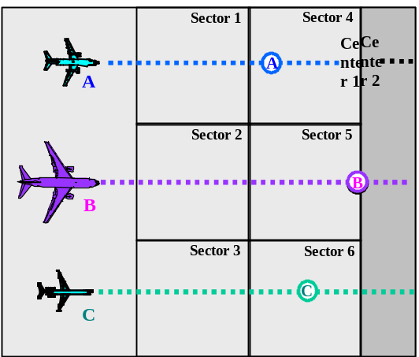
Source: ref.26
Figure 6-8. Path-independent spacing.
Figures 3-7 and 3-8 illustrate several of the advantages to the spacing tool approach. First, the degree of route deviations required for spacing conformance is minimized. Second, the traffic density and spacing workload is distributed across more sectors. This distribution of flights reduces the impact of dissimilar speeds among sequential flights, in a stream, thus allowing more opportunity for natural overtakes. It also provides for a more equitable distribution of delays based on the nominal performance of the aircraft. In addition, the integration of aircraft separation and TFM constraint conformance tools result in more efficient trajectories with fewer false alarms and missed alerts. By allowing flights to remain on independent paths (delaying any merge until the spacing-reference fix), speed control may be exercised more effectively.
The solutions generated by CE-6 automation are based on accurate aircraft performance models, which provide practical trajectories that can be flown by the aircraft. The capability of ATSP to define realistic trajectory solutions is vital to the negotiation process in that iterative communications with FD regarding trajectory option are averted. Accurate performance modeling also enables negotiation procedures in which realistic bounds on potential conflict or TFM constraint conformance options are determined by ATSP and presented to users to solicit solution preferences. The type of ATSP-FD negotiation that is used would depend on traffic intensity and situation complexity. In constrained airspace during intense traffic and workload conditions, the transmittal to FD of trajectory solutions rather than trajectory bounds data by ATSP would facilitate the negotiation process by limiting the range of options under consideration. In less time-critical situations, trajectory bounds data would enable FD to identify trajectory optimization preferences beyond those proposed by ATSP.
Controller Operations -- CE-6 ATSP automation provides controller interfaces for managing the trajectory prediction, probing and conformance resolution operations and conducting trajectory negotiation with FD.
Data entry and display devices and attendant procedures provide controllers with options to select aircraft stream and reference fix subjects for traffic flow management. Aircraft streams are defined according to flight origin or destination, routing, flight direction, airspace region to be penetrated, aircraft type, or other logical classification. A reference fix may by an individual published waypoint or a temporary waypoint manually positioned by controllers, a set of waypoints, and arbitrary arc, a formal boundary, or other meaningful designator. Reference fixes may be in the controller's sector airspace or downstream sectors.
Generally, a network of reference fixes would be established to manage multi-sector traffic. Controllers in different sectors would use this common set of reference fixes to coordinate operations. By this process, sector teams would determine aircraft separation and TFM constraint conformance resolutions based on common traffic planning goals (e. g., crossing time schedules or spacing restrictions at waypoints several sectors downstream).
Controller's have options for managing the resolution tactics applicable to aircraft separation and TFM constraint violations and trajectory change requests. Controllers define the degree of freedom permissible for use by decision support tools in constructing trajectory options. These allow trajectory changes to be defined according to speed, altitude, vectoring and routing parameters or to be unconstrained. Controllers use automatic resolution advisory tools (see Appendix B) to examine trajectory options for potential conformance violations. These modes allow a range of controller interaction in defining the trajectory options. Controller are provided with tools to modify, exchange, store and recall and the trial plans.
ATSP trajectory negotiation with FD is conducted using an extensive set of formalized data link messages supported by data display and entry devices that facilitate message manipulation. The messages are structured parametrically to enable efficient transmittal of trajectory intent, preference, constraint and request data and approval, rejection and acknowledgement information. The message data composition and format are such that they are readily understood and processed by controllers, pilots and automated functions.

FD Operations
FD operations in CE-6 are complimentary to those described in the preceding paragraphs for ATSP. FD exchanges trajectory data with ATSP, determines trajectory preferences, and negotiates clearances. The FD would not have computerized computational resources comparable in processing capability to those of ATSP automation, and FD operations are scaled accordingly. Flight-specific and time-responsive trajectory analysis tools and concise negotiation procedures are essential to FD participation in CE-6. Lengthy clearances would be problematic.ref.53
Pilots view and compose data link messages using selectable menus. Trajectories transmitted to FD for negotiation define an extended 4D flight path or near-term maneuver requirements. The extended 4D flight path describes crossing time, speed and altitude for waypoints along the projected trajectory. Near-term maneuver requirements describe speed, heading or altitude assignments or bounds on these assignments. The FMS automatically reviews the message to confirm consistency with aircraft performance capabilities, and advises the pilot accordingly on the message display. Inconsistencies between ATSP and FMS aircraft models, databases and trajectory analysis algorithms, such as those involving dissimilar speed, altitude or route change or heading/vectoring/path stretching solution strategies, would disrupt the negotiation process and are precluded in CE-6.
Pilots perform a logical validation and assessment of the ATSP trajectory proposal. At minimum, pilots have the option to respond to an uplinked message with and affirmative acknowledgement (i.e., ROGER), affirmative acknowledgement with automated loading (autoload) of the message into the FMS mode control selection panel (i.e., ROGER/ENTER), or negative acknowledgement (i.e., UNABLE). Autoload is a simple, single-stroke, selection entry by the pilot, which precludes manual copying of the message contents.
Pilots may also choose to examine trajectory options to determine preferences. Previous researchref.53 indicates that negotiation procedures should be established that would enable the FMS to automatically generate a trajectory preference or trajectory change request based on pilot-set parameters. For example, the pilot would specify the speed range usable by the FMS in determining a profile, or accept or modify speed bounds suggested by ATSP. The pilot would review the resulting profile generated by the FMS to assess acceptability, and invoke the single-stroke automated transmit (autosend) function to downlink the message.

AOC Operations
AOC decision support systems would take advantage of the ATSP-generated wind and weather forecasts to update flight planning and flight following factors, and make timely determinations of requirements to update the filed flight data. The ATSP-disseminated atmospheric parameters would locally calibrate a common ATSP and AOC gridded weather database, reducing instances of inconsistent trajectory assessments between ATM and AOC systems. AOC transmits trajectory preference updates to FD by data link as warranted by flight plan analysis.

NAS Functional Impacts
This section discusses the NAS impacts, including planned NAS architecture components, of the concept as described. Section 7.1 describes functional requirements, and section 7.2 shows the functional design which derives from these requirements.

Functional Requirements
The following functional changes from the current NAS, expressed in terms of technology and infrastructure, are needed to support the concept. These are described in the areas of communications, navigation, surveillance, automation, weather and traffic management.

Communications
Trajectory negotiation is facilitated through use of two-way air-ground data link between ATSP computer systems and the FMSs on the flight decks and two-way ground-ground data link between ATSP and AOC computer systems. AOC also provides trajectory planning data to FD through air-ground data link. Calibration data are exchanged to support trajectory modeling and analysis, and negotiation data are exchanged to support trajectory adjustment. Calibration data exchanged between ATSP and FD systems include dynamic factors describing trajectory state and intent and atmospheric conditions. Calibration data exchanged between AOC and ATM systems generally include less-dynamic factors describing aircraft performance and flight operating procedures. Negotiation data exchanged between ATSP and FD systems describe trajectory preferences and constraints. The following paragraphs summarize the data link message categories pertaining to trajectory negotiation.
Flight-Specific Operating Factors – These data affect flight performance and normally vary day-by-day from flight-to-flight. These data would be transmitted to ATM from the AOC pre-departure by New Age Flight Planref.37 by ground-ground data link, and subsequently updated as appropriate. Flight-specific factors include usable takeoff and landing runways, acceptable arrival and departure runway delay, approach and landing qualifications of crew and aircraft, required time of arrival (RTA) and FMS capabilities, and applicable cost index.
Aircraft-Specific Performance and Procedures– These data refer to both engine/airframe performance characteristics and specific airline/pilot standard operating policies or practices, specific to each aircraft or aircraft type. These data are relatively static, and would not change on a flight-by-flight, day-to-day basis. This data would be transmitted to ATM from the AOC pre-departure via a New Age Flight Plan by ground-ground data link. Relevant performance data include thrust and drag calibration factors, actual thrust and drag models, and selected performance parameters such as ascent and descent rates or envelopes as a function of speed profile. Relevant procedural data include turn rates or bank angles as a function of aircraft state and thrust management procedures or target ascent and descent rates.
Aircraft State -- Aircraft state data include time-critical flight status information. These data would be transmitted from the aircraft periodically by air-ground data link. State data include present aircraft position, altitude, velocity, heading, weight, actual navigation performance, and other trajectory dynamics (i.e., track angle and altitude change rate).
Trajectory Intent – These data describe the user-calculated active downstream trajectory corresponding to the current flight plan and clearances. These data would initially be sent from AOC in a New Age Flight Plan with additions/changes downlinked from the aircraft to ATM by air-ground data link. Intent data would be updated typically whenever: (1) a flight plan edit occurs, (2) a waypoint is crossed, (3) a trajectory is changed due to tactical maneuvering or environmental conditions, or (4) upon ATM interrogation. Intent data for a string of downstream four-dimensional trajectory control points (e.g., en route waypoints, TOD, arrival fix) could include each control point’s name, 2D location, altitude, and crossing time and weight. Additionally the data may include the point type and the turn radius associated with a flight path transition. Intent data would describe preferred speed and altitude profiles for climb, cruise and descent segments, and runway threshold crossing speed.
Atmospheric Characteristics – Meteorological data include aircraft in-flight measurements of atmospheric state and ATSP dissemination of atmospheric forecasts. The in-flight atmospheric measurements would be transmitted from the aircraft to ATM periodically by air-ground data link. Atmospheric predictions would be uplinked according to scheduled event or upon request to aircraft. The request would specify data content and scope (e.g., weather grid or points along a trajectory for a specific time period). Atmospheric state data include wind speed and direction, air temperature, air pressure, and turbulence reports.
Trajectory Preferences – The air-ground data linked preference information include FD or ATSP-generated trajectory trial plan and change request messages, proposed near-term speed, altitude and heading maneuver and fix crossing requirements messages, interrogation message requesting preference data, and acceptance and rejection messages. Trajectory trial plan, change request and near-term preference data are analogous to intent data except the preference data apply to provisional trajectories.
Trajectory Constraints – The air-ground data linked constraint information include trajectory speed, altitude, route and time bounds issued by ATSP or FD, local TFM procedural restrictions issued by ATSP, and updates issued by FD concerning aircraft performance envelopes, runway acceptability, crew and aircraft qualifications, aircraft equipage, and other operational factors.
The data link communication message system is a critical element in integrating ATSP, AOP and AOC operations and technologies in CE-6. The data link message set used for trajectory negotiation is designed to be in conformance with the data processing requirements of ATSP, AOP and AOC automation. The data content and structure or these messages support the trajectory determination, prediction and assessment functions of FMS units and ATSP and AOC decision support tools.

Navigation
There are no new functional navigation requirements imposed by the CE-6 concept beyond those that are subjects of current development efforts of the aviation industry. GPS is certified as a means of navigation and supports the determination of accurate trajectory state information and accurate adherence to trajectory intent. The on-board navigation system has a Required Navigation Performance (RNP) level with sufficient accuracy to support trajectory negotiation applications.
Aircraft participating in CE-6 operations have advanced FMS units capable of accurately adhering to a planned position, altitude, and time-defined trajectories, including RTA applications. These advanced FMS units typically include a central flight management computer, airplane systems inputs of air data, inertial reference and engine sensor parameters, digital flight control computers, and a pilot interface consisting of electronic flight displays, mode control selection panel, and control display unit (CDU). The display system includes a primary flight display, a navigation display, an engine display, and the data link message display. FMS vertical profile planning programs compute crossing speeds, altitudes and times at downstream waypoints based on altitude and cost index selection parameters. The navigation database contains pre-specified routes, fixes, and arrival and departure procedures with altitude and speed constraints by waypoint. The FMS retains the active and provisional trajectories, which may be may be modified, exchanged, stored and retrieved. The active route provides guidance and situation information, and the provisional route enables review of proposed routing and profiles or FD-initiated trajectory changes.ref.53

Surveillance
Aircraft participating in CE-6 operations are equipped to transmit their state and intent information computed in the FMS. The ATSP surveillance function fuses the FMS-derived state information with that obtained from area radar.

Automation
CE-6 ATSP decision support tools support the following automation functions:
- develop knowledge of state and intent of traffic
- develop knowledge of atmospheric conditions
- perform trajectory modeling
- perform aircraft separation and TFM constraint violation probing
- accept user preferences
- perform trajectory trial planning
- provide interactive display interface for trajectory negotiation
These automation functions are supported by appropriate two-way data link between ATSP, FD and AOC.

Weather
ATSP provides accurate atmospheric modeling of winds aloft, temperature, pressure and turbulence conditions, and provides gridded and along-track atmospheric forecast information to aircraft. These data are updated regularly by down linking of wind and temperature measurements from participating aircraft.

Traffic Management
There are no changes required for strategic traffic management at the Command Center level. Local traffic management participates in setting the TFM constraints at the ATSP sector and facility level. Local TFM constraints include miles-in trail spacing, time-based metering, and altitude, speed, route and related procedural restrictions.

Functional Design
Figure 7-1 is a high level functional design diagram showing those NAS systems and services that are essential for supporting CE-6. Current and future air traffic systems and services which are general to ATM but not specifically utilized in CE11 are not shown.

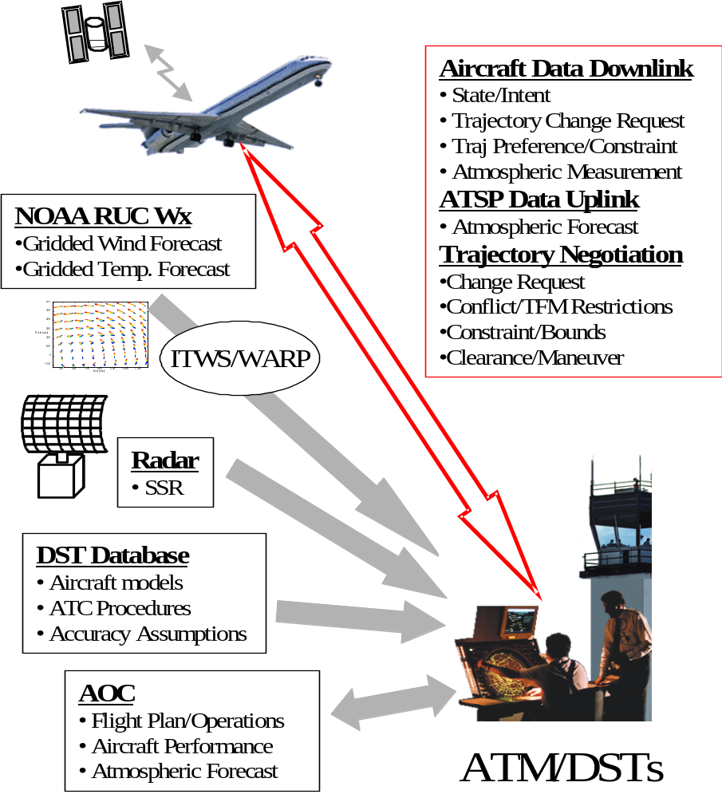

Figure 7-1. CE-6 Functional Design Diagram

The aircraft maintains accurate state and intent information and trajectory conformance using GPS as the primary navigation input to the FMS. Each aircraft transmits state and intent information ground receivers. The down linked state data are fused with secondary surveillance radar data for improved total situation awareness by ATSP. The aircraft downlinks atmospheric measurements and ATSP uplinks atmospheric forecasts. AOC transmits aircraft performance and flight operations information to ATSP and trajectory planning information to the aircraft. ATSP conducts aircraft separation and TFM constraint violation probing, and transmits provisional trial plan or trajectory bounds data to the aircraft. ATSP also provides the aircraft with local TFM constraints. Aircraft FMS assess the trial plan or trajectory bounds data, generate trajectory preferences or trajectory change requests. These are subsequently transmitted to ATSP after pilot review, modification and approval. Controllers and pilots review and assess trial plans, constraints, and request, and negotiate trajectory adjustments using interactive display interfaces.

User/Operator Roles and Responsibilities
This section addresses impacts on CE-6 on the roles and responsibilities of the active participants, focusing on controller and pilots.

ATSP Roles and Responsibilities
The air traffic controllers manage aircraft in a similar manner as today, but employ advanced decision support tools and data link communication. Controller operating functions associated with CE-6 include the use of automatic resolution advisories and interactive display interfaces (see Appendix B).

Pilot Roles and Responsibilities
In CE-6, pilots use the FMS interactive display function integrated with data link communication to conduct trajectory negotiation with ATSP. CE-6 provides pilots with concise trajectory negotiation procedures and capabilities to modify trajectory planning parameters and modify, exchange, store and retrieve active and provisional trajectories in the FMS.

Dispatcher Roles and Responsibilities
CE-6 does not have significant effects on AOC operator roles and responsibilities.

Operator Modes and Scenarios
This section illustrates the CE-6 concept using a hypothetical flight.

Normal or Nominal Mode
Before the departure of BRC926, a LAX to ORD flight, the AOC submits information to ATM describing trajectory intentions and preferences specific to today’s flight and the aircraft’s standard performance characteristics. These calibration data include take-off weight, runway preferences, acceptable delay factors, climb, descent and cruise profile characteristics, and the aircraft engine and aircraft operating specifications. CTAS processes these data to define alternative surface routings and departure trajectories to and from the user preferred and other qualifying runways. CTAS uses this information to update the airport taxi routing and runway utilization plan. CTAS also uses aircraft position data sent by ADS data link during taxi-out to update route and trajectory alternatives.
After takeoff from its preferred runway, BRC926 periodically downlinks aircraft state information to ATSP by air-ground data link, including current position, time, heading, altitude, and velocity vector, and atmospheric state measurements describing current wind , temperature and pressure. Upon receipt of the initial aircraft airborne state report, ATM uplinks an atmospheric forecast to BRC926 describing the predicted meteorological state at 3D points along the planned flight trajectory. BRC926’s FMS uses the atmospheric prediction data and its database of local standard departure procedures to recalculate its projected trajectory based on its current ATM clearance. BRC926 then downlinks a trajectory intent report describing the FMS-projected Mach/CAS speed and altitude climb profile and times and altitudes at downstream waypoints.
The FMS-derived and AOC-provided calibration data are used by the ATSP automation to predict the departure trajectory as well as to construct alternative trajectories. The high fidelity trajectory prediction and assessment capability afforded by the calibration data, aircraft dynamics modeling, and conflict probe and trial planning DSTs, enables a controller to identify an efficient maneuver adjustment to BRC926 that avoids a potential conflict with an arrival flight to the airport. This maneuver permits removal a standard local procedural altitude restriction that would require BRC926 to cross under the crossing and descending arrival traffic pattern. This maneuver deviation is less costly than would be the altitude restriction. This provisional trajectory plan is uplinked to the aircraft. The FMS reviews the plan and determines that the plan conforms with the aircraft’s performance capabilities and is more fuel-efficient than the current active trajectory. The pilot cognitively accepts the plan and transmits a ROGER/ENTER downlink message which autoloads the plan into the FMS as the active trajectory. Similarly, the ATSP provisional plan is converted to active status by the automation, and noted by the controller.
ATSP automation uses the aircraft state reports to display accurate position, heading and speed data for BRC926, enhancing the controller’s ability to monitor the trajectory dynamics and verify compliance with the clearance. BRC926 continues to downlink aircraft state and atmospheric measurement periodically during climb, and will do so for the remainder of the trip.
BRC926 downlinks a report of the FMS-determined aircraft weight at top of climb. This information is used by ATSP to calibrate its flight state data and modeling processes, enhancing trajectory prediction accuracy. Also at top of climb, BRC926 downlinks a request for an atmospheric prediction update. ATM responds by uplinking an atmospheric forecast describing the predicted meteorological state at the downstream waypoints along the current planned trajectory. The FMS-projected trajectory is recalculated, and BRC926 downlinks a trajectory intent report describing the FMS-preferred speed and altitude profile and times and altitudes at downstream waypoints. The data linked information are used by ATSP to enhance the ATM trajectory prediction models that are supporting multi-sector probing for potential violations of aircraft minimum separation and local TFM spacing constraints along BRC926’s intended trajectory. The automated probing identifies down-sector TFM spacing violations that, according to the results of ATSP trial planning, could be resolved by an altitude diversion to BRC926. Instead of transmitting this resolution to the aircraft, the controller elects to uplink the relevant TFM spacing constraint information using automated procedures. The FMS determines that a speed reduction is a preferred fuel-efficient solution, and the pilot downlinks the corresponding trajectory change request. The controller probes this alternative for potential conflicts and TFM constraint violations, determines that it is acceptable, and approves the speed change by data link acknowledgement. The FMS and ATSP active trajectories are updated.
These air-ground data link transactions by BRC926 during cruise are repeated at trajectory change points, such as top of step climb and key turn points, as well as at occurrences of deviations from the intended trajectory. ATSP decision support tools continue to update trajectory predictions, perform trajectory probing, and display advisories and data to controllers.
At a scheduled time prior to top of descent, ATM uplinks an atmospheric prediction update and a trajectory intent interrogation. The atmospheric forecast describes the predicted meteorological state at 3D points along the currently planned descent trajectory. In response to the interrogation, the BRC926 FMS recalculates its forward trajectory and downlinks a trajectory intent describing the FMS-projected Mach/CAS speed and altitude descent profile, arrival runway threshold crossing speed, and the arrival runway and runway exit identifiers. ATSP automation processes the dynamically updated calibration information to refine the arrival airspace and runway utilization plan.
This air-ground and ground-ground data linked information improves the accuracy of the ATSP trajectory prediction models in comparison to the current baseline ATM system. ATSP automation processes the assembled calibration data (i.e., aircraft performance, pilot procedures, flight operating factors, aircraft state, intent and atmospheric parameters) to define alternative arrival trajectories to the user preferred and other qualifying runways. As result of the ATSP assessment, BRC926 is issued a provisional plan to reduce cruise speed before top of descent without changing the top of descent location. The resulting trajectory is the most cost-effective alternative for the prevailing traffic situation. The FMS confirms the plan’s acceptability, the pilot approves, and the clearance change negotiation is completed through routine data link transaction and data processing procedures.

Off-Nominal Mode Scenarios
There are no currently identified off-nominal mode scenarios that drive CE-6 concept development.

Failure Mode Scenarios
There are no currently identified failure mode scenarios that drive CE-6 concept development. If ATSP CE-6 decision support tools fail, ATM operations revert to those of the current system. If a FD or AOC automation function fails, that operator or aircraft cannot participate in CE-6 services and the ATSP develops the most acceptable resolution given the available information.

Operational Processes/Operational Sequence Diagrams
An overview of the CE-6 operation is depicted in Figure 10-1.

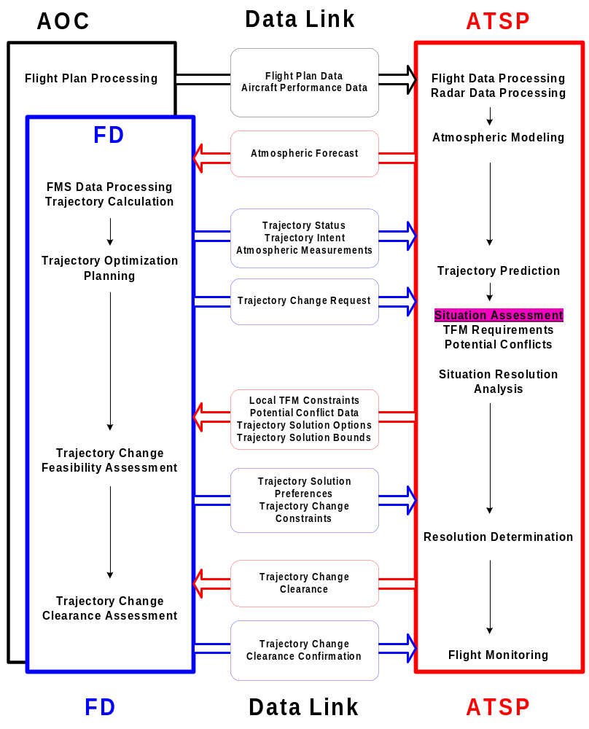
Figure 10-1 CE-6 Operational Sequence Overview

Benefits
En route trajectory negotiation improves the performance of FMS and ATM automation and enhances situation awareness, resulting in improved flight operating efficiency, reduced workload and associated safety impacts. The primary potential benefits of the CE-6 are derived from improvements in the trajectory assessment and prediction capabilities of advanced ATSP automation and FMS units. The effective operation of many advanced ATSP automation enhancements (e.g., potential conflict and local TFM constraint violations probe and various sequencing, scheduling and spacing algorithms) and FMS features depend primarily on the capability to accurately determine current aircraft state and predict future states. The accuracy of these underlying trajectory algorithms are enhanced by the higher fidelity aircraft performance information, aircraft state and intent data, and atmospheric measurement and forecast data provided by the CE-6. Trajectory negotiation significantly enhances these benefits by including user preferences as a major factor in the trajectory decision-making processes. Additional benefits are provided by displaying more accurate trajectory state information derived from the calibration data to controllers to assist in evaluating the current and evolving traffic situation and negotiating the appropriate response for delivering aircraft to the desired end state.
Key CE-6 potential benefits impacts are summarized in the following paragraphs.

Capacity
More Efficient Use Airspace System Capacity – Due to more accurate current and predicted situation information (e.g., aircraft position and velocity vector, winds aloft, runway exit), FMS-equipped aircraft conform better to planned or assigned trajectories and ATSP is more responsive to changing situations. These improvements enable effective negotiation and implementation of sequence and schedule plans designed to increase throughput and reduce delays .
Enhanced ATM En Route Sequence and Schedule Planning – Improved automated trajectory analysis and negotiation capabilities enhance the ability of advanced ATM automation tools to develop aircraft sequence and schedule plans to fully utilize available airspace capacity, resulting in reduced delays due to better planning.

Flexibility
Expanded Range of Resolution Options -- Data exchange and trajectory negotiation enable ATSP and users to be aware of, consider and adapt to each others' constraints and preferences.

Efficiency
More Fuel and Time Efficient Traffic Avoidance Resolutions – With improved surveillance and ATM automation prediction capabilities using ATSP-FMS-AOC data, the knowledge of the structure of potential conflicts and intervention options is improved, leading to negotiation of more efficient conflict resolution maneuvers.
Reduced ATM Interruptions for False Potential Conflict Determinations – Improved trajectory data exchange processes and automated trajectory analysis capabilities reduce the likelihood of incorrect predictions of violations of minimum separation requirements, reducing unnecessary trajectory delays and diversions.

Access
Improved Access to High-Density Operations -- Improved sequence and schedule planning and situation assessment by ATM facilitates access by non-scheduled users requesting entry into high-density operations.

Issues and Key Decisions
CE-6 is under initial development as a concept. The key issues concern refinement and validation of the basic concept and development of the details. Validation of the concept should involve operations staff at an early stage to confirm the concept is proceeding in the proper direction.
Specific issues are identified in Appendix B-2 of the DAG TM Research Plan ref.2 as excerpted below:

“Operations” categories
Separation assurance while adhering to RTA
- Will the ATSP be able to maintain separation assurance for conflicting aircraft on high-energy idle-thrust descents?
Mixed-equipage integration and segregation
- How will the ATSP simultaneously handle aircraft equipped and not equipped with FMS?
- Can the ATSP integrate aircraft on 4D (RTA) trajectories with aircraft on MIT trajectories?
Time horizons
- What decision-freeze time horizons are needed in the trajectory request/evaluation/negotiation process?
- How soon before entering the modified flight plan environment must the trajectory negotiation be complete?
- How much time is required to complete trajectory negotiation?
- At what point do negotiations need to be started to avoid excessive time pressure and workload?
- When is the traffic and constraint information sufficiently reliable to submit a trajectory request and begin negotiation?
Traffic situation complexity
- What is the level of dynamic density that exceeds controller ability to perform safe separation with no route structure?
- Assuming ATSP has ultimate responsibility for separation assurance, is there an upper feasibility limit of traffic situation complexity for which the trajectory request/evaluation/negotiation process can be applied?
Environmental predictions
- How is the trajectory negotiation process affected by large changes in weather and winds?
CNS infrastructure & aircraft capability limitations
- What CNS architecture and capabilities (ground and airborne) are needed to support air-ground trajectory negotiation?
- What level of certifications will be required for FD systems, and will this level be low enough to justify this concept element as a distinct transition step on path to free maneuvering?
Negotiation
- How far will the ATSP allow negotiation to continue before enforcing a final solution?
- Under what conditions would the ATSP find the trajectory request unacceptable?

“Human Factors” categories
Roles & responsibilities
- What are sector controller, TMC, and TFM roles and authority for approval of proposed amendments? (e.g., does sector controller have authority to deny an amendment outside of his sector? If not, how are ground approvals coordinated?)
- Will a D-side controller be required to prevent loss of R-side SA while accommodating user preferences.
- If the ATSP is responsible for separation assurance, does the FD need to perform conflict detection before making a trajectory request?
- What is appropriate balance between FD and AOC in developing user preferences for proposed Flight Plan amendment?
- Does the ATSP have the authority to refuse a conflict-free / constraint-free trajectory request that was submitted to meet user preferences?
Workload mgmt, task balancing
- How does the trajectory request/evaluation/negotiation process affect workload for flight crew and ATSP?
Using automation
- How much does the pilot need to know about the data and process used in trajectory calculations?
- Can automation reduce ATSP workload in handling high frequency of flight plan amendments?
- What automation capabilities would the ATSP find useful in conflict detection and provisional planning?
Situation awareness and predictability
- Will the ATSP be able to maintain adequate SA in the passive compliance-monitoring role?
Coordination and negotiation
- How is intra-and inter-facility coordination affected by the trajectory negotiation process, especially if trajectory is deemed unacceptable by only one ATSP?
- How are pilot and ATSP "cognitive models" of "simple" trajectories balanced in the negotiation process?

“Data Exchange” categories
Content, frequency, accuracy
- What content and fidelity must be transferred in a trajectory request for a confident evaluation to be performed by the ATSP?
- What fidelity of aircraft performance capability and user preferences does the ATSP need to know for trajectory request evaluation?
- How much of the remaining flight plan must be included in the trajectory request?
- Under what conditions or time horizons should trajectory requests specify 2D, 3D, or 4D trajectories?
- What fidelity of traffic information and spatial and temporal constraints is required to form robust trajectory requests?
- What information does the ATSP need to adequately monitor trajectory compliance?
Data link mechanism
- What data link bandwidth is required for trajectory negotiation?
- What data exchange update rate is required to maintain data integrity?
- What communication capabilities and characteristics (e.g., data integrity, addressing latency, data rate) are required to support FD trajectory requests to the ATSP?
- How is the constraint information needed by the FD to develop robust trajectory requests maintained and transferred to the user?

“Decision Support” categories
Overall functionality: FMS designed for trajectory-negotiation operations
- How does the FD DST integrate user preferences (FD/AOC), near term conflicts, and aircraft performance to arrive at optimal, conflict free 4D trajectory request?
Overall functionality: ATSP DST designed for trajectory-oriented operations
- What ATSP DST capabilities are required to facilitate "trajectory orientation"?
- What ATSP automation capability is needed to ensure a solution trajectory exists which meets all constraints?
Interface (display, input, alerting)
- How will complex trajectories be displayed on a standard CDTI?
- What display features are required to support the ATSP in monitoring trajectory compliance?
- How is the new 4D-trajectory request presented (displayed) to the FD/ATSP for considerations?
Constraint management
- Do constraints need to have relative priority assigned to ensure conflicts are resolved?
RTA-capable CD&R algorithms
- What assumptions and constraints are used in trajectory synthesis by the FD and ATSP?
- Are identical algorithms required for FD and ATSP trajectory synthesis?

“Procedures” categories
Negotiation
- If ATSP denies trajectory request, what additional information is transferred to the FD for possible negotiation?
- How shall failsafe negotiation be insured in time for implementation?
- What aspects of the negotiation process are automated and in what aspects does the human play a role?
Trajectory-oriented ATSP
- What ATSP procedures are required to facilitate "trajectory orientation"?
- What procedure for information distribution should be followed by the ATSP after receipt of a trajectory request?
Trajectory evaluation
- What procedures are followed when a trajectory request is unacceptable to the ATSP?
- What procedures and tools are used by the ATSP to evaluate trajectory requests?
Monitoring
- What procedures are needed for the ATSP to monitor trajectory adherence?
Degraded-mode operations
- What procedures are followed if the FD automation supporting trajectory request and negotiation fails?
- What procedures are followed if the ATSP automation to support trajectory evaluation and negotiation fails?
- How do interruptions in voice communications affect negotiation process?
- Can procedures be developed to provide the level of robustness to communications failures provided by today's "positive control" procedures?
Constraint management
- After conflict free trajectory is negotiated that meet airspace and RTA constraints, is complete new negotiation needed for each new conflict?

“Safety” categories
Automation failures
- Will conflict free FMS trajectories be robust to failures of individual aircraft to execute them accurately?

Appendix A. Operational Requirements Table

A.1 Operational Requirements – Separation Assurance Area

The following operational needs statements are addressed by CE-6, Trajectory Negotiation for User-Preferred Separation Assurance. The numbers provide a trace to the matrix of operational needs statements supporting the AATT ATM/OPSCON.

ONS # | ONS Text
1_235 | ADS-B enables positive control in non-radar environments.
1_365 | Standards may vary depending on equipage and the quality of positional data for individual flights.
1_375  4_370 | Through a data link to the properly equipped cockpit, provide users- routine communications- updated charts, current weather, SUA status, and other data- basic flight information services, including forecast weather, NOTAMs, and hazardous weather warnings- airport information, including Runway Visual Range (RVR), braking action and surface condition reports, runway availability, and wake turbulence and wind shear advisories - clearances and frequency changes in the form of pre-defined messages.
1_435 | Controller workload under peak traffic remains equivalent to the workload controllers absorbed in the 1990s under lighter traffic demand. This increased ATC efficiency has been achieved through the implementation of decision support systems for traffic management and control, dynamic alteration of airspace boundaries, reduced vertical separation minima, improved air/ground communications and coordination, and enhanced ground/ground coordination aids.
1_437 | User-Air Traffic Service Provider exchange of state and intent data will improve the accuracy of, and consistency between, FMS and ground-based trajectory predictions.
1_438 | Before changing a flight’s trajectory, the controller must ensure not only that the revised trajectory is free of conflicts, but that the transition to that trajectory is also conflict free. The system therefore provides a ‘trial plan’ conflict probe for testing alternative trajectories.
1_440  5_515 | Air safety has been increased through the implementation of conflict detection and resolution tools, the inclusion of the flight deck in some separation decision-making, and greatly enhanced weather detection and reporting capabilities.
4_110 | Improved navigation precision, coupled with changes in service provider separation procedures allow an improved ability to accommodate user-preferred arrival/departure routes, climb/descent profiles, and runway assignment.
4_251b | This includes access to better information regarding the kind & amount of traffic coming into a terminal area. It also includes improved capability for conflict alert and for automated coordination between service providers within the terminal area and in neighboring facilities.
4_475 | visual separation by pilots in terminal areas is expanded by 2005 to allow all-weather pilot separation when deemed appropriate by the service provider.
4_485 | The increased use of this distributed responsibility is made feasible through improved traffic displays on the flight deck, combined with appropriate rules, procedures, and training to support the new roles and responsibilities of the users and service providers.
4_490 | To assure aircraft separation, service providers use improved tools and displays.
4_515 | Aircraft-to-airspace and aircraft-to-terrain separation will remain the service provider’s responsibility
4_520 | the service provider maintains separation between controlled aircraft and active SUAs, and between controlled aircraft and terrain/obstructions.
4_775 | High density areas still require the oversight from ATC for sequencing and primary separation assurance
5_210 | Decision support systems such as the conflict probe assist the provider in developing safe and effective traffic solutions.
5_235  5_440 | Additional intent and aircraft performance data is provided to decision support systems, thus improving the accuracy of trajectory predictions. This information is combined and presented on the service provider’s display.
5_240  5_445 | Since there are different separation standards depending on the flight’s equipage and the quality of the positional data, service provider displays indicate the quality of the resulting aircraft positions and the appropriate equipage information.
5_295 | Improved decision support tools for conflict detection, resolution, and flow management allow increased accommodation of user-preferred trajectories, schedules, and flight sequences.
5_315  5_470 | Structured routes are the exception rather than the rule, and exist only when required to meet continuous high density, to provide for the avoidance of terrain and active SUAs, and to facilitate the transition between areas with differing separation standards.
5_420 | user intent and aircraft performance data to decision support systems, thus improving the accuracy of ground-based trajectory predictions.
5_430 | The use of satellite-based navigation and surveillance data will not only increase on-board capabilities ranging from cockpit traffic and enhanced collision avoidance logic, but will also be used by ground-system automation for enhanced conflict probe and alerting.
5_520  5_580 | Improving the provider’s ability to identify conflicts will also reduce the number of occasions when there is intervention, allowing the user to fly the trajectory proposed with higher frequency.
5_550 | As in the departure and arrival operations, increased decision support allows significant improvement in en route separation assurance.
5_560 | there will be improved coordination between the service provider and the flight deck to aid the flight in weather avoidance.
5_565 | improved information available from common weather sources, service providers will be more effective in controlling aircraft in airspace that contains hazardous weather and in providing weather advisories to pilots.
5_575 | Decision support systems will assist in conflict detection and the development of conflict resolutions.
5_605 | Service providers will continue to be responsible for maintaining separation between aircraft and certain types of airspace (specifically, active special use and adjacent controlled airspace), terrain, and obstructions
5_615 | When flights are in close proximity to the newly activated SUA, the provider will use aircraft-to-aircraft conflict detection tools as aids to prevent them from entering the restricted airspace. Both earlier intervention and the closer-proximity resolution activities result in more efficient routing of aircraft
5_790 | high density areas still require the oversight from ATC for sequencing and primary separation assurance.
5_805 | Use of the ground based conflict probe has been modified to allow for airborne procedures to resolve most conflicts, thus allowing maximum routing flexibility with the least restrictions.
5_845 | In en route airspace, the use of moving maps for CFIT avoidance, CDTI, and weather depiction has begun, albeit, the user application stressed may be different.
6_155 | Most aircraft navigate using a global satellite navigation system whose improved accuracy will generate the required safety for reduced separation standards.
6_380 | The pilot’s ability to support climbs, descents, crossing and merging routes is supplemented by the service provider’s conflict probe decision support system.
6_415b  6_455b | Service providers, aided by supporting automation and electronic visual displays, are able to acquire and view timely and reliable flight information to dynamically address necessary changes to the trajectories.
6_460  6_370 | pilots may coordinate with service providers for clearance to conduct specified cockpit self-separation operations. ... the pilot’s view of nearby traffic supplements the service provider’s big picture of longer term traffic flow.

A.2 Operational Requirements – Traffic Management, Synchronization Area

The following operational needs statements are addressed by CE-6, Trajectory Negotiation for User-Preferred Local TFM Conformance.

ONS # | ONS Text
1_422 | The most obvious user benefit is a reduction in the per-flight direct operating cost that every user operating under IFR can obtain through real-time optimization of their flight trajectory.
3_185 | continuous updating of the flight object improves real-time planning for both the user and the service provider. ... improves the effectiveness of ongoing traffic management initiatives and the collaborative decision making
4_311 | Properly equipped aircraft are given authority to maneuver as necessary to avoid weather cells, or to follow such aircraft using self-spacing procedures.
4_315  3_225 | When appropriate, clear properly-equipped aircraft to self-separate and maintain sequence (“station-keeping”).
4_316 | Appropriately equipped aircraft are given clearance to merge with another arrival stream, and/or maintain in-trail separation relative to a leading aircraft.
4_450 | more effective collaborative decision making, with the AOCs collaborating with ATM in deciding TFM initiatives which are then data linked to the pilots and service providers.
4_585 | On final approach, the service provider may give the pilot responsibility for station keeping to maintain the required sequence and spacing to the runway.
4_646 | To enhance operations during peak capacity periods, arrival operations are enhanced by taking advantage of aircraft FMS to enable Required Time of Arrivals (RTAs) at designated approach points.
4_755 | the pilot will be able to select which route he wishes to follow.
4_765 | pilots ... fly to meet required times of arrival
4_770  5_355 | Free maneuvering operations in low density areas is being performed.
4_775 | High density areas still require the oversight from ATC for sequencing and primary separation assurance
5_115 | The use of en route airborne holding has been reduced with the implementation of other procedures that improve traffic flow patterns and make maximum use of available terminal capacity
5_125 | By the year 2000, ATC considers AOC and flight deck preferences while assigning routes and controlling aircraft.
5_145 | These metering and merging separation procedures could provide the crew the flexibility to more efficiently manage their flight with respect to aircraft performance, crew preferences, and ATC considerations by allowing aircraft to stay on the cleared route in cases were ATC would otherwise have to vector the aircraft to achieve the desired spacing.
5_200 | remain at that altitude until the point is reached from which an optimum descent profile should commence.
5_210 | Decision support systems such as the conflict probe assist the provider in developing safe and effective traffic solutions.
5_235  5_440 | Additional intent and aircraft performance data is provided to decision support systems, thus improving the accuracy of trajectory predictions. This information is combined and presented on the service provider’s display.
5_295 | Improved decision support tools for conflict detection, resolution, and flow management allow increased accommodation of user-preferred trajectories, schedules, and flight sequences.
5_345 | When appropriate, use a “metering spacing technique” to provide the user the flexibility to efficiently manage a flight.
5_400 | Perform some spacing activities that were previously performed by the service provider. These activities will be performed for metering or merging purposes. (Flight Deck)
5_420 | user intent and aircraft performance data to decision support systems, thus improving the accuracy of ground-based trajectory predictions.
5_450 | Reduced or time-based separation standards will be developed based on technology and aircraft capability, further increasing system capacity and safety.
5_510 | Cockpit technology improvements will allow more user-preferred routings, SID to STAR or from airport-to-airport.
5_530 | This will facilitate more effective collaborative decision making, allowing users to collaborate with ATM in deciding TFM initiatives.
5_545b | traffic management services are provided in the en route area
5_575 | Decision support systems will assist in conflict detection and the development of conflict resolutions.
5_685 | The service provider will also be involved in the coordination of modified flight trajectories for active flights.
5_695 | This will allow earlier and immediate coordination with either the pilot or the airline operations center to provide adjustments with minimal intervention and movement.
5_700 | Traffic flow service providers will work with the service provider in active communication with the pilot to re-plan the flight trajectory.
5_710 | increased information exchange between the en route, arrival, departure and surface decision support tools will enable better coordination of cross-facility traffic flows with fewer constraints. These improved capabilities will also allow for greater accommodation of user requests, including carrier preferences on the sequencing of their arrival aircraft.
5_740 | Modified routes can be developed collaboratively between the AOC and the service provider and then data linked to the cockpit and downstream ATC facilities.
5_790 | high density areas still require the oversight from ATC for sequencing and primary separation assurance.
6_285 | Perform some separation and merging activities that were previously performed by the service provider.
6_300 | Provide additional user intent and aircraft performance data to decision support systems, thus improving the accuracy of ground-based trajectory predictions.
6_380 | The pilot’s ability to support climbs, descents, crossing and merging routes is supplemented by the service provider’s conflict probe decision support system.
6_415b  6_455b | Service providers, aided by supporting automation and electronic visual displays, are able to acquire and view timely and reliable flight information to dynamically address necessary changes to the trajectories.
6_460  6_370 | pilots may coordinate with service providers for clearance to conduct specified cockpit self-separation operations. ... the pilot’s view of nearby traffic supplements the service provider’s big picture of longer term traffic flow.
6_465  6_375  6_240 | Pilots may obtain approval for special maneuvers such as reduced separation in-trail climb, in-trail descent, lead climb, lead descent, limited duration, station keeping as well as lateral passing maneuvers
6_525b | ATC oversight is still required for sequencing, but collaborative decision making has greatly increased among the service provider, AOC, and the aircraft.
7_125 | This approach is commonly referred to as “control by time of arrival” ... Under this approach, both GA and DoD users would be able to make more effective use of NAS resources during reduced capacity conditions.
7_295 | Adhere to allocated arrival times assigned by the service provider. In some instances, international flights are excepted from this responsibility.
7_300 | Using increased knowledge of the intent of traffic flow initiatives, arrange user resources to help solve traffic flow problems.
7_474 | Cumulative delay data ...enables ...controllers to allocate discretionary tasktime to coordinate expedited trajectories for flights that have absorbed delay, rather than for flights that have not been delayed.
7_650 | Increasingly, national and local TFM service providers adapt to an environment of increased user flexibility, collaborative partnership, and information sharing among themselves and with the airspace users

Appendix B. Automated Resolution Advisories
Previous reseachref.26 provides the following description of a trial planning concept which may be used as a basis for investigating an automated resolution advisories interface for CE-6. Key features include active and provisional trajectory planning and automatic, semi-automatic and manual advisories:

Active and Provisional Planning -- Active and provisional trajectory planning supports trajectory negotiation by providing a configuration control mechanism for managing trajectory plans under dynamic ATC operations.
Definitions:
Ownership: Only one sector owns a flight at a time. Ownership provides the controller “write” protection (for modifying the active trajectory plan) and the authority to issue clearances to an “owned” flight.
Active: The active trajectory plan is the ATC plan that is “visible” to all sectors (“read-only” access), regardless of ownership. Only the sector with ownership can modify the active plan. The active plan reflects the best prediction that can be made by the DST given the current clearance and any expected transitions (e.g., delay strategy for flow-rate conformance, or a descent to cross a fix along a STAR). The active plan forms the basis for conflict probe and the monitoring of conformance to clearances and restrictions (in terms of altitude profile, speed profile, routing, and time). Active plans form the basis of flight information that is generally read-accessible by all “operators” (i.e., other controllers and users (pilot/AOC)). Active plans are particularly critical to the configuration management for distributed air-ground (user-ATM) trajectory planning such as trajectory negotiation or airborne free maneuvering.
Provisional: The provisional-trajectory plan is a plan that may be created by any operator. By default, a provisional plan is only visible to the operator who created it. The creator of a provisional plan may modify it as desired (i.e., the creator is the only one who has default read and write access). The read-access rule may be modified by the creator (i.e., setting permission) to allow read access to any identified operator(s). No other operators have write permission. However, other operators who receive read permission (e.g., another sector, the R/D-side complement to the creator, or the user) may duplicate the plan and modify the copy as their own provisional (with its own read/write permission settings). The only operator who may upgrade a plan from provisional to active status is the controller with ownership (or in the case of free maneuvering, the pilot). Provisional trajectories are updated to reflect the latest state and planning data, but are not necessarily monitored to the extent accorded active plans.
Modifications: Controllers may modify plans via manual and automatic functions. Depending on the controller’s preferences, both active and provisional plans may be modified either automatically, by “active” advisories (e.g., an TMA constraint), or manually through discrete controller inputs. This mapping of “active advisories” to active/provisional plans allows the system to automatically update the plans based on the advisory functions invoked by the controller. This update is intended to reduce workload by minimizing controller interactions to cases that must be identified by exception (rather than rule). Within the ATM industry, manual updates of provisional plans are commonly referred to as “trial” plans.
Locked: Active and provisional-trajectory plans may be “locked” by the owning controller (i.e., a lock freezes identifies aspects of the plan for the DST to freeze such as the current speed clearance in cruise). Any trajectory profile/segment that is locked is immediately monitored for conformance. The unlocked profile/segments are not monitored for conformance. For example, a controller may lock an active advisory for an arrival to descent 100 nmi from its destination, descend at Mach 0.82/330 knots, and cross the TRACON boundary at 14:41:52 GMT. Once locked, the DST will monitor that flight’s conformance with its altitude, speed, lateral, and time predictions.
Monitoring: Monitoring for conformance with altitude, speed, routing, and time profiles may be applied to both active and provisional-trajectory plans. Results regarding active plans are displayed on the primary displays for conflict probe, meet-time/spacing, and clearance conformance. Monitoring cues for analysis of active plan conformance (e.g., conflict probe) are prominently displayed automatically. Cues related to provisional plans will be displayed in the secondary display functions (e.g., a provisional/trial plan list), and displayed by exception according to human-factors standards and controller-defined preferences.
The Active/Provisional-trajectory plan approach is based on the need to develop a system that maintains/supports the situational awareness of “owning” controllers and other operators. The potential for controller overload and confusion is great because of two factors: the complexity of provisional “hypothetical” plans, and the geometric growth of conflict trajectory analysis combinations that can exist when hypothetical plans are compared with all the possible combinations of other hypothetical plans across multiple sectors. These comparisons (specifically conflict probe and spacing) must be limited in a way that makes it easy for the controller to know and understand the basis of the advisories we are displaying.
Automatic, Semi-Automatic, and Manual Advisory Levels -- Definitions:
Automatic Advisories: Advisories that are generated without requiring dynamic controller input are “automatic.” For example, a controller may configure CE-6 automation to automatically suggest cruise- and descent-speed advisories for any flights subject to arrival-metering delays. Automatic and semi-automatic advisory functions may be applied to flow-rate conformance (metering or spacing) and/or conflict resolution. A controller may configure their DST to automatically update the active plans of their “owned” flights based on the current advisory (as a form of controller intent). Alternatively, controllers may configure their DST to automatically create provisional plans based on the automatic advisories (leaving the active plans alone until the controller upgrades the provisional plan to active). Automatic advisories continuously update to reflect the latest state of the traffic and airspace.
Semi-automatic Advisories: Semi-automatic advisories are a hybrid of automatic and manual functions. Controllers must activate the semi-automatic function by a dynamic input that indicates the flight(s) for which advisories are to be generated, and the type of advisory to be generated (i.e., the control “degree of freedom” such as speed for metering). For example, a controller may configure CE-6 automation to generate path-stretch (delay) advisories only when the controller clicks on a flight and invokes the semi-automatic path-stretch mode. In response, CE-6 automation will determine the range (to vector) and the turn-back course that is necessary to absorb any remaining metering delay. Although this type of advisory requires explicit input from the controller, it minimizes controller workload by automatically determining the appropriate clearance advisory once it is invoked. Similar to automatic advisories, controller may configure their DST to automatically update the active plans of their “owned” flights based on the current advisory (as a form of controller intent). Alternatively, controllers may configure their DST to automatically create provisional plans based on the semi-automatic advisories (leaving the active plans alone until the controller upgrades the provisional plan to active). Controllers may configure their DST to either update semi-automatic advisories (to continuously reflect the latest state of the traffic and airspace), or provide a single advisory response that “times out” after a designated/default period of time.
Manual Advisories: Manual advisory capability allows the controller to modify the state of DST predictions/analyses based on direct input. Manual input may be applied to either active plans (e.g., to update the intent model based on the latest clearance) or provisional plan (i.e., “trial” planning). In this case, the controller must not only decide on the control degree of freedom, but must also decide on the actual value (e.g., speed, altitude, routing) to use. DST advisories for items such as conflict probe and flow-rate conformance automatically provide the controller with feedback on the state of conformance based on the manual input. Manual inputs may be used by the controller to also override, correct, or guide the higher levels of advisory generation. For example, the controller may have selected an automatic cruise/descent-speed advisory for metering, but wishes to manually adjust the descent speed (e.g., trial plan) for conflict resolution. As the controller trial plans the descent speed to resolve a conflict, the automatic “meet-time” function responds by adjusting the cruise speed and top of descent to meet the time.
Mapping Of Automation/Advisory Level To Trajectory-Plan Type -- The following table presents a mapping of the trajectory-plan types (active/provisional) against the level of automation/advisory that a controller may select. Depending on the situation, controllers may configure the DST functions to match one of the six combination cases.
Trajectory Plan Type | Level of Automation/Advisory
Trajectory Plan Type | Automatic | Semi-Automatic | Manual
Active | Controller choice for applications with high probability of acceptance | Controller choice (does the controller want the active plan to reflect this action?) | Controller choice (to update active plans & intent based on actual clearance/decisions)
Provisional | Controller choice for applications with “lower” probability of acceptance | Controller choice (accept trial plan or reset parameters) | Controller choice (trial planning)
The combination of automatic, semi-automatic, and manual advisory capabilities provides a powerful tool for minimizing controller workload. Depending on controller preferences, techniques, and the type of traffic problem, some cases are easier to generate “acceptable” advisories for than others. For example, past controller simulations indicate automatic “meet-time” advisories tend to have a better “batting average” of controller acceptance than conflict resolution. Contributing factors include the relative complexity of conflict problems compared to metering delays, and the fact that metering conformance tends to reduce conflicts (by meeting conflict-free metering times) as opposed to conflict resolutions (which may or may not lead to other conflicts or metering conformance). In any case, the combination of automation level allows controllers to customize their advisory support to the capabilities that best match their preferences and traffic problems. In addition, the combination allows the controller to use the manual tools as a way to correct advisories (by exception) rather than develop plans for all flights (as a rule). This combination overcomes the workload issue related to a system that depends entirely on trial planning without total automation that would take the controller out of the loop.

References

- Advanced Air Transportation Technologies (AATT) Project, “Concept Definition for Distributed Air/Ground Traffic Management (DAG-TM),” Version 1.0, NASA, Aviation System Capacity Program, September 30, 1999.
- Advanced Air Transportation Technologies (AATT) Project, “Research Plan for Distributed Air/Ground Traffic Management (DAG-TM),” Version 1.01, NASA, Aviation System Capacity Program, September 30, 1999.
- Advanced Air Transportation Technologies (AATT) Project, NASA, Aviation System Capacity Program, “ATM Concept Definition,” Version 1.0, NASA Ames Research Center, October 1997.
- Ballin, Mark G.; Wing, David J.; Hughes, Monica F.; and Conway, Sheila R.: Airborne Separation Assurance and Traffic Management: Research of Concepts and Technology. AIAA-99-3989, August 1999.
- Bilimoria, K., Communication, EDX Phase 2 Data Prioritization meeting, NASA Ames Research Center, Moffett Field, CA, June 30, 1998.
- Carlson, L. and Rhodes, L., “Operational Concept for Traffic Management Collaborative Routing Coordination Tools,” the MITRE Corporation, Center for Advanced Aviation System Development, McLean, VA, MP 98W0000106, July 1998.
- Cole, R., Green, S., Schwartz, B., Benjamin, S., “Wind Prediction Accuracy for Air Traffic Management Decision Support Tools,” 3rd USA/Europe Air Traffic Management R&D Seminar, Napoli, June 2000.
- Coppenbarger, R., “En Route Data Exchange Phase 2 Field Evaluation, CTAS Software Requirements, Version 2.0,” January 2000.
- Coppenbarger, R., “En-Route Climb Trajectory Prediction Enhancement Using Airline Flight-Planning Information,” AIAA-99-4147, AIAA Guidance, Navigation, and Control Conference, August 1999.
- Coppenbarger, R., and Salcido, R., “En route Climb Trajectory Prediction Enhancement Using Airline Flight Planning Information,” AIAA Paper No. 99-4147, August 1999.
- Couluris, G. J., Weidner, T., Sorensen, J. A., “Initial Air Traffic Management (ATM) Enhancement Potential Benefits Analysis,” TM 96151-01, Seagull Technology, Inc., September 1996.
- Couluris, G.J., Weidner, T., and Sorensen, J.A., “Final Approach Enhancement and Descent Trajectory Negotiation Potential Benefits Analysis,” TM 97142-02, Seagull Technology, Inc., July 1997.
- Datta, K., and Barrington, C., “Effects of Special Use Airspace on Economic Benefits of Direct Flights,” Sverdrup contractor report to NASA’s AATT project, 1996.
- Davidson, T. G., Birtcil, L., Green, S., “Comparison of CTAS/EDA and FMS Time-of-Arrival Control Strategies,” AIAA 99-4230, AIAA Guidance, Navigation and Control Conference, August 1999.
- Davidson, T.G., Birtcil, L., “Comparison of Fuel Optimal, CTAS and FMS Time-of-Arrival Control Strategies for MD-80 Aircraft Trajectories,” TM 98178-02, Seagull Technology, Inc., September 1998.
- Davidson, T.G., Birtcil, L., “Comparison of Fuel Optimal, CTAS and FMS Time-of-Arrival Control Strategies for B-747 Aircraft Trajectories,” TM 98178-03, Seagull Technology, Inc., September 1998.
- Davidson, T.G., Birtcil, L., “Sector Tools Descent Advisor Potential Benefits Analysis,” TR98-154-0, Seagull Technology, Inc., April 1998 (draft).
- Davidson, T.G., Weidner, T., Birtcil, L., “En Route/Descent Advisor Potential Benefits Assessment,” TM 98175.6-01, December 1998.
- Eurocontrol Experimental Centre, “Study of the Acquisition of Data from Aircraft Operators to Aid Trajectory Prediction Calculation,” EEC Note No. 18/98, EEC Task R23, EATCHIP Task ODP.ET5.ST03, September 1998.
- FAA, “Concept of Operations for the National Airspace System in 2005,” Revision 1.3, June 1997.
- FAA/CAASD TFM Architecture and Requirements Team (TFM-ART) reports: 1) Operational Description, 2) Functional Decomposition, and 3) System Architecture, 1993.
- Favennec, B., Salembier, P., “ESCAPADE: Display of Downlinked Aircraft Parameters,” 2nd USA/Europe ATM R&D Seminar, December 1998.
- FMS-ATM Next Generation (FANG) Team, “FMS-ATM Next Generation (FANG) Operational Concept, Version 2.0” DOT/FAA/AND-98-12, FAA, November 1998.
- FMS-ATM Next Generation (FANG) Team, “FMS-ATM Next Generation (FANG) Required Capabilities,” DOT/FAA/AND-98-13, FAA, November 1998.
- Green, S., “AATT Concept for Constrained En route Airspace,” NASA AATT Milestone 5.11, NASA Ames Research Center, September 1999.
- Green, S., “En route Spacing Tool: Efficient Conflict-free Spacing to Flow Restricted Airspace,” 3rd USA/Europe Air Traffic Management R&D Seminar, Napoli, June 2000.
- Green, S., den Braven, W., and Williams, D., “Development and Evaluation of a Profile Negotiation Process for Integrating Aircraft and Air Traffic Control Automation,” NASA TM 4360, April 1993.
- Green, S., Goka, T., and Williams, D., “Enabling User Preferences through Data Exchange,” AIAA-97-3682, AIAA Guidance, Navigation, and Control Conference, August 1997.
- Green, S., Grace, M., “Conflict-free Planning for En Route Spacing: A Concept for Integrating Conflict Probe and Miles-in-Trail,” AIAA-99-3988 AIAA Guidance, Navigation, and Control Conference, August 1999.
- Green, S., Vivona, R., “AATT En route Descent Advisor (EDA) Concept,” NASA AATT Milestone 5.10, NASA Ames Research Center, September 30, 1999.
- Green, S., Vivona, R., “Field Evaluation of Descent Advisor Trajectory Prediction Accuracy,” AIAA-96-3764, AIAA Guidance, Navigation, and Control Conference, July 1996.
- Green, S., Vivona, R., Grace, M., and Fang, T., “Field Evaluation of Descent Advisor Trajectory Prediction Accuracy for En Route Clearance Advisories,” AIAA-98-4479, AIAA Guidance, Navigation, and Control Conference, August 1998.
- Heimerman, Kathryn, “Proceedings of the First FAA Dynamic Density / Air Traffic Control Complexity Technical Exchange Meeting, November 1997,” the MITRE Corporation, Center for Advanced Aviation System Development, McLean, VA, MP 98W0000015, November 1998.
- Honeywell, Inc., “Documentation for En Route Data Exchange (EDX) Phase 2 AMI,” NASA Contract No. NAS2-98001, RTO 25, October 1999.
- Leiden, K., Green, S., “Trajectory Orientation: A Technology-Enabled Concept Requiring a Shift in Controller Roles and Responsibilities,” 3rd USA/Europe Air Trafic Management R&D Seminar, Napoli, Italy, June 2000.
- NASA, “NASA Strategic Plan,” NASA Policy Directive (NPD)-1000.1, 1998.
- RTCA, "Operational Concepts and Data Elements Required to Improve Air Traffic Management (ATM)-Aeronautical Operational Control (AOC) Ground-Ground Information Exchange to Facilitate Collaborative Decision Making," Document No. RTCA/DO-241, RTCA SC-169 (7 October 1997)
- Schleicher, D., Weidner, T., “NASA/FAA Initial User-CTAS Data Exchange Field Evaluation, Initial Project Plan,” TM 98178-01, Seagull Technology, Inc., September 1998.
- Schleicher, D., Weidner, T., Coppenbarger, R., “En Route Data Exchange Phase 2 Field Evaluation, CTAS Software Requirements, Version 1.0,” TM 99185.01-02, Seagull Technology, Inc., February 1999.
- Schleicher, D., Weidner, T., Coppenbarger, R., “NASA/FAA Initial User-CTAS Data Exchange (EDX Phase 2) Field Evaluation, Project Plan,” TM 98185.01-01, Seagull Technology, Inc., February 1999.
- Select Committee on Free Flight Implementation, “Joint Government/Industry Operational Concept for the Evolution of Free Flight,” RTCA Inc., August 1997.
- Sridhar, B., Seth, K., and Grabbe, S, “Airspace Complexity and its Application in Air Traffic Management,” 2nd USA/Europe Air Traffic Management R&D Seminar, Orlando, Florida, December 1998.
- Thedford, W.; Vivona, R.; and Hodgdon, C.: En route Constrained Airspace Concept Definition. SRC final report, NASA Contract: RTO-07: NAS2-980005, September 1999.
- Vivona, R., Ballin, M., Green, S., Bach, R., McNally, D., “A System Concept for Facilitating User Preferences n En Route Airspace,” NASA Technical Memorandum 4763, November 1996.
- Wanke, Craig, “Using Air-Ground Data Link and Operator-Provided Planning Data to Improve ATM Decision Support System Performance,” IEEE 0-7803-4150-3/97, March 1997.
- Weidner, J., Davidson, T.G., Birtcil, L., “Potential Benefits of User Preferred Descent Speed Profile,” Seagull Technology, Inc., Report 00188.26-02, July 2000
- Weidner, J., Davidson, T.G., Dorsky, D., “En Route Descent Advisor (EDA) and En Route Data Exchange (EDX) ATM Interruption Benefits,” Seagull Technology, Inc., Report 00188.26-01, July 2000
- Weidner, J., Green, S., “Modeling ATM Automation Metering Conformance Benefits,” 3rd USA/Europe Air Traffic Management R&D Seminar, Napoli, June 2000.
- Weidner, J., Mueller, T., “Comprehensive Benefits Assessment of En Route Data Exchange (EDX),” Seagull Technology, Inc., Report 00188.27-01, July 2000
- Weidner, T., Couluris, G. J., Sorensen, J. A., “Initial Data Link Enhancement to CTAS Build 2 Potential Benefits Analysis,” TM 98151-01, FAA Prime Contract No. DTFA01-96-Y-01009, Seagull Technology, Inc., June 1998.
- Weidner, T., Davidson, T.G., “Fuel-Related Benefits Analysis of En Route Data Exchange,” TM 98175.9-01, Seagull Technology, Inc., December 1998.
- Williams, D.H., and Green, S.M., “Airborne Four-Dimensional Flight Management in a Time-Based Air Traffic Control Environment,” NASA TM 4269, March 1991.
- Williams, D.H., Green, S.M., “Pilot Simulation of an Air-Ground Profile Negotiation Process in a Time-Based air Traffic Control Environment,” NASA Technical Memorandum 107748, April 1993.
- Williams, D.H., Green, S.M., “Flight Evaluation or the Center/TRACON Automation System Trajectory Prediction Process,”, NASA/TP-1998-208439, July 1998.
- Williams, D.H., Green, S.M., den Braven, W., Arbuckle, P.D., “Profile Negotiation: An Air/Ground Automation Integration Concept for Managing Arrival Traffic,” AGARD Guidance and Control Panel 56th Symposium on Machine Intelligence in Air Traffic Management, Berlin, Germany, May 1993.

