Ecological Condition of Streams in the Coast Range Ecoregion
of Oregon and Washington

Lillian G. Herger and Gretchen Hayslip

2000

U.S. Environmental Protection Agency, Region 10
Office of Environmental Assessment
1200 Sixth Avenue
Seattle, Washington 98101

Publication Number: EPA 910-R-00-002

Suggested Citation:

Herger, L.G. and G. Hayslip. 2000. Ecological condition of streams in the Coast Range ecoregion of Oregon and Washington. EPA-910-R-00-002. U.S. Environmental Protection Agency, Region 10, Seattle, Washington.

Table of Contents

List of Tables ii

List of Figures iii

List of Appendices iv

Executive Summary v

Acronyms and Abbreviations ix

I. Introduction 1
I. A. Conceptual Framework 1
I.B. Regional EMAP (R-EMAP) Purpose 2

II. Coast Range R-EMAP Project --Overview 3

III. Ecoregion Description 3

IV. Study Design and Methods 5
IV. A. Site selection/sampling 5
IV. B. Field and Lab Methods 6

V. Data Analysis and Interpretative Methods 7

VI. Description of Indicators 9
VI. A. General Stream Resources 9
VI. B. Chemical Characteristics 9
VI. C. Physical Habitat Description 13
VI. D. Fish and Amphibian Resources 29
VI. E. Benthic invertebrates 35

VII. Relations Between Indicators and Stressors 38

VIII. Conclusions 40

IX. References 41

X. Glossary 47

XI. Appendices 51

List of Tables

Table 1. Extent of sampling by stream order. 9
Table 2. Summary of chemical indicators. 10
Table 3. Table of standards for freshwater (Washington State 1992, ODEQ 1998). 11
Table 4. Percent of streams dominated by 4 major substrate sizes 16
Table 5. Mean disturbance index value for all, 1st, 2nd and 3rd order streams for five
disturbance categories. 24
Table 6. Definition of the five LWD size classes based on piece length and diameter. 24
Table 7. Mean LWD quantity (pieces per 100m) by size class in all, 1st, 2nd and 3rd
order streams. 26
Table 8. Frequency of occurrence of vertebrates. 30
Table 9. Description of benthic macroinvertebrate indicator 36
Table 10. Summary statistics for seven macroinvertebrate metrics, Coast Range
ecoregion, 1994-1995 37
Table 11. Examples of expected functional feeding-group ratios for scrapers and shredders 37
Table 12. Possible combinations of stressor and indicator relationships. 39

List of Figures

Figure 1. Percent of the total stream km within each of six stream resource categories. 5
Figure 2. Sample cumulative distribution function with 90th percentile confidence intervals. 8
Figure 3. Relation of percent slope to basin area and stream order. 14
Figure 4. Relation of mean thalweg depth to mean wetted width by stream order. 15
Figure 5. Percent of stream km within each geomorphic channel type. 15
Figure 6. Percent of streams within each stream order category dominated by three substrate classes 17
Figure 7. Summary of substrate size by stream order expressed as geometric mean (log10). 17
Figure 8. Cumulative distribution function of overall riparian coverage. 18
Figure 9. Cumulative distribution function of coniferous riparian canopy presence. 19
Figure 10. Cumulative distribution function of deciduous riparain canopy presence. 19
Figure 11. Cumulative distribution function of mixed tree canopy presence. 20
Figure 12. Cumulative distribution function of bank shade. 20
Figure 13. Cumulative distribution function of mid-channel canopy shade. 21
Figure 14. Relation of mid-channel shade to stream width. 21
Figure 15. Histogram of mean bank and mid-channel riparian shade by stream order. 22
Figure 16. Cumulative distribution function of riparian disturbance (all types). 23
Figure 17. Percent of overall riparian disturbance attributed to each of the major disturbance categories.. 23
Figure 18. Cumulative distribution function of LWD pieces (diameter ≥ 10cm). 25
Figure 19. Cumulative distribution function of medium to very large sized LWD. 26
Figure 20. Percent of stream length within each of the four habitat types. 27
Figure 21. Comparison of mean percent of stream length within each of three water type categories by stream order. 27
Figure 22. Box plot of percent pool by stream order. 28
Figure 23. Box plot of maximum pool depth by stream order. 28
Figure 24. Box plot of natural fish cover by stream order. 29
Figure 25. Histogram of vertebrate family occurrence. 31
Figure 26. Histogram of fish species occurrence. 31
Figure 27. Histogram of amphibian species occurrence. 32
Figure 28. Percent of vertebrate species within each temperature guild.. 33
Figure 29. Percent of vertebrate species within each sensitivity guild. 34
Figure 30. Percent of vertebrate species within each habitat guild. 34
Figure 31. Percent of vertebrate species within each trophic guild. 35
Figure 32. Cumulative distribution function of total invertebrate taxa richness. 37
Figure 33. Cumulative distribution function of EPT taxa richness. 38

List of Appendices

Appendix 1. List of map sites with associated stream identification number. 52
Appendix 2. Summary statistics for 11 water chemistry indicators collected from Coast Range ecoregion REMAP sites. 53
Appendix 3. Summary statistics for physical habitat metrics based on samples collected from Coast Range ecoregion REMAP sites. 54
Appendix 4. List of fish and amphibian species identified during 1994-1995 field sampling of Coast Range ecoregion REMAP sites. 56
Appendix 5. Species characteristics classification for freshwater fish species identified at Coast Range ecoregion REMAP sites.. 57
Appendix 6. Species characteristics classification for amphibian species identified during 1994-1995 field sampling of Coast Range ecoregion REMAP sites. 59
Appendix 7. Summary statistics for vertebrate metrics based on samples collected from coastal ecoregion sites 60
Appendix 8. Summary statistics for seven macroinvertebrate indicators based on samples collected from riffles of Coast Range ecoregion REMAP sites.. 62
Appendix 9. R values of significant correlations (P<0.05) between ecological indicators and stressor indicators of Coast Range ecoregion REMAP sites.. 63

Executive Summary

The Environmental Monitoring and Assessment Program (EMAP) was initiated by EPA to estimate the current status and trends of the nation's ecological resources and to examine associations between ecological condition and natural and anthropogenic influences. The long-term goal of EMAP is to develop methods and procedures for measuring environmental resources with the purpose of determining condition relative to a set of environmental or ecological values. Two major features of EMAP are the use of probability-based sample site selection and the use of ecological indicators.

The EMAP surveys locate sample reaches with a randomized, systematic design (Stevens and Olsen 1999) that yields a regional representative set of sample sites. This design allows one to make statistically valid interpolations from the sample data to the entire length of stream in a study area. Within each randomly selected sample site, field data are collected from a stream reach, 40 wetted channel widths long (minimum length of 150m). Ecological indicators are objective, well-defined, and quantifiable surrogates for environmental values. These indicators are of four main types: water chemistry, physical habitat, vertebrates (fish and amphibians) community, and macroinvertebrate community data.

The EMAP approach is applicable to projects of smaller geographic scale and time frames. These regional EMAP (R-EMAP) projects are conducted through partnerships between EPA’s Office of Research and Development (ORD), EPA regions, states, and tribes. Co-operators on the Coast Range Ecoregion REMAP project were Oregon Department of Environmental Quality (ODEQ) and Washington Department of Ecology (Ecology). These agencies conducted the field sampling for the project and have generated reports on specific sets of indicators for their respective states.

The Coast Range Ecoregion REMAP project focuses on wadeable (1st through 3rd order) streams in the Coast Range ecoregion within EPA Region 10 (Oregon and Washington). The Coast Range ecoregion includes the Pacific coast mountain range and coastal valleys and terraces. The combination of maritime weather system and high local topographic relief results in large differences in local precipitation, which ranges from 55-125 inches average annual rainfall. The Coast Range ecoregion was once densely forested, but timber harvest has occurred extensively throughout the coastal mountains and is an ongoing industry in the ecoregion. Dairy cattle operations, including forage/grain cultivation and feedlots, are concentrated in larger valleys and along the coast. Human development is concentrated on land bordering water, particularly ocean bays.

EPA Region 10 analyzed data collected from 104 sample sites within the Coast Range ecoregion of Washington and Oregon. The purposes of this report are: 1) describe the ecological condition of wadeable, 1st through 3rd order streams of the Coast Range Ecoregion, 2) examine the relationship between the indicators of ecological condition of these streams and indicators of ecological stressors, and 3) provide the states of Washington and Oregon with information that can assist in the development of biological criteria using fish, amphibian, and macroinvertebrate assemblage information.

The fish and aquatic vertebrate assemblage present in a given reach can provide an indication of the stream and riparian quality. Extensive life history information is available for many species, and because many of these species are high order consumers, they often reflect the responses of the entire trophic structure to environmental stress. Also, fish provide a more publicly understandable indicator of environmental degradation. Fish generally have long life histories and integrate pollution effects over longer time periods and large spatial scales. In the Coast Range ecoregion, 95% of the 1st - 3rd order streams, representing an estimated 23,020 km of streams, held vertebrates (fish and/or amphibians) and 78% held fish. Streams without fish were mostly 1st order streams (only 1.2% of this length is 2nd order). This is an expected result as these smaller, and often steeper, streams are the upward limit of fish distribution. A total of 36 different species were sampled, representing 10 fish families (24 species) and eight amphibian families (12 species).

Salmonids were the most broadly distributed vertebrate family in the region, followed by sculpins. Dicamptodontids (Cope’s and Pacific giant salamanders) were the most common amphibian family. Coastal cutthroat trout were the most broadly distributed vertebrate species. Although cutthroat trout inhabit the greatest stream length, the abundance of other salmonids was higher where they co-occurred with cutthroat trout. Both coho salmon and steelhead had significantly higher abundance compared to cutthroat trout in streams where cutthroat trout were sympatric.

Aquatic macroinvertebrates play important functional roles in lotic ecosystems and are good indicators of stream quality. They represent a fundamental link in the food web between organic matter resources (e.g., leaf litter, periphyton, detritus) and fishes. Within biogeographical regions, aquatic macroinvertebrate assemblages respond in predictable ways to changes in stream environmental indicators. The number of macroinvertebrate taxa present in the Coast Range indicates the overall condition of streams. The total number of taxa ranges from 5 to 60 species in the Coast Range ecoregion. In an assessment of Oregon Coast Range streams, Canale (1999) found that streams with less than 30 taxa were indicative of impaired stream conditions based on analyses developed from Oregon reference sites. In this study, we found approximately 30% of stream km had less than 30 taxa.

Stream physical habitat structure includes all those structural attributes that influence or sustain organisms within the stream. Habitat assessments generally provide a critical understanding of the stream’s ecological function. Some common physical habitat attributes are stream size, channel gradient, channel substrate, habitat complexity, and riparian vegetation. Of the physical habitat indicators analyzed, the percent sand and fine sediment was most often correlated to biotic indicators, with an inverse relation to benthic invertebrate species and sensitive and coldwater vertebrate species. Sand and fine sediment was the common substrate size (40% of stream km had sand/fine as the dominant substrate size fraction) in the ecoregion. Although fine sized sediment occurs naturally in the Coast Range due to the geology, human disturbance can still influence its quantity. The correlation of agriculture and road type disturbance to the percent of fine sediment suggests these riparian indicators may be sensitive to detecting human disturbance beyond background (natural occurrence).

Physiochemical water quality characteristics affect the ability of species to persist in a given lotic habitat. Water quality data are collected to determine the acid-base status, trophic condition (nutrient enrichment), and the presence of chemical stressors. Physical data collected included light penetration (e.g., turbidity, suspended solids), temperature and ionic strength (e.g., conductivity). Chemical data collected included concentrations of dissolved gases, major cations, anions, and nutrients. Temperature and dissolved oxygen (DO) were frequently correlated with physical and biotic indicators. Stream temperature was generally inversely correlated with biotic indicators, however the streams were generally cold. For vertebrates, the direction of the correlation for DO was typically opposite that of temperature.

The Coast Range R-EMAP project was the first in a series of partnerships between EPA Region 10, EPA ORD, Oregon Department of Environmental Quality, and Washington Department of Ecology. Other projects include assessments of the upper Deschutes and upper Chehalis basins and the Western Cascades ecoregion. Also, this project laid the foundation for upcoming Western EMAP project that will begin in 2000 and cover the entire western United States.

Acknowledgments
This study would not be possible without the field efforts of Oregon Department of Environment Quality and Washington Department of Ecology. We especially thank Rick Hafele and Mike Mulvey (ODEQ) and Glenn Merritt (Ecology). EPA’s Office of Research and Development in Corvallis, Oregon, provided a great deal of support in the preparation of this report. We thank Alan Herlihy, Bob Hughes (Dynamac), Phil Kaufmann, for sharing their ideas and for critiquing our approach. Marlys Cappaert (Dynamac) helped us with database management. Finally, we thank EPA Region 10 personnel Pat Cirone, Lorraine Edmond, Geoff Poole, and Kristen Ryding for their suggestions and critical reviews.

Acronyms and Abbreviations

CDF cumulative distribution function

DLG digital line graphs

RF3 River File, Version 3

Ecology Washington Department of Ecology

DO Dissolved oxygen

DOC Dissolved organic carbon

EPA Environmental Protection Agency

EMAP Environmental Monitoring and Assessment Program

HUC Hydrologic Unit Code

LWD Large woody debris

NADP National Atmospheric Deposition Program

ODEQ Oregon Department of Environmental Quality

ORD EPA’s Office of Research and Development

TP Total phosphorus

QA/QC Quality assurance and quality control

R-EMAP Regional Environmental Monitoring and Assessment Program

Ecological Condition of Streams in the Coast Range Ecoregion
of Oregon and Washington

I. Introduction

This document will summarize data collected in the Coast Range ecoregion of Oregon and Washington. The project has been a cooperative effort between the Environmental Protection Agency (EPA) Office of Research and Development (ORD), EPA Region 10, Washington Department of Ecology, and Oregon Department of Environmental Quality.

I. A. Conceptual Framework
EMAP (Environmental Monitoring and Assessment Program) was initiated by EPA to estimate the current status and trends of the nation's ecological resources and examine associations between ecological condition and natural and anthropogenic influences. The surface water component of EMAP is based on the premise that the condition of stream biota can be addressed by examining biological and ecological indicators of stress. The long-term goal of EMAP is to develop ecological methods and procedures that permit the measurement of environmental resources to determine if they are in an acceptable or unacceptable condition relative to a set of environmental or ecological values. Two major features of EMAP are the use of ecological indicators and probability-based selection of sample sites.

I. A.1. Overview of EMAP Indicators
The following is a partial list of the indicators used in EMAP to detect stress in stream ecosystems.

Indicator | Rationale
Water chemistry | Water chemistry affects stream biota. Numeric standards are available from which to evaluate some water quality parameters.
Watershed condition | Disturbances related to land use affect stream biota and water quality. These indicators function at the watershed scale.
Instream physical habitat and riparian condition | Instream and riparian alterations affect stream biota and water quality. Physical habitat in streams includes all those physical attributes that influence organisms within the stream.
Benthic macroinvertebrate assemblage | Benthic assemblages reflect overall biological integrity of the stream and monitoring these assemblages is useful in assessing the current status of the water body as well as long-term changes (Plafkin et al. 1989). Because benthic assemblages respond to an array of stressors in different ways, it is often possible to determine the type of stress that has affected a assemblage (Klemm et al. 1990).
Vertebrate assemblages | Vertebrates are a meaningful indicator of ecological integrity, especially to the public. Fish and amphibians occupy the upper levels of the aquatic food web and are both directly and indirectly affected by chemical and physical changes in their environment. Water quality and habitat conditions that negatively affect lower levels of the food web will affect the abundance, species composition, and condition of a given vertebrat assemblage (Karr et al. 1986).

I. A. 2. Overview of EMAP Sample Design
Monitoring, assessments, and control efforts are typically based on subjectively selected localized stream reaches. Peterson et al. (1998; 1999) compared subjectively selected localized lake data with probability-based sample selection and showed the results for the same area to be substantially different. The primary reason for these differences was lack of regional sample representativeness of subjectively selected sites. Stream studies have been plagued by the same problem. A more objective approach is needed to assess stream quality on a regional scale.

EMAP uses a statistical sampling design that views streams as a continuous resource. This allows for answering questions in terms of length of the stream resource in various conditions (Herlihy et al., In Press) and avoids problems related to using discrete (i.e. site specific) stream data. Sample sites are randomly selected from a systematic grid based on 1:100,000 scale landscape maps overlaid (USGS’ digital line graphs) with hydrography (EPA’s ‘river file 3’ data). The EMAP systematic grid provides uniform spatial coverage, making it possible to select stream sample locations in proportion to their occurrence (Overton et al. 1990). This design allows one to make statistically valid interpolations from the sample data to the entire length of stream in a study area. Stream order, ecoregion, or other abiotic factors may be used to classified sample selection in order to tailor the sample population to the landscape of question.

I. A. 3. EMAP Objectives
EMAP has three primary objectives (Thornton et al. 1994):

1. Estimate the current status, trends and changes in selected indicators of the condition of the ecological resources with known confidence.

2. Estimate the geographical coverage and extent of the nation’s ecological resources with known confidence.

3. Seek associations among indicators of ecological resource condition and natural and anthropogenic indicators of stress.

I.B. Regional EMAP (R-EMAP) Purpose
Using EMAP's indicator concepts and statistical design, Regional EMAP (R-EMAP) applies the EMAP approach to projects of smaller geographic scale and time frames. R-EMAP is conducted through partnerships between ORD, EPA Regions, States, tribes and others. The objectives of R-EMAP are to:

- Evaluate and improve EMAP concepts for state and local use.

- Assess the applicability of EMAP indicators at differing spatial scales.

3. Demonstrate the utility of EMAP for resolving issues of importance to EPA Regions and to States.

II. Coast Range R-EMAP Project -- Overview

The Coast Range Ecoregion REMAP project focuses on wadeable (1st through 3rd order) streams in the Coast Range Ecoregion within EPA Region 10. Co-operators on this project were Oregon Department of Environmental Quality (ODEQ) and Washington Department of Ecology (Ecology). These agencies conducted the field sampling for the project and have generated reports on specific sets of indicators for their respective States. Within the framework of EMAP and R-EMAP this project focuses on synthesizing the data from both states with the following three objectives:

1. Describe the ecological condition of wadeable, 1st through 3rd order streams of the Coast Range Ecoregion.

2. Examine the relationship between the indicators of ecological condition of these streams and indicators of ecological stress.

This document presents the results from the Coast Range Ecoregion R-EMAP project. It will describe the range in condition of each of the physical, chemical and biological indicators measured. The relationship between indicators and stressors will be examined with emphasis on the relation of human-caused riparian disturbance to indicators.

III. Ecoregion Description

The Coast Range ecoregion includes the Pacific coast mountain range and coastal valleys and terraces (Map 1)(Omernik 1987). Local relief is between 1,500 and 2,000 feet, with mountains generally below 4,000 feet. The combination of maritime weather system and high local topographic relief results in large differences in local precipitation, which ranges from 55-125 inches average annual rainfall. The Coast Range ecoregion was once densely forested, but timber harvest has occurred extensively throughout the coastal mountains and is an ongoing industry in the ecoregion. Dairy cattle operations, including forage/grain cultivation and feedlots, are concentrated in larger valleys and along the coast. Human development is concentrated on land bordering water, particularly ocean bays.

The Coast Range Ecoregion contains many unique terrestrial and aquatic ecosystems ranging from nearly pristine to areas with extensive timber harvest, agriculture, or urbanization. In the north, the Coast Range Ecoregion encompasses the lower elevation portions of the Olympic National Park. This area includes over 60 miles of undeveloped Pacific coast, (the largest section of wilderness coast in the lower 48 states) and the largest remaining old growth and temperate rain forests in the Pacific Northwest. The middle portion of the ecoregion includes areas with large dairy operations (Tillamook Bay) and coastal tourism development (northern Oregon coast). The southern extent of the ecoregion includes the dune areas of the southern Oregon coast (which is a diverse landscape of unique native plants species, wetlands and old-growth Sitka spruce forests) as well as large wilderness areas.

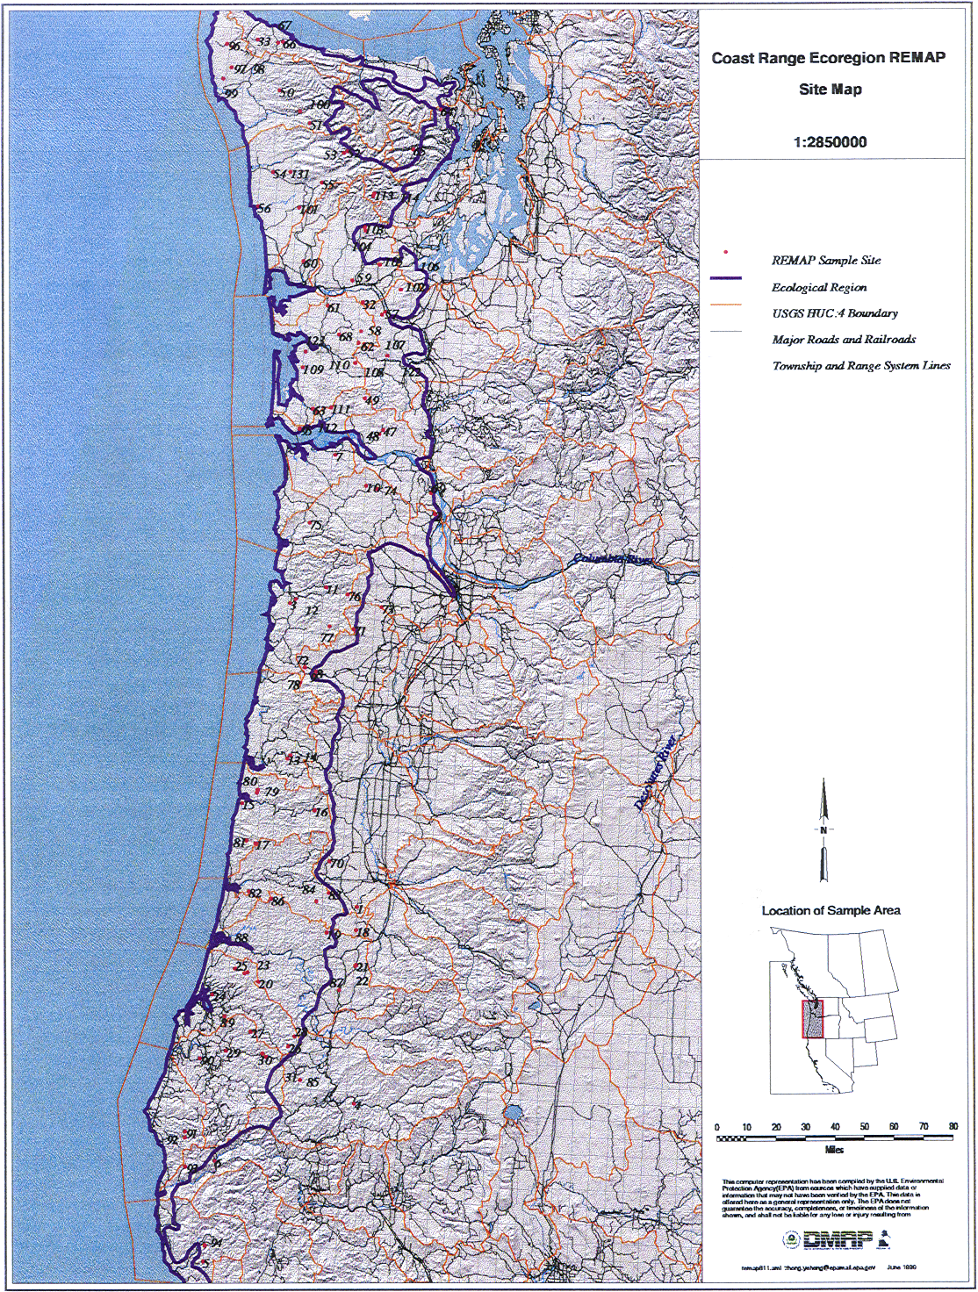
Assessments by state agencies have established that inability of some rivers and streams in the ecoregion to support beneficial uses results from altered sediment and flow regimes, degraded physical habitat and elevated temperature, fecal coliform, and nutrient levels (Oregon Department of Environmental Quality 1990; Washington Department of Ecology 1990). Types of land management that affect beneficial uses are livestock grazing, agriculture, forestry and urbanization.

IV. Study Design and Methods

IV. A. Site selection/sampling
Study sites were selected from a sample population of all mapped (1:100,000 scale) 1st through 3rd order streams in the Coast Range ecoregion, using EMAP-Surface Water protocols (Herlihy et. al., In Press). Stream order was used to define the initial sample population because it was a convenient and fairly reliable method for insuring that only wadeable streams would be included. A systematic random sample of this population allowed for an unbiased estimate of condition in the population. As 1st order streams were the vast majority of the stream lengths and a sufficient sample size of higher order (2nd and 3rd order) streams was needed, a variable selection probability was used that gave a higher probability of selection to higher stream orders. The end result was an equal sample size for the three stream orders. This variable selection probability by stream orders is accounted for when making the regional estimates by using site weighting factors. Each site was assigned a weight based on the occurrence of its type in the stream database. First order streams had a larger weighting factor than 2nd or 3rd order streams. Therefore, there was not a one to one relation of sample sites to the stream miles each site represents.

Of the total sites selected, 30% were deleted from the actual sampling site population based on reconnaissance findings. Reasons for deletion were: inaccessibility, denial of access, no channel present, non-wadeable, or dry channel (Figure 1). A total of 104 sites were sampled at least once within the ecoregion, 47 in Washington and 57 in Oregon. The elevation of sampled sites ranged from 5m to 670m. Several sites occurred outside of the current ecoregion boundary because the sites were selected in 1994 from the Coast Range ecoregion area defined in Omernik 1987. Since that time, ecoregion boundaries were refined. The current Coast Range ecoregion boundary and sample site locations are shown on Map 1 and site codes are in Appendix 1.

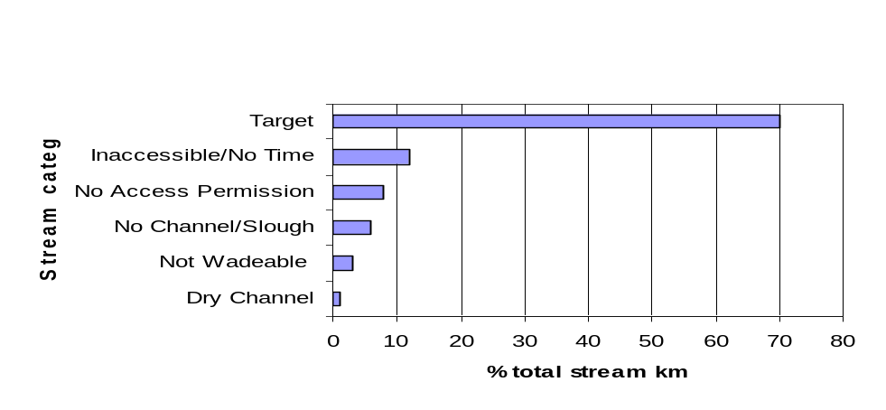

Figure 1. Percent of the total stream km within each of six stream resource categories.

ODEQ and Ecology collected data during summer/fall 1994 and 1995. Within each sample segment, field measurements were made on the randomly selected stream reach, 40 wetted channel widths long (minimum length of 150m). Water chemistry, physical habitat, vertebrates (fish and amphibians), and macroinvertebrate data were collected at each site. The sampling season was from July to October of each year, corresponding with the low flow period. A minimum of 10% of the sites was re-sampled annually, to evaluate index period variability.

IV. B. Field and Lab Methods
All data were collected with Hayslip et al. 1994 field methods which are modified from Klem and Lazorchak (1994) (Updated version of these methods are available in Lazorchak et al. 1998). Refer to this document for methods as only minimal explanation is provided here. There were minor differences in the types of data collected between the two states. Only those data common to both states and collected in the same way are included in this report. Landscape data common to both states were not available.

IV.B. 1.Water chemistry
Oregon DEQ and Washington Ecology used comparable sampling/analysis protocols and QA/QC procedures for this project. Following methods in Hayslip et al. (1994), data for 11 water quality parameters were collected at all sites. Measurements of temperature, pH, and conductivity, were collected in situ. Water samples were analyzed for total alkalinity, chloride, dissolved organic carbon (DOC), ammonium, nitrate, total phosphorous (TP), and sulfate. Dissolved oxygen (DO) was measured with a meter in Washington and with Winkler titration in Oregon.

IV.B. 2.Physical Habitat
Physical habitat data were collected with a slightly modified version of the procedures described by Kaufmann and Robison (1998) for the U.S. EPA’s EMAP surveys. The physical habitat metrics used are described in Kaufmann et al. (1999). The following three types of habitat variables were measured or estimated:

continuous parameters: Thalweg profile (a longitudinal survey of depth), and presence/absence of fine sediments were collected at either 100 or 150 equally spaced points along the stream reach. A subjective determination of the geomorphic channel type (e.g. riffle, glide, pool) was made at each point. Crews also tallied large woody debris along the reach.

transect parameters: Measures/observations of channel wetted width, depth, substrate size, canopy closure, and fish cover taken at eleven evenly spaced transects in each reach. Gradient measurements and compass bearing between each of the 11 stations are collected to calculate reach gradient and channel sinuosity. This category also includes measures and/or visual estimates of riparian vegetation structure, human disturbance, and bank angle, incision and undercut.

reach parameters: Channel morphology class for the entire reach was determined (Montgomery and Buffington 1993) and instantaneous discharge was measured at one optimally chosen cross-section.

IV.B. 3. Vertebrates
The objectives of the vertebrate assemblage assessment were to 1) collect all except the most rare species in the assemblage and 2) collect data for estimates of relative abundance of species in the assemblage. Fish were sampled with one-pass electro-fishing in all portions of the sample reach. Fish were identified, counted, and measured and voucher specimens were collected. Amphibians that were captured were identified and counted only. Although these methods were not used to estimate absolute abundance, standardized collection techniques were important for consistent measures of proportionate abundance of species.

IV.B. 4. Benthic invertebrates
At each of 11 transects, macroinvertebrates were collected at varying points along each transect (including margins) with a D-frame kick net (500 μm mesh). Site selection employed a systematic spatial sampling design that minimized bias in positioning the sampling stations. The samples were composited according to habitat type: depositional (pool) and erosional (riffle). In this analysis, we will only be presenting the results of the riffle samples. For each sample, 300 organisms were identified to the finest practical taxonomic level.

V. Data Analysis and Interpretative Methods

Data quality objectives and quality assurance procedures followed those outlined in Chaloud and Peck (1994), Merritt (1994) and Hayslip (1993). EPA contractor Dan Palmiter entered and compiled the raw data. EPA ORD office in Corvallis, OR calculated most metrics. Summary statistics and data analyses were generated with Statistica software (Statsoft Inc. 1995) and S-PLUS (Mathsoft 1998). Data from repeat visits to these sample sites will be used in future analyses to test for between-year and within-year variability.

There is some variability in the number of samples for various indicators. For example, chloride was measured at 84 of the 104 sites. For these indicators, the cumulative weight of the sites sampled is used to calculate the percentage of stream for each particular indicator. For chloride, the percent stream kilometers of a particular chloride level are reported based on the weighted cumulative stream kilometers of those 84 sample sites rather than the entire 23245 km of the entire sample. From here on, the valid stream km for a particular indicator will simple be referred to as ‘stream km’.

The primary method for evaluating indicators was cumulative distribution frequencies (CDFs). CDFs present the complete data population variation and allow one to estimate the proportion of the population above or below a particular value (Larsen and Christie 1993). The advantage of this method is that the complete data for the population is presented with uncertainty estimates. Because value judgements are not imposed, different criteria for evaluating the data can be used (Larsen and Christie 1993). Details of the statistical foundation for EMAP methods are in Diaz-Ramos et al. (1996).

Confidence intervals are not presented graphically for each of the indicator estimates. Rather, the range of confidence intervals and other summary statistics are in appendices of summary statistics for each of the indicator categories (water chemistry, physical habitat, vertebrates, and benthic invertebrates. Generally, confidence intervals were close to the sample values as illustrated by this CDF example of mid-channel canopy density (Figure 2).

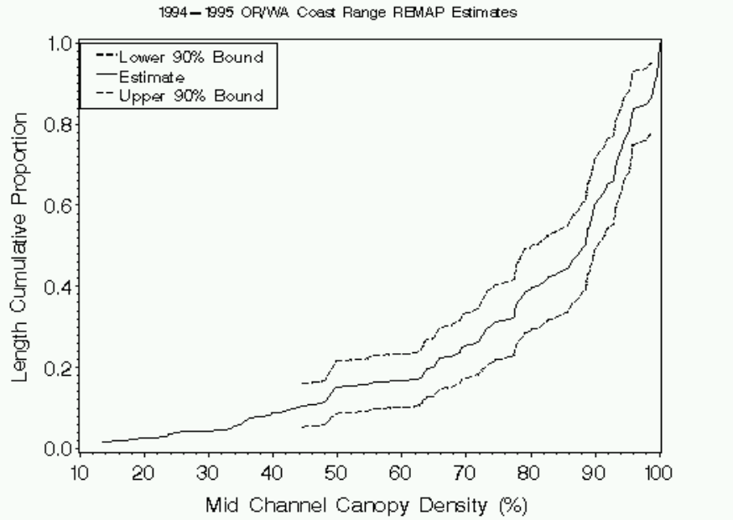

Figure 2. Sample cumulative distribution function with 90th percentile confidence intervals.

Beyond describing the ecological condition based on the Coast Range data, it is possible to apply an interpretation of the acceptable biological status for management application. The nominal condition (not degraded by human influence) is the basis for making these comparisons and for detecting impairment. There are several methods for defining nominal condition that may be used including:

Reference conditions are developed from the analysis of carefully selected sites that represent the best attainable watershed condition, habitat structure, water quality and biological parameters (Hughes 1995). The idea being that these ‘best sites’ approximate pre-settlement conditions. Sample sites can then be compared to this benchmark to describe there relative condition. The reference condition can also be developed from historical data, however historical data, especially for biological assemblages is almost non-existent for the entire Coast Range Ecoregion. The characteristics of appropriate reference sites will vary among ecoregions and for different waterbody types. Currently, a reference condition has not been defined for the entire Coast Range Ecoregion of Oregon and Washington

Quantitative Models: By plotting biological variables against human disturbance variables or natural variables, one can predict reference condition through curve fitting (Hughes 1995). Models of this type have not been developed for the Coast Range ecoregion. Then site data can be compared to this curve to determine how far it deviates for the nominal condition.

Cumulative Distribution Functions (CDFs) is a method of plotting the environmental data from a population of sites in order to describe the characteristics of the population. With adequate sample size it is possible to define sub populations based on the gradient of condition. The sites at the low end of the range for a given indicator are further from the nominal condition than sites at the high range. For example sites that have dissolved oxygen measures <8mg/l may be considered to be below the nominal condition. This method requires a large enough data set to represent the population in question (in this study, 1st through 3rd order streams of the Coast Range Ecoregion).

For this descriptive analysis of the condition of coast range streams, we will rely on analysis of the CDF’s and on comparing these data to other studies and standards relevant to the coast range ecoregion.

VI. Description of Indicators

VI. A. General Stream Resources
An analysis of USGS digital format maps (DLG) and EPA Reach Files, Version 3 (RF3) yielded 33,270 km of 1-3 order stream in the Coast Range ecoregion. Drawing random samples from this population resulted in the characterization of the total stream km in the ecoregion as shown in Figure 1. Target stream sites (useable sample sites) were drawn (total of 104 sites) from 70% of the stream length therefore the data analysis will be useful for applying inferences to 23,245 km of the 38,700 km of the ecoregion. Of these 104 ‘target’ sample sites 57 were in Oregon representing 14830 km of stream, and 47 were in Washington representing the remaining 8420 km of stream length. The other 30% of the sites could not be sampled due to reasons presented in Figure 1.

Sample selection was classified by stream order, with the number of samples relatively equally distributed between the three stream orders. Each 1st order sample represents a proportionately large number of stream miles due to the far larger 1st order stream length in the ecoregion (Table 1).

Table 1. Extent of sampling by stream order, Coast Range ecoregion 1994-95.

Order | # of samples | km stream length | % total stream length
1st | 35 | 16323 | 70
2nd | 31 | 3781 | 16
3rd | 38 | 3141 | 14
Total: | 104 | 23245 | --

VI. B. Chemical Characteristics
Data for 11 water quality variables were collected from over 100 sites (for most indicators). The rationale for the selection of each indicator is summarized in Table 2. Summary statistics for all water chemistry indicators are in Appendix 2. Results were compared to current water quality standards of Oregon and Washington (Table 3). Often, water chemistry measurements varied temporally. For example, nutrient levels varied with stream flow and pH varied diurnally due to solar radiation and photosynthetic activity. Temperature and DO were especially temporally variable. Because sites were not continuously sampled and timing of sampling was not intended to capture the peak concentration of chemical indicators, data interpretation reflects a single view in time.

Table 2. Summary of chemical indicators.

Indicator/units | Rationale | Responses related to management activities
Stream Temperature | Biological activity  Growth and survival of species | Riparian shade reduction  Altered stream morphology
Dissolved Oxygen (DO) | Growth and survival of fish,  Sustain sensitive benthic invertebrates  Organic material processing | Fine sediment inputs  Organic debris loading (slash and dairy)  Riparian shade reduction  Point sources (industrial, municipal waste)
pH | Fish production  Benthic invertebrate survival | Mining discharge  Organic debris loading (slash)
Alkalinity | Indicates a waterbody’s ability to neutralize pH
Conductivity | Indicator of dissolved ions. | Agriculture return flow, industrial inputs, and mining discharge
Total phosphorous (TP) | Stimulates primary production.  Usually the limiting nutrient in freshwater aquatic systems. Delivery to lentic systems can result in nutrient enrichment that impairs water quality, recreational uses. Toxicity to fish is not typically a problem. | Increases due high erosion rates, organic matter inputs from recreation, septic tanks and livestock.  Storm water runoff.
Inorganic nitrogen  (Nitrate NO₃⁻and Ammonium NH₄⁺) | Nitrogen (NO₃⁻N, NH₄⁺ -N) are important nutrients for aquatic plants. But, ionic forms of nitrogen,( nitrate and ammonium) can limit growth. Nitrate is essentially non-toxic to aquatic biota (Rand and Petrocelli 1985), yet accumulations of nitrogen can result in nutrient enrichment that can impair beneficial uses. | Forest harvest disrupts nitrogen cycling (decreases root uptake and alters moisture regimes).  Fertilization from agriculture, livestock waste, and point sources of sewage disposal.
Chloride (Cl⁻) | Not generally an environmental concern, may be good surrogate for general human disturbance in watersheds (Herlihy et al. 1998) | Industrial output, fertilizer use, livestock waste, sewage, and use of road de-icing salts.

Table 3. Table of standards for freshwater (Washington State 1992, ODEQ 1998).

Indicator | Standards for Oregon | Standard for Washington¹
water temperature | ≤ 17.8°C or 12.8° during times of salmon spawning, incubation and emergence. Based on seven-day moving average of daily maximum. | ≤16°C (AA) and ≤18°(A) waters
Dissolved oxygen | ≥11mg/L in waters that support salmon spawning to fry emergence. ≥8mg/L in cold-water aquatic resources waters, and ≥6.5 mg/L in cool-water aquatic resources waters. | >9.5 mg/L (AA) >8 mg/L (A)
pH | 6.5 to 8.5 (general basin standards listed for several basins within the Coast Range ecoregion) | 6.5 to 8.5 for A and AA waters
¹Streams within the Washington portion of the sample data are designated as either Class A or AA which are state beneficial use classifications (Merritt et al. 1999).

VI.B. 1. Water temperature
Because stream temperature is temporally variable, dependent on climatic conditions, a single measurement is of very limited value in characterizing stream conditions. Therefore, any conclusions of ecoregion wide summer temperature have limited validity. Temperature ranged from 7 to 25°C. First and second order streams had lower water temperatures (7 to 18°C) and 3rd order streams had highest temperatures recorded and greatest variability of temperatures. Using the Washington State standard as the threshold for low water quality due to warm temperatures, most streams are considered cold. At the time of sampling, two sites were 18°C or warmer, representing 1% of the stream length.

VI.B. 2. Dissolved oxygen
Dissolved oxygen (DO) content is related to turbulence and temperature (and to a lesser degree atmospheric pressure). Decreased DO levels are associated with inputs of organic matter, loss of substrate interstitial spaces due to sedimentation, as well as increased temperature and reduced stream flow (MacDonald et al. 1991). As with temperature, conclusions must be drawn with caution, as DO is temporally variable and a single measurement is of questionable value for characterizing stream condition. In the study sample, DO ranged from 1.1 mg/L to 12.2 mg/L (mean 8.7 mg/L). The water quality standard of 8mg/L for cold water resources (Oregon) and Class A waters (Washington) were met in 80% of stream km at the time of sampling. The highest standard of 11 mg/L was met by 3% of stream km. These streams had relatively low water temperatures at the time of sampling as 11 mg/L is approximately 100% DO saturation between 9-11.5 °C at elevations <2000 ft (American Public Health Association 1989). An estimated 14% of the stream km did not meet the water quality standard of ≥6.5 mg/L at the time of sampling.

DO (mg/L) | % stream km
>6.5 | 86
>8 | 80
>11 | 3

VI.B. 3. pH
At atmospheric pCO2, one would expect rain to have pH of 5.6 due to carbonic acid. At the National Atmospheric Deposition Program’s (NADP) Alsea site in western Oregon, rainfall pH was 5.3 and sulfate was 5-8 μeq/L (NADP 2000). These values indicate that little ‘acid rain’ falls in the Coast Range. The pH of the REMAP study sites ranged from 5.5 to 8.1 with mean 7.1. The water quality standard of 6.5 to 8.5 was met by 86% of stream km. The remaining 14% were below (higher acidity) the standard.

VI.B. 4. Indicators associated with pH

Alkalinity:
Alkalinity is the capacity of the solutes of water to react with and neutralize acid. Past studies have found that alkalinity ranges from 0.20 to 0.72 meq/L (200 to 720 μeq /L) in rivers of the Coast Range ecoregion (Welch et al. 1998). EMAP data reflected this finding with mean alkalinity 569 μeq/L (range 80 to 1679 μeq/L). Alkalinity is ≤800 μeq/L in 80% of stream km. Although there is no alkalinity standard because there is no effect on biota, alkalinity it is important because of the buffering effect on pH. Waters with alkalinity >200 μeq/L are considered not sensitive to acid deposition, while an alkalinity of 50-200 μeq/L is a gray area (A. Herlihy, OSU, Pers. Comm. 2000).

Specific Conductance:
Specific conductance measures the ion concentration of water and can be used as a surrogate for total dissolved solids. It is useful for detecting water quality impairments from mining and agriculture. Because aquatic biota are considered to be relatively insensitive to conductivity, there are no known recommended criteria (MacDonald et al. 1991). Although there are no standards, high conductance measurements give cause for further attention. As is typical in coastal streams (Welch et al. 1998), conductance was low with 74% of stream km having conductance of ≤100 μS/cm (96% were ≤200 μS/cm).

VI.B. 5. Phosphorous
Because of the phosphorous content, Coast Range streams are considered naturally oligotrophic and sensitive to nutrient inputs (Welch et al. 1998). The significant outcome of nutrient inputs is increased amounts of algal growth. Both phosphorous and nitrogen limit photosynthesis in oligotrophic streams, but in the Coast Range ecoregion, phosphorous is typically much more limited due to characteristic N:P ratios of 20:1 (Welch et al. 1998). Although there are no state standards, EPA (1986) recommends <50 μg/L total phosphorous (TP) for streams that deliver to lakes. Total phosphorous exceeded 50 μg/L in 25% of stream km. Differences based on stream order were not observed. In streams that do not deliver to lentic systems, a standard of 0.10 mg/L (100μg/L) has been suggested (MacKenthun 1973 as mentioned in MacDonald et al. 1991). Only 12% of stream km exceeded 100 ug/L TP.

VI.B. 6. Nitrate
Nitrogen was analyzed as nitrite-nitrate (NO₂⁻ NO₃⁻) in Washington and as nitrate in Oregon. Due to the very minor occurrence of the nitrite constituent the data of the two states were combined and referred to as nitrate (A. Herlihy, OSU, Pers. Comm. 1999).

Inorganic nitrogen (nitrate-nitrogen) is the predominant form of nitrogen in lotic systems (Welch et al. 1998) and is readily assimilated by plants for growth. This trend was demonstrated in the data as 1st and 2nd order streams had higher mean nitrate (NO₃⁻ ) concentrations than downstream 3rd order streams, indicating that nitrogen is taken up by aquatic biota as it is delivered downstream. There is no national standard for nitrate but concentration of <0.3 mg/L (<300 μeq/L) would probably prevent eutrophication (Cline 1973 as mentioned in MacDonald et al. 1991). All of the estimated stream km had ≤30 μeq/L nitrate.

VI.B. 7. Chloride
Chloride (Cl⁻) is present generally at low levels in all natural waters (Hem 1985) with a worldwide mean in rivers estimated as 7.8 mg/L (range 1 to 280,000 mg/L). Chloride does not usually negatively affect biota and is considered a good tracer because it is involved in relatively few chemical processes relative to other ions (Feth 1981). Chloride was found to be an indicator of human disturbance in the Mid-Atlantic region of the U.S. (Herlihy et al. 1998). In the Coast Range data set, chloride was low (84% of stream km <2 mg/L) in most streams. Coastal waters can receive significant inputs of chloride due to atmospheric transfer (1-20 mg/L in coastal rainfall) (Welch et al. 1998). The Alsea National Acid Deposition Project found chloride concentrations from atmospheric deposition of 1-2 ppm (1-2mg/L). Although chloride as an indicator of human disturbance is problematic in coastal areas because of sea salt inputs, the fact that chloride was <2mg/L in most streams supports the notion that human inputs at most sites are low (mostly from atmospheric sources) (A. Herlihy, EPA, Pers. Comm. 2000).

VI.B. 8. Sulfate
Quantities of sulfate (SO₄²⁻) are usually low in Pacific Coast rivers with reported concentrations of 10 to 30uM (McClain et al. 1998). Acid deposition is typically low in the western United States with mean sulfate deposition of 1.2 to 8.2 kg/ha/year (Stolte and Smith 1999, In Review) and anthropogenic sources of sulfate are currently low in the Coast Range ecoregion (Welch et al. 1998). As with chloride, there is no standard or suggested value for sulfate in surface waters. The mean value for the EMAP data was 85.1 μeq/L with 80% of stream km having estimated sulfate concentration of <100 μeq/L.

VI. C. Physical Habitat Description
Variations in geology, gradient, and basin size form different types of stream channels. These channel types vary in how they process inputs of water, sediment and LWD which influences overall form as well as resilience to natural and human disturbance. In this section, watershed scale features (stream order, basin size, and gradient) describe the stream in the context of the overall landscape and provide context for the relationship of other physical habitat features at smaller spatial scales. Physical stream characteristics (substrate, LWD, habitat units, fish cover) and riparian characteristics are also presented. When possible, characteristics are related to stream order. Summary statistics for physical habitat data are in Appendix 3.

VI.C. 1. Watershed scale features
Stream order (Strahler 1957) describes the location of the stream within a watershed. In the ecoregion, first order streams have a relatively narrow range of watershed area and have the broadest range of gradient as both lowland tributaries of larger streams and steeper headwater streams are present in the Coast Range (Figure 3). Third order streams have relatively larger watershed area and have the smallest range of gradients not exceeding 4%. Second order streams are intermediate.

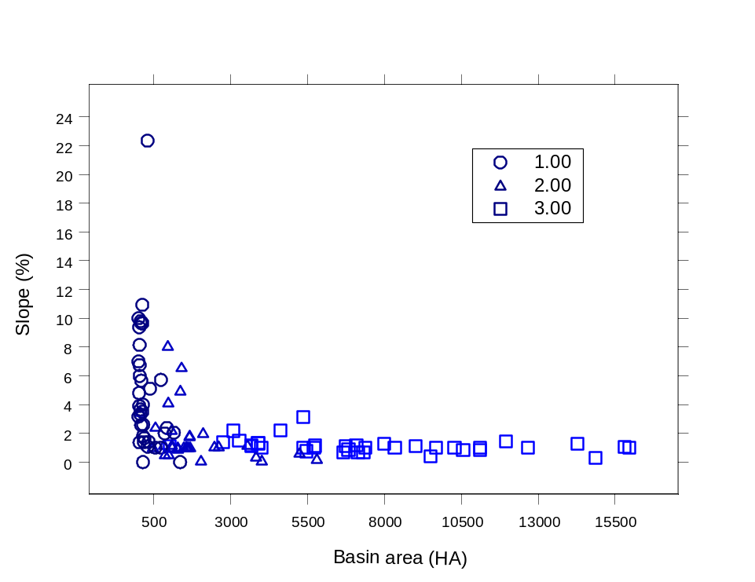

Figure 3. Relation of percent slope to basin area and stream order.

As with basin area, stream order was related to stream width and depth (Figure 4). First order streams were narrower and shallower than 3rd order streams and 2nd order were intermediate. Mean thalweg depth for 1st, 2nd, and 3rd order streams was 16, 37, and 55 cm respectively, with an overall mean depth of 25 cm estimated for the Coast Range. Mean wetted stream width by order was 2.3, 5.1, and 11.6 m with an overall mean for the Coast Range of 4m. Stream width and depth were also correlated (r=0.71).

Most of the channels of the ecoregion have a pool-riffle channel (Montgomery and Buffington 1998) (Figure 5). In this channel type, flow converges and scours on alternating banks resulting in a laterally oscillating sequence of bars, pools, and riffles. Although the pool-riffle channel morphology is typical of low gradient, free-flowing alluvial channels, this channel form also occurred in steeper reaches with large roughness elements (LWD, rock outcrops or riparian trees) that force flow and accumulate sediment resulting in a pool-riffle sequence. The second most common channel type is step-pool (17%). These channels have channel spanning roughness elements (LWD, large sediment sizes) that trap sediment, forming pools below these steps. This results in an alternating pattern of turbulent flow over steps into pools. This channel type is associated with steeper gradients; coarse bed material and confined channels (Montgomery and Buffington 1998). The other types of channel forms, plane bed, cascade and braided, are rare.

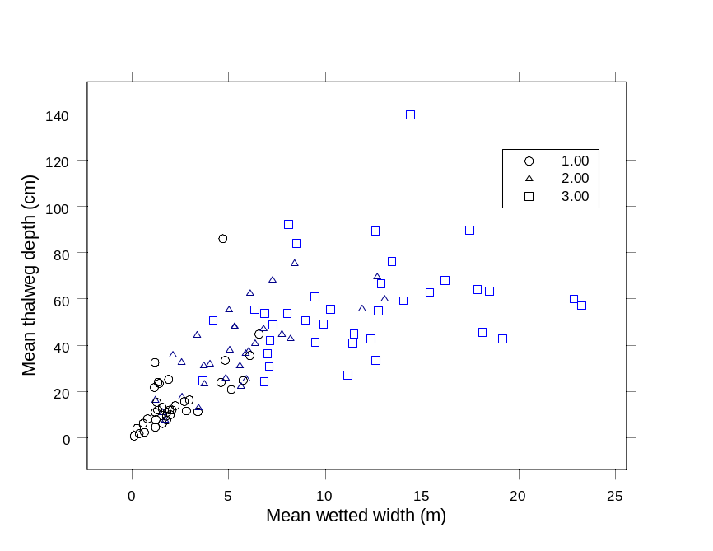

Figure 4. Relation of mean thalweg depth to mean wetted width by stream order.

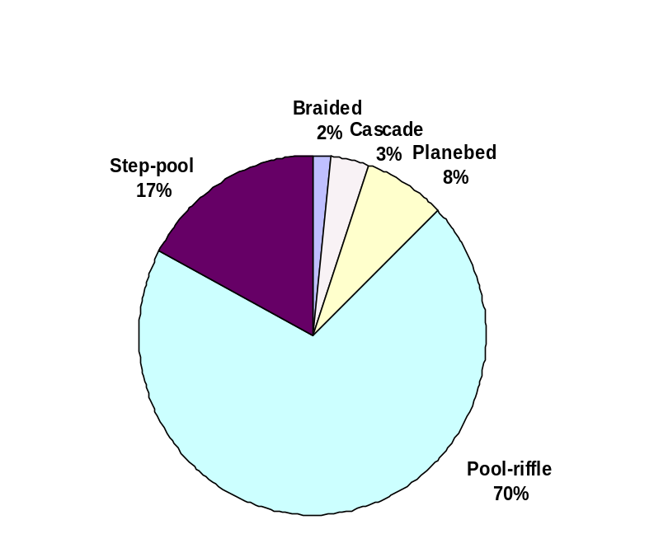

Figure 5. Percent of stream km within each geomorphic channel type.

Summary: the wadeable streams of the Coast Range represent a broad range of basin areas and gradients. Stream order indicates where a channel lies in relation to the entire channel network and is often related to channel size and gradient. Characteristics of slope and basin area, as well as other watershed scale characteristics such as flow, influence channel morphology in turn influencing habitat forming processes and ultimately the distribution of species. In order to assess stream condition it is necessary to acknowledge these relationships, as they can confound the interpretation of the relationship of human influence to stream condition. For example, a small low gradient stream may have naturally abundant fine sediment accumulations due to the lack of stream power combined with the geology of the area. One influence of human disturbance is to increase fine sediment accumulations yet it is difficult to separate these effects without estimates of stream power.

VI.C. 2. Substrate
Stream substrate size is influenced by geology, transport capacity, and channel morphological characteristics that influence sediment processes. The following describes the characteristics of surface substrate particle size in the ecoregion. Substrate particle size data were collected at five locations along each of the 11 evenly spaced transects at each sample site. Data were expanded to reflect the proportion of the stream channel area.

Looking at the ecoregion-wide data, small gravel or finer sized substrate (<16mm diameter) category was the most common substrate size in the ecoregion averaging 54% of the stream surface substrate across all stream km. The sand and fines fraction (<2mm diameter) had a mean of 42% of the stream substrate across all stream km. Coarse substrate (>16mm diameter) was less common with mean 32% of stream km. Other substrate types (bedrock, hardpan, organics, etc.) formed a limited portion of the overall substrate.

Within site substrate variability can be characterized with the dominant substrate particle size. Defining dominance as >50 % of the surface substrate in a particular substrate size fraction yields the following results (Table 4). Overall, relatively common (29%). Bedrock dominated channels were rare and none of the streams had organic material as the dominant substrate. Note, many channels did not have a dominant substrate size class.

Table 4. Percent of streams dominated by 4 major substrate classes (>50% of stream substrate). Values generated from the pebble measurements in sample sites reaches and expanded to percent of stream km using probability-weighting factors.
 |  | % of stream km with dominant particle size
Size category | Description | All | 1st order | 2nd order | 3rd order
< 2mm | Sand and fines | 38 | 44 | 34 | 8
2-250mm | Gravel/cobble | 29 | 28 | 27 | 41
250-4000 | Boulder/bedrock | 4 | 0 | 16 | 10
Other | Wood or detritus | 0 | 0 | 0 | 0
 | Total | 71 | 72 | 77 | 59

Differences in dominant substrate size as well as the degree of dominance were found between stream orders. The fine substrate class dominated first and second order streams to a greater extent than third order streams, while third order streams were more commonly dominated by the gravel/cobble substrate size (Table 4, Figure 6). Third order streams had the greatest variety in substrate sizes within reaches, where substrate categories more rarely expressed dominance. Also, there was less overall variability in substrate quantity by category among third order reaches (lower standard deviation). Lower variability of substrate size in the third order streams is also reflected in the box plot of geometric mean substrate size by stream order (Figure 7). Correlations between measure of overall substrate size (geometric diameter) and measures of stream size (gradient and basin area) were very weak, possibly because of differences in slope that were not correlated with stream size.

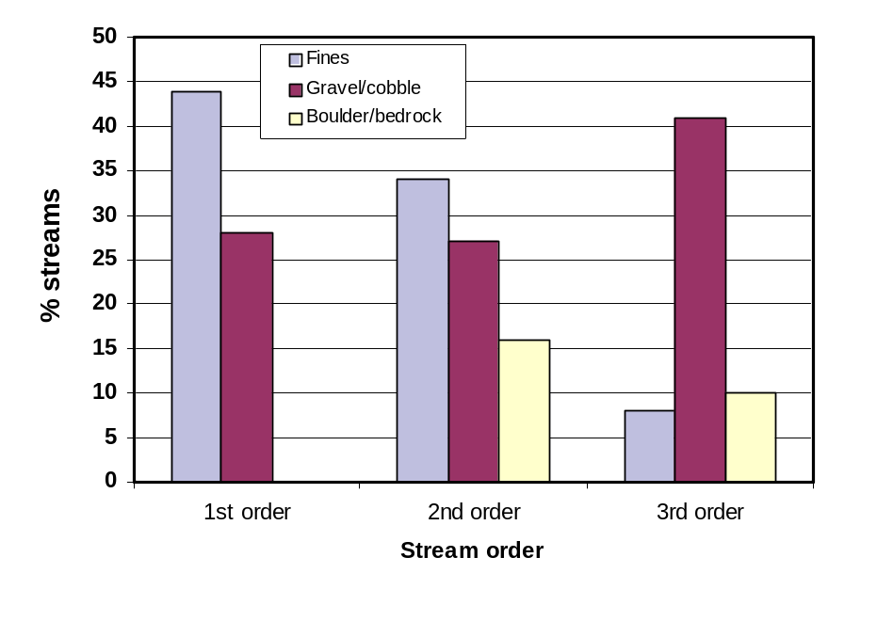

Figure 6. Percent of streams within each stream order category dominated by three substrate classes (dominance defined as ≥50% stream surface substrate).

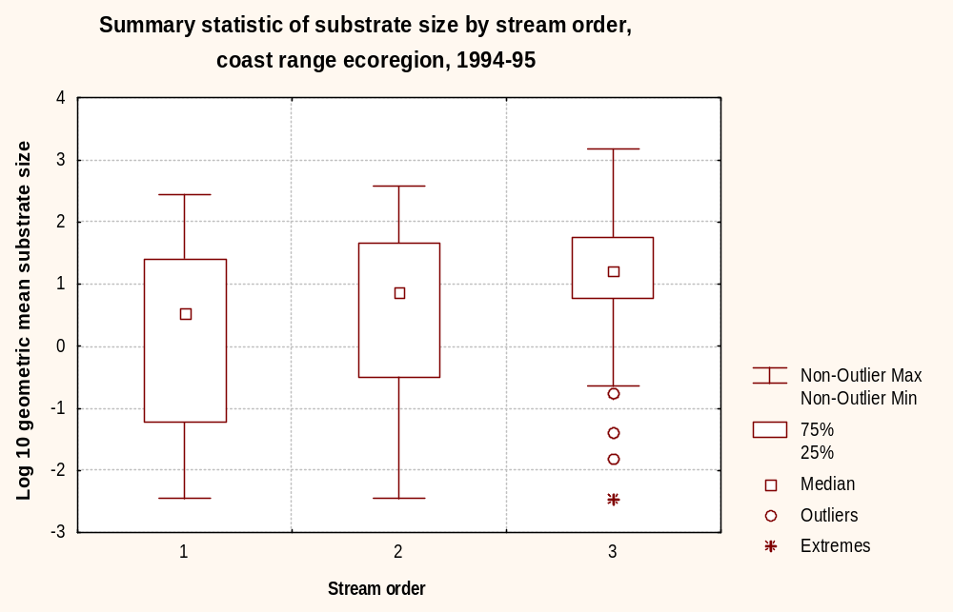

Figure 7. Summary of substrate size by stream order expressed as geometric mean (log10).

VI.C. 3. Riparian vegetation
Riparian vegetation is important to stream processes for several reasons: 1) influences channel form through root strength; 2) contributes roughness elements (LWD) that force pools and form steps; 3) provides allochthonous inputs of organic matter, and; 4) shades and insulates the channel which influences both summer and winter water temperature. Expressed as a proportion of the reach, riparian cover data were collected for three vegetation heights (canopy >5m, mid level .5 to 5m, and ground cover). Visual estimates of cover density and general structural/species vegetation classes (e.g. coniferous, deciduous) of each layer were recorded. Overall, riparian vegetation was dense. The proportion of the reaches with riparian vegetation presence (combination of all three vegetative layers) was approximately 100% for most of stream km (Figure 8). This was true for each of the three levels of riparian vegetation considered separately. Because riparian density was high throughout the ecoregion density did not vary significantly by stream order.

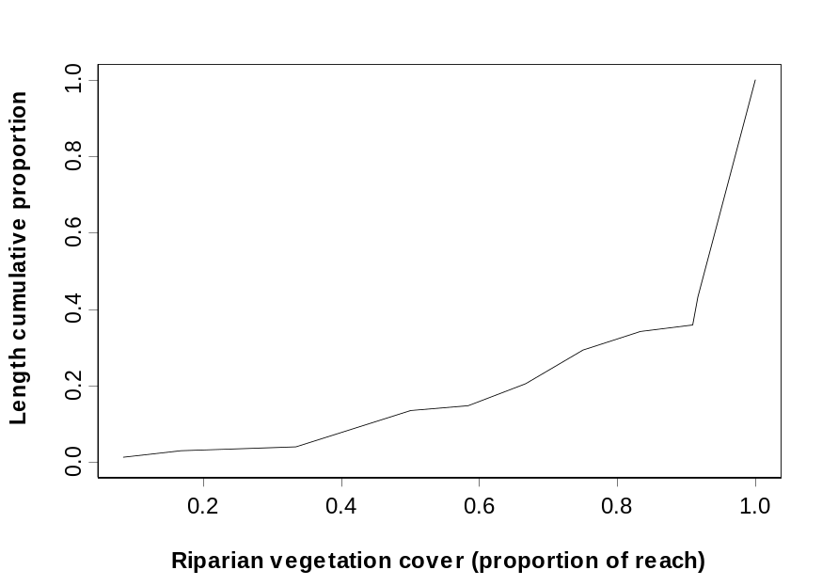

Figure 8. Cumulative distribution function of overall riparian coverage (includes ground-layer, low canopy, high canopy).

Three types of canopy (riparian vegetation >5m) cover types were considered, coniferous, deciduous, and mixed coniferous and deciduous cover. Coniferous riparian canopy was rare, exceeding 10% in only 20% of stream km with most channels having a deciduous or mixed stand (Figures 9, 10, and 11). Canopy composition did vary significantly by stream order with first order streams having highest mean proportion of coniferous canopy and 2nd order streams have highest mean proportion of deciduous canopy.

Summary: riparian zones are highly vegetated overall and significant relationships between vegetation and stream order/size were not detected. The coniferous component of the canopy was relatively minor overall with most streams having a deciduous or mixed coniferous/deciduous canopy. There was some variation in canopy cover species type by stream order.

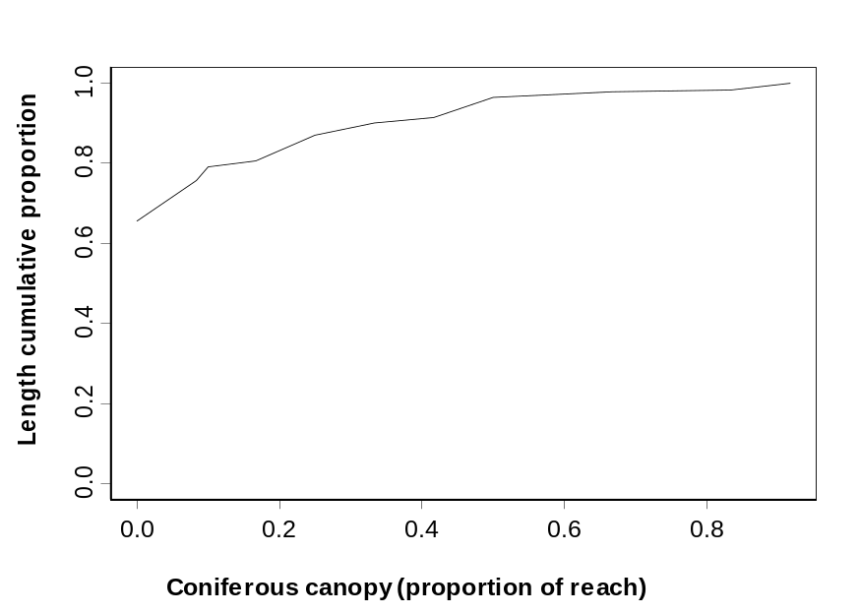

Figure 9. Cumulative distribution function of coniferous riparian canopy presence.

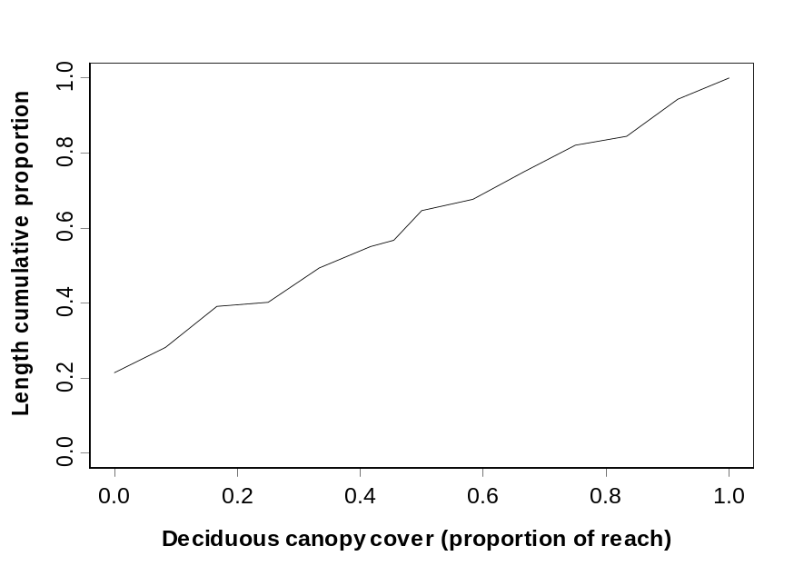

Figure 10. Cumulative distribution function of deciduous riparain canopy presence.

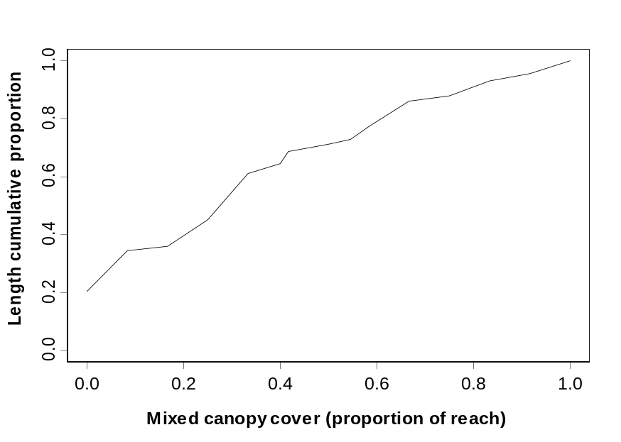

Figure 11. Cumulative distribution function of mixed (coniferous and deciduous) tree canopy presence.

Stream shading from riparian canopy is based on the average of densiometer readings at each of the 11 transects at each sample site. Separate calculations from the bank and mid channel were made. Overall, shade was high with mean bank shading of 89% and mean mid-channel shade of 80% estimated for the ecoregion (Figures 12 and 13).

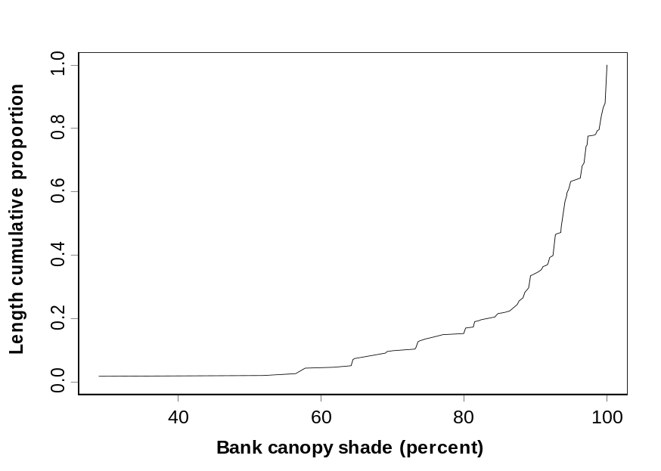

Figure 12. Cumulative distribution function of bank shade.

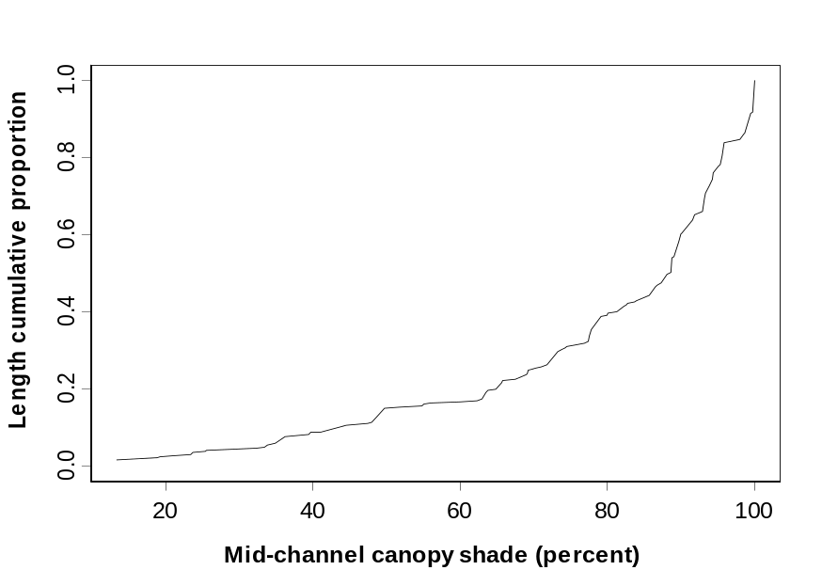

Figure 13. Cumulative distribution function of mid-channel canopy shade.

As expected, stream shade was related to stream size. The strongest relationship was between mid channel percent shade and bankfull width (Figure 14) with mid channel shade decreasing as bankfull width increases. The relation of shade to stream size was also reflected in stream order differences with third order streams having lower percent mid-channel and bank shade (Figure 15).

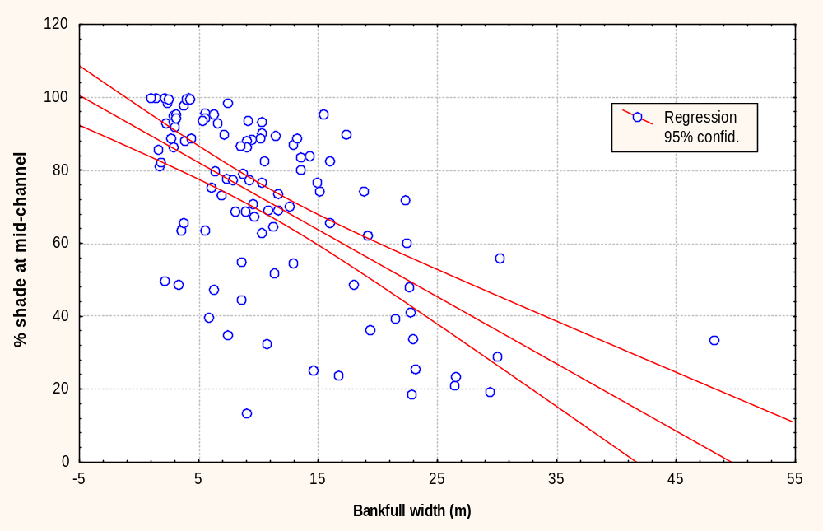

Figure 14. Relation of mid-channel shade to stream width (r= -.62).

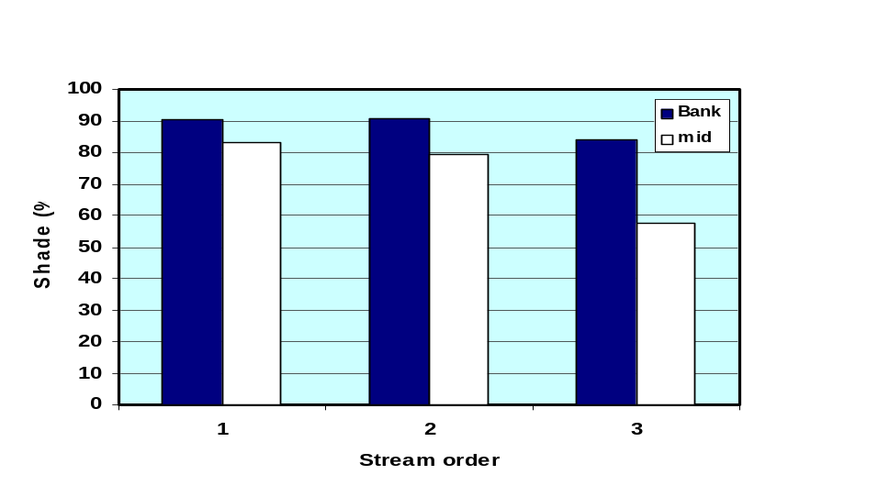

Figure 15. Histogram of mean bank and mid-channel riparian shade by stream order.

VI.C. 4. Riparian disturbance indicators
Currently, stress indicator data are available only for human-caused riparian disturbance. These data were collected by examining the channel, bank and riparian area on both sides of the stream at each of the 11 evenly spaced transects and visually estimating the presence and proximity of disturbance (Hayslip et al. 1994). Eleven different categories of disturbance were evaluated. Each disturbance category is assign a value based on its presence and proximity to the stream (1.67, in channel or on bank; 1.0, within 10m of stream; .67, beyond 10m from stream; and 0, not present). Data were expanded to calculate a proximity-weight disturbance index for each reach (Kaufmann et al. 1999). This index combines the extent of disturbance (based on presence or absence) as well as the proximity of the disturbance to the stream.

Most streams had some level of human-caused riparian disturbance when including all disturbance categories; with average 1.34 disturbance index (Figure 16, Table 5). An estimated 16% of stream km had no riparian disturbance. Of the disturbed sites, logging was the most common form of riparian disturbance (42%) followed by roads (26%) and agriculture (both pasture and crops 15%) (Figure 17).

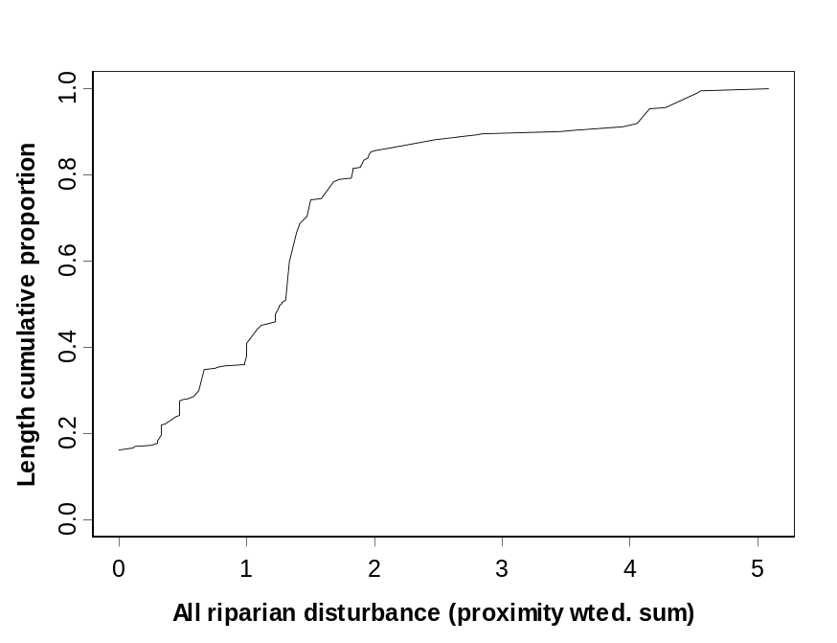

Figure 16. Cumulative distribution function of riparian disturbance (all types).

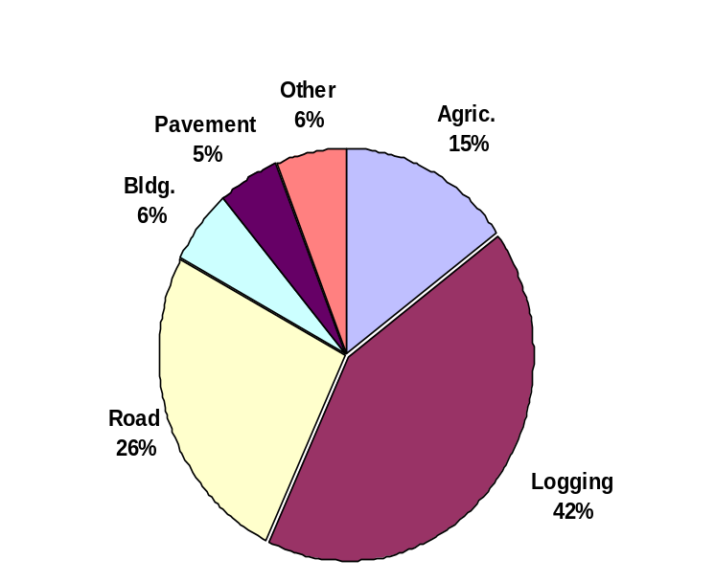

Figure 17. Percent of overall riparian disturbance attributed to each of the major disturbance categories. Percentages based on estimated stream km with riparian disturbance.

Using the range of riparian disturbance index range of values (0 to 1.67), it was possible to express the level of individual disturbance categories in terms of low, medium and high (≤0.67,low; 0.67 to 1.0, medium, and 1.0 to1.67, high). Disturbance was generally low (Table 5). Mean disturbance index for logging, agriculture (combines both pasture and crop thus possible score of 2 x 1.67), and roads was < 0.67 for each. Significant differences in riparian disturbance between stream orders were not observed. First order streams had more logging disturbance than 2nd and 3rd order streams but differences were not significant (P>0.05). When all disturbance categories were added the average for all sites was 1.34 (and ranged from 1.3 to 1.53 for 1st –3rd orders), which indicates a high level of disturbance for the combined categories).

Table 5. Mean disturbance index value of 1st, 2nd and 3rd order streams for five disturbance categories.
 |  | Stream order
Disturbance category | All | 1st | 2nd | 3rd
Logging | 0.56 | 0.61 | 0.48 | 0.41
Roads | 0.35 | 0.36 | 0.31 | 0.33
Agriculture | 0.20 | 0.16 | 0.33 | 0.26
Buildings | 0.08 | 0.05 | 0.16 | 0.13
Pavement | 0.07 | 0.06 | 0.11 | 0.09
All disturbance combine | 1.34 | 1.30 | 1.53 | 1.34

VI.C .5. LWD
Large woody debris (LWD), as single pieces or in accumulations, alters flow and traps sediment, thus influencing channel form and related habitat features. The quantity, type and size of LWD recruited to the channel from the riparian zone and hillslopes is important to stream function in channels that are influenced by LWD (typical of 1st -3rd order streams in the Pacific Northwest). Loss of LWD without a recruitment source can result in long-term alteration of channel form as well as loss of habitat complexity in the form of pools, overhead cover, flow velocity variations, and retention and sorting of spawning-sized gravels. Field data were categorized into five size classes (very small, small, medium, large, very large) based on the following length/diameter matrix (Table 6). The following is an overview of LWD quantity (pieces per 100m) by size class in the ecoregion.

Table 6. Definition of the five LWD size classes based on piece length and diameter.
 | Length (m)
Diameter (m) | 1.5-5 | >5-15 | >15
0.1-0.3 | Very small | Small | Medium
>0.3-0.6 | Small | Medium | Large
>0.6-0.8 | Small | Large | Large
>0.8 | Medium | Large | Very large

Mean in-channel LWD of all sizes (≥10cm diameter and ≥ 1.5 m long) was estimated as 43.4 pieces/100m of stream km (Table 7 and Figure 18). There was a negative correlation between LWD quantity and stream size, which was an expected result as LWD retention is higher in smaller streams where individual pieces can key in to the banks and stream power is less able to float wood downstream. Another contributing factor may be that larger streams have historically received more intense logging pressure due to the location in the more accessible lowlands (Bob Hughes, Dynamac, Pers. Comm. 1999). Thus, smaller streams may have retained their input source for a longer period and this LWD is still evident in the channel. LWD quantity was significantly different between stream order (1st, 48.3; 2nd, 36.0; and 3rd, 28.4 mean pieces per 100m).

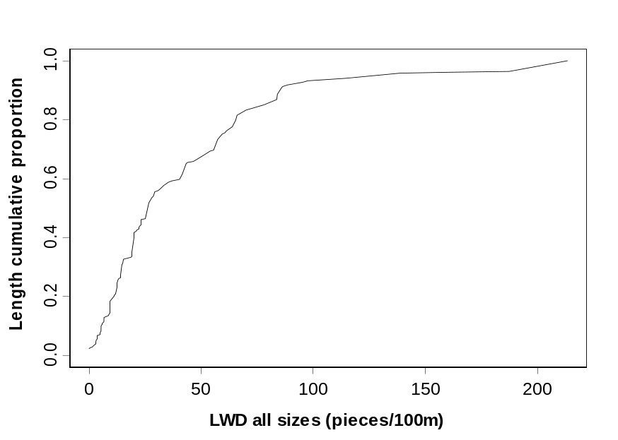

Figure 18. Cumulative distribution function of LWD pieces (diameter ≥ 10cm).

Table 7. Mean LWD quantity (pieces per 100m) by size class in 1st, 2nd and 3rd order streams, Coast Range ecoregion 1994-95.

Size class | Stream order
 | All streams | 1st | 2nd | 3rd
Very Small | 20.3 | 21.4 | 18.9 | 16.2
Small | 11.2 | 12.7 | 8.9 | 6.5
Medium | 6.1 | 7.1 | 4.8 | 3.2
Large | 5.1 | 6.2 | 2.9 | 2.1
Very Large | 0.7 | 0.9 | 0.4 | 0.3
All pieces | 43.4 | 48.3 | 36.0 | 28.4

Because larger sized LWD pieces have a greater ability to influence channel form, analyzing the medium and larger sized pieces provides a different view of the LWD content of the streams. There were fewer medium and larger sized pieces (mean 11.9 pieces/100m) than the smaller size class (Table 7 and Figure 19). Differences between stream orders were significant with first order streams having the greatest abundance of medium and larger sized LWD (mean 14.2 pieces/100m). For the west side of the Cascade Mountains, the National Marine Fisheries Service (NMFS) suggests stream channels should have >80 pieces per mile (5 pieces per 100m) of LWD >24in (>60cm) diameter in order to be properly functioning (NMFS 1996). Generally, streams of the ecoregion met this criterion as the mean number of pieces in this large and very large size class averaged 5.8 pieces per 100m across all stream orders. LWD of these size classes was much more abundant in 1st order streams than in 2nd or 3rd order (Table 7). Overall, NMFS LWD criterion was not met 61% of the stream km. Streams that did not meet the NMFS criterion by stream order are as follows: 52 % of 1st, 77 % of 2nd, and 83 % of 3rd order streams.

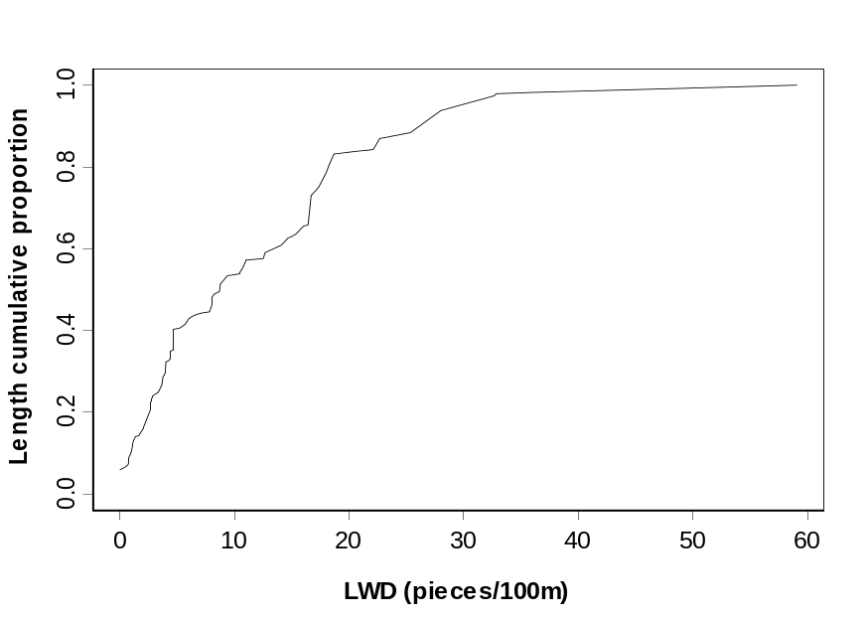

Figure 19. Cumulative distribution function of medium to very large sized LWD.

VI.C. 6. Habitat units
Habitat units are the reach scale classification of habitat based on physical stream features. Fast water areas (i.e. riffles and cascades) are those with higher water velocity, surface turbulence and often shallower water depth in wadeable streams (Bisson et al. 1982). Slow water areas (i.e. glides and pools) have low water velocity, less surface turbulence and are the deeper portion of the streams. These categories are useful for describing the habitat of streams as species assemblages use these areas differently.

Overall, streams of the ecoregion had a greater proportion of slow water than fast (Figure 20). Dry/subterranean flow areas and waterfalls were relatively minor in terms of stream length. Major categories of habitat unit types (fast and slow water) were poorly correlated with measures of stream size (e.g. basin area and bankfull width), although significant differences in proportions of habitat types were observed for stream orders (analysis of variance, P≤0.05). First order streams had the greatest proportion of stream length in fast water and in dry condition (Figure 21). Length of stream in falls was very minor (< 0.5% stream length in each stream order). As expected, 1st and 2nd order streams had a greater percentage of stream length in falls due to the greater stream gradients.

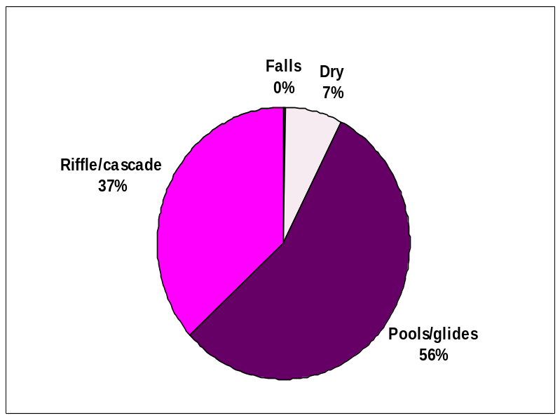

Figure 20. Percent of stream length within each of the four habitat types.

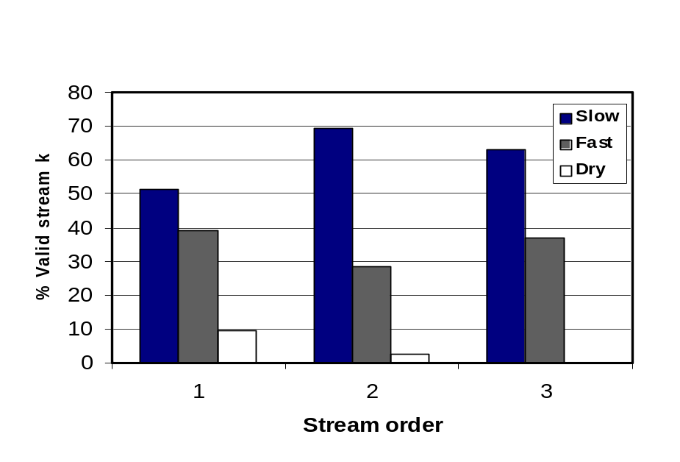

Figure 21. Comparison of mean percent of stream length within each of three water type categories by stream order.

Pool formation and depth is a function of processes that influence bed form including stream size, substrate type and availability and quantities of large roughness elements that force pools or accumulate sediment that form steps. Thus, pool quantity and residual depth are related to stream power as well as channel complexity. In the Coast Range, both pool quantity and residual depth were related to stream size. Pool quantity expressed as percent of stream reach in pool was inversely correlated with stream width and varied by stream order with a mean of 27, 40 and 24% for 1st, 2nd and 3rd order streams (Figure 22). Pool depth was directly correlated with stream width and varied consistently by stream order 47.8, 95.8, and 129.1 cm, for 1st – 3rd order streams, respectively (Figure 23).

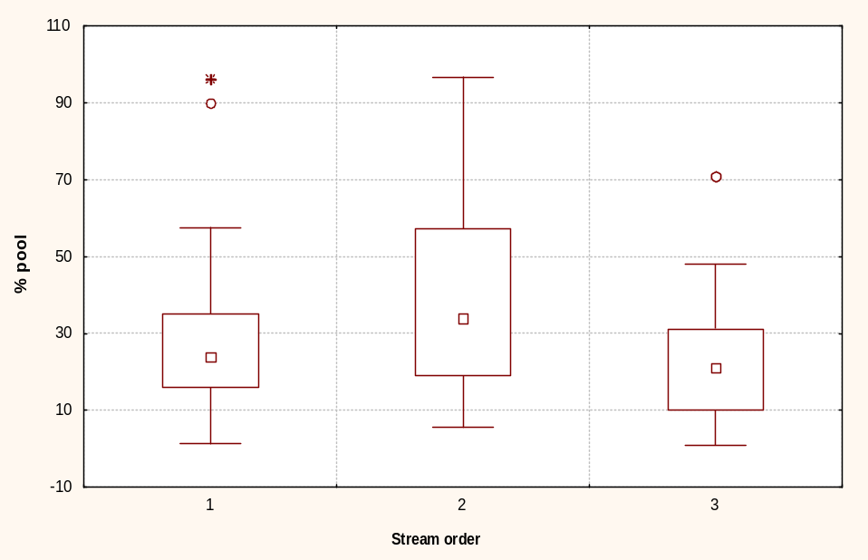

Figure 22. Box plot of percent pool by stream order. Median, 75-25% quartiles, and non-outlier min-max, shown with inner box, outer box, and bars, respectively.

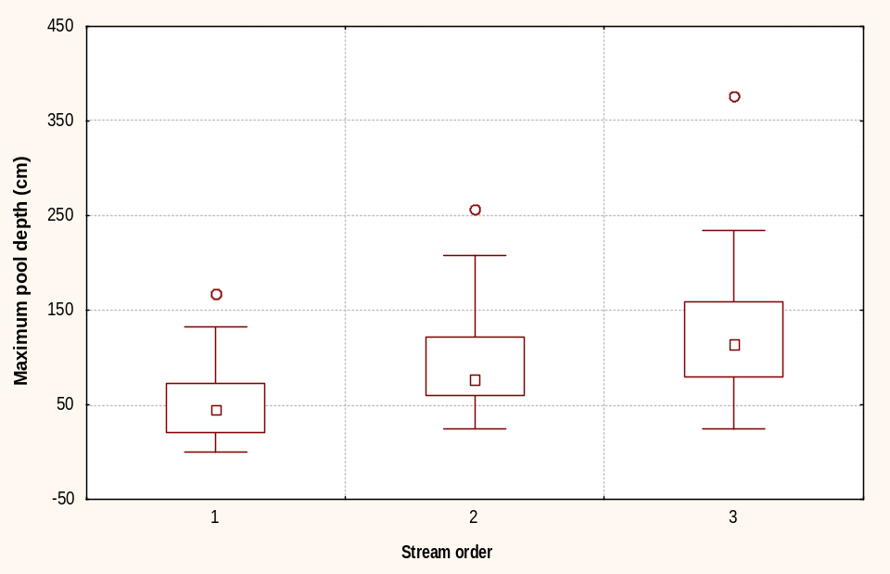

Figure 23. Box plot of maximum pool depth by stream order. Median, 75-25% quartiles, and non-outlier min-max, shown with inner box, outer box, and bars, respectively.

VI.C. 7. Fish cover
Many structural components of streams are used by fish as concealment from predators and as hydraulic refugia (e.g. bank undercuts, LWD, boulders). Although this metric is defined by fish use, fish cover is also indicative of the overall complexity of the channel which is likely beneficial to other organisms. Using the metric of natural fish cover (includes overhanging vegetation, undercut banks, LWD, brush, and boulders), the mean of 0.62 areal cover proportion was estimated for the ecoregion. Mean cover decreased by stream order (mean .67, .53, and .49 by 1st 2nd and 3rd stream order) and differences were significant between 1st and 2nd and 1st and 3rd order streams (Figure 24). Also, the quantity of natural fish cover was inversely correlated to stream width.

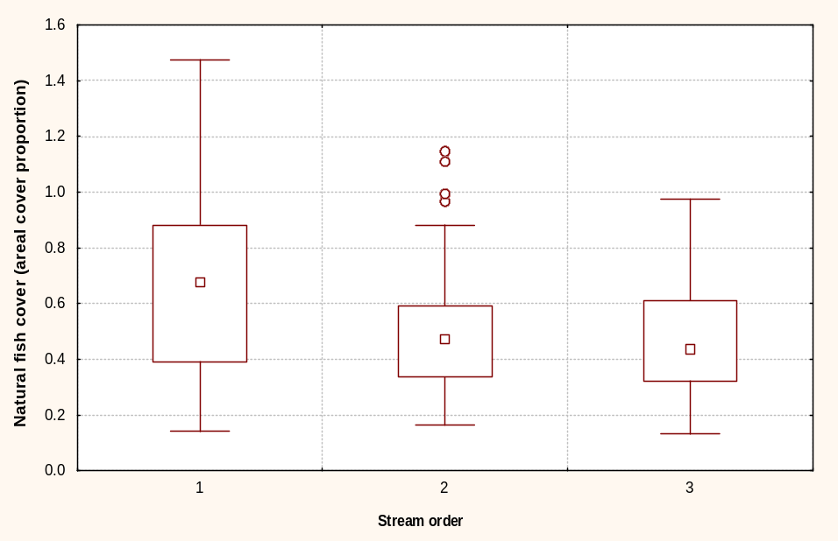

Figure 24. Box plot of natural fish cover by stream order. Median, 75-25% quartiles, and non-outlier min-max, shown with inner box, outer box, and bars, respectively.

VI. D. Fish and Amphibian Resources
101 of the 104 sites were sampled for vertebrates (fish and amphibians) representing an estimated 23020 stream km. Of these, 95% held vertebrates (fish and/or amphibians) and 78% held fish. Streams where amphibians were captured but fish were absent occurred in 17% of stream km. A total of 36 different species were sampled, representing 10 fish families (24 species) and eight amphibian families (12 species) (Appendix 4). General frequency statistics are in Table 8.
Table 8. Frequency of occurrence of vertebrates, Coast Range ecoregion 1994-95.

Statistic | # of Sites | Total estimated stream km | % of stream length
sites w/fish | 89 | 17982 | 78
sites w/o fish | 12 | 5039 | 22
sites w/amphibians | 58 | 15159 | 66
sites w/o amphibians | 43 | 7861 | 34
sites w/amphibians and no fish | 10 | 38549 | 17
sites w/no vertebrates | 2 | 1184 | 5
total sites sampled | 101 | 23020 | 100
sites w/non-native amphibians | 1 | 65.0 | 0
sites w/non-native fish | 6 | 982 | 4
sites w/non-natives all | 7 | 1047 | 5
Sites w/native anadromous sp. | 70 | 10483 | 46

Fish were present at most sample locations (78% stream km). Streams without fish were mostly 1st order streams (only 1.2% of this length was 2nd order). This was an expected result as these smaller, and often steeper, streams are the upward limit of fish distribution.

Non-native species were rare in the ecoregion. Only four non-native species (3 fish, 1 amphibian) were sampled, occurring in 5% of stream km. Of these, only brook trout occurred at more than one site. This char species had the broadest non-native species distribution (3% of streams).

Salmonids were the most broadly distributed vertebrate family in the region, followed by cottids Figure 25). Dicamptodontids (Cope’s and Pacific giant salamanders) were the most common amphibian family. Coastal cutthroat trout were the most broadly distributed vertebrate species (Figure 26). This cutthroat trout sub-species is distributed on the West Coast of North America from Northern California to Southeast Alaska (Wydoski and Whitney 1979). Coastal cutthroat trout use a variety of habitats, including large and small rivers, very small, ocean-connected, streams and isolated stream reaches above migration barriers. Often, coastal cutthroat trout are the only salmonid species present in high elevation streams (Connelly and Hall 1999). This species has a variety of life history strategies with anadromous, fluvial and resident forms as well as intermediates (Trotter 1989). This life-history variability may be in response to high environmental variability (pressure) under which the species evolved (Northcote 1997).

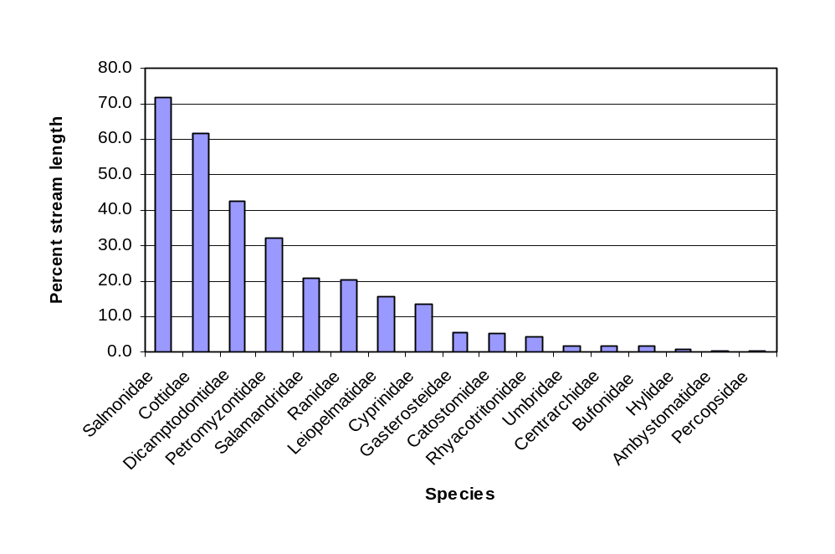

Figure 25. Histogram of vertebrate family occurrence.

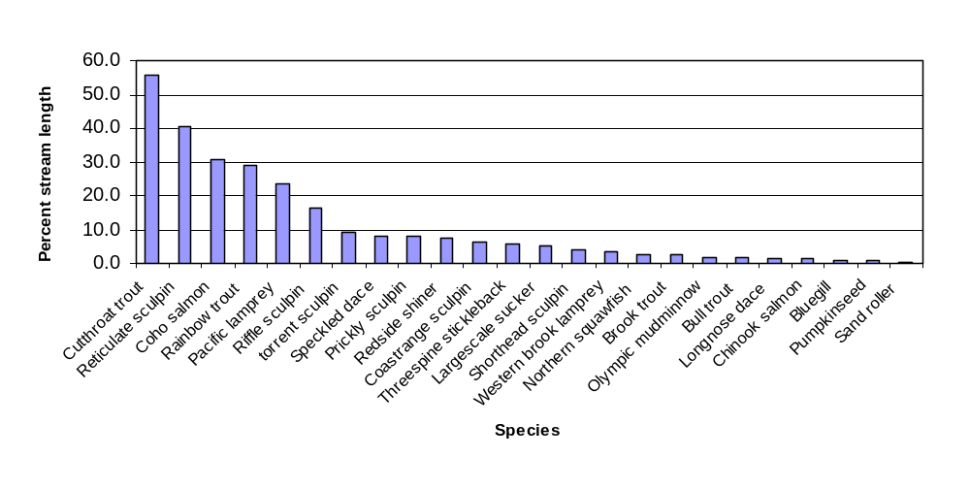
Figure 26. Histogram of fish species occurrence.

Although cutthroat trout inhabit the greatest stream length, the abundance of other salmonids was higher where they co-occurred with cutthroat. Both coho and steelhead had significantly higher abundance (based on percent of total fish individuals captured) compared to cutthroat in streams where cutthroat were sympatric. The abundance and distribution of coho salmon and steelhead can be difficult to evaluate due to the frequency of stocking of these two species (e.g. Oregon put-and-take rainbow fisheries, coho planting in coastal Washington).
The dominant cottid species, reticulate sculpin (Figure 25), are native to coastal streams of Washington and Oregon north to the Puget Sound with disjunct distribution in Central and northern California (Lee et al. 1980).

The rarest native fish species sampled was the sand roller with distribution in <1% of the estimated stream miles. Its distribution within the Coast Range ecoregion is limited to streams within the Columbia River basin (Lee et al. 1980).

Pacific giant salamanders were the most broadly distributed amphibian, with presence estimated in over 30% of stream km, followed by rough-skinned newts (Figure 27). Approximately one third of the estimated stream km did not have amphibians.

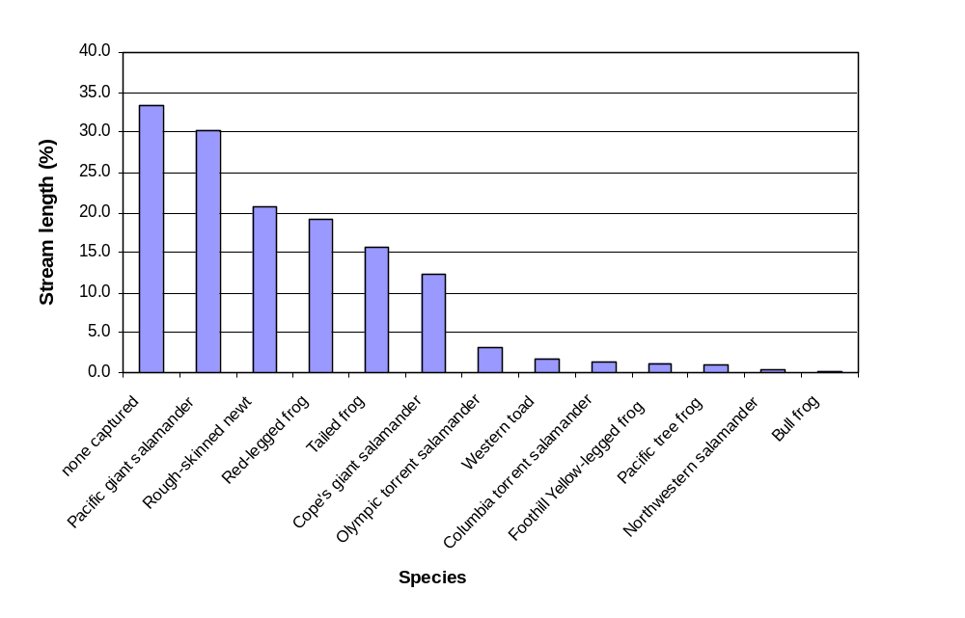

Figure 27. Histogram of amphibian species occurrence.

Guild description:
The habitat characteristic descriptions of vertebrate species are listed in Appendix 5 and Appendix 6 and summary statistics for vertebrate metrics are Appendix 7. Fish classification is based on Zarabon et al. (1999) and amphibian classification is based on Stebbins 1954 and Bob Hughes’ personal conversations with Deanna Olsen, Robert Storm, Andrew Blaustein, and Bruce Bury. Amphibians were placed within the context of the fish classifications as much as possible to generate an overall compatible vertebrate dataset (Personal comm. Shay Howlin, Oregon State University, 1999). The following classifications are used to build indices of biological integrity (IBIs) but they are also useful for providing an overview of the species within the ecoregion:

- Temperature guilds—3 classifications; warm, cool, and cold water preference.

- Sensitivity guilds--tolerant, intermediate, and sensitive are classifications based on species ability to tolerate pollution and disturbance that is human induced.

- Habitat guilds—refers to where species typically occur in their physical environment. Hiders use more protected habitats, benthic species are closely associated with substrate (can be indicative of habitat complexity) and water column species are commonly found there.

- Trophic guilds give insight into the trophic organization of vertebrate assemblages based on diet: filter feeders, herbivores, invertivores, and invertivore/piscivore.

Most Coast Range vertebrates are cool and coldwater species (Figure 28) and are sensitive or intermediately sensitive to habitat change (Figure 29). There are substantially more benthic and hider species than water column species Figure 30) and most species are invertivores or invertivores/piscivores (Figure 31).

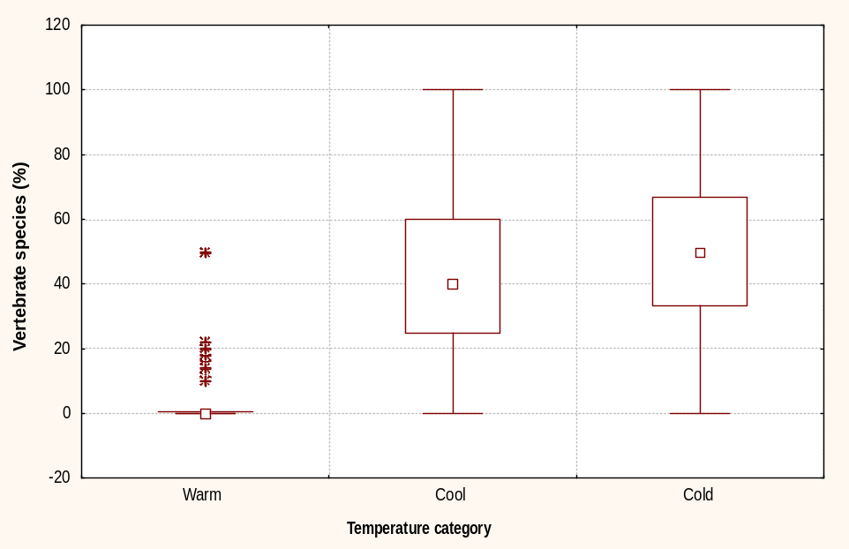

Figure 28. Percent of vertebrate species within each temperature guild. (percentages based on site relative abundance expanded by site weighting factor). Median, 75-25% quartiles, and non-outlier min-max, shown with inner box, outer box, and bars.

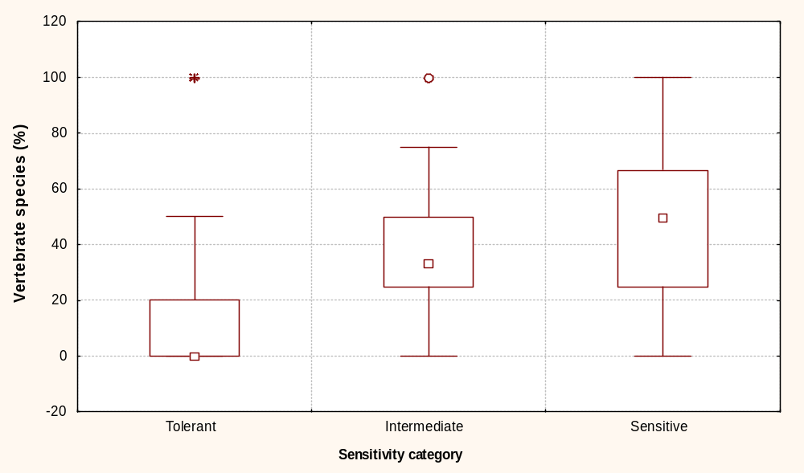

Figure 29. Percent of vertebrate species within each sensitivity guild (percentages based on site relative abundance expanded by site weighting factor). Median, 75-25% quartiles, and non-outlier min-max, shown with inner box, outer box, and bars.

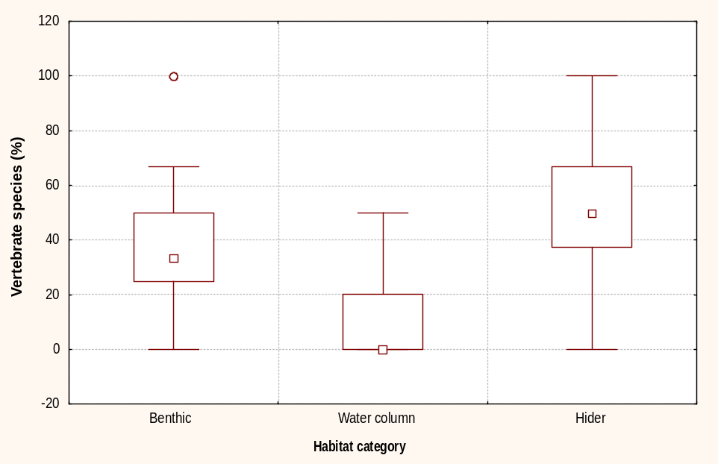

Figure 30. Percent of vertebrate species within each habitat guild, Coast Range ecoregion (1994-95) (percentages based on site relative abundance expanded by site weighting factor). Median, 75-25% quartiles, and non-outlier min-max, shown with inner box, outer box, and bars.

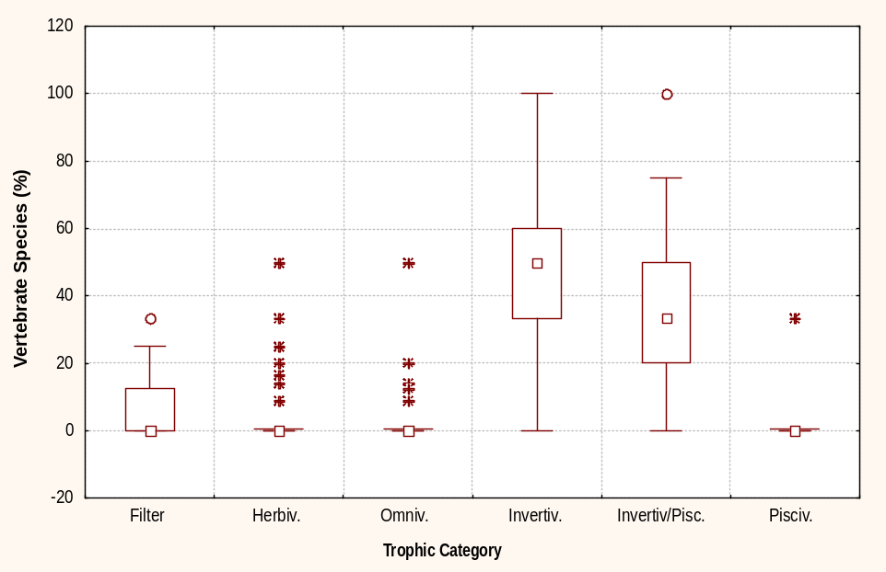

Figure 31. Percent of vertebrate species within each trophic guild, Coast Range ecoregion (1994-95) (percentages based on site relative abundance expanded by site weighting factor). Median, 75-25% quartiles, and non-outlier min-max, shown with inner box, outer box, and bars.

VI. E. Benthic invertebrates
Macroinvertebrates were collected at each of the 11 transects (one D-net kick per transect). These transect samples were combined into a reach composite sample based on habitat type of each transect (either riffle or pool). This approach resulted in uneven sampling effort between sites (Ecology 1999). Only data collected from riffles were used in this analysis. Riffle data were available from 93 of the 104 sample reaches representing 20,l22 stream km. The following seven metrics were comparable between the two states and were used in the analysis (Table 9).

Table 9. Description of benthic macroinvertebrate indicator metrics (Source: Resh and Jackson 1993 and Resh 1995).

Metric | Description | Rationale
Taxa richness | Overall variety of the macroinvertebrate assemblage - the total number of different taxa. Useful measure of diversity or variety of the assemblage. Sensitive to most types of human disturbance. | ¹Decreases with low water quality associated with increasing human influence. Sensitive to most types of human disturbance.
EPT taxa richness | Number of taxa in the orders Ephemeroptera (mayflies), Plecoptera (stoneflies) and Trichoptera (caddis flies) | ¹In general, these taxa are sensitive to human disturbance.
Intolerant taxa richness | Taxa richness of those organisms considered to be sensitive to perturbation. | Taxa that are intolerant to pollution based on classification from Wisseman 1996.
% EPT | Percent of the total sample organisms that is ephemeroptera, plecoptera and trichoptera. A composite measure for identity and dominance.
% Chironomid | Percent of the total sample organisms that is in the family Chironomidae. A composite measure for identity and dominance. | ¹Presumed higher pollution tolerance of this dipteran family
% scrapers | Percent of organisms that scrape upon periphyton. A measure of trophic organization based on feeding strategies and guilds. | Scrapers tend to increase where algae is abundant, typically when streams are enriched or open to sunlight.
% shredders | Percent of organisms that shred leaf litter. A measure of trophic organization based on feeding strategies and guilds | ¹Shredders are sensitive to toxicants and to modifications of the riparian zone.
¹ rationale based from Resh and Jackson 1993.

The metric ‘taxa richness’ gives an overall indication of the variability of macroinvertebrate communities in the Coast Range (Figure 32). The total number of taxa ranges from 5 to 60 species. These seven metrics are described in Table 10 and more complete summary statistics are presented in Appendix 8.

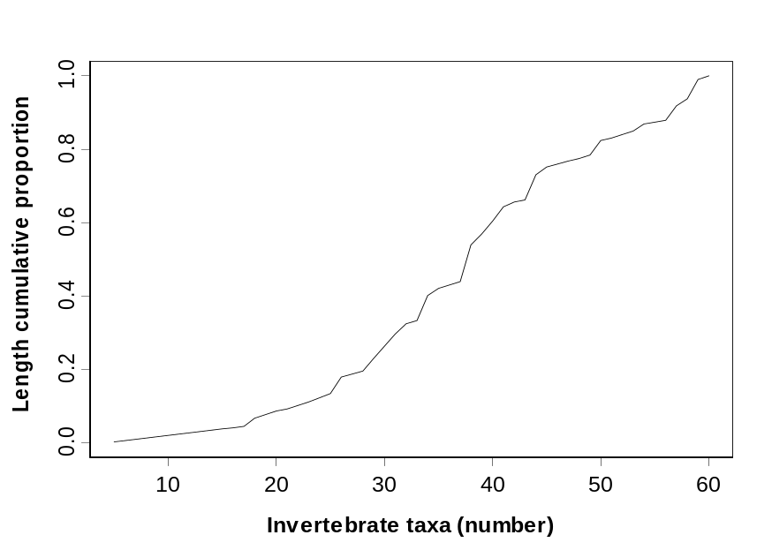

Figure 32. Cumulative distribution function of total invertebrate taxa richness.

Table 10. Summary statistics for seven macroinvertebrate metrics, Coast Range ecoregion, 1994-1995.
Metric | Mean | Median | Min | Max | Range | Std. Dev.
Taxa richness | 38.3 | 38.0 | 5.0 | 60.0 | 55.0 | 11.99
EPT taxa richness | 19.4 | 17.0 | 1.0 | 37.0 | 36.0 | 8.42
Intolerant taxa richness | 8.0 | 7.0 | 0.0 | 22.0 | 22.0 | 6.01
% Chironomid | 29.9 | 29.3 | 0.3 | 86.8 | 86.5 | 19.78
% EPT | 45.3 | 42.8 | 1.5 | 97.5 | 96.0 | 23.20
% scrapers | 15.4 | 10.5 | 0.2 | 95.6 | 95.4 | 15.08
% shredders | 14.2 | 12.7 | 0.0 | 82.4 | 82.4 | 11.23

Although the frequency of shredders and scrapers show a more narrow range of variability, these values are within those described by Resh (1995) for the expected ratios of functional feeding groups where a range of stream size and riparian condition are represented (Table 11).

Table 11. Examples of expected functional feeding-group ratios for scrapers and shredders from Resh (1995) based on information from Cummins and Wilzbach (1985).

Metric | Shaded small streams | Open, small streams | Open, medium streams
% shredders | >25% | >10% | <5%
% scrapers | <25% | >25% | >25%

In an assessment of Oregon Coast Range streams Canale (1999) found critical levels of total taxa richness and EPT taxa richness of 30 and 18 as indicative of impaired stream condition based on analyses developed from Oregon reference sites. Comparing these results, approximately 30% of stream km had <30 taxa richness (Figure 32) and approximately 50% had <18 EPT taxa (Figure 33).

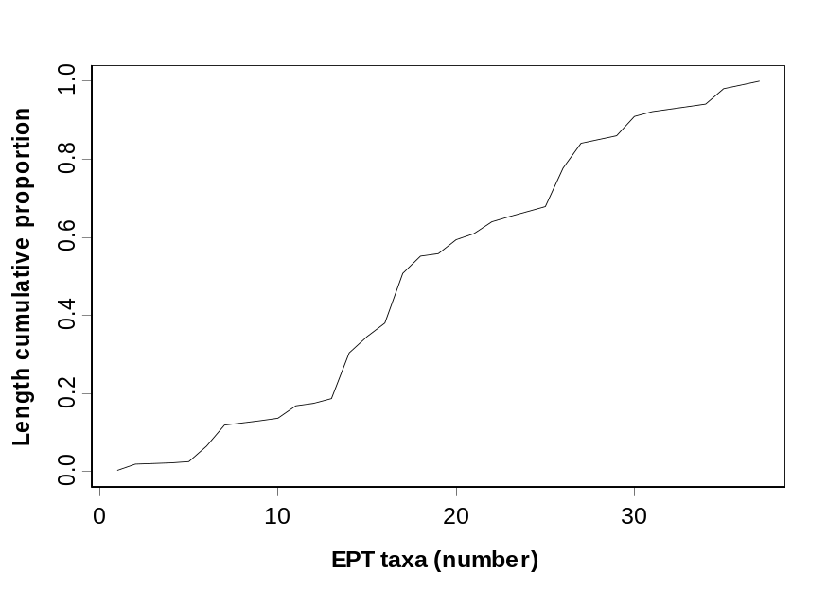

Figure 33. Cumulative distribution function of EPT taxa richness.

VII. Relations Between Indicators and Stressors

Our second objective was to examine relationships between indicators of stream condition (chemistry, benthics, and vertebrates) and stressor indicators by posing the following questions:

What were the consistent indicator/stress relationships among metrics?

How strong were these relationships – could a linear relationship be detected?

To examine indicator/stressor relationships simple correlation tests (Pearson product-moment, P≤ 0.05 significance level) were run on all combinations of indicators as illustrated by the following matrix (Table 12). Both water chemistry and physical habitat are stressors as well as indicators of stress, depending on the relationship. Although correlations do not imply cause/effect relationships they can provide insight into the ecological processes that may be at work. Significant correlations are termed weak, moderate, or strong where r< .50, r>50 and<.75, and r>.75 , respectively.

Table 12. Possible combinations of stressor and indicator relationships.
 | Stressors
Indicators | Water chemistry | Physical habitat | Riparian disturbance
Water chemistry | -- | X | X
Physical habitat | -- | -- | X
Benthic inverts. | X | X | X
Vertebrates | X | X | X

Many significant correlations between indicators were detected yet most were weak (Appendix 9). Combining correlation results, observations of scatter plots, and our knowledge of indicators described in the previous section, we could further refine the stressors of importance. The following statements summarize the outcome of correlations between indicators:

- Most of the statistically significant correlations between water chemistry and physical habitat indicators lacked a detectable linear relationship (very low r-values). Many chemistry indicators were correlated to percent sand/fines. Of these, DO had a moderate correlation.

- Several water chemistry indicators were correlated with agricultural riparian disturbance. These correlations vary in a predictable direction, being positively correlated with nutrient inputs and negatively correlated with DO. Most of these correlations were weak.

- All correlations of physical habitat indicators with riparian disturbance were weak. The most consistent relationships were for percent sand/fines, which is positively correlated to most of the disturbance types. Both logging disturbance and habitat complexity indicators are related to stream order.

- Vertebrate indicators (metrics of individuals, families, species and individuals) were consistently negatively correlated with indicators of shade, cover and LWD. These results would be unexpected but for the fact that habitat features and fish species were found to vary with stream size which tends to mask the actual relationship. All correlations were weak

- All benthic invertebrate metrics assessed (taxa richness, EPT taxa and intolerant taxa) are positively correlated with DO. As previously mentioned, the benthic indicators had low values according to comparisons of Oregon reference condition (50% <18 EPT taxa). The abundance of fine sediment and the correlation of invertebrate metrics and % fines support this relationship.

- All benthic invertebrate metrics were inversely correlated with increasing fine sediment. EPT taxa had a moderate correlation. EPT and intolerant taxa metrics had weak yet consistent correlations with road and agricultural riparian disturbance. None were correlated to logging riparian disturbance.

Summary
Of the physical habitat indicators, percent sand and fine sediment was most often correlated to biotic indicators, with an inverse relation to benthic invertebrate and sensitive vertebrate indicators. Sand and fine sediment are common substrate size (40% of stream km had sand/fine as the dominant substrate size fraction) in the ecoregion. Although fine sized sediment occurs naturally in the Coast Range due to the geology, human disturbance can still influence its quantity. The correlation of agriculture and road type disturbance to the percent of fine sediment suggests these riparian indicators may be sensitive to detecting human disturbance beyond background (natural occurrence).

Chemical stressors of temperature and DO were frequently correlated with physical and biotic indicators. Overall the streams were cold, with only 1% exceeding water quality standards. Within this range of cold temperatures, there was an apparent relationship between relatively warm temperatures and biotic indicators, as indicators of vertebrate productivity and species diversity were positively correlated to temperature. Note that these values do not necessarily represent the warmest summer temperatures as they are based on only one sample. Continuous data would likely yield different results (Mochan 1998).

Univariate correlations indicate weak yet possibly meaningful relationships between biota and physical habitat with the strongest being the inverse relation between benthic invertebrate and fine sediment quantity. To further explore the relation between benthic invertebrates and indicators of physical habitat diversity, other variables (LWD quantity, thalweg variability, and substrate variability) were added to the regression model. Multiple variables of habitat diversity did not improve the model beyond the correlation with percent fine sediment. Improvement was found when variables of stream size (bankfull and basin area) were included, thus accounting for the differences in stream order. Because macroinvertebrates are variable within a reach (e.g. macroinvertebrate community differences between pools and riffles), habitat indicators that are also variable on a sub-reach scale are most likely to be related. This is consistent with our finding that percent fine sediment was consistently correlated with macroinvertebrate abundance and that other indicators of habitat diversity did not improve the model.

VIII. Concluding Statement

This report provides a description of stream condition in the Oregon and Washington Coast Range ecoregion based on 1994-95 data collected with EMAP methodology. When more data become available further analyses could be pursued including: 1) assess ecoregion-wide condition of streams and rank stressors by comparing stream data to reference condition and 2) use landscape indicators developed from spatial data (Multi-Resolution Land Characteristics generated from TM satellite imagery or air photo analysis) to establish relationship between stream condition and landscape processes. These types of information will be useful for defining trends in condition and determining ecological risk to stream resources.

IX. References

American Public Health Association. 1989. Standard methods for the examination of water and wastewater, 17th edition. Lenore S. Clesceri et al. Editors. Published jointly by the American Public Health Association, American Water Works Association and Water Pollution Control Federation. Baltimore, Maryland.

Bisson, P. A, J., L. Nielson, R. A. Palmason, and L.E. Gore. 1982. A system of naming habitat types in small streams, with examples of habitat utilization by salmonids during low stream flow. Pages 62-73 in N. B. Armantrout, ed. Acquisition and utilization of aquatic habitat information. American Fisheries Society, Portland, Oregon.

Canale, G. 1999. BORIS Benthic evaluation of ORegon rIverS. Draft report. Department of Environmental Quality Laboratory - Biomonitoring Section. Portland, Oregon.

Chaloud, D.J. and D.V. Peck. 1994. Environmental Monitoring and Assessment Program - Surface Waters: Integrated Quality Assurance Project Plan for the Surface Waters Resource Group, 1994 Activities. EPA 600/X-91/080, Rev. 2.00. U.S. Environmental Protection Agency, Office of Research and Development, Las Vegas, NV 89193.

Cline, C. 1973. The effects of forest fertilization on the Tahuya River, Kitsap Peninsula, Washington. Washington State Department of Ecology. Olympia. 55pp.

Connolly, P.J. and J.D. Hall. 1999. Biomass of coastal cutthroat trout in unlogged and previously clear-cut basins in the central Coast Range of Oregon. Transactions of the American Fisheries Society 128:890-899.

Cummins, K.W. and M.A. Wilzbach. 1985. Field procedures for analysis of functional feeding groups of stream macroinvertebrates. Contribution 1611, Appalachian Environmental Laboratory, University of Maryland, Frostburg, MD.

Diaz-Ramos, S., D.L. Stevens, Jr., and A.R. Olsen. 1996. EMAP Statistics Methods Manual. EPA/620/R-96/XXX. Corvallis, OR: U.S. Environmental Protection Agency, Office of Research and Development, National Health and Environmental Effects Research Laboratory.

EPA. 1986. Quality criteria for water:1986. U.S. Environmental Protection Agency, Office of Water Regulations and Standards. Washington, D.C.

EPA. 1998. National Water Quality Inventory, 1996 Report to Congress. U.S. Environmental Protection Agency, Office of Water, Washington, D.C. EPA 841-R-97-008.

Feth, L.H. 1981. Chloride in natural continental water—a review. U. S. Geological Survey. Water Supply Paper 2176. United States Government printing office, Washington, D.C.

Hayslip, G., D.J. Klemm and J.M. Lazorchak. 1994. 1994 Field Operations and Methods Manual For Streams in the Coast Range Ecoregion of Oregon and Washington and the Yakima River Basin of Washington. Environmental Monitoring Systems Laboratory. U.S. Environmental Protection Agency. Cincinnati, Ohio.

Hayslip, G. 1993. EPA Region 10 instream biological monitoring handbook -for wadeable streams in the Pacific Northwest). EPA/910/9-92-013. U. S. Environmental Protection Agency, Region 10, Seattle, Washington..

Hem, J.D. 1989. Study and interpretation of the chemical characteristics of natural water. 3rd Edition. U.S. Geological Survey. Water Supply Paper 2254.Washington D.C.

Herlihy, A.T., J.L. Stoddard, and C.B. Johnson. 1998. The relationship between stream chemistry and watershed land cover data in the mid-Atlantic region, U.S. Water, Air, and Soil Pollution. 105:377-386.

Herlihy, A.T., D.P. Larsen, S.G. Paulsen, N.S. Urquhart, and B.J. Rosenbaum. 2000. Designing a spatially balanced randomized site selection process for regional stream surveys: the EMAP mid-Atlantic pilot study. Environmental Monitoring and Assessment pg 95-114.

Hughes, R.M. 1995. Defining acceptable biological states by comparing with reference conditions. Pages 31-47 in W. S. Davis and T. P. Simon editors Biological assessment and criteria; tools for water resource planning and decision making. Lewis Publishers. Boca Raton, Fl.

Karr, R J., K.D. Fausch, P.L. Angermeier, P.R. Yant, I.J. Schlosser. 1986. Assessing biological integrity in running waters a method and its rationale. Illinois Natural History Survey, Special Publication 5. State of Illinois, Champaign.

Kaufmann, P.R., P. Levine, E.G. Robison, C. Seeliger, and D.V. Peck. 1999. Quantifying physical habitat in wadeable streams. EPA 620/R-99/003. Environmental Monitoring and Assessment Program, U.S. Environmental Protection Agency, Corvallis, OR.

Kaufmann, P.R. and E.G. Robison. 1998. Physical habitat characterizaton. Pages 77-118 In J.M. Lazorchak, D.J. Klemm and D.V. Peck, eds., Environmental Monitoring and Assessment Program -- Surface Waters: Field Operations and Methods for Measuring the Ecological Condition of Wadeable Streams. EPA/620/R-94/004F. Office of Research and Develop., U.S. Environmental Protection Agency, Washington, D.C.

Klemm, D. J., P.A. Lewis, F. Fulk, and J.M. Lazorchak. 1990. Macroinvertebrate field and laboratory methods for evaluating the biological integrity of surface waters. Office of Research and Development, U.S. Environmental Protection Agency, Cincinnati, Ohio. EPA-600-4-90-030.

Klemm, D.J. and J.M. Lazorchak (editors). 1994. Environmental Monitoring and Assessment Program 1994 pilot field operations manual for streams. EPA/620/R-94/004. U.S. Environmental Protection Agency, Office of Research and Development, Cincinnati, Ohio.

Larsen, D.P. and S.J. Christie (editors). 1993. EMAP-surface waters 1991 pilot report. EPA/620/R-93/003. U.S. Environmental Protection Agency, Office of Research and Development. Washington, DC. 201pp.

Lazorchak, J.M., D.J. Klemm and D.V. Peck (eds). 1998. Environmental Monitoring and Assessment Program -- Surface Waters: Field Operations and Methods for Measuring the Ecological Condition of Wadeable Streams. EPA/620/R-94/004F. Office of Research and Develop., U.S. Environmental. Protection Agency, Washington, D.C.

Lee, D.S., C.R. Gilbert, C.H. Hocutt, R.E. Jenkins, D.E. McAllister, and J.R. Stauffer Jr. 1980 - et seq. Atlas of North American freshwater fishes. Publication #1980-12 North Carolina Biological Survey. North Carolina State Museum of Natural History.

Leonard, W.P., H.A. Brown, L.L. C. Jones, K.R. McAllister, and R.M. Storm. 1993. Amphibians of Washington and Oregon. Seattle Audubon Society. Seattle, Washington.

MacDonald, L.H., A.W. Smart, and R.C. Wissmar. 1991. Monitoring guidelines to evaluate effects of forestry activities on streams in the Pacific Northwest and Alaska. U. S. Environmental Protection Agency, Region 10, NPS Section. EPA/910/9-91-001. Seattle, WA.

MacKenthun, K.M. 1973. Toward a cleaner environment. U.S. Environmental Protection Agency. Washington D.C.

Mathsoft. 1998. S-PLUS 4.5 statistical software. Data Analysis Products Division, Mathsoft Inc. Seattle, WA.

McClain, M.E., R.E. Bilby, and F.J. Triska. 1998. Nutrient cycles and responses to disturbance in River ecology and Management: lessons from the Pacific Coastal Ecoregion. R. J. Naiman and R. E. Bilby editors. Springer Press, New York.

Merritt, G.D. 1994. Biological Assessment of wadeable Streams in the Coast Range Ecoregion and the Yakima River Basin: Final Quality Assurance Project Plan. Washington State Department of Ecology, Environmental Investigations and Laboratory Services, Olympia, WA, 15 pp.

Merritt, G.D., B. Dickes, and J.S. White. 1999. Biological assessment of small streams in the Coast Range ecoregion and the Yakima River Basin. Washington State Department of Ecology, Environmental Assessment Program. Publication No. 99-302. Olympia, Washington.

Mochan, D. 1998. A preliminary summary of 1998 Oregon Plan and REMAP temperature data. Oregon DEQ Biomonitoring Section, Oregon DEQ Laboratories, Portland, OR.

Montgomery, D.F. and J.M. Buffington. 1998. Channel processes, classification and esponse in River ecology and Management: lessons from the Pacific Coastal Ecoregion. R. J. Naiman and R. E. Bilby editors. Springer Press, New York.

National Atmospheric Deposition Program (NRSP-3)/National Trends Network. 2000. ADP Program Office, Illinois State Water Survey, 2204 Griffith Drive, Champaign, IL.

National Marine Fisheries Service. 1996. Appendix II in Coastal salmon conservation: working guidance for comprehensive salmon restoration initiatives on the Pacific Coast. National Marine Fisheries Service, Northwest Region, Protected Resources Division, Portland OR. (contact Garth Griffin 503-231-2005).

Northcote, T.G. 1997. Why sea-run? An exploration into the migratory/residency spectrum of coastal cutthroat trout. Pages 20-26 in J. D. Hall, P. A. Bisson, and R. E. Gresswell, editors. Sea-run cutthroat trout: biology, management, and future conservation. Oregon Chapter, American Fisheries Society, Corvallis.

ODEQ. 1990. 1990 Water Quality Status Assessment Report [305(b) Report]. Oregon Department of Environmental Quality. Portland.

ODEQ. 1998. Listing Criteria for Oregon’s 1998 303d List of water quality limited water bodies. Oregon Department of Environmental Quality. Portland.

Omernik, J.M. 1987. Aquatic ecoregions of the conterminous United States—map supplement. Annals of the Association of American Geographers. 77:118-125.

Overton, W.S., D. White, and D.L. Stevens, Jr. 1990. Design Report for EMAP, Environmental Monitoring and Assessment Program. EPA 600/3-91/053. U.S. Environmental Protection Agency, Corvallis, OR.

Peterson, S.A., D.P. Larsen, S.G. Paulsen, and N.S. Urquhart. 1998. Regional lake trophic patterns in the northeastern United States: three approaches. Environmental Management 22:789-801.

Peterson, S.A., N.S. Urquhart, and E.B. Welch. 1999. Sample representativeness: a must for reliable regional lake condition estimates. Environmental Science and Technology. 33:1559-1565.

Plafkin, J.L., M.T. Barbour, K.D. Porter, S.K. Gross, R.M. Hughes. 1989. Rapid Bioassessment Protocols For Use In Streams and Rivers: Periphyton, Benthic Macroinvertebrates and Fish. EPA/444/4-89-001. U.S. Environmental Protection Agency, Washington D.C.

Rand, G.M. and S.R. Petrocelli. 1985. Fundamentals of Aquatic Toxicology, methods and applications. Hemisphere Publishing Corp. New York.

Resh V.H. 1995. Freshwater benthic macroinvertebrates and rapid assessment procedures for water quality monitoring in developing newly industrialized countries. Pages 167-177 in W. S. Davis and T. P. Simon editors Biological assessment and criteria; tools for water resource planning and decision making. Lewis Publishers. Boca Raton, Fl.

Resh, V.H. and J.K. Jackson. 1993. Rapid assessment approaches to biomonitoring using benthic macroinvertebrates. Pages 195-223 in D. M. Rosenberg and V. H. Resh editors. Freshwater biomonitoring and benthic macroinvertebrates. Chapman and Hall, New York.

StatSoft, Inc. 1995. STATISTICA for Windows (Computer program manual). Tulsa, OK. StatSoft Inc. 2325 East 13th Street, Tulsa, OK 74104.

Stebbins, R.C. 1954. Amphibians and reptiles of western North America. McGraw Hill. New York.

Stevens, D.L., Jr. and A.R. Olsen. 1999. Spatially restricted surveys over time for aquatic resources. Journal of Agricultural, Biological and Environmental Statistics.

Stolte, K.W. and W.D. Smith. In Review. 1998 forest health monitoring national technical report. USDA Forest Service General Technical Report.

Strahler, A.N. 1957. Quantitative analysis of watershed geomorphology. American Geophysical Union Transactions 38:913-920.

Thornton, K.W, G.E. Saul, and D.E. Hyatt. 1994. Environmental monitoring and assessment program: assessment framework. EPA/620/R-94/016. Research Triangle Park, N.C.: U.S. Environmental Protection Agency, Office of Research and Development, EMAP Center.

Trotter P.C. 1989. Coastal cutthroat trout: a life history compendium. Transactions of the American Fisheries Society 118:463-473.

Washington State. 1992. Chapter 173-201 WAC, Water Quality Standards for surface waters of the State of Washington. Statutory Authority: Chapter 90.48 RCW. 92-24-037 (Order 92-29), 173-201A-010, filed 11/25/92. Olympia, Washington.

Washington Department of Ecology. 1990. 1990 Statewide Water Quality Assessment [305(b) Report]. Olympia, Washington.

Welch, E.B., J.M. Jacoby, and C.W. May. 1998. Stream quality in River ecology and Management: lessons from the Pacific Coastal Ecoregion. R. J. Naiman and R. E. Bilby editors. Springer Press, New York.

Wisseman, R. 1996. Benthic Invertebrate Biomonitoring and Bioassessment in Western Montane Streams. Aquatic Biology Associates, Inc. Corvallis, OR.

Wydoski, R.S. and R.R. Whitney. 1979. Inland fishes of Washington. University of Washington Press. Seattle, Washington.

Zaroban, D.W., M.P. Mulvey, T.R. Maret, R.M. Hughes, and G. D. Merritt. 1999. Classification of species attributes for Pacific Northwest freshwater fishes. Northwest Science. 73(2) 81-92.

X. Glossary

Abiotic Non-living characteristic of the environment.

Accuracy The closeness of a measured or computed value to its true value.

Acidity A measure of the number of free hydrogen ions (H+) in a solution that can chemically react with other substances.

Alkalinity Measure of the negative ions that are available to react and neutralize free hydrogen ions. Some of most common of these include hydroxide (OH), sulfate (SO₄²⁻), phosphate (PO₄), bicarbonate (HCO₃) and carbonate (CO₃)

Allochthonous inputs Organic matter derived from an external source.

Anadromous life history Moving from sea to freshwater for reproduction.

Aquatic community An association of interacting populations of aquatic organisms in a given waterbody or habitat.

Assemblage A phylogentic subset of a biological community (e.g., fish assemblage, macroinvertebrate assemblage).

Best management practices (BMP) Methods, measures, or practices to prevent or reduce water pollution, including structural and nonstructural controls and operation and maintenance procedures.

Benthic Pertaining to the bottom (bed) of a water body.

Bioassay A toxicity test that uses selected organisms to determine the acute or chronic effects of a chemical pollutant or whole effluent.

Biocriteria See biological criteria.

Biological assessment An evaluation of the biological condition of a waterbody that uses biological surveys and other direct measurements of resident biota in surface waters.

Biological criteria Numeric values or narrative expressions that describe the reference biological integrity of aquatic assemblages within a water body that has been assigned a designated aquatic life use.

Biological integrity Characteristic of an aquatic system described as "A balanced, integrated, adaptive community of organisms having species composition, diversity, and functional organization comparable to that of natural habitat of the region" (Karr and Dudley, 1981)

Biological monitoring The use of a biological entity as a detector and its response as a measure to determine environmental conditions.

Biological oxygen demand The amount of oxygen that can be taken up by nonliving organic matter as it decomposes by aerobic biochemical action.
Biological standard A legally established State rule that includes a designated biological use (goal) and biological criteria.

Cobble Substrate particles 64-256 mm in diameter (also referred to as rubble).

Channel The section of the stream that contains the main flow.

Channelization The straightening of a stream; this is generally a result of human activity.

Community The entire biological component of an ecosystem.

Community component Any portion of a biological community. The community component may pertain to the taxonomic group (fish, invertebrates, algae), the taxonomic category (phylum, order, family, genus, species), the feeding strategy (herbivore, omnivore, carnivore) or organizational level (individual, population, community association) of a biological entity within the aquatic community.

Confidence interval An interval defined by two values, called confidence limits, calculated from sample data with a procedure which ensures that the unknown true value of the quantity of interest falls between such calculated values in a specified percentage of samples.

Designated uses Types of water uses specified in water quality standards for each waterbody or segment, whether or not they are being attained. For example, salmonid spawning, primary contact recreation, shellfish harvest.

Dissolved oxygen Oxygen dissolved in water and available for organisms to use for respiration.

Ecological Indicator Objective, well-defined, and quantifiable surrogates for environmental values.

Ecoregion A relatively homogeneous area defined by similarity of vegetation, landform, soil, geology, hydrology, and land use. Ecoregions help define designated use classifications of specific waterbodies.

Embeddedness The degree to which boulders, rubble, or gravel in the stream bed are surrounded by fine sediment.

Eutrophication The natural and artificial addition of nutrients to a waterbody, which may lead to depleted oxygen concentrations. Eutrophication is a natural process that can be accelerated and intensified by human activities.

Functional groups Groups of organisms that obtain energy in similar ways.

Fluvial life history Migrating between rivers and tributaries.

Glide Slow, relatively shallow stream section with little or no surface turbulence.

Geomorphic channel types Various categories of stream channels based on similarities in channel pattern, bed material mobility, sediment transport mechanisms, position in the stream network and various combinations of slope and valley characteristics.
Gravel Substrate particles between 2 and 64 mm in diameter.

Headwaters The origins of a stream.

Hydrologic Unit Code (HUC) Used by the U.S. Geological Survey to reference hydrologic accounting units throughout the United States.

Impairment A detrimental effect on the biological integrity of a waterbody caused by an impact that prevents attainment of the designated use.

Impoundment A body of water contained by a barrier, such as a dam.

Land uses Activities that take place on the land, such as construction, farming, or tree clearing.

Metric A descriptive measure; as used in this document, a biological unit of measurement (e.g. number of taxa, number of juvenile salmonids).

Macroinvertebrate Organisms that lack a backbone and can be seen with the naked eye.

Nominal condition Ecological condition indicating absence of human-caused degradation.

Non-native species A species that is not native to a particular location.

Nonpoint source pollution Pollution from sources that cannot be defined as discrete points, such as runoff from areas of timber harvest, agriculture and grazing.

Oligotrophic Waterbody with low nutrient inputs and low organic production.

Outfall The pipe through which industrial facilities and wastewater treatment plants discharge their effluent (wastewater) into a waterbody.

Phosphorous A nutrient that is essential for plants and animals.

Phototrophic type of energy pathway where light is converted to chemical energy by plant photosynthesis.

pH A numerical measure of the concentration of the constituents that determine water acidity (concentration of H⁺ to HO⁻). Measured on a scale of 1.0 (acidic) to 14.0 (basic); 7.0 is neutral.

Pool Portion of a stream with reduced current velocity, often with deeper water than surrounding areas, and a smooth surface.

Population Ecological: an aggregate of interbreeding individuals of a biological species within a specified location. Statistical: the total universe addressed in a sampling effort.

Precision The closeness of repeated measurements of the same quantity.

Resident life history All life history stages occur in relatively localized water body.

Riffle An area of the stream with relatively fast currents and cobble/gravel substrate.
Riparian area or zone The area of vegetation located on the bank of a natural watercourse, such as a stream, where the flows of energy, matter, and species are most closely related to water dynamics.

Riprap Layer of large durable material (usually rocks used) used to protect a stream bank from erosion.

Sediment Fragments of rock, soil, and organic material transported and deposited in streams by water, wind or other natural phenomena. Can refer to any size of particles but is often used to indicate only particles smaller than 6mm.

Stream order A ranking of streams from headwaters to river terminus, that designates the relative position of a stream or stream segment in a drainage basin.

Stream reach Section of stream between two specific points.

Stressor Any physical, chemical, or biological entity that can induce an adverse response.

Substrate The composition of the stream or river bottom ranging from rocks to mud.

Sympatric Co-occurring in the same area.

Transport capacity The amount of energy available for the stream to entrain and transport sediment particles.

Toxicological indicators The effects of chemicals on laboratory organisms.

Taxon (plural taxa) A level of classification within a scientific system that categorizes living organisms based on their physical characteristics.

Tolerance The ability to withstand a particular condition, e.g., pollution-tolerant indicates the ability to live in polluted waters.

Tributary A body of water that drains into another, typically larger, body of water.

Turbidity Optical property of water that describes the amount of light that is refracted. Primarily related to the amount of silt and clay, turbidity is also influenced by organic particles, compounds and organisms.

Water quality criteria Maximum concentrations of pollutants that are acceptable, if those waters are to meet water quality standards. Listed in state water quality standards.

Water quality standards Written goals for state waters, established by each state and approved by EPA. Water quality standards have three parts: designated uses, water quality criteria and an anti-degradation policy.

Watershed A region or area bounded by ridgelines or other physical divides and draining ultimately to a particular watercourse or body of water.

XI. Appendices
Appendix 1. List of map sites with associated stream identification number.

Map # | Stream-id | Lat-dd | Long-dd | Map # | Strum-id | Lat-dd | Long-dd
1 | OR790S | 43.921 | 123.234 | 66 | WA860S | 48.176 | 124.174
2 | OR796S | 45.890 | 122.862 | 67 | WA861S | 48.169 | 124.210
3 | OR798S | 45.403 | 123.830 | 68 | WA863S | 46.747 | 123.615
4 | OR799S | 42.943 | 123.170 | 69 | OR001S | 45.992 | 122.896
5 | OR813S | 42.111 | 124.094 | 70 | OR003S | 44.139 | 123.439
6 | OR814S | 42.614 | 124.066 | 71 | OR005S | 45.296 | 123.377
7 | OR818S | 46.151 | 123.586 | 72 | OR007S | 45.092 | 123.696
8 | OR822S | 45.075 | 123.619 | 73 | OR009S | 45.413 | 123.193
9 | OR823S | 45.055 | 123.621 | 74 | OR011S | 45.998 | 123.277
10 | OR826S | 46.009 | 123.355 | 75 | OR013S | 45.808 | 123.734
11 | OR831S | 45.495 | 123.588 | 76 | OR017S | 45.465 | 123.436
12 | OR832S | 45.425 | 123.793 | 77 | OR019S | 45.302 | 123.546
13 | OR835S | 44.635 | 123.775 | 78 | OR021S | 45.015 | 123.722
14 | OR836S | 44.652 | 123.754 | 79 | OR025S | 44.469 | 123.959
15 | OR838S | 44.398 | 124.059 | 80 | OR027S | 44.455 | 123.964
16 | OR839S | 44.387 | 123.564 | 81 | OR029S | 44.214 | 124.011
17 | OR840S | 44.203 | 123.949 | 82 | OR031S | 43.963 | 123.971
18 | OR841S | 43.806 | 123.229 | 83 | OR033S | 43.981 | 123.430
19 | OR846S | 43.784 | 123.426 | 84 | OR035S | 43.936 | 123.510
20 | OR848S | 43.517 | 123.863 | 85 | OR037S | 43.043 | 123.539
21 | OR850S | 43.633 | 123.211 | 86 | OR039S | 43.934 | 123.814
22 | OR851S | 43.627 | 123.219 | 87 | OR043S | 43.502 | 123.318
23 | OR852S | 43.560 | 123.941 | 88 | OR045S | 43.574 | 124.024
24 | OR853S | 43.438 | 124.164 | 89 | OR047S | 43.333 | 124.071
25 | OR854S | 43.555 | 123.959 | 90 | OR049S | 43.116 | 124.215
26 | OR855S | 43.206 | 123.634 | 91 | OR053S | 42.749 | 124.278
27 | OR856S | 43.266 | 123.892 | 92 | OR055S | 42.719 | 124.275
28 | OR857S | 43.258 | 123.596 | 93 | OR057S | 42.575 | 124.259
29 | OR858S | 43.164 | 124.046 | 94 | OR059S | 42.191 | 124.091
30 | OR859S | 43.162 | 123.803 | 95 | WA001S | 46.267 | 123.850
31 | OR862S | 43.147 | 123.778 | 96 | WA002S | 48.145 | 124.580
32 | WA780S | 46.913 | 123.464 | 97 | WA003S | 48.130 | 124.537
33 | WA788S | 48.178 | 124.360 | 98 | WA004S | 48.030 | 124.534
47 | WA826S | 46.289 | 123.260 | 99 | WA007S | 47.971 | 124.586
48 | WA828S | 46.268 | 123.285 | 100 | WA009S | 47.834 | 124.013
49 | WA831S | 46.439 | 123.403 | 101 | WA011S | 47.358 | 123.967
50 | WA832S | 47.933 | 124.171 | 102 | WA014S | 46.987 | 123.198
51 | WA833S | 47.781 | 123.935 | 103 | WA016S | 47.282 | 123.484
52 | WA835S | 47.654 | 123.646 | 104 | WA017S | 47.266 | 123.476
53 | WA836S | 47.643 | 123.672 | 105 | WA018S | 47.105 | 123.363
54 | WA837S | 47.523 | 124.174 | 106 | WA019S | 47.104 | 123.357
55 | WA838S | 47.489 | 123.815 | 107 | WA022S | 46.710 | 123.475
56 | WA840S | 47.350 | 124.265 | 108 | WA023S | 46.708 | 123.432
57 | WA842S | 46.873 | 123.297 | 109 | WA024S | 46.572 | 123.858
58 | WA843S | 46.858 | 123.320 | 110 | WA025S | 46.611 | 123.487
59 | WA848S | 47.018 | 123.548 | 111 | WA026S | 46.384 | 123.636
60 | WA850S | 47.096 | 123.907 | 112 | WA027S | 46.355 | 123.730
61 | WA851S | 46.886 | 123.711 | 113 | WA028S | 47.452 | 123.432
62 | WA853S | 46.770 | 123.461 | 114 | WA029S | 47.440 | 123.440
63 | WA855S | 46.371 | 123.766 | 122 | WA062S | 46.656 | 123.264
64 | WA856S | 47.891 | 122.989 | 123 | WA065S | 46.651 | 123.845
65 | WA858S | 47.683 | 123.171 | 131 | WA089S | 47.530 | 124.049

Appendix 2. Summary statistics for 11 water chemistry indicators collected from coastal ecoregion sites, 1994-1995.

Indicator | Units | n | Weighted stream km | Mean | -95% confid. | +95% confid. | Median | Minimum | Maximum | Range | Variance | Std.Dev. | Std. Error
Alkalinity | μeq/L | 98 | 22571 | 564.645 | 560.674 | 568.617 | 479.568 | 79.528 | 1678.488 | 1598.960 | 92667.780 | 304.414 | 2.026
Chloride (Cl⁻) | μeq/L | 84 | 20097 | 165.393 | 162.069 | 168.717 | 115.645 | 0.846 | 2820.600 | 2819.754 | 57813.475 | 240.444 | 1.696
Conductivity | uS/cm | 103 | 23163 | 90.0 | 89.4 | 90.7 | 74.0 | 29.0 | 493.0 | 464.0 | 2566.629 | 50.662 | 0.333
Dissolved oxygen (DO) | mg/L | 102 | 22773 | 8.74 | 8.71 | 8.77 | 9.60 | 1.10 | 12.15 | 11.05 | 5.907 | 2.431 | 0.016
Dissolved organic carbon (DOC) | mg/L | 71 | 16149 | 2.8 | 2.7 | 2.8 | 1.6 | 0.5 | 13.0 | 12.5 | 9.416 | 3.069 | 0.024
Ammonium (NH₄⁺) | μeq/L | 103 | 23163 | 6.638 | 6.337 | 6.939 | 1.428 | 0.714 | 128.507 | 127.793 | 545.925 | 23.365 | 0.154
Nitrate (NO₃⁻) | μeq/L | 103 | 23163 | 11.072 | 10.889 | 11.256 | 5.069 | 0.714 | 78.532 | 77.818 | 202.679 | 14.237 | 0.094
pH | -log[H] | 102 | 22843 | 7.1 | 7.1 | 7.1 | 7.1 | 5.5 | 8.1 | 2.6 | 0.212 | 0.460 | 0.003
Total phosphorous | ug/L | 101 | 22790 | 65.8 | 64.2 | 67.3 | 20.0 | 5.0 | 580.0 | 575.0 | 14078.098 | 118.651 | 0.786
Sulfate (SO₄²⁻) | μeq/L | 85 | 20181 | 85.147 | 84.124 | 86.170 | 66.624 | 5.205 | 472.614 | 467.409 | 5497.438 | 74.145 | 0.522
Temperature | Celsius | 102 | 22773 | 12.9 | 12.9 | 13.0 | 12.5 | 7.3 | 25.3 | 18.0 | 4.603 | 2.145 | 0.014

Appendix 3. Summary statistics for physical habitat metrics based on samples collected from coastal ecoregion sites, 1994-1995.

CASENAME | Indicator | Units | N | MEAN | CONFID. | CONFID. | MEDIAN | MIN | MAX | VARIANCE | STD_DEV | S. E.
XSLOPE | Mean Slope | % | 23228 | 3.76 | 3.72 | 3.81 | 2.39 | 0.00 | 22.35 | 11.787 | 3.433 | 0.023
XDEPTH | Mean thalweg Depth | cm | 23228 | 25.27 | 24.99 | 25.56 | 20.87 | 0.67 | 139.81 | 490.342 | 22.144 | 0.145
XWIDTH | Mean wetted Width | m | 23228 | 4.02 | 3.97 | 4.07 | 2.25 | 0.12 | 23.26 | 16.457 | 4.057 | 0.027
XWD_RAT | Mean width/depth | m/m | 23228 | 23.61 | 23.44 | 23.77 | 20.87 | 6.04 | 104.14 | 169.040 | 13.002 | 0.085
AREA_HA | Watershed area | Hectares | 23228 | 1497.52 | 1458.69 | 1536.35 | 197.05 | 9.24 | 15957.23 | 9117486.317 | 3019.518 | 19.812
SINU | Sinuosity | m/m | 23228 | 1.97 | 1.91 | 2.02 | 1.27 | 0.00 | 72.39 | 17.833 | 4.223 | 0.028
PCT_SAFN | Sand/fine substrate | % | 23228 | 42.08 | 41.69 | 42.46 | 36.36 | 0.00 | 100.00 | 888.054 | 29.800 | 0.196
PCT_SFGF | Fine gravel/smaller | % | 23228 | 54.18 | 53.83 | 54.54 | 56.36 | 3.85 | 100.00 | 753.963 | 27.458 | 0.180
PCT_BIGR | Coarse gravel/larger | % | 23228 | 32.24 | 31.87 | 32.62 | 25.45 | 0.00 | 94.23 | 832.948 | 28.861 | 0.189
PCT_BDRK | Bedrock | % | 23228 | 1.68 | 1.61 | 1.76 | 0.00 | 0.00 | 69.09 | 35.129 | 5.927 | 0.039
PCT_ORG | Organic matter | % | 23228 | 5.26 | 5.17 | 5.35 | 1.92 | 0.00 | 30.00 | 47.780 | 6.912 | 0.045
V1W_MSQ | All LWD | m²/m³ | 23228 | 0.68 | 0.66 | 0.71 | 0.19 | 0.00 | 9.33 | 3.203 | 1.790 | 0.012
V4W_MSQ | Lg./xlarge LWD | m²/m³ | 23228 | 0.22 | 0.21 | 0.22 | 0.07 | 0.00 | 2.66 | 0.175 | 0.418 | 0.003
PCT_FA | Falls | % | 23228 | 0.38 | 0.37 | 0.40 | 0.00 | 0.00 | 5.33 | 0.964 | 0.982 | 0.006
PCT_DRS | Dry/subsurface | % | 23228 | 7.15 | 6.89 | 7.40 | 0.00 | 0.00 | 87.33 | 398.464 | 19.962 | 0.131
PCT_FAST | Fast water | % | 23228 | 37.01 | 36.68 | 37.35 | 34.67 | 0.00 | 84.56 | 676.418 | 26.008 | 0.171
PCT_SLOW | Glides/pools | % | 23228 | 55.75 | 55.42 | 56.08 | 56.00 | 10.67 | 100.00 | 663.352 | 25.756 | 0.169
PCT_F_NO | Fast w/o falls | % | 23228 | 36.63 | 36.30 | 36.96 | 34.67 | 0.00 | 82.55 | 657.109 | 25.634 | 0.168
PCT_POOL | All pool types | % | 23228 | 29.02 | 28.77 | 29.28 | 23.00 | 1.00 | 96.64 | 394.860 | 19.871 | 0.130
RPA100R | Residual mean dpth | cm | 23228 | 11.89 | 11.73 | 12.05 | 8.23 | 0.00 | 74.12 | 153.448 | 12.387 | 0.081
RPD75 | Res. Depth >75cm | #/reach | 21250 | 0.63 | 0.61 | 0.64 | 0.00 | 0.00 | 6.00 | 1.034 | 1.017 | 0.007
XAR | Mean stream area | m² | 23228 | 2.55 | 2.49 | 2.62 | 0.59 | 0.00 | 32.94 | 26.014 | 5.100 | 0.033
MAXDEP | Max. thalweg depth | cm | 23228 | 66.54 | 65.84 | 67.25 | 58.95 | 0.00 | 376.93 | 3014.644 | 54.906 | 0.360
XBKF_W | Mean bankfull width | m | 23228 | 6.88 | 6.80 | 6.96 | 5.20 | 0.84 | 48.10 | 37.143 | 6.095 | 0.040
XINC_H | Mean incision height | m | 23228 | 1.23 | 1.22 | 1.25 | 0.99 | 0.08 | 5.32 | 0.912 | 0.955 | 0.006
XCL | Riparian canopy >.3m DBH | cover | 23228 | 0.23 | 0.23 | 0.23 | 0.21 | 0.00 | 0.67 | 0.027 | 0.164 | 0.001
XFC_ALL | All fish cover types | Sum areal prop. | 23228 | 0.63 | 0.63 | 0.64 | 0.56 | 0.13 | 1.48 | 0.098 | 0.313 | 0.002
XFC_BIG | Structural fish cover | Areal prop. | 23228 | 0.31 | 0.31 | 0.32 | 0.28 | 0.04 | 0.82 | 0.041 | 0.204 | 0.001
XFC_NAT | Natural fish cover | Areal prop. | 23228 | 0.62 | 0.62 | 0.62 | 0.55 | 0.13 | 1.48 | 0.098 | 0.313 | 0.002

Appendix 3 continued. Summary statistics for physical habitat metrics based on samples collected from coastal ecoregion sites, 1994-1995.

CASENAME | Indicator | Units | N | MEAN | CONFID. | CONFID. | MEDIAN | MIN | MAX | VARIANCE | STD_DEV | S. E.
XGB | Riparian bare ground | cover | 23228 | 0.18 | 0.18 | 0.18 | 0.14 | 0.00 | 0.73 | 0.023 | 0.151 | 0.001
XC | Riparian canopy | cover | 23228 | 0.41 | 0.40 | 0.41 | 0.33 | 0.01 | 0.89 | 0.061 | 0.246 | 0.002
XG | Riparian ground layer | cover | 23228 | 0.65 | 0.65 | 0.65 | 0.61 | 0.13 | 1.09 | 0.042 | 0.204 | 0.001
XCMW | Canopy and mid woody | cover | 23228 | 0.74 | 0.73 | 0.74 | 0.79 | 0.01 | 1.51 | 0.145 | 0.381 | 0.002
XCMGW | Riparian woody cover | cover | 23228 | 0.92 | 0.91 | 0.93 | 0.96 | 0.02 | 1.81 | 0.194 | 0.440 | 0.003
XPCM | Riparian canopy and midlayer | Prop. Reach | 23228 | 0.86 | 0.86 | 0.86 | 1.00 | 0.08 | 1.00 | 0.046 | 0.214 | 0.001
XPCMG | 3 layer riparian veg. | Prop. Reach | 23228 | 0.86 | 0.85 | 0.86 | 1.00 | 0.08 | 1.00 | 0.047 | 0.217 | 0.001
PCAN_C | Riparian canopy-coniferous | Prop. Reach | 23228 | 0.10 | 0.10 | 0.10 | 0.00 | 0.00 | 0.92 | 0.037 | 0.193 | 0.001
XPCAN | Riparian canopy-all | Prop. Reach | 23228 | 0.87 | 0.86 | 0.87 | 1.00 | 0.08 | 1.00 | 0.044 | 0.211 | 0.001
XPMID | Riparian mid layer veg. | Prop. Reach | 23228 | 0.98 | 0.98 | 0.98 | 1.00 | 0.58 | 1.00 | 0.002 | 0.046 | 0.000
PCAN_D | Riparian canopy-deciduous | Prop. Reach | 23228 | 0.41 | 0.41 | 0.42 | 0.42 | 0.00 | 1.00 | 0.114 | 0.338 | 0.002
PCAN_M | Riparian canopy-mixed | Prop. Reach | 23228 | 0.35 | 0.35 | 0.36 | 0.33 | 0.00 | 1.00 | 0.091 | 0.302 | 0.002
XCDENBK | Canopy density-bank | % | 22434 | 89.38 | 89.21 | 89.55 | 93.85 | 28.88 | 100.00 | 172.521 | 13.135 | 0.088
XCDENMID | Canopy density mid channel | % | 23228 | 79.20 | 78.92 | 79.48 | 88.64 | 13.37 | 100.00 | 464.045 | 21.542 | 0.141
W1_HALL | All riparian disturb. | Prox. Wt. Pres. | 23228 | 1.34 | 1.32 | 1.36 | 1.28 | 0.00 | 5.08 | 1.433 | 1.197 | 0.008
W1_HAG | Agric. Riparian dist. | Prox. Wt. Pres. | 23228 | 0.20 | 0.19 | 0.21 | 0.00 | 0.00 | 2.11 | 0.215 | 0.463 | 0.003
W1H_LOG | Logging riparian dist. | Prox. Wt. Pres. | 23228 | 0.56 | 0.56 | 0.57 | 0.67 | 0.00 | 1.50 | 0.209 | 0.457 | 0.003
W1H_ROAD | Road riparian dist. | Prox. Wt. Pres. | 23228 | 0.35 | 0.34 | 0.35 | 0.33 | 0.00 | 1.00 | 0.105 | 0.324 | 0.002
W1H_BLDG | Building riparian dist. | Prox. Wt. Pres. | 23228 | 0.08 | 0.07 | 0.08 | 0.00 | 0.00 | 0.69 | 0.035 | 0.186 | 0.001
W1H_PVMT | Pavement riparian dist. | Prox. Wt. Pres. | 23228 | 0.07 | 0.07 | 0.07 | 0.00 | 0.00 | 0.83 | 0.035 | 0.188 | 0.001
W1_HNOAG | Non-ag. Riparian dist. | Prox. Wt. Pres. | 23228 | 1.14 | 1.13 | 1.15 | 1.25 | 0.00 | 4.03 | 0.818 | 0.904 | 0.006
LSUB_DMM | Substrate diameter | Geo. Mean dia. | 23228 | 0.24 | 0.22 | 0.26 | 0.70 | -2.45 | 3.18 | 2.052 | 1.432 | 0.009
all wood | All LWD | Ave. #/100m | 21933 | 43.42 | 42.81 | 44.02 | 26.67 | 0.00 | 213.33 | 2073.19 | 45.53 | 0.31
v. small w. | Very small LWD | Ave. #/100m | 21933 | 20.27 | 19.85 | 20.69 | 7.33 | 0.00 | 153.33 | 1005.37 | 31.71 | 0.21
small w. | Small LWD | Ave. #/100m | 21933 | 11.20 | 11.08 | 11.32 | 8.67 | 0.00 | 35.72 | 82.04 | 9.06 | 0.06
med. W. | Medium LWD | Ave. #/100m | 21933 | 6.13 | 6.06 | 6.21 | 4.00 | 0.00 | 22.64 | 30.86 | 5.56 | 0.04
large w. | Large LWD | Ave. #/100m | 21933 | 5.09 | 5.00 | 5.18 | 2.67 | 0.00 | 39.37 | 43.31 | 6.58 | 0.04
v. large w. | Very large LWD | Ave. #/100m | 21933 | 0.72 | 0.70 | 0.73 | 0.00 | 0.00 | 4.37 | 1.12 | 1.06 | 0.01

Appendix 4. List of fish and amphibian species identified during 1994-1995 field sampling of Coast Range ecoregion REMAP sites. Extent of distribution indicated by percent of the total stream km represented by the sample.

Family | Genus | Species | Common name | % stream km | sites | total wt
Fishes
Catostomidae | Catostomus | macrocheilus | LARGESCALE SUCKER | 5.4 | 6 | 1232.4
Centrarchidae | Lepomis | macrochirus | BLUEGILL | 0.9 | 1 | 198.4
Centrarchidae | Lepomis | gibbosus | PUMPKINSEED | 0.9 | 1 | 198.4
Cottidae | Cottus | perplexus | RETICULATE SCULPIN | 40.6 | 48 | 9338.1
Cottidae | Cottus | gulosus | RIFFLE SCULPIN | 16.6 | 20 | 3814.3
Cottidae | Cottus | rhotheus | TORRENT SCULPIN | 9.3 | 24 | 2149.9
Cottidae | Cottus | asper | PRICKLY SCULPIN | 7.8 | 12 | 1795.6
Cottidae | Cottus | aleuticus | COASTRANGE SCULPIN | 6.3 | 12 | 1442.5
Cottidae | Cottus | confusus | SHORTHEAD SCULPIN | 3.9 | 5 | 909.0
Cottidae |  |  | unidentified cottid | 1.4 | 1 | 320.5
Cyprinidae | Rhinichthys | osculus | SPECKLED DACE | 7.8 | 17 | 1797.6
Cyprinidae | Richardsonius | balteatus | REDSIDE SHINER | 7.6 | 12 | 1744.5
Cyprinidae | Ptychocheilus | oregonensis | NORTHERN PIKEMINNOW | 2.6 | 3 | 587.3
Cyprinidae | Rhinichthys | cataractae | LONGNOSE DACE | 1.1 | 4 | 260.0
Gasterosteidae | Gasterosteus | aculeatus | THREESPINE STICKLEBACK | 5.7 | 9 | 1317.3
Percopsidae | Percopsis | transmontana | SAND ROLLER | 0.3 | 1 | 65.0
Petromyzontidae | Lampetra | tridentata | PACIFIC LAMPREY | 23.7 | 45 | 5463.2
Petromyzontidae | Lampetra | richardsoni | WESTERN BROOK LAMPREY | 3.7 | 6 | 854.3
Petromyzontidae |  |  | Unidentified lamprey | 5.1 | 3 | 1170.1
Salmonidae | Oncorhynchus | clarki | CUTTHROAT TROUT | 55.6 | 60 | 12788.9
Salmonidae | Oncorhynchus | kisutch | COHO SALMON | 30.8 | 47 | 7087.9
Salmonidae | Oncorhynchus | mykiss | RAINBOW TROUT | 28.8 | 54 | 6629.5
Salmonidae | Salvelinus | fontinalis | BROOK TROUT | 2.5 | 4 | 585.0
Salmonidae | Salvelinus | confluentus | BULL TROUT | 1.6 | 2 | 373.9
Salmonidae | Oncorhynchus | tshawytscha | CHINOOK SALMON | 1.1 | 4 | 260.0
Umbridae | Novumbra | hubbsi | OLYMPIC MUDMINNOW | 1.7 | 2 | 400.6

Amphibians
Ambystomatidae | Ambystoma | gracile | NORTHWESTERN SALAMANDER | 0.3 | 1 | 80.1
Bufonidae | Bufo | boreas | WESTERN TOAD | 1.7 | 1 | 390.0
Dicamptodontidae | Dicamptodon | tenebrosus | PACIFIC GIANT SALAMANDER | 30.2 | 24 | 6959.2
Dicamptodontidae | Dicamptodon | copei | COPE'S GIANT SALAMANDER | 12.3 | 8 | 2842.0
Hylidae | Pseudacris | regilla | PACIFIC TREE FROG | 1.1 | 2 | 243.7
Leiopelmatidae | Ascaphus | truei | TAILED FROG | 15.6 | 16 | 3592.4
Ranidae | Rana | aurora | RED-LEGGED FROG | 19.1 | 18 | 4401.4
Ranidae | Rana | boylii | FOOTHILL YELLOW-LEGGED FROG | 1.1 | 2 | 264.6
Ranidae | Rana | catesbiana | BULLFROG | 0.3 | 1 | 65.0
Rhyacotritonidae | Rhyacotriton | olympicus | OLYMPIC TORRENT SALAMANDER | 3.1 | 2 | 710.5
Rhyacotritonidae | Rhyacotriton | kezeri | COLUMBIA TORRENT SALAMANDER | 1.4 | 1 | 320.5
Salamandridae | Taricha | granulosa | ROUGH-SKINNED NEWT | 20.7 | 17 | 4755.1
 |  |  | no vertebrates captured | 5.1 | 2 | 1183.7

Appendix 5. Species characteristics classification for freshwater fish species identified at Coast Range ecoregion REMAP sites. Results from all sampling included (includes repeat visit results, 1994-1996 data). Classification based on Zaroban et al. (1999).

Family/Species |  |  | Common Name | Origin¹ | Tolerance | Habitat | Temperature | Feeding

Catostomidae
Catostomus macrocheilus |  |  | largescale sucker | OR, WA | tolerant | benthic | cool | omnivore

Centrarchidae
Lepomis macrochirus |  |  | bluegill | Non-native | tolerant | water column | warm | invert/piscivore
Lepomis gibbosus |  |  | pumpkinseed | Non-native | tolerant | water column | cool | invert/piscivore

Cottidae
Cottus aleuticus |  |  | coastrange sculpin | OR, WA | intermediate | benthic | cool | invertivore
Cottus asper |  |  | prickly sculpin | OR, WA | intermediate | benthic | cool | invert/piscivore
Cottus perplexus |  |  | reticulate sculpin | OR, WA | intermediate | benthic | cool | invertivore
Cottus gulosus |  |  | riffle sculpin | OR, WA | intermediate | benthic | cool | invertivore
Cottus confusus |  |  | shorthead sculpin | OR, WA | sensitive | benthic | cold | invertivore
Cottus rhotheus |  |  | torrent sculpin | OR, WA | intermediate | benthic | cold | invert/piscivore

Cyprinidae
Ptychocheilus oregonensis |  |  | northern pikeminnow | OR, WA | tolerant | water column | cool | invert/piscivore
Rhinichthys cataractae |  |  | longnose dace | OR, WA | intermediate | benthic | cool | invertivore
Rhinichthys osculus |  |  | speckled dace | OR, WA | intermediate | benthic | cool | invertivore
Richardsonius balteatus |  |  | redside shiner | OR, WA | intermediate | water column | cool | invertivore

Gasterosteidae
Gasterosteus aculeatus |  |  | threespine stickleback | OR, WA | tolerant | hider | cool | invertivore

OR = native to Oregon, WA = native to Washington (does not imply occurrence in both states).

Appendix 5 continued. Species characteristics classification for freshwater fish species identified during 1994-1995 field sampling of Coast Range ecoregion REMAP sites. Results from all sampling included (includes repeat visit results, 1994-1996 data).Classification based on Zaroban et al. (1999).

Family/Species | Common name | Origin | Tolerance | Habitat | Temperature | Feeding

Percopsidae
Percopsis transmontana | sand roller | OR, WA | intermediate | hider | cool | invertivore
Petromyzontidae
Lampetra tridentata | Pacific lamprey | OR, WA | intermediate | hider | cool | filter feeder
Lampetra richardsoni | western brook lamprey | OR, WA | intermediate | hider | cool | filter feeder

Salmonidae
Oncorhynchus tshawytscha | chinook salmon | OR, WA | sensitive | water column | cold | invertivore
Oncorhynchus kisutch | coho salmon | OR, WA | sensitive | water column | cold | invertivore
Oncorhynchus clarki | cutthroat trout | OR, WA | sensitive | water column | cold | invert/piscivore
Oncorhynchus mykiss | rainbow trout | OR, WA | sensitive | hider | cold | invert/piscivore
Salvelinus fontinalis | brook trout | Non-native | sensitive | hider | cold | invert/piscivore
Salvelinus confluentus | bull trout | OR, WA | sensitive | hider | cold | invert/piscivore

Umbridae
Novumbra hubbsi | Olympic mudminnow | WA | tolerant | hider | warm | invertivore

Non-native = non-native, exotic, or introduced species. OR = native to Oregon, WA = native to Washington (does not imply occurarence in both states).

Appendix 6. Species characteristics classification for amphibian species identified during 1994-1995 field sampling of Coast Range ecoregion REMAP sites. Results from all sampling included (includes repeat visit results, 1994-1996 data). Classification based Stebbins 1954 and Bob Hughes personal conversations with Deanna Olsen, Robert Storm, Andrew Blaustein, and Bruce Bury.

Common name | Genus | Species | Origin | tolerance | habitat | temperature | Feeding
Ambystomatidae
northwestern salamander | Ambystoma | gracile | native | tolerant | lentic | none | invert/carnivore
Leiopelmatidae
tailed frog | Ascaphus | truei | native | sensitive | benthic/hider | cold | invert/carnivore
Bufonidae
western toad | Bufo | boreas | native | sensitive | lentic | none | invert/carnivore
Dicamptodontidae
Cope's giant salamander | Dicamptodon | copei | native | intolerant | hider | cold | invert/carnivore
Pacific giant salamander | Dicamptodon | tenebrosus | native | intolerant | benthic/hider | cold | invert/carnivore
Hylidae
Pacific tree frog | Pseudacris | regilla | native | tolerant | lentic | none | invert/carnivore
Ranidae
red-legged frog | Rana | aurora | native | intolerant | edge | none | invert/carnivore
foothill yellow-legged frog | Rana | boylii | native | intolerant | benthic/hider | cool | invert/carnivore
bullfrog | Rana | catesbiana | non-native | tolerant | lentic | warm | invert/carnivore
Salamandridae
rough-skinned newt | Taricha | granulosa | native | tolerant | edge | none | invert/carnivore
Rhyacotritonidae
*Columbia torrent salamander | Rhyacotriton | kezeri | native | intolerant | benthic/hider | cold | invert/carnivore
*Olympic torrent salamander | Rhyacotriton | olympicus | native | intolerant | benthic/hider | cold | invert/carnivore
*based on interpretation of amphibian descriptions in Leonard et al. 1993.

Appendix 7. Summary statistics for vertebrate metrics based on samples collected from coastal ecoregion sites, 1994-1995.

Metric | Stream km | Mean | Confid. | Confid. | Median | Min. | Max. | Range | Var. | Std. Dev. | S.E.
# benthic species | 23003 | 1.41 | 1.40 | 1.43 | 1.00 | 0.00 | 6.00 | 6.00 | 1.19 | 1.09 | 0.01
% benthic individuals | 23003 | 39.95 | 39.51 | 40.38 | 35.63 | 0.00 | 100.00 | 100.00 | 1125.53 | 33.55 | 0.22
% benthic species | 23003 | 33.50 | 33.21 | 33.78 | 33.33 | 0.00 | 100.00 | 100.00 | 479.47 | 21.90 | 0.14
# water column species | 23003 | 0.45 | 0.45 | 0.46 | 0.00 | 0.00 | 3.00 | 3.00 | 0.45 | 0.67 | 0.00
% water column individuals | 23003 | 10.62 | 10.37 | 10.88 | 0.00 | 0.00 | 82.50 | 82.50 | 396.86 | 19.92 | 0.13
% water column species | 23003 | 9.92 | 9.73 | 10.11 | 0.00 | 0.00 | 50.00 | 50.00 | 221.11 | 14.87 | 0.10
# hider species | 23003 | 1.93 | 1.91 | 1.94 | 2.00 | 0.00 | 5.00 | 5.00 | 1.34 | 1.16 | 0.01
% hider individuals | 23003 | 44.28 | 43.82 | 44.75 | 37.61 | 0.00 | 100.00 | 100.00 | 1280.68 | 35.79 | 0.24
% hider species | 23003 | 51.43 | 51.10 | 51.77 | 50.00 | 0.00 | 100.00 | 100.00 | 659.13 | 25.67 | 0.17
# warmwater species | 23003 | 0.09 | 0.08 | 0.09 | 0.00 | 0.00 | 2.00 | 2.00 | 0.11 | 0.33 | 0.00
% warmwater individuals | 23003 | 1.00 | 0.93 | 1.06 | 0.00 | 0.00 | 30.68 | 30.68 | 24.76 | 4.98 | 0.03
% warmwater species | 23003 | 1.59 | 1.51 | 1.67 | 0.00 | 0.00 | 50.00 | 50.00 | 40.60 | 6.37 | 0.04
# cool water species | 23003 | 1.76 | 1.74 | 1.78 | 1.00 | 0.00 | 7.00 | 7.00 | 2.55 | 1.60 | 0.01
% cool water individuals | 23003 | 37.76 | 37.31 | 38.21 | 33.33 | 0.00 | 100.00 | 100.00 | 1214.68 | 34.85 | 0.23
% cool water species | 23003 | 40.95 | 40.57 | 41.33 | 40.00 | 0.00 | 100.00 | 100.00 | 860.65 | 29.34 | 0.19
# cold water species | 23003 | 1.92 | 1.90 | 1.94 | 2.00 | 0.00 | 5.00 | 5.00 | 1.68 | 1.29 | 0.01
% cold water individuals | 23003 | 56.09 | 55.62 | 56.57 | 61.95 | 0.00 | 100.00 | 100.00 | 1342.06 | 36.63 | 0.24
% cold water species | 23003 | 52.32 | 51.92 | 52.71 | 50.00 | 0.00 | 100.00 | 100.00 | 951.45 | 30.85 | 0.20
# filter feeder species | 23003 | 0.33 | 0.32 | 0.33 | 0.00 | 0.00 | 2.00 | 2.00 | 0.23 | 0.47 | 0.00
% filter feeder individuals | 23003 | 1.72 | 1.67 | 1.78 | 0.00 | 0.00 | 44.50 | 44.50 | 18.18 | 4.26 | 0.03
% filter feeder species | 23003 | 6.00 | 5.88 | 6.12 | 0.00 | 0.00 | 33.33 | 33.33 | 88.44 | 9.40 | 0.06
# herbivore species | 23003 | 0.16 | 0.15 | 0.16 | 0.00 | 0.00 | 1.00 | 1.00 | 0.13 | 0.36 | 0.00
% herbivore individuals | 23003 | 3.30 | 3.11 | 3.49 | 0.00 | 0.00 | 96.49 | 96.49 | 213.23 | 14.60 | 0.10
% herbivore species | 23003 | 4.46 | 4.31 | 4.60 | 0.00 | 0.00 | 50.00 | 50.00 | 129.80 | 11.39 | 0.08
# omnivore species | 23003 | 0.05 | 0.05 | 0.06 | 0.00 | 0.00 | 1.00 | 1.00 | 0.05 | 0.23 | 0.00
% omnivore individuals | 23003 | 1.21 | 1.13 | 1.29 | 0.00 | 0.00 | 33.33 | 33.33 | 37.21 | 6.10 | 0.04
% omnivore species | 23003 | 1.97 | 1.85 | 2.09 | 0.00 | 0.00 | 50.00 | 50.00 | 85.87 | 9.27 | 0.06
# invertivore species | 23003 | 1.91 | 1.89 | 1.93 | 1.00 | 0.00 | 7.00 | 7.00 | 2.53 | 1.59 | 0.01
% invertivore individuals | 23003 | 50.99 | 50.52 | 51.46 | 62.39 | 0.00 | 100.00 | 100.00 | 1317.10 | 36.29 | 0.24
% invertivore species | 23003 | 44.41 | 44.06 | 44.76 | 50.00 | 0.00 | 100.00 | 100.00 | 728.74 | 27.00 | 0.18
# invertivore/piscivore species | 23003 | 1.34 | 1.33 | 1.35 | 1.00 | 0.00 | 4.00 | 4.00 | 0.78 | 0.88 | 0.01
% invertivore/piscivore individuals | 23003 | 37.59 | 37.13 | 38.06 | 27.03 | 0.00 | 100.00 | 100.00 | 1291.90 | 35.94 | 0.24

Appendix 7 continued. Summary statistics for vertebrate metrics based on samples collected from coastal ecoregion sites, 1994-1995.

Metric | Stream km | Mean | Confid. | Confid. | Median | Min. | Max. | Range | Var. | Std. Dev. | S.E.
% invertivore/piscivore species | 23003 | 37.47 | 37.12 | 37.83 | 33.33 | 0.00 | 100.00 | 100.00 | 760.69 | 27.58 | 0.18
# piscivore species | 23003 | 0.02 | 0.01 | 0.02 | 0.00 | 0.00 | 1.00 | 1.00 | 0.02 | 0.13 | 0.00
% piscivore indivduals | 23003 | 0.04 | 0.03 | 0.04 | 0.00 | 0.00 | 2.63 | 2.63 | 0.10 | 0.31 | 0.00
% piscivore species | 23003 | 0.54 | 0.49 | 0.59 | 0.00 | 0.00 | 33.33 | 33.33 | 17.72 | 4.21 | 0.03
# tolerant species | 23003 | 0.39 | 0.39 | 0.40 | 0.00 | 0.00 | 4.00 | 4.00 | 0.41 | 0.64 | 0.00
% tolerant individuals | 23003 | 6.73 | 6.48 | 6.97 | 0.00 | 0.00 | 100.00 | 100.00 | 360.00 | 18.97 | 0.13
% tolerant species | 23003 | 10.90 | 10.65 | 11.15 | 0.00 | 0.00 | 100.00 | 100.00 | 375.69 | 19.38 | 0.13
# sensitive species | 23003 | 1.78 | 1.77 | 1.80 | 2.00 | 0.00 | 6.00 | 6.00 | 1.75 | 1.32 | 0.01
% sensitive individuals | 23003 | 45.72 | 45.26 | 46.18 | 50.00 | 0.00 | 100.00 | 100.00 | 1247.83 | 35.32 | 0.23
% sensitive species | 23003 | 43.02 | 42.66 | 43.37 | 50.00 | 0.00 | 100.00 | 100.00 | 751.27 | 27.41 | 0.18
# intermediate species | 23003 | 1.55 | 1.54 | 1.57 | 1.00 | 0.00 | 6.00 | 6.00 | 1.57 | 1.25 | 0.01
% intermediate individuals | 23003 | 42.40 | 41.94 | 42.86 | 40.00 | 0.00 | 100.00 | 100.00 | 1268.38 | 35.61 | 0.23
% intermediate species | 23003 | 40.94 | 40.57 | 41.30 | 33.33 | 0.00 | 100.00 | 100.00 | 785.59 | 28.03 | 0.18
# alien species | 23003 | 0.05 | 0.04 | 0.05 | 0.00 | 0.00 | 1.00 | 1.00 | 0.04 | 0.21 | 0.00
% alien individuals | 23003 | 0.27 | 0.25 | 0.29 | 0.00 | 0.00 | 16.67 | 16.67 | 3.07 | 1.75 | 0.01
% alien species | 23003 | 1.10 | 1.03 | 1.18 | 0.00 | 0.00 | 50.00 | 50.00 | 34.11 | 5.84 | 0.04
# fish families | 23003 | 1.94 | 1.92 | 1.96 | 2.00 | 0.00 | 6.00 | 6.00 | 1.97 | 1.40 | 0.01
# native fish species | 23003 | 2.68 | 2.65 | 2.71 | 2.00 | 0.00 | 10.00 | 10.00 | 5.25 | 2.29 | 0.02
# native fish families | 23003 | 1.92 | 1.90 | 1.94 | 2.00 | 0.00 | 6.00 | 6.00 | 1.92 | 1.38 | 0.01
# native amphibian species | 23003 | 1.07 | 1.05 | 1.08 | 1.00 | 0.00 | 4.00 | 4.00 | 0.95 | 0.97 | 0.01
# native amphibian families | 23003 | 1.07 | 1.05 | 1.08 | 1.00 | 0.00 | 4.00 | 4.00 | 0.95 | 0.97 | 0.01
# native vertebrate species | 23003 | 3.75 | 3.72 | 3.78 | 3.00 | 0.00 | 11.00 | 11.00 | 5.35 | 2.31 | 0.02
# native vertebrate families | 23003 | 2.99 | 2.97 | 3.01 | 3.00 | 0.00 | 7.00 | 7.00 | 2.47 | 1.57 | 0.01
# native anadromous species | 23003 | 0.84 | 0.83 | 0.86 | 0.00 | 0.00 | 4.00 | 4.00 | 1.17 | 1.08 | 0.01
# vertebrate individuals | 23003 | 107.64 | 106.03 | 109.24 | 40.00 | 0.00 | 555.00 | 555.00 | 15424.47 | 124.20 | 0.82
# vertebrate species | 23003 | 3.80 | 3.77 | 3.83 | 3.00 | 0.00 | 11.00 | 11.00 | 5.46 | 2.34 | 0.02
# fish species | 23003 | 2.73 | 2.70 | 2.76 | 2.00 | 0.00 | 10.00 | 10.00 | 5.42 | 2.33 | 0.02

Appendix 8. Summary statistics for seven macroinvertebrate indicators based on samples collected from riffles of 93 coastal ecoregion sites, 1994-1995.

METRIC | Stream km | MEAN | CONFID. | CONFID. | MEDIAN | MIN. | MAX. | RANGE | VARIANCE | STD.DEV. | S.E. | SKEWNESS | KURTOSIS
Taxa richness | 20122 | 38.3 | 38.18 | 38.51 | 38.0 | 5.0 | 60.0 | 55.0 | 143.78 | 11.99 | 0.08 | 0.00 | -0.59
EPT taxa richness | 20122 | 19.4 | 19.32 | 19.55 | 17.0 | 1.0 | 37.0 | 36.0 | 70.97 | 8.42 | 0.06 | 0.12 | -0.68
Intolerant taxa richness | 20122 | 8.0 | 7.87 | 8.04 | 7.0 | 0.0 | 22.0 | 22.0 | 36.15 | 6.01 | 0.04 | 0.71 | -0.45
% Chironomid | 20122 | 29.9 | 29.64 | 30.18 | 29.3 | 0.3 | 86.8 | 86.5 | 391.22 | 19.78 | 0.14 | 0.48 | -0.66
% EPT | 20122 | 45.3 | 45.02 | 45.66 | 42.8 | 1.5 | 97.5 | 96.0 | 538.20 | 23.20 | 0.16 | 0.27 | -0.84
% scrapers | 20122 | 15.4 | 15.20 | 15.61 | 10.5 | 0.2 | 95.6 | 95.4 | 227.45 | 15.08 | 0.11 | 1.82 | 4.14
% shredders | 20122 | 14.2 | 14.09 | 14.40 | 12.7 | 0.0 | 82.4 | 82.4 | 126.14 | 11.23 | 0.08 | 1.12 | 3.02

Appendix 9. R values of significant correlations (P<0.05) between ecological indicators and stressor indicators. Data were not weighted. Riparian vegetation = canopy and mid level vegetation, shade = mid stream shade, and LWD =med and large sized (>10cm).

Water chemistry indicators and physical habitat stressor indicators:

 | Riparian veg. | Shade | % sand and fines | LWD | % pools | Max. pool depth | Width/ depth ratio | Mean depth
Alkalinity
Cl⁻
DO | +.334 |  | -.543 |  | -.343 |  | +.302 | +.278
NH₄⁺ |  |  | +.266 |  |  | -.225
NO₃⁻ |  |  |  |  | -.268 | -.273
PH | +.258 |  | -.283 |  | -.368
SO₄²⁻ |  |  | -.229 |  |  |  | +.248
Temp. |  | -.294 |  | -.258
TP |  |  | +.326

Water chemistry indicators and riparian disturbance:

 | All disturbance | Logging | Roads | Agricultural
Alkalinity |  |  |  | +.311
Cl⁻ |  |  |  | +.408
DO | -.320 |  | -.231 | -.509
NH₄⁺ | +.304 |  | +.270 | +.541
NO₃⁻
pH |  | -.362
SO₄²⁻
Temperature |  | -.288
TP | +.306 |  | +.376 | +.407

Physical habitat indicators and riparian disturbance:

 | All disturbance | Logging | Roads | Agricultural
Riparian veg. | -.237 |  |  | -.391
Shade |  | +.289
Fish cover
% sand and fines | +.469 |  | +.391 | +.406
LWD |  | +.200 | +.208
% pools |  | +.238
Max. pool depth |  | -.211

Appendix 9 continued. R values of significant correlations (P<0.05) between ecological indicators and stressor indicators. Data were not weighted. Riparian vegetation = canopy and mid level vegetation, shade = mid stream shade, and LWD =med and large sized (>10cm).

Vertebrate indicators and water chemistry indicators:

 | Alk | Cl⁻ | DO | NH₄⁺ | PH | TP | SO₄²⁻ | Temp
# native fish families |  | +.323 |  |  |  |  | -.231 | +.413
# native fish species |  |  |  |  |  |  |  | +.355
# fish species |  |  |  |  |  |  | -.229 | +.347
# hider species |  |  |  |  | +.266 |  |  | +.227
# vertebrate species |  |  |  |  |  |  |  | +.352
# sensitive species
# water column species | +.338 | +.256 |  |  |  |  |  | +.462
# omnivorous individ. |  |  | -.424 | +.954
Percent alien individ.

Vertebrate indicators and physical habitat:

 | Riparian veg. | Shade | % sand and fines | LWD | % pools | Max. pool depth | Cover
# native fish families |  | -.268 |  | -.236 |  | +.220 | -.247
# native fish species |  | -.271 |  | -.262 | -.204 | +.220 | -.303
# fish species |  | -.272 |  | -.258 | -.199 | +.224 | -.292
# hider species |  | -.215 |  |  | -.198 | +.286
# vertebrate species |  | -.275 |  |  | -.202 | +.240 | -.258
# sensitive species |  |  | -.336 | -.240 | -.205 | +.254 | -.361
# water column species
# omnivorous individ. |  |  | +.204
Percent alien individ.

Vertebrate indicators and riparian disturbance:

 | All disturbance | Logging | Roads | Agricultural
# native fish families | +.302 |  | +.222 | +.391
# native fish species | +.233 |  |  | +.295
# fish species | +.247 |  |  | +.299
# hider species
# vertebrate species |  |  |  | +.245
# sensitive species
# water column species | +.305 |  | +.272 | +.410
# omnivorous individ. | +.286 |  | +.256 | +.453
Percent alien individ.
Appendix 9 continued. R values of significant correlations (P<0.05) between ecological indicators and stressor indicators. Data were not weighted. Riparian vegetation = canopy and mid level vegetation, shade = mid stream shade, and LWD =med and large sized (>10cm).

Benthic invertebrate indicators and water chemistry:

 | Alk | Cl⁻ | DO | NH₄ | PH | TP | SO₄²⁻ | Temp
Taxa richness |  |  | +.476 |  | +.458
EPT taxa |  |  | +.607 |  | +.264
Intolerant taxa | +.238 |  | +.332 |  |  |  | +.347 | -.514

Bethic invertebrate indicators and physical habitat:

 | Riparian veg. | Shade (mid stream) | % sand and fines | LWD | % pools | Max. pool depth | Cover
Taxa richness | +.273 |  | -.383
EPT taxa | -.247 |  | -.624
Intolerant taxa |  | +.211 | -.420

Benthic invertebrate indicators and riparian disturbance:

 | All disturbance | Logging | Roads | Agricultural
Total taxa
EPT taxa | -.362 |  | -.330 | -.407
Intolerant taxa | -.373 |  | -.444 | -.421

