Findings of the
Special Regions Science Analysis Group

By the MEPAG Special Regions Science Analysis Group

David Beaty, co-chair (Mars Program Office, JPL/Caltech), Karen Buxbaum, co-chair (Mars Program Office, JPL/Caltech), Michael Meyer, co-chair (NASA HQ), Nadine Barlow (N. Ariz. Univ.), William Boynton (Univ. Ariz.), Benton Clark (LMA), Jody Deming (Univ. Wash.), Peter Doran (Univ. Illinois), Kenneth Edgett (MSSS), Steven Hancock (Foils Engineering), James Head (Brown Univ.), Michael Hecht (JPL/Caltech), Victoria Hipkin (CSA), Thomas Kieft (NM Inst. Mining & Tech), Rocco Mancinelli (SETI Inst.), Eric McDonald (Desert Research Inst.), Christopher McKay (ARC), Michael Mellon (Univ. Colorado), Horton Newsom (Univ. NM), Gian Ori (IRSPS, Italy), David Paige (UCLA), Andrew Schuerger (Univ. Florida), Mitchell Sogin (Marine Biological Lab), J. Andrew Spry (JPL/Caltech), Andrew Steele (CIW), Kenneth Tanaka (USGS, Flagstaff), Mary Voytek (USGS, Reston)

April 13, 2006

This report has been approved for public release by JPL Document Review Services (CL#06-0854), and may be freely circulated.

Recommended bibliographic citation:
MEPAG SR-SAG (2006). Findings of the Special Regions Science Analysis Group, Unpublished white paper, 66 p, posted April 2006 by the Mars Exploration Program Analysis Group (MEPAG) at http://mepag.jpl.nasa.gov/reports/index.html.
or

Beaty, D.W.; Buxbaum, K.L.; Meyer, M.A.; Barlow, N.G.; Boynton, W.V.; Clark, B.C.; Deming, J.W.; Doran, P.T.; Edgett, K.S.; Hancock, S.L.; Head, J.W.; Hecht, M.H.; Hipkin, V.; Kieft, T.L.; Mancinelli, R.L.; McDonald, E.V.; McKay, C.P.; Mellon, M.T.; Newsom, H.; Ori, G.G.; Paige, D.A.; Schuerger, A.C.; Sogin, M.L.; Spry, J.A.; Steele, A.; Tanaka, K.L.; Voytek, M.A.; (2006). Findings of the Special Regions Science Analysis Group, Unpublished white paper, 66 p, posted April 2006 by the Mars Exploration Program Analysis Group (MEPAG) at http://mepag.jpl.nasa.gov/reports/index.html.

Correspondence authors:
Inquiries should be directed to David W. Beaty (David.Beaty@jpl.nasa.gov, 818-354-7968), Karen L. Buxbaum (Karen.L.Buxbaum@jpl.nasa.gov, 818-393-1135), or Michael A. Meyer (mmeyer@mail.hq.nasa.gov, 202-358-0307).

Executive Summary

To be written later.
Executive Summary 2
1. INTRODUCTION 4
1a. “Special Regions”--History and the Current Problem 4
1b. This study 5
1c. How does this study extend the results of PREVCOM? 5
1d. Future Steps 6
2. APPROACH 6
3. CLARIFICATION OF THE EXISTING SPECIAL REGION DEFINITION 7
4. BOUNDARIES FOR THE PRESENT ANALYSIS 7
4a. Time frame 7
4b. Maximum depth of penetration by an impacting spacecraft 9
5. IMPLICATIONS FROM MICROBIOLOGY 11
5a. Introduction 11
5b. Lower temperature threshold 12
5c. Water activity threshold 14
5d. Other possible limits to terrestrial life 17
5e. Discussion 18
6. WATER ON MARS 18
6a. The equilibrium distribution of water 18
6b. Water activity: How dry is “dry”? 21
6c. The possible effect of semi-permeable crusts 23
6d. Water in other epochs 24
7. MARS ENVIRONMENTS IN THERMODYNAMIC DISEQUILIBRIUM 26
7a. Introduction 26
7b. Gullies 27
7c. Mid-latitude geomorphic features that may indicate deposits of snow/ice 31
7d. Glacial Deposits 35
7e. Craters 37
7f. Young volcanics 40
7g. Slope streaks 43
7h. Recent outflow channels? 45
7i. The non-discovery of geothermal vents 46
7j. Low-latitude ground ice. 46
7k. The polar caps. 47
8. REVISION OF THE SPECIAL REGION DEFINITION AND GUIDELINES 49
9. DISCUSSION OF NATURALLY OCCURRING SPECIAL REGIONS 50
9a. Risk Acceptability 50
9b. Special regions on Mars within the temporal and spatial limits of this analysis 51
10. DISCUSSION OF SPACECRAFT-INDUCED SPECIAL REGIONS 53
11. ACKNOWLEDGEMENTS 56
12. REFERENCES 57
APPENDIX I - Acronyms and Abbreviations 65
APPENDIX II. Derivation of Figure 9.1 66

1. INTRODUCTION

1a. “Special Regions”--History and the Current Problem
In 2002, COSPAR introduced the term “special region” as a part of Mars planetary protection policy. Prior to 2002, planetary protection related requirements for spacecraft going to the martian surface consisted of two categories that were distinguished by the purpose of the mission:

- IVa. Landers without extant life detection investigations
- IVb. Landers with extant life detection investigations.

However, by 2002 exploration results (primarily from the MGS orbiter, and soon after confirmed by Mars Odyssey) strongly suggested that some parts of Mars might be more likely than others to attract interest for extant life investigations and potentially be more vulnerable to the effects of Earth-sourced biological contamination. This led to the introduction of the concept of “special regions,” which are environments on Mars that need a high degree of protection independent of the mission purpose.

In April 2002, a COSPAR planetary protection workshop formulated a draft definition of “special region” and proposed that a new mission categorization, Category IVc, be established for missions that come (or might come) into contact with them. This proposal was presented to COSPAR at its 2002 meeting, and was formally adopted shortly afterwards (http://www.cosparhq.org/scistr/PPPolicy.htm). NASA followed up by incorporating the special regions concept into its policy by means of modification of NASA Procedural Requirements 8020.12C Planetary Protection Provisions for Robotic Extraterrestrial Missions, which was issued in 2005.

DEFINITON #1.
Existing definition of “special region” (from COSPAR 2002 & 2005, NASA, 2005):
“… a region within which terrestrial organisms are likely to propagate, or a region which is interpreted to have a high potential for the existence of extant Martian life forms. Given current understanding, this applies to regions where liquid water is present or may occur. Specific examples include but are not limited to:
  - Subsurface access in an area and to a depth where the presence of liquid water is probable
  - Penetration into the polar caps
  - Areas of hydrothermal activity”

In 2005, an NRC committee (referred to as NRC PREVCOM) completed a NASA-requested detailed 2-year study entitled Preventing the Forward Contamination of Mars (NRC, 2006). In their analysis of “special regions,” NRC PREVCOM found that in using the current special region definition, “there is at this time insufficient data to distinguish with confidence “special regions” from regions that are not special.” They also raised an important issue of scale—“Mars exhibits significant horizontal and spatial diversity on km to cm spatial scales,” but some of the relevant observational data have a spatial resolution no better than ~3x10⁵ km². NRC PREVCOM recommended an interim policy in which all of Mars is considered a “special region.”

For further information on planetary protection policy and history related to Mars, the interested reader is referred to excellent recent reviews by DeVincenzi et al. (1998) and NRC (2006).

1b. This study
Purpose. At the November 2005 MEPAG meeting, NASA requested that MEPAG prepare a community-based analysis of the definition of “special region,” and if possible, propose clarifications that make the definition more useful for mission planning and PP implementation. MEPAG in turn chartered the Special Regions Science Analysis Group (SR-SAG) and gave it the following assignment:

- Propose, if it is possible to reach consensus, a quantitative clarification of the definition of “special region” that can be used in a practical way to distinguish between regions on Mars that are “special,” “non-special,” and “uncertain.”
- Prepare a preliminary analysis, in text form, of the kinds of martian environments that should be considered “special” and “non-special.” If possible, also represent this in map form.

Methodology. The SR-SAG consisted of 27 members with scientific backgrounds in various aspects of microbial survival, physics, geology, and planetary protection. The group included three members who also served as part of NRC PREVCOM. The SAG met by means of weekly teleconferences (with several sub-groups working in parallel) in December 2005 and January 2006, along with extensive e-mail exchange. From February 6-8, a three-day Special Regions Workshop was held in Long Beach, CA to integrate results.

1c. How does this study extend the results of PREVCOM?
We consider the present study to be an extension of the work of the NRC’s PREVCOM Committee (NRC, 2006). Given the phrasing of COSPAR’s definition of special regions, and more importantly, the “specific examples” listed, NRC PREVCOM brought forward their recommendation that “until measurements are made that permit confident distinctions to be drawn between regions that are special on Mars and those that are not, NASA should treat all direct contact missions as category IVs” [missions to special regions, for which they recommended specific biological cleanliness requirements]. NRC PREVCOM worked with the existing definition and elected not to recommend modifications or qualifications to COSPAR’s language. They advised that the community should endeavor to expand current understanding through measurement and analysis in order “to permit confident distinctions to be drawn.” This led to the purpose of the SR-SAG, which was to consider the COSPAR definition and to propose necessary and appropriate clarifications, qualifications, and extensions that would allow an improved ability to recognize special regions (and to allow different people to reach the same interpretation of the definition).

NRC PREVCOM was explicit in its advice that the Mars Program should pursue measurements to define special regions. While this study recognizes that models carry uncertainty and that measurements will be forthcoming in the course of exploration, we have extended currently available information through the use of very conservative models and analysis.

1d. Future Steps
Our knowledge about Mars and the limits of life on Earth will continue to evolve in the coming years. While the analysis reported here has attempted to make conservative assumptions and add additional margins to proposed thresholds, the SR-SAG anticipates that findings reported here may be reviewed and, if necessary updated, several years from now unless sudden discoveries require an earlier revision.

2. APPROACH

The charge to the SR-SAG was to prepare a community-based analysis of the definition of “special region,” and to propose clarifications and/or guidelines that make the definition both less ambiguous and more practical. The SR-SAG used the following general approach:

- Consider the terms in the existing COSPAR definition, and clarify as needed.
- Establish temporal and spatial boundary conditions for analysis.
- Identify applicable threshold conditions for propagation of terrestrial organisms.
- Evaluate the distribution of the identified threshold conditions on Mars, using both data and models, as appropriate.
- Analyze on a case-by-case basis those geological environments (including those which are hypothetical) on Mars that could (or would if they existed) potentially exceed the biological threshold conditions.
- Describe conceptually the possibility for spacecraft-induced conditions that could exceed the threshold levels for propagation; and propose an approach to respond to this possibility.

A comment about the scientific literature pertaining to water on Mars. There is a very large, and what appears at first glance to be conflicting, literature relating to water on Mars. This has created a certain confusion in the community. However, the conclusions of many of the papers in the literature have qualifications involving time or circumstances. In order to know how to interpret the literature, and how to apply it correctly to specifics of the special region question, the SR-SAG found it necessary to start from first principles to derive its own understanding of the potential for water on Mars during the time period of interest. This has given SR-SAG a context for assimilating and integrating the many relevant details in the literature.

3. CLARIFICATION OF THE EXISTING SPECIAL REGION DEFINITION

The special region definition (above, DEFINITION #1) consists of two parts: 1) a defining statement consisting of two clauses, and 2) a description of where, under the current interpretation, special regions may occur. The SR-SAG concludes that the first part is still useful, as long as some of the terms are clarified. The second half needs to be revised and extended with an updated statement of ‘current understanding.’

The first clause of the defining statement includes the following words, which need clarification.

- Propagate. The verb ‘propagate’ has two meanings, for which synonyms are ‘reproduce’ and ‘spread.’ For the purpose of this analysis, we have assumed the former meaning only. Although there has been extensive discussion that a biological contamination event requires BOTH reproduction and dispersion in order to create a problem for future explorers, a more conservative position is that reproduction alone is sufficient to create questions, and this was taken as the point of departure for this study.
- Likely. It is assumed for the purpose of this analysis that the probability of growth of terrestrial organisms under all martian environmental conditions cannot be accurately determined. However, the probability that specified geological conditions exist within a certain time period can be estimated, in some cases quantitatively.

The second clause in the defining statement pertains to possible martian life forms and their likely locations. Because there is no information on martian life forms, the hardiest Earth organisms are used as a proxy. However, the clause remains as part of the definition since, in the future, our understanding of potential martian life may change and affect the parameters defining special regions. As a consequence, the SR-SAG analysis and this report concentrate on the forward contamination of Mars with live organisms from Earth. The focus here is on identification of parts of the martian environment in which viable terrestrial organisms would be unable to propagate, and establishment of an objective description of such areas so that appropriate planning and implementation for planetary protection can occur.

4. BOUNDARIES FOR THE PRESENT ANALYSIS

The analysis of martian special regions required certain boundary conditions to be established as a basis for study. One significant boundary condition was the time frame to use in the identification of special regions. Another was a spatial boundary (depth) to be applied to this analysis of applicable environments in order to understand the potential of an inadvertent crash to contaminate the subsurface. Discussion of these two key boundaries—time and depth—is presented below.

4a. Time frame
With respect to special regions, timeframe issues can be viewed in three ways—how long to avoid special regions, how long do special regions exist, or how long until they may exist. Current planetary protection standards proscribe atmospheric entry by any Mars orbiter for a 50-year period if spacecraft assembly has not incorporated explicit protocols for bioburden reduction beyond assembly in a class 100,000 cleanroom. This time span was selected towards the beginning of Mars exploration when it was envisioned that the pace of Mars exploration would be quicker than it has been. Because of the technical challenges of accomplishing successful Mars missions, their high cost, and the transition from a “space race” to the more measured pace of international space cooperation, fewer than 20 missions have been launched and only about a third of those were successfully implemented in the three decades since the early Viking missions. Furthermore, from recent orbiter and rover missions it has become recognized that Mars is far more diverse than earlier explorations had indicated, with a very large number of scientific sites now identified for future exploration. Many cognizant researchers now anticipate that the period of biological exploration will span the current century, and this study makes no explicit assumptions about the length of the exploration period.

Based on input from the NASA Planetary Protection Officer, this study used a 100-year timeframe over which the existence of martian special regions would be considered and could be encountered by any given mission. This figure was accepted as a premise for the SR-SAG analysis. It allowed for the analysis of martian environments to take into account past and present climate but not to extend to the distant future of climate change driven by obliquity cycles on Mars. It included consideration of current naturally occurring special regions, the possibility that a region could become a special region within the next 100 years (from the date of a mission’s arrival) due to a natural event (e.g., eruption of a volcano), and the timescale for spacecraft-induced special regions.

How might the environmental conditions on Mars over approximately the next 100-200 years differ from those of today? The primary factor controlling long-term climate change on Mars is the variation in the planetary obliquity (the tilt of its spin axis with respect to its orbital plane) with time. The martian obliquity has varied between 15 deg and 35 deg during the last 5 million years, with a periodicity of about 120,000 years (Laskar et al., 2004). This variation is widely regarded to have been responsible for major climate variations in the past (e.g. Jakosky and Carr, 1985; Mischna et al. 2003; Haberle et al., 2003; Head et al., 2003; Head et al., 2005; Mischna and Richardson, 2005; Forget et al., 2006; Head et al., 2006). For example, when the obliquity is greater than about 30°, the annually averaged saturation vapor pressure at the martian poles is greater than at the equator, a condition that drives a major redistribution of both water and CO₂ on a planetary scale. At present, Mars has a tilt of 25.2° and is about halfway through one of these obliquity cycles, though it is presently in a quiescent period of very little obliquity change. This means that 100 years from now the martian obliquity will be only marginally higher than at present, which is not of significance for long-term climate change (Nakamura and Tajika, 2003).

The south polar cap does appear to be able to change within a 100-year time scale. There are observations showing changes in the CO₂ ice cover from one year to another (Malin et al., 2001; Thomas et al., 2005), observations showing changes on the decade time scale in the outline of the cap (or equivalently the degree of CO₂ ice cover), and observations that show that water ice is exposed where the CO₂ ice is disappearing (Titus et al., 2003; Bibring et al., 2004). In addition, there are less-direct inferences from the water vapor seasonal behavior over many decades that suggested the same type of behavior but possibly with more extreme results (e.g., the entire CO₂ cap potentially disappearing in some years). From a stability standpoint, there is no reason why the CO₂ ice can't come and go, possibly on the decade to century time scale (see Jakosky et al. 2005a, Jakosky et al. 2005b). Whether and how this might affect climatic conditions elsewhere on Mars is not known. However, we do not have evidence that these south polar CO₂ effects are causing significant changes in the planetary distribution of water.

The SR-SAG consensus is that the martian climate 100 years (and 1000 years) from now will likely be essentially the same as it is today.

PREMISE. A 100-year time span may be used to assess the potential for special regions that may be encountered by any given mission.

4b. Maximum depth of penetration by an impacting spacecraft
While planetary protection concerns itself with all of Mars (surface and subsurface), not all of Mars is accessible to inadvertent contamination by robotic spacecraft. Thus, a practical analysis of special regions must take into consideration the part of the surface and shallow subsurface that is vulnerable to contamination. For all missions, aside from planned operations, there is the possibility of accidental subsurface access as a result of hard impact (i.e., a crash). There can also be access to the subsurface as a result of intentional hard impact (e.g., end of mission disposal of hardware or hard landing of entry, descent, and landing hardware). To directly address these issues, it is possible to analyze impact scenarios and physical conditions at Mars to put bounds on the problem of depth in physical terms.

The maximum depth of accidental disturbance by a spacecraft would occur in the event of a crash perpendicular to the surface at full velocity. A relevant scenario for analysis is the case of a spacecraft launched on a modern heavy launch vehicle having a mass of up to about 2400 kg and arriving with a relative velocity of about 4 km/s. This is comparable to a worst-case crash scenario for a system of the size of the 2009 Mars Science Laboratory.

The depth of such an impact can be estimated with crater scaling laws. For impact into dry regolith the following fit to dry sand impact data is suitable (Holsapple, 1993)

V=0.14 (1700/ρ) M^{0.83} U^{1.02} / G^{0.51}

where V is crater volume in m³, ρ is the regolith density in kg/m³, M is the impacting mass in kg, U is the velocity in km/s, G is the strength of gravity relative to earth (about 0.38). The term (1700/ρ) has been included to extend the original model to densities other than the nominal sand density of 1700 kg/m³.

For impacts into icy material the following weak rock fit is used (Holsapple, 1993)

V=0.009 (2100/ρ) M U^{1.65}

Again, the model has been extended with a density dependence. This model is intended for impacts into targets with strengths averaging about 7.6 MPa over large areas. The laboratory strength of frozen soils and ice are on the order of 20 MPa at -25°C (Lee et al., 2002), and higher at lower temperatures, so even allowing for a reduction in strength due to size effects, this model may overestimate crater sizes to some extent. This is appropriate for the purpose of estimating maximum depths.

It remains to specify how the crater depth and diameter are related to the volume. The assumption will be made that the crater is a paraboloid with a depth-to-diameter ratio of 1/4. This is a typical ratio for the maximum transient dimensions of a simple crater. It should approximately agree with the final ratio of an icy crater, but the final crater in dry granular material would be shallower. The volume of a paraboloid with depth H and diameter D is V=π H D² /8, and the assumption H/D=1/4 leads to the depth being H=0.54 V^{1/3}.

Crater depths estimated in this way for a 2400 kg spacecraft impacting at 4 km/s show a maximum depth of about 5 meters for impact into dry regolith material with a density of 1100 kg/m³, which is thought to be a reasonable lower-bound average density for a region extending to several meters in depth. The depths in icy material are less than for dry material, but for impacts into icy material at 4 km/s there will be some melting which should also be considered. This aspect of the impact was examined with the CTH shock physics code (McGlaun et al., 1990). The variation of the shock strength with depth suggested that incipient melting would not occur below depths of about 5 meters.

In summary, the worst-case depth of disturbance created by the accidental impact of a spacecraft with mass up to 2400 kg is estimated to be about 5 meters. The penetration depths for other masses and velocities can be estimated in a similar manner. Figure 4.1 shows how the estimated depths vary with spacecraft mass when the impact velocity is 4 km/s, for several assumed regolith densities. For example, a 10,000 kg spacecraft impacting at 4 km/s has an estimated maximum penetration depth of up to 8 meters. 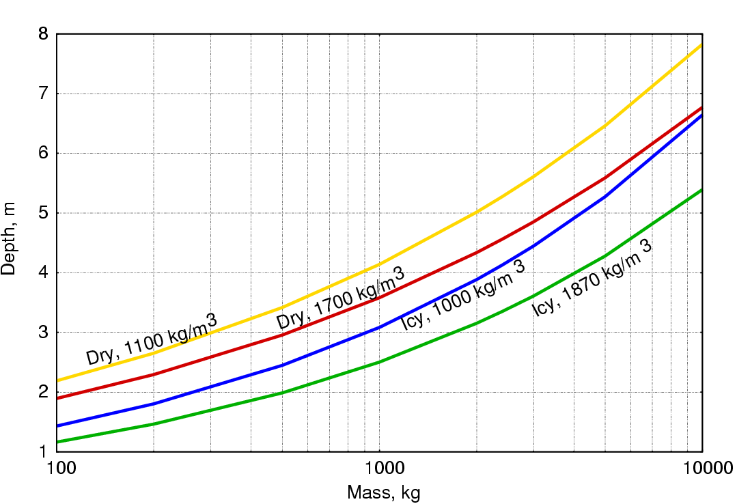
Figure 4.1. Crater depth for a spacecraft impacting Mars at 4 km/s.
In the future, we can expect innovative mission concepts to incorporate deliberate access of the deep subsurface through hard impacts, innovative drills, or melt probes. For these, it will be necessary to analyze the possibility of spacecraft-induced special regions resulting from planned exploration into the deeper martian subsurface (see Section 8).

FINDING. Although naturally occurring special regions anywhere in the 3-D volume of Mars need protection, only those in the outermost ~5 m of the martian crust can be inadvertently contaminated by a spacecraft crash—special regions deeper than that are not of practical relevance for missions with a mass up to about 2400 kg.

5. IMPLICATIONS FROM MICROBIOLOGY

5a. Introduction
There are many environmental factors to be considered in assessing the ability of microbial life to grow and reproduce. As a starting point for our analysis we considered terrestrial life forms that might be capable of growth under extreme conditions of the martian environment, thresholds for environmental factors that would prevent growth and replication, and the physiological and nutritional constraints terrestrial microbes must overcome to pose a threat of widespread forward contamination of Mars over a defined time frame. In general our strategy has been to find any terrestrial representative (no matter where it is from) that demonstrates the worst-case scenario. We are not assigning any special Mars or spacecraft relevance to any of these organisms or situations, although we are documenting observations that suggest the metabolic or physiological possibility of reproduction.

Table 5.1 Some factors that may affect the survival and reproduction of Earth microbes on Mars
Factor
Water availability and activity
- Activity of liquid water
- Past/future liquid (ice) inventories
- Salinity, pH, and Eh of available water
Chemical environment
- Nutrients
- C, H, N, O, P, S, essential metals, essential micronutrients
- Fixed nitrogen
- Availability/mineralogy
- Toxin abundances and lethality
  - Heavy metals (e.g., Zn, Ni, Cu, Cr, As, Cd, etc., some essential, but toxic at high levels)
  - Globally distributed oxidizing soils
Energy for metabolism
- Solar [surface and near-surface only]
- Geochemical [subsurface]
  - Oxidants
  - Reductants
  - Redox gradients
Conducive physical conditions
- Temperature
- Extreme diurnal temperature fluctuations
- Low pressure (Is there a low-pressure threshold for terrestrial anaerobes?)
- Strong biocidal UVC irradiation
- Galactic cosmic rays and solar particle events (long-term accumulated effects)
- Solar UV-induced volatile oxidants, e.g., O₂–, O–, H₂O₂, O₃
- Climate/variability (geography, seasons, diurnal, and eventually, obliquity variations)
- Substrate (soil processes, rock microenvironments, dust composition, shielding)
- High CO₂ concentrations in the global atmosphere
- Transport (aeolian, ground water flow, surface water, glacial)
Modified after Rummel (2006)

The Mars environment is extremely cold and dry, and the surface is bathed in ultraviolet radiation during the daytime and significantly influenced by galactic cosmic radiation at all times. Because Mars is cold, but not always, and extremely dry, but perhaps not everywhere, the concept of “special region” describes those places where environmental conditions might be compatible with microbial propagation. The special-region concept allows mission planners to address the requirements of planetary protection in regions on Mars where terrestrial Earth organisms might survive and proliferate.

5b. Lower temperature threshold
It is well documented that microorganisms on Earth live at temperatures well below the freezing point of pure water, e.g., inside glacial and sea ice and permafrost. This is possible because certain impurities such as mineral acids or salts can reduce the freezing point of water. These impurities can prevent freezing of intergranular veins in ice and thin films in permafrost and permit transport of nutrients to and waste products from microbes. Furthermore, from viability and survival studies, we know that some cells can resist freezing. Survival strategies include synthesis of stress proteins; reduction in cell size; dormancy; sporulation; adaptive modifications to their cellular components (e.g., changes in their fatty acid and phospholipids composition); or an alteration in the “structured” water in their cytoplasm (Russell et al., 1992; Thieringer et al., 1998). These and other adaptations allow them to operate more efficiently than mesophilic organisms at low temperatures. Temperature influences growth rates and cell replication by affecting the conformation of cellular macromolecules and other cellular constituents, which in turn control substrate acquisition and determine the rates of enzymes reactions and metabolism (Russell et al., 1990). The relationship between temperature and reaction rate (k) can be described by an Arrhenius equation

k =Ae^{-Ea/RT}

where Ea is the activation energy; A is a constant, R is universal gas constant; T is absolute temperature. The activation energy for most enzymes is usually on the order of 420 kJ/mol. Therefore, although reactions rates would fall considerably with a drop in temperature, there is no thermodynamic restriction on growth at low temperatures. Although thermodynamics predicts some metabolic activity at low temperatures, the lower temperature limit for cell division is probably set by freezing of the internal solution of the cell rather than reduction in enzymatic activity at low temperature. Therefore, we chose an empirical rather than theoretical approach to setting a lower temperature limit to cell replication.

In developing a rationale for setting a lower temperature threshold, we evaluated published reports of microbial activity that provide direct and/or indirect evidence that microorganisms survive or thrive at temperatures below -5°C. The studies we evaluated fell into three groups, direct measurements of cell replication, measurements of metabolic activity, and indirect measurements of inferred microbial activity (e.g., N₂O production in ice cores). Based on a proposal by Morita (1997), metabolic studies were categorized further into those providing evidence of 1) survival metabolism, i.e., the extremely weak metabolism of immobile, probably dormant communities; 2) maintenance metabolism of communities with access to nutrients and free to move but still below thresholds for growth; or 3) actual growth and cell division leading to propagation. The metabolic activity measured, the methods used, the temperature limits, and the categories of the responses are listed in Table 5.2. In addition, several studies have inferred microbial activity below -20°C from anomalous concentrations or stable isotope signatures of products of microbial metabolism. For example, Sowers (2001) proposed nitrification as the likely explanation for peak concentrations of N₂O and high d¹⁵N and low d¹⁸O of N₂O in Lake Vostok ice core from the penultimate glacial maximum, about 140,000 years ago. Price and Sowers (2004) estimated that the rates of biomass turnover at -40°C correspond to 10 turnovers of cellular carbon per billion years. Table 5.2 is not exhaustive, but is representative of a broad and diverse literature on biological activity at low temperatures.

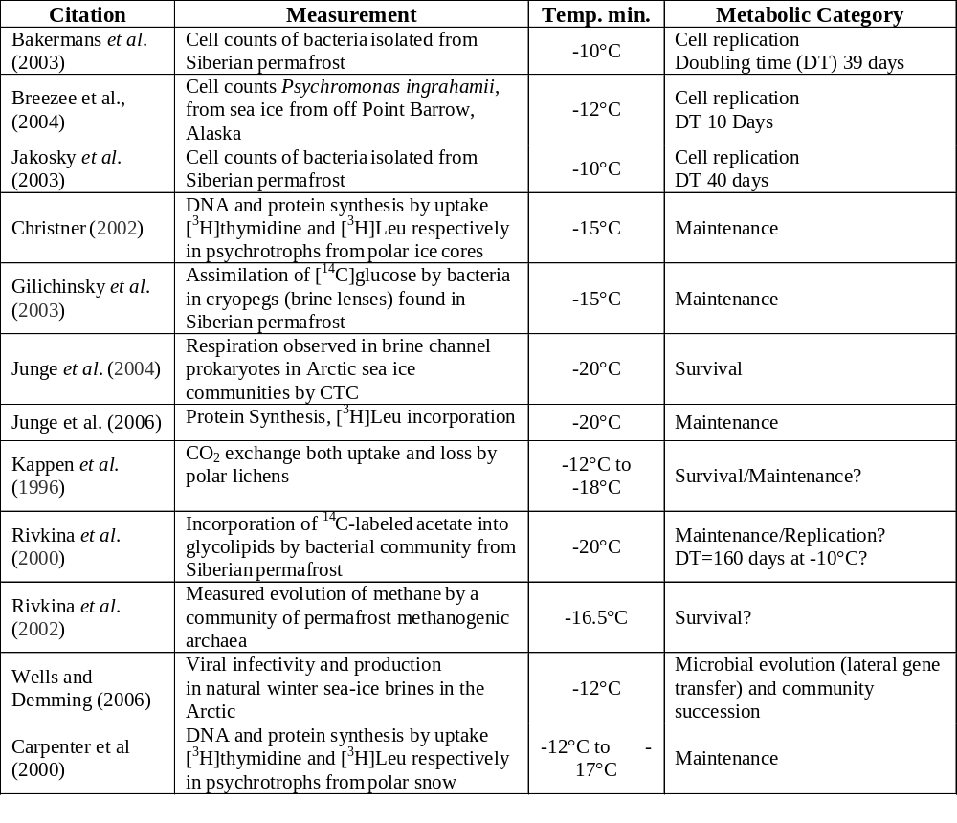Table 5.2 Observations of biological activity at low temperatures
To summarize these data, many groups have demonstrated some metabolic activity (using various measures and by various techniques) at temperatures down to -20°C. At the lowest temperatures, activity was very low (insufficient to support cell replication) and was not sustained beyond a few weeks. Although reported levels of metabolic activity at temperatures down to -15°C might support growth, no one has demonstrated cell replication at or below -15°C. There are no studies that have systematically looked at growth and replication at 1 degree increments below -15°C. We therefore recommend a lower temperature threshold of -20°C, below which there is no evidence to indicate that replication is possible. [If Earth organisms were to be discovered in the future that were able to replicate at temperatures at or below -20°C, this finding would be reevaluated.]

FINDING. Based on current knowledge, terrestrial microorganisms are not known to be able to reproduce at a temperature below about -15°C. For this reason, with margin added, a temperature threshold of -20°C is proposed for use when considering special regions.

5c. Water activity threshold
Although many terrestrial microorganisms can survive extreme desiccation in a quiescent state, e.g., as spores, they all share an absolute requirement for liquid water in order to grow, i.e., to multiply and to increase their biomass. Various measures are used to quantify the availability of liquid water to biological systems, depending on the scientific discipline (e.g., soil microbiology, food microbiology, plant physiology, plant pathology). Water activity (a_{w}) (that is, the activity of liquid water) is related to percent relative humidity (rh) as follows:

a_{w} = rh/100

when the relative humidity of an atmosphere is in equilibrium with the water in a system (a solution, a porous medium, etc.). For pure water, a_{w} = 1.0. Water activity decreases with increasing concentrations of solutes and as increasing proportions of the water in a system are sorbed to surfaces, e.g., during desiccation in a porous medium such as the martian regolith (Table 5.3).
Desiccation (matric-induced water activity) and solutes impose related but different stresses on microbial cells. Cytoplasmic a_{w} must approximate extracellular a_{w} in order to avoid excessive turgor (osmotic) pressure, plasmolysis, or plasmoptysis (cell explosion); however, some positive turgor pressure is required for cellular expansion during growth. Microbes respond to decreasing a_{w} by accumulating intracellular compatible solutes, a response that has been well characterized in many different microorganisms and which requires expenditure of energy for transport or synthesis (Brown, 1976; 1990; Csonka, 1989; Welsh, 2000).

Low a_{w} in a porous medium has the added effect of decreasing nutrient availability. As a soil loses water, the water films on the surfaces of soil particles become thinner and also discontinuous. This limits solute diffusion and also impedes microbial motility. Solute diffusion is reduced by a factor of approximately 2 and microbial mobility is negligible when a soil loses moisture such that a_{w} drops to ~0.99 or less (Papendick and Campbell, 1981; Wong and Griffin, 1976). Thus, low matric-induced water activity in a porous medium imposes starvation conditions due to the diminished solute diffusion and microbial motility. Filamentous organisms (fungi, algae, cyanobacteria, and actinomycetes) may overcome this limitation by extending filaments through air voids in a partially desiccated soil, but this extends their desiccation tolerance only to a_{w} of approximately 0.9. In the absence of exogenous energy sources, bacteria might be able to undergo 2-3 rounds of reductive cell division, but this is not an increase in biomass and thus is not true growth. Desiccation stress is usually more inhibitory to microbial growth and activity than a solute-induced water stress with an equivalent a_{w}, primarily due to desiccation-induced nutrient limitation. However, specific solutes may be toxic to microbes, e.g., sodium ions are inhibitory to some degree to all microbes if they accumulate intracellularly.

Table 5.3 Conditions resulting in various water activities (a_{w}) and microbial responses to (a_{w}) values.
Water activity (a_{w}) | Condition or response
1.0 | Pure water
Solute-induced effects
0.98 | Seawater
0.75 | Saturated NaCl solution
0.29 | Saturated CaCl₂ solution
0.98 to 0.91 | Lower solute-induced a_{w} limit for growth of various plant pathogenic fungi
0.69 | Lower solute-induced a_{w} limit for growth of Rhizopus, Chaetomium, Aspergillus, Penicillium (filamentous fungi)
0.62 | Lower solute-induced a_{w} limit for growth of Xeromyces (Ascomycete fungus) and Saccharomyces (Ascomycete yeast) (growth in 83% sucrose solution)
Matric-induced effects
0.999 | Average water film thickness = 4 µm
0.9993 | Average water film thickness = 1.5 µm
0.996 | Average water film thickness = 0.5 µm
0.99 | Average water film thickness = 3 nm
0.97 | Average water film thickness < 3 nm (< 10 H₂O molecules thick)
0.93 | Average water film thickness < 1.5 nm (< 5 H₂O molecules thick)
0.75 | Average water film thickness < 0.9 nm (< 3 H₂O molecules thick)
0.999 | Matric-induced a_{w} at which microbial motility ceases in a porous medium
0.97 to 0.95 | Lower matric-induced a_{w} limit for growth of Bacillus spp.
0.88 | Lower matric-induced a_{w} limit for growth of Arthrobacter spp.
0.93 to 0.86 | Matric-induced a_{w} at which microbial respiration becomes negligible in soil
Compiled from Papendick and Campbell (1981), Harris et al. (1981), Griffin et al. (1981), Sommers et al. (1981), Potts (1994).

Halophilic microbes (including members of the Bacteria, Archaea, and Eukarya) can proliferate in saturated NaCl solutions (a_{w} = 0.75). Growth in concentrated brines of other salts with lower water activity than 0.75 have not been documented. However, there have been reports of microbial communities in Don Juan Pond in Antarctica, where during the winter the residual water is nearly saturated with CaCl₂ (a_{w} ~ 0.3) (Siegel et al., 1979); in MgCl₂- and KCl-rich Dead Sea brine (a_{w} = ~0.67); and in deep anoxic basins in the Mediterranean, where the water is nearly saturated with MgCl₂ (5.0 M, a_{w} ~0.3) (van der Wielen, 2005). In the case of Don Juan Pond, the algal mat communities develop during the summer in melt water at the margins of the pond, which is essentially fresh water. Growth in the saturated or nearly saturated CaCl₂ brine is highly unlikely. Similarly, the microbes in Dead Sea brine are likely survivors from brief intervals of growth following dilution with fresh water (Aharon Oren, personal communication). The presence of microbes in the anoxic Mediterranean brines is indicated by 16S rRNA genes and some enzymatic activity; however, there is no direct evidence of biological growth in the brine. The DNA and enzymes could ultimately be derived from microbes that grew in overlying water with much lower salinity and not in the highly concentrated brine. Thus, we consider 0.75 to be the lowest salt-induced water activity that allows propagation of terrestrial microorganisms.

The lowest solute-induced water activity for which well-documented growth has been shown is 0.62. This is the case of xerophilic fungi growing in highly concentrated (83% W/V) sucrose solutions (Harris, 1981). Sucrose solutions as microbial habitats are more relevant to food microbiology than to naturally occurring environments such as brines or soils. Nonetheless, this value of a_{w} serves as a useful benchmark.

The lowest matric-induced water activity that allows microbial proliferation is dictated by solute diffusion and the availability of nutrients in solution. The lowest matric induced a_{w} enabling growth of bacteria in culture is approximately 0.88. More importantly, the a_{w} at which microbial respiration becomes negligible as a soil loses moisture is approximately 0.86 to 0.93 (Sommers et al., 1981). Soil respiration is a culture-independent measure, and thus serves as a good indicator of the metabolic capabilities of all soil microbes. The actual a_{w} at which microbial proliferation ceases is, in all likelihood, higher than this in that soil microbes can respire by endogenous metabolism under conditions that are too dry for cell proliferation.

Water in contact with ice deserves special attention. The a_{w} of pure liquid water at any temperature is 1.0 and is not temperature-dependent. However, the a_{w} of ice is temperature-dependent and declines from 1.0 as temperature decreases. The a_{w} of ice is equal to the water vapor pressure over ice divided by the water pressure over pure liquid water. Thus, at T = 0°C, a_{w} of ice = 1.0; at T = -20°C, a_{w} = 0.82, at T = -40°C, a_{w} = 0.67; and so forth. Note that relative humidity meters (e.g., Vaisala humicap sensors) read a_{w} and so a relative humidity meter placed in an atmosphere in equilibrium over pure ice at -40°C will read 67%.

The water activity of any solution in equilibrium with ice will be equal to the water activity of the ice and does not depend on which molecules are in solution or their quantity (Koop, 2002). Physically the solution will gain or lose water until the a_{w} is equal between the solid phase (ice) and the liquid phase (the solution). This allows the a_{w} of ice-rich regions on Mars to be predicted solely from a measurement of temperature. Similarly, the eutectic temperature of any solution can be predicted since that is the temperature at which the a_{w} of ice is equal to the a_{w} of the saturated solution.

FINDING. Based on current knowledge, terrestrial organisms are not known to be able to reproduce at a water activity below 0.62; with margin, an activity threshold of 0.5 is proposed for use when considering special regions.

5d. Other possible limits to terrestrial life
SR-SAG concluded that a number of factors (some listed in Table 5.1, some not) contribute to a reduction in the probability of propagation, but for none except temperature and water activity is it possible at the present time to define practical threshold criteria that would apply to all terrestrial microbes.
The nutritional requirements for terrestrial microorganisms on Mars were considered to be key factors in limiting the proliferation of microorganisms on Mars. Terrestrial microorganisms require exogenous sources of nutrients, and accessible organic and/or inorganic nutrients in martian regolith have not been demonstrated (Biemann et al., 1977; Biemann and Lavoie, 1979). Although terrestrial chemoautotrophs do not require organic nutrients, they do require exogenous nutrient and energy sources, not all of which can be obtained in gaseous form. The diurnal temperature fluctuations shorten durations at temperatures above the minimum required for growth and require organisms to be capable of surviving repeated exposure to eutectic freezing. Both elicit a stress response that diverts resources towards repair of cell damage rather than cell division. The strong biocidal UVC irradiation on Mars helps to further constrain the proliferation of terrestrial microorganisms on Mars by two key processes: (a) UVC irradiation can quickly reduce the viability of sun-exposed bioloads on spacecraft surfaces, and (b) UVC irradiation will likely reduce long distance dispersal of the remaining viable bioloads by imposing a highly lethal non-ionizing radiation environment on the dispersed microorganisms. For organisms near or at the surface, long term exposure to galactic cosmic rays and solar particle events will certainly increase lethality and reduce viability.
None of these secondary factors have been adequately measured or modeled for the martian surface or near-subsurface to allow us to set thresholds about their effect on survival, growth and proliferation of microorganisms on Mars. However, all combine to lower the likelihood that Earth organisms will be able to propagate or even spread at the surface while remaining viable.
FINDING. Despite knowledge that UV irradiation at the surface of Mars is significantly higher than on Earth, UV effects have not been adequately modeled for the martian surface or near-subsurface to allow us to set thresholds about their effects on growth and proliferation of microorganisms on Mars. However, UV may be considered as a factor that limits the spread of viable Earth organisms.

5e. Discussion
We conclude that thresholds for temperature of -20°C and water activity (0.5 a_{w}) define conditions below which Earth organisms will not grow or replicate. Such conditions that might exist on Mars must actually exceed both of these parameters for periods of time sufficient to allow growth and cell division to occur. We consider these to be very conservative values. Cell division has never been observed below sustained temperatures of -12°C, and 0.5 a_{w} is much lower than the minimum value for matric-induced water activities that allow for microbial propagation in terrestrial environments. This value is more conservative (lower) than the lowest solute induced a_{w} known to be compatible with growth: the unusual case of yeasts growing in a concentrated solution of sugar. Modeling studies predict that long-term conditions exceeding these thresholds will not persist long enough to permit cell division cycles, which may require weeks to years for completion.
Although it is impossible to assign with certainty values for probability of growth of an Earth organism on Mars, we can be confident that assignment of “special region” requires that conditions exceed minimal temperature and water activity parameters defined above. In addition, the litany of environmental stressors discussed above further reduces the likelihood of propagation of terrestrial organisms.

FINDING. The most practically useful limits on the reproduction of terrestrial micro-organisms are temperature and water activity, for which threshold values (with margin) can be set at -20°C and 0.5, respectively.

6. WATER ON MARS

Water on Mars is best analyzed in two broad, distinct classifications: the parts of Mars that are at or close to thermodynamic equilibrium, and those that are in long-term disequilibrium.

6a. The equilibrium distribution of water
Numerical thermodynamic models of martian surface and subsurface temperatures have been successfully used for decades to examine the physical nature of the surface layer (e.g., Kieffer et al. 1977) and the behavior of subsurface volatiles (e.g., Leighton and Murray, 1966). The repeatability of thermal inertia results from data set to data set (e.g., Jakosky et al. 2000) indicates that these models are generally accurate to better than a few degrees during most seasons and are even more accurate on an annual average.

These types of models are used extensively in predicting the behavior of subsurface ice (e.g., Leighton and Murray 1966; Zent et al. 1986; Mellon and Jakosky, 1995). Comparison between Mars Odyssey Gamma Ray Spectrometer (GRS) measurements (indicating the presence of subsurface hydrogen and subsurface ice) and theoretical models of ice stability based on these same thermodynamic numerical models demonstrates excellent agreement between theory and observation (Mellon et al. 2004).

The strong general agreement between models of ground temperature and ground ice, and observations of temperature and hydrogen suggests that such numerical simulations capture the major portion of the relevant physical processes that control these phenomena. These models are based on well-characterized physical processes of solar heat, radiation, conduction, etc. They have been validated by analytic solutions and by the general consistency with spacecraft observations (including planets other than Mars). The errors in these models tend to be related to missing or oversimplified secondary physics. For example, emissivity variations from one region to another due to changes in mineralogy can affect the kinetic surface temperature and is usually not included in numerical simulations. The magnitude of these errors can be as much as a few degrees.
Figure 6.1: Example subsurface temperature profiles for (a) a homogeneous subsurface and (b) a layered subsurface, from Mellon 2004. Each curve is a diurnal average temperature profile superimposed at 25-day intervals for a full martian year. Both cases are for 55° south latitude for a thermal inertia of 250 J m⁻² K⁻¹ s^{-1/2} and an albedo of 0.25. For the layered case the thermal inertia is increased at and below 50 cm to 2290 J m⁻² K⁻¹ s^{-1/2} to correspond to densely ice-cemented soil. The magnitude of the temperature oscillation is reduced by almost a factor of 5 at or below the ice table.

A critically important value of thermodynamic models is that they have predictive value down to spatial scales much finer than the observational data. The footprint of the GRS instrument, for example, is approximately 3 x 10⁵ km², whereas the scale of relevance to biology is microns. However, based on the arguments above, interpretation of the intensive variables to a wider range of spatial scales than is observed from spacecraft can be done with a good degree of confidence.

For the purpose of this study, equilibrium is defined as the condition in which reservoirs of H₂O are stable against evaporation and condensation. In equilibrium, all ice resides at or below the frostpoint, around -75°C on contemporary Mars and, thus, below the viability threshold for life. Models show that ice is in diffusive equilibrium with the atmosphere, and is therefore not stable in places where diurnal or seasonal temperature fluctuations significantly exceed -75°C (Mellon et al., 2004). Even temporary warming causes rapid sublimation, while a cold fluctuation brings only slow ice accumulation, simply because the atmosphere does not supply a significant source of water. Thus Mars’ ample supply of near-surface water is stubbornly sequestered in solid form at temperatures below the frost point, either on the polar caps or in vast high latitude, subsurface locations (Leighton & Murray 1966). Figure 6.1 shows how typical seasonal temperature fluctuations are sharply attenuated when ice underlies a dry surface. Ice does not survive where the thermal wave penetrates, and the high thermal conductivity of ice resists the further propagation of that wave.

It follows that the existence of ice per se does not justify a special region designation. Even the polar cap is not susceptible to melting owing to its cold climate and large thermal inertia (Arthern and Winebrenner, 2000).
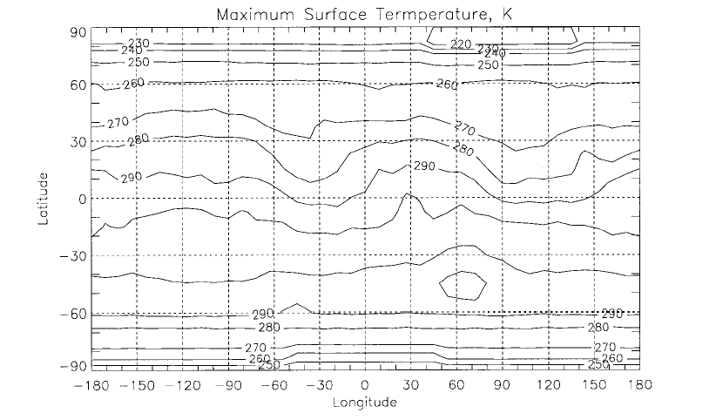
Figure 6.2. Peak surface temperature on Mars (from Haberle 2001). The warm areas correspond to the most arid spots.

Consider now the “warm” places, as indicated by the peak temperature map in Figure 6.2. While the surface of Mars at many low-latitude locations may exceed 0°C in the peak of the day, the temperature 10-20 cm below those surfaces remains perpetually below -40°C, as is easily determined experimentally by observing mean surface temperatures, as shown in Figure 6.3 or theoretically from the simplest of climate models. Any liquid that might form at the higher surface temperature (disgorged from a spacecraft, for example) would be transported in a matter of minutes or hours to the relatively cold region just below the surface where it is too cold for propagation of life, and eventually to a permanent polar or subpolar reservoir by the process of evaporation and condensation.

Persistent liquid water on Mars thus requires a significant departure from equilibrium physics in the form of either long-term disequilibria (caused either by geothermal sources of heat and water or by vestigial sources from prior climates that have survived for 10⁴-10⁷ years by virtue of giving up their water very slowly) or from short-term disequilibria (from the influence of a spacecraft on a cold, icy site or a transient event such as a meteorite impact). Relative to the dewpoint/frostpoint, a “natural” pool of liquid water on Mars is as far from equilibrium as a boiling pool of water would be on Earth. It would require both a highly local, anomalous source of heat and a substantial reservoir of water to keep it charged.
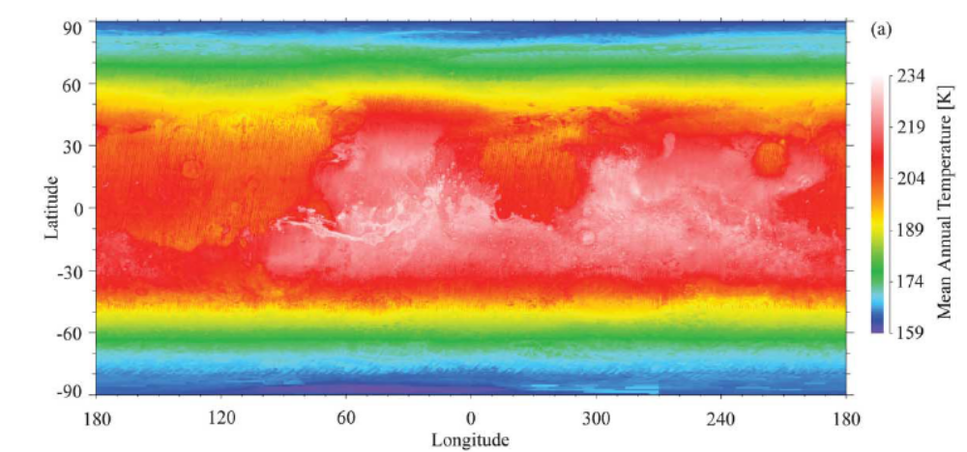
Figure 6.3. Mean annual surface temperature on Mars, roughly equivalent to the surface temperature below the annual oscillations (from Mellon 2004).

6b. Water activity: How dry is “dry”?
On Earth, life can exist and propagate in soils we might casually consider “dry,” often surviving on thin films of water in capillaries or at grain boundaries. Water activity (a_{w}) was introduced in the previous section as a quantitative measure of dryness, and a water activity threshold was established below which life cannot propagate. Water activity, a measure of availability of water, is physically equivalent to the relative humidity in the pores of the soil (although expressed as a decimal fraction rather than a percentage). At a microscopic level, it is typically surface tension associated with the concave geometry of water or ice droplets that holds vapor pressure below nominal saturation, resulting in water activity values less than unity. Alternatively, salt content can lower the saturation vapor pressure as well as the melting point. Water activity is thus a proxy for the specific physics and bioavailability of thin films of water needed for microbe propagation, and obviates the need to consider specific soil properties or the presence of brines. Moreover, if soil is in equilibrium with the surrounding atmosphere, then water activity can be determined directly from the atmospheric relative humidity. In a single, easily determined parameter, we can capture the detailed microscopic interactions of microbes, water, and soil.

While the absolute humidity (i.e., the partial pressure of water) varies with time and location on Mars, it seldom climbs much above 0.8 microbar, corresponding to a dewpoint of -75°C (Farmer & Doms 1979). Relative humidity is the ratio of this partial pressure to the saturation vapor pressure of the air or soil, which is strictly a function of temperature, varying exponentially with 1/T. Over the large temperature extremes of a martian day, the relative humidity may go to 100% at night as frost is deposited, and fall to very low values in the warmth of the day, but the absolute humidity will vary very little.

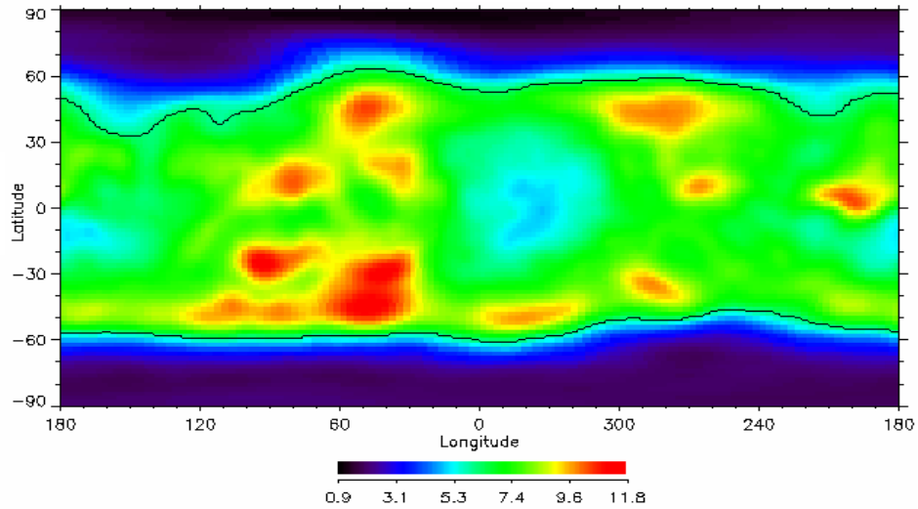

Figure 6.4. Map of epithermal neutrons, which are very sensitive to subsurface hydrogen and water ice, from the GRS instrument on Mars Odyssey (Mellon and Feldman, 2006). Only summer data from both hemispheres are used (winter CO₂ frost obscures the ice signature by adding hydrogen poor mass atop the soil - seasonal CO₂ can be as much as a meter or more at high latitudes). Beyond a threshold boundary of 6 counts/second, ice detection falls off rapidly toward the equator. This boundary is more diffuse in the northern hemisphere than in the southern hemisphere.

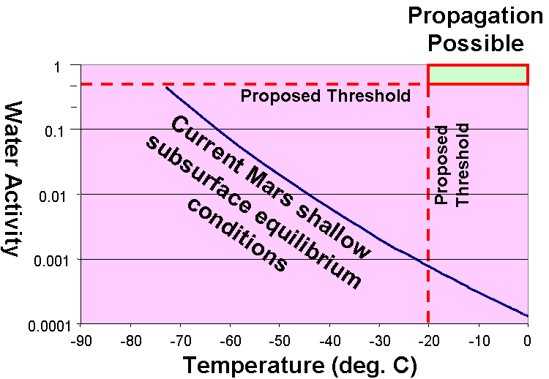
Figure 6.5. Water activity of present-day Mars vs. temperature in equilibrium with the present-day atmosphere, assumed to have a water partial pressure of 0.8 μbar. The region of concern for life propagation is shown in the upper right. The water activity of pure ice is less than one over the range of temperatures on Mars (e.g., 0.46 at -90°C). The water activity of materials on Mars at subfreezing temperatures is always less than the value of the water activity of pure ice. This is a small correction and not shown here.

Figure 6.5 shows the equilibrium water activity of martian soil as a function of temperature, derived by assuming the absolute humidity to be 0.8 microbar, in equilibrium with the
atmosphere. In warm soil, a_{w} is literally orders of magnitude too small to support life – there
simply is not enough water to sufficiently dampen the soil. Water activity approaches unity at the frostpoint, but at a temperature far too low to support life. The box in the upper corner of Figure 6.5 delineates the conditions under which terrestrial life could propagate, far from the water equilibrium.

6c. The possible effect of semi-permeable crusts
On Earth, soil crusts can provide a significant permeability barrier, through which the rate of fluid flow can be lower than the rates of resupply or fluid loss on either side of the barrier. In such cases, water can be trapped in a transient way, even when it is out of equilibrium with the atmosphere.

Observed crusts on Mars. Crusts are common at the martian landing sites visited through 2005. Observations to date show them to be relatively weak and friable. Viking “duricrusts” at Chryse Planitia (Viking-1) were readily broken by digging action, and those at Utopia Planitia (Viking-2) were disaggregated simply by shaking them in the acquisition scoop (Clark et al., 1982). Many crusted materials have been seen at both MER landing sites, but all seem to be easily broken as the wheels pass over them (Richter et al., 2004 and Richter et al., 2006). To date, no examples of high-strength crusts have been discovered at any of the five landing sites. Although we have no data on the permeability of any of these crusts, because of their friability, discontinuous nature, and porosity, they do not appear to be particularly impermeable.

Terrestrial analogs. Since other types of crusts, possibly more impervious, might exist elsewhere on Mars, it is important also to consider other kinds of crusts known from terrestrial experience. Surface crusts associated with soils on Earth are classified as biological, chemical, or physical (Soil Survey Staff, 1999).
- Biological crusts are composed of mosaics of cyanobacteria, green algae, lichens, mosses, microfungi, and other bacteria (Belnap et al. 2001).
- Chemical crusts are largely formed where water containing dissolved salts, commonly carbonate, sulfate, and chlorides, accumulates in shallow depressions allowing evaporation and precipitation at the surface. Common settings for chemical crust include dry lakebeds or sabkas. Salt crust may also form at the soil surface from capillary rise of salt-rich soil moisture.
- Physical crusts primarily result from the formation of aggregates from a reconstituted, reaggregated, or reorganized layer of mineral particles. Common types include structural (e.g., raindrop impact), depositional (surface flooding), freeze-thaw, and vesicular. Aggregates can range from ~10⁻² to 10² mm in diameter, the larger aggregates due to the formation of soil structure.
- Another type of soil crust is the strongly cemented subsoil layer where the soil matrix has been cemented by the extensive accumulation of carbonate, salt, and silica (e.g., duricrust, caliche).
Common attributes among all types of surface crust is that they generally enhance surface sealing, provide surface stability, limit wind and water erosion, increase aggregation of binding of soil particles, and are commonly < 10 cm thick.

Because it is so common to desert regions on Earth, perhaps the best terrestrial crust-forming analog for the martian surface is a type of physical crust referred to as vesicular crust. This is associated with reg soils or desert pavements, features ubiquitous to nearly all arid deserts (McFadden et al., 1998). Vesicular crusts typically underlie a single surface layer of cobbles or gravel. Desert crusts are primarily derived from the long-term accumulation of aeolian dust (particle diameters <0.1 mm) and require 10³ to 10⁵ years to form (McDonald et al., 1995). The density of this type of crust ranges from about 1.5 to 1.9 g/cm³ and they are commonly 3-10 cm thick (McDonald 1994).

Permeability. The measured saturated hydraulic conductivity of desert crust typically ranges from 0.75 to 0.5 cm/hr. Actual conductivity is typically lower than that measured at saturated conditions due to trapped air within the crust (McDonald et al., 1996; McDonald 2002, Young et al. 2004; Meadows et al., 2005). Terrestrial desert crusts are not completely impermeable because a wide range of processes, primarily dispersive stress and tensional release result in the formation of voids, pores, and fractures that prevent the continuous sealing of the soil matrix. Even the most cemented layers (e.g., caliche, duricrust) always have fractures that limit the horizontal and vertical extent of cementation and sealing. Although the formation of crust fractures is exacerbated by biological processes (e.g., root propagation), dispersive or tension stress is first required to promote development of fractures. On the surface of Mars, processes such as freeze-thaw, formation of ice, and ground shaking due to seismic activity and meteorite impact are likely to enhance formation and propagation of fractures in crusted materials.

Moisture retention happens because the rate of water recharge (on Earth, primarily via rain) exceeds the rate of water loss (i.e., transmission through the crust). For example, monitoring of moisture and temperature in soil beneath physical crusts in hyperarid deserts indicates that the crust will enhance moisture retention (several months) and have a lower soil temperature (~3-6°C) relative to soils that lack physical crusts (McDonald, writ. comm. 2006). However, on Mars, the only currently known mechanism for recharge is vapor diffusion from the atmosphere. For such cases, with time the mean rate of diffusive gain will equal the mean rate of diffusive loss, and equilibrium will be attained (although both rates will be lower than when crust is absent). Although other crust-related processes may be discovered in the future, SR-SAG concludes that to within its standard of confidence, this is not an environment that will lead to the presence of liquid water.

FINDING. Although soil crusts on Mars have been observed at the past landing sites, and other crust types are hypothetically possible elsewhere, experience with desert crusts on Earth shows that the effect of a semi-permeable crust is to retard, not prevent, the achievement of equilibrium.

6d. Water in other epochs
While an extensive literature speculates on mechanisms to form liquid water on Mars at different times and under different climate conditions ((see Carr, 1996 for an excellent overview, review, and references), common to all of them is the explicit understanding that present-day equilibrium conditions do not support the persistence of water in the liquid form at the surface.

A number of articles (e.g., Clow 1987, McKay 1991, Wallace 1979, Carr 1983) have discussed the state of liquid water on early Mars (the Noachian; see Tanaka, 1986), in the context of explaining the liquid source for the valley networks, a series of sinuous and often dendritic channels occurring in the southern uplands. Debate continues about the environmental conditions necessary for the formation of valley networks in earliest Mars history; hypotheses range from warmer conditions with rainfall and runoff (e.g., Craddock and Howard, 200*) to cold conditions, with melting of accumulated snowpack by basal heating (e.g., Carr and Head, 2003). Uncertainty also exists about whether conditions were persistent or episodic, with some attributing conditions to be punctuated, due to impact effects (e.g., Segura et al., 2002), while others envisioning longer term stable early climates (e.g., Craddock and Howard, 200*). New data suggest that conditions for valley network formation might have lasted for periods long enough to fill large impact craters to the point of overflow (e.g., Fassett and Head, 2006) and to form deltas within craters (e.g., Malin and Edgett, 2003; Moore et al, 2003). Although special circumstances (the combination of obliquity-induced snow deposition and volcanic intrusion; Fassett and Head, 2006) may have caused very local valley networks into the Hesperian period, most of this type of activity was complete by the Late Noachian-Early Hesperian, over 3 billion years ago. Most investigators agree that by the end of the Early Hesperian, a thickening globally continuous cryosphere characterized the upper crust of Mars (e.g., Clifford, 1993; Clifford and Parker, 2001) and that surface conditions were much like they are today, a hyper-arid, cold polar desert.

The large Lat Hesperian-Early Amazonian-aged outflow channels (see review and discussion in Carr, 1996) are testimony to the penetration of this global cryosphere by impact cratering, cracking or melt-through, and the catastrophic release of groundwater held under hydrostatic head. The outflow of water appears to have occurred over relatively short time periods but the effects of these huge amounts of water on the surface suggest to some that the atmosphere may have been changed significantly, possibly supporting transient periods of warm, wet climate (see review in Baker, 2001). Others believe that the outflow channels may have created oceans (e.g., Clifford and Parker, 2001) while still others believe that any standing bodies of water would have quickly frozen and sublimed away, leaving only an icy sediment residue (e.g., Kreslavsky and Head, 2002).

Liquid water generation has also been addressed for more modern Mars (the Amazonian), inspired either by the knowledge of climate change that must result from orbital forcing, or in an attempt to explain a specific class of middle- and polar-latitude gullies and other singular geological phenomena. The shortest climate cycle likely to affect precipitation would be that driven by the precession of perihelion, a 50 kyr oscillation that modulates the peak summer temperatures at the poles.

Most studies of water on modern Mars (e.g., Farmer 1976, Zent et al. 1986, Haberle 2001, Richardson 2005) assume snowfall or other means of recharging surface sources neither of which apply in the present phase of the climate cycle. For example, recognizing that liquid water would be short-lived, Farmer (1976) states that “the ice would melt and refreeze each day during the summer until it is finally dissipated.” More recently Richardson and Mischna (2005) mapped “transient liquid water potential,” essentially an assessment of locations where the temperature and pressure conditions are compatible with liquid water under varying orbital configurations. As in the earlier works, an unknown recharging mechanism is postulated, presumably associated with periodic climate change.

FINDING. Where the surface and shallow subsurface of Mars are at or close to thermodynamic equilibrium with the atmosphere (using time-averaged, rather than instantaneous, equilibrium), temperature and water activity in the martian shallow subsurface are considerably below the threshold conditions for propagation of terrestrial life. The effects of thin films and solute freezing point depression are included within the water activity.

7. MARS ENVIRONMENTS IN THERMODYNAMIC DISEQUILIBRIUM

7a. Introduction
Section 6 of this report argued that where Mars is at or close to long-term thermodynamic equilibrium, the threshold conditions for propagation of terrestrial organisms are not met anywhere at the martian surface and shallow sub-surface. However, there remains the possibility that some parts of Mars are not at equilibrium. For the purpose of this analysis, we distinguish short-term disequilibrium (i.e., the changes in heating that occur on a daily or annual cycle), and long-term disequilibrium (changes that happen as a result of geologic processes with a time constant longer than 1 year). Long-term disequilibrium conditions are the subject of this section.

All over the planet the daily and annual temperature cycles result in heating and cooling within the outermost skin of Mars. Within this process, the positive and negative excursions from equilibrium offset each other—on average, the material is at equilibrium. This has been described as a ‘dynamic equilibrium’. In such an environment, any liquid that might form at the higher temperature would be transported in a matter of hours to one of the cold ice reservoirs by the process of evaporation and condensation. This would have the effect of leaving the surface perpetually desiccated. For the purpose of identifying and evaluating environments in long-term disequilibrium, some workers (e.g., Hock and Paige, 2006) have set up an ‘annual equilibrium’ criterion, and then look for excursions from that.

One of the implications of the laws of thermodynamics is that systems tend to move towards equilibrium. Thus, an environment in long-term disequilibrium is one where water and temperature were in equilibrium under conditions at an earlier time, but those conditions have changed, and do not hold for the present. Geological deposits formed under such conditions will seek the modern equilibrium. As discussed below, there are several examples where the path could take such deposits through a liquid water field as they adjust to new conditions. Long-term disequilibrium environments might survive for 10⁴-10⁷ years by virtue of giving up their water very slowly.

Long-term disequilibrium develops in response to certain geological processes. These processes operate at different rates, at different times, and exhibit different kinds of geologic and geomorphic manifestations. In evaluating martian environments, there are two ways to proceed, both of which are used in this report:

- Description of processes. These constitute ‘theory’ for integrating a series of observations (example: geothermal vent). In some cases, there may be multiple working hypotheses to explain a given observation. There are also processes that are currently hypothetical, because the predicted observation has not yet been recorded (but in some cases is the focus of active search).
- Description of geomorphologic features. The acquisition and analysis of orbital images generates these kinds of basic data, but the linkage of the observations to the inferred geological processes is interpretive and further aided by supporting data from other approaches (example: dissected mid-latitude mantled terrain).

7b. Gullies
Martian middle- and high-latitude gullies are geomorphic features whose age and origins are not fully understood, and there is a very real possibility that their genesis involved liquid water. The geomorphology and stratigraphic relations of these landforms to adjacent features suggest that some might be so young that they could be sites at which liquid water can occur, at least for brief periods, on the martian surface today.
Description. Middle and high latitude gullies were first described by Malin and Edgett (2000). The largest examples can be seen in Mars Odyssey THEMIS and Mars Express HRSC images, but the vast majority of these landforms are small enough that they are best recognized and described using images of better than 7 m/pixel, such as those from the Mars Global Surveyor MOC (Figure 7.1).

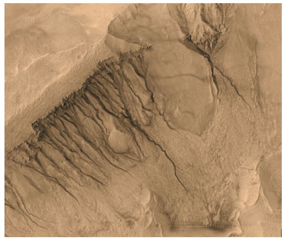
Figure 7.1. Typical mid-latitude gullies on the wall of a crater located at 39.0°S, 166.1°W. This is a sub-frame of MOC image E11-04033, colorized using information derived from THEMIS VIS color data products. The picture covers an area 3 km wide. The upper left corner of the image is the surface outside the crater in which the gullies occur; topography slopes downhill toward the lower right.

Gullies always have a channel and usually exhibit an apron, unless it has been buried. Channels are commonly banked, and in some cases, meandered, but straight (not banked or meandered) examples also exist. Some gully channels are leveed. Gullies often (but not in all cases) exhibit an alcove above the channel; these form by undermining, collapse, and dry mass movement of debris (Malin and Edgett, 2000). Gully channels commonly originate at a point about 200–800 m below the local surface outside of the depression in which the feature occurs (Malin and Edgett, 2000; Gilmore and Phillips, 2002; Heldmann and Mellon, 2004). Gully aprons, in some cases, are made up of dozens to hundreds of individual flow lobes. The majority of the tens of thousands of gullies identified in spacecraft images occur in the walls of craters, troughs, valleys, pits, and depressions. However, some variants on the theme are found on dune slip faces, crater central peaks, and the mountains surrounding Argyre Planitia (Malin and Edgett, 2000; Baker, 2001; Reiss and Jaumann, 2003).
Where Malin and Edgett (2000) lumped all of the gullies in this range of settings into a single group, Edgett et al. (2003) suggested that today they should be split into sub-groups, and their differences may imply differences in how they form and whether a volatile is involved. The study of gullies is on-going, and little research has yet addressed the geomorphic details that distinguish, for example, the gullies formed on dunes versus crater walls versus crater central peaks and the mountains rimming Argyre. Some gully-like forms occur at equatorial latitudes, but they do not exhibit all of the relevant morphologic criteria that distinguish the middle and high latitude landforms. Specifically, the equatorial features are (a) the straight, narrow avalanche chutes and attendant talus deposits that have formed on some steep slopes among light-toned, layered rock outcrops in the Valles Marineris and associated chaotic terrains, and (b) the abundant alluvial fans occurring within a unique impact crater, provisionally-named Mojave, located at 7.6°N, 33.1°W (Williams et al., 2004)
Planetary Distribution. Nearly all cases occur at a location poleward of 30° latitude in both hemispheres (Figure 7.2). Gullies occurring equatorward of 30° are very rare; the majority of these are poleward of 27° and mainly located on the north walls of Nirgal Vallis (Malin and Edgett, 2000; Edgett et al., 2003).
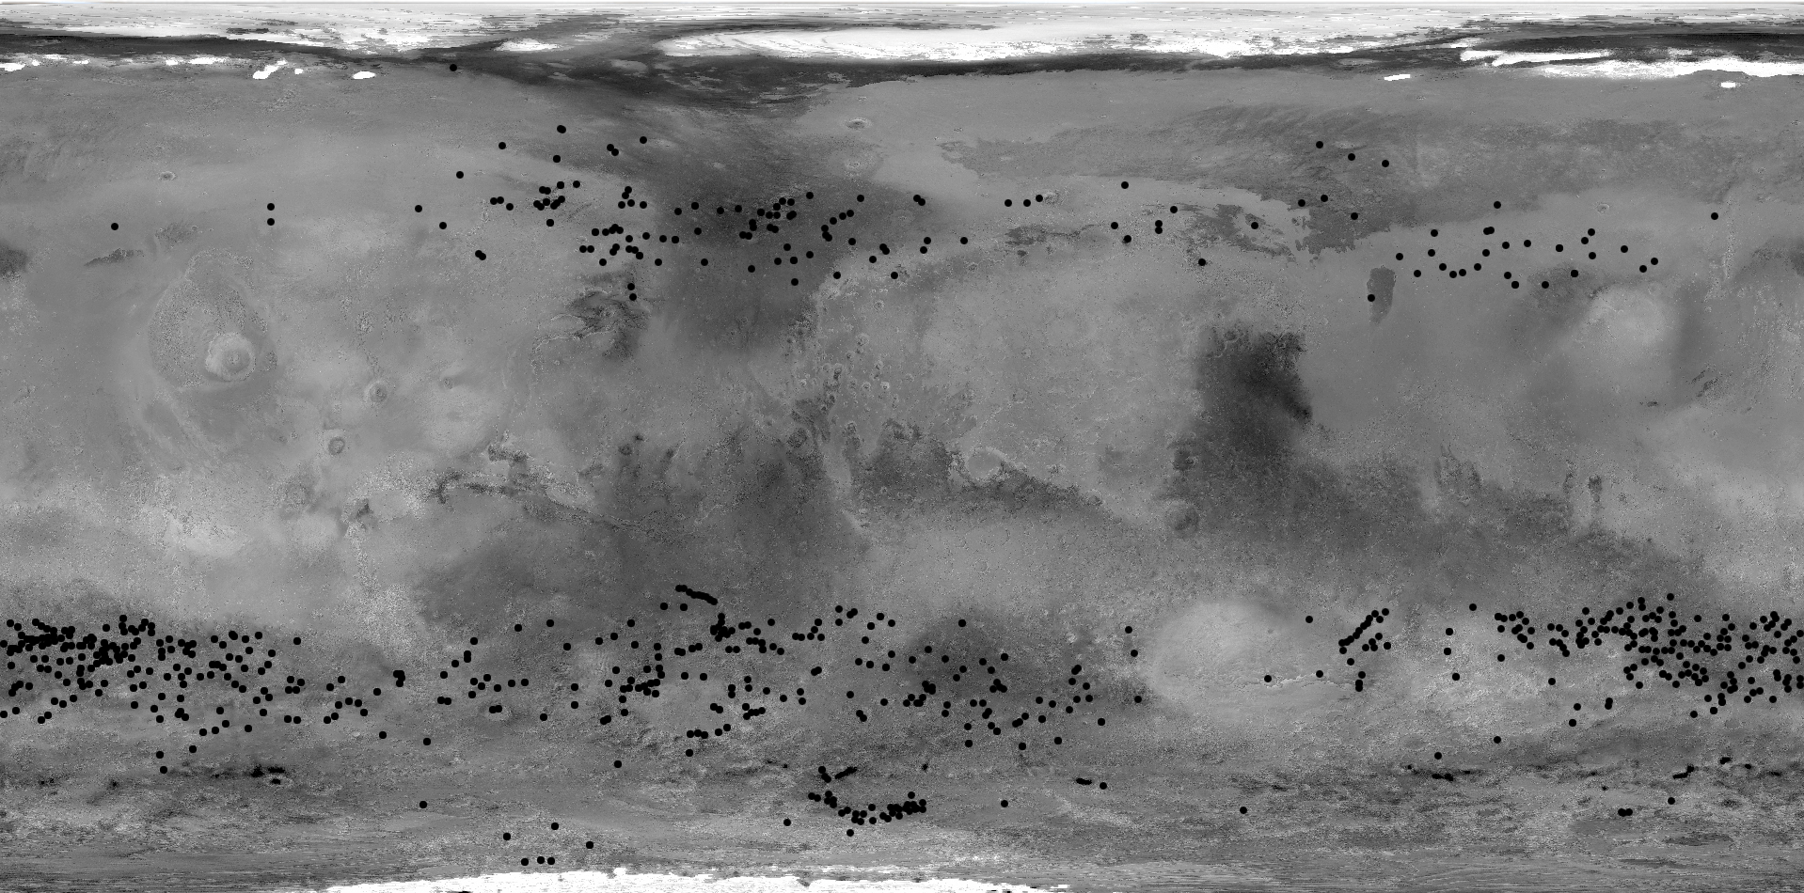
MER-B
MPF
V-1
MER-A
V-2
0
30
60
90
30
90
60
0
330
300
270
240
210
180
30
90
150
60
120
180
Figure 7.2. Martian gully locations identified in MGS MOC images by K. Edgett and M. C. Malin through September 2005. Simple cylindrical projection map.
Possible relationship to water. The origin of the gullies has been much discussed and debated over the past six years, but no single explanation has yet satisfied all investigators interested in the subject. The majority of published results regarding middle and high latitude gullies have centered on the hypothesis that liquid water is involved, and that the geomorphic expression of the banked channels, tributary channels, meandering channels, and flow lobes in apron deposits are all clues regarding the rheologic properties of water-rich debris flows that have come through a given gully channel on more than one occasion (Malin and Edgett, 2000; Hartmann et al., 2003).
Among the liquid water hypotheses are those that invoke groundwater (Malin and Edgett, 2000; Goldspiel and Squyres, 2000; Mellon and Phillips, 2001; Gilmore and Phillips, 2002; Heldmann and Mellon, 2004), melting of ground ice (Costard et al., 2001), and melting of a surface-covering snow pack (Lee et al., 2001; Christensen, 2003). Most publications about gullies on dune slip faces also involve water (Reiss and Jaumann, 2003; Mangold et al., 2003; Miyamoto et al., 2004a), although it is acknowledged that CO₂ or dry granular flow might also or instead have contributed. In cases where water is invoked to explain the origin of gullies, discussion has included the notion that pure water (Heldmann et al., 2005) or brines (Burt and Knauth, 2002) may have been the agent responsible for the observed landforms. The gullies occur in a wide range of settings, most of them very far from volcanic regions, suggesting that igneous-induced hydrothermal processes are not likely involved (Malin and Edgett, 2000).
Alternate hypotheses center on genesis by release of carbon dioxide that had been trapped below ground (Musselwhite et al. 2001; Hoffman, 2002), but Stewart and Nimmo (2002) concluded that it is very difficult to trap sufficient quantities of CO₂ beneath the surface. Others suggested that the gullies formed by dry, granular flow, thus not requiring participation of a volatile such as water or CO₂ (Treiman, 2003; Shinbrot et al. 2004), but this hypothesis does not explain banked or leveed channels, aprons consisting of many flow lobes, or association of channel heads with specific rock layers..
Age. The age of the gullies is central to the concern as to whether these landforms represent “special regions.” The critical issue is whether liquid water can come to the surface at the head of a gully channel and run down to and deposit material in the gully apron today or sometime during the next 100 years.
Estimates for the age of gullies are based on their general geomorphic and stratigraphic youth and their lack of superimposed impact craters. Pulling these observations together, Malin and Edgett (2000) concluded that the gullies could be less than 1 million years old, but this estimate was based on virtually no information regarding the absolute age of any particular landform. Reiss et al. (2004) examined small impact craters superimposing aeolian megaripples in Nirgal Vallis, which are also superposed by gully aprons. In their research, Reiss et al. (2004) concluded that the gullies in Nirgal Vallis—assuming the approach to deriving absolute ages from impact crater size-frequency distributions provides quantities that approach the true age of features on Mars—must be younger than 3 million years and might even be younger than 300,000 years in age. Other investigators have focused on the role of obliquity excursions, and whether gullies might only be active under different temperature and pressure conditions than exist today (e.g., Costard et al., 2001; Christensen, 2003; Bermann et al., 2005). However, the work of Heldmann et al. (2005) argued that modern pressure and temperature conditions are a better fit when the measured run-out distances of gully channel/apron complexes are considered, suggesting that the gullies are episodically active today.
The small sampling of gullies available in MGS MOC images at the time Malin and Edgett (2000) published their results suggested that all gullies are quite young relative to the martian geologic time scale. Among that small sample, gully channels and aprons were seen to cut or superpose landforms that are otherwise considered to be relatively young, such as aeolian dunes, aeolian megaripples, and patterned ground similar to that found in terrestrial periglacial settings. Furthermore, some gullies have dark floors, indicating that dust does not settle and persist on these surfaces for periods longer than a martian season. The absence of dust on dark channel floors might be attributed to aeolian redistribution on a sandy surface, or to recent movement of material through the gully channel by non-aeolian processes (e.g., runoff of a liquid).
MGS MOC has continued to collect new images of gullies, almost daily, since 2000, so the sample is much larger today. In the larger sample very good examples of gully aprons and channels that have been cut by fissures and faults, peppered with small impact craters, or superimposed by windblown sand have now been recognized (Edgett et al., 2003). However, these “old” gully examples are in the minority, and in most cases where craters superpose the gully surfaces, multiple craters occur, suggesting that they are secondary to a larger impact that happened elsewhere. In other words, the number of craters on the landforms associated with a gully is not necessarily a good indicator of age.
The MOC team has recently (http://www.msss.com/mars_images/moc/2005/09/20/dunegullies/) described a case in which repeated imaging by MOC revealed the formation of a new gully on a sand dune slip face (Hellespontus region, west of the Hellas Basin). The gullies formed sometime between 17 July 2002 and 27 April 2005 (Malin and Edgett, 2005). The setting of this gully (a sand dune field on the floor of a crater) is distinctly different from that of the mid-latitude gullies that form on crater walls, and strongly suggests that there is more than one gully-forming process. Further observation of Mars is clearly needed. The fact that the Hellespontus gully-forming event occurred during the current decade shows that it is possible that some material can flow through at least some gully systems in the modern era.
There are no obvious geomorphic criteria that can be used to predict which gullies might become active in this century. The MGS MOC is presently being used to monitor the hundreds of gully sites (tens of thousands of individual gullies) to look for additional evidence of change, including features that might indicate whether water is present and/or has flowed down the relevant slopes in recent years. Features being sought include new gullies, or channels within a pre-existing gully complex, and gullies in which bright material—perhaps ice or salts—has appeared. Other than the fact that gullies are restricted to certain kinds of slopes, we do not have a means of predicting where a gully may form in a location where one did not previously exist. Thus, for the purpose of planetary protection, concern should extend to gully-forming regions, not just to the specific preexisting features. The scale of these regions, however, is as yet undefined.

FINDING. Some—although, certainly, not all—gullies and gully-forming regions might be sites at which liquid water comes to the surface within the next 100 years. At present, there are no known criteria by which a prediction can be made as to which—if any—of the tens of thousands of gullies on Mars could become active during this century.

7c. Mid-latitude geomorphic features that may indicate deposits of snow/ice
The middle martian latitudes exhibit a variety of surficial geomorphic features that suggest to some investigators that ice-bearing materials were deposited over much of the surface at these latitudes, perhaps during a prior obliquity excursion. Although many questions remain, a small and slowly growing literature describes evidence that ice-rich materials may once have mantled middle latitude terrain, covering intercrater plains, crater walls, and other landforms. Two features, in particular, are relevant here:

- A ubiquitous mantle that was deposited and has since become roughened by erosion in geologically recent time. The texture of this mantle is latitude-dependent. For the purpose of this report, this deposit is referred to as the mid-latitude mantle.
- Accumulations of materials most commonly found on poleward-facing slopes of mid-latitude topographic features, such as crater walls and massifs. For the purpose of this report, this deposit is referred to as pasted-on terrain.

Mid-latitude mantle. A layered deposit, estimated to be 1–10 m thick, mantles much of the surface of Mars between 30 and 60º latitude in the northern and southern hemispheres (Kreslavsky and Head, 2000; 2002; Mustard et al., 2001). The terrain once described as “softened” in Viking-era literature (e.g., Squyres and Carr, 1986) is, at MGS MOC scale, actually “roughened terrain” (Malin and Edgett, 2001). Examples of the texture of the mantle are shown in Figure 7.3.

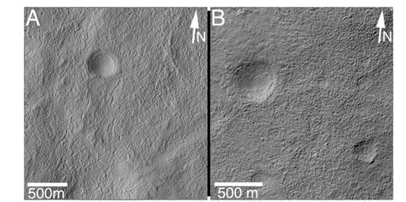
Figure 7.3. Examples of mid-latitude roughened mantled surfaces in each hemisphere. (A) Northern hemisphere example from MOC image SP2-51906, near 30.0°N, 323.5°W. (B) Southern hemisphere example from MOC image M00-03091, near 40.1°S, 171.6°W. Both images are illuminated from the left.

A progression from smooth-surfaced mantle to roughened and pitted mantles has been observed and described briefly by Malin and Edgett (2001) and Mustard et al. (2001). In some places, the erosion reveals that the mantle is layered (Milliken and Mustard, 2003). Because of the latitudinal relationship, Kreslavsky and Head (200) hypothesized that the smoothing was due to a climate-controlled deposition of ice and dust, and Mustard et al. (2001) proposed that the roughening resulted from sublimation of ice from a mixture of ice and dust that settled from the atmosphere to produce the mantle. As discussed earlier in this report, thermodynamic models indicate that in the mid-latitude regions shallow ice is unstable under current atmospheric conditions (Mellon and Jakosky, 1995; Mellon et al., 2004), potentially accounting for the desiccation interpreted to have occurred there (e.g., Head et al., 2003).

The mid-latitude mantle material exhibits several distinct morphologies that change as a function of latitude. Lower latitudes of ~30 – 45° are characterized by regions of smooth, intact mantle adjacent to regions where the mantle has been completely stripped from the surface, whereas higher latitudes of ~45 – 55° commonly exhibit a knobby surface texture indicative of incomplete removal of the material (Milliken and Mustard, 2003; Milliken et al., 2003). Latitudes poleward of ~55° exhibit the least dissection and removal of the material, suggesting the mantle deposit has experienced less erosion at these latitudes and may still be ice-rich beneath a thin layer of ice-free dust (Mustard et al., 2001; Milliken and Mustard, 2003). The Mars Odyssey GRS data also detect an increased abundance of H⁺ within the upper ~1m of the surface at latitudes higher than ~55°, supporting the hypothesis that these regions might currently include near-surface water ice.
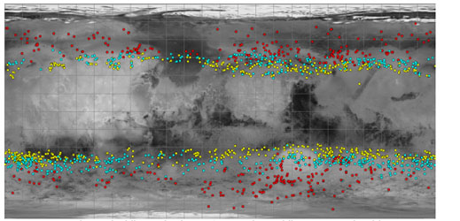
Figure 7.4. Map showing the locations of MGS MOC images in which occur different erosion styles of the mid-latitude mantling materials on a Viking MDIM base (from Milliken and Mustard, 2003). Colors: Localized removal (yellow), Knobby/wavy texture (cyan), Scalloped texture and total mantle cover (red).

The latitude-dependence of the mid-latitude mantle, its variations in morphology with latitude, and the symmetry between the northern and southern hemispheres suggest the deposition and removal of this layer is related to global changes in climate (Mustard et al., 2001; Head et al., 2003). These deposits do not appear to be forming today, but instead appear to have formed as a result of past geologic processes during earlier periods of higher obliquity. The mantle blankets all pre-existing surfaces, independent of topography and surface composition, suggesting it originated by airfall deposition of dust cemented by ice precipitated from the atmosphere during favorable climate conditions. Periods of high obliquity have been proposed to cause changes in the martian climate that result in both an increase in atmospheric dust loading and a net transport of water from polar to mid-latitude regions, providing a mechanism for multiple cycles of deposition and removal of ice-rich layers that is linked to orbital variations (Head et al., 2003). The paucity of superposed craters, together with the correlations with recent periods of higher obliquity, suggested to Head et al. (2003) that the mantle was emplaced between 2 and 0.5 million years age, and has been undergoing sublimation and desiccation for the last half million years. In summary, these surficial ice deposits formed in an earlier geologic period, when Mars had a different pattern of surface insolation, and are no longer in equilibrium for the current orbital configuration. However, there is no evidence for melting over much of this region, and active layers are not predicted (Kreslavsky et al., 2006).

‘Pasted-on’ terrain. Among the wide variety of distinctive landforms found at middle latitudes, the one that is of concern here because of its apparently youthful age is that of mantles of material that appear to have been preferentially preserved on poleward-facing slopes in craters and on massifs and hills in both martian hemispheres (Figure 7.5). Described colloquially among researchers in the Mars science community as “pasted-on” material, these mantling deposits were initially noted by Malin and Edgett (2001) who speculated that they bore some resemblance to accumulations of snow left behind on colder, more-frequently shadowed surfaces. However, the materials are not light-toned like snow. Mars Odyssey THEMIS VIS images provided wide fields of view than MGS MOC, and thus greater vistas showing these “pasted-on” accumulations became readily apparent, leading Christensen (2003) also to note that these accumulations seem to most commonly occur on poleward-facing slopes at mid-latitudes, and to expand upon the Malin and Edgett (2001) speculation that these might represent remnants of old snow accumulations.

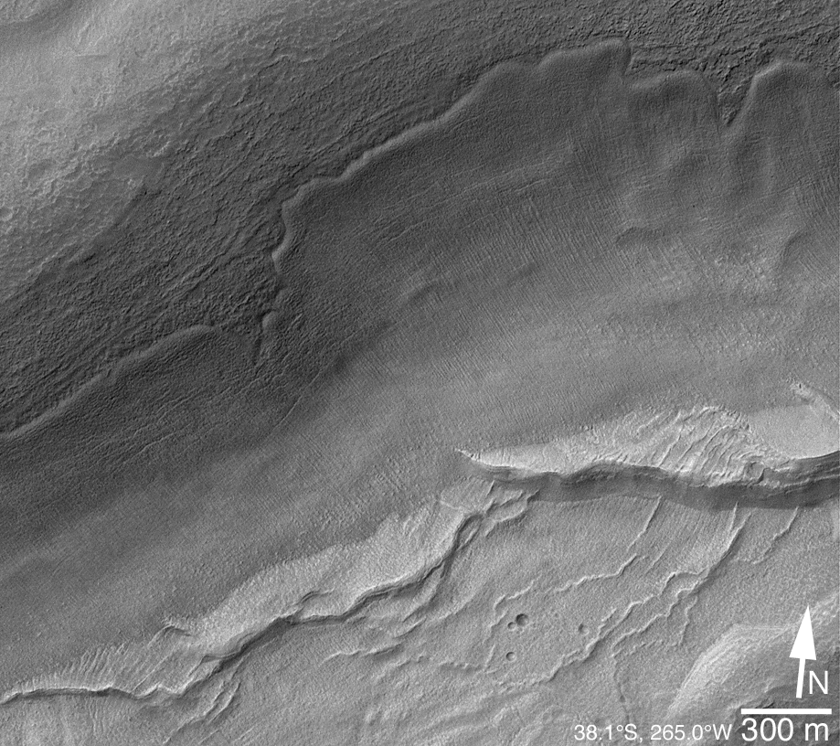
Figure 7.5. A southeast-facing slope with a mantle of ‘pasted-on’ terrain (after Christensen, 2003). This has been interpreted as snow or ice beneath a residue of dust that is protecting the material from further sublimation. The image is from MGS MOC.

Christensen (2003) and Milliken et al. (2003) proposed that the pasted-on terrain is a mixture of dust and ice (snow), and further proposed that they might be the source of water that creates middle-latitude gullies. However the mutual relationship between gullies and the pasted-on terrrain is not simple, since there is a wide range of geomorphic attributes of mid-latitude slope-mantling materials, there is a wide range of mid-latitude gullies, and the relationships between them vary. For example, some gullies do not occur in association with such mantles. No one has yet published a detailed study on whether or how the two types of landform are related globally, although Milliken et al (2003) showed that there is a strong correlation between viscous flow features, dissected mantle terrain, and gullies within the ±30 – 50° latitude zones. Also, where gullies and mantles occur together, gullies cut the mantles and in some cases head at locations higher up the slope than the margin of the mantle/accumulation. It is possible that some gullies may be the final erosional product left by the melting of a prior mantle that is no longer present. In any case, our present understanding of the possible genetic relationship between gullies and mantles is missing some important details. Much work on the topic remains to be done.

Is there a part of Mars that currently has an active layer? Permafrost is ground remaining frozen (temperature below the freezing point of water) for more than two consecutive years. An active layer in permafrost regions is defined as a near-surface layer that undergoes freeze-thaw cycles due to day-average surface and soil temperatures oscillating about the freezing point of water. A “dry” active layer may occur in parched soils without free water or ice but significant geomorphic change through cryoturbation is not produced in these environments.

We have enough information to be able to conclude that a wet active layer is currently absent on Mars. Kreslakvsy et al. (2006) used recent calculations on the astronomical forcing of climate change to assess the conditions under which an extensive active layer could form on Mars during past climate history. Their examination of insolation patterns and surface topography predicts that an active layer should form on Mars in the geological past at high latitudes as well as on pole-facing slopes at mid-latitudes during repetitive periods of high obliquity in the geological past. They examine global high-resolution MOLA topography and geological features on Mars and find that a distinctive latitudinal zonality of the occurrence of steep slopes and an asymmetry of steep slopes at mid-latitudes can be attributed to the effect of active layer processes. They conclude that the formation of an active layer during periods of enhanced obliquity throughout the most recent period of the history of Mars (the Amazonian) has led to significant degradation of impact craters, rapidly decreasing the steep slopes characterizing pristine landforms. However, their analysis indicates that an active layer has not been present on Mars in the last ~5 Ma, and that conditions favoring the formation of an active layer were reached in only about 20% of the obliquity excursions between 5 and 10 Ma ago. Conditions favoring an active layer are not predicted to be common in the next 10 Ma. The much higher obliquity excursions predicted for the earlier Amazonian appear to be responsible for the significant reduction in magnitude of crater interior slopes observed at higher latitudes on Mars.

FINDING. Because some of the ‘pasted-on’–type mantle has a spatial, and possibly a genetic, relationship to gullies (which in turn are erosional features possibly related to water), the ‘pasted-on’ terrain may be a special region. The mid-latitude mantle, however, is thought to be desiccated, with low potential for the possibility of transient liquid water in modern times.Because the mid-latitude mantle and some kinds of gullies may have a genetic relationship, the mantle is interpreted to have a significant potential for modern liquid water.

7d. Glacial Deposits
Low-Latitude. The topic of glaciation—even at equatorial latitudes— has been discussed and debated for more than 3 decades (e.g., Williams, 1978; Lucchitta, 1981; Kargel and Strom, 1992; Head and Marchant, 2003; Neukum et al., 2005, Forget et al., 2006). New spacecraft data, and evidence from terrestrial analogs, have provided insight into these types of deposits in the equatorial region of Mars. Head and Marchant (2003) have presented evidence that the large lobate deposits on the northwest flanks of the Tharsis Montes volcanoes resulted from the accumulation of ice and snow, its flow outward to form glaciers, followed by the cessation of ice accumulation, collapse of the glaciers and the production of distinctive glacial deposits that remain today. Similar deposits occur around the base of the Olympus Mons scarp (e.g., Milkovich et al., 2006) and are interpreted by some to represent debris-covered glacial deposits. Climate modeling shows that during periods of higher obliquity, water is mobilized from the polar regions, carried by the atmosphere to the tropics, rises along the western flanks of Tharsis, and is preferentially deposited as snow and ice as the rising moist air is adiabatically cooled (Forget et al., 2006).
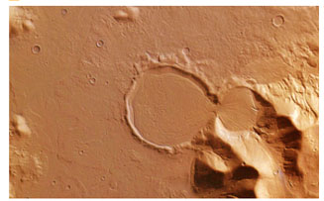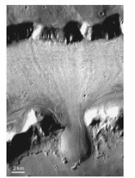
Figure 7.6: Left: An example of a feature hypothesized to be a glacial deposit (Head et al., 2005). Located in Promethei Terra at the eastern rim of the Hellas Basin, at about latitude 38º South and longitude 104º East. From HRSC (Credits: ESA/DLR/FU Berlin (G. Neukum). http://www.esa.int/SPECIALS/Mars_Express/SEMN3IRMD6E_0.html. Right: A lobate flow that appears to have been funneled between a gap between two obstacles in the fretted terrain of the Deuteronilus Mensae region (40N, 25E,THEMIS v12057009). The flow has been interpreted by some to be ice-rich, although this interpretation is not unique. From the superposed craters it is known to be tens to hundreds of millions of years old.

One of the major impediments to the glacial interpretation of these deposits in the past has been the lack of occurrence of eskers, drumlins, and other indications of classic wet-based glaciation (e.g., Zimbelman and Edgett, 1992). Recently analyzed terrestrial analogs of the huge deposits at Arsia Mons (~180,000 km²) (Head and Marchant 2003) and Pavonis Mons (Shean et al., 2005) show that glaciers typical of polar latitudes on Earth (cold-based glaciers, where the glacier flows over permafrost and deforms internally to the glacier, rather than with melting at the base) is a more appropriate analog to these tropical features on Mars. Thus, even when these glaciers were forming on Mars several tens to hundreds of millions of year age (Head et al., 2005; Shean et al., 2006), there was little to no melting associated with them. Although we cannot rule out that there may be some residual ice at depth in these deposits, because of their age it would certainly be below a thick sublimation till—residual shallow ice is highly unlikely.

Geomorphic features that may have involved liquid water in these regions include features interpreted by some investigators to be impact craters, pingos, mud volcanoes, and the possible basal melts from ice caps. However, under current climatic conditions at mid to high latitudes where the supply of water from a shallow source may be present, the water source would be quickly exhausted, as surface recharge is virtually impossible.
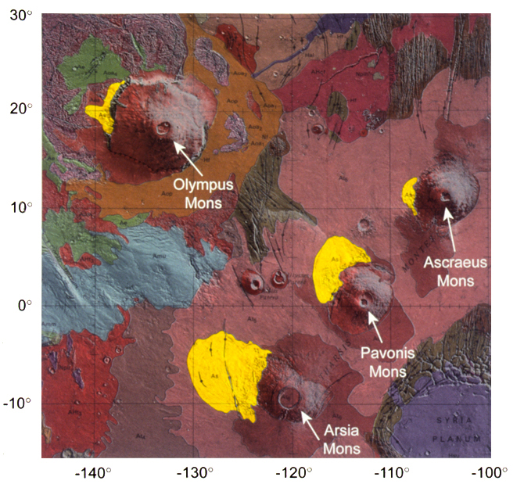
MER-B
MPF
V-1
MER-A
V-2
0
30
60
90
30
90
60
0
330
300
270
240
210
180
30
90
150
60
120
180
Figure 7.7. Location of lobate deposits (yellow) on the NW margin of Olympus Mons and the Tharsis Montes (from Scott and Tanaka, 1986) interpreted by Head and Marchant (2003), Shean et al. (2005) and Mikovich et al.(2006) to be tropical mountain glaciers. See Scott and Tanaka (1986) for further description of additional units. Lobate debris aprons and lineated valley fill are concentrated in the 30-50° North and South latitude bands (e.g., Squyres, 1979; Squyres and Carr, 1986). Lobate debris aprons and lineated valley fill are concentrated in the 30-50° North and South latitude bands (e.g., Squyres, 1979; Squyres and Carr, 1986).

Middle- and high-latitude. The mid-latitude regions exhibit additional geomorphic features for which some researchers have suggested that ice was or still is a part of the material. These include kilometer-scale flow features, interpreted by some as indicating they flowed in a viscous manner, found on some pole-facing slopes (Milliken et al., 2003), aprons surrounding massifs and mesas in the Deuteronilus, Protonilus, and Promethei Terra regions, and lineated valley floor materials and concentric crater floor features that exhibit distinct erosional textures and morphologies that have been a topic of discussion since the Viking era (e.g., Berman et al., 2005; Pierce and Crown, 2003; Carr, 2001; Squyres and Carr, 1986; Squyres, 1979; Zimbelman et al. 1989). The lineated valley floor material was once considered to be the product of creep or flow of ice-rich material (e.g., Squyres, 1979). Although Malin and Edgett (2001) noted that lineated
floor materials also occur in completely-enclosed troughs, from which no material can flow, Head et al (2006a, b) have shown that there is ample evidence for accumulation zones, zones of convergence and folding, and ablation zones very similar to terrestrial debris covered valley glaciers and glacial landsystems on Earth. Superposed craters, however, indicate that these deposits have not been active for tens to hundreds of millions of years (e.g., Mangold et al., 2003). Although these features are typically located in the 30-50 degree latitude range, effective maps are not yet available.

While there is no consensus about middle or equatorial latitude ice (e.g., discussions of glaciers and other flows at middle latitudes), the presence of high-latitude ice on Mars is unquestioned. The key issue for the purpose of biological propagation is whether any of it ever exceeds a temperature of -20°C. In the high-latitude areas we see no geomorphic evidence for melting, and there are theoretical grounds for believing that is not possible for melting to occur naturally at present.

7e. Craters
Description, Distribution, Age. Impact events can excavate to depths where ice and/or liquid water may exist, and can heat the surrounding region for a significant time, creating an environment that is out of thermodynamic equilibrium with its planetary setting. During martian history, although cratering events have certainly exceeded the threshold conditions for biological propagation, the heating is transitory, and the thermal anomalies are erased with time. Since craters are everywhere on Mars, the challenge is to identify which, if any, craters have the potential to retain enough heat to still harbor liquid water within 5 m of the surface at the present time. Impact craters occur randomly both in time and location on the martian surface.

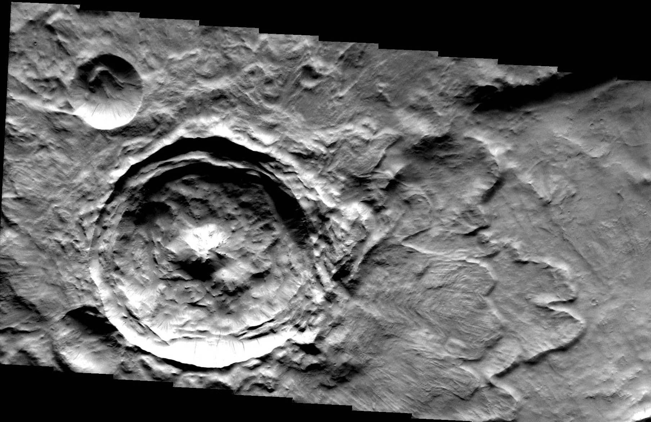
Figure 7.8. One of the freshest large craters. This crater is 11.5 km in diameter, is located at 13.70N 29.52E, and shows a well-developed central peak (where models indicate that a long-lived hydrothermal system could operate). The adjacent craters are all covered with ejecta deposits, indicating those craters are older. The roughness of the floor is due to wall collapse during formation. Note the well-developed fluidized ejecta blanket to the right. V10297019 (THEMIS daytime visible), north is to the right.

Water in the target volume. The first question to address is which craters accessed volatile-rich material in the surface. Impact craters display a relationship between their depths of excavation (d) and their diameters at the time that maximum depth is reached (i.e., the transient crater diameter, D_{t}). For small bowl-shaped craters (“simple craters”; typically <7-km-diameter on Mars (Garvin et al., 2000)), the observed crater diameter (D) is approximately the transient crater diameter and the excavation depth is ~1/5 of this diameter (d ≈ D/5). For larger (“complex”) craters, d ≈ D_{t}/10, but the currently observed rim diameter is larger than the transient diameter due primarily to wall collapse (Melosh, 1989). Several empirically derived relationships between D and D_{t} for complex craters have been suggested; one example is that described by Croft (1985):

D_{t} = D_{sc}^{0.15}D^{0.85}

where D_{sc} = simple-to-complex transition diameter ≈ 7 km on Mars. Using this relationship, we find that
d ≈ 0.13 D^{0.85}

As noted in Section 6, Gamma Ray Spectrometer results and thermal modeling suggest that volatile-rich material lies at depths <1 m in the latitude range poleward of ~45°-50° in both hemispheres. All craters impacting into these regions excavate into ice-rich regolith. At lower latitudes, the regolith becomes more desiccated due to daily, seasonal, annual, and long-term insolation cycles, with the desiccation zone reaching depths of 10 m or more in the equatorial region. Thus, craters <50-m-diameter are not reaching volatiles near the equator.

Fresh impact craters on Mars often display a layered (i.e., “fluidized”) ejecta morphology, which is widely believed to form by vaporization of subsurface volatiles during crater formation (see review in Barlow, 2005), although laboratory experiments suggest that similar morphologies could be produced simply through the interaction of an expanding ejecta curtain and the atmosphere (e.g., Schultz and Gault, 1979). Although regional variations occur, the smallest craters that show a layered ejecta morphology in the ±30° latitude zone are typically between 3 and 5 km in diameter. The current best models for layered ejecta blanket formation suggests that the surface material must contain at least 15-20% ice before the layered ejecta patterns begin to form (Woronow, 1981; Stewart et al., 2001). This suggests that craters <3-5 km in diameter excavated into material which is largely devoid of ice. The corresponding excavation depths are 600 m to 1 km. Thus, within the equatorial region, craters smaller than ~3-km-diameter probably did not penetrate into enough volatile-rich material to create special regions at present.

Crater-induced heating and hydrothermal systems. The amount of heating associated with the impact-induced shock wave depends on the transient crater diameter and the location within or outside of the crater (Pierazzo et al., 2005). Part of the kinetic energy associated with incoming bolides is converted into impact melt and part of it goes into heating the target material during crater formation (Ivanov and Deutsch, 1999). Numerical modeling indicates that this heating is highest under the transient crater floor, within the region where central peaks and central pits form. In martian craters larger than 30 km, another significant heat source is the uplifted geotherm under the central uplift (Abramov et al., 2005a, b). Hydrothermal systems are expected to be particularly active within the central peak/central pit regions and in association with impact melts along the crater floor. Heat within the ejecta blanket and near the crater rim dissipates more rapidly, particularly with the cold surface temperatures prevailing on present-day Mars.

Water supply is a critical issue for the formation of an impact generated hydrothermal system. Even small impact craters emplaced in ice can produce liquid water (Stewart et al., 2001). Using the relationship above between crater diameter and depth of excavation, for areas with ice at a depth greater than 600 m, craters up to 3 km in diameter, where basement uplift is not an issue, are unlikely to produce a hydrothermal system of any extent or duration. Larger craters could potentially access liquid aquifers at depth.

Numerical models also indicate that impact melt sheets and central uplifts/pits associated with larger complex craters can produce active hydrothermal systems that can survive on time scales of up to ~10⁶ years (Ivanov and Deutsch, 1999; Newsom et al., 2001; Rathbun and Squyres, 2002; Abramov and Kring, 2005a; b) The lifetime of an impact-induced hydrothermal system is related to crater size and the geothermal gradient. The maximum potential lifetime for a hydrothermal system is the conductive cooling time for the hot rock produced by an impact. For example, a recent calculation by Abramov and Kring (2005a), estimates a 67,000-year lifetime for a hydrothermal system in a 30 km diameter crater on Mars.

Based on the above general considerations, SR-SAG proposes the conservative guidelines in Table 7.1 for the maximum amount of time a crater environment has the potential to retain enough heat in the shallow martian subsurface to exceed the threshold conditions for microbial propagation, assuming a supply of water is available. In general, the thermal lifetimes for craters smaller than 3 km in diameter are too short to be significant for the purpose of special region analysis. In addition, very young and fresh craters larger than 30 km in diameter have not been identified (Table 7.2).

Cratering frequency. A 10-km-diameter crater is expected to form on Earth approximately every 10⁵ years (Morrison et al., 1994). The impact rate on Mars is considered to be ~1.3 times higher than the terrestrial impact rate due to Mars’ proximity to the asteroid belt, but the impact energy will be less because the typical asteroid impact velocity is 8.6 km/s on Mars compared to ~17 km/s on Earth. Adjusting the terrestrial impact probability plot for Mars suggests that one 40-km-diameter crater could be expected to form approximately every million years on Mars and a 10-km-diameter crater would statistically form every ~30,000 yrs. Thus, although the probability that a crater of sufficient size has formed recently enough to still retain an active hydrothermal system is very low, there is a small chance that such a crater exists.

Table 7.1. Approximate relationship between crater size and maximum duration of heating
Crater Size (diameter) | Time for which crater environment has potential to retain enough heat to exceed threshold conditions
3 km | 100 years
10 km | 1,000 years
30 km | 100,000 years

Identification of the most recent large craters. Young craters can be identified by the following characteristics:

- Sharp rim and crater depth approximately equal to those values expected for a pristine crater of equivalent size.
- No superposed features on either the crater or its ejecta blanket. Such superposed features would include dunes, floor deposits, tectonic/fluvial features, or small impact craters.
- Ejecta blanket and interior morphologies that are sharp and well preserved.
- The crater and its ejecta blanket displaying thermally distinct signatures in daytime and/or nighttime infrared views.

Very few impact craters >5-km-diameter display these characteristics. Table 7.2 lists northern hemisphere craters identified from MOC, MOLA, and THEMIS analysis which appear to be among the freshest craters on the planet (from data of Malin and Edgett, 2001; Smith et al., 2001, and Christensen et al., 2004; interpretation by Barlow). These craters have a similar rating of extremely fresh using the criteria listed above, none are named, and this list will clearly keep growing as our exploration of Mars proceeds. We do not have precise ways of dating craters on Mars; however, the approximate age can be estimated from the degree of degradation of the crater morphology (Barlow, 2004). Based on this kind of analysis, we do not have reason to believe that any of the craters in Table 7.2 are as young as the limits specified in Table 7.1.

Table 7.2. Freshest large craters in the northern hemisphere of Mars identified to date
LATITUDE (N) | LONGITUDE (E) | DIAMETER (KM) | CENTRAL STRUCTURE | EJECTA*
7.03 | 117.19 | 18.0 | Central Peak | MLERSRd
7.16 | 174.41 | 9.6 | Floor Pit | MLERS
8.93 | 43.82 | 10.9 | Summit Pit | MLERS
12.10 | 169.24 | 5.9 | Summit Pit | SLERS
13.70 | 29.52 | 11.5 | Central Peak | MLERS
16.95 | 141.70 | 13.6 | Floor Pit | MLERSRd
19.51 | 141.18 | 9.2 | Floor Pit | MLERS
20.01 | 246.68 | 7.9 | None | SLERSRd
23.19 | 207.76 | 28.3 | Central Peak | MLERSRd
Notes: *Ejecta classifications from Barlow et al. (2000).

FINDING. No craters with the combination of size and youthfulness to retain enough heat to exceed the temperature threshold for propagation have been identified on Mars to date.

7f. Young volcanics
Description, distribution. Volcanism or magmatic intrusion may be capable of generating special regions on Mars by warming up near-surface rocks and melting ground ice. Some key examples of fluvial channels in spatial and temporal association with volcanic eruption products have been documented on Mars (e.g., Burr et al., 2002; Mouginis-Mark, 1990; Mouginis-Mark and Christensen, 2005). Subsurface magmatic intrusions (e.g., dikes and sills) have also been implicated in fluvial activity in volcanic regions (e.g., Tanaka et al., 1998; Head et al., 2003b). Since the time period of interest for special regions consideration is from now until 100 years (from the date of a mission’s arrival) in the future, we need to consider both recent volcanic rocks that might still be warm and the possibility of future volcanic eruptions.

A first-order assessment can be made from global geologic mapping of Mars and model-dependent absolute ages derived from impact crater densities. The youngest volcanic materials on Mars are considered to have formed during the Late Amazonian Epoch, in which the number craters per 10⁶ km², or N(1), is less than 160 (Tanaka, 1986). These Late Amazonian volcanic materials were originally mapped with Viking images at 1:15,000,000 scale (Scott et al., 1986-87). That mapping effort led to identification of relatively young volcanic rocks associated with the Tharsis Montes and Olympus Mons. In addition, young deposits of the Medusae Fossae Formation have an uncertain origin but could be volcanic (e.g., Scott and Tanaka, 1982). Improved mapping at 1:15,000,000 scale, based on Mars Orbiter Laser Altimeter (MOLA) topographic data and early Thermal Emission Imaging System (THEMIS) data, covers the northern plains of Mars, or about a third of the planet. Based on this mapping, the youngest volcanic province on Mars is map unit AEC₃ from Tanaka et al. (2005), the distribution of which is shown on Figure 7.9. These materials include a broad, lightly cratered region of lava flows and vents associated with Cerberus Fossae (Plescia, 1990, 2003; Keszthelyi et al., 2000); although some investigators have proposed that the materials are not volcanic (Murray et al. 2005) or while volcanic, may be exhumed and therefore not necessarily young (Malin and Edgett 2001).

Age. Volcanic products on Mars are largely considered to be mafic (e.g. Greeley and Spudis, 1981; many Mars meteorite studies), which are dark in color. The relatively youngest volcanic materials are therefore assumed to be relatively dark (see Figure 7.9) because of the progressive accumulation of thin coatings of dust that collect after dust storms. Age can also be estimated from cratering density. Viking, MOC, HRSC, and THEMIS data demonstrate that no such dark, uncratered surfaces occur on Mars. The highest resolution images, from MOC, show the volcanoes and flows of the Tharsis Montes and Olympus Mons, for example, to have been covered by mantles of fine-grained material (i.e., dust), that, in most cases, has been there long enough for the materials to become somewhat indurated and sculpted by wind erosion (Malin and Edgett 2001). The youngest volcanic materials might be those associated with the Cerberus Fossae/southeastern Elysium Planitia and Marte and Athabasca Valles systems, south of the Elysium Rise.
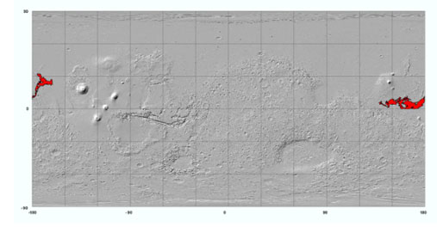
Figure 7.9. Shaded-relief map of Mars (simple cylindrical projection) showing the distribution of the youngest volcanic rocks on Mars (map unit AEC₃ from Tanaka et al. 2005). These volcanics are of Late Amazonian age, which includes geologic time from the present to about 300-500 Ma. Although there is no current indication that any of these rocks are as young as 1000 years, we cannot say with certainty that the activity in this volcanic region has ceased, and that future eruptions are impossible.

The absolute ages of these possibly volcanic surfaces are estimated by crater density and models of crater production rate (Hartmann and Berman, 2000; Hartmann and Neukum, 2001). Such age determinations have to be considered with caution. First, there is debate at present as to whether or not secondary craters dominate the populations of sub-kilometer craters (McEwen et al., 2005), which have been incorporated when evaluating the ages of the youngest surfaces (Hartmann and Neukum, 2001).

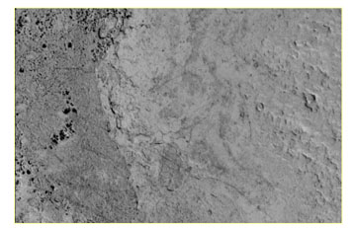
Figure 7.10. Three distinct, apparent volcanic surfaces in Elysium Planitia progressively younger from right to left (appearing rugged and cratered, bright and partly incised, and dark, respectively). The youngest unit is Late Amazonian (in the Tanaka et al 2005 map); the middle unit is Late and Middle Amazonian, and the cratered unit is Late Hesperian (Cerberus Fossae 3 and 2 and Utopia Planitia 2 units, respectively). This shows the episodic nature of eruptions in volcanic regions. Image width 3.7 km., part of MOC image R11-01377.

Second, the error in the model ages is uncertain and considered to be a factor of 2 (Hartmann and Neukum, 2001). Third, the geology of the dated rocks may be complex in some cases. If the crater counts include multiple outcrops of lava flows and other volcanic materials, then the counts provide a mean age. Some surfaces may be much older than others within the counted area. Crater obliteration processes, particularly for softer materials such as volcanic ash, may result in surface ages that are much younger than the rock emplacement ages.

In addition, no known “warm” surfaces—that is, those that can be attributed to volcanic or magmatic heating--have been detected on Mars from spacecraft imaging or thermal remote-sensing datasets.

The possibility of eruptions within the next 100 years. To establish a volcanic recurrence rate, information is needed for multiple eruptions. Geologic mapping and crater dating investigations, however, have not yet resolved this to any useful precision. For example, for the materials interpreted to be geologic units consisting of multiple, overlapping lava flows, it is uncertain in detail how many eruptive episodes were involved. Thus the duration of the Late Amazonian constrains the mean recurrence interval for volcanic materials of this epoch. Its duration ranges from 150 to 1100 Ma, given the factor of 2 age uncertainties (see Hartmann and Neukum, 2001, Fig. 14). The recurrence interval is the inverse of the ages in years times 100 for a 100-year period, or 9.1 x 10⁻⁸ to 6.7 x 10⁻⁷. If, however, the materials of the Cerberus Fossae region and other volcanic materials were to have a recurrence interval of 10 Ma, equivalent to a younger estimate of its age from sub-kilometer crater densities (Hartmann and Neukum, 2001), then the probability of recurrent volcanism for a hundred year period at any of these sites is on average <10⁻⁵. Volcanic episodicities related to longer time periods have also been discussed by Wilson et al. (2001) and Neukum et al. (2004).

In summary, the recurrence and extent of volcanic eruptions on Mars appears to be sufficiently low in the most recently active regions that the occurrence of special regions due to either recent or renewed volcanism seems unlikely. However, without more precise geologic mapping of eruption deposits and their age dating, it is not possible to determine exactly the recent volcanic recurrence interval of local volcanic areas on Mars that may be of interest to future landed missions. For example, Athabasca Valles, proposed by some to be one of the youngest fluvial and volcanic systems on Mars, was seriously considered as a candidate landing site for the Mars Exploration Rovers (e.g., Golombek et al., 2003), yet its detailed geologic history remains elusive.

Potential to exceed propagation thresholds. Since volcanic heat is lost with time, only extremely young volcanics have the potential to exceed the propagation thresholds. An obvious question, therefore is how much time is too much? A simple calculation was done using an infinitely thick slab with an initial temperature of 1000°C cooling in an environment with a surface temperature of -40°C, and the following parameters: thermal conductivity of the surface = 2.5 W/m/K, heat capacity of the surface = 800 J/kg/K, and density of the surface = 2600 kg/m³. As is typical of solutions to the heat flow equation, the initial cooling is very rapid, but after the first few tens of years, the cooling slows considerably. The temperature of the surface drops to less than -20°C within about 1000 y. Although it is beyond the scope of this report to analyze the possible cooling histories of all configurations of eruptive volcanic rocks, the 1000-year figure is a useful practical guideline. Volcanic rocks older than that cannot have retained enough heat exceed the -20°C propagation limit within the upper 5 m of the martian crust. This limit is very conservative in the sense that the upper five meters will almost certainly be dry as well as cold. It is more difficult to put a limit on the amount of time for loss of water from the system, but this is not necessary since both threshold conditions must be satisfied for propagation. More detailed treatments of the interactions of magma and ice on the Earth and Mars can be found in Wilson and Head (2002) and Head and Wilson (2002), respectively.

Volcanic rocks younger than 1000 years old have not been discovered on Mars, so we do not have evidence for shallow volcanic-related special regions.
FINDING. We do not have evidence for volcanic rocks on Mars of an age young enough to retain enough heat to qualify as a modern special region.

7g. Slope streaks
Description and Age. Dark- and light-toned slope streaks (Figure 7.11) occur in dust-mantled regions, particularly Arabia Terra, Tharsis, and various hills and slopes in the regions between Tharsis and Elysium in the northern hemisphere (Figure 7.12). Sullivan et al. (2001), Schorghofer et al. (2002), and Aharonson et al. (2003) have presented basic summaries on the subject. Slope streaks typically originate at a point on a slope that is often associated with a roughness element, such as a small knob. The streaks then continue downslope for hundreds of meters or more. They usually have a narrow, well-contained shape that spreads out into a single fan or multiple, sometimes anastomosing or braided, forms as it proceeds down the slope. Slope streaks have sharp boundaries, usually (but not always) with a nearly constant brightness throughout the feature, and their albedo contrast with the surrounding terrain has been seen to decrease over time.

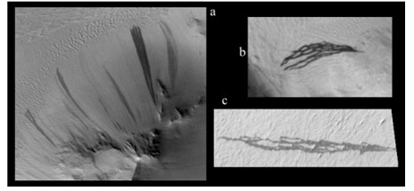
Figure 7.11. Slope streak examples (from Phillips and Chyba, 2006). Typical slope streaks (a, MOC image M16-00596, 27N 133 W, 5.9 m/pixel) have a point source and a wedge-shaped, sometimes digitate, appearance. More complex examples (b, image M16-00596, 27N 133 W, 5.9 m/pixel; c, image E02-00308, 0N, 165W, 4.4 m/pixel) have an intricate, braided, sometimes anastomosing shape. These features are widely interpreted to be the result of dry dust avalanches, but one working hypothesis for what triggers them to form involves water.

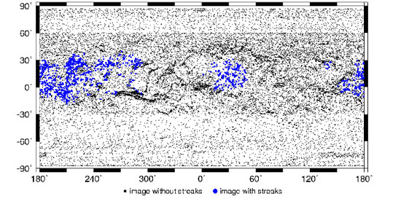
Figure 7.12. Map of the distribution of dark slope streaks (from Aharonson et al., 2003)

Slope streaks are relevant to the present analysis regarding special regions because they form in response to modern geologic processes, and some investigators have proposed that these features might involve the action of liquid water (Schorghofer et al., 2002; Ferris et al., 2002; Miyamoto et al., 2004b). New slope streaks have been identified in comparisons between Viking and MOC images, and new streaks have even observed to have formed during the Mars Global Surveyor mission, on timescales as short as ~100 days (Malin and Edgett, 2001; Sullivan et al., 2001; Schorghofer et al., 2002; Aharonson et al. 2003; Miyamoto et al., 2004b).

Possible Relationship to Water: There are two current working hypotheses for their formation mechanism.
- The dry models suggest that the streaks form through dust movement. In the dry process, oversteepening slopes caused by air fall deposits of dry dust eventually collapse, forming a dust avalanche (Williams, 1991; Sullivan et al., 2001; Miyamoto et al., 2004). In support of the dry model: all light and dark slope streaks occur in low thermal inertia areas mantled by accumulations of dust thick enough to be evident as such in MGS MOC images.
- The second class of models involves water, but the role of water varies between models. Early models such as Ferguson and Luchitta (1984) suggested that the dark streaks could be stains on the surface produced by wet, briny debris flows. These flows could form when a slope intersected an aquifer, allowing the periodic release of fluid from a wet subsurface layer. Schorghofer et al. (2002) suggested that water could lubricate avalanches, or the sublimation of near-surface ice could trigger mass movements. Ferris et al. (2002) proposed a model involving groundwater springs which infiltrate and saturate the surface, creating the dark streaks. Miyamoto et al. (2004b) concluded that the streaks are not debris flows, but could not eliminate the possibility that water is involved in the streak-forming process.
Despite the various hypotheses in the literature, key observations include: 1) there are no obvious subsurface sources of water, 2) at these equatorial latitudes very near-surface ice is unstable, and 3) wind might be a controlling factor in the streak occurrence (Aharonson, writ. comm., 2006). For these reasons, it is unlikely that substantial quantities of water are involved in slope streak formation (Aharonson, writ. comm.., 2006). There is, however, an open question on the role of trace amounts of transient H₂O in triggering these dust avalanches, for example by changing cohesion or porosity of the dust matrix.

7h. Recent outflow channels?
Description, Age. One of the prominent aspects of martian geology is the evidence for ancient outflow channels. Could the process that created them continue to the present era? The youngest such feature that has been dated is Athabasca Vallis (10N, 157E)--Burr et al. (2002) give the age of the latest flood at Athabasca as 2-8 My. Some other channels nearby are only slightly older. Furthermore, there are also some young channels just to the southeast of Olympus Mons that Basilevsky et al. (2006) date at 20 My. These examples indicate the presence of deep groundwater that might have episodically erupted to the surface along faults (or caused by dikes). Although this type of feature may have continued to form until the geologically recent past, we do not have evidence that any are active today, or have reason to predict that any will be active within the next 100 years.

7i. The non-discovery of geothermal vents
An important objective of the THEMIS infrared investigation on Mars Odyssey has been the search for temperature anomalies produced by surface cooling or heating due near-surface liquid water or ice, or hydrothermal or volcanic activity. THEMIS has mapped virtually all of Mars at night in the infrared at 100-m per pixel resolution, and has observed portions of the surface a second time up to one Mars’ years later. An analysis has been performed of all of these images to search for maximum temperatures greater than those expected from rocks or bedrock alone (220K), and no example has been found in any image of a temperature that requires an internal heat source (Christensen, writ. comm., 2006).

The THEMIS database has also been searched for spatial patterns that might indicate evaporative cooling associated with near-surface water, or to recent volcanic activity or hydrothermal heating. The THEMIS nighttime images exhibit very high spatial variability owing to variations in surface properties such as rock layers, exposed bedrock, sand and granule dunes (Christensen, writ. comm., 2006). These thermal variations greatly complicate the search for anomalous patterns associated with sub-surface water. To overcome the effects of these surface temperature complexities, a search for seasonal changes in surface temperature was undertaken in an effort to isolate changes due to dynamic heating or cooling processes from those due to thermophysical properties. This process involved the use of histogram adjustments of the overlapping portions of two images to remove the additional complicating temperature changes produced by the two-hour variation in local time of the Odyssey orbit, and by the differences in season between the different observations. In addition, numerous image pairs have been converted to thermal inertia using the THEMIS Standard Thermal Model as a quantitative means to remove the time of day and seasonal effects. To date no significant changes have been detected, but this analysis will continue throughout the Odyssey extended missions. Based on the analysis thus far, there is no evidence in the THEMIS thermal images for the existence of near-surface liquid water or ice that is close enough to the surface to be capable of producing measurable thermal anomalies.

The MGS MOC investigation has also addressed this issue, by focusing on imaging of relatively young volcanic and impact landforms and searching for evidence that activity is occurring today—such as eruption, production of flows (mud or lava), and the like. No such features have been found in MOC or other orbiter images.

FINDING. Despite a deliberate and systematic search spanning several years, no evidence for the existence of near-surface liquid water close enough to the surface to be capable of producing measurable thermal anomalies has been found.

7j. Low-latitude ground ice.
It has been suggested that when the south polar cap has exposed water ice, the water vapor content of the martian atmosphere could climb and might make ground ice stable to low latitudes (e.g., Jakosky et al. 2005). It may be possible for ice to be emplaced onto the surface or into the top meter during these episodes. While the ice is not stable today, it has been suggested that ice that had been previously deposited might still exist in a transient state while in the process of disappearing.

However, diffusion processes controlling potential ice deposition in the equatorial regolith are thought to occur on 100 to 5000 year time scales (Feldman et al., 2005). If the time scale of uncovered polar water ice is shorter than 100 years it is difficult for significant amounts water ice to accumulate. Polar cap exposure on longer time scales, such as would result from orbital oscillations, might result in higher concentrations of equatorial ground ice, but also would result in a different distribution of high-latitude ground ice than is observed today (Mellon et al., 2004). In addition, "transient" ice would be stable and in equilibrium with the atmosphere only in regions and depths where subsurface temperatures are typically below the new frost point (for even a 10 fold increase in atmospheric water the new frost point would only be 212 K). Subsequent replenishment of the CO₂ cap on the south polar region and subsequent reduction of atmospheric water vapor would result in removal of now unstable ice by sublimation on the same time scale as its emplacement. Thus, presently observed equatorial concentrations of hydrogen are more likely to be the result of one or more hydrated minerals and not due to transient water ice (Feldman et al., 2005).

7k. The polar caps.
In the initial COSPAR definition of special region (see Definition #1), the polar caps are mentioned as an example of a special region. Using findings of this analysis and the proposed guidelines in this report, the polar caps would no longer fit the definition nor serve as valid examples. Jakosky et al. (1993) (as well as others) have calculated that at the present obliquity, the maximum summer temperatures typically reach about 200 K at the pole (Figure 7.13). This temperature is consistent with the amount of atmospheric water vapor observed in the atmosphere during northern polar summer, which is about 10 precipitable microns (pr μm) with a 10 km scale height. More water vapor is observed in the atmosphere during the north polar summer (~100 pr μm), which is consistent with a surface ice temperature of ~210K.

Contributing to the perpetual low temperature is not only the latitude (hence low sun angle) but also the high conductivity of solid ice. Polar ice is highly conducting material (e.g., Paige and Keegan, 1994). Paige and Keegan determined the thermal inertia of the polar ice caps and found them to be in the neighborhood of 2000 (MKS units), which is consistent with solid ice. While snow and firn might produce more insulating material, both measurements of thermal inertia and models (Arthern et al., 2000) indicate that the polar ice is, indeed, highly conducting, and the annual skin depth is around 10m. That means that seasonal changes must heat up a slab 10m thick to affect a significant change in surface temperature. The argument is particularly compelling at the north pole, which currently experiences cool summers at aphelion (and will continue to do so for many thousands of years). The south polar cap, despite receiving more summer sunlight, is protected by a layer of highly reflective CO₂ ice, which holds the surface temperature at a constant 145K. While these models include the high conductivity and heat capacity of ice, none of these models take into account the additional latent heat loss when the sublimation rate is high—this would cause the present models to be overly optimistic regarding the potential for warming the polar cap material.

The warmest places on the polar caps might be steep slopes where the strata of the polar layered deposits are visible and the ice may be actively retreating. Equatorward facing slopes or low latitude ice would indeed receive more insolation. This may account for the higher atmospheric water vapor if the slopes reach temperatures of 210-212K.

Figure 7.13. Jakosky et al 1993 plot of maximum summer time temperature of the ice surface at the pole (similar north and south). The scatter is due to eccentricity and perihelion variations. The largest surface temperature is roughly 205-210 K

Even local heating of the surface of this ice to temperatures greater than -20°C is not thermodynamically possible in today’s climate. As described above, Mars’ large mass of polar ice is at an annual mean temperature of ~-110°C (at least 50°C lower than the coldest ice on Earth) and is known to have high thermal conductivity. Consider, for example, local warming due to a patch of dark particulate material (analogous to the source of cryoconite holes on Earth (NRC, 2006; p.75-78)). Assuming albedo of 0.15, nominal thermal properties, and 85N latitude, model calculations indicate that the ice temperature will never exceed -43°C. Alternatively, consider the heat balance required to maintain ice at -20°C. At this temperature, radiation to the sky would be ~220W/m², and the latent heat of sublimation would be nearly 60 W/m² for a total of 280W/m². Conductive losses to the subsurface would be of comparable magnitude, depending on the specific model. But even with a perfectly clear sky and a low (dark) albedo of 0.15, a flat surface at 85 N in the peak of the day in midsummer only receives ~210 W/m² insolation.

FINDING. The martian polar caps are too cold to be naturally occurring special regions in the present orientation of the planet.

8. REVISION OF THE SPECIAL REGION DEFINITION AND GUIDELINES

SR-SAG concluded that it could fulfill its assignment concerning reducing ambiguity in the term “special region” by retaining the original COSPAR definition and by adding an updated set of clarifications and implementation guidelines (DEFINITION #2). These guidelines are as quantitative as possible based on the SR-SAG analysis, and are intended to allow the definition to be interpreted in a common way by the many different interest groups who are stakeholders in Mars exploration.

DEFINITION #2.
Existing definition of “special region” with proposed implementation guidelines:

A special region is defined as a region within which terrestrial organisms are likely to propagate, or a region that is interpreted to have a high potential for the existence of extant martian life forms.

Proposed implementation guidelines:

- Definitions. For the purpose of this definition, propagate means to reproduce. Other kinds of activity, including cell maintenance, thickening of cell walls (as aspect of growth), and mechanical dispersal by aeolian processes are not sufficient.
- Period of applicability. The time period over which these guidelines are to be applied is defined as from the present until 100 years after spacecraft arrival on Mars.
- ‘Non-special’ regions. A martian region may be categorized non-special if the temperature will remain below -20°C or the water activity will remain below 0.5 for a period of 100 years after spacecraft arrival. All other regions on Mars are designated as either special or uncertain.
  - Uncertain regions. If a martian environment can simultaneously exceed the threshold conditions of -20°C and water activity over 0.5, propagation may be possible. It may not be possible to show that such environments are capable of supporting microbial growth, but such areas will be treated in the same manner as “special regions” until they are shown to be otherwise.
- Induced special regions. Even in an otherwise “non-special” region, a spacecraft may create an environment that meets the definition of a “special” or “uncertain” region, as described above. Because of the many dependencies related to spacecraft design, planned or accidental operations, or landing site, the possibility of a mission causing a spacecraft-induced special region should be analyzed on a case-by-case basis.
- Impact scenarios. As a practical consideration, for evaluating accidental impact scenarios involving both naturally occurring and induced special regions, it is considered sufficient to consider maximum crater depth to be <5 meters for impacting hardware of <2400kg.

9. DISCUSSION OF NATURALLY OCCURRING SPECIAL REGIONS

9a. Risk Acceptability
A key term in the definition of special region (see Definition #1, #2) is “likely to propagate.” “Likely” implies a probability. The lay usage of the word “likely” is that it implies a probability level of 50%. However, that is clearly not the intent of COSPAR as applied to planetary protection—something significantly lower, but non-zero, would be consistent with probability thresholds used elsewhere in PP policy. Not every martian environment that has non-zero probability to exceed the threshold conditions for propagation is special; only those for which the magnitude of that potential reaches “likely” would qualify.

Risk consists of a probability and an adverse consequence (i.e., the probability that terrestrial organisms placed in a certain martian environment will propagate). A crucial question is the degree to which this risk is acceptable. There are different ways to reduce the risk of biological contamination of Mars, including sterilizing all spacecraft sent to Mars, sterilizing spacecraft sent to certain places on Mars, avoiding certain places on Mars altogether, and not flying spacecraft to Mars at all. Although SR-SAG considered this risk mitigation issue in some detail, it is important to note that the SR-SAG is entirely composed of members of the Mars science community. SR-SAG’s risk tolerance may reflect that of the majority of the science community, but there are clearly other stakeholders in Mars exploration who may have very different perspectives on risk tolerance.

A process referred to as “expert elicitation” is commonly used in risk analysis studies to determine a consensus risk tolerance level. As an analogous example, this kind of a process might be used to determine the acceptable level of risk that there is an exogenous termite in a shipment of imported lumber. In these kinds of cases, although it would be desirable to have the risk be as low as possible, setting the risk level too low typically introduces unacceptable consequences in other areas. In order to determine the difference between acceptable and unacceptable risk, it is helpful to set quantitative risk standards. Such risk standards have been used in martian planetary protection for many decades for parameters like orbital lifetime and trajectory biasing. Although SR-SAG recognized that it could probably define a consensus quantitative risk standard, they quickly recognized that for at least two reasons doing so would not have practical value:

- The probability that T and a_{w} will exceed their threshold values in a given martian environment within 100 years of mission arrival cannot be quantitatively determined for all martian environments.
- Even if T and a_{w} exceed their threshold values in a specific martian environment, the probability of propagation of a population of mixed terrestrial microbes cannot be quantitatively estimated. There are too many additional factors involved that are poorly understood. We have minimal ability to do this even on Earth.

For these reasons, SR-SAG chose not to propose a quantitative risk standard, and opted instead to use a qualitative determination of acceptability of risk for different martian environments (Table 9.1). This risk acceptability includes the likelihood that the environment exists at all, or will exist within 100 years (e.g., the probability that volcanic activity will commence); the risk that if the environment exists propagation is possible (gullies exist, but can organisms propagate there within 100 years?); and the risk that an extreme hypothesis that is difficult to test and impossible to reject will turn out to be correct. One of the essential aspects of exploration is that there is an element of the unknown—that is why the exploration is justified in the first place. Although there is risk in encountering the unknown, as scientific knowledge progressively increases, it is clearly possible to develop strategies for carrying out exploration activity in a relatively safe (although not risk-free) way. The only way to fully eliminate risk is to stop direct contact missions, and go to passive observation.

9b. Special regions on Mars within the temporal and spatial limits of this analysis

Environments that definitely exceed the threshold conditions. SR-SAG cannot identify any regions on Mars in which the threshold conditions for propagation are exceeded at the present time.

Environments of Concern. Using the guidelines described in this document (Definition #2), there are martian environments (based on understanding as of April, 2006) that might exceed the threshold conditions for propagation of terrestrial organisms. They are summarized in Table 9.1. Of these, only the mid-latitude pasted-on terrain and the gully-forming regions are thought to be of high enough concern for exceeding the threshold conditions during the next 100 years that the SR-SAG believes they should be treated as special regions for the purposes of planetary protection.

Table 9.1. Listing of Mars environments of concern as possible special regions
Classification of martian environments by their potential to exceed the threshold conditions in temperature and water activity for microbial propagation (within the boundary conditions of the analysis).
A. Observed features for which there is a significant (but still unknown) probability of association with modern liquid water | B. Observed features for which there is a low, but non-zero, probability of a relationship to modern liquid water | C. Not known to exist, but if examples could be found, would have a high probability of association with modern liquid water.
- Recent gullies and gully-forming regions  - Mid-latitude “pasted-on” terrain | - Low-latitude slope streaks  - Low-latitude features hypothesized to be glaciers | - Volcanic environments young enough to retain heat.  - Impact environments young enough and large enough to retain heat  - Modern outflow channels

Gullies and pasted-on terrain of concern here were formed at the same latitudes and on slopes where insolation conditions might (although this, to, is highly uncertain and inconclusive) be conducive to their development. The relationship between gullies and pasted-on terrain is complex--there might be more than one type of each, and they may have asynchronous, or no, relationship. These are clearly an area for future research attention. The following relationships are worth noting:
- There is a very real possibility that the gullies were formed by the action of liquid water, and the possibility (although less-well documented and studied as of the present time) that “pasted-on” terrain provided that water (at least in some cases).
- The gullies and pasted-on terrain both occur at middle latitudes.

Map distribution. Based on the analysis above, several boundaries of primary significance to interpreting the possible presence of special regions on Mars can be shown in map format (Figure 9.1; for additional details on the construction of this map, see Appendix II).
Figure 9.1. Map of the stability of ice in the shallow martian subsurface, as shown by synthesis of results from three thermodynamic models presented at the Mars Water Conference (2006) by Aharonson and Shorghofer, Mellon and Feldman, and Chamberlain and Boynton. For details, see Appendix II.
MER-B
MPF
V-1
MER-A
V-2
MAP BOUNDARY A. 6 counts/second isopleth from GRS instrument (summer data only) on Mars Odyssey.
0
30
60
90
30
90
60
0
330
300
270
240
210
180
30
90
150
60
120
180
MAP BOUNDARY A
MAP BOUNDARY B. Modeled equatorward limit of stability of ice at depth of 5 m.
MAP BOUNDARY C. Observed equatorward extent of either gullies or mantled terrain.
MAP BOUNDARY B
MAP BOUNDARY C
See text for sources of information.

BOUNDARY A: The 6 count/second isopleth (using summer data only) from the GRS instrument (Figure 6.4).
BOUNDARY B: The most equatorward position of the limit of ice stability at a depth of 5 m, using the three planetary scale thermodynamic models presented at the Mars Water Conference in Feb. 2006. Each of these models uses somewhat different methodology and somewhat different input parameters, so the derived results are somewhat different (although they are all based on the same physics). The SR-SAG is not in a position to judge which, if any, of these models is correct. However, they all have the same general form, with an equatorial belt where none of them show that ice is stable within 5 m of the surface, north and south polar zones where all of them agree there is continuous ice within 1 m of the surface, and an intermediate zone where ice is discontinuous or within 1-5 m of the martian surface. For the purpose of Figure 9.1, the equatorial and polar zones were mapped only where all three models agreed; thus, the mid-latitude zone also incorporates all of the model-dependent uncertainty.
BOUNDARY C: The observed distribution of gullies and mid-latitude mantles has a relatively well-defined equatorward limit (see Figures 7.2 and 7.4). The map distribution of the roughened mantles of Mustard et al. (2001) is known (Figure 7.4), but the “pasted-on” mantles of Christensen (2003) have not been sufficiently mapped. As a practical matter, the distribution of gullies and roughened mantles is very similar. Because of the possibility that either could be an environment where the threshold conditions for microbial propagation are exceeded, this boundary is drawn to encompass both.

The map areas between these boundaries is subject to the following interpretations.

The equatorial belt (i.e., the region equatorward of all three map boundaries) is a region within which ice is thermodynamically unstable within 5 m of the martian surface at the present time. Gullies are absent. Although shallow liquid water could be present in a disequilibrium environment, such environments have yet been identified. The youngest volcanics on Mars are present within this region (see Figure 7.10), but there is no evidence that they are young enough to retain enough heat support modern liquid water. To date, despite ongoing searches, no thermal anomalies have been identified.
Between Boundaries B and C, ice is thermodynamically unstable within 5 m of the martian surface at the present time, and gullies, pasted-on terrain, and mantles are locally present. The geologic processes associated with gullies and pasted-on terrain is still a subject of active research, but there is a significant possibility that theycould be either continuously or episodically active, and their activity could cause the threshold conditions for temperature and water activity to be exceeded. Because these features are only locally present within this region (especially on certain kinds of crater walls), there are large areas where there is no evidence of either gullies or mantles. Note that gullies and mantles are not limited in their map distribution to the area between Boundaries B and C—both extend to considerably higher latitude than Boundary B.
Between Boundaries A and B is a region within which there is evidence (from models) that ice is stable at a depth from 1-5 m, or within which it is discontinuously or seasonally present. Such discontinuities can be caused by variations in albedo, variations in thermal inertia, slope effects (e.g., poleward-facing slopes get less sun that equatorward-facing slopes). The longitudinal variation in the position of the Boundary B is primarily related to variations in thermal inertia of the martian near-surface materials. The worst-case crash scenarios within this region are potentially capable of penetrating to ice.
The area poleward of Boundary A represents the polar regions, where there the GRS data have been interpreted show essentially continuous shallow frozen ground and ice caps at each pole. It is too cold for naturally occurring liquid water at any time during the year.

10. DISCUSSION OF SPACECRAFT-INDUCED SPECIAL REGIONS

The analysis and discussion to this point has focused on identification of naturally occurring environments on Mars within which terrestrial life forms might be able to propagate. To complete the analysis, consideration was given to whether the arrival of a spacecraft could induce a special region on Mars even when one did not exist at the landing site beforehand. Spacecraft are capable both of generating heat, and carrying liquid water, both of which could have an effect on the threshold conditions for propagation. Most importantly, in regions where there is (or may be) ice present, it is conceivable that local heating would result in the formation of liquid water for some amount of time. If conditions were created that exceeded the temperature and water activity thresholds for significant periods, replication of spacecraft-borne terrestrial bioburden could not be ruled out.

A series of representative scenarios for different mission types, including orbiters, landers/rovers, balloons, and drill missions were considered, for both nominal and non-nominal (crash) scenarios. Also considered were different operational factors: descent engine exhaust plumes, power/heat sources, roving into special regions, on-surface activities (e.g., sampling – scoops, drills, rock abrasion tools, melt probes) and burn-up/break-up scenarios for discarded descent hardware.

The complexity of considering all the potential scenarios with respect to induced special regions led to the conclusion that general categorization is not possible or practicable. The recommendation, therefore, is that analysis of spacecraft-induced special regions for Mars missions should be done on a case-by-case basis, with mission project teams being required to produce something equivalent to a “Mars environmental impact assessment” as part of the early stage mission planning. [Such an analysis may form part of the support documentation for the mission certification request.]

The use of RTGs (radioisotope thermal generators) on spacecraft will necessitate an extended analysis, since they can act as a perennial heat source, creating temperatures local to the RTG above the threshold temperature condition. In the case of a non-nominal landing, resulting in the co-location of near-surface ice, an RTG and contaminated spacecraft parts, it would be possible to have a disequilibrium condition for many months, exceeding the proposed threshold conditions for propagation of terrestrial organisms.

A key factor in the assessment of spacecraft-induced environmental changes is the minimum duration for the conditions to be above the thresholds before qualifying as a special region and therefore a PP concern. At one extreme, the pressure or friction associated with sampling, for example with a scoop, may cause melting of ice in the timeframe of seconds or less. At the other extreme, longer duration increases in temperature associated with spacecraft activity can be predicted, for example deliberate or accidental contact of a perennial heat source with the surface. In this scenario, the local ice will act as a heat sink, dissipating heat rapidly, but there may be a longer period of time (up to years) where the temperature and/or water activity thresholds are exceeded.

It is recognized that microbial propagation is not an instantaneous process—a finite amount of time above the temperature and water activity thresholds is necessary in order for the mechanics of biological propagation to take place. As an example, food spoilage in a refrigerator demonstrates that microbes are active at low temperatures but are slow growing, with the amount of time for spoilage dependent on temperature. Unfortunately, for the analysis of growth rates pertinent to spacecraft-induced special regions, there is not the same volume and quality of data to draw from as for the analysis of the temperature and water activity thresholds presented in Section 5 above; and, while there are abundant data on growth responses of organisms to temperature, little is available in the range of interest to this problem. It was possible, however, to search the literature for the highest documented growth rates at the temperatures of interest and report here on the growth rates of whatever microorganism was the subject of that literature. Organisms isolated from polar environments seem to be the most cold tolerant that have been tested, whereas microorganisms responsible for food spoilage under refrigeration seem to grow the best at cold but not extreme temperatures. We found that the highest documented growth rates at the temperatures of interest (-15°C to +5°C) were based on an early study of Sporotrichum carnis (Ratkowsky et al 1982, Haines 1931). We concluded that significant replication of this or any other terrestrial microorganism would not occur if the temperature excursion to a maximum of -5°C did not exceed 22 hours, to 0°C did not exceed 3 hours, and to 5°C did not exceed 1 hour. Subsequent work on growth rate models (Ratkowsky et al 1983), based on estimates for the doubling time of terrestrial organisms in ideal culture at 5°C, support these conclusions. [For an analysis pertinent to conditions for possible microbial growth at Mars, it is worth noting that the boiling point of water at martian atmospheric pressure of 8.6 mbar is 5°C; therefore, there is no need to extend this kind of analysis to temperatures higher than shown in Table 10.1.] The proposed times in Table 10.1 may be overly restrictive in that they are based on organisms in the exponential growth phase and do not take into account the latency that would precede growth and division once adequate temperatures were attained.

Table 10.1 Proposed times for which localized spacecraft-induced environments may exceed the temperature threshold of -20°C with no cell replication resulting
Not-to-exceed temperature of spacecraft-induced environment | Elapsed time before replication of terrestrial organism could occur
-5°C | 22 hours
0°C | 3 hours
5°C | 1 hour

It was further concluded that a cumulative limit for qualification as a special region could NOT reasonably be set. While some organisms are able to "bank" metabolic activity and benefit from serial exposure to favorable conditions, little or no data is available evaluating the affect of freeze thaw cycles that range from +5°C to -20°C or below on microbial metabolism. Indeed, it is reasonable to expect that repeated freeze/thaw cycles would have cumulative negative effects on the majority of organisms; the SR-SAG was not able to translate this into a quantitative implementation guideline that is based on experimental data. Further conservatism is present in this recommendation since over this period of time the other stressors in the martian environment would mitigate against faster replication. Microbial psychrophily is an active area of research, and as additional studies targeting physiological responses and cold adaptation provide new information, future assessments can define additional boundaries including cumulative limits.

FINDING. It is possible for spacecraft to induce conditions that could exceed for some time the threshold conditions for biological propagation, even when the ambient conditions were in equilibrium before the spacecraft arrived. Whether a special region is induced or not depends on the configuration of the spacecraft, where it is sent, and what it does. This possibility is best evaluated on a case-by-case basis.

11. ACKNOWLEDGEMENTS

Early drafts of this report were presented at two conferences/workshops, and the discussions at those meetings helped clarify many issues: The Mars Water Workshop (Feb. 23-24, 2006; at Ames Research Center), and the Mars Planetary Protection Working Group (March 2-3, 2006; at Ames Research Center). The following Mars scientists contributed data or ideas to this analysis: Oded Aharonson (Caltech), Ralph Milliken (Brown University), Cynthia Phillips (SETI Institute), Aaron Zent (ARC), Matt Chamberlain (Planetary Science Institute), Michael Carr (USGS Retired), Aharon Oren (Hebrew University of Jerusalem), Phil Christensen (Arizona State University), Bruce Jakosky (University of Colorado, Boulder). Valuable review comments were received from Margaret Race, Deneb Karentz, Pericles Stabekis, John Rummel, Gerhard Kminek, Christopher Chyba, Steve Clifford, and Michael Carr. Although the reviewers listed provided many constructive comments and suggestions, they were not asked to endorse the conclusions or recommendations of the final report.

12. REFERENCES

Abramov, O. and D. A. Kring (2005a). Impact-induced hydrothermal activity on early Mars. Journal of Geophysical Research, V. 110, doi:10.1029/2005JE002453.
Abramov, O., D. A. Kring, (2005). Numerical modeling of an impact-induced hydrothermal system at the Sudbury crater. Journal of Geophysical Research-Planet, V.109, Number E10, pp. E10007.
Aharonson O., N. Schorghofer and M. F. Gerstell (2003). Slope streak formation and dust deposition rates on Mars. Journal of Geophysical Research, V. 108(E12), 5138, doi:10.1029/2003JE002123.
Appelbaum, J., D. J. Flood, (1990). Solar radiation on Mars. Solar Energy, 45, pp. 353-363.
Arthern R.J., D. P. Winebrenner E.D. (2000). Densification of water ice deposits on the residual north polar cap of Mars. Icarus 144, pp. 367-381.
Baker, V. R. (2001). Water and the martian landscape. Nature, 412, pp. 228-236 doi:10.1038/35084172.
Baker, V.R., R.G. Strom, J.S. Kargel, J.M. Dohm and J.C. Ferris (2001). Very recent, water-related landforms on Mars. LPSC 32, Abstract 1619.
Bakermans, C., A. I. Tsapin, V. Souza-Egipsy, D. A. Gilichinsky and K. H. Nealson (2003). Reproduction and metabolism at
-10°C of bacteria isolated from Siberian permafrost. Environmental Microbiology, 5, pp. 321-326.
Barlow, N. G. (2004). Martian subsurface volatile concentrations as a function of time: Clues from layered ejecta craters. Geophys. Res. Lett., 31, doi:10.1029/2003GL019075.
Barlow, N. G. (2005). A review of Martian impact crater ejecta structures and their implications for target properties, in Large Meteorite Impacts III (T. Kenkmann, F. Hörz, and A. Deutsch, eds.), Geological Society of America Special Paper 384, pp. 433-442.
Basilevsky, A.T., S. Werner, G. Neukum, S. van Gasselt, J. W. Head and B. A. Ivnov (2006). Potential life habitat at the eastern flank of the Olympus Mons seen in MEX HRSC and MGS MOC images of Mars. Lunar and Planetary Sciences XXXVIII, Abstract #1179.
Belnap J., J. Hilty Kaltenecker, R. Rosentreter, J. Williams, S. Leonard, D. Eldridge (2001). Biological Soil Crusts: Ecology and Management. Technical Reference 1730-2, Department of the Interior, Washington D.C., p. 118.
Bermann, D. C., W. K. Hartmann, D. A. Crown, and V. R. Baker (2005). The role of arcuate ridges and gullies in the degradation of craters in the Newton Basin region of Mars. Icarus, 178, pp. 465-486, doi:10.1016/j.icarus/2005.05.011.
Biemann, K., J. M. Lavoie (1979). Some final conclusions and supporting experiments related to the search for organic compounds on the surface of Mars, Journal Geophysical Research, 84, pp. 8385-8390.
Biemann, K., J. Oro, P. Toulmin, III, L. E. Orgel, A. O. Nier, D. M. Anderson, P. G. Simmonds, D. Flory, A. V. Diaz, D. R. Rushneck, J. E. Biller, A. L. Lafleur (1977). The search for organic substances and inorganic volatile compounds in the surface of Mars. Journal of Geophysical Research, 82, pp. 4641-4657.
Bibring, J.-P., 12 others, and the OMEGA team (2003), Perennial water ice identified in the south polar cap of Mars, Nature, 428, 627–630, doi:10.1038/nature02461.
Breezee, J., N. Cady and J. T. Staley (2004). Subfreezing Growth of the Sea Ice Bacterium. Psychromonas ingrahamii. Microb. Ecol., 47, pp. 300-304.
Brown, A.D. (1976). Microbial water stress. Bacteriol. Rev., 40, pp. 803-846.
Brown, A.D. (1990). Microbial Water Stress: Physiology, Principles and Perspectives. John Wiley and Sons, Chichester.
Burr, D. M., J. A. Grier, A. S. McEwen and L. P. Keszthelyi (2002). Repeated aqueous flooding from the Cerberus Fossae: Evidence for very recently extant, deep groundwater on Mars. Icarus, 159, pp. 53-73.
Burt, D. M., and L. P. Knauth (2002) Eutectic brines on Mars: Origin and possible relation to young seepage features, Icarus, 158(1), 267271, doi:10.1006/icar.2002.6866.
Carpenter, E. J., S. Lin, D. G. Capone (2000). Bacterial activity in South Pole snow. Appl. Environ. Microbiol. 66, pp. 4514-4517.
Carr, M. H. (1983). Stability of streams and lakes on Mars. Icarus 56, pp. 476-495.
Carr, M.H. (1989). Water on Mars. Oxford University Press, New York, p. 229.
Carr, M. H. (2001). Mars Global Surveyor observations of Martian fretted terrain. Journal of Geophysical Research, V. 106(E10), pp. 23571-23594.
Carr, M.H. and J.W. Head (2003). Basal melting of snow on early Mars: A possible origin of some valley networks. Geophysical Research Letters, 30, doi: 10.1029/2003GL018575.
Chamberlain, M. A. and W. V. Boynton (2006). Response of Martian Ground Ice to Orbit-Induced Climate Change, (abs.), posted Feb. 2006 in Mars Water Workshop Feb. 23-24, 2006 at http://es.ucsc.edu/~fnimmo/website/mars2006.html.
Christensen, P. R. (2003). Formation of recent martian gullies through melting of extensive water-rich snow deposits. Nature, 422, pp. 45-48, doi:10.1038/nature01436.
Christensen, P. R. and 10 co-authors (2004). The Thermal Emission Imaging System (THEMIS) for the Mars 2001 Odyssey Mission. Space Science Reviews, V. 110, pp. 85-130.
Christner, B. C. (2002). Incorporation of DNA and Protein Precursors into Macromolecules by Bacteria at -15ºC. Appl. Environ. Microbiol. 68, pp. 6435-6438.
Clark, B.C., A.K. Baird, R.J. Weldon, D.M. Tsusaki, L Schnabel, and M.P. Candelaria (1982). Chemical Composition of Martian Fines. Journal of Geophysical. Research, 87, pp. 10059-10067.
Clifford, S.M. (1993). A model for the hydrologic and climatic behavior of water on Mars. Journal of Geophysical Research, 98, pp. 10,973-11,016.
Clifford, S.M. and T.J. Parker (2001). The evolution of the martian hydrosphere: implications for the fate of a primordial ocean and the current state of the northern plains. Icarus, 154, pp. 40-79.
Clow G. D. (1987). Generation of liquid water on Mars through the melting of a dusty snowpack. Icarus, 72, 95-127.
Cockell, C. S., D. C. Catling, W. L. Davis, K. Snook, R. L. Kepner, P. Lee, C. P. McKay (2000). The ultraviolet environment of Mars: Biological implications past, present, and future. Icarus 146, pp. 343-359.
COSPAR (2002), Planetary Protection Policy, October 2002, as amended, March 2005; http://www.cosparhq.org/scistr/PPPolicy.htm.
Costard, F., F. Forget, N. Mangold, and J. P. Peulvast (2001). Formation of recent martian debris flows by melting of near-surface ground ice at high obiquity. Science, 295, pp. 110-113, doi:10.1126/science.1066698.
Costard F., F. Forget, N. Mangold, J. P. Peulvast (2002). Formation of Recent Martian Debris Flows by Melting of Near-Surface Ground Ice at High Obliquity. Science 295, pp. 110-113.
Craddock, R.A. and A.D. Howard (2002). The case for rainfall on a warm, wet early Mars. Journal of Geophysical Research, 107, doi: 10.1029/2001JE001505.
Croft, S. K. (1985). The scaling of complex craters. Proceedings of the 15th Lunar and Planetary Science Conference, Part 2, in Journal of Geophysical Research, V. 90, pp. C828-C842.
Csonka, L. N. (1989). Physiological and genetic responses of bacteria to osmotic stress. Microbiol. Rev. 53, pp. 121-147.
DeVincenzi, D.L., M. S. Race and J. P. Klein (1998). Planetary protection, sample return missions and Mars exploration: History, status, and future needs. Journal of Geophysical Research, 103, pp. 28577-28585.
Edgett, K. S., M. C. Malin, R. M. E. Williams, and S. D. Davis (2003). Polar- and middle-latitude martian gullies: A view from MGS MOC after 2 Mars years in the mapping orbit. Lunar and Planetary Science XXXIV, Abstract No. 1038.
Farmer C. B. and P. E. Doms (1979). Global and seasonal variation of water vapor on Mars and the implications for permafrost. Journal Geophysical Research, 84, pp. 2881-2888.
Farmer C. B. (1976). Liquid water on Mars. Icarus 28, pp. 279-289.
Feldman, W C, Mellon, M T, Nelli, S, Murphy, J R, Maurice, S , Gasnault, O, 2005, Time Scales for Discharge of Near-Equatorial WEH on Mars: Implications for a Recent Climate Change. AGU abstract, 2005 meeting.
Ferguson, H., M., and B. K. Lucchitta (1984). In Reports of the Planetary Geol. Program 1983, NASA Tech. Memo. TM-86246, pp. 188-190.
Ferris, J. C., J. M. Dohm, V. R. Baker, and T. Maddock III (2002). Dark slope streaks on Mars: Are aqueous processes involved? Geophys. Res. Lett., 29(10), doi:10.1029/2002GL014936.
Forget, F., R. M. Haberle, F. Montmessin, B. Levrard, and J. W. Head (2006). Formation of glaciers on Mars by atmospheric precipitation at high obliquity. Science, 311, 368–371, doi:10.1126/science.1120335.
Garvin, J.B., S. E. H. Sakimoto, J. J. Frawley, and C. Schnetzler (2000). North polar region craterforms on Mars: Geometric characteristics from the Mars Orbiter Laser Altimeter. Icarus, V. 144, pp. 329-352.
Gilichinsky, D., E. Rivkina, V. Shcherbakova, K. Laurinavichus and J. Tiedje (2003). Supercooled water brines within permafrost - an unknown ecological niche for microorganisms: a model for astrobiology. Astrobiology 3, pp. 331-341.
Gilmore, M. S. and E. L. Phillips (2002). Role of aquicludes in formation of martian gullies. Geology, 30(12), pp. 1107–1110, doi: 10.1130/0091-7613(2002)030<1107:ROAIFO>2.0.CO;2.
Goldspiel J. M., S. W. Squyres (2000). Groundwater Sapping and Valley Formation on Mars. Icarus, 148, 176-192.
Golombek, M.P., and 21 others (2003). Selection of the Mars Exploration Rover landing sites. Journal of Geophysical Research, 108, doi:10.1029/2003JE002074
Greeley, R., and P. D. Spudis (1981), Volcanism on Mars. Reviews of Geophysics and Space Physics, 19(1), pp. 13–41.
Griffin, D.M. (1981). Water potential as a selective factor in the microbial ecology of soils. Water Potential Relations in Soil Microbiology, J.F. Parr et al., eds., Soil Science Society of America, Madison, WI, pp. 119-140.
Haberle R. M., C. P. McKay, J. Schaeffer, N. A. Cabrol, E. A. Grin, A. P. Zent, R. Quinn (2001). On the possibility of liquid water on present-day Mars. Journal of Geophysical Research 106, 23,317-23,326.
Haberle, R. M., J. R. Murphy and J. Schaeffer (2003). Orbital change experiments with a Mars general circulation model. Icarus, 161, pp. 66-89.
Haines, R.B. (1931). The influence of temperature on the rate of growth of Sporotrichum carnis from -10 to 30°C. J. Exp. Biol., pp. 379-388.
Harris, R.F. (1981). The effect of water potential on microbial growth and activity. Water Potential Relations in Soil Microbiology, J.F. Parr et al., eds., Soil Science Society of America, Madison, WI, pp. 23-95.
Hartmann, W.K. and D.C. Berman (2000). Elysium Planitia lava flows: Crater count chronology and geological implications. Journal of Geophysical Research, 105, pp. 15,011-15,026.
Hartmann, W.K., and G. Neukum (2001). Cratering chronology and the evolution of Mars. Space Science Rev., 96, pp. 165-194.
Hartmann, W. K., T. Thorsteinsson, and F. Sigurdson (2003). Martian hillside gullies and Icelandic analogs, Icarus, 162, pp. 259–277, doi:10.1016/S0019-1035(02)00065-9.
Head, J.W. and L. Wilson (2002). Mars: a review and synthesis of general environments and geological settings of magma-H2O interactions. In Volcano-Ice Interaction on Earth and Mars, Geo. Soc. Sp. Pub. 202, pp. 27-57.
Head, J.W. and D.R. Marchant (2003). Cold-based mountain glaciers on Mars: Western Arsia Mons. Geology, 37, pp. 641-644.
Head, J.W., A.L. Nahm, D.R. Marchant and G. Neukum (2006a). Modification of the dichotomy boundary on Mars by Amazonian mid-latitude regional glaciation. Geophysical Research Letters, 33, doi: 10.1029/2005GL024360.
Head, J.W., D.R. Marchant, M.C. Agnew, C.I. Fassett and M.A. Kreslavsky (2006b). Extensive valley glacier deposits in the northern mid-latitudes of Mars: Evidence for Late Amazonian obliquity-driven climate change. Earth and Planetary Science Letters, 241, pp. 663-671.
Head, J.W., L. Wilson and K.L. Mitchell (2003). Generation of recent massive water floods at Cerberus Fossae, Mars by dike emplacement, cryospheric cracking, and confined aquifer groundwater release. Geophysical Research Letters, 30, doi: 10.1029/2003GL017135.
Head, J. W., L. Wilson, and K. L. Mitchell (2003b), Generation of recent massive water floods at Cerberus Fossae, Mars, by dike emplacement, cryospheric cracking, and confined aquifer groundwater release, Geophys. Res. Lett., 30(11), 1577, doi:10.1029/2003GL017135.
Head, J. W., D. R. Marchant, M. C. Agnew, C. I. Fassett and M. A. Kreslavsky (2006). Extensive valley glacier deposits in the northern mid-latitudes of Mars: Evidence for Late Amazonian obliquity-driven climate change. Earth and Planetary Sci. Lett., 241, pp. 663-671.
Head, J. W. and 13 authors (2005). Tropical to mid-latitude snow and ice accumulation, flow and glaciation on Mars. Nature, 434, pp. 346-351.
Head, J. W., J. F. Mustard, M. A. Kreslavsky, R. E. Milliken, and D. R. Marchant (2003a). Recent ice ages on Mars. Nature, 426, pp. 797-802, doi:10.1038/nature02114.
Head, J.W. and 13 coauthors (2005). Tropical to mid-latitude snow and ice accumulation, flow and glaciation on Mars. Nature, 434, pp. 346-351.
Hecht, M.H. (2002). Metastability of liquid water on Mars. Icarus, 156, 373-386.
Kargel, J.S. and R.G. Strom (1992). Glacial geomorphic evidence for a late climatic change on Mars. Workshop on the Martian Surface and Atmosphere Through Time, pp. 82-83.
Heldmann, J. L., and M. T. Mellon (2004). Observations of martian gullies and constraints on potential formation mechanisms. Icarus, 168, pp. 285–304, doi:10.1016/j.icarus.2003.11.024.
Heldmann, J. L., O. B. Toon, W. H. Pollard, M. T. Mellon, J. Pitlick, C. P. McKay, and D. T. Andersen (2005). Formation of martian gullies by the action of liquid water flowing under current martian environmental conditions. Journal of Geophysical Research, 110, E05004, doi:10.1029/2004JE002261.
Hock, A. N. and D. A. Paige (2006). Ground Ice Temperatures On Mars—Implications for Habitability. (abs.) Posted Feb. 2006 in Mars Water Workshop Feb. 23-24, 2006 at http://es.ucsc.edu/~fnimmo/website/mars2006.html.
Hoffman, N. (2002). Active polar gullies on Mars and the role of carbon dioxide. Astrobiology, 2(3), pp. 313–323.
Holsapple, K. A. (1993). The Scaling of Impact Processes in Planetary Sciences. Annu. Rev. Earth Planet. Sci., 21, pp. 333-373, 1993.
Ivanov, B. A. and A. Deutsch (1999). Sudbury impact event; cratering mechanics and thermal history. Special Paper Geological Society of America, 339, pp. 389-397.
Jakosky, B. M. and M. H. Carr (1985). Possible precipitation of ice at low latitudes of Mars during period of high obliquity. Nature, 315, pp. 559-561.
Jakosky, B. M., B. G. Henderson, M. T. Mellon (1993). The Mars water cycle at other Epochs: Recent history of the polar caps and layered terrain. Icarus 102, pp. 286-297.
Jakosky, B. M., M. T. Mellon, H. H. Kieffer, P. R. Christensen, E. S. Varnes, and S. W. Lee (2000). The thermal inertia of Mars from the Mars Global Surveyor Thermal emission spectrometer. J. Geophys. Res. 105, 96439652.
Jakosky, B. M., K. H. Nealson, C. Bakermans, R. E. Ley and M. T. Mellon (2003). Subfreezing activity of microorganisms and the potential habitability of Mars' polar regions. Astrobiology 3, pp. 343-350.
Junge, K., H. Eicken, and J. W. Deming (2004). Bacterial Activity at -2 to -20°C in Arctic Wintertime Sea Ice. Appl. Environ. Microbiol. 70, pp. 550-557.
Junge, K., H. Eicken, B. Swanson, and J. W. Deming (2006). Bacterial incorporation of leucine into protein down to -20°C with evidence for potential activity in subeutectic saline ice formations (submitted to Cryobiology).
Kappen, L., B. Schroeter, C. Scheidegger, M. Sommerkorn and G. Hestmark (1996). Cold resistance and metabolic activity of lichens below 0ºC. Advanced Space Research, 18, pp. 119-128.
Kargel, J. S., and R. G Strom (1992). Ancient glaciation on Mars. Geology, 20, pp. 3–7.
Keszthelyi, L., A. S. McEwen, and T. Thordarson (2000). Terrestrial analogs and thermal models for martian flood lavas. Journal of Geophysical Research, 105, pp. 15027–15049.
Kieffer, H. H., T. Z. Martin, A. R. Peterfreund, B. M. Jakosky, E. D. Miner, and F. D. Palluconi 1977. Thermal and albedo mapping of Mars during the Viking primary mission. J. Geophys. Res. 82, 42494291.
Koop, T. (2002). The water activity of aqueous solutions in equiibrium with ice. Bull. Chem. Soc. Japan. 75:2587-2588.
Kreslavsky, M.A. and J.W. Head (2000). Kilometer-scale roughness of Mars: Results from MOLA data analysis. Journal of Geophysical Research, 105, pp. 26,695-26712.
Kreslavsky, M.A. and J.W. Head (2002). Fate of outflow channel effluents in the northern lowlands of Mars: The Vastitas Borealis Formation as a sublimation residue from frozen ponded bodies of water. Journal of Geophysical Research, 107, doi: 10.1029/2001JE001831.
Kreslavsky, M.A., J.W. Head and D.R. Marchant (2006). Periods of active permafrost layer formation during the geological history of Mars: Implications for circum-polar and mid-latitude surface processes. Planetary and Space Science, in press.
Kuhn, W.R., S. K. Atreya (1979). Solar radiation incident on the martian surface. J. Mol. Evol. 14, pp. 57-64.
Laskar, J; A. C. M. Correia, M. Gastineau, F. Joutel, B. Levrard, P. Robutel (2004). Long term evolution and chaotic diffusion of the insolation quantities of Mars. Icarus 170, pp. 343-364.
Lee, M. Y., A. Fossum, L.S. Costin, and D. Bronowski (2002). Frozen Soil Material Testing and Constitutive Modeling. Sandia National Laboratories Report SAND2002-0524, March 2002.
Lee, P., C. S. Cockell, M. M. Marinova, C. P. McKay, and J. W. Rice, Jr. (2001). Snow and ice melt flow features on Devon Island, Nunavut, Arctic Canada as possible analogs for recent slope flow features on Mars, Lunar Planet. Sci. XXXII, Abstract 1809.
Leighton R.B., B. C. Murray (1966). Behavior of carbon dioxide and other volatiles on Mars. Science 153, pp. 136-144.
Lucchitta, B. K. (1981). Mars and Earth: Comparision of cold-climate features. Icarus, 45, pp. 264-303.
Malin, M. C., and K. S. Edgett (2000). Evidence for recent groundwater seepage and surface runoff on Mars. Science, 288, pp. 2330–2335.
Malin, M. C. and K. S. Edgett (2001). Mars Global Surveyor Mars Orbiter Camera: Interplanetary cruise through primary mission. Journal of Geophysical Research, V. 106, pp. 23429-23570.
Malin, M. C., and K. S. Edgett (2005). 8 Years at Mars #1: New Dune Gullies, Malin Space Science Systems Public Communication, MOC2-1220. http://www.msss.com/mars_images/moc/2005/09/20/dunegullies/.
Malin, M. C., M. A. Caplinger, and S. D. Davis (2001), Observational evidence for an active surface reservoir of solid carbon dioxide on Mars, Science, 294, 2146–2148, doi:10.1126/science.1066416.
Mangold, N. (2003). Geomorphic analysis of lobate debris aprons on Mars at Mars Orbiter Camera scale: Evidence for ice sublimation initiated by fractures. Journal of Geophysical Research, 108, doi: 10.1029/2002JE001885.
Mangold, N., and F. Costard (2003). Debris flows over sand dunes on Mars: Evidence for liquid water. Journal of Geophysical Research, 108(E4), 5027, doi:10.1029/2002JE001958.
McDonald, E.V. (1994) The relative influences of climatic change, desert dust, and lithologic control on soil-geomorphic processes and hydrology of calcic soils formed on Quaternary alluvial-fan deposits in the Mojave Desert, California [Ph.D. Dissertation]: University of New Mexico, 383 p.
McDonald, E.V. (2002). Numerical Simulations of Soil Water Balance in Support of Revegetation of Damaged Military Lands in Arid Regions. Arid Land Research and Management 16(3), pp. 277-291.
McDonald, E.V., L. D. McFadden and S. G. Wells (1995). The relative influences of climate change, desert dust, and lithologic control on soil-geomorphic processes on alluvial fans, Mojave Desert, California: Summary of results: In: R.E. Reynolds and J. Reynolds (eds.), Ancient surfaces of the east Mojave Desert, San Bernardino County Museum Association Quarterly, 42(3), pp. 35-42.
McDonald, E.V., F. B. Pierson, G. N. Flerchinger and L. D. McFadden (1996). Application of a process-based soil-water balance model to evaluate the influence of Late Quaternary climate change on soil-water movement in calcic soils. Geoderma, 74, pp. 167-192.
McEwen, A.S., and 8 others (2005). The rayed crater Zunil and interpretations of small impact craters on Mars. Icarus, 176, pp. 351-381.
McFadden, L.D., E. V. McDonald, S. G. Wells, K. Anderson, J. Quade and S. L. Forman (1998). The vesicular layer of desert soils: Genesis and relationship to climate change and desert pavements based on numerical modeling, carbonate translocation behavior, and stable isotope and optical dating studies. Geomorphology, pp. 101-145.
McGlaun, J. M., S. L.Thomson, and M. G. Elrick (1990). CTH: A Three-Dimensional Shock Wave Physics Code. Int. J. Impact Engng. Vol. 10, pp. 351-360.
McKay C.P. and W. L. Davis (1991). Duration of liquid water habitats on early Mars. Icarus 90, pp. 214-221.
Meadows, D.G., M.H. Young, E.V. McDonald (2005). A laboratory method for determining the unsaturated hydraulic properties of soil peds. Soil Science Society America Journal, 69:807-815.
Mellon, M. T., and B. M. Jakosky (1995). The distribution and behavior of Martian ground ice during past and present epochs. Journal of Geophysical Research, 100, pp. 11781-11799.
Mellon, M. T., and R. J. Phillips (2001). Recent gullies on Mars and the source of liquid water. Journal of Geophysical Research, 106(E10), pp. 23165–23179, doi:10.1029/2000JE001424.
Mellon, M. T. and W. C. Feldman (2006). Martian Ground Ice: Global and Regional Ice Stability (abs.). Posted Feb. 2006 in Mars Water Workshop Feb. 23-24, 2006 at http://es.ucsc.edu/~fnimmo/website/mars2006.html.
Mellon, M. T., W. C. Feldman, and T. H. Prettyman (2004). The presence and stability of ground ice in the southern hemisphere of Mars. Icarus, 169, pp. 324-340.
Melosh, H. J. (1989). Impact Cratering: A Geologic Process. Oxford University Press, New York, p. 245.
Milkovich, S.M., J.W. Head and D.R. Marchant (2006). Debris-covered piedmont glaciers along the northwest flank of the Olympus Mons scarp: Evidence for low-latitude ice accumulation during the Late Amazonian of Mars. Icarus, 181, pp. 388-407.
Milliken, R. E. and J. F. Mustard (2003). Erosional morphologies and characteristics of latitude-dependent surface mantles on Mars. 6th International Conference on Mars, Abstract #3240.
Milliken, R.E., J.F. Mustard and D.L. Goldsby (2003). Viscous flow features on the surface of Mars: Observations from high-resolution Mars Orbiter Camera (MOC) images. Journal of Geophysical Research, 108, doi: 10.1029/2002JE002005.
Milliken, R. E., J. F. Mustard, and D. L. Goldsby (2003). Viscous flow features on the surface of Mars: Observations from high-resolution Mars Orbiter Camera (MOC) images. Journal of Geophysical Research, 108(E6), doi: 10.1029/2002JE002005.
Mischna, M. A., M. I. Richardson, R. J. Wilson, and D. J. McCleese (2003). On the orbital forcing of Martian water and CO₂ cycles: A general circulation model study with simplified volatile schemes, Journal of Geophysical Research 108(E6).
Mischna, M. A. and M. I. Richardson (2005). A reanalysis of water abundances in the martian atmosphere at high obliquity. Geophys. Res. Lett., doi:10.1029/2004GL021865, L03201.
Miyamoto, H., J. M. Dohm, V. R. Baker, R. A. Beyer, and M. Bourke (2004a). Dynamics of unusual debris flows on martian sand dunes. Geophys. Res. Lett., 31, L13701, doi:10.1029/2004GL020313.
Miyamoto, H., J. M. Dohm, R. A. Beyer, and V. R. Baker (2004b). Fluid dynamical implications of anastomosing slope streaks on Mars. Journal Geophysical Research, 109, E06008, doi: 10.1029/2003JE002234.
Moore, J.M., A.D. Howard, W.E. Dietrich and P.M. Schenk (2003). Martian layered fluvial deposits: Implications for Noachian climate scenarios. Geophysical Research Letters, 30, doi: 10.1029/2003GL019002.
Morita, R. Y. (1997). Bacteria in Oligotrophic Environments (Chapman & Hall, New York).
Morrison, D., C. R. Chapman, and P. Slovic (1994). The impact hazard, in Hazards due to Comets and Asteroids (T. Gehrels, ed.), University of Arizona Press, p. 59-91.
Mouginis-Mark, P. J. (1990), Recent water release in the Tharsis region of Mars, Icarus, 84(2), 362–373, doi:10.1016/0019-1035(90)90044-A.
Mouginis-Mark, P. J., and P. R. Christensen (2005), New observations of volcanic features on Mars from the THEMIS instrument, J. Geophys. Res., 110, E08007, doi:10.1029/2005JE002421.
Murray, J. B., and 12 others (2005). Evidence from the Mars Express High Resolution Stereo Camera for a frozen sea close to Mars’ equator. Nature, 434, pp. 352–356, doi:10.1038/nature03379.
Musselwhite, D. S., T. D. Swindle, and J. I. Lunine (2001). Liquid CO₂breakout and the formation of recent small gullies on Mars. Geophysical Research Lett., 28(7), pp. 1283–1285, doi:10.1029/2000GL012496.
Mustard, J.F., C.D. Cooper, and M.K. Rifkin (2001). Evidence for recent climate change on Mars from the identification of youthful near-surface ground ice. Nature, 412, pp. 411-414.
Nakamura, T , E Tajika, E (2003) Climate change of Mars-like planets due to obliquity variations: implications for Mars, Geophysical Research Letters, 30:13:18-22
National Aeronautics and Space Administration (2005). Planetary Protection Provisions for Robotic Extraterrestrial Missions. NPR 8020.12C, Washington, D.C., April 2005.
National Research Council (2006). Preventing the Forward Contamination of Mars, National Academy Press, Washington, D.C.
Neukum, G., and 10 others (2005). Recent and episodic volcanic and glacial activity on Mars revealed by the High Resolution Stereo Camera. Nature, 432, pp. 971–979.
Newcombe, D. A., A. C. Schuerger, J. N. Benardini, D. Dickinson, R. Tanner, K. Venkateswaran (2005). Survival of spacecraft-associated microorganisms under simulated martian UV irradiation. Appl. Envir. Microbio. 71, pp. 8147-8156.
Newsom, H. E., J. J. Hagerty, and I. E. Thorsos (2001). Location and sampling of aqueous and hydrothermal deposits in Martian impact craters. Astrobiology, V. 1, pp. 71-88.
Paige, D. A. and K. D. Keegan (1994). Thermal and Albedo Mapping of the Polar Regions of Mars Using Viking Thermal Mapper Observations: 2.South Polar Region. Journal of Geophysical Research 99, pp. 25,993-26,013.
Papendick, R.I. and G.S. Campbell (1981). Theory and measurement of water potential. In Water Potential Relationships in Soil Microbiology, J.F. Parr et al., eds., Soil Science Society of America Publications, Madison, WI, pp. 1-22.
Patel, M. R., J. C. Zarnecki and D. C. Catling (2002). Ultraviolet radiation on the surface of Mars and the Beagle 2 UV sensor. Planetary Space Science 50, pp. 915-927.
Phillips, C. B. and C. F. Chyba (2006). Dark Slope Streaks On Mars: Formation, Changes, And Fading (abs.). Posted Feb. 2006 in Mars Water Workshop Feb. 23-24, 2006 at http://es.ucsc.edu/~fnimmo/website/mars2006.html.
Pierazzo, E., N. A. Artemieva, and B. A. Ivanov (2005). Starting conditions for hydrothermal systems underneath Martian craters: Hydrocode modeling. In Large Meteorite Impacts III (T. Kenkmann, F. Hörz, and A. Deutsch, eds.), Geological Society of America Special Paper 384, pp. 443-457.
Pierce, T. L. and D. A. Crown (2003). Morhpologic and topographic analyses of debris apons in the eastern Hellas region, Mars. Icarus, 163(1), pp. 46-65.
Plescia, J. B. (2003). Cerberus Fossae, Elysium, Mars: A source for lava and water. Icarus, 164(1), pp. 79-95, doi:10.1016/S0019-1035(03)00139-8.
Plescia, J.B. (1990). Recent flood lavas in the Elysium region of Mars. Icarus, 88, pp. 465-490.
Potts, M. (1994). Desiccation tolerance of prokaryotes. Microbiol. Rev. 58, pp. 735-805.
Price, P. B. and T. Sowers (2004). Temperature dependence of metabolic rates for microbial growth, maintenance, and survival. Proc. Natl. Acad. Sci. USA 97, pp. 1247-1251.
Rathbun, J.A., and S.W. Squyres (2002). Hydrothermal systems associated with martian impact craters. Icarus, 157(2), pp. 362-372.
Ratkowsky, D.A., J. Olley, T.A. McMeekin, and A. Ball (1982). Relationship between temperature and growth rate of bacterial cultures. Journal of Bacteriology, pp. 1-5.
Ratkowsky, D.A., R.K. Lowry, T.A. McMeekin, A.N. Stokes, and R.E. Chandler (1983). Model for bacterial culture growth rate throughout the entire biokinetic temperature range. Journal of Bacteriology, pp. 1222-1226.
Reiss, D. and R. Jaumann (2003). Recent debris flows on Mars: Seasonal observations of the Russell Crater dune field. Geophys. Res. Lett., 30(6), 1321, doi:10.1029/2002GL016704.
Reiss, D., S. van Gasselt, G. Neukum, and R. Jaumann (2004). Absolute ages and implications for the time of formation of gullies in Nirgal Vallis, Mars. Journal of Geophysical Research, 109, E06007, doi:10.1029/2004JE002251.
Richardson, M.I. and M.A. Mischna (2005). Long-term evolution of transient liquid water on Mars. Journal of Geophysical Research, 110, doi: 10.1029/2004JE002367.
Richter, L., R. Arvidson, J. Bell, N. Cabrol, S. Gorevan, R. Greeley, K. Herkenhoff, D. Ming, R. Sullivan, and the MER Athena Science Team (2004). Rock and Soil Physical Properties at the MER Gusev Crater and Meridiani Planum Landing Sites. 35th COSPAR Scientific Assembly, Paris, July 18-25.
Richter, L. et al. (2006). Surficial Crusting of Soil-like Materials at the MER Landing Sites. To be submitted to Journal of Geophysical Research.
Rivkina, E.M., E. I. Friedmann, C. P. McKay and D. A. Gilichinsky (2000). Metabolic activity of permafrost bacteria below the freezing point. Appl. Environ. Microbio., 66, pp. 3230-3233.
Rivkina, E. M., K. S. Laurinavichus, D. A. Gilichinsky and V. A. Shcherbakova (2002). Methane Generation in Permafrost Sediments. Doklady Biol. Sci. 383, pp. 179-181.
Rummel, J. D. (2006). Preventing the Forward Contamination of Mars: Concerns, Questions, and Required Actions, IEEE Proceedings, 2006 NEED COMPLETE REFERENCE.
Russell N. J. (1992). Physiology and molecular biology of psychrophilic microorganisms. In Molecular Biology and Biotechnology of Extremophiles, Herbert R. A. and Sharp R. J. (eds), pp. 203-224.
Russell, N. J., P. Harrisson, I. A. Johnston, R. Jaenicke, M. Zuber, F. Franks and D. Wynn-Williams, D. (1990). Life at Low Temperatures. Phil. Trans. R. Soc. Lon. B, 326, pp. 595-611.
Schorghofer, N., O. Aharonson, and S. Khatiwala (2002). Slope streaks on Mars: Correlations with surface properties and the potential role of water. Geophys. Res. Lett., 29 (23), 2126, doi:10.1029/2002GL015889.
Schuerger, A. C., R. L. Mancinelli, R. G. Kern, L. J. Rothschild, C. P. McKay (2003). Survival of endospores of Bacillus subtilis on spacecraft surfaces under simulated Martian environments: Implications for the forward contamination of Mars. Icarus 165, pp. 253-276.
Schuerger, A. C., J. T. Richards, P. E. Hintze, and R. Kern (2005). Surface characteristics of spacecraft components affect the aggregation of microorganisms and may lead to different survival rates of bacteria on Mars landers. Astrobiology 5, pp. 545-559.
Schuerger, A. C., J. T. Richards, D. A. Newcombe, K. Venkateswaran (2006). Rapid inactivation of seven Bacillus spp. under simulated Mars UV irradiation. Icarus 181, pp 52-62.
Schultz, P.H. and D.E. Gault (1979). Atmospheric effects on Martian ejecta emplacement. Journal of Geophysical Research, 84, pp. 7669-7687.
Scott, D.H. and K.L. Tanaka (1982). Ignimbrites of Amazonis Planitia region of Mars. Journal of Geophysical Research, 87, pp. 1179-1190.
Scott, D.H., K.L. Tanaka, R. Greeley, and J.E. Guest (1986-87). Geologic maps of the western and eastern equatorial and polar regions of Mars. U.S. Geol. Surv. Misc. Inv. Ser. Map I-1802-A, B, C.
Segura, T.L., O.B. Toon, A. Colaprete and K. Zahnle (2002). Environmental effects of large impacts on Mars. Science, 298, 1977-1980.
Shean, D.E., J.W. Head and D.R. Marchant (2005). Origin and evolution of a cold-based tropical mountain glacier on Mars: The Pavonis Mons fan-shaped deposit. Journal of Geophysical Research, 110, doi: 10.1029/2004JE002360.
Shean, D.E., J.W. Head, M. Kreslavsky, G. Neukum and the HRSC Co-I Team (2006). When were glaciers present in Tharsis? Constraining age estimates for the Tharsis Montes Fan-shaped deposits. LPSC 37, Abstract 2092.
Shinbrot, T., N. H. Duong, L. Kwan, and M. M. Alvarez (2004). Dry granular flows can generate surface features resembling those seen in martian gullies, Proc. Natl. Acad. Sci., 101(23), pp. 8542-8546, doi:10.1073/pnas.0308251101.
Siegel, B.Z., G. McMurty, S.M. Siegel, J. Chen, P. Larock (1979). Life in the calcium chloride environment of Don Juan Pond, Antractica. Nature 280, pp. 828-829.
Smith, D. E. and 23 co-authors (2001). Mars Orbiter Laser Altimeter: Experiment summary after the first year of global mapping of Mars. Journal of Geophysical Research, V. 2001, pp. 23689-23722.
Soil Survey Staff. (1999). USDA-NRCS, Washington, DC, Soil taxonomy: A basic system of soil classification for making and interpreting soil surveys. United States Department of Agriculture Handbook, Natural Resources Conservation Service Number 436.
Sommers, L. E., C. M. Gilmour, R. E. Wildung, and S. M. Beck (1981). The effect of water potential on decomposition processes in soils. In Water Potential Relationships in Soil Microbiology, J.F. Parr et al., eds., Soil Science Society of America Publications, Madison, WI, pp. 97-117.
Sowers, T. (2001). N₂O record spanning the penultimate deglaciation from the Vostok ice core. Journal of Geophysical Research Atmos. 106, pp. 31903–31914.
Stewart, S. T., and F. Nimmo (2002). Surface runoff features on Mars: Testing the carbon dioxide hypothesis. Journal of Geophysical Research, 107(E9), 5069, doi:10.1029/2000JE001465.
Stewart, S. T., J. D. O’Keefe, and T. J. Ahrens (2001). The relationship between rampart crater morphologies and the amount of subsurface ice. Lunar and Planetary Science XXXII, abstract 2092 (CD-Rom).
Sullivan, R., P. Thomas, J. Veverka, M. Malin, and K. S. Edgett (2001). Mass movement slope streaks imaged by the Mars Orbiter Camera. Journal Geophysical Research, 106(E10), 23607–23633, doi:10.1029/2000JE001296.
Squyres, S. W., (1979). Urey Prize lecture: Water on Mars, Icarus, 79, pp. 229–288.
Squyres, S. W. and M. H. Carr (1986). Geomorphic evidence for the distribution of ground ice on Mars. Science, 231, pp. 249-252.
Tanaka, K.L. (1986). The stratigraphy of Mars, Proc. Lunar Planet. Sci. Conf., 17th, Part 1, J. Geophys. Res., 91, suppl., E139-158.
Tanaka, K.L. and M.G. Chapman (1990). The relation of catastrophic flooding of Mangala Valles, Mars, to faulting of Memnonia Fossae and Tharsis volcanism. Journal of Geophysical Research, 95, pp. 14,315-14,323.
Tanaka, K.L., J.A. Skinner, Jr., and T.M. Hare (2005). Geologic map of the northern plains of Mars. U.S. Geol. Surv. Sci. Invest. Map SIM-2888.
Tanaka, K.L., J.M. Dohm, J.H. Lias, and T.M. Hare (1998). Erosional valleys in the Thaumasia region of Mars: Hydrothermal and seismic origins. Journal of Geophysical Research, 103, pp. 31,407-31,419.
Tanaka, K.L., K.F. Mullins, J.A. Skinner, Jr., J.A.P. Rodriguez, and C.M. Fortezzo (2006). Stratigraphy of north polar deposits on Mars: Major new findings. LPSC XXXVII, Abstract #2344.
Thieringer, H. A., P. G. Jones, and M. Inouye (1998). Cold shock and adaptation. BioEssays, 20, pp. 49-57.
Thomas, P. C., M. C. Malin, P. B. James, B. A. Cantor, R. M. E. Williams, and P. Gierasch (2005), South polar residual cap of Mars: Features, stratigraphy, and changes, Icarus, 174, 5335–559, doi:10.1016/j.icarus.2004.07.028.
Titus, T. N., H. H. Kieffer, and P. R. Christensen (2003), Exposed water ice discovered near the south pole of Mars, Science, 299, 1048–1051, doi:10.1126/science.1080497.
Treiman, A. H. (2003). Geologic settings of martian gullies: Implications for their origins. Journal of Geophysical Research, 108(E4), 8031, doi:10.1029/2002JE001900.
van der Wielen, P. W. J. J., H. Bolhuis, S. Borin, D. Daffonchio, C. Corselli, L. Giuliano, G. D’Auria, G.J. de Lange, A. Huebner, S.P. Varnavas, J. Thomson, C. Tamburini, D. Marty, T.J. McGnity, K. N. Timmis, BioDeep Scientific Party (2005). The enigma of prokaryotic life in deep hypersaline anoxic basins. Science 307, pp. 121-123.
Wallace, D. and C. Sagan (1979). Evaporation of ice in planetary atmospheres: Ice-covered rivers on Mars. Icarus 39, 385-400.
Wells, L.E. and J. W. Deming (2006). Modeled and measured dynamics of virus-like particles in Arctic winter sea-ice brines. Environ. Microbiol. (in press).
Welsh, D.T. (2000). Ecological significance of compatible solute accumulation by micro-organisms: from single cells to global climate. FEMS Microbiol. Rev. 24, pp. 263-290.
Williams, R. M. E., K. S. Edgett, and M. C. Malin (2004). Young fans in equatorial crater in Xanthe Terra, Mars. Lunar Planet. Sci. XXXV, Abstract 1415.
Williams, R. S. (1978). Geomorphic processes in Iceland and on Mars: A comparative appraisal from orbital images. Geol. Soc. Am. Abstracts with Programs, 91st annual meeting, V. 10, pp. 517.
Williams, S. H. (1991). Dark talus streaks on Mars are similar to aeolian dark streaks. Lunar Planet. Sci. XXII, pp. 1509–1510.
Wilson, L. and J.W. Head (2002). Heat transfer and melting in subglacial basaltic volcanic eruptions: implications for volcanic deposit morphology and meltwater volumes. In Volcano-Ice Interaction on Earth and Mars, Geo. Soc. Sp. Pub. 202, pp. 5-26.
Wilson, L., E.D. Scott and J.W. Head (2001). Evidence for episodicity in the magma supply to the large Tharsis Volcanoes. Journal of Geophysical Research, 106, 1423-143.
Wong, P.T.W. and D.M. Griffin (1976). Bacterial movement at high water potentials. In artificial and natural soils. Soil Biol. Biochem, 8, pp. 215-218.
Woronow, A. (1981). Preflow stresses in Martian rampart ejecta blankets: A means of estimating the water content. Icarus, V. 45, pp. 320-330.
Young, M.H., E. V. McDonald, T. C. Caldwell, S. G. Benner, and D. Meadows (2004). Hydraulic properties of desert pavements in the Mojave Desert, U.S.A. Vadose Zone Journal, Soil Science Society of America (3:956-963).
Zent A.P., F. P. Fanale, J. R. Salvail, S. E. Postawko (1986). Distribution and state of H2O in the high-latitude shallow subsurface of Mars. Icarus 67, pp. 19-36.
Zimbelman, J.R. and K.S. Edgett (1992). The Tharsis Montes, Mars: Comparison of volcanic and modified landforms. LPSC 22, pp. 31-44.
Zimbelman, J. R., S. M. Clifford, and S. H. Williams (1989). Concentric crater fill on Mars: An aeolian alternative to ice-rich mass wasting. Proc. 19th Lunar Planet. Sci. Conf., pp. 397–407, Lunar and Planetary Institute, Houston, Texas.

APPENDIX I - Acronyms and Abbreviations

ARC – Ames Research Center
COSPAR – Committee on Space Research
GRS – Gamma Ray Spectrometer, an instrument on the on the 2001 Mars Odyssey mission (http://grs.lpl.arizona.edu/content/learning/aboutgrs/)
HEND – High-Energy Neutron Detector; part of the Gamma Ray Spectrometer suite of instruments
HRSC – High Resolution Stereo Camera, an instrument on the 2003 Mars Express spacecraft.
IR – Infrared
MDIM – Mars digital image model, constructed from roughly 4600 Viking Orbiter images.
MEPAG – Mars Exploration Program Analysis Group
MER – Mars Exploration Rover, a NASA lander launched in 2003
MGS – Mars Global Surveyor - a NASA orbiter launched in 1996
MKS – System of metric units based on meters, kilograms, and seconds.
MOC – Mars Orbiter Camera, an instrument on the 1996 Mars Global Surveyor spacecraft.
MOLA – Mars Orbital Laser Altimeter; an instrument on the 1996 Mars Global Surveyor spacecraft (http://ltpwww.gsfc.nasa.gov/tharsis/mola.html)
NASA – National Aeronautics and Space Administration
NRC – National Research Council
NRC PREVCOM – Was a committee of the National Academy of Sciences that was therefore
independent of NASA
PP – Planetary Protection
RTG – Radioisotope Thermal Generator
SR-SAG – Special Regions – Science Advisory Group
THEMIS – Thermal Emissions Imaging System
UV – Ultra Violet
VIS – Visible

APPENDIX II. Derivation of Figure 9.1

Using the following process, a map of the martian shallow equilibrium ice was developed.

- The data from the GRS instrument on Mars Odyssey are widely accepted as a clear indication of high latitude shallow ground ice. For the purpose of mapping, only summer data from both hemispheres are used (winter CO₂frost obscures the ice signature by adding hydrogen poor mass atop the soil - seasonal CO₂ can be as much as a meter or more at high latitudes). Using an arbitrarily selected threshold value of 6 counts per second, the region of permanent shallow ground ice can be shown. Note #1: Poleward of that boundary, there are fewer than 6 c/s (the epithermal neutrons go down as H goes up). Note #2: The position of the 6 c/s threshold value should be considered blurred on a 600km scale due to the GRS neutron footprint.
- Several equilibrium thermodynamic models for Mars have been calculated at a planetary scale. These models predict the distribution of ice equatorward of the GRS 6 c/s threshold. Because the GRS can't detect deeper than about a meter, this gives us a way to model the ice distribution to deeper depths. At the 2006 Mars Water Conference (http://es.ucsc.edu/~fnimmo/website/mars2006.html), the models developed by three independent research teams (Chamberlain and Boynton, 2006; Mellon and Feldman, 2006; Aharonson and Schorghofer) were presented. These models use somewhat different methodology and inputs, but the results have a very similar structure. In each case, there is a north and south mid-latitude belt that can be thought of as discontinuous ice, and/or a zone of ice less detectable by GRS due to its depth, along with an equatorial belt with no near-surface ice. The position of the mid-latitude belts is somewhat different in the three models. To allow for appropriate conservatism, a boundary was drawn (dashed line on Figure 9.1) that encompasses the most equatorward indication of ice in any of the models. Thus, Zone 3 also represents model-dependent uncertainty.
- Equilibrium thermodynamic models show that the depth to the top of the ice table increases abruptly at about the position of the dashed line. This has been studied extensively (e.g., Farmer and Doms, 1979; Paige, 1992). It is typical in model results for the transition from 5 m to infinite to occur in less than a degree of latitude. In order to further represent appropriate conservatism, the north and south dashed lines were each shifted one degree of latitude towards the equator, so as to encompass possible ice within 5 meters of the surface.

NRC PREVCOM was a committee of the National Research Council (of the National Academies of Science) that, at NASA’s request, examined planetary protection measures for Mars. Subsequent to accepting its statement of task, an NRC committee operates independently of its sponsoring agency.
The NRC PREVCOM’s Statement of Task included the language that “to the maximum possible extent, the recommendations should be developed to be compatible with an implementation that would use the regulatory framework for planetary protection currently in use by NASA and the Committee on Space Research (COSPAR).” The full NRC PREVCOM statement of task is given on pp. vii-viii, NRC PREVCOM (2006).
matric effects are those induced by the adhesive and cohesive properties of water in contact with a solid surface
The UV irradiation on Mars is significantly higher in the UVC region (190 – 280 nm) than on Earth due to a generally thinner atmosphere and the lack of an extensive ozone layer (Applebaum and Flood, 1990; Cockell et al. 2000; Kuhn and Atreya, 1979; Patel et al., 2002). On Earth, the ozone layer attenuates all UV irradiation below 290-300 nm, i.e., no UVC wavelengths reach the Earth’s surface. The presence of UVC irradiation on Mars creates an environment at the surface that exhibits a total UV flux (200 - 400 nm) that is up to three orders of magnitude more biocidal than on Earth (Cockell et al. 2000; Patel et al., 2002). Recent models suggest that the high UVC flux on Mars can act to reduce the viability of some sun-exposed microbial cells on spacecraft surfaces by greater than six orders of magnitude in as short a time as a few tens of minutes to no more than several hours (Newcombe et al., 2005; Schuerger et al., 2003; 2006). In addition, the downwelling UVC will penetrate pits, cracks, and other microscopic topographical features on spacecraft materials, resulting in some of the more sheltered microorganisms becoming inactive in reasonably short periods of time (Schuerger et al., 2005). However, the biocidal effects of UVC cannot reach deeply embedded bioloads, cannot penetrate UV-absorbing materials, and cannot affect bioloads on internal components of spacecraft.
By analogy (for those of us old enough to remember) it takes only a short time to defrost a freezer, but a relatively long time for the ice to accumulate again.
Spacecraft-induced special regions are mentioned in DEFINITION #2 but are developed in Section 10.

