A RARE F-2 TORNADO EVENT IN BEAR, IDAHO

Melissa M. Hurlbut
WFO Jacksonville, Florida (former affiliation WFO Boise, Idaho)
November 2006

ABSTRACT

Observational and model data were studied to assess the evolution of a significant microburst and tornado event in the Boise, Idaho, County Warning Forecast Area (CWFA). A squall line that formed ahead of a cold front produced damaging winds and severe hail across Baker County, Oregon. As the southern end of this squall line continued to evolve, a strong F2 tornado was spawned over Adams County, Idaho, which damaged structures, leveled trees across 5,000 acres of the Payette National Forest, and caused one injury. Data limitations in the West, including terrain-induced beam blockage, data voids due to large distances (≥ 200 km) between radars, and limited real time surface data make severe weather decision making particularly challenging. Climatological records show that tornadic events in the Intermountain West are rare. Therefore, with limited data available for storm interrogation and the rarity of tornadic events within the region, proper pre-storm environmental analysis and utilization of available data sets throughout the event are especially crucial. This paper documents the pre-storm environment and the evolution of a tornadic cell through Bear, Idaho.

- Introduction

On 4 June 2006, a quickly developing squall line swept across central Oregon and Idaho, which caused one injury and extensive damage to structures and the Payette National Forest. The southern portion of the line produced significant microburst damage across Baker and Adams counties, quarter sized hail in Cuprum, Idaho, and a strong F2 tornado in Bear, Idaho.

Aerial surveys of the tornado damage, conducted by the Payette National Forest Service, revealed that up to 5,000 acres of timber were blown down, snapped in half, or uprooted. The path was 21 km (13 miles) long with a 0.8 km (half mile) width in some locations (Fig. 1). Houses in Bear, Idaho, where the tornado first touched down, suffered substantial roof damage. A storm survey concluded that the extensive damage along its path indicated that this tornado reached at least F2 intensity, with winds of up to 135 kt (157 mph) (Fujita, 1981). Climate records show this tornado was likely the strongest known F2 tornado in Idaho. The last tornado that produced comparable damage was an F3 that struck Gooding County, Idaho, in April of 1940 (NCDC 2006).

Forecasting tornadic events is challenging at any location. However, there are several complications in the West not seen in the Central and Eastern parts of the United States, which bring additional challenges. Data available to a warning forecaster may be lacking in the West due to several factors, including radar beam blockage, high elevation radars, low population density, and a lack of observational equipment. Lower elevation angles from the WSR-88D radar are often blocked by terrain. This is especially problematic at longer distances from WSR-88D sites where storm structure frequently cannot be viewed below three kilometers (approximately 10,000 ft) above ground level (AGL). Additional complications in available low level radar data arise when radars are placed at high elevation sites. Since the WSR-88D is not capable of viewing data below the 0.5º elevation angle, portions of storms that are located in valleys beneath this lowest slice can not be viewed, even at close distances to the radar. Using radar data from neighboring offices is not often advantageous due to the distance between radars. Over complex terrain, surface observation sensors are placed far apart as well. Furthermore, in sparsely populated areas, fewer “ground truth” reports from storm spotters are available (Fujita et al 1989). Additionally, most of the existing storm spotters reside in the valleys.

Climate records indicate an average of three tornadoes are reported per year in Idaho, most of which are below F2 strength. Many of these reports come from the populated Snake River Valley (Fig. 2). While tornadoes likely occur over the higher terrain, many of these events are not seen or reported due to low population density.

Records from 1880 (Grazulis 1993) indicate that no known tornadoes in Idaho history have reached F4 or greater strength. In addition, only two F3 tornadoes have been recorded. National Climatic Data Center (NCDC) records from 1950 through the end of April 2006 indicate nine tornadoes in Idaho have reached F2 strength. NCDC records also show an increase in reports over the past 50 years. This is likely due to an increase in population rather than strictly an increase in the occurrence of these events. In addition, developments in technology, such as the introduction of the WSR-88D, have also led to an increase in detection of severe events (Fujita et al 1989).

The majority of Idaho tornado events occur in the late spring and summer during the late afternoon when surface instability is usually at its highest. Tornadogenesis in the West is not often a result of supercells. Most of these tornadoes are “landspouts”. Landspouts do not form from mesocylones but instead develop during the early stages of convection in areas of strong low level instability where boundary layer vorticity is stretched into the updraft and tightened (Bluestein 1985). Another less common form of tornadogenesis is often referred to in the field as a “gustnado”. This is a short-lived, shallow vortex that develops along a gust front as it coincides with a strong updraft (Wakimoto, R., and J.W. Wilson, 1989).

Given that tornadic events in the West are rare, a warning meteorologist must carefully examine and understand the environment prior to event onset and monitor environmental changes over time. Potential impacts of terrain (Fig. 2) on the near storm environment are also imperative to know. These impacts may enhance or decrease tornado potential.

2. Synoptic and Mesoscale Environment

On the morning of 4 June 2006, a negatively-tilted short wave trough at 500 mb moved across central Washington and Oregon (Fig. 3). A 500 mb vorticity maximum advected over central Oregon, with convection already developing ahead of this maximum as early as 1200 UTC (all times in UTC). A 250 mb jet streak quickly moved northeast across Oregon, which placed Baker County and the West Central mountains in the favorable left exit region, which would enhance lift (Fig. 3). A northwest to southeast oriented 850 mb thermal ridge stretched across the Snake River valley ahead of the cold front. Previous studies in the northwestern United States (Evenson and Johns, 1995) have shown that a 500 mb negatively tilted trough and a northwest to southeast oriented 850 mb thermal ridge are favorable conditions for a significant severe weather event.

Advanced Microwave Sounding Unit (AMSU) satellite data showed that precipitable water (PW) values were over an inch off the coast, while the 1200 sounding at Boise showed 22.4 mm (0.88 inches), which was 160% of normal. Strong southwesterly flow of 50 kt at 500 mb ahead of the short wave trough enabled the transfer of mid-level moisture over the higher terrain.

Most locations reported surface dew point values in the mid 40s to lower 50s (all temperatures in degrees F) throughout the morning (Fig. 4). These values typically support active deep convection in this area. Dew points in the area of interest were mainly in the lower 50s, and remained in the lower 50s throughout the event. The 1200 sounding at Boise (KBOI) indicated 711 Jkg-1 of Surface-Based CAPE (SBCAPE) and a lifted index of -3 ºC could be achieved at the time of maximum surface heating using a maximum temperature of 84 and a dew point of 48. However, 1800 model data forecast that over 1,500 Jkg-1 of SBCAPE could be realized in association with the upper trough.

Modification of the KBOI sounding (Fig. 5) using observed surface dew points and expected cooling aloft yielded greater understanding of the near storm environment. The environment was already favorable for hail formation with mid-level shear and sufficient CAPE in the -10 to -30 ºC “hail growth” layer. Ample deep-layer shear and CAPE throughout all levels existed. Additionally, daytime heating in combination with the rapid cooling aloft associated with the passing upper trough would create very steep lapse rates later in the day, which would further increase the threat of large hail and strong downburst winds.

A veering wind profile and 0-6 km bulk shear values of 60-70 kt was also forecast in model data. The hodograph from 0-6 km showed a turning of the shear vector that would favor right moving supercells. Further analysis of the hodograph (Fig. 6) showed that an increase of southeasterly to southwesterly wind speeds, or backing of the low-level winds, would increase the storm relative helicity (SRH).

3. Storm Evolution

As the cold front progressed across central Washington and Oregon, a squall line formed along the boundary. By approximately 1605 this line began to move into Baker County (Fig. 7). Radar limitations at this distance and over complex terrain affected storm interrogation. The southern end of the squall line was located 115 nm from the radar and the lowest slice, 0.5º, was sampling at four km (approximately 13,000 ft) AGL. Therefore, the evolution of the lowest portions of the storm below this elevation could not be detected by radar.

Velocity data at the 0.5º elevation angle showed indications of up to 30 kts of mid-level rotation, while storm structure shown from reflectivity data may have been unrepresentative of the severity (Fig. 8). Reflectivity cores were less than 50 dBZ at the freezing level of approximately 3.7 km (12000 ft) above sea level (ASL) and above. The strongest reflectivities of the storm were located in the valley near Sumpter, Oregon. At 1630, two separate calls from trained spotters in this location revealed that the line was producing estimated winds of 52 kts (60 mph) and 1.9 cm (0.75 inch) hail.

By 1650 a rear-inflow notch (RIN) and bow echo first became apparent, supporting spotter reports of severe winds (Fig.9). Surface winds were still from a southeasterly to southerly direction, which supported increased helicity. Velocity data revealed a tightening couplet in the mid levels of the storm.

By 1717, reflectivity data suggested large hail was possible with 60 to 65 dBZ cores at 4.7 km (15,300 ft) ASL, and 55 to 60 dBZ cores at 6.9 km (22,500 ft) ASL (Fig.10). Outbound velocities at the 0.5º level had increased to nearly 30 kt while storm top divergence had increased to 70 kt. Around this time, a Remote Automated Wind Sensor (RAWS) station at Flagstaff Hill, approximately 16 km (10 miles) East of Baker City, measured a wind gust of 70 kt (80 mph).

By 1734, reflectivity cores of 60 to 65 dBZ (Fig.11) were observed at 7.3 km (24,000 ft) and implied increased severity. The 50 dBZ core extended to nearly 9.1 km (30,000 ft). At this point the storm began to deviate to the right of the mean wind.

Five minutes later, outbound velocities at the 0.5º level increased to nearly 40 kt and expanded in area (Fig.12). Storm top divergence increased to 80 kt. The storm maintained this magnitude of storm top divergence over the next hour. A damaging downburst was soon reported by a spotter located 6.2 km (10 miles) north of Halfway, Oregon.

By 1805, outbound velocities at the 0.5º level again increased, with speeds near 50 kt. The storm began to show an increase in rotational velocities while strong outbound velocities of 50 kt had been maintained (Fig.13). The Velocity Azimuth Display (VAD) wind profile at KBOI showed that wind speeds had increased and veered from a south to southwest direction (Fig. 14). Mesonet data from a valley to the east indicated surface winds from the southeast, which would create a veering profile ahead of the storm. Adjusting the hodograph with the Mesonet and VAD winds more than doubled the SRH to 250 m²s-², which led to increased tornado potential. The storm approached a northwest to southeast oriented portion of Hells Canyon, where it is possible that the observed low level southeasterly winds could channel moisture through the Canyon (Monteverdi et al 2003). This higher dew point air likely increased the buoyancy within this local environment which enhanced the severity of the storm.

As the storm moved over the canyon around 1809 to 1814, the detected rotation appeared to weaken. However, outbound velocities remained strong (Fig.15), and for the first time in the storm's existence, 50 to 55 dBZ cores extended up to 10.4 km (34,000 ft) (Fig.16). From here the storm progressed quickly. At 1827, the storm displayed a clear RIN and rotational velocities jumped up to 40 kt (Fig.17). Within the next few minutes tornadogenesis occurred, and rotational velocities increased to 45 kt. Eyewitness reports in Bear, Idaho indicated the tornado touchdown time was near 1830. Quarter sized hail was also reported from Cuprum, Idaho. Ten minutes after touchdown, the storm finally began to weaken.

4. Summary and Conclusions

In the Bear, Idaho tornado case, environmental analysis showed that conditions were favorable for damaging winds, large hail, and tornado formation. Utilizing a variety of available datasets, a forecaster could continue to evaluate how this near-storm environment progressed and continued to support severe potential.

In this case, Mesonet data showed that dew points remained high while temperatures increased. VAD wind profile data showed an increase in south to southwest winds, and an increase in southeasterly winds at the surface ahead of the storm, which would increase the SRH.

Although radar data were unavailable beneath three kilometers (approx. 10,000 ft), there were indications of the storm’s increasing severity. Persistent rotation in storm-relative motion (SRM) and base velocity data and continual ground truth reports of severe weather indicated that the storm was maintaining strength. The storm was relatively unimpeded by rough terrain as it traversed across a valley. An increase in storm inflow and a rapid increase in reflectivity values as the storm passed over Hell’s Canyon were noted shortly before the cell became tornadic.

Examining these important near-storm environmental clues where data sources are limited is vital in severe weather episodes. By utilizing all datasets and keeping a constant state of awareness of how the environment is evolving, a forecaster can use the information available to make better warning decisions.

Acknowledgements

The author would like to thank Peter Wolf, Angela Lese, Jon Zeitler, and Randy Graham for their constructive criticism and valuable insights into this case. The author would also like to thank Angela Enyedi, Jay Breidenbach, George Skari, and Charles Redman for their helpful insights as well. Additional thanks goes to Timothy Barker for archiving and providing data for this case.

Author

Melissa Hurlbut is a journeyman forecaster at National Weather Service Jacksonville, Florida, Weather Forecast Office. Prior to her current position she worked as an Intern in Boise, Idaho, and participated in the Student Career Experience Program in Jacksonville, Florida. She received a B.S. in meteorology from Embry-Riddle Aeronautical University in 2005. Melissa has received several individual awards for severe weather operations. She has an additional paper on Severe Weather Threat Discrimination in Southeast Oregon and Southwest Idaho using Pre-storm Environmental Data listed in the 23rd Severe Local Storms Conference preprints.

References

Bluestein, H.B., 1985: The formation of a “landspout” in a “broken-line” squall line in Oklahoma. Preprints, 14th Conf. on Severe Local Storms, Indianapolis, 267-270.

Evenson, E.C., and R.H. Johns, 1995: Some Climatological and Synoptic Aspects of Severe Weather Development in the Northwestern United States. National Weather Digest, 20, 1, 34-50.

Fujita, T.T., 1981: Tornadoes and downbursts in the context of generalized planetary scales. J. Atmos. Sci., 38, 1511-1634.

Fujita, T.T., 1989: The Teton-Yellowstone Tornado of 21 July 1987. Mon. Wea. Rev., 117, 1913-1940.

Grazulis, T. P., 1993: Significant Tornadoes 1680–1991. Environmental Films, 1326 pp..

Monteverdi, J.P., C.A. Doswell, G.S. Lipari, 2003: Shear Parameter Thresholds for Forecasting Tornadic Thunderstorms in Northern and Central California. Mon. Wea. Rev., 18, 357-370.

NCDC, 2006: Storm data. Vol. 48, No. 5..

Wakimoto, R., and J.W. Wilson, 1989: Nonsupercell tornadoes. Mon. Wea. Rev., 117, 113-1140.

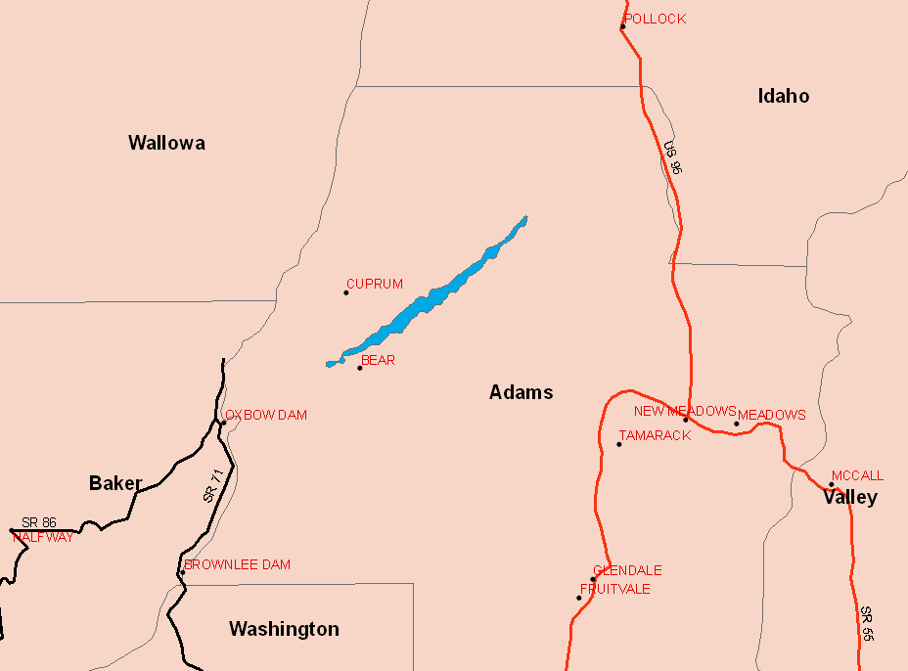
Figure 1: Tornado path (blue) through Adams County.
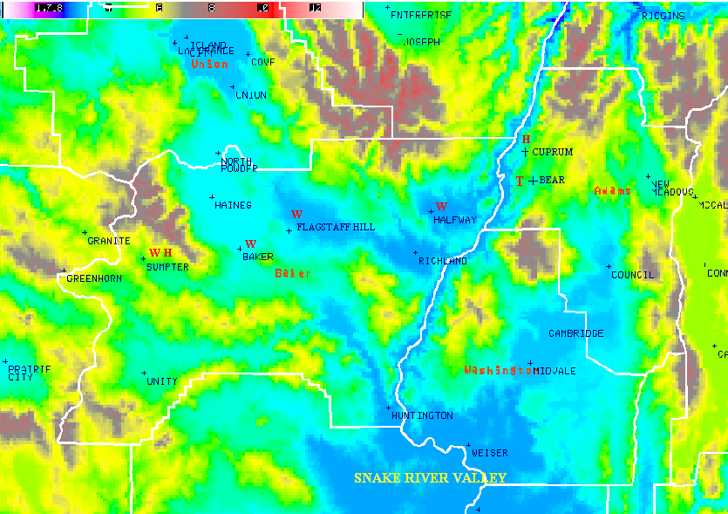
Figure 2: High resolution topography image including storm reports. W represents wind reports, H represents hail reports, and T represents the location of tornado touchdown. County names are in red and city names are in blue.

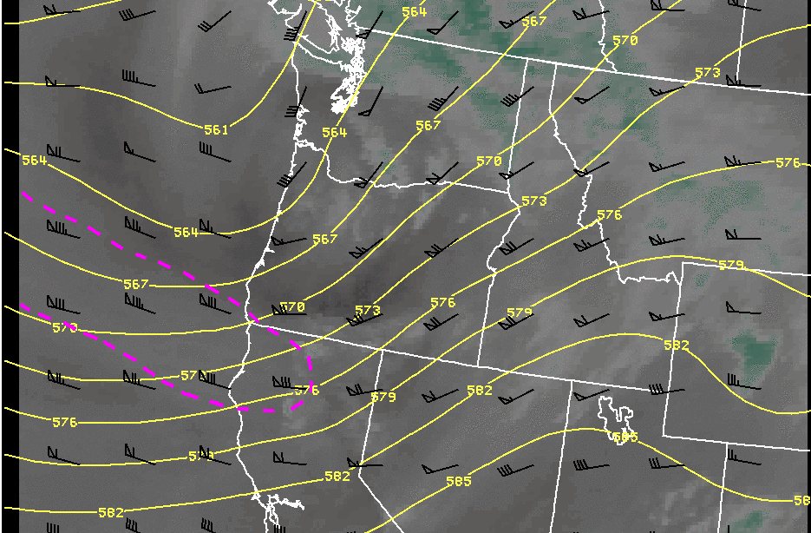
Figure 3: 1200 UTC water vapor image with 500 mb heights and 250 mb winds overlaid. The pink dashed line represents the 80 kt isotach, showing the position of the wind maximum.

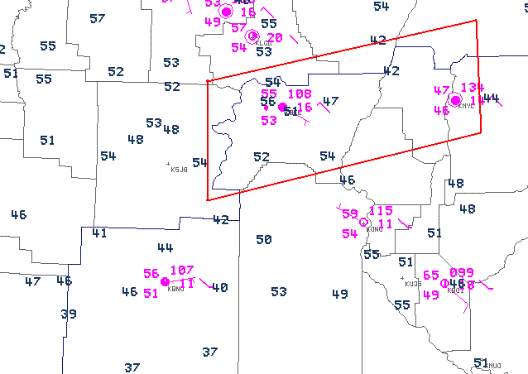
Figure 4: 1200 UTC ASOS plot, shown in pink, and Mesonet dew point temperatures, shown in blue. The area of interest is outlined in red.
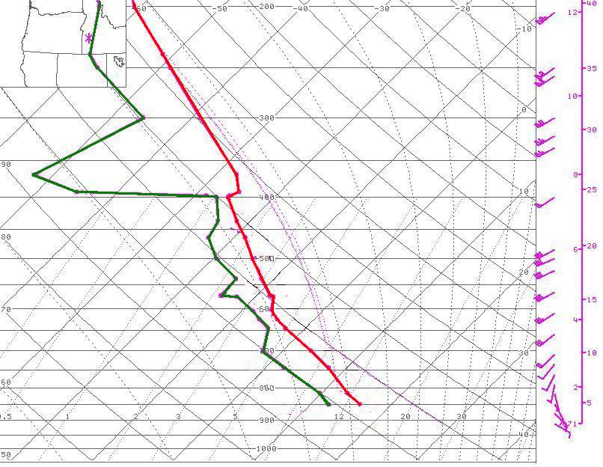
Figure 5: Modified 1200 UTC sounding at KBOI.

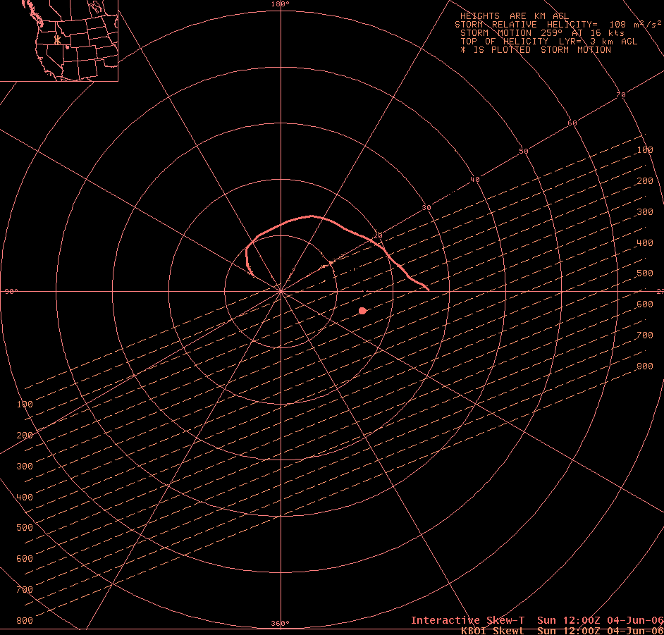
Figure 6: 1200 UTC Hodograph at KBOI modified with VAD winds at 1815 UTC.
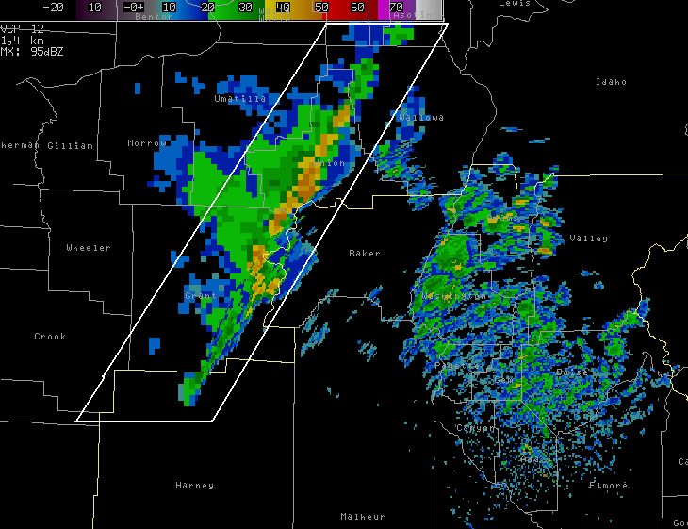
Figure 7: KCBX composite reflectivity of the squall line (white polygon) moving into Baker County at 1605 UTC.
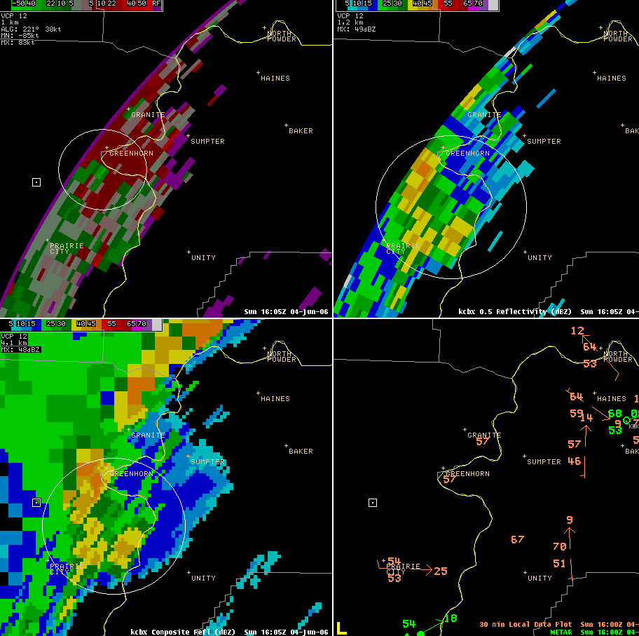
Figure 8: 1605 UTC showing KCBX 0.5º SRM, 0.5º reflectivity, Mesonet dew point data (shown in orange), and composite reflectivity. The area of interest is encircled in white. KCBX is located southeast of the squall line.
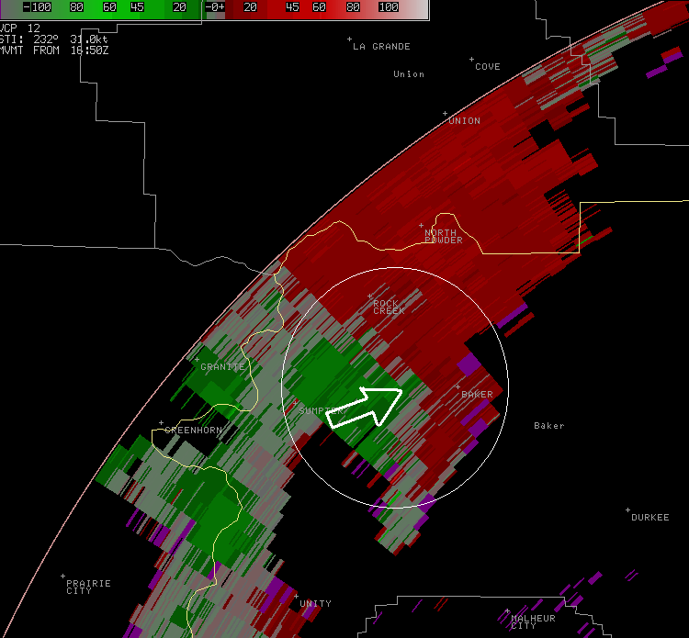
Figure 9: KCBX 0.5º SRM image at 1650 UTC showing the RIN (arrow) and a tightening rotation.
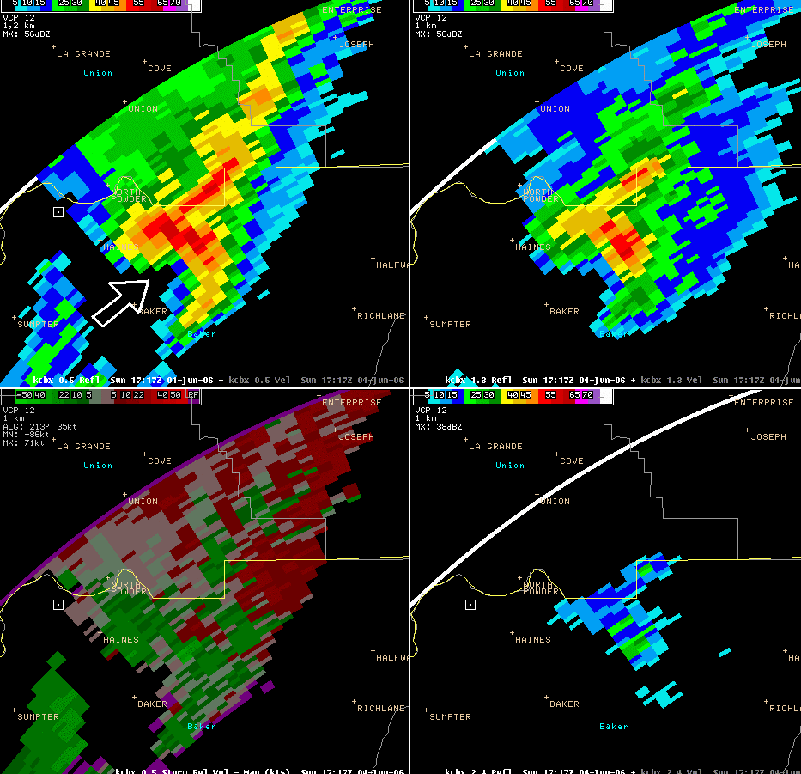
Figure 10: 1717 UTC displaying the RIN (arrow) and increase in reflectivities. Shown are the KCBX 0.5º, 1.3º, and 2.4º reflectivities, and the 0.5º SRM.
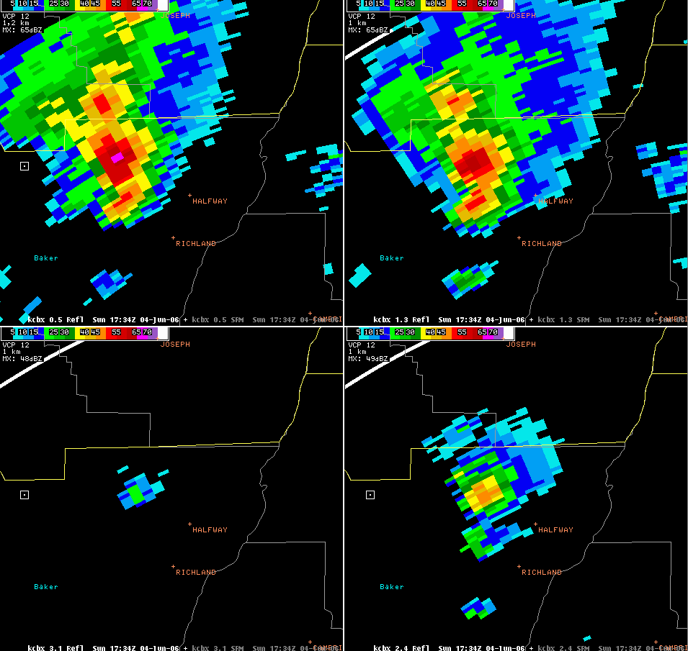
Figure 11: 1734 UTC KCBX 0.5º, 1.3º, 2.4º, and 3.1º slices, displaying an increase in reflectivities.

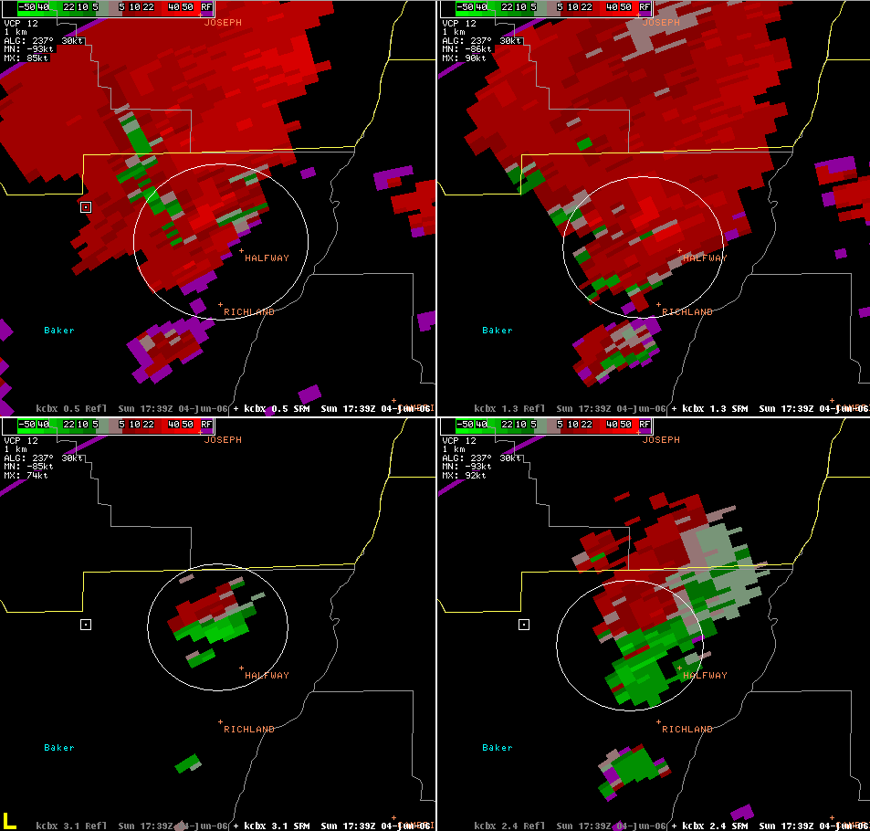
Figure 12: 1739 UTC KCBX 0.5º, 1.3º, 2.4º, and 3.1º SRM showing a large area of strong outbound velocities and increased storm top divergence, which are encircled in white.

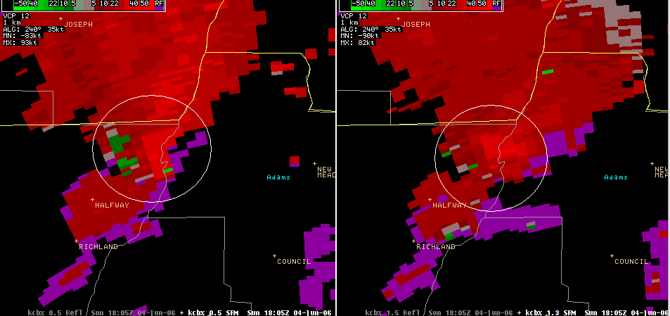
Figure 13: 1805 UTC KCBX 0.5º and 1.5º SRM showing increase in rotational velocities, which is encircled in white.

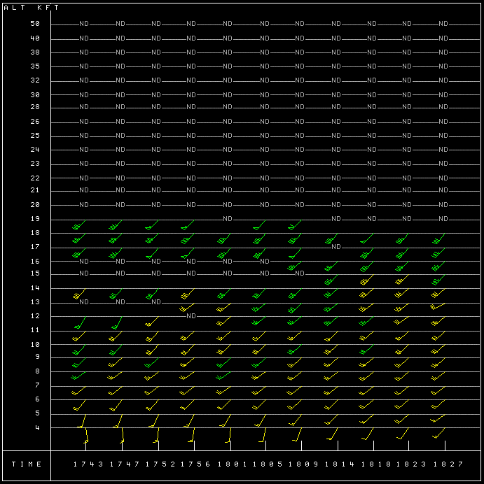
Figure 14: KCBX VAD wind profile from 1743 UTC through 1827 UTC showing an increase in south to southwest winds.

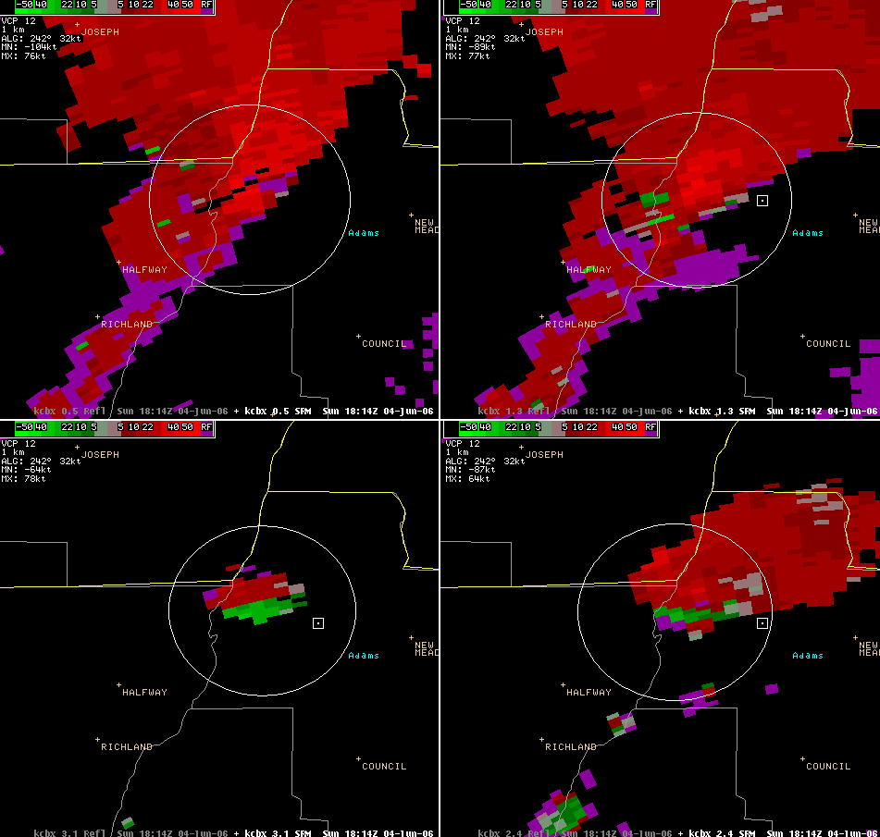
Figure 15: 1814 UTC KCBX 0.5º, 1.3º, 2.4º, and 3.1º SRM showing increased outbound velocities and storm top divergence, which are outlined in white.

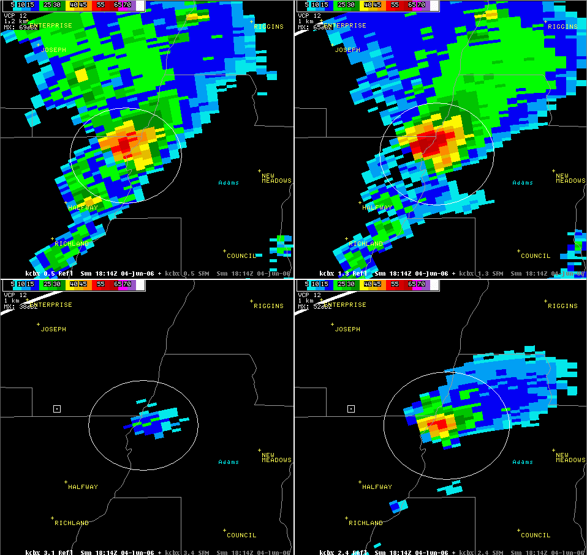
Figure 16: 1827 UTC KCBX display of 50 to 55 dBZ cores extending up to 10.4 km.
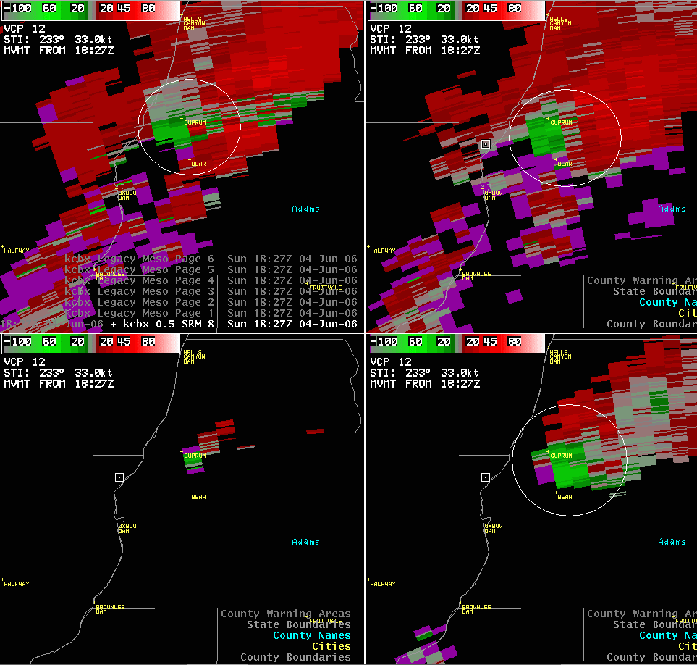
Figure 17: 1827 UTC KCBX 0.5º, 1.3º, 2.4º, and 3.1º SRM showing a rapid increase in rotational velocity.

