ACIA Arctic Climate Impact Assessment

ACIA Secretariat, University of Alaska Fairbanks, Fairbanks, Alaska, USA 99775-7740
www.acia.uaf.edu
Statement
by
Dr. Robert W. Corell, Chair
Arctic Climate Impact Assessment
Mandated by the Arctic Council and the International Arctic Sciences Committee
and
Senior Fellow, American Meteorological Society
before
The Committee on Commerce, Science, and Transportation
United States Senate
February 5, 2004
Introduction:
Mr. Chairman, Members of the Committee, thank you for the opportunity to participate in today’s Full Committee hearing on Climate Change Impacts. I am honored to testify before you today on behalf of an international team of 300 scientists, other experts, and elders and other insightful indigenous residents of the Arctic region who are preparing a comprehensive analysis of the impacts and consequences of climate variability and changes across the Arctic region, including the impacts induced by increases in UV radiation arising from depletion of stratospheric ozone in the region. I am Dr. Robert W. Corell, Chair of the Arctic Climate Impact Assessment (ACIA), which was established and charged to conduct the assessment by the Arctic Council and the International Arctic Sciences Committee. The Arctic Council is composed of senior officials from the eight Arctic countries (U.S. is represented by senior officials of the Department of State) and the leadership from the six major indigenous peoples organizations of the Arctic region. The International Arctic Sciences Committee (IASC) was founded to encourage and facilitate cooperation in all aspects of Arctic research; the US is represented by an appointment made by the National Academy of Science.
Assessing the Impacts induced by Climate Change across the Arctic Region:
The Arctic Climate Impact Assessment (ACIA) is a four-year comprehensive scientific assessment that was established and charged at the Ministerial meeting of the Arctic Council in Barrow, Alaska in the fall of 2000. The ministers called for the ACIA to (i) evaluate and synthesize knowledge on the impacts and consequences of climate variability and change and increased ultraviolet radiation across the Arctic region, and (ii) support decision and policy making processes for the eight Arctic countries and their residents. ACIA is charged with assessing environmental, human health, social, cultural and economic impacts and consequences, including recommendations, by assessing how climate and UV radiation have been changing in the Arctic, how they are projected to change in the future, and the likely impacts of those changes. Most importantly, the assessment is charged with the responsibility of providing useful information to the governments, organizations, and peoples of the Arctic and the world to help them respond to the challenges and opportunities presented by climate change. Arctic Council sponsors ACIA through its Arctic Monitoring and Assessment Program (AMAP) and its Conservation of Arctic Flora and Fauna (CAFF) program and in cooperation with the International Arctic Sciences Committee (IASC). The ACIA teams of authors, including substantial expert contributions by indigenous and other residents of the Arctic, will submit their final reports, including their scientific and technical findings to the Arctic Council and the International Arctic Sciences Committee during the Ministerial meeting of the Arctic Council in Reykjavik, Iceland in November of this year. The scientific and technical document which is expected to total over 1600 pages organized into 17 chapters of the Assessment has already been revised after being subjected to a comprehensive external review by an independent group of over 225 international scientists and other experts from over a dozen countries. The synthesis and overview report, which will summarize the scientific and technical findings, is in its final preparation, and it too will be externally reviewed. Because the Assessment is still in its final phases, my testimony will be in the form of a progress report that provides a preliminary “snapshot” of the knowledge and insights gleaned from the analysis, synthesis and documentation concerning the impacts and consequences of climate variability and change across the Arctic region.
Preliminary Findings Regarding the Key Impacts of Climate Change across the Arctic Region:
The IPCC’s Third Assessment Report summarized the evidence that the Earth’s, and more particularly the Arctic’s, climate is changing more rapidly and persistently than at any time since the beginning of civilization. While some climate changes reflect natural variability, careful investigations of the strength and patterns of change indicate human influences are responsible for most of the changes since the mid-20th century. As projected both by this Assessment and the IPCC, these climatic changes are the largest and are being experienced most intensely in the Arctic region. For example, over the past 50 years, the average temperatures across the Arctic have risen by nearly twice as much as the global average with some parts of the Arctic region experiencing much greater increases. That unusual changes are underway is indicated by increases in surface and oceanic temperatures, an overall increase in precipitation that is more evident in some sub-regions of the Arctic than in others, large reductions in sea ice and glacier volume, increases in river runoff and sea level, the thawing of permafrost, and shifts in the ranges of plant and animal species. Overall, the Assessment details significant disruptive impacts while identifying a number of potential opportunities for indigenous and other residents, communities, economic sectors, and governments of the region. Because we are still in the final stages of completing the scientific and technical aspects of the assessment, I am only able to outline some of the most important findings that I believe are likely to be among those that will be included in the Assessment when we complete the process this fall.
The ACIA’s reports have been prepared by teams of scientists and other experts who have conducted their work in the tradition of an independent process of research, analysis, and assessment based on published data and information. In addition, this assessment has undertaken substantial efforts to engage experts from indigenous and other resident communities across the Arctic region, drawing upon their insights as a companion to the scientific and technical findings. As an example of what is being experienced by those in the region, let me quote from an indigenous person’s experiences.
“Nowadays snows melt earlier in the springtime. Lakes, rivers, and bogs freeze much later in the autumn. Reindeer herding becomes more difficult as the ice is weak and may give way… All sorts of unusual events have taken place. Nowadays the winters are much warmer than they used to be. Occasionally during winter time it rains. We never expected this; we could not be ready for this. It is very strange… The cycle of the yearly calendar has been disturbed greatly and this affects the reindeer herding negatively for sure…”

This 2002 observation by Larisa Avdeyeva, an elder from Lovozero, Russia, summarizes many of the insights emerging from both the scientific analyses and the insights of indigenous peoples across the Arctic. With this perspective as a backdrop, I would like to outline some of the findings that are likely to highlight the Assessment when it is released this fall:

Arctic Climate is Warming Rapidly and Much Larger Changes are Projected:
Records of increasing temperatures, melting glaciers, reductions in extent and thickness of sea ice, thawing permafrost, and rising sea level all provide strong evidence of recent warming in the Arctic (e.g., the plot on the next page indicates the overall increase in Northern hemisphere temperatures over the past 1000 years). There are regional variations due to circulation patterns in the atmosphere and oceans, with some areas experiencing more warming than others and a few areas even show a slight cooling; but for the Arctic as a whole, there is a clear warming trend. There are also patterns within this overall trend; for example, in most places, temperatures in winter are rising more rapidly than in summer. In Alaska and western Canada, the average winter temperatures have increased by as much as 3 to 4˚C over the past 60 years, which is a significant increase given that the global average increase over the past 100 years has been only about 0.6±0.2°C. With respect to future changes, all of the models, regardless of the emissions scenario or computer model selected, project very significant warming for the Arctic over the next 100 years. Although these models do not agree on the regional and temporal details of the projected warming, there is little doubt that the world will warm significantly during the decades ahead and that the Arctic region will experience more warming than the rest of the world. On average, the models project that the Arctic is very likely to warm by more than twice the global average over the 21st century.
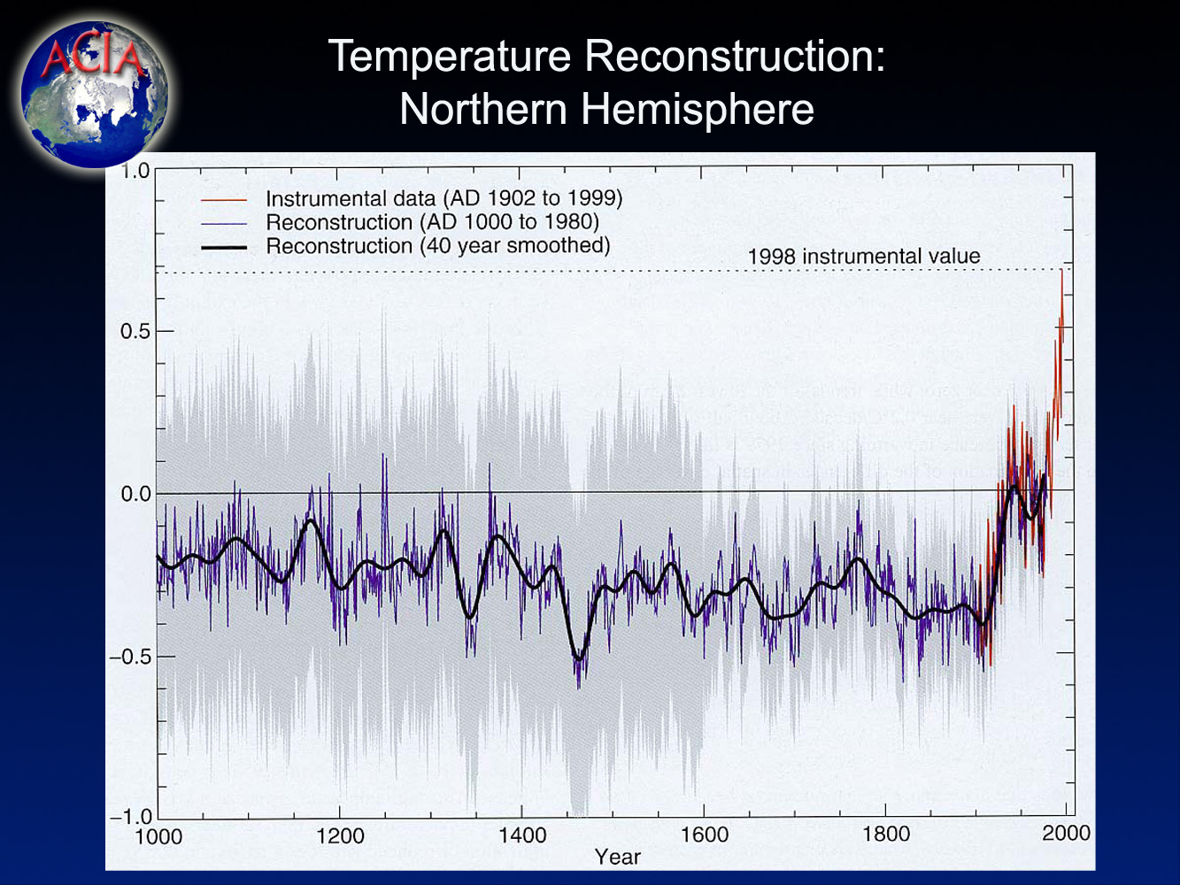

One of the changes that is of particular importance is the rate at which Arctic sea ice is melting and the projection by models that there is likely to be an even more rapid reduction in the extent and seasonal duration of sea ice in the future. Not only will the melting back of the sea ice lead to seasonal opening of potentially important marine transportation routes, but the reduced sea ice extent and duration will lead to significant changes in the surface reflectivity, cloudiness, humidity, exchanges of heat and moisture, and ocean circulation, particularly along coastlines and near ice margins. Over the past 30 years, Arctic sea ice extent has decreased, on average, by about 10%, and this change has been 20% faster over the past two decades than over the past three decades. The average of the five ACIA model simulations project that there will be substantial reductions in summertime sea ice around the entire Arctic Basin, with one model projecting an ice free Arctic in the summer by the middle of this century (See graphic on the next page). On average, the climate models project an acceleration of in sea ice retreat, with periods of extensive melting spreading progressively further into spring and fall.
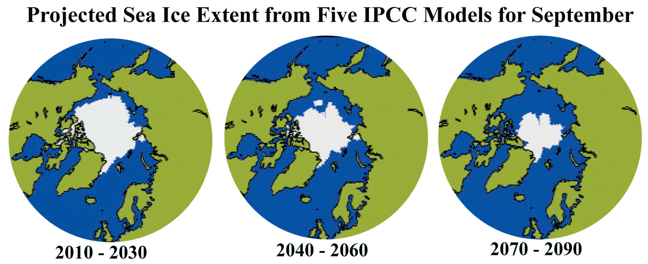
As a result of the sea ice meltback, the navigation season in the Northern Sea Route, for example, – the number of days per year in which there are easily navigable conditions, often defined as less than 50% sea ice concentration – is projected to increase from the current 20-30 days per year to 90-100 days by 2080. Passage is presently feasible for ice-breaking capable ships in seas with about 75% sea ice concentration, suggesting a navigation season for ice-breaking vessels of around 150 days a year by 2080. Opening new shipping routes and extending the navigation season could have very important economic implications because there will very likely be increased access to the region’s oceanic and near coastal resources. However, potentially important issues regarding sovereignty, safety, and environmental preservation will also arise as more nations enter the region. While easing access to oceanic and coastal resources, the longer melt season on land may also make access to inland resources more difficult.
- Warming Across the Arctic and its Consequences are likely to have Major Implications for the Entire World:
The likelihood of continued melting of glaciers including the Greenland Ice Sheet have significant implications for the entire planet as the total land-based ice in the Arctic has been estimated to be about 3,100,000 cubic kilometers which, if melted, would correspond to a sea-level equivalent of about 8 meters. The Greenland Ice Sheet dominates land ice in the Arctic. Over the past two decades, the melt area on the Greenland ice sheet has increased on average by about 0.7%/year (or about16% from 1979 to 2002), with considerable variation from year to year (See graphic on the next page). The total area of surface melt on the Greenland Ice Sheet broke all past records in 2002. IPCC estimated that a sustained increase in Arctic temperatures of 3ºC would lead to the melting of the Greenland Ice Sheet over a period of 1000 years – the ACIA models suggest that regional warming will be much higher that this by the end of the 21st century, putting us past the threshold for the long-term disintegration of that ice sheet. Recent studies of glaciers in Alaska already indicate an accelerated rate of melting. This rapid retreat of Alaskan glaciers represents about half of the estimated loss of mass by glaciers worldwide; the largest contribution by glacial melt to rising sea level identified for any region.

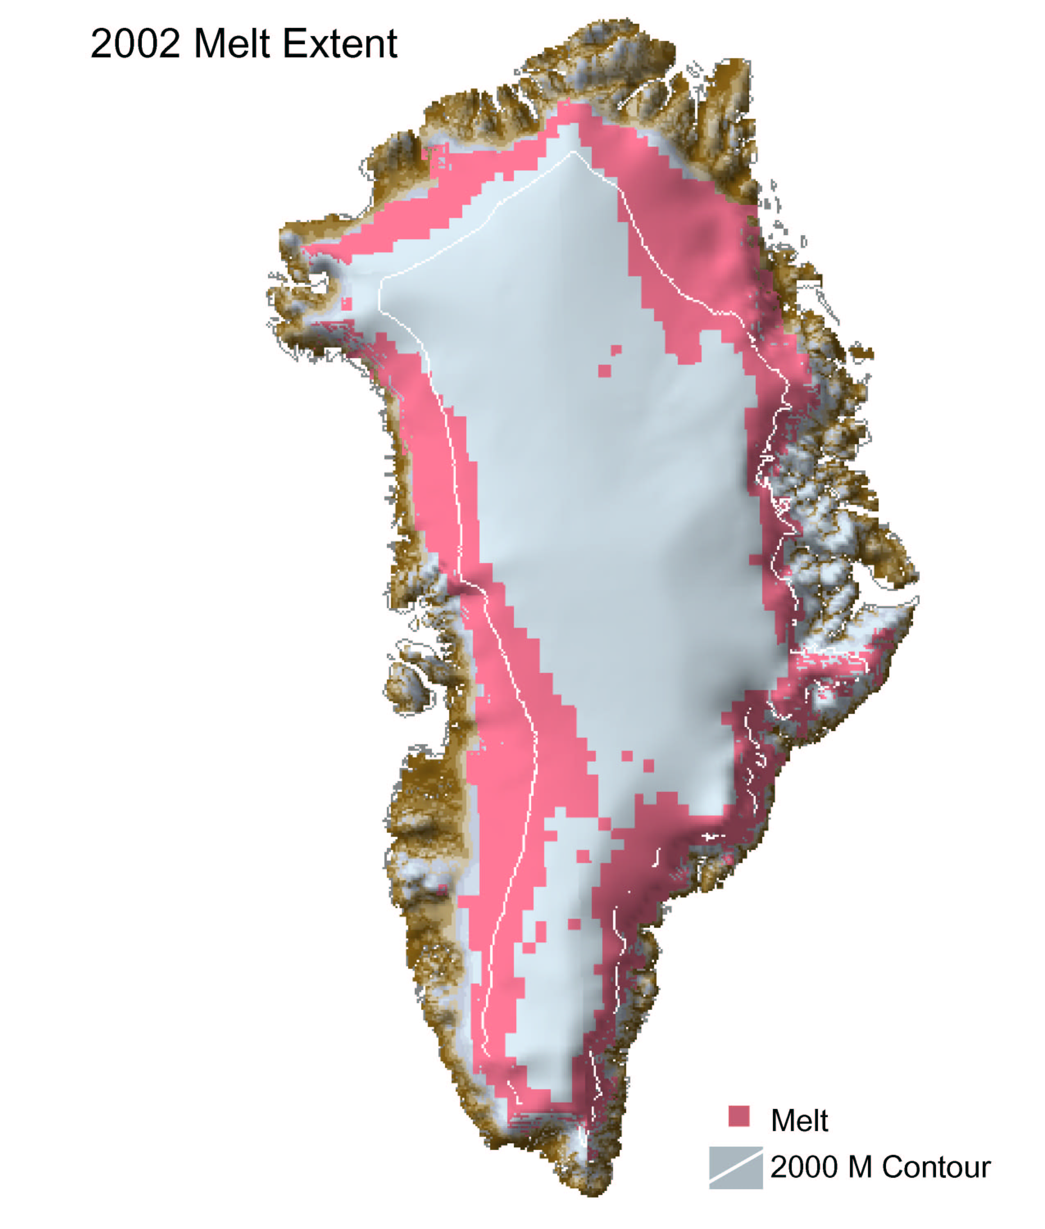
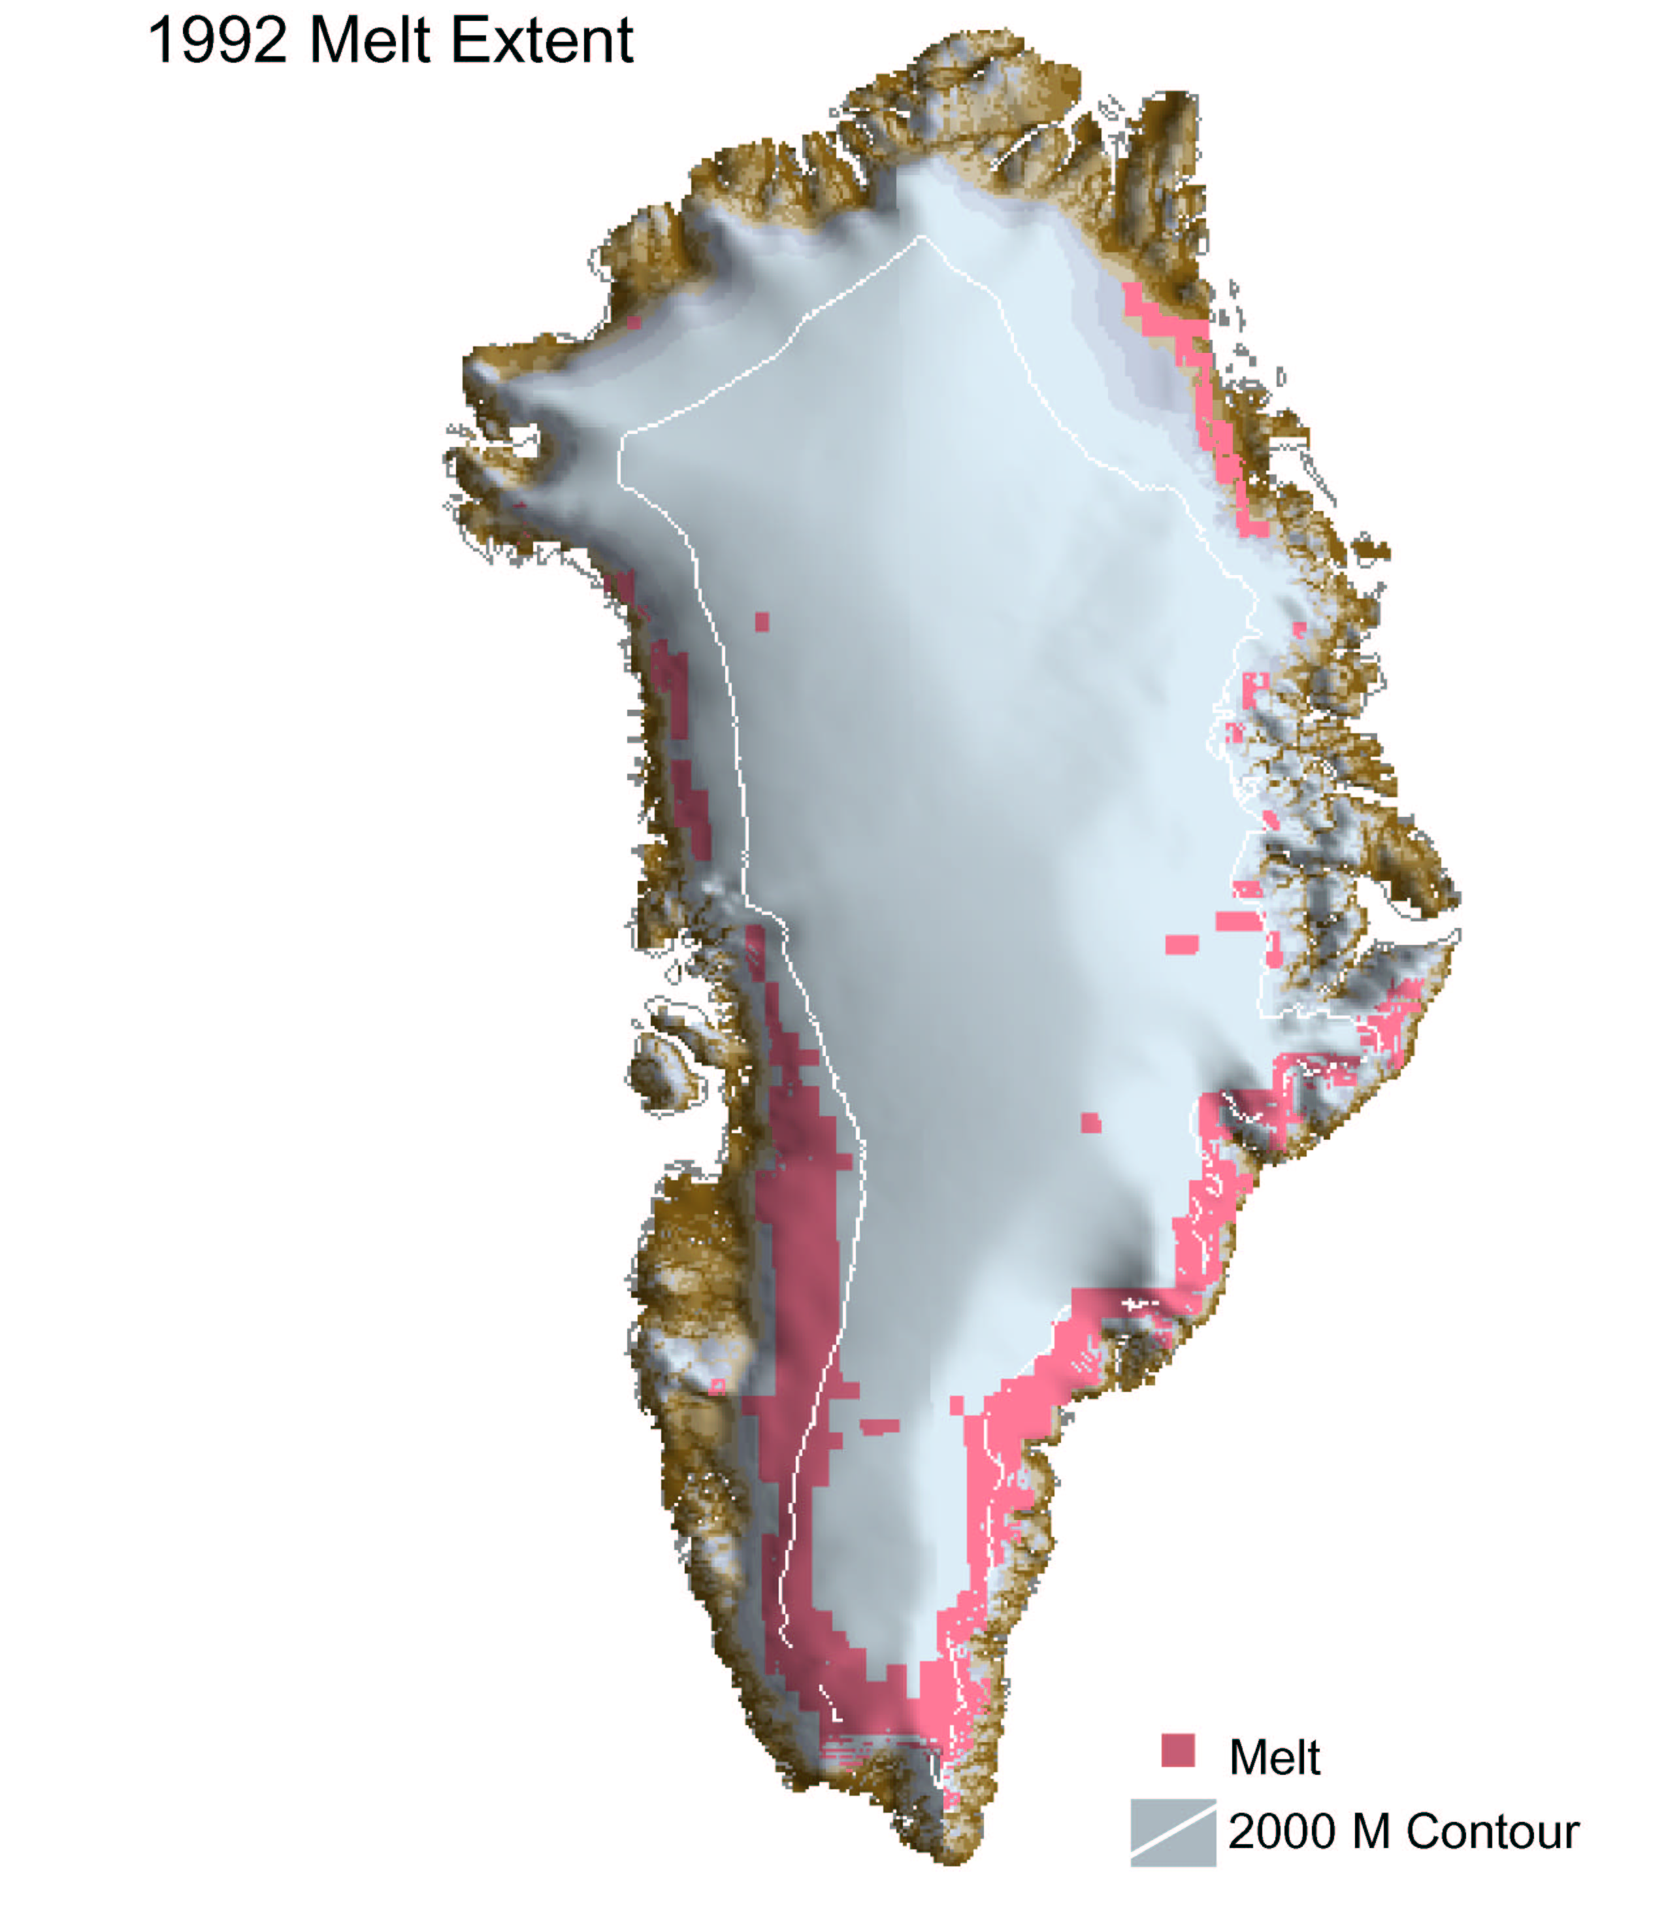
1992 Melt Extent
2002 Melt Extent

The Arctic exerts a special influence over global climate. There are three major mechanisms by which Arctic processes can influence climate change on global scales. The first of these involves the snow and ice that reflect most of the incoming solar energy back to space. The melting back of the snow and ice reveals the land and water surfaces beneath, which are much darker. These darker surfaces now absorb rather than reflect back the Sun’s energy. This warms the surface further, causing faster melting, which in turn causes more warming, and so on, creating a self-reinforcing cycle, amplifying and accelerating warming trends.
A second mechanism by which Arctic processes can influence changes in global climate is through alterations in ocean circulation patterns. One of the ways the energy from the Sun absorbed by the oceans is transported from the equator toward the poles is through the globally interconnected circulation of ocean waters. As these oceanic waters move northward, the uniquely very cold, dense, and highly saline (salty) waters in the North Atlantic sinks which drives an overturning or sinking process called thermohaline circulation; the process that drives global oceanic circulation (depicted in the graphic on the next page). However, as more fresh and less dense waters enter the North Atlantic from melting of sea ice, glaciers, and increased river outflows into the Arctic oceanic basin, this freshwater then mixes with the saltier water producing a less density sea water that weakens the sinking process and has the potential to weaken or even shut down thermohaline circulation. There is increasing scientific evidence that this weakening process has already begun and virtually all the climate models indicate a continuation of the weakening during this century. It is not likely that there will be complete shutdown in this century, but as IPCC and studies from this Assessment indicate, this is a process which must be more fully understood as the consequences affect both the timing and magnitude of the warming trends, including the potential for local cooling in Europe even in a globally warming planet.
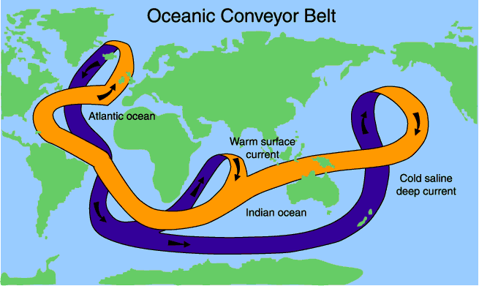
The unique location where very salty and dense seawater sinks that then creates thermohaline circulation -- a global circulation process.

A third way that Arctic warming can potentially amplify climate change throughout the global is by stimulating the release of greenhouse gases trapped in Arctic soils and sea sediments. For example, methane and CO₂ are currently trapped in permafrost (frozen soil) that underlies much of the Arctic region. Permafrost is already thawing in many areas and thawing is expected to accelerate as warming intensifies, which has the potential of accelerating the release methane and CO₂. In addition, the soils and vegetation of the boreal forests now serve as a major global storehouse for carbon. Boreal (northern) forests contain 40% of the world’s reactive soil carbon, an amount similar to all the carbon that is stored in the atmosphere. Available studies do not yet indicate whether the net effect of the projected changes will be to take up or release more carbon overall as climate change proceeds, but recent studies suggest that over the Arctic as a whole, more productive vegetation will probably increase carbon storage in ecosystems over this century. There are other mechanisms that could lead to the release methane, including the vast amounts of methane currently trapped at shallow depths in Arctic oceanic sediments (stored in a solid icy form called methane hydrates). If the temperature of the water at the seabed rises a few degrees, these hydrates could ultimately be released as methane and enter the atmosphere. Because each molecule of methane is about 30 times as potent (60 times as potent over a 100 year timeframe) at trapping heat in Earth’s atmosphere as a molecule of CO₂, it is essential that we advance our understanding of this long-term potential effect on global climatic processes.
- Impacts from the Projected Shifts in Arctic Vegetation and Changes in the Biosphere:
Climate-induced changes in Arctic landscapes are important to people and animals in terms of habitat, food, fuel, and culture. The major Arctic vegetation zones include the polar deserts, tundra, and northern part of the boreal forest. Climate warming is projected to cause vegetation shifts because rising temperatures favor taller, denser vegetation, and will thus promote the expansion of forests into the Arctic tundra, and tundra into the polar deserts. This change, along with rising sea levels, is projected to shrink tundra area to its lowest extent in at least the past 21,000 years, potentially reducing the breeding area for many migratory bird species and the grazing areas for land animals that depend on the open landscape of tundra and polar desert habitats. Half the current tundra area is projected to disappear in this century.
Arctic agriculture is a relatively small industry in global terms. Agriculture in the north consists mostly of cool season forage crops, cool-season vegetables, small grains, and the raising of cattle, sheep, goats, pigs, and poultry, and reindeer. While agriculture in the Arctic is presently limited by climatic factors, especially in the cooler parts, it is also limited by the lack of infrastructure, the small population base, the remoteness from markets, and land ownership issues. Warming is projected to advance the potential for commercial crop production northward throughout this century, with some crops now suitable only for the warmer parts of the boreal region becoming suitable as far north as the Arctic Circle. Average annual yield potential will likely increase because of an increase in the suitability for higher yielding varieties and lowering the probabilities of low temperatures limiting growth. Longer and warmer growing seasons are thus very likely to increase the potential number of harvests and hence seasonal yields for perennial forage crops.
- Animal Species’ Diversity, Ranges, and Distribution are Likely to Change:
Arctic marine fisheries provide an important food source globally, and are a vital part of the economy of virtually every Arctic country. Because they are largely controlled by factors such as local weather conditions, ecosystem dynamics, and management decisions, projecting the impacts of climate change on marine fish stocks has been and will likely continue to be difficult. Based on available information, however, projected warming is likely to improve conditions for some important fish stocks such as cod and herring, because higher temperatures and reduced ice cover could possibly increase productivity of their prey and provide more extensive habitat. Although projected conditions are likely to benefit some species, they are likely to negatively affect others, including northern shrimp, the extent of which will probably contract decreasing its abundance, for example, reducing the large catch (about 100,000 tons a year) currently taken from Greenlandic waters. The total effect of climate change impacts, however, will likely be of less magnitude than that of fisheries management decisions. While it is unlikely that climate change effects on fisheries will have long-term Arctic-wide social and economic impacts, certain areas of the region that are heavily dependent on fisheries may be dramatically affected, particularly indigenous and other residents of the region.
Climate also has a profound influence on marine mammals. Years with little or no ice in the Gulf of St. Lawrence (1967, 1981, 2000, 2001, 2002) resulted in years with almost zero production of seal pups, whereas in other years, these numbered in the hundreds of thousands. Polar bears are intimately tied to the sea ice where they hunt ringed seals and other ice-associated seals, and use ice corridors to move from one area to another. Their seal hunting success, which depends on good spring ice conditions, is essential for the polar bear’s survival. Changes in ice extent and stability are thus of critical importance. The earliest impacts of warming are likely to occur at the southern limits of the polar bears’ distribution, such as James and Hudson Bays, and, indeed, such impacts have already been documented. As the loss of sea ice continues, the increasing loss of habitat for polar bear is likely to have significant and rapid consequences for their populations and for the indigenous people whose culture is tied to the polar bear and who depend on the polar bear for food, clothing, and other needs. Indigenous people are already reporting that the thinning and depletion of sea-ice in the Arctic will "push to extinction" key marine mammals, including polar bear, walrus, and some species of seal that are hunted by Inuit in Alaska, northern Canada, Greenland, and Chukotka in the Federation of Russia. As such, climate change in the Arctic is a human and cultural, as well as environmental issue, which they report will in the long-term threaten the very existence of Inuit as a hunting culture.
Caribou (North American forms of Rangifer tarandus) and reindeer (Eurasian forms of the same species) are of primary importance to inland peoples throughout the Arctic for food, shelter, fuel, tools, and other cultural items. Caribou and reindeer herds depend on the availability of abundant tundra vegetation and good foraging conditions, especially during the calving season. Climate-induced changes to Arctic tundra are projected to cause vegetation zones to shift significantly northward, reducing the area of tundra and the traditional pastures for these herds. Freeze-thaw cycles and freezing rain are also projected to increase. Further, data suggest that migrations of other animal species (moose, red deer, etc into Fennoscandia) into the tradition pasturelands of reindeer herders have significant implications for the ability of the reindeer populations to forage for food and raise healthy calves. Much of the redistribution of species is climate induced, though it is important to note that the development of roadways, pipelines, and other civilian infrastructure also impact the abilities of herders to maintain their tradition ways of herding and, hence the culture that is endemic to these peoples. Future climate change could thus mean a potential decline in caribou and reindeer populations, threatening human nutrition and the cultural base of indigenous households and a way of life for those Arctic communities that have existed as many as 9,000 years.
- Thawing Ground Will Disrupt Transportation, Buildings, and other Infrastructure:
Much important transportation on land in the Arctic is over frozen tundra and across ice roads and bridges. Rising temperatures are already creating increasing challenges on these routes and the problems are projected to increase as temperatures continue to rise. In addition, the incidence of mud and rockslides and avalanches are sensitive to the kinds of changes in weather that are anticipated to accompany warming. The number of days per year in which travel on the tundra is approved by the Alaska Department of Natural Resources has dropped from over 200 to about 100 in the past 30 years, causing a 50% reduction in days that oil and gas exploration and extraction equipment can be used. Forestry is another industry that requires frozen ground and rivers. Higher temperatures mean a longer period during which the ground is thawed and thinner ice on rivers. This leads to a shortened period during which timber can be moved from forests to sawmills and increasing problems associated with transporting wood.
Permafrost, the foundation for these transportation pathways, is soil, rock, or sediment that has remained below 0°C for two or more years. Permafrost presently underlies most of the land surfaces in the Arctic region. “Continuous” permafrost thickness varies from a few meters to hundreds meters. Permafrost temperatures over most of the sub-Arctic land areas have increased by several tenths of a degree C up to 2°C during the past few decades, and the depth of the layer that thaws each year is increasing in many areas (see graphic on the next page). Over the coming hundred years, these changes are projected to continue and their rate to increase, with permafrost degradation projected to occur over 10-20% of the present permafrost area, and the southern limit of permafrost projected to shift northward by several hundred kilometers.
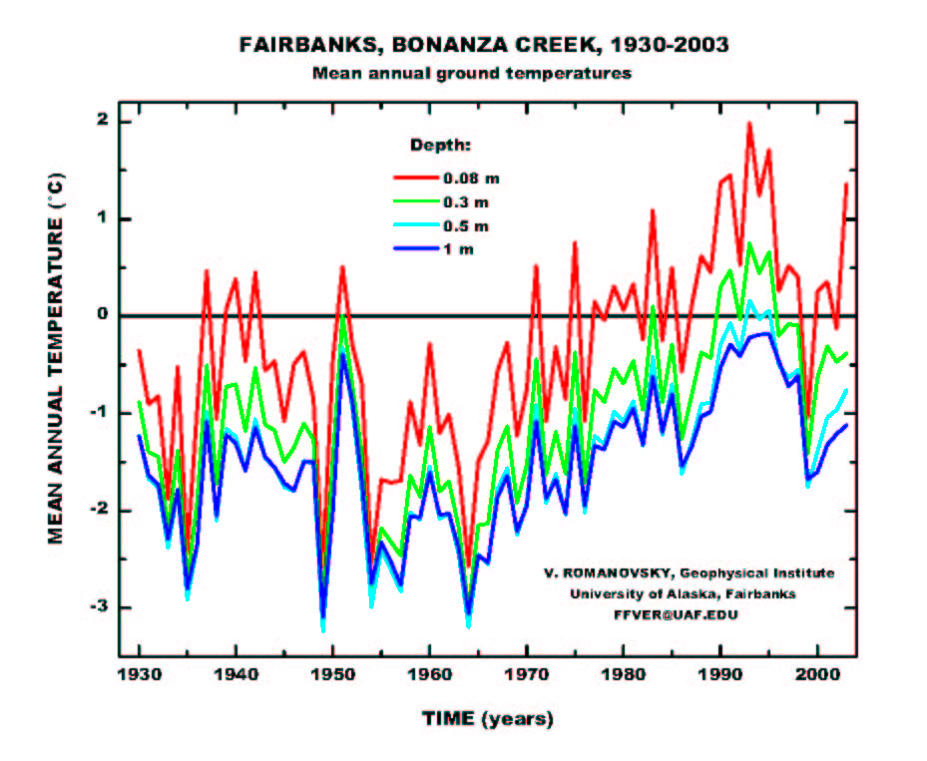
6. Indigenous Peoples and other Residents of the Arctic are likely to Face Major Impacts Due To Climate and other Environmental Changes:
The Arctic is home to thousands of indigenous communities whose cultures and activities are shaped by the Arctic environment. They have interacted with their environment over generations through careful observations and skillful adjustments in subsistence activities and lifestyles. Through ways of life closely linked to their surroundings, these peoples have developed uniquely insightful ways of observing, interpreting, and responding to the impacts of environmental changes. Indigenous observations and perspectives are therefore of special value in understanding the processes and impacts of Arctic climate change. There is a rich body of knowledge based on their careful observations of and interactions with the world. Holders of this knowledge use it to make decisions and set priorities. The ACIA has attempted to incorporate knowledge and insights from indigenous peoples with data from scientific research, bringing together these complementary perspectives on Arctic climate change.
Across the Arctic, indigenous peoples are already reporting the effects of climate change. In Canada’s Nunavut Territory, Inuit hunters have noticed the thinning of sea ice, a reduction in ringed seals in some areas, and the appearance of insects and birds not usually found in their region. Inupiat hunters in Alaska report that ice cellars are too warm to keep food frozen. Inuvialuit in the western Canadian Arctic are observing an increase in thunderstorms and lightning, previously a very rare occurrence in the region. Athabascan people in Alaska and Canada have witnessed dramatic changes in weather, vegetation, and animal distribution patterns over the last half-century. Sámi reindeer herders in Norway observe that prevailing winds relied on for navigation have shifted and that snow can no longer be relied on to travel over on trails that people have always used and considered safe. Indigenous peoples who are accustomed to the wide range of natural climate variations are now noticing changes that are unique in the long experience of their peoples.
Climate change will affect human health in the Arctic. The impacts will differ from place to place due to regional differences in climate change as well as variations in health status and adaptive capacity of different populations. Rural Arctic residents in small, isolated communities with a fragile system of support, little infrastructure, and marginal or non-existent public health systems appear to be most vulnerable. People who depend on subsistence hunting and fishing, especially those who rely on just a few species, will be vulnerable to changes that heavily impact those species (for example, reduced sea ice impacts on ringed seals and polar bears). Age, lifestyle, gender, access to resources, and other factors affect individual and collective adaptive capacity.
7. Climate in the Context of other Changes across the Arctic Region:
Climate change is occurring in the context of many other changes taking place in the Arctic. Environmental changes include chemical pollution, increased ultraviolet radiation, habitat destruction, and over-fishing. Social and economic changes include technological innovations, trade liberalization, urbanization, self-determination movements, and increasing tourism. All of these changes are interrelated and the consequences of these phenomena will depend largely on their interactions. Some of these changes will exacerbate impacts due to climate change while others alleviate impacts. Some changes will improve peoples’ ability to adapt to climate change while others hinder adaptive capacity. The degree to which people are resilient or vulnerable to climate change depends on the cumulative stresses to which they are subject as well as their capacity to adapt to these changes. Adaptive capacity is greatly affected by political, legal, economic, social, and other factors. Responses to environmental changes are multi-dimensional. They include adjustments in hunting, herding, and fishing practices as well as alterations in the political, cultural, and spiritual aspects of life. Adaptation can involve changes in knowledge and how it is used, for example, using new weather prediction techniques. Arctic people have historically altered their hunting and herding grounds and the species they pursue in response to changing conditions; however, they are increasingly indicating that the rapid rate of climate changes is limiting their capacities to adapt.
Concluding Thoughts
The ACIA represents the first effort to comprehensively examine climate change and its impacts in the Arctic region. As such, it represents the initiation of a process, rather than simply a set of reports. The ACIA brought together hundreds of scientists from around the world whose research focuses on the Arctic. It also included the insights of indigenous peoples who have a long history of gathering knowledge in this region. Linking these different perspectives is an exciting process for both the science community and the indigenous and other residents of the Arctic and it clearly has great potential to continue to improve our knowledge of climate change and its impacts. A great deal has been learned from this process and these interactions, though much remains to be studied and better understood. This Assessment is illustrating that climate change presents major and growing concerns to the Arctic region and the entire world. While these concerns are important now, they are even more important for the future generations that will inherit the legacy of our current stewardship. Climate change thus deserves and requires urgent attention by policymakers and the public worldwide. The assessment process should continue, and expand to more comprehensively include all issues of importance to Arctic residents as well as to the wider world.
Contact Information:
E-Mail Contacts for the Arctic Climate Impact Assessment
Robert W. Corell, Chair (global@dmv.com)
Gunter Weller, Executive Director of the Secretariat (gunter@gi.alaska.edu)
Patricia Anderson, Deputy Executive Director of the Secretariat (patricia@iarc.uaf.edu)

The Arctic Council was established on September 19th, 1996 in Ottawa, Canada. A high level intergovernmental forum, the Council provides a mechanism to address the common concerns and challenges faced by the Arctic governments and the people of the Arctic. The members of the Council are Canada, Denmark, Finland, Iceland, Norway, the Russian Federation, Sweden, and the United States of America. The Association of Indigenous Minorities of the North, Siberia and the Far East of the Russian Federation, the Inuit Circumpolar Conference, the Saami Council, the Aleutian International Association, Arctic Athabaskan Council and Gwich'in Council International are Permanent Participants in the Council. There is provision for non-arctic states, inter-governmental and inter-parliamentary organizations and non-governmental organizations to become involved as Official Observers. The Arctic Council is a high-level intergovernmental forum that provides a mechanism to address the common concerns and challenges faced by the Arctic governments and the people of the Arctic as a means of improving the economic, social and cultural well being of the north.
The International Arctic Sciences Committee was founded 28 August 1990 by national science organizations in all the arctic countries. It provides the major venue for national science organizations, mostly academies of science, to facilitate and foster cooperation in all fields of arctic research. It currently brings together scientists from Canada, China, Denmark, Finland, France, Germany, Iceland, Italy, Japan, The Netherlands, Norway, Poland, Republic of Korea, Russia, Sweden, Switzerland, United Kingdom, and the United States of America.
The IPCC Summary for Policymakers from the Third Assessment Report (2001) states, “Climate change in polar regions is expected to be among the largest and most rapid of any regions on the Earth, and will cause major physical, ecological, sociological, and economic impacts, especially in the Arctic, Antarctic Peninsula, and Southern Ocean”.

