ENVIRONMENTAL ASSESSMENT

FOR THE CONSTRUCTION AND OPERATION OF A VISITOR/EDUCATION CENTER AT NASA STENNIS SPACE CENTER

JOHN C. STENNIS SPACE CENTER

HANCOCK COUNTY, MISSISSIPPI

Lead Agency: National Aeronautics and Space Administration, John C. Stennis Space Center

Proposed Action: Construction and Operation of a Visitor/Education Center

For Further Information: Michael J. Blotzer, Environmental Officer
NASA Code RA02, Building 1100
John C. Stennis Space Center
Stennis Space Center, Mississippi 39529-6000
(228) 688-2004

Date: August 2006

Abstract: This document is an environmental assessment that examines the environmental impacts of a proposed plan to clear land and to construct a building for the operation of a Visitor/Education Center at a location next to the Mississippi Welcome Center on Interstate 10 along Highway 607 in Hancock County Mississippi.
Executive Summary

The National Aeronautics and Space Administration (NASA) proposes to clear land and construct a building for the operation of a Visitor/Education Center within the SSC Buffer Zone located at the southwest corner of Exit 2 on Interstate 10 along Highway 607. The complex would be located 305 meters (1,000 feet) west of the existing Mississippi Welcome Center.

The location for the Visitor/Education Center was not considered to have any feasible alternatives other than the “No Action Alternative.” The high visibility and availability of the land for the project was considered integral to the project’s success. The "No Action Alternative" is described as the benchmark against which the proposed actions are evaluated. The “No Action Alternative” would have no adverse environmental impacts, would have no beneficial economic impact and would not meet the purpose of and need for action.

This project would require a Mississippi Department of Environmental Quality (MDEQ) storm water permit for construction, a wetlands disturbance authorization from the U.S. Army Corps of Engineers – Vicksburg District, an MDEQ water withdrawal permit and an MDEQ National Pollutant Discharge Elimination System Permit.

The most notable impacts would be short-term fugitive air emissions, short-term intermittent noise from construction, wetlands disturbance, storm water runoff, groundwater withdrawal, a waste water outfall and the generation of solid waste. Other aspects that require consideration are energy conservation, water conservation, native plant landscaping, and the purchase of materials under comprehensive procurement guidelines for using materials with recycled content.

Table of Contents
EXECUTIVE SUMMARY.......................................................................................................i
ACRONYMS...........................................................................................................................iv
1.0 Purpose of and Need for Action 1
2.0 Proposed Action and Alternatives 3
3.0 Existing Environment and Environmental Consequences of Alternatives 7

3.1 Air Quality 8
3.2 Noise 8
3.3 Water Quality 8
3.4 Groundwater Resources 9
3.5 Wetlands and Flood Plains 10
3.6 Biotic Resources 12
3.7 Threatened and Endangered Speies 12
3.8 Archaeological and Cultural Resources 13
3.9 Transportation 13
3.10 Waste Generation 13
3.11 Socioeconomics 14
3.12 Public and Employee Health and Safety 14
3.13 Pollution Prevention and Environmental Justice 14
3.14 Cumulative Impact 15
4.0 Agencies and Individuals Consulted 16
5.0 List of Preparers 17
6.0 References 18
7.0 Distribution List 19

Appendix A Environmental Reviews and Consultations...............................................................20

Figures

Figure 1 – General Vicinity Map….......................................................................................................4
Figure 2 – Local Area Map…................................................................................................................5
Figure 3 – Proposed Site Map………...............................................................................................…6
Figure 4 – Wetlands Map....................................................................................................................11
Acronyms/Abbreviations

ABFE Advisory Base Flood Elevations
CFR Code of Federal Regulations
COE U.S. Army Corps of Engineers
DMR Mississippi Department of Marine Resources
EIS Environmental Impact Statement
EO Executive Order
FEMA Federal Emergency Management Agency
LEED Leadership in Energy & Environmental Design
MDEQ Mississippi Department of Environmental Quality
PM₁₀ particulate matter, 10 micron
NASA National Aeronautics and Space Administration
NEPA National Environmental Policy Act
NPDES National Pollutant Discharge Elimination System
ppm parts per million
SSC Stennis Space Center
1.0 Purpose of and Need for Action

The National Aeronautics and Space Administration (NASA) proposes to clear land and construct a building within the SSC Buffer Zone located at the southwest corner of Exit 2 on Interstate 10 along Highway 607. A general vicinity map is provided as Figure 1. A local area map is provided as Figure 2. The building would be located 305 meters (1,000 feet) west of the existing Mississippi Welcome Center, on an 80.5 hectares (199 acres) NASA-owned tract of land.

The NASA Stennis Space Center (SSC) currently operates a public Visitors’ Center (StenniSphere) within the confines of the Center’s security perimeter (Fee Area). The public gains access to the site via a bus that runs from the Mississippi Welcome Center to the Visitors’ Center and back. Visitors are currently allowed access to Building 1200 (StenniSphere) but there is a potential for visitors to gain access to other buildings and facilities. In the wake of 9/11, the Center’s management committed to moving the Visitors’ Center operation off-site. The relocation to the proposed site, approximately three miles away, would eliminate the risks to security posed by admitting the general public to buildings within the SSC Fee Area. Visitor’s would continue to be able to tour the SSC Fee Area but would not leave the tour bus. StenniSphere would be converted to offices and conference room space.

In addition to the security risk to Stennis Space Center posed by the general public, the nature of the rocket propulsion test mission of NASA, along with the requisite associated transportation, storage and use of propellants, pose a safety risk to visitors. The relocation, three miles away, would eliminate such risks.

It is intrinsic to NASA's mission to disseminate information, as broadly and practically as possible, about its activities and the results of its research and exploration. The relocation to the proposed new site would allow for significantly more exposure to the general public and would allow far more convenient access.

The Stennis Space Center has been, for several years, working in partnership with the non-profit corporation MAST, Inc. to enable construction of a state-of-the-art Science and Education Center, which would be named “INFINITY at NASA Stennis Space Center.” MAST, Inc., is led by a Board of Directors comprised of some of southern Mississippi’s most prominent community and business leaders, and was created specifically to make the INFINITY concept a reality. The INFINITY building and exhibit designs are already in place. The MAST, Inc., organization is currently in the midst of a campaign to raise private capitol for building construction. The State of Mississippi has already committed significant financial resources to this project.

If MAST, Inc., is successful in its fund-raising endeavors, it is NASA Stennis Space Center’s intention to enter into agreement with MAST, Inc., for construction of the INFINITY facility, and have it serve as the official Visitors’ Center of the NASA Stennis Space Center. In the event that MAST, Inc., is not successful in its fund-raising endeavors, it is the intention of Stennis Space Center to construct a stand-alone, NASA operated, Visitors’ Center. The environmental impacts would be the same for either scenario so this assessment addresses the environmental issues as a single project. Consequently, the project shall hereinafter be referred to as the “Visitor/Education Center.”

The Visitor/Education Center would house indoor and outdoor displays that highlight the advanced science, technology, and engineering activities that occur daily at the Stennis Space Center, and would include exhibits for NASA and SSC resident agencies. It would be dedicated to encouraging young people to aspire to become scientists, mathematicians and engineers and to take up the important work of exploration. It would also serve to enhance science literacy among the general public. Currently there are plans for a 3-D immersive theatre, an earth gallery and a space gallery for visitors to learn about Earth’s land, ocean and atmospheric resources as well as Earth’s relationship to the solar system and the universe. The Center would include a gift shop and food service.

Site preparation and infrastructure development would begin in Fall of 2006. Building construction would occur during 2007 with opening of daily operations proposed to start in early 2009. The footprint for the building site is provided in Figure 3.

This environmental assessment of the proposed project has been conducted to comply with the requirements of the National Environmental Policy Act (NEPA), the Council on Environmental Quality regulations for implementing the procedural provisions of NEPA (40 CFR Parts 1500-1508), and NASA's policies and procedures (14 CFR 1216.7).

2.0 Proposed Action and Alternatives

The proposed action is to clear and grub a 12.5 hectare (31 acres) site and construct a Visitor/Education Center of approximately 8,360 square meters (90,000 square feet) with associated parking lots and roads.

This project would require a Mississippi Department of Environmental Quality (MDEQ) storm water permit for construction, a wetlands disturbance authorization from the U.S. Army Corps of Engineers – Vicksburg District, an MDEQ water withdrawal permit and an MDEQ National Pollutant Discharge Elimination System (NPDES) Permit.

The location for the Visitor/Education Center was not considered to have any alternatives. The high visibility and availability of the land for the project was considered integral to the project’s success. No alternative is discussed further in this environmental assessment.

Inclusion of the "No Action Alternative" is prescribed by the Council on Environmental Quality guidelines implementing the National Environmental Policy Act. The "No Action Alternative" provides the benchmark against which the proposed actions are evaluated.
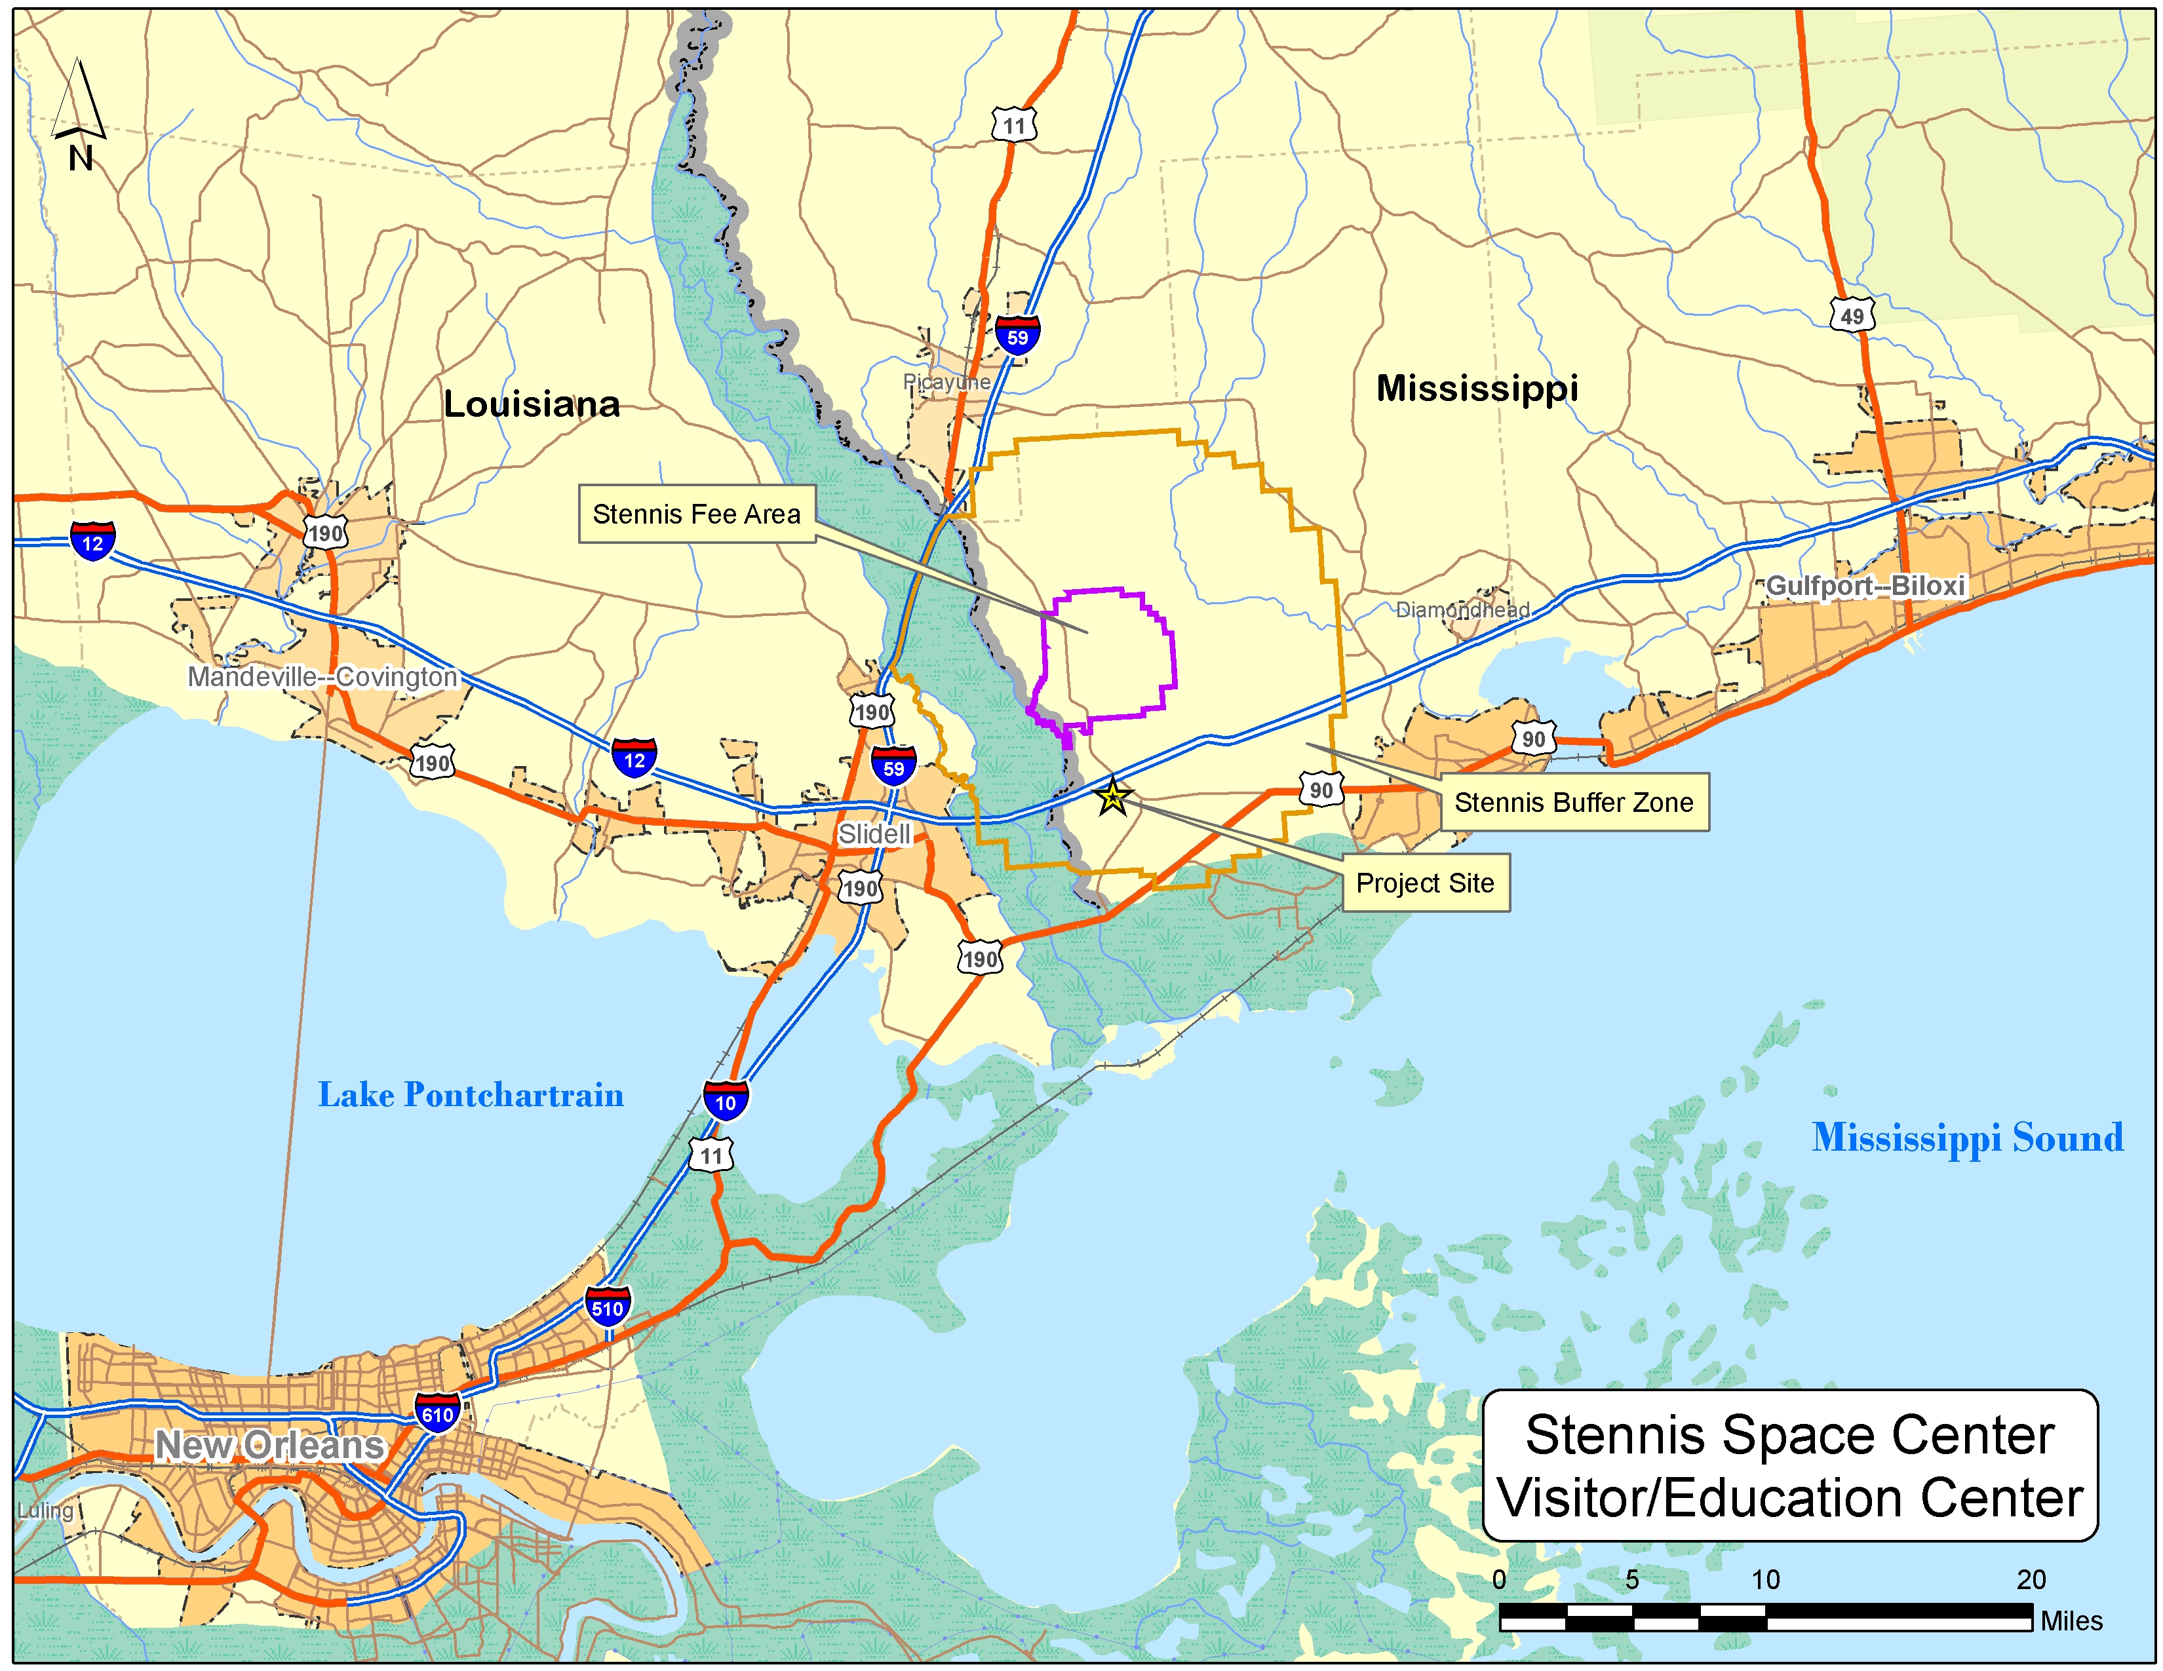
Figure 1 – General Vicinity 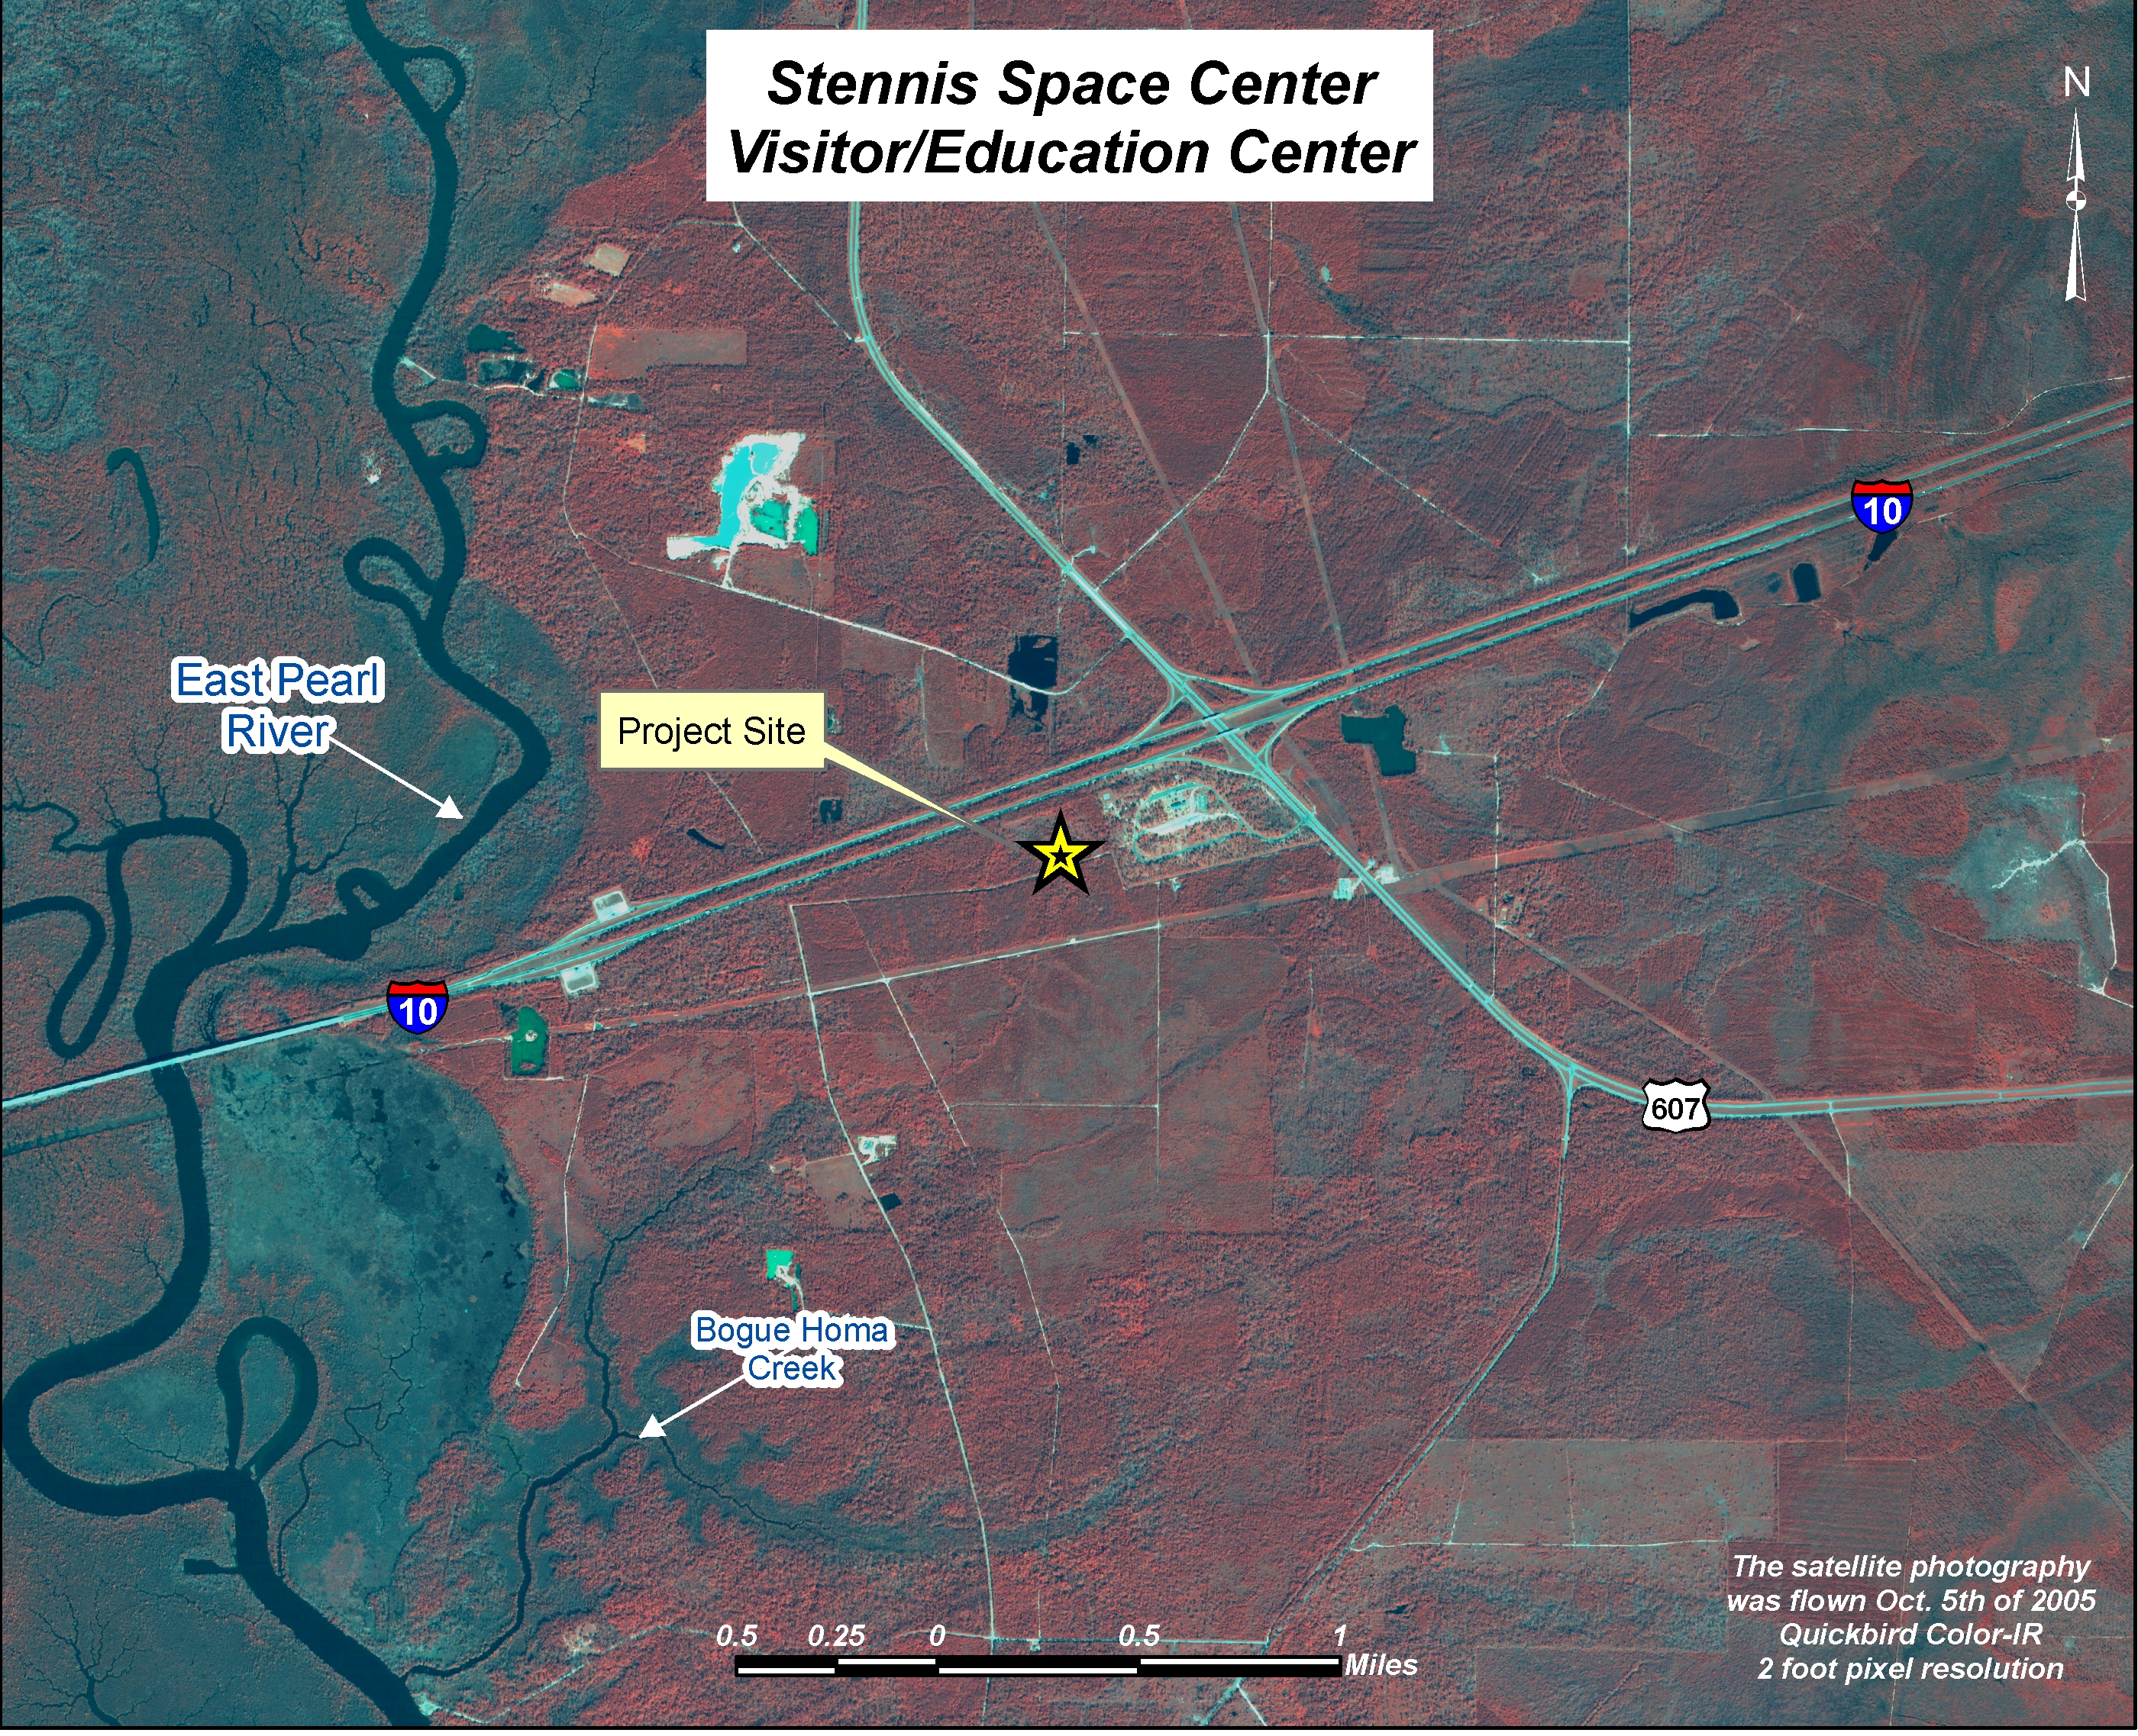
Figure 2 – Local Area Map
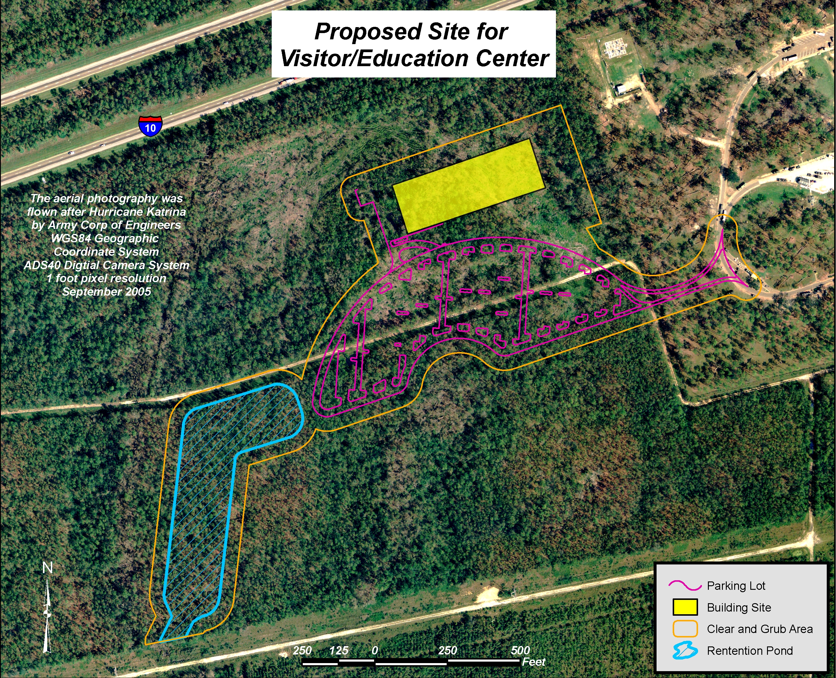
Figure 3 – Proposed Site
3.0 Existing Environment and Environmental Consequences of Alternatives

NASA’s John C. Stennis Space Center (SSC) is located near the Gulf of Mexico in western Hancock County, Mississippi, approximately 89 kilometers (55 miles) northeast of New Orleans, Louisiana and approximately 48 kilometers (30 miles) west of Biloxi/Gulfport, Mississippi. Rocket testing operations at SSC necessitated development of a "Buffer Zone" for safety and acoustic considerations. A perpetual restrictive easement on 506 square kilometers (125,001 acres) was acquired, which extends six miles in all directions from SSC. In 2002 NASA purchased 80.5 hectares (199 acres) of property within the Buffer Zone along Interstate 10 at Exit 2. The proposed project site for the Visitor/Education Center is approximately 4.8 kilometers (3 miles) south of SSC.

The NASA property topography is flat with a range of 15 to 20 feet in elevation. Vegetation consists of pine and mixed bottomland hardwood species. There are intermittent streams within the area flowing into Bouge Homa Creek which flows to the East Pearl River. There are currently no structures on the property. The closest structures are the I-10 Mississippi Welcome Center, a Mississippi Power substation and a Mississippi Department of Transportation I-10 weigh station. There is no physical evidence that any activity harmful to the environment has occurred on the property. The area history appears to be exclusively silvaculture or free range grazing.

Approximately 80 % of marketable timber on the proposed 12.5 hectare (31 acre) construction site was removed by NASA’s Natural Resources Management Program in October 2004. The remaining marketable timber was removed in June 2006.

The construction site is located in close proximity to a major interstate highway. There is no evidence of threatened or endangered species in the area or ecologically sensitive habitats. The closest archeological site that is potentially eligible for the National Register is the town site of Logtown that is approximately two miles to the southeast.

The Mississippi Department of Marine Resources (DMR) owns 486 hectares (1200 acres) of property west of the NASA property and has included their property within the Mississippi Coastal Preserves Program. MAST, Inc is working in partnership with the DMR to enhance exposure to and understanding of the unique ecosystem located within the DMR property boundaries.

The following sections describe possible impacts that may occur during construction or operation of the Visitor/Education Center. The most notable impacts would be short-term fugitive air emissions, short-term intermittent noise from construction, wetlands disturbance, storm water runoff, groundwater withdrawal, a waste water outfall and the generation of solid waste.

3.1 Air Quality

The proposed site is considered to be in a rural area for air quality. It will probably remain rural due to NASA's restrictive easement Buffer Zone. The ambient air quality of the three southern Mississippi counties (Hancock, Harrison and Jackson) is considered to be in attainment for PM₁₀, ozone, carbon monoxide, sulfur dioxide, nitrogen oxides, and lead.

Air emissions from the construction of the Visitor/Education Center would include short-term fugitive air emissions from construction activities. Dust from the site would be controlled with water spray to minimize these emissions.

The new facility would require natural gas fired boilers for heat and hot water. No emergency generators are planned to be installed.

Bus service is currently provided for visitors at the Mississippi Welcome Center to tour SSC and visit the current NASA visitor’s center located in Building 1200. The relocation of the visitor’s center to the Welcome Center location would not cause discontinuance of the bus service. The visitor experience would continue to include a tour of SSC to see the rocket test stands first hand but would not include a stop at Building 1200. Therefore, air emissions from buses would continue and may increase depending on the success of attracting visitors.

The “No Action Alternative” would have no additional air emissions.

3.2 Noise

Current noise at the proposed construction site consists mostly of traffic noise from the interstate highway. Other noise is typical of an interstate rest area. Noise from activities associated with the development of the proposed site and building construction would have a short-term intermittent impact. Noise from operations at the Visitor/Education Center would be consistent with current noise levels.

The "No Action Alternative" would result in no additional noise.

3.3 Water Quality

The proposed site would be located within the Pearl River Watershed Basin and the Lower Pearl Sub-basin. This basin is characterized as estuarine, is bounded by salt marsh, and is tidally influenced. The waters are classified as Fish and Wildlife streams and are considered to be of fair to good water quality. Waters in this classification are intended for fishing, the propagation of fish, aquatic life and wildlife.

The Visitor/Education Center would generate waste water from restrooms and food service facilities. This would require a new waste water treatment system. This system is proposed to be a hybrid microbial filter-reed wastewater treatment system. This type of system combines microbial filter technology with vascular plant waste water treatment technology. The system uses rooted, cold tolerant plants such as the common reed growing on the surface of a microbial rock filter bed. NASA currently utilizes this type of waste water treatment system at two SSC locations. The concept for the treatment system was published in a NASA Technical Memorandum by B.C. Wolverton and R.C. McDonald in 1982. Using an estimate of 1,500 visitors per day using 26.5 liters (7 gallons) of water each, the treatment system would be required to treat approximately 39,742 liters (10,500 gallons) of waste water per day. The type of system described above is capable of treating over 3,028,000 liters (800,000 gallons) per day. The size of the system to be installed would be adjusted depending on future engineering calculations. The treatment system would be fenced to prevent public access and it would be located on the west side of the Visitor/Education Center at a distance that would be within the proposed construction site but as far away from the Visitor/Education Center as possible. The treated waste water would require an MDEQ NPDES permit to discharge into state waters.

Construction activities would impact storm water runoff from an area that would include the Visitor/Education Center, roads and parking lots. An MDEQ Large Construction Storm Water Permit would need to be secured by the construction contractor prior to clearing and grubbing the site. A 1.2 hectare (3 acre) storm water detention pond would be established to collect storm water during construction and following construction the pond would collect parking lot runoff. A storm water pollution prevention plan would need to be developed as part of the permitting process. Weekly inspections of the site would be required to ensure compliance with the permit and plan.

The "No Action Alternative" results in no new waste water outfall.

3.4 Groundwater Resources

Several aquifers can be traced through Hancock County, Mississippi. The area is underlain by fresh water-bearing, southward-tipping sands of the Miocene and Pliocene ages. Within these fresh water-bearing sands, one unconfined aquifer is found near the surface with ten or more confined aquifers at a greater depth. The fresh water-bearing zone is 600 to 900 meters (2,000 to 3,000 feet) thick in the area. Individual aquifers range from 30 to 140 meters (100 to 450 feet) in thickness, with most measurements closer to 30 meters. Solids content does not exceed 315 ppm. The aquifers have plentiful, almost untapped supplies of fresh water.

Potable water would be supplied by a new well. Preliminary estimates indicate that a well with a minimum of 378 liters (100 gallons) per minute would be required. The depth of a well to meet these requirements would be at 274 to 335 meters (900 to 1100 feet). Employees with Potable Water System Certification would treat the groundwater with chlorine gas for disinfection. The cylinders of chlorine gas would be contained in a pump house inaccessible to the public. A water tower would be necessary to store water for fire protection systems. The size of the water tower would be based on final building design requirements. An MDEQ water withdrawal permit and a Mississippi State Department of Health water supply approval and identification number would be required.

The "No Action Alternative" would have no change to groundwater usage.

3.5 Wetlands and Flood Plains

The site is within the Pearl River Watershed. Tributaries flow west to Bogue Homa Creek, then to the East Pearl River (Figure 2). The Pearl River empties into Lake Borgne which discharges into the Mississippi Sound.

As a result of the wetlands hydrology, the presence of hydric soils and hydrophytic vegetation, a large portion of the NASA Buffer Zone is considered jurisdictional wetlands by the U.S. Army Corps of Engineers (COE). A site specific Jurisdictional Determination was completed by the U.S. Army Corps of Engineers, Vicksburg District, on May 9, 2005. This extent of wetlands was superimposed on an aerial view of the proposed site (Figure 4). Of the 12.5 hectares (31 acres) to be disturbed 3.7 hectares (9.05 acres) is considered wetland and would require mitigation. A request for authorization to disturb wetland areas was sent to the COE on May 19, 2006.

The disturbance of wetlands on NASA owned land in Hancock County is covered under an existing General Permit #CELMK-OD-FE 14-GPD (Vicksburg District)-53 issued by the COE. As required by the permit, a Final Mitigation Plan was developed by NASA and the COE. NASA mitigates the unavoidable impacts to wetland functions associated with construction projects through creation, restoration, or enhancement and continued management of wetlands on property owned by NASA in the SSC Buffer Zone area. Management of wetlands and mitigation areas is conducted in accordance with 14 CFR 1216.205, Procedures for evaluating NASA actions impacting floodplains and wetlands.

The proposed site has been inspected and the compensatory mitigation credit factors have been calculated. The credit factor worksheet is attached in Appendix A. Of the 470.61 credits that SSC currently has available, 54.78 credits would be charged against the "Mitigation Bank" for the Visitor/Education Center. Calculations are based on the "Charleston Method" developed by the COE of the Charleston District. This method incorporates information about the project such as the quality of the wetlands, construction plans, parking areas, and fill material.

According to the Flood Insurance Rate Map for Hancock County, Mississippi (September 18, 1987) the proposed location is classified as Zone "C" meaning an area of minimal flooding. Recent maps developed by the Federal Emergency Management Agency (FEMA) show post Hurricane Katrina Advisory Base Flood Elevations (ABFE). The proposed location is in an area with an ABFE of 20 feet. The ABFE map is provided in Appendix A. The building to be constructed for the Visitor/Education Center would be built to keep the building elevations at 20 feet above sea level.

The “No Action alternative” would have no impact to wetlands.

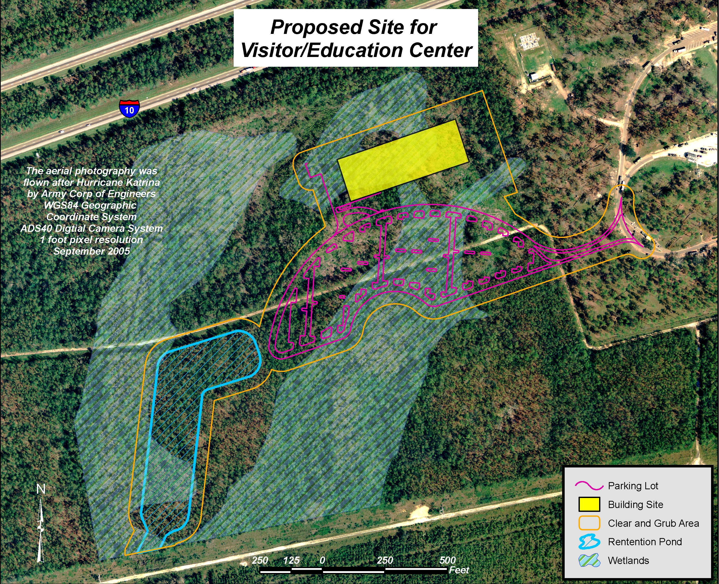
Figure 4 – Wetlands Map
3.6 Biotic Resources

The proposed location is in an area characterized by pine and mixed bottomland hardwood species. The dominant species found in bottomland hardwood communities are black gum, swamp tupelo and pond cypress. The understory includes ash species, black willow, red maple, poison ivy, honeysuckle and grapes. Very few grass or forb (herbs other than grass) species occur in these communities. Marketable timber was removed in October 2004 and June 2006.

The proposed construction site is located adjacent to an interstate highway so the area wildlife is currently impacted by the noise and pollution of heavy traffic. The proposed construction and operation of the new facilities would cause displacement of common wildlife such as deer, turkey and quail into adjacent wooded areas. These species would likely be replaced in the proposed area by species that are often found in open areas such as various songbirds.

The "No Action Alternative" would result in no additional impact.

3.7 Threatened and Endangered Species

Threatened and endangered species that are suspected to have ranges or suitable habitats that include western Hancock County are the Gulf sturgeon, eastern indigo snake, Florida panther, gopher tortoise, bald eagle, red-cockaded woodpecker, American peregrine falcon and Louisiana quillwort. The SSC Fee Area has been surveyed for the presence of these species on several occasions. The most recent faunal study was completed in 1998 by Dr. E.D. Keiser and Dr. P.K. Lago entitled “Survey for Five Endangered Animal Species at the Stennis Space Center, Hancock County, Mississippi.” The study found no indications of the occurrence of indigo snakes, red-cockaded woodpeckers, or peregrine falcons. One abandoned burrow was found that may have been dug by a gopher tortoise, but no individuals were sighted. Dr Jean Wooten has completed several vegetation surveys within the SSC Fee Area and has not found any species of quillwort present.

The U.S. Fish and Wildlife Service concurs with the opinions of Keiser, Lago and Wooten in a letter to NASA, February 1999, although they request a visual survey for federally listed species be conducted prior to any earth or vegetation disturbance. A visual inspection of the proposed site for the Visitor/Education Center was conducted in October 2003 by a COE representative, a NASA contractor environmental representative and the NASA Natural Resources Manager. No known federally listed species or species habitats were sighted. Additional trips to the site since the initial inspection have not provided any evidence of resident or transient threatened or endangered species.

Based on the Keiser and Lago report, the Wooten opinion, the concurrence by the U.S. Fish and Wildlife Service and a visual inspection of the proposed site for the facilities, construction would not affect any threatened or endangered species that may exist in the SSC vicinity.

The "No Action Alternative" would result in no impact to threatened or endangered species.
3.8 Archaeological and Cultural Resources

According to the NASA Historic Preservation Officer, a survey of the SSC Fee Area and Buffer Zone conducted by the U.S. Corps of Engineers in 1988 concluded that the SSC area was too disturbed to be historically significant. Nevertheless, as a proactive measure, SSC would investigate and assess the relevance of any artifacts, skeletal remains or structures discovered by contractors hired to clear the land and excavate the site. Contractors would be provided training on identification of these items.

There are no anticipated adverse archaeological or cultural impacts expected from this construction project. If items of potential archaeological or cultural interest are uncovered during construction, further construction in the immediate area would cease until the requirements of Section 106 of the National Historic Preservation Act have been satisfied.

The “No Action Alternative” would have no impact to archaeological resources.

3.9 Transportation

Interstates 10 and Mississippi 607 serve the Mississippi Welcome Center area. Highway 607 connects with U.S. Highway 90 approximately 9.6 kilometers (6 miles) southeast of the proposed site.

According to 2004 data collected by the Gulf Regional Planning Commission, the annualized average daily traffic (AADT) total for Interstate 10 west of Highway 607 is 35,000. The 2004 AADT for Highway 607 south of Interstate 10 is 7,400. Traffic is not expected to increase because of the new facilities but it is expected to draw more people off of the interstate and highway. Planning guidelines prepared for the Visitor/Education Center estimate that attendance may be between 1,430 and 1,980 visitors per day. A traffic light may be installed at the entrance to the Mississippi Welcome Center if warranted.

The “No Action Alternative” would not increase traffic to the Mississippi Welcome Center area or change traffic patterns around the center.

3.10 Waste Generation

The Visitor/Education Center would generate solid waste from facility operations and maintenance. The solid waste generated would consist of household-type wastes.

NASA is committed to pollution prevention, including recycling and reuse activities to achieve waste minimization goals. Recycling collection areas would be established in the new facility for paper, cardboard, aluminum cans and plastic bottles.

The "No Action Alternative" would produce no additional solid waste.
3.11 Socioeconomics

Construction would require temporary employment of approximately 50 employees through construction contractors. The Visitor/Education Center would require between 50 and 65 employees responsible for day to day operations. Some of the employees currently working at StenniSphere would be transferred to the Visitor/Education Center.

There would be a beneficial economic impact based on tourist expenditures at the Visitor/Education Center and at locations nearby that provide services.

The “No Action Alternative” would result in no temporary or permanent employment opportunities and no beneficial economic impact.

3.12 Public and Employee Health and Safety

The Visitor/Education Center would adhere to Occupational, Health, and Safety Administration standards for protection of employee’s onsite. The Center would also adhere to the SSC Safety and Health Procedures and Guidelines which details specific emergency procedures for responding to natural and human-generated emergencies.

The “No Action Alternative” would not require additional training for employees at the proposed site on emergency procedures.

3.13 Pollution Prevention and Environmental Justice

In accordance with Executive Order (EO) 12856, “Federal Compliance with Right-to-Know Laws and Pollution Prevention Requirements,” NASA has written a pollution prevention strategy into the SSC Pollution Prevention Plan. This plan encourages elimination or reduction of the use and purchase of toxic chemicals, energy efficiency, solid waste reduction and recycling, water conservation, hazardous waste minimization, and oil spill prevention.

In accordance with EO 13101, “Greening the Government Through Waste Prevention, Recycling, and Federal Acquisition,” NASA prevents pollution by recycling and reusing materials whenever possible. Additionally, NASA complies with federal policies for acquisition and use of environmentally preferable products by purchasing items made from recycled materials such as carpet, insulation, and concrete.

In accordance with EO 12898, “Federal Actions to Address Environmental Justice in Minority Populations and Low-Income Populations,” NASA considers environmental justice issues during program and project planning consistent with the SSC Environmental Justice Strategy. Any disproportionately high and adverse effects of proposed programs at SSC on minority or low-income populations would be identified and action would be taken to resolve public concern. Because of the size of the SSC Buffer Zone surrounding the Fee Area, there are no environmental justice concerns associated with this project.

Policies and procedures for the Visitor/Education Center would be consistent with the NASA plans and Executive Orders.

During the design phase of this facility, engineers working on this project would pursue Leadership in Energy and Environmental Design (LEED) Green Building certification. The intent would be to achieve “Silver” Certification. This certification requires planners to consider issues related to sustainability such as water efficiency, energy efficiency, native plant landscaping, and conservation of materials and resources. By incorporating sustainability principles into the planning process, environmental impacts are minimized for new building construction.

Additional pollution prevention strategies that are being considered include the use of hydrogen powered buses with fuel cells and an innovative power system that makes efficient use of energy and provides cooling without the use of ozone depleting substances. These potential pollution prevention opportunities would be used to demonstrate emerging technologies that have less environmental impact than current practices.

The “No Action Alternative” would not require additional recycling activities, purchase of materials with recycled content, or the opportunity to use emerging technologies for water and energy efficiency.

3.14 Cumulative Impact

Cumulative impact is the impact on the environment which results from the incremental impact of the action when added to other past, present, and reasonably foreseeable future actions regardless of what agency (Federal or non-Federal) or person undertakes such other actions. Cumulative impacts can result from individually minor but collectively significant actions taking place over a period of time.

Future enhancements for the Visitor/Education Center may include the possible addition of a large format theatre, additional exhibition space, workshop and storage space.

Long term cumulative impacts for development of the Mississippi coastal counties have been addressed in the U.S. Army Corps of Engineers Environmental Impact Statement Enhanced Evaluation of Cumulative Effects Associated with U.S. Army Corps of Engineers Permitting Activity for Large-Scale Development in Coastal Mississippi, August 2005. This environmental impact statement (EIS) provides information on land use and population growth of Hancock County from 1972 to 2000. According to the report, in 2000 natural cover accounted for 84 percent of Hancock County’s total acreage. Medium and high density urban land and transportation infrastructure accounted for most of the rest. In 1972, 26.2 percent of land or 32,778 hectares (80,994 acres) in Hancock County was deciduous/mixed bottomland hardwood/swamp compared to 2000 when this decreased to 24.1 percent or 29,899 hectares (73,879 acres). The disturbance to wetlands by the Visitor/Education Center of 3.7 hectares (9.05 acres) adds to this decline by 0.003 percent, a small impact on the overall land cover in the County.

The “No Action Alternative” would not add to the cumulative environmental impact of development in Hancock County.

4.0 Agencies and Individuals Consulted

The U.S. Army Corps of Engineers, Vicksburg District was consulted on the determination of jurisdictional wetlands at the proposed construction site that would be regulated under Section 404 of the Clean Water Act. Their correspondence is provided in Appendix A.
5.0 List of Contributors and Preparers

Name | Position | Expertise
Michael J. Blotzer | NASA, SSC Environmental Officer | Environmental Management
Hugh V. Carr | NASA, SSC Environmental Specialist | Natural Resources  Wetlands
Craig J. Case | U.S. Army Corps of Engineers Forester | Timber Management
Marco J. Giardino | NASA, SSC Historic Preservation Officer | Archeological and Cultural Resources
Dave H. Golden | Applied Geo Technologies Scientist | Wetlands  Wildlife
Jenette B. Gordon | NASA, SSC Environmental Specialist | Water Quality  Solid Waste  Pollution Prevention
Carolyn D. Kennedy | NASA, SSC Environmental Specialist | NEPA Management  Air Quality
John A. Wilson | InDyne, Inc. Director of Educational Programs | Education Program
Dale A. Woolridge | NASA, SSC Design and Construction Project Manager | Project Management

6.0 References

Campbell, Dr. Charles. 2002. Estimation of the Economic Impact of the MAST, Inc. I-10 Visitor Center on the Local Area Including Harrison, Hancock, and Pearl River Counties in Mississippi, and St. Tammany Parrish in Louisiana for Fiscal Year 2001. Updated April 2006.

Federal Emergency Management Agency, Flood Insurance Rate Map, Hancock County, Revised Map, September, 1987.

Federal Interagency Committee for Wetlands Delineation. 1989. Federal Manual for Identifying and Delineating Jurisdictional Wetlands, U.S. Army Corps of Engineers, U.S. Environmental Protection Agency, U.S. Fish and Wildlife Service, and U.S. Department of Agriculture Soil Conservation Service, Washington, D.C., Cooperative Technical Publication.

Gulf Regional Planning Commission. 2004. 2004 Traffic Counts, www.grpc.com.

James, Curtis B. U.S. Fish and Wildlife letter dated February 23, 1999 regarding the presence of federally listed species within the Fee Area of the Stennis Space Center, Hancock County, Mississippi.

Keiser, E.D. and P.K. Lago. 1991. Survey of the Amphibians, Reptiles, Birds, and Mammals on the 3,000 acre Stennis Space Center, ASRM Site Final Report, University of Mississippi, University, Mississippi.

Keiser, E.D. and P.K. Lago. 1998. Survey of Five Endangered Animal Species at the Stennis Space Center, Hancock County, Mississippi.

MDEQ. 2000. Pearl River Basin Status Report.

NASA. 1995. Environmental Justice Strategy, John C. Stennis Space Center.

NASA. 1998. SPG 8715.1, John C. Stennis Space Center SSC Safety and Health Procedures and Guidelines.

NASA. 2002. SCWI-8500-0017-ENV, John C. Stennis Space Center Pollution Prevention Plan.

NASA. 2006. SCWI-8500-0026-ENV, John C. Stennis Space Center Environmental Resources Document.

NASA. 2003. Historic Preservation Plan, John C. Stennis Space Center.

Smith, W., P. Nichols Jr., and L. Walton. 1978. Soil Survey of Hancock County, Mississippi, United States Department of Agriculture, Soil Conservation Service.

U.S. Army Corps of Engineers, Mobile District. 2005. Final Environmental Impact Statement for Enhanced Evaluation of Cumulative Effects Associated with the U.S. Army Corps of Engineers Permitting Activity for Large-Scale Development in Coastal Mississippi.

Wolverton, B.C. and R.C. McDonald. 1982. Basic Engineering Criteria and Cost Estimation for Hybrid Microbial Filter-Reed (Phragmites communis) Wastewater Treatment Concept. NASA Technical Memorandum – 84669.

Wooten, J.W. 1990. A Fall Botanical Survey of a portion of the National Aeronautics and Space Administration Installation Stennis Space Center Mississippi, John C. Stennis Space Center.

Wooten, J.W. University of Southern Mississippi letter dated April 21, 1998 regarding the presence of species of Isoetes within the SSC Fee Area.

7.0 Distribution List

Maury Oceanographic Library, Building 1003, Stennis Space Center, MS 39529

Bay St. Louis - Hancock County Library, 312 Highway 90, Bay St. Louis, MS 39520

Kiln Public Library, 17065 Highway 603, Kiln, MS 39556

Margaret Reed Crosby Memorial Library, 900 Goodyear Blvd., Picayune, MS 39466

St. Tammany Parish Library, 555 Robert Blvd., Slidell, LA 70458

U.S. Fish and Wildlife Service, 2524 South Frontage Road, Suite B, Vicksburg, MS

Mississippi Department of Archives and History, P.O. Box 571, Jackson, MS

National Aeronautics and Space Administration, Headquarters, Library, 300 E Street SW, Washington, DC
APPENDIX A

Environmental Reviews and Consultations

NOTE

This appendix includes:

1. Calculation of wetlands mitigation bank credits
2. The FEMA ABFE map
3. Correspondence from the U.S. Army Corps of Engineers on jurisdiction wetlands


