Fourth International Workshop on
Sample Environment at
Neutron Scattering Facilities

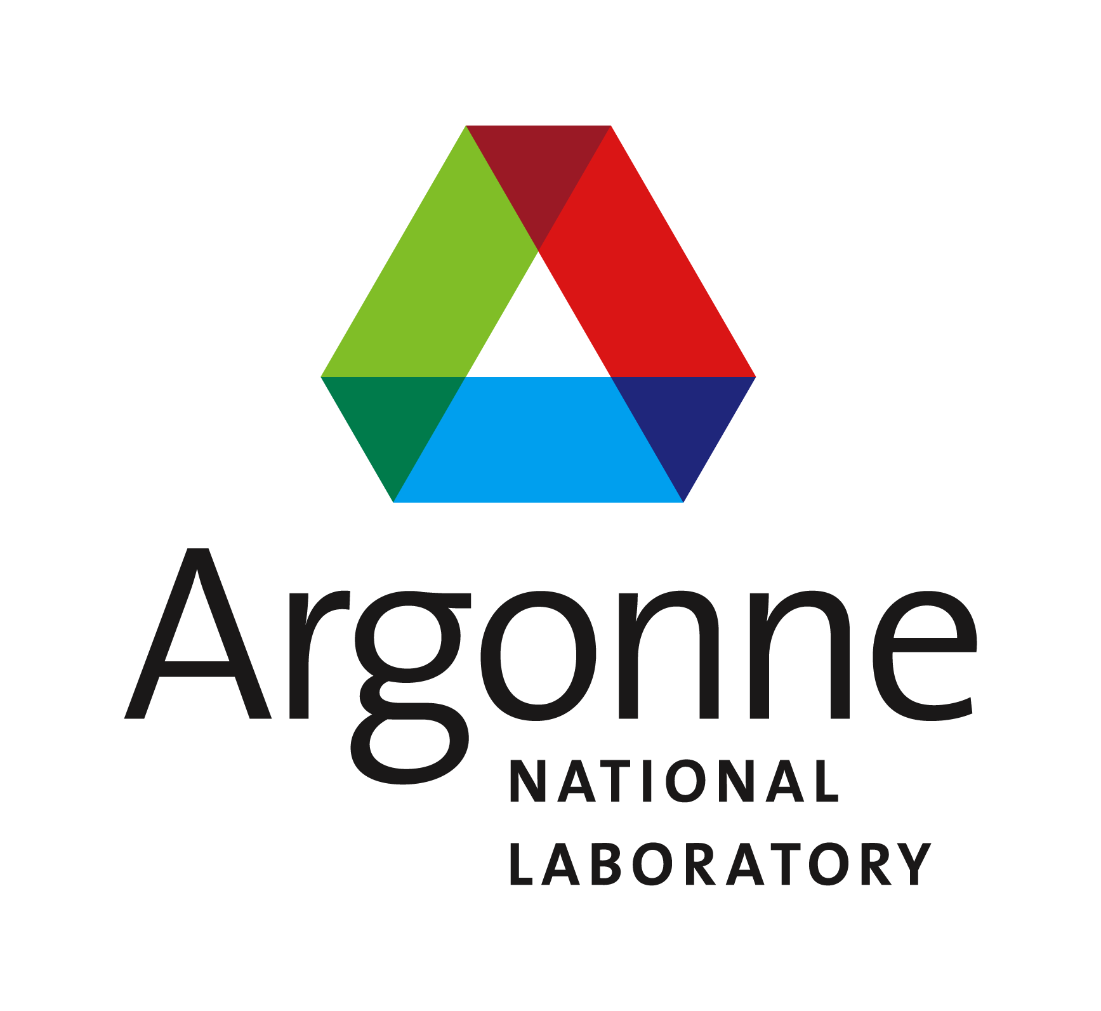

Argonne, IL USA
September 6-8, 2006
Wednesday, September 6, 2006 Building 360, L119
08:00am to 08:30am Registration and Gathering Time
08:30am to 09:00am Welcome & Introductions – Ray Teller and Ken Volin
Session I Chair: Michael Meissner
09:00am to 09:20am Ever Improving Sample Environment at the IPNS
Ken Volin, IPNS/ANL, Argonne, IL USA.
09:20am to 09:40am Overview of the “Modernization of Sample Environment” Project
Eddy Lelièvre-Berna, N. Belkhier, E. Bourgeat-Lami, S. Demas, J.–P. Gonzales, J.–L. Laborier, O. Losserand, P. Martin, L. Mélési, P. Mendes, J.–L. Ragazzoni, and X. Tonon, ILL, Grenoble, FRA
09:40am to 10:00am Alignment Techniques for Installing Neutron Scattering Instruments using Modern Laser Interferometry
Scott Moore, J. L. Robertson, G. B. Taylor, CNS/ORNL, Oak Ridge, TN, USA, E. R. Blackburn, M. W. Humphreys, ORNL, Oak Ridge, TN, USA, and C. E. Stalsworth, Y-12/ORNL, Oak Ridge, TN, USA
10:00am to 10:30am Break and Discussions – Building 360 L145
Session II Chair: Zoe Bowden
10:30am to 10:50am Sample Environment on High Resolution Fourier Diffractometer on IBR-2 Reactor
Valeriy Simkin, FLNP/JINR, Dubna, RUS
10:50am to 11:10am Spreadsheet Calculations for Sample Environment Problems
Lou Santodonato, SNS/ORNL, Oakridge, TN USA
11:10am to 11:30pm Cryofurnace Made Simple
Bruce Hill and J. W. Wenzel, SNS/ORNL, Oakridge, TN USA
11:30am to 11:50am 7th Framework Programme Sample Environment Joint Research Activity
Moderator: E. Lelièvre-Berna
11:50pm to 02:00pm Lunch and Discussions – Argonne Cafeteria Building 213, Dining Rm B
Session III Chair: Scott Olsen
02:00pm to 02:20pm Novel Cryogen Level Monitors
Xavier Tonon , Olivier Losserand, N. Belkhier, J.-P. Gonzales, P. Mendes, J.-L. Ragazzoni, X. Tonon, and E. Lelièvre-Berna, ILL, Grenoble, FRA
02:20pm to 02:40pm The Quest for Rapid Cooling and Setpoint Equilibration
Lakeisha Walker, SNS/ORNL, Oakridge, TN USA
02:40pm to 03:00pm Sample Environment Innovation at the GPPD Instrument
Evan Maxey, IPNS/ANL, Argonne, IL USA
03:00pm to 04:00pm Poster Session I – Building 360, L145
• Update on Thermometry at ILL
Xavier Tonon, J. Gonthier, N. Belkhier, J.-P. Gonzales, O. Losserand, P. Mendes,J.-L. Raggazoni, and E. Lelièvre-Berna, Institut Laue Langevin, Grenoble, FRA.
• Controls Engineering for a Compact Crystal Positioning System
Prishantha Dunstan, C. Hoffmann, R. Viola, E. Miller, P. Carman, L. Santodonato and G. Granroth, SNS, Oak Ridge National Laboratory, Oak Ridge, TN, USA
• Hydrogen Under Pressure at ISIS
Andy Church and C. Goodway, ISIS/RAL, Oxfordshire, UK
• Gas Pressure Cells Designed and Built at the IPNS for Neutron Scattering Experiments
Bob Kleb and Rich Vitt,, IPNS/ANL, Argonne, IL USA
• Direct Pressure Measurement using Ruby Fluorescence
Beth Evans and J. W. Dreyer, ISIS/RAL, Oxfordshire, UK
Session IV Chair: Ken Volin
04:00pm to 05:00pm Tour of the IPNS Sample Environment
05:00pm End of Workshop Day
Thursday, September 7, 2006 Building 360, L119
08:30am to 09:00am Gathering Time
Session V Chair: Jurgen Peters
09:00am to 09:20am Packaging Top-Loading Closed-Cycle Refrigerators for Beamline Research
Dan Dender, NCNR/NIST, Gaithersburg, MD USA
09:20am to 09:40am EPICS Control of Sample Environment
Rodney R. Porter, IPNS/ANL, Argonne, IL USA
09:40am to 10:00am SEA – a Modular Sample Environment Control System
Markus Zolliker and M. Koennecke, Laboratory for Developments and Methods, SINQ/PSI, Villigen, SUI
10:00am to 10:30am Break and Discussions – Building 360, L145
Session VI Chair: Marcus Zolliker
10:30am to 10:50am Refrigerator Cryostats at BENSC
Michael Meissner and S. Gerischer, BENSC/HMI, Berlin, GER
10:50am to 11:10am Latest Developments in Closed Cycle Cryostats at Forschungsneutronenquelle Heinz Maier-Leibnitz (FRM II)
Heinrich Kolb and J. Peters, Forschungsneutronenquelle Heinz Maier-Leibnitz , GER
11:10am to 11:30pm Exploitation of Pulse Tubes at ISIS
Beth Evans and O. Kirichek, ISIS/RAL, Oxfordshire, GBR
11:30am to 11:50am Open Discussion on Information Interchange via the Web
Moderators:?
11:50pm to 02:00pm Lunch and Discussions - Argonne Cafeteria Building 213, Dining Rm B
Session VII Chair: Eddy Lelievre-Berna
02:00pm to 02:20pm Combined Levitation and Neutron Diffraction to Investigate Liquids at ExtremeTemperatures
R. Weber, J.E. Rix, Containerless Research, Inc., Evanston, IL, 60202, USA, C.J. Benmore, J.E. Siewenie, IPNS/ANL, Argonne, IL, USA, and L.J. Santodonato, SNS/ORNL, Oak Ridge, TN, USA
02:20pm to 02:40pm Design and Implementation of a Cryogenic Loading Capability on the Spectrometer for Materials Research at Temperature and Stress (SMARTS)
Tim Woodruff, V. Krishnan, R. Vaidyanathan, Advanced Materials Processing and Analysis Center; Mechanical, Materials and Aerospace Engineering, University of Central Florida, Orlando, FL USA, and B. Clausen, T. Sisneros, D. Brown, M. Bourke, LANSCE/MST, Los Alamos National Laboratory, Los Alamos, NM USA
02:40pm to 03:00pm Automatic Sample Changer for Cryogenic Sample Environments
Jim Rix and R. Weber, Containerless Research, Inc, Evanston, IL USA, L. J. Santodonato, B. Hill, J. Hodges, M. Rennich, SNS/ORNL, Oak Ridge, TN, USA, and K.J. Volin, IPNS/ANL, Argonne, IL, USA
03:00pm to 04:00pm Poster Session II – Building 360, L145
• Super Solid Helium
Richard Down and D. Bruce, ISIS/RAL, Oxfordshire, UK.
• Sample Environment Testing and Diagnostics using LabVIEW
Rich Como and K. J. Volin, IPNS/ANL, Argonne, IL USA.
• New Power-Bays for ILL-type Furnaces
Steffen Demas, P. Martin, N. Belkhier, E. Lelièvre-Berna, ILL, Grenoble, FR
• Advanced Magnets for Pulsed Neutron Scattering at ISIS
Dave Bunce and R. Down, ISIS/RAL, Oxfordshire, UK.
• New Pressure Cells at ISIS
Andy Church and C. Goodway, ISIS/RAL, Oxfordshire, UK
Session VIII Chair: Scott Moore
04:00pm to 04:20pm Radial Collimators, Reducing SE Background on the SEPD
Joe Fieramosca, IPNS/ANL, Argonne, IL USA
04:20pm to 04:40pm Pulsed Magnetic Field Experiments for Neutron and X-Ray
Hiroyuki Nojiri, K. Ohoyama, and Y. H. Matsuda, Institute for Materials Research, Tohoku University, Sendai, JPN

04:40pm to 05:00pm New High Field Magnet for Neutron Scattering at Hahn-Meitner Institute
Peter Smeibidl, BENSC/HMI, Berlin, GER
05:00pm End of Workshop Day

06:00pm to 8:00pm No-Host Reception at the Argonne Exchange Club, Building 617
Snacks and Cash Bar
Friday, September 8, 2006 Building 360, L119
08:30am to 09:00am Gathering Time
Session IX Chair: Dan Dender
09:00am to 09:20am Sample Environments at the OPAL Neutron Beam Facility
Scott Olsen, J.Schulz, S.Kennedy, R.Robinson, R.Piltz, G.Davidson, M.Perry, G.Horton, Bragg Institute, Australian Nuclear Science and Technology Organisation, Sydney, AUS
09:20am to 09:40am 0.3K– 900K Gas-Loading Apparatus Capability at the NIST Center for Neutron Research
Juscelino Leão, D. Dender, and C. M. Brown, NCNR/NIST, Gaithersburg, MD USA
09:40am to 10:00am Sample Environments for Controlled Gas Deposition up to 10 kbar
Klaus Kiefer, D. Wallacher and M. Meissner, BENSC/HMI, Berlin, GER.
10:00am to 10:30am Break and Discussions – Building 360, L145
Session X Chair: Lou Santodonato
10:30am to 10:50am Rheo-SANS at NIST Center for Neutron Research
Bryan Greenwald, NCNR/NIST, Gaithersburg, MD USA
10:50am to 11:10am The New Motion Control Systems for TS2
Dennis Cowdery, ISIS/RAL, Oxfordshire, GBR
11:10am to 12:00pm Workshop Summary – Ken Volin and Michael Meissner
Announcement of location of next workshop!
12:00pm Conclusion of Workshop

