


Albuquerque Operations Office

Program Guidance for the Disposition of Excess Facilities

September 14, 2001
Rev. 0 – Final Draft
ERD-92001-01

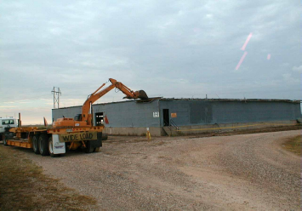
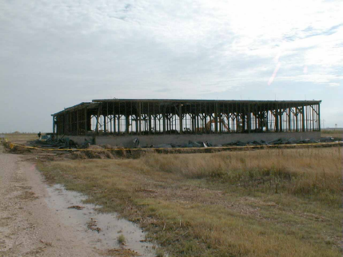
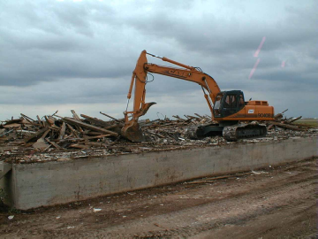

Intentionally Left Blank
Table of Contents
1.0 Introduction 1
1.1 Background 1
1.2 History of the DOE Excess Facilities 1
1.3 Need for Program Guidance 2
1.4 Implementation and Contents of the Program Guidance 2
2.0 Planning Overview 3
2.1 Key Planning Documents and Data Management Systems 3
2.2 Establishing Metrics and Reporting Progress 3
2.3 Planning for Appropriations 4
2.3.1 Planning for Appropriations of Process Contaminated Excess Facilities 4
2.3.2 Planning for Appropriations of Non-Process Contaminated Excess Facilities 4
2.3.3 Prioritizing facilities for D&D/ Site Specific Prioritization Process 5
2.3.4 Establishing EM Priorities within the AL EM Program 5
2.4 Technology Demonstration and Deployment 6
2.5 Managing the Inventory of Excess Facilities – Data Collection and Entry 6
2.6 AL Excess Facility Five Year Plan 6
3.0 Project Management Systems/Requirements 6
3.1 Lifecycle Data Planning Elements for D&D 7
3.2 Baseline Change Process Relative to Transition of New Facilities to EM 7
4.0 The Facility Disposition Process 8
4.1 Facility Landlord Pre-Transition Activities (Preparing A Process Contaminated Facility for Transition to EM) 8
4.1.1 Departmental Guidance, References and Requirements 8
4.1.2 Excess Declaration 11
4.1.3 Early Actions 12
4.1.4 Conduct of Early Actions (Authorization Basis) 12
4.1.5 End Point Development 13
4.1.6 Pre-Transition Activities 13
4.1.7 Pre-Transfer Agreement (Memorandum of Agreement) 13
4.1.8 Pre-Transfer Stabilization Operations 13
4.1.9 Project Management and Documentation Requirements for Pre-Transition and Key Documents 14
4.2 Post Transition Activities Implemented by Environmental Management Program for process Contaminated Facilities 15
4.2.1 Facility Deactivation 15
4.2.2 Safe Storage 15
4.2.3 Facility Decommissioning 15
4.2.4 Final End State and Close out 16
5.0 Timelines for Transferring Process Contaminated Excess Facilities 16
5.1 Overview of a Timeline for Major Process Contaminated Facilities 16
5.2 Timeline Details of Facility Transition Activities 17
5.3 Timeline for Identifying Work Scope and Cost Associated with Contaminated Facilities 17
6.0 Lessons Learned 18
6.1 Deactivation Cost Reduction Opportunities 18
6.2 Requirements – Based Surveillance and Maintenance Cost Reduction Opportunities 18
6.4 Decommissioning Cost Reduction Opportunity 19
7.0 Roles and Responsibilities 19
7.1 Albuquerque Operations Office Organizations 19
7.2 Roles and Responsibilities of the Established Disposition Process 23
7.2.1 Description of Process (Figure 6) Elements 24
8.0 Appendix I
8. 1 Definitions I
8.2 Pre-Transfer Agreement Example II
8.3 Transfer Activities Checklist IV
8.4 Excess Facility Transfer Workbook V
8.4.1 Instructions V
8.4.2 Excess Facility Transfer Workbook Cost Information VIII
8.4.3 Excess Facility Transfer Workbook General Facility Information IX
8.4.4 Excess Facility Transfer Workbook Key Activities and Milestones X
8.5 Outline for Excess Facility Five Year Plan XI
8.6 Excess Facility Five Year Forecast Workbook XII
8.7 References XIII

1.0 Introduction

1.1 Background
The end of the cold war brought about a significant downsizing of the Department of Energy’s Nuclear Weapons Production Complex. As a result, there are a number of buildings and structures within the complex that no longer serve a specific mission need or purpose, and have either become excess to mission needs, or anticipated to become excess in the coming years.
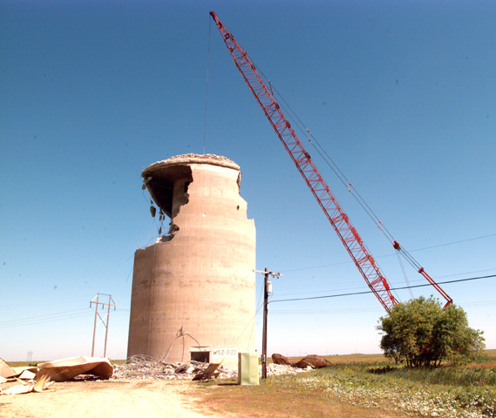

This document describes the Albuquerque Operations Office’s (AL) approach to managing all excess facilities. For the purposes of this document, an excess facility is defined as a building and the building’s ancillary supporting structures, and includes buildings, which are process contaminated as well as those, which are not process contaminated. For purposes of planning, budgeting, and prioritizing buildings within the Excess Facilities Program, a distinction will be made regarding those facilities and structures which are deemed to have been contaminated by operational processes (both radiological and chemical), and those which are not process contaminated.
Programmatic Goals
- Achieve facility disposition in a cost effective, expeditious manner.
- Proceeding in a manner to protect the environment, worker, and the public and in compliance with all applicable laws and regulations.
It will be the goal of the Environmental Restoration Division (ERD), to be the service center for providing a centralized, coordinated, integrated, and cost-effective means of managing the disposition of all excess facilities within the AL Complex. The mission of the AL Excess Facilities Program is identified as follows:

“To provide for the disposition of all excess facilities within the AL complex in the most expeditious and cost effective manner, while protecting the environment, workers, the public, and complying with all applicable laws and regulations.”

1.2 History of the DOE Excess Facilities
Within the Department of Energy (DOE), the Office of Environmental Management (EM) has been chartered with responsibility to fund and manage the Deactivation and Decommissioning (D&D) of process-contaminated facilities. In 1995, at the direction of the DOE Headquarters, the acceptance of additional work scope to the EM Program was suspended. As a result of this action, a number of process contaminated facilities and the Landlord Program placed structures, which would have normally been transferred to the EM for D&D, in a standby status. Over time, the investment required to maintain the facilities in a safe condition has increased, while the overall Landlord funding to maintain these facilities has decreased. In 1999, the DOE reversed its decision regarding the addition of new workscope to the EM Program, and identified a transition process within the Life Cycle Asset Management (LCAM) Directive. The transition process identified in LCAM requires a review to be performed and documented prior to transferring the responsibility for the facility to the EM Program. For purposes of this program guidance, these facilities are identified as “Process Contaminated Excess Facilities Meeting the Pre-Transition Requirements.”

Another grouping of process contaminated excess facilities includes those that were already transitioned by the Landlord Program to the EM program, before 1995. A few of these facilities were included within the site Environmental Restoration Baseline as defined scope of work for D&D.

In addition to the process contaminated excess facilities, there are non-process contaminated facilities and structures, which are identified as excess to the site’s mission. These, by definition are not complex projects, and therefore, not expected to be transferred to the EM Program. Some of these facilities and structures are beyond their design life, and contain materials such as asbestos and lead paint. It is anticipated that these facilities can undergo D&D with the use of standard industrial methods, or may be potential candidates for reuse. In most instances, the responsibility for the disposition of these facilities and structures are to remain with Landlord Program. However, this responsibility will continued to be reviewed on a case-by-case basis, and consideration will be given to past activities conducted in the facilities to ensure that they are not candidates for transfer to the EM Program. These facilities are not typically part of the above mentioned Environmental Restoration Baseline, and D&D activities should be defined and included as part of the site’s landlord planning and budgeting documentation.

1.3 Need for Program Guidance
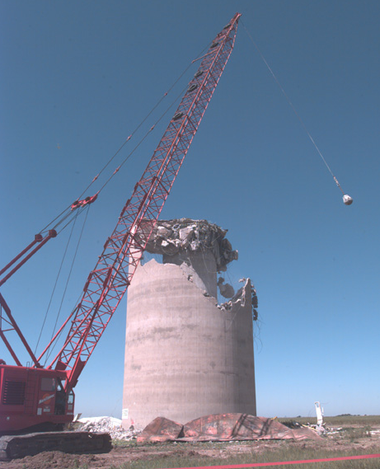
As stated in the AL Performance Plan, “AL will support the Department’s mission to:
- Maintain a safe, secure and reliable nuclear weapons stockpile
- Manage nuclear materials awaiting permanent disposition
- Achieve a restored environment
- Maintain a strong science and technology base.

In this regard, the Excess Facility Program as well as this guidance document supports the AL Performance Plan and the Department’s mission. This Program Guidance describes the disposition process and provides guidance for implementation of a disposition process for those facilities that are declared excess to mission needs. The processes described and set forth within this document are applicable irrespective of Program Office Funding.

1.4 Implementation and Contents of the Program Guidance
Within AL the Excess Facility Program manager is responsible for providing AL representation to several national committees, including: The D&D Focus Area and the D&D Focus Area User Steering Committee; the National Disposition Committee, and the National Facilities Deactivation Initiative. In addition to support provided to various committees, ERD provides the resources to assist with the integration and management of various D&D activities for several programs, such as the EM Program, National Nuclear Security Administration, Office of Science, and Defense Programs.

This document addresses several facets of excess facilities management concepts and requirements, which include:
- Coordinating the timely identification of excess facilities with the programmatic landlord.
- Ensuring that excess facilities achieve and maintain a safe shutdown status in a manner, which maximizes the efficacy of final facility disposition.
- Determining appropriate surveillance and maintenance requirements.
- Determining facility disposition (reuse, economic development, community transition, historic preservation, or demolition).

The disposition process described in this guidance is intended to encourage use of a graded approach to the LCAM requirements. The program allows for consideration of differences among facilities, and provides a method for determining the extent to which actions are appropriate for the facility. The depth of detail and the magnitude of resource expenditure should be commensurate with the magnitude of the hazards involved.

This guidance document is organized to follow a typical disposition process for a process- contaminated facility. For a non-process contaminated facility, the disposition process should be followed using a graded approach. The disposition process includes: the planning required to support the disposition of a facility, the transition from operations to shutdown, deactivation of the facility, and achieving a safe shutdown status for the facility. Finally the remaining sections identify roles and responsibilities, provide information regarding important timelines to support the budget formulation, project management requirements, and an appendix (glossary of terms, a transfer checklist, and a workbook to facilitate data gathering in support of transition, and references).
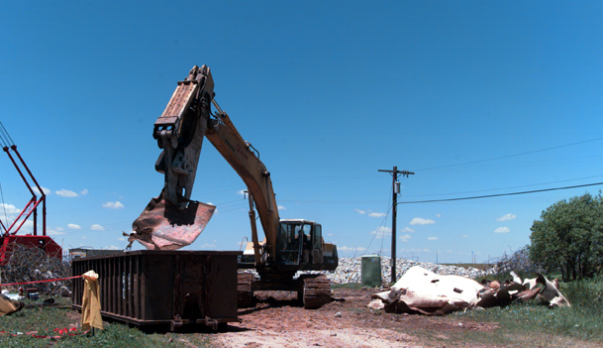

2.0 Planning Overview

2.1 Key Planning Documents and Data Management Systems
Currently, within the Department of Energy, various aspects of the Excess Facility Program are represented within several different planning documents. As an aid to those involved in the Excess Facility Program, those documents are identified below, along with a brief summary of the contents. In addition to the plans identified below, ERD has initiated the collection of data, which will enable AL to prepare information supporting anticipated departmental requests for new funding. This information is found below under the subheading, “Planning for Appropriations.”
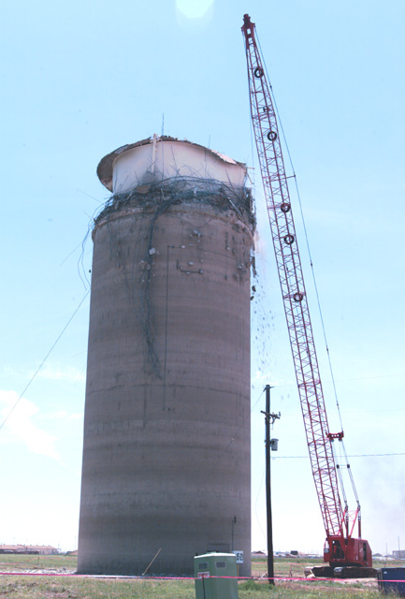

Multiyear Program Plan
The Multiyear Program Plan is prepared and issued by DOE-HQ. The plan identifies and establishes functional priorities at the Operations Office for D&D technology development and deployments.

Ten Year Comprehensive Site Plan
The plan is assembled by the site contractor and submitted through the Area Office to SPD (or NPD for the SNL and LANL). A critical element to the Excess Facility Program planning process is the timeframe for when the site contractor and DOE believe that a particular facility is (or will be) declared as excess.

Integrated Project and Budgeting System (IPABS)
This database identifies both the general scope and cost of EM program funded activities (including a projection of cost and scope for those process-contaminated facilities, which are anticipated to transfer to EM). Each of the site’s contractors is responsible for entering and maintaining the data in IPABS.

Environmental Liability Estimate
This is an EM planning activity, which provides an estimate of the DOE’s current environmental liability. The Chief Financial Office (CFO) generally coordinates the planning activity.

Environmental Restoration Project Baseline
This document identifies the cost, schedule and scope of environmental restoration projects. Baselines are required for each project per LCAM, and DOE Order 413.3. The development of the estimate is prepared by the site contractor and reviewed and approved by DOE.

Site Integrated D&D Project Baseline
This document identifies the cost, schedule and scope of D&D projects. Baselines are required for each project per LCAM. The development of the estimate is prepared by the site contractor and reviewed and approved by DOE.

2.2 Establishing Metrics and Reporting Progress
Establishing metrics and the reporting of progress for excess facilities should be done using appropriate guidance. For the Excess Facility Program guidelines have been identified in the Handbook for Integrated Project Management (HIPM). A copy of this document can be obtained from the Waste Management Division. In general, a formal quarterly review is conducted, and documentation of this review is presented in the OEOS Quarterly Report. For the Excess Facility Program cost and schedule status shall be reported in the OEOS Quarterly report. In conjunction with the OEOS Quarterly report and review, EM requires the site to provide a project and cost status of EM funded activities in the IPABS. IPABS requires that cost, schedule and several performance metrics be updated on a monthly basis. Assistance to access this information as well as the review and granting of requests for passwords are provided through the Waste Management Division.
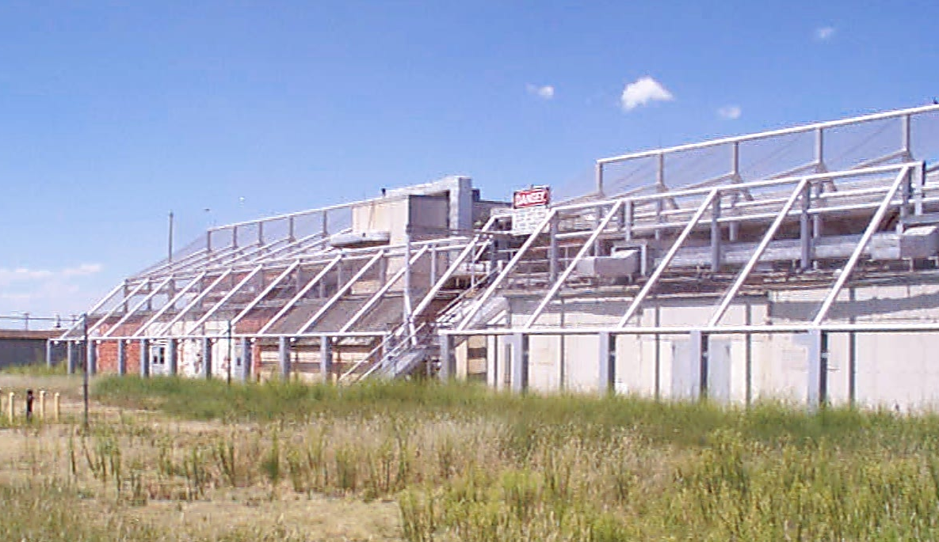

2.3 Planning for Appropriations
For a process contaminated excess facility, the responsibility for the disposition of the excess facility is both the responsibility of the current facility program owner (Operating Landlord Program), and the receiving program (EM if it is a process contaminated facility). The Operating Landlord is responsible for funding all the activities associated with placing the process contaminated excess facility in a safe shutdown condition, and for providing adequate surveillance and maintenance funding to EM until the facility has completed the planned demolition. For a non-process contaminated excess facility, the responsibility for the disposition of the excess facility is the responsibility of the current facility program owner. Because the DOE has identified these responsibilities as such, the following guidance for planning for appropriations is provided below. Integration of the funding sources, prioritization of the workscope is intended to occur in the Site Integrated D&D Baseline. Additional guidance for the Site Integrated D&D Baseline, as well as project management of the scope is provided in a later section of this document.
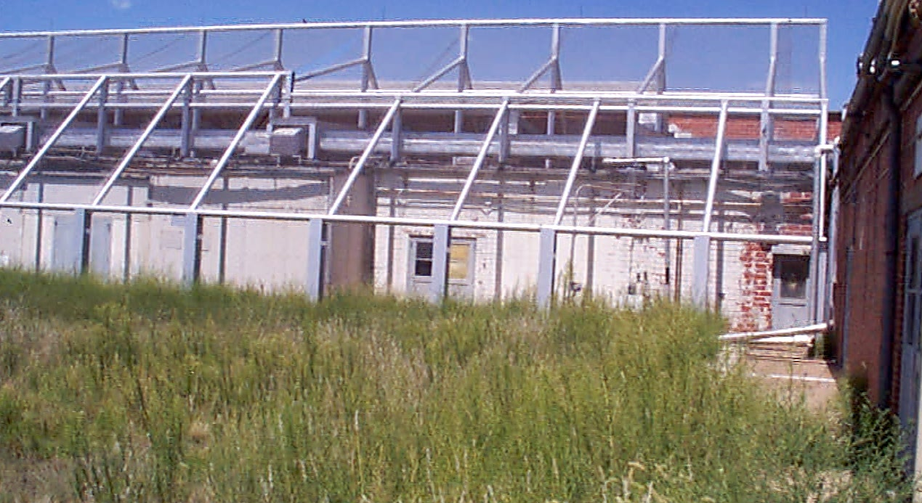

2.3.1 Planning for Appropriations of Process Contaminated Excess Facilities
For process contaminated excess facilities, the EM Program requires that both the scope and cost of EM activities be identified within IPABS. This database is updated on a semi-annual basis and is done in conjunction with the budget formulation process. Because the data entered into IPABS is currently restricted to those facilities, which are EM’s responsibility or have obtained a signed Memorandum of Agreement, a request for the sites to identify candidate process contaminated facilities is coordinated by ERD. This is important, as IPABS, as currently defined, can only be seeded with work approved to be part of the EM Program workscope. The information is requested annually in the August 1 time frame. An example of the type of information requested is provided as part of the appendix in the “Excess Facility Transfer Workbook”. This information is also provided to EM and DP, serves as the landlord program’s response to EM to identify those “process contaminated” excess facilities available for transition.

Additional definitions and departmental guidance regarding the disposition process for excess facilities are available in the LCAM. In general, the LCAM requires that facilities (which meet the transition requirements) be identified two years in advance of the budget appropriation year. Lifecycle Planning Data elements are identified in the project work control section of this document, which, if captured within site specific planning initiatives, can enhance the Department’s ability to define the Excess Facility Program, cost, schedule and scope.

2.3.2 Planning for Appropriations of Non-Process Contaminated Excess Facilities
Non-process contaminated facilities are buildings, which in the past served as office space, or contain hazards, which are common in an industrial type facility (such as asbestos, and non-regulated chemical products). Responsibility for the stabilization, deactivation and decommissioning of non-process contaminated facilities resides with the Landlord PSO. Thus the identification of funds to support such activities is usually done in association with the development of their respective budgeting processes. Budget guidance is updated and issued annually in and supported by the site ten-year plan (also referred to as the site institutional plan).

Identification of a non-process contaminated facility for disposition is initiated by the site contractor in consultation with staff members from the Area Office, SPD and/or NPD. Once a facility has been identified as excess, a projected excess date is identified in both the institutional site plan, and in the FIMS database. As a complement to the site institutional plan, the worksheet “Five Year Forecast of Excess Facilities” (provided in the appendix) shall be used on an annual basis to identify the excess facilities along with an early cost estimate. An update of the “Five Year Forecast” worksheet should be provided annually in the August timeframe.

In the past, funding for the disposition of a non process contaminated facility has been limited, and thus it is required that the identified standby condition for the facility is defined to ensure that the facility does not deteriorate to the point of becoming a structural safety hazard. Items to consider include: ensuring the stability of the structure to prevent collapses, the possible creation of biohazards, and potential liability issues for those whom will eventually be involved in the demolition of the facility.

The scope, and cost associated with the disposition of non-process contaminated should also be identified as part of the site Integrated D&D baseline. Because these projects are typically performed using landlord-funding sources they should be easily identified within the WBS index of the baseline. Planning for these projects should be consistent with the site ten-year plan. It is suspected that the priorities for such selecting these projects should give consideration to the following:
- The need to reuse partials of property which these structures occupy
- The need to eliminate potential safety hazards from developing as a result of a deteriorating structure
- Regulatory requirements to remove the facility

2.3.3 Prioritizing facilities for D&D/ Site Specific Prioritization Process
The following criteria will be used to prioritize the facilities for transfer to the EM Program, as well as for prioritizing the facilities for actual decommissioning within AL.

- Facilities that are contaminated and/or present a safety health risk to current or future workers or the environment.
- Facilities which in their present state will require a large capital investment to maintain ES&H requirements and to perform required Surveillance and Maintenance activities. For example, a building which is in need of a roof replacement, or one in which the walls or structural supports have deteriorated enough that the building has become a significant hazard. Another example could also be one in which there has been significant deterioration of the structure, to the extent that inadvertent intruders (mice, snakes, pigeons) have begun to nest in the building and are creating a potential bio-hazard (i.e. hantra-virus).
- Facilities, which occupy parcels of real estate, which are of prime interest to the Departments continued mission, and/or stakeholders.
- All other facilities, including those, which do not have large ES&H requirements, but have associated facility maintenance costs.
The site contractor should have a defined process by which facilities are identified and prioritized in support of the sites request for funding. The site prioritization process should be risk based, and provide consideration to Environmental risks, stakeholder and regulator concerns or requirements, the expected rate of return and cost benefit of facility disposition.

2.3.4 Establishing EM Priorities within the AL EM Program
Within AL, the AL EM Corporate Review Board consolidates and establishes funding priorities for the AL EM Program. The AL EM Corporate Review Board was established in 1997 to afford the various AL EM Program Sponsors with an opportunity to review funding requests, changes, and programmatic impacts at the AL EM Corporate Level. For funding allocations, the following criteria are used by the AL EM Corporate Review Board to establish program priorities (as documented in the Handbook for Integrated Project Management):
Establishing Funding Priorities for Environmental Management Dollars
- Albuquerque Environmental Management Corporate Review Board (AL EM CRB) reviews priorities per established criteria.
- Criteria are safety, compliance based.
- Members of AL EM CRB include Division Level EM Program Management Team.

- Ensure critical safety and compliance. Eliminate imminent danger, safety, and environmental threats; ensure continuation of critical landlord operations.
- Ensure contract and environmental compliance. Minimize regulatory fines and penalties; fulfill legal, contractual obligations, e.g., potentially responsible party and contractual pension benefit obligations.
- Ensure short-term completions. Activities complete (to Paths to Closure definition, long-term surveillance and maintenance mode), within 24 months or less, positive Return on Investment, and assure previous performance measures have been met and good project management.
- Ensure balance of remaining work is completed. Examples include legacy waste work off, environmental restoration, technology development, national and educational program initiatives such as: the Waste Management Educational and Research Consortium; the Historically Black Colleges and Universities; institutional programs such as Agreements in Principle and the Citizens Advisory Boards; and Core EM mission support.

2.4 Technology Demonstration and Deployment
ERD in coordination with the Technology Development Division, Area Office point of contact, and site contractor continually look for opportunities to develop and deploy new and innovative technologies associated with disposition activities. The objective is to improve productivity while enhancing the safety and cost effectiveness of D&D activities. A variety of DOE complex-wide demonstrations, seminars and conferences are sponsored each year to allow networking with national and international experts regarding the latest technological developments associated with disposition activities. In addition to preparing and submitting proposals to D&D Focus Area, through the National Environmental Technology Laboratory, the site contractor often identifies technology needs in the IPABS database. Sites are expected to support technology deployments.

2.5 Managing the Inventory of Excess Facilities – Data Collection and Entry
The FIMS Database is the official database for identifying DOE assets. The data contained in FIMS is required to be updated on an annual basis. In addition to FIMS, IPABS provides data entry fields for the site contractor to identify the planned transition dates for each facility. Within AL, the Administrator for FIMS is within CTSD.

2.6 AL Excess Facility Five Year Plan
Using the information collected through IPABS, FIMS, and the Site ten-year Plan, an AL Excess Facility Five-year Plan (EFFY) will be developed and maintained on an annual basis. The contents of the EFFY will identify for AL management and DOE-HQ the cost/schedule of excess facilities, which are planned for disposition. The EFFY will be prepared and maintained by the ERD. An outline of the contents is identified in the appendix.

3.0 Project Management Systems/Requirements
As for any EM Project, it is required by LCAM that the cost, scope, schedule and an appropriate work breakdown structure be identified in a baseline. Guidance to assist with project planning (i.e. the defining of cost, scope, schedule and the work breakdown structure) is contained within the Project Management Manual (PMM) issued by ERD. As described in the PMM, the site integrated D&D baseline is separate from the site ER baseline. The integrated D&D baseline contains the technical scope, cost, and schedule supporting the facility disposition process, regardless of the funding source. In addition, the PMM also identifies the process used to review and validate contents of the baseline, and progress reporting requirements
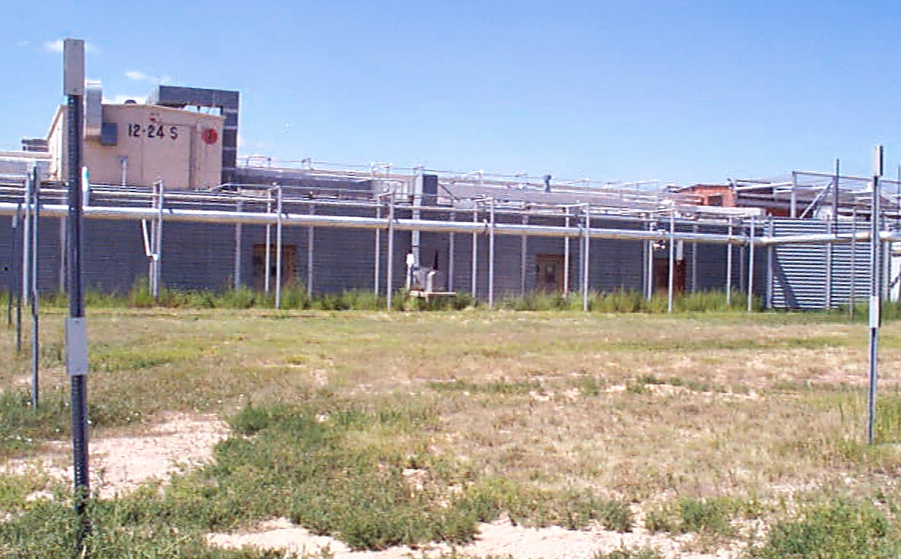

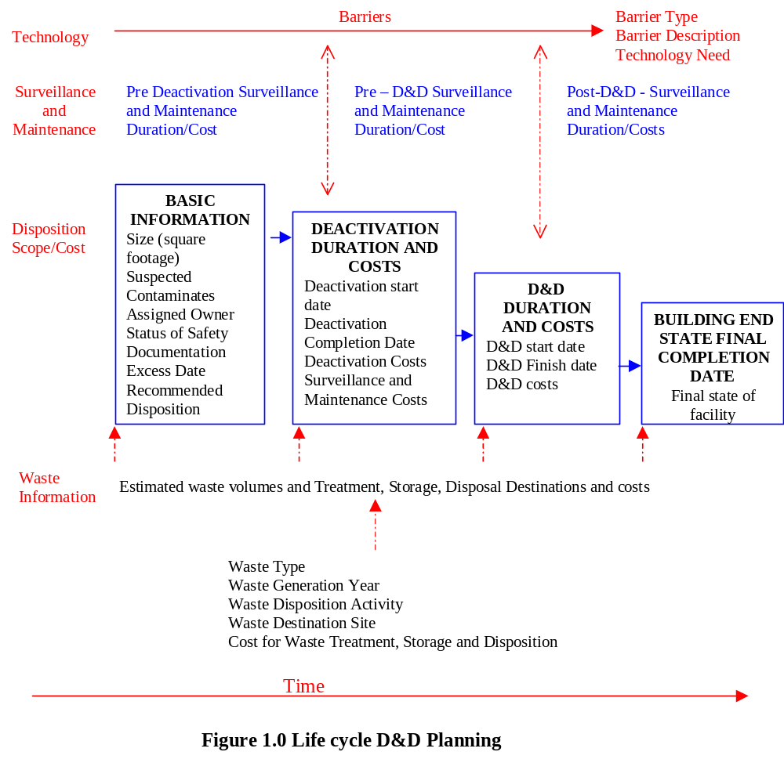

3.1 Lifecycle Data Planning Elements for D&D
Figure 1.0, Lifecycle Data Elements for D&D, identifies those data elements, which if captured in the baseline can improve the overall lifecycle planning, as well as enhance the Department’s knowledge relative to the magnitude and cost of the Excess Facility Program. Work control, and baseline change control processes are described within the PMM. The activities identified below are required by those sections of the 430.1 Lifecycle Assets Management Directive Order (LCAM), which were not replaced by Directive 413. Additional guidance to support D&D project definition and execution are provided in the supporting guidance documents to 430.1. The project management aspects of D&D are to be implemented using the requirements as stated in Directive 413 and the ERD PMM.

3.2 Baseline Change Process Relative to Transition of New Facilities to EM
The LCAM identifies the need for DOE projects to be managed by use of a baseline change control process. The ERD PMM identifies the AL BCP process for EM activities. Additional AL guidance is provided in the Handbook for Integrated Project Management. As new scope is added to the site integrated D&D baseline the site should prepare a BCP package and submit it for review and approval using the approval process identified in the ERD PMM. The timing for new scope to be added to the site integrated baseline is after acquiring a signed Memorandum of Agreement, normally this occurs in late fall (around October/November), and prior to spending funding for the D&D activity. The timing for developing and submitting a BCP can precede the fiscal year in which EM plans to initiate funding for D&D by 2 years.

4.0 The Facility Disposition Process
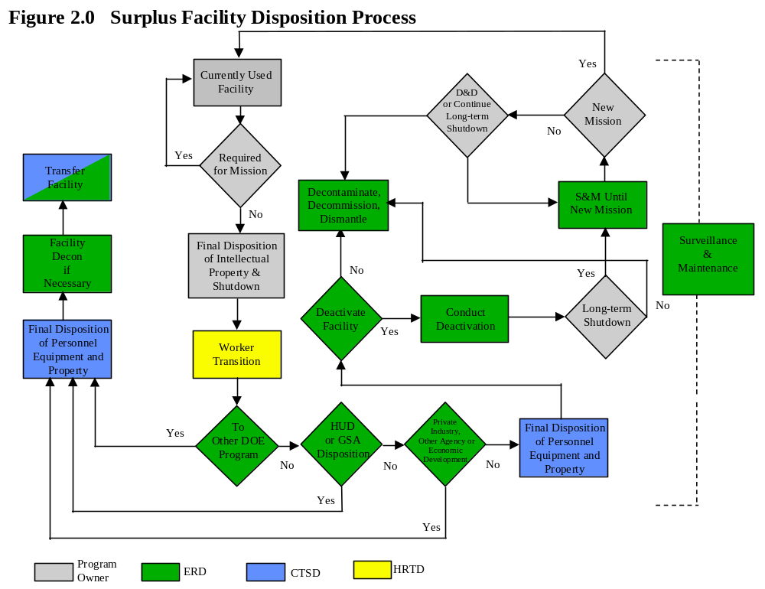The facility disposition process initiates with the declaration of excess. The facility disposition process is explained in this section and depicted in Figure 2.0. Figure 2.0 delineates the major elements of the disposition process and assigns responsibilities for actions and major decisions. The Figure displays responsibilities by AL divisions for simplicity. Roles and responsibilities are included in Section 8.0, Roles and Responsibilities. The actions identified, as “Program Owner” should be coordinated through NPD/SPD. Although the focus of this disposition process is on process contaminated excess facilities, many of the activities identified should also be prepared and pursued for a non-process contaminated facility. Each site contractor should have established internal procedures (as required by the DOE’s guidance on Integrated Safety Management) detailing the implementation of DOE Directives relative the facility disposition.

4.1 Facility Landlord Pre-Transition Activities (Preparing A Process Contaminated Facility for Transition to EM)

4.1.1 Departmental Guidance, References and Requirements
Departmental requirements, guidelines and references to assist with the planning and execution of excess facilities can be found within the LCAM Directive. In addition to LCAM there are several guideline documents, which support LCAM. A listing of these documents is provided in the appendices. As DOE facilities become excess, many that are radioactively and/or chemically contaminated will become candidates for deactivation by EM. Drivers for affecting the transfer of facilities to EM include:

- DOE Order 430.1A, Life Cycle Asset Management (LCAM) - Calls for a pre-transfer review. It also specifies a two-year advance notification (unless otherwise agreed) to match DOE’s budget cycle.

Facility Transition
- When operations are finished, the facility is placed into a safe and stable shutdown condition by the landlord program in accordance with a safe shutdown plan, prepared by the site contractor.
- The status and condition of the facility at this time of transition is to be documented. Often it is suggested, as defined in LCAM, that a transition package be prepared.
- Administrative records for the facility are updated by the landlord Program to reflect the changed status of the facility. This includes such records as:
- Safety basis/authorization basis documents
- Asset management documentation
- Configuration management, including drawing updates, cancellation or revision of procedures, license or permit changes, etc.
- The systems and equipment that must remain operational are identified, and a Surveillance and Maintenance Plan is written.
- For a facility that is to be transferred to EM for disposition, a formal turnover of custody is per performed, often referred to as the “Pre-Transition Review”. The turnover process includes:
- A pre-transfer review of what has been done to shut the facility down and prepare it for turnover
- A walkdown inspection of the facility to verify that it is in safe and stable condition, and that the documents being turned over with the facility are complete and represent its condition.

A Memorandum of Agreement to formally document the change of custody and agreement on which of the items listed above will be done is often prepared in support of the facility transition.

- DOE Guide 430.103, Deactivation Implementation Guide - States that the transferor should establish a stable facility with respect to high-level waste and hazardous materials. The approach, scope, cost, to achieve this stable facility condition should be documented in a deactivation plan for the facility.

In general, there are eight steps to ensure a successful transition of excess process contaminated facilities. The eight steps to successful transition of excess facilities include:

- Excess Declaration,
- Identify and Perform Early Actions,
- Identify Facility Condition,
- Assess and Adjust Authorization Basis,
- End Point Development and Allocation,
- Transition Activities,
- Pre-Transfer Review,
- Facility Transfer.
- Memorandum of Agreement
- Project Management for Pre-Transition Activities.
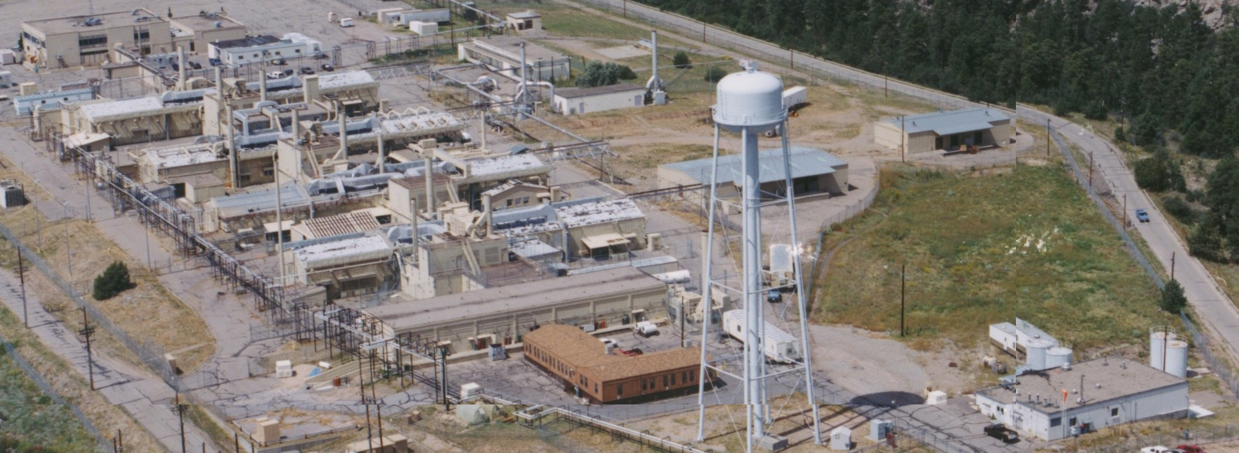
Point A in the Figure 3.0 is the identification of a facility as excess to the site mission. Point B in Figure 3.0 is completion of a Memorandum of Agreement. At Point B, the intended is for the transferor and EM to reach an agreement and achieve an understanding of the facility condition and any associated liabilities, which are inherent to the facility. A checklist of activities to be addressed by the transferor and receiver is also provided in the Appendix. Experience has indicated that each facility situation will differ, and thus this process and the checklist should be adapted to best suit each specific situation.

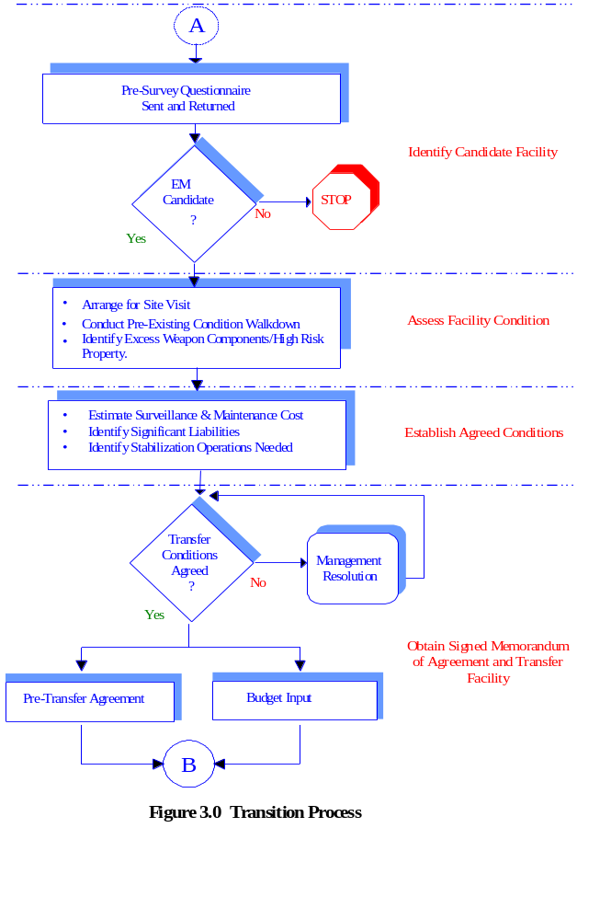

4.1.2 Excess Declaration
DOE-HQ, Albuquerque Operations Office, and the Area Office, in consultation can initiate the process of identifying an excess facility. The ultimate decision for communicating facility status is the Principle Secretarial Office (PSO). Figure 4.0 identifies possible disposition paths, which should be explored, as the facility has been declared excess to DOE mission. Once facilities are determined to be excess to DOE mission needs and a candidate for transfer to EM, the PSO provides Request to Transfer notification to EM-1 for demolition. In most instances the sites have either identified some facilities as excess via a memorandum to their PSO, or in their site institutional plans, or in the Facility Information Management System (FIMS) database. Initial notification should be provided two years prior to October 1 of the year of desired transfer. The notification should be initiated by the site and coordinated through ERD. ERD will then forward the request to the appropriate HQ PSO and EM-1. Following this notification, the site should then coordinate the information, which exists in the site institutional plans, FIMS, IPABS, and 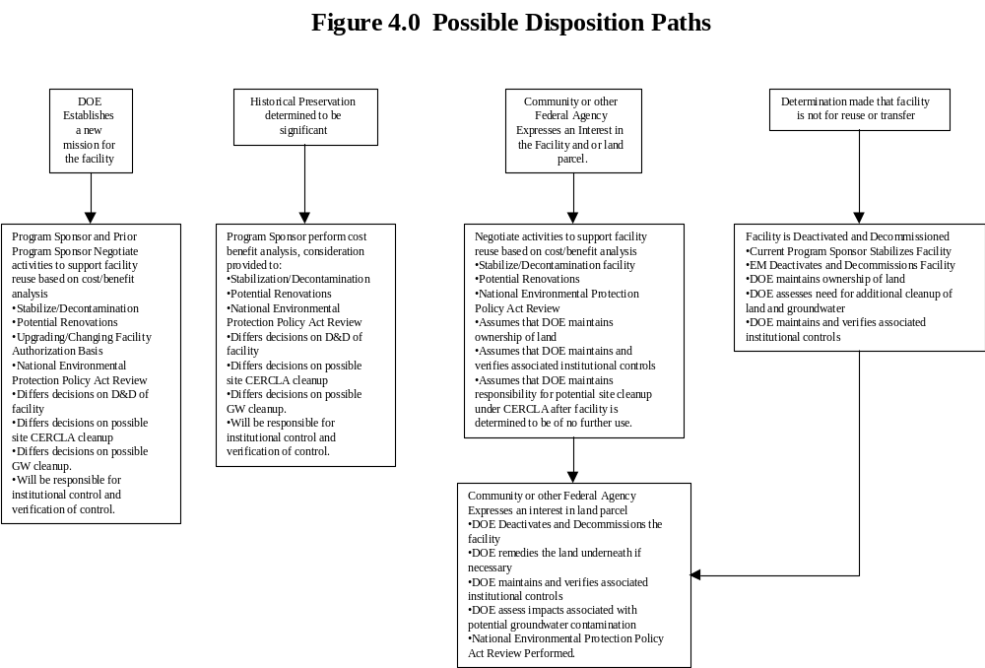finally the baseline to ensure that the data presented for facility excess is the same. Final notification is documented with a formal request for transfer in a like manner as the initial notification, but in general, this will be the responsibility of the HQ PSO to send forth to EM. In parallel to initial notification, early actions and disposition interface/coordination and the formation of the Transition Planning Team should be initiated. The assembly of the Transition Planning Team will be coordinated through ERD in conjunction with EM-20, and the responsible Landlord Program. The team mix can include

facility or project management personnel from the site contractor, Area Office, Albuquerque Operations Office and DOE-HQ. The use of a graded approach is highly recommended (dependent on the complexity, hazards, risks and programmatic impacts of the facility).

Transition Planning Team roles and responsibilities may include:
- Providing strategies and guidance for managing interfaces.
- Providing access to full range of skills within respective organization structures
- Approving strategies and plans.
- Mediating institutional and financial issues.
- Performing prompt conflict resolution of roadblocks.
- Ensuring schedule and budget for the activity are consistent with overall priorities and allocations.

4.1.3 Early Actions
Early Actions are generally those actions that can begin without waiting for the completion of the planning process. The focus of these early actions should be on hazard and risk reduction and can include immediate or longer-term actions to stabilize unsafe conditions (e.g. prevention of deterioration). Responsibility for funding of these actions is normally with the Landlord PSO. While planning for the conduct of early actions, the following should be considered: should only commence where there is no possibility that work done will have been unnecessary; do not abandon (without full comprehension) any structures and/or equipment that may be required during deactivation and decommissioning for either (a) safety, or (b) future work; and changes in configuration and status of systems and structures as a result of transition activities can result in new safety issues. In some instances, it is suggested that the planning and budgeting (by the PSO) of early actions commence three years prior to transition of the facility, to ensure that funding is available to support the workscope. For timeline information, see Table 1 - Transfer Budget Timeline Elements, in Section 5.0.

Early on, as the facility begins to be declared as excess, a graded characterization of the facility to establish the existing conditions should be completed. This requires the identifying and characterizing, and providing for stabilization (if necessary), adequate storage, removal of all hazardous, combustible materials and radioactive materials/wastes remaining in systems/facilities. In addition, the identification, inventory and disposition of any weapon components or high-risk materials (if any); and identification, inventory, and periodic assessment of the condition of physical assets in the maintenance program should be performed. It is expected that the identification of the facility’s condition be managed, planned and performed by the Landlord PSO. Information on the facility’s status will be used for the pre-transfer review.

End Points can be used as follows:
- Provide input for scheduling and cost estimating.
- Create detailed work plans for each space and system in the facility.
- Document decisions for performance-based contracting or out-sourcing of work.
- Demonstrate conformance to agreements negotiated with third parties.
- Show compliance with Federal, State, and Local laws and regulations and negotiated agreements.
- Determine which activities (end points) are to be completed during transition by the operating program, and which are to be passed on for completion in the disposition phase.

Defining a disposition path dependent on whether facility will be moved directly to decommissioning, or be taken to deactivation status for an extended duration is another early action to be performed. Considerations to determine disposition path include conceptual lifecycle costs for deactivation versus decommissioning relative to available budget; projected cost of ongoing Surveillance and Maintenance agreements among DOE, State Regulators, and various stakeholders.

4.1.4 Conduct of Early Actions (Authorization Basis)
In addition to the above, it may be necessary for the site contractor to assess and adjust the authorization basis of the facility prior to initiating work on early actions. The assessment and adjustment of the facility authorization basis may be necessary to ensure that safety conditions are appropriately reflected as the facility continues throughout the disposition process. It is expected that the Landlord PSO perform this initial assessment and adjustment. Two scenarios are possible, a facility without a current authorization basis or a facility with a current authorization basis. In either scenario, reference should be made to the appropriate DOE Requirements, Standards and Guides for Technical Safety Reviews, Safety Analysis Reports, and Unreviewed Safety Question to define an acceptable method for adjusting the authorization basis of the facility.

4.1.5 End Point Development

Items reviewed and documented in the pre-transfer report include:
- Identification of the physical boundaries of the facility.
- Drawings and photographs depicting facility condition.
- Records reflecting the as built and as-modified configuration changes.
- Characterization data accurate and complete listing of types.
- Identification of remaining special nuclear and fissionable materials.
- Listing of documents that define the authorization basis.
- Surveillance and maintenance requirements and plans.
- Inventory or estimate and locations of existing toxic substances and/or wastes.
- Inventory and location of existing weapon components or high-risk property.
- Current status of implementation of the facility’s safe shutdown plan.
- Identification of plans to remove personal property and excess equipment not required.
- Identification of any permits, licenses and agreements that remain imposed.
- A listing of outstanding commitments to regulatory authorities, stakeholders, and DOE.
- Identification of resources needed to support the facility disposition.
- Information on any other factors such as potential future use, long-range site plans, facility condition and potential health, safety and environmental hazards that could influence the election of decommissioning alternatives or deactivation alternatives.

Another useful early action involves the establishment, and defining of endpoints. The LCAM defines this as “a method to ensure that prior to completion of mission activities (e.g., production, research, etc.) necessary to place the facility, systems and materials in safe and environmentally secure conditions pending disposition are identified and implemented.” End point development should be performed for the preferred disposition path for the excess facility. Specifying the end points for a facility’s space, systems, and major equipment is the key to identifying when a facility has been transitioned or disposition.

4.1.6 Pre-Transition Activities
Prior to the transition, a pre-transition review (or survey) will be conducted at the facility. The depth and length of the review should be commensurate with the existing hazards of the facility. This pre-transition and the resulting reports support the development of a memorandum of agreement. The review results in a report, which is intended to document the scope, facility conditions, associated funding (when transferring facilities between Program Offices), required actions for facility transition, suggested surveillance and maintenance activities, remaining hazardous/radioactive materials. The pre-transfer review also identifies those activities, which will be completed by the Landlord PSO prior to transition of the facility to the EM Program. The results of the review are normally documented in a pre-transfer report.

The pre-transfer review and report is typically prepared by EM-20 with support from the transition. Logistics, comments in the report are coordinated by ERD. Because of the detailed information contained in this report, and involved in the review, an initial facility survey questionnaire is typically sent along with a request to the site-operating contractor to compile initial information to aid in the review. The facility survey questionnaire combined with a facility walkdown is used to capture a “snapshot” of the facility condition and status and is used as the basis for decisions related to rectifying conditions, estimating budgets needs, and timing of the pending transfer.

4.1.7 Pre-Transfer Agreement (Memorandum of Agreement)
The results of the pre-transfer review are used to arrive at agreement on the conditions for transfer between the Landlord PSO and the EM PSO. This Pre-Transfer Agreement (also referred to as the Memorandum of Agreement), for which an example is shown in the Appendix, can serve as the summary report of the review. The complexity of the agreement will vary depending on the scope of transfer and complexity of the facility. Part of the conditions for transfer that should be addressed include if, how much, and when budget is to be transferred from the Landlord PSO’s program to EM’s to support the transfer of funding target for S&M activities as mentioned in LCAM.

4.1.8 Pre-Transfer Stabilization Operations
Based on the results of the surveys it may be appropriate for the existing facility staff to conduct stabilization and hazard elimination operations prior to transfer. If so, the following is recommended:
- Landlord Program and EM Program agree on stabilization operations to be completed and documented.
- At the completion, the EM Program verifies that stabilization operations have achieved agreed upon end points. Exceptions are resolved.
- Based on the results of the survey and Pre-Transfer Agreement, an estimate of the effects on the EM budget performed, and the budget adjusted as appropriate through the ERD PMM process.

4.1.9 Project Management and Documentation Requirements for Pre-Transition and Key Documents
Project management requirements for D&D are included in O 413, and O430.1A. Implementation guidance of these two directives is included in the ER PMM. In short, the site contractor is expected to develop, actively manage and submit for DOE approval and Integrated D&D Baseline per the ER PMM. Each project should have a process, which enables the implementation of 4 key critical decisions.

4.1.9.1 Development, Approval of a baseline change proposal
Prior to transition and initiating the expenditure of funding on pre-transition activities, it required that a BCP be prepared by the site contractor and approved by the Area Office. The purpose of the BCP is to identify cost/schedule/scope for the pre-transition activities, which are normally defined within the MOA (signed by the site landlord program and EM-1), and the supporting pre-survey report. Progress towards completion of these activities should be statused in the DP sections of the AL OEOS Quarterly Report. Because of the highly visible nature of the activities (i.e. signed by DP and EM), they should be reflected in the contractor performance plans.
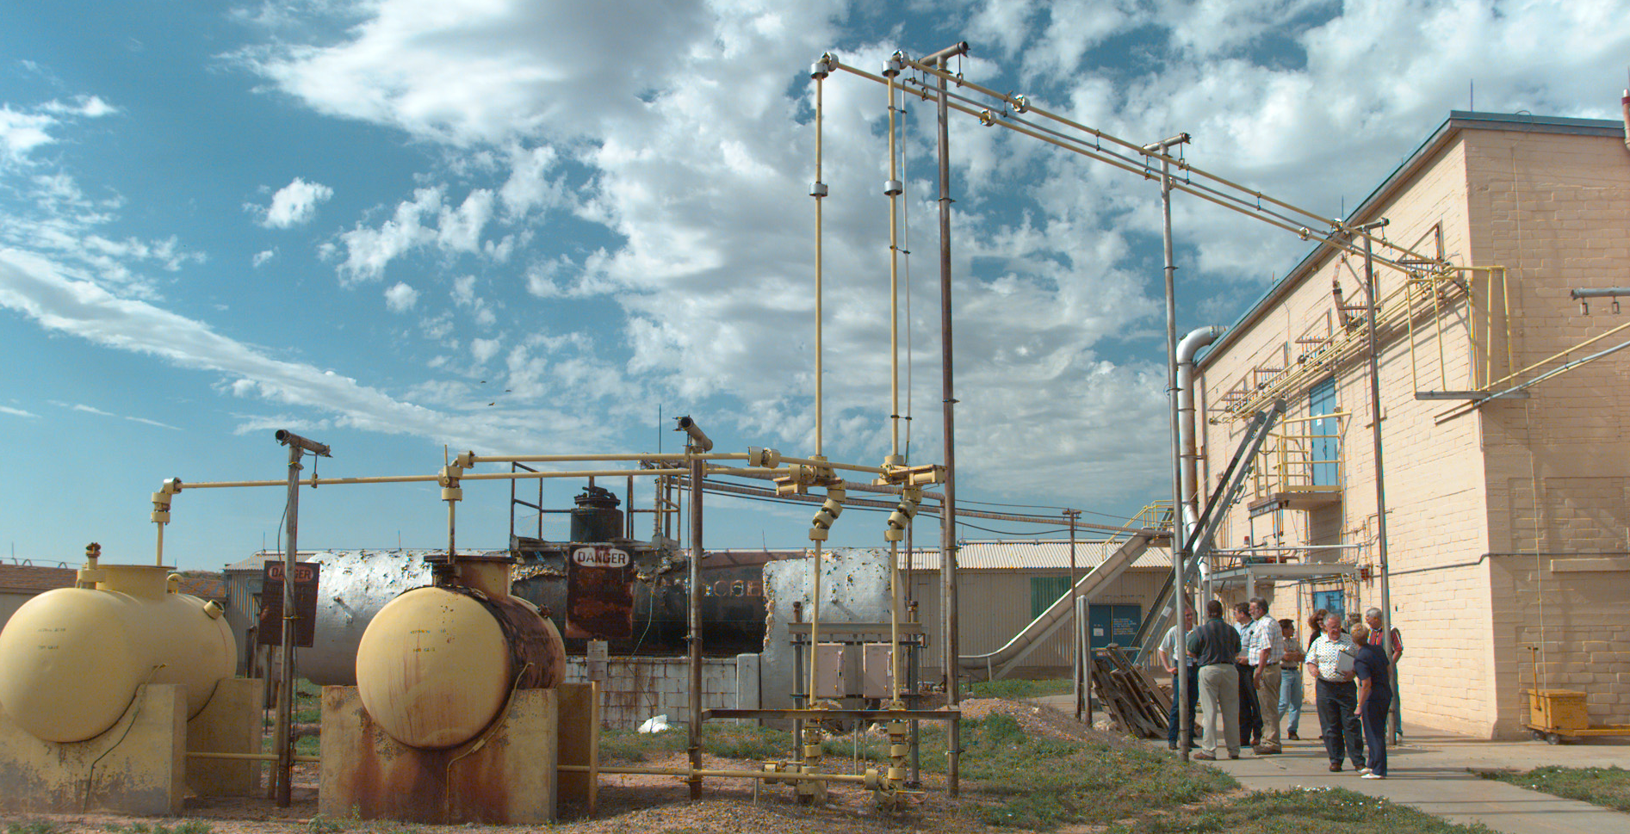
A formal statement (letter) should be issued from the site contractor to the Area Office documenting completion of all pre-transition activities.

4.1.9.2 Surveillance and Maintenance Plan
This document is required per LCAM to be completed by the operating program and maintained along with the disposition of the facility. After facility transition, the EM program maintains the S&M plan. After the transition timeframe the EM baseline should include cost associated with implementing the surveillance and maintenance plan.

4.1.9.3 Updating IPABS Information, the Project Baseline Summaries
Typically along with the acceptance of the facility by EM, the site will obtain a separate Project Baseline Summary (PBS). The site contractor should ensure that the information contained in IPABS is up-to-date and maintained as required. To facilitate planning for an upcoming facility transition review the worksheets identified in the Appendix as attachment 3 should be completed and returned to ERD no later than August 1 on an annual basis. These worksheets can be provided electronically in excel upon request from the ERD SFPM.

4.1.9.4 Updating the Integrated D&D Site Baseline
Project management elements of the ERD PMM apply to the Integrated D&D Site Baseline. The LCAM and the supporting guidance documents are useful in facilitating the identification of WBS elements for deactivation and decommissioning of the facility. It is also required that as the workscope is entered into the baseline, that a more detailed cost estimate be developed as required by the PMM. Opportunities to implement/deploy D&D technologies to reduce the cost of D&D should be identified. As an example, the Tritium System Test Assembly Facility has a Large Scale Demonstration Project, which was awarded via EM-50). It is also encouraged that waste minimization/recycling practices be incorporated into the D&D activities, and that goals/metrics be identified within the baseline as appropriate. A baseline change proposal should be prepared and submitted, after the site has obtained a final signed memorandum of agreement.

4.1.9.5 Preparing an Operational Facility for Safe Shutdown and Transition
This stage includes the recognition that the facility is excess, the safe shutdown of the facility and the formal transfer of the facility from operational status to excess status. When operations are finished, the facility is placed into a safe and stable shutdown condition in accordance with a written plan, “Safe Shutdown Plan”. The “safe shutdown plan” should be made available to the transition review team. The facility at this time can be declared excess awaiting deactivation. In addition to the safe shutdown plan the following should be completed prior to, or in parallel with initiating the transition process:

- Obtain an acknowledgement from the responsible DOE program office that the facility is no longer needed to support mission, and can be considered excess.
- Initiate retirement of the facility and its contents from the site asset management system.
- Provide notification to ERD for the facility to be added to the inactive facility list.

4.2 Post Transition Activities Implemented by Environmental Management Program for process Contaminated Facilities

At the end of a facility’s life cycle, when the facility is no longer needed to support a DOE mission, the facility undergoes a process referred to as the final disposition. This is a series of stages where the facility is bought to the final end state. The following section provides a brief description of the disposition process with focus key decision points:

- Facility Deactivation
- Safe Storage
- Facility Decommissioning
- Post Decommissioning

4.2.1 Facility Deactivation
In the deactivation stage, a series of activities is defined and executed which transforms the facility from its condition at the end of operations to a passive and stable state that can be maintained and monitored over a long period of time at minimal cost. Deactivation is carried out as a project, and typically includes activities that reduce the remaining hazards in the facility (or reduce the custodial cost of the facility), such as removal of process material, stabilization, decontamination, and isolation the facility and its systems. A deactivation project plan is written to establish a baseline scope of work and derive a more detailed cost estimate. When deactivation is completed and the facility is in a passively safe condition requiring minimum care and monitoring. At the completion of the deactivation process a final report is prepared to document project accomplishments, lessons learned, and the facility status.

4.2.2 Safe Storage
After facility deactivation and before decommissioning, when the facility is in a passively safe and stable condition a waiting decommissioning the facility is considered to be in a safe storage. During this period, which may span years, surveillance and maintenance and planning for decommissioning activities are performed. It is required that the surveillance and maintenance plan be updated to reflect this facility status.

4.2.3 Facility Decommissioning
Decommissioning is typically the final stage for the facility. A range of possible alternative end states is evaluated and the best one chosen. This is done as a “non-time critical removal action” under the Comprehensive Environmental Response, Compensation, and Liability Act (CERCLA) rules. The public is given a chance to participate in the choice of end states. The possible alternatives might include cleanout and conversion for another use, decontamination and demolition, or possibly another alternative. DOE has defined a decommissioning “framework” that meets these requirements within LCAM and its supporting Decommissioning Guidance Document, DOE G 430.-4. Prior to the commencement of the decommissioning phase a readiness review for starting field operations should be performed and results documented. The readiness review requirements are contained in DOE-STD-1120-98, section 3.4.1. Decommissioning is performed as a project in accordance with a Decommissioning Project Plan.

Once decommissioning is complete a final report is prepared to document project accomplishments, lessons learned, and identify any remaining activities, which should be considered.

4.2.4 Final End State and Close out
Decommissioning will not always be the final action, particularly at sites where follow-on remedial action for soil and water is required to complete the cleanup. When this is the case, follow-up responsibilities will be coordinated with the Environmental Restoration Division. In addition, long-term monitoring of the site may be required, whether or not additional remedial action is performed. The post-decommissioning Close out plan should be prepared to document any additional remediation or monitoring requirements.

5.0 Timelines for Transferring Process Contaminated Excess Facilities
Planning Elements | Budget Cycle General Timeframes (months) | Years Prior to Spending | Years Prior to Transition
Transition planning and engineering to support estimates and early actions | May - June | 2 | 3
Field estimate of transition cost | July - October | 2 | 3
EM budget guidance development | October - December | 2 | 3
Field Office budget preparation | December - April | 2 | 3
DOE HQ budget review and iteration | April - September | 2 | 3
OMB budget review | September - February | 1 | 2
Congressional budget review and authorization | February - October | 1 | 2

Table 1.0 Budget Timeline Elements

5.1 Overview of a Timeline for Major Process Contaminated Facilities
Table 1 illustrates an overall timeline for an excess facility, which may require the completion of substantial stabilization and pre-transition activities prior to transfer to the EM program. This case is one in which the Landlord program will need to identify appropriate funds to prepare the facility for

Transition. The overall duration of 3 to 3-1/2 years is dictated by:
- Associated planning and engineering to support budget estimates, and conduct of stabilization activities,
- The DOE, Executive Branch, and Congressional 2 year budget cycle for the Landlord program, and
- The time required to perform the pre-transition activities.

5.2 Timeline Details of Facility Transition Activities
Details of the one-year schedule are shown in the example below, Figure 4.0. If for some reason such activities require more than one year, then the overall timeline could extend in one-year increments because of the fiscal year budgeting constraints. In Figure 5.0, the EM two-year budget cycle does not control the transition/transfer timeline and can be initiated about the time of formal notification that a facility is to be transferred. In the case of a facility for which sufficient funds are already available in the Landlord Program, or can be transferred from other budgets, the EM budget cycle would then become limiting.
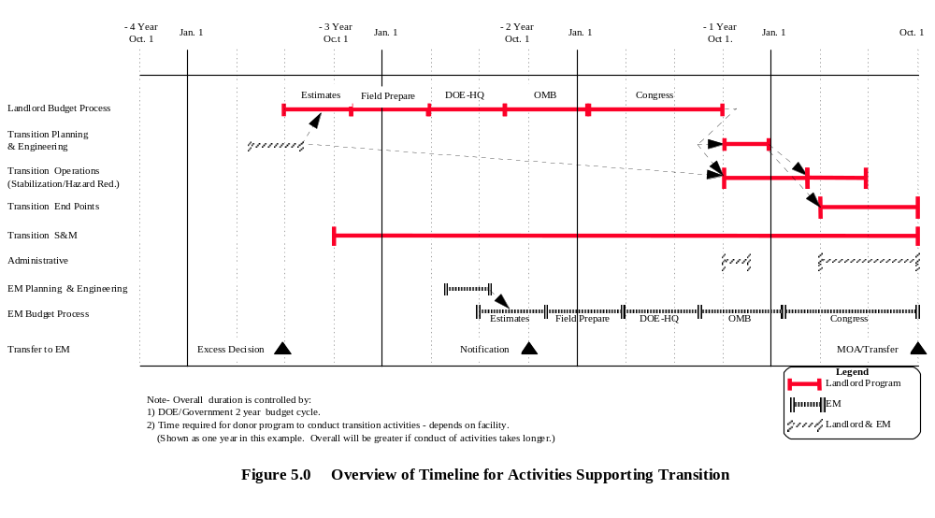

5.3 Timeline for Identifying Work Scope and Cost Associated with Contaminated Facilities
Because the landlord program maintains responsibility for the facility, until it is transferred to the EM Program for D&D, it is important for the landlord program to identify and fund pre-transition activities accordingly in their budget formulation. Per LCAM, the transition review and memorandum of agreement are required to be completed two years in advance of the budget year the facility is expected to transfer into the EM Program. In order to support the transfer of facilities pre-transition activities must be planned and completed in the years prior to the formulation year. As an example, suppose the landlord’s desire is to transfer a facility to the EM Program in fiscal year 2003. In support of the transfer, the Landlord Program needs to identify those transition activities and complete the pre-transition work scope in the fiscal year prior to FY 2003 (that year being FY 2002). To facilitate the collection of this information, ERD has assembled a workbook, and an example of the information requested as part of the workbook is provided in the appendix. The workbook can be provided electronically, upon request, and is maintained by ERD.

6.0 Lessons Learned
The following information is provided as a sharing of lessons learned. This section contains information from past experiences of those involved in the facility disposition process. When inactive facilities come into EM custody, the immediate focus is to ensure that all hazards are under control, and to eliminate as many of them as possible. Over the longer term, there is a significant cost burden that increases with time, associated with the care and maintenance of these idle facilities. Since the mission for these facilities has ended, there is no longer any reason to continue managing residual risks, and these facilities should be decommissioned to eliminate the hazards. Unfortunately, resources are limited and decommissioning is generally deferred as a lower priority. The available resources go towards keeping the inventory of inactive facilities in a safe and stable condition, rather than removing them altogether. These ongoing costs tend to increase as newly inactive facilities are added to the inventory and the older ones deteriorate. Since associated surveillance and maintenance costs do not go away until the facility does, the challenge is to find ways to reduce these ongoing costs, so that some ground can be gained by decommissioning the worst facilities with the funds that are made available. Sites are encouraged to identify cost savings initiatives. There are several approaches that can be pursued:
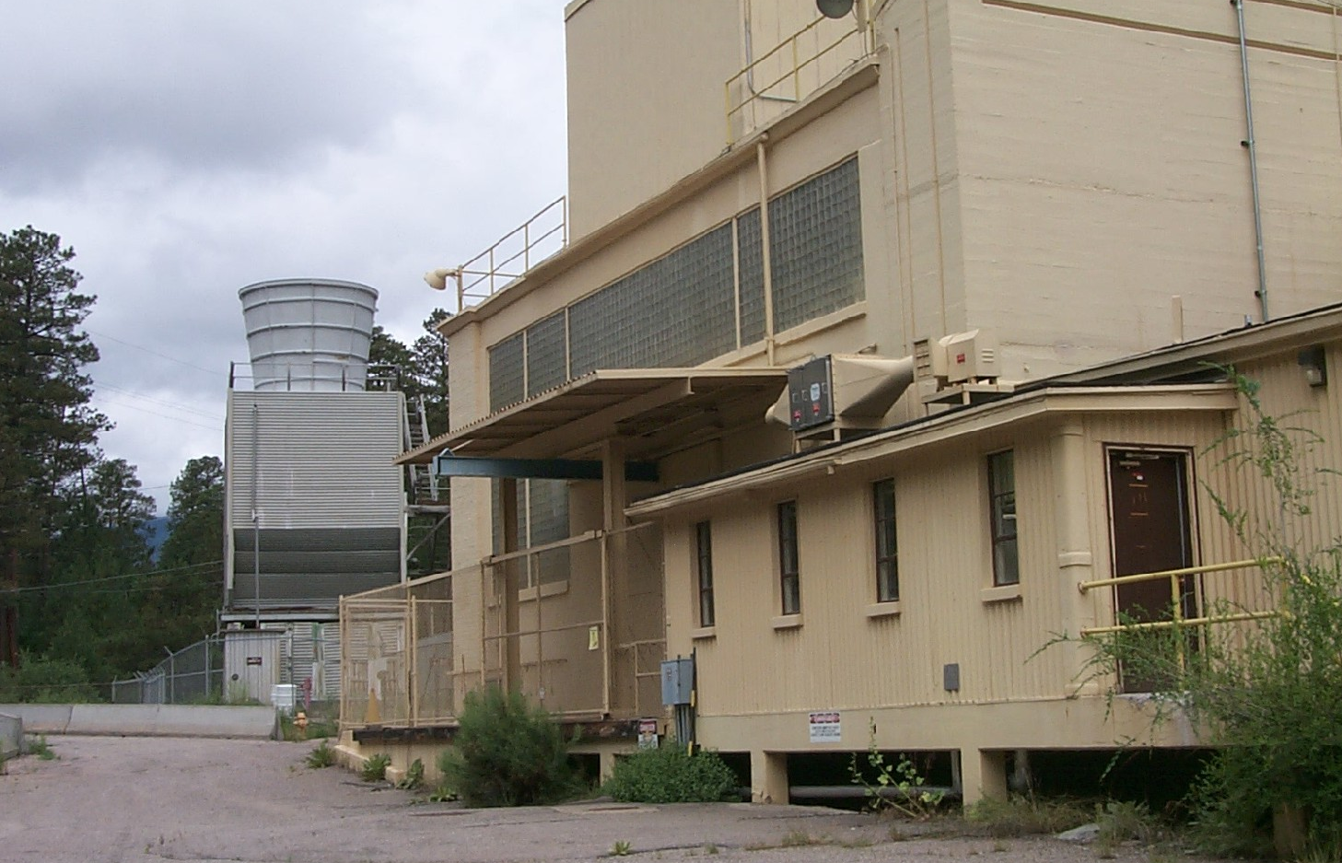

- Reduce Surveillance and Maintenance by deactivation of facilities. This reduces custodial costs by eliminating hazards that require costly stewardship.
- Review ongoing Surveillance and Maintenance to reduce or eliminate unnecessary activities.
- Apply other innovative concepts to eliminate the hazards or the facilities (for example, Assets for Services subcontracts).
- Increase productivity by means of the selective application of carefully chosen innovative technology and methods.

6.1 Deactivation Cost Reduction Opportunities
For some facilities, the residual hazards require that surveillance, maintenance, utilities or custodial services be dedicated to keep them under control. Some examples are:

- The presence of fissile material requires a whole array of precautions like special containers, spacing control, safeguards, and accountability that would not otherwise be needed
- The amount of combustible materials in the facility is high enough to require that fire detection, alarm, and suppression systems remain functional.
- The amount and location of residual radioactive material requires barriers to control the spread of contamination, ventilation, and effluent monitoring systems remain operational.

In cases like these, a deactivation project is initiated to reduce or eliminate hazards and thereby eliminate the ongoing costs. Since projects of this type can be expensive and take a long time, they are chosen judiciously on the basis that the investment may result in a significant reduction both of risk and long-term costs. The site is encouraged to identify to the DOE at least one major deactivation underway each year.

6.2 Requirements – Based Surveillance and Maintenance Cost Reduction Opportunities
In some instances, when a facility becomes inactive, the landlord program turns over surveillance and maintenance (S&M) plan that is based on what was required during operations. Frequently, the driver for an activity no longer exists or applies in the inactive state of the facility, but the S&M activity is continued. Sites should review the S&M program for the facility against federal, state, and local laws and regulations, DOE directives, and other drivers to determine areas for cost reductions.

The following procedure should be used to reduce the cost of S&M:
- Evaluate or reevaluate the existing S&M at the facility.
- Collect information about S&M activities, including cost frequency, and drivers (baseline data).
- Review and evaluate baseline data to identify opportunities for cost reduction by discontinuing or eliminating unnecessary activities.
- Revise the S&M plan for the facility.
- Implement the revised plan.

S&M occurs throughout a facility’s life cycle. As conditions change in the facility, the need for S&M activities may also change, and the S&M plan should be revised accordingly to reflect changes in facility condition.7.3 Assets for Services Cost Reduction Opportunity
Another innovative way to reduce the costs associated with the custody of inactive facilities is an “Assets for Services” (AFS) subcontract. In this approach, one or more facility is demolished by a subcontractor in return for the salvage value of components included within them. If the target facility does not have sufficient value, assets (equipment) from other facilities including non-process contaminated excess facilities are included in the contract. Ideally, this could result in a net cost of zero/or a payment to the government, but in practice DOE usually obtains these services at a reduced rate.

6.4 Decommissioning Cost Reduction Opportunity
Decommissioning removes the hazards permanently, thus eliminating the risks to the worker, public and the environment, along with all S&M costs. Unfortunately, the cost to decommission is sometimes high and can take years to recover the investment. However, certain recurring S&M costs like roof replacements also carry a high price tag. In these cases, decommissioning can be justified as avoiding these recurring cots. Other examples of justifying demolition and removal of the facility may be that the facility is impacting the site’s environmental restoration mission by preventing the site completing soil or groundwater remediation due to the location of the facility. The site should attempt to quantify such situations and identify the cost that can be avoided to the DOE.
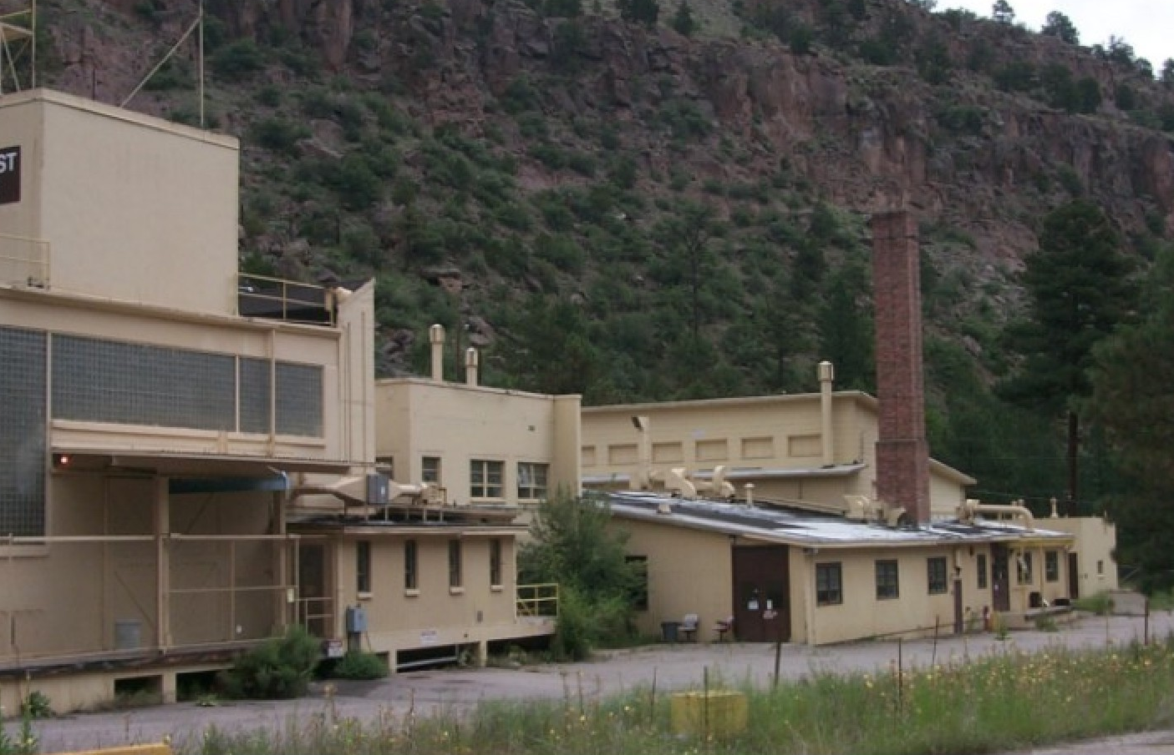

7.0 Roles and Responsibilities

7.1 Albuquerque Operations Office Organizations
Area Office (AO)
Provide day-to-day oversight and management of M&O contractors. Area Office personnel are extensively involved in all aspects of the excess facility disposition process

Budget and Resources Management Division (BRMD) BRMD provides corporate resource planning, analysis, and management services in support of the Albuquerque Operations Office mission, including those portions of other Field/Operations Office’s activities related to the stewardship of weapons. Specific to the Environmental Management Programs, BRMD establishes and maintains an administrative control of funds process to ensure compliance with anti-deficiency statues, appropriations act limitations, and other policies and procedures issued by the DOE, Office of Management and Budget, Treasury, Congress and the President relating to funds management and control. BRMD plans, formulates, and executes all AL Program Direction budgets.

Customer and Technology Services Division (CTSD) CTSD provides timely, quality, cost-effective information technology tools and systems, and the planning, facilities, logistic and administrative support to facilitate the accomplishment of the overall mission of the Albuquerque Operations Office. CTSD has the responsibility of managing the Facility Information Management System (FIMS), which identifies a wide range of information regarding the assets of the Department. The data in FIMS includes the identification of property assets, programmatic ownership, general costs associated with past and current operations, anticipated date of facility excess, and facility characteristics costs, which is used for assisting with the planning for the disposition of an excess facilities.

Environmental Restoration Division (ERD) ERD plans, coordinates, and implements the Environmental Restoration Program including remedial actions and decontamination and decommissioning (D&D). Specific to D&D, ERD is responsible for coordination of those facilities and structures, which are identified as excess to the mission needs. This responsibility includes:
- Safe Shutdown/’Mothballing’/Deactivation (in conjunction with landlord)/and decommissioning of excess facilities
- Coordination of pre-transfer reviews
- Coordination of documentation required in support of the transfer to EM. Participate in the pre-transfer reviews, and transition activities.
- Evaluation of S&M Activities to ensure ES&H
- Planning, prioritization, etc.
- Review of Stockpile and Maintenance Budget to ensure adequate dollars are being requested for excess facilities (to include Surveillance and Maintenance, as well as pre-transition activities).
- Preparing and executing of EM budget activities in support of D&D Activities. Review and assistance in preparing the budget for Defense Programs.
- Assisting as the AL point of contact in the development of the Memorandum of Agreement.
- Providing baseline guidance to the sites.
- Representation of D&D activities with the D&D Focus Area, and D&D National Disposition Committee.

Environment, Safety and Health Division (ESHD) – ESHD provides technical services to AL, and the Office of Defense Programs/ HQ Core Technical Group. Technical services include areas such as: environment, safety, and health protection; Air and water quality; effluent and environmental monitoring; waste operations regulations; National Environmental Policy Act evaluation; industrial and construction safety; firearms safety; explosives safety; electrical safety; fire protection; occupational safety; radiation protection; industrial hygiene; and quality assurance.

Facility Landlord (Landlord)
The landlord is responsible for the operation of a facility prior to becoming excess and is usually responsible for its deactivation as well. The Landlord Program is responsible for assuring that all files, design drawings, information, etc. (especially classified) are dispositioned properly or transferred to new areas. The landlord is also responsible for performing safe shutdown and deactivation as appropriate and required before (or as) the facility is being processed for final disposition. Final facility need decisions are the responsibility of the facility owner, which is primarily DP for AL. The landlord is the program responsible for the operations conducted in the facility and constitutes the appropriate AL division (SPD, for example), Area Offices and appropriate M&O organizations. Each site/Area Office will be required to develop a capital surplus asset management plan as part of it’s Integrated Comprehensive Asset Management Program which is submitted annual in the Integrated Comprehensive Asset Management Planning (ICAMP) Report. Guidance and policy for developing these programs and plans is currently in development and will be predicated on requirements of DOE Order 430.1, Life-Cycle Asset Management (LCAM) and subsequent AL policy, Resourceful Reuse: A guide to Planning Future uses of DOE sites (May 1996), DOE/AL’s Integrated Site Planning Functional Requirements (current version, as revised by OMB A-11), and DOE/AL’s Real Property Functional Requirements (July 1996). DP will also be responsible for managing the transition of intellectual property and seeing the facility to a safe shutdown.

Independent Safety Review Division (ISPD) – ISPD maintains a cross-sectional, independent, corporate perspective focusing on safety management systems and processes, and as necessary initiates new systems and processes; and responds to cross-cutting environment, safety and health issues for AL management. Provides independent safety reviews for AL management; manages crosscutting initiatives such as the Functions, Responsibilities, and Authorities Manual (FRAM) and the AL Safety Employee Concerns Program. Coordinates the ES&H budget formulation plan, the administrative budget development and execution, the OSS Strategic/Operational Plan process, the AL Core Technical Group participation, usage and policy, external matrixed technical support to AL.

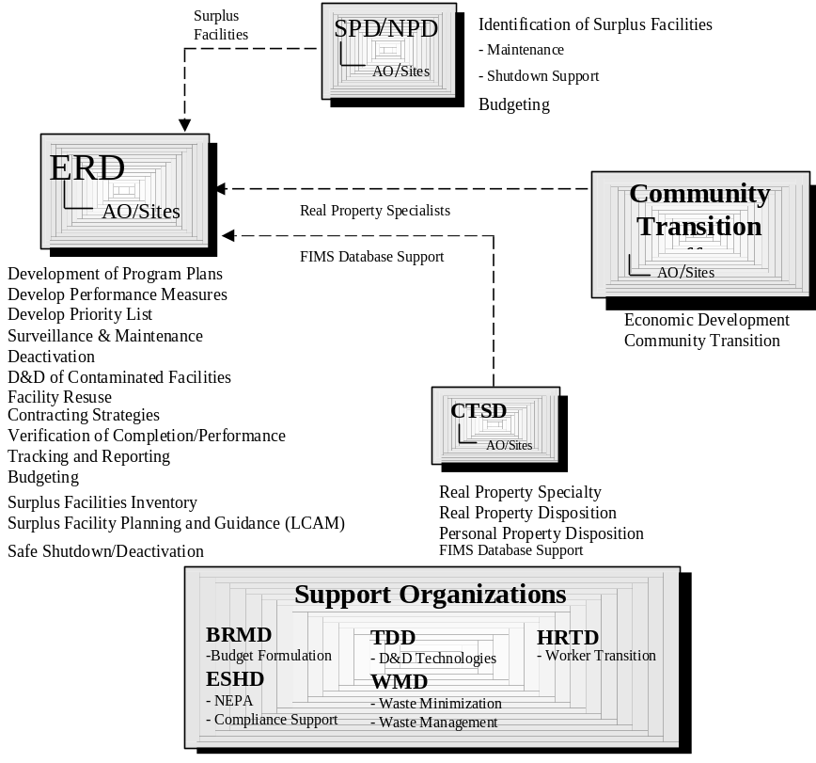Management and Operating Contracts Division (MOCD)– MOCD solicits, negotiates and administers all Management and Operating (M&O) contracts assigned to AL In addition MOCD incorporates responsibilities for the following programs: Contractor Human Resource Management, Business Management Oversight, Personal and Real Property Management, and Contractor Training Assistance. The M&O Contracts Division also solicits, negotiates and administers utilities and utilities related contracts for the entire AL complex. Specific to this guidance document, the Property Management Branch develops, implements, and administers policy and guidelines for the planning, acquisition, control, disposal, and overall management of the AL Personal Property Program. Assures that regulations, policies, and directives are kept current and utilized for all AL personal property management activities; develops, implements, and administers the policies, procedures, and guidelines for the acquisition, control, and disposition of AL Real Property Program at each AL site conducting the program missions of AL; reviews and approves personal property management systems established by AL Divisions, Area Offices, and operating contractors.

Nuclear Material Stewardship Project Office (NMSPO) – NMSPO provides field management of the Department’s Nuclear Materials Stewardship Program to ensure successful interim storage and consolidation of plutonium and other nuclear materials in an efficient, effective, and safe manner; implements nuclear materials technology, standards and data management. NMSPO serves as principal integrator for planning, packaging, transportation, interim storage and surveillance systems; expedites removal of plutonium, and eventually, all nuclear materials from facilities and sites to be remedied to reduce mortgages, and minimizes the need for new storage facilities.

Nuclear Programs Division (NPD) NPD assures that assigned facilities (LANL and SNL) are programmatically justified and appropriate to meet future program mission. Assures that new or modified facilities are constructed or backfitted to meet appropriate safety and environmental requirement. NPD is the AL line organization responsible for construction and startup for new or modified nuclear material processing, manufacturing, and storage facilities. Manages design, construction, project planning and execution, readiness review, authorization basis documentation, NEPA, and restart/start approval for new, reconfigured and modified nuclear material facilities. Manages facility and program mission integration. Implements and administers capital and expense project planning, development, validation and execution; facilities engineering; value engineering; project quality assurance and configuration management; independent cost estimating; and the respective project systems management processes.

Sites/M&O Contractors
The sites/M&O contractors are responsible for site facilities through contracts with the DOE including those activities necessary for an excess facility disposition. M&O contractors may perform D&D activities with subcontractor support or may play an integrating role with DOE direct contractors depending on the contracting and management strategy chosen.

Site Programs Division (SPD) – SPD assures that facilities and capabilities at Pantex, Kansas City is appropriate to support future program missions. SPD coordinates with the site offices and AL functional divisions to assure that operational requirements are integrated with programmatic requirements; and assures that new or downsized facilities are programmatically justified and are constructed or backfitted to meet appropriate safety and environmental requirements. SPD is responsible for construction and startup for new or modified facilities. SPD supports excess facilities disposition planning by validating the continued need of facilities and determining the state of readiness in which each facility should be maintained. SPD is responsible for implementing and administers capital and expense project planning; facilities engineering; value engineering; project quality assurance and configuration management; and the respective project systems management processes.

Technology Development Division (TDD) TDD is responsible for the development and implementation of technology research and development (R&D) programs and projects within the Nuclear Weapons Complex. TDD’s responsibilities are directly associated with the national laboratory, and Production Plants core competencies and are both domestic and international in scope. Within TDD is the Energy Technologies Branch, which is responsible for the development and implementation of technologies for decontamination and dismantlement. D&D technologies will be used when they can prove to produce either a cost or time savings and the technology is proven as opposed to experimental. Currently, most D&D problems can be solved with relatively low-tech processes and equipment, but when technical challenges arise, TDD will pursue a technology that solves the problem effectively.

Waste Management Division (WMD) WMD provides the program management for all sanitary, hazardous, nuclear, and mixed wastes for the Pantex, Kansas City, Los Alamos National Laboratory, Sandia National Laboratories, and the Inhalation/Toxicology Research Institute. In addition WMD provides technical and programmatic support in the area of wastes management when necessary and appropriate; provides external interface on waste issues as appropriate, and keeps AL management advised on waste issues as needed. Plans, coordinates and implements waste minimization and pollution prevention for DOE/AL.

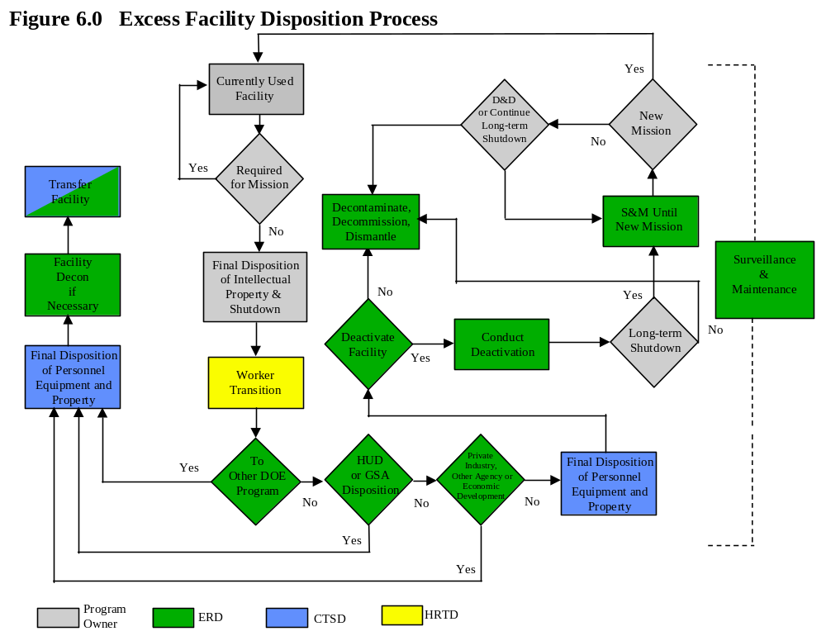

Weapon Programs Division –WPD is responsible for providing field-level program management of the nuclear weapons program. WPD maintains the policy, direction, and oversight of the process for disposition and disposal of excess weapon components and materials. The Personal property guidelines define weapon components as inherently “high risk”, and they are therefore subject to additional administrative constraints. WPD can assist this effort by lending expertise for identification of weapon components, identification of hazards or security classifications, and appropriate method for demilitarization, sanitization, and disposal for weapon components.

Roles and Responsibilities of the Established Disposition Process
The facility disposition process initiates with the declaration of excess of the facility. The facility disposition process is explained in this section and depicted in figure 6.0.

Figure 6 delineates the major elements of the disposition process and assigns responsibilities for actions and major decisions. The Figure displays responsibilities by AL divisions for simplicity. Each task or key decision will likely involve the interaction of the Area Offices as well as the M&O contractors. The process flow presented is assuming a typical scenario and does not account for specific circumstances (special disposition alternatives, regulatory/community restrictions, etc.) that may alter the process.

7.2.1 Description of Process (Figure 6) Elements
Currently used facility - The facility that is currently used houses operations supporting AL’s prime mission, defense production and facility information is maintained in FIMS databases for that facility. The facility also must comply with facility management Orders for which NPD/SPD has oversight responsibility. The facility landlord is the prime organization responsible for its operation, upkeep, and function.

Required for Mission? - This decision, the need for a currently used facility, is made by the landlord program. The facility is considered excess at this point if the decision is no.

Final Disposition of Intellectual Property and Shutdown - The landlord program is responsible for assuring that all files, design drawings, information, etc. (especially classified) are dispositioned properly or transferred to new areas. The landlord is also responsible for performing safe shutdown and deactivation as appropriate and required before (or as) the facility is being processed for final disposition.

Worker Transition - If the shutdown of a facility impacts workers, then the transition of the workers to new programs, projects and/or facilities. HRTD, with help from supporting organizations, is the primary responsible organization for this action.

Transfer to other DOE Programs? - Some facilities excess to one DOE program may be transferred to another DOE program for use in the other program’s mission. ERD will make this decision along with support from other programs (NPD/SPD, for example) and HQ. In addition, the facility landlord may have made arrangements for the transfer of a facility to another program.
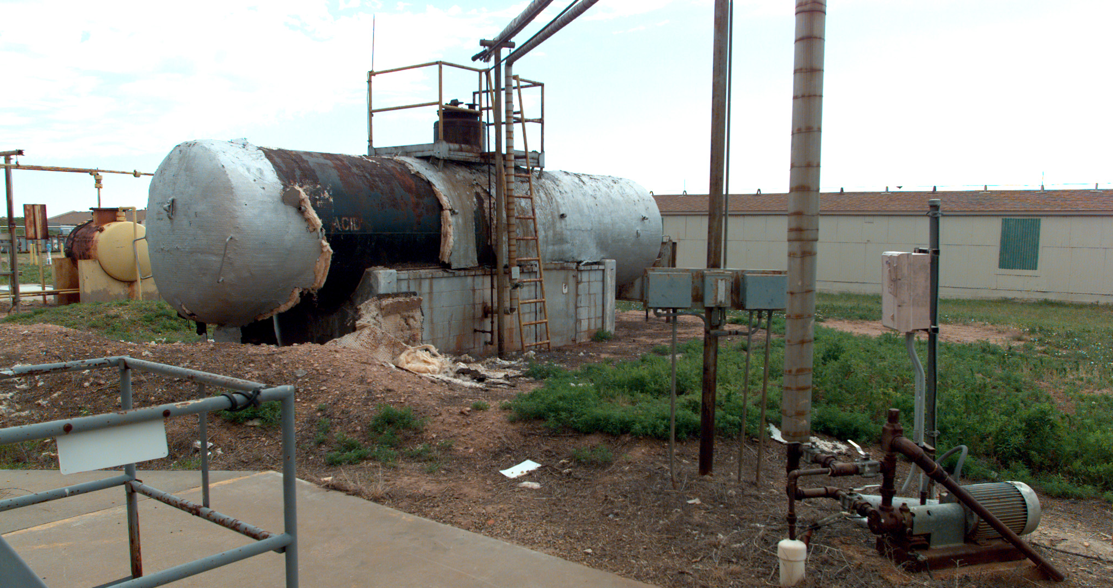

Final Disposition of Personal Equipment/Property and real property - Equipment in facilities being prepared for transfer to other owners or economic development purposes must be dispositioned. Personal property disposition is handled by CSTD.

Facility Decontaminated if Necessary - If a facility is being transferred to other programs or outside agencies or corporations and is contaminated, that facility will need to be cleaned up to appropriate standards. ERD will be responsible for managing/overseeing this action.

Transfer of Facility - The facility will be transferred to its designated recipient with appropriate actions needed to complete this task. CSTD will oversee this transfer along with the new recipient. CSTD will be involved if personal property is included in the transfer.

HUD or GSA Reporting/Disposition? - Excess facilities not required by DOE must be screened by HUD to determine if the facility may be used in its homeless assistance program, as required by law. GSA may also have uses for an excess facility, on-site or off-site removal, if feasible. ERD will manage the decision action in conjunction with the realty specialist(s) in CSTD.

Other Agency, Private Industry, or Economic Development? - ERD will make this decision (along with support from various sources) based on matching facility capabilities with needs of other agencies or private industry. Economic development, in conjunction with site closures and downsizing, may also require the transfer of facilities or property to private industries or local governments.

Final Disposition of Personal Equipment/Property and real property - If the facility will not be transferred to any other entity and will be decommissioned, any personal property in the facility will be dispositioned in conjunction with the disposition plans of the facility. CSTD handles the disposition of personal property as well as managing the disposition of non-contaminated real property. This task could lead to the end of the process.

Deactivate Facility? - The landlord is responsible for deactivation and shutdown of a facility. If the facility needs further deactivation beyond what was done when the facility first became excess (in the case of long-term ‘mothballing’, for example), then that will take place and will be overseen by ERD.

Conduct Deactivation - The landlord is responsible for deactivation. ERD will oversee the additional deactivation activities that may not have taken place when the facility first became surplus. Activities might include source reduction, utilities downgrade or shutdown, minor decontamination, or any other activity that leads to the reduction of surveillance and maintenance costs. These deactivation activities could be precursors to long-term ‘storing’ of the facility.

Long-term Shutdown? - The former facility user may want to put the facility in long-term ‘storage’ with the idea that it may be used for new scope or mission change. The program landlord in conjunction with ERD support will make this decision.
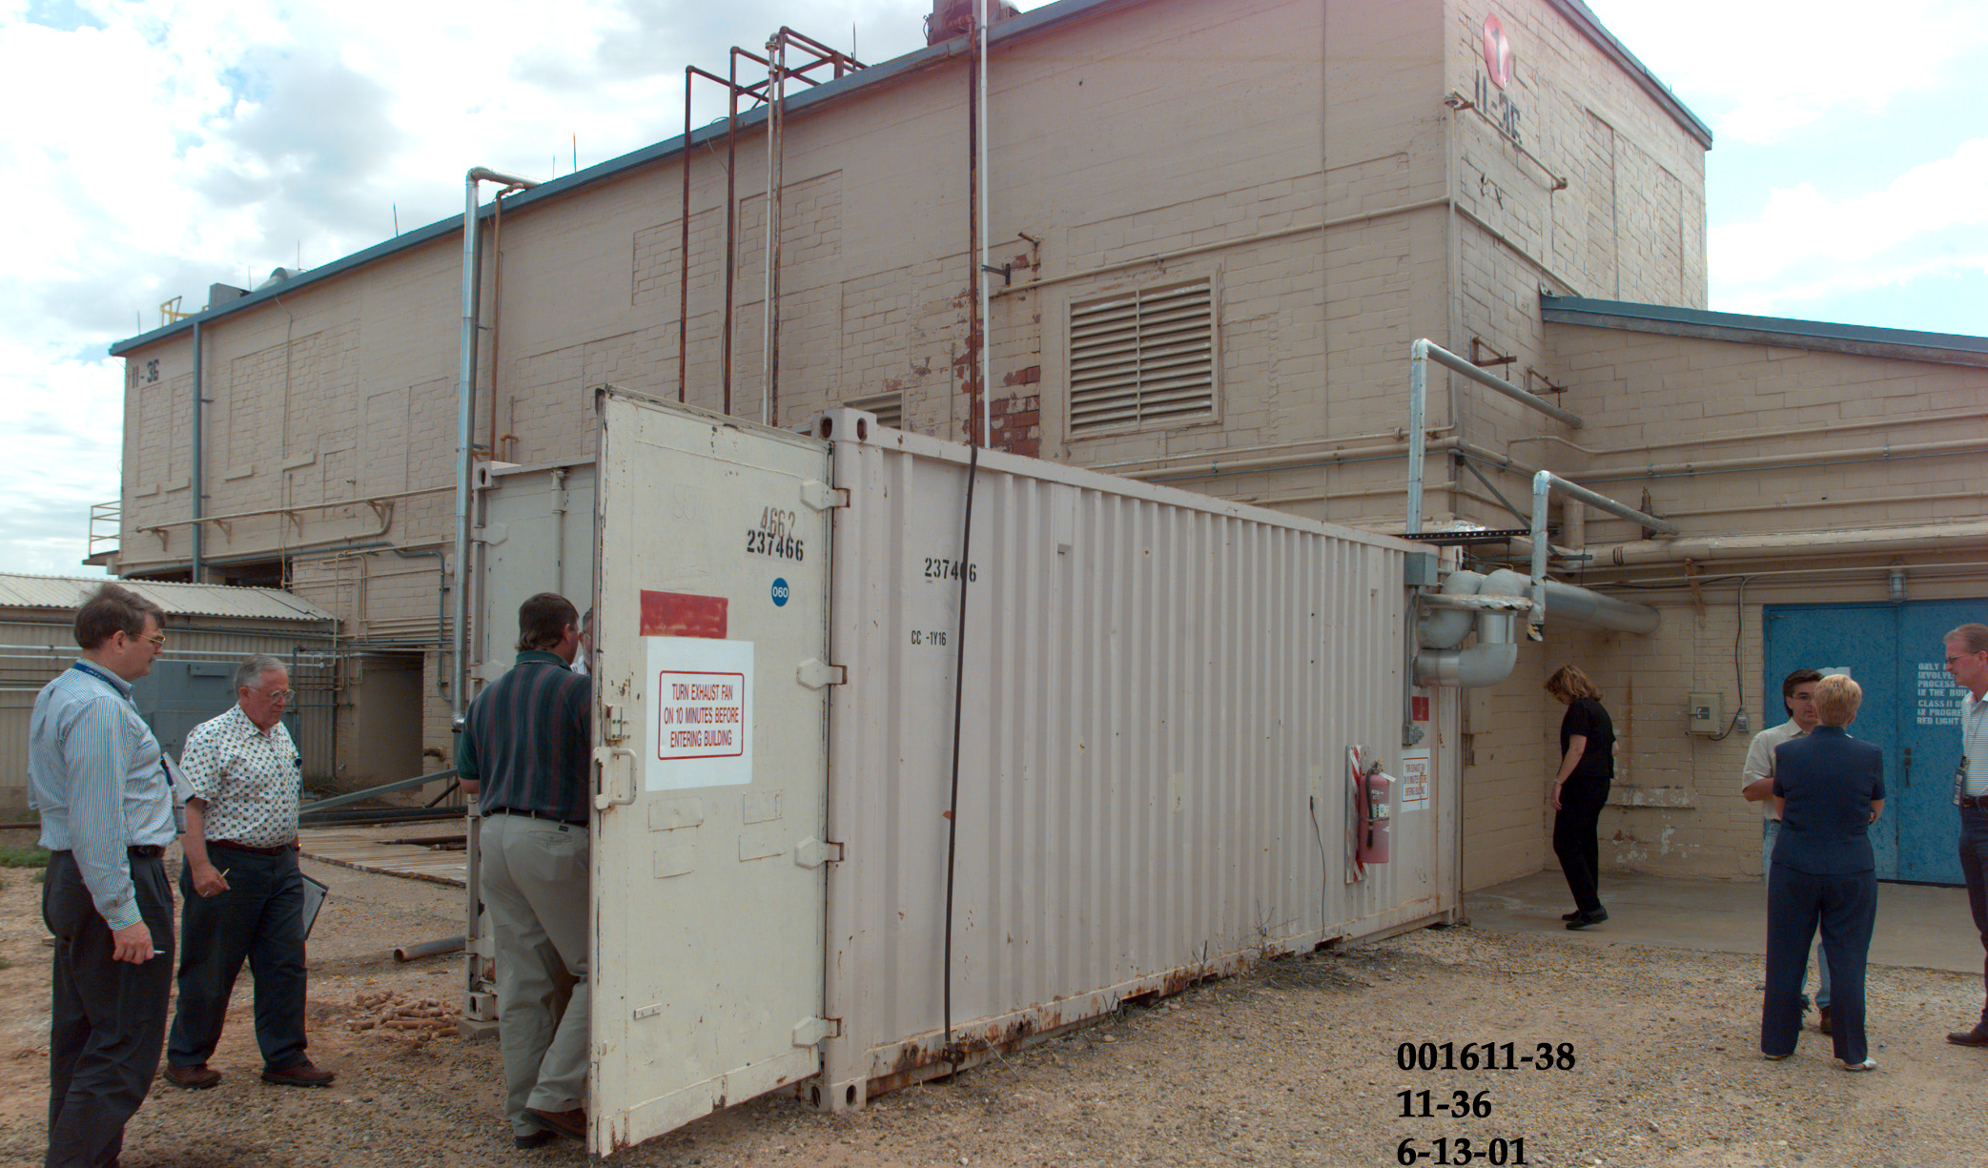

Surveillance and Maintenance until New Mission - ERD will insure that the shutdown facility will have the appropriate surveillance and maintenance as it waits for a new mission or eventual decommissioning.

New Mission? - The program landlord (in this instance it may be NPD/SPD), with support from ERD, determines if the facility can be used somewhere else in it’s program.

D&D or Continue Long-term Shutdown? - The decision to keep the facility in long-term ‘storage’ or D&D the facility is made by the program landlord with support from ERD.

Decontaminate, Decommission, Dismantle - The final stage of the excess facility disposition process. This stage, managed by ERD, sees the facility through decommissioning, cleanup, dismantlement, or any other activity to get the facility to it’s determined end state. Usually, the facility and associated structures are completely removed and all waste is handled according to regulatory requirements and cost/benefit constraints.
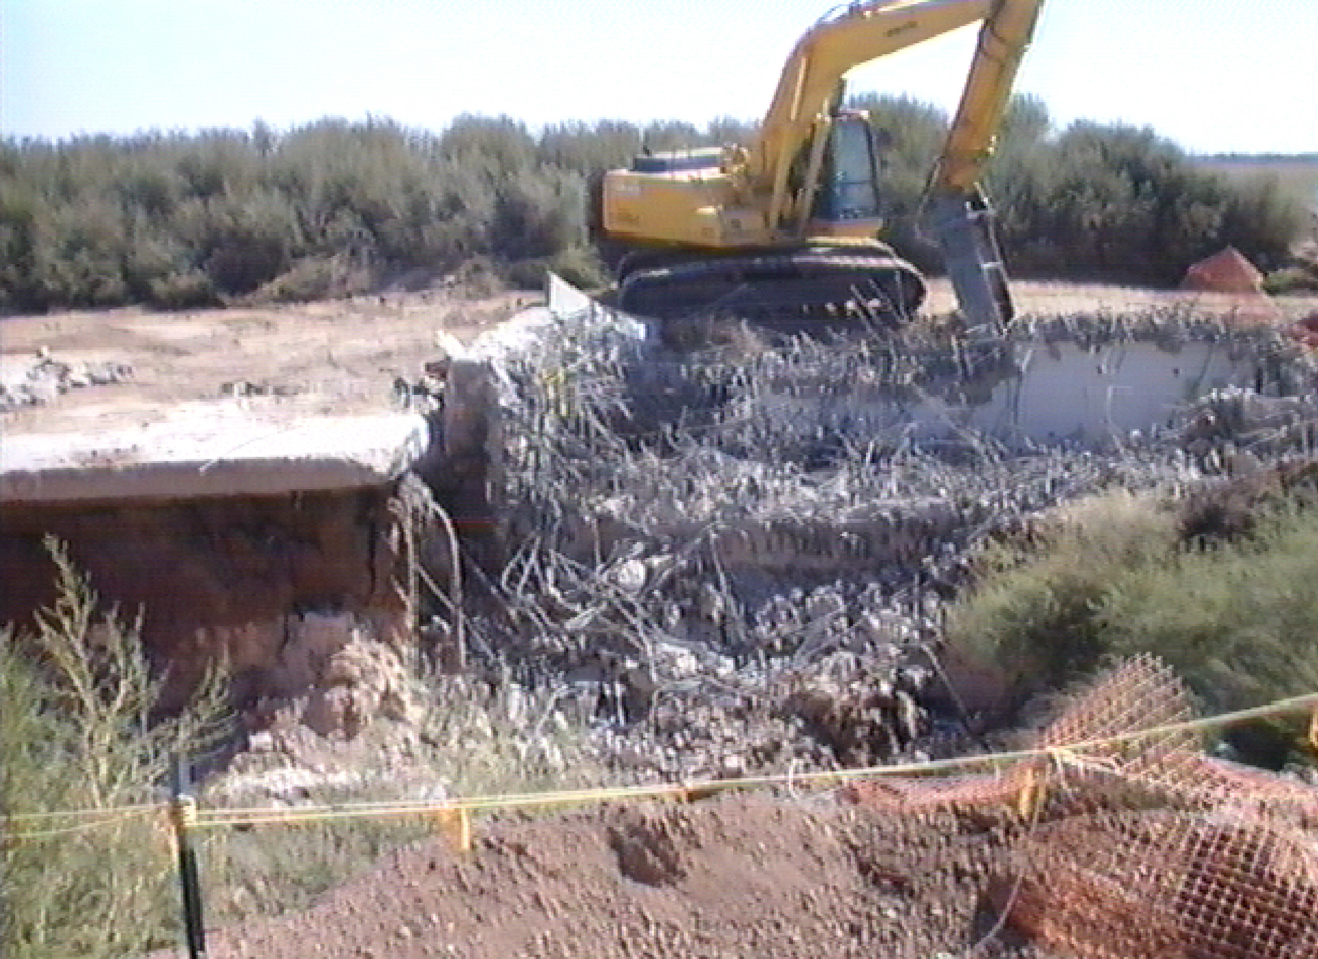

Surveillance & Maintenance - Monitoring, sampling, and general maintenance activities will continue on excess facilities as required and appropriate until the facility reaches its final end-state. ERD will be responsible for overseeing S&M activities once it becomes surplus.

8.0 Appendix

8. 1 Definitions

Deactivation and Decommissioning (D&D)- Deactivation in this phrase applies to the process of eliminating/reducing a facility’s hazards to appropriate standards. Deactivation moves an operational facility to a non-operational state, usually for the purposes of placing the facility into a storage mode, and includes completion of pre-transition activities. Decommissioning is the final stage of this process and encompasses implementation of those activities required to achieve the defined end state for the facility.

Deactivation/Safe Shutdown – The process of moving an operational facility to a non-operational state, usually for purposes of future D&D. Includes shutdown of major equipment and utilities, removal/stabilization of source contamination and general reduction of surveillance and maintenance

Facility Disposition - The process of bringing an excess facility to its final end state. The facility may be decommissioned, decontaminated, dismantled, reused, sold, transferred, or end up in any of several similar actions which yield the best economic benefit to DOE, meet regulatory requirements, or satisfy stakeholder interests.

HUD or GSA Disposition - Process by which excess facilities that DOE is planning on decommissioning are screened by HUD to determine if the facility may be used for housing. GSA may also have uses for an excess facility (or the facility may be on lease from GSA).

Integrated Site Planning Functional Requirements - An implementation document for LCAM that defines AL’s minimum requirements (performance based expectations) for integrated site planning and includes an Appendix focused on Excess Facilities.

Life Cycle Asset management (LCAM) - DOE Order 430, which contains requirements for surveillance and maintenance, deactivation and transfer, as well as D&D of excess facilities.

Surplus Facility - A facility, building, or structure (may include supporting equipment) that is no longer needed to meet a DOE mission.

Surveillance & Maintenance (S&M) - Requirements necessary to maintain a facility’s structural integrity according to appropriate regulations and DOE Orders (maintenance) and to operate the facility (if necessary) at minimum levels (utilities). Also, the requirements to monitor affected (or potentially affected) environmental media, maintain required security measures, and control of access according to regulations, DOE Order or protocol. Different levels and types of S&M are required depending on whether the facility is operational, deactivated (waiting for D&D), being D&D, or in a post-D&D state.

8.2 Pre-Transfer Agreement Example

Overview
On date, overall management responsibility for the ______ facility shall be transferred from Landlord Program to EM Program.

Purpose of this Document
The purpose of this document is to state the conditions of transfer and related responsibilities. It is intended to be a single source that includes:
a) Subjects to be addressed in a future Memorandum of Agreement to transfer the facility.
b) Agreement for ongoing or future facility use, if any, by the transferring organization.
Details of parts of this agreement may be finalized after the condition assessments have been further evaluated.

Scope of Transfer
The goal of the transfer is to proceed with deactivation of the _________ building (building number) and related facilities.
(Provide a brief description of the scope of the transfer. Include a listing of buildings, property, etc. that will be transferred. )

Exceptions and Special Conditions
The following exceptions or special conditions apply:
- Address excluded scope of transfer
- Address timing issues
- Address budget issues
- Provide a list of pre-existing conditions worthy of note
- Facility Use Commitments after Transfer
If there are agreements for use of parts of the facility by the Landlord Program after transfer, describe what they are and the duration. Examples are office space, laboratory facilities, electrical distribution or other operational equipment that supports nearby facilities, etc.
If there are other agreements or commitments for use of parts of the facility after transfer, for example by outside organizations, describe what they are and the duration. An example might be for long-term storage of specific types of waste prior to ultimate disposal.

Transfer of Budget
Transfer of the surveillance and maintenance (S&M) budget targets shall be effective date and consist of:

Amount (Example Only) | Projected for FY
$1,400,000 | 2001
$1,300,000 | 2002
$1,100,000 | 2003

Transfer of Personnel
Transfer and/or re-assignment of personnel shall be addressed as a human resource matter outside the scope of this document. All organizations shall cooperate to prudently address this issue with the current staff of the Facility.

Transfer Schedule
The transfer shall commence on date; however, the details of the transfer for specific facilities, records, and government property and the relocation of personnel shall occur over a transition period as indicated in the target dates below. The transfer will be considered completed upon completion of the following Transfer Elements.

Statement of Responsibilities
The following general responsibilities are in support of the transfer. Table 2, provides some examples of possible actions.

Landlord Program and EM Program, Jointly
A small joint management team shall be formed to implement and ensure a smooth seamless transfer and transition of activities and responsibilities. This team shall address the following transfer elements and determine target dates for their completion.
In addition the team will jointly perform, conduct surveillance and maintenance for a period of ______ days. In addition the team should complete the transfer of: personnel (as appropriate); purchase orders and subcontractors; records and documents.

Landlord Program
The Landlord Program shall be responsible for: continuing the decontamination and waste conditioning operation as agreed upon; removal of equipment as agreed upon; conduct stabilization operations; removal of materials as agreed upon.

EM Program
The EM Program shall take responsibility for the management of surveillance and maintenance of facilities and materials, custody of materials, plan and implement the deactivation of transferred facilities.

Table 2 Example Landlord Program/EM Program Action List
Transfer Actions | Status | Target Date
Listing of facilities to be transferred is finalized and agreed upon.
Budget transfer amount verified and agreed upon.
Memorandum of Agreement is signed.
Pre-existing condition survey completed and documented.
Transfer of Regulatory Permits and agreements.
Receiver assumes responsibility for Facility S&M.
Receiver takes custody of special materials, if any.
All records, documents, and property transferred.
All current staff personnel re-assigned or transferred with the facility.
All current operations are terminated with exceptions identified to remain for deactivation.
Listing of government owned real and personal property to be transferred is finalized and agreed to.
Listing of contracts and purchase orders to be transferred are finalized and agreed to.

8.3 Transfer Activities Checklist
Subject | Notes
Identify Candidate Facility | This is either by a transferring or receiving organization.
Conduct a Facility Survey | Determine status of structures and systems using questionnaire and walkdown checklist (provided in a separate document).
Decision to Proceed | Agreement reached in principal and schedule of activities identified using this checklist. Contacts are named in transferring and receiving organizations for interface during the transfer.
Pre-Transfer Agreement | Use the results of the pre-transfer review and items below to put in place a pre-transfer agreement that sets forth the scope of transfer, expectations on conditions, budget that will be transferred, and others. An example is in Section 6.
Physical Boundaries/Transfer Scope | Identify all structures, outbuildings, tanks, etc. that should be in the scope of the transfer. Identify any issues of separation of systems that serve other facilities that are not to be transferred.
Staffing | Identify staff that know the plant and would be important to continuity. If non-exempt, arrange for re-assignment. If exempt, make arrangements for their availability via contract or agreement to transfer.
Budget | Identify for appropriate fiscal years.  Funds transfer for S&M.  Funds needed for deactivation.  Funds needed for post-deactivation S&M.
Authorization Basis | Status, list of defining documents, S&M requirements to maintain the safety envelop.
Nuclear & Fissionable Materials Inventory | Obtain a listing.
Identify prior commitments and other actions to be Tracked | Generate a List. For example:  State Regulatory Commitments  DNFSB Commitments
Permits, Licenses, Agreements, Safety Analysis, Stakeholder Commitments, etc. | Identify and coordinate with commitments above.
Characterization – Toxic, Hazardous and Radioactive materials | Obtain a listing; use pre-existing condition survey to augment listing if needed. Propose a level of cleanup prior to transfer.
Assets and Property Mgt. | Construct a list of excess assets - limited to those of significant value. Identify which property should transfer, which should stay.
Safe Shutdown Implementation Plan (if applicable) | Verify safe shutdown needs.  Address the configuration and contamination conditions that should be achieved upon transfer.
Schedule Integration | Develop a conceptual level schedule that integrates initiation of deactivation with completion of operations.
Perform Pre-Transfer Operations | See notes above. For stabilization and hazard elimination, agree and conduct as a condition of transfer.
Formal documents for conducting the transfer | Transfer Memorandum of Agreement (MOA), Facility Use Agreement (for post transfer). Draft, negotiate, revise, finalize – see attachments.

8.4 Excess Facility Transfer Workbook

8.4.1 Instructions
This workbook provides a standardized format for submitting estimated cost, schedule, and other relevant data to support the Budget Formulation Year (or current year + 2) excess contaminated facility transition. The definitions of data elements presented in this workbook are the same as those in Integrated Planning, Accounting, Budgeting System (IPABS). Cells colored white require your input. The following directions explain how to enter the excess facility data using the four data collection tabs.

Cost
Enter the estimated life-cycle cleanup cost for each facility by year using the cells provided. Life-cycle costs should be entered in constant year dollars. If there are any projected costs for long-term environmental stewardship activities, the costs for those activities should be entered after completion of the projected decommissioning cleanup. The total of Budget Formulation Year (or current year + 2) estimated costs would be calculated and presented as a total in the Budget Formulation Year (or current year + 2) budget. The sum of costs entered after the projected decommissioning cleanup completion date will be calculated and presented as long-term environmental stewardship costs.

Facility Name – Identify the name associated with the facility. If the site has determined to associate other adjacent process contaminated ancillary structures or associated building with the main building then is it is suggested that you identify it as a complex. It is also requested that you identify all the structures by name and Facility Information Management System (FIMS) number in the general information tab under the general facility description field.

Facility Information Management System (FIMS) Property Sequence Number – All associated FIMS property numbers should be provided in this field.

Estimated start date for activity – A month and year date should be provided in this field for the associated estimated cost field. This information will assist in the identification of milestones and key activities. For example a date should be provided for when the landlord program is expected to initiate pre-transition activities, which will prepare the facility for program transfer to Environmental Management (EM) Program.

Estimated completion date for activity - A month and year date should be provided in this field for the associated estimated cost field. This information will assist in the identification of milestones and key activities. For example a date should be provided for when the landlord program is expected to complete pre-transition activities, which will prepare the facility for transfer to the EM program.

Current funding target requested by landlord program of ongoing Surveillance and Maintenance of the facility – The requested funding level associated with the cost for implementing surveillance and maintenance at the facility should be identified in this field. This cost should be identified beginning in FY 2002(or with the current execution fiscal year) and extend through FY 2020 to support the Lifecycle Asset Management (LCAM) directive requirements regarding transfer of target. No adjustments should be made to account for deactivation and decommissioning to this cost, as it is a target transfer.

Pre-transition costs – These activities are to be funded by the landlord program in support of preparing the facility for programmatic transfer to the EM Program. In some instances, the costs are identified in the transition survey reports and documented in the memorandum of agreement. In general these costs are required for the removal and disposition of waste, performing characterization, and completing facility stabilization activities. Reference should be made to LCAM (and the supporting LCAM guides for deactivation and transition of facilities) for further guidance. In most situations these costs should be identified in the two to three years proceeding the planned transition year.

EM cost to deactivate – The cost associated with deactivation should be identified for the facility. These costs should not appear any sooner than the planned transition year. The definition of deactivation is provided in IPABS guidance, as well as in LCAM.

Surveillance &Maintenance required during EM deactivation and decommissioning – After initial deactivation is performed there may be a reduction in the cost associated with surveillance and maintenance. The associated cost should appear beginning in the fiscal year of transition (in this case it should be FY 04) and continuing through the fiscal year the facility is decommissioned.

EM cost to decommission – The costs associated with facility decommissioning to achieve the final identified end state for the facility. These costs are to be funded by EM, and can initiate in the first year of transition. These costs should include activities required to plan and execute for the disposition, waste disposal, etc. The definition is provided in IPABS guidance.

LTSM costs after D&D - Projected costs for long-term environmental stewardship activities, the costs for those activities should be entered after the projected decommissioning cleanup completion.

General Facility Information
Use the fields to identify/provide: the facility square footage; a general description of the facility; the current condition of the facility; any suspected process contaminants; status the authorization basis; regulatory drivers; purpose, scope and overall technical approach to be pursued; assumptions and methodology used to generate cost estimates; and a projected end-state. If already completed, the EM-generated summary reports for each facility can be a starting point for these narratives. If the projected facility cleanup activities will result in any residual contamination requiring post-cleanup monitoring or other long-term environmental stewardship activities, please include these in the Life-Cycle Cleanup Narrative. The Budget Formulation Year (or current year + 2) work scope is particularly important, as it will define projected accomplishments to support the Budget Formulation Year (or current year + 2) budget request for EM.

Facility square footage – Identify the total square footage associated with the facility and ancillary structures which are included as part of the facility.

General description of the facility – Provide a general description of the facility, this could include facility history, materials of construction, location of facility. If there are concerns with regards to contaminants in the vicinity or underneath the facility (i.e. a possible cleanup site) please identify it in the description. For example, if it is necessary that the structure be removed to support completion of an identified corrective action, other remedial action, or is suspected as being a source contributor to an identified vadose zone or groundwater contaminate plume please identify this in the description.

Current condition of the facility – It is important to identify the general condition of the facility. Narrative should state if the facility is deteriorating, the status of operating systems which supported mission activities, roof and structural integrity, any signs of intrusion, status of surveillance and maintenance activities. This narrative will support the preparation of the Budget Formulation Year (or current year + 2) budget formulation.

Suspected process contaminants – Provide narrative that identifies the suspected process contaminants that are non-industrial in nature. In addition, the narrative should describe how much characterization and analysis has been performed on the facility.

Status of authorization basis – The narrative should identify the current hazard level and status of the authorization basis. For example, is there an existing Biohazard analysis or safety analysis report that documents the current condition of the facility?

Regulatory and directives (drivers) – Narrative should be provided which identifies any local, state, federal regulatory drivers or DOE Directives which require action be taken to disposition the facility. This could also include any regulatory agreements and associated regulatory milestones. This narrative will support the preparation of the Budget Formulation Year (or current year + 2) budget formulation.

Purpose, scope and overall technical approach – The narrative should provide a brief description of the scope associated with the project beginning in Budget Formulation Year (or current year + 2) and out through decommissioning. In addition, the overall assumed technical approach associated with deactivation and decommissioning should be identified.

Assumptions and methodology used to generate cost estimates – Narrative should identify both the key parameters (units of measurements, volumes of waste assumed), which are used to generate the cost estimates as well as the methodology used to perform the cost estimate. In addition to providing assumptions to support cost estimates, it is suggested that key planning assumptions be identified as well, especially those that may influence the project logic.

Projected end-state – Narrative should describe in general what the planned end state is for the project. For example, is it envisioned that an empty field will be the result of the project, will there be a pad remaining, is there contamination underneath the foundation, which will require additional action, by the environmental restoration project.

Life-Cycle Cleanup Narrative – In general terms this narrative should identify the overall activities to be taken by both the landlords program and the EM program such in such a way that each program’s responsibility is easily identifiable.

Key Activities & Milestones
Enter the projected start and completion dates for the activities anticipated for each excess facility. The following phases should have start and completion dates along with narrative to identify the associated work activities: Current S&M activities (pre-transition), Landlord Program pre transition activities required per LCAM or MOA, Post transition activities by EM required for deactivation, S&M activities post deactivation - pre decommissioning, EM activities for decommissioning, Post decommissioning. If the facility in question does not require deactivation, start and completion dates for that activity are not applicable.

8.4.2 Excess Facility Transfer Workbook Cost Information

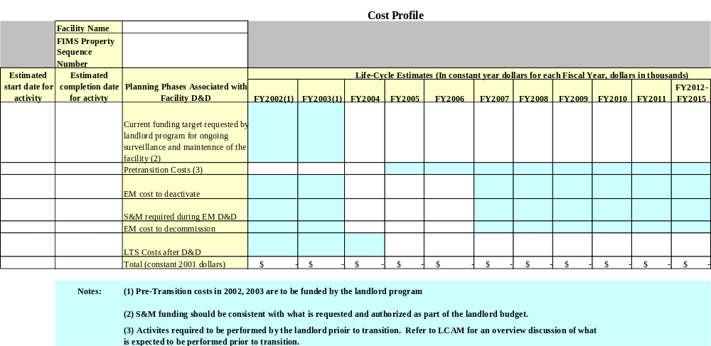

8.4.3 Excess Facility Transfer Workbook General Facility Information

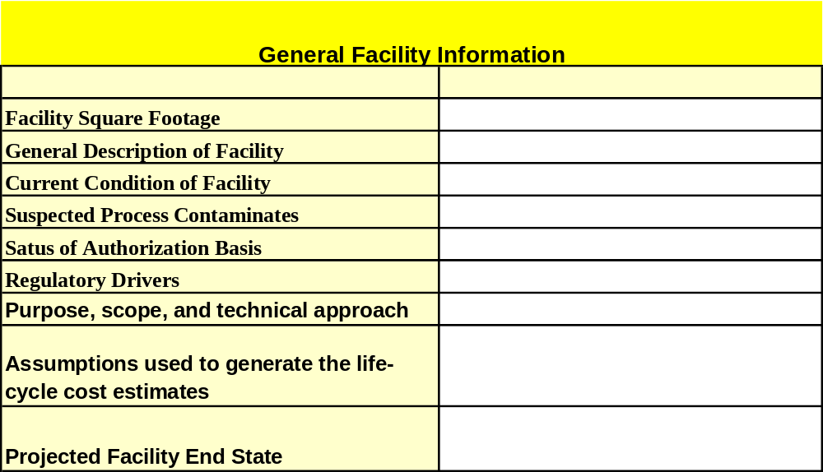

8.4.4 Excess Facility Transfer Workbook Key Activities and Milestones

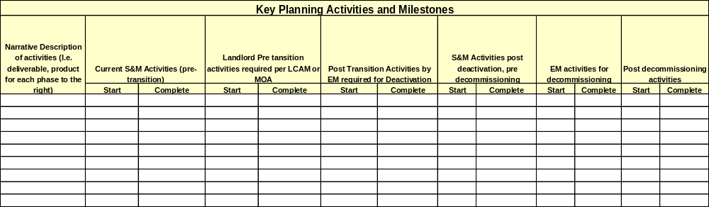

8.5 Outline for Excess Facility Five Year Plan

Background
History of Contaminated Excess Facilities
General description of AL excess facilities
Number of excess facilities
Current condition of excess facilities
Cost of maintaining excess facilities in a safe standby condition

Highest Priorities
Identify prioritization criteria
Identify Site Priorities
Identify Integrated Priorities for AL Excess Facility Program

Current Situation
Funding for demolition competes with mission, ES&H, and ER activities
Funds expended on surveillance and maintenance

Scope, cost and schedule
Information provided for the next 5 years, numbers of facilities expected to be identified for excess, contamination profile, history of each facility, general cost associated with each facilities and the overall profile.

Overall potential savings to the Department
Savings presented if work initiated in next two years, cost of D&D versus the cost of S&M.

Summary

8.6 Excess Facility Five Year Forecast Workbook

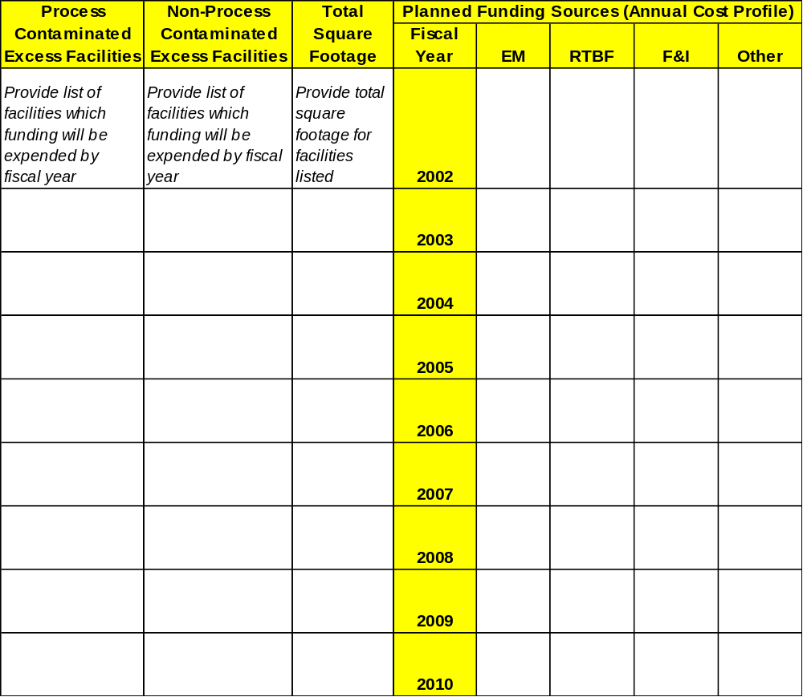

8.7 References
- DOE Order 430.1A, Life Cycle Asset Management, October 14, 1998
- DOE Guide 430.1-2, Surveillance and Maintenance During Facility Disposition, October 1, 1997
- DOE Guide 430.1-3, Deactivation Implementation Guide, October 1, 1997
- DOE Guide 430. 1-4, Decommissioning Implementation Guide, September 2, 1999
- DOE/EM-0318, Facility Deactivation Guide Methods and Practices Handbook, May 1998
- DOE/STD-1120-98, Integration of ES&H Into Facility Disposition Activities, May, 1998
- DOE-STD-1072-94, Guideline to Good practices for Facility Condition Inspections at DOE Nuclear Facilities, June 1994.
- DOE/EM-0341, The Requirements-Based Surveillance and Maintenance Review Guide.
- DOE Guide 430.1-5, Transition Implementation Guide, June 2000.



