Enhanced Fujita Scale
Damage Field Guide

EF Scale

EF | Wind (MPH)
0 | Up to 85
1 | 86-110
2 | 111-135
3 | 136-165
4 | 166-200
5 | >200

National Weather Service
April 25, 2007
Table of Contents

Damage Indicator | Page
1. Small Barns or Farm Outbuildings (SBO) 1
2. One- or Two-Family Residences (FR12) 3
3. Manufactured Home - Single Wide (MHSW) 12
4. Manufactured Home - Double Wide (MHDW) 18
5. Apartments, Condos, Townhouses [3 stories or less] (ACT) 21
6. Motel - Less than or equal to four stories (M) 24
7. Masonry Apartment or Motel Building (MAM) 26
8. Small Retail Building [Fast Food Restaurants] (SRB) 29
9. Small Professional Building [Branch Banks, etc.] (SPB) 33
10. Strip Mall (SM) 35
11. Large Shopping Mall (LSM) 38
12. Large Isolated Retail Building (LIRB) 40
13. Automobile Showroom (ASR) 44
14. Automobile Service Building (ASB) 45
15. Elementary School (ES) 46
16. Junior or Senior High School (JHSH) 50
17. Low-Rise Building: 1 - 4 Stories (LSB) 51
18. Mid-Rise Building: 5 - 20 Stories (MRB) 52
19. High-Rise Building: Greater Than 20 Stories (HRB) 56
20. Institutional Building (IB) 58
21. Metal Building Systems (MBS) 60
22. Service Station Canopy (SSC) 63
23. Warehouse Building (WHB) 64
24. Electrical Transmission Line (ELT) 66
25. Free-Standing Towers (FST) 67
26. Free-Standing Light, Luminary, Flag Poles (FSP) 68
27. Trees: Hardwood (TH) 70
28. Trees: Softwood (TS) 73

1. Small Barns or Farm Outbuildings (SBO)
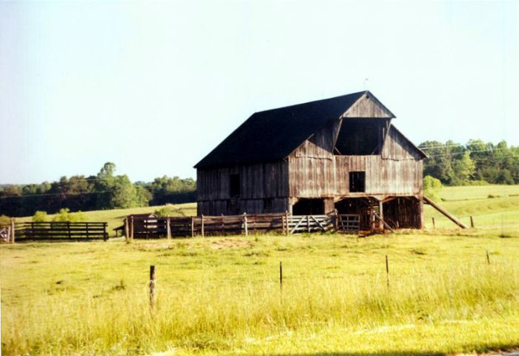

- Less than 2500 sq ft
- Wood or metal post and beam construction
- Wood or metal roof trusses
- Wood or metal panel siding
- Metal or wood roof
- Large doors

DOD | Damage description | EXP | LB | UB
1 | Threshold of visible damage | 62 | 53 | 78
2 | Loss of wood or metal roof panels | 74 | 61 | 91
3 | Collapse of doors | 83 | 68 | 102
4 | Major loss of roof panels | 90 | 78 | 110
5 | Uplift or collapse of roof structure | 93 | 77 | 114
6 | Collapse of walls | 97 | 81 | 119
7 | Overturning or sliding of entire structure | 99 | 83 | 118
8 | Total destruction of building | 112 | 94 | 131
SBO DOD 6
MPH: 81 (EF0) - 97 (EF1) - 119(EF2)
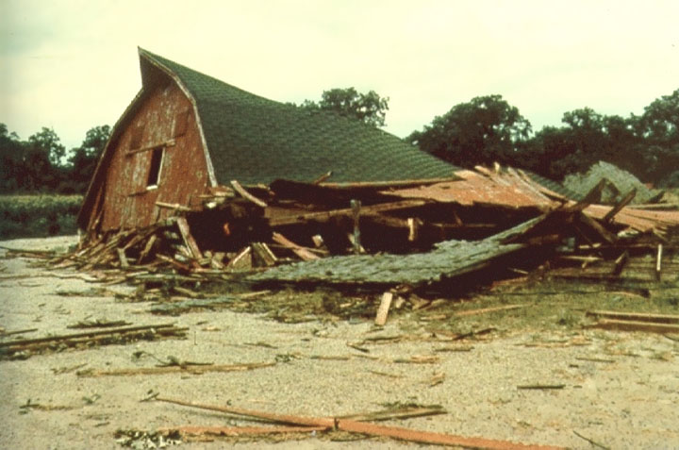
Collapse of walls

Estimate should be on the very lowest end of DOD6 based on relative good roof condition. Est wind 80-85 mph (EF 0).

2. One- or Two-Family Residences (FR12)
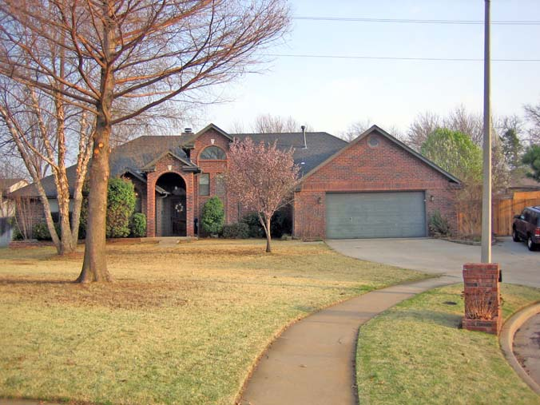

- Asphalt shingles, tile, slate or metal roof covering
- Flat, gable, hip, mansard or mono-sloped roof or combinations thereof
- Plywood/OSB or wood plank roof deck
- Prefabricated wood trusses or wood joist and rafter construction
- Brick veneer, wood panels, stucco, EIFS, vinyl or metal siding
- Wood or metal stud walls, concrete blocks or insulating-concrete panels
- Attached single or double garage

DOD | Damage description | EXP | LB | UB
1 | Threshold of visible damage | 65 | 53 | 80
2 | Loss of roof covering material (<20%), gutters and/or awning; loss of vinyl or metal siding | 79 | 63 | 97
3 | Broken glass in doors and windows | 96 | 79 | 114
4 | Uplift of roof deck and loss of significant roof covering  material (>20%); collapse of chimney; garage doors collapse inward; failure of porch or carport | 97 | 81 | 116
5 | Entire house shifts off foundation | 121 | 103 | 141
6 | Large sections of roof structure removed; most walls remain standing | 122 | 104 | 142
7 | Exterior walls collapsed | 132 | 113 | 153
8 | Most walls collapsed, except small interior rooms | 152 | 127 | 178
9 | All walls | 170 | 142 | 198
10 | Destruction of engineered and/or well constructed residence; slab swept clean | 200 | 165 | 220

FR12 DOD 2
MPH: 63 - 79 (EF0) - 97 (EF1)
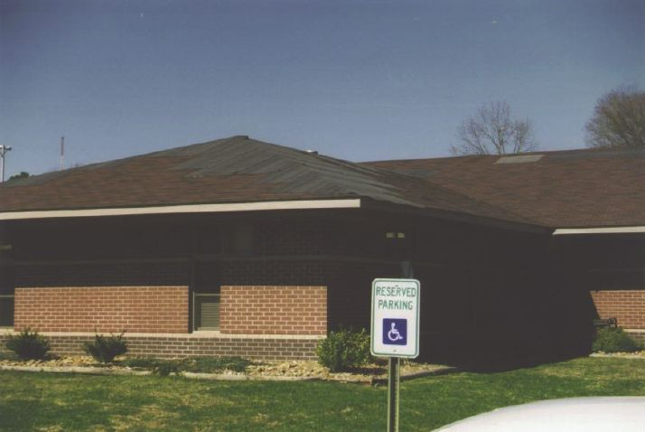
Loss of roof covering material (<20%), gutters and/or awning; loss of vinyl or metal siding

FR12 DOD 4
MPH: 81 (EF0) - 97 (EF1) - 116 (EF2)
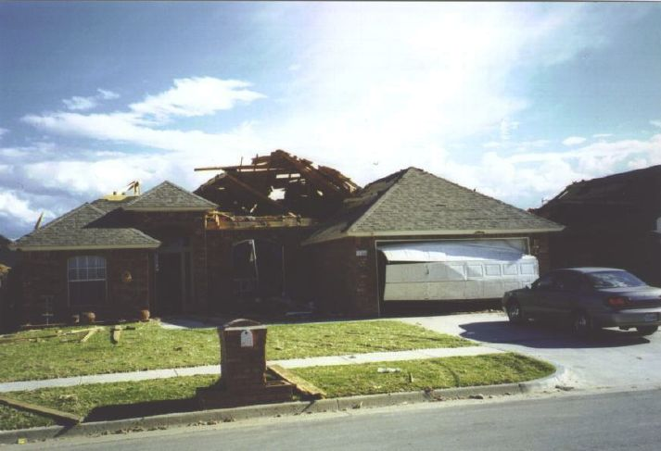
Uplift of roof deck and loss of significant roof covering material (>20%); collapse of chimney; garage doors collapse inward; failure of porch or carport
FR12 DOD 4
MPH: 81 (EF0) - 97 (EF1) - 116 (EF2)
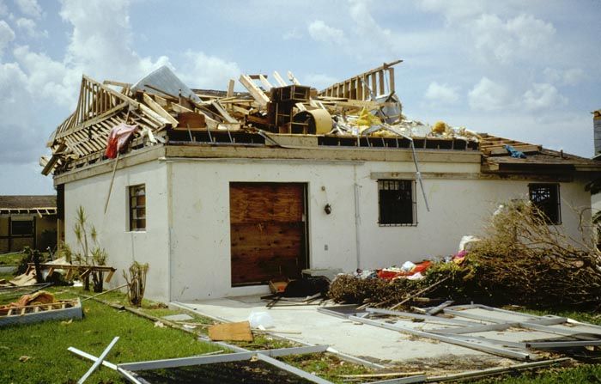
Uplift of roof deck and loss of significant roof covering material (>20%); collapse of chimney; garage doors collapse inward; failure of porch or carport

FR12 DOD 6
MPH: 104 (EF1) - 122 (EF2) - 142 (EF3)
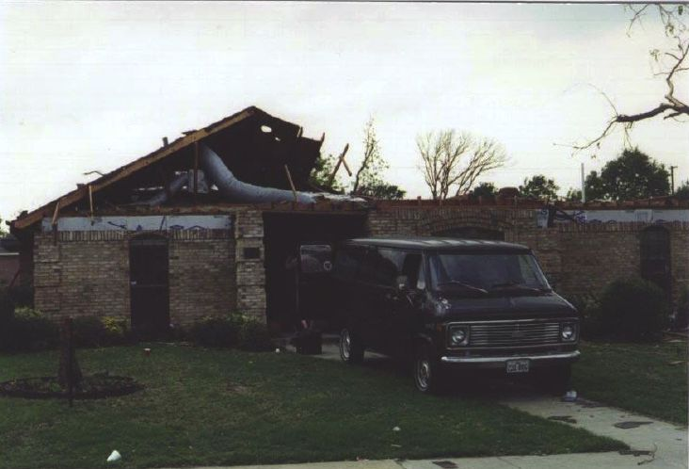
Large sections of roof structure removed; most walls remain standing
FR12 DOD 6
MPH: 104 (EF1) - 122 (EF2) - 142 (EF3)
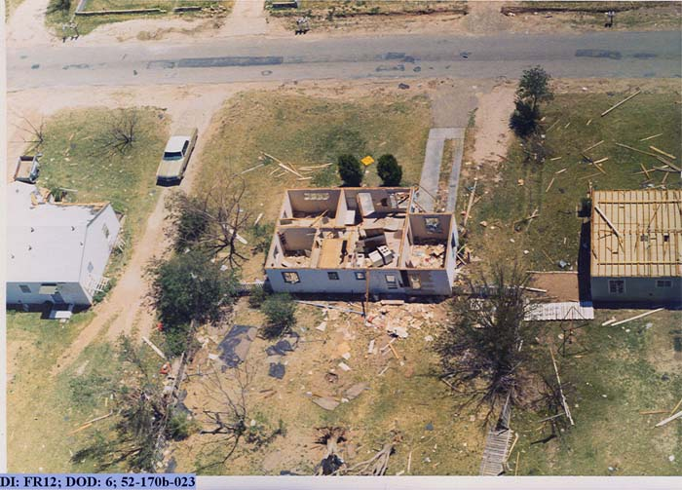
Large sections of roof structure removed; most walls remain standing

FR12 DOD 6
MPH: 104 (EF1) - 122 (EF2) - 142 (EF3)
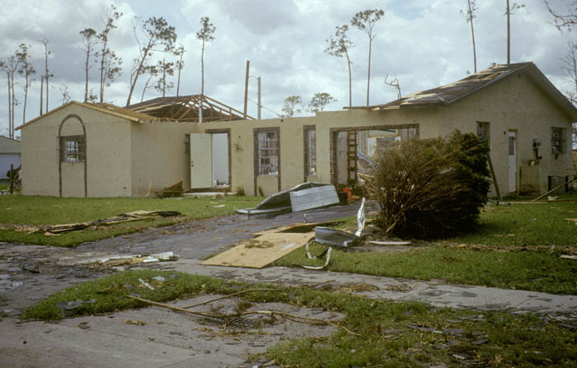
Large sections of roof structure removed; most walls remain standing
FR12 DOD 7
MPH: 113 (EF2) - 132 (EF2) - 153 (EF3)
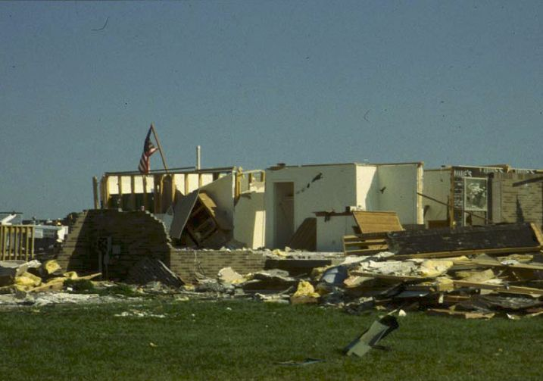
Exterior walls collapsed

FR12 DOD 7
MPH: 113 (EF2) - 132 (EF2) - 153 (EF3)
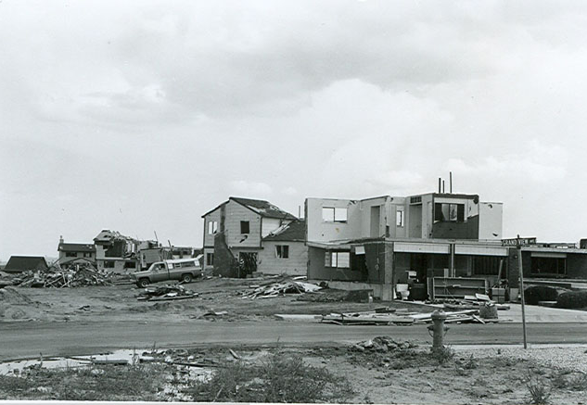
Exterior walls collapsed
FR12 DOD 8
MPH: 127 (EF2) - 152 (EF3) - 178 (EF4)
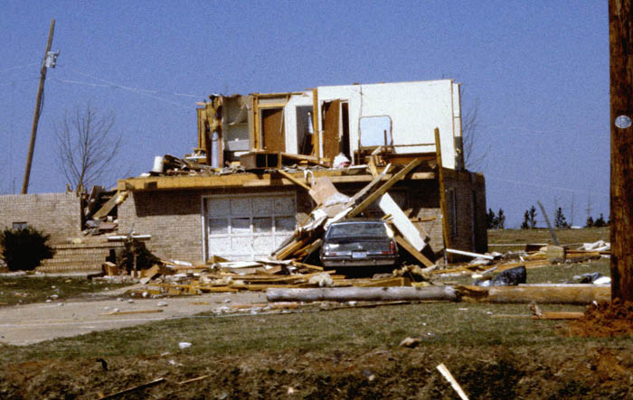
Most walls collapsed, except small interior rooms

FR12 DOD 8
MPH: 127 (EF2) - 152 (EF3) - 178 (EF4)
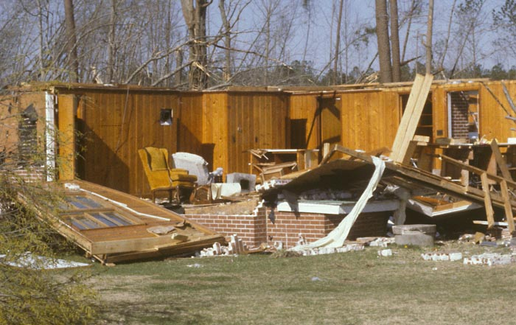
Most walls collapsed, except small interior rooms
FR12 DOD 8
MPH: 127 (EF2) - 152 (EF3) - 178 (EF4)
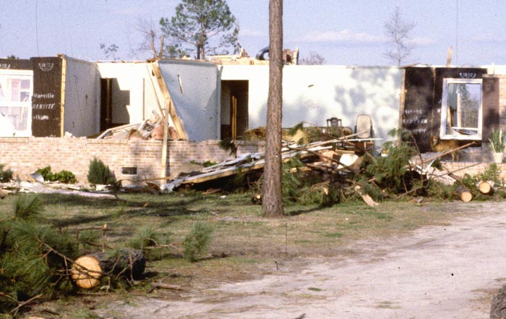
Most walls collapsed, except small interior rooms

FR12 DOD 9
MPH: 142 (EF3) - 170 (EF4) - 198 (EF4)
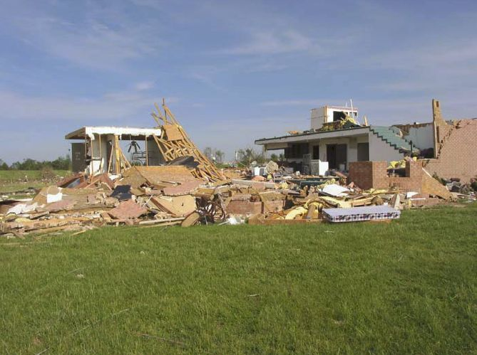
All walls collapsed
FR12 DOD 9
MPH: 142 (EF3) - 170 (EF4) - 198 (EF4)
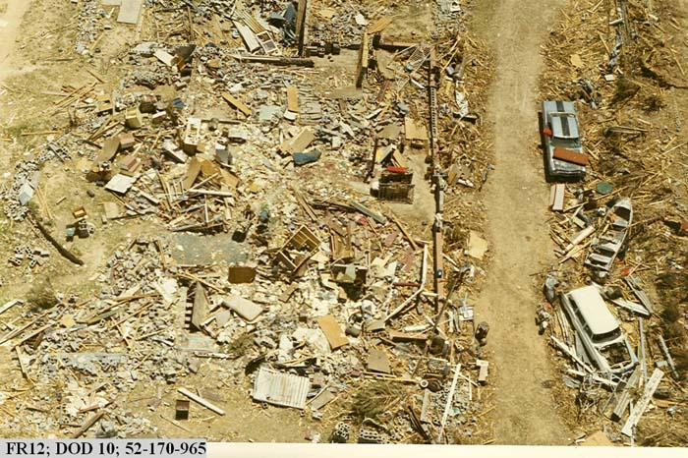
All walls collapsed

FR12 DOD 9
MPH: 142 (EF3) - 170 (EF4) - 198 (EF4)
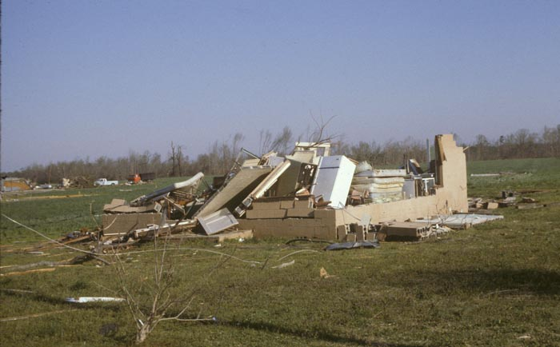
All walls collapsed
FR12 DOD 10
MPH: 165 (EF3) - 200 (EF5) - 220 (EF5)
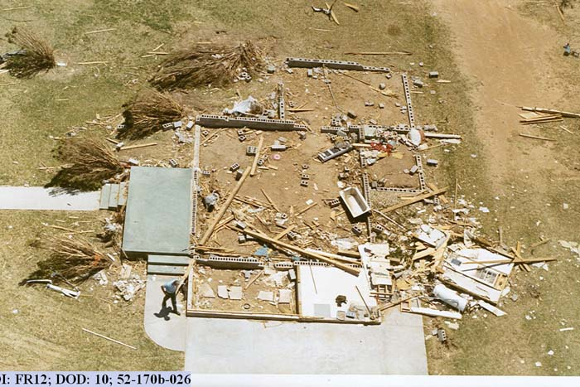
Destruction of engineered and/or well constructed residence; slab swept clean

FR12 DOD 10
MPH: 165 (EF3) - 200 (EF5) - 220 (EF5)
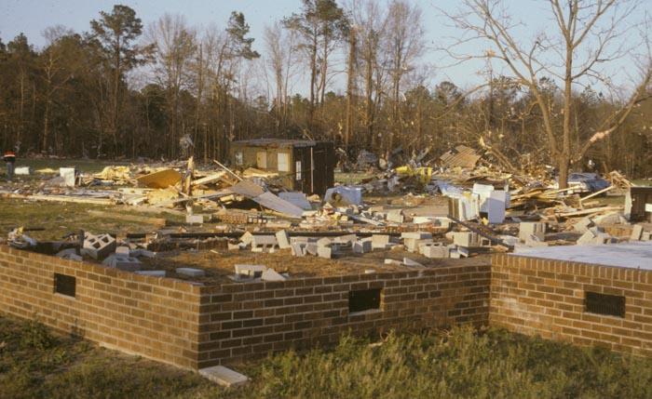
Destruction of engineered and/or well constructed residence; slab swept clean

3. Manufactured Home - Single Wide (MHSW)
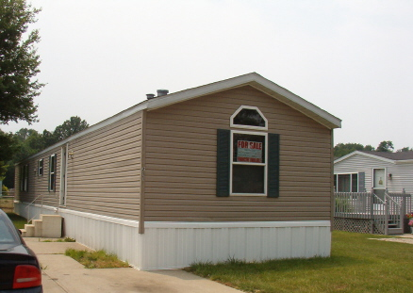

- Steel undercarriage supported on concrete block piers
- Metal straps and ground anchors (Frame and/or over-the-top strap anchors)
- Asphalt shingles or one-piece metal roof covering
- Wood roof joists
- Metal, vinyl or wood siding
- Wood stud walls and partitions
- Better construction in post 1974 models in coastal areas

DOD | Damage description | EXP | LB | UB
1 | Threshold of visible damage | 61 | 51 | 76
2 | Loss of shingles or partial uplift of one-piece metal roof covering | 74 | 61 | 92
3 | Unit slides off block piers but remains upright | 87 | 72 | 103
4 | Complete uplift of roof; most walls remain standing | 89 | 73 | 112
5 | Unit rolls on its side or upside down; remains essentially intact | 98 | 84 | 114
6 | Destruction of roof and walls leaving floor and undercarriage in place | 105 | 87 | 123
7 | Unit rolls or vaults; roof and walls separate from floor and undercarriage | 109 | 96 | 128
8 | Undercarriage separates from unit; rolls, tumbles and is badly bent | 118 | 101 | 136
9 | Complete destruction of unit; debris blown away | 127 | 110 | 148
MHSW DOD 3
MPH: 72 (EF0) - 87 (EF1) - 103 (EF1)
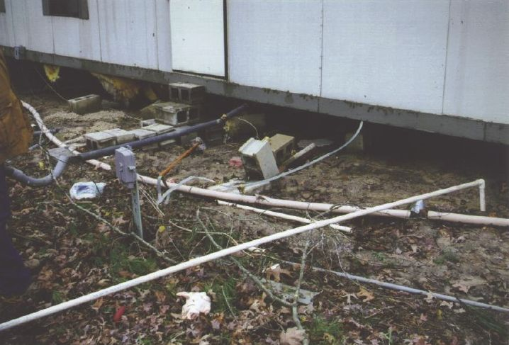
Unit slides off block piers but remains upright

MHSW DOD 3
MPH: 72 (EF0) - 87 (EF1) - 103 (EF1)
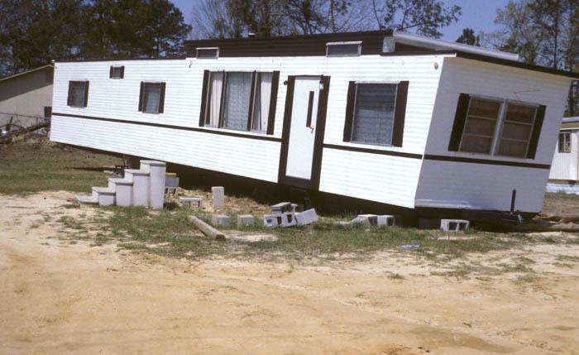
Unit slides off block piers but remains upright
MHSW DOD 4
MPH: 73 (EF0) - 89 (EF1) - 112 (EF2)
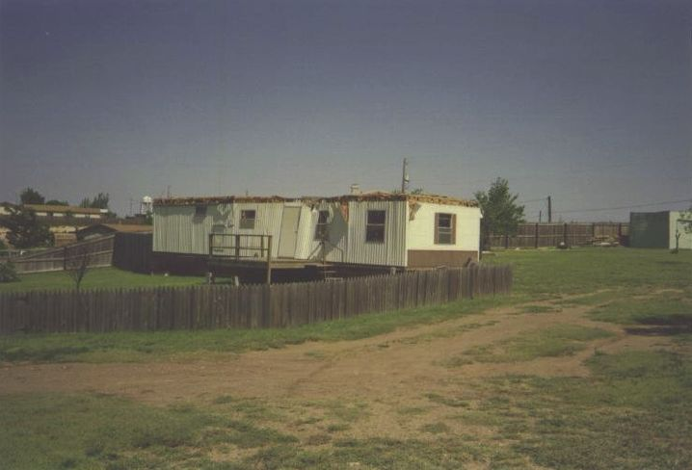 Complete uplift of roof; most walls remain standing

MHSW DOD 4
MPH: 73 (EF0) - 89 (EF1) - 112 (EF2)
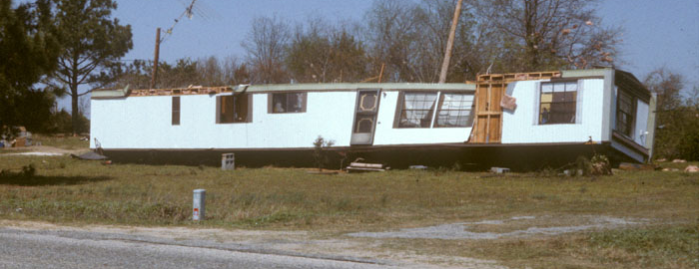
Complete uplift of roof; most walls remain standing
MHSW DOD 5
MPH: 84 (EF0) - 98 (EF1) - 114 (EF2)
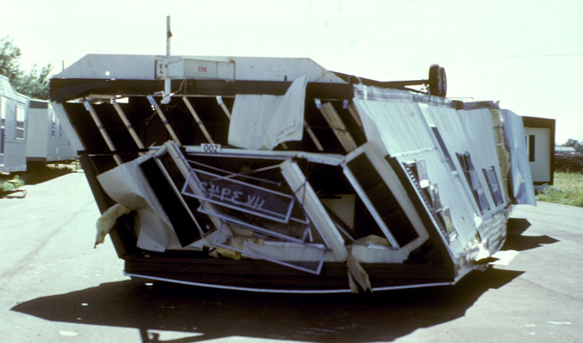
Unit rolls on its side or upside down; remains essentially intact

MHSW DOD 5
MPH: 84 (EF0) - 98 (EF1) - 114 (EF2)
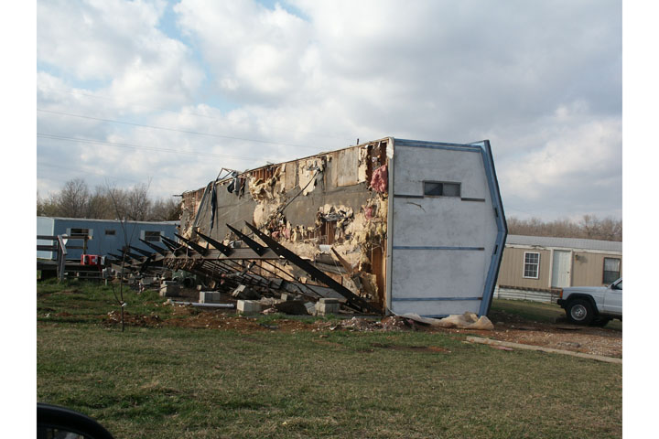
Unit rolls on its side or upside down; remains essentially intact
MHSW DOD 5
MPH: 84 (EF0) - 98 (EF1) - 114 (EF2)
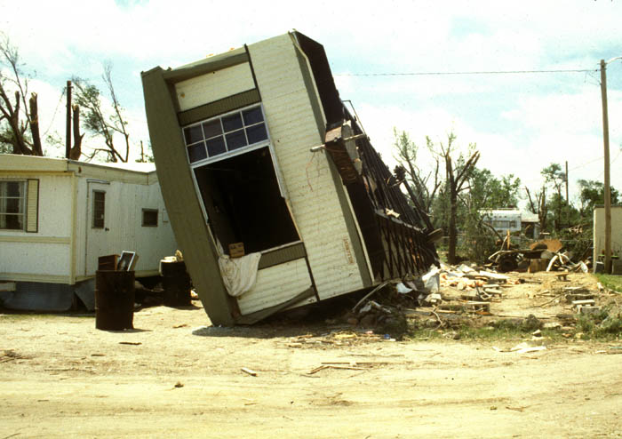
Unit rolls on its side or upside down; remains essentially intact

MHSW DOD 6
MPH: 87 (EF1) - 105 (EF1) - 123 (EF2)
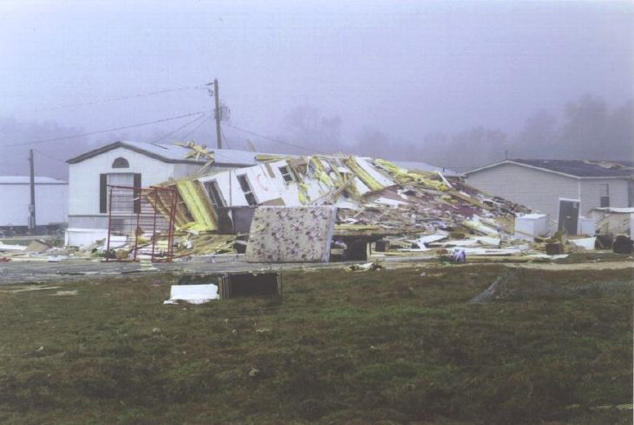
Destruction of roof and walls leaving floor and undercarriage in place

MHSW DOD 9
MPH: 110 (EF1) - 127 (EF2) - 148 (EF3)
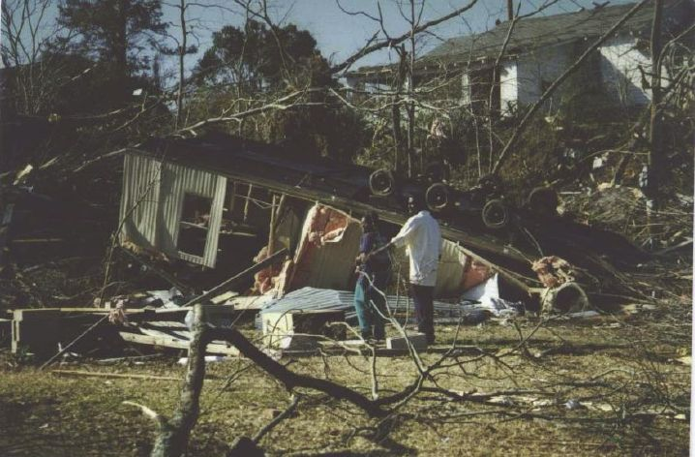
Complete destruction of unit; debris blown away

4. Manufactured Home - Double Wide (MHDW)
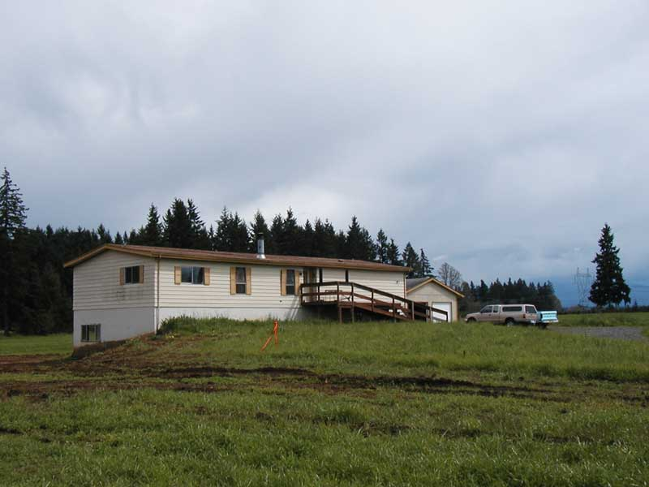

- Steel undercarriage supported on concrete block piers
- Multi-unit connection at roof, floor and end walls
- Frame straps and ground anchors spaced at 10 - 12 ft apart
- Flat, gable or hip roof shape
- Asphalt shingles or metal roof panels
- Plywood/OSB roof decking
- Wood rafter or shallow joist construction
- Metal, vinyl or wood siding

DOD | Damage description | EXP | LB | UB
1 | Threshold of visible damage | 61 | 51 | 76
2 | Loss of shingles or other roof covering (<20%) | 76 | 62 | 88
3 | Damaged porches or carports | 78 | 67 | 96
4 | Broken windows | 83 | 68 | 95
5 | Uplift of roof deck and loss of significant roof covering material (>20%) | 88 | 75 | 108
6 | Complete uplift of roof; most walls remain standing | 93 | 77 | 110
7 | Unit slides off CMU block piers | 94 | 78 | 109
8 | Removal of entire roof structure leaving most walls standing | 97 | 80 | 117
9 | Complete destruction of roof and walls leaving undercarriage in place | 113 | 93 | 131
10 | Unit rolls, displaces or vaults | 114 | 82 | 130
11 | Undercarriage separates from floor, rolls and tumbles, badly bent | 127 | 109 | 145
12 | Complete destruction of unit; debris blows away | 134 | 119 | 154

MHDW DOD 5
MPH: 75 (EF0) - 88 (EF1) - 108 (EF1)
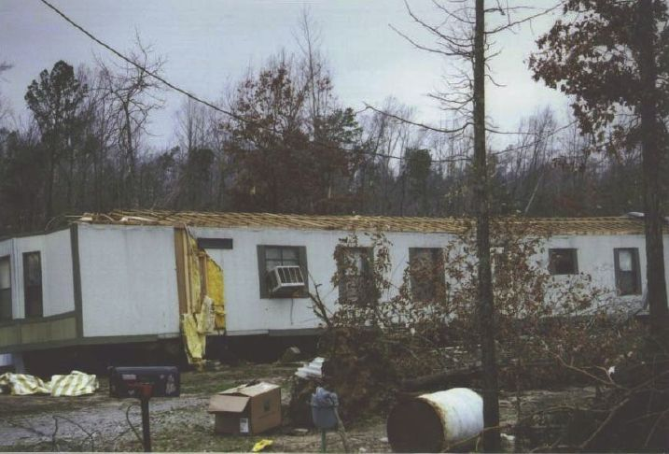
Uplift of roof deck and loss of significant roof covering material (>20%)

MHDW DOD 7
MPH: 78 (EF0) - 94 (EF1) - 109 (EF1)
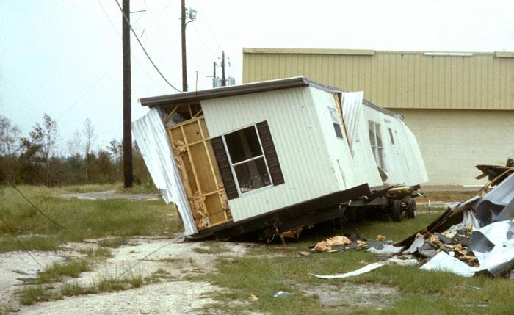
Unit slides off CMU block piers
MHDW DOD 11
MPH: 109 (EF1) - 127 (EF2) - 145 (EF3)
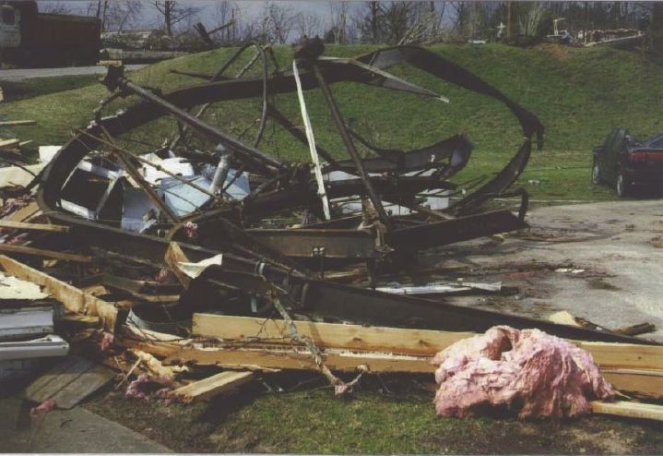
Undercarriage separates from floor, rolls and tumbles, badly bent

5. Apartments, Condos, Townhouses [3 stories or less] (ACT)
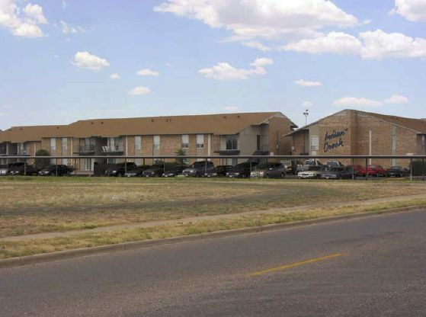

- Flat, gable, hip or mansard roof
- Asphalt shingles, tile, metal or BUR roof covering
- Plywood/OSB roof decking
- Light-framed wood or metal roof trusses
- Wood, metal or vinyl panels, stucco brick veneer or EIFS wall covering; combinations of wall coverings
- Wood or metal stud walls
- Wood floor diaphragms
- Sliding patio doors; balconies

DOD | Damage description | EXP | LB | UB
1 | Threshold of visible damage | 76 | 63 | 95
2 | Loss of roof covering (<20%) | 99 | 82 | 121
3 | Uplift of roof decking; significant loss of roof covering | 124 | 107 | 146
4 | Uplift or collapse of roof structure leaving most walls standing | 138 | 120 | 158
5 | Most top story walls collapsed | 158 | 138 | 184
6 | Almost total destruction of top two stories | 180 | 155 | 205

ACT DOD 2
MPH: 82 (EF0) - 99 (EF1) - 121 (EF2)
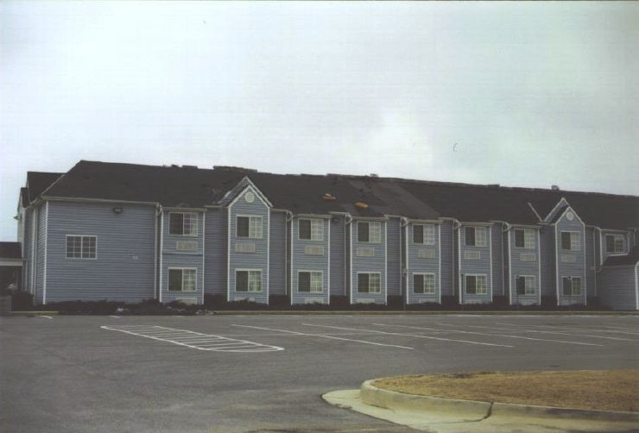
Loss of roof covering (<20%)

ACT DOD 4
MPH: 120 (EF2) - 138 (EF3) - 158 (EF3)
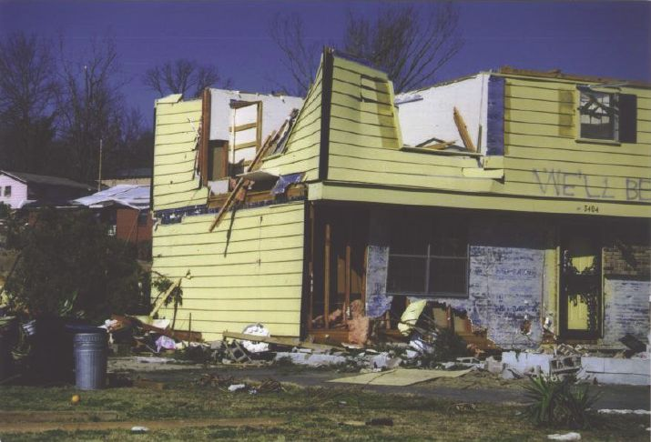
Uplift or collapse of roof structure leaving most walls standing
ACT DOD 4
MPH: 120 (EF2) - 138 (EF3) - 158 (EF3)
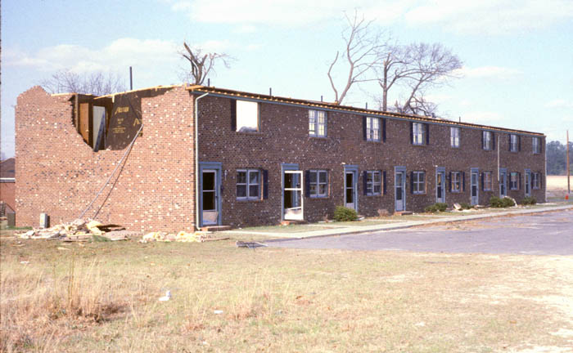
Uplift or collapse of roof structure leaving most walls standing

ACT DOD 5
MPH: 138 (EF3) - 158 (EF3) - 184 (EF4)
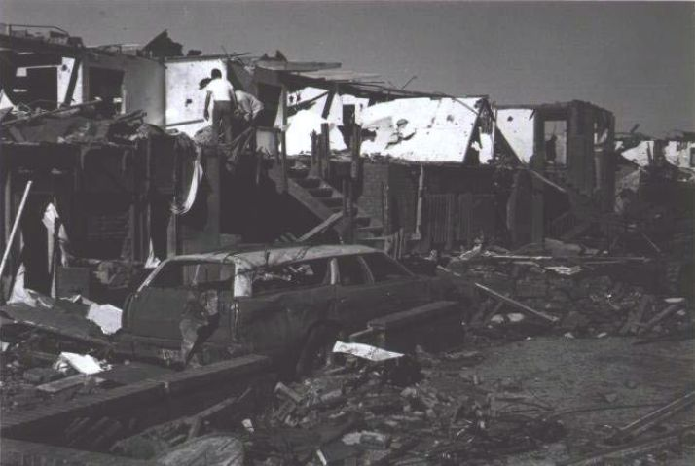
Most top story walls collapsed

6. Motel - Less than or equal to four stories (M)
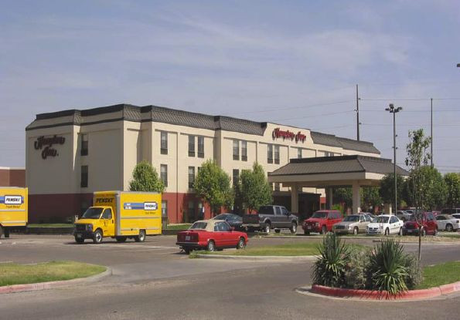

- Facility made up of one or more multi-story, rectangular buildings
- Flat, gable, hip or mansard roof
- Asphalt shingles, tile, slate or BUR roof covering
- Plywood/OSB roof decking
- Wood or metal prefabricated roof trusses
- Wood floor diaphragms
- Wood or metal stud walls
- Stucco, EIFS, wood, metal or brick veneer wall cladding
- Canopy over driveway at entrance
- Exterior walkways or balconies

DOD | Damage description | EXP | LB | UB
1 | Threshold of visible damage | 66 | 54 | 83
2 | Loss of roof covering (<20%) | 80 | 67 | 99
3 | Broken windows or patio doors | 89 | 74 | 107
4 | Uplift of roof decking; significant loss of roof covering (>20%); loss of EIFS wall cladding | 95 | 80 | 116
5 | Uplift or collapse of canopy over driveway | 99 | 81 | 118
6 | Uplift or collapse of roof structure leaving most walls standing | 123 | 103 | 143
7 | Collapse of top story exterior walls | 138 | 121 | 156
8 | Collapse of most top story walls | 143 | 127 | 162
9 | Collapse of top two floors of three or more stories | 170 | 144 | 185
10 | Total destruction of entire building | 190 | 163 | 217

M DOD 8
MPH: 127 (EF2) - 143 (EF3) - 162 (EF3)
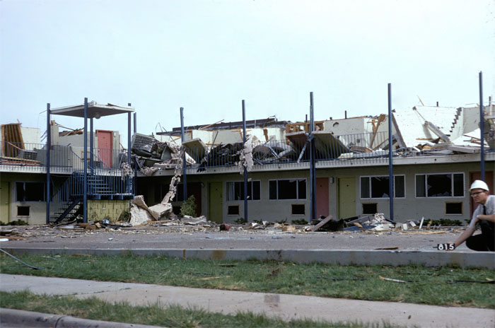
Collapse of most top story walls

7. Masonry Apartment or Motel Building (MAM)
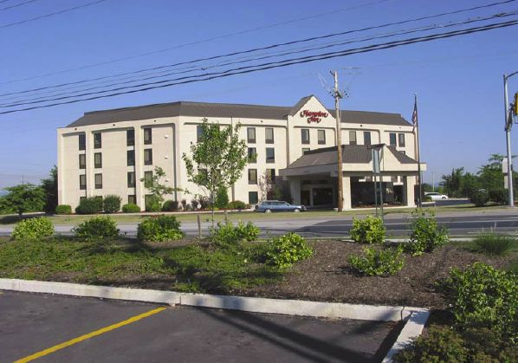

- Less than or equal to four stories
- Facility made up or one or more multi-story, rectangular buildings
- Flat, gable, hip or mansard roof
- Asphalt shingles, tile, slate or BUR roof
- Light steel roof framing with metal deck and lightweight insulation
- Pre-cast or hollow-core concrete roof and floor system
- CMU non-bearing walls
- CMU load-bearing walls
- Stucco, EIFS, or brick veneer wall cladding
- Exterior walkways or balconies

DOD | Damage description | EXP | LB | UB
1 | Threshold of visible damage | 65 | 54 | 81
2 | Loss of roof covering (<20%) | 80 | 67 | 101
3 | Uplift of lightweight metal roof decking | 95 | 81 | 116
4 | Uplift of concrete roof decking | 121 | 103 | 143
5 | Collapse of top story walls | 133 | 115 | 150
6 | Collapse of top two floors of three or more stories | 156 | 132 | 180
7 | Total destruction of a large section of building | 180 | 160 | 205
MAM DOD 5
MPH: 115 (EF2) - 133 (EF2) - 150 (EF3)
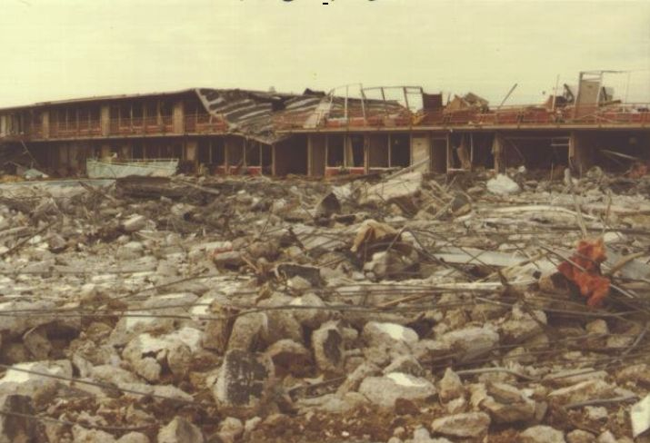
Collapse of top story walls

MAM DOD 5
MPH: 115 (EF2) - 133 (EF2) - 150 (EF3)
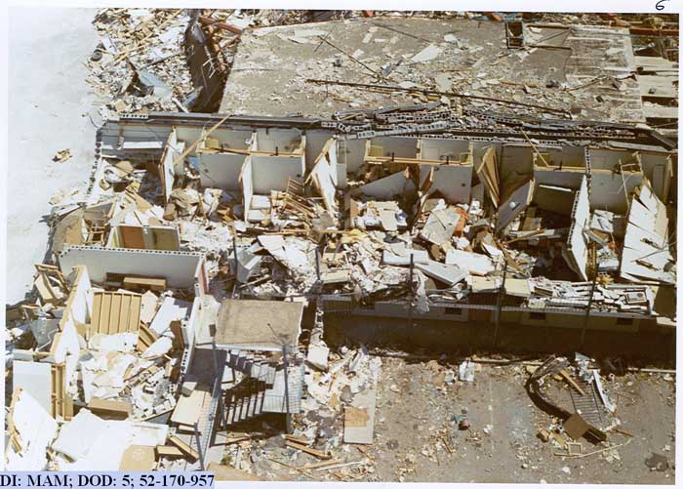
Collapse of top story walls
MAM DOD 5
MPH: 115 (EF2) - 133 (EF2) - 150 (EF3)
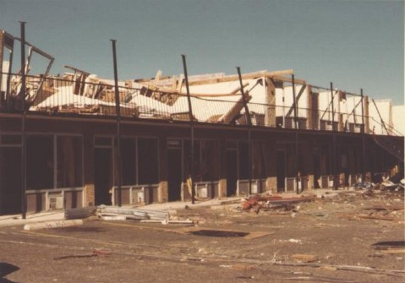
Collapse of top story walls

8. Small Retail Building [Fast Food Restaurants] (SRB)
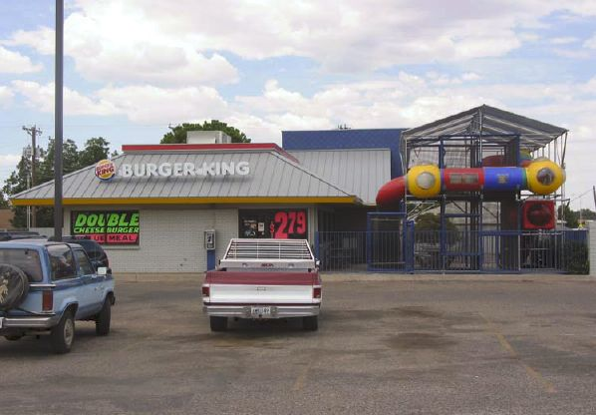

- Best example is fast-food restaurant
- Flat, hip, gable, mansard or monoslope roof
- Asphalt shingles, metal panels, slate, tile, single-ply or BUR roof covering
- Plywood/OSB roof decking
- Wood or metal roof structure consisting of trusses or rafters and joists
- Wood or metal stud walls
- Typically have large areas of window glass and double entry doors
- Canopies, covered walkways or porches
- Wood, brick veneer, metal or vinyl siding, concrete blocks, EIFS or stucco wall cladding

DOD | Damage description | EXP | LB | UB
1 | Threshold of visible damage | 65 | 54 | 81
2 | Loss of roof covering (<20%) | 78 | 65 | 98
3 | Broken glass in windows and doors | 86 | 72 | 103
4 | Uplift of roof decking; significant loss of roof covering (>20%) | 98 | 81 | 119
5 | Canopies or covered walkways destroyed | 98 | 83 | 114
6 | Uplift or collapse of entire roof structure | 119 | 101 | 140
7 | Collapse of exterior walls; closely spaced interior walls remain standing | 138 | 120 | 159
8 | Total destruction of entire building | 167 | 143 | 193
SRB DOD 3
MPH: 72 (EF0) - 86 (EF1) - 103 - EF1)
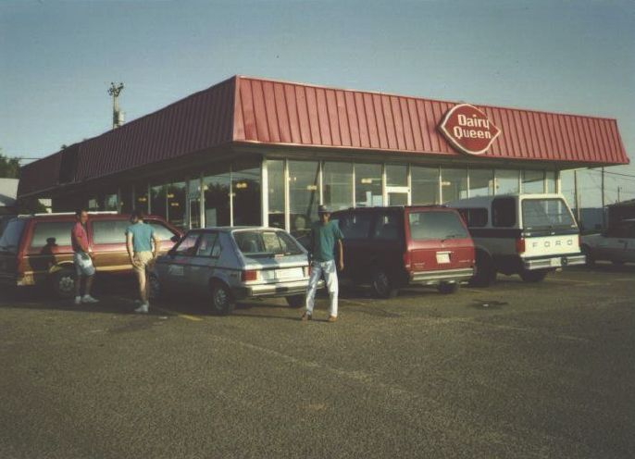
Broken glass in windows and doors

SRB DOD 4
MPH: 81 (EF0) - 98 (EF1) - 119 (EF2)
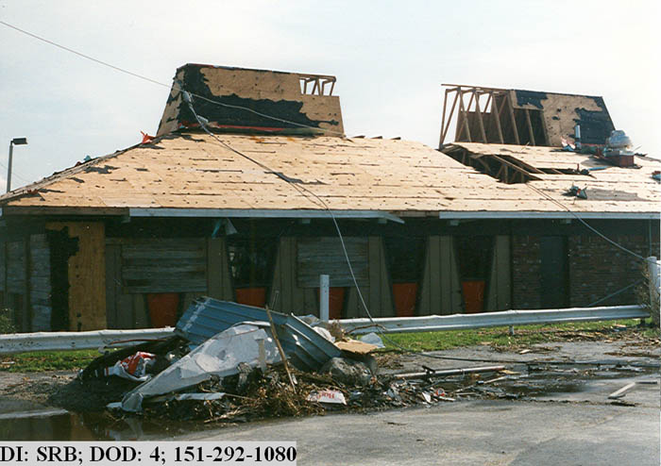
Uplift of roof decking; significant loss of roof covering (>20%)
SRB DOD 4
MPH: 81 (EF0) - 98 (EF1) - 119 (EF2)
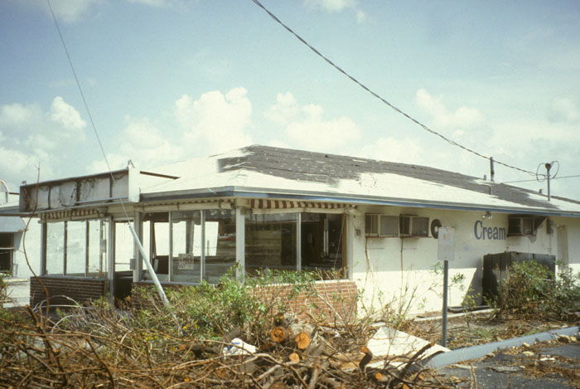
Uplift of roof decking; significant loss of roof covering (>20%)

SRB DOD 5
MPH: 83 (EF0) - 98 (EF1) - 114 (EF2)
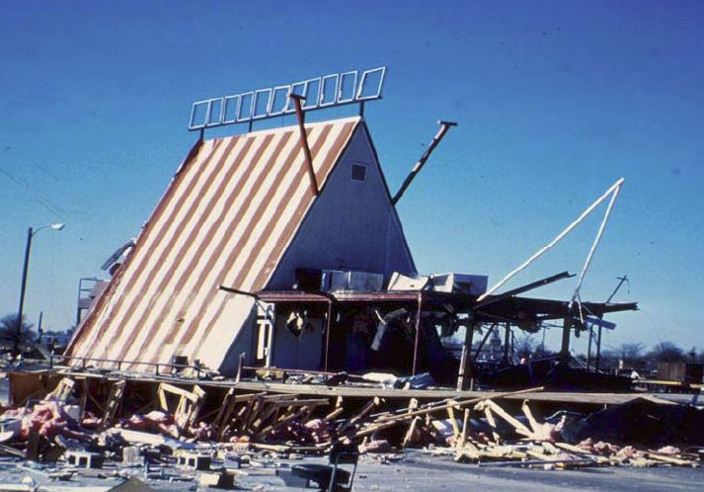
Canopies or covered walkways destroyed
SRB DOD 7
MPH: 120 (EF2) - 138 (EF3) - 159 (EF3)
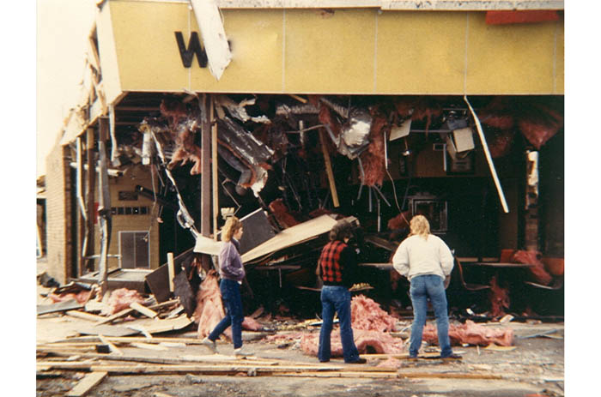
Collapse of exterior walls; closely spaced interior walls remain standing

9. Small Professional Building [Branch Banks, etc.] (SPB)
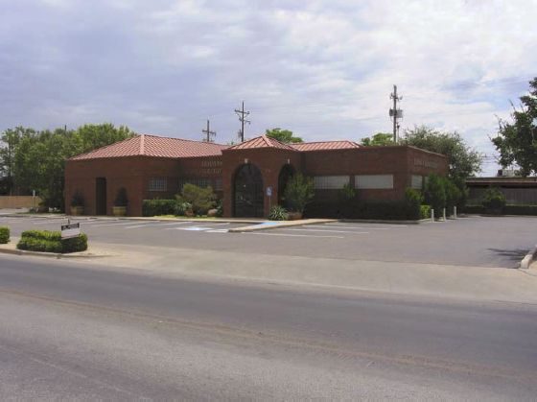

- Flat, gable, hip, mansard or mono-slope roofs with or without parapet walls
- Asphalt shingles, tile, slate, metal panels, single-ply or built-up roof covering
- Light-frame steel construction, steel joists and formed metal decking
- Load-bearing masonry construction with steel or wood roof structure
- Timber post and beam construction
- Wood or metal stud walls, non-bearing masonry walls
- Metal or vinyl panels, stucco or EIFS cladding
- Skylights and/or clearstories

DOD | Damage description | EXP | LB | UB
1 | Threshold of visible damage | 65 | 54 | 81
2 | Loss of roof covering (<20%) | 78 | 65 | 98
3 | Broken windows, including clear story windows or skylights | 89 | 74 | 107
4 | Exterior doors fail | 100 | 82 | 118
5 | Uplift of roof decking; significant loss of roof covering (>20%); loss of rooftop HVAC equipment | 100 | 84 | 117
6 | Collapsed façade or parapet walls | 103 | 85 | 123
7 | Uplift or collapse of entire roof structure | 124 | 105 | 145
8 | Collapse of exterior walls; closely spaced interior walls remain standing | 144 | 123 | 165
9 | Total destruction of entire building | 157 | 148 | 200

SPB DOD 1
MPH: 54 - 65 (EF0) - 81 (EF0)
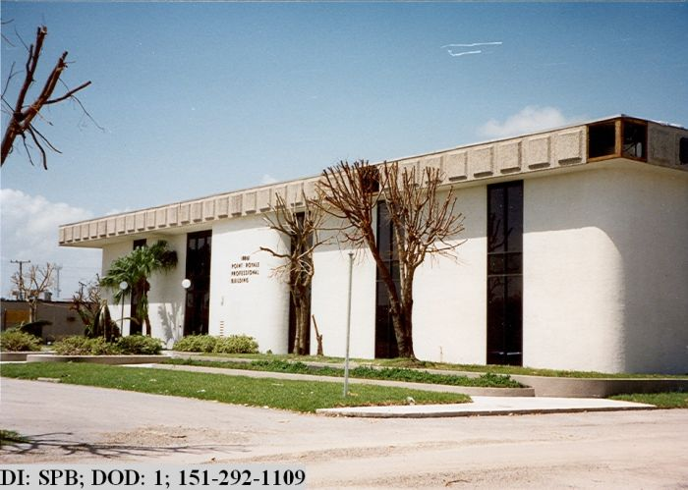
Threshold of visible damage

10. Strip Mall (SM)
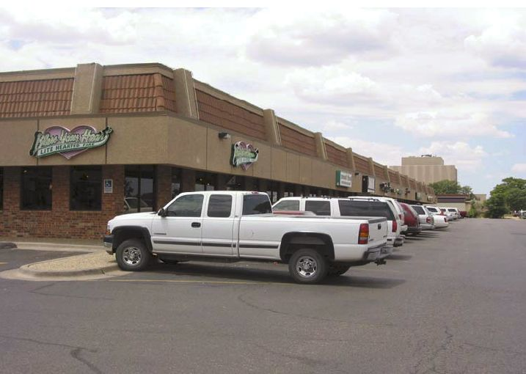

- Large, rectangular single-story building with large surrounding parking lots
- Flat roof with parapet wall
- Built-up roofing or single-ply roof membrane with rigid insulation
- Wood or metal deck, wood-fiber cement panels
- Light-frame steel roof support with steel joists or joist girders
- Brick or concrete block wall construction
- Large window glass and glass entry doors
- Covered walkway attached to building

DOD | Damage description | EXP | LB | UB
1 | Threshold of visible damage | 65 | 54 | 81
2 | Uplift of roof covering at eaves and roof corners | 80 | 66 | 100
3 | Broken windows or glass doors | 88 | 72 | 105
4 | Uplift of roof decking | 101 | 84 | 122
5 | Collapsed façade or parapet walls | 103 | 85 | 125
6 | Covered walkways uplifted or collapsed | 103 | 86 | 125
7 | Uplift or collapse of entire roof structure | 122 | 103 | 143
8 | Collapse of exterior walls; closely spaced interior walls remain standing | 140 | 117 | 165
9 | Complete destruction of all or a large section of building | 171 | 147 | 198
SM DOD 3
MPH: 72 (EF0) - 88 (EF1) - 105 (EF1)
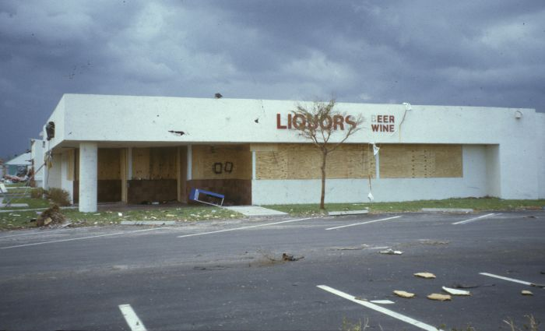
Broken windows or glass doors

SM DOD 3
MPH: 72 (EF0) - 88 (EF1) - 105 (EF1)
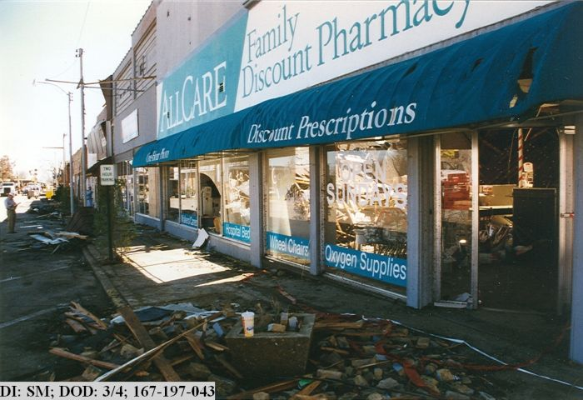
Broken windows or glass doors
SM DOD 7
MPH: 103 (EF1) - 122 (EF2) - 143 (EF3)
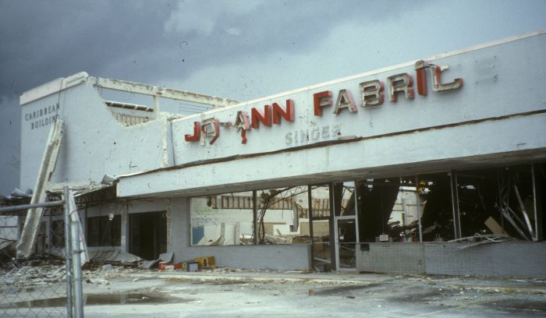
Uplift or collapse of entire roof structure

11. Large Shopping Mall (LSM)
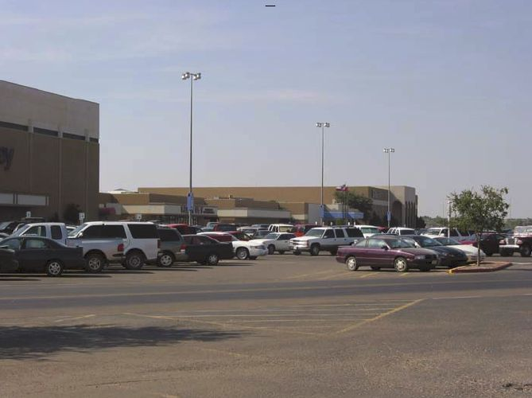

- Typically one or two stories
- Flat roof; some areas with relatively large spans
- Skylights and clear stories
- Single-ply or BUR with or without roof gravel
- Metal stud walls with brick veneer, stucco or EIFS cladding
- Light steel structural framing with open web joists, light metal framing or 3-D space framing
- Glass at entries

DOD | Damage description | EXP | LB | UB
1 | Threshold of visible damage | 71 | 59 | 86
2 | Loss of roof covering (<20%) | 85 | 69 | 105
3 | Broken skylights, clearstory windows and atrium walls broken | 92 | 75 | 114
4 | Uplift of some roof decking; significant loss of roofing material (>20%); loss of rooftop HVAC | 108 | 92 | 128
5 | Wall cladding stripped starting at corners and progressing to  other areas | 111 | 94 | 131
6 | Roof structure uplifted or collapsed | 128 | 108 | 150
7 | Exterior walls in top story collapsed | 144 | 124 | 166
8 | Interior walls of top story collapse | 160 | 139 | 185
9 | Complete destruction of all or a large section of the building | 204 | 176 | 247
LSR DOD 4
MPH: 92 (EF1) - 108 (EF1) - 128 (EF2)
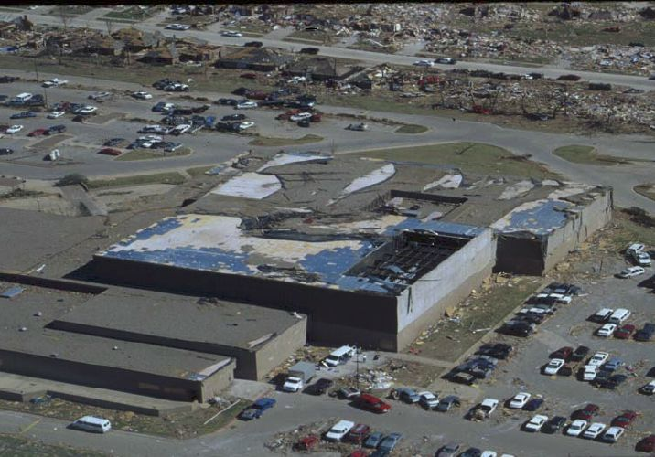
Uplift of some roof decking; significant loss of roofing material (>20%); loss of rooftop HVAC

12. Large Isolated Retail Building (LIRB)
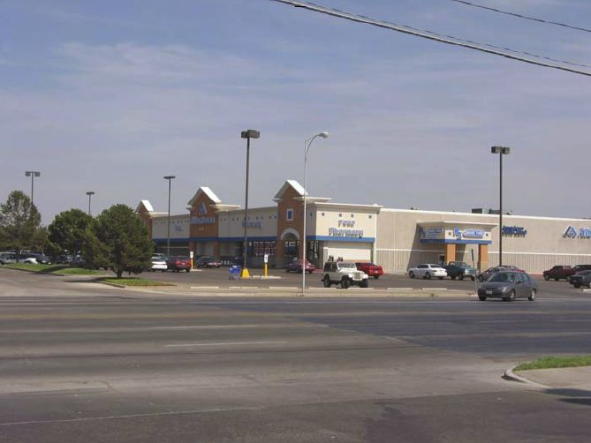

- Flat roof with BUR and gravel or single-ply membrane roof; generally has a 2-3 ft parapet
- Open web joists and steel girders or joist girders supported by tall pipe columns
- Metal deck with rigid insulation or lightweight concrete fill slab
- Large windows on front side of building
- CMU walls, tilt-up concrete panels, metal stud walls covered with EIFS or combinations of these

DOD | Damage description | EXP | LB | UB
1 | Threshold of visible damage | 68 | 57 | 83
2 | Loss of roof covering (<20%) | 81 | 68 | 103
3 | Uplift of some roof decking; significant loss of roofing material (>20%); loss of rooftop HVAC | 103 | 87 | 123
4 | Long roof spans collapsed downward | 122 | 103 | 144
5 | Uplift and removal of roof structure | 134 | 114 | 157
6 | Inward or outward collapse of exterior walls | 137 | 118 | 158
7 | Complete destruction of all or a large section of the building | 173 | 147 | 201

LIRB DOD 2
MPH: 68 (EF0) - 81 (EF0) - 103 (EF1)
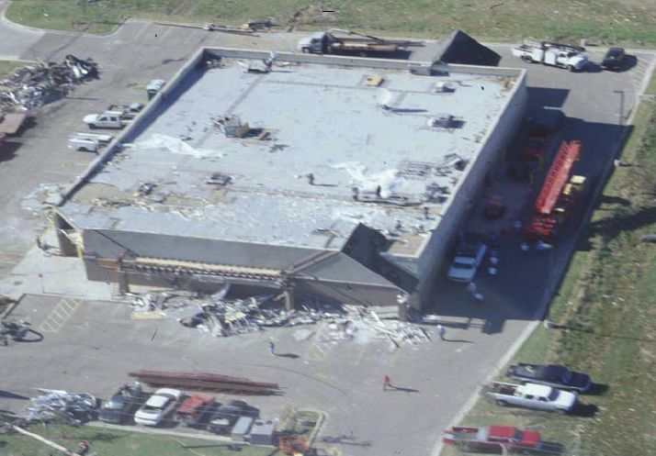
Loss of roof covering (<20%)

LIRB DOD 6
MPH: 118 (EF2) - 137 (EF3) - 158 (EF3)
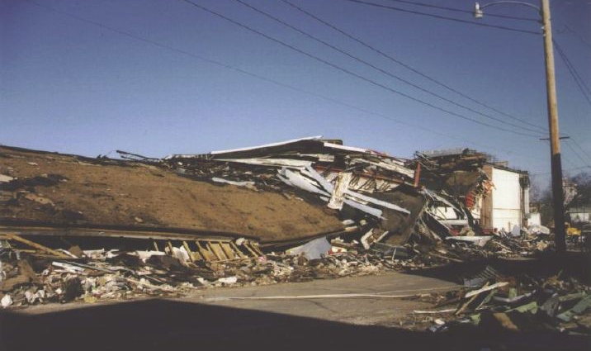
Inward or outward collapse of exterior walls
LIRB DOD 7
MPH: 147 (EF3) - 173 (EF4) - 201 (EF5)
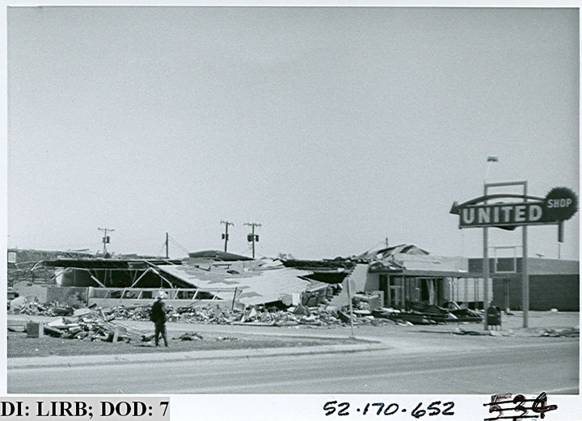
Complete destruction of all or a large section of the building

LIRB DOD 7
MPH: 147 (EF3) - 173 (EF4) - 201 (EF5)
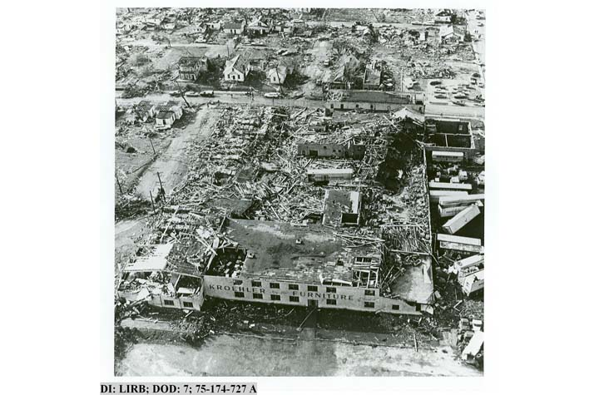
Complete destruction of all or a large section of the building
LIRB DOD 7
MPH: 147 (EF3) - 173 (EF4) - 201 (EF5)
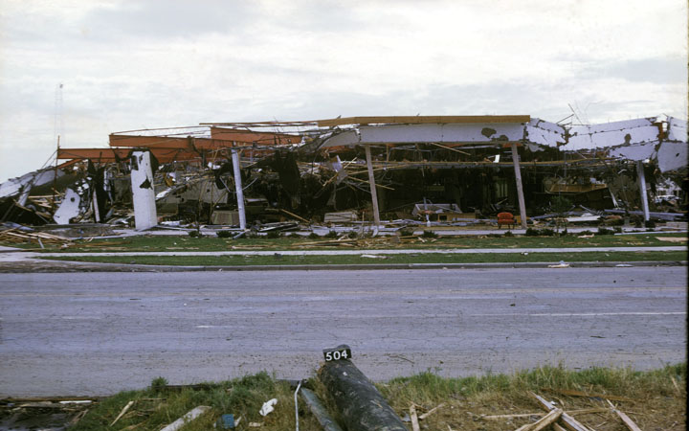
Complete destruction of all or a large section of the building

13. Automobile Showroom (ASR)
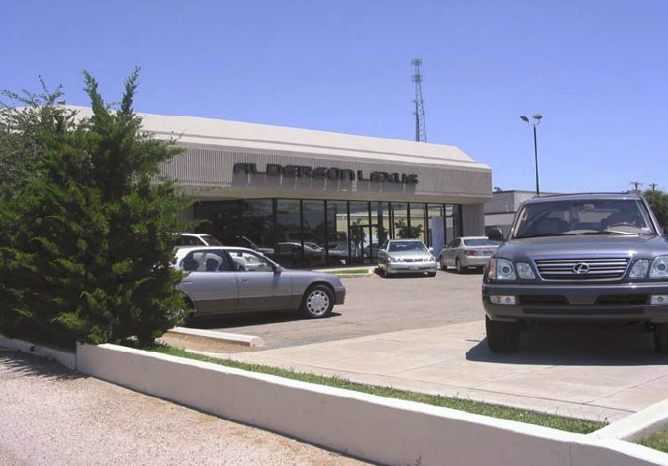

- Most showrooms are single-story buildings with flat roof
- Roof system is BUR or single-ply membrane
- Metal roof deck or plywood panels
- Steel structural framing with open web steel joists
- Metal stud walls with EIFS, stucco or tilt-up panels
- Exterior walls on 2 or 3 sides have large glass windows

DOD | Damage description | EXP | LB | UB
1 | Threshold of visible damage | 65 | 47 | 80
2 | Loss of roof covering (<20%) | 80 | 67 | 101
3 | Broken glass in windows or doors | 87 | 71 | 106
4 | Uplift of some roof decking; significant loss of roofing  material (>20%); loss of rooftop HVAC | 101 | 83 | 120
5 | Cladding stripped off walls | 112 | 94 | 132
6 | Uplift or collapse of roof structure | 118 | 98 | 140
7 | Exterior walls collapsed | 126 | 106 | 148
8 | Complete destruction of all or a large section of the building | 157 | 138 | 181

14. Automobile Service Building (ASB)
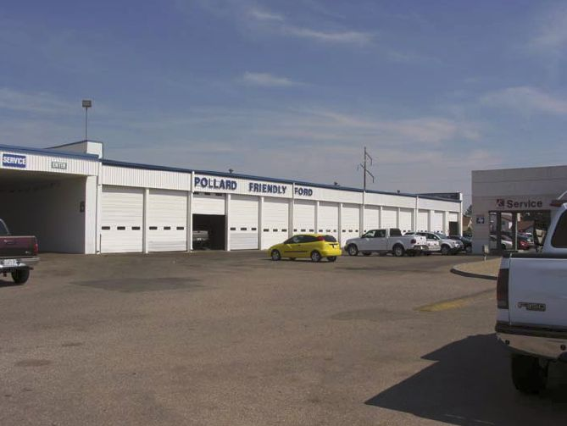

- Single story building with flat roof and relatively tall walls with parapet
- Roof coverings are typically BUR with gravel or single-ply membrane
- Roof structure is light steel framing or open web steel joists and metal roof deck
- Exterior walls are concrete masonry or precast tilt-up panels
- Numerous large metal overhead doors

DOD | Damage description | EXP | LB | UB
1 | Threshold of visible damage | 63 | 46 | 79
2 | Loss of roof covering (<20%) | 78 | 65 | 99
3 | Failure of large overhead doors | 91 | 77 | 110
4 | Uplift of some roof decking; significant loss of roofing material (>20%); loss of rooftop HVAC | 98 | 80 | 119
5 | Collapse of non-bearing masonry or tilt-up walls | 114 | 94 | 134
6 | Uplift or collapse of roof structure | 121 | 102 | 143
7 | Collapse of load-bearing walls | 128 | 106 | 149
8 | Complete destruction of all or a large section of the building | 157 | 138 | 181

15. Elementary School (ES)
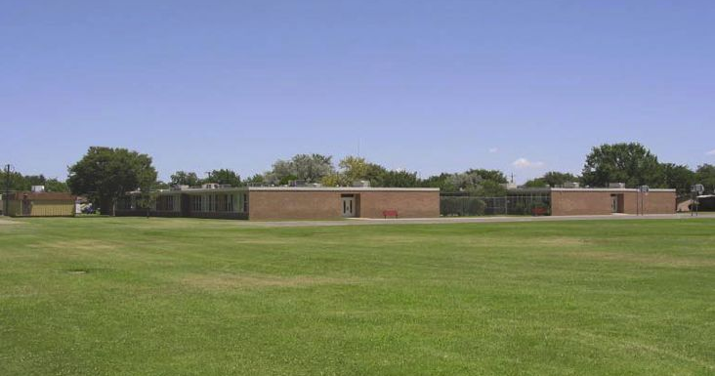

- These buildings are typically single story with flat roofs
- Building may contain a small gym or cafeteria with moderately long spans between supports
- Buildings have long interior hallways with bearing or non-bearing walls
- BUR, single-ply membrane or metal standing seam roof panels
- Metal or plywood roof decking supporting rigid insulation boards or a lightweight poured gypsum deck
- Roof structure consists of open web steel joists bearing on exterior walls and steel interior girders
- Exterior non-bearing walls constructed with CMUs, glass curtain walls or metal studs with brick veneer, stucco or EIFS cladding
- CMU bearing walls with brick veneer, stucco or EIFS cladding
- Walls can have a large percentage of window glass

DOD | Damage description | EXP | LB | UB
1 | Threshold of visible damage | 65 | 47 | 80
2 | Loss of roof covering (<20%) | 79 | 66 | 99
3 | Broken windows | 87 | 71 | 106
4 | Exterior door failures | 99 | 85 | 118
5 | Uplift of some roof decking; significant loss of roofing material (>20%); loss of rooftop HVAC | 101 | 82 | 121
6 | Damage to or loss of wall cladding | 108 | 92 | 127
7 | Uplift or collapse of roof structure | 125 | 108 | 148
8 | Collapse of non-bearing walls | 139 | 117 | 162
9 | Collapse of load-bearing walls | 153 | 130 | 180
10 | Total destruction of a large section of building or entire building | 176 | 152 | 203
ES DOD 5
MPH: 82 (EF0) - 101 (EF1) - 121 (EF2)
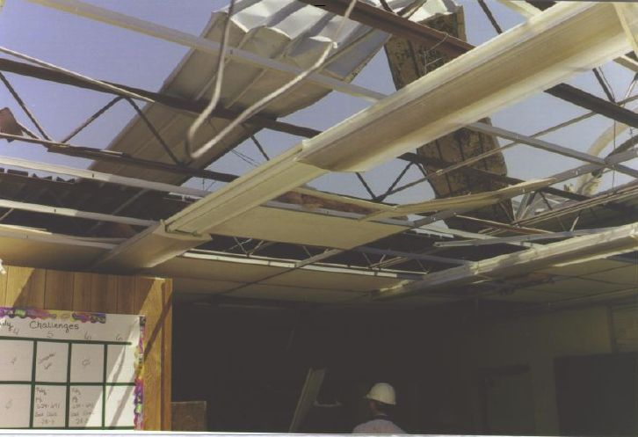
Uplift of some roof decking; significant loss of roofing material (>20%); loss of rooftop HVAC

ES DOD 5
MPH: 82 (EF0) - 101 (EF1) - 121 (EF2)
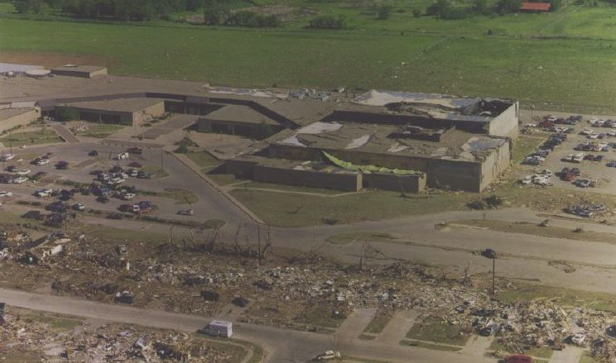
Uplift of some roof decking; significant loss of roofing material (>20%); loss of rooftop HVAC
ES DOD 8
MPH: 117 (EF2) - 139 (EF3) - 162 (EF3)
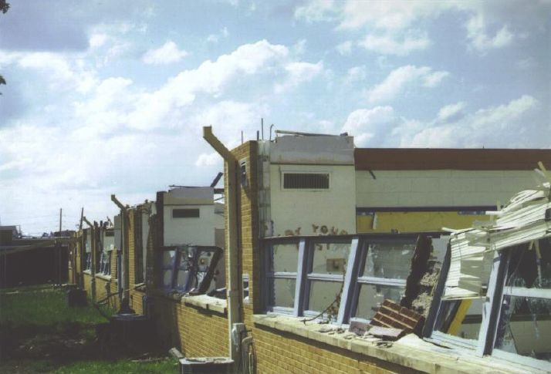
Collapse of non-bearing walls

ES DOD 8
MPH: 117 (EF2) - 139 (EF3) - 162 (EF3)
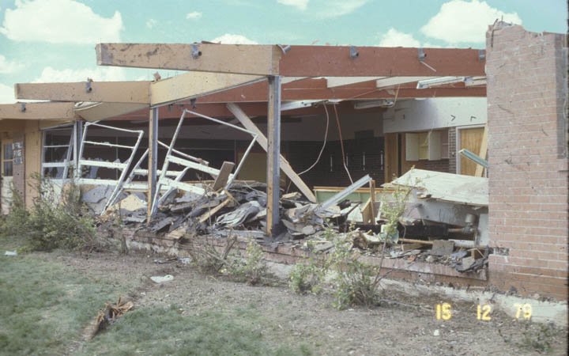
Collapse of non-bearing walls
ES DOD 9
MPH: 130 (EF2) - 153 (EF3) - 180 (EF4)
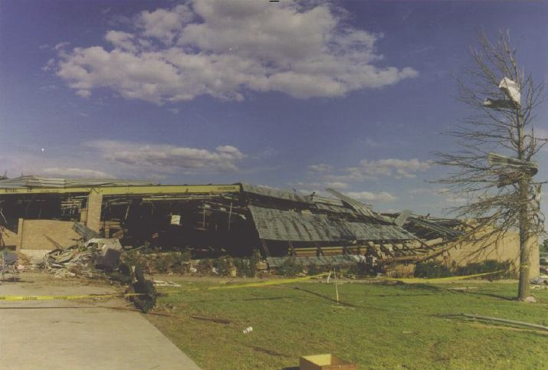
Collapse of load-bearing walls

16. Junior or Senior High School (JHSH)
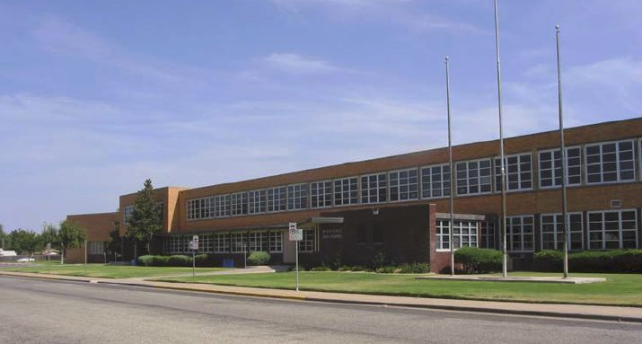

- Generally large one or two-story buildings with flat roofs
- May contain gymnasiums, cafeteria and auditorium with large structural spans; may have a basement
- Classroom wings have interior hallways with bearing or non-bearing interior walls
- BUR or single-ply membrane roof covering with or without gravel
- Structural system may consist of an all steel structure or an all reinforced concrete structure or a combination of both
- Roof structure may be light steel construction with open web joists supported on steel beams; corrugated metal roof deck with rigid insulation or poured gypsum deck
- Exterior walls constructed of concrete or clay blocks with brick veneer, stucco or EIFS; metal and glass curtain walls; walls may have more than 30% windows

DOD | Damage description | EXP | LB | UB
1 | Threshold of visible damage | 68 | 55 | 83
2 | Loss of roof covering (<20%) | 79 | 66 | 99
3 | Broken windows | 87 | 71 | 106
4 | Exterior door failures | 101 | 83 | 121
5 | Uplift of some roof decking; significant loss of roofing material (>20%); loss of rooftop HVAC | 101 | 85 | 119
6 | Damage to or loss of wall cladding | 108 | 92 | 127
7 | Collapse of tall masonry walls at gym, cafeteria or auditorium | 114 | 94 | 136
8 | Uplift or collapse of light steel roof structure | 125 | 108 | 148
9 | Collapse of exterior walls in top floor | 139 | 121 | 153
10 | Most interior walls of top floor collapsed | 158 | 133 | 186
11 | Complete destruction of all or a large section of building | 192 | 163 | 224

17. Low-Rise Building: 1 - 4 Stories (LSB)
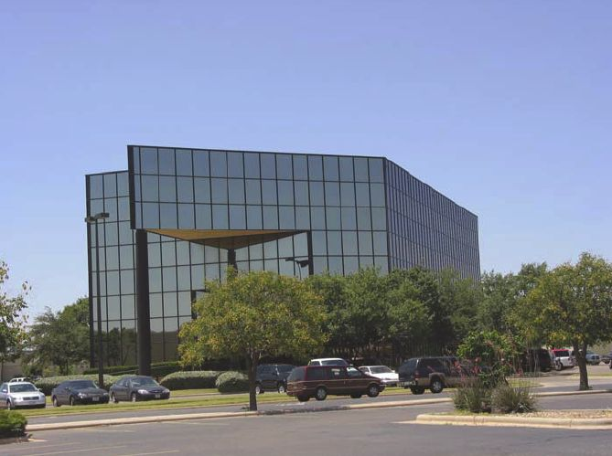

- Generally consist of rectangular modules but can be "odd shaped" in plan
- Most will have flat roofs but can have gable, hip or mansard shapes
- Roofing materials include BUR, single-ply membrane, metal panels or standing seam
- Roof deck is wood or metal deck, poured gypsum deck or concrete slab
- Steel or reinforced concrete structural frame
- Glass and metal curtain walls, metal studs with EIFS, non-bearing masonry walls with stucco or brick veneer
- Examples are office buildings, medical facilities, and bank buildings.

DOD | Damage description | EXP | LB | UB
1 | Threshold of visible damage | 68 | 55 | 83
2 | Loss of roof covering (<20%) | 80 | 67 | 103
3 | Uplift of metal roof decking at eaves and roof corners;  significant loss of roofing material (>20%) | 101 | 83 | 120
4 | Broken glass in windows, entryways or atriums | 101 | 83 | 122
5 | Uplift of lightweight roof structure | 133 | 114 | 157
6 | Significant damage to exterior walls and some interior walls | 143 | 122 | 167
7 | Complete destruction of all or a large section of building | 188 | 161 | 221

18. Mid-Rise Building: 5 - 20 Stories (MRB)
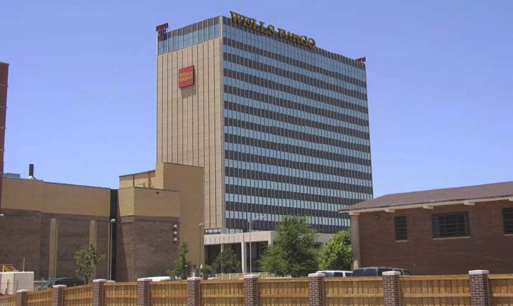

- Generally consist of rectangular shapes but can have curved or triangular footprints
- Roofs are generally flat; may have an elevator/mechanical penthouse; parapet walls
- Structural frame is steel or reinforced concrete
- Roofing materials are BUR or single-ply membrane with or without gravel
- Penthouse is steel framing with metal panels, or metal studs with stucco or EIFS
- Exterior cladding is glass or metal curtain walls; pre-cast concrete window wall panels or a combination of the two
- Roof structure consists of metal deck, poured gypsum deck or concrete slab
- Examples are office buildings, medical facilities, and residential buildings

DOD | Damage description | EXP | LB | UB
1 | Threshold of visible damage | 70 | 58 | 86
2 | Loss of roof covering (<20%) | 83 | 68 | 103
3 | Damage to penthouse roof and walls; loss of rooftop HVAC equipment | 92 | 75 | 113
4 | Damage to parapet walls or coping | 99 | 83 | 118
5 | Broken glass in curtain walls; glass in entryways; significant damage to building interior | 101 | 83 | 120
6 | Uplift of lightweight roof decking; significant loss of roofing material (>20%) | 119 | 98 | 140
7 | Broken curtain wall panel anchors | 129 | 110 | 150
8 | Uplift or collapse of roof structure | 136 | 118 | 158
9 | Significant damage to curtain walls and some interior walls | 145 | 120 | 167
10 | Permanent structural deformation | 210 | 181 | 268
MRB DOD 5
MPH: 83 (EF0) - 101 (EF1) - 120 (EF2)
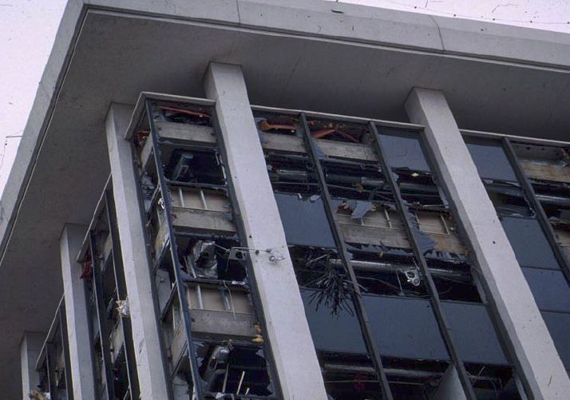
Broken glass in curtain walls; glass in entryways; significant damage to building interior

MRB DOD 5
MPH: 83 (EF0) - 101 (EF1) - 120 (EF2)
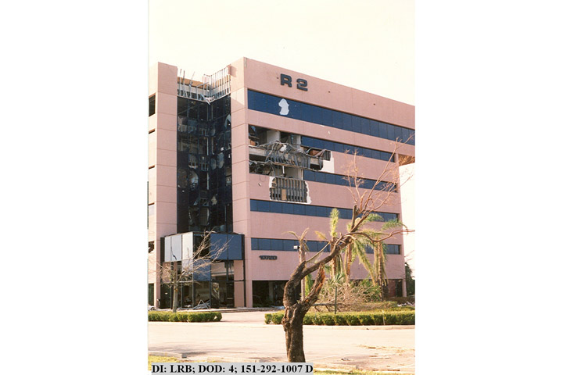
Broken glass in curtain walls; glass in entryways; significant damage to building interior
MRB DOD 5
MPH: 83 (EF0) - 101 (EF1) - 120 (EF2)
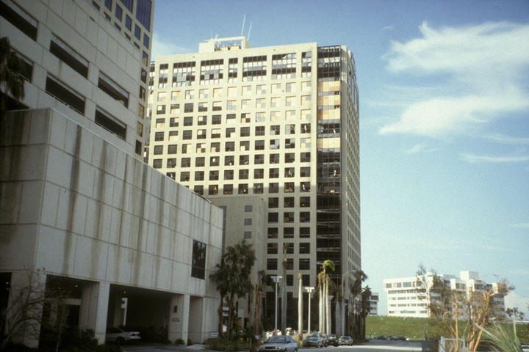
Broken glass in curtain walls; glass in entryways; significant damage to building interior

MRB DOD 5
MPH: 83 (EF0) - 101 (EF1) - 120 (EF2)
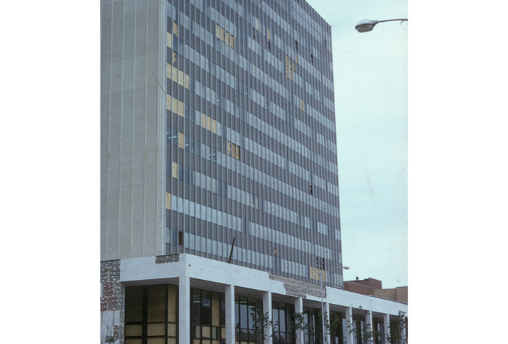\
Broken glass in curtain walls; glass in entryways; significant damage to building interior

MRB DOD 9
MPH: 120 (EF2) - 145 (EF3) - 167 (EF4)
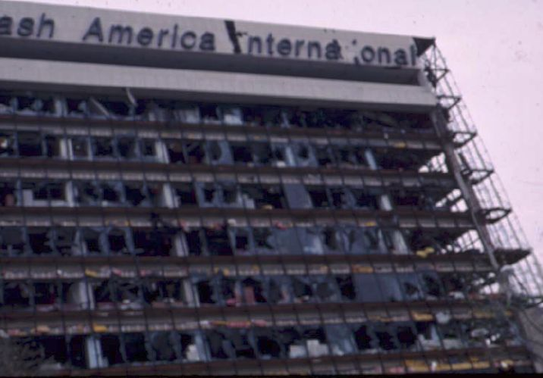
Significant damage to curtain walls and some interior walls

MRB DOD 9
MPH: 120 (EF2) - 145 (EF3) - 167 (EF4)
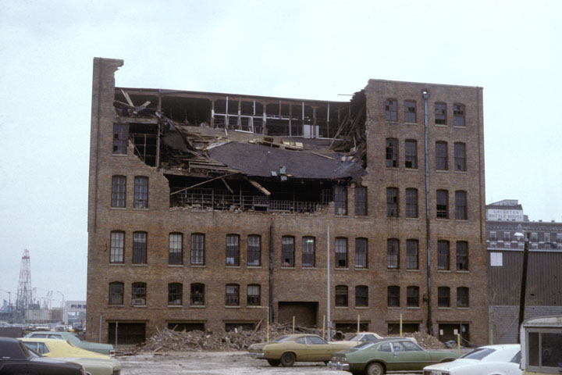
Significant damage to curtain walls and some interior walls

19. High-Rise Building: Greater Than 20 Stories (HRB)
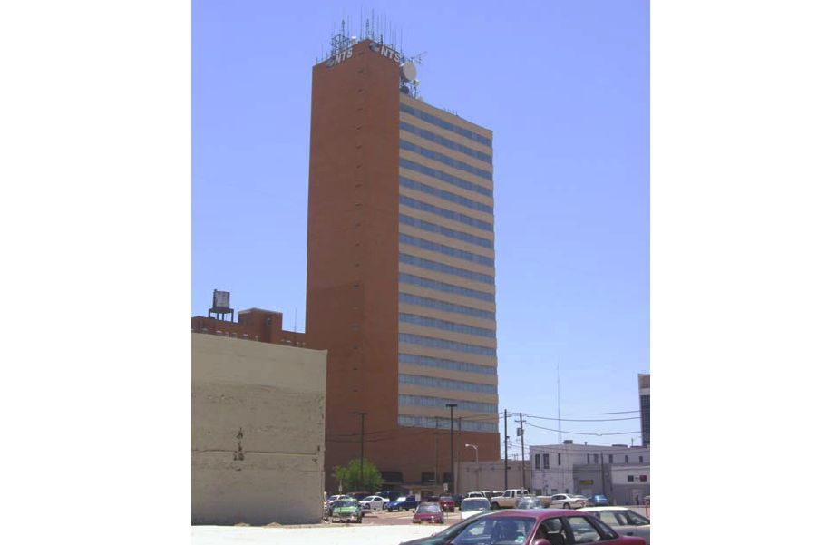

- Generally consist of rectangular shapes but can have curved or triangle footprints
- Roofs are generally flat but may have a more complex roof shape as part of esthetic statement
- Roofing material single-ply membrane fully adhered, polyurethane foam roof, metal or copper clad roof covering
- Penthouse is steel framing with metal panels
- Structural frame is steel or reinforced concrete
- Exterior cladding is glass or metal curtain walls or pre-cast concrete window panels
- First floor often has very large glass areas that are susceptible to debris impact
- Atriums with overhead glazing or tall window walls
- Examples are hotels, office buildings, and condominiums

DOD | Damage description | EXP | LB | UB
1 | Threshold of visible damage | 70 | 58 | 86
2 | Loss of roof covering (<20%) | 86 | 69 | 107
3 | Damage to penthouse roof and walls; loss of rooftop HVAC  equipment | 93 | 75 | 111
4 | Broken glass in exterior walls at 1st and 2nd floors; broken glass in entryways | 101 | 83 | 120
5 | Damage to parapet walls or coping | 104 | 87 | 122
6 | Broken curtain wall panel anchors | 129 | 110 | 157
7 | Significant loss of roofing material (>20%) | 143 | 115 | 165
8 | Significant damage to curtain walls and interior walls | 145 | 123 | 172
9 | Uplift or collapse of roof structure | 159 | 123 | 183
10 | Permanent structural deformation | 228 | 190 | 290
HRB DOD 8
MPH: 123 (EF2) - 145 (EF3) - 172 (EF4)
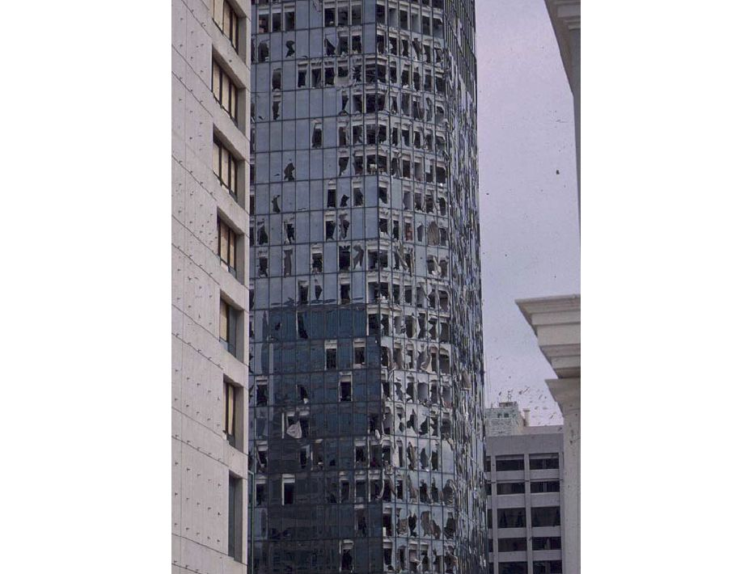
Significant damage to curtain walls and interior walls

HRB DOD 8
MPH: 120 (EF2) - 145 (EF3) - 167 (EF4)
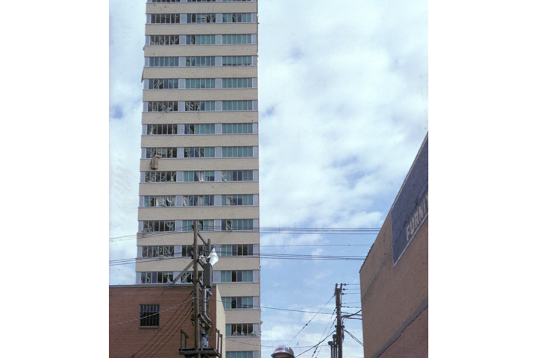
Significant damage to curtain walls and interior walls
20. Institutional Building (IB)
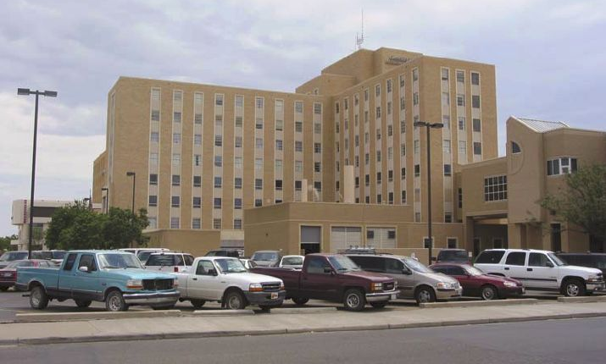

- Examples are hospitals, courthouses, university buildings, state and federal buildings, jails
- Range in height from 1 - 10 stories
- Roofing materials include fully adhered and mechanically fastened singleply membranes, polyurethane foam, copper clad domes
- Structure is normally reinforced concrete
- Walls are masonry with cut stone or precast panels - very ornate
- Balcones, porches and porticos with heavy façade
- Relatively small windows

DOD | Damage description | EXP | LB | UB
1 | Threshold of visible damage | 72 | 59 | 88
2 | Loss of roof covering (<20%) | 86 | 72 | 109
3 | Damage to penthouse roof and walls; loss of rooftop HVAC equipment | 92 | 75 | 111
4 | Broken glass in windows or doors | 95 | 78 | 115
5 | Uplift of lightweight roof deck and insulation; significant loss of roofing material (>20%) | 114 | 95 | 136
6 | Façade components torn from structure | 118 | 97 | 140
7 | Damage curtain walls or other wall cladding | 131 | 110 | 152
8 | Uplift of pre-cast concrete roof slabs | 142 | 119 | 163
9 | Uplift of metal deck with concrete fill slab | 146 | 118 | 170
10 | Collapse of some top story exterior walls | 148 | 127 | 172
11 | Complete destruction of all or a large portion of building | 210 | 178 | 268
IB DOD 5
MPH: 95 (EF1) - 114 (EF2) - 136 (EF3)
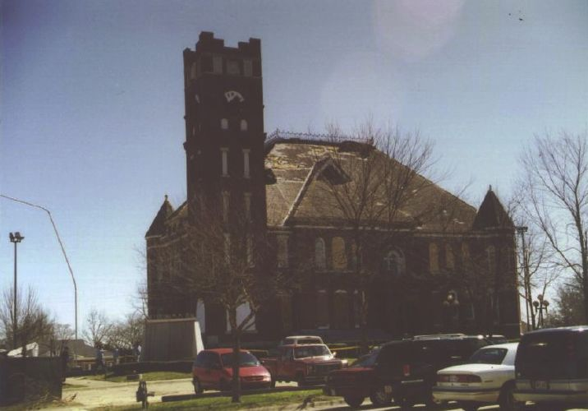
Uplift of lightweight roof deck and insulation; significant loss of roofing material (>20%)

21. Metal Building Systems (MBS)
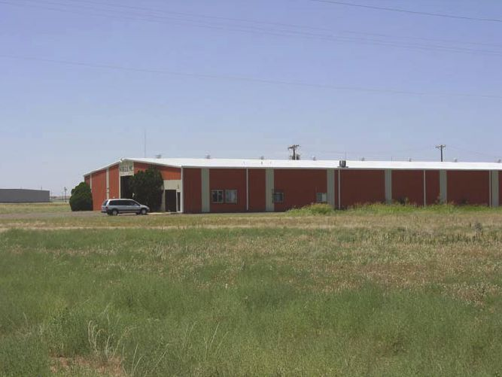

- Examples are warehouses, industrial facilities, small arenas
- Metal panel walls and standing seam roof
- Nearly always have a gable roof and relatively tall walls
- Large overhead doors
- Large-span single bay rigid frames
- Z or C-shaped purlins and girts span between rigid frames
- Lateral loads resisted by x-bracing in direction parallel to ridge
- Relatively weak end-wall frames

DOD | Damage description | EXP | LB | UB
1 | Threshold of visible damage | 67 | 54 | 83
2 | Inward or outward collapsed of overhead doors | 89 | 75 | 108
3 | Metal roof or wall panels pulled from the building | 95 | 78 | 120
4 | Column anchorage failed | 117 | 96 | 135
5 | Buckling of roof purlins | 118 | 95 | 138
6 | Failure of X-braces in the lateral load resisting system | 138 | 118 | 158
7 | Progressive collapse of rigid frames | 143 | 120 | 168
8 | Total destruction of building | 155 | 132 | 178
MBS DOD 3
MPH: 78 (EF0) - 95 (EF1) - 120 (EF2)
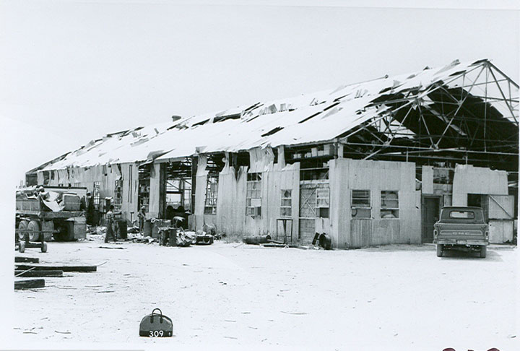
Metal roof or wall panels pulled from the building

MBS DOD 5
MPH: 95 (EF1) - 118 (EF2) - 138 (EF3)
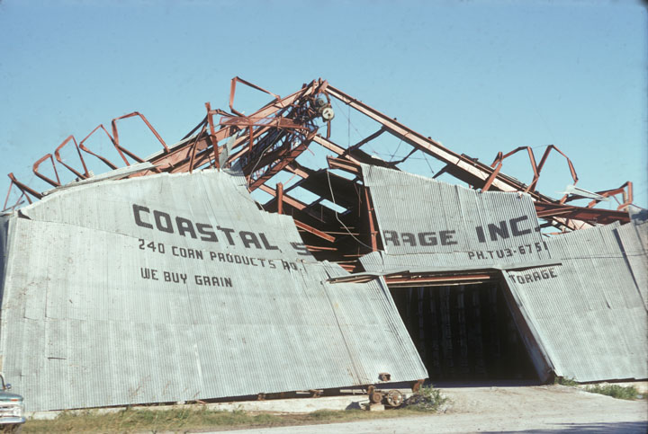
Buckling of roof purlins

MBS DOD 7
MPH: 120 (EF2) - 143 (EF3) -168 (EF4)
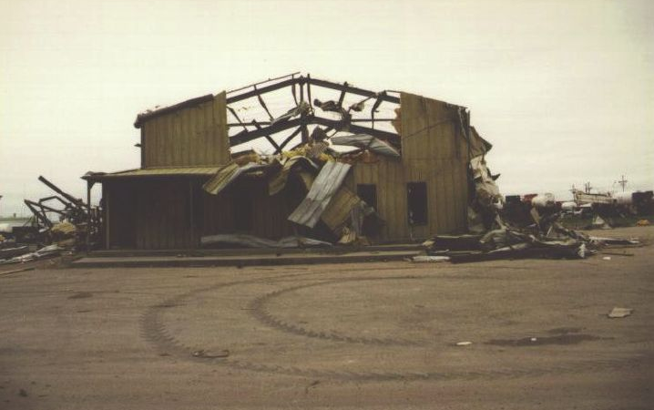
Progressive collapse of rigid frames

MBS DOD 8
MPH: 132 (EF2) - 155 (EF3) -178 (EF4)
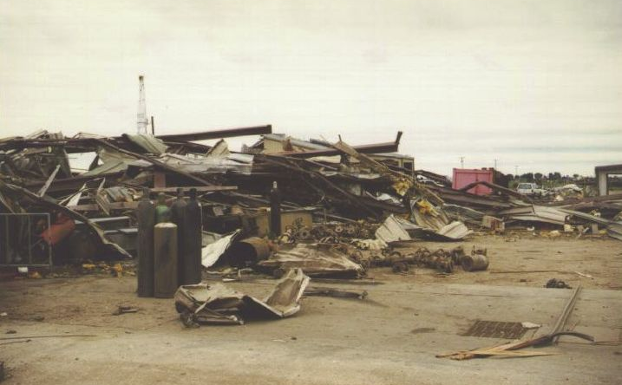
Total destruction of building

22. Service Station Canopy (SSC)
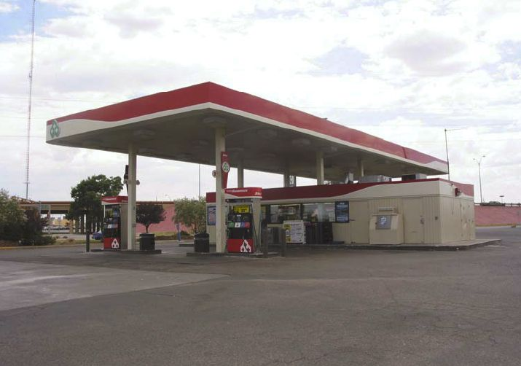

- Modern service stations consist of a very large canopy covering the entire pump area and small building that houses cashier and retail space
- Canopy structure constructed of steel beam framework supported on 4 or more tall columns
- Metal panels cover bottom side of the canopy
- Light weight fascia materials, either metal or plastic, cover the perimeter of canopy

DOD | Damage description | EXP | LB | UB
1 | Threshold of visible damage | 63 | 45 | 79
2 | Fascia material blown from canopy | 78 | 64 | 96
3 | Metal roof panels stripped from canopy | 92 | 74 | 113
4 | Columns bend or buckle under wind load | 109 | 88 | 135
5 | Canopy collapsed due to column foundation failure | 114 | 90 | 144
6 | Complete destruction of canopy | 133 | 110 | 163

23. Warehouse Building (WHB)
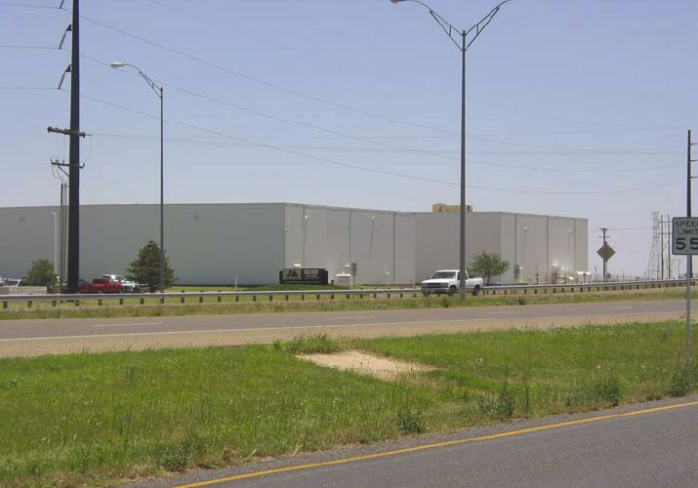

- This category includes all building systems except Metal Building Systems
- Examples include warehouse, storage and industrial buildings
- Buildings are generally rectangular in plan with flat, gable or hip roofs
- Built-up roofs with gravel, single-ply membrane ballasted, mechanically attached or fully adhered
- Light-frame steel construction with masonry bearing walls
- Large overhead doors
- Pre-cast concrete columns, beams and double tees with tilt-up wall panels
- Heavy timber construction with stud walls and wood panels

DOD | Damage description | EXP | LB | UB
1 | Threshold of visible damage | 68 | 55 | 83
2 | Loss of roofing material (<20%) | 83 | 69 | 105
3 | Inward or outward collapse of overhead doors | 88 | 75 | 107
4 | Uplift of roof deck; significant loss of roofing material (>20%); loss of rooftop HVAC equipment | 103 | 88 | 122
5 | Collapse of other non-bearing exterior walls | 114 | 93 | 126
6 | Collapse of pre-cast concrete tilt-up panels | 124 | 102 | 144
7 | Total destruction of a large section of building or entire building | 158 | 131 | 186
WHB DOD 5
MPH: 93 (EF1) - 114 (EF2) - 126 (EF2)
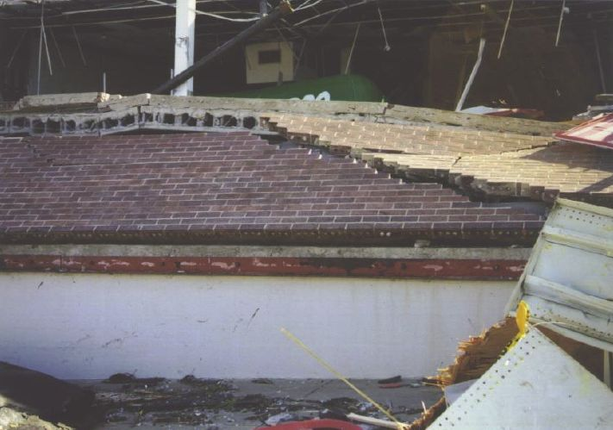
Collapse of other non-bearing exterior walls

WHB DOD 7
MPH: 131 (EF2) - 158 (EF3) - 186 (EF4)
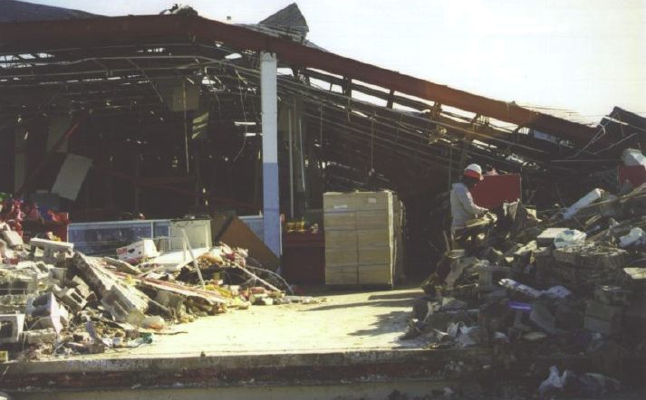
Total destruction of a large section of building or entire building

24. Electrical Transmission Line (ELT)
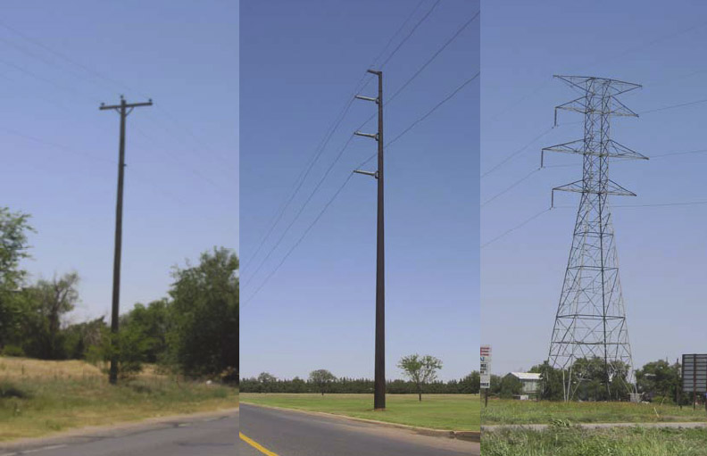

- Single wood poles with wood cross arms
- Single steel or concrete poles with metal cross arms
- Metal trussed towers

DOD | Damage description | EXP | LB | UB
1 | Threshold of visible damage | 83 | 70 | 98
2 | Broken wood cross member | 99 | 80 | 114
3 | Wood poles leaning | 108 | 85 | 130
4 | Broken wood poles | 118 | 98 | 142
5 | Broken or bent steel or concrete poles | 138 | 115 | 149
6 | Collapsed metal truss towers | 141 | 116 | 165

25. Free-Standing Towers (FST)
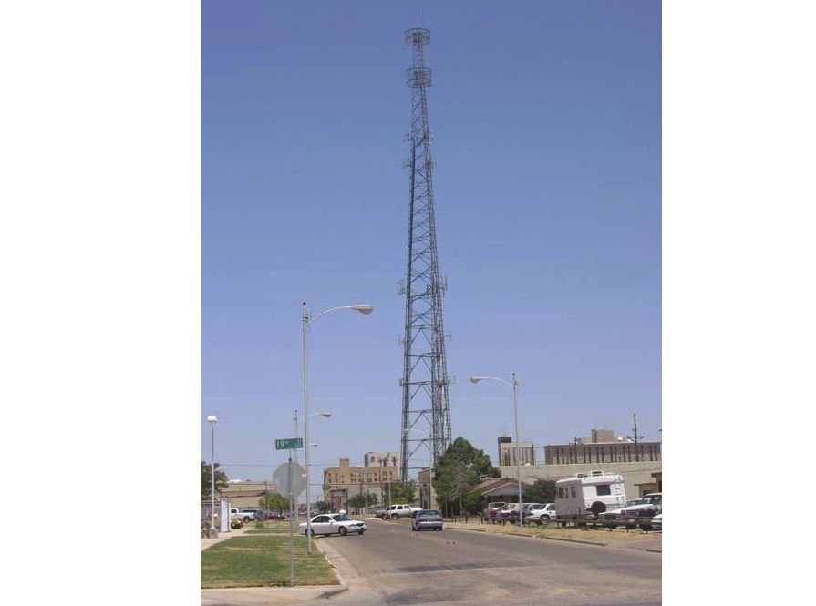

- Cell phone pole or tower
- Microwave tower

DOD | Damage description | EXP | LB | UB
1 | Threshold of visible damage | 92 | 76 | 113
2 | Collapsed cell-phone pole or tower | 133 | 113 | 157
3 | Collapsed micro-wave tower | 136 | 116 | 160

26. Free-Standing Light, Luminary, Flag Poles (FSP)
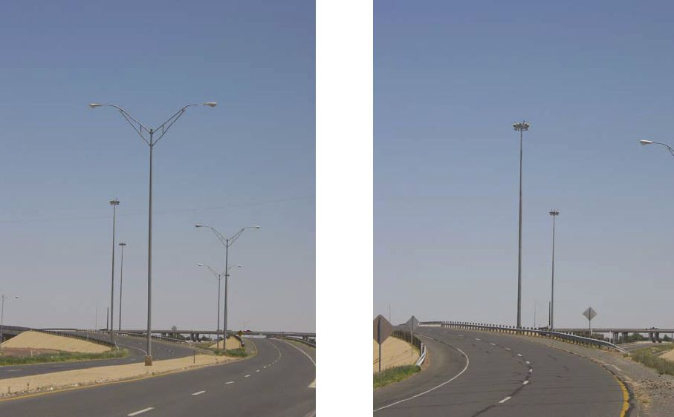

- Cantilevered metal pole

DOD | Damage description | EXP | LB | UB
1 | Threshold of visible damage | 81 | 67 | 100
2 | Bent pole | 102 | 85 | 120
3 | Collapsed pole | 118 | 99 | 138

FSP DOD 3
MPH: 99 (EF1) - 118 (EF2) - 138 (EF3)
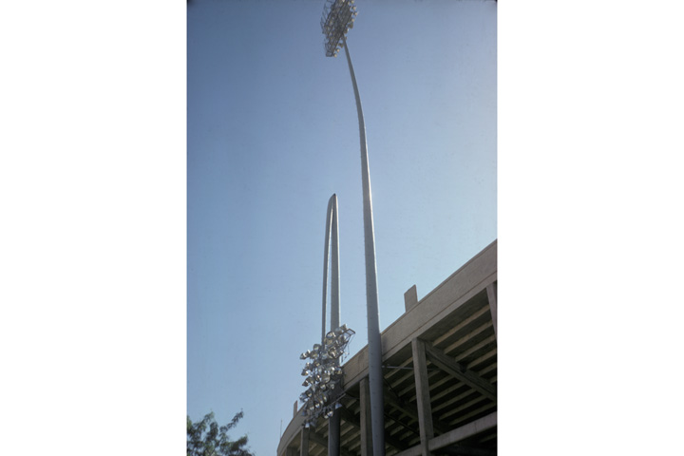
Collapsed pole

FSP DOD 3
MPH: 99 (EF1) - 118 (EF2) - 138 (EF3)
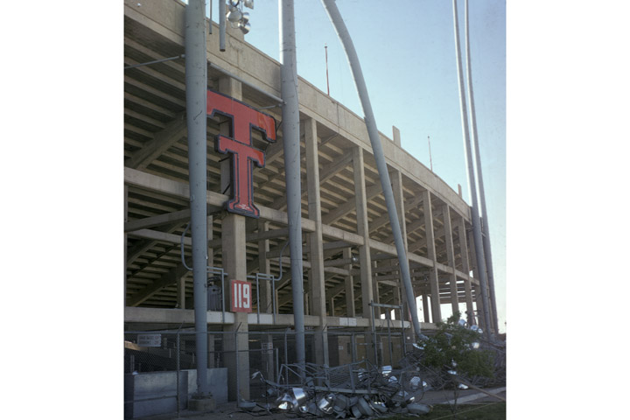
Collapsed pole

27. Trees: Hardwood (TH)
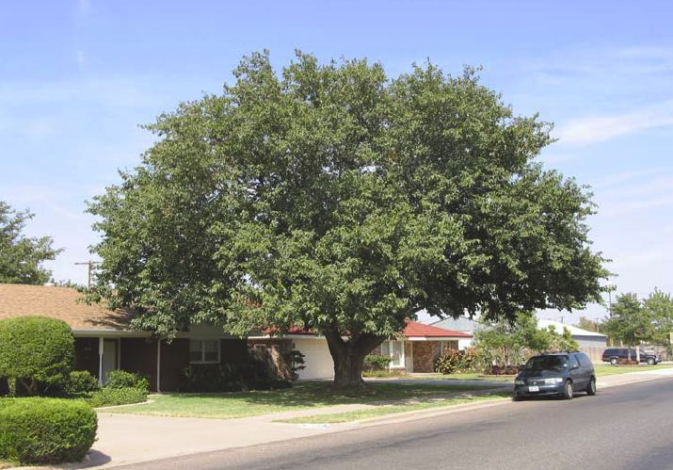

- Hardwood: Oak, Maple, Birch, Ash

DOD | Damage description | EXP | LB | UB
1 | Small limbs broken (up to 1” diameter) | 60 | 48 | 72
2 | Large branches broken (1”-3” diameter) | 74 | 61 | 88
3 | Trees uprooted | 94 | 76 | 118
4 | Trunks snapped | 107 | 93 | 134
5 | Trees debarked with only stubs of largest branches remaining | 143 | 123 | 167
TH DOD 3
MPH: 76 (EF0) - 94 (EF1) - 118 (EF2)
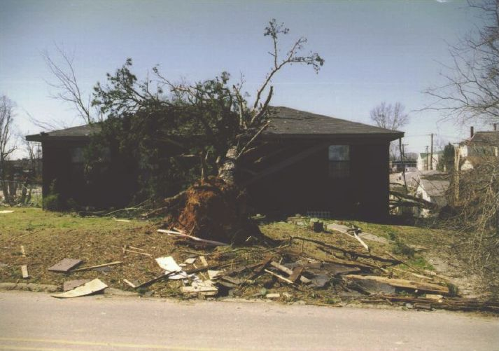
Trees uprooted

TH DOD 4
MPH: 93 (EF1) - 107 (EF1) - 134 (EF2)
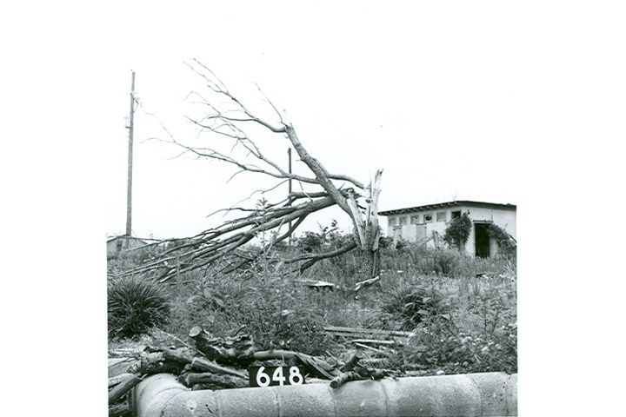
Trunks snapped
TH DOD 5
MPH: 123 (EF2) - 143 (EF3) - 167 (EF4)
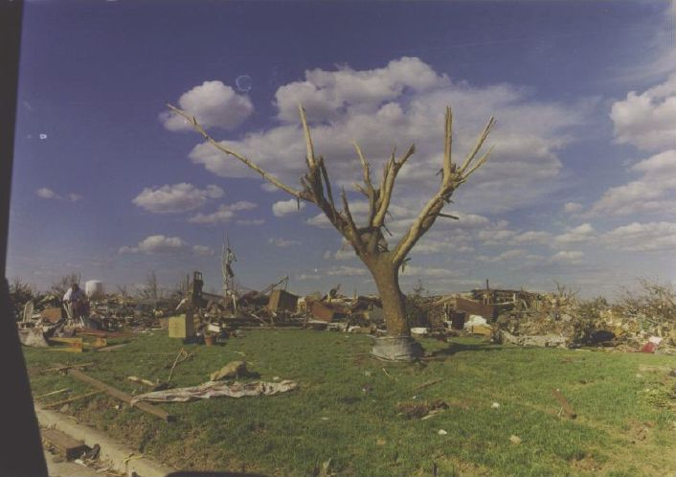
Trees debarked with only stubs of largest branches remaining

28. Trees: Softwood (TS)
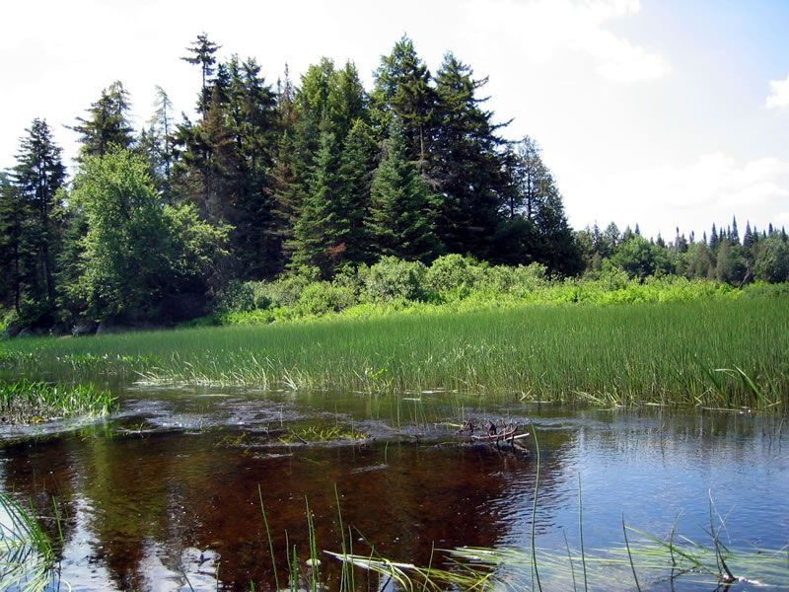

- Softwood: Pine, Spruce, Fir, Hemlock, Cedar, Redwood, Cypress

DOD | Damage description | EXP | LB | UB
1 | Small limbs broken (up to 1” diameter) | 60 | 48 | 72
2 | Large branches broken (1”-3” diameter) | 75 | 62 | 88
3 | Trees uprooted | 87 | 73 | 113
4 | Trunks snapped | 104 | 88 | 128
5 | Trees debarked with only stubs of largest branches remaining | 131 | 112 | 153

TS DOD 4
MPH: 88 (EF1) - 104 (EF1) - 128 (EF2)
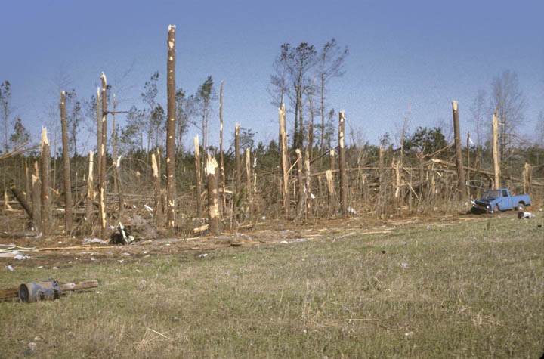
Trunks snapped

