Report on the Annual Review of the
FY 2005 Advanced Technology Development Program



August 9 & 10, 2005
Argonne IL

November 2005

U.S. Department of Energy

Office of FreedomCAR and Vehicle Technologies
High Power Energy Storage Program



November 3, 2005

Dear Colleague:

This document is a summary of the evaluation and comments provided by the review panel for the FY 2005 Department of Energy (DOE) Advanced Technology Development (ATD) program annual review. The review was held at the Argonne National Laboratory on August 9-10, 2005.

A panel of knowledgeable, independent reviewers assessed the accomplishments of the ATD program and provided valuable feedback. The recommendations of the panel will be helpful to DOE as it prepares plans for the research to be carried out in FY 2006. This research continues in support of the U.S. DOE’s FreedomCAR and Vehicle Technologies (FCVT) program’s efforts to develop high-performance, rechargeable lithium batteries for use in hybrid electric vehicles (HEVs).

We would like to express our sincere appreciation to the members of the review panel. We are very appreciative of experts who are willing to listen to the many presentations and provide us with feedback and recommendations on the program. Without your participation, this review would not have been possible.

Thank you for participating in the FY 2005 DOE ATD annual review meeting. We look forward to your participation in the FY 2006 review.


Tien Duong
Technology Development Manager

November 3, 2005

Dear Colleague:

This document summarizes the comments provided by the review panel on the ATD program. The recommendations of the panel were carefully considered in developing the FY 2006 work plan for the ATD program.

Overall, the reviewers’ were happy with both the focus and accomplishments of the program, even though they had a number of recommendations for improvement.

The main focus of the reviewers’ comments is the desire for this program to address real world battery issues, particularly by focusing on fundamental causes of poor performance, including at low temperature. Reviewers were very impressed with some of the abuse tolerance testing and diagnostics work, but recommended that the program diversify to consider additional materials.

Some of the main actions that DOE management plans to take in FY 2006, both in response to reviewer suggestion and for other reasons, are:

- Two advanced chemistries will be investigated in 2006 in order to extend and continue to relevance of this program to US developers.

- A new focus on SEI diagnostics and formation processing will be initiated to both characterize these and to understand how they impact battery performance.

- Low temperature research will be expanded in 2006 including in-situ diagnostics to understand the fundamental cause of poor low temperature performance.

Once again, I would like to thank the review panel and all attendees for participating in the FY 2005 DOE ATD program annual review meeting. Please feel free to provide us with further suggestions for improving this annual meeting. We look forward to improving this program over the coming year and to your participation in the FY 2006 review.

Sincerely,

David Howell
ATD Manager
FreedomCAR and Vehicle Technologies Program

Report on the Annual Review of the
FY 2005
Advanced Technology Development (ATD) Program

August 9 & 10, 2005
Argonne IL

November 2005

U.S. Department of Energy
Office of FreedomCAR and Vehicle Technologies
High Power Energy Storage Program

:

INTRODUCTION

This report presents comments from the review panel at the FY 2005 Advanced Technology Development (ATD) program annual review, held August 9-10, 2005 at Argonne National Laboratory in Argonne, IL. The objectives of this meeting were to:

- Review FY 2005 accomplishments and FY 2006 plans for the ATD program

- Foster interactions among the National Laboratories, universities, and private companies conducting battery research and testing

- Provide an opportunity for industry program participants (automotive manufacturers, OEMs, etc.) to learn of laboratory capabilities and accomplishments in battery diagnostics, testing, and evaluation R&D and thereby facilitate technology transfer

- Provide guidance to DOE program managers regarding future program priorities.

The priorities for this program were first identified in 1999 during a series of DOE/industry workshops, specifically with the PNGV (now called the FCVT) Tech Team. The program is organized such that five national laboratories (ANL, BNL, LBNL, INL, and SNL) and ARL work in close coordination to achieve the objectives of the program, which are to address the barriers to the commercialization of high-power lithium-ion batteries. These barriers are:

- Insufficient calendar life.
- Poor low temperature operation and performance.
- Poor response to abuse scenarios.
- High cost.

Over the past year the ATD program has been re-organized into focus areas that directly address these barriers. The main focus areas of work, and the organization of the review meeting, are:

- Understand life-Limiting Mechanisms & More Accurately Predict Life
- Understand and Enhance Low Temperature Performance
- Understand and Enhance Abuse Tolerance
- Cell Level Cost Reduction

The review panel members, listed in Table 1, are experts from a variety of organizations including battery manufacturers, auto suppliers, and consultants to the automobile companies. Note that six of the seven reviewers are employees of battery developers or major automotive supply companies. A special thank you goes to the members of this panel for providing valuable feedback to the ATD Program. Without their participation this review would not have been possible.

A complete list of participants (speakers, reviewers, and general participants) is provided in Appendix A.

Table 1: Technical Advisory Panel Members
Reviewer | Affiliation
- Mohamed Alamgir | Compact Power
- Tom Barbarich | Lithion/Yardney
- Per Onnerud | Tiax LLC
- Joe Stockel | NRO
- Jim Symanski | JCI
- N. Raman | Saft
- Andrew Webber | Energizer

Table 2 lists the presentations in the order they were given at the meeting.

Table 2: Presentations Given at the Meeting
Presenter | Presentation Topic
Understand and Enhance Low Temperature Performance
G. Henriksen (ANL) | Project Introduction
A. Jansen (ANL) | Low-Temperature Performance Characterization
K. Gering (INL) | Low-Temperature Performance & Characterization
K. Gering (INL) | Low-Temperature Electrolyte Modeling
D. Dees (ANL) | Low-Temperature Cell Performance Modeling
Understand life-Limiting Mechanisms & More Accurately Predict Life
G. Henriksen (ANL) | Project Introduction
J. Christophersen (INL) | Accelerated Aging at INL
I. Bloom (ANL) | Accelerated Aging at ANL
F. McLarnon (LBNL) | Diagnostics at LBNL
D. Abraham (ANL) | Diagnostics at ANL
D. Dees (ANL) | Electrochemical Cell Modeling
G. Henriksen | Advanced Chemistry 18650 Cells
V. Battaglia (LBNL) | TLVT Methodology Validation
J. Christophersen (INL) | TLVT Reference Performance Test Studies
Understand and Enhance Abuse Tolerance
G. Henriksen (ANL) | Project Introduction
K. Amine (ANL) | Cell Component Thermal Reactivity & Improvements
P. Roth (SNL) | Cell-Level Thermal Abuse Studies
D. Abraham (ANL) | Diagnostics – Thermal Abuse Related
X.Q. Yang (BNL) | Diagnostics – Thermal Abuse Related
P. Roth (SNL) | Overcharge Tolerance Studies
Cell Level Cost Reduction
G. Henriksen (ANL) | Project Introduction
K. Amine (ANL) | Advanced Materials Evaluation & Development
R. Jow (ARL) | Advanced Electrolyte Development
A. Jansen (ANL) | Cell Packaging Evaluation
A. Jansen (ANL) | Cell Packaging Cost Study
Program Status
G. Henriksen (ANL) | FY 2006 Preliminary Plan

ORGANIZATION OF THE REVIEW

This report summarizes the comments on the program as a whole, on each presentation in each focus area (including comments provided by non-reviewers), and summarizes a discussion session held with reviewers immediately following the review meeting. The criteria that were used by the reviewers to provide feedback on the ATD program were:

- Focus areas of the program are clear and appropriate
- Organization and resources applied to each focus area are appropriate
- Specific recommendations for additions or deletions from the program

Reviewers were asked to provide comments and recommendations on each project as well. The criteria used by the reviewers to provide feedback on the projects were:

- Relevance to overall DOE/FCVT goals and ATD program objectives
- Approach to solving problems and collecting data
- Technical accomplishments collaborations
- Approach to and Relevance of Proposed Future Research
- Specific Strengths and Weaknesses
- Recommendations/Additions or deletions to the work

Program and focus area review forms are shown in Appendix B. Summaries of the reviewers' comments on the ATD program begin on page 7, and their comments and scores on the individual projects begin on page 9. Additional comments provided by other attendees are summarized beginning on page 43. The transcribed reviewers’ comments are available upon request.

Note that as relatively few reviewers provided strengths and weaknesses, that information has been incorporated into the recommendations/additions area.

Overview of Reviewer’s Comments

Overall, the reviewers’ were happy with both the focus and accomplishments of the program, even though they had a number of recommendations for improvement.

The reviewers felt that, overall, the program has very good focus, suggested that priorities be safety, calendar life, and cost, and recommended more work on additives. Some thought that low temperature performance could be handled at the system level. They also noted that the abuse data was particularly relevant to battery developers.

Regarding the low temperature electrolyte investigation, reviewers suggested working more closely with industrial suppliers both to identify and procure promising electrolytes. Some asked that the methodology used to choose the gen 3 materials be presented.

They wrote that the average presentation was better than that at an ECS conference or similar scientific meeting. They were also very satisfied with the organization, and particularly noted the good and improved collaborations between the laboratories.

Some reviewers, continuing a comment from last year’s review, felt that the diagnostics teams must come to a clear conclusion on the primary causes of power fade and low temperature performance.

One reviewer commented very favorably on the proposed addition of formation studies, noting that a formation protocol (aging and cycling) that is quick is important to large volume battery manufacturers as long formation processes are costly. National labs could greatly help in this process and speed development for multiple electrolyte/active materials combinations.

One recommendation was to more tightly tie the cost modeling to the well established consumer battery market. The reviewer who suggested this was concerned that anticipated reductions in material prices would not actually materialize for HEV batteries which, for the foreseeable future, will require smaller materials volumes than the consumer battery market.

Another was to diversify materials selection and cell development and give more attention to non-conventional suppliers, who might be more “HEV” hungry, in addition to the Asian suppliers.

A related point was to increase the number of cells being built for testing purposes, and to consider multiple materials and their combinations, rather than one large cell build.

Finally, one reviewer felt that the TLVT validation task may need more cells and test channels to obtain sufficiently accurate data. He recommended purchasing additional testers, especially in the areas where a lack of a full statistical design of experiments is a limiting factor.

The reviewers’ recommendations along with DOE’s planned responses are presented in Table 3. In some cases, the action that DOE will implement in response to a recommendation is provided; in other cases, management felt that only an explanation was required to clarify an issue raised by a reviewer and that no action was necessary.

Table 3: Reviewer Recommendations and FY 2006 Actions
Comments/Recommendations |  | FY 2006 Action/Response
Overall
- Consider employing multiple material suppliers and cell manufacturers.  - Consider multiple materials and their combinations, rather than one large cell build.  - Increase the number of cells being built for testing purposes.  - Study commercial high-power 18650 cells more. | - The suppliers and cell manufacturer being used by ATD have been qualified through a thorough evaluation of their materials’ and cells’ quality and consistency. In addition, the ATD program does screen a large number of materials from multiple suppliers.  - The ATD program evaluates multiple materials, including additives, through in-house cell builds at ANL. In addition, the program plans to contract with a commercial electrode manufacturer to evaluate several advanced materials, as well as numerous variations in electrode composition.  - The number of gen 3 cells to be built is based on testing and diagnostics needs and resource constraints.  - The ATD program has refrained from studying commercial cells because researchers do not know what chemistry, including additives, are in the cells which makes analysis of the test results extremely difficult. The US DOE regularly benchmarks commercial cells.
Life Prediction and Enhancement
- Make the interface (SEI) a central theme of testing and diagnostics.  - Use diagnostics to develop a fundamental understanding of power fade  - The TLVT validation task may need more cells and test channels to obtain sufficiently accurate data.  - Recommend more feedback between the modelers and the diagnostics and testing teams. | - The ATD program will start an effort in 2006 on the positive and negative interfaces and their impact on life.  - The ATD program will start a new diagnostics effort in 2006 on the SEI and its impact on power fade and life.  - The TLVT validation task will proceed with available channels. It is assumed that developers will have access to approximately the same number of channels. In addition, the purpose of this task is to validate the methodology, and therefore to determine if the number of test channels is currently sufficient.  - The diagnostics and modeling teams regularly meet and exchange information. More effort will be made to present the results of this collaboration in the future.

Low Temperature Performance
- Focus the diagnostic work on the causes of poor low temperature performance.  - Begin improvement of low T charge acceptance.  - Work more closely with industrial suppliers to identify, procure, and screen promising electrolytes.  - Do not use button cells for low T, high power, work. | - In 2006, the ATD program will begin a new focus on in-situ diagnostics studies at low temperature and on the SEI in an attempt to isolate the root causes of low temperature performance degradation.  - The low temperature work in 2006 will include an investigation of low T charge acceptance.  - ATD will continue to work with numerous industrial suppliers and is beginning a new effort in 2006 to identify better low T electrolytes.  - Button cell data is being used as an initial screening tool when large numbers of material parameters need to be investigated. The ATD researchers are aware of reliability issues and have implemented strict quality control to mitigate them. They perform tests on five identical cells whose capacities must agree with within a few percent. Outliers are replaced at the start of the test. Promising results are further investigated with pouch or large fixture cells.

Abuse Tolerance
- Additive work should not be transferred to SNL until performance has been evaluated.  - Develop safety standards to determine how safe the cell has to be.  - Continue investigating coated/doped cathodes for better safety and stability. | - The ATD program performs preliminary performance screening on all materials prior to abuse testing. If materials perform well in abuse testing, they are considered for further and larger scale performance testing to verify performance is not degraded.  - DOE works closely with auto manufacturers who develop requirements and will forward this request to the USABC. The ATD program is focused on the impact of electrochemistry on abuse response, as opposed to cell and battery design impacts.  - Work on coated and doped cathodes will continue.
Cell Level Cost Reduction
- Provide additional rationale for gen 3 materials selections  - Use consumer battery cost numbers more in cost projections.  - Develop material specifications for anode, cathode, electrolyte, etc. | - Detailed rationale has been presented at previous ATD review meetings. The program’s results confirm that cathode stability is the most important factor in both cell life and abuse tolerance. Therefore, the gen 3 cell build focuses on studying the impact of a more stable (and lower cost) cathode material on life and abuse tolerance. Other gen 3 materials were selected on the basis of not interfering with the study of this alternative cathode material.  - The program will double check its cost projections against similar projections in the consumer battery market.  - Detailed specifications are material and chemistry dependent. General specifications for electrode materials have been developed, such as particle size, particle size distribution, and morphology. These have been presented at previous reviews.

REVIEWER COMMENTS

Overall Program Evaluation

Appropriate Focus
The reviewers felt that, overall, the program has very good and appropriate focus. They pointed out that the national laboratories have dedicated and knowledgeable people assigned to the program and felt that the average presentation was better than that at an ECS conference or similar scientific meeting.

One reviewer questioned one presenter’s statement that the 1/3 cathode material is becoming a “standard.” He recommended that a group more closely follow the Li-ion industry (including consumer batteries, not just high power HEV). He pointed out that the portable power market will dominate the industry for the foreseeable future, with the HEV market just being a fraction of the market size. Thus, certain cost projections may not be realistic, especially for materials that are already used in the portable power segment. This situation could result in a price (and technology) picture which is somewhat different than that assumed by the program.

Another concern was the manner in which the advanced chemistry, including additives, was chosen. A related request was made for the program to develop materials specifications necessary to achieve the goals.

One reviewer recommended that, as a strategy, materials selection should be diversified and that non-conventional, more “HEV” hungry, suppliers should be given more attention. Note that the program did solicit 1/3 cathode material from a number of suppliers and chose the best for its gen 3 cell build.

A recommendation that has been made before and was made again was that abuse tests and validation should be based on full scale cells and not with button cell or 18650 cells.

Organization and Resources
Reviewers were very satisfied with the organization, and particularly noted the good and improved collaborations. Several suggestions were made regarding resources, and those were:

The TLVT validation task may need more cells and channels to obtain accurate enough data. It appears the program is limited by both the amount of battery testers and the amount of cells that can be fabricated. This reviewer recommended purchasing additional battery testers, especially in the areas where a lack of a full statistical design of experiments is a limiting factor.

For test cells, one reviewer recommended qualifying additional suppliers.

Recommendations
In addition to those mentioned above, the reviewers made a number of suggestions, including:

- Low Temperature Studies:
  - Focus the diagnostic work on the causes of poor low temperature performance,
  - Begin improvement of low T charge acceptance.
- Life Testing
- Make the interface a central theme of testing and diagnostics.
- Continue investigating coated/doped cathodes for better safety and stability.
- Consider multiple materials and their combinations, rather than one large cell build.
- Abuse Testing
  - Additive work should not be transferred to SNL until performance has been evaluated.
  - Develop safety standards; determine how safe the cell has to be.
- Low Cost Materials - Develop specifications for anode, cathode, electrolyte, etc.
- Study commercial high-power 18650 cells.

One reviewer commented on the planned addition of formation studies, noting that a fast formation protocol is important to large volume battery manufacturers as long formation processes are costly. National laboratories could greatly help in this process and speed development for multiple electrolyte/active materials combinations.

One reviewer thought that the material presented this year duplicated some of material from last year, as the testing and analysis of gen 2 has been completed. He suggested considering the following with the gen 3 build: if cell formation is critical to life and safety; and if raw material impurities particularly affect life or safety?

Another reviewer asked if the cost of the electronics for cell balancing was overlooked. The ATD program is focused on cell level issues and considers battery module and pack issues to be an appropriate focus for developers. However, the battery-level cost model incorporates all battery components including the electronics associated with the battery management system.

Presentations and Logistics
The reviewers found this year's presentations much more focused than in previous years.

One reviewer suggested that more time be spent on diagnostics related to capacity and power fade. Another reviewer asked that focus area conclusions be presented at the beginning of each section, and that PIs present their conclusions first and then present results.

The reviewers also requested that the annual review materials be distributed to reviewers ahead of time, which will be done next year.

Project Specific Evaluations

The reviewers also provided comments and scores on each individual project. Table 4 shows the relative score and ranking of each presentation. This is followed by detailed comments and scores on each presentation. Note that in some cases the scores for a project do not correspond well with the written comments. Some lower ranked projects may receive positive comments and some higher ranked projects receive moderate criticism.

Table 4: Project Specific Rankings
PI | Project | Score | Rank
X. Q. Yang | Diagnostics—Thermal Abuse Related | 86.0 | 1
P. Roth | Cell-Level Thermal Abuse Studies | 85.2 | 2
G. Henriksen | Advanced Chemistry 18650 Cells | 83.2 | 3
F. McLarnon | Diagnostics at LBNL | 82.0 | 4
P. Roth | Overcharge Tolerance Studies | 79.7 | 5
V. Battaglia | TLVT Methodology Validation | 79.4 | 6
K. Amine | Cell Comp’t Thermal Reactivity & Improvements | 79.0 | 7
K. Amine | Advanced Materials Evaluation & Development | 78.8 | 8
K. Gering | Low-Temperature Electrolyte Modeling | 78.3 | 9
D. Dees | Electrochemical Cell Modeling | 78.0 | 10
I. Bloom | Accelerated Cell Aging at ANL | 75.7 | 11
D. Dees | Low-Temperature Cell Performance Modeling | 75.1 | 12
J. Christophersen | Accelerated Cell Aging at INL | 74.8 | 13
D. Abraham | Diagnostics at ANL | 74.7 | 14
A. Jansen | Low-Temperature Performance Characterization | 72.7 | 15
J. Christophersen | TLVT Reference Performance Test Studies | 70.7 | 16
D. Abraham | Diagnostics—Thermal Abuse Related | 70.0 | 17
K. Gering | Low-Temp. Performance & Characterization | 68.2 | 18
A. Jansen | Cell Packaging Evaluation | 65.3 | 19
A. Jansen | Cell Packaging Cost Study | 64.9 | 20
R. Jow | Advanced Electrolyte Development | 62.2 | 21

Low Temperature Performance Characterization, A. Jansen -- WS = 72.7, Rank = 15

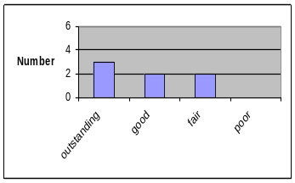Relevance to overall DOE/FCVT goals and ATD program objectives

The reviewers found this project to be very relevant, writing that low T performance was a key issue. One wrote that “one of the top problems is associated with high rate cycling at low T.”

Approach to solving problems and collecting data

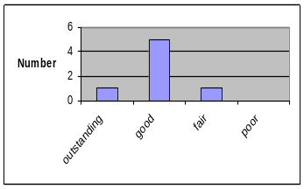The reviewers thought that the approach was good for evaluating Li plating at low T. They also wrote that the use of reference electrodes and impedance spectroscopy was appropriate, with the latter being one of the better methods to detect Li plating.

One reviewer noted that if Li desolvation is a limiting process, one electrode will be limiting on charge and the other on discharge. One could thus use a current interrupt technique to verify this flipping effect between the two electrodes.

Another wrote that diagnostic techniques are a limiting factor in this study and suggested performing correlation studies to purposely form lithium to test the techniques. This would allow a determination of when lithium is formed. NMR techniques should be used for this as it differentiates between lithium containing compounds and metallic lithium.

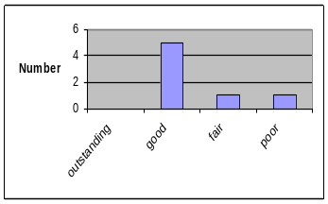
Technical Accomplishments and Collaboration are appropriate and timely

Most reviewers found the progress to be impressive, and particularly noted the collaboration with other labs, especially with P. Ross of LBNL.

They suggested opening discussions with electrolyte manufacturers to solicit input with regards to solvent, salts, and additives.
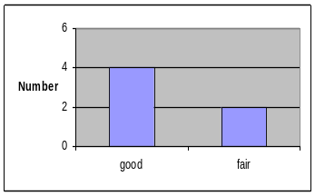

Approach to and Relevance of Proposed Future Research

One reviewer didn’t think the binder needed to be looked at further, instead suggesting that the effect of viscosity on concentration polarization needed further examination. However, another reviewer suggested more investigation of non-fluorinated binders.

Another commented on the search for low T electrolytes, asking if JPL and other labs hadn’t already done much of the work. Another noted that Matsusita used to use ethyl propinate but no longer does, suggesting cycle life may be a problem.

One reviewer wrote that the future plans appeared to be nearly the same as in the previous year.

Recommendations/Additions or deletions to the work scope, Strengths & Weaknesses

In addition to the recommendations mentioned above, reviewers wrote that the PIs needed to identify the root causes of the low T performance (work thus far has concentrated on characterization testing). If the issue involves the interface (impedance rise is shared equally between electrodes and this suggests an electrolyte-interface effect), then one must study the interface thoroughly, maybe in collaboration with LBNL, to identify the root cause.

Another reviewer wrote that as -30°C is a difficult target, PIs should map power capability (temperature vs. power) of the system for key electrolyte combinations. This will allow manufacturers to effectively assess what is needed to realize a functional system.

Low Temperature Performance & Characterization, K. Gering -- WS = 68.2, Rank = 18

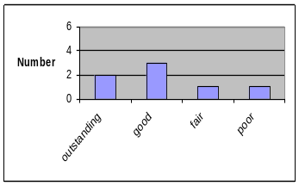Relevance to overall DOE/FCVT goals and ATD program objectives

Again, many reviewers found this to be a key performance issue. One reviewer wrote that the there did not appear to be a clear picture of direction in this presentation.

Approach to solving problems and collecting data
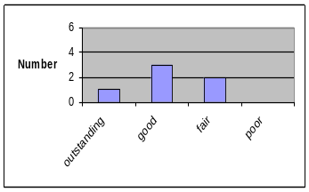
Reviewers liked the finding that polarization may be one of the contributors to low T capacity loss and recommended performing reference polarization curves during charge/discharge to validate the Li solvation hypothesis.

They also suggested that the formation study needs clearly stated objectives, such as gas generation, voltage mapping of chemical and electrochemical reactions, SEI completeness, first cycle efficiency increase, etc.

Finally, one reviewer questioned why INL was developing button cells which typically cannot sustain high rates of discharge (see note in table 3).
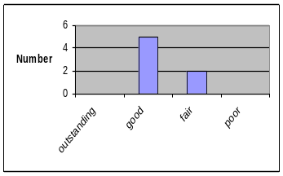

Technical Accomplishments and Collaboration are appropriate and timely

The reviewers were very satisfied with the accomplishments in this area, but noted that the program needs to identify the root causes of poor low T performance. They commented positively on the INL/ANL collaboration.

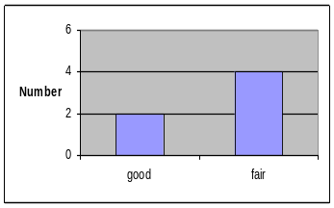
Approach to and Relevance of Proposed Future Research

Very few reviewers commented in this area, one wrote that he didn’t “understand the SRPT test” or its purpose.

Recommendations/Additions or deletions to the work scope, Strengths & Weaknesses

One reviewer commented that button cells were not a true representation of full size cylindrical cells.

A second recommendation was to observe “both electrodes for polarization during charge and discharge.”
Low Temperature Electrolyte Modeling, K. Gering -- WS = 78.3, Rank = 9

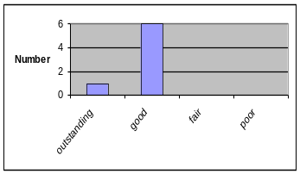Relevance to overall DOE/FCVT goals and ATD program objectives

The reviewers were somewhat mixed on this project’s relevance. Comments included “has appropriate focus. It is important to achieve a large database that industry can tap into when investigating new materials systems.”

Other reviewers were less certain, they didn’t see value in predicting conductivity since it is relatively easy to measure and may not be central to the low T performance degradation.

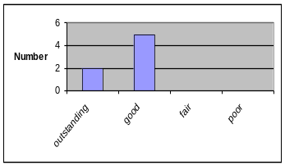
Approach to solving problems and collecting data

Reviewers were more positive about this project’s approach. They found the correlation between experimental results and modeling to be impressive and noted that it would enable high confidence when exploring new electrolytes.

One noted the “good consideration of the effect of polarization on localized electrolyte conductivity.” Another wondered if the claim that high viscosity causes polarization is reasonable speculation or actual finding.

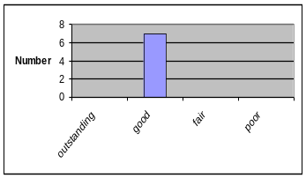
Technical Accomplishments and Collaboration are appropriate and timely

Reviewers were very positive about the results presented, particularly the correlation of model and measurement data. And they noted the interest in the desolvation issue.

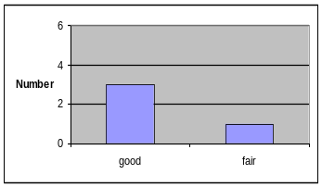One reviewer noted that the anode and cathode “concentration profiles appear very symmetrical .., which raises validity questions… an effort to explain this behavior should be undertaken,” another suggested closer collaboration with the modeling effort of Dr. Dees.

Approach to and Relevance of Proposed Future Research

Three reviewers commented on the future research, one supported the extension of the database to new systems; a second questioned whether the use of additives envisioned will lead to the considerable improvements needed for low T performance, and third suggested more attention be paid to the SEI.

Recommendations/Additions or deletions to the work scope, Strengths & Weaknesses

Reviewers made a large number of comments in this area. One suggested that less time be spent on modeling the conductivity, since that is relatively easy to determine experimentally.

Another suggested validating the desolvation hypothesis before trying to fix the problem. If changing the anode doesn't change results, how about the cathode? This reviewer was also concerned about literature reports showing major changes in low T performance with various carbons.

As an additional activity, one reviewer wrote “battery manufacturers are concerned about salt precipitation at high power. Mapping local salt concentrations as a function of porosity (pore size and volume) and power levels could therefore guide electrode builds and even help interpret diagnostics when failures are apparent.” Another noted that developers would like to see discharge curves modeled against rate and electrolyte changes.

Strength – Developing models are a good approach to understanding physical phenomena.
Weakness – PI needs to correlate his results with developing good experimental approaches to validate model.
Low Temperature Cell Performance Modeling, D. Dees -- WS = 75.1, Rank = 12

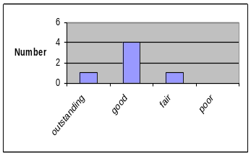Relevance to overall DOE/FCVT goals and ATD program objectives

As with other projects in this low temperature area, reviewers felt that this was important to battery developers. One reviewer commented that the battery field is starting to realize the importance of interfacial phenomena, similar to what the presenter discussed.

They thought that the focus should be on a better understanding of the physical/chemical cause of the problem, and questioned the focus on the positive electrode when a significant issue is plating at the negative.
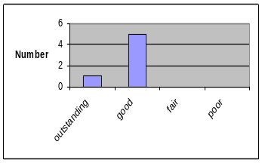

Approach to solving problems and collecting data

The reviewers thought that the approach was sound and comprehensive, especially if it could be applied at the anode as well. Another wrote that the approach “sounds as good as one can do given the poor knowledge of the real interfacial films,” which underscores the importance of knowing what those films are.

One reviewer requested a better connection to an actual cell.

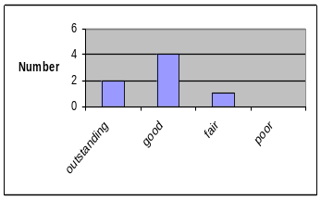
Technical Accomplishments and Collaboration are appropriate and timely

Very few reviewers provided comments in this area, those that did wrote “excellent collaboration with INL” and “good use of INL's electrolyte work.”

One reviewer questioned the impact of salt concentration build-up during high rate charge/discharge on viscosity and ion transport. According to the graph, it looks large (1.4 vs. 0.9M) although text says it isn't a big factor.
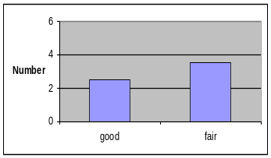

Approach to and Relevance of Proposed Future Research

Several reviewers suggested increasing the work on the anode, where plating will occur.

One reviewer suggested mapping temperatures to performance to determine threshold performance. Another requested that the model be connected to the whole battery, helping non-modelers interpret results.

Recommendations/Additions or deletions to the work scope, Strengths & Weaknesses

The reviewers thought that this line of work was very helpful and should continue, but noted that there is a weakness with the unclear connection to the battery as a whole. One asked if “binderless/conductor less electrode work provided better estimates of material properties for this modeling?”

One reviewer, continuing a suggestion made previously, suggested further emphasis on interfacial phenomena. Another requested modeling of iron phosphate, spinel, and nickelate (both 1/3 and Ni-rich) systems, as different developers are targeting different systems and a selection has not been made yet.

Strength – Developing models are a good approach to understanding physical phenomena Weakness – PI needs good dataset to validate model and parameter changes, especially over a defined temperature range.

Accelerated Aging at INL, J. Christophersen -- WS = 74.8, Rank = 13

Relevance to overall DOE/FCVT goals and ATD program objectives

Reviewers recognized this testing work as “absolutely necessary,” noting that it helps modelers, provides cells for diagnostics, and that faster testing methods to predict degradation are important.

Another wrote that it is “good for battery developers… to have baseline performance to compare their own development to. This type testing is highly important.”
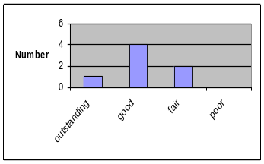

Approach to solving problems and collecting data

Reviewers were very satisfied with the testing approach, writing that the plan was well laid out. One reviewer thought that it “would be beneficial to acquire other types of batteries and map performance in these alternate chemistries.”

Technical Accomplishments and Collaboration are appropriate and timely

The reviewers were very happy with both the accomplishments and the collaborations, particularly between INL and ANL. One wrote “… gives a good organized presentation of the team’s work.”

Approach to and Relevance of Proposed Future Research
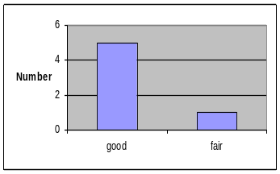
One reviewer suggesting testing the effectiveness of the formation/aging protocol to improve the test matrix.

Two reviewers suggested testing some commercial high rate 18650 cells to check models.

Recommendations/Additions or deletions to the work scope, Strengths & Weaknesses

The most significant concern was related to the “test program being limited by both cells and test channels.” This was identified as a “significant weakness in the program.”

One reviewer questioned the empirical models, asking how the DSM model compares to the t^{1/2} and t fade rates. This has been raised in the past, with some reviewers questioning the value of empirical models in general.
Accelerated Aging at ANL, I. Bloom -- WS = 75.7, Rank = 11

Relevance to overall DOE/FCVT goals and ATD program objectives

As with the INL aging project, reviewers found this one very relevant, writing “very important to characterize the behavior of cells.” They particularly noted the attempt to characterize the behavior in terms of SEI growth, writing “it is critical to understand growth of interfacial layers on…the electrodes.”

However, they wrote that it would be preferable to see a more direct linkage to chemistry.
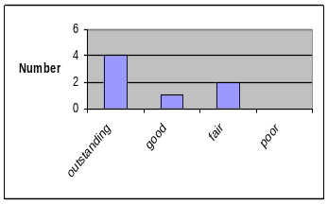
Approach to solving problems and collecting data

The reviewers were generally positive about the approach; finding the dV/dQ analysis useful for studying degradation reactions. Another wrote that this was a “unique approach within the program…and is therefore…important.”

But one reviewer was concerned about the lack of understanding of the major contributions to degradation, and felt the project would benefit from quantification of the proposed mechanisms.

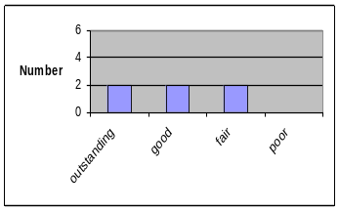
Technical Accomplishments and Collaboration are appropriate and timely

Most reviewers were appreciative of the accomplishments, and the interpretation of the dV/dQ data. They also commented on the use of different methods to investigate the data and found the suggestion for differences (peak #2 height) between calendar and cycle life reasonable. They also wrote that the collaborations among the labs were excellent.

However, one reviewer thought the presentation and the conclusions were very similar to the previous years. He also suggested that the “electrochemical analyses be coupled with the physical analyses to support hypothesized failure modes?”

Approach to and Relevance of Proposed Future Research

Very few reviewers provided comments on the future research. One suggested testing multiple electrolyte/electrode combinations, especially for interpretation of the cathode SEI which appears to limit cycle life for some systems.

Recommendations/Additions or deletions to the work scope, Strengths & Weaknesses

The main recommendation for this project was to bring more chemical and electrochemical understanding to bear on the observations. Reviewers requested linkage to what's happening in the cell and how it is related to the two-step fade mechanism. They suggested that the program initiate a chemistry-based collaboration to link the observations to chemical processes.
Diagnostics at LBNL, F. McLarnon -- WS = 82.0, Rank = 4

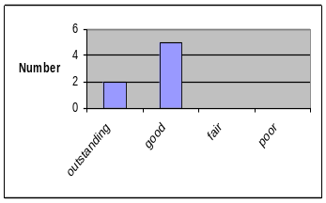Relevance to overall DOE/FCVT goals and ATD program objectives

The reviewers were divided on the relevance and novelty of this research. Their comments included “key work in trying to understand fade” and “diagnostics are highly important to … map degradation mechanisms.” However, one questioned “how much help this work provides to making a better battery?”

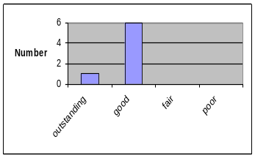Approach to solving problems and collecting data

Reviewers generally found the approach to be good. They particularly noted the work on water contamination, but questioned how this is being used to explain the two regions of power fade. They did think these techniques could be used to develop hypotheses on failure modes.

One reviewer suggested using NMR to detect lithium in the anode. In addition, “experimentation could have included more work on sample conditioning” to control and determine the conditions under which Li deposition occurred to quantify the analysis technique.

Technical Accomplishments and Collaboration are appropriate and timely

The reviewers were generally happy with the accomplishments, writing “the interfacial studies using carbon were good,” “very useful insight as to fade and importance of carbons,” and “good interpretation of results.”

However, one reviewer questioned the novelty of this data, writing “results are similar to those in the literature… Lecht found Fl and P on the cathode. Is this related to impedance rise at the cathode?”

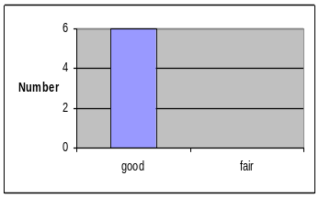Approach to and Relevance of Proposed Future Research

The one suggestion was for the diagnostics work to “understand the correlation of certain impurities to degradation and not just the existence of these impurities.” Another, however, thought the “work plan is much more focused” than what they were used to seeing. A third reviewer suggested more work on carbon types in the cathode.

Recommendations/Additions or deletions to the work scope, Strengths & Weaknesses

One reviewer suggested that low T work be combined with this work. The intention should be to determine what is happening at the interface (as researchers in that field insisted) that impacts the low T performance.

Another reviewer suggested using a combination of electrochemical measurements and modeling to understand the connection between impurities and degradation mechanisms. He suggested using controlled correlation experiments with purposely added impurities of the type found in degraded cells.

Strength – Strong technical team.
Weakness – Needed to provide some of this analysis throughout INL tests to identify patterns in some of the results

Diagnostics at ANL, D. Abraham -- WS = 74.7, Rank = 14

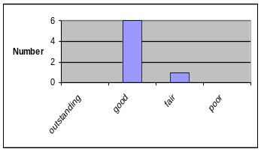Relevance to overall DOE/FCVT goals and ATD program objectives

Three reviewers provided comments here. One simply wrote “diagnostics are important,” a second agreed and thought the diagnostics report was very beneficial for developers. The third wrote “relevance is diminished as no clear link to the system is achieved.”

Approach to solving problems and collecting data

The two comments provided on this project’s approach were vague. One reviewer thought the focus on power degradation was appropriate, but another wrote that other techniques should be used but did not specify anything further.

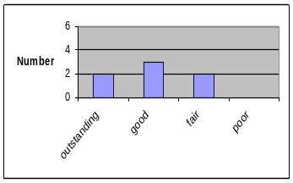Technical Accomplishments and Collaboration are appropriate and timely

The reviewers’ comments were somewhat inconsistent here. Some felt that the accomplishments were significant, writing “completion of the diagnostics report is a major accomplishment,” and “several key findings were presented which will help in developing advanced cells.”

But another was frustrated by the lack of a clear explanation of the cause of power fade, writing “what physically happened...to cause the impedance rise? …What physical changes occur?”

Approach to and Relevance of Proposed Future Research

Only two reviewers provided a comment here, and they disagreed on the binder free work. One wrote “work with binder free...electrodes may prove especially helpful” while another wrote “investigation of binder-free electrodes does not appear to be a good approach ... Degradation is in many cases coupled to the binder system.”

Recommendations/Additions or deletions to the work scope, Strengths & Weaknesses

Continuing a theme from previous reviews, some reviewers requested more linkage between the diagnostics work to the power fade. They suggested more physical measurements using SEM, XPS, IR, etc. that could indicate what caused the power fade. Another suggested replacing the binder-free study with one investigating the binder’s influence on power fade.

Strength - Organizes and present well with conclusions on each page showing supporting data.
Electrochemical Cell Modeling, D. Dees -- WS = 78.0, Rank = 10

Relevance to overall DOE/FCVT goals and ATD program objectives

Three reviewers provided comments, all very positive. They thought the use of modeling to attack life was important to realizing the program’s goals and was a cornerstone to quality systems development.

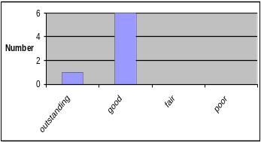Approach to solving problems and collecting data

The reviewers were generally very comfortable with this approach, writing “excellent work.” However, one reviewer was “uncomfortable about the lack of knowledge of the active area. This could provide be a huge fudge factor that enables one to get a good fit with an inappropriate model.”

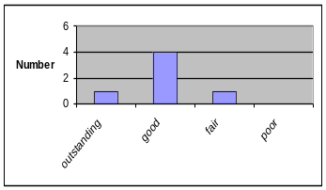Technical Accomplishments and Collaboration are appropriate and timely

The reviewers were complimentary about the technical accomplishments. Two mentioned that the presentation would benefit from linking the model parameters to the performance limitations of present cells.

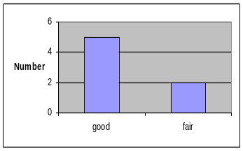Approach to and Relevance of Proposed Future Research

Only two reviewers provided comments here, one felt that it was “not clear where the modeling effort is going,” while the second thought that it would be beneficial to show the model for a unit system, which could be translated into multiple geometries to help developers in scaling a battery.

Recommendations/Additions or deletions to the work scope, Strengths & Weaknesses

One reviewer suggested measuring the active area, perhaps using an absorption method like one using methylene blue.

Another reviewer requested that a cell design parameterization study be done. Study different pulse lengths while tracking how power changes with time for various electrode/electrolyte combinations. Then determine if power degradation is the same for a 5s pulse as for a 15s pulse.

Execute and report on items listed in the presentation:
- Gain confidence – benchmark to actual performance both AC and HPPC (area of high developer interest);
- Parametric studies – explore failure modes and guide experiments.
Advanced Chemistry 18650 Cells, G. Henriksen -- WS = 83.2, Rank = 3

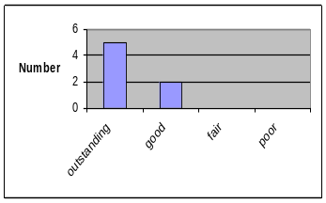Relevance to overall DOE/FCVT goals and ATD program objectives

Reviewers were unanimously positive about this project’s relevance, writing that the development of the NMC cathode focuses on the goal and might improve safety and lower cost.

The two questions the reviewers had concerned the means by which this material and other gen 3 components were chosen and why the program appears limited by the number of cells.

Approach to solving problems and collecting data

The reviewers were surprisingly positive about the approach considering their uncertainty with how the new chemistry was chosen. Here they wrote that electrode thickness and loading are both important for rate capability and life and they were glad this was being investigated before all cells are made.

One reviewer expressed the concern that the new material appears to have higher ASI than alternate 1/3 materials in the market and suggested investigating multiple suppliers (but continue with Seimi) and multiple cell builders. The latter, which not only spreads the risk, might allow an investigation of the impact of cell building technique on performance and safety.

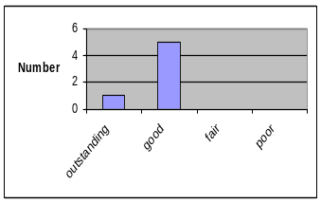
Technical Accomplishments and Collaboration are appropriate and timely

The reviewers were all very positive about this project’s accomplishments and collaboration with industry; and also appreciated the schedule presented. One questioned the use of vapor grown carbon fiber due to its high cost.

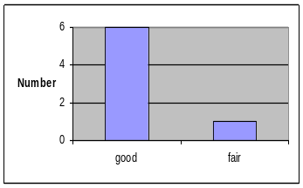Approach to and Relevance of Proposed Future Research

Very few reviewers provided comments here, but one expressed concern about the numerous components that have been changed (from gen 2 to gen 3) and which appear not to have be tested in a matrixed way. There is a general concern about the ability to decouple these components from the resulting cell’s performance.

Recommendations/Additions or deletions to the work scope, Strengths & Weaknesses

The reviewers provided a fairly large number of recommendations, including:

Perform a critical evaluation of the electrolyte (high T, low T, stability), the new salt (price, long-term performance), and add additives to this work.

Build cells using alternate cell manufacturers (using similar chemical system) to associate cell builds to performance and safety.

There is a need for a cost model that clearly shows the cost advantage of the new system, and the program should compare costs between spinel, Li(Ni,Co,Mn)_{1/3}O₂, and gen 2. Additional technical investigations would be useful here so that industry understands why this is a clear selection from the national lab’s perspective.

Finally, one reviewer asked if there was “a plan for the coated electrodes to be used to determine root causes and mechanisms of failure?”

TLVT Methodology Validation, V. Battaglia -- WS = 79.4, Rank = 6

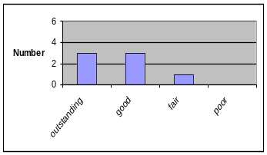Relevance to overall DOE/FCVT goals and ATD program objectives

The reviewers were uniformly positive about the importance of this work, writing that it was very relevant and would be a real aid to developers.

Approach to solving problems and collecting data

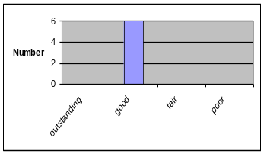The reviewers were much more concerned about the approach, specifically the number of cells being tested to validate the TLVT. They wrote that “collecting data appears to be a problem. Not enough test channels” and “I wish more cells/channels were available for more accurate modeling,” and suggested utilizing external laboratories if there is an equipment availability issue

One reviewer thought that it was unfortunate that the current pulse was limited to 3C. A new matrix that comprises power degradation studies at higher power pulses would be more appropriate.

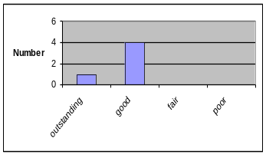
Technical Accomplishments and Collaboration are appropriate and timely

Although this project has been active for over one year, some reviewers thought that it was too premature to judge accomplishments.

One reviewer wrote that “collaboration with other labs and industry is adequate,” but one reviewer suggested further collaboration with auto and battery manufacturers.

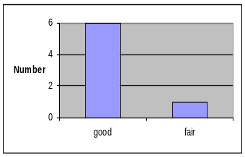
Approach to and Relevance of Proposed Future Research

Comments similar to those above were also raised here, including “good, considering the limited resources” and “use more cells.” One reviewer was not convinced that the TLVT would handle two step models or other models where a new failure mechanism starts to appear only at long times (e.g., loss of electrolyte through the seals.)

Recommendations/Additions or deletions to the work scope, Strengths & Weaknesses

One reviewer expanded upon the recommendation to use external resources. “Life testing at NSWC, Crane is inexpensive. An 8.75Ahr cell costs about $14.5k/year to test. … similar testing capabilities and costs are available from Lockheed Martin located in Clarksburg, MD.”

Following up on a theme from above, one reviewer expressed concern that the model will overestimate actual life if testing does not go far enough to capture new, long-term, degradation mechanisms. The two step fade mechanism seen in gen 2 cells seems to indicate that this is a real possibility.

Finally, one reviewer asked if a case study could be done using consumer technology (small cells) to validate the method, pointed out also that smaller consumer cells would alleviate issues with test channel availability.

TLVT Reference Performance Test Studies, J. Christophersen-- WS = 70.7, Rank = 16

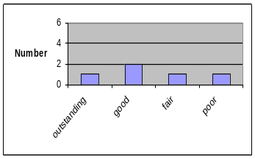Relevance to overall DOE/FCVT goals and ATD program objectives

Most of the reviewers found this task to be relevant, writing, e.g., that the “goal of the MPPC test seems reasonable,” that the work was “very relevant,” and had the right focus. “It is important to create protocols that can be used by developers… to compare data without disclosing their own methodologies.”

One reviewer thought this was less critical, saying that it appeared to be "nice to do" work, especially in light of the poor understanding of the cause of power fade.

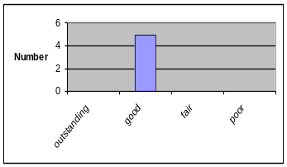
Approach to solving problems and collecting data

The reviewers were also happy with the approach taken, writing “method appears rigid and well thought out, within the frame of existing resources.” One reviewer recommended that “when changes are made to test protocols, they need to be clearly identified and justified. It would be beneficial to show how changes to test protocols affect data interpretation. It would also be beneficial to obtain periodic updates to test data – maybe posted on a webpage.”

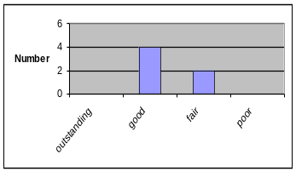
Technical Accomplishments and Collaboration are appropriate and timely

Most reviewers were positive about the accomplishments. Some comments included “progress towards finding an alternative to the HPPC test has been made,” and “identified key differences in constant current/power tests.”

However, one was unsure if the objective of shortening the time to accomplish aging protocols was successful or not.
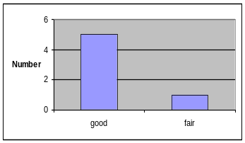

Approach to and Relevance of Proposed Future Research

Only one reviewer provided a written comment in this area, writing “good approach – variations of protocol are essential not only for comparison of protocols, but also the relative sensitivity to protocols on battery life.”

Recommendations/Additions or deletions to the work scope, Strengths & Weaknesses

The reviewers had a number of recommendations for this project. Two suggested ending the work which was surprising given the generally positive comments provided above. “Work is unlikely to significantly advance our understanding of cell performance. The program should focus on understanding fade, and less on looking at the various test protocols.”

Another asked that more information be extracted from these tests, that the researchers try to explain the differences seen in testing and create a hypothesis He also warned that although the 3C rate has worked in the past, it may not be adequate for new systems.

One reviewer suggested an additional task, to permit prediction of a system that is over-designed, i.e. “start at low polarization to accomplish power levels and then gradually increase voltage window to accomplish similar power as the battery degrades. Maybe this can be modeled as far as power levels go, but can only be validated if data is available. Automotive manufacturers are likely installing systems that are slightly over-designed, at least in the beginning of product life.”

Finally, several reviewers were confused by the speed and number of acronyms in the presentation, and “could not follow the presentation.” They recommended specifying the differences between the HPPC and MPPC tests.

Cell Component Thermal Reactivity and Improvements, K. Amine -- WS = 79.0, Rank = 7

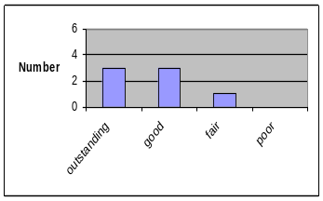Relevance to overall DOE/FCVT goals and ATD program objectives

Nearly all reviewers thought that the relevance of this project was very high. They wrote that “oxygen release can explain combustion, heat generation and gas generation in cell, so the appropriate focus is on the cathode,” “critical factor in large batteries,” and “highly relevant...but competitive factors will still be cost and power as abuse tolerance is a necessity.”

One reviewer was not convinced of this project’s relevance, writing that the program could pursue this “for a long time without realizing that all the effort has not really advanced our goal.”

Approach to solving problems and collecting data

The reviewers were very positive about this project’s approach. They wrote “excellent approach to investigating the thermal stability,” “good thermal studies.”

One reviewer questioned whether the thermal runaway at 130°C is caused by anode SEI breakdown or if it might be due to a loss of mechanical integrity of the separator which melts near 130°C. Another reviewer suggested that the DSC study would have benefited from more variation in rate conditions.

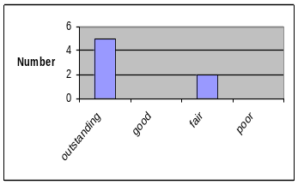
Technical Accomplishments and Collaboration are appropriate and timely

Although the scores in this area are high, the reviewers were more neutral in their comments, writing, e.g., “work on reactivity of cathode and anode has been excellent, high quality work, but I am not sure the work on additives has real value in a practical system ... as they all have significant drawbacks.”

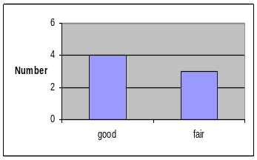
Approach to and Relevance of Proposed Future Research

Few reviewers provided comments here, but those that did questioned some aspects of the future work. “Until we are sure that the additives (phoslyte) have no deleterious effects on performance…don’t commit too many resources to them.” Another found the emphasis on electrolyte and additives to be appropriate. There were also questions about the Air Products proprietary salt and the new Japanese salt, with reviewers unclear of their status and composition.

Recommendations/Additions or deletions to the work scope, Strengths & Weaknesses

The reviewers identified a number of strengths, including that the project leader is knowledgeable in multiple methods, and that these safety studies coupled with measurements at Sandia are state-of-art, world class, and of high value to manufacturers.

The reviewers noted that graphite selection, cathode, electrolyte, processing and cell size all play a significant role in abuse response and therefore the current results should be taken with that in mind.

Also, one reviewer suggested that studies be correlated with gas generation results and to the amount of electrolyte in each cell, as that can greatly influence the thermal response.

Cell Level Thermal Abuse Studies, P. Roth -- WS = 85.2, Rank = 2

Relevance to overall DOE/FCVT goals and ATD program objectives

Reviewers agreed that this abuse work was very relevant, writing “key … especially now that they are being used to explain safety, not just document it,” and “high importance to commercialization of Li-ion for HEVs.”

One reviewer requested that the program make clearer how these studies will enable manufacturers to make the safer cells. This request, for practical advice regarding abuse tolerance, has been mentioned in previous years as well and the program is striving to provide this.

Approach to solving problems and collecting data

The reviewers were very positive about the approach, but also made some suggestions, including considering the effect of the separator, specifically determining if it melts causing a short which heats the cathode to 200°C.

One reviewer recommended increased focus on electrolyte studies in multiple cathode systems. Another requested that the researchers list the most significant drawbacks of each system, in terms of safety. Then, the safety studies should aim at lowering kinetics and pressure increases. “J/g” as a stand alone measure is of less importance.

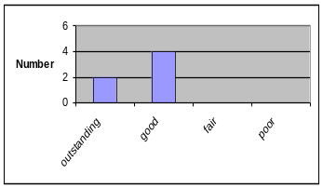
Technical Accomplishments and Collaboration are appropriate and timely

Most reviewers thought the accomplishments were outstanding, providing comments like “the link between gas evolution, thermal data, and heat of reaction is very good,” and “gives industry both a feel for the runaway events and a way of quantifying and measuring it on a materials level.” The also wrote that the collaborations were excellent and that the work has provided increased understanding.

One reviewer wondered why the electrolyte salt would have a large effect, particularly if oxygen evolution at cathode is the primary driver to thermal runaway.

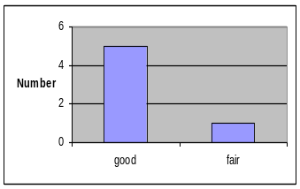
Approach to and Relevance of Proposed Future Research

Reviewers had a couple of suggestions for this project’s future work, writing that they should “test coated cathodes (ZrO and MgO),” and that additives and aged electrodes could be added to the test matrix. Finally, it was suggested to deemphasize work on the 1/3 compound and collect data on more electrolyte/active material combinations, which would be more useful to the average developer who is still considering multiple options.

Recommendations/Additions or deletions to the work scope, Strengths & Weaknesses

Reviewers provided an unusually large number of comments here, which may indicate their interest in the abuse tolerance area.

They suggested continued emphasis on understanding through modeling of safety events, but warned that the program may need to specify the chemistry before the modeling will work well.

They also wrote that the program should spend more time correlating the studies with how the cells will actually be used. “It is important to understand failures at 100% SOC, but an actual HEV battery system may not be at full SOC often or ever. It might be interesting to determine how the 1/3 compound compares to gen 2 at 50% SOC. In addition, a safety study of aged electrodes would be valuable.”

One reviewer noted that 900 mAh cells may be less problematic than very large (5-10Ahr cells) in evaluating safety. Note that the ATD program has considered this issue in the past, and has determined that the 18650 size cells are appropriate for evaluating the contribution of the electrochemistry to the abuse response of cells. The impact of cell design on abuse response, which is not being investigated by the program, is much more critical in the larger cells.

Another reviewer recommended only pursuing additives and salts whose performance has been well characterized. This same reviewer was concerned about Sandia coating electrodes, and pointed out that it requires a lot of time and resources to optimize coating.

Reviewers also questioned why there was more gas with the new NMC material?

Diagnostics – Thermal Abuse Related, D. Abraham -- WS = 70.0, Rank = 17

Relevance to overall DOE/FCVT goals and ATD program objectives

The reviewers were not as positive in their assessment of this project as they were on others in the abuse arena. They noted that these were not easy experiments and that there appeared to be good agreement between the results of Amine, Roth, and Abraham on the delithiation of graphite.

On the other hand, some wrote that although this could be very important work, it needed improvement due to the limited data. They also thought that the project needed a better connection with the testing results.

Approach to solving problems and collecting data

The reviewers were fairly positive but provided two suggestions. They thought this was good analysis of cell components and that the methodologies used were appropriate. However, one suggested that mapping techniques for SEM would be beneficial and that NMR should be employed for Li detection at the anode.

One reviewer suggested using harvested electrodes coupled with unaged counter electrodes to gain insight into what impacts electrochemical performance and cycle life. The goal would be to determine if decomposition products on particle surfaces affect cycle life.
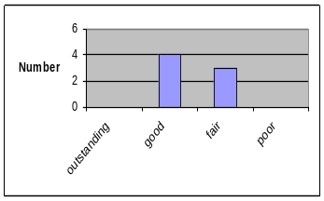

Technical Accomplishments and Collaboration are appropriate and timely

The reviewers were much more divided about the accomplishments. They wrote that the collaboration between labs was good, but that the studies presented were too limited and would be better if the entire picture could be presented together.

Approach to and Relevance of Proposed Future Research

One reviewer thought that unless the cells were unique and provide significant advantages, there was no point in repeating these types of experiments.

Others suggested using more techniques, including electrochemical and thermal studies of abused electrodes. Finally, one reviewer suggested studying significantly aged cells.

Recommendations/Additions or deletions to the work scope, Strengths & Weaknesses

The recommendations here included determining if the sticking of the cathode to the separator indicated partial melting of the separator. Since the cathode is stuck to the separator, researchers could use the methods being developed for C and binder free electrodes. If possible, remove from separator first.

One reviewer suggested studying the SEI at the cathode and its potential influence on safety. In a related comment, one reviewer asked how the surface chemistry of these samples compares to those from fresh cells and from those that underwent calendar life tests performed at INL?

Diagnostics – Thermal Abuse Related, X.Q. Yang -- WS = 86.0, Rank = 1

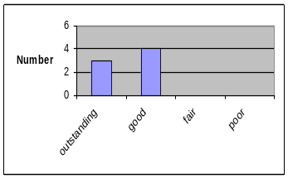Relevance to overall DOE/FCVT goals and ATD program objectives

Reviewers were very positive about this diagnostics effort overall, including in the relevance area. They noted that it displayed good focus on the cathode, that this was a very unique tool, highly relevant, and was an excellent complement to thermal studies.

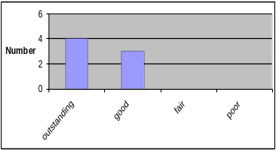Approach to solving problems and collecting data

The reviewers were particularly complementary about the XAS, writing that it was excellent to distinguish between bulk and surface processes and were also glad that the PI looked at the cathode both with and without electrolyte.

“Great use of … soft and hard X-rays.” One reviewer thought that Rietveld refinements would be interesting for quantification of Ni²⁺ disorder between lithium and transition metal site. He also questioned whether the DSC studies show a shift in baseline after reaction, and if so whether this was due to material loss? In that case it invalidates the results.

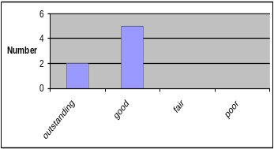
Technical Accomplishments and Collaboration are appropriate and timely

The reviewers were fairly positive about the accomplishments, commenting that this was a “very good contribution to our understanding of materials,” and “excellent results.”

One reviewer commented on the good explanation on the effect of MgO, but questioned if the surface is so thoroughly covered, how would that affect the cell’s impedance?

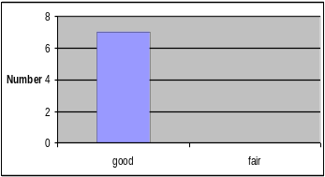
Approach to and Relevance of Proposed Future Research

Reviewers felt that this work was “right on target,” suggesting further testing of cells with the MgO coating. They also commented on the good collaboration among the labs.

Recommendations/Additions or deletions to the work scope, Strengths & Weaknesses

Among the strengths mentioned were the X-ray technique itself and the high competency of the PI.

Reviewers also recommended further work to evaluate the coated cathodes. They commented on the many reports on ZrO and MgO coated cathodes to improve cycle life, overcharge, and thermal stability.

Another recommendation was for the project to quantify the amount of impurities formed as a function of time/temperature, which would help diagnostics connect better to the safety results.
Overcharge Tolerance Studies, P. Roth-- WS = 79.7, Rank = 5

Relevance to overall DOE/FCVT goals and ATD program objectives

The reviewers were almost unanimous in finding this project to be “highly relevant.” One reviewer, however, thought that the potential risk associated with overcharge could be mitigated by good redundant pack/cell protection.

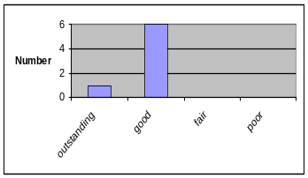
Approach to solving problems and collecting data

They were also fairly positive about the approach, commenting particularly on the component analysis and gas analysis. However, one suggested more selectivity in these experiments to ensure that we are learning things applicable to other chemistries. Another reviewer wrote that separator testing needs to include rapid heat rates and temperature control at the separator and that the researchers should go to higher voltages to determine the separator breakthrough potential.

Technical Accomplishments and Collaboration are appropriate and timely

Reviewers were positive about the accomplishments, writing “excellent results,” and “nice work on anode and lithium metal.”

One reviewer questioned why the 1/3 cathode showed improved overcharge tolerance when so much gas was created. And another suggested clarification on the anode’s role in overcharge, especially in aged cells, where more Li deposition would be expected.

Approach to and Relevance of Proposed Future Research

Only two reviewers provided comments here, one found the “focus on additives good.” Another pointed out that the separator’s role is really to shut-down events such as “soft shorts” and slow down runaway, not eliminating “explosive events.” Tests should reflect the mode of failures for which the separator is intended, namely preventing smaller failures and their progression.

Recommendations/Additions or deletions to the work scope, Strengths & Weaknesses

One reviewer recommended testing if a short circuit develops near the separator melt and determining if this contributed to self heating. Another recommended testing the Air Products' salt, while others suggested ensuring that additives did not adversely impact performance.

Advanced Materials Evaluation & Development, K. Amine -- WS = 78.8, Rank = 8

Relevance to overall DOE/FCVT goals and ATD program objectives

The reviewers provided far more comments on this project than any of the others. All seemed to find the relevance of this work high, calling it a “vital part of the program,” and saying “cost reduction is key.” But, at the same time, they had serious reservations, questioning the “cost impact of the new salt.”

One reviewer in particular questioned many of the assumptions associated with materials costs, writing that “the portable power market for Li-ion batteries are 5 to 10 times larger than the HEV market even if 1-5 million vehicles are produced,” thus one cannot expect HEV materials to become cheaper than materials used for portable power market.

Approach to solving problems and collecting data

One reviewer thought that this project’s approach was well thought out. However, another wrote extensively about the work that was done (or not done) to qualify the gen 3 chemistry. “The gen 3 chemistry seems to have been specified without doing an initial full control of cost. The technical ..data collected to do this evaluation is outstanding. However, the analysis and …strategy behind going to the gen 3 selection was not presented at the meeting….”

Technical Accomplishments and Collaboration are appropriate and timely

The reviewers were generally very positive about the accomplishments. One particularly noted that it was good that multiple chemistries are being investigated. He wrote that companies are evaluating spinel, phosphate, and nickelates and no clear selection has been made.

“Study shows significant technical background that should allow a thorough cost analysis. However, all systems should be modeled in order to do cost analysis.” This reviewer suggested continued consideration of the gen 2 cathode on a cost basis and the phosphate system in view of life and power performance results coming from other groups.

Approach to and Relevance of Proposed Future Research

Only two reviewers provided comments in this section, one suggesting that the PI “include gen 2 in addition to the 1/3 compound, since gen 2 has been proven to have relatively long life.”

Recommendations/Additions or deletions to the work scope, Strengths & Weaknesses

As mentioned before, one reviewer recommended evaluating performance and cost before using additives and salts.

Another reviewer suggested integrating the cost modeling as technical work is progressing to stay current with the cost feasibility of the systems being investigated.

Another suggested investigating stabilized spinels (doped with Li, O replaced with F, or Co for some Mg). In general, this reviewer suggested making systems more powerful and smaller, even if using more expensive materials, as making the battery smaller would provide major cost reductions.

Finally, one reviewer requested more justification for the titanium oxide anode proposal. Specifically, to consider the reduced voltage and related increased cell count/cost against increased cost of other materials (collectors and separator).

Advanced Electrolyte Development, R. Jow -- WS = 62.2, Rank = 21

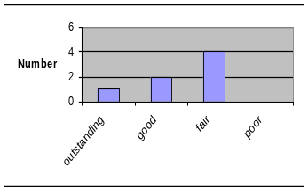Relevance to overall DOE/FCVT goals and ATD program objectives

This project received only two comments from the reviewers, who wrote “need more focus,” and “not obvious what is done here that is not already being studied at other national labs.”

Approach to solving problems and collecting data

The reviewers were disappointed with this project’s approach, particularly the lack of low T charging experiments. They wrote comments such as “no systematic approach,” and “low T performance must look at charging.”

They did agree that the low T issue should be looked at as a complete system and one reviewer thought the approach was appropriate.

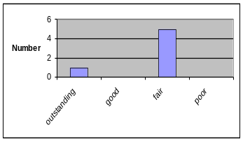
Technical Accomplishments and Collaboration are appropriate and timely

The reviewers were somewhat negative about this project’s accomplishments, writing “need stronger links to other labs,” and “would not … blame poor performance on the manufacturer,” and “conclusions appear self evident.”

However, some reviewers saw real value in the presented results, writing that the “poor low T performance of LiFePO₄ is a key finding,” and that the “techniques/interpretation seem well thought out,” and “conclusions appear very reasonable.”
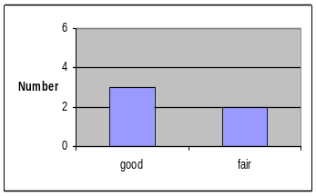

Approach to and Relevance of Proposed Future Research

Three reviewers provided comments here and they did not believe that bulk properties of the electrolyte were a key concern, but that “solvent ratio optimization and salt development are both appropriate research areas.”

Recommendations/Additions or deletions to the work scope, Strengths & Weaknesses

Reviewers were not convinced that the LiBoB work should be continued, particularly because its low T performance is poor. They were also frustrated that ARL did not know the electrolyte composition in the commercial cells.
Cell Packaging Evaluation, A. Jansen-- WS = 65.3, Rank = 19

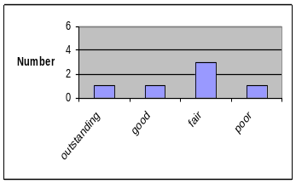Relevance to overall DOE/FCVT goals and ATD program objectives

The reviewers agreed that this work should come to an end, as planned by the program

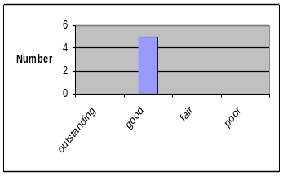Approach to solving problems and collecting data

The reviewers thought that this work was of high quality and was well thought out, providing a good understanding of the issues.

One reviewer wrote that we still need some electrolyte permeability measurements and should determine if electrolyte permeability also affects O₂, H₂O diffusion.

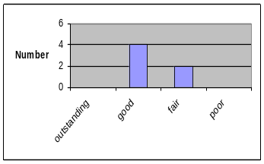
Technical Accomplishments and Collaboration are appropriate and timely

Only one reviewer commented here, writing “agree with conclusions, good work.”

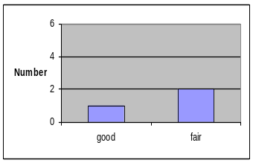
Approach to and Relevance of Proposed Future Research

No comments.

Recommendations/Additions or deletions to the work scope, Strengths & Weaknesses

One reviewer wrote that he agreed with the plan to complete this project, with no reflection on the PI, while another wrote that “if packaging is continued, suggest looking at electrolyte leakage/permeability.”
Cell Packaging Cost Study, A. Jansen -- WS = 64.9, Rank = 20

Relevance to overall DOE/FCVT goals and ATD program objectives

The two reviewers who provided a comment wrote “very relevant,” and “good to see other can/pouch designs being looked at, as they affects cost and energy density.”

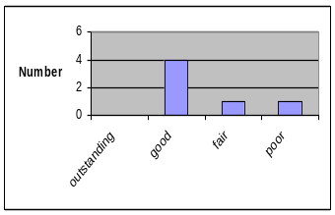
Approach to solving problems and collecting data

Only one reviewer commented here, writing “with due respect to PI – let developers with manufacturing capability cost out external materials.”

Technical Accomplishments and Collaboration are appropriate and timely
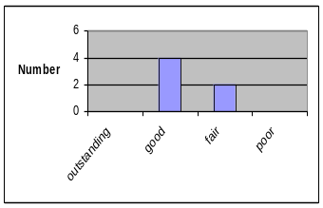
Two reviewers provided comments here, writing “good, would be great if we had prototype cells to test,” and “a good baseline study, useful for future considerations.”

Approach to and Relevance of Proposed Future Research

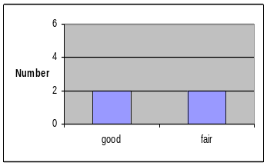One reviewer provided a comment here, writing “does cell case affect cycle life and such? Can we get some cells made for testing to determine viability of design?”

Recommendations/Additions or deletions to the work scope, Strengths & Weaknesses

No comments.

Additional Comments and Suggestions

In addition to the seven official reviewers, attendees were provided with review forms and encouraged to provide comments. Two did provide comments on the overall program and the individual projects. A brief summary of these comments is provided in this section.

Overall Program Evaluation
Focus areas | Should focus on separator contribution to cell behavior, specifically abuse tolerance and low T behavior.
Organization and Resources | Some of the work seems duplicative. Consider combining the low T performance, accelerated aging, modeling efforts, and diagnostics efforts into one coordinated effort to enhance communication and coordination.
Recommendations | Strongly recommend a consensus review.

Low Temperature Performance Characterization, A. Jansen
Relevance | Several battery developers have achieved good low T performance. They might provide more insight into the type of solvents to be used for low T. It is important that the study indicates two mechanisms. But it has not identified any clear cause and is hindered by poor differentiation between T and permanent performance effects.
Approach | Use of Li₄TiO is of questionable value. Failure to establish the ICL prevents any conclusion regarding plating characteristics.
Accomplishments | Collaboration with other national labs is good, but more is needed. No new info provided.
Future Research | Need to establish method to identify plating vs. interfacial effects.
Recommendations | Measure permanent capacity loss. Identify performance in presence of known low T electrolyte. Good work, but behind industry, need to collaborate with industry.  Strength - Area needs focus. Weakness - Study fails to take advantage of existing knowledge (PC is known poor performer).

Low Temperature Performance & Characterization, K. Gering

Approach | Jump start this effort by beginning with state of the art electrolytes being used by others. Re-evaluate use of SRPT profile. Not clear that viscosity is a key issue.
Accomplishments | Pace needs improvement, use more collaboration outside of program. Focus more on irreversible effects.
Future Research | Future work focuses on a new chemistry with incomplete starting information.

Low Temperature Electrolyte Modeling, K. Gering

Relevance | Good modeling, will contribute significantly.
Accomplishments | Significant progress.
Recommendations | Some manufacturers, like Lithion, have worked with JPL to place the Rovers on Mars. Need to utilize this expertise. (Note that interactions with JPL are ongoing).

Low Temperature Cell Performance Modeling, D. Dees
Relevance | Does shed light on reversible temp affects.
Approach | Need to feed results from modeling back into experimental side, don't see feedback. Should focus more on cycling behavior and not only discharge.

Accelerated Aging at INL, J. Christophersen

Approach | Impact of various DOD and temperatures should be further investigated.
Recommendations | Incorporate low T into cycle and calendar life studies.

Accelerated Aging at ANL, I. Bloom

Relevance | PI is looking at first principle mechanisms of failure for life. Very relevant.
Approach | Theories are interesting but unsupported. PI should focus on a complete explanation of the data.
Accomplishments | dVdQ offers unique view of aging process.
Future Research | Not convinced gen 2is fully characterized. It may be premature to move to gen 3.
Recommendations | Need to focus on determination of cathode effects. Does changing electrolyte affect anode SEI? Would use more difficult aging conditions. Strength - SEI theory has merit. Weakness - Data does not show that the anode effects are independent of the cathode.

Diagnostics at LBNL, F. McLarnon

Relevance | 300ppm of water is very unlikely. Even mfrs with poor cells typically achieve < 50ppm. Should use more realistic values.
Approach | Good. More work required to clarify the difference between normal SEI formation and reduction of impurity content.
Accomplishments | Best work to date on SEI composition.
Future Research | PI should further characterize the in-vitro electrolyte composition. Specifically analyze the wash from separator and anode.
Recommendations | Establish best case impurity content then repeat heat treatment. Strength - Very relevant, adds to knowledge.

Diagnostics at ANL, D. Abraham
Relevance | Light on technical details
Approach | Little new information. Could be less critical of others in program.
Future Research | Need more quantitative info on gen 2.
Recommendations | Surface film characteristics were not presented well. Since more work is planned here, I recommend reviewing papers from ECS (San Antonio, 2004) for in-situ characterization.

Electrochemical Cell Modeling, D. Dees

Recommendations | Need to work with the three layer separator used in most 18650 cells. This will play a strong role in the conductivity of the overall cell.

Advanced Chemistry 18650 Cells, G. Henriksen

Relevance | Recommend more fully evaluating gen 2.
Approach | Difficult to see how this will improve knowledge of any of the targeted areas.
Recommendations | Use 80% SOC for worse case scenario. Strength - Good characterization of initial material. Weakness - Poor understanding of characteristics. How will this build on gen 2 work?

TLVT Methodology Validation, V. Battaglia

Approach | The model proposed for use in the validation appears weak.
Accomplishments | Team appears to be prepared to move forward.
Recommendations | Use low T in calendar studies.

TLVT Reference Performance Test Studies, J. Christophersen

Relevance | Good support.
Recommendations | Should better investigate path dependence.

Cell Component Thermal Reactivity and Improvements, K. Amine

Relevance | Study may provide some insight into actual mechanisms.
Approach | Study should focus less on additives and electrolyte qualification.
Accomplishments | Collaboration with SNL is strong, but recommendations are not shown in context of overall performance and life of the cell.
Future Research | Refocus the efforts to explain basic reactions.
Recommendations | Branch out into other areas, such as variable temperature shut down separator, over discharge tolerant anodes, etc.

Cell Level Thermal Abuse Studies, P. Roth

Relevance | Modeling results provide good insight into basic mechanisms.
Approach | Study can provide a good method to confirm root cause hypothesis.
Recommendations | Need to include separator effects such as shutdown. And the model should be expanded to at least a short string condition.

Diagnostics – Thermal Abuse Related, D. Abraham

Relevance | Well coordinated with other lab efforts.
Approach | Needs more quantifiable surface analysis to characterize changes. Cannot rely on SEM to confirm separator change.
Accomplishments | Information regarding de-lithiation of anode appears to be very important.
Recommendations | Need to further characterize the anode reactions. Specifically include the de-lithiation reactions in the energy balance.

Diagnostics – Thermal Abuse Related, X.Q. Yang

Relevance | Excellent focus on 1st principle effects.
Approach | Need to duplicate the aged cell characterization using 1/3 material.
Accomplishments | Great deal of new and useful information.
Recommendations | Continue with structural characterization.

Overcharge Tolerance Studies, P. Roth

Relevance | Separator work is timely and can help to make data driven development decisions.
Approach | PI is coordinating well with ANL, the results of characterizing cells with plated anodes compliments the previous presentations.
Recommendations | Perform separator test with other solvent and salt combination. Perform overcharge with all cathode materials.

Advanced Electrolyte Development, R. Jow

Recommendations | The low T electrolyte effort should include separator effects. Do the proposed solvents elicit the same wettability and wicking characteristics?

Cell Packaging Evaluation, A. Jansen

Relevance | Little additional info required for material down select
Approach | Thorough system analysis.

Cell Packaging Cost Study, A. Jansen

Recommendations | Need to include effects of liquid cooling into cost analysis

Appendix A

Meeting Attendees

Meeting Attendees
DOE High Power Battery R&D Program
FY 2005 ATD Program Annual Review Meeting
Argonne National Laboratory
August 9 & 10, 2005
* = Reviewer

- Abraham, Daniel Argonne National Laboratory
- Alamgir, Mohamed* Compact Power
- Amine, Khalil Argonne National Laboratory
- Ang, Valerie The Aerospace Corporation
- Ashtiani, Cyrus DaimlerChrysler
- Babinec, Susan The Dow Chemical Company
- Barbarich, Thomas* Yardney Technical Products
- Barnes, James U.S. Department of Energy
- Barsukov, Igor Superior Graphite Company
- Battaglia, Vincent Lawrence Berkeley National Laboratory
- Belharouak, Ilias Argonne National Laboratory
- Bell, Anthony SK USA Inc.
- Blakemore, Bruce Ford Motor Company
- Bloom, Ira Argonne National Laboratory
- Bolomey, Pascal Ferro Corporation
- Borodin, Oleg University of Utah
- Brodd, Ralph* Broddarp of Nevada, Inc.
- Bugga, Ratnakumar Jet Propulsion Laboratory
- Busking, Sara Ann Argonne National Laboratory
- Carlson, Steven Optodot Corporation
- Casteel, William Air Products and Chemicals, Inc.
- Ceasar, Gerald U.S. Department of Commerce/NIST
- Chen, Zonghai Argonne National Laboratory
- Chiang, Yet-Ming Massachusetts Institute of Technology
- Christophersen, Jon Idaho National Laboratory
- Chu, Andrew A123 Systems, Inc.
- Cochran, Steven Cochran Consulting
- Cornell, Stephen Plastic Technology Partners
- Dees, Dennis Argonne National Laboratory
- Deng, Zhongyi Ferro Corporation
- Deppe, John DOE Consultant
- Dixon, Brian Phoenix Innovation, Inc.
- Doninger, Joseph Dontech Global, Inc.
- Doughty, Daniel Sandia National Laboratories
- Elliott, Brian TDA Research, Inc.
- Fan, Jiang GP Battery Technologies
- Farrell, Greg Optodot Corporation
- Fuentevilla, Daphne Naval Surface Warfare Center
- Fulop, Ric A123 Systems
- Gallego, Maritza Superior Graphite Company
- Gering, Kevin Idaho National Laboratory
- Gredlics, Michael Crown Packaging Technology
- Habib, Mohammad General Motors R&D Center
- Henriksen, Gary Argonne National Laboratory
- Henry, Francois-Xavier Superior Graphite Company
- Henry, Kent ADA Technologies, Inc.
- Hoerpel, Gerhard Degussa AG
- Horiba, Tatsuo Hitachi Vehicle Energy, Ltd.
- Hossain, Sohrab MER Corporation
- House, Evan Lithium Power Systems, Corp.
- Howell, David U.S. Department of Energy
- Jansen, Andrew Argonne National Laboratory
- Jeevarajan, Judith NASA-JSC
- Johnson, Christopher Argonne National Laboratory
- Jow, Richard Army Research Laboratory
- Kang, Sun-Ho Argonne National Laboratory
- Katiyar, Ram University of Puerto Rico
- Kawauchi, Shigehiro Argonne National Laboratory
- Kejha, Joseph Lithchem International
- Kepler, Keith Farasis Energy, Inc.
- Kodali, Satyanarayana U.S. Army/TACOM
- Kumar, Bijayendra Energetics, Inc.
- Laughton, David Superior Graphite Company
- Liu, Gao Lawrence Berkeley National Laboratory
- Liu, Jun Argonne National Laboratory
- Loutfy, Raouf MER Corporation
- Lu, Wenquan Argonne National Laboratory
- MacLean, Gregory MacLean Consulting
- Magnuson, Douglas Gold Peak Industries North America
- Mahy, Tyler CIA
- Marin, Fernando FMC Lithium
- McLarnon, Frank Lawrence Berkeley National Laboratory
- Mehall, Mark Ford Motor Company
- Miller, James Argonne National Laboratory
- Miller, Thomas NASA Glenn Research Center
- Moore, Gregory BST Systems, Inc.
- Moore, Stephen Lithium Power Systems
- Murphy, Timothy Idaho National Laboratory
- Newman, Aron Physical Sciences, Inc.
- Oh, Jeon Keun SK Corporation
- Olszewski, Mitchell Oak Ridge National Laboratory
- Onnerud, Per* TIAX, LLC
- Orens, Jeffrey Air Products and Chemicals, Inc.
- Park, Sang-Ho Argonne National Laboratory
- Pesaran, Ahmad National Renewable Energy Laboratory
- Raman, N. S.* Saft America, Inc.
- Roberts, David Air Products and Chemicals, Inc.
- Rogers, Jerry General Motors R&D Center
- Roth, Pete Sandia National Laboratories
- Schultz, Peter Argonne National Laboratory
- Shah, Pinakin Mine Safety Appliances Company
- Shi, Zhong Lithium Power Technologies, Inc.
- Sloan, Benjamin Optodot Corporation
- Smith, Grant University of Utah
- Smith, Novis Lithchem (Toxco)
- Snyder, Kent Ford Motor Company/USABC
- Spotnitz, Robert Battery Design LLC
- Stockel, Joseph* National Reconnaissance Office
- Symanski, James* Johnson Controls, Inc.
- Tarabocchia, John Degussa Corporation
- Tataria, Harshad General Motors
- Thackeray, Michael Argonne National Laboratory
- Thomas-Alyea, Karen TIAX LLC
- Tran, Thanh Naval Surface Warfare Center
- Vaughey, John Argonne National Laboratory
- Wang, Qingzheng Argonne National Laboratory
- Webber, Andrew* Energizer
- Weinstock, Irwin SENTECH, Inc.
- White, Ralph* University of South Carolina
- Yanagida, Katsunori Sanyo Energy (USA) Corporation
- Yang, Xiao-Qing Brookhaven National Laboratory
- Yoon, Won-Sub Brookhaven National Laboratory
- Zaleski, Peter Zaleski Consulting

Appendix B

ATD Program Review Forms

TITLE: XXXXX

PRINCIPAL INVESTIGATOR: XXXXX

Using the following criteria, please rate the work presented in the context of the ATD program objectives to help develop high-performance rechargeable batteries for use in HEVs.

Please provide specific comments to support your evaluation.
1. Relevance to overall DOE/FCVT goals and ATD program objectives. Does the project contribute to the attainment of ATD objectives? What else, if anything, might the project do to attain the appropriate objective?
4 - Outstanding. The project is sharply focused on key technical barriers to the development of advanced high power batteries. |  | Specific Comments:
3 - Good. Most aspects of the project will contribute to significant progress in overcoming key technical barriers |  | Specific Comments:
2 - Fair. Some aspects of the project may lead to progress but other aspects should be re-directed. |  | Specific Comments:
1 - Poor. The project is very unlikely to make significant contributions to overcoming the barriers. |  | Specific Comments:

2. Approach to solving problems and collecting data. Is the technical approach appropriate to address the barriers associated with this program area? Will the approach provide the data needed to further our understanding of the critical barriers?
4 - Outstanding. It is difficult for the approach to be improved significantly. |  | Specific Comments:
3 - Good. The approach is generally well thought out and effective, but could be improved in a few areas. |  | Specific Comments:
2 - Fair. The approach has some weaknesses that should be addressed. |  | Specific Comments:
1 - Poor. The approach is not appropriate to the program’s needs. |  | Specific Comments:

3. Technical Accomplishments and Collaboration are appropriate and timely. Are the pace of work and the overall accomplishments reasonable and are appropriate collaborations within and outside the program being utilized effectively?
4 - Outstanding. The project has made excellent progress and is cooperating with other labs very effectively. |  | Specific Comments:
3 - Good. The project has shown significant progress and is collaborating with other labs well. |  | Specific Comments:
2 - Fair. The project has shown only a modest amount of progress and could improve its collaborations. |  | Specific Comments:
1 - Poor. The project has demonstrated little or no progress. |  | Specific Comments:
4. Approach to and Relevance of Proposed Future Research
2 – Good. Future work plan builds on past progress and is appropriately focused. |  | Specific Comments:
1 - Fair. Future work plan could be improved. |  | Specific Comments:

Specific Strengths and Weaknesses

Recommendations/Additions or deletions to the work

PANEL V: ATD PROGRAM OVERALL EVALUATION

Using the following criteria, please rate the program in the context of DOE objectives. Please provide specific comments to support your evaluation.

1. Focus areas of the program are appropriate and comprehensive. Are there additional focus areas the program should address? Are any of the current focus areas not needed?

2. Organization and resources applied to each focus area, use of expertise and resources. Is the program organized in an efficient manner? Are the resources being allocated appropriately?

Recommendations/Additions or deletions to the Program (please use opposite side for comments if necessary)

Reviewer Name (Optional, but encouraged)

Low T investigations currently account for approximately 15% of the program’s effort.
Present cost studies are based on large quantities of materials (enough to supply 100,000 HEV batteries). In addition, the standard materials used in consumer batteries must be modified to work in high-power batteries.
The ATD program has decided that the abuse tests being done are valid on 18650 sized cells. The increased cost and danger of larger (5-10Ahr) cells recommended against using these.
The ATD program evaluated cell developers prior to the gen 1 and gen 2 cell build and has found its current supplier, Quallion, to be superior to all others.
Note that this has been done in a generic sense. Detailed specifications are chemistry specific.
The DOE regularly benchmarks commercial cells. The ATD program has refrained from studying commercial cells in the past because researchers do not know what chemistry, including additives, are in the cells.
The score for each project was calculated in the following manner. The raw score in each review category of a project, e.g., Σ(relevance scores), was multiplied by the total number of reviewers divided by the number who actually provided a score. Outstanding = 4, Good = 3, Fair = 2, and Poor = 1. Thus, if only 4 of 7 reviewers gave a score in the relevance category, the raw relevance score was multiplied by 7/4 to get the weighted score (WS). The weighted scores for each review area were then summed within each project to provide the total weighted score for the overall project. Total weighted score = WS (relevance) + WS (approach) + WS (accomplishments) + WS (plans), which is what is reported in the table above.
Note that the ATD program is planning to expand the diagnostics focus on the interface is 2006.
The ATD program will begin a focused SEI investigation in 2006.
Note that this is problematic in that researchers will not know the chemistry of these cells, or how they were manufactured. So drawing conclusions will be difficult.
Data of this nature were presented at previous reviews, although the results are still difficult to interpret.
The model has been used for this purpose.
The program evaluated alternative 1/3 materials from six different suppliers.
Note that the ATD program did qualify cell builders prior to the gen 1 and 2 cell builds.
ATD has developed a cell cost model, and this model has identified the spinel system as the lowest cost long-term system. But the 1/3 material was chosen as being lower cost system than gen 2, and providing safety improvements.
Most of the ATD data is available on a set of password protected websites.
Note that SNL performs full cell abuse testing.
SNL does not currently coat electrodes but indicated a desire to do so in its future plans.
The ATD program will repeat this experiment with an improved 1/3 cathode material.
The ATD researchers are investigating high voltage stability of separators, this work will be presented at future meetings.
A cost analysis has been performed on these systems in the past by ATD, but the data was not presented at this meeting.
Gen 2 has been thoroughly studied during the past four years by the ATD program.
Some such investigations have been reported on in the past.
The FCVT goal associated with energy storage is “Electric Drivetrain Energy Storage with 15-year life at 300 Wh with discharge power of 25 kW for 18 seconds and $20/kW.”
The ATD objective is to understand the factors that limit calendar life, abuse tolerance, and performance over the desired temperature range of high-power Li-ion cells so that improvements can be made in these three key areas, and to addresses cost at the cell level through the identification and/or development of lower-cost cell materials, components, and technologies. .

