REVERSE LANE STANDARDS AND ITS STRATEGIES

SOUTHEAST UNITED STATES HURRICANE STUDY

TECHNICAL MEMORANDUM NUMBER 1

Final Report

Prepared for:
U.S. Army Corps of Engineers
Federal Emergency Management Agency
United States Department of Transportation

Prepared by:
PBS&J
1901 Commonwealth Avenue
Tallahassee, Florida

June 2000

09-0855.10
TABLE OF CONTENTS

Page Number
List of Figures
List of Tables
1.0 Introduction 1-1
2.0 Traffic Conditions During Hurricane Floyd 2-1
2.1 Introduction 2-1
2.2 Florida 2-1
2.3 Georgia 2-4
2.4 South Carolina 2-5
2.5 Conclusions 2-9
3.0 User Needs 3-1
4.0 ITS Technology Review 4-1
4.1 Surveillance Systems 4-1
4.2 Traffic Information Dissemination 4-6
4.3 Freeway Control 4-12
4.4 Signal Control Systems 4-14
4.5 Traveler Information Systems 4-17
4.6 Navigation/Route Guidance Systems 4-18
4.7 Communications Between Field Devices And Control Centers 4-20
4.8 Incident Management Systems 4-22
4.9 Automated Vehicle Location Systems 4-23
4.10 Computer Aided Dispatching 4-24
5.0 Review Of ITS Legacy Systems And Existing Evacuation Strategies 5-1
5.1 ITS Applications And Systems 5-1
5.2 Reverse Lane Evacuation Strategies, Plans And Supporting Activities 5-9
6.0 Design Guidelines And Operational Components Of One Way Evacuation Operations 6-1
6.1 Introduction 6-1
6.2 Definition Of Strategies 6-1
6.3 Impacts Of Alternatives 6-2
TABLE OF CONTENTS (CONT.)

6.4 Selection Of Strategy 6-17
6.5 Operation Of Selected Strategy 6-20
7.0 Implementation Recommendations 7-1
7.1 General 7-1
7.2 One Way Operations 7-1
7.3 Operation Of Selected Strategy 7-11
7.4 ITS Applications - Identification Of Early Deployment 7-12
7.5 General Recommendations 7-19
7.6 Recommendations – Florida 7-24
7.7 Recommendations - Georgia 7-29
7.8 Recommendations - North Carolina 7-33
7.9 Recommendations - South Carolina 7-36
Appendix A-1
List Of Abbreviations A-2
Florida Traffic Counts A-5
Georgia Traffic Counts A-17
South Carolina Traffic Counts A-20
Meeting Minutes A-27

LIST OF FIGURES

Figure Number Title Page Number
5-1 Florida Trumpet Interchange Layout 5-12
5-2 Florida One-Way Plan 5-16
5-3 Georgia One-Way Plan 5-19
5-4 North Carolina One-Way Plan 5-23
5-5 South Carolina One-Way Plan 5-27
7-1 Evacuation Events Timetable 7-9
7-2 Florida ITS Recommendations 7-27
7-3 Georgia ITS Recommendations 7-32
7-4 North Carolina ITS Recommendations 7-35
7-5 South Carolina ITS Recommendations 7-39
LIST OF TABLES

Table Number Title Page Number
6-1 Alternative Strategies Impacts and Benefits 6-20
7-1 Florida ITS Recommendations 7-28
7-2 Georgia ITS Recommendations 7-33
7-3 North Carolina ITS Recommendations 7-36
7-4 South Carolina ITS Recommendations 7-40

1.0 INTRODUCTION

In September of 1999, Hurricane Floyd skirted the Southeast Coast of the United States and made landfall in eastern North Carolina. During the storm’s life, an estimated 3 million people evacuated from their homes in the states of Florida, Georgia, South Carolina and North Carolina. This storm occurred two weeks after Hurricane Dennis made landfall in eastern North Carolina. Hurricane Dennis saturated the ground before Hurricane Floyd struck. This resulted in unprecedented flooding in that part of the state. Hurricane Floyd was a Category 4 storm that closely followed the path of Hurricane Hugo in 1989, until 2 days before it made landfall. For these and many other reasons, the affected population took this storm more seriously than past storms.

Consequently, officials in the affected areas witnessed record congestion problems. For example, the trip on I-26 from Charleston to Columbia, S.C. normally takes approximately two hours. Reports of 16-18 hour travel times were commonplace. The normal trip time from Savannah to I-95, which is a half hour drive, took 3 hours. Evacuees traveling westbound from Jacksonville, Florida experienced travel times of seven hours per 35 miles.

The unusual circumstances that surrounded this event, a very active storm season and very high water levels encountered only two weeks prior to Hurricane Floyd, presented unexpected problems for the public agencies responsible for evacuating affected areas. The agencies were better equipped to deal with Floyd than previous hurricanes. They mobilized and pre-positioned personnel and equipment in anticipation of landfall. The public, responding at an unusually high rate to the evacuation warnings, created unanticipated and unprecedented congestion. Elected officials and the public were not aware of the dynamics involved and voiced some dissatisfaction with the management of the traffic congestion. They also felt that management agencies could have provided more information to the public. The impact of Floyd on the transportation system offered transportation officials a window to identify some areas for improvement. While there have been public complaints about the evacuation process, the evacuations in all states accomplished their primary purposes:

- Evacuees from the vulnerable areas of each state evacuated before the damaging weather arrived.

- The evacuation occurred without loss of life.

According to FHWA statistics, 3,600 people move to the coasts. This equates to 1,314,000 people per year. In addition, the baby boomer generation is aging and starting to retire. The coastal areas are particularly affected as they becomes less a seasonal population and more permanent population. With the present rates of growth along the Atlantic and Gulf coasts, it would not be practical to construct a roadway network with the capacity necessary to evacuate the number of people that evacuated during Floyd. Public agencies need other strategies to manage evacuation traffic and resulting congestion during such large storms.

In October 1999, the U. S. Army Corps of Engineers contracted PBS&J to “conduct studies to determine the nature and causes of the transportation problems encountered during the evacuation”. The Corps of Engineers also charged PBS&J with “developing specific recommendations and tools to assist the emergency management community to reduce or eliminate transportation problems in the future”, in the four southeastern states of Florida, Georgia, South Carolina and North Carolina.

The purpose of this report is to develop two specific tools to assist transportation officials in the management of the hurricane evacuation planning process. The tools include:

- Strategies to transpose “coast-bound” lanes of travel to the direction of evacuating traffic on controlled access facilities, such as the Interstate Highways; and

- Intelligent Transportation System (ITS) applications that will better manage existing roadway capacity, manage traffic congestion and provide more information to the affected public.

- The use of an Intelligent Transportation System (ITS) involves the use or application of technology to improve the efficiency and safety of transportation systems. This includes transporting people and freight using the modes of car, truck, bus, rail, air and water.

As the project developed, it was determined that many of the technology recommendations developed by the states or PBS&J were not purely ITS applications. Therefore, we expanded the second part of our scope to include these non-ITS applications of technology.

We are grateful for the cooperation and assistance of the state and federal agencies. Personnel from these agencies conceived many of the recommendations presented in this report.

2.0 TRAFFIC CONDITIONS DURING HURRICANE FLOYD

2.1 INTRODUCTION

The states of Florida, Georgia and South Carolina began collecting traffic counts before the evacuation and continued throughout the reentry period. The respective DOT’s collected the counts with both permanent traffic counting equipment and portable traffic counters. SCDOT and GDOT personnel made some sample manual counts during the evacuation process. These counts were directional volume counts only. Without speed data, there are unexplainable peaks and drops in the count data that are partially attributable to the high congestion. Based upon the count data alone, it is not exactly clear when the congestion eased or the traffic volumes dropped. We have summarized the traffic counts below.

2.2 FLORIDA

Florida Department of Transportation personnel collected traffic counts on I-10, I-75, I-95, S.R. 528 and the Florida Turnpike, among other roadways during Hurricane Floyd. FDOT polled permanent count stations and made sample counts. FDOT personnel plotted the counts against the yearly average. Evacuations began in South Florida on September 13 at 4:00P.M, and continued into September 14 in Duval County, with the voluntary evacuation order given at 10:00 A.M.

I-10

On September 13, westbound traffic on I-10 in Baldwin County, west of Jacksonville, jumped to a peak of 2,400 vehicles per hour (vph), a figure equivalent to 133% of the normal traffic volume
on that roadway segment.

The westbound traffic volumes rose to a high of 3,200 vph on September 14. Westbound traffic volumes returned to near normal conditions by September 16. Eastbound traffic, during reentry on September 15, rose as high as the westbound traffic during evacuation on September 13. The reentry counts showed sharp drops each day between 6:00 P.M. and 6:00 A.M. Complete count data was not available further west on I-10.

I-75

FDOT collected some sample counts on I-75 in Hamilton County, south of the Georgia state line, on September 16. The southbound volumes were half of the normal volumes. The peak 9northbound volumes (2,200 vph) were 176% of the normal peak volumes (1,250 vph.)

I-95

FDOT polled permanent count stations at four locations along I-95 during the storm, between the dates of September 13 and 17th. Those locations are in St. Lucie County, Flagler County, south of St. Augustine, Duval County, south of I-295 on the south side of Jacksonville and Nassau County, two miles south of the Georgia state line.

At the St. Lucie site, the level of northbound traffic rose to 136% (1,550 vph) of the normal level on September 13, at 2:00 P.M. Traffic returned to normal conditions by the afternoon of September 16. The southbound reentry traffic remained below average throughout the afternoon of September 17.

In Flagler County, the northbound traffic was much higher and peaked on both September 13th and 14th at 2,300 vph, or 177% of normal conditions. Traffic remained very high all day for those two days. The expected nighttime drop in traffic between 6:00 P.M. and 6:00 A.M. was 64% of the normal P.M. peak hourly traffic for the day. The southbound traffic rose 15% above normal during the September 13 evacuation. However, the southbound reentry traffic volumes did not rise above normal conditions.

Complete count data was unavailable for the site south of I-295. Count data was collected during the evacuation period, which began at 10:00 A.M. on September 14, and the count peaked at 2,300 vph, or 177% of normal conditions. The southbound traffic counts jumped up on September 14 at noon, by 5% over the peak hourly rate. The southbound counts remained at or below normal conditions, except for a short increase of 13% in mid-afternoon on September 16.

At the Nassau County count station, the northbound traffic rose 40% on September 13 to 1,750 vph and to 200% or 2,400 vph on September 14. The amount of the increase was almost equal to the increase at the site south of I-295. This could indicate that there was little route diversion to I-10, or simply that more traffic from north Jacksonville replaced the traffic that was diverted to I-10. The latter is more likely the case. The southbound volumes remained far below normal throughout the week, including through reentry.

Florida’s Turnpike

FDOT collected count data from sites in Broward, Palm Beach and St. Lucie Counties. FDOT suspended toll collections on September 14, and resumed operations on September 16, for the area south of West Palm Beach. Toll collections resumed on September 17, for the area north of West Palm Beach.

At the Broward site, traffic volumes remained well below normal during evacuation and increased slightly by 12% in both directions during reentry. At this location, the roadway appeared to be underutilized.

On September 13, the northbound traffic jumped 246% to 1,600 vph, at the Palm Beach site. During reentry, northbound traffic remained near normal levels. The southbound traffic spiked much higher and dropped much more sharply. On September 13, 15 and 16, the southbound counts peaked at 146% (950 vph), 141% (920 vph) and 130% (830 vph), respectively, above normal conditions. Interestingly, the nighttime drops were sharper and longer than normal.

Traffic county data at the St. Lucie site was not available before September 14. The northbound traffic on September 14 jumped 375% to 1,400 vph. The traffic volume dropped just as sharply in the evening, and remained well below average until September 16. Similarly, the southbound traffic volumes during reentry on September 15 also jumped 443% to 1,775 vph, within four hours, and then experienced a similarly rapid reduction in volume that evening. The traffic volumes through the night of September 15 and during September 16 remained at 150% to 200% above normal.

S.R. 528 (Bee Line Expressway)

The Bee Line Expressway serves as a major evacuation route from the Brevard County area. This route includes the cities of Melbourne, Cape Canaveral and Cocoa Beach, among others. Brevard County issued the mandatory evacuation of the barrier islands of Brevard County at 4:00 P.M. on September 13.

There are two count stations along S.R. 528. One is west of the Brevard-Orange County Line, and the other is approximately 8 miles further west, and west of U.S. 441/S.R. 5. The westbound traffic at the eastern site jumped very quickly, and peaked one hour after the mandatory evacuation. The increase was 310% of normal traffic or 2,800 vph. Traffic volumes dropped sharply, beginning at 11:00 P.M. on September 13, but remained very high during the night. The westbound traffic volumes peaked higher on September 14 with 3,000 vph, or 250% of the normal traffic volume for the same period. Traffic volumes experienced a near vertical drop at 3:00 P.M. on September 14, going from 2,400 vph to 350 vph by 5:00 P.M. At 1:00 PM on September 13, the eastbound traffic rose 198%. It is likely this eastbound movement consisted of people leaving work early in Orlando to prepare for evacuation. After this movement subsided, eastbound traffic volumes remained very low through 7:00 A.M. on September 15.

Traffic counts at the site west of U.S. 441, were considerably higher than the more eastern site. This result was most likely due to evacuating traffic traveling on U.S. 441 from Vero Beach. Traffic at this count station peaked on September 13 at 9:00 A.M. at 133%, or 2,950 vph, and then peaked again at 233%, or 2,100 vph, at 5:00 P.M. Traffic peaked even higher on September 14 at 9:00 A.M. at 141%, or 3,400 vph.

2.3 GEORGIA

GDOT collected counts at two permanent count stations on I-95 and I-16. The State initiated the one-way plan on I-16 from Savannah to U.S. 1 on September 14 at 3:00 PM, and continued the one-way operation until 6:00 A.M. on September 15. During this period, the evacuation from Florida was already underway.

I-95

The I-95 count station is located near the town of Midway. The traffic volumes on I-95 rose sharply from 6:00 A.M. to 12:00 P.M., and started to drop at 3:00 P.M. The peak hourly volume was 2,200 vph. This volume was 185% of the average weekday volume. The daily northbound volume was also 185% of the average weekday volume. It is unclear whether the drop in traffic was due to increased congestion, or the opening of the one-way operation. The daily northbound traffic volumes between September 15 and September 17 ranged from 14% to 84% of the average weekday volume. As expected, the southbound traffic volumes dropped between September 14 and September 17. On September 16, the southbound daily traffic volume was 16% of the average weekday volume.

I-16

The I-16 count station is located near the town of Dublin. Unfortunately, this count station is west of the original limits of the one-way operation. On September 14, the westbound daily traffic soared to 468%, or 42,275 vehicles per day (vpd), of the average weekday volume. The count remained very high on the morning of September 15 at 196% of the average weekday volume, but dropped quickly after 9:00 A.M.

The eastbound traffic volumes on I-16 dropped to 61% of the average weekday volume on September 14. The highest hourly volume was 423 vph. On September 16, traffic volumes during reentry jumped to 34,675 vpd or, 380%, of the average weekday volume and peaked at 2,742 vph in two lanes. This increase was followed by 21,550 vpd, or a 136% increase over the average weekday volume on September 17.

2.4 SOUTH CAROLINA

During evacuation and reentry, SCDOT continuously polled the permanent counters to view developing trends of the counts. SCDOT also placed some portable counters on non-Interstate facilities. SCDOT has six permanent traffic count stations on Interstates 26, 526, 95 and 20. SCDOT personnel plotted the counts collected during the week of the hurricane against data collected the week before, comparing data to reveal trends in traffic volumes.

I-20

This Interstate is an east-west facility that runs from I-95 in Florence, through Columbia to Augusta, Georgia. Count Station 42, located west of Florence, experienced very high westbound volumes. The westbound 24-hour count on September 14, 1999, was 233%, or 20,200 vpd, of the previous week. The counter showed no westbound volume until 10:00 A.M., when it registered an immediate and rapid increase. The westbound count peaked that day at 5:00 P.M. at 1,806 vph or 903 vph/lane. As expected, the counts dropped off rapidly between midnight and 7:00 A.M. on September 15. On September 15, the westbound count peaked at 1,974 vph, or 989 vph/lane. By 5:00 P.M., the volume dropped below counts for a normal weekday from the previous week.

The counts on I-20 indicate the roadway was underutilized, since the counts never reached the roadway capacity of 3,000 vph in one direction. It is reasonable to assume the behavioral response may have been lower in the northern part of the state than the southern part.

I-26

There are two permanent count stations on I-26. Count Station 20 is between Columbia and I-95, near the Town of Bowman. Count Station 31 is west of S.C. 642, between I-95 and Charleston. The voluntary order to evacuate the Charleston area was effective at 7:00 A.M. on September 14. The mandatory order followed at 12:00 P.M. Traffic was one-wayed westbound from Charleston to I-95 at 9:30 P.M. on September 14. Conversely, traffic was one-wayed eastbound from I-77 to Charleston on September 17 at 10:00 A.M.

At Count Station 31, on September 14, the traffic rose sharply and peaked at 10:00 a.m. with 4,500 vph, indicating that the count virtually doubled from the previous week. Beginning at 10:00 A.M., traffic volumes decreased steadily over two hours to 1,300 vph. This decrease seemed to be indicative of heavy congestion slowing traffic over the counter and reducing the traffic count. During the evening hours, traffic volumes wavered between 250 and 1,100 vph. The daily traffic on September 14 was 25,270 vpd, or 60% of the daily traffic observed during the previous week. Westbound traffic volumes remained well below normal through September 17.

The eastbound counts closely match those in the westbound direction. Eastbound traffic levels bottomed out by 10:00 P.M. at less than 10 vph on September 14. Traffic remained at very low levels through September 16. The eastbound traffic counter did not register any traffic counts during the westbound one-way operation. This counter is an older ATR model than can only count in one direction. The SCDOT would need to change the wiring to allow for counts in the opposite direction.

At Count Station 20, westbound traffic peaked on September 14, concurrently with traffic at Station 31, even though Station 20 is further west. At Station 20, the westbound counts remained high and the daily total was 44,924 vpd, or 297% of daily totals from the previous week. The traffic volumes fluctuated by 700 vph, but remained well above normal levels, through 12:00 P.M. on September 15. During the eastbound reentry, the westbound counter recorded no volume.

During the one-way eastbound reentry, traffic volumes on the eastbound lanes peaked at 4163 vph and stayed within the range of 3,800 to 4,000 vph for eight hours. This measurement equates to 2,000 vph per lane. Traffic volumes dropped quickly after 8:00 P.M. The daily volume for the eastbound lanes was 322% of the daily volume for the previous week. Traffic remained high at 35,900 vpd, or 175% of the daily volume for the previous week, through September 17.

Traffic counts on I-26 show the potential of what a successful one-way operation can accomplish. During the westbound evacuation, the maximum volume per lane was 1,445 vph. The westbound evacuation was heavily congested with lengthy delays. SCDOT and Highway Patrol (SCHP) personnel confirmed the traffic flowed very smoothly during eastbound reentry. The eastbound maximum per lane volume was 2,082 vph.

I-526

I-526 is a loop Interstate around the Charleston urban area. It currently extends from U.S. 17 in Mount Pleasant, counterclockwise across the Wando, Cooper and Ashley Rivers to U.S. 17, west of Charleston. Count station 46 is located between I-26 and Mount Pleasant. Eastbound traffic traveling toward Mount Pleasant dropped to nearly zero by 11:00 P.M. on September 14. Eastbound traffic volumes on September 14 were 85% of volumes from the previous week. Traffic returned to near normal levels, 80%, by September 17, without the typical sharp A.M. and P.M. peak hour volumes. The westbound traffic on September 14 dropped sharply after the first hour of the A.M. peak hourly traffic. Traffic volumes rebounded slightly at 10:00 A.M., and then dropped quickly, with some erratic jumps through the day until midnight. Based upon observations of traffic, the heavy congestion, and the difficulty of merging onto I-26 could account for the sudden drops in traffic counts.

I-95

I-95 runs parallel to the coast and is located 15 miles inland near the Georgia State Line and upwards of 60 miles inland elsewhere in South Carolina. The entire route does not serve as a primary evacuation route, since it only carries traffic parallel to the coast. Evacuating traffic uses small sections of I-95 to connect to westbound evacuation routes, particularly in the Hilton Head area.

Count Station 28 is between the Georgia State Line and I-26. The mandatory evacuation of Chatham County, Georgia was issued effective September 14 at 7:00 A.M. The voluntary order to evacuate the coastal counties of South Carolina was effective at 10:00 AM with a mandatory evacuation effective at 12:00 P.M.

Northbound traffic for September 14 was 27,200 vpd, or 160% of the volumes from the previous week. Traffic levels peaked at 11:00A.M. at 1,919 vph. Traffic remained well above average until 11:00 P.M. Traffic essentially dropped to zero on September 15 for the entire day. The traffic flow was essentially back to normal by 2:00 P.M. on September 16, with 87% of the levels from the week before.

Southbound traffic at Count Station 28 increased by 23% to 18,000 vpd on September 13. The peaking pattern matched the previous week. There was a more pronounced increase of the counts to a higher peak in the northbound direction on September 14. Volumes peaked at 2:00 P.M. at 2,244 vph. The daily volume was 25,400 vpd, or 145% over the daily volumes in the previous week. Traffic did not drop to levels equal to the previous week, until midnight. Traffic volumes were at 30% of normal on September 15.

While counts at station 28 were much higher than in the preceding week, they remained below capacity. This does not mean I-95 was underutilized. The results do indicate that due to I-95’s orientation, it is not as critical a link as the east-west routes.

Count station 19 on I-95 is northbound between the Cities of Manning (northeast of I-26) and Florence. The counts at that location on September 14 were 129% (5,222 vehicles per day) of the counts from the previous week. For the next two days, the northbound daily count was 54% (2172 vehicle per day) of the daily average of the previous week. The counts did not peak sharply, but rather, showed gradual increases. Similar to I-20, it would appear that this section of I-95 was underutilized, since the counts did not drop suddenly, indicating a possible congestion problem.

A significant number of evacuees were diverted to I-26 to move inland and seek shelter. This diversion considerably reduced traffic on I-95 north of I-26: however, this diversion of traffic further magnified the congestion on I-26. In the future, SCHP will have a field commander stationed at the interchange to make any decisions to shut down the ramps between the two Interstates.

2.5 CONCLUSIONS

There are a number of general observations that one can make about the count data. They are:

- The daily traffic count totals confirmed and supported the reported congestion problems.

- If one analyzed the counts, using the Highway Capacity Manual software, it would appear the level of service should be good, and at least level of service C in some cases. Visual observations by DOT personnel and law enforcement agencies indicated the levels of service were much lower. This would indicate the counts were capacity constrained and did not reflect the true demand that was delayed by congested roads.

- Generally, the changes in traffic volumes during reentry were generally not as sharp or as high as that during evacuation. This is expected.

- An invaluable source in future storms would be the collection of vehicle classification and speed data. These data would allow engineers to determine the cause of the fluctuations in traffic due to heavy congestion, versus those associated purely with changes in volume. Engineers could better assess the level of service, or how well traffic flowed.

- Some traffic counters were not designed for counting two ways, when the one-way operation was in effect. DOT personnel have to change the wiring on “ATR” models to count in the opposite direction.

- Additional count stations are needed to provide a better understanding of some types of traffic movements.

- The polling of the permanent count stations and the collection of sample counts manually, can provide leading indicators or trends of developing problems.

- The highest per lane volumes were between 1,500-1,650 vph. Beyond that level, it appears based upon reported events that the traffic flow broke down.

- The counts collected on I-26 during the one-way reentry demonstrate the potential capacity for reentry. By all accounts, the one-way reentry worked very well with minimal incidents.

3.0 USER NEEDS

PBS&J, with assistance from the Federal Highway Administration (FHWA), conducted interviews with the stakeholders in the four states. These interviews, supplemented with telephone calls to follow up, served to define the status of present and past hurricane planning and ITS applications, and to define the agencies’ future developments. The interviews were excellent debriefings of what worked well and what did not. We conducted the interviews as opportunities for the stakeholders to express their own assessments of their hurricane evacuation processes. Nevertheless, most importantly, these interviews were used to identify their respective needs. The personnel from the Departments of Transportation included senior management, traffic engineering, maintenance and operations staff. The highway patrol personnel included field personnel directly involved in the evacuation, including communications and senior management personnel. The following agencies were interviewed:

Florida
Department of Transportation (FDOT)
Department of Law Enforcement (FDLE)
Department of Community Affairs (Emergency Management Division) (DCA)
Florida Highway Patrol (FHP)

Georgia
Department of Transportation (GDOT)
Georgia State Patrol (GSP)
Georgia Emergency Management Agency (GEMA)

North Carolina
Department of Transportation (NCDOT)
State Highway Patrol (NCSHP)

South Carolina
Department of Transportation (SCDOT)
Highway Patrol (SCHP)

The results of those meetings are documented in Appendix B. From these interviews, we have determined that there are multiple users with various needs. The three users identified are: evacuation personnel (transportation officials, law enforcement officials, and emergency management agency officials at state, county, and local levels); evacuees (residents and tourists); and the media. However, we also recognize that the needs of evacuees and the media are very similar. Therefore, we have categorized user needs into two groups.

First, the needs identified for evacuation personnel to address:

- Planning sessions at the multi-county and multi-state levels;

- Better coordination between various evacuation agencies (such as transportation, law enforcement, and emergency management agencies) at the local, county, multi-county, and multi-state levels during an emergency;

- More convenient tools to communicate with each other;

- More convenient tools to communicate with the public;

- Timely information at all levels concerning road closures, road conditions, weather, expected travel times, incidents, lane closures, and availability of alternative routes;

- Capacity of evacuation routes, increased and efficiently utilized to reduce the potential for operational failures during evacuation;

- Capacity of local streets that provide access to and from evacuation routes, increased and efficiently utilized to prevent bottlenecks at evacuation route access points;

- Evacuation route designs examined and modified, if necessary, to accommodate evacuation management strategies;

- Methods and strategies to maximize the efficiency of detecting, responding to and clearing incidents on evacuation routes;

- Policies regarding the lifting of toll fees;

- Data collected and archived for the development of future evacuation plans and to ensure the validation of models used in developing plans; and

- Evacuation strategies that reduce the time required for implementation, due to the short time period available for evacuation.

Evacuees and the media have a different set of needs identified below; these needs primarily refer to the subject of information.

- Timely and accurate information regarding evacuation route conditions, including expected travel time to destinations, incidents, road closures, lane closures, weather, the route to a certain destination, and the availability of alternative routes, taking into consideration that travelers may be tourists;

- Timely and accurate information regarding services available at the evacuation destinations and along evacuation routes, taking into consideration that travelers may be tourists;

- Timely and accurate information regarding the conditions expected at their selected destination (shelters, hotels or private homes), taking into consideration that travelers may be tourists;

- Timely and accurate information regarding alternative evacuation destinations to evacuees that request this information, taking into consideration that travelers may be tourists; and

- Timely and accurate information to evacuees at evacuation destinations, regarding conditions at home.

4.0 ITS TECHNOLOGY REVIEW

The purpose of this section is to introduce Intelligent Transportation System (ITS) technologies that are candidates for deployment on evacuation routes. The section also presents a discussion of the applications of these technologies to the evacuation process.

4.1 SURVEILLANCE SYSTEMS

The successful deployment of ITS applications depends on reliable and accurate data on traffic conditions in the transportation network, in as close to real-time as possible. Network surveillance systems provide the required data. In general, network surveillance can be classified as traffic detection systems, CCTV cameras and environmental detectors. The communication systems between the field devices and traffic management centers are discussed in Section 4.7.

DETECTION SYSTEMS

Detection systems collect various traffic parameters that are used by advanced freeway and surface street traffic management, advanced traveler information and other ITS functions. These parameters include occupancy, volume, vehicle classification, queue length and speed.

During the evacuation process, detection systems can be used to:

- Provide automatic detection of incidents;

- Provide data to support the implementation of various control strategies;

- Monitor traffic trends during the evacuation process;

- Provide data necessary for traveler information systems; and

- Provide historical data for planning future evacuations.

Traditionally, inductance loop detectors have been the predominant type of detector used. Loop detectors have several advantages compared to other technologies, including their mature technology and accuracy in measuring traffic flow. The main disadvantage of loop detectors; however, is the difficulty of installation and maintenance without disrupting traffic flow. Loop detectors can also require frequent maintenance and repairs, resulting in an increase in their life-cycle costs.

Several non-intrusive technologies have been used for traffic detection, to overcome the problems associated with loop detectors. These technologies include passive infrared, active infrared, true presence microwave, Doppler microwave, passive acoustic, pulse ultrasonic and video image processing. These technologies vary in their capabilities and cost.

Criteria that may be used to compare traffic detector performance include accuracy, environmental susceptibility, reliability, functionality, maturity, ease of installation and calibration, potential disturbance to traffic during installation and maintenance, susceptibility to construction activities (if such activities are planned) and the type of communication medium available/required.

The capability to detect traffic accurately during adverse weather conditions is of particular importance to the hurricane evacuation process. In addition, if reversible lane or shoulder-use strategies are to be implemented, the selected technology should be capable of detecting traffic on the reversed lanes and/or shoulders, if used. This is important because some detection technologies need to be installed facing traffic. Such technologies might not be appropriate for reversible lane operations. In addition, if the detection technology is to be used to enforce reversible lane operations by detecting violators, then a detection technology that allows the detection of wrong way traffic might be used.

The capital and life cycle costs of detection vary significantly, depending on the selected technology/device. When comparing costs between technologies, both the unit cost as well as the number of units required should be considered. In addition, capital, operation and maintenance costs must be considered.

Closed Circuit Television (CCTV) Cameras

CCTV is an important component of transportation network surveillance. CCTV cameras can be used to:

- Verify congestion or incidents detected by system sensors;

- Obtain more information such as the location, cause and nature of the incident and congestion in order to respond appropriately and more quickly;

- Verify that the incident or congestion has cleared;

- Monitor evacuation route operation, including operation of Dynamic Message Signs (DMS) and driver responses to DMS and Highway Advisory Radio (HAR) messages;

- Monitor ramp metering operations, if used;

- Monitor local streets that provide access to and from the evacuation routes; and

- Assess impact of hazardous objects and the degree of flooding on the road.

CCTV systems consist of video camera units, mounting structures, controller cabinets housing the control equipment, communication system connecting cameras to control centers, video monitors and camera controls located at the control centers.

With the explosive growth of video cameras in the private consumer market, the CCTV camera technology is being advanced significantly on a regular basis. Most major CCTV vendors have introduced Digital Signal Processing (DSP) cameras. DSP cameras offer several advantages over their analog counterparts, including electronic zoom, potential improvement in image quality, reduction in size and weight, image stabilization, reduction in power and potential improvement in reliability. CCTV camera technology is continuously changing, with new advancements occurring over short periods.
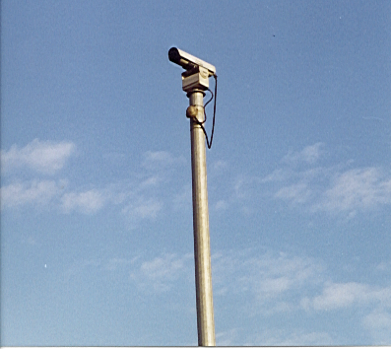
One important decision in selecting a CCTV camera involves whether to use color or black-and-white cameras. Black-and-white cameras generally have higher resolution than color cameras. In addition, black and white cameras have better low-light performance than color cameras, which makes them better cameras in locations where there is a lack of highway lighting. On the other hand, color camera images are more pleasing and allow a sharper depiction of individual vehicles, if such a description is needed for the ITS application.

For freeway applications, it is necessary to use zoom lengths that provide a wide angle of view to view all lanes (and shoulders) in both directions at close ranges. The zoom lengths must also allow for zooming in on a location up to at least half-mile a way. The lens must also work in low-light conditions.

CCTV camera enclosures are used to protect the camera from environmental conditions. Sealed and pressurized camera housings are normally used for ITS applications. Camera enclosure units come with a sunshield and waterproof seal to protect the camera and lens assembly from moisture.

CCTV camera locations on evacuation routes should be selected to provide views of evacuation routes, adjacent street operations, on-ramp operations and off-ramp operations at major access points to the evacuation routes. If possible, the locations should be selected to provide views of DMS's for message verification. The CCTV cameras must be located and mounted to reduce the effects of the severe environmental conditions of a storm, such as wind and rain.

Portable CCTV cameras can also be used, in addition to permanent CCTV camera installations. Portable systems are typically mounted on a light truck, van or on a trailer. These systems should include portable power sources.

The cost of the CCTV camera itself, including the zoom lens, pan/tilt unit, camera control receiver and environmental enclosure, costs approximately $5,000. However, the cost of the poles required for camera mounting, around $8,000, and the cost of video transmission (depending on the selected technology) can be high.

Environmental Detectors

Environmental detectors can be used to detect adverse weather and pavement conditions. Categories of environmental sensors that could be useful for evacuation route monitoring include:

- Road condition sensors which measure wetness or dryness;

- Sensors that measure rainfall amounts and gauge rising water; and

- Sensors that detect the presence of heavy rain or high wind.

Several environmental detection systems are available commercially. Information from these sensors could be used to decide whether or not to close the road. The information could also be disseminated to travelers and used in incident detection algorithms.

Aerial Surveillance

Aerial surveillance systems use fleets of aircraft, such as helicopters and small planes, equipped with video cameras to identify and report incidents and congestion.

The advantages of these systems include:

- They can cover a large area;

- They can identify and verify incidents with the aid of video images; and

- They can help obtain information concerning traffic conditions, not only on the primary evacuation routes, but also on other roadways for possible traffic diversion, and on the access to and from evacuation routes.
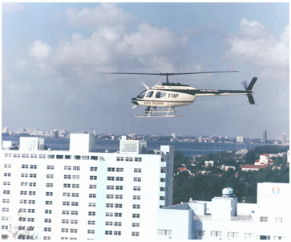
One disadvantage of these systems is their high capital and operating costs, particularly when the goal is to provide full coverage of a large area for long periods. Time of detection is obviously a function of aircraft headway. In addition, the operation of these systems can be affected by severe weather conditions.

Probe Surveillance

Probe surveillance provides an alternative approach for surveillance of the roadway network. Vehicles acting as probes can provide information on each link traversed. This information can be transmitted to a central computer, where it can be used to determine the traffic conditions in the network including link speeds, link travel times and origin-destination of vehicles. Emerging technologies that use vehicles as probes include automatic vehicle identification (probably using the equipment that is used for electronic toll collection), automatic vehicle location identification and cellular telephone probes.

4.2 TRAFFIC INFORMATION DISSEMINATION

Traffic information dissemination allows traffic information to be disseminated using roadway equipment like DMS's or HAR. The emphasis is on the provision of basic traffic information or other advisories that require minimal or no add-on in-vehicle equipment to receive the information. Careful placement of the roadway equipment provides the information at points in the network where the drivers have a recourse, and can tailor their routes to account for the new information.

Dynamic Message Signs (DMS’s)

DMS’s are traffic control devices used for warning, regulation, routing and management. The DMS display can be electronic or mechanical and can include words, numbers or symbols. DMS’s could be used for two main purposes during the evacuation process:

- Advisory: DMS's can be used to display a variety of information to motorists, including incident locations and nature, traffic conditions, severe environmental and weather conditions, toll status and lane/shoulder/ramp use status. Timely, reliable and useful travel information allows drivers to make decisions about changing routes, mode of transportation, time of travel, destination, lanes and/or preparing to slow down or stop.

- Guidance: DMS's can be used to display alternative evacuation routes, alternative destinations and/or alternative shelter locations.

A DMS unit consists of a display board and controller. These signs can be controlled remotely, using a communication system, or can be programmed in the field to display the messages.
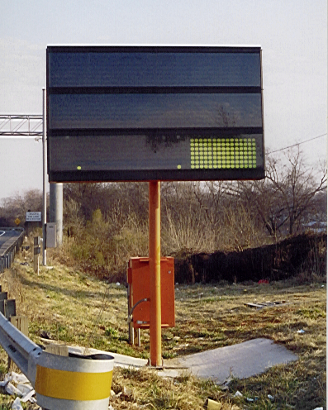
The DMS’s should be placed at points on the evacuation routes, and on the local streets leading to these routes, where drivers have a recourse and can tailor their routes to account for the newly presented information. In addition, DMS’s could be placed at intermediate points between interchanges, particularly in rural areas where the freeway interchanges are far apart, to deliver travel information to motorists. Information regarding travel times and conditions would reduce the anxiety level of motorists stranded in traffic.

DMS's can only deliver a limited amount of information to motorists. This is because motorists approaching the DMS’s only have a limited time to read, comprehend, remember and react to highway advisory or guidance messages.

DMS’s can either be permanently installed or be portable, to serve a specific need. The technologies for the portable DMS displays are the same as those for permanent DMS displays. Portable DMS’s should include portable power sources. The primary source could be a diesel engine or solar panels. The back-up system is often a battery system or a diesel engine. The sign is either mounted on a trailer pulled by a separate vehicle, or mounted on a truck. The North Carolina Department of Transportation (NCDOT) uses trailer-mounted DMS units, semi-permanently installed where there is a telephone and power drop. This gives the Department the option of moving these signs around, if needed. The South Carolina Department of Transportation (SCDOT) will have predetermined sites for the DMS units. Each site will allow the anchoring of the DMS trailer and might include a telephone line drop.

Permanent signs are normally installed on truss support structures, cantilevers or existing structures. The truss support structure is the ideal structure type, because it provides excellent visibility. However, it is the most expensive alternative. The structure and installation cost of a truss support structure is about $80,000, compared to about $40,000 for a cantilever structure. Permanent DMS’s installed on roadside concrete pedestals and portable DMS’s are acceptable, but are less effective than truss-mounted and cantilever DMS’s, since they are not in the motorists’ line of sight. Some DMS technologies also have narrow cones of vision, resulting in a decrease in the legibility distances of the signs, as they are placed further away from the traveling lanes.

There are several DMS technologies available for highway applications, with varying capabilities and costs. In general, these technologies can be classified into three different categories, including light reflecting, light emitting and hybrid. Light-reflecting signs reflect light from some external source such as the sun, headlights or overhead lighting. These technologies include foldout, scroll, rotating drum and reflective disk matrix. Light-emitting DMS’s generate their own light on or behind the viewing surface. These include neon (blank-out), lamp (incandescent lamp), fixed-grid or shuttered matrix fiber optic, and light emitting diode (LED) signs. Hybrid signs combine two DMS technologies to produce hybrid displays. These include reflective disk/fiber optic and LED/fiber optic.

DMS technologies vary in performance and costs. Some of the performance measures of DMS technologies include visibility, legibility distance, viewing angle, sensitivity to the environment, energy consumption, technology maturity, reliability and maintainability. The cost is also different, depending on the technology. In general, light-emitting and hybrid technologies cost more and perform better than light-reflecting technologies. A permanent, light-emitting sign costs about $100,000. Depending on the support structure used, the structure and mounting cost is about $70,000. Additional cost is required for communications between the traffic management center and the DMS.

There are several types of communications media that can be used for transmitting data to and from a DMS location. These include fiber optics, leased telephone lines, twisted-pair cable and wireless communications. Section 4.7 contains a discussion of these technologies.

One important consideration in selecting DMS technologies for evacuation route operation is the sign visibility and legibility distance under various weather conditions. Light-emitting and hybrid technologies have better visibility and legibility distance than light-reflecting technologies. The reversible lane/shoulder-use operations, if used, should be considered when selecting a DMS technology and location. In particular, fiber optic and LED signs have a very narrow cone of vision. If the number of lanes is increased in a given direction, the signs might not be legible to vehicles on the outside lines. In addition, if shoulder operations are conducted, there may be a very limited number of locations for placing portable signs. One possibility might be to locate DMS’s in the median.

Highway Advisory Radio (HAR)

Highways Advisory Radios (HAR's) are used to provide information to motorists in a specific geographic area, via their automobile radios on the AM band. Just recently, the FCC has authorized the use of low power FM HAR’s. The information can include alternative evacuation destinations/routes, congestion on evacuation routes, incident information, shelter locations, lodging/dining availability, gas station locations, rest area locations, weather information and other advisory information. Communication technologies enable transportation agencies to call a recorder or transmitter from a remote location and switch between prerecorded messages.

HAR has an advantage over commercial radio traffic broadcasts, in that commercial stations do not broadcast continuous traffic information. In addition, since HAR has a limited range, it is possible to disseminate information that is most relevant to the motorists in the HAR coverage area.

HAR messages should be short, to allow those who drive into the narrow HAR coverage area to hear the message twice. This requirement limits message duration to 60 seconds or less.
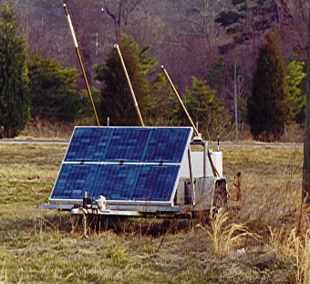
HAR systems use either 10-watt transmission or low-power transmission (0.1 watt). 10-watt transmission has a broadcast radius of about 3 to 6 miles. FCC Licensing is required for the 10-watt HAR systems. The licensing procedure includes studies to confirm that the HAR system does not interfere with other AM licensed broadcast stations. Low power systems (0.1 watts) do not require licensing. With low power transmissions, transmitters can allow unique messages to broadcast for smaller zones, compared to the 10-watt transmitters.

HAR can be classified into two types of systems:

- Vertical Antenna HAR Systems: These systems are the most widely used HAR systems. They use individual antennae, or a series of antennae electronically connected together to transmit information. Vertical antenna systems are small and easy to install, and less costly than the cable systems discussed below. They can be used to disseminate information to motorists before evacuation route entry (at the access points). However, they are subject to damage by vandalism or weather, which could be a problem during hurricane evacuations. In addition, the signal may interfere with other coverage HAR zones on the same or adjacent roadways. Portable and permanent vertical HAR have been used.

- Inductive cable antenna HAR systems: These systems use cable installed either under the pavement or adjacent to the road. Generally, the cable antenna systems operate at low power levels (0.1 watt) and consist of an antenna using buried coaxial cable along the roadside. This limits the transmission to a short lateral distance of 100 ft to 150 ft. The signal system is strong enough to provide a full coverage of multi-lane facilities without causing interference to other HAR systems. If installed below ground, these systems are not subject to damage by weather or vandalism. These systems must extend the full length of the coverage area and are more costly to purchase, install and maintain, and cannot be transported from one location to another.

Portable trailer and van mounted vertical antenna HAR’s are in use today. The portable HAR technology is the same as those in the permanent HAR systems, except for the alternate power source and mobility requirements. Portable installations could be beneficial to hurricane evacuation efforts, since they could be transported to evacuation routes whenever needed. However, the susceptibility of vertical antenna HAR’s to weather conditions should be considered.

If a HAR system is utilized, fixed signage should be placed on the evacuation routes to indicate the presence of the HAR stations. These signs should include a pair of flashing lights to inform motorists of the presence of HAR messages. The sign locations should take into consideration, the decision points along the evacuation routes and other sign locations on the routes.

A vertical antenna HAR station costs about $60,000. This cost does not include the extra costs required for communications and signing.

HAR operations can be controlled locally or remotely. Local control requires site visits to change the HAR messages. Remote control involves calling the HAR station using a communication medium such as a standard telephone line or a cellular telephone. The advantage of cellular communications is that they do not require ground line installations. From the remote location, the operator can turn the system on or off, load new messages, change messages and decide which messages to play. This is the best method for controlling station operation.

4.3 FREEWAY CONTROL

Freeway control can be classified into dynamic mainline control and ramp control.

Dynamic Mainline Control

Dynamic mainline control can be used to increase the capacity of the limited access facilities to accommodate traffic during the evacuation process. Reversing lanes or using shoulders as traveling lanes will accomplish this capacity increase.

Dynamic mainline control includes the following technologies:

- Lane-use control signals: These are overhead signals that indicate lane use availability. The signal displays used are a downward green arrow, amber X, flashing amber X and red X. The displays are used to indicate whether a travel lane is available for use, using the greed arrow or red X in the final on/off stages. They alert motorists to the gradual shift in use by displaying amber “X” in a lane that is about to close or change direction and a red “X once a shift is complete. The technologies used for these signals are fiber optic, LED, neon (blank-out) and bulb matrix. The signals can be controlled and monitored from a central location, such as a traffic management center. In one application studied, these signs are placed at an average of 1,000 ft.

- Gates: Hydraulically or electrically controlled lifting gates (barriers) present a physical barrier in the road that could be used to close the lanes to traffic. One example is the Semaphore barrier gates, which are similar to the ones used for rail-grade crossing. The gate control and monitoring can be done from a traffic management center. The software at the traffic management center would prevent operation of the devices in an improper sequence, such as the lowering of a gate without the corresponding popup delineators in place (if such delineators are used).

- Pop-up delineators: These systems can be used to raise or lower delineators remotely.

- Movable Lane Barriers: These are physical barriers installed temporarily by transfer vehicles to separate lanes of opposing traffic. Such barriers are often used in the morning and/or afternoon peak periods. One type of such a barrier consists of three-foot concrete segments, joined by pins.

- Surveillance: Dynamic mainline control might include sensors that detect wrong-way vehicles and CCTV cameras that allow monitoring of traffic and lane-use control signal displays.

Ramp Control

Freeway ramp control involves the use of control devices, such as traffic signals, signs and gates, to balance demand and capacity, in order to maintain optimum freeway operations and prevent operation breakdowns. The primary applications of ramp control include entrance ramp metering, entrance ramp closure, and exit ramp closure.

Entrance ramp metering includes allowing vehicles to enter the freeway at a given rate, typically 4 to 15 vehicles per minute for single lane metering. The rates may be fixed, based on time-of-day, or may be variable minute-by-minute, (traffic responsive) based on measured parameters on and off the freeway main line. One or more signals are used to control the ramp traffic. Ramp metering can be implemented on a local level, (for individual ramps) or on a system-wide basis. In system-wide control, individual metering rates are determined based on the overall system conditions, not just the conditions in the immediate vicinity of the ramp. System-wide control requires communications between field controllers and the traffic management center

Entrance ramp and exit ramp closures involve closing ramps with automatic gates or manually placed barriers. Manually placed barriers include cross bucks, barrels or cones. Automatic barriers are similar to the ones used at railway crossings. Manual placement of barriers is labor intensive. Thus, the use of automatic barriers that enable a ramp to be opened or closed automatically from a control center increases the efficiency and flexibility of the operation.

Ramp control system operation can be enhanced with the use of other ITS elements, such as network surveillance to modify the control strategy, and information dissemination technologies to notify travelers of changes in ramp operation.

In general, a ramp control system includes signal displays (signals), local controller, vehicle detectors, control logic, communications and a central management system. Advance ramp control signs with flashing beacon can also be used to warn motorists of changes in ramp operations.

Ramp metering and/or closure could be an important strategy to ensure efficient operations on evacuation routes. However, these strategies should be evaluated to determine their potential adverse effects on local traffic.

4.4 SIGNAL CONTROL SYSTEMS

Considerable benefits can be obtained from the implementation of computerized signal control systems. These systems can coordinate the operations of surface street signals and integrate the operations of these signals with other ITS services. In addition, they provide the ability to monitor the operation of various field devices from a central location, allowing the maintenance of system operations with minimal resources. Operating parameters of the field devices can be checked and modified from the central computer. In addition, the systems can produce various reports of equipment and operation failures, and provide data for use in planning future improvements.

During the hurricane evacuation process, the signal control systems must be optimized to accommodate the rapid changes in traffic demands during the process. The traffic timing plans should be responsive to the changes in the demands as the evacuation process progresses. There is a need for integrating the traffic signal control on the evacuation routes, the signal control on the highways leading from and to these routes and other implemented ITS services such as ramp metering, incident management and reversible lane control to achieve the overall system objectives. Advances in computerized signal control, control algorithms and communication technologies will allow the implementation of integrated control systems.

A typical computerized traffic control system consists of a central computer, local controllers, field masters (if needed depending on system configuration), communication system, detection system, signal displays and supporting structures. Many signal control systems are available in the market. These systems can be classified into central, two-level distributed (hybrid) and three-level distributed systems (closed loop systems). The user interface, equipment monitoring capabilities and data management capabilities of these systems have improved significantly in recent years. Traditionally, field signal controllers could be classified into NEMA controllers and Type 170 family of controllers. In recent years, several controller vendors have introduced Model 2070 controllers, which have superior processing capabilities compared to traditional controllers.

Most traffic signal control systems in the U.S. operate in the Time of Day (TOD) control mode. In this mode, intersections are coordinated using timing plans that are switched at specific times of the day/day of the week. Because of the day-to-day fluctuations in traffic patterns, traffic responsive strategies have been developed to provide a better match of plan-to-traffic conditions, compared to simple TOD selections.

In the U.S., all traffic control systems can operate using the first generation traffic responsive strategy. In this strategy, timing plans are developed off-line, using one of the signal optimization models, and stored in the central computer and/or the field master in a timing plan library. Timing plans are selected from this library based upon traffic conditions that are measured through a traffic detection system. The traffic parameters used in the selection include volume, occupancy, queue length or a combination of these factors.

Attempts have been made since the late 1970's to develop adaptive control systems that have higher degrees of traffic responsiveness than the first-generation control strategies. In these systems, signal timing parameters are generated on-line, based on detector measurements. In general, these systems have produced better results than the first generation control, which selects the signal timing plan from a library generated off-line from another month, perhaps another year. Currently, there are a number of adaptive traffic control systems deployed around the world. The most widely used among these are the British SCOOT and the Australian SCATS systems. Evaluation results show that these systems can produce significant improvements in performance, compared to TOD control.

Early attempts to develop adaptive traffic control systems were unsuccessful, and did not gain popularity. However, in the past few years, the Federal Highway Administration (FHWA) has sponsored the development of a collection of adaptive traffic control strategies called RT-TRACS. Promising results have been obtained from early field tests and simulation studies of the RT-TRACS system and other SCOOT and SCATS systems used around the country.

Most traffic control systems in the U.S. allow the system operator to specify “special events” plans that can be implemented for special traffic patterns that differ from the normal time-of-day/day-of-week operations. Special event timing plans can be developed to accommodate various traffic patterns anticipated during evacuation. As the evacuation process progresses, these timing plans can be selected either manually in the field, by the operator at the traffic management center, by a traffic responsive algorithm or by a combination of the two.

Existing adaptive signal control systems, on the other hand, must be reviewed to evaluate their effectiveness in producing plans that accommodate shifts in traffic demands of the type expected during the evacuation process. Effectiveness of this type of system should not be tested during an evacuation.

4.5 TRAVELER INFORMATION SYSTEMS

Traveler information systems can be used to disseminate real-time travel information to evacuees during, before and after the evacuation and reentry processes. The information could include traffic conditions, advisories, toll information, incident information and weather information. It could also include the availability of such facilities as hotel rooms, eateries, rest areas, gas stations, stores and hospitals and could allow hotel room reservations. The information is provided by traveler information centers, and can be accessed by travelers either before the trip or while en-route. These systems differ from traffic information dissemination systems that use HAR and DMS technologies (see Section 4.2) in their ability to provide more information to travelers. This is because there is no limit on message lengths with these systems.

The traveler information systems discussed in this section deliver travel conditions and service information. This information could also include best routes and alternate routes, times, modes and/or destinations for their trips.

In general, the traveler information systems can be classified into basic and interactive services. Basic services include the collection and real-time dissemination of travel information, which are not tailored to a specific traveler, but rather are disseminated over a wide area to all travelers through the existing infrastructure and low cost user equipment, such as FM subcarriers and cellular data broadcast. The information can be accessed using devices such as telephones (landline and wireless), kiosks, television, radio, personal computers and Personal Digital Assistants (PDAs).

Interactive traveler information services differ from basic traveler information services, in that the provided information is tailored to a traveler request. For example, travelers can specify a number of routes and ask the system to provide the traffic and incident information that are relevant to these routes. Interactive travel information systems could be:

- Real-time interactive request/response systems, and

- Systems that send a tailored stream of information to the traveler, based on a pre-submitted profile.

A range of two-way communication systems may be used to support the required digital communications between travelers and the traveler information centers. Telephones, kiosks,
pagers, PDAs, personal computers, digital television and a variety of in-vehicle devices can be used for interactive travel information systems.

In recent years, several traveler information systems have been implemented around the country under public/private partnerships. Under these partnerships, private companies collect real-time data from various sources and provide basic and interactive information to travelers. These systems generate revenue through advertisement and/or the sale of information to travelers.

4.6 NAVIGATION/ROUTE GUIDANCE SYSTEMS

Navigation/route guidance systems differ from the traveler information systems discussed in Section 4.5, in that they provide travelers with very detailed information (turn-by-turn in many cases) regarding best route, destination, mode and/or time for their trip. These systems can be categorized into:

- Static systems that calculate the best routes based on parameters selected by the user (shortest route, scenic route, etc.) and the existing physical infrastructure; and

- Dynamic systems that calculate the best routes based not only on parameters selected by the user and the existing physical infrastructure, but also on real-time traffic data, such as incidents, travel time and roadway closures.

The equipment required for the static systems includes location determination, map database, best route computation capabilities and interactive traveler interface equipment. No data exchange with the infrastructure is required since the devices themselves calculate the best routes. The static systems can be vehicle-mounted or portable. The portable type uses handheld navigators, which are extensions of the personal data assistants, such as palmtop computers.

The location determination function required for these systems is accomplished using Global Positioning System (GPS), dead reckoning and/or map matching technologies. The static systems can also include static yellow page information about restaurants, hotels, entertainment and shopping. Many car manufacturers around the world are offering or are planning to offer static route guidance as an option in their vehicles. Hand-held navigators are also commercially available. Some of the in-vehicle systems include turn-by-turn guidance. Some systems can be operated by voice commands and include speech interfaces that read directions and points of interests.

There are two types of dynamic route guidance systems. The first type is the device-based system. These are becoming quite available in the market. These systems are an evolution of the static systems that allow the route guidance devices to receive real-time information and determine the best routes based on the information they receive. In addition to autonomous route guidance equipment, this type of system requires a digital receiver capable of receiving real-time information about traffic, transit and road conditions. The real-time information is received using two-way, wide-area wireless or one-way (broadcast) communication technologies.

Another type of dynamic route guidance system is the infrastructure-based system. Infrastructure-based systems differ from the device-based systems, in that the best routes are determined at a central location rather than by the in-vehicle or portable device. This approach simplifies the in-vehicle and portable equipment requirements. Furthermore, the route selection can be based on better information regarding predicted traffic operations, taking into consideration the overall system control strategy objectives in addition to individual traveler objectives. Such systems can also provide turn-by-turn guidance and support pre-trip planning.

Other devices, such as kiosks, personal computers, telephones and pagers, can also be used to access this information. Two-way data communications are required for infrastructure-based systems.

4.7 COMMUNICATIONS BETWEEN FIELD DEVICES AND CONTROL CENTERS

This section briefly describes the types of the communication systems that have been used for data and command communications between traffic control centers and field devices, such as traffic controllers, DMS, HAR, detectors and CCTV cameras. The communication subsystem is one of the most critical and expensive components of ITS systems. The types of information that are communicated between the traffic control centers and the field devices include control commands, detector data, video and field equipment status.

The following is a description of the landline communication technologies used for ITS applications:

- Twisted-Pair Cable: Twisted-pair cable is traditionally agency-owned and can be used for low-speed data transmission (1,200 bps - 9,600 bps). Installation can be underground in conduit, underground by direct burial, or aerial using existing or new utility poles. Twisted-pair cable bandwidth limitations prevent transmission of live full-motion television images. However, recent technologies allow the transmission of slow-scan television.

- Leased Telephone Lines: Varieties of telephone circuits are available through local or regional telephone companies for transmitting data. Voice grade data channels are used for low speed data transmission between control centers and traffic signals, ramp meters, DMS, detectors and camera control. Two-way digital data channels (2,400-9,600 bps) are used for the above applications when higher data rates are required. T-1 channels have a very high data capacity (operate at 1.544 Mpbs) and can be used for transmitting video.

- Fiber Optic: Fiber optic cable is a high capacity communication medium that is used for transmitting data and video images via several communication channels with immunity to electrical interference. To transmit video, voice and other data, the information is converted to a coded pulse of light, introduced into the optical fiber and transmitted by internal reflection of the light wave within the fiber. Fiber optic communications typically require right-of-way and conduit throughout the network.

- Coaxial Cable: Coaxial cable can transmit both data and video, via several communication channels. Fiber optic technologies are increasingly being used to replace coaxial cable systems.

Wireless communication technologies for ITS applications include:

- Radio Networks: Radio frequencies can be used to broadcast voice and data, but not make video transmission. Radio frequencies can support a signal rate of 9,600 bps.

- Microwave: Microwave systems are point-to-point high frequency communication systems that can be used for transmitting data and video. These systems are relatively expensive due to the infrastructure costs required to interconnect communications.

- Spread Spectrum Radio: These systems operate by transmitting a signal bandwidth over a wide range of the frequency spectrum. For this reason, electromagnetic noise has less effect on signal integrity. Spread Spectrum Radio systems have been used for data and video transmission.

- Cellular Radio: Cellular radio is based on the concept of “cells”, which are 2 to 20 miles across. At the center of each cell is a control radio that handles the network management functions, including the assignment of frequency sub-channels. Cellular technology is not currently appropriate for continuous communication service due to the service costs involved. However, it is a candidate for applications that require communications at infrequent intervals. Cellular radio supports data and voice communications.

- Packet Radio: This technology is similar to the cellular radio technology, but it does not support voice communications.

- Satellite Communications: The costs of making frequent satellite transmissions are generally excessive in comparison with that of other technologies. Long-haul trucking companies are using mobile satellite technology communication for dispatching purposes.

4.8 INCIDENT MANAGEMENT SYSTEMS

Incident management is a coordinated and planned approach for responding to incidents. Incidents can be localized roadway incidents (such as crashes, stalls and road closures) or regional emergencies (such as hurricanes, earthquakes and flooding). A successful incident management system requires the involved stakeholders to coordinate and cooperate before, during and after an incident. The stakeholders can include elected officials, state DOT's, enforcement agencies, fire and emergency medical services, hazardous materials (Hazmat) agencies and contractors, offices of emergency management, environmental protection agencies, towing services, service patrol providers, regional authorities, media representatives, special event promoters, and information service providers. Traffic management teams, that include some or all of these stakeholders, have been established in many regions nationwide to address the need for coordinated incident management in their regions.

The incident management process includes detecting, responding to and clearing incidents. Detection of incidents can be automatic, based on data gathered using traffic detectors as discussed in Section 4.1. They can be also based on other technologies such as cellular telephone calls from motorists, aircraft patrols, fixed observers, motorists’ call boxes, service patrols and CCTV cameras. In any event, a central system is needed for data fusion and for the determination of locations, types and severity of the incidents.

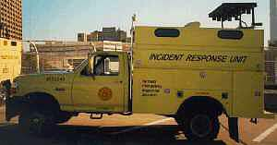

Various strategies have been used to reduce incident response and clearance times. These include the use of equipment storage sites at key locations, tow truck contracts, highway service patrols, incident response teams, accident investigation sites, legislation supporting vehicle removal policies and on-site traffic control. In addition, several techniques have been employed to improve emergency vehicle access and traffic flow, including barrier openings, barrier gates and emergency ramps.

Other management strategies include police escorts and wrong-way entrance of non-emergency response vehicles, shoulder utilization, contra flow diversion of traffic and alternative flow diversion.

4.9 AUTOMATED VEHICLE LOCATION SYSTEMS

Automated vehicle location (AVL) systems track and monitor the location of vehicles. Shipping companies and movers of valuable cargo were the pioneers of AVL applications to reduce losses due to theft. Emergency service providers such as police, fire and emergency medical agencies have coupled the technology with computer aided dispatching systems to provide quicker responses to service requests. AVL technology consists of a geo-positioning satellite (GPS) receiver in the vehicle that triangulates on stationary satellites to determine the latitude and longitude of the receiver. Accuracy can be within a few feet, depending on the sophistication of the receiver.

The mobile unit in the vehicle includes the GPS receiver and a radio transmitter. The radio transmitters can be VHF, cellular or digital phones. Some models offer the ability to add mobile data terminals and laptop computers. A unique code programmed in each unit provides a special identity to that signal. The in vehicle unit can be programmed to send alarms for special events, which would include a panic button signaling special assistance. A special event code can disable a vehicle if reported stolen.

Commercial trucking companies are making extensive use of AVL systems to track valuable cargo. Their systems also possess text-messaging capability in the vehicles. This feature can provide a means to send specific weather alerts so trucks can accomplish a number of purposes. One, their assets and cargo can be moved to a safe area. Two, truck volumes can be removed from the evacuation routes early, thereby increasing the capacity of the facility.

Central site software monitors the location of the mobile units through their unique code. Color-coded maps are available showing the location of the vehicles and their status.

4.10 COMPUTER AIDED DISPATCHING

Police, fire and emergency medical services use computer aided dispatch systems to more efficiently track the location of vehicles. The systems allow dispatchers to send the closest available units, even though they would be leaving their normal response area. The operators can use the systems to refine patrol or response boundaries and better deploy special pieces of equipment through examination logs of service calls.

The systems are map-based point and shoot technology. The software allows the dispatchers to see the vehicle’s actual location in real-time. With incident information, the dispatcher can route the responding vehicles around traffic backups.

5.0 REVIEW OF ITS LEGACY SYSTEMS AND EXISTING EVACUATION STRATEGIES

5.1 ITS APPLICATIONS AND SYSTEMS

This section presents a review of the existing and planned ITS systems in Florida, Georgia, North Carolina and South Carolina that have a direct impact on hurricane evacuation planning. The list of ITS projects is not all inclusive of the projects in each state. This review is important for the selection of ITS technology deployments, because the type of existing and planned systems in the region give an indication of what systems are most needed, feasible and proven. In addition, the knowledge of existing and planned systems allows the selection of early ITS deployments that make use of the capital expenditures already planned or spent for ITS deployment in the region. Furthermore, the review of the existing systems will allow identification of the requirements for the integration between these systems and any new ITS systems implemented for the evacuation process.

FLORIDA

Intelligent Transportation Systems Strategic Plan for Florida: This project developed an ITS strategic plan for Florida, which will serve to provide an overall vision and direction for ITS in Florida.

Florida Statewide ITS Architecture and Standards: This project will develop an ITS architecture for Florida.

Florida Fiber Network (FFN): This will be a shared-resources project that will provide about 2,000 miles of fiber optic cable and duct infrastructure, installed along one side of all interstate and Turnpike roadways throughout the state. In exchange for this installation, the FFN contractor will have the right to use DOT rights-of-way for its own commercial fiber optic network.

I-4 ITS Corridor Plan: This study will provide an assessment of the I-4 corridor from Tampa to Daytona Beach and produce ITS architecture for the corridor.

Regional Application of Rural ITS in Florida’s Coordinated Transportation System: This project supports the efforts of the Florida’s commission for the Transportation Disadvantaged, to provide regional, multi-agency application of ITS technologies in rural areas of Florida. The project will provide transit service for the people that need these services for life-sustaining functions. The project will provide a model for a regional, electronically coordinated transit service in rural areas involving several transit and paratransit organizations.

The Florida Traveler Information Radio Network (TIRN): TIRN is a public/private partnership between TIRN Broadcasting, Inc. and the Florida Department of Transportation (FDOT). According to this partnership, TIRN Broadcasting provides a completely dedicated radio network, consisting of 19 commercial radio stations covering the State of Florida. FDOT provides right-of-way access for up to 4,600 new roadway signs to be constructed in locations throughout the state, including the Florida Turnpike and major expressways. The signs will advertise the radio network to travelers. TIRN is responsible for purchasing and installing the signs. The FDOT will get one minute in each ten for messages to travelers, and the right to take over the network to alert travelers if there are major accidents or pending natural disasters. TIRN can sell four minutes of advertising for each ten-minute period. After a period of time, a new contract will be negotiated that might require TIRN to pay a fee to the FDOT, depending on whether or not a profit is made. It was estimated that TIRN would invest about $9 million for the initial deployment of about 2,000 signs. The radio station investment is estimated to be $25 million.

Motorist Call Boxes: FDOT is deploying a statewide motorist aid system using roadside call boxes.

Freeway Incident Management Teams: Several teams are operational in Florida.

Lee-Collier Incident Management Study: FDOT is studying possibility of implementing incident management teams in the two-county area along I-75.

Jacksonville I-10 Intelligent Transportation System: The project involves the construction of fiber optic cable, CCTV cameras and vehicle detection along six miles of I-10, and is presently underway.

Jacksonville Interstate DMS: Eight DMS's located around Jacksonville are operational.

Jacksonville Transportation Management Center (TMC): The project will construct a 1,600-sq. foot traffic management center (TMC) for the Jacksonville ITS systems.

Pensacola Bay Bridge: The project consists of wrong way vehicle detection, coupled with high visibility signs and warning signals.

Pensacola Bay Bridge on I-10: The project consists of one permanently mounted dynamic message sign and CCTV camera at each end of the bridge for incident monitoring.

S.R. 528 (Bee Line Expressway): The corridor has one dynamic message sign locate between S.R. 436 and U.S. 17.

I-4 Surveillance and Motorist Information System (SMIS): SMIS includes traffic surveillance, incident management and travel information dissemination using DMS signs along 39 miles of I-4 from US-192 to the north of Lake Mary Boulevard. The ITS technologies deployed on this section includes fifty CCTV cameras, sixty-nine or stations spaced at 1/2 miles, twenty-four dynamic message signs and five weather station indicating pavement conditions (wet or dry). FDOT will extend the existing system to Saxon Blvd. (eastward) in Volusia County and to US 27 in Polk County (westward). An option exists within this phase to extend the system an additional ten miles to bring the system to SR 44 in Volusia County. The entire SMIS will be in place for the greater Orlando area by the year 2008. The ultimate SMIS will include sections of SR 408, SR 417 and SR 528.

Daytona Beach Smart Highway Project: The project limits include I-4 between SR 44 (west) and I-95 (east) and I-95 between I-4 (south) to US 92 (north). The system includes 10 CCTV cameras, 10 detector stations (placed approximately 1/2 miles a part) and 4 dynamic message signs.

I-4 Motorist Assistance Program: This program is a public-private partnership that offers two service patrol trucks on I-4 in Orange and Seminole Counties.

Orlando Area ATIS: An Advanced Traveler Information System with private information service providers is planned for the Turnpike, I-4, SR 408, SR 417 and SR 528.

Broward and Palm Beach I-95 and I-595 Systems: A network of DMS's on the I-95 and I-595 corridors in Broward County is under construction, and a detection system for the I-595 corridor is planned. FDOT plans to extend the DMS system to I-95 in Palm Beach County.

Service Patrols, Miami, FL: These roving service patrols provide motorist assistance for the I-95, SR 836, SR 826, SR 112, SR 874, SR 878 and SR 924 corridors.

I-95 SunGuide Project, Miami, FL: The project includes DMS’s, trailblazer signs, detector stations, accident investigation sites and ramp meters.

SunGuide Advanced Traveler Information Systems (ATIS): This is a public/private partnership in Palm Beach, Dade and Broward Counties. Methods of information dissemination will include an Internet Web Site, commercial radio and television broadcasts, automated call-in, and other personal and remote devices. The private team will be responsible for data collection and dissemination while generating revenue through the sale of travel information and advertisements to make the service cost-effective.

Golden Glades Interchange, Miami, FL: The project is in progress and includes the installation of DMS, CCTV and detectors.

I-275 Sunshine Skyway Bridge: The system warns travelers of high wind and/or poor visibility and lowers speed limits during these periods using dynamic speed limit signs. The project includes wind sensors, static signs with flashing lights and CCTV cameras.

Florida Turnpike ITS System: Currently, Florida’s Turnpike has three HAR installations located at service plazas throughout the Turnpike system. The HAR units are located at Snapper Creek Service Plaza in west Dade County, Okeechobee Toll Plaza in north Dade County and the Palm Beach Service Plaza near West Palm Beach. The Turnpike uses these units to provide customer service information. The Turnpike has a traffic management center that currently serves as an incident command center. Presently there are no CCTV, DMS or detection devices controlled by the center.

Florida Turnpike ATIS Phase I: The project will include 6 more HAR and 20 DMS installations. They will be installed two per service plaza, two in Palm Beach County for route diversion to/from I-95 and six in Dade County for route diversion to/from the HEFT and S.R. 874, S.R. 826 and I-75.

GEORGIA

Statewide Strategic Plan for ITS: Georgia DOT has prepared an aggressive 20-year plan for the expansion of ITS. The plan includes four, 5-year sets of deployment objectives with regional transportation control centers in each GDOT district. The plan includes the improvement or complete integration with Atlanta Hartsfield International Airport, Ga. 400 Toll Plaza, Georgia State Patrol, Georgia Emergency Management (GEMA), Savannah Ports Authority, regional railroads, transit agencies and regional airports. GDOT plans to expand ATIS services and facilities.

Georgia Navigator: Georgia Navigator is DOT’s state of the art traffic management and traveler information system. The system integrates freeway traffic management and surveillance, the MARTA transit system, and city and county signal systems. Through the GIS-based traveler information system, users can get current traffic congestion, expected travel times, airline schedules, MARTA schedules and weather information. GDOT originally developed the system for the 1996 Olympics. It has been expanded within the Metropolitan Atlanta area. GDOT has added remote traffic control centers in Athens and Savannah, and others are planned. The system includes 300+ video detection cameras, 45+ dynamic message signs, 67+ traffic surveillance cameras, one camera mounted on a helicopter, and 110 information kiosks.

Weather Monitoring System: Georgia DOT is installing 16 remote weather stations. Maintenance personnel will use the system in their daily activities and the information will be on the traveler information system for public use. Four of these sites are in the coastal area along I-95 and I-26. This project is the prototype of a statewide system. The system will detect temperature, precipitation, pavement chemicals, pavement temperature, etc. These sites are primarily in the rest areas, weigh stations and welcome centers.

Fog Detection System: Georgia DOT is constructing a fog detection and warning system. It is located on I-95 between U.S. 82 (Exit 6) and U.S. 341 (Exit 7). This is an area of recurring fog where the roadway crosses the Turtle River. The project includes two DMS’s in each direction and two CCTV’s.

HERO’s: Georgia DOT established a system of motorists’ assistance patrols (HERO) for the metropolitan Atlanta area before the 1996 Olympics. The HERO’s are equipped and trained to make minor repairs, provide first aid, provide traffic control, and extricate accident victims.

Macon Signal System: Georgia DOT and the City of Macon are constructing a citywide signal system with fiber optic communications and CCTV.

Savannah Signal System: Georgia DOT and the City of Savannah have jointly funding an advanced traffic management system, including fiber optic communications, three DMS signs, one highway advisory radio station, six CCTV cameras, and, initially, thirteen controllers. GDOT has installed the Georgia Navigator software.

NORTH CAROLINA

Statewide ITS Strategic Plan: NCDOT is preparing a statewide strategic plan. The project includes the development of stakeholders and a mapping of existing systems and facilities to the National ITS Architecture.

Regional Traffic Management Centers: NCDOT has installed CCTV, dynamic message signs, detection systems along I-85 and I-40 in the cities of Greensboro, Winston-Salem and Raleigh. Each has a regional traffic management center. The Raleigh center will also serve as central point for regional and multi-state incident coordination. There are long range plans to establish TMC's in the smaller cities of Asheville, Wilmington and Fayetteville. The CARAT system described below is fourth regional traffic management area serving the Charlotte or Metrolina area of the state.

The regional traffic management centers are part of a multi-agency effort including State Highway Patrol, local city traffic engineering agencies and 911 centers.

Incident Management Program: NCDOT has established multi-agency incident management teams as part of its statewide incident management program. The teams include NCDOT, State Highway Patrol, Emergency Management, police, fire and rescue agencies. The teams are currently in 20 counties. They have developed detour maps improved incident management practices. These teams include incident management and motorist assistance patrols (IMAP) in the major cities along I-85 and I-40. The cities include Asheville, Charlotte, Gastonia, Salisbury, Greensboro, Winston-Salem, Durham and Raleigh. It is likely team(s) will be established in the northeast area of the state.

UTCS Signal Systems: NCDOT has installed UTCS (Urban Traffic Control Systems) computerized signal systems in all of the major cities of the state, including the cities of Fayetteville, Raleigh, Durham, Greensboro, High Point and Charlotte. NCDOT has upgraded each of the original systems in the last 10 years with fiber optic communications, CCTV, software and controllers.

Closed Loop Signal Systems: NCDOT has installed closed loop signal systems in smaller cities throughout the state and on key U.S. highways. These areas include Rocky Mount, Morehead City, Jacksonville, Salisbury, Gastonia and Asheville, among others.

CARAT: NCDOT is constructing an integrated freeway management system along I-77 in Charlotte through a design-build contract. The system will include a fiber optic communications system, CCTV, dynamic message signs, and microwave and inductive loop detection systems.

Kinston Signal System: NCDOT has just awarded a construction contract to install a citywide signal system, incorporating CALTRANS Type 2070 Lite controllers, CCTV and a fiber optic communications system.

Wilmington Signal System: NCDOT and the City of Wilmington constructed a citywide closed loop signal system. The communication media used is twisted pair cable. The system continues to be expanded with roadway construction in the Wilmington area.

Other ITS Devices: CCTV, HAR and DMS signs have been added in various locations along I-40, I-85 and I-95. Along I-95 and I-40, weather-sensing units have been installed to detect specific recurring local weather problems such as fog.

SOUTH CAROLINA

Statewide Fiber Optic Network: SCDOT is considering a public-private partnership to install fiber optic cable on all Interstate Highways. The State of South Carolina would obtain the use of a specified number of fibers, and the private vendor would be able to market the rest for commercial purposes.

State Traffic Management Center: SCDOT has developed a state traffic management in their central office in Columbia to remotely monitor CCTV cameras along I-85 (Greenville and Spartanburg), I-77 (Rock Hill) and I-26 (Charleston). Each of these systems has a local traffic management center housed in a mobile office with the SHEP patrols. The traffic management center monitors various closed loop signal systems throughout the state maintained by the SCDOT.

SHEP Patrols: SCDOT has established motorist assistance patrols (SHEP) along I-85 (Greenville and Spartanburg), I-77 (Rock Hill-metropolitan Charlotte) and I-26 (Charleston). The SHEP units are equipped with push bumpers, fuel, water, winches and tire changing tools. They perform incident management duties by shutting down lanes, protecting accident investigations and removing debris from the roadways. The South Carolina Highway Patrol dispatches the SHEP patrols.

Charleston Signal System: The City of Charleston replaced their centralized signal system after Hurricane Hugo with a newer system using CALTRANS Type 170 controllers.

I-26 Widening: The latest widening of I-26 west of Charleston and I-526 will include CCTV cameras with remote monitoring in Columbia at the State Traffic Management Center.

5.2 REVERSE LANE EVACUATION STRATEGIES, PLANS AND SUPPORTING ACTIVITIES

There are two efforts included in the states’ response to hurricane evacuation preparedness. The first is an agency’s preparedness for storm cleanup and the restoration of normal services. Most state Department of Transportation agencies have a system of placing their staff on standby before a storm, readying certain equipment for clean-up operations, and even pre-deploying personnel and equipment to staging areas before the arrival of a storm. This process expedites these agencies’ ability to respond to the damage by having their crews already en-route or staged before evacuation activity begins. Highway patrol agencies have similar contingency plans. For example, the North Carolina Highway Patrol places all patrol personnel on standby with orders to be ready to depart for a one-week assignment with a 45-minute notice. They deploy their personnel in eight person squads, headed by a line sergeant. The South Carolina Highway Patrol has a standby list for deployment to coastal areas for hurricanes.

The second effort is the planning and implementation of measures to manage evacuation traffic. In the aftermath of Hurricanes Hugo and Andrew, three states within this study area, South Carolina, Georgia and Florida, realized they could not undertake large-scale evacuations such as Hugo and Andrew. They initiated planning efforts to develop other strategies strictly as contingencies. These study efforts included a plan to transpose coast-bound lanes of travel to the direction of evacuating traffic on limited access facilities, such as the Interstate Highways. This activity is referred to as one-waying. The following sections describe the states' efforts before Hurricane Floyd and their present activities since that hurricane.

FLORIDA

District 8, Florida’s Turnpike, of the Department of Transportation (FDOT) and the Department’s Office of Statewide Planning both developed one-way plans after Hurricane Hugo. The Traffic Operations staff prepared the District plan and included staffing and equipment needs. The Florida Turnpike has some unique design features that made the original plan very difficult to implement. That plan extended the entire length of the Turnpike from Dade County to Wildwood in Lake County. An urban section without raised barrier wall runs the entire length of the Turnpike through Dade, Broward and Palm Beach Counties. Most of the interchanges within this same area are a trumpet design as shown in the Figure 5-1.

The important feature of the trumpet interchange design is that all movements on and off the Turnpike are made through a single toll plaza. Two of the four movements are free, depending on the plaza’s location, relative to a mainline plaza. The intersection of this combined two-way ramp, with the crossroad results in large intersections that are difficult to barricade to prevent cars from entering the closed roadway. The crossing roadways are typically six-lane divided roadways with high volumes. The original plan included the use of approximately 250 Florida Highway Patrol troopers. The single FHP Troop that serves the Turnpike has, at full strength, only 120 troopers. Due largely to that staff requirement and the lack of an identified alternative to that staff need, FDOT did not develop the plan further.

The plan, developed by the Office of Statewide Planning, looked at transportation improvements to enhance roadway capacity for hurricane evacuations. The recommendations included strategies that addressed planning and communication, transportation system management, transportation demand management, capital improvements and funding issues.

FDOT conducted another study called Operation Crossover in 1997 that looked at a scaled back one-way plan. This one-way plan extended from Lantana Toll Plaza in central Palm Beach County, to the northern terminus of Florida’s Turnpike at Wildwood. This section covers a
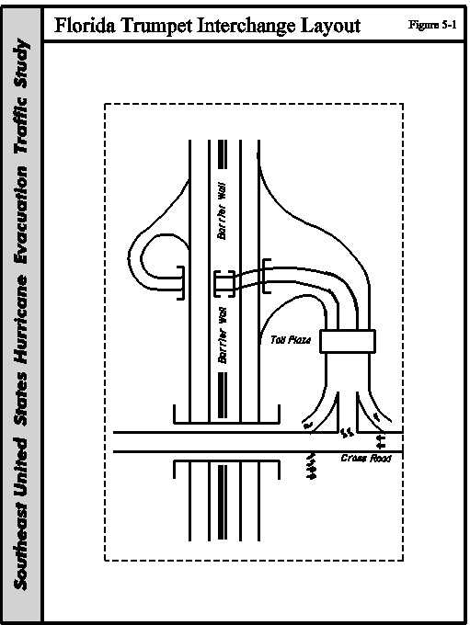

distance of 212 miles, seventeen interchanges, three main line toll plazas and six service plazas. It included the use of 171 FHP troopers per shift, three FHP planes, three highway advisory radio stations and six DMS signs. This study addressed the staffing needs in detail, EMS coordination, equipment needs and wrecker services.

After Hurricane Opal in 1996, the agencies involved in emergency management, including Florida Department of Community Affairs, Division of Emergency Management (DCA), FHP and FDLE, developed a regional response plan to provide the proper staff and equipment to support hurricane evacuation and recovery operations. The plans stipulated that agencies would not move personnel and equipment from outside the region into the face of the storm. The agencies would confine exposure to the storm to the local staff. The agencies were concerned that bringing in out-of-region equipment and personnel would complicate the sheltering of emergency personnel and equipment. The agencies were also concerned that exposing out-of-region personnel and equipment could seriously reduce those agencies’ abilities to respond during rescue and recovery operations. The regional response plans coordinated the individual county evacuation plans together. The regional plans standardized the evacuation routes across a region. For each regional plan, each agency involved agreed to specific duties during an evacuation, based upon available staffing.

DCA prepared a feasibility study to one-way I-75, Alligator Alley, across southern Florida, between the Cities of Fort Lauderdale and Naples. This study found that Alligator Alley is underutilized as an evacuation route. It examined various storm tracks affecting southeast and southwest Florida and how one-waying I-75 either westbound or eastbound would affect the clearance times. The study found that better utilization of Alligator Alley without one-waying would be more beneficial. While there are some benefits to reduced westbound clearance times, the decision to use this strategy must be balanced by the lack of shelters for evacuees in southwest Florida. The study recommended using anything other than the normal lane configuration in only one scenario. In that one scenario, it was recommended that the eastbound shoulder be used as a driving lane.

As part of the Governor’s Task Force efforts, the Florida Highway Patrol and FDOT have developed a revised one-way plan for Florida’s Turnpike. This plan for the Turnpike will have a one-way section from Fort Pierce to Osceola Parkway in Osceola County south of Orlando. FDOT will build a paved crossover in the median to move all traffic back to the normal northbound lanes. Figure 5-2 shows the corridor. This plan balances the very high staffing requirements with the additional capacity benefits. This section does not have a barrier median. FDOT and FHP have estimated it will take five to six hours to set up. The operation would be set up for implementation at daybreak, and the one-way plan would operate only in the daytime. This would provide approximately twelve hours of operation, including the two-hour dismantling of the operation. FDOT hopes this is an interim solution. It is FDOT’s desire to widen the small bridges in this section and to use the shoulder as a third lane in the future.

The Task Force staff has developed some criteria for deciding whether to use a one-way plan. This criteria includes times of advisory, expected landfall, arrival time of the tropical force winds, watch and warning issuances, probabilities of landfall, portions of coast in the maximum probability areas, changes in probability from previous reports, storm’s angle of approach, storm intensity (current and forecast), changes in central pressure and etc. Generally, the State is targeting Category 3 storms or greater, increasing strength in storm conditions (higher wind, lower pressure, forward direction), two or more counties (principally in the south, southwest and Tampa Bay areas, counties with clearances of 36 hours or greater.

In addition, FHP has led an effort to develop one-way plans for the following facilities. This has been a cooperative effort of FHP, FDOT, State Emergency Management Division, National Guard, FDLE and the various local sheriff’s police and emergency management agencies. The routes are shown in Figure 5-2 and listed below:

- I-10 westbound from Jacksonville to Tallahassee

- I-10 eastbound from Pensacola to Tallahassee

- I-4 eastbound from Tampa to Orlando

- I-4 westbound from Orlando to Tampa

- S.R. 528 (Bee Line Expressway) from I-95 to Orlando

- Alligator Alley westbound from Broward County to west coast

- Alligator Alley from eastbound from the west coast to Broward County

- I-75 northbound from Charlotte County to Tampa

FHP and FDOT have developed detailed materials, equipment and staffing plan for each corridor. These plans will include a list of equipment and materials that must be purchased or
rented. These agencies are working with the State Emergency Management Division and the Florida Department of Law Enforcement to find additional law enforcement resources. They have developed the staffing plans using the uniformed law enforcement personnel such as FHP and the Game and Fish Commission first. The plans include the use of non-uniformed officers such as FDLE. National Guard will fill any unmet needs. FHP and DOT will train and equip the non-uniformed officers and National Guard personnel in traffic control techniques. These agencies have recognized that if they use the National Guard, the go/no go decision to implement a one-way plan would have to occur earlier. The National Guard is a part-time occupation for essentially all of its force. Historically, it takes the National Guard twelve hours to mobilize. The National Guard does not have powers of arrest; they can only detain suspected lawbreakers. FHP has found that drivers, particularly in time of emergency, will obey uniformed officers with

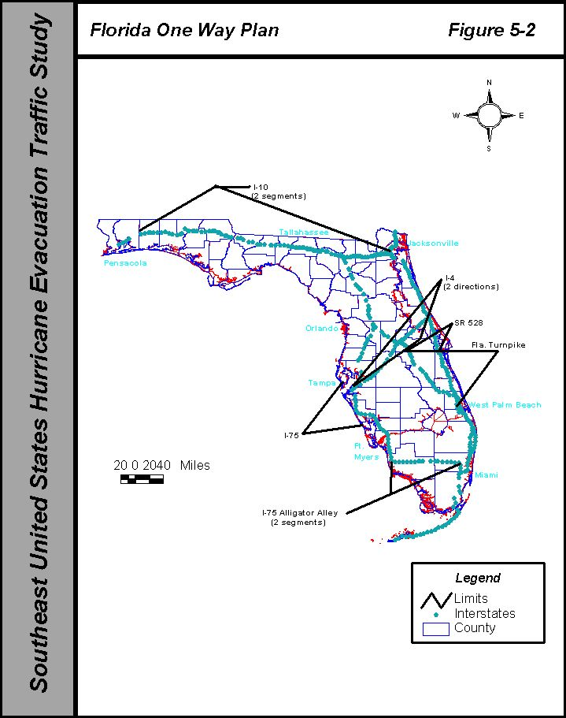

marked patrol cars better than military and DOT personnel. Field assignments, at the grassroots level, will include a mixture of FHP, National Guard and other law enforcement personnel.
FDOT and FHP are studying methods to close the crossovers during normal operations and the ramps during one-way operations. They are considering movable gates and detachable guardrails as long-range solutions.

The staffing plan for the candidate corridors, beyond that for other evacuations needs are as follows:

- I-10 westbound: 155 officers

- I-10 eastbound: 156 officers

- I-4: 210 officers

- S.R. 528 (Bee Line Expressway): 20 officers

- Alligator Alley: 155 officers

- I-75 northbound: 209 officers

- Florida’s Turnpike (S.R. 91): 77 officers

These officers will come from the Florida Highway Patrol, DOT, Florida Marine Patrol, Game and Fish Commission, various Sheriff’s offices and local police departments.

The State conducted a field exercise May 16-18, 2000 as part of a larger exercise to one way I-10 from Jacksonville to Tallahassee as part of the annual hurricane preparedness exercises. The exercise included the mobilization and deployment of personnel and equipment, but it stopped short of actually closing the roadway.

GEORGIA

After Hurricane Hugo, the Georgia Department of Transportation (GDOT) District Office in Jessup developed a detailed operations plan to one way I-16 from Savannah to U.S. 1 as a contingency. The architects of the plan did not establish criteria for implementation, including the category of storms that would warrant use of the plan. Since Georgia State Patrol (GSP) had not embraced the plan along with other state and local agencies, GDOT developed the plan using their own vehicle enforcement officers. The plan required the reversed eastbound lanes to exit at U.S. 1. If these drivers wanted to continue west on I-16, they had to cross over I-16 and reenter at the westbound ramp. The use of the overpass as the “crossover” and termination of the one-way operation proved to be a major bottleneck during Hurricane Floyd. Figure 5-3 shows the corridor.

GDOT implemented this plan during Hurricane Floyd. GSP volunteered to assist in the one-way operation and relieved GDOT of the staffing burden. This participation was instrumental in making the plan work. GDOT determined the operation successful since all threatened areas were evacuated in time.

However, the plan did not go through without a few glitches. More people heeded the evacuation orders than needed and, that compounded the congestion. In addition, GDOT did not have all the designated DMS signs in place for the one-way operation

Nevertheless, GDOT has extended the limits of the one-way plan to Dublin at the U.S. 319/441 Interchange. GDOT will construct a crossover to transition the reversed lanes to the normal westbound lanes. GDOT will merge traffic from two reversed lanes to one before the crossover.
They will also merge the normal westbound lanes to one also before the crossover. GDOT has
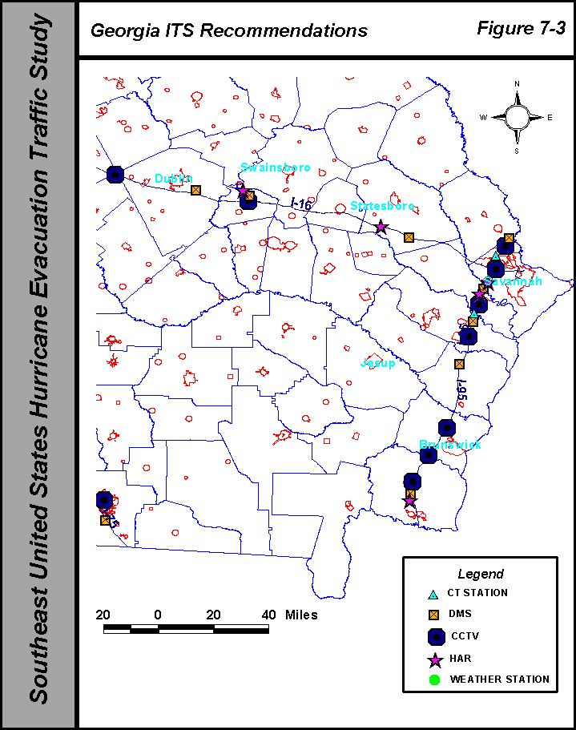

also refined the plan to address various operation issues.

The revised one-way plan includes the use of the following resources:

- 74 Georgia State Patrol officers

- 20 (minimum), 50 (desirable) portable DMS signs along I-16

- 110 GDOT personnel

The Georgia Emergency Preparedness Agency (GEMA) developed a multi-agency task force on evacuation and shelters to study the problems and improve operations specifically associated with Hurricane Floyd. Some of the transportation related recommendations that are being implemented are:

- Coordination with other DOT agencies.

- GDOT has established staging areas for equipment and staff resources

- Contractual arrangements with fuel suppliers to provide refueling services for state and private vehicles during evacuation

- Established a staging area at the State Operations Center for media during evacuations to improve the flow of information to the media and to the public.

- Establishment of a toll free number for public information

- Consideration of comfort stations along the major evacuation routes

- Unified radio system for state agencies

- Implementation of staged reentry

GDOT has developed some decision criteria for implementing a one-way plan. The need to one way will be closely monitored with respect to the coastal counties pending evacuation orders. A final decision to one-way will be made before the issuance of a voluntary evacuation order. They expect the storm will have to be at least a Category 2 to implement one-way plan.

The GDOT Office of Traffic Engineering has prepared a study of what ITS elements should be added in the coastal area to support hurricane evacuation. The draft report has identified signalization and signage needs. This includes isolated, as well as, coordinated signal timing and evacuation route signing. The report has a list of CCTV, DMS, HAR and count station locations that will enhance the evacuation process. GDOT evaluated each site for its usefulness during evacuation but also at all other times. This will help guide the priorities for installation.

Ultimately, GDOT intends to build a replacement traffic management center in the Savannah area that will serve the City of Savannah and their signal system and GDOT’s freeway management activities. In the interim, GDOT will likely construct a temporary traffic management center. GDOT will also be able to control the ITS devices described above from the state TMC in Atlanta.

NORTH CAROLINA

NCDOT had not developed a one-way plan before Hurricane Floyd. During Hurricane Floyd when the traffic congestion intensified on I-40, NCDOT developed a preliminary plan to one-way I-40. The traffic congestion eased, so they did not implement plan. Due to the prolonged and unprecedented flooding in eastern North Carolina, there were significant problems in communicating some 1,500-road closures to the public and to other agencies.

As a result, of Hurricane Floyd the state agencies in conjunction with local agencies have looked at the issues of regional evacuations. NCDOT and others are looking at operational issues along evacuation routes throughout the eastern part of the state. As part of that effort, NCDOT is upgrading many of the closed loop signal systems along the U.S. 70 corridor between Morehead City and Raleigh. The upgrades will provide traffic responsive operation for timing plan selection and the use of predetermined special timing plans evacuation. NCDOT is also upgrading the evacuation route signing along I-95.

NCDOT has developed an operations plan to one way I-40 from the eastern terminus in Wilmington to I-95. This work is a cooperative effort of the Division of Motor vehicles, State Highway Patrol, Division of Emergency Management. The plan includes physical layout of devices such as signs, barricades, DMS and HAR. The plan also includes the location of SHP and NCDOT staff. Figure 5-4 shows the corridor. The plan includes the following manpower and equipment beyond “normal” evacuations:

- 33 State Highway Patrol/DMV officers

- 40 NCDOT personnel

- 27 DMS signs

- 4 HAR units

The plan also addresses the availability of traveler facilities such as food, restrooms, road condition information. The plan has included an analysis of closing certain interchanges. The plan also addresses the public information efforts that are essential to a one-way operation.
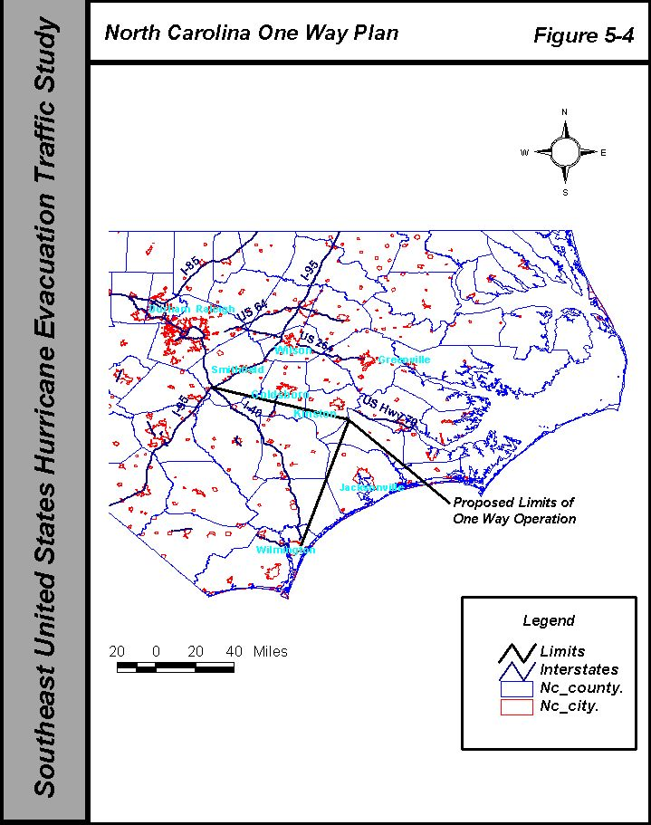
NCDOT staff in conjunction with other agencies has developed a process for approving the implementation of a one-way operation. The recommendation will start with the Division Engineer in Wilmington upward to the Chief Engineer to the State Highway Administrator, Secretaries of DOT and Department of Crime Control and Public Safety to the Governor. The Secretary of Department of Crime Control and Public Safety oversees the State Highway Patrol and Emergency Management Divisions. The process is intended to occur within one hour upon the initial recommendation. NCDOT will mobilize men and materials in local maintenance yards 24 to 48 hours in advance of landfall by loading materials and servicing equipment. Twelve hours before evacuation NCDOT will deploy top assigned work sites and standby to await the actual one-way order. NCDOT has established there will be a local command post on the corridor in Wilmington along the one-way route. Other observers will be positioned throughout the area to observe weather and traffic conditions that will be used to make the one-way recommendation.

They have developed a plan for the deployment of ITS elements that will support future evacuations. This plan includes DMS, HAR, CCTV, count station, weather instruments (wind gauges), information kiosks and traffic signal improvements throughout the eastern part of the state. It includes Interstate, U.S. N.C. route and secondary routes that are primary evacuation routes.

NCDOT has also developed and will make available to the public July 1, 2000 an expanded traveler information website. The website will serve to groups of users. It will be a computerized road condition system to replace a manual reporting system now in use fro DOT and other state personnel. It will provide specific descriptions of incidents, durations and contacts. It will automatically notify of managers of the incidents by email. The system utilizes an extensive collection of pull down menus to expedite the data input. NCDOT’s call center staff will utilize the system to answer citizen calls. The system will also provide citizens less specific information on road and weather conditions. NCDOT will install the first traveler information kiosk in one of the welcome centers on I-95 this year.

SOUTH CAROLINA

The Traffic Engineering Division of the South Carolina Department of Transportation (SCDOT) developed a concept plan to one-way I-26 from Charleston to I-95 after Hurricane Hugo. The plan included one-swaying all lanes westbound to evacuate the coastal areas. Certain minor interchanges would be closed. South Carolina Highway Patrol (SCHP) personnel would staff all closed ramps. After the concept plan was developed by SCDOT, it was reviewed with the SCHP. The plan is a concept that has not been adopted by all state and local agencies and is still currently under evaluation. Therefore, an operations plan has not been developed.

During Hurricane Floyd, the Governor ordered the eastbound lanes of I-26 reversed to evacuate Charleston. The limits of that reversal extended from Charleston to I-95. SCDOT and SCHP personnel used the original concept plan and developed an operation plan on the day of the evacuation to facilitate the reversal. Because of time delays in implementing the one-way operation, and the higher than expected evacuation warning response, traffic congestion was very extensive. The Governor also ordered the implementation of a one-way plan to expedite reentry. The reentry plan was developed during the storm. It included one-swaying I-26 from Columbia to Charleston. State Highway Emergency Patrol (SHEP), a unit of SCDOT, vehicles were used for incident management only on reentry.

This year the state agencies in consultation with local agencies have looked at the regional evacuation issues in depth. One of the key elements of the regional evacuation plan is not have evacuation routes to cross each other. This fundamental principal will significantly reduce inland bottlenecks at isolated locations. This principal will require mandatory turns at key locations. The state agencies are working with their counterparts in Georgia for ways to improve evacuation flow between the two states.

The Emergency Preparedness Division has estimated the clearance time reductions due to a one-way operation. These reductions range from 0 to 60%, depending on the category of storm and the response scenario. The clearance times are as follows:

Year 2000
Central Conglomerate of South Carolina Counties
Clearance Times (hours)

Normal Lane Use I-26 One-Way
Low Tourist High Tourist Low Tourist High Tourist
Category 1 Hurricane
Rapid Response 10.3 11.9 6.2 7.2
Medium Response 10.5 12.2 9.0 9.0
Long Response 12.0 12.3 12.0 12.0
Category 2 Hurricane
Rapid Response 14.3 16.7 8.5 9.9
Medium Response 14.6 17.0 9.0 10.1
Long Response 14.7 17.1 12.0 12.0
Category 3 Hurricane
Rapid Response 18.8 21.8 11.1 12.8
Medium Response 19.2 22.2 11.3 13.0
Long Response 19.3 22.3 11.4 13.1
Category 4-5 Hurricane
Rapid Response 21.8 24.5 12.8 14.2
Medium Response 22.2 24.8 13.0 14.5
Long Response 22.3 24.9 13.1 14.6
Source: South Carolina Hurricane Evacuation Restudy, PBSJ

SCDOT and SCHP revised the implemented evacuation one-way plan. They are extended the limits to I-77 in Columbia. Figure 5-5 shows the corridor. An essential element of the plan is the absence of lane drops. All normally westbound traffic will exit onto an existing two-lane ramp onto I-77. This traffic will circle the city and dissipate onto local streets or rejoin I-26 by way of I-20. The reversed lanes will cross over the median west of the interchange on a paved crossover. A similar scenario exists for reentry. The evacuation and reentry plans include designated emergency access
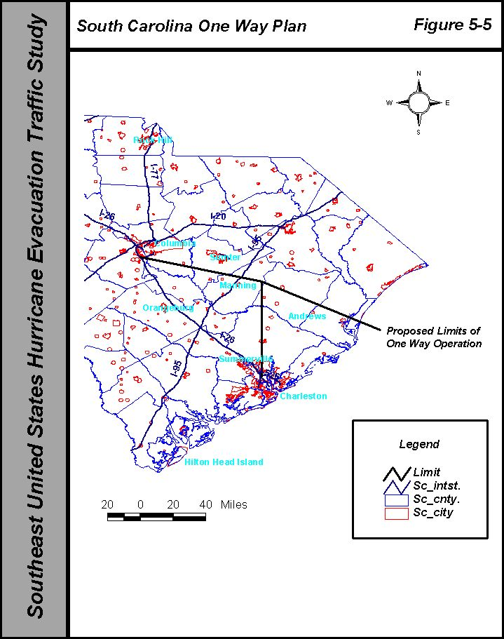
routes to go the opposite direction of the one-way traffic. These designated routes utilize a series of parallel routes between Charleston and Columbia. SCDOT has designated certain critical links for on-site observers during the evacuation to monitor and report traffic conditions. The revised plan will include 200-215 Highway Patrol troopers and approximately 800-900 National Guard troops. The National Guard units will be matched with specific Highway Patrol units to minimize retraining. The National Guard troops will rendezvous with their Highway Patrol and be transported to and from their duty sites to assist in manning barricades. The National Guard will provide commercial versions of the military meals ready to eat (MRE’s), aerial surveillance and wrecker services to move any disabled or wrecked vehicles. The National Guard will also provide wrecker services during the one-way operation. They will be prepositioned at four sites between Charleston and Columbia. Each wrecker will be equipped with an 800 MHz radio set to Highway Patrol frequencies. These wreckers are capable of towing any size vehicle.

State Law Enforcement Division (SLED), Civil Air Patrol and the National Guard will provide aerial surveillance during the evacuation. This will include specific intelligence flights as needed early during the storm’s advancement and continuous flying during the one-way operation as weather permits.

SCDOT and Highway Patrol staff have not developed detailed criteria for the implementation of a one-way plan. They expect to implement the one-way operation for a category 3 storm. The present thinking it will occur no later than the mandatory order and as early as the voluntary evacuation order. Integrated timetables of all participating agencies are being carefully studied for the mobilization so the state has more flexibility to implement on a short notice without overextending staff and equipment during prolonged operations.

SCDOT is constructing an “X” shaped crossover to facilitate one-way operations for evacuation and reentry. The design speed is 45 mph. SCDOT will close the crossover during normal operations with water filled barrier portable wall. This will eliminate the need for any special equipment to move the wall and provide good visibility of the closed crossover, while providing good protection. During an event, a two-person crew can drain the water and move the wall behind.

SCDOT is also constructing some small crossovers to connect various ramps to facilitate access to and from I-26 during evacuation and reentry. Initially, SCDOT plans to close these crossovers with flexible delineators. A flexible delineator is a plastic flexible post with reflective material that attaches to a base plate. The post is removable and attaches to a base plate that is permanently anchored flush into the pavement.

SCDOT is planning to add CCTV at the I-95 and I-77 interchanges with I-26. SCDOT will use leased T-1 communications to feed the video to the traffic management center. SCDOT will also add some permanent count stations. The revised one-way plan will include designated sites for portable DMS signs. They envision having grounding, power, telecommunications and anchoring provisions in place for the next evacuation.

The South Carolina Emergency Preparedness Division moved into a renovated building in April. This facility includes a dedicated emergency operations center (EOC). SCDOT will provide feed their CCTV images to the EOC by leased T-1 communications. At the time of this report that had not been completed.

The SCDOT and Highway Patrol are developing a revised website to provide real time traveler information. It is envisioned the website will include contact names and numbers for information, evacuation routes based upon the user’s zip code.

6.0 DESIGN GUIDELINES AND OPERATIONAL COMPONENTS OF ONE WAY EVACUATION OPERATIONS

6.1 INTRODUCTION

This chapter involves a discussion of issues that will affect the selection and operation of an alternative strategy, designed to expedite the flow of traffic during a hurricane evacuation. Chapter 7 contains the actual recommendations for alternative strategies.

6.2 DEFINITION OF STRATEGIES

There are five basic strategies for freeway operations, for use in hurricane evacuation. Each of these five strategies has different implications of costs (labor and equipment), roadway capacity and safety. This chapter discusses the issues of the alternative strategies and provides guidance in the selection of a strategy. In the next chapter, we present the recommendations. They are:

- Normal lane operation. Vehicular traffic remains in the normal lane configuration without adjustments. The coast-bound lanes will largely go unused. Very large backups can arise as happened during Hurricane Floyd. Public dissatisfaction will be the highest, due to long delays and the relatively unused coast-bound roadway.

- All lanes reversed. This alternative involves shifting traffic over to the reversed lanes. All coast-bound ramps must be closed and barricaded, and some inland-bound ramps must be closed. This operation requires the extensive use of law enforcement personnel and traffic control devices to close the on-ramps and some of the off-ramps to the reversed lanes. The setup of the operation requires the use of a “rolling roadblock” of troopers to sweep the corridor of any coast-bound traffic before reversing lanes. The plan needs additional personnel to patrol the corridor, since they will not have the opposing lanes of traffic to turn around.

- No lanes reversed, and the right side paved shoulder is used as a driving lane. This strategy requires minimal labor to get three or more inland bound lanes. The law enforcement agency must make a sweep of the affected shoulder to clear all disabled vehicles and remove any debris from the roadway. The use of the shoulder will limit the mobility of police patrols.

- One coast-bound lane is reversed, with the remaining coast-bound lanes not reversed. The remaining coast-bound lane is used for public access to the coast. This alternative also provides at least one more inland-bound lane. The public can use the roadway to drive to the coast. This operation requires placing cones or barricades between the two lanes of opposing traffic on one side of the median. The plan needs additional personnel patrol the corridor to prevent vehicles from crossing into the non-reversed lane.

- One coast-bound lane is reversed, with the remaining coast-bound lanes not reversed. The remaining coast-bound lane is restricted to emergency vehicle access only. This alternative provides at least one additional inland-bound lane, while maintaining access only for law enforcement and emergency service vehicles. The public cannot use the roadway to drive to the coast. This operation requires placing cones or barricades between the two lanes of opposing traffic on one side of the median. This concept should lessen the potential of head-on accidents, since there will be minimal coast-bound traffic. The capacity of this contra-flow is no different from the previous alternative.

6.3 IMPACTS OF ALTERNATIVES

Due to the following conditions, the alternative involving the use of three lanes, with a contra-flow lane for public access to the coast, was not given further consideration:

- Very high difficulty to enforce the contra-flow restrictions

- Extensive time required to setup cones and barricades between the opposing coast-bound lanes

- Difficulty in maintaining the cones and barricades between the opposing coast-bound lanes, particularly in deteriorating weather conditions of high wind and rain.

Marginal capacity benefits

In order to accurately compare alternatives, we have categorized the issues into four groups. The categories are costs, geometry, law enforcement, traffic control and other. At the end of this section, Table 6-1 compares the impacts of the four alternatives.

COSTS

The alternatives to the basic normal lane operation will require both capital and recurring or per event costs. As an example, the capital costs will include pavement construction, permanent signing, CCTV, variable message signs, highway advisory radios and other equipment purchases. For normal lane operation, there are no additional capital costs. The three-lane operation using the shoulder will require shoulder strengthening, as described below in the section on construction. The use of the alternatives with three lanes, with a contra-flow lane or all lanes reversed, requires the construction of median crossovers at each end of the section. The all-lanes-reversed alternative requires two-lane crossovers. These last two alternatives will need barricades or other protective devices to close the paved crossovers during normal conditions. In addition, some ramp crossovers are needed to connect certain ramps together to facilitate the reversed direction.

The recurring costs will include the labor and materials expended every time one of the alternative strategies is deployed. This includes:

- Police personnel for patrols and roadblocks;

- DOT personnel to setup, take down and monitor traffic control devices installed;

- DOT personnel to monitor traffic operations and respond to incidents; and

- Traffic control devices (barricades, highway advisory radios, RPM’s, signs and variable message signs).

The normal lane operation would have minimal recurring costs other than additional labor for law enforcement and DOT that would be necessary, due to the very high traffic volumes. The alternative of providing three lanes using the right shoulder will have the next lowest recurring costs. These costs would be necessary for additional police patrols and DOT personnel to monitor the shoulder driving and respond quickly to incidents. Both the all lanes reversed and the three-lane w/contra-flow lane alternatives will have high recurring costs. It is expected that the three-lane alternative would need more police patrols to prevent a head-on accident with the coast-bound lane.

GEOMETRY

The category geometry includes geometric design and construction, as well as traffic operations issues.

Traffic Capacity

As was discussed in Chapter 3, the maximum service volume or the capacity of the roadway during an evacuation is approximately 1500 vehicles per hour (vph) per lane. This volume equates to the Level of Service D directional service volume, as defined in the 1994 Highway Capacity Manual. For other studies, we have computed the following planning level roadway capacities:

Interstate Vehicular Roadway Capacities

Condition Capacity (vehicles per hour per direction)
Normal Two Way Operation 3,000
Three Lane (one contra-flow lane) 3,900
Three Lane (using outside shoulder) 4,200
One-Way (all four lanes reversed) 5,000

The alternative, using the outside shoulder, assumes a full width (10’) paved shoulder and two-foot offset to the guardrail exists. If the paved shoulder is only ten-foot wide with no offset to guardrail, the three-lane capacity is 4000 vehicles per hour.

While each of the alternatives provide 30% to 167% increases in capacity over conventional operation, the selection of the alternative must involve consideration of the geometric conditions and enforcement issues before selection.

Congestion

By virtue of its lower traffic capacity, the normal lane operation will have the highest congestion and the highest driver dissatisfaction. The largely unused coast-bound lanes in normal operation will be a cause of driver frustration as was demonstrated in Hurricane Floyd. The use of the paved shoulder as a driving lane will be an indirect cause of increased congestion. The absence of a paved shoulder will not provide a place to stop disabled vehicles, allow emergency vehicles to pass and accident investigations to occur on the right side of the roadway.

Similarly, the three-lane alternative with the contra-flow lane will have a two to four-foot right shoulder next to the median. This will also not provide adequate room for emergency vehicles to pass. This same alternative will not permit drivers to exit or reenter the contra-flow lane until they reach the end of the contra-flow lane. Due to the high risk of crossing the coast-bound lane on a freeway, it is not possible to allow vehicles to exit or reenter the contra-flow lane.

Design

The two alternatives with lanes reversed will need paved crossovers to transition traffic across from and back to the original roadway. The design must include provisions to adequately drain large amounts of water, which will arrive in the latter stages of the evacuation.

The design speed of the crossovers must consider that higher average speeds will likely occur during the later stages of evacuation as the traffic lightens. Higher speeds can also occur if the DOT and highway patrol agencies efficiently manage the rapidly increasing traffic congestion, without severe degradation of the operating speeds.

Guardrail Treatments

The design speed of the facility determines the requirement for a guardrail on a facility. Standards do not permit the absence of a guardrail and its end treatments if the operating speeds are lower. For any alternative, when the coast-bound lanes are reversed, the formerly downstream ends of guardrails will not have the proper upstream end treatments. The operating speeds during an evacuation are likely to be low and the potential damage due to impact of a guardrail end is less.

Shoulder Design and Maintenance

The three-lane alternative using the outside shoulder will have the only direct impact on the outside paved shoulder. Typically, the first four feet of the paved shoulder is the same design as the adjacent driving lane. The remainder of the paved shoulder has a much lighter construction. Prolonged use of the shoulder as a driving lane, particularly by trucks will decrease the life of the pavement.

Most states use a ten-foot wide paved shoulder on new construction. However, each corridor in this report described in Section 6.2 has bridges with less than full width shoulder. Many of these bridges are relatively small, but others are large, such as the Cape Fear River Bridge on I-40 in North Carolina or the Thomas B. Manual Bridge on the Florida Turnpike. These narrow bridges effectively eliminate the use of the paved shoulder as a driving lane in the short term.

All of the states in the study area use some type of rumble strips to minimize run-off-the-road accidents. The different designs include full width and partial width rumble strips. Some are ground into the paved shoulder; others are cast or rolled into the pavement as the pavement is constructed.

A few states have experimented with a raised, ribbed thermoplastic edge line and extra thick thermoplastic transverse lines across the shoulders. These experiments have not revealed a design that has long life. Generally, the rumble strip is about one foot from the painted edge line and its width is such that the left wheel cannot avoid the rumble strip. The lateral placement of the rumble strip is critical to its effectiveness. Moving the rumble strip towards the center of the paved shoulder reduces the early warning to the driver that he or she has run off the roadway. This increases the exposure to rear-end and run-off-the-road accidents.

Safety

Inherently, any alternative with high congestion and long delays will cause drivers to become frustrated and take dangerous chances. This frustration became evident in Georgia, when drivers began using the eastbound lanes for westbound travel on I-16, before the Georgia State Patrol and DOT were ready. However, all the alternatives except normal operations have higher safety risks because the use of the roadway is not something that violates drivers’ normal expectations. The contra-flow lane alternative has a special safety risk since the cars will be traveling in opposite directions, potentially at high speeds with no restrictive barriers other than cones or barricades.

LAW ENFORCEMENT

The availability of nearby highway patrol officers was one of the most critical factors in the two lane reversal operations undertaken in Hurricane Floyd. The operation of any lane reversing strategy requires anywhere from 67 officers on I-16 in Georgia to 350 officers for I-75. These numbers are tentative based upon preliminary staffing estimates.

Emergency Access

The alternative strategies to normal operations must consider how emergency medical, fire and wrecker services will get access to an incident. Normal access from the opposite direction will not be available in the all lanes reversed strategy. Access will be difficult with the contra-flow lane alternative. The nearest responder may not be the one that can arrive the most swiftly. Dispatchers will have to consider how the responder will get the incident scene. Emergency response vehicles equipped with AVL, automated vehicle location devices and computer aided dispatching can best adjust for these route restrictions.

DOT's and law enforcement agencies must maintain very close coordination with emergency medical, fire and wrecker services. One of the biggest impacts on traffic during the Floyd evacuation was the amount of disabled vehicles from accidents, breakdowns and no gas. People left without enough gas or the prolonged trip caused their vehicles to breakdown or run out of gas. In some areas, wrecker services closed earlier to evacuate.

Incident Management

It has been well documented by FHWA that good incident management provides excellent reductions in accidents (primary and secondary because of an initial accident), congestion and delay. Very high traffic volumes such as that experienced most recently in Hurricane Floyd produce incidents that require immediate action. This may include unanticipated congestion, accidents, disabled vehicles, debris in roadway and weather problems. The operations plan of any alternative strategies must anticipate that these events will happen. Equipment, personnel and the decision-making authority must be in place to respond. This authority would include legal authority to remove abandoned vehicles.

Communication problems constitute the biggest complaint of the four state’s DOT’s and highway patrol agencies. There were situations where highway patrol vehicles could not talk to each other and many cases where DOT personnel could not talk to corresponding highway patrol personnel. An effective incident management plan must permit the decision-makers and field supervisors to be able communicate directly. Not only were there problems with lack of communications, there were situations where communications had to be relayed through two dispatchers. By the time a message arrived at its destination it was often dated, its accuracy was significantly reduced, and therefore it was of limited value.

Patrol Needs

Any event that has higher than normal traffic volumes and congestion requires additional police patrols. However, lane reversal strategies and the use of the shoulder as a driving lane require more officers to cover the same area due to limited access and mobility. When all lanes are reversed, officers may have to use parallel roads to return up above the patrol zone. If the officers have four-wheel drive vehicles, then the patrol vehicles can use the median.

The use of the shoulder as a driving lane necessitates that the shoulder be kept clear of accidents and breakdowns. Any vehicles stopped on the shoulder will cause an immediate backup.

All of the states in the study area have either planes or helicopters available for aerial surveillance. If the aircraft are equipped for the expected weather, then they can be very effective tools to cover a lot of area. Personnel in an aircraft can view any causes and lengths of backups much quickly than personnel on the ground. Aerial surveillance can give an initial assessment of a situation faster than the use of other methods.

Roadblock Needs

The states of South Carolina and Georgia learned from actual experience that only uniformed law officers are effective in controlling traffic. In similar situations, the other states have recognized the same problem. Drivers disregarded DOT personnel and DOT personnel do not have the power to detain or arrest drivers if there is an incident. Therefore, when ramps or roadways must be closed, law enforcement officers must staff the roadblocks and direct traffic.

TRAFFIC CONTROL

Barricades and Protective Devices

Barricades and protective devices include cones, barricades, barrier walls and devices intended to warn, alert and protect drivers from hazards and guide them through area. The weather, lighting conditions (day versus night) and the purpose of the device, dictate the type of device to be used. Nighttime or low light conditions require that retro-reflective material that reflects light be applied to the cones or barricades. Battery powered steady burn and flashing lights on barricades provide additional target value and guidance.

Type I barricades, cones and vertical markers are not suitable for hurricane evacuation, due to the potential of wind instability. Type II barricades and drums are used to guide drivers through an area. Type III barricades are used to close off ramps. Temporary barrier walls provide more protection, but they are also considerably more difficult to place. The temporary barrier walls are typically concrete and weigh 450 pound per linear foot. This equals to 4500 pounds for a standard ten-foot wall section. This would require a heavy forklift or loader to move. There are approved water filled barrier walls that can easily be drained and moved by two people.

There are long-term solutions that will lessen the demand on law enforcement officers and their vehicles at every roadblock. The choice of a solution must consider the popularity of sport utility vehicles and their ability to drive off the roadway. The long-term solutions must be very visible, able to discourage most drivers, be tamper-proof and not be a safety or view obstruction in normal operations. Some viable alternatives include:

- Lockable swing gates with pre-mounted road closed signs

- Extensions of existing fencing

- Removable guardrail sections

- Delineator posts

- Landscaping – bushes and embankments

The various paved crossovers in the median and the ramps must be blocked, so during normal operations a confused driver will not drive the wrong way and cause a head-on collision. Any decision-making regarding these devices must take into account the fact that no obstacle requiring protection should be in the clear zone. As an example, the use of a concrete barrier wall would require approach-end crash attenuators, if placed in the clear zone of the roadway. The closure method must include devices that are easily opened with heavy or special equipment.

During normal operation, the devices closing the crossovers must clearly indicate the crossovers are closed. In some cases, the closing device must provide adequate guidance to the drivers for the proper alignment of the vehicle. For example, a crossover on a curved ramp will need to properly convey the crossover is closed and the ramp curves in a particular direction. Reflective delineators on the devices are an excellent low maintenance means to do so.

One important aspect in the selection of devices for any purpose is the ability to transport and place them efficiently. The element of time is critical to implement one of the alternative strategies. A plan which requires excessive time to load equipment and place traffic control devices will lose the advantage of its increased capacity, because less time will be available for the actual operation of the alternative strategy.

Raised Pavement Markers (RPM’s)

Most DOTS’ install one-way, raised pavement markers (RPM’s) along the painted lane lines. This is fine, except when traffic is reversed during a nighttime evacuation. The MUTCD stipulates the colors shall be white, yellow or red. The white RPM’s, sometimes referred to as colorless, are for use on lines separating traffic in the same direction. Yellow RPM’s are used to separate traffic moving in opposite directions. The red RPM’s denote prohibited movements, for example the wrong way on a ramp. The MUTCD does not require, but most states do require, the use of RPM’s with all pavement marking lane lines.

Signs

Signs are an essential element to good traffic control. The absence of signing will cause confusion about one’s location, where services are located, and what movements one can make. If we do not provide signs to communicate this information, then drivers will stop and ask directions. The act of stopping to get information will limit the effectiveness of the police officers directing traffic, cause congestion and raise driver dissatisfaction. The use of good signing will lessen the demands on the police officers.

During an evacuation, people often leave their origin, unsure of their destination or how they will get there, with no route familiarity. Evacuation is complicated in a lane reversal strategy when there are no signs facing traffic in the reversed lanes. People will lack information about where they are and where services are, as was evident in Floyd.

If an agency uses a highway advisory radio, then public must know it is operating and what frequency to use. Static signs can provide that information. Remotely operated flashing lights on the fixed signs can advise the public the highway advisory radio is operating.

The closure of ramps or reversing of roadways will require the use of signs to control undesired movements. This will include regulatory signs concerning the road closures and informational signs to guide drivers to certain services and shelters. The regulatory signing also provides the regulatory authority to enforce the operations.

OTHER

The category of other includes issues that did not readily fit with other issues. This category includes four very critical issues, the limits of the one way plan, when to implement a strategy, the time to mobilize and the time to implement.

Limits of One-Way Plan

The timing used to terminate an alternative strategy is critical to prevent the termination point from being the cause of a bottleneck in traffic. This issue applies to any of the alternative strategies, which are: three lanes with a contra-flow lane, three lanes with the shoulder or reverse lane operations. The most basic indicator of the termination point involves when the traffic volumes have reduced to a level where normal lane operations can take place at a reasonable level of service. This reduction can be facilitated through one of three methods.

One, there can be route diversion where traffic has already diverted to other parallel routes. Certain routes have usable parallel routes that can serve as a relief. Examples are: U.S. 90 that parallels I-10 through the entire length of North Florida, portions of U.S. 441, which parallels I-75 through Florida, sections of S.R. 46 that parallels I-16 in Georgia, U.S. 117 that parallels I-40 in North Carolina and segments of U.S. 78, U.S. 176 and U.S. 178 that parallel I-26 in South Carolina.

Two, the geometry of the proposed termination can provide a natural lane reduction onto another facility. An excellent example is the I-26 one-way termination in Columbia, S.C. The lane reversal operation terminates at I-77. The normal westbound lanes exit onto I-77 onto a two-lane exit ramp. Traffic can then rejoin I-26 at I-77/I-26 interchange or traffic can exit at other locations on I-77 into Columbia or continue north. The reversed lanes use a crossover beyond the I-77 exit ramps to move onto the westbound lanes of I-26. In this example, there is no lane reduction.

Three, lane widening can provide another natural termination point. In this situation, the strategy encourages traffic flow toward a widened section of roadway. The added lane(s) for the widened roadway can serve as point to move traffic to the original alignment. An example of this is I-26 in Charleston. SCDOT is widening I-26 west of I-526. The added lanes could provide an opportunity in their reentry plan to move the reversed lanes from the westbound side of the roadway back to the eastbound roadway.

Plans for reversed lane and contra-flow operations, must include provisions that address how the two-way operation will terminate and the one-way operation will begin. The traffic must merge to one lane and then exit onto another facility. The design of the transitions must consider the posted and operating speeds to affect a safe transition. Signing with flashing arrow boards and dynamic message boards are essential elements.

When to Implement a Strategy

There are two elements entailed in the issue of a timeframe for strategy implementation. One, what hours will the alternative strategy operate? Two, when do we implement the strategy? There is no clear answer to those questions. The initiation of the alternative strategy must begin with a determination of how long will it take to evacuate, with some margin of safety, the vulnerable population by the various alternatives. That decision will determine the starting time of the alternative strategy implementation. The mobilization and the implementation time will bring about that decision time earlier.

Florida has developed a multi-page checklist that guides senior management in the determination the criticalness of the present situation. The checklist evaluates the present weather and traffic conditions with the past conditions and those forecasted to determine if conditions are worsening and pointing to a one-way or another alternative strategy. While the checklist does not provide a quantitative score, it guides senior management to consider all factors to arrive at the most educated decision with the data currently available.

The staff of each state generally believes a one-way operation should not be used for anything less than a category three storm.

The hurricane evacuation clearance times of many vulnerable areas exceed the time necessary to precisely forecast landfall. The National Hurricane Center issues the hurricane watch 36 hours before the damaging winds are predicted to make landfall and the hurricane warning is issued 24 hours before landfall. In many cases, the evacuation and an alternative strategy must already be underway to ensure the safe removal of the vulnerable population from the storm’s path, before the announcement of a more accurate landfall locale. It is harder to manage the response to a parallel storm, such as Floyd, because it affects a larger area and potentially requires a larger evacuation. A rapidly developing storm, close to the coast could leave the state agencies a very narrow window to respond. The one-way operation should be in place no later than the mandatory evacuation. Strong consideration should be given to having the manpower and equipment and equipment either deployed and standing by for the order to begin shut down or to deploy to forward staging areas. An important consideration will be how much rest the staff has had before beginning 12-hour shifts. If the manpower is deployed shortly before the voluntary order then it may be necessary to undergo a shift change about the time of the mandatory evacuation.

Obviously, it will be necessary to mobilize long before the storm’s path is accurately predicted. This expense will have to be considered.

There is inherent risk in running an alternative strategy during nighttime hours. The darkness can add to the confusion. The darkness limits the visibility of the DOT and police personnel and any special traffic control devices. In Hurricane Floyd, South Carolina operated the one-way plan during the night, due to a late start. The benefit of running the alternative through the night may make the difference in successfully evacuating everyone. Far greater negative consequences would result from leaving evacuees stranded on the road as the storm hits.

Implementation Time

For normal lane operation, there is no implementation time. The use of the shoulder lane as a driving lane will require a patrol sweep of the corridor, to ensure the shoulder is clear of all vehicles and debris. DOT or the highway patrol agency must remove any vehicles on the shoulder before commencing operations. Debris on the shoulder was the source of many flat tires on I-16 in Georgia. The lane reversing strategies require a lot of staffing (DOT and highway patrol) and equipment to remove disabled vehicles, close ramps, setup temporary traffic control, close and sweep the lanes of coast-bound traffic before reversing traffic. The estimated timeframe for lane reversal is approximately three to four hours, and varies by corridor.

Mobilization Time

Mobilization time is the time required to notify personnel and load and move personnel, equipment and materials to the corridor. Alternatives requiring many personnel that are not locally available will have to include additional travel time. For example, the North Carolina Highway Patrol would have to move troopers from the western part of the state. This process could take between three to five hours to execute. State officials would have to notify the National Guard, which would take upwards of twelve hours to mobilize.

Special or unique equipment, such as barrier wall moving equipment or highway advisory radios, would require transportation from central depots or job sites.

For normal lane operation, there is no significant impact from mobilization time. The use of the shoulder lane as a driving lane requires minimal preparation. Lane reversal strategies, on the other hand, require the mobilization of a lot of personnel (DOT and highway patrol) and equipment.

Toll Collection Facilities

The geometry of the toll collection plaza, with the large paved apron approaching and departing the toll plaza, provides an excellent location to cross over traffic to the other side of the median. However, one must consider that most toll plazas do not have attenuators protecting all the islands. The downstream ends of the non-reversible lanes typically do not have the attenuators. During Hurricane Andrew in Florida, the toll islands were hit frequently. To protect the state's investment in the equipment, the coin machines were removed during the reentry process to minimize damage.

A toll facility is not only a source of revenue collection. The facility can also present a capacity restriction for a roadway. The plaza building and the money transaction process limit the free flow of traffic. If a storm is imminent, the toll agency needs to monitor traffic conditions and prepare to potentially cease toll operations.

6.4 SELECTION OF STRATEGY

The selection of any alternative strategy must involve a consideration of the geometric factors, and the ability of the law enforcement agency to patrol and manage the operation. Foremost in the decision process to use an alternative strategy is whether the alternative strategy reduces the clearance time. In the study conducted for Florida Department of Community Affairs, Division of Emergency Management, PBS&J found, for a limited number of storm scenarios, the evacuation process would benefit from a plan to one way I-75, Alligator Alley, in south Florida. Therefore, well before hurricane season, the initial screening of alternatives must include a determination of whether the corridor is fully utilized as an evacuation route. Corridor utilization will not be a problem for the Interstates 16, 26 and 40 in Georgia, South Carolina and North Carolina. In Florida, with its peninsula shape, careful thought must be given that an evacuation of one coast does not place the evacuees in the path of the storm if it changes direction and affects the other coast.

However, one-waying an interstate does not guarantee the evacuation clearance times will be substantially reduced. To assess the benefits of one-waying an analysis of the upstream and downstream links is necessary to ensure there are not other bottlenecks or constrictions that will affect the clearance times. It is reasonable to expect that increasing the capacity of an interstate facility will require other improvement measures at the downstream of the one-way limits to accommodate the increased traffic volumes. These measures should include geometric changes, signal timing, alternate routes and other measures to divert traffic onto other routes where capacity cannot be obtained through temporary or permanent solutions.

The actual experiences of Georgia and South Carolina can be invaluable in other states’ efforts to develop alternative strategies.

REENTRY PLAN

The states, with the exception of South Carolina, consider the use of alternative strategies for reentry to be entirely different from the use of those strategies for evacuation purposes. The Governor of South Carolina has mandated that the state shall use a one-way plan for reentry after a hurricane. The other states consider the reentry a non-life-threatening situation. It is their position that after a storm, eminent danger does not exist. Public agencies need to control and manage the reentry process to make the area safe and passable, by removing downed power lines and completing basic debris removal to open essential roadways. In addition, law enforcement agencies need to limit access to protect private property and prevent criminal activities.

Table 6-1

ALTERNATIVE STRATEGIES IMPACTS AND BENEFITS
Operation →  Feature ↓ | Normal | 3 Lanes w/Contra- Flow | 3 Lanes w/ Shoulder | Lanes  Reversed
Costs
Capital | Very Low | High | Low | Medium
Recurring (per event) | Very Low | High | Low | Medium
Geometry
Capacity | Lowest | Low | Medium | High
Congestion | Highest | Medium | Medium | Low
Design | None | Medium | None | High
Guardrail Treatments | No Change | Medium | Low | High
Shoulder Design and Maint. | No Change | Low | High | Low
Safety (Low = less desirable) | Low | Lowest | Medium | Medium
Law Enforcement
Emergency Access | Lowest | Low | V. Limited | Limited
Incident Management | Lowest | Medium | V. Limited | Medium
Patrol Needs | Lowest | Low | High | High
Roadblock Needs | Lowest | Medium | Medium | High
Traffic Control
Barricades | None | High | Very Low | Medium
Highway Advisory Radio | No Change |  | Low | High
RPM’s | No Change | Medium | No Change | High
Signs – Permanent | No Change | Medium | Very Low | Medium
Signs – Temporary | No Change | Very High | Very Low | High
DMS | No Change | Very High | No Change
Other
Implementation Time | None | Very High | Very Low
Mobilization Time | None | Very High | Very Low

6.5 OPERATION OF SELECTED STRATEGY

The successful operation of an alternative strategy requires very close coordination with the emergency management agencies, law enforcement agencies and the state Department of Transportation. No agency can make one of these strategies work without the other agencies’ full cooperation and assistance.

PRE-SEASON PLANNING

Before the hurricane season, the agencies must make plans for the season. This includes making sure equipment is in working order and pre-deployed as planned and materials are stockpiled. However, it also should include training exercises to test the plan. These exercises provide excellent tests of plans not under live conditions. Evacuation exercises consist of tabletop and fields exercises to:

- Validate one’s plans

- Test the readiness of the agencies

- Test assumptions of the plans

- Train the staff

- Develop a working relationship with sister agencies

- Response to unanticipated problems through inserted scenarios

- Test mobilization, deployment and implementation times

- Crosscheck each agency’s timetable for activities and what the impact if the assumptions are changed.

- Test interagency and multi-agency communications systems

This can occur without the added stresses of an emergency condition. The State of Florida has undertaken these types of exercises yearly for hurricane evacuation planning. This year they undertook a field exercise to mobilize and deploy personnel and equipment for a one-way evacuation westbound on I-10. Georgia mobilized and almost implemented their I-16 one-way evacuation plan twice, but stopped as traffic eased. This operation proved to be an excellent training opportunity and revealed the need for specific refinements in their operation. South Carolina conducted the field and tabletop exercise to one-way I-26 from Charleston and Columbia.

During the course of each year, changes will occur to the evacuation routes. Construction work may create bottlenecks. Accidents may damage evacuation route signs. Periodically each year, and during the development of a new evacuation route, the maintaining agency should periodically perform field inspections of the evacuation routes to ensure maintenance problems do not become an issue during an event.

EVENT OPERATIONS

During a storm, the responsible agencies must consider and put into effect, actions which will make an alternative strategy successful. These elements include: incident management, a good operations plan and strong effective communications.

Incident management includes not only managing on-scene events, such as traffic accidents and vehicular breakdowns, but also includes an organizational structure designed to manage the unexpected. Problems will arise. How these problems are managed is instrumental to the plan’s success. Each state EOC needs to designate an event or incident commander to solicit the input of team members and make the command decisions when a problem arises. A procedure must be in place if unexpected problems arise what will be process to allow deviation from the plan and who will make those decisions. This would include weather problems, equipment problems, accidents or other unforeseen problems.

An operations plan details the specific assignments and duties of all staff. It describes the decision making process. The plan also describes where the staging areas will be, and what redeployment activities must be launched to initially protect assets, for example, personnel and deployment for clean-up operations.

During a hurricane evacuation, agencies will be working very closely together under high stress. Communication will be critical. Communication activities will include basic conversational discussions, as well as the ability to communicate remotely. It is essential that each agency staff be able to speak the other’s language. For example, aerial surveillance reports provided by another agency for the highway patrol must be communicated using terms that make the information useful. A description stating that traffic is moving does not provide much factual data. Having that information then relayed over different radio systems to the highway patrol further limits its usefulness. To overcome the problems discussed in the previous example, cross training will be a necessity. In addition, means for direct communication will be important, as well.

7.0 IMPLEMENTATION RECOMMENDATIONS

7.1 GENERAL

This chapter presents our finding and recommendations for both one-way operations and ITS applications to support hurricane evacuation. This chapter also describes some other non-ITS solutions to support hurricane evacuation. We have divided the chapter into two major sections: one-way operations and specific state recommendations. We have divided the state specific recommendations into two categories: ITS applications and non-ITS solutions.

7.2 ONE WAY OPERATIONS

This section includes our recommendations for the selection of an alternative and a discussion regarding which design guidelines each alternative should include.

SELECTION OF STRATEGY

The three-lane alternative, which includes the use of a contra-flow lane, and the use of the coast-bound lane for emergency access, is not a viable candidate for further consideration. This alternative takes longer to setup than the all reverse-lane alternatives. The three-lane alternative has a significantly lower capacity and is inherently less safe. Therefore, we have dropped this alternative from further consideration. Two alternatives to normal lane operations are viable. They include, the three-lane alternative, which includes the use of the paved shoulder, and reversing all lanes. How is the alternative selected? A fatal flaw analysis can determine the appropriate alternative for the near-term period, during the pre-season planning for future events. What are the fatal flaws to alternative selection?

Normal Lane Operations

- Does the facility have the capacity to meet the expected demand within the available time to evacuate?

- Can the evacuation be made safely considering the levels of congestion?

- Does a normal lane operation meet the reasonable expectations of the public?

Three-Lanes with Shoulder

- Are shoulders with offsets to obstacles at least ten feet wide?

- Are the shoulders in good condition?

- Will the use of the shoulder result in sufficient capacity to move the expected volume of traffic?

All Lanes Reversed

- Is there time to construct paved crossovers and other items?

- Is there sufficient personnel and equipment to implement such an operation? If not, can we find alternatives?

The long-term decision will be policy matter. The state must weigh whether it should reconstruct shoulders, widen bridge decks and possibly move obstacles to use the shoulder as a driving lane, or whether to spend construction money to build crossovers, buy traffic control devices and spend more recurring costs per event to use a reverse lane operation.

GEOMETRY

Design

We recommend that the design of the paved crossovers include recognition that a smooth one-way operation may yield near normal operating speeds. This is evident with the reentry plan used by South Carolina, where “high” operating speeds were reported. We recommend that on the paved crossovers utilized, a design speed of 55 mph is considered. This design will minimize safety problems and decrease the potential for the use of the crossovers to create a bottleneck, due to their geometric design.

Guardrail Treatments

The one-way reversal of a facility will place the downstream ends of the guardrail and the lap joints of the guardrail facing on-coming traffic. Any project to correct only the downstream ends could prove quite expensive. This type of project would require the removal of sections of guardrail ends and flaring back the guardrails with upstream end treatments. No mechanism exists for correcting the lapping joints of the sections of guardrail. The states need to recognize this absence as a risk posed by the use of the one-way plan, during an evacuation.

Shoulder Design and Maintenance

Prolonged use of the shoulder as a driving lane during hurricane evacuations will have a detrimental impact on the life of the shoulder. Truck traffic will only make the situation worse. It is impractical to assume signage will effectively prevent trucks from using the paved shoulder. A significant amount of temporary signage would be required to restrict trucks to normal driving lanes. Therefore, we recommend the shoulders be reconstructed for higher traffic loads, to create a long-term solution.

Shoulder width has a significant impact on the capacity of the shoulder as a driving lane. The absence of a two-foot offset to the guardrail recommend by AASHTO reduces the capacity of the shoulder by 83%. We recommend, if the shoulder lane is considered as part of a long-term solution for hurricane evacuation, the states must then recognize that capacity will be substantially reduced, unless, where practical, the guardrails are offset. The states may also wish to consider relocating guardrails, if possible.

LAW ENFORCEMENT

Emergency Access

Both the use of the shoulder as a driving lane and reversing lanes will restrict emergency access along the evacuation route. This reduction in access will increase response time. The emergency medical and fire departments should consider the possibility of pre-positioning units, to lessen then impact of the reduced access. Any response vehicle must be equipped for driving on wet shoulders and across medians. Four-wheel drive vehicles may be best suited for this purpose.

Incident Management

Any implementation of an alternative strategy, such as the use of the shoulder, or reversing lanes, requires a designated field command structure to oversee the operation and make decisions when problems arise. This structure will expedite the removal of accidents and disabled vehicles, and allow the closing of ramps, when backups occur. CALTRANS has estimated that the closure of a lane for a single minute delays each car four to five minutes. By this rationale, a twelve-minute lane closure will create an hour delay, per vehicle.

To expedite lane openings, the state agencies need to make provisions for vehicle removal. Motorist’s assistance patrols and police vehicles equipped with push-bumpers can expedite this process. This process will often include other, more difficult removals. There will be the need for wreckers, and the repair of flat tires and refueling. State agencies should have provisions for wreckers, not on call, but on-site. Rather than pay a wrecker by the call, a state could contract their services by the hour, so that they will remain on the corridor as long as necessary. Another option is the use of National Guard wreckers. These wreckers are typically capable of moving any street legal size and weight vehicle.

Incident management goes beyond the regional and state level. Hurricane Floyd demonstrated the need for interstate coordination with adjacent states. Conference calls with emergency managers provide excellent preparation and coordination with those involved. Conference calls are now used as statewide tools within each state. The next step is to involve the adjacent states. This is discussed further in Section 7.5.

Patrol Needs

As discussed above, law enforcement patrols will likely need four-wheel drive vehicles to cross the medians, if an alternative strategy is used. Aerial surveillance can lessen the need for additional patrol units to cover an area that has restricted access. Aerial surveillance is a more proactive method of locating developing problems. We strongly recommend the use of aerial surveillance.

Roadblock Needs

Each state’s one-way plans have identified, in most cases, the fact that law enforcement staffing needs far outweigh the staff that is available locally. Each state has learned that the only effective deterrent to wrong way movements at closed ramps is the presence of uniformed officers. Each state must find a way to resolve this issue. A hierarchy determines where personnel should be recruited. The first priority is uniformed officers experienced in traffic enforcement; the second priority is other uniformed officers such as marine police, campus police, wildlife and forest rangers. The third priority is investigative officers that typically do not have traffic enforcement experience. The last priority is staff from other agencies such as DOT or the National Guard.

The use of this mixture of officers will require training and the acquisition of equipment, such as vests, raingear, flashlights, flares, etc. Officers with different experience levels should be assigned together. Since recruits from the National Guard and DOT have no powers of arrest, and similar staff from other agencies will have limited experience with traffic control, they should be assigned to officers and personnel with the necessary authority and experience.

TRAFFIC CONTROL

Barricades

The use of the shoulder as driving lane does not require any barricades, unless the state desires to close certain exit ramps to limit access to and from the evacuation route.

The reverse lane operation requires an extensive barricade plan to close ramps to prevent wrong way movements. Wind is a consideration in later stages of the evacuation; therefore, we recommend using the larger Type III barricades. The size of these barricades makes them more effective for use in roadway closures, mounting signs. They are also more visible than other barricade types, and remain stable in high wind. The arrangement of the barricades, to close either the upstream or the downstream end of a ramp, must effectively discourage wrong way movements. The arrangement of the barricades must force a driver to consciously maneuver around the barricades.

Raised Pavement Markers (RPM’s)

The MUTCD mandates certain colors of the RPM’s relative to driving direction, as discussed in Chapter 6. The RPM’s, while very beneficial in low light and inclement weather, also have legal implications. If white RPM’s are installed in the contra-flow direction, this action will violate MUTCD requirements. We recommend no change to the RPM’s, for reversed lane operations.

Signs

The use of the shoulder as a driving lane does not require special signing. However, signs are needed for four primary purposes in a reversed lane operation. One need concerns location information. The addition of milepost signs is the most basic solution. Second, evacuees need information about exits or destinations. We recommend the addition of sign panels, which provide mileage information to control cities for the reversed lanes, to the backside of mileage destination signs. FHWA designates control cities to provide consistency in signing along a corridor. Third, if a state allows traffic to exit from the reversed lanes, at a minimum, a temporary exit direction sign is needed at the beginning of the ramp. The easiest way to achieve this goal and make the message large enough is with portable dynamic message signs.

The closure of ramps requires that certain regulatory signs be installed, to provide legal authority to law enforcement officers and provide clear direction to the driving public. The basic road closed signs can be pre-mounted on the barricades used to block the ramps. Portable barricades do not elevate the signs high enough for good visibility. In addition, the barricades are not stable in high winds. We recommend that DOT’s use flip-type signs. The flip-type signs are hinged and fold down. They display no sign face when not in use. The use of these signs will minimize the need to bring a crew out to set posts and mount signs.

OTHER

Limits of One-Way Plan Operation

Section 7.3 described methods of terminating the one-way operation. The preferred hierarchy of methods is:

- Terminate without lane drops onto other facilities

- Terminate after traffic has diverted sufficiently onto parallel routes

- Terminate onto a widened section, particularly approaching an urbanized area.

- Terminate where the geometric alignment provides good sight distance and room for traffic control devices.

Hours of Operation

The lead-time to implement any alternative strategy is longer than one has for an accurate forecast of the storm’s path. It is preferable to begin a one-way operation in the morning to maximize the use of natural light. This provides a safer environment for both the police and Dot personnel and to the public. Figure 7-1 shows the events leading up to the landfall of a hurricane. Late developing, close-in storms could leave precious little time to effect a complete evacuation. The state agencies’ plans must allow for nighttime operations. This means reflective clothing, flashing lights on police vehicles, lights on barricades and, in some cases, portable lighting. Portable lighting should be used in high accident areas.

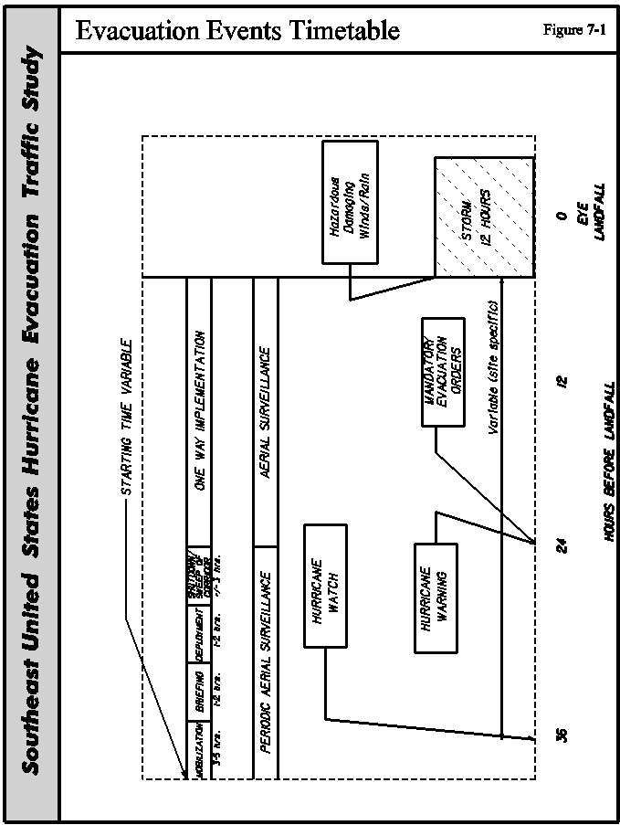

When to Implement a Strategy

Each state should prepare an analysis as discussed for South Carolina in Section 5.2. This analysis will determine the potential clearance time reductions will realize for certain scenarios of category storms, response rates and tourist occupancy. This analysis with estimates of current tourist occupancy and traffic data to gauge the behavioral response can guide senior management towards a decision whether to employ an alternative strategy. There is not sufficient data to correlate traffic counts and weather information with behavioral response to generate quantitative estimates of when certain traffic counts should trigger a one-way operation.

Similarly, weather conditions must be considered. This should include a comparison similar to what Florida has developed that compares past conditions, present and forecasted conditions to see a trend of what the storm might do. This comparison considers the storm intensity, track, angle of approach, wind speed, air pressure.

We recommend that for appropriate storms as identified by an analysis similar to that prepared for South Carolina each state be prepared to implement an alternative strategy no earlier than the voluntary order and no later than the mandatory order. This is a twelve order maximum window. If the mobilization and forward staging were based upon the mandatory order then a rapid change in traffic conditions would not give the state ample time to respond.

Mobilization Time

Each state needs a plan that includes pre-positioning equipment and materials. This includes arrow boards, signs and barricades. DOT’s should stockpile special use items, such as dynamic message signs and highway advisory radios. This stockpile must be convenient to the evacuation corridor. The stockpile of equipment and materials must be large enough to meet all of the needs for the evacuation strategy, with some reserve. If a DOT cannot acquire adequate nearby stockpiles, then they need a good inventory of the locations from which equipment can be transferred. This inventory should identify the availability of each piece of equipment. We recommend that each DOT not rely on contractors and vendors to supply barricades, dynamic message signs and highway advisory radios. Experience has proven this does not always work. The contractors and vendors have obligations to secure their work sites and own equipment. As a result, they may not be able to respond quickly enough if the equipment is available.

REENTRY PLAN

Reversed lane operations and use of the paved shoulder as a driving lane have some inherent safety risks, due to their unconventional and unexpected use. The major decision to use alternative lane operation is the presence of eminent danger. The concern of eminent danger does not exist after the storm. The evacuation is very disruptive and causes personal concern for injury or loss of family members, pets, property and businesses. The immediate concern for the state and local agencies after a storm is rescue and recovery. This includes removing live utility lines and opening major streets for emergency, law enforcement and public agency vehicles. The second concern is the security and protection of property damaged or abandoned during the storm. The agencies do not need the mass of traffic an alternative lane operation would carry into the area. We recommend that reentry plans not include alternative lane operations in order to give state and local agencies the time to secure the area and make an initial clean-up effort to open essential roads. This will serve to prevent further injury and damage.

7.3 OPERATION OF SELECTED STRATEGY

PRE-SEASON PLANNING

We recommend the state agencies conduct training off-season exercises to prepare and acquaint the different agencies. GDOT personnel were, in some ways, fortunate to have had two planned implementations of the one-way plan called off at the last minute. GDOT had mobilized and sent staff to their assigned positions with their equipment for two hurricanes. Each event provided a practical and invaluable training exercise that permitted GDOT to fine tune their plan before its actual implementation. Florida and South Carolina are greatly benefiting from their one-way exercises. Their exercises tested the thoroughness of the plans, each agency’s timetables and their interaction. In some cases, these exercise exposed minor flaws or glitches that need further development. As an example, the construction of the new Emergency Operations Center in Columbia severely limited portable radio communications to and from the building. These exercises also provide a forum to discuss with all the agencies any changes to the assumptions of the plan. As an example, if the State feels they should be prepared to implement a one-way operation at the beginning of the voluntary evacuation order, then this advances the mobilization and staging of equipment and materials. This might overextend certain critical assets such as pilots. These exercises provide a test and a place to discuss these types of issues.

EVENT OPERATIONS

A good communication network is the foremost concern of all DOT and highway patrol agencies in the study area. We have cited some examples where these agencies needed to communicate, and were prevented from doing so, due to failures involving their individual radio systems. Direct communication is essential. Each state’s DOT and highway patrol agencies need to have radio systems that can allow them to communicate directly, at least at the supervisory level.

Many DOT’s and Highway Patrol agencies utilize cellular telephones to aid in their normal duties. These agencies units share the commercial bandwidths with commercial and private users. Users overextend the capacity and available bandwidth of cellular systems during significant weather. Transmission towers go off-line due to damage or power outages. We recommend the agencies do plan to rely on cellular phones for the communications.

7.4 ITS APPLICATIONS - IDENTIFICATION OF EARLY DEPLOYMENT

This section discusses the suitability of the ITS technologies, reviewed in the previous section, for early deployment. The criteria used in this assessment include:

- Benefits: A high priority should be placed on those ITS elements that are associated with high user and system benefits, during the evacuation process. The benefits of elements should be determined during non-hurricane activities. Benefits should also be determined, based on the degree to which each of the elements can address hurricane evacuation user needs.

- Costs: Both the initial cost, (non-recurring) and management and operating costs (recurring) costs, should be considered when selecting ITS technologies.

- Established benefits: Technologies with established benefits are those that have been implemented in several locations around the nation, which is an indicator of the potential demand for these technologies. In addition, the deployment of these technologies should have demonstrated tangible benefits in an operational setting. Thus, they are candidates for early deployment, since a limited amount of risk is associated with their deployment.

- Enabling technology: An ITS technology is a candidate for early deployment, if it enables the implementation of a range of other technologies that are also useful in addressing hurricane evacuation needs.

- The availability/maturity of the technologies: One of the important factors in technology selection is the availability and maturity of the technologies. Early deployment should not rely on technologies that do not exist, or may prove too costly and/or unreliable for commercial applications.

- Existing/planned system: A technology is a candidate for early deployment if it has already been included in existing/planned ITS systems in the region.

- The implementation, operation, maintenance and institutional issues associated with the deployment should be considered when selecting the early winners.

The following sections present a discussion of the technologies reviewed in the previous sections.

Surveillance Systems

Surveillance systems are good candidates for early deployment. The information gathered by network surveillance is required by most other ITS services. In addition, the benefits from deploying surveillance systems are well established, and several vendors are available to offer competing surveillance technologies, indicating the maturity of the technologies.

A key component of surveillance system is data gathering. Data gathering includes video images, visual observations, traffic count data (volume, speed, vehicle classification and passenger occupancy) and weather information. A well-developed system of automated data collection stations is essential in the decision-making, incident monitoring and information dissemination to the pubic.

Planning units typically operate and maintain the permanent count stations on the DOT highway systems as part of long range planning efforts. These count stations are invaluable because they typically have the ability to collect, save and transmit count data very accurately with minimal human interaction. They do not require employees to get in traffic to set counter hoses, etc. Many of states use software that is cumbersome for quick collecting and reducing of the data. Newer software provides quick reduction, saving and plotting of the transmitted data. The design of the older equipment did not permit bi-directional counting. For situations where lanes may be reversed, then the older equipment needs to be replaced.

The surveillance system costs could be high, particularly if full coverage of the evacuation routes is required. Thus, careful evaluation of the needs will be necessary, when selecting the technology type and deployment locations of CCTV cameras and detectors. The co-location of several devices together, where practical, will reduce communication and power service costs. DOT’s should utilize data from existing and planned surveillance systems on the evacuation routes and adjacent routes.

Transportation agencies are considering aerial surveillance during the evacuation process. This could be a cost-effective alternative to infrastructure-based surveillance, realizing the limitations of aerial surveillance listed in Section 5.1. Probe surveillance, based on vehicles equipped with equipment that supports toll collection, is presently too expensive for hurricane evacuation applications, due to the high costs of the roadside readers. However, if proven accurate, emerging probe surveillance technologies, such as tracking vehicles based on cellular telephone calls, could be a cost-effective alternative to determine travel time on evacuation routes.

During recent evacuation operations, fluctuations in flood water levels made the dispersal of timely, accurate, road closing information difficult. Weather information systems that gauge the level of water at critical points in the evacuation network are potential applications that could help alleviate future confusion of this nature. These systems also have the capability to advise travelers of the speed limit, based on visibility and wind conditions.

The main institutional issue associated with network surveillance, is the requirement of information sharing (video and data) between jurisdictions. Inter-jurisdictional agreements might be required between agencies, regarding the control, operation and maintenance of these devices. Concerns also exist, involving the public perception of invasion of privacy issues, associated with the use of probe vehicles and CCTV cameras. Another issue associated with surveillance systems, is the lack of technical expertise among current agency personnel to implement, operate, maintain and administrate the system. A final issue involves the traffic disruption that could occur during maintenance, particularly in the case of intrusive types of detectors.

Traffic Information Dissemination

One of the most important users’ needs during hurricane evacuation, concerned the dissemination of real-time information to travelers. Early deployment should include traffic information dissemination using DMS and Vertical Antenna HAR. Both DMS and HAR technologies are mature and there are many vendors of these technologies. In addition, the benefits of these systems are well established, particularly when used in conjunction with surveillance and traffic management systems. The implementation of the information dissemination systems will provide immediate benefits to evacuation travelers. These benefits will come without the requirement of high investment in new in-vehicle equipment, as is required by the more advanced traveler information systems. Both DMA and HAR devices were used by state DOT’s, during the Hurricane Floyd reentry operation.

The cost to install, maintain and operate DMS is relatively high. Thus, location sites should be selected carefully, to provide the maximum benefits from the deployed DMS. Although portable systems are generally less effective than permanent systems, the use of portable DMS and HAR should be considered to increase the flexibility of deployment and reduce the costs. Portable devices could be shifted from site to site, during the evacuation process. However, it will also be essential to ensure that these devices can communicate with the central system that disseminates information during hurricane evacuation. The portable equipment should also have tie downs to secure them during high winds.

The DMS and HAR technologies are already in existence, or planned for many sections of the four state study area, along hurricane evacuation routes and adjacent corridors. These devices will be useful during the hurricane evacuation process. It is critical that the information delivered using the DMS signs is accurate, reliable and useful. Thus, future procedures are also needed for collecting, fusing and disseminating the data gathered through these technologies.

Dynamic Mainline and Ramp Control

Dynamic mainline and ramp control, using ITS technologies, should not be selected for early deployment at locations where reversible lane/shoulder-use strategies are to be implemented. The costs for installation and maintenance are very high. In addition, these systems provide very limited benefit along the study area corridors, during non-hurricane activities

Surface Street Control

Hurricane evacuation ITS strategies should include an update of existing traffic signal control systems, if necessary. Strategies should also include the development of signal plans, suitable for various hurricane scenarios, to ensure efficient and integrated operations of evacuation routes and adjacent streets. Signal timing control is one of the most mature ITS strategies, and is very effective, in terms of a cost-benefit ratio. In addition, the benefits of an optimized signal timing control are well established. As indicated in Section 5.4, increasing the efficiency of signal control operations along evacuation routes and adjacent streets is an important hurricane evacuation user service requirements. Better timing plans and/or flashing operations have been suggested to address this need.

Several vendors are competing to provide two-level distributed control systems, three-level distributed control systems and signal control field equipment with varying capabilities. Computerized signal systems are being installed in the southeast region. Many of the old centralized systems in the metropolitan areas are being replaced by state-of-the-art two-level distributed traffic control systems. Closed loop (three-level distributed systems) are also being upgraded to include new TMC closed loop system software, TMC equipment and field equipment.

Agencies are also interested in regional traffic control. The potential benefits of integrated regional control strategies have been clearly established through many trial implementations. Inter-jurisdictional arrangements and regional communication internetworking are required to implement these strategies. Interoperability issues between jurisdictions are also a concern, although the current development of ITS standards will address these issues.

It should be noted that, while there are tremendous benefits to surface street control, as described above, surface streets are not considered in this study.

Traveler Information Systems

For the near-term deployment, basic, low-cost, traveler information services should disseminate information to travelers. Radio, television and personal computers will provide access to the information. Agencies involved in the evacuation process have already begun to establish web sites for use in the dissemination of evacuation information. Other possible methods entail including systems like those associated with the Florida TIRN network, as well as kiosks placed at rest areas, hotels and shelters. In areas such as the Southeast Florida region, where advanced traveler information systems are planned, the systems will help disseminate basic and interactive information to travelers.

In the future, advanced systems that utilize in-vehicle traveler information and hand-held computer technologies will become more mature, less costly, more widely used, and can become an important part of the evacuation process.

Navigation/Route Guidance Systems

These systems require in-vehicle and/or personal equipment and are currently expensive and not widely available. They are typically options on high-end vehicles. Although static route guidance systems such as the location of hotels, shelters, gas stations and other facilities are becoming more available, the information in these systems is static. At this point, these systems are not sophisticated enough to determine the real-time status of the facilities that is important in the case of hurricane evacuation.

Dynamic route guidance could play an important role in the future of hurricane evacuation, when the required infrastructure becomes available, the equipment becomes more widely available and the cost is reduced.

A potential application of navigation and route guidance systems is their possible use in conjunction with the travel demand forecast system being developed for this project. When that system is perfected, some form of the output could be distributed to route planning vendors such as AAA, Smart Routes and ETAK among others. These vendors could provide their customers with en-route information on route expected congestion.

Incident Management Systems

These systems are excellent candidates for early deployment. They rely on mature technologies and exist in numerous locations around the nation, including the southeast United States. Numerous studies have shown that incident management systems are one of the most effective ITS systems in terms of cost to benefit ratio. In addition, the deployment of these systems around the nation has demonstrated tangible benefits associated with their use.

Automatic incident detection cost is high, since system detectors would be required every 1/3-1/2 miles with these systems. However, experience suggests that non-automated detection methods such as cellular telephone calls, motorist call boxes calls and aircraft patrols can serve as a primary and sufficient source of incident detection. Thus, non-automated incident detection methods are recommended for near-future, Hurricane Evacuation ITS deployment.

Incident management requires inter-jurisdictional coordination between a large number of transportation, emergency and enforcement agencies. This constitutes a major challenge for incident management system implementation. Incident management plans should precede the implementation of the technology. These plans should be continuously evaluated and refined. Traffic management teams, which include various agencies involved in the incident management process, should be formed where they do not exist to resolve the technical and institutional issues associated with these systems.

Automated Vehicle Locations Systems and Computer Aided Dispatching Systems

Large sections of the Interstates and other freeways within this study area run through very rural areas. The emergency medical teams and fire departments in these areas are small. Therefore, the benefits of AVL and computer-aided dispatching systems are limited. The large urban emergency medical and fire departments typically already possess such systems. While these systems provide benefits, they are not near term candidates for further implementation for hurricane evacuation.

7.5 GENERAL RECOMMENDATIONS

The following four categories of ITS systems include elements for near-term implementation: surveillance, traffic information dissemination, traveler information and incident management. The recommendations presented in this section, include those proposed by the state agencies that may be in draft form, as well as those we have developed. General recommendations described in this section are not repeated in the following state specific sections.

Surveillance Systems

This category of applications includes CCTV, aerial surveillance and count stations. The recommendations for CCTV sites were chosen using the following criteria:

- System interchanges connecting two freeway facilities

- Termini (beginning and ending) of one-way freeway operations

- Interchanges with high exchange of traffic between the cross road and the freeway route

- Other potential bottlenecks during a hurricane evacuation such as high bridges

The locations for permanent count stations include sites that will either:

- Provide for gaps in data

- Provide two way counting during reverse lane operations

- Provide volume, speed and occupancy at key sites

Traffic Information Dissemination

The means to get information to potential evacuees, evacuees en-route and the evacuated population vary depending on an individual’s status. Those individuals who are considering whether to evacuate can rely best on commercial TV, radio, telephone, maybe newspapers, Internet sources for timely information. The amount of information can be more detailed, lengthy and include graphics. Those who are en-route must rely on short very concise messages over commercial radio, pagers, cell phones, HAR and DMS signs. Those who have evacuated will likely have to use information specific sources that they do not know. As an example, they may have evacuated to another state and have to rely on local radio, newspapers and TV or word of mouth when they can return.

The state needs to provide information to travelers on the emergency services that are available during extended travel times such as hurricane evacuations.

Recommendations for traffic information dissemination applications include dynamic message signs and highway advisory radios. Criteria for the recommendations for dynamic message signs include:

- Opportunities for good route diversions, particularly on approach to system interchanges;

- System interchanges that may be closed during one-way operations; and

- Approaches to one-way operations if they are beneficial during normal operations, otherwise portable dynamic message signs would be used.

Highway advisory radio systems are not effective without signage to alert drivers to the correct frequency. Since the radios do not broadcast all of the time, it is recommended that permanent signs with remotely operated flashing lights be installed. Recommendations for highway advisory radio sites include the following criteria:

- Approaches to one-way operation, so exclusive information can be broadcast to drivers; and

- Rural areas where commercial radio and motorists’ services are limited.

Traveler Information Systems

Recommendations for traveler information systems include Internet travel information sites, information kiosks and usage of the commercial broadcast and print media. This category also includes permanent signage that will provide location information to evacuees, shelter information and destination information for reverse lane operations.

Dr. Jay Baker in post-Hurricane Floyd behavioral studies found that direct Internet usage was not a major provider of information to people trying to decide to evacuate. The Internet and its related Intranet applications provide a gateway for the media, other agencies and travel information service providers to share and disseminate information. Therefore, the Internet is an essential tool for data sharing and information dissemination.

FHWA already provides “hot links” to each state’s travel information web page. In addition, FHWA and the study area states agreed through meetings in Atlanta, to develop common data for use as traveler information on their individual Internet sites. This data includes information regarding: road closures, current traffic volumes, speed and detour routes. The states recognize traveler information as a major issue and agreed that single sources of contact with the media should be established for road closure information.

The use of common data should be also expounded upon to include an interagency Intranet site, developed solely for information sharing. These Intranet sites would allow internal access to detailed information amongst affected Departments and states.

Evacuees en-route from their homes have two principal means through which they can receive traveler information. The first include DMS and HAR devices that address route specific issues, and the second include commercial broadcast media. The message lengths of the DMS’s and HAR’s must be kept brief. Therefore, the use of the commercial media is very important. The states should work in partnership with the media to broadcast information about road conditions, shelters and services. This service is especially important in the case of shelters. Large numbers of evacuees sought shelter far from their homes, and often had difficulty locating nearby shelters. DOT's should consider the provision of signage for shelters located off major evacuation routes that will house out-of town evacuees.

Incident Management Systems

Incident management recommendations include the use of freeway management teams and service call centers. This recommendation also includes the need for incident operation plans. Staffing plans can often become outdated, due to staff turnover, promotions and transfers. State agencies need to review each operations plan and periodically update the staffing list.

In study meetings in Atlanta, the states agreed that the conference calls conducted within the State of Florida would expand to include neighboring States. This decision will provide an early warning of hurricane events that are about to occur that will affect these states. Similarly, the states will use the conference calls to alert the host states that are sheltering evacuees that evacuated areas are open for reentry. The host states will then relay that information through the local emergency managers. The decisions made at the meetings in Atlanta in October and since then are a first step. They were designed as a building block that could be incorporated in preparations for the 2000 hurricane season.

The next step should be a more formal partnership to create a southeast transportation information sharing system to integrate data sharing not only during emergencies but also for other traffic flow activities in the Southeast region. The information would be available to decision makers and to the traveling public.

Automated Vehicle Locations Systems and Computer Aided Dispatching Systems

The text messaging systems included in commercial truck fleets is an excellent system for broadcasting detailed messages about the upcoming storms. One way to increase the roadway capacity is to reduce the broad mix of vehicle types. For level terrain, a truck is equivalent to 1.5 passenger vehicles and an RV is equivalent to 1.2 passenger vehicles. Any percentage decrease in truck traffic results in half again percentage increase in total capacity. As an example, if the traffic stream comprises 90% cars and 10% trucks and the truck percentage was reduced to 5% by diverting trucks off the one-way route then the roadway capacity will increase by 2.5%. This assumes no effects of grade. If bridges with grades greater than 2%, then additional improvements in capacity can be realized.

7.6 RECOMMENDATIONS – FLORIDA

ITS APPLICATIONS

In the highly urbanized areas of Florida, FDOT has constructed major ITS systems and is planning others. These systems will offer, upon completion, major improvements in hurricane evacuation. The recommended improvements are concentrated in the rural sections of the study corridors. This includes sections of I-10, I-75, I-4, I-275, the Florida Turnpike, S.R. 821 and I-95. FHP and FDOT are continuing to refine their one-way plans. That effort will affect the final recommendations shown in Table 7-1.

Surveillance

Figure 7-2 and Table 7-1 show specific recommendations for CCTV sites.

FDOT has a well-developed system of permanent count stations; therefore, no additional sites are
proposed. Before Hurricane Floyd, FDOT’s software, used to poll and process the permanent count stations, allowed easy use of the count stations during hurricane evacuations. Because of the hurricane, FDOT has allocated $300,000 to replace the software and expedite the data reduction and dissemination to the emergency mangers. This process needs to be completed.

Traffic Information Dissemination

These improvements include HAR and DMS signs as shown in Figure 7-2 and listed in Table 7-1.

Traveler Information

Florida has several advanced travel information systems in development. Each should incorporate the technology to share data.

Incident Management

Florida has a very decentralized organization, comprised of eight operating districts. Each is responsible for all planning, design, construction and maintenance within a geographical area. A by-product of that organization is that most ITS systems do not interact with each other. There are some exceptions, such as the ITS systems proposed in the south Florida area along I-95 and I-595.

The next step in the logical migration of the ITS system in Florida, is tying the regional systems together. FDOT has begun a first step by creating a state ITS Engineer to perform coordination efforts. This engineer and his or her future staff should develop a plan to integrate the various components of the regional freeway-related system. The ultimate product would be the sharing of data and video with adjacent systems, and providing that data to the State Emergency Operations Center. It should be stressed that the regional systems will not be giving up operational control. They will simply share data and be able to alert each other to developing problems.

NON-ITS SOLUTIONS

During the Floyd evacuation, the availability of motorists’ services and access to restrooms were a problem, due to the extended travel times. The state needs to arrange with private operators to ensure fuel is available and restaurants are open during the critical evacuation period. FDOT needs to be responsible for keeping the rest areas open. In addition, the state needs to pre-arrange for the fueling of state vehicles during an evacuation. Low fuel was an issue, and FDOT had to rent a fuel tanker to refuel state vehicles and private vehicles that were stranded.

FHP has 800 MHz radios in all patrol cars, in the southern half of the state, where that system exists. The 800 MHz system is incomplete in the northern half of the state. FHP must provide the capability for direct communication between local police and sheriff units, FDLE, other state law enforcement agencies and FDOT during an incident. Presently, this level of communication is not possible. FDOT has limited ability to communicate with FHP directly. Due to this problem, Florida should make the completion of the statewide 800 MHz systems a high priority.
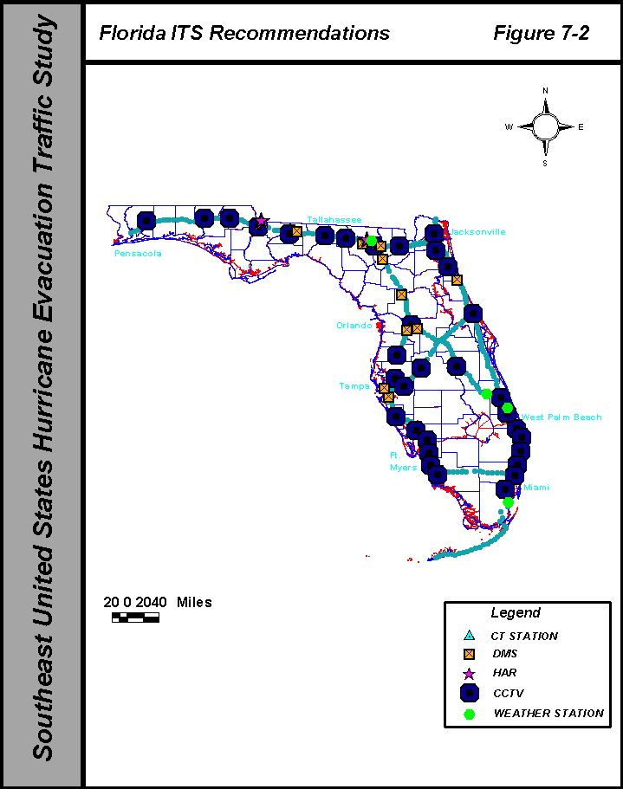

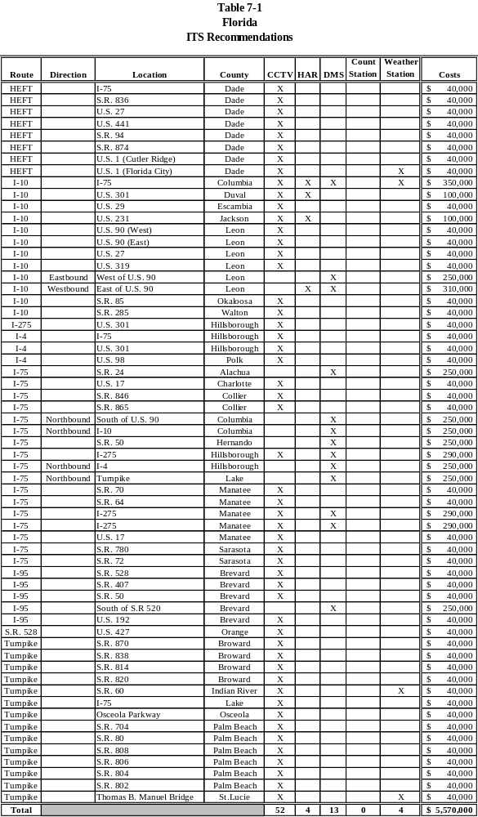

7.7 RECOMMENDATIONS - GEORGIA

ITS APPLICATIONS

GDOT is studying the application of ITS elements in the coastal region of the state. The recommendations shown in Figure 7-3 are part of the draft recommendations of GDOT’s study. It is the desire of the ITS staff of GDOT to implement that package this year, along with other improvements of the study corridors.
Surveillance

Figure 7-3 and Table 7-2 show the proposed locations of CCTV sites, taken from the GDOT draft report.

Traffic Information Dissemination

These improvements include HAR and DMS signs as shown in Figure 7-3 and in Table 7-2.

Incident Management Systems

As part of the implementation package described above, GDOT intends to construct a temporary traffic management center in the Savannah area to operate the field components. Ultimately, GDOT plans to construct a permanent traffic management center, jointly with the City of Savannah. GDOT will operate the center and the field components, using the Georgia Navigator software. This will permit the State Traffic Management Center in Atlanta to share data and receive the CCTV. It will also permit the State Traffic Management Center to operate the system during periods when the regional center is not staffed.

GDOT should deploy HERO units from Atlanta during evacuation and reentry to perform incident management duties.

NON-ITS SOLUTIONS

During the evacuation, motorists’ services and restroom availability were a problem, due to the extended travel times. The state needs to pre-arrange with private operators to ensure fuel is available and restaurants are open during the critical evacuation period. GDOT also needs to keep the rest areas and welcome centers open.

GDOT has begun implementation to phase out their UHF and VHF radio systems and replace then with 900 MHz radios from Southern LINC. Recently, GDOT received approval to expand the replacement outside the Atlanta metro area. Until GDOT completes that conversion, GDOT and GSP cannot communicate directly in the coastal area, due to incompatible radio frequencies. GDOT needs to complete the radio system conversion. As an interim step, senior managers in the District offices should receive 900 MHz radios, to allow them to communicate with GSP supervisors.

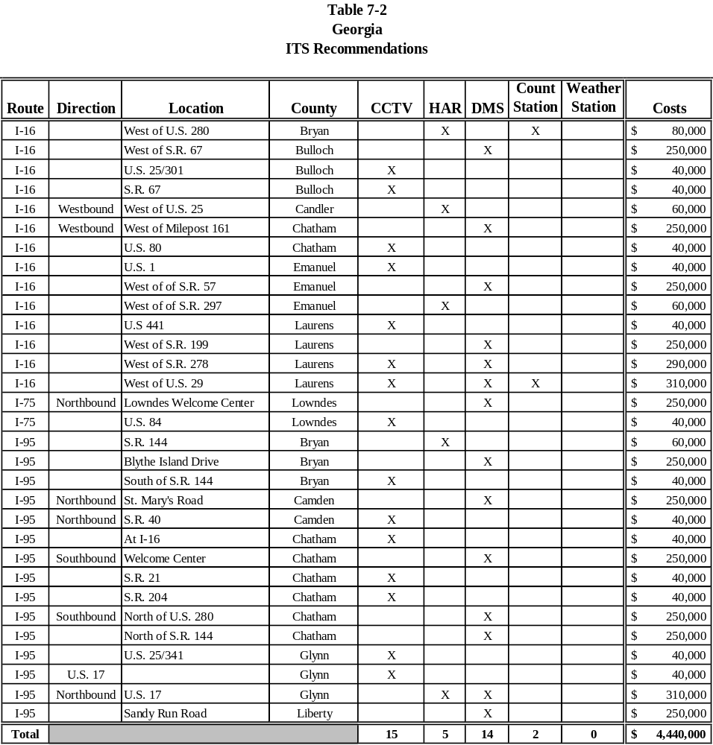

7.8 RECOMMENDATIONS - NORTH CAROLINA

ITS APPLICATIONS

We have developed a proposed list of ITS field elements, shown in Figure 7-4 for North Carolina, along I-40, I-95 and I-440. The proposed ITS elements extend further inland, due to the destinations of evacuees. The Raleigh area is the major destination of evacuees from all over the eastern part of the state. Raleigh is the confluence of one interstate and four U.S. highways that potentially convey evacuation traffic either from the coast or from South Carolina.

Surveillance

The proposed list of ITS field elements contains CCTV and count stations.

Currently, NCSHP’s ten OH-58 helicopters are not equipped for minimum weather flying, and their pilots are not trained for such flying. Aerial surveillance can provide excellent means to cover a large area, and see the true situation during an incident. We recommend at least one helicopter be equipped and its crew be trained for minimum weather flying.

Traffic Information Dissemination

The list of proposed elements in Table 7-3, and as shown in Figure 7-4, includes dynamic message signs and highway advisory radios.

Incident Management Systems

NCDOT has created an ITS operations unit to support the field personnel in the fourteen divisions of the Division of Highways. This unit will provide overall operational management and support of ITS systems for the NCDOT. Part of the plan includes the establishment of a state traffic management center in Raleigh.
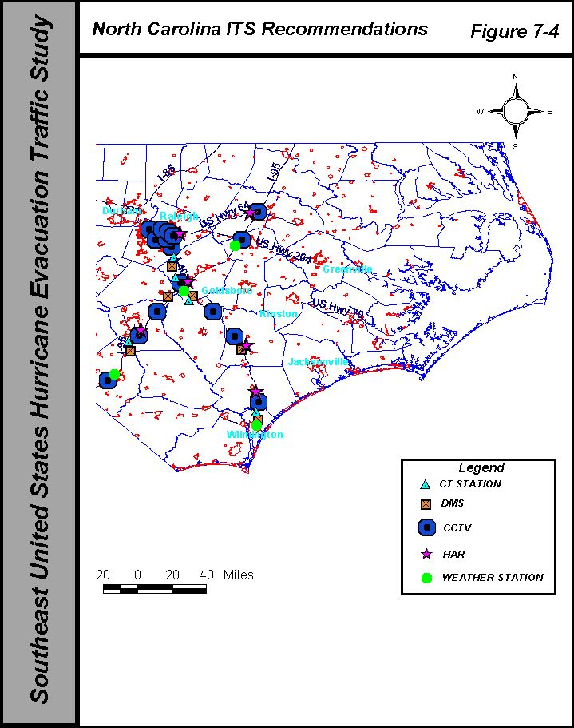

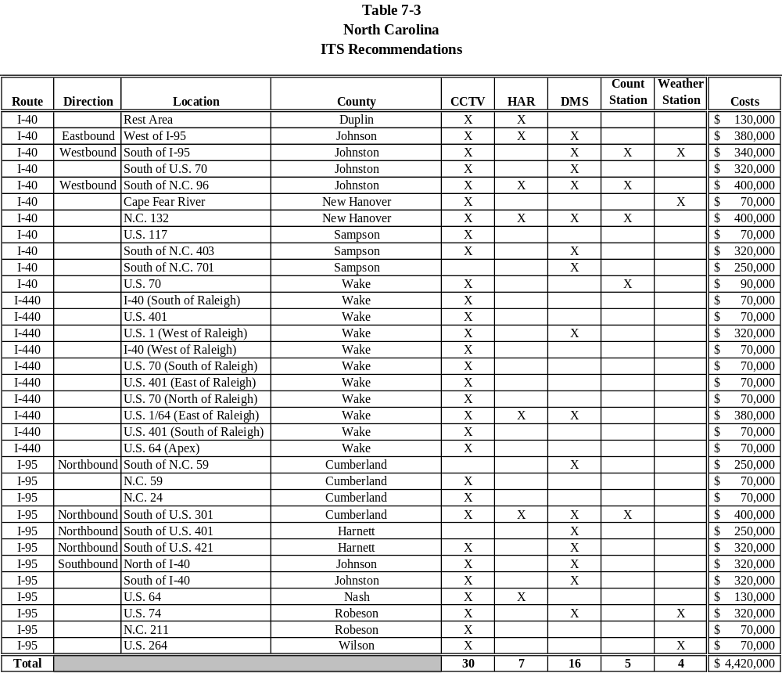
The present traffic management center in Raleigh, serving the I-40 area west of Raleigh, will expand its function. The center will become both the Raleigh Regional Traffic Management Center and the State Transportations Center. This center will share data and video with the other regional traffic management centers in Charlotte and Greensboro. The Raleigh Traffic Management Center will provide back-up control, during periods when the other centers are not manned.

NCDOT should consider the use of its IMAP, motorists’ assistance patrols, on I-40 during an evacuation. The use of these patrols would require redeployment from other parts of the state.

NON-ITS SOLUTIONS

During the Floyd evacuation, the lack of motorists’ services and restrooms were a problem in other states, due to the extended travel times. The state needs to arrange with private operators, to ensure fuel is available and restaurants are open during the critical evacuation period. NCDOT needs to keep the rest areas and welcome centers open.

7.9 RECOMMENDATIONS - SOUTH CAROLINA

ITS APPLICATIONS

SCDOT has developed an interim plan for ITS implementation to support hurricane evacuations. Table 7-4 contains those recommendations. We have expanded the list to include ITS elements along I-20, I-77, I-95 and I-526.

Surveillance

SCDOT maintains a well-developed system of count stations on Interstates. We have proposed some additions to support hurricane evacuations. The SCDOT software used to poll and process the counts permitted good use of the count stations during the evacuation for Hurricane Floyd. Some counters at the permanent count stations need to be replaced to allow bi-directional counting, during one-way operations. These items, along with CCTV sites are included in Table 7-4, and shown in Figure 7-5.

SCHP currently leases a plane with a pilot for various patrol functions. They also call upon other state agencies for assistance. SCHP should continue its efforts to obtain and equip an aircraft for its exclusive use.

Traffic Information Dissemination

Table 7-4 includes dynamic message signs and highway advisory radios.

Incident Management Systems

We recommend continued use of the SHEP patrols. SCDOT should utilize redeployed SHEP units from other parts of the state to assist with incident management during evacuation and reentry.

NON-ITS SOLUTIONS

During the evacuation, motorists’ services and restrooms were a problem, due to extended travel times. The state needs to arrange with private operators to ensure fuel is available and restaurants are open during the critical evacuation period. SCDOT also needs to keep the rest areas and welcome centers open.

After Hurricane Hugo, SCDOT identified limitations in their radio communications. SCHP operates on 800 MHz, low band (VHF) and high band (UHF) radios. Multiple radios are installed in each patrol car to ensure any trooper can talk to any other. SCHP cannot presently communicate directly with any other state law enforcement agency in South Carolina. Further, the only SCDOT personnel that SCHP can communicate with directly are the SHEP units. While SCHP and SCDOT have developed an interim plan to use SCHP portable radios for key senior managers in hurricane evacuations, it is a temporary measure. These agencies need a statewide communications system, such as the 800 MHz systems, that permit each agency to have secure routine communication within their agency, and direct communication during incidents with other departments.
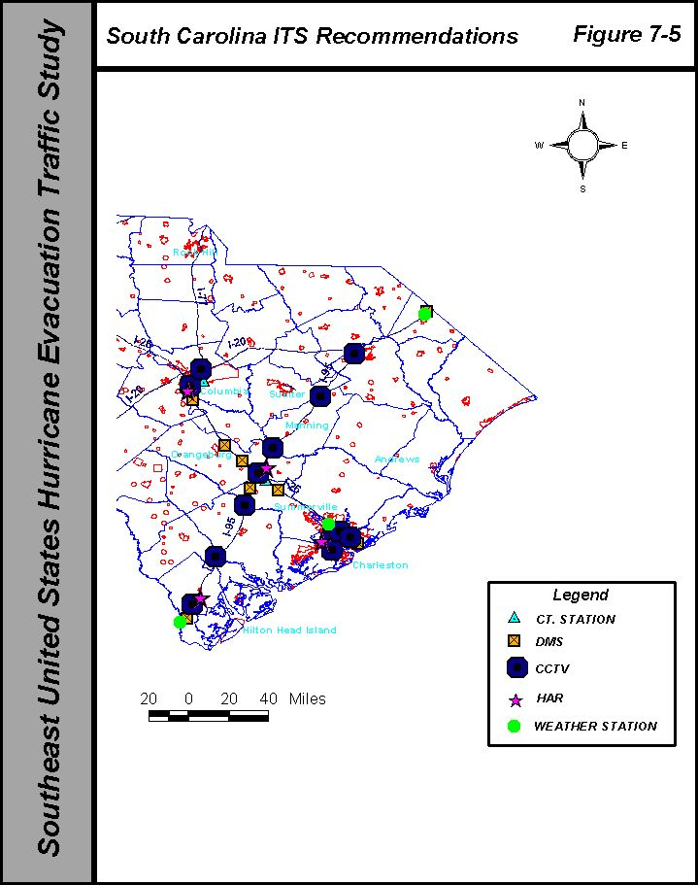

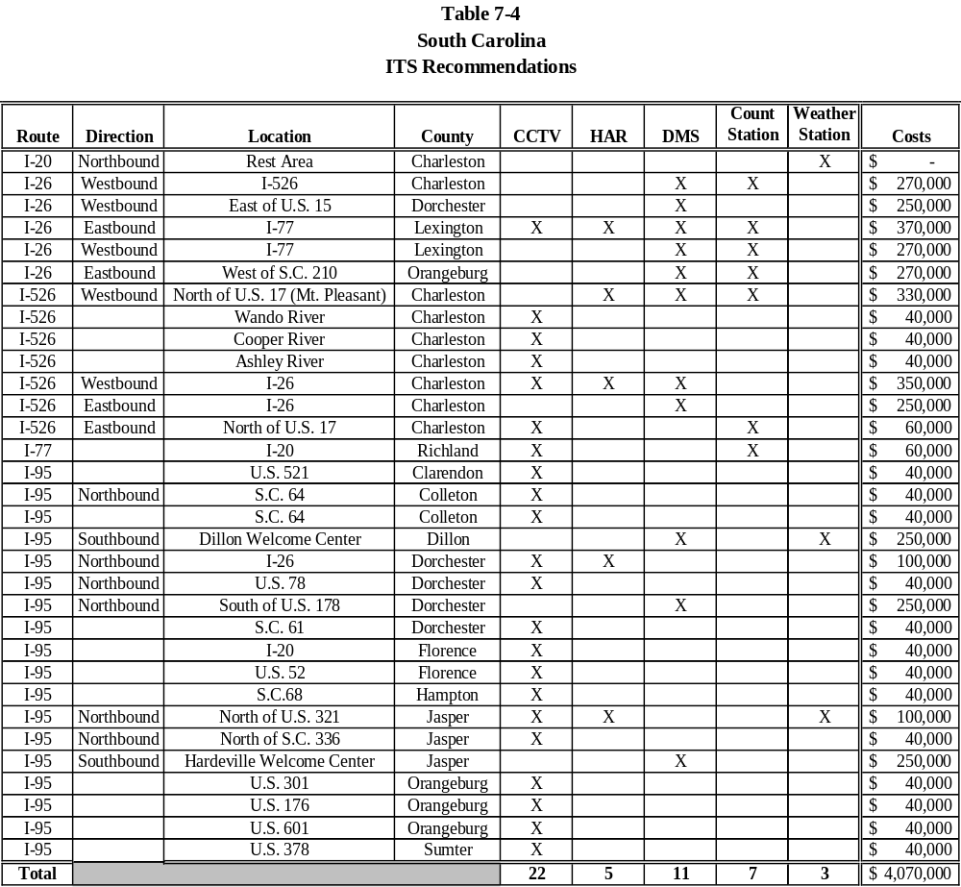

APPENDIX

LIST OF ABBREVIATIONS

ATIS (Advanced Traffic Information System): System dedicated to the collection, analysis storing and dissemination of traffic flow data conditions to users in their choices of route selection.

ATMS (Advanced Traffic Management System): System dedicated to the operation of a specific traffic control system such as traffic signals, freeway surveillance and ramp metering.

AVL (Automated Vehicle Location): Technology that utilizes GPS to calculate position of a specific vehicle and transmit that information to a central site.

ATR (Automatic Traffic Recorder): Self-contained recording device to collect various types of traffic data. They can be portable devices using pneumatic hoses or permanent installations using permanent in-pavement sensors.

CCTV (Closed Circuit TeleVision): Used for surveillance of traffic conditions.

DCA: Florida Department of Community Affairs (Emergency Management Division)

DMS (Dynamic Message Sign): Portable of permanently mounted message signs where the messages can be remotely operated. The message face is not a fixed sign panel but it incorporates a technology that can be changed.

EOC (Emergency Operations Center): A centralized inter-agency facility to coordinate and manage operations related to various emergency operations related to weather, natural disasters, acts of war and etc.

FDLE: Florida Department of Law Enforcement

FDOT: Florida Department of Transportation

FHP: Florida Highway Patrol

FHWA: Federal Highway Administration.

GDOT: Department of Transportation

GSP: Georgia State Patrol

GEMA: Georgia Emergency Management Agency

GPS (Global Positioning System): Technology that utilizes multiple satellites and a radio receiver to calculate latitude, longitude and altitude. The calculation of the previous and current position allows the calculation of speed and distance traveled.

HAR (Highway Advisory Radio): Self contained low power radio transmitters licensed by the FCC on certain frequencies for the express purpose of disseminating traffic information.

HERO: Georgia Department of Transportation’s motorist assistance patrol

IMAP: North Carolina Department of Transportation’s motorist assistance patrol

ITS (Intelligent Transportation Systems): use or application of technology to improve the efficiency and safety of transportation systems. This includes transporting people and freight using the modes of car, truck, bus, rail, air and water.

MUTCD: FHWA’s Manual of Traffic Control Devices. Regulatory and guide document for signing, pavement markings, traffic signals and traffic control devices in the United States.

NCDOT: North Carolina Department of Transportation

NCDMV: North Carolina Division of Motor Vehicles

NCSHP: North Carolina State Highway Patrol

RPM (Raised Pavement Marker): Reflectorized device mounted on or ground in the roadway to improve delineation of the travel lanes and edges of the roadway.

SCDOT: South Carolina Department of Transportation

SCHP: South Carolina Highway Patrol

SHEP: South Carolina Department of Transportation’s motorist assistance patrol

TMC (Traffic Management Center): A central facility housing equipment and personnel to operate specific traffic signal systems, freeway surveillance systems, ramp metering systems and etc.

TOC (Traffic Operations Center): Frequently and interchangeable term with TMC. Sometimes referred to a center that oversees all transportation operations and not technology specific applications such as traffic signals.

UTCS (Urban Traffic Control System): Software developed by FHWA to operate groups of primarily large signal systems. The software used direct communications to intersections and centralized databases on mainframe computers.

FLORIDA TRAFFIC COUNTS

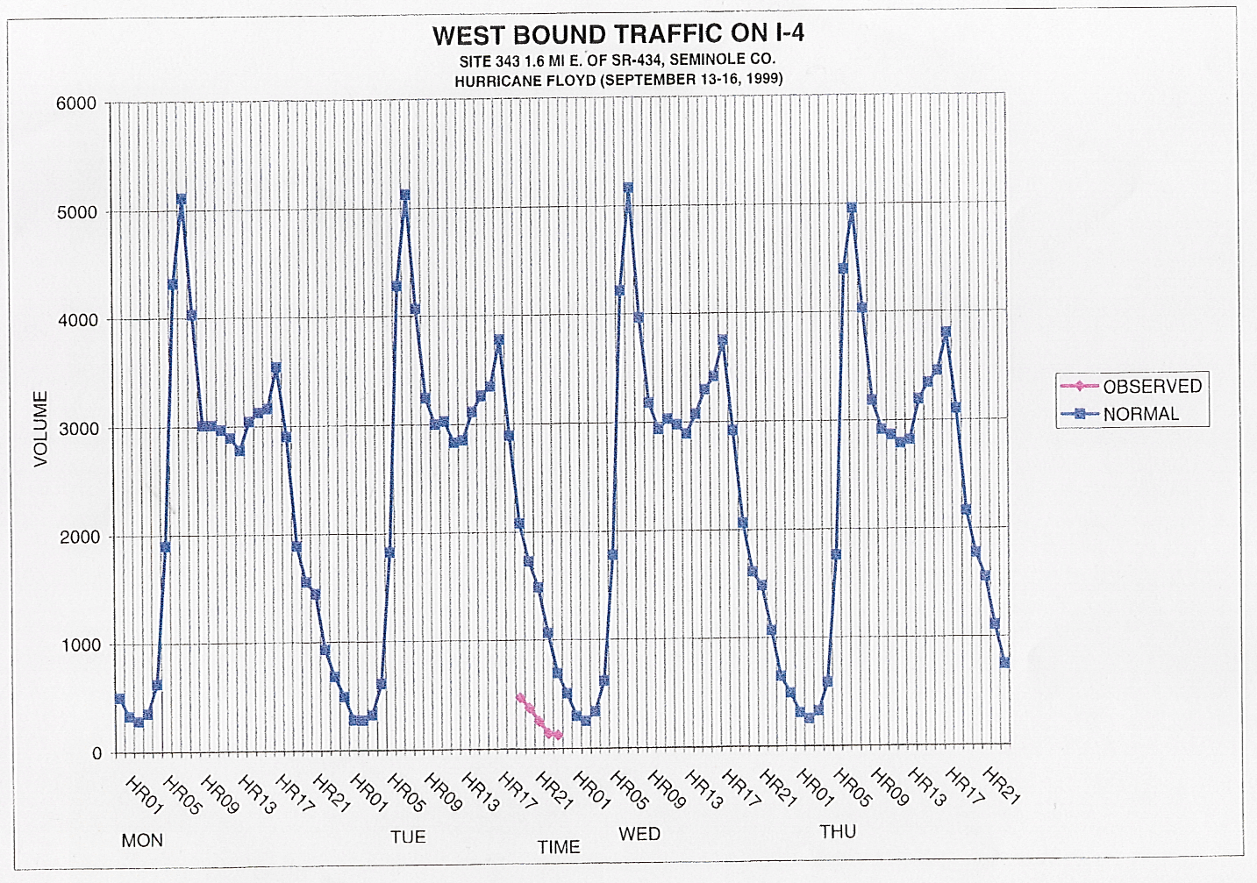
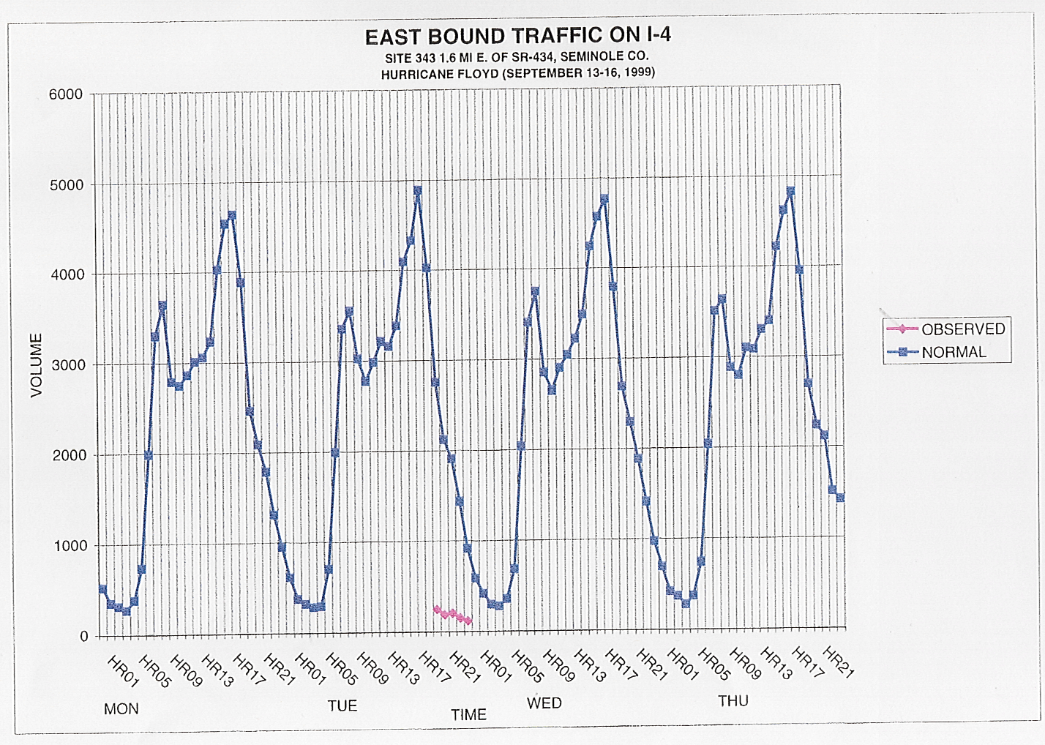
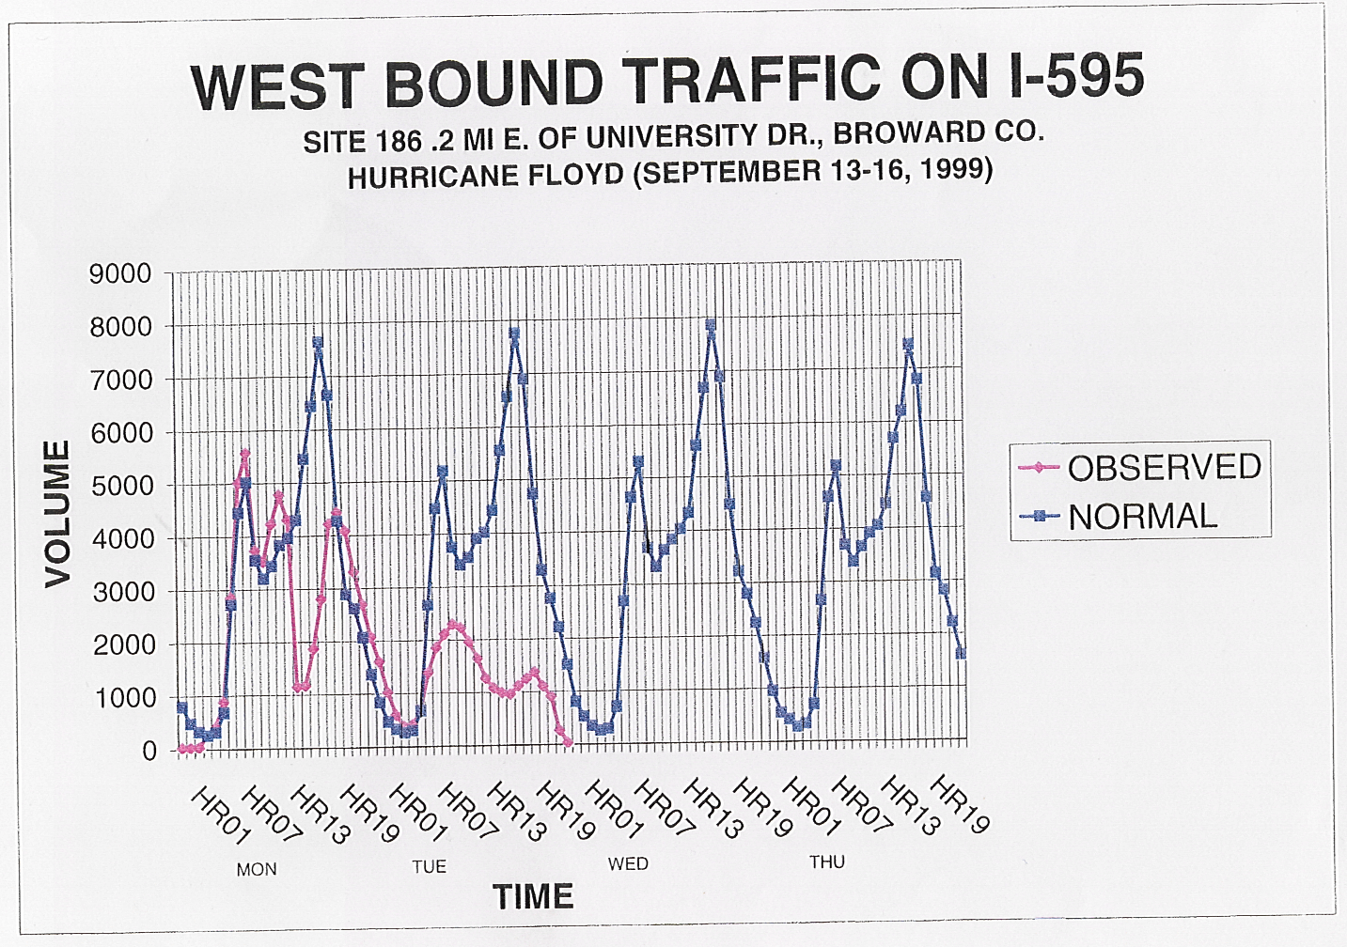
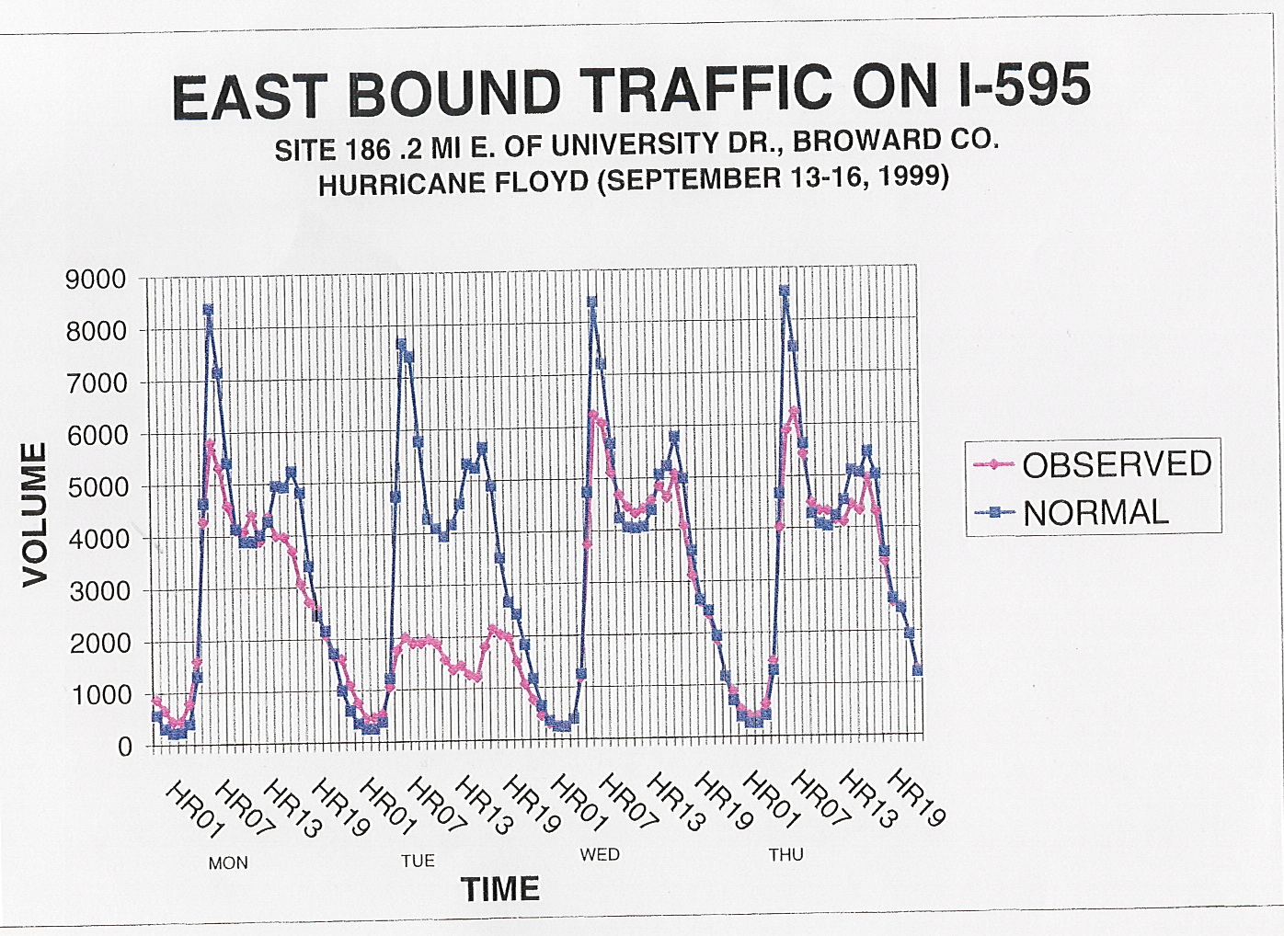
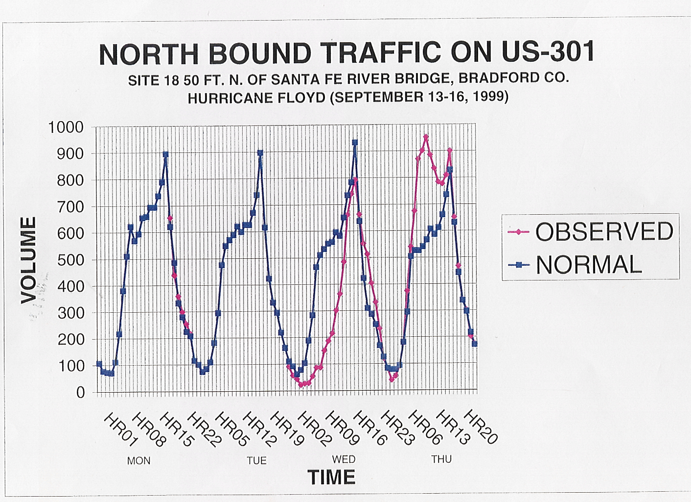
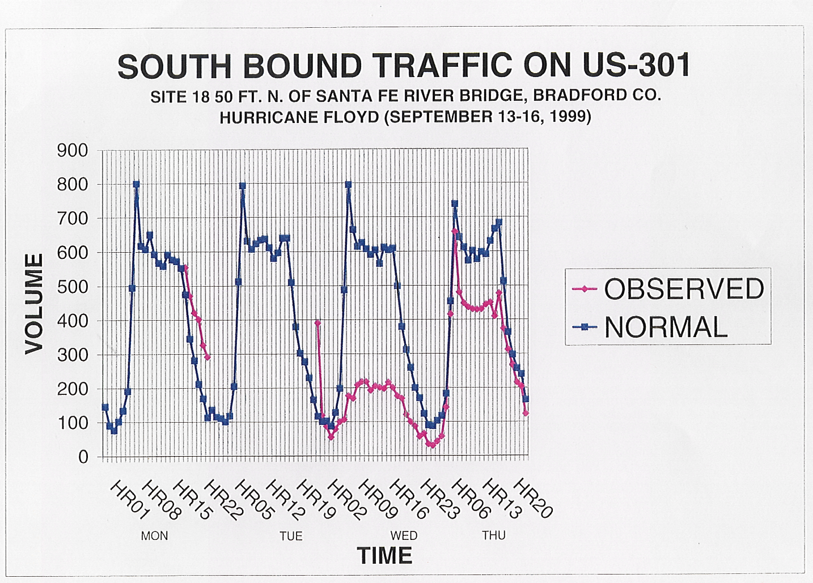
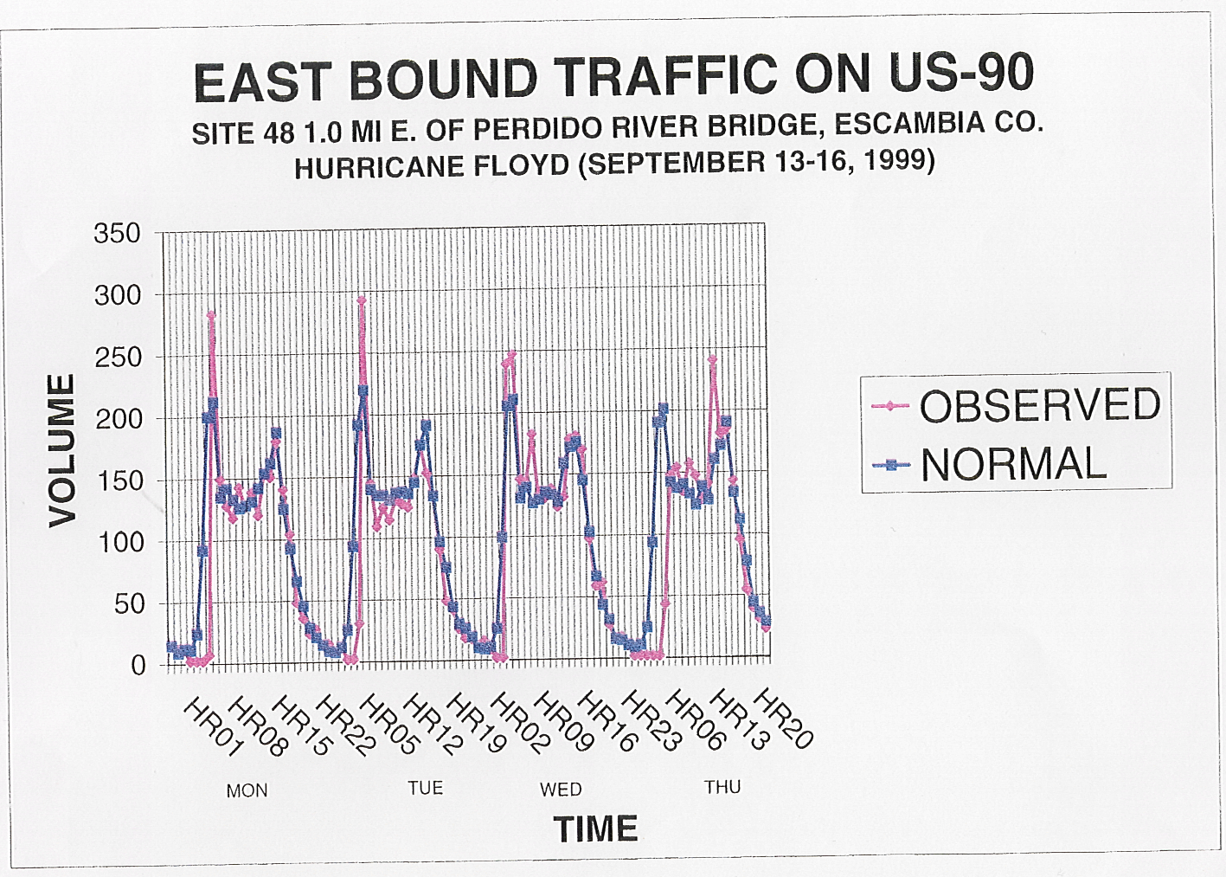
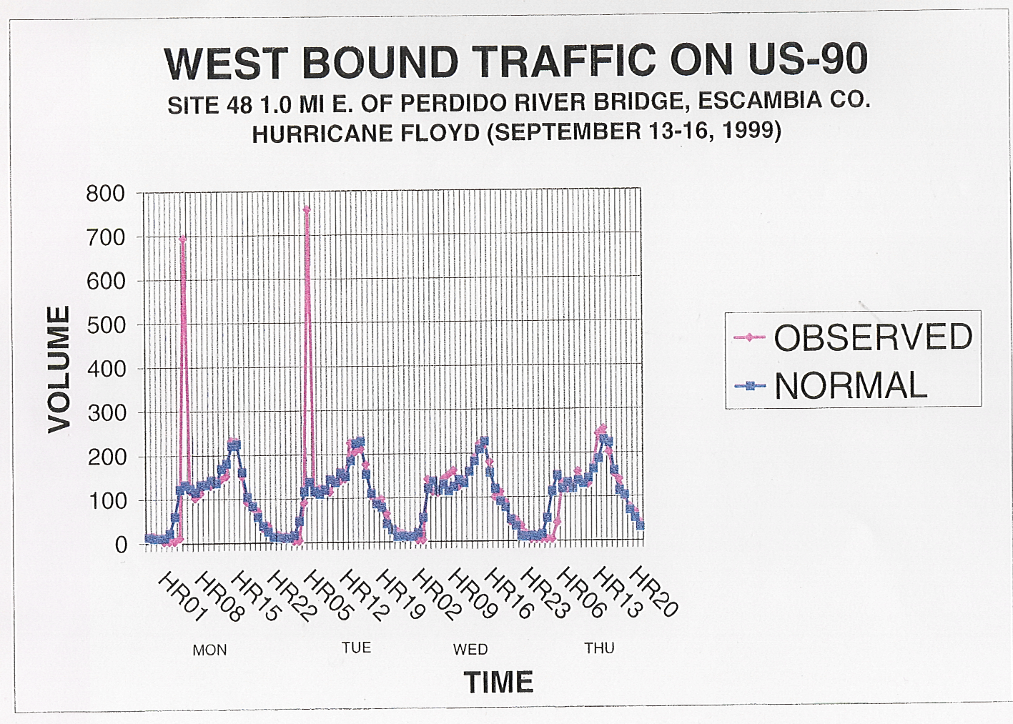

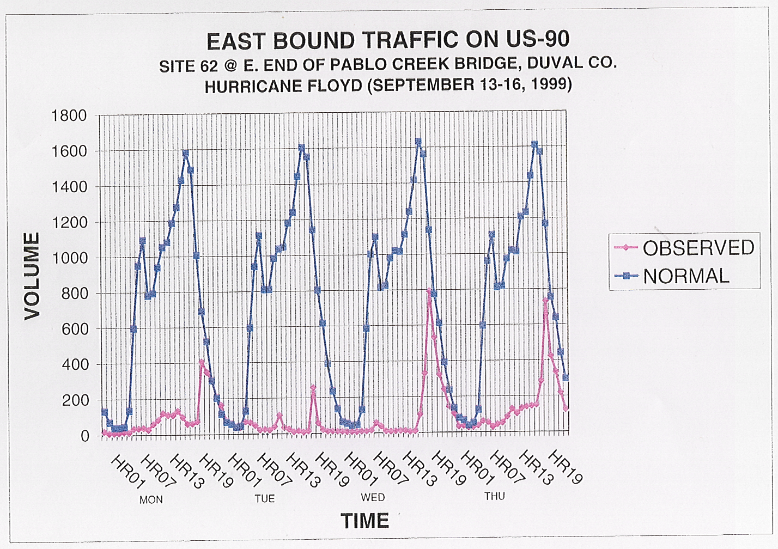
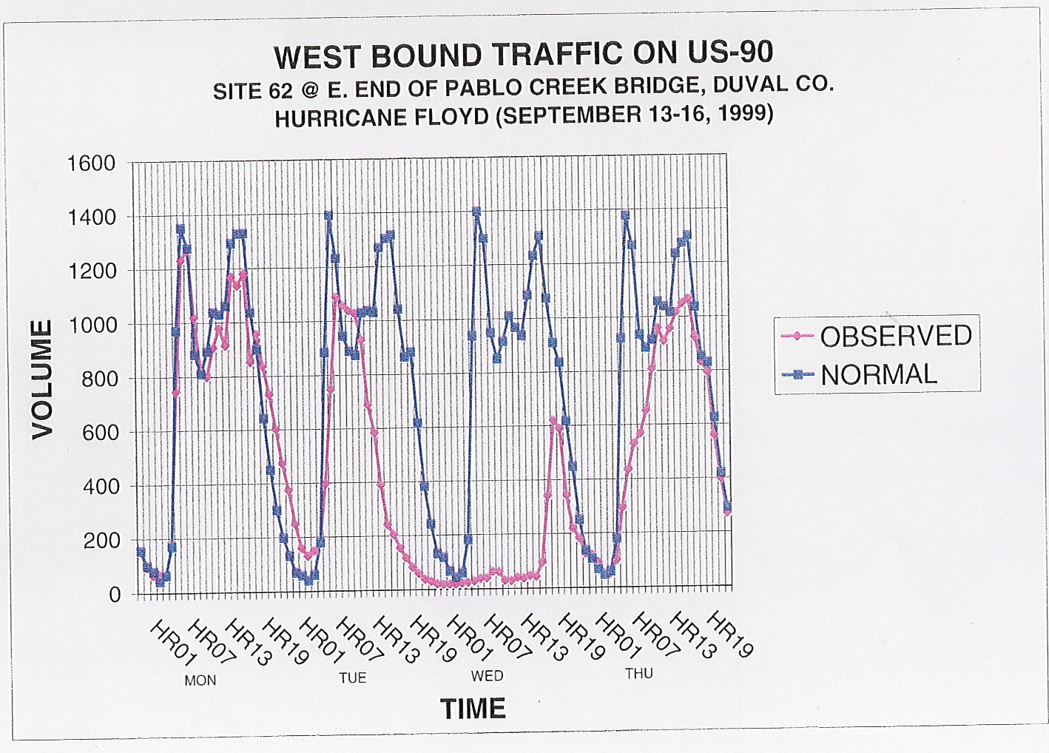
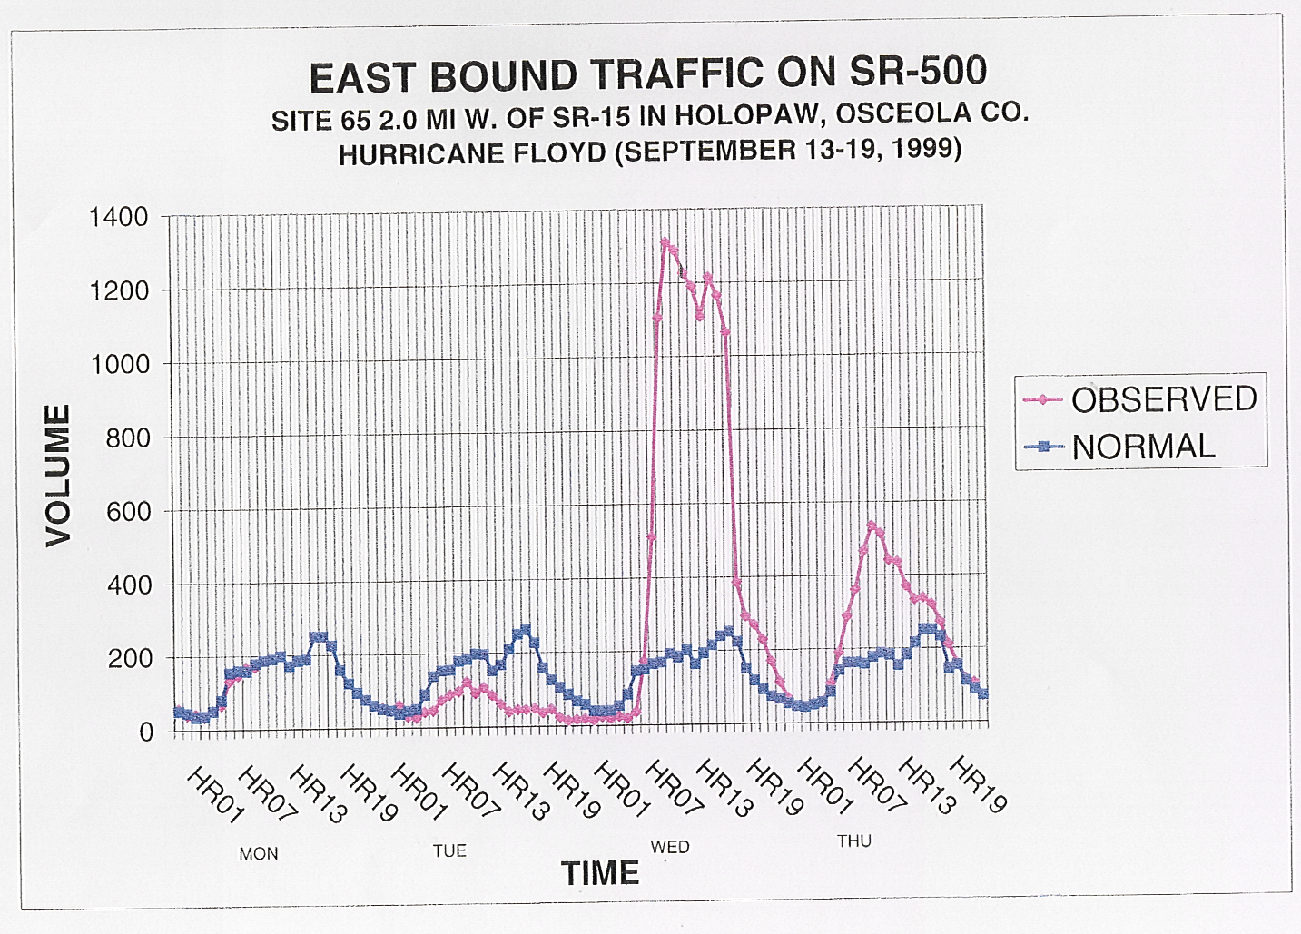
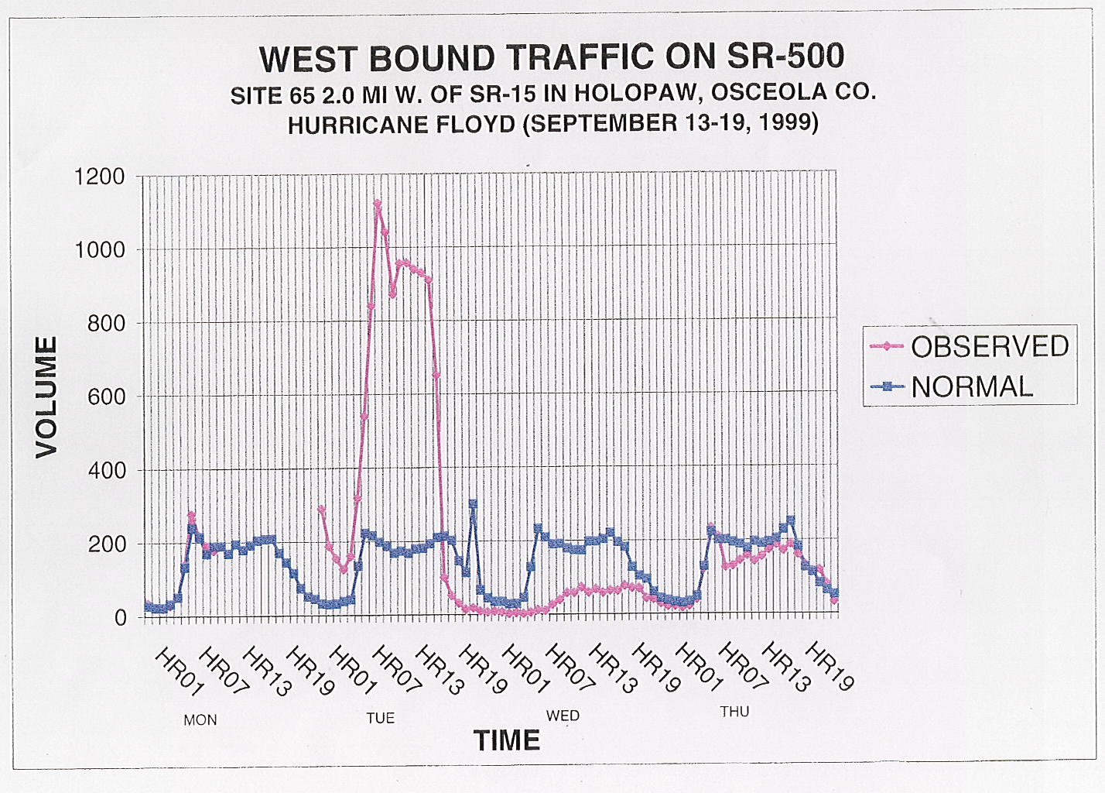

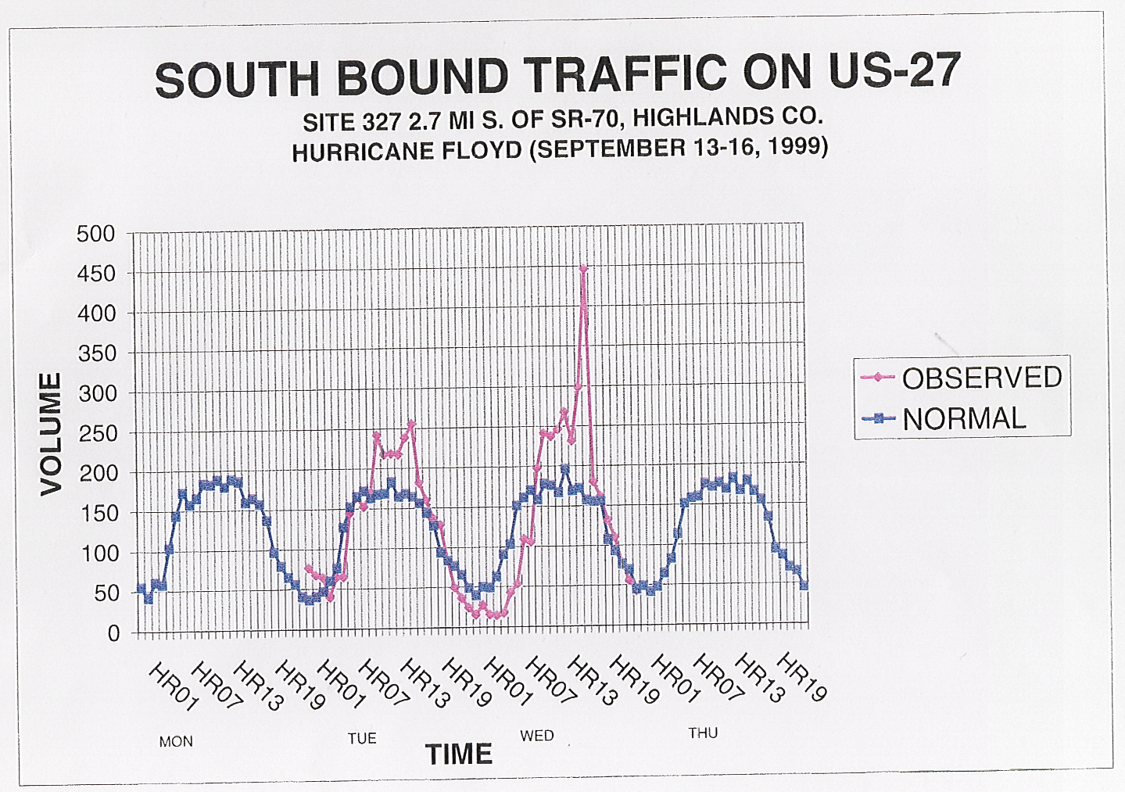
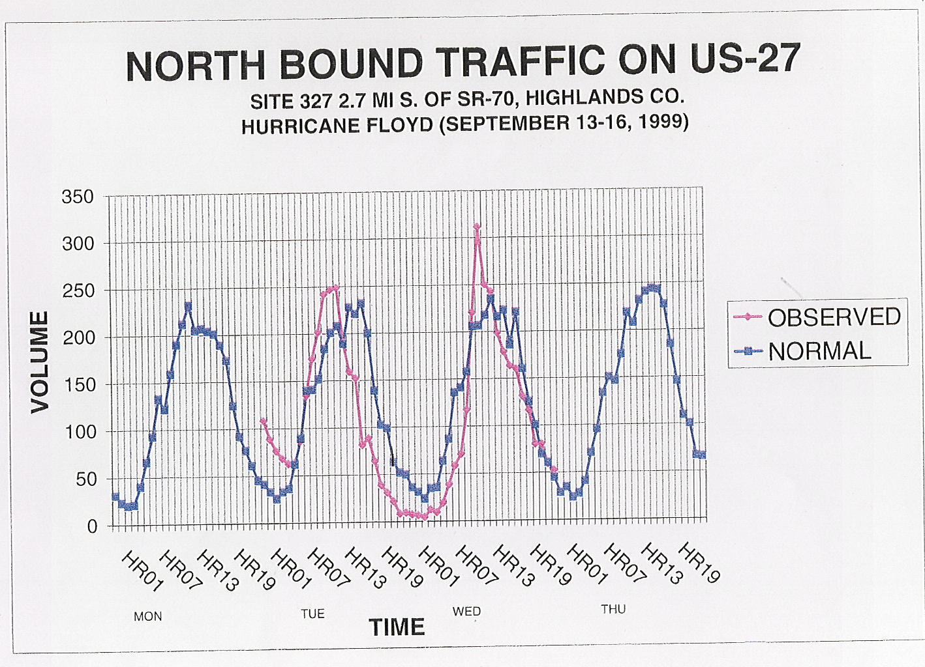

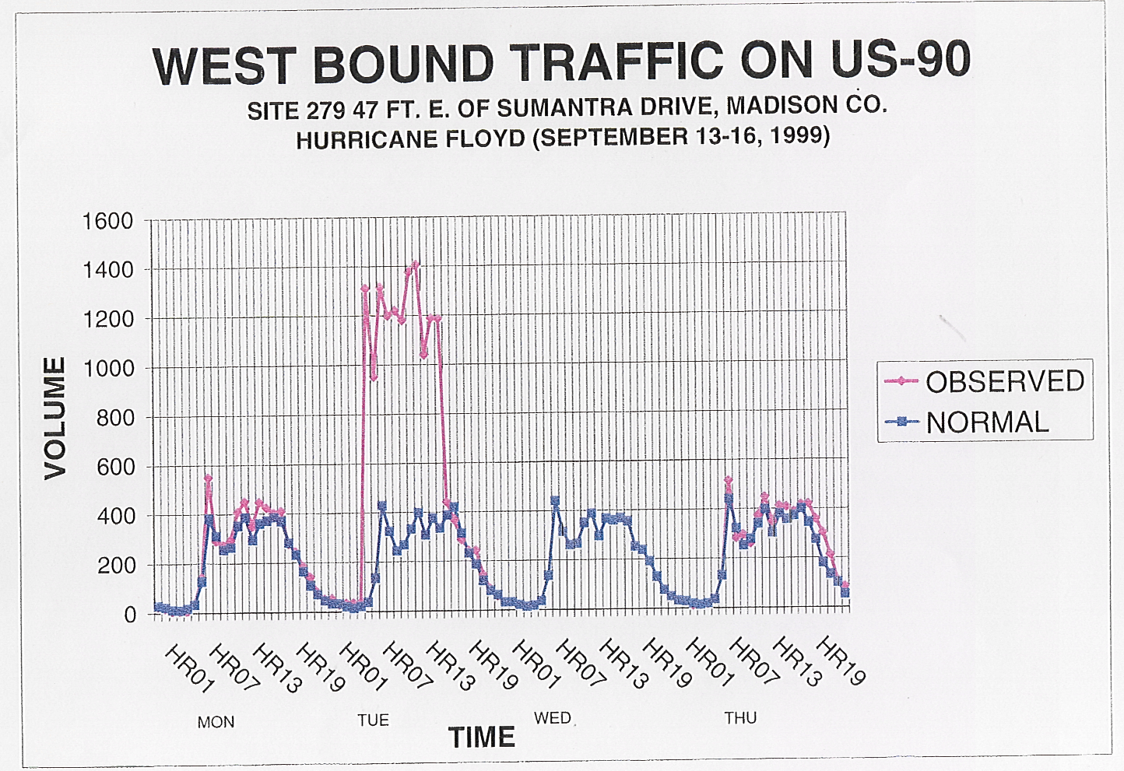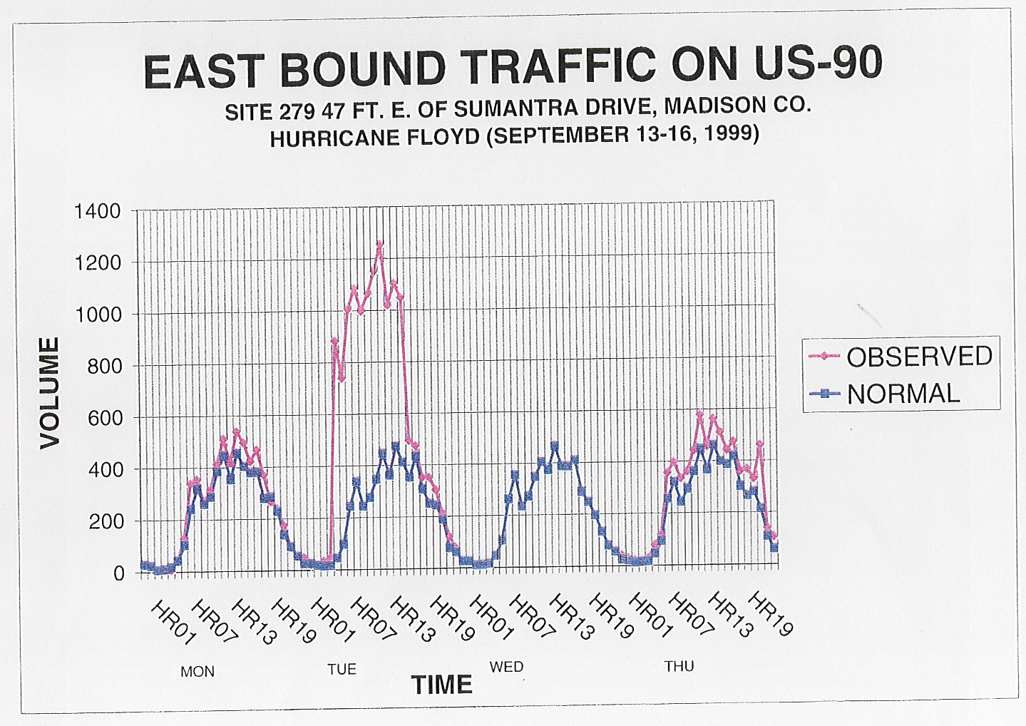

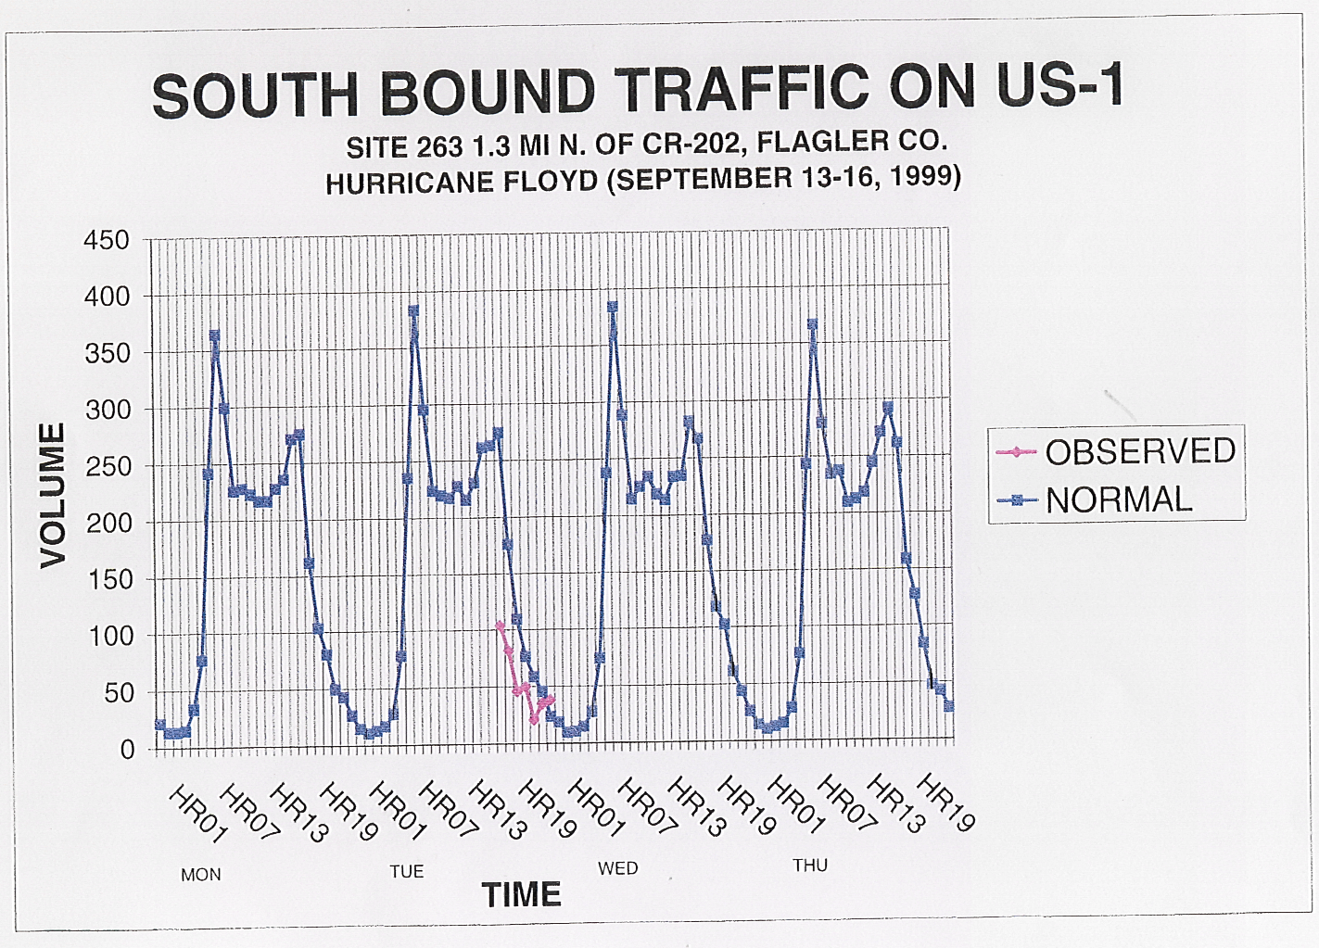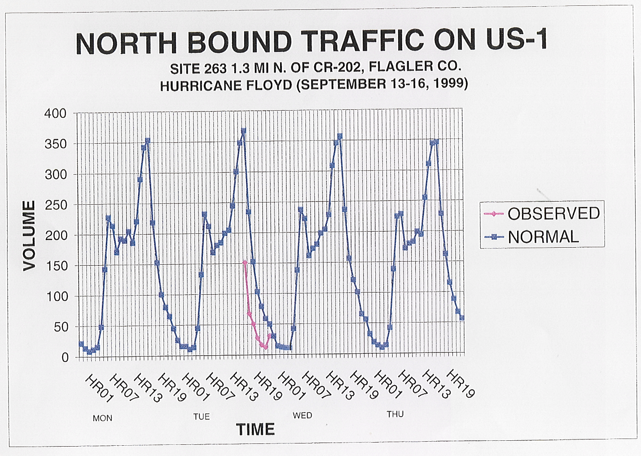

GEORGIA TRAFFIC COUNTS

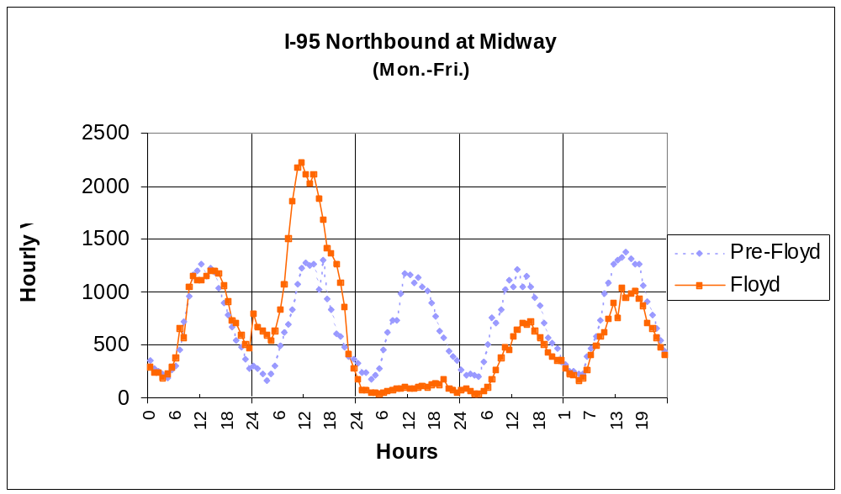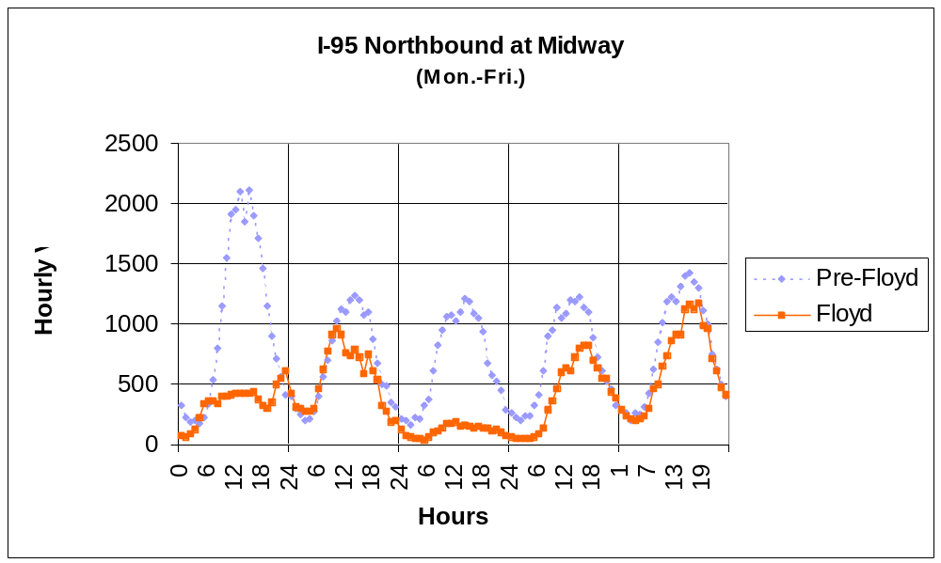
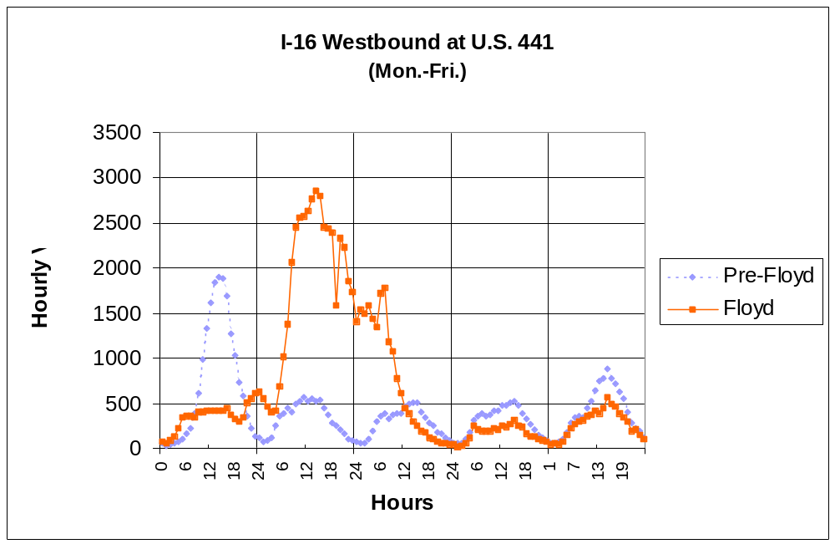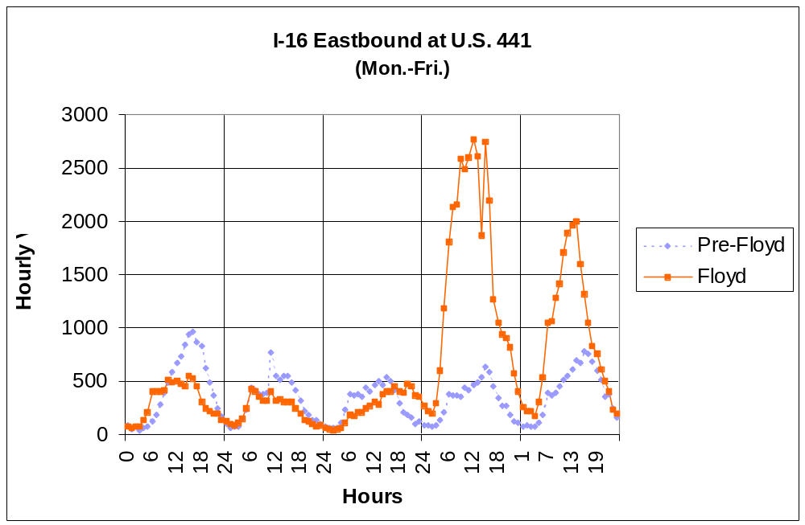

SOUTH CAROLINA TRAFFIC COUNTS

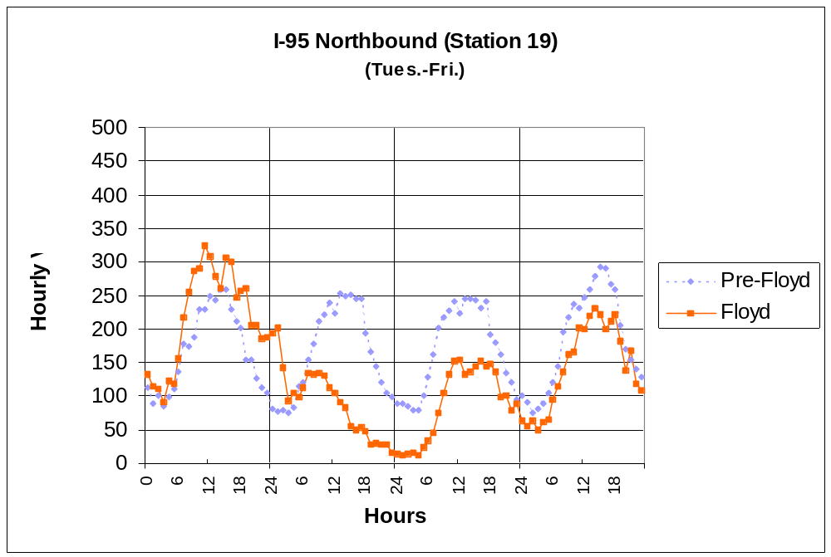
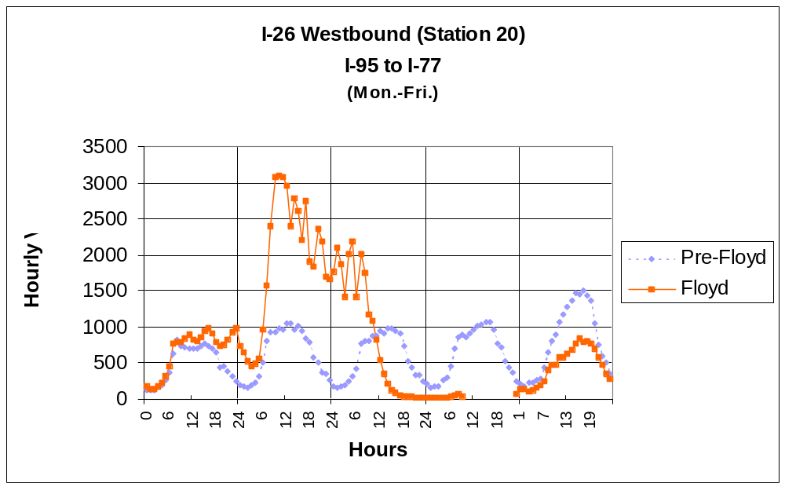
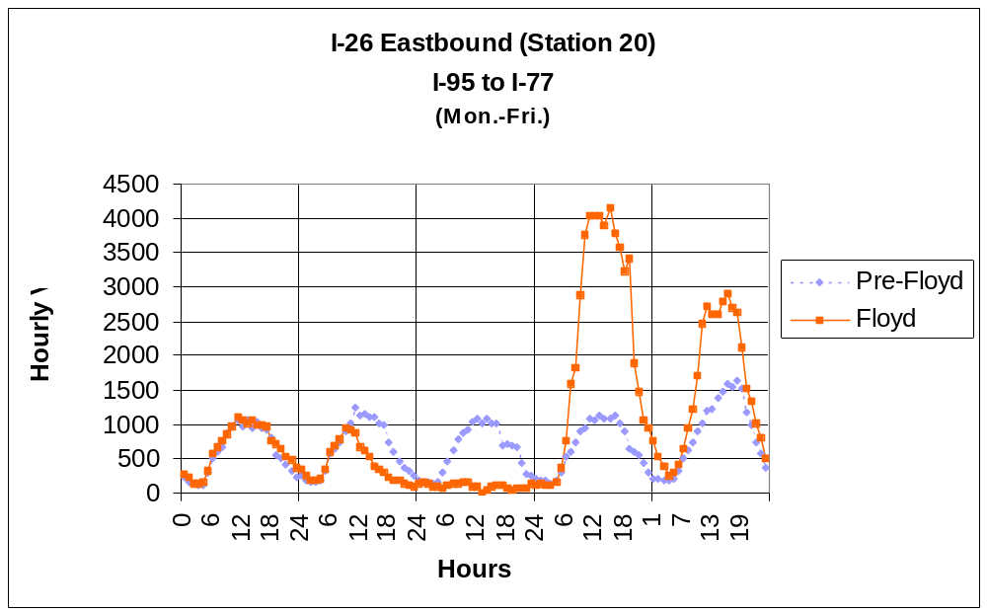
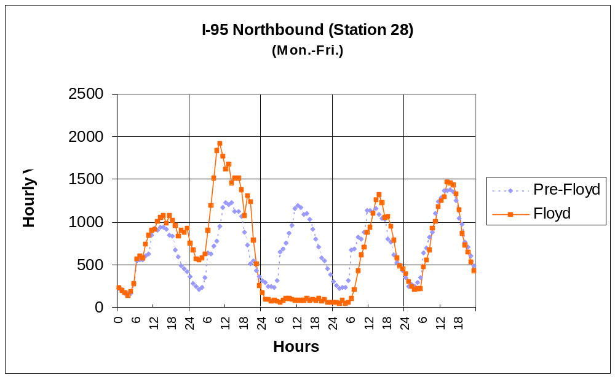
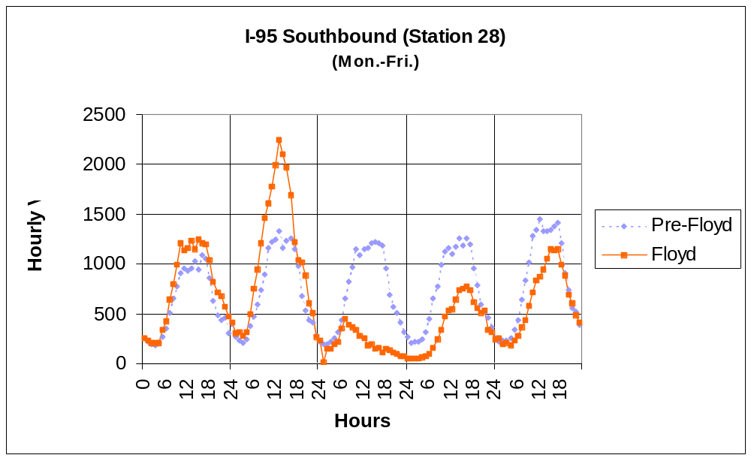
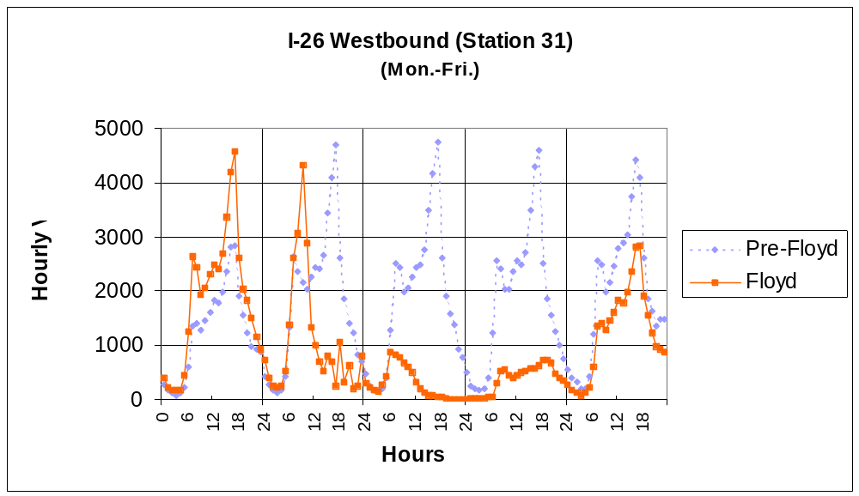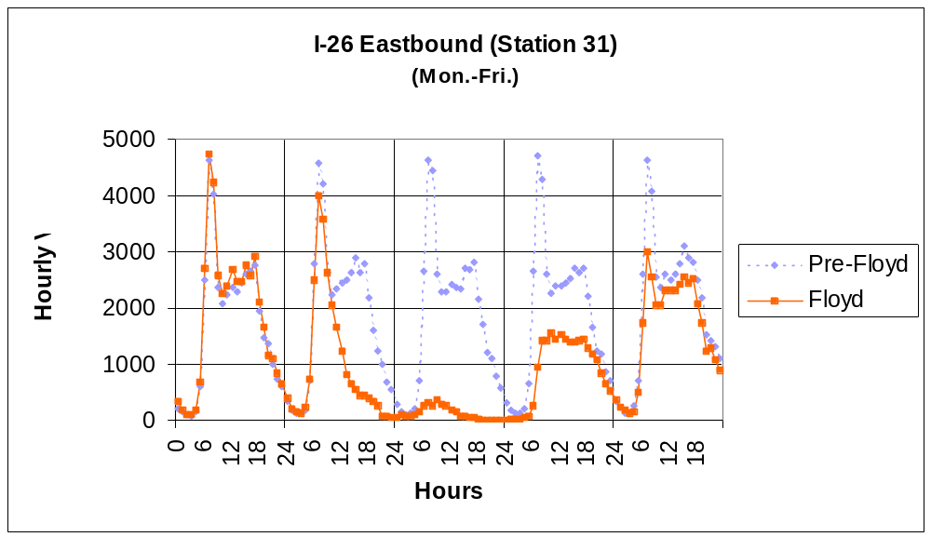
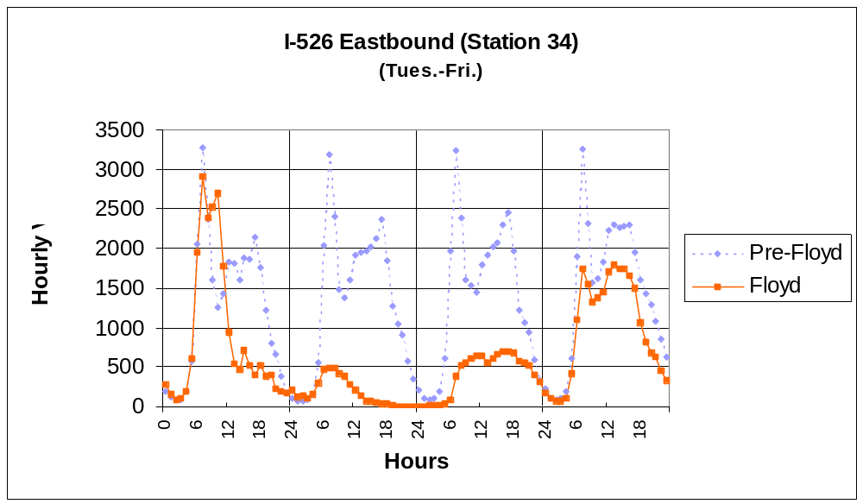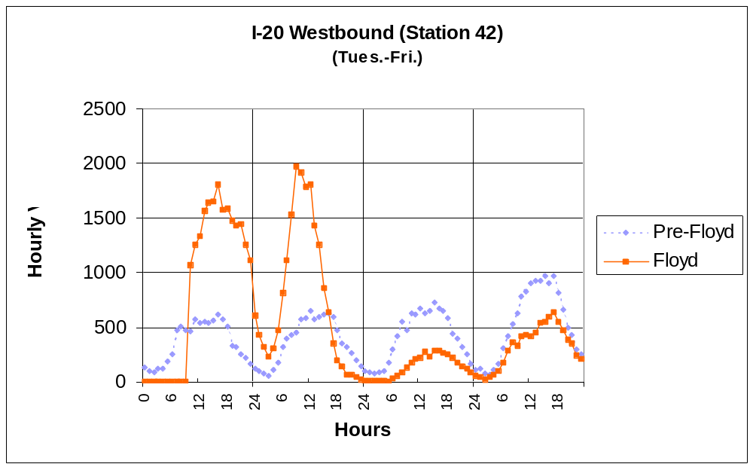
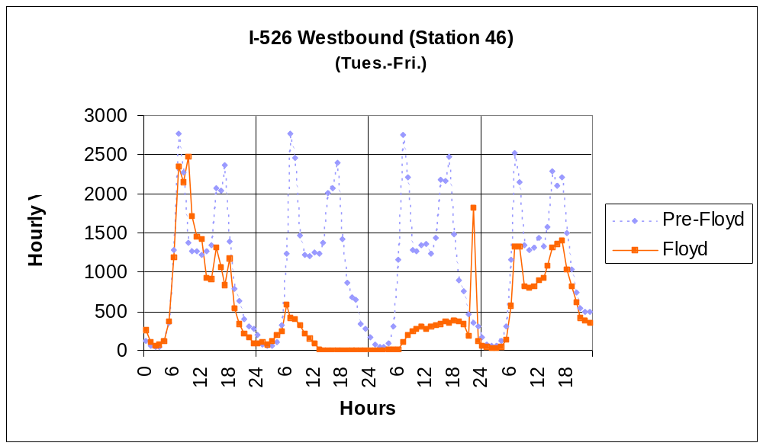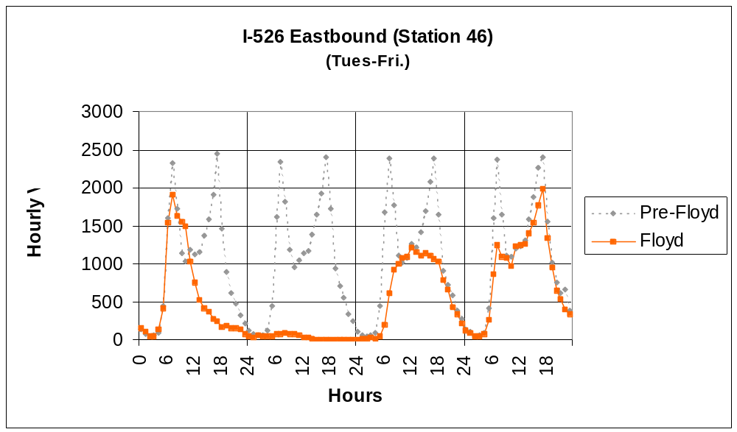

MEETING MINUTES

SOUTHEAST UNITED STATES HURRICANE STUDY
MEETING MINUTES
Florida Highway Patrol and Florida Department of Transportation
January 20, 2000

Attendees Agency Telephone Email
Lt. Col. Billy Dickson Highway Patrol – Field Operations (850) 733-4030 dickson.billy@hsmv.state.fl.us
Major Kevin Guidry Highway Patrol – Field Operations (850) 488-1009 guidry.kevin@hsmv.state.fl.us
Capt. Mark Trammell Highway Patrol – Field Operations (850) 486-1058 trammell.mark@hsmv.state.fl.us
Capt. Robert S. Duncan Highway Patrol – Orlando Troop D (407) 737-2300 duncanrs@flcjn.net
Lt. Larry Peterson Highway Patrol – Troop H (850) 342-0233 peterson.larry@ hsmv.state.fl.us
Michael Loehr DCA – Emergency Management (850) 413-9872 michael.loehr@dca.state.fl.us
Ken Morris FDLE – Tallahassee (850) 410-8399 kenmorris@fdle.state.fl.us
Steve Decker FDOT – EOC Coordinator (850) 488-3546 steven.decker@dot.state.fl.us
Mark Bartlett FHWA – Tallahassee (850) 942-9650 mark.d.bartlett@fhwa.dot.gov
Alf Badgett PBSJ (704) 522-7275 habadgett@pbsj.com

Alf Badgett introduced the purpose of the meeting and the project schedule. He also provided a brief description on FHWA-Washington’s work beyond the PBSJ study. The discussion, not necessarily in order of how it was discussed, is grouped in relevant topics below:

GENERAL

Evacuation is a county decision. It was quoted that “evacuation (decision) is not about people but economy”. Those present felt it is important the local counties make the evacuation decisions but it is more effective. Some counties have at times balked or been slow to decide to evacuate due to the affect on the local economy. For multi-regional evacuations, it is a state decision. While Floyd was a bad storm with many people evacuating, Opal was the state’s watershed event.

The Florida Highway Patrol (FHP) has a fixed wing aircraft (Cessna 172’s) for each troop. They have four OH-58 helicopters equipped with pilots rained for night flying and minimum weather. The helicopters are equipped with the FLARE system. FHP plans to equip them with night vision.

FHP owns seven portable variable message signs (VMS) acquired through a Highway Safety grant for $ 180,000. FHP also owns four trailer mounted radar units that display the measured speed.

As a potentially threatening storm approaches, FHP places all troopers on notice and they go on twelve-hour shifts. Evacuation duty assignments are based upon using resources only within the region. Except extreme cases, troopers are not deployed outside their home area.

The Department of Community Affairs (Emergency Management Division) (DCA), Florida Department of Law Enforcement (FDLE), FHP FDOT and others have used the regional organization for hurricane activities since 1996.

The State of Florida emergency response system places law enforcement officers of the following agencies, under FDLE * for traffic management:

- FHP
- Florida Wildlife, including the personnel of the old Fish and Game and Florida Marine Patrol agencies
- DMV
- Dept. of Agriculture *
- Dept. of Insurance *
- Alcohol and Beverage Control *

The above listed agencies noted with an asterisk are not trained through their normal duties in traffic control.

Before Hurricane Floyd, FHP and FDOT had not developed an operational plan to one-way a freeway facility. Due to staff limitation and extra responsibilities in the regional response organization, state agencies had not identified additional staffing sources within a given region that could respond in the required time.

Communications

Florida Department of Transportation (FDOT) personnel have no ability to talk by radio directly with FHP except for Florida’s Turnpike staff that have 800 MHz radios.

FHP uses the 800 MHz radio system in the south part of the state and low band in north Florida. Patrol cars are not equipped with all radio frequencies. There is a plan for a statewide 800 MHz radio communications network. FHP and others are pursuing funding to complete the system.

FDLE uses different low band frequencies from the FHP. The sheriffs’ offices operate 450 MHz.

The state law enforcement agencies have begun a program to share dispatching through five regional dispatch centers. All dispatchers are trained to dispatch for any of the participating agencies.

The state emergency broadcast system available throughout the state is intended for a warning and not public information and participation is voluntary.

HURRICANE FLOYD

Generally, the evacuation went well as designed. All vulnerable residents safely evacuated by 4:00 P.M. from the coastal areas.

Evacuation Problem Areas

Traffic on all Interstates was very heavy, particularly I-10 between Tallahassee and Jacksonville. The public responded higher than expected for a Category 2 evacuation; this caused more congestion than predicted. The inability to get the evacuees efficiently to the shelters in the host areas caused a lot of congestion onto the Interstate. The host county transportation system is essential and critical to the evacuation process.

Vehicles (state and private) ran out of gas on I-10. It was a very big problem. FDOT rented a tanker to fill portable gas cans carried by FDOT and FHP personnel.

Jefferson County passed out flyers in gas stations to provide information to evacuees seeing shelter and services.

Reentry Problem Areas

Road closure information was not timely enough. Traveler information was a problem during evacuation and reentry. The nature of the evacuees is different in the coastal area and information needs to be developed to communicate to these different groups.

POST HURRICANE ACTIVITIES

The State held a series of five regional meetings to address hurricane evacuation issues. A series of reports prepared by Steve Decker summarize each regional meeting. The preliminary staffing and material costs of each one-way plan listed below. FDOT estimated has or can rent only 10% of the equipment required to implement a one-way plan. In particular, the plans need many VMS signs. The amount of VMS signs each FDOT district has is widely variable.

Col. Dickson stated that a one-way plan is not a “silver bullet” and the solution to all evacuations. He does not want to see a one-way plan as a panacea to all evacuation problems. FHP believes the priorities of the evacuation strategies are 1) normal two-way operation, 2) use westbound right shoulder as a third lane and 3) reverse eastbound lanes.

FHP is working with FDOT to develop one-way plans as a contingency for the following corridors and directions:

- I-10 westbound from Jacksonville to Tallahassee
- I-10 eastbound from Pensacola to Tallahassee
- I-4 eastbound from Tampa to Orlando
- I-4 westbound from Orlando to Tampa
- S.R. 528 (Bee Line Expressway) from east end to Orlando
- Florida’s Turnpike from Lantanna Toll Plaza to Orlando
- Alligator Alley westbound from Broward County to west coast
- Alligator Alley from eastbound from the west coast to Broward County
- I-75 northbound from Charlotte County to Tampa

Capt. Duncan and Lt. Peterson each discussed the particular plans they have been developing. Lt. Peterson has a portion of the plan to one-way I-10 westbound from Jacksonville to Tallahassee. Capt. Duncan is working on the plans to one-way I-4 (both directions) and S.R. 528. They explained the process of making site visits to each interchange ramp along a particular corridor. From each site visit, they developed a sketch of the signing, barricading and formulated staffing assignments. They also met with local law enforcement agencies to explain the plan. The plans include aerial photos and detailed narratives of each officer’s responsibilities and how the plan will work. FHP will designate an incident commander, probably a major for a one-way plan. These plans also include the use of VMS signs. The plan addresses the control of rest areas and how the FHP communication centers will interact. The plans include details for the startup and shutdown of the one-way operation. They have addressed certain signing that will be needed to identify services and provide locational information to destinations on the reversed lanes. FHP will “severely” limit access to and from the reversed lanes. FHP hopes HAR’s (highway advisory radios) will available to assist with traveler information.

FHP feels the availability and use of air ambulances are important to respond quickly to accidents. They feel the helicopters must be pre-deployed during the one-way operation.

FHP will use troopers patrolling in small zones to monitor to accidents and disabled vehicles. The zones will be set small enough so that troopers using other routes to get back to the upstream end of their zones without compromising coverage on the evacuation route.

The I-10 westbound plan will include the use of U.S. 90 for wrecker, emergency vehicles and FHP access. FHP estimates it will take 2-3 hours for clearance and setup. FHP will use aerial surveillance. They will escort first vehicles through on the reversed lanes.

The S.R. 528 plan will use the toll plaza area to cross over the reversed lanes. FDOT is studying the need for downstream attenuators in the toll plaza.

FHP is in favor of using the shoulder as a driving lane wherever possible. They feel it is inherently safer, easier to setup and would over the course of the evacuation move more traffic since there would be less mobilization time.

The state is not considering or developing a one-way plan for the above corridors for reentry.

In all regions except Orlando, there are not enough law enforcement officers to fulfill their required duties and to implement a one-way plan. FDLE estimated these regions have no more than ½ of the staff necessary. It will be necessary to train the other departments’ law enforcement personnel. FHP and other officers with normal duties in traffic control will be mixed with those that do not.

National Guard has agreed to support the one-way plan. The National Guard has no powers of arrest; they can only detain people. The National Guard typically has a twelve-hour notification and mobilization time. The use of National Guard will have to consider this constraint in developing timetables for implementation. It will likely require the state to make the go/no go decision to one-way earlier with less accurate weather forecasts.

FDOT is creating a State ITS Engineer to coordinate all the districts’ ITS activities. The state has a statewide strategic plan for ITS.

FDOT has committed to installing signing along major state routes for key shelters. Steve Decker is coordinating this effort with the FDOT District offices. He has developed a flip down sign.

FDOT is investigating means to provide emergency refueling service to give vehicles enough gas to get to a gas station. Some wrecker services provided free towing services, particularly if they were already in the area.

FHP is working with the trucking associations to curtail commercial vehicles during a hurricane evacuation. This would improve the roadway capacity and safety. Any truck traffic would be confined to the normal lanes and not the reversed lanes. The trucking associations are agreeable and volunteered to curtail trips during Hurricane Floyd.

Traveler Information

We need, for hurricane evacuations, to tell the public what to do, when to do it, where to go and when they can return. Therefore, we need different messages with different methods to transmit them for the different “audiences”.

There are three groups that we need to design travel information systems. We need to provide information for those at their origin about who needs to evacuate but also those who do not. TV, radio and the Internet are good methods for this type of information. DCA felt we communicated well on who needed to evacuate but not those who did not need to leave. Evacuees need good information en-route. This is limited largely to radio and signs (VMS and static). Evacuees need information at their destinations (shelters, hotels, and private homes) when and how they can return. DCA relies on the statewide conference calls with the 67 counties to advise each other on reentry status. It is their intention to use the host county to relay reentry information to evacuees sheltered in their county. They will expand this conference call to include adjacent states.

The state needs agreements and cooperation with commercial radio and TV stations to provide travel information.

DCA is considering the use of broadcast faxes to disseminate more information to local law enforcement agencies.

NEXT STORM ACTIVITIES

FHP suggested that future roadway construction be analyzed for improvements that would improve hurricane evacuation. They suggested the rumble strips on the shoulders be moved closer to the white edgeline. This would allow the shoulder be used as an emergency driving lane while not reducing the effectiveness of the rumble strip if it was moved away from the driving lane.

FDOT will only close roads at the request of FHP. IN the past requests were received from other agencies without coordination.

Traveler Information

FHP feels FDOT needs a lot more permanent VMS signs on the Interstates.

We need to better move and guide evacuees to the shelters in the host areas.

FHP plans to use the trailer mounted radar units. They have found them effective to regulate speed.

DCA would like to expand Jefferson County’s idea of flyers to evacuees. They also would like to give them FHP officers.

Each county needs to develop some sort of reentry plan. There is a security and safety issue of restricting access to residents and property owners. The reentry plan has a great affect on traffic as drivers are checked for legimate right of access.

Communications

The FHP wants to complete the statewide 800 MHz radio system for all law enforcement agencies and FDOT.

FHP is requesting funds to install mobile data terminals in patrol cars. The system would use secure cellular datapak technology. The estimated price is based upon leased equipment with a recurring cost of $ 7,000,000 per year.
SOUTHEAST UNITED STATES HURRICANE STUDY
MEETING MINUTES
Georgia Department of Transportation
January 13, 2000

Attendees Agency Telephone Email
Chuck Gregg GEMA (912) 691-5560 cgregg@gema.state.ga.us
Jeff Griffith GDOT District 5 (912) 427-5788 jeffery.griffith@dot.state.ga.us
Chad Hartley GDOT Distr. 5 Maint. (912) 427-5740 chad.hartley@dot.state.ga.us
Jerry Morris GDOT State Maint. (912) 386-3312 jerryc.morris@dot.state.ga.us
Bryant Poole GDOT State Maint. (404) 656-5316 bryant.poole@dot.state.ga.us
Floyd Moore FHWA - Atlanta (404) 562-3654 floyd.moore@fhwa.dot.gov
George Schoene FHWA-D.C. (202) 366-2197 george.schoene@fhwa.dot.gov
Alf Badgett PBSJ (704) 522-7275 habadgett@pbsj.com

The meeting was a continuation of a discussion with Texas DOT staff about one-waying limited access highways for hurricane evacuation. These minutes include the end of that discussion.

Alf Badgett introduced the purpose of the meeting and the project schedule. He also provided a brief description on FHWA-Washington’s work beyond the PBSJ study. The discussion, not necessarily in order of how it was discussed, is grouped in relevant topics below:

GENERAL

Evacuation orders are a local county decision.

Georgia Department of Transportation

It is GDOT’s general philosophy that they take cover during the passing of the storm and to end operations when the weather becomes dangerous. In a mandatory evacuation, optional personnel are evacuated. Essential personnel are asked but not required to stay; they did.

GDOT maintenance personnel use low band radios and each district has a different frequency. GDOT construction personnel use high band radios. Newer radios are equipped with multiple frequencies. Area maintenance engineers and higher has both district frequencies.

GDOT developed a one-way plan for I-16 as a contingency plan. GDOT never advertised or touted the plan. The plan used GDOT law enforcement personnel for enforcement. GDOT law enforcement personnel are the weigh station officers and truck enforcement patrolmen. GSP did not commit to the plan due to staffing limitations

GDOT had mobilized and deployed twice before without implementing the plan. In each case, the effort was called off. The previous occurrences were Hurricanes Bertha and Fran in 1996. During the first mobilization, GDOT used their personnel with barricades to establish the roadblocks. Citizens challenged their authority. GDOT decided to use vehicles to block more effectively the closed ramps and to employ police for the roadblocks.

The one-way plan requires GDOT and others to decide 36-48 hours before landfall if they will mobilize for a one-way operation.

Georgia State Patrol

Georgia State Patrol is adding push bumpers to patrol cars to removed disabled vehicles from the roadway.

HURRICANE FLOYD

GDOT had been warned by the Chatham County Emergency Management staff of a possible desire to one-way I-16. GDOT placed staff on standby, began moving equipment to safe areas, and propositioned other equipment. GDOT mobilized Monday afternoon before the storm for the one-way operation. GDOT had already begun moving vulnerable equipment and positioning other cleanup equipment.

The official request by Chatham County Emergency Management came Monday night. GDOT intended to time the one-way plan implementation with the mandatory evacuation order. Traffic congestion hampered this goal.

The mandatory evacuation order of the barrier islands was effective at 8:00 A.M. with the voluntary order of other areas at the same time. The mandatory evacuation order of the inland areas was effective at 12:00 P.M.

Georgia DOT (GDOT) had developed a plan to one-way I-16 as described in handouts. The one-way limits extended from the eastern terminus of I-16 in downtown Savannah to U.S.1 near Swainsboro. GDOT developed the plan using GDOT law enforcement officers to provide the police service to close ramps and direct traffic. These officers are the truck enforcement and weigh station patrol units.

Before the deployment for the one-way plan GSP volunteered to help and deployed their officers instead of the GDOT enforcement officers. This was essential element to the success of the plan.

The one-way plan included GSP pilot cars to close down the eastbound lanes before implementation of the one-way operation. The pilot cars were utilized from the downstream end and not in sections simultaneously. All eastbound I-16 traffic was diverted onto GA 297. This provided a buffer between the eastbound traffic and the one-way operation. GSP used line patrols to keep traffic flowing, clear accidents and disabled vehicles. GSP also employed aerial surveillance. The westbound one-way began at Montgomery Street in downtown Savannah. GDOT selected U.S. 1 as the terminus because it was a major north-south route and it could dissipate traffic onto other routes.

GDOT’s one-way plan employs construction personnel for many of the evacuation activities. This includes traffic monitoring and collecting sample traffic counts. Their first priority is to secure construction records. This did not interfere with setting up for the one-way plan. This allows GDOT to save the maintenance personnel for clean up operations.

Evacuation Problem Areas

GDOT felt the mobilization and deployment of personnel and equipment to one-way I-16 needs to be faster. Too much time was lost in setting up.

Not all of the VMS signs were available; none were requested and brought in from outside of the District. District 5 has five portable VMS signs. The one-way operation began without all of the signs and barricades in place. GDOT feels they can rent VMS signs from the contractors though it was not attempted. GDOT uses verbal and gentlemen’s agreements to secure contractor equipment and personnel.

District 5 does not have any portable highway advisory radios (HAR’s). The Department has found them undependable.

Congestion on I-16 was very heavy. The drive from downtown Savannah to I-95 normally takes about 30 minutes and during the evacuation took 3 hours. Travel from Savannah to Atlanta took 12 hours.

In spite of the congestion the plan went as expected and GDOT and GSP felt it worked well. The congestion occurred due to the late start of the one-way plan and the design of the downstream terminus. Everyone who needed to evacuate from Chatham County did in time. The public’s expectation of travel time was much higher.

The single lane ramp between I-95 northbound and westbound I-16 caused long backups on I-95. The ramp and paved shoulders are not wide enough for two lanes of travel. GDOT monitored the traffic on I-95 from 10:00 to 1:00 P.M. due to their inability to get there before the weather got to bad.

There were many accidents along I-16 and I-95. Many patrolmen were tied up filling out accident forms.

Numerous private vehicles ran out of gas because the drivers were not prepared. Georgia State Patrol (GSP) had great difficulty getting wreckers to remove vehicles since those businesses were closing to evacuate.

GSP used the right shoulder for emergency access and for patrolling. GSP had considerable problems with flat tires on their patrol vehicles. These flat tires occurred due to debris on the paved right shoulder. GSP had to call out wreckers to fix flat tires after they used the spare tire.

Emergency vehicles, particularly ambulances, coming to Savannah to help evacuate patients interfered with the one-way accident and nearly caused some accidents.

The first rest area is west of Dublin. Vehicles in the reversed lanes were not allowed to exit or reenter before the terminus of the one-way operation; therefore, bathrooms became a problem. All exits and entrances for the normal westbound lanes were open.

Reentry Problem Areas

Some cars that were abandoned or disabled and left on the shoulders were vandalized. Vehicles left on the shoulders of the reversed lanes need to be turned around before reentry. Turning them during reentry caused problems.

Traveler Information

More public information is needed. The public information staff needs more knowledge of the conditions and status of the one-way plan.

Communications

Interagency radio communications is a problem. Some essential DOT managers can communicate with their 900 MHz radios with GSP. Some GDOT staff were not aware of this. Bryant Poole stated that one had to know the GSP numbers. Southern Link is the vendor of this service.

GDOT closed some offices and shut down their transmitters due to flooding potential. These were the area offices in Savannah and Brunswick.

Not all GDOT vehicles have radios. They are in all supervisors’ vehicles.

The cell phones did experience congestion problems.

POST HURRICANE ACTIVITIES

GDOT is revising the plan to one-way I-16 to extend the reversal to Dublin and U.S. 441. GDOT will construct a paved crossover to move the diverted traffic back to the normal westbound lanes. GDOT does not feel the one-way can extend to Macon due to the configuration of the I-16 and I-75 interchange.

GDOT is considering portable and permanent VMS signs. Traffic Engineering has developed a draft plan for deployment of ITS components in the coastal area to facilitate hurricane evacuation.

GDOT is considering installing permanent antennae to improve reception and coverage area.

It is desired to lessen the travel demand by using more in county shelters.

Traveler Information

GDOT needs to coordinate with the welcome center employees to disseminate evacuation information. There is town operated visitor center in Metter. GDOT feels they need to work them to provide evacuation information.

NEXT STORM ACTIVITIES

GDOT is considering adding portable toilets in weigh stations.

GDOT is considering moving up the beginning of the one-way operation for a similar storm. They will definitely mobilize sooner.

GDOT hopes the counter data could be used to provide data to guide the start of the next one-way operation.

Some exits and entrances in the reversed lanes will be open to allow for traffic dispersion and to use services and food.

The evacuation of pets and animals needs to be considered. There were some problems due to prolonged travel time drivers had to stop to give animals a rest breaks alongside the Interstate.

GDOT is considering adding a rest area within the limits of the one-way plan.
SOUTHEAST UNITED STATES HURRICANE STUDY
MEETING MINUTES
North Carolina Department of Transportation
December 6, 1999

Attendees Agency Telephone Email
Don Goins NCDOT Operations (919) 733-7621 jgoins@dot.state.nc.us
David Allsbrook NCDOT Operations (919) 733-2330 dallsbrook@dot.state.nc.us
Terry Hopkins NCDOT Traffic Eng. (919) 250-4151 thopkins@dot.state.nc.us
Theresa Wyatt NCDOT Operations (919) 715-5657 twyatt@dot.state.nc.us
Kelly Hutchinson NCDOT Construction (919) 733-2210 khutchinson@dot.state.nc.us
David Snyder FHWA - Raleigh (919) 856-4354 dsnyder@fhwa.dot.state.nc.us
Don Voelker FHWA - Raleigh (919) 856-4347 dvoelker@fhwa.dot.state.nc.us
George Schoene FHWA-D.C. (202) 366-2197 george.schoene@fhwa.dot.gov
Alf Badgett PBSJ (704) 522-7275 habadgett@pbsj.com

Alf Badgett introduced the purpose of the meeting and the project schedule. He also provided a brief description on FHWA-Washington’s work beyond the PBSJ study. The discussion, not necessarily in order of how it was discussed, is grouped in relevant topics below:

GENERAL

Evacuation orders are a local county decision. Local NCDOT managers keep in touch with local emergency management officials.

The North Carolina Emergency Management Division (NCEMD) develops the evacuation plans and NCDOT has a secondary role in that effort.

If a storm is forecast, NCDOT notifies all Divisions and 100 men in eight men crews with their equipment. They load up and standby for deployment. In the past, they were equipped for road clearing operations. Due to Floyd, the equipment needs may change.

It is NCDOT’s general philosophy that they take cover during the passing of the storm and to stop operations when the weather becomes dangerous.

The maintenance yards and equipment yards have limited backup power through generators. That generally did not prove to be problem in Hurricane Floyd.

Local maintenance engineers and some construction personnel have radios equipped to talk directly with State Highway Patrol. Division Engineers and Incident Management and Assistance Patrol (IMAP) units also have radios equipped to talk to State Highway Patrol.

Not all NCDOT vehicles are equipped with radios. Radios are in all supervisor vehicles.

NCDOT had not developed any plans for one-waying I-40 from Wilmington inland before Hurricane Floyd.

Most evacuation routes are already signed.

DOT has historically not used special event signal timing plans to move evacuation traffic.

HURRICANE FLOYD

Accommodations for deployed personnel were a problem. Utility companies apparently have agreements to reserve large blocks of rooms at hotels and they preempted NCDOT. Personnel from four western divisions were pre-positioned to Raleigh and Greensboro 24 hours before the storm made landfall.

The county evacuation plans need to expand to address regional problems.

Evacuation Problem Areas

Due to the prolonged flooding problems and extensive road closures the NCDOT ran out of barricades and had to manufacture them. The Traffic Engineering Branch had difficulty getting enough VMS signs to the eastern part of the state. They could not rent enough VMS signs.

Congestion on I-40 was very heavy. Traffic moved at 20 miles per hour. The normal trip of two hours took five hours.

The Third (Wilmington) Division office initiated the effort to one-way I-40. NCDOT assembled a team in Raleigh and developed a rough plan in about an hour. The plan included pilot cars to start the one-way operation. The traffic congestion began to ease and NCDOT did not implement the one-way plan.

Aerial traffic surveillance was not used.

Reentry Problem Areas

The Fourth Division headquarters in Greenville was flooded and they had to relocate temporarily.

Traveler Information

NCDOT used its web site to post all road closures and they continuously updated it. The Division offices were required to report to the Chief Engineer every three hours of road closures.

NCDOT personnel manned a telephone service center after the immediate passing of the storm to respond to the public’s inquiries. Due to the large numbers of calls, NCDOT called in additional staff to answer telephones.

NCDOT recognizes the traveler information system needs to address shelter information.

Communications

Interagency radio communications is a problem. NCDOT feels there were some communications problems with State Highway Patrol communicating the status of road closures.

The cell phones did not experience congestion problems except in areas, such as Buxton, where the loss of all electricity cut off the cell phone system.

There were some local telecommunications problems due to flooding.

NCEMD wants a NCDOT manager in each local emergency operations center. NCDOT feels they cannot spare enough local managers and wants a regional emergency transportation center.

POST HURRICANE ACTIVITIES

NCDOT developed a rough estimate for implementation of ITS on I-40. This $ 44 million plan included approximately six CCTV cameras, VMS signs, automated gates to close ramps and a third westbound lane on I-40. NCDOT is going to develop a plan. The plan will not include roadway construction.

As an alternative, they are considering using the shoulder for a third lane instead of reversing the eastbound lanes. An interagency team is leaning towards this alternative. The Cape Fear River Bridge at the east end does not have a full width outside shoulder. The right shoulder is eight feet wide.

Independent of the storm, NCDOT is installing cable guardrail in the median to prevent cross median head-on accidents. The median on I-40 is very flat.

NCDOT is developing a contingency plan to one-way I-40. That effort will include conditions for implementation, physical setups of equipment, staffing and material needs. Tentatively, the one-way operation will extend to I-95. They may extend the plan to Raleigh.

NCDOT is developing special event signal timing plans. Division Traffic Services personnel will implement them. There are no current plans to upgrade more arterial signal systems to allow remote implementation of special event signal timing plans.

Traveler Information

See attached memo of a telephone conversation with Kelly Hutchinson concerning the traveler information system plans.

Misc.

The Governor’s Hurricane Workshop meeting is March 12/00 to 3/15/00 at Sea Trail Resort in Sunset Beach.

NEXT STORM ACTIVITIES

NCDOT is developing a longer-range plan of regional traffic management centers in Charlotte, Greensboro/Winston Salem/High Point area, Raleigh/Durham/Research Triangle Park area, Fayetteville, Asheville and Wilmington. The traffic management center in Raleigh would serve as the supervisory control center and as a backup to a regional center.

SOUTHEAST UNITED STATES HURRICANE STUDY
MEETING MINUTES
North Carolina State Highway Patrol
December 6, 1999

Attendees Agency Telephone Email
Lt. Col. C.D. Blackman Highway Patrol – Field Operations (919) 733-4030 cblackman@ncshp.org
Major Ralph Price Highway Patrol – Field Operations (919) 894-1449 rprice@ncshp.org
Major D.G. King Highway Patrol – Field Operations (336) 449-1371 dking@ncshp.org
Capt. B.A. Apple Highway Patrol - Wilmington (919) 486-1058 bapple@ncshp.org
Lt. Walter Wilson, Jr. Highway Patrol - Greenville (252) 758-5300 wwilson@ncshp.org
G.W. Griffin Highway Patrol - Communications (919) 733-7956 ggriffin@ncshp.org
David Snyder FHWA - Raleigh (919) 856-4354 dsnyder@fhwa.dot.state.nc.us
George Schoene FHWA-D.C. (202) 366-2197 george.schoene@fhwa.dot.gov
Alf Badgett PBSJ (704) 522-7275 habadgett@pbsj.com

Alf Badgett introduced the purpose of the meeting and the project schedule. He also provided a brief description on FHWA-Washington’s work beyond the PBSJ study. The discussion, not necessarily in order of how it was discussed, is grouped in relevant topics below:

GENERAL

Local NCDOT highway maintenance engineers and some construction personnel have radios equipped to talk directly with State Highway Patrol. Division Engineers and Incident Management and Assistance Patrol (IMAP) units also have radios equipped to talk to State Highway Patrol.

The State Highway Patrol (SHP) does not use fixed wing aircraft. They have eleven OH-58 helicopters. They are not instrument-equipped and the pilots are not trained for that type of flying.

As a potentially threatening storm approaches SHP places all troopers on standby. They are instructed to pack and load to leave for a one-week duty out of town. They must leave within 45 minutes after receiving orders. SHP deploys troopers in squads from the same units. A squad includes a sergeant and seven troopers. Deployed troopers are generally used at roadblocks, rather than as patrols, due to unfamiliarity of the local roads.

SHP uses the Motorola 800 MHz radio system in four of five areas of state. Elsewhere they use low band communications. They have 19 channels/frequencies. All vehicles are equipped with the low band frequencies. Frequencies are assigned to certain troops. Officers deployed away from their normal stations use the frequencies of the troops they are assisting.

HURRICANE FLOYD

Evacuation Problem Areas

Traffic completely stopped at times on I-40 as far west as Burlington.

The intense driving rain coming down sideways made travel very difficult. The maximum safe speed was about 30 mph.

Certain roadways flooded prematurely and required early road closures. These roadways included NC 24, NC 210 and NC 53.

By 6:00 P.M., the traffic on I-40 began to clear before the storm.

Generally, the evacuation went well except for the high volume of traffic on I-95 due to evacuations from South Carolina, Georgia and Florida.

State Highway Patrol arranged through local commanders with hotels to accommodate out of town troopers. They pay the state standard rates.

The college students did not want to evacuate and the parents wanted them out of harm’s way.

U.S. 74 was under-utilized during the evacuation.

During the storm, NCDOT developed a contingency plan to one-way I-40. The plan, as presented to SHP, only provided SHP 1½ hours to implement. SHP was concerned how evacuating traffic would tie to Raleigh traffic. This plan would have dumped traffic onto I-95.

Reentry Problem Areas

NCDOT wanted to reopen roadways with 12” of water on them, which SHP felt, should not be done.

VMS signs are needed in the Bogue Banks areas.

Many of the islands, particularly in the Wilmington and Morehead City areas, have multiple jurisdictions. The jurisdictions did not coordinate well their reentry decisions before the 1999 hurricane season. As an example, the Towns of Emerald Isle and Atlantic Beach wanted to close access the barrier islands while other towns wanted the roads open. Current policy requires SHP to man the checkpoints and the reentry is coordinated through the local emergency operations center (EOC). The towns advise their EOC if they are “open” or “closed” to the public. Then SHP officers with the EOC staff will determine if a road is clear. If the road is clear and a town has declared they are “open”, then SHP will allow residents to go there. SHP staff felt this worked well except signs are needed on the roads leading to the checkpoints to advise drivers in advance if particular towns are open or closed.

Communications

Road closure information was not timely enough. The opening and closing of roads as the water levels changed was confusing. Traveler information was a problem during evacuation and reentry. The nature of the evacuees is different in the coastal area and information needs to be developed to communicate to these different groups. I.e. in the Dare County area, 95% of the evacuees are tourists. In the Morehead City area, they are mostly local residents.

The state needs one clearinghouse for traffic information.

POST HURRICANE ACTIVITIES

The State Highway Patrol is working with NCDOT on a one-way plan for I-40. The State Highway Patrol is concerned with the following issues pertaining to a one-way plan:

- Requires hard closures of ramps.
- They need about 3-4 hours to move officers to the corridor and to implement.
- How does the plan interface with the freeways around Raleigh?
- How does plan handle traffic on I-95 that was swamped with other evacuating traffic?
- The design of the I-40 rest areas in the median causes some problems for traffic control to prevent wrong way movements.
- The plan must be a regional one.

SHP needs four to five hours to facilitate the evacuation of Dare County due to the travel time to get officers to that part of the state.

They have been advised that NCDOT is not in favor of using the shoulder as a driving lane. The NCDOT is concerned that:

Shoulders are not designed for sustained traffic.
Shoulders are needed for EMS and law enforcement access and disabled vehicles.

The SHP staff felt camera surveillance would be helpful. They are in favor of highway advisory radios (HAR) based upon their experiences with the fog system in Haywood County on I-40 that incorporates variable message signs (VMS) signs and HAR.

SHP thought some evacuation routes were not signed. They feel the shelters need to be signed.

Traveler Information

More timely information on road closures is needed. The question was raised since there were 1500 roads closed at the peak if we should tell them what roads are open than what roads are closed.

NEXT STORM ACTIVITIES

When asked about staged evacuations to manage the evacuation traffic it was found that is done some in Wilmington and the Outer Banks area of Dare County. The more inland areas are asked to evacuate first before the further east areas.

SHP is in favor of mandatory evacuation routes such that evacuees would be required to take a certain route. This is similar the nuclear power plant evacuation routes.

Capt. Apple would like to flash the traffic lights on College Road in Wilmington with SHP monitoring. The troopers would only direct traffic as needed to accommodate the side streets. He feels the signals were cycling too much to the side streets for too long.

Communications

The SHP wants a common radio system or one that allows communications across departments to other law enforcement agencies and to DOT. SHP mentioned there is a NLEEC designated radio frequency already reserved that could provide some means of communications across departments.
SOUTHEAST UNITED STATES HURRICANE STUDY
MEETING MINUTES
November 3, 1999

Attendees Agency Telephone Email
Dick Jenkins SCDOT (803) 737-1455 jenkinsrf@dot.state.sc.us
Don Turner SCDOT (803) 737-1459 turnerds@dot.state.sc.us
Capt. Harry Stubblefield SC Highway Patrol (803) 896-8091 stubblefield_harrya@scdps.state.sc.us
Steve Ikerd FHWA (803) 253-3885 sikerd@sc.fhwa.dot.gov
John Sullivan FHWA (803) 765-5282 jsulliva@sc.fhwa.dot.gov
Don Steinke FHWA (202) 366-1993 don.steinke@fhwa.dot.gov
Alf Badgett PBSJ (704) 522-7275 habadgett@pbsj.com

Alf Badgett introduced the purpose of the meeting and the project schedule. He also provided a brief description on FHWA-Washington’s work beyond the PBSJ study. The discussion, not necessarily in order of how it was discussed, is grouped in relevant topics below:

HURRICANE FLOYD

Prior to Hurricane Floyd, SCDOT and SCHP did not pre-position equipment for lane reversal on I-26 before the storm. The plan used to implement the lane reversal was a concept plan that SCDOT and Highway Patrol had not fully embraced by all state and local agencies. The implementation of the plan was developed within a day of the Hurricane (Floyd).

SHEP (State Highway Emergency Patrol), motorist assistance patrol, units were used during the evacuation and reentry to assist motorists and incident management on I-26. The SHEP units are also used to provide real time visual traffic reports.

Evacuation Problem Areas

The timing of the voluntary and mandatory evacuations was too close together. People heeded the voluntary evacuation order more seriously and clogged the roadways for those who needed to evacuate.

Traffic was very slow and the travel time to Columbia on I-26 took upwards of fourteen hours compared to a normal 2-½ hour drive.

Everyone wanted to use I-26 and not the other parallel routes. The two principal bottlenecks were I-526/26 and I-26/95. Drivers became frustrated and crossed over median and returned to Charleston. Highway Patrol issued some tickets for this problem but they were later forgiven. This also hinders the clearing process by Highway Patrol to implement the one-way plan.

In many of the small towns along the evacuation routes, the traffic signals delayed traffic. Some local intersections that were supposed to have local police officers directing traffic went unmanned. This resulted in some traffic back-ups. Since these towns only have a few signals, it is felt modernizing the equipment would have limited value since they are isolated intersections and coordination is unnecessary.

Highway Patrol utilized some aerial surveillance from other agencies. It is felt the quality of the observations were of limited benefit. The observations were relayed through each agencies' dispatchers. In addition, by the time the State EOC receives the information, it was dated and its value was further reduced.

There were some problems with fuel availability due to extended travel times and a lack of motorists’ preparation. In some cases businesses closed early.

SCDOT and Highway Patrol observed numerous vehicles that were carrying and pulling everything they owned which further reducing the roadway capacity.

Reentry Problem Areas

The reentry worked well once traffic was clear of Columbia. Eastbound traffic moved at near highway speeds. However, in Columbia there was a 10-mile backup in Columbia on I-26. This was related to some temporary crossover construction and some lane assignments at the merge points.

VMS’s (variable message signs) were used on reentry to advise of ramp closures at I-95/I-26. They were also use at US 378 to advise of alternate routes to I-95.

HAR’s (highway advisory radios) were used on reentry in Columbia. They were used to advise the eastbound traffic in the formerly westbound lanes that they would be “express” to Charleston. Drivers stopped anyway on the medians where the crossovers were located and asked directions.

Communications

Radio communications within Highway Patrol and with other units was a problem as previously discovered in Hurricane Hugo. The communications difficulties exist because of the variety of equipment that is not necessarily compatible. Highway Patrol has 800 MHz along I-26, in Charleston. Elsewhere Highway Patrol uses high and low band frequencies depending on local conditions. All officers have a low band radio and either a high band or 800 MHz radio. The Highway patrol uses the local government 800 MHz in Charleston. They use the SCANA owned system on I-26. Any reconfigurations of talk groups are expensive. All lieutenants and above have NEXTEL cell telephones. In areas where there is not digital service, they may also have analog telephones. Some Highway Patrol units in Columbia have mobile data terminals.

SCDOT uses both low and high band frequencies, depending on local conditions. The SCDOT and Highway Patrol radios are on different frequencies. The Highway Patrol officers using 800 MHz radios cannot talk to SLED (State Law Enforcement Division), Wildlife or DOT units. Any communications between departments and between different frequencies have to be relayed/repeated by the dispatchers. The low band radios are limited to 10-15 mile range. Key personnel have cell telephones, typically District Engineers, Resident Engineers and higher.

SCDOT SHEP units use 800 MHz and low band radios. The units are based in Columbia, Charleston, Rock Hill, and Spartanburg and are dispatched through Highway Patrol. The SHEP units are on different talk groups from Highway Patrol and cannot talk directly to the officers.

In general, both Highway Patrol and SCDOT have experienced reliability problems with their cell telephones during peak usage times.

The new State EOC (Emergency Operations Center) will be a dedicated and equipped facility unlike the present facility shared with the Department of Education. This new EOC will exhibit a high state of readiness. The local EOC’s generally do not have pre-positioned equipment.

POST HURRICANE ACTIVITIES

In general, the SCDOT and Highway Patrol do not want to use the paved shoulders for driving lanes. They are needed for breakdowns and emergencies and are not structurally built for heavy use. Although there are parallel roads on both sides of I-26, the turn around for the officers is too long. The use of a contra-flow lane where one lane remains open for traffic going to the coast and three lanes serve one direction for evacuation is not an option from the Governor. All lanes of I-26 are to be directed to Columbia in an evacuation.

SCDOT

The present one-way evacuation plan is basically the same as that implemented during Hurricane Floyd except that it extends to Columbia instead of I-95. The SCDOT and Highway Patrol is updating and refining and more detailed operations plans are being developed. At this time, a detailed staffing plan has not been completed.

SCDOT is constructing paved crossovers at each end of the I-26 corridor as well selected interchanges on I-26. Permanent gates will close the crossovers during normal conditions. The crossovers will be designed for 45 mph.

SCDOT, Highway Patrol and FHWA will conduct an in-depth field review of the evacuation routes to identify any obstacles that must be considered in developing the overall plan.

SCDOT is considering adding some sort of movable gates on the ramps that would be closed during a one-way operation. They do not envision automated gates due to costs, maintenance and frequency of use. They will be used with Highway Patrol officers to enforce the one-way plan. Officers are essential and are very effective.

The SCDOT is considering making certain routes mandatory rather than advisable to manage evacuation congestion in certain areas. This concept is complicated by the need for seasonal residents and property owners who need to secure property and take care of family members. In particular, Hilton Head is a special concern with its high number of retirees with mobility problems.

The SCDOT does not presently have a formal ITS (Intelligent Transportation System) Statewide Plan. The Executive Director and other senior management have been supportive of ITS and most work has been accomplished through road construction projects.

Most VMS’s are cell telephone accessible. A plan is being developed where they and the HAR’s will be located. The SCDOT is considering installing ground rods and tie downs so they will be properly grounded and secured during high winds. They are looking at the concept of a longer-range project to install fiber optic cable in the right of way for video and data communications along Interstates and to Myrtle Beach. This would possibly be a public/private partnership.

SCDOT will be adding surveillance cameras at the critical interchanges on I-26 so those interchanges will have coverage in all directions. Those interchanges are I-77, I-95, and I-526. The method of communicating the video to Columbia has not been determined but they are considering T-1 or dial up communications.

SCDOT will be adding a few permanent count stations along I-26. They will have dial-up access, and will be able to provide traffic count and speed data.

SCDOT is studying the addition of cameras on some arterial signal systems along evacuation route where telephone communications with signal systems are present.

A plan is being formulated to provide the camera surveillance video at the State EOC.

A widening project on I-26 is currently under construction between mileposts 199 and 210 near Charleston. The project includes full motion video and detection. This project will be complete in the spring of 2000. The Department is investigating extending this to I-526 through fiber communications. Work is proceeding to transmit the video and data to Columbia.

SCDOT is not considering one-waying I-95 to evacuate the coastal area. I-95 parallels the coast and it does not safely remove residents from the area. I-95 is used for evacuation in some areas but it will not be one-wayed. Further, it is too labor intensive to one-way both I-26 and I-95.

SCDOT has established communications links with Georgia and North Carolina for sharing transportation operations information.

SC Highway Patrol

Highway Patrol is developing a detailed plan of each officer’s evacuation duties including narratives and digital photos. Highway Patrol is preparing a PowerPoint presentation for briefing all officers prior to a plan implementation. The plan will identify whom and from what units the officers will be deployed to assist storm-affected units.

Highway Patrol is investigating either transferring surplus National Guard four-wheel drive vehicles or buying such vehicles for Interstate shoulder and median patrol use.

Highway Patrol is considering the purchase of their own plane. In any case, future Highway Patrol efforts will include the observers.

Highway Patrol would like the exit numbers painted or displayed at each interchange to assist aerial surveillance. This would allow their observers and pilots that are not thoroughly familiar with the corridors to easily determine their locations. SCDOT is working with them on this matter.

Traveler Information

Highway Patrol and SCDOT are developing a real time web site for public access for travel conditions. SCDOT wants a system to advise motorists early of alternate routes. The preparation and distribution of literature in hotels for evacuation is also being considered. It may be zip code based.

The group discussed staged evacuations to manage the congestion. It was felt it was a good idea but most were unsure how this could be made to work considering each driver's behavior. Staggered evacuations are not considered popular with the public and would be very difficult to enforce.

Communications

Highway Patrol is studying the feasibility of a new statewide 800 MHz radio system for all the state law enforcement agencies. An estimated price from Motorola to Highway Patrol is $ 10,000,000.

NEXT STORM ACTIVITIES

The implementation of the one-way plan will depend on the storm intensity. It is thought at this time the storm must be at least a “high category 2”. The City of Charleston agrees with this idea.

The rest areas along I-26 will be open during evacuation and during reentry for services. Highway Patrol will be on-duty to prevent wrong way movements.

During the next event, SCDOT will close the ramps at the major interchanges of US 301 and US 601. Traffic from I-95 will not be allowed to enter I-26.

The group was doubtful that restrictions on vehicle types could be done.

SCDOT

SCDOT estimates it will take them about 1 1/2 hours to mobilize. They will pre-position certain equipment and materials in local maintenance yards. VMS signs and HAR’s from other surveillance systems in the state will likely be shifted during an event to the I-26 corridor. VMS signs and HAR’s will be preprogrammed but not necessarily pre-positioned.

SHEP units will be used during evacuation and reentry to assist motorists and incident management.

SC Highway Patrol

SCHP will deploy officers to the coastal areas if there appears to be a need for a one-way plan implementation. SCHP estimates it will take about six hours to mobilize and deploy the necessary officers. Once the officers are on-site, the actual time to implement the plan will take about 2 to 2 ½ hours, primarily to clear all traffic in the opposite direction.

During the one-way operation, Highway Patrol will use line patrols to monitor traffic, enforce traffic laws and assist motorists. The Highway Patrol will utilize the median and not the crossroads for their line patrol officers to run contra-flow to one-way traffic.

Supervisors will be assigned to cover an approximate six-interchange area for local decision making and to back up the regular patrolmen.

The interchange of I-95/I-26 is a very critical element of the one-way plan. The Highway Patrol will station a captain or lieutenant at the I-95/I-26 interchange to monitor traffic and make command decisions if all the ramps need to be closed to eliminate all movements between the two interchanges.

Communications

Highway Patrol will issue four portable radios to SCDOT senior management to permit SCDOT and Highway Patrol senior management to directly communicate and manage the overall command and control the evacuation operations.

