Introduction

The purpose of this document is to help you understand what is a query, the value of a query and how to write a query. It also provides you with instructions on how to write several Verification Edit Profiles and how to apply and enter them into the Quality Analysis (verification) Tool.

There are 3 Sections to this document.

Section 1: Understand what a query is and how to write a query.

Section 2: Learn how to write Verification Edit Profiles using queries.
Section 3: Enter and apply your verification Edit Profiles into the Quality Analysis (verification) Tool.

Section 1: Understand what a query is and how to write a query.

What is a Query?

A query describes records meeting certain criteria that you specify. Think of a query as a lid on a box with geometric-shaped holes. Only objects that have the correct shape can be placed in the box; others do not fit. In this case the query (the lid) has been defined to select circles and stars, and to exclude all other objects. A query is a request for certain records.



Why Create a Query?

Understanding how to create and use queries is central to making effective use of the Quality Analysis Tool software. It helps you narrow the scope of what you will look at and makes analysis manageable.

Use a query any time you want to work with a subset of all the records in your database. For instance, you may want to select all records with a Parental AGI greater than $30,000.

Queries are used in most functions of the Quality Analysis Tool to perform specific functions, such as printing, importing, etc. Generally, any time working with a subset of records makes sense; the Quality Analysis Tool software provides the option to use a query. Queries are available in any dialog box where you see the “Selection Criteria” button.

Except for the Record Layout Report, queries may be used in combination with the standard reports available in the Quality Analysis Tool software.

- A query will select the students you want to study. The report you choose to use, in combination with the query, will give you the information you want to see for the students selected in your query.

How to build queries? First, let’s look at some definitions and rules.

Key Terms

Query
A request to retrieve data from the Quality Analysis Tool using criteria that you

specify.

(SELECTED FOR VERIFICATION = Y)

This query finds all records with the CPS Verification set to Yes.

Operator
A component of a query statement. Describes the relationship between a data field and its specified value. Operators used in the Quality Analysis Tool software are equal to (=), greater than (>), greater than or equal to (>=), less than (<), less than or equal to (<=) not equal to (<>), Like, and Not Like.

EFC Difference <> 0

This query finds all records where the EFC Changed.

And
Used to connect two segments of a query. Both segments must be true for a record to be selected.

(DEPENDENCY STATUS = I) AND (EFC = 0)

This query finds all records where the student is Independent and has an EFC of 0.

Or
Used to connect two segments of a query. Only one of the segments must be true for a
record to be selected.

(DEPENDENCY STATUS = I) OR (EFC = 0)

This query finds all records independent student records and all records where EFC is 0.

Like
An operator that is used in a query to find values in a field that match a specified pattern, or “character string.”

(Student’s U.S. Income Tax Paid = 0) AND (Transaction Like “IN”)

This query finds all records where student’s taxes paid equals 0 on the initial ISIR transaction.

Parentheses
Sets apart two or more statements within a complex query and define the order in which the data fields are processed.

(Student’s Total Worksheet A > 1000 AND Parent’s Number in College = 2) AND EFC < 3000

This query finds all records where Student’s Worksheet A is less than 1000 and Parent’s Number in College equals 2. THIS RECORDS ARE FOUND FIRST BECAUSE OF THE PARENTHESES. Then the RESULT of this parenthetical statement is processed with EFC <3000.

Parameter Query

A type of query that has fixed fields but not fixed values. When you create a
parameter query, you specify the field name and operator for the query. Instead of
specifying a value, you’ll use the Prompt at Execution option. This option tells the
Quality Analysis Tool to prompt you for the field values at the time you use the query.

Parent’s Number of Family Members > ([Parameter])

Before this query will run, you will be asked to specify a number for the Parent’s Number of Family Members. PARAMETER means – YOU SPECIFY

User-defined Field
Special fields that you create for your own use. User-defined fields can be used in
all modules for building queries.

SAP = 2

This query finds all records where SAP user-defined filed is 2, e.g. “C” average.

Rules
- Queries are processed from left to right, or beginning to end; however, AND is applied first, even if it appears after OR in the query statement.
- Parentheses change the order of precedence. Expressions enclosed in parentheses are processed before AND and OR. In the case of nested expressions, innermost parentheses are processed first.
- Both segments of the query connected by AND must be true for a field value to be selected.
- Only one of the segments connected by OR must be true for a field value to be selected.

Components of a Simple Query Statement

A query statement has three components:

- Data Field 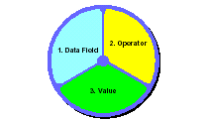
- Operator
- Value

Data Field includes all available data fields in the Quality Analysis Tool software and any user-defined field. When you build a query, the fields that are available will be presented in alphabetical order in a drop down list.

User-defined fields can also be used in a query. These are special fields that you create for your use.

Operator describes the relationship of a data field to its value:

= Equal to <> Not equal to
< Less than > Greater than
<= Less than or equal to >= Greater than or equal to
Like Similar to Not Like Different from

- Note that whenever you use Transaction in a query, you need to use the Like and Not Like Operators. Also, be careful when using the <> (not equal to) operator because it will not recognize (Blank) values.

Use an operator to describe the relationship of the data field to a specified value. For example:

Parent’s Adjusted Gross Income => $30,000

Value specifies criteria for selection. Specifying the value is the third step in building a query. The value must be valid. You have two options when specifying a value for your query:

You can provide a value at the time you create the query. This value will be a constant; it will automatically be used each time the query is used.

You can choose a value each time you run a query. Leave the value field blank at the time you create the query and mark the “Prompt at Execution” box. This type of query is often known as a parameter query. Parameter queries are convenient if you query on the same fields regularly but want to use different values. This query finds all records with Parents’ Adjusted Gross Income of less than $50,000 and prompts you to enter the value for Student’s Adjusted Gross Income at the time you run the query. The query finds only the records that meet both criteria.

(PARENT’S ADJUSTED GROSS INCOME < 50,000) AND (STUDENT’S
ADJUSTED GROSS INCOME) < [PARAMETER])

When the software reads this query and comes to the box [PARAMETER] it will ask you to provide a value for Student’s Adjusted Gross Income.

Now that we know the Terms and the Rules, we can begin our discussion of queries.

Predefined Queries

The Quality Analysis Tool comes with a set of twelve pre-defined queries. These queries are commonly used. However, you may use predefined queries as templates to create your own queries.

When you open the Query dialog box for the first time, you will see the predefined queries are stored as the first set of records in the Query database and they are labeled: “PREDEFINED QUERY” in the upper right corner of the Query dialog box. You cannot delete a predefined query.

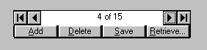Select File, Tools, Query: Use the arrow button in the database buttons box to locate the predefined query you want to use.

Another way of accessing predefined queries would be to CLICK the RETRIEVE button in the Query dialog box. All queries will be displayed. All predefined queries will be identified by a ‘checked’ box.

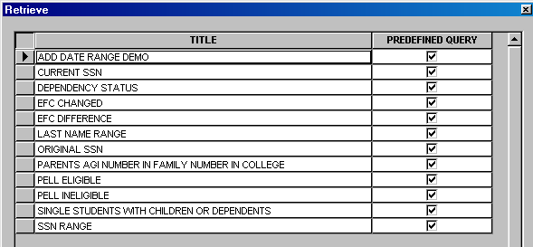

Building a Simple Query: In this demonstration, we build a simple query to select all records that have Parental AGI less than or equal to $30,000.

Step Action

1 | Select Tools – Query from the menu bar. The query Dialog box displays.
2 | A blank record displays. Select Add to build a new query.
3 | Enter a Title – something descriptive that readily identified the query. In this case, enter Parent’s AGI less than or equal to $30,000
4 | Click the Field down arrow to see the list of available fields in the Quality Analysis Tool software. With the cursor, select the desired field.  In this case, select Parent’s Adjusted Gross Income
5 | Select the appropriate Operator by clicking the down arrow to see the full list.  In this case, select <=
6 | Enter the Value to be measured against the field you selected.  In this case, enter 30,000  (If you want to make this a Parameter Query, you would leave the Value field blank and mark the Prompt at Executive box.)
7 | Click the Append button to add the statement to the query. The following query statement displays:  (Parent’s AGI <= 30,000)
8 | Click Save, to save the query. A Record Updates Saved dialog box displays.
9 | Click OK to return to the Quality Analysis Tool main menu.

Next, you will need to decide on a report to run to give you the information you want to see for the students you have selected using this query.

Building a Simple Query (continued): You have created a simple query to select all records with Parent’s AGI less than or equal to $30,000.

Next, test your query by printing a report. Let’s use a Custom Report to display the last name, first name, SSN, and Parent’s AGI for the students selected using this query.

Step Action

10 | Select Tools – Custom Report from the menu bar.
11 | Enter a Code. Type 01
12 | Enter a Description. Type Parent’s AGI less than or equal to 30000
13 | Select Field Descriptions. Click Last Name - Demo, First Name - Demo, Original SSN, Parent’s Adjusted Gross Income
14 | Optional: Click Resequence. This will move all of the Fields you selected to the top of the Field Description column.
15 | Click Save
16 | Click OK to return to the Quality Analysis Tool main menu.
17 | Select File - Print
18 | Select a Report. Click Custom Report
19 | Select a Report File Destination. Click Printer or File or Screen.
20 | Click ellipsis button near Custom Code. Select 01.
21 | Click OK to leave the dialog box.
22 | Select Last Name under Sort Order.
23 | Click Selection Criteria. Click the Query Title ellipsis button. Select Parent’s Adjusted Gross Income.
24 | Click OK twice to leave the dialog box.
25 | Click OK to initiate printing.

Whenever the Selection Criteria option is available in QA Tool (for example, in Print), you can use these queries to identify groups of records.

Custom Report produced by the Simple Query

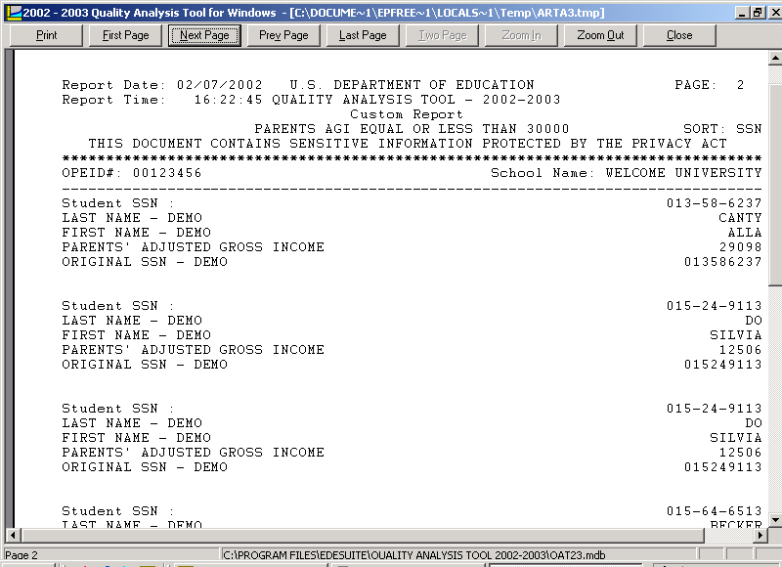

The Custom Report generated using the query displays the requested data for those students whose Parental AGI is less than $30,000.

There are many standard reports available in the Quality Analysis Tool software. Refer to the Report Section of this document to become more familiar with the various types of report the software has to offer.

Remember:

Query + Appropriate Report = Data you want to study

What Is a Complex Query?

A complex query is formed by linking two or more simple queries together and using an AND or an OR connector. Complex queries provide you with a powerful tool for working with your Quality Analysis Tool database.

AND

Both segments of the query connected by AND must be true for a record to be selected.

Think of two overlapping circles, each circle representing the records selected by a
query statement. When an AND connect is used, the query selects only those records
that represent the overlap of the two circles. For example, the following query would
only select independent students that have an EFC of O:

Dependency Status = “I” AND EFC = 0
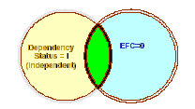

Independent students without an EFC equal to 0 and dependent students would not be included in the query.

OR

Only one of the segments connected by OR must be true for a record to be selected. Let’s used the overlapping circles again diagram again. When an OR connector is used, the query selects all records represented by the two circles, not just records represented by the overlap of the circles.

Order of Precedence

You can use OR and AND connectors in the same query. Be sure to keep in mind the order of precedence. Queries are processed from left to right; however, AND is applied first, even if it appears after OR in the query statement.

Parentheses
Use parentheses to further define the order of precedence. Additional parentheses create an expression by connecting two or more fields. You can use the expression in a query statement as you would use a field.
Building a Complex Query: In this demonstration, we build a complex query to select all records where Student’s Total Worksheet A is less than 1000 and Parent’s Number in College equals 2 and EFC is less than 3000. Let’s build this query with a parenthesis.

Step Action

1 | Select Tools – Query from the menu bar. The query Dialog box displays.
2 | A blank record displays. Select Add to build a new query.
3 | Enter a Title – something descriptive that readily identified the query. In this case, enter Student’s Worksheet A and EFC and Number in College
4 | Click the Field box. Select Student Worksheet A
5 | Select the appropriate Operator. Select <
6 | Enter the Value. Enter 1000
7 | Click the Append button to add the statement to the query.
8 | Click the Field box. Select Parent’s Number in College
9 | Select the appropriate Operator box. Select =
10 | Enter the Value. Enter 2
11 | Click the Append button to add the statement to the query.
12 | Click the Field box. Select EFC
13 | Select the appropriate Operator box. Select <
14 | Enter the Value. Enter 3000
15 | Click the Append button to add the statement to the query. A three-statement query displays.
16 | Click on the first line of the query, then click the add Left button
17 | Click on the second line of the query, then click the add Right button  The first two statements are nested within parentheses, and will be processed first.
18 | Click Save, to save the query. A Record Updates Saved dialog box displays.
19 | Click OK to return to the Quality Analysis Tool main menu.

Next, test your query by printing a report. You may select an appropriate standard report or use a Custom Report. You may follow instructions on page 6 of this section and select Field Descriptions you would like to see for these selected students.

Modifying a Query

To modify a query:

Step Action
1 | Select Tools – Query from the menu bar. The query Dialog box displays.
2 | Use the arrow buttons in the database buttons box to locate the query you want to modify.
3 | Modify the query. Click any line to select it and change the Field, Operator, or Value. Then click the Change button.  -You can also delete lines or add new lines to the query.  -To add new lines, select the line that should appear after the new line.  Specify the Field, Operator, and Value for the new line, the click Append.  -Use the other buttons located around the Criteria box to fine-tune the  query statement if necessary.
4 | To delete a line, select the line and click Remove
5 | Click Save to save the query, then Click OK.
6 | Click OK to close the Query dialog box or click Add to create another query.

These procedures may be used to modify a predefined query or modify a query you have created.

Although predefined queries maybe used to create new queries, remember predefined queries cannot be deleted.

What’s New!

- A New predefined query on EFC tolerance

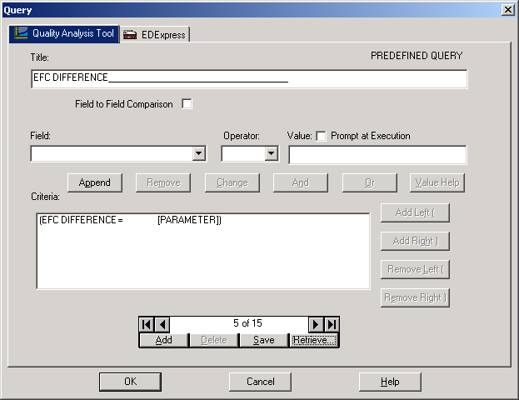

The EFC Difference is a new predefined query in the 2002-2003 Quality Analysis Tool software. This predefined query will allow you to establish an EFC tolerance.

In the graphic above, you see that this is a “Prompt at Execution” query. When you run the query you will be asked to enter a value for the EFC Difference you want to study, e.g. 500. This predefined query, when used in combination with the desired report, will display a list of students whose EFC change equals $500.

What’s the difference between the “EFC Changed” and the “EFC Difference” predefined queries?

The “EFC Changed” predefined query, when used with an appropriate report, provides all students whose EFC changed from initial to paid-on transaction. The “EFC Difference” predefined query allows you to specify the EFC tolerance you want to study.

- A New Field to Field Comparison

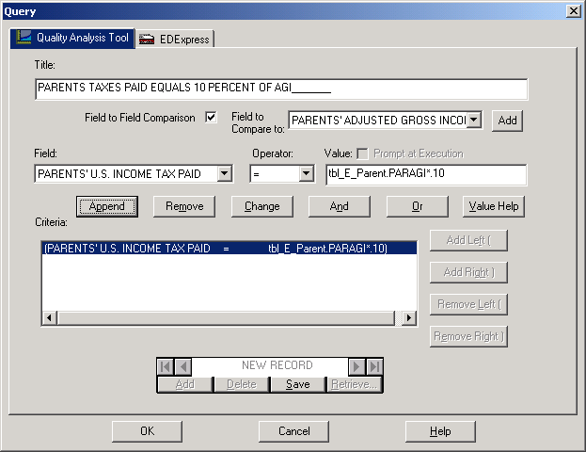

You can compare numeric fields within records using the new Field to Field Comparison Option. This query option allows you to compare one field to another field.

In the graphic above, records are selected if the Parent’s U.S. Income Tax Paid equals 10 percent of Parent’s Adjusted Gross Income.

Important Points

- Mark the checkbox to build the “Field to Field Comparison” query.
- Fields are compared within the same ISIR transaction number. For example, a field to field query compares the numeric fields in the 01 transaction only with other numeric fields in the 01, not with the numeric fields in the student’s 02 transaction.
- The Field to Field Comparison option is not available if you marked “Prompt at Execution” or Current Date.

Query Management Report

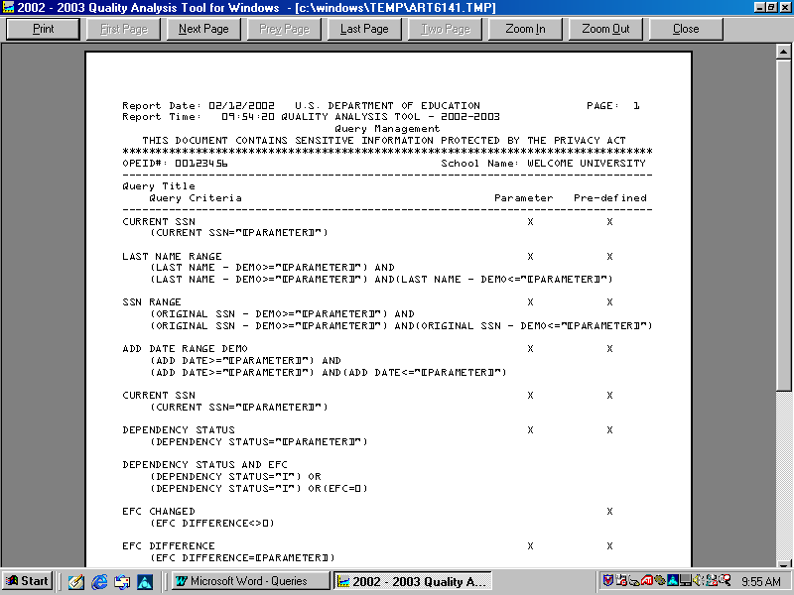

The Query Management Report is a list of both the queries you have created and the predefined queries provided with the QA Tool software. This report is locate under: File, Print. Under Report – select Query Management.

All queries may be found in the Query dialog box which you will find under FILE, TOOLS, QUERY. However, you must use the arrow keys to scroll through each query in your database.

This report display all queries in a list format and indicate which are PARAMETER or PREDEFINED queries.

Summary

- Queries used to select a specific group of students/records in your Quality Analysis Tool database.

- Queries are built. They are built using three components:

  - A data field
  - An operator
  - A value

Queries are further defined by connectors, such as AND, OR, parentheses and parameter values, Like, etc.

- The Quality Analysis Tool has twelve Predefined Queries that cannot be deleted.

- Queries may be modified or expanded upon to produce the precise selection tool that you need.

- NEW for 2002-2003: EFC Difference Predefined Query and Field to Field Comparison Query

Remember:

Query + Appropriate Report = Data you want to study

Section 2: Learn how to write Verification Edit Profiles using queries.

If you would like to see what the impact was on the Verification that was applied to your student records, you can write the applicable Verification Edit Profiles and enter it into the Tool . Once entered, you can apply it to your student records and run reports to determine their effectiveness.

Helpful Pointers:

- Develop a written list of your Verification Profiles.
- Develop a Title for each Profile. The Title Box on the Query Screen does not allow for spaces or symbols. If you have numerous Verification Profiles, your ‘naming’ mechanism may be critical.

- Become familiar with the data fields listed in the “Field” box on the Query Screen. The “Field” box contains:

    - All FAFSA data fields,
    - All fields that are by-products of the EFC calculation, and
    - Any user-defined fields that you create

- Construct your Verification Profile queries with the Query Screen Data Fields in mind.

Example: A Verification Profile might be: All Single students with dependents. It will take 3 data fields to construct the Query.

    - Is Student Married? = 2
    - Have children you support = 1, OR
    - Have dependents other than children or spouse = 1

- Special Note: The Household Size data field requires “2” digits. If you are entering 3 in the household, you would enter “03”.
- Determine which User-Defined fields are needed before attempting to construct you Verification Profile queries.
- Run a “Query Management” Report to get a listing of all your queries to review the queries you have constructed.

Steps in Constructing Verification Profiles

First: Construct a query for the profile.
Second: Use the query as a Verification Profile.
Third: Confirm that verification has been entered into the Quality Anlaysis (verification) Tool . You may choose to construct all th queries for you Verification Profiles first, then complete Steps 2 and 3.
Listed below are 8 examples of Verification Edit Profiles that you can review. Just click on the Verification Edit Profile that you would like to review and it will link you to how to construct the Verification Edit Profiles.

Verification Edit Profile 1: Dependent Students with parents AGI<=0
Verification Edit Profile 2: Dependent/Resident student with Parental Taxes Paid>25%of AGI and EFC<12546.

Verification Edit Profile 3: Dependent/Non-resident student with Parental Taxes Paid>25% of AGI and EFC <21760.
Verification Edit Profile 4: Independent with dependents other than a spouse, AGI and Untaxed Income <11610.
Verification Edit Profile 5: Dependent with Income Exclusions>20% of AGI.
Verification Edit Profile 6: Independent with Income Exclusions >20% of AGI.
Verification Edit Profile 7: Orphan/Ward of the Court (New &Transfers Only).
Verification Edit Profile 8: CPS Verification Edit Profile
Note: If your institution has not developed
specific verification selection criteria and
your institution uses the federal edits as its
only verification selection criteria,
Verification Edit Profile 8 is the only profile
you will need.

Section 3: Enter and apply your verification Edit Profiles into the Quality Analysis (verification) Tool.

Click on the following link to learn how to apply and enter your Verification Edit Profiles into the Tool.

Apply and Enter your Verification Edit Profiles

