Exhibit A.
Study Awareness Materials and Commitment Statements
Revised Dec 14, 2007


The Effects of Kentucky Virtual High School’s
Hybrid Course in Algebra I on Teaching Practices,
Classroom Quality, and Adolescent Learning

Research Project Summary
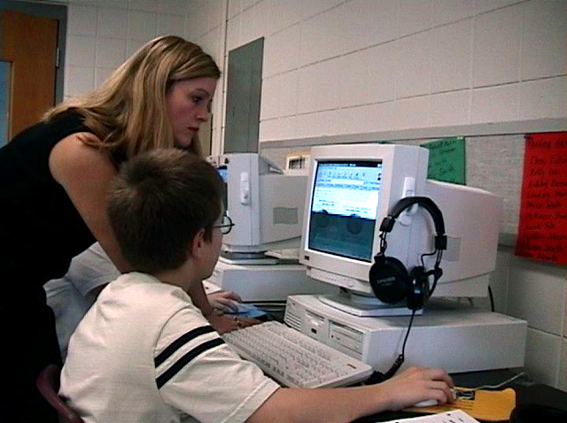
Algebra I has emerged in recent years as a critical gatekeeper course, necessary to prepare students for the rigorous mathematics curriculum required for high school graduation and successful post-secondary experiences. Therefore, providing Algebra I teachers with the very best resources and professional development to ensure effective instruction has become a priority in Kentucky and across the nation. This research study is designed to test, through a rigorous experimental design, an approach that combines online and technology enhanced instruction with face-to-face classroom instruction to address this need. This hybrid or “blended” approach has shown promising results in Kentucky and elsewhere.
Teachers who receive the intervention in this study will apply the hybrid approach using the Kentucky Virtual High School’s (KVHS) online course curriculum in Algebra I. They will be supported by extensive professional development in hybrid instruction and research-based practices for teaching Algebra I. The KVHS course is fully aligned with national and new state standards for Algebra instruction. The results on improved instructional practices, classroom quality, and student learning will be compared to those in control sites in which Algebra I instruction will continue as it has with traditional classroom instruction.
Participating schools will be randomly assigned to either an intervention group or a control group in Spring 2008 and participating teachers will assume the intervention or control status assigned to their school. Data collection for both intervention and control groups will begin in the Spring 2009, and continue through spring 2010. Participating teachers in the intervention schools will begin professional development in May 2008, and will continue with the facilitated face-to-face and online support of a master teacher as they implement the intervention in school year 2008-2009. Teachers will continue to have access to all of the online resources for instruction in 2009-2010, as well as on-demand support from KVHS. Results of the study will be made available following a technical review by the U.S. Department of Education, Institute for Education Sciences.

Who Will Be Conducting the Research and How It Will Be Funded
The research will be conducted by the Regional Educational Lab-Appalachia, housed at The CNA Corporation in Alexandria, VA, and is funded by the United States Department of Education, Institute of Education Sciences. The Principal Investigators (PIs) for the study will be Dr. Linda Cavalluzzo from The CNA Corporation and Dr. Deborah Lowther from Education Innovations, Center for Research in Education Policy (CREP), University of Memphis, TN. Dr. Cavalluzzo is an expert in virtual and online programs, and in empirical analyses of teacher effectiveness and workforce issues. Dr. Lowther is an expert in technology integration and co-author of two leading technology integration textbooks, which have received national awards and have been translated into multiple languages, Instructional Technology and Media for Learning and Integrating Technology into the Curriculum.
Implementation of the intervention will be supported by KVHS staff from the Kentucky Department of Education, and by one or more master teachers of mathematics from the Collaborative for Teaching and Learning (CTL), a not-for-profit consulting and professional development organization based in Louisville, KY. The KVHS staff and the master teacher will be available for support throughout the study. The master teacher will serve as the primary facilitator for effective practices in Algebra I in a hybrid environment.

Research Summary Continued

Key Research Questions
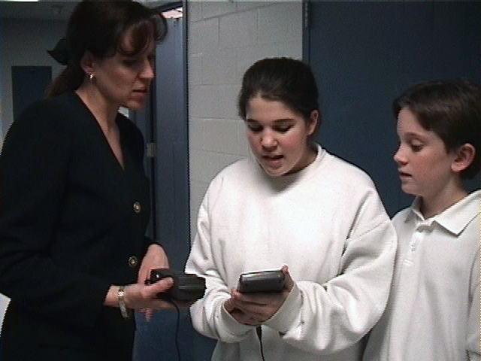
The study will measure the effects of the hybrid instructional format on:
- instructional practices of teachers,
- classroom quality, and
- mathematics learning of adolescents.

In addition, researchers will measure differences in effectiveness among students with different characteristics, such as gender, race/ethnicity, income, and age.

Data Collection and Measures of Effectiveness
Data will be collected from teachers and students in the intervention and control groups in each of the following areas. To gauge program effectiveness, outcomes in the intervention group will be compared with outcomes in the control group before and after the intervention.
- Student mathematics knowledge and skills: based on post-assessments of Algebra I knowledge, including an end-of course assessment and PLAN score in mathematics in the fall of 10th grade, controlling for prior performance in mathematics, as measured by scores on the 8th grade KCCT.

- Additional student outcomes: In addition to outcomes on assessments in mathematics, subsequent course enrollments in mathematics, course grades, and high school continuation rates will be examined.

- Instructional practices and classroom quality: a range of indicators will be analyzed using data collected through (1) surveys of teachers; and (2) classroom observations that will take place during one-day visits to each school in the Spring of 2008-2009.

- Baseline data for all Algebra I students: baseline administrative data must be collected for all Algebra students in the study. These data will be used to help ensure that any measured differences in outcomes between students in intervention and control schools are a result solely of the intervention.

What Teachers in the Control Group Can Expect
Regionally-located sessions will be offered to teachers in the control group in the fall of school year 2008 that will provide an overview and describe their responsibilities during the study, and discuss opportunities for receiving the intervention at the conclusion of the study. Alternative sessions will be offered for teachers unable to attend the initial meetings.

Professional Development Teachers in the Intervention Group Can Expect
A one-day workshop for intervention group teachers will take place in Spring 2008. Teachers will receive an orientation and initial training in the use of courseware for the KVHS Algebra I course, and for professional development in research-based practices for Algebra I. From this point forward, teachers will be enrolled in an online classroom that will provide access to the courseware they will use for Algebra I instruction beginning in school year 2008-2009. The online classroom will also serve as the forum for communicating with their learning community over the course of the project.
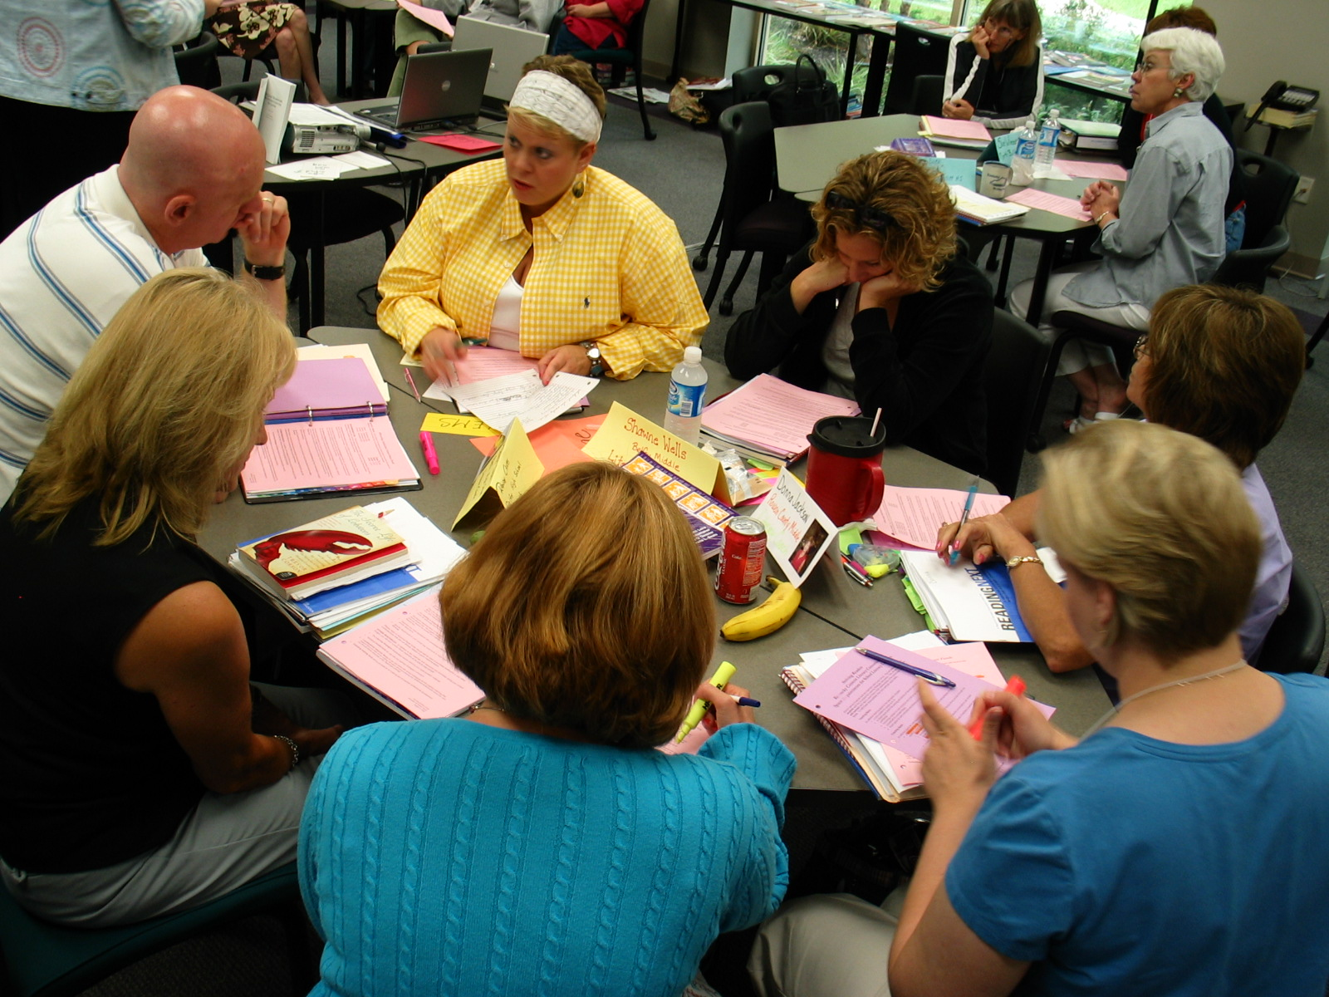
Teachers will also attend a two-day workshop at the conclusion of the 2007-2008 school year and one-hour online meetings every week for five weeks during the summer, focused on effective practices for Algebra I. Independent learning activities will be assigned prior to each online session. This design was specifically chosen to get teachers off to a good start with the professional development program, and to ensure that each teacher is comfortable with use of the online resources that the program will draw on. The goal of the two-day workshop is to complete four units of the course, leaving five more to be completed over the summer.
During the 2008-2009 school year teachers will instruct their Algebra I classes in a blended format. Weekly online discussion sessions led by a master teacher will help teachers draw on resources introduced during the summer, as well as their own experiences, to build context for instruction, select strategies appropriate to development of key mathematical concepts, and discuss plans and experiences. Teachers will receive a schedule of upcoming topics, and will be required to select in advance at least one session per month in which they will participate.
Classroom teachers will continue to have access to the online instructional materials, in 2009-2010. Teacher supports in 2009-2010 include continued access to online resources and to their learning community. In addition, teachers may call or e-mail KVHS to answer questions, or for assistance.

Participation

Eligibility
Schools in Kentucky housing a 9th grade may be eligible for participation in this study.

Selection
Invited schools that wish to participate must complete the enclosed application materials verifying that the availability of technology and technology supports to accommodate the technology-based curriculum, the willingness of their Algebra I teachers to participate in the study, and building and district level administrative support for the study.


Assignment to Intervention and Control Groups
After a sufficient pool of eligible participants is obtained, the list of participating schools will be randomized to assign schools to either the intervention or control groups. Once the school is assigned, all Algebra I teachers in the school will be assigned to the same group. The intent is to assign approximately 30 schools to the hybrid approach and 30 to continue their normal instructional approach.

Participant Requirements
Schools | Teachers
- Have adequate technology and technology supports, as established and verified by KVHS  - Agree to data collection plan  - Agree to participation by all teachers of Algebra I  - Complete the enclosed administrator form and submit according to the application procedures | - Teach Algebra I during school year 2008-2009  - Agree to participate in data collection  - Agree to participate in professional development  - Complete the enclosed teacher form and submit according to the application procedures

Frequently Asked Questions

Why does my school have to agree to participate in the study before we know whether we will be assigned to an intervention or control group?
Random assignment of participants is critical to the validity of the study. Randomization ensures that the intervention group does not vary systematically from the control group in ways that may distort measurement of the effectiveness of the intervention.

If my school is chosen as a control site, when will we be able to try the hybrid approach?
KDE will give enrollment priority to the control schools by having an initial registration period open only to them. Control schools will be able to enroll in the program at this point, if they wish. At the end of this initial registration period, any remaining slots will be opened by KDE to non-study schools.

Will students in participating classrooms be able to drop, add, or change Algebra I classrooms if they wish?
Yes. Schools should follow their normal policies and procedures regarding student assignments.

There are three teachers of Algebra I in my building, and only two of them want to participate in the study. Is this acceptable?
It is the desire and intent of the research that every teacher teaching Algebra I in a building selected as an intervention site is using the hybrid approach. This is important to ensure that students enrolled in Algebra I for the 2008-2009 school year are not assigned purposely to specific classes because of the teacher’s participation in the study. If this requirement is a concern, you should contact Dr. Linda Cavalluzzo or Dr. Linda Hargan to discuss your situation.

My Algebra I teacher is retiring this Spring. Will this prevent us from participating?
No. As long as the school commits to the participation of the replacement teacher, we will offer alternatives for those teachers to receive the required professional development to enable them to participate fully in hybrid instruction.

Application Process and Contact Information
Applications are enclosed. Please note that EACH TEACHER participating in the project must complete an application form. If you need additional forms, please make copies. Also, the administrator form must be signed by the building principal as well as by the district superintendent, who has been informed of your invitation to participate in this study.
If you have questions concerning the project overall, the professional development requirements, etc., contact:

Linda Hargan or Jo Ann Mosier, CTL, 502-895-9500
lhargan@ctlonline.org or jmosier@ctlonline.org

If you have questions about your technology status and resources and requirements for the study, contact:

Terri De Yong, KDE, 502-564-4772
terri.deyong@education.ky.gov

If you have questions about the research design or specific data collection procedures or instruments, contact:
Linda Cavalluzzo, CNA, 703-824-2197
cavallul@cna.org

Please mail or fax application materials to:

Dr. Linda Hargan
Collaborative for Teaching and Learning
2303 River Road, Suite 100
Louisville, KY 40206

Fax: 502-895-9521

Responses to this data collection will be used only for statistical purposes. The reports prepared for this study will summarize findings across the sample and will not associate responses with a specific district or individual. Researchers will not provide information that identifies you, your school, or your district to anyone outside the study team, except as required by law.
Administrators Commitment Statements

The Effects of Kentucky Virtual High School’s Hybrid Course in Algebra I on Teaching Practices, Classroom Quality, and Adolescent Learning

School Name: District:

Principal Name:

School Phone: School Fax:

School Address:

Principal’s School E-Mail Address:

Algebra I School Information

Current number of faculty teaching Algebra I:

Total number of Algebra I class sections:

Please complete the following information for each Algebra I teacher. Please add a separate sheet if additional space is needed. (please print)

Teacher Name | State Identification Number | # of Algebra I  Class Sections | Teacher Expected to Return in 07-08

Total number of students currently enrolled in Algebra I:

9th graders 10th graders Other (specify grade)

Technical Requirements

In order to make the most of your online learning experience, there are several technical requirements that schools and individual participants will need to fulfill. Please review the guidelines below to help ensure your online success.

Minimum System Requirements
Microsoft Windows
- Operating System: Windows 2000 or XP
- Internet Browser: Microsoft Internet Explorer 6.0 or 7.0, Netscape 7.1 or 8.0, or Firefox 1.0
- Sound Card & Speakers
- Web Browser with Java enabled
- Real One Player 2
- Macromedia Flash Player
- Macromedia Shockwave Player

Macintosh OS
- Operating System: Mac OS 10.2, 10.3, or 10.4
- Internet Brower: Netscape 7.1, Firefox 1.0, Apple Safari 1.0, 1.1, 1.2 or 2.0
- Sound Card & Speakers
- Web Browser with Java enabled
- Real One Player 2
- Macromedia Flash Player
- Macromedia Shockwave Player

My school has  high-speed and/or  dial-up Internet access for students, either through a laboratory or lap tops on carts.  No  Yes Other:

What is the maximum number of students able to be served by the lab(s) and/or lap tops on carts? | Lab(s)  Lap tops on carts

Each teacher of Algebra I has high-speed Internet access in the classroom and continuous access to an LCD, Smartboard, or similar projection device.  No  Yes Other:

Technology Coordinator’s Signature: Date:

Technology Coordinator’s Printed Name:

Statement of Commitment

I support the participation of my school in the Kentucky Hybrid Algebra I Research Project, and have assurance of the Algebra I teachers identified above of their commitment to the project. If my school is chosen as a control site, we will welcome observers into the school, make time available for student assessments, and provide requested data as described in the research study materials.

If my school is selected as an intervention site, the identified teachers will participate in the required professional development, we will welcome observers into the school, make time available for student assessments, and provide requested data, as described in the research study materials. I understand that each participating Algebra I class must be scheduled into to the computer lab or equivalent a minimum of two class periods per week in order to ensure effective implementation of the hybrid Algebra I course, and make that commitment.

I understand that responses to this data collection will be used only for statistical purposes, that the reports prepared for this study will summarize findings across the sample and will not associate responses with a specific district, school or individual, and that no information will be provided that identifies me, my teachers, or my district to anyone outside the study team, except as required by law.

Principal’s Signature: Date:

Principal’s Printed Name:

I have reviewed the research study materials and I support the participation of this school in the Kentucky Hybrid Algebra I Research Project. If I should leave my position, I will inform my successor of the importance of the study and continued school participation through the completion of the research.

Superintendent’s Signature: Date:

Superintendent’s Printed Name:

THANK YOU FOR YOUR INTEREST IN THIS VERY IMPORTANT RESEARCH OPPORTUNITY!

Teacher Commitment Statement

The Effects of Kentucky Virtual High School’s Hybrid Course in Algebra I
on Teaching Practices, Classroom Quality, and Adolescent Learning
Make copies of this form as needed for each Algebra I teacher.

Teacher Name:

School: District:

Principal Name:

School Phone: School Fax:

Teacher’s School E-Mail Address:

Home Address:

Home Phone: Cell Phone:

Teacher’s Home E-mail Address:

I prefer to receive electronic communications:  At Home  At School  Both

Are you currently teaching Algebra I?  No  Yes
If yes, At which grade(s)? How many classes of – Regular:
How many classes? Advanced:
Avg. # Students per period: Remedial:

Do you plan to remain in your current building and assignment for next year?
❑ No  Yes

Are you currently certified to teach mathematics?  No  Yes
If not, please describe your existing certification.

Are you certified to teach at the grade level you are assigned?  No  Yes
If not, please specify the grade levels for which you are approved.

Number of years teaching: Number of years teaching Algebra I:

Do you, or have you taught other mathematics courses?  No  Yes
If yes, please list . Currently:
2006-2007:
2005-2006:

Have you taught on-line?  No  Yes
If yes, what course(s)? When?

(Please turn over.)
Have you ever taught a hybrid course?  No  Yes
If yes, what course(s)? When?

Have you ever taken an on-line course?  No  Yes
If yes, what course(s)? When?

I have  high-speed and/or  dial-up Internet access
❑ At Home  At School  In My Classroom Other:

I have an LCD, Smartboard or equivalent projection device in my classroom.  No  Yes

Statement of Commitment

I am interested in participating in the Kentucky Hybrid Algebra I Research Project. If my school is chosen as a control site, I will welcome observers into my class periodically, make time available for student assessments, and provide requested data as described in the research study materials. I will continue to teach Algebra I to the best of my ability as a professional educator.

If my school is selected as an intervention site, I will participate in the required professional development, welcome observers into my class periodically, make time available for student assessments, and provide requested data, as described in the research study materials. I will implement the hybrid Algebra I course to the best of my ability as a professional educator.

I understand that responses to this data collection will be used only for statistical purposes, that the reports prepared for this study will summarize findings across the sample and will not associate responses with a specific district or individual, and that no information will be provided that identifies me or my district to anyone outside the study team, except as required by law.

Teacher’s Signature: Date:

Teacher’s Printed Name:

THANK YOU FOR YOUR INTEREST IN THIS VERY IMPORTANT RESEARCH OPPORTUNITY!

(Letter from the Chief State School Officer to Eligible Districts and Schools)

Dear Principal,

The Kentucky Department of Education is pleased to inform you and your Superintendent that your school may participate, if you so choose, in a federal study involving the teaching of Algebra I. The research study will quantify the benefits, in terms of improved instructional practices, classroom quality, and student outcomes, of teaching Algebra I in a hybrid classroom environment. Teachers in hybrid classrooms will use Kentucky Virtual High School’s (KVHS) online course curriculum in Algebra I to help support student learning. KVHS’s hybrid course is fully aligned with new state and national standards. Teachers who participate in the program will learn, with a community of other participating teachers, effective practices, strategies, and activities in hybrid and Algebra I instruction.

Kentucky Virtual High School is a KDE program that, since 2000, has brought online courses to students who lack other access to the classes they need. In the past two years, KVHS has been experimenting with using the curriculum in face-to-face classes to help support effective instruction, and is quite enthusiastic about the improvement participating teachers have seen in their classrooms. It is our goal, and that of the Institute of Education Sciences at the U.S. Department of Education, that at the conclusion of this study, we will know just how effective the approach can be. If it is as effective as we hope, steps will be taken to make hybrid instruction more widely available to students and teachers in Kentucky (and nationally).

Qualified applicants will be randomly assigned to either a treatment or control group. Random assignment in treatment and control groups is critical to accurate measurement of the effectiveness of instructional interventions. As you consider this opportunity, be assured that responses to this data collection will be used only for statistical purposes, that the reports prepared for this study will summarize findings across the sample and will not associate responses with a specific district, school, or individual, and that no information will be provided that identifies participants or their district to anyone outside the study team, except as required by law.

We feel honored that one of our programs has been identified as a promising practice that is worthy of careful evaluation and possible recommendation for more widespread use. Please read the enclosed research summary brochure and review the application package as you consider your potential participation with your Algebra I teachers. Staff from the Collaborative for Teaching and Learning will contact you soon to determine your interest, or you may contact them as described on the last page of the brochure.

Sincerely,

Chief State School Officer

(Follow-up e-mail from the Commissioner, Kentucky Department of Education)
DATE

Dear Principal,

I am writing to encourage you to consider participation in a research study on the teaching of Algebra I using a combination of classroom-based and on-line instruction. This is a federal initiative, and the results will provide critical information to educators in Kentucky and the nation concerning the effects of this approach on student learning. You may have received information in the mail concerning the study, but to date we have either not received a response as to your interest or ability to participate, or in some instances, you indicated inadequate lab facilities as your reason for not participating.

Background materials about the study are attached for your review. As you consider or reconsider this request, please be assured that KDE is willing to offer technical assistance to enable you to participate.

I would like to emphasize that information collected in support of this study will be used only for statistical purposes. The reports prepared for this study will summarize findings across the sample and will not associate responses with a specific district, school or individual. The study team will not provide information that identifies you, your school, or your district to anyone outside the study team, except as required by law.

In the next few days you will be contacted by phone by either Linda Hargan or Jo Ann Mosier, from the Collaborative for Teaching and Learning. Please try to take or return the call so that they can explain the requirements for participation and make a determination of the status of your school's participation.

Thank you for taking time from your busy schedule to address this issue.

Commissioner
Kentucky Department of Education

Attachments:
Letter from Commissioner, KDE
Brochure
School and District Commitment Form
Teacher Commitment Form

