Unit 4: Disaster Medical Operations—Part 2

In this unit you will learn about:

- Public Health Considerations: How to maintain hygiene and sanitation.

- Functions of Disaster Medical Operations: How to conduct the four major subfunctions of disaster medical operations.

- Disaster Medical Treatment Areas: How to establish them and what their functions are.

- Patient Evaluation: How to perform a head-to-toe patient evaluation to identify and treat injuries.

- Basic Treatment—How To:

- Treat burns.
- Dress and bandage wounds.
- Treat fractures, dislocations, sprains, and strains.
- Apply splints to hands, arms, and legs.
- Treat hypothermia.
- Control nasal bleeding.

Unit 4: Disaster Medical Operations—Part 2
Objectives | At the conclusion of this unit, the participants should be able to:  - Take appropriate sanitation measures to protect public health.  - Perform head-to-toe patient assessments.  - Establish a treatment area.  - Apply splints to suspected fractures and sprains, and employ basic treatments for other wounds.
Scope | The scope of this unit will include:  - Introduction and Unit Overview.  - Public Health Considerations  - Functions of Disaster Medical Operations.  - Establishing Treatment Areas.  - Conducting Head-to-Toe Assessments.  - Treating Burns.  - Wound Care.  - Treating Fractures, Sprains, and Strains.  - Splinting.  - Treating Hypothermia.  - Unit Summary.
Estimated Completion Time | 2 hours 30 minutes
Training Methods | The lead Instructor will begin this session by welcoming the participants to Unit 4: Disaster Medical Operations—Part 2, and will introduce the instructors for the session. The Instructor will then present a brief review of Disaster Medical Operations— Part 1, covering the “killers” and triage procedures. Next, the Instructor will present a brief overview of the unit topics. This section will end with a presentation of the unit learning objectives.  Then, the Instructor will present the public health considerations for disaster medical operations, including sanitation, hygiene, and water purification.  Then, the Instructor will present an overview of how disaster medical operations are organized and the responsibilities of each operational function.  The Instructor will then discuss where to establish a treatment area, and how the treatment area should be organized.

Training Methods (Continued) | Next, the Instructor will explain and demonstrate the procedures for conducting head-to-toe patient assessments using an Instructor, a participant, or a mannequin. The participants will then be assigned into pairs so that they can practice head-to-toe patient assessments under observation. The Instructors and/or cadres will observe the participants to ensure that they are performing the skills as taught.  Next, the Instructor will describe the treatment of burns, and the care of wounds to avoid infections. Topics will include the difference between bandages and dressings and bandaging techniques. The Instructor will demonstrate using dressings to control bleeding, and bandaging techniques using the mannequin.  The next section will deal with the treatment of fractures, sprains, and strains. An exercise will give the participants the opportunity to practice applying splints. The exercise will be followed by segments on how to diagnose and treat hypothermia. The unit will conclude with a summary.
Resources Required | - Community Emergency Response Team Instructor Guide  - Community Emergency Response Team Participant Manual  - Visuals 4.1 through 4.28
Equipment | In addition to the equipment listed at the front of this Instructor Guide, you will need the following equipment for this unit:  - A computer with PowerPoint software  - A computer projector and screen  - 1 mannequin (optional)  - 1 stretcher  - 1 box of examination gloves  - 1 box of 4" × 4" dressings  - 1 triangular bandage per participant  - 2 towels  - Splinting material  - Note cards  - Masking tape

Notes | A suggested time plan for this unit is as follows:  Introduction and Unit Overview 5 minutes  Public Health Considerations 5 minutes  Functions of Disaster Medical Operations 5 minutes  Establishing Treatment Areas 15 minutes  Conducting Head-to-Toe Assessments 25 minutes  Treating Burns 15 minutes  Wound Care 20 minutes  Treating Fractures, Dislocations, Sprains, and Strains 15 minutes  Splinting 25 minutes  Treating Hypothermia 10 minutes  Nasal Injuries 10 minutes  Unit Summary 5 minutes  Total Time: 2 hours 30 minutes

Unit 4: Disaster Medical Operations—Part 2

 |  |  | Introduction and Unit Overview
 | Introduce Unit |  | Introduce this unit by welcoming the participants to Unit 4 of the CERT training program.  Introduce the instructors for this session and ask any new instructors to describe briefly their experience in medical operations.
 | Visual 4.1 |  |  | Unit 3 Review  The “Killers”:  - Airway obstruction  - Excessive bleeding  - Shock  All “immediates” receive airway control, bleeding control, and treatment for shock.  Visual 4.1
Review the main points from Unit 3:

- Airway obstruction, excessive bleeding, and shock are “killers.” Victims with signs of these life-threatening conditions must receive urgent treatment.

 |  |  | Introduction and Unit Overview (Continued)
 | Visual 4.2 |  |  | Unit 3 Review  Triage involves:  - Rapid assessment.  - Rapid treatment.  Visual 4.2
 |  |  | Triage has proven to be an effective way to evaluate and prioritize the treatment of mass casualties in a disaster situation.
 |  |  | Introduce the unit topics by telling the participants that this unit will provide them with the information for performing treatment, setting up a medical treatment area, and transporting victims.
 | Visual 4.3 |  |  | Unit Introduction  Topics:  - Public health concerns  - Organization of disaster medical operations  - Establishing treatment areas  - Conducting head-to-toe assessments  - Treating injuries  Visual 4.3

 |  |  | Introduction and Unit Overview (Continued)
Explain that the unit will cover:

- Public health concerns related to sanitation, hygiene, and water purification.

- Organization of disaster medical operations.

- Establishing treatment areas.

- Conducting head-to-toe assessments.

- Treating wounds, fractures, sprains, and other common injuries.

Emphasize the need for practice by telling the participants that they will have the opportunity to practice many of the treatment techniques that they will learn.

 |  |  | Objectives
 | Visual 4.4 |  |  | Unit Objectives  - Take appropriate measures to protect public health.  - Perform head-to-toe patient assessments.  - Establish a treatment area.  - Apply splints to suspected fractures and sprains, and employ basic treatments for other wounds.  Visual 4.4
Tell the group that at the end of this unit, they should be able to:

- Take appropriate sanitation measures to protect public health.

- Perform head-to-toe patient assessments.

- Establish a treatment area.

- Apply splints to suspected fractures and sprains, and employ basic treatments for other wounds.

 |  |  | Introduction and Unit Overview (Continued)
 |  |  | Tell the group that the next section will cover the organization of disaster medical operations.
 | Ask Question |  |  | Ask the group if anyone has any questions from the last unit.  Ask if anyone has a question about what will be covered in this unit.
 |  |  | Public Health Considerations
 | Introduce Topic |  | Introduce this topic by reminding the group that when disaster victims are sheltered together for treatment, public health becomes a concern. Measures must be taken, both by CERT members and programmatically, to avoid the spread of disease.
 | Visual 4.5 |  |  |  | Public Health Considerations  - Maintain proper hygiene.  - Maintain proper sanitation.  - Purify water (if necessary).  Visual 4.5
Explain that the primary public health measures include:

- Maintaining proper hygiene.

- Maintaining proper sanitation.

- Purifying water (if necessary).

 |  |  | Public Health Considerations (Continued)
 | Instructor’s Note |  |  | If there is reason to believe that some victims may be contagious, those victims should be isolated from the other victims in the treatment area. Dressing and other supplies used for these victims should be disposed of separately.
 |  |  | Maintaining Hygiene
 | Introduce Maintaining Hygiene |  | Introduce hygiene by telling the group that maintenance of proper hygiene is critical even under makeshift conditions.
 | Visual 4.6 |  |  |  | Steps to Maintain Hygiene  - Wash hands frequently using soap and water.  - Wear latex gloves; change or disinfect after each patient.  - Wear a mask and goggles.  - Keep dressings sterile.  - Avoid contact with body fluids.  Visual 4.6
Tell the group that some steps that individual workers can take to maintain hygiene are to:

- Wash hands frequently using soap and water. Hand washing should be thorough (at least 12 to 15 seconds) with an antibacterial scrub if possible.

- Wear latex gloves at all times. Change or disinfect gloves after examining and/or treating each patient. As explained earlier, under field conditions, workers can use rubber gloves that are sterilized between treating victims using bleach and water (1 part bleach to 10 parts water).

- Wear a mask and goggles. If possible, wear a mask that is rated “N95.”

 |  |  | Public Health Considerations (Continued)
- Keep dressings sterile. Do not remove the overwrap from dressings and bandages until use. After opening, use the entire dressing or bandage, if possible.

- Avoid contact with body fluids. Thoroughly wash areas that come in contact with body fluids with soap and water or diluted bleach as soon as possible.

 |  |  | Stress the importance of practicing proper hygiene techniques even during exercises.
 |  |  | Maintaining Sanitation
 | Introduce Maintaining Sanitation |  | Introduce proper sanitation by cautioning the group that poor sanitation is also a major cause of illness, disease, and death.
 | Visual 4.7 |  |  | Maintaining Sanitation  - Control disposal of bacterial sources.  - Put waste products in plastic bags, tie off, and mark as medical waste.  - Bury human waste.  Visual 4.7
Explain that CERT medical operations personnel can maintain sanitary conditions by:

- Controlling the disposal of bacterial sources (e.g., latex gloves, dressings, etc.).

- Putting waste products in plastic bags, tying off the bags, and marking them as medical waste. Keep medical waste separate from other trash, and dispose of it as hazardous waste.

- Burying human waste.

 |  |  | Public Health Considerations (Continued)
 |  |  | Again, stress the need to practice proper sanitation, even during exercises.
 |  |  | Water Purification
 | Introduce water Purification |  | Introduce water purification by pointing out to the group that potable water supplies are often in short supply or are not available in a disaster. Remind the group to purify water for drinking, cooking, and medical use by heating it to a rolling boil for 1 minute, or by using water purification tablets or unscented liquid bleach.
 | Instructor’s Note |  |  | The bleach/water ratios are:  - 8 drops of bleach per gallon of water (16 drops if the water is cloudy).  Let the bleach/water solution stand for 30 minutes. Note that if the solution does not smell or taste of bleach, add another six drops of bleach, and let the solution stand for 15 minutes before using.
 |  |  | Also tell the participants that rescuers should not put anything on wounds other than purified water. The use of other solutions (e.g., hydrogen peroxide) on wounds must be the decision of trained medical personnel.
 | Ask Question |  |  | Ask the group if anyone has any questions about the public health considerations related to disaster medical operations.
 |  |  | Stress that CERT members must use latex gloves, goggles, and a mask during all medical operations and that they must cover all open wounds as a way of preventing the spread of disease.

 |  |  | Functions of Disaster Medical Operations
 | Visual 4.8 |  |  | Functions of Disaster Medical Operations  - Triage  - Treatment  - Transport  - Morgue  Visual 4.8
Point out that there are four major subfunctions of disaster medical operations:

- Triage: The initial assessment and sorting of victims for treatment based on the severity of their injuries.

- Treatment: The area in which disaster medical services are provided to victims.

- Transport: The movement of victims from the triage area to the treatment area. If professional help will be delayed, for efficiency of operations, victims can be transported to the treatment area by CERT members.

 |  |  | - Morgue: The temporary holding area for victims who have died as a result of their injuries.
 | PM, P. 4-4 |  | Refer the participants to the Disaster Medical Operations Organization chart in the Participant Manual.
 | PM, P. 4-5 |  | Refer the participants to page 4-5 in the Participant Manual. Explain that this diagram shows the flow of patients through the disaster medical system.  Explain that the last unit dealt with the procedures conducted in triage, and that this unit will focus on treatment.

 | PM, P. 4-4 | Disaster Medical Operations Organization

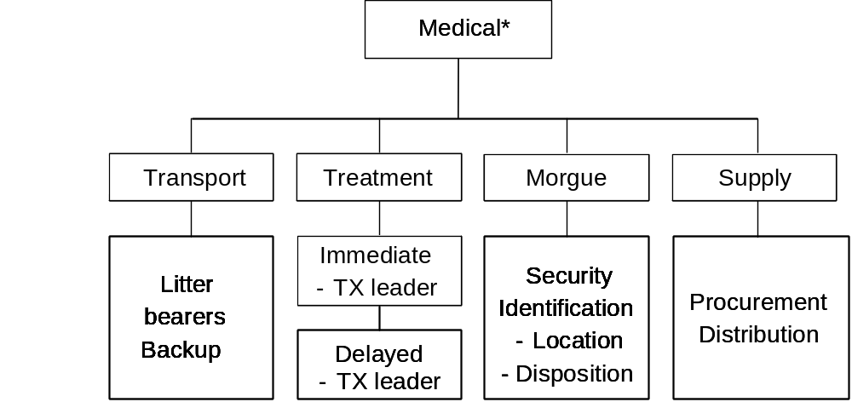

Disaster Medical Operations Organization, showing the subfunctions of disaster medical operations: Transport, Treatment, Morgue, and Supply.

*Note that triage is organized under search and rescue.

 | PM, P. 4-5 | Flow of Patients

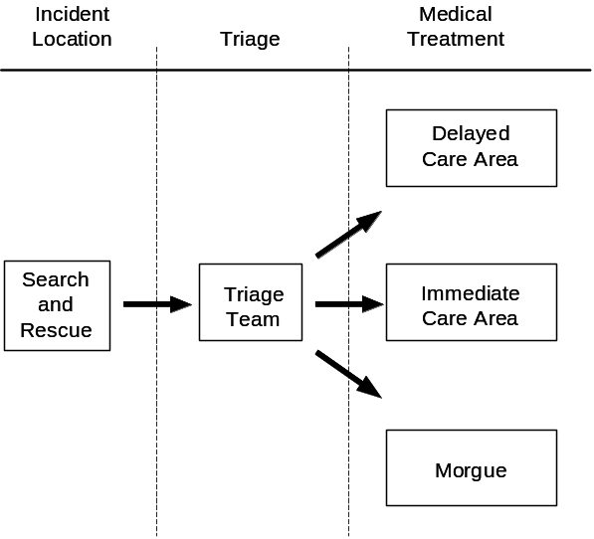

Patient Flowchart, which shows how the patients are rescued, triaged, and sent to the medical treatment areas according to the extent of their injuries (“I,” “D,” or “Dead”).

 |  |  | Establishing Treatment Areas
 | Introduce Topic |  | Introduce this topic by emphasizing that because time is critical during an emergency, CERT medical operations personnel will need to select a site and set up a treatment area as soon as injured victims are confirmed.  Explain that the treatment area is the location where the most advanced medical care possible will be given to victims.
 | Visual 4.9 |  |  |  | Establish Treatment Areas  The site selected should be:  - In a safe area.  - Close to (but upwind and uphill from) the hazard.  - Accessible by transportation vehicles.  - Expandable.  Visual 4.9
The site selected should be:

- In a safe area, free of hazards and debris.

- Close to, but upwind and uphill from, the hazard zone(s).

- Accessible by transportation vehicles (ambulances, trucks, helicopters, etc.).

- Expandable.

 | PM, P. 4-6 |  | Refer the participants to the Treatment Area Site Selection diagram in the Participant Manual.
 | Instructor’s Note |  |  | If you live in an area (near a large body of water) that is subject to on-shore or off-shore winds, tell the group that it may not be possible to establish an upwind treatment site. Suggest that they establish their treatment areas in an area that is perpendicular to the wind direction.

 | PM, P. 4-6 | Treatment Area Site Selection

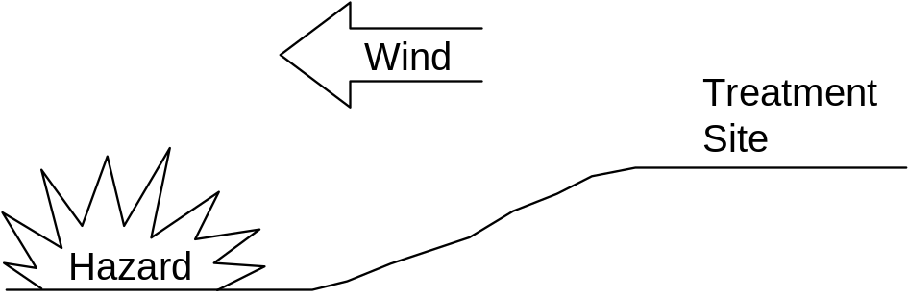

Treatment Area Site Selection, uphill and upwind from hazard.

 |  |  | Establishing Treatment Areas (Continued)
 |  |  | Treatment Area Layout
 | Introduce Treatment Area Layout |  | Introduce this section by stressing that the treatment area must be protected and clearly delineated using a ground cover or tarp, and that signs should identify the subdivisions of the area:  - “I” for Immediate care.  - “D” for Delayed care.  - “DEAD” for the morgue.
Explain that the “I” and “D” divisions should be relatively close to each other to allow:

- Verbal communication between workers in the two areas.

- Shared access to medical supplies (which should be cached in a central location).

- Easy transfer of patients whose status has changed.

Also, point out that a clearly marked treatment area will help in transporting victims to the correct location.

Explain that patients in the treatment area should be positioned in a head-to-toe configuration, with two to three feet between victims.

 | Visual 4.10 |  |  | Establishing Treatment Areas  Graphic: Treatment Area Layout  Visual 4.10
 | PM, P. 4-7 |  | Refer the participants to the Treatment Area Layout diagram in the Participant Manual.

 | PM, P. 4-7 | Treatment Area Layout

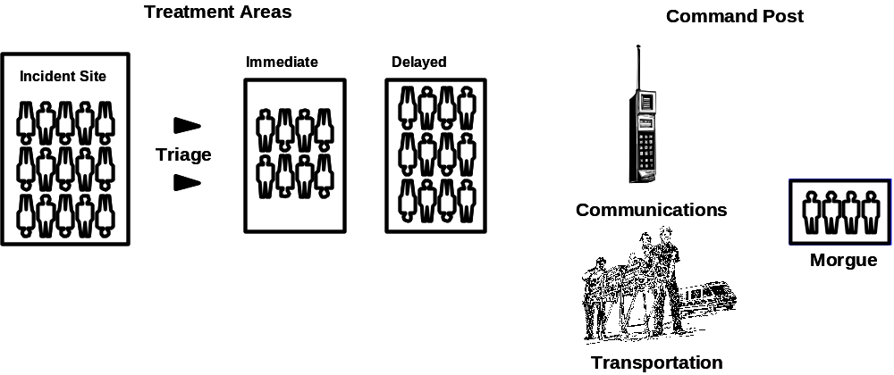

Treatment Area Layout, showing the organization for the incident site, triage, communications, transportation, and morgue.

 |  |  | Establishing Treatment Areas (Continued)
This system will provide:

- Effective use of space.

- Effective use of available personnel. (As a worker finishes one head-to-toe assessment, he or she turns around and finds the head of the next patient.)

 |  |  | Treatment Area Organization
 | Introduce Treatment Area Organization |  | Introduce this section by telling the participants that the CERT team must assign leaders to maintain control in each of the medical treatment areas. These leaders will:  - Ensure orderly victim placement.  - Direct assistants to conduct head-to-toe assessments.
Emphasize the need for thorough documentation of victims in the treatment area, including:

- Available identifying information.

- Description (age, sex, body build, height, weight).

- Clothing.

- Injuries.

- Treatment.

- Transfer location.

 |  |  | Treatment Area Planning
 | Introduce Treatment Area Planning |  | Finally, introduce the obvious need for planning before disaster strikes, including:  - Roles of personnel assigned to the treatment area.  - Availability of setup equipment needed, such as ground covers/tarps and signs for identifying divisions (immediate, delayed, morgue).

 |  |  | Establishing Treatment Areas (Continued)
 | Instructor’s Note |  |  | Stress that the morgue site should be secure, away from, and not visible from the treatment area.
 |  |  | Recommend strongly that the participants take part in practice exercises so that they can develop a good operational plan and practice rapid treatment area setup.
 | Instructor’s Note |  |  | Ask the group if anyone has any questions about treatment area site selection or organization.
 |  |  | Tell the participants that the remainder of this unit will deal with treatment of injuries and public health considerations within the treatment area.

 |  |  | Conducting Head-to-Toe Assessments
 | Introduce Topic |  | Introduce this topic by telling the group that the first steps that they will take when working with a victim will be to conduct a triage and rapid treatment. After all victims in an area have been triaged, CERT members will begin a thorough head-to-toe assessment of the victim’s condition.  Remind the group that, during triage, they looked for “the killers.”
- Airway obstruction.

- Excessive bleeding.

- Signs of shock.

 | Visual 4.11 |  |  | Indicators of Injury  - Bruising  - Swelling  - Severe pain  - Disfigurement  Provide immediate treatment for life-threatening injuries!  Visual 4.11
Stress that a head-to-toe assessment goes beyond the “killers” to try to gain more information to determine the nature of the victim’s injury. Describe what to look for during a head-to-toe assessment:

- Bruising

- Swelling

- Severe pain

- Disfigurement

 |  |  | Conducting Head-to-Toe Assessments (Continued)
 | Instructor’s Note |  |  | Emphasize that the participants should pay careful attention to how people have been hurt (the mechanism of injury) because it provides insight to probable injuries suffered.
 |  |  | A head-to-toe assessment can be done in place in a lightly damaged building. If the building is moderately damaged, the victim should be moved to a safe zone or to the treatment area for the head-to-toe assessment.
 | Instructor’s Note |  |  | Tell the students that you will discuss light, moderate, and heavy damage in a later section.
 | Visual 4.12 |  |  |  | Conducting Victim Assessment  A head-to-toe assessment:  - Determines the extent of injuries and treatment.  - Determines the type of treatment needed.  - Documents injuries.  Visual 4.12
Explain that the objectives of a head-to-toe assessment are to:

- Determine, as clearly as possible, the extent of injuries.

- Determine what type of treatment is needed.

- Document injuries.

Stress the importance of wearing safety equipment when conducting head-to-toe assessments.

 |  |  | Conducting Head-to-Toe Assessments (Continued)
 | Instructor’s Note |  |  | (Field Conditions) If you wish, suggest that if the medical team runs out of latex gloves, they can use rubber gloves and clean them between treating victims in a bucket of bleach-and-water solution (1 part bleach to 10 parts water) to reduce the risk of cross contamination.
Explain that head-to-toe assessments should be:

- Conducted on all victims, even those who seem alright. Everyone gets a tag.

- Verbal (if the patient is able to speak).

- Hands-on.

Tell the participants that, whenever possible, they should ask the person about any injuries, pain, bleeding, or other symptoms. Stress that, if the victim is conscious, CERT members should always ask permission to conduct the assessment. The victim has the right to refuse treatment. Then:

- Pay careful attention.

- Look, listen, and feel for anything unusual.

 |  |  | Emphasize the importance of talking with the conscious patient to reduce anxiety.

 |  |  | Conducting Head-to-Toe Assessments (Continued)
 | Visual 4.13 |  |  | Head-to-Toe Assessment  - Head  - Neck  - Shoulders  - Chest  - Arms  - Abdomen  - Pelvis  - Legs  - Back  Visual 4.13
Stress the need for conducting head-to-toe assessments systematically, checking body parts from the top to the bottom for continuity of bones and soft tissue injuries in the following order:

- Head

- Neck

- Shoulders

- Chest

- Arms

- Abdomen

- Pelvis

- Legs

- Back

 |  |  | Conducting Head-to-Toe Assessments (Continued)
Explain that completing the assessment in the same way every time will make the procedure quicker and more accurate.

Remind the group to check their own hands for patient bleeding as they complete the head-to-toe assessment.

Tell the participants to perform an entire assessment before beginning any treatment. Also, tell them to treat all unconscious victims as if they have a spinal injury.

 | Instructor’s Note |  |  | Stress that triage and head-to-toe assessments in a disaster setting are not day-to-day operations. Explain that, if the rescuer or victim is in immediate danger, safety is more important than any potential spinal injury. Rescuer and victim safety is the priority.
 |  |  | Closed-Head, Neck, and Spinal Injuries
 | Introduce Spinal Injuries |  | Introduce this section by explaining that when conducting head-to-toe assessments, rescuers may come across victims who have or may have suffered closed-head, neck, or spinal injuries.
 | Instructor’s Note |  |  | Define a closed-head injury for the participants as a concussion-type injury, as opposed to a laceration, although lacerations can be an indication that the victim has suffered a closed-head injury.
 |  |  | Tell the group that the main objective when CERT members encounter suspected injuries to the head or spine is to do no harm. They should minimize movement of the head and spine, while treating any other life-threatening conditions.

 |  |  | Conducting Head-to-Toe Assessments (Continued)
Tell the participants that the signs of a closed-head, neck, or spinal injury most often include:

- Change in consciousness.

- Inability to move one or more body parts.

- Severe pain or pressure in head, neck, or back.

- Tingling or numbness in extremities.

- Difficulty breathing or seeing.

- Heavy bleeding, bruising, or deformity of the head or spine.

- Blood or fluid in the nose or ears.

- Bruising behind the ear.

- “Raccoon” eyes (bruising around eyes).

- “Uneven” pupils.

- Seizures.

- Nausea or vomiting.

- Victim found under collapsed building material or heavy debris.

 | PM, P. 4-11 |  | Refer the participants to list of symptoms in their Participant Manuals.  Stress that if the victim is exhibiting any of these signs, he or she should be treated as having a closed-head, neck, or spinal injury.  Tell the group to keep the spine in a straight line when doing the head-to-toe assessment.

 | PM, P. 4-11 | Symptoms

The signs of a closed-head, neck, or spinal injury most often include:

- Change in consciousness.

- Inability to move one or more body parts.

- Severe pain or pressure in the head, neck, or back.

- Tingling or numbness in extremities.

- Difficulty breathing or seeing.

- Heavy bleeding, bruising, or deformity of the head or spine.

- Blood or fluid in the nose or ears.

- Bruising behind the ear.

- “Raccoon” eyes (bruising around eyes).

- “Uneven” pupils.

- Seizures.

- Nausea or vomiting.

- Victim found under collapsed building material or heavy debris.

 |  |  | Conducting Head-to-Toe Assessments (Continued)
 | Instructor’s Note |  |  | Demonstrate “creative” in-line stabilization, using a table and towels.
Explain that, in a disaster, ideal equipment is rarely available, so the CERT members may need to be creative by:

- Looking for materials that can be used as a backboard—a door, desktop, building materials—anything that might be available.

- Looking for items that can be used to stabilize the head on the board—towels, draperies, or sandbags—by tucking them snugly on either side of the head to immobilize it.

 | Instructor’s Note |  |  | Moving victims should only be done for the safety of the rescuer and victim or when professional help will be delayed and a medical treatment area is established to care for multiple victims.

 |  |  | Conducting Head-to-Toe Assessments (Continued)
 |  |  | Exercise: Conducting Head-to-Toe Assessments
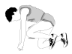 | Conduct Exercise |  | Purpose: This exercise allows the participants to practice conducting head-to-toe assessments on each other.  Instructions: Follow the steps below to facilitate this exercise:  - Assign the group to pairs.  - Ask the person on the right to be the victim and the person on the left to be the rescuer.  - Ask the victims to lie on the floor on their backs and close their eyes.  - Ask the rescuer to conduct a head-to-toe assessment on the victim following the procedure demonstrated earlier.
 | Instructor’s Note |  |  | Observe each pair and correct improper techniques.
- After the rescuer has made at least two observed head-to-toe assessments, ask the victim and rescuer to change roles.

- Allow each new rescuer at least two observed head-to-toe assessments.

- After all of the participants have had the opportunity to be the rescuer, discuss any problems or incorrect techniques that may have been demonstrated initially. Explain how to avoid the problems during emergencies.

 | Instructor’s Note |  |  | Ask if anyone has any additional questions about conducting head-to-toe assessments.
 |  |  | Tell the group that next, they will learn where and how to set up a treatment area.

 |  |  | Treating Burns
 | Visual 4.14 |  |  | Treating Burns  - Cool the burned area.  - Cover to reduce infection.  Visual 4.14
 | Introduce Topic |  | Tell the group that the objectives of first aid treatment for burns are to:  - Cool the burned area.  - Cover with a sterile cloth to reduce the risk of infection (by keeping fluids in and germs out).

 |  |  | Treating Burns (Continued)
Explain that burns may be caused by heat, chemicals, electrical current, and radiation. The severity of a burn depends on the:

- Temperature of the burning agent.

- Period of time that the victim was exposed.

- Area of the body that was affected.

- Size of the area burned.

- Depth of the burn.

 | Instructor’s Note |  |  | Tell the group to exercise extreme caution around victims who appear to have burns when there is no obvious cause for the burns. These burns may indicate chemical burns, which present a risk to the rescuer.
 |  |  | Burn Classifications
 | Visual 4.15 |  |  |  | Layers of Skin  - Epidermis  - Dermis  - Subcutaneous layer  Visual 4.15
Explain that the skin has three layers:
- The epidermis, or outer layer of skin, contains nerve endings and is penetrated by hairs.
- The dermis, or middle layer of skin, contains blood vessels, oil glands, hair follicles, and sweat glands.
- The subcutaneous layer, or innermost layer, contains blood vessels and overlies the muscle and skin cells.

 |  |  | Treating Burns (Continued)
 |  |  | Depending on the severity, burns may affect all three layers of skin.
 | PM, P. 4-14 |  | Refer the participants to the chart titled, Burn Classification, in the Participant Manual. Tell the group that burns are classified as first-, second-, or third-degree depending on their severity.
 | Visual 4.16 |  |  | Classifications of Burns  - First degree  - Second degree  Third degree  Visual 4.16
 | PM, P. 4-14 |  | Refer the group to the list of Guidelines for Treating Burns in the Participant Manual. Review the guidelines with the group:  - Remove the victim from the burning source. Put out any flames and remove smoldering clothing unless it is stuck to the skin.  - If skin or clothing are still hot, cool them by immersing in cool water for not more than 1 minute or covering with clean compresses that have been wrung out in cool water. Cooling sources include water from the bathroom or kitchen; garden hose; and soaked towels, sheets, or other cloths. Treat all victims of third-degree burns for shock.

 | PM, P. 4-14 | Burn Classification

Classification | Skin Layers Affected | Signs
1st Degree | - Epidermis (superficial) | - Reddened, dry skin  - Pain  - Swelling (possible)
2nd Degree | - Epidermis  - Partial destruction of dermis | - Reddened, blistered skin  - Wet appearance  - Pain  - Swelling (possible)
3rd Degree  (Full Thickness  Burns) | - Complete destruction of epidermis and dermis  - Possible subcutaneous damage (destroys all layers of skin and some or all underlying structures) | - Whitened, leathery, or charred (brown or black)  - Painful or relatively painless

 | PM, P. 4-14 | List of Guidelines for Treating Burns

Guidelines for treating burns include:

- Removing the victim from the burning source. Put out any flames and remove smoldering clothing unless it is stuck to the skin.

- Cooling skin or clothing, if they are still hot, by immersing them in cool water for not more than 1 minute or covering with clean compresses that have been wrung out in cool water. Cooling sources include water from the bathroom or kitchen; garden hose; and soaked towels, sheets, or other cloths. Treat all victims of third-degree burns for shock.

- Covering loosely with dry (or moist, based on local protocols), sterile dressings to keep air out, reduce pain, and prevent infection.

- Elevating burned extremities higher than the heart.

- Do not use ice. Ice causes vessel constriction.

- Do not apply antiseptics, ointments, or other remedies.

- Do not remove shreds of tissue, break blisters, or remove adhered particles of clothing. (Cut burned-in clothing around the burn.)

Infants, young children, and older persons, and persons with severe burns, are more susceptible to hypothermia. Therefore, rescuers should use caution when applying cool dressings on such persons. A rule of thumb is do not cool more than 15 percent of the body surface area (the size of one arm) at once, to prevent hypothermia.

 |  |  | Treating Burns (Continued)
- Cover loosely with dry (or moist, based on local protocols), sterile dressings to keep air out, reduce pain, and prevent infection.

- Elevate burned extremities higher than the heart.

- Do not use ice. Ice causes vessel constriction.

- Do not apply antiseptics, ointments, or other remedies.

- Do not remove shreds of tissue, break blisters, or remove adhered particles of clothing. (Cut burned-in clothing around the burn.)

 | Instructor’s Note |  |  | Debunk the myth about using any ointment or salve on a burn. Salve will hold heat in the burn area and later have to be scrubbed off.
 |  |  | Caution the group that infants, young children, and older persons, and persons with severe burns, are more susceptible to hypothermia. Therefore, rescuers should use caution when applying cool dressings on such persons. A rule of thumb is do not cool more than 15 percent of the body surface area (the size of one arm) at once, to prevent hypothermia.
 | Ask Question |  |  | Ask if anyone has a question about the treatment for burns.
Explain that in the next section, the participants will learn to treat other injuries that are common after disasters:

- Lacerations

- Amputations and impaled objects

- Fractures, dislocations, sprains, and strains

- Nasal injuries

- Hypothermia

 |  |  | Wound Care
 | Visual 4.17 |  |  |  | Wound Care  - Control bleeding  Prevent secondary infection  - Clean wound—don’t scrub  - Apply dressing and bandage  Visual 4.17
 | Introduce Topic |  | This section will focus on cleaning and bandaging to control infection:  Tell the group that the objectives of treatment for wounds are to:  - Control bleeding.  - Prevent secondary infection.  Add the reminder that treatment for controlling bleeding was covered during the last session. Explain that the focus of this section is on cleaning and bandaging, which will help to control infection.
 |  |  | Explain that wounds should be cleaned by irrigating with water, flushing with a mild concentration of soap and water, then irrigating with water again.
 | Instructor’s Note |  |  | Demonstrate the procedure for cleaning wounds using the mannequin or another instructor.
Emphasize that the participants should not scrub the wound. Mention that a bulb syringe is useful for irrigating wounds. In a disaster, a turkey baster may also be useful.

Tell the group that, when the wound is thoroughly cleaned, they will need to apply a dressing and bandage to help keep it clean and control bleeding.

 |  |  | Wound Care (Continued)
Explain the difference between a dressing and a bandage:

- A dressing is applied directly to the wound.

- A bandage holds the dressing in place.

 | Instructor’s Notes |  |  | Demonstrate the correct procedure for dressing and bandaging a wound.  Demonstrate some techniques for tying a bandage if no tape is available.
 |  |  | Point out that, if a wound is still bleeding, the bandage should place enough pressure on the wound to help control bleeding without interfering with circulation.
 | Visual 4.18 |  |  |  | Rules of Dressing  - In the absence of active bleeding, remove dressing and flush, check wound at least every 4-6 hours.  - If there is active bleeding, redress over existing dressing and maintain pressure and elevation.  Visual 4.18
Explain that the participants should follow these rules:

- In the absence of active bleeding, dressings must be removed and the wound must be flushed and checked for signs of infection at least every 4 to 6 hours.

Signs of possible infection include:

- Swelling around the wound site.
- Discoloration.
- Discharge from the wound.
- Red striations from the wound site.

 |  |  | Wound Care (Continued)
- If there is active bleeding (i.e., if the dressing is soaked with blood), redress over the existing dressing and maintain pressure and elevation to control bleeding.

If necessary based on reassessment and signs of infection, change the treatment priority.

 |  |  | Amputations
 | Visual 4.19 |  |  | Treating Amputations  - Control bleeding  - Treat for shock  - Save tissue parts, wrapped in clean cloth  - Keep tissue cool  - Keep tissue with the victim  Visual 4.19
Emphasize that the main treatments for an amputation (the traumatic severing of a limb or other body part) are to:

- Control bleeding.

- Treat shock.

Stress that when the severed body part can be located, CERT members should:

- Save tissue parts, wrapped in clean material and placed in a plastic bag, if available.

- Keep the tissue parts cool.

- Keep the severed part with the victim.

 |  |  | Wound Care (Continued)
 |  |  | Impaled Objects
 |  |  | Tell the group that they may also encounter some victims who have foreign objects lodged in their bodies—usually as the result of flying debris during the disaster.
 | Visual 4.20 |  |  |  | Treating Impaled Objects  Impaled Objects:  - Immobilize.  - Don’t move or remove.  - Control bleeding.  - Clean and dress wound.  - Wrap.  Visual 4.20
Explain that, when a foreign object is impaled in a patient’s body, the participants should:

- Immobilize the affected body part.

- Not attempt to move or remove the object, unless it is obstructing the airway.

- Try to control bleeding at the entrance wound without placing undue pressure on the foreign object.

- Clean and dress the wound. Wrap bulky dressings around the object to keep it from moving.

 | Ask Question |  |  | Ask if anyone has any questions about wound care.
 |  |  | Tell the participants that the next topic will address treatment for fractures, dislocations, sprains, and strains.

 |  |  | Treating Fractures, Dislocations, Sprains, and Strains
 | Visual 4.21 |  |  | Treating Fractures, Dislocations, Sprains, and Strains  - Objective: Immobilize the injury and joints above and below the injury.  - If questionable, treat as a fracture.  Visual 4.21
 | Introduce Topic |  | Tell the group that the objective when treating a suspected fracture, sprain, or strain is to immobilize the injury and the joints immediately above and below the injury site.  Point out that because it is difficult to distinguish among fractures, sprains, or strains, if uncertain of the type of injury, CERT members should treat the injury as a fracture.
 |  |  | Fractures
 | Introduce Fractures |  | Introduce this section by explaining that a fracture is a complete break, a chip, or a crack in a bone. There are several types of fractures (refer the participants to the illustrations titled, Closed and Open Fractures, in the Participant Manual):
 | PM, P. 4-17 |  | - A closed fracture is a broken bone with no associated wound. First aid treatment for closed fractures may require only splinting.  - An open fracture is a broken bone with some kind of wound that allows contaminants to enter into or around the fracture site.  Emphasize that open fractures are more dangerous because of the risk of severe bleeding and infection. Therefore, they are a higher priority and need to be checked more frequently.

 | PM, P. 4-17 | Closed and Open Fractures

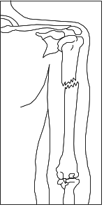
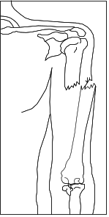

Closed Fracture  Closed Fracture in which the fracture does not puncture the skin. | Open Fracture  Open Fracture in which the bone protrudes through the skin.

 |  |  | Treating Fractures, Dislocations, Sprains, and Strains (Continued)
 | Visual 4.22 |  |  | Treating an Open Fracture  - Do not draw exposed bones back into tissue.  - Do not irrigate wound.  Visual 4.22
Stress that when treating an open fracture:

- Do not draw the exposed bone ends back into the tissue.

- Do not irrigate the wound.

 | Visual 4.23 |  |  | Treating an Open Fracture  DO:  - Cover wound.  - Splint fracture without disturbing wound.  - Place a moist 4" x 4" dressing over bone end to prevent drying.  Visual 4.23
Continue by telling the group that they should:

- Cover the wound with a sterile dressing.

- Splint the fracture without disturbing the wound.

- Place a moist 4" x 4" dressing over the bone end to keep it from drying out.

 |  |  | Treating Fractures, Dislocations, Sprains, and Strains (Continued)
 |  |  | Tell the group that splinting procedures will be covered later in this session.
 | PM, P. 4-18 |  | Explain that displaced fractures may be described by the degree of displacement of the bone fragments. (Refer the participants to the illustrations titled, Displaced and Nondisplaced Fractures, in the Participant Manual.) Explain that if the limb is angled, then there is a displaced fracture.  Explain that nondisplaced fractures are difficult to identify, with the main signs being pain and swelling. Stress that the participants should treat a suspected fracture as a fracture until professional treatment is available.
 |  |  | Dislocations
 | Introduce Dislocations |  | Introduce this section by telling the group that dislocations are another common injury in emergencies.  Explain that a dislocation is an injury to the ligaments around a joint that is so severe that it permits a separation of the bone from its normal position in a joint.  Tell the participants that the signs of a dislocation are similar to those of a fracture, and that a suspected dislocation should be treated like a fracture.  Stress that the participants should not try to relocate a suspected dislocation. They should immobilize the joint until professional medical help is available.
 |  |  | Sprains and Strains
 | Introduce Sprains and Strains |  | Introduce this section by explaining that a sprain involves a stretching or tearing of ligaments at a joint and is usually caused by stretching or extending the joint beyond its normal limits.  Point out that a sprain is considered a partial dislocation, although the bone either remains in place or is able to fall back into place after the injury.

 | PM, P. 4-18 | Displaced and Nondisplaced Fractures

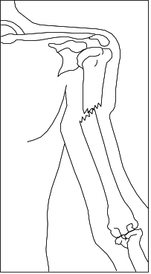
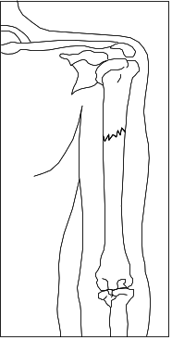

Displaced Fracture  Displaced fracture in which the fractured bone is no longer aligned. | Nondisplaced Fracture  Nondisplaced fracture, in which the fractured bone remains aligned.

 |  |  | Treating Fractures, Dislocations, Sprains, and Strains (Continued)
 | Visual 4.24 |  |  | Signs of Sprain  - Tenderness at injury site  - Swelling and/or bruising  - Restricted use or loss of use  Immobilize and elevate.  Visual 4.24
Tell the group that the most common signs of a sprain are:

- Tenderness at the site of the injury.

- Swelling and/or bruising.

- Restricted use, or loss of use.

Remind the group that the signs of a sprain are similar to those of a nondisplaced fracture. Therefore, they should not try to treat the injury other than by immobilization and elevation.

Tell the group that a strain involves a stretching and/or tearing of muscles or tendons. Strains most often involve the muscles in the neck, back, thigh, or calf.

Point out that in some cases, strains may be difficult to distinguish from sprains or fractures. When uncertain whether an injury is a strain, sprain, or fracture, treat the injury as if it is a fracture.

Ask if anyone has any questions about sprains or strains.

 |  |  | Splinting
 | Introduce Topic |  | Introduce this topic by explaining that splinting is the most common procedure for immobilizing an injury.  Point out that cardboard is the material typically used for “makeshift” splints but a variety of materials can be used, including:  - Soft materials. Towels, blankets, or pillows, tied with bandaging materials or soft cloths.  - Rigid materials. A board, metal strip, folded magazine or newspaper, or other rigid item.  Add that anatomical splints may also be created by securing a fractured bone to an adjacent unfractured bone. Anatomical splints are usually reserved for fingers and toes but, in an emergency, legs may also be splinted together.
 | PM, PP. 4-20 & 4-21 |  | Refer the participants to the pages titled, Splint Illustrations, in the Participant Manual.

 | PM, P. 4-20 | Splint Illustrations

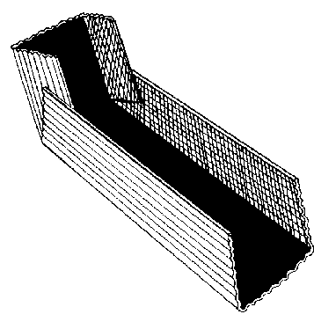

Cardboard Splint

Cardboard Splint in which the edges of the cardboard are turned up to form a “mold” in which the injured limb can rest.

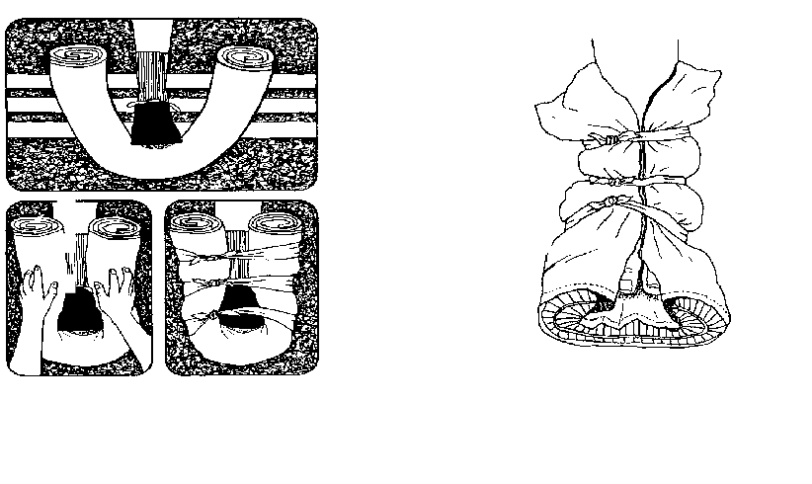
Splinting Using a Towel

Splinting using a towel, in which the towel is rolled up and wrapped around the limb, then tied in place.

Pillow splint

Pillow splint, in which the pillow is wrapped around the limb and tied.

 | PM, P. 4-21 | Splint Illustrations

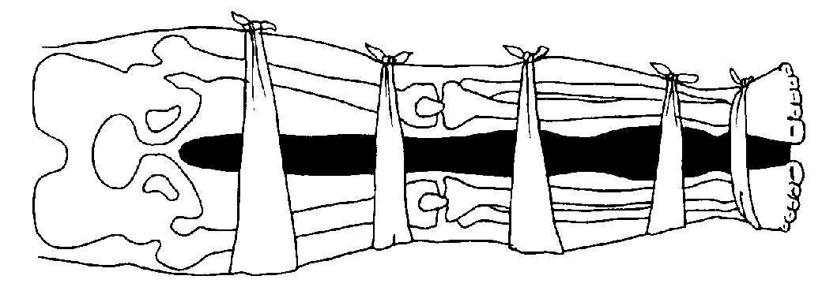

Splinting Using A Blanket

Splinting using a blanket in which the victim’s legs are immobilized by tying blankets at intervals from mid-thigh to feet.

 |  |  | Splinting (Continued)
 | Instructor’s Note |  |  | Soft materials should be used to fill the gap between the splinting material and the body part.
 | Visual 4.25 |  |  |  | Guidelines for Splinting  - Support the injured area.  - Splint injury in the position that you find it.  - Don’t try to realign bones.  - Check for color, warmth, and sensation.  - Immobilize above and below the injury.  Visual 4.25
During the demonstration, be sure to point out the guidelines for splinting:

- Support the injured area above and below the site of the injury, including the joints.

- If possible, splint the injury in the position that you find it.

- Don’t try to realign bones or joints.

- After splinting, check for proper circulation (warmth, feeling, and color).

- Immobilize above and below the injury.

 | Instructor’s Note |  |  | Demonstrate the correct procedures for splinting the upper and lower leg.
 |  |  | Tell the participants that, with this type of injury, there will be swelling. They should remove restrictive clothing, shoes, and jewelry when necessary to prevent these items from acting as tourniquets.

 |  |  | Splinting (Continued)
 | Ask Question |  |  | Ask if anyone has any questions about splinting procedures.
 |  |  | Exercise: Splinting
 | Conduct Exercise |  | Purpose: This exercise allows the participants to practice on each other the procedures for splinting. Use cardboard and gauze provided by the participants.  Instructions: Follow the steps below to facilitate this exercise:
- Assign the group to pairs. Ask the participants to switch partners from the previous exercise.

- Ask one person to be the victim and one person to be the rescuer.

- Ask the victims to lie on the floor on their backs or sit in a chair.

- Ask the rescuer to apply a splint on the victim’s upper arm using the procedure demonstrated earlier. Then, ask the rescuers to apply a splint to the victim’s lower leg.

 | Instructor’s Note |  |  | Observe each group and correct improper technique. Be sure to check for bandages that are too tight or too loose.
- After the rescuer has made several observed attempts at splinting, ask the victim and the rescuer to change roles.

- Allow each new rescuer at least one observed attempt to apply the splint.

- After all of the participants have had the opportunity to be the rescuer, discuss any problems or incorrect techniques that were observed. Explain how to avoid the problems in emergency situations.

 | Ask Question |  |  | Ask if anyone has any questions about correct procedures for splinting.
 |  |  | Tell the group that the next section will address treatment for nasal injuries.

 |  |  | Nasal Injuries
 | Introduce Nasal Injuries |  | Introduce this section by telling the group that bleeding from the nose can have several causes.
 | Visual 4.26 |  |  | Nasal Bleeding  - Causes:  - Blunt force  - Skull fracture  - Nontrauma-related conditions  - Blood loss can lead to shock.  - Victims may become nauseated and vomit if they swallow blood.  Visual 4.26
Explain that bleeding from the nose can be caused by:

- Blunt force to the nose.

- Skull fracture.

- Nontrauma-related conditions such as sinus infections, high blood pressure, and bleeding disorders.

Caution the group that a large blood loss from a nosebleed can lead to shock and that actual blood loss may not be evident because the victim will swallow some amount of blood.

Point out that victims who have swallowed large amounts of blood may become nauseated and vomit.

Demonstrate the methods for controlling nasal bleeding:

- Pinching the nostrils together

- Putting pressure on the upper lip just under the nose

 |  |  | Nasal Injuries (Continued)
 | Instructor’s Note |  |  | Demonstrate the correct procedures on the mannequin.
Tell the participants that while treating for nosebleeds, they should:

- Have the victim sit with the head slightly forward so that blood trickling down the throat will not be breathed into the lungs. Do not put the head back.

- Ensure that the victim’s airway remains open.

- Keep the victim quiet. Anxiety will increase blood flow.

 | Ask Question |  |  | Ask if anyone has any questions about any of the injuries covered to this point in the unit.
 |  |  | Tell the group that the next section will address treatment for hypothermia.

 |  |  | Treating Hypothermia
 | Introduce Topic |  | Introduce this topic by explaining that hypothermia is a condition that occurs when the body’s temperature drops below normal.  Tell the group that hypothermia may be caused by exposure to cold air or water or by inadequate food combined with inadequate clothing and/or heat, especially in older people.
 | Visual 4.27 |  |  | Symptoms of Hypothermia  Primary signs and symptoms:  - A body temperature of 95° Fahrenheit (37° Celsius) or less  - Redness or blueness of the skin  - Numbness accompanied by shivering  Visual 4.27
Point out that the primary signs and symptoms of hypothermia are:

- A body temperature of 95° Fahrenheit (37° Celsius) or less.

- Redness or blueness of the skin.

- Numbness accompanied by shivering.

 |  |  | Treating Hypothermia (Continued)
 | Visual 4.28 |  |  | Symptoms of Hypothermia  At later stages, hypothermia will be accompanied by:  - Slurred speech.  - Unpredictable behavior.  - Listlessness.  Visual 4.28
Add that in later stages, hypothermia will be accompanied by:

- Slurred speech.

- Unpredictable behavior.

- Listlessness.

Explain that because hypothermia can set in within only a few minutes, participants should treat victims who have been rescued from cold air or water environments by:

- Removing wet clothing.

- Wrapping the victim in a blanket or sleeping bag and covering the head and neck.

- Protecting the victim against the weather.

- Providing warm, sweet drinks and food to conscious victims. Do not offer alcohol or massage.

- Placing an unconscious victim in the recovery position.

- Placing the victim in a warm bath if the victim is conscious.

Tell the participants not to allow the victim to walk around even when he or she appears to be fully recovered. If the victim must be moved outdoors, they should cover the victim’s head and face.

 |  |  | Unit Summary
 | Summarize Unit |  | Begin the summary by first congratulating the group on completing the disaster medical operations sessions. Remind them that they have learned an enormous amount about how to recognize and treat life-threatening and other common disaster-related injuries—and that they have proven their knowledge and skills in high-pressure exercises.
 | Summarize Key Points |  | Summarize the key points of this unit:  - To safeguard public health, take measures to maintain proper hygiene and sanitation, and purify water if necessary. All public health measures should be planned in advance and practiced during exercises.  - Disaster medical operations include four subfunctions:  - Triage  - Treatment  - Transport  - Morgue
- Head-to-toe assessments should be verbal and hands-on. Always conduct head-to-toe assessments in the same way—beginning with the head and moving toward the feet. If injuries to the head, neck, or spine are suspected, the main objective is to not cause additional injury. Use in-line stabilization and a backboard if the victim must be moved.

- Treatment areas must be established as soon as casualties are confirmed. Treatment areas should be:

- In a safe area that is close to, but uphill and upwind from, the hazard area.
- Accessible by transportation vehicles.
- Expandable.

 |  |  | - Burns are classified as first-, second-, or third-degree depending on severity and the depth of skin layers involved. Treatment for burns involves removing the source of the burn, cooling the burn, and covering it. For third-degree burns, always treat for shock.

Unit Summary (Continued)
- The main first aid treatment for wounds consists of:

- Controlling bleeding.
- Cleaning.
- Dressing and bandaging.

In the absence of active bleeding, dressings must be removed and the wound checked for infection at least every 4 to 6 hours. If there is active bleeding, a new dressing should be placed over the existing dressing.

- Fractures, sprains, and strains may have similar signs, and diagnosis may not be possible under disaster conditions. Treat suspected fractures, sprains, and strains by immobilizing the affected area using a splint.

Remind the group that there is much more to learn about medical operations than could possibly be presented in two 2½-hour sessions. Recommend strongly that the participants attend additional seminars that are offered through the American Red Cross or through community colleges.

Remind the group also that disaster medical operations is a team effort and that, like all teams, they must practice together so that they can function as a team under pressure. Encourage the participants to attend exercise simulations whenever they are offered locally.

Homework Assignment

Ask the participants to read and familiarize themselves with Unit 5: Light Search and Rescue Operations before the next session.

Ask them to obtain a blanket for use during Unit 5.

Thank all of the participants for attending the session and remind the group of the date and time of the next session, if necessary.

