Arizona Absolute Ground Control Inspection on the MDOQ Imagery

Zack Adkins
APFO Service Center Support Section

Background

In 2007, imagery for the state of Arizona was acquired with full state, 1 meter NAIP coverage. In previous years, NAIP imagery had been tied to a relative accuracy specification; for Arizona NAIP 2007, this specification was changed to absolute accuracy. This meant the imagery would be tied to true ground control points instead of older imagery datasets. Once the true ground control was acquired from different sources, the points were then implemented into the NAIP inspection process. In the NAIP inspection process, the ground control points were used. However the points had never been checked against the older imagery dataset (MDOQs (mosaicked digital ortho quarter quads) loaded on the APFO GDW (geodata warehouse)). This document will outline that process, focusing on the results, statistics, and the comparison of the MDOQ inspection results to the NAIP inspection results.

Inspection Methodology

The inspection of the ground control points on the MDOQ imagery used the same process as the NAIP inspection. First, a control point shapefile was loaded into ArcMap. Then, a new empty shapefile was created for the MDOQ control point data. Next, imagery was loaded from the APFO GDW. Inspection began once all layers were loaded. Based upon supplemental data (see figure 1), the photo identifiable control points were located and digitized on the MDOQ imagery where the inspector deemed valid (see figure 1). After digitizing, each point was then assigned a “quality” value from 1 to 5 (1 being the best, 5 meaning a recommendation of removal from the inspection database). Once all control points for the state were checked, then the “Point Distance” tool was used to check the offset distance between the true ground points and the points digitized on the MDOQ. This data enabled the inspector to determine the horizontal accuracy of the imagery as well as the reliability of the true ground control point dataset.
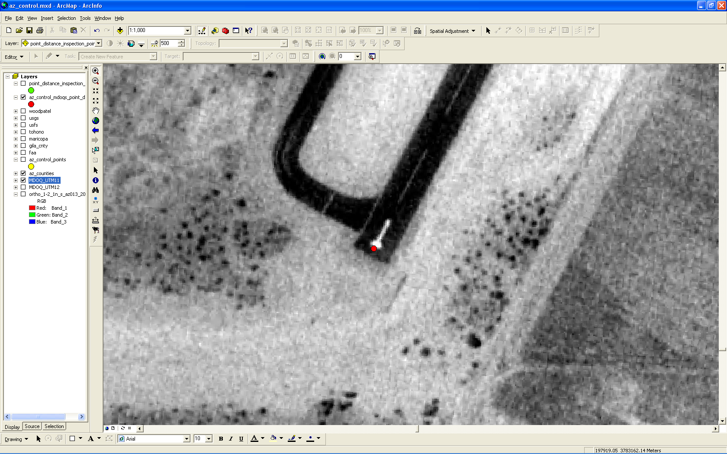
Figure 1: Digitizing control on the MDOQ imagery (the red dot is the digitized point).

MDOQ Inspection Statistics

For Arizona NAIP 2007, there were 544 true ground control points. Of the 544, 527 were used in the MDOQ point inspection process. The reasons for not inspecting 17 of the points were various; usually the feature picked did not exist on the older MDOQ imagery. The overall point offset statistics for the 527 points that were checked is shown below:

Minimum Offset Distance: 0.105758 meters
Maximum Offset Distance: 19.809101 meters
Mean Offset Distance: 2.59158 meters
Standard Deviation: 1.951404 meters
RMSE: 3.244112 meters

The overall percent accuracy for the entire state was 94.877%. Of the 527 points, 27 were over 6 meters offset from true ground, which is outside (barely) the 2007 NAIP absolute control specification. A histogram illustrating the point offset is illustrated in figure 2 below. Blue represents points within tolerance; red represents points out of tolerance.

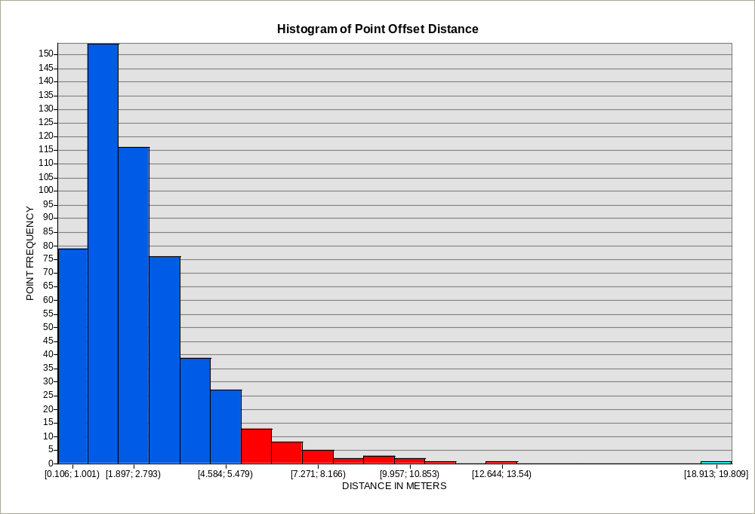
Figure 2: Histogram showing offset with point frequency

The point quality rating is a good way of judging each point’s overall value as a photo identifiable, true ground control point. Each point that was digitized received a value of 1 through 5. Points rated a “1” are of the highest quality; “5” ratings are recommended to be deleted altogether. Here are the statistics for the point quality ratings:

“1” Rating: 3 points
“2” Rating: 128 points
“3” Rating: 322 points
“4” Rating: 59 points
“5” Rating: 15 points

From this data, it can be observed that most of the points were of average quality, but were still very usable in the inspection.
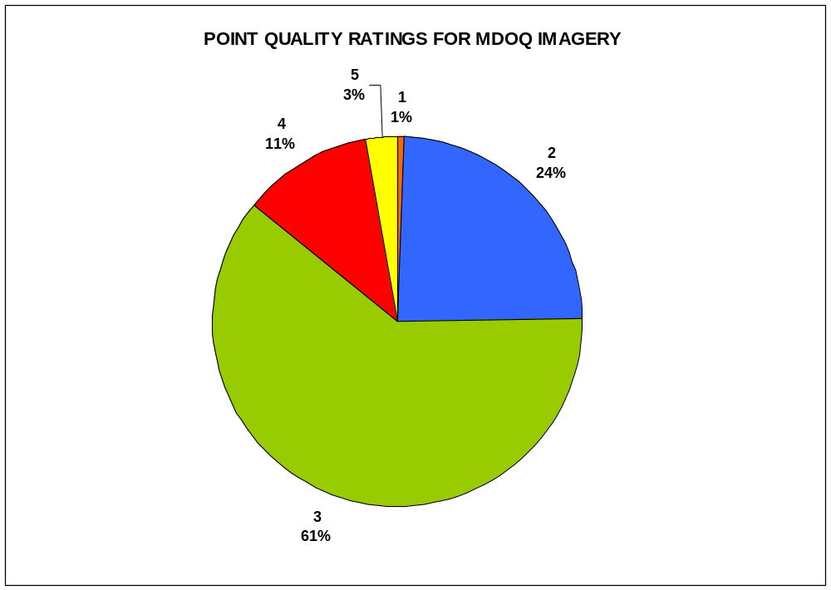
Figure 3: Graph showing point quality ratings percentages

Here is the breakdown of the point quality ratings within tolerance (6 meters offset from true ground):
1 Rating: 100% within tolerance
2 Rating: 97% within tolerance
3 Rating: 94% within tolerance
4 Rating: 97% within tolerance
5 Rating: 87% within tolerance

There is nothing out of the ordinary here; the better the rating, the more likely the point is to be within tolerance and vice versa.

Comparing MDOQ Inspection Statistics with NAIP Inspection Statistics

The MDOQ points were inspected exactly the same way as the NAIP points. The statistical methods and collections were identical; however the statistical outcomes will be different. In the NAIP inspection there were 544 points to be measured; this time 530 points were inspected with 14 points not inspected. In this case, many of the ground control features no longer existed on the NAIP imagery. Here are the general offset statistics between the true ground control points and the 2007 NAIP imagery:

Minimum Offset Distance: 0.058385 meters
Maximum Offset Distance: 20.592761 meters
Mean Offset Distance: 2.114408 meters
Standard Deviation: 1.946102 meters
RMSE: 2.873679 meters

The graph below illustrates how close the point offset statistics are between points digitized on the NAIP imagery and the MDOQ imagery.

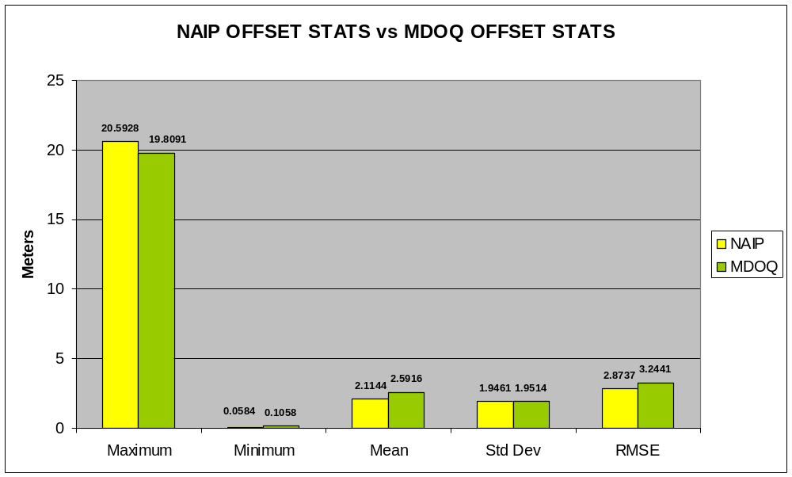
Figure 4: Graph showing NAIP and MDOQ offset statistics

The quality ratings for the control points differed somewhat between the NAIP imagery and the MDOQ imagery.

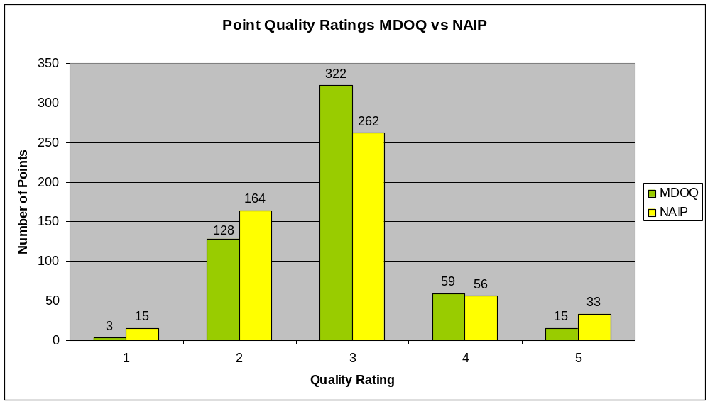
Figure 5: Graph showing NAIP and MDOQ point quality ratings

The graph above illustrates that the points on the NAIP imagery had five times as many “1” ratings. This is due to the fact that the NAIP imagery is generally of a higher quality, newer, and the state of Arizona acquired new control thus making the better points more photo identifiable. The MDOQ imagery had more points rated as average (3) and half as many recommended for inspection database removal (5). Most of the points rated a “5” on the NAIP imagery were selected on features that have changed over the last 10 years or on features that no longer exist.
It would also be worthwhile to compare the point statistics based upon accuracy order. The accuracy order for the control points ranged from sub foot to two meter. In this comparison, the highest order accuracy will be examined (sub foot). There were 119 points that were sub foot accuracy. These are the offset statistics for the sub foot points measured on the NAIP imagery:
Minimum Offset Distance: 0.210594 meters
Maximum Offset Distance: 4.665197 meters
Mean Offset Distance: 1.575352 meters
Standard Deviation: 0.9974 meters
RMSE: 1.865109 meters
These are the offset statistics for the sub foot points measured on the MDOQ imagery:

Minimum Offset Distance: 0.105758 meters
Maximum Offset Distance: 13.508835 meters
Mean Offset Distance: 2.764579 meters
Standard Deviation: 2.24229 meters
RMSE: 3.559877 meters

The following histograms (figures 6 and 7) illustrate the point offsets for the NAIP and MDOQ points. None of the sub foot points measured on the NAIP imagery was out of tolerance; 7 of the sub foot MDOQ points were out of tolerance.

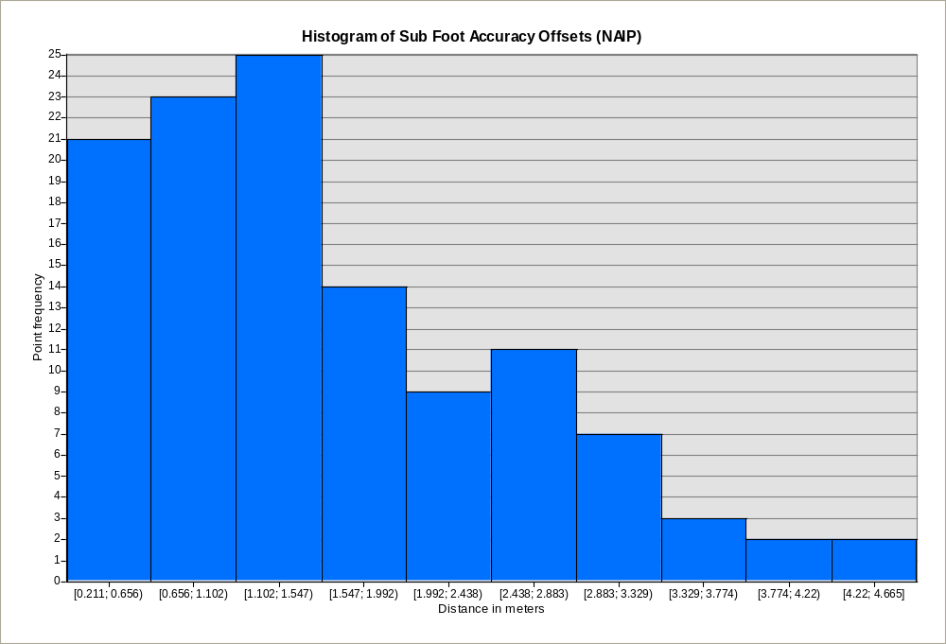
Figure 6: Histogram showing point offset frequency for NAIP

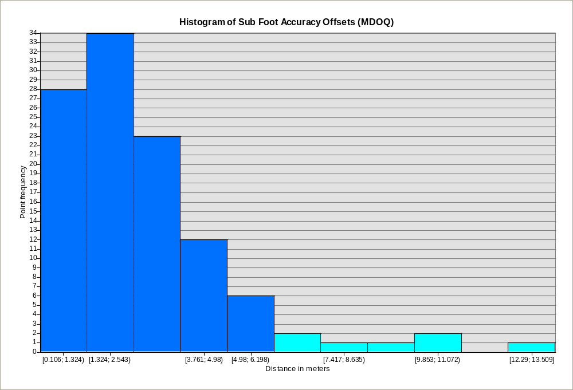
Figure 7: Histogram showing point offset frequency for MDOQ imagery

The graph in figure 8 illustrates the difference between the sub foot points on the NAIP imagery and the MDOQs. With the higher order accuracy points, the differences between the NAIP points and the MDOQ points is much greater than the point dataset as a whole. The RMSE was twice as high for the MDOQs than the NAIP. This emphasizes that a highly accurate, photo identifiable point located on high quality imagery can be very valuable.
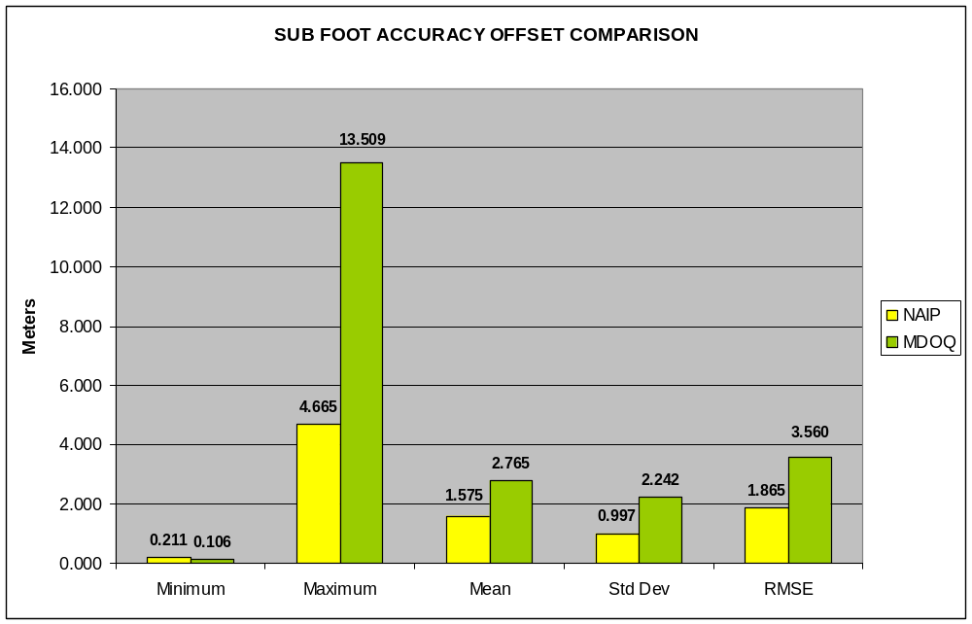
Figure 8: Graph comparing MDOQ and NAIP offsets on sub foot accuracy

The comparison of the distance between MDOQ points and the NAIP points shows some interesting outcomes. Of the 544 total control points, 515 were digitized on both the MDOQ and the NAIP imagery. The following are the offset statistics between the MDOQ points and the NAIP points measured at each common absolute control station:

Minimum Offset Distance: 0.094528 meters
Maximum Offset Distance: 12.342549 meters
Mean Offset Distance: 2.865047 meters
Standard Deviation: 1.77895 meters
RMSE: 3.37241 meters

The two following examples illustrate the offset between the MDOQ points and the NAIP points in relation to the absolute ground control. The yellow point is the true ground control point, green is the inspection point digitized on NAIP, and red is the inspection point digitized on the MDOQ. The distance between the NAIP and MDOQ points is 12.34 meters. This was the largest offset distance value. Notice how the point digitized on the NAIP image is more accurate. It is only 1.18 meters from true ground; the MDOQ point is 13.51 meters from true ground.

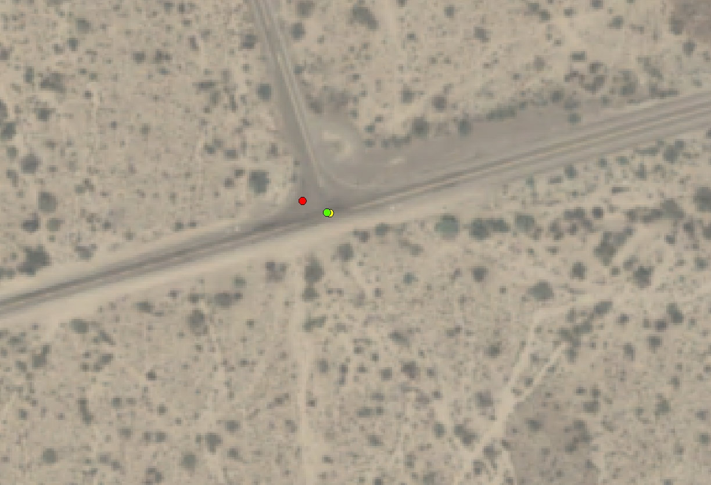
Figure 9: Inspection point offset on NAIP image

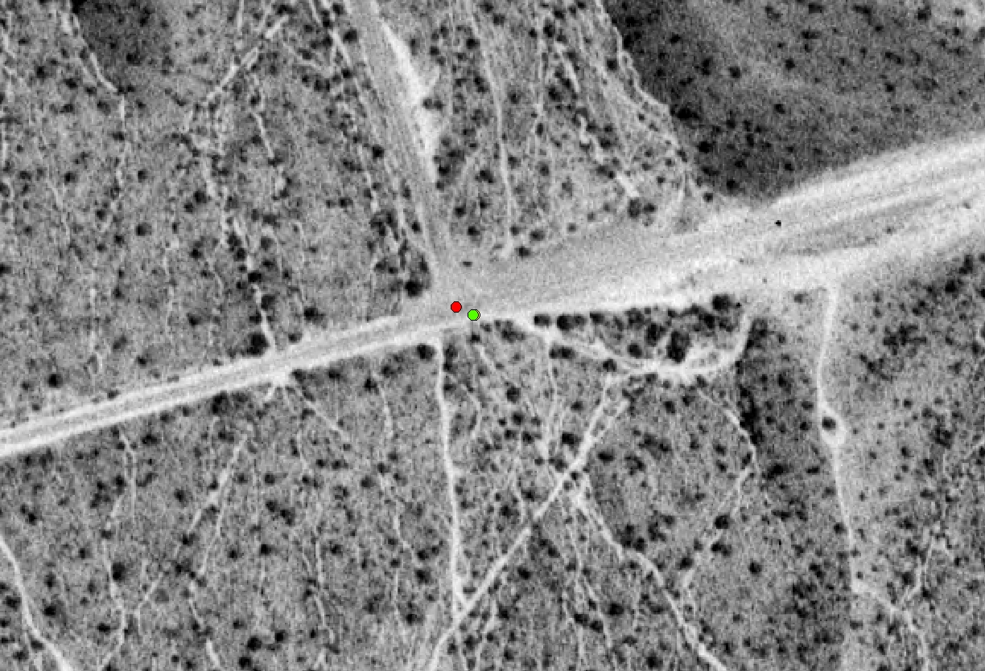
Figure 10: Inspection point offset on MDOQ image (the yellow point is beneath the green point)

In figure 11, the frequency distribution of the offset values between the MDOQ and NAIP points is illustrated. Most of the values are between 2.5-3.5 meters.

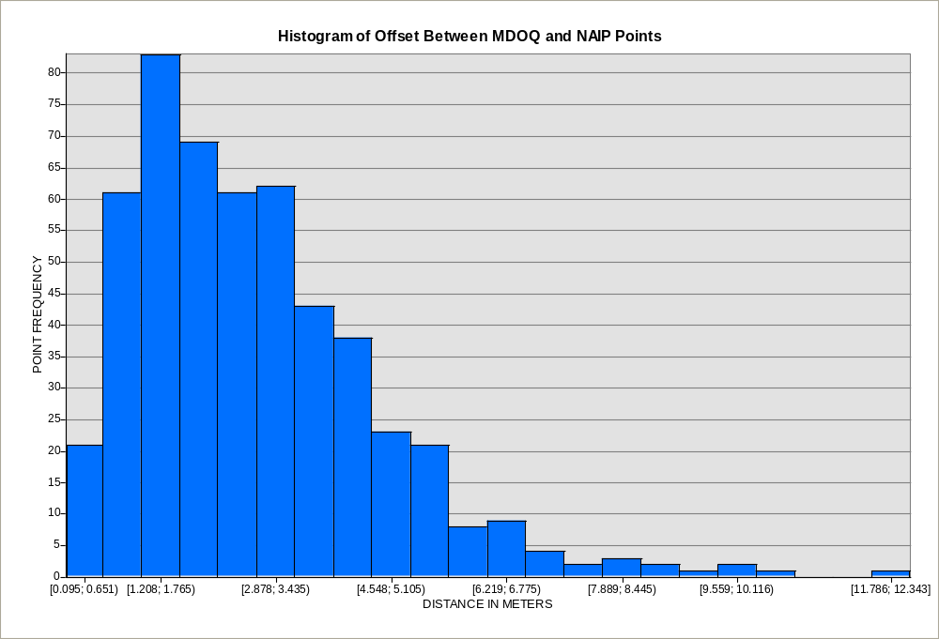
Figure 11: Histogram of point distance between NAIP and MDOQ points

Although there is no distance specification tolerance set for offset between the MDOQ and the NAIP points, one could hypothetically create a tolerance. Currently, the tolerance for absolute accuracy control is 6 meters offset from true ground. If you imagine a right isosceles triangle (see figure 12), then a distance tolerance between the NAIP and MDOQ points could be created. Using the Pythagorean Theorem (a² + b² = c²), that distance would be 8.5 meters. If this were the specification, 6 of the 515 point distances would be out of tolerance, leading to 99% accuracy between the MDOQ and NAIP imagery.
NAIP POINT
MDOQ POINT
TRUE GROUND POINT
6 meters
6 meters
8.5 meters
Figure 12: Estimating offset tolerance between MDOQ and NAIP points

Conclusions

These previous data examples are just a few that one can do for a statistical review. Many different conclusions can be drawn from these statistics. The graph in figure 4 illustrates the overall closeness between the MDOQ point offsets from true ground and the NAIP point offsets from true ground; none of the overall statistical categories have a large amount of variance. The overall percentage horizontal accuracies (for AZ) were close also: 94.877% for the points on the MDOQs and 95.660% for the points on the NAIP imagery. Perhaps the greatest deduction can come from the offset distance statistics between the NAIP points and the MDOQ points. Although there is no specification in the NAIP contract regarding this, there were only 6 distances out of 515 that were out of the hypothetical tolerance (8.5 meters). As it was stated above, this is 99% within tolerance. Could it then be said that the two point data sets (MDOQ and NAIP) for the entire state of Arizona are 99% accurate to each other?
One may ask, “Why move to an absolute accuracy specification if the offset results are so close?” The relative accuracy specification (relative to the MDOQs) has some issues. NAIP imagery horizontally tied to the MDOQs is potentially less accurate as an image base layer. It can be less accurate to digitize upon (e.g. CLU polygons), less accurate for other vector datasets in a GIS, and less valuable as a product. This was illustrated in the comparison of the higher order accuracy control points. The absolute ground control accuracy specification is more advantageous in the long run. The specification is tighter and more understandable than the relative specification. Image datasets may not become more accurate immediately, but will over time. Since the NAIP imagery is used in a GIS, a more accurate dataset is a more valuable dataset. With the move to absolute ground control as a horizontal accuracy specification, there will be less manipulation of datasets over time to correct errors. Since this control point evaluation was only done on one state, it would be viable to perform this analysis on another state in the future.
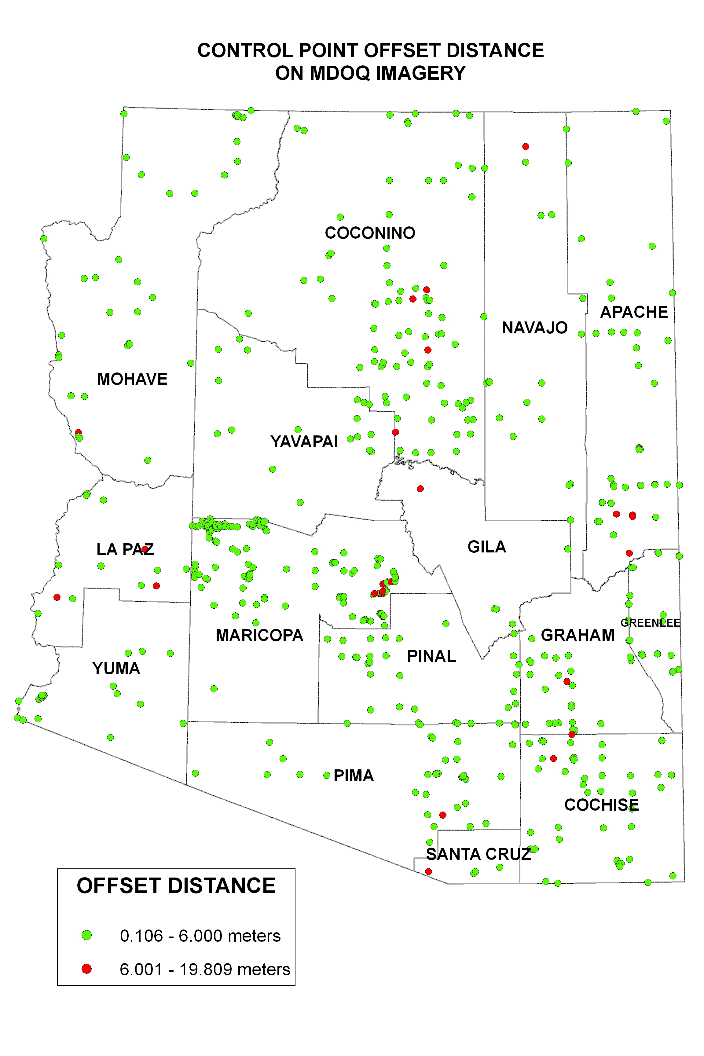
Map 1: Control point offset between true ground and the MDOQs

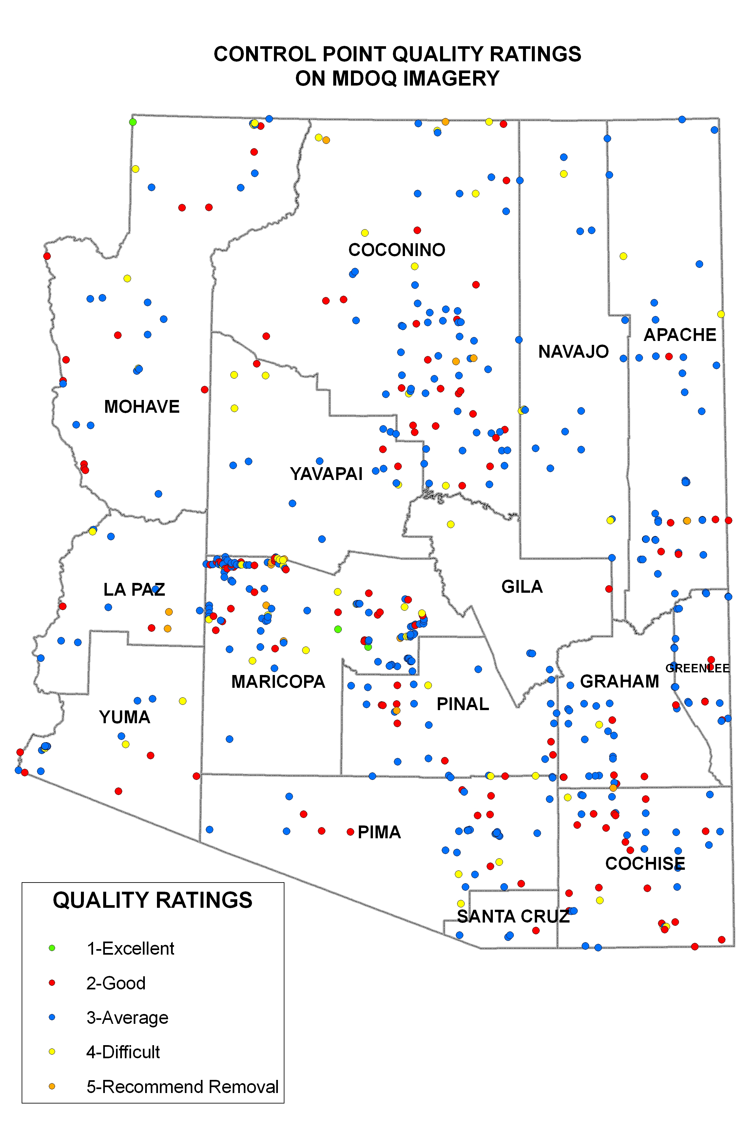
Map 2: Control point quality ratings on MDOQ imagery
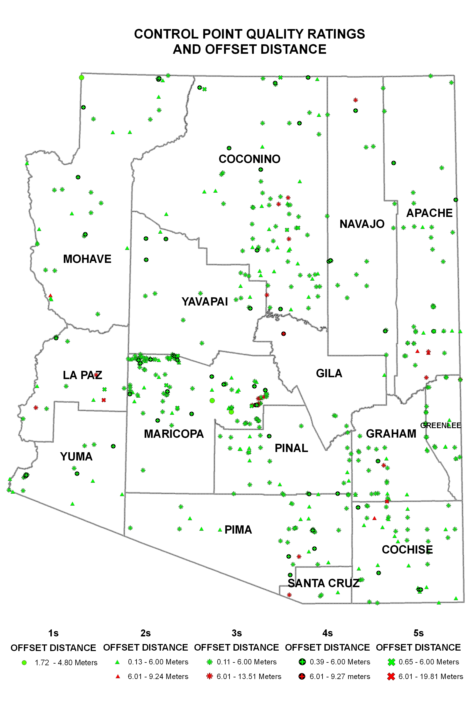
Map 3: Control point quality ratings with offset distance

