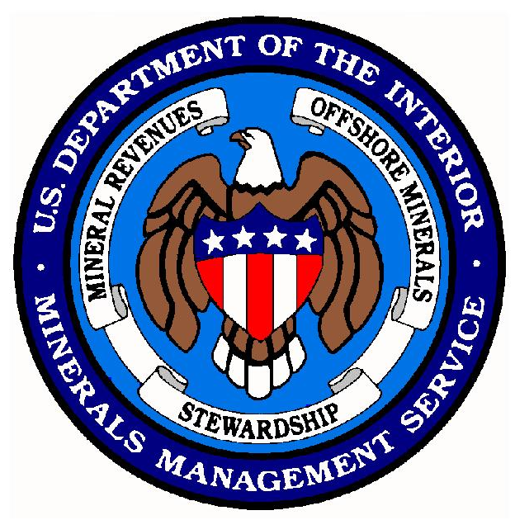

Minerals Management Service
Environmental Studies Program:

A History of Biological Investigations
in the Gulf of Mexico, 1973-2000

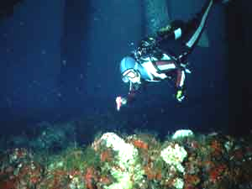

April 2003

Table of Contents

Page
Preface ii
1. Introduction 1
1.1. The Nature and Direction of MMS Biological Studies 2
1.2. The Role of the U.S. Geological Survey and its Biological Resources Division 2
2. Environmental Mapping 3
2.1. Western Gulf Environmental Mapping 3
2.2. Eastern Gulf Environmental Mapping 3
3. Marine Ecosystems Studies 5
3.1. Continental Shelf Ecosystems Studies 6
3.1.1. Eastern Gulf of Mexico Benchmark Program and the Mississippi-Alabama-Florida Shelf Ecosystems Study (“MAFLA”) 6
3.1.2. South Texas OCS Benchmark Program (STOCS) 7
3.1.3. Topographic Features Program 7
3.1.4. Northeastern Gulf of Mexico and Mississippi-Alabama Programs 8
3.1.5. Southwest Florida Shelf Ecosystem Program 9
3.1.6. Texas-Louisiana Shelf Ecosystems Program 10
3.2. Deep-Sea Ecosystems Studies 10
3.2.1. Deep-Sea Information Synthesis 11
3.2.2. Northern Gulf of Mexico Continental Slope Study 11
3.2.3. Chemosynthetic Community Studies and Community Conservation 11
3.2.4. Northern Gulf of Mexico Continental Slope Habitats And Benthic Ecology 13
3.2.5. Other Deep-Sea Efforts 13
4. Coastal Studies 14
4.1. General Coastal Studies – Central Gulf Marshes 14
4.2. Texas Coastal Ecosystems Program 14
4.3. Louisiana Coastal Ecosystems Program 15
4.4. Northeastern and Eastern Gulf of Mexico Coastal Ecosystems Programs 15
5. Living Marine Resources 17
5.1. Protected Species 17
5.2. Fishes and Fisheries 19
5.3. Birds 20
6. Effects of Oil and Gas Activities 21
6.1. Effects on Biota 21
6.2. Coastal Effects 22
6.3. Marine Effects 22
6.4. Rig and Platform Monitoring Program 23
6.5. Oil Spill Effects Program 24
6.6. Effects Modeling Program 24
7. Miscellaneous Biological Studies and Relevant Documents 25
7.1. Miscellaneous Biological Studies 25
7.2. Gulf of Mexico Region Coastal Marine Institute Program 25
7.3. Other Documents 26
7.3.1. Regional Studies Plans and Studies Development Plans 26
7.3.2. Information Transfer Meeting Proceedings 27
7.3.3. Workshops and Symposia 27
APPENDIX: The Environmental Studies Program (ESP) – AN OVERVIEW 29
A.1. Early History and Development of the ESP 29
A.2. Regional Responsibilities and Organization 30
A.3. Studies Planning and Selection 30
A.4. Studies Procurement, Conduct, Completion, and Dissemination 31
Preface

This account entitled Minerals Management Service Environmental Studies Program: A History of Biological Investigations in the Gulf of Mexico, 1973-2000 is intended to provide a brief history of more than a quarter-century of biological studies supported by the subject agencies since the inception of the Environmental Studies Program (ESP). It is written for those interested either in the entire “Biological Program” or in specific research conducted under one or more biological categories. (In reality, most “biological” studies have been interdisciplinary, relating biological data to the physical, geological, and chemical environment.) We trust it will prove useful to administrators, program reviewers and advisors, academicians, and the interested public.

This document reviews historic and recent biological studies and is arranged to give individual descriptions of “series” of studies such as Environmental Mapping, Marine Ecosystems, Coastal Studies, Living Marine Resources, and Effects of Oil and Gas Activities.

Comments, suggestions, and corrections are welcome. These should be brought to the attention of:

Chief, Environmental Sciences Section
Office of Leasing and Environment
Minerals Management Service
1201 Elmwood Park Boulevard
New Orleans, Louisiana 70123-2394

The Minerals Management Service Environmental Studies Program:
A History of Biological Investigations in the Gulf of Mexico, 1973-2000

1. Introduction
This review attempts to categorize (where possible) the biological studies conducted in the Gulf of Mexico by the Minerals Management Service (MMS). The intent is to illustrate the record of studies selections within the MMS Environmental Studies Program (ESP) from the early 1970’s (when the question was “where do we start accumulating information?”), through 2000 and a little beyond. The ESP was administered by the Bureau of Land Management (BLM), a U.S. Department of the Interior (DOI) sister Agency of the MMS, until the 1982 creation of MMS. This review does not discuss costs or final results of individual projects, but it serves to document ESP direction and accomplishments. The costs of studies (by fiscal year) and the details of their purpose, procurement, methods, and results can be found for many reports received since 1992 on the MMS internet site:

http://www.gomr.mms.gov/homepg/regulate/environ/techsumm/rec_pubs.html

This site is a listing of all reports conducted during the covered period (1992-present), with a collection of selected “Technical Summaries” written as required under contract. In a few cases, the entire text of a given volume is provided for direct printing. The Technical Summaries offer a great deal of insight into the management, fiscal, and scientific details of recent programs.

For information on the availability of studies documents up to 1994 the reader is referred to Gulf of Mexico Programmatic Documents and Contract Deliverables, last updated in November 1994 and now superceded by the above website. This document lists studies into certain convenient biological categories or groupings, for example. “Marine Ecosystems,” “Living Marine Resources,” and “Coastal Studies.” We have attempted, when possible, to parallel those groupings in Sections 2 through 7 below, for those needing additional information on content or availability. Some studies or “tasks” within studies arguably fall into more than one category. Some of these are mentioned under two of the several categories (e.g., “Protected Species” and “Effects of Oil and Gas Activities” or “Environmental Mapping” and “Marine Ecosystems”). Under each of the categories of studies below, the report products are then discussed separately by geographical or resource subcategory.

Some of the older studies are still available from the sources given in Gulf of Mexico Programmatic Documents and Contract Deliverable, but many are no longer readily available from any source. Some of the older studies are obsolete in whole or part, or have been updated.

Many of the MMS-sponsored studies have required the publication of interim or annual reports under the requirements of the respective contract or agreement, especially for the large, multiyear programs. This has been a convention over most of the course of the ESP, and these reports are listed in the website above. These were written as a public record of research progress. They also reflect MMS’s need for accountability in the extremely unlikely event that a contractor somehow failed or the MMS elected to cancel a program. After final reports are published, the interim reports are not generally requested nor are they offered for wide distribution. For these reasons, we cite below only a final report title and the date of final report acceptance and publication.

The reader must understand, then, that the date of procurement award and project startup may have been one to several years before publication and that the study planning and procurement might have been up to 3 years earlier than that. While we have attempted to include all major biologically oriented programs in this review, other minor miscellaneous reports and some written mostly for internal planning may have been omitted. We trust that this review will provide some insight into the history and growth of the ESP in general and the “Biological Program” in particular. In reality, most “biological” studies have been interdisciplinary, relating biological data to the physical, geological, and chemical environments.

1.1. The Nature and Direction of MMS Biological Studies
Many of the early ESP projects (“Benchmark Studies”) were interdisciplinary regional assessments of the hydrography, geology, chemistry, and biology of an area (e.g., south Texas, and the Mississippi-Alabama-Florida area – MAFLA). These were designed to provide an overview of “baseline” conditions in “frontier” areas (those without significant histories of oil and gas development). The baseline data were to be used for environmental comparisons after development. But there has been an historical trend toward the study of selected resources and issues (but still sometimes on a regional scale).

Most recent (1985+) biological programs have been directed at target species or habitats, or anthropogenic effects. A number of criteria may enter into a study’s selection for support. These criteria may include legal status (i.e., species listed as endangered or threatened), distribution and rarity (e.g., chemosynthetic communities), productivity (e.g., seagrasses), commercial or recreational use (fish communities at offshore platforms), importance as habitat (e.g., soft bottoms and platform jackets), sensitivity or vulnerability (e.g., mangrove forests and salt marshes), aesthetics (e.g., coral reefs), or status of knowledge (e.g., any newly discovered reefs or topographic features – this has happened several times), and/or the potential for environmental damage (e.g., modeling fates and effects of various operational discharges, spills, and noise; or the monitoring/measuring of actual effects under known conditions). Clearly, studies of some resources/effects are justifiable on the basis of a number of these criteria. [Miscellaneous, non-scientific considerations may influence the process as well, for example, congressional involvement, States’ objections, General Accounting Office (GAO) reports, or public perceptions.]

Predictably, most of these studies (especially the early ones) focused on the shallow resources on the continental shelf. But the MMS has now supported a number of generalized and resource-specific efforts pertaining to the ecology of the continental slope. Most field studies have been conducted entirely within the confines of Federal waters in the Exclusive Economic Zone (EEZ). However, both “paper” and field studies have been aimed toward States’ waters when their biological resources are believed to be (1) especially vulnerable to OCS activities (e.g., salt marshes, mangroves, and estuaries) or (2) when a knowledge of the shoreward distribution of index benthic communities offers a more complete picture of distribution and life requirements (e.g., seagrasses and shallow “live bottom”). Only recently have MMS studies ventured into the Mexican EEZ. One of these, a collaborative deep-sea effort by Mexican and U.S. scientists, investigates benthic ecology basin wide. Depending on the procurement conditions and nature of international research efforts, these studies may require a series of State Department actions and permitting.

1.2. The Role of the U.S. Geological Survey and its Biological Resources Division
A close working relationship between the MMS and the U.S. Geological Survey (USGS) was established in response to Secretary Babbitt’s August 1994 request to all DOI Directors to strengthen the ties between DOI’s science bureaus (e.g., the USGS) and resource management bureaus (e.g., the MMS). A Memorandum of Understanding (MOU) between the MMS and the newly created National Biological Service (NBS) was signed in 1995. (The initial reprogramming of funds from MMS began earlier in FY 1994.) The NBS, formed primarily from the research arm of the U.S. Fish and Wildlife Service, was merged into the USGS in 1996 to become the present Biological Resources Division (BRD) of the USGS. Since then, much of the MMS biological research has been, and continues to be, conducted through or by the BRD. Research managers and staff of MMS and USGS meet regularly to discuss future research.

Examples of USGS/BRD-administered studies for the MMS in the Gulf of Mexico Outer Continental Shelf (OCS) Region include studies of coastal wetland impacts from oil and gas pipelines, community structure of demersal fishes at pinnacles in the northeastern Gulf, the GULFCET II study, Northeastern Gulf Coastal and Marine Ecosystem Programs - a Data Search and Synthesis, and the subsequent Characterization and Trends of Recreational and Commercial Fishing from the Florida Panhandle.

2. Environmental Mapping
The MMS environmental mapping program has provided many popular documents and maps to the public including forty-one, 1:250,000-scale, bathymetric maps with the Federal OCS lease grid overprints, and a large series of reports and maps on geological features and geohazards, the latter produced mostly by the USGS. These have little, if any, information of a biological nature per se, but they do provide general information of interest to all, including biologists and biological studies planners.

The environmental mapping products described below accomplish much more than simply illustrating the distribution of given ecosystems and living resources in targeted areas. They frequently relate biological resources with geological, physical, chemical, sedimentary, and other nonbiological characteristics. All environmental mappings were done in waters from the beach or estuary to a depth characteristic of the subject resource or, at most, out to the edge of the continental shelf. None were deep-sea efforts.

2.1. Western Gulf Environmental Mapping
The six series of Submerged Lands of Texas mapping efforts were produced for as many areas of Texas by the Bureau of Economic Geology at the University of Texas at Austin. These areas were Corpus Christi, Galveston-Houston, Brownsville-Harlingen, Beaumont-Port Arthur, Bay City-Freeport, and Port Lavaca, (published in 1983, 1985, 1986, 1987, 1988, and 1989, respectively). They plotted benthic macroinvertebrates and associated wetlands against sedimentary and geochemical characteristics. The mapping for the heavily-industrialized Galveston-Houston area also plotted the same communities against total organic carbon and the elements of barium, boron, calcium, chromium, iron and lead. The latter chemical data sets are now likely obsolete both in terms of age and original accuracy.

Early studies of the South Texas OCS (STOCS program; see Section 3.1.2, below) resulted in an early (1977) USGS environmental mapping volume (“atlas”), which accompanied the report entitled Environmental Studies, South Texas Outer Continental Shelf, Biology and Chemistry.

Another mapping effort was the Northwestern Gulf of Mexico Shelf Bio-Atlas (1983), which plotted the distributions of demersal fishes and shrimps from information gleaned from several different reports. This is described in greater detail in Section 5.2., “Fishes and Fisheries.”

The Flower Garden Banks projects provided additional maps. In 1985, the MMS received a final synthesis report, The Flower Gardens: A Compendium of Information, which included a summary report and nine map sheets at a scale of 1:48,000.

2.2. Eastern Gulf Environmental Mapping
Towards the end of the early MAFLA Benchmark Program of BLM, a new series of mapping efforts were begun on the wide, carbonate, west Florida shelf platform. These addressed two benthic biological resources: “hard bottom” communities and seagrasses.

A preliminary mapping study, the Eastern Gulf of Mexico Marine Habitat Study, was conducted following the MAFLA studies to gather additional habitat information on the west Florida shelf from Pensacola south to Charlotte Harbor, with emphasis on selected hard bottom areas that might harbor epifauna and demersal fishes. Ten areas (five in the western panhandle of Florida and five in southwestern Florida) were selected for geophysical characterization (sub-bottom profiling and side scan sonar). Following the geological work, photographic and videographic imaging of the bottom produced early estimates of the types and amounts of biota the areas held. This program was a precursor to the Southwest Florida Shelf Ecosystem Program (see Section 3.1.5), a full-blown environmental field study with a great deal of faunal sampling, hydrographic work, and sediment and midwater measurements. A sizeable geophysical and imaging element produced two volumes of large-format maps (Marine Habitat Atlases) showing the relationships between attached hard bottom animal and plant communities, bottom type, and associations with depth, distance from shore, nutrients, illumination, currents and other factors. This work was done offshore from St. Petersburg south to the Florida Keys and from Florida State waters to the shelf’s edge in water depths of more than 150 m. In all, this program required a decade to complete.

Another parallel final report, the 1991 Southwest Florida Nearshore Benthic Habitat Study further extended the mapping efforts within Florida’s State waters, generally less than 20 m deep.

Three surveys of seagrasses have been funded by the MMS in the eastern Gulf. The MMS has long recognized seagrasses as an ecologically important and potentially vulnerable resource. Besides being important primary producers, seagrasses are significant sources of forage for the West Indian manatee (Manatus trichecus), the green sea turtle (Chelonia midas) and a host of detritus feeders. They also provide expansive and productive prairies within which myriads of small motile invertebrates and fishes live, and they support diverse communities of attached flora/fauna. Being shallow flowering plants, seasonal changes can be expected in seagrass beds. But even in the summer and fall, tropical storms can devastate great patches of prairie. Cumulative anthropogenic activities seem to have reduced estuarine seagrass densities in places such as the Laguna Madre, Mississippi Sound, and Tampa Bay. The MMS surveys were conducted with combinations of photosleds, divers, and aerial overflights (in clear, shallow waters). These were the Western Florida Coast Seagrass Inventory; Anclote Key to Palmetto Island (1984); the Florida Big Bend Seagrass Habitat Study (1985); and the accompanying Florida Big Bend Seagrass Habitat Study Photographic Atlas (1985).

Much of the Southwest Florida Shelf Ecosystem Program (Section 3.1.5) consisted of a series of photographic and geophysical surveys across and along the shelf, in addition to the extensive sampling and process-oriented studies. The several large reports received from this long, complex program were accompanied by two large-format Marine Habitat Atlases that displayed habitat and community sites. Several more-or-less distinct benthic habitats and epifaunal community types which varied in response to lighting, substrates, currents, nutrients, and other factors were identified.

Following the identification of significant topographic features during the Mississippi-Alabama Marine Ecosystem Program (Section 3.1.4), itself an ecological mapping effort, additional mapping was done in western, muddy parts of the region, which differ considerably physiographically, from the coarser quartzose eastern parts. The mapping revealed the geological/geophysical structure and the nature of the fauna with remotely operated vehicles (ROV’s). The final report, Mississippi-Alabama Shelf Pinnacle Trend Habitat Mapping Study, was published in 1992.

3. Marine Ecosystems Studies
In the 1970’s, the BLM funded a series of ambitious descriptive regional field studies (“Benchmark” programs) around the Gulf of Mexico and other regions. These were conducted in “frontier” areas (those with little or no history of oil and gas activity). In theory the bodies of data collected were the “benchmarks” against which future effects might be compared. In most cases, these studies of the continental shelf (and sometimes the uppermost slope), were the first truly systematic, multidisciplinary, multiyear studies of a given area. The study areas were based on a size that was realistic in terms of science (i.e., an area believed to have a contiguously distinctive or characteristic physiography and/or zoogeography) and logistically practical to study. For example, the continental shelf offshore Texas-Louisiana is a wide, muddy expanse of shelf. The South Texas area is predominantly sandy. The wide southwestern Florida platform is characterized by sand and low-profile carbonate outcroppings, and the Georgia Bight, influenced by the Gulf Stream, is characterized by the distinctive subtropical Carolinean fauna. (In the early years, the BLM Gulf of Mexico OCS Office funded a similar South Atlantic Benchmark Program (1977) in the Georgia Bight from Daytona Beach, Florida, to Cape Fear, North Carolina). These benchmark programs often evolved from year to year based on existing data and new findings. Typically these studies developed an early framework of biological and supplemental data upon which to build. (The early efforts of many regional ecosystem studies were designed with a paucity of hard, organized, regional information taken systematically). During these studies, nearly all size and trophic classes of marine biota were described from the microscopic to the large megafauna and within the plankton, neuston, nekton, and benthos. Analyses of contaminants in water, biota, and sediments, the sediment type and chemistry, and the hydrographic structure were all used in multivariate analyses of biological diversity, biomass, and numbers. Virtually all combinations and types of organism/abiotic-factor comparisons were made, especially in the early STOCS and MAFLA programs.

In 1977, the GAO criticized BLM for relying too heavily upon very large, unfocused, multidisciplinary databases. The BLM responded by contracting the National Research Council (NRC) to recommend changes to studies planning by restructuring the program and developing numerical criteria to tie study selection to OCS-related management decisions. To be selected, a study had to provide information useful for timely management decisions. Thereafter, studies tended to focus more directly on elements that made a region environmentally distinct or important in some way. The later studies also focused on many aspects of the Texas-Louisiana Shelf, with its well-developed offshore oil and gas industry.

In biological studies and oceanographic studies with significant biological content, the biotic elements of greatest attention have since been mainly benthic and benthopelagic forms. The reasoning for this was that the benthos was most easily studied quantitatively, it was relatively immobile, and it would ultimately be the most likely component affected chronically by contaminants. As such, it was argued, the benthos would respond to environmental change in the most detectable way, if not the fastest. In more recent studies (a lesson from European researchers), some greater emphasis has been placed on fast growing, short-generation forms such as meiofauna and zooplankton to detect change. While the studies tended to be mission-oriented (related to environmental impact statements or technical petroleum operations, for example), they still had to be based on solid science and statistical convention.

The sampling methodologies for benthic marine ecosystem investigations were most often conventional, accepted quantitative and semi-quantitative trawls, box corers, water bottles, sensors, and cameras, in keeping with the MMS function as a regulatory (as opposed to a research-and-development) agency. Some studies have included experimental elements, biochemical assays; histopathology, productivity, genetic, and behavioral elements; and other types of information as the regional character and purpose would require. In some latter studies (starting in the mid-1980’s), it proved useful to deploy in situ monitoring systems and moorings to measure environmental processes that helped explain the biological observations made with conventional samplers. This was especially true for southwest Florida, Mississippi-Alabama, and later deep-sea programs.

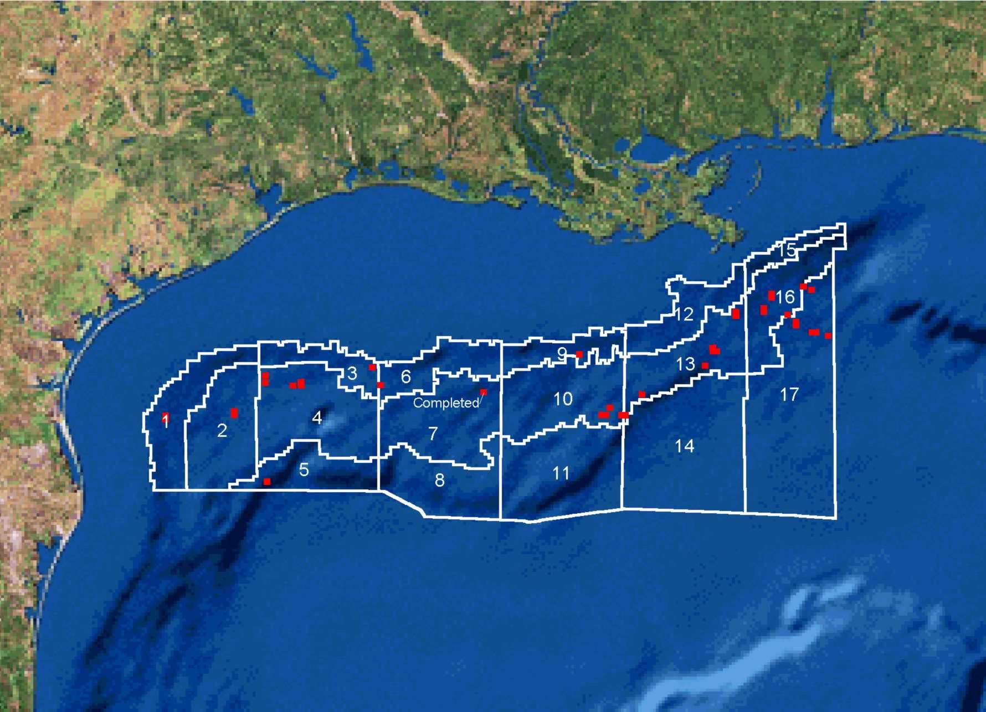
In some programs, ROV’s were effectively used; and for the deep-sea studies, manned submersibles were required to study highly complex chemosynthetic communities.
Grid Map for ROV Surveys showing 17 established grid areas in the Central and Western Planning Areas of the Gulf of Mexico. Red points indicate lease blocks with ROV survey requests issued (one survey in Grid 7 has been completed as indicated). Bathymetry is shown at 400 m, 1,000 m, and 2,000 m.

Final reports were typically published in sets of 4 to 10 volumes (including often-voluminous appendices), each with a topical area or synopsis, although some information synthesis reports were single volumes. The ecosystems studies devoted to the northern Gulf of Mexico shelf are described in Section 3.1, and those devoted to the continental slope are described in Section 3.2 below. These are discussed separately because of the inherent differences in community structure, process rates, habitat and biological diversity, and trophic patterns, for example.

3.1. Continental Shelf Ecosystems Studies

3.1.1. Eastern Gulf of Mexico Benchmark Program and the Mississippi-Alabama-Florida Shelf Ecosystems Study (“MAFLA”)
The MAFLA Program was one of the first BLM marine ecosystem programs in the Gulf of Mexico along with the South Texas OCS (STOCS) Program described below. One of the overriding considerations in developing the MAFLA Program was that, of all Gulf areas, it was believed to be one of the least affected by any human activities, including those related to oil and gas. (Well before the ESP, there were a handful of leases drilled in the southern southwest Florida area. In a small and brief study in 1993, the USGS relocated these undeveloped sites and made a favorable assessment of “health.”) In contrast to the eastern Gulf, most northwestern shelf areas west of Mississippi had been drilled extensively, and it was argued by many that chronic, low-level exposures to oil, metals, and other contaminants made reliable trend analyses impossible. The MAFLA Program measured and compared virtually every biotic and habitat compartment in the region. Beginning in 1975, the BLM began to receive MAFLA reports in earnest. The early workshop report, Marine Environmental Implications of Offshore Drilling, Eastern Gulf of Mexico, became a landmark work. A pilot, a Multivariate Analysis of the MAFLA Water Column Baseline Data, was conducted in 1974, and in 1977, a study of hydrocarbon loads in animal tissues. As a side note, the accuracy of all of the measurements of trace metals, hydrocarbons, and other contaminants made in the 1970’s have been called into question, compared to later measurements made with more advanced equipment and protocols.

The massive, multidisciplinary, and multiyear MAFLA sampling programs were procured in 1975 and 1977 (and published in 1977 and 1979, respectively). The first was published in 13 loosely connected volumes. In contrast to more recent studies, these studies described midwater plankton, neuston, and suspended matter and emphasized the measurements of contaminants and natural chemical species in biota, sediments, and water. The second main report (1979) furthered the knowledge found in the first.

Another major report in 1979 was related to ichthyoplankton distribution and abundance. While a large and expensive study for its time, there were some weaknesses in the comparisons of data, and an apparent reluctance of investigators in differing areas of expertise to converse. After reviews of the MAFLA program, the STOCS program, and similar ones in other Regions, the BLM studies program, in its infancy, began to redesign programs and target resources to make determinations most useful for DOI management decisions.

3.1.2. South Texas OCS Benchmark Program (STOCS)
Procured from 1975 to 1978, the STOCS Program consisted of a massive and diverse series of multidisciplinary efforts. In the year-one studies, baseline efforts were combinations of information syntheses, atlases, and pilot field studies. These included works on plankton and fisheries (National Marine Fisheries Service [NMFS]); biology and geology (Texas A&M University [TAMU]); geology (USGS); zooplankton, ichthyoplankton and eggs (TAMU and NMFS); and ground fishes (NMFS). The second year’s efforts produced a massive report containing 10 volumes on environmental biology and chemistry. It was entitled Environmental Studies, South Texas Outer Continental Shelf, Biology and Chemistry (1977) and was accompanied by a USGS mapping volume. The third year’s report (of the same name) was published as a seven-volume report in 1979, and a synthesis volume was produced in 1980. The major biological and chemical efforts described above were conducted by a consortium of Texas Universities (Rice, University of Texas, and TAMU).

3.1.3. Topographic Features Program
For many years before BLM systematic ecological investigations started, commercial snapper and grouper fishermen had been aware of a number of topographic prominences on the continental shelf from Texas to west Florida. Partly through oil and gas exploration, their presence became known to a wider group of oceanographers, recreational divers and fishermen, and even navigators (for anchoring -- a particularly destructive activity). By the early 1970’s, researchers, notably at TAMU, had begun to conduct topographic, biological and geophysical investigations in the western Gulf. As early as the 1950’s other workers were describing other topographic features in the eastern Gulf. Regardless of their geological origins (e.g., salt domes, chemical or biological accretion, or erosion), these features provide substrates for attached and cryptic flora and fauna as well as a habitat for a rich demersal and pelagic fish population. The Topographic Features Program has been one of the highest profile and longest lasting of the ESP initiatives, second only perhaps to the Marine Ecosystems Studies (above).

Reefs and other topographic irregularities are seen by many as special places of great value for a number of reasons: (1) They often support a variety of attached epibenthic animals and plants not found on ubiquitous soft bottoms; (2) They often provide protective and trophic niches; (3) They collectively comprise only a tiny percentage of ocean bottom; (4) As disjunct features, they pose interesting zoogeographic questions; (5) They provide places for recreational activities including fishing and diving as well as commercial fisheries, and (6) They are deemed by many to be aesthetically pleasing.

It has been argued that if the soft muddy bottom was the exceptional substrate, it would get more attention. From the beginning of the Environmental Studies Program the BLM recognized that the management of the oil and gas industry in areas with topographic features would have to be inherently different than for the far more common soft-bottom areas, and it initiated a series of studies. In 1976, the BLM received its first preliminary report on biological (and geological) reconnaissance of selected topographic features off Texas. Through 1981, the BLM had received six major reports on the topographic features in the western Gulf, their fauna and its vertical zonation, water and sediment dynamics, and chemical contaminants. The last of these, the Northern Gulf of Mexico Topographic Features Study included studies of the two Flower Garden Banks, nine minor banks, and the eastern Gulf’s Florida Middle Grounds, in addition to other banks had already been studied. By then, all known “banks” (as opposed to the lower-profile “hard bottoms”) had been investigated to one extent or another with photographic imaging, diver collections, and in situ instrumentation. Detailed topographic and zonational maps were now available for most of them, and these were being employed to develop stipulations to manage exploration and drilling in and around the features. In 1982, under the new Minerals Management Service, topographic features studies continued with a special emphasis on the conspicuous Flower Garden Banks.

The East and West Flower Garden Banks are located at the edge of the continental shelf, slightly over 175 km south-southeast of Galveston, Texas. The banks are topographic expressions of uplift caused by underlying salt domes originating from Jurassic, Louann evaporite deposits 15 km below the seafloor. The crests of these isolated banks, which are 19 km apart, are occupied by submerged coral reefs that rise to within approximately 15 m of the surface. Together, the bank zones containing high diversity coral reefs cover over 450 acres.

In 1984, the National Oceanic and Atmospheric Administration (NOAA) formally announced its intent to consider the Flower Garden Banks as a marine sanctuary under the Marine Protection, Research & Sanctuaries Act 1972. The two banks (East and West FGB) received formal designation in 1992. This was the tenth designated marine sanctuary and the first in the Gulf. Subsequently, in 1996, Stetson Bank was added to the Sanctuary. Much of the data obtained in MMS-supported studies were used in the arguments for designation.

In 1985 the MMS received a final synthesis report, The Flower Gardens: A Compendium of Information, which included a summary report and nine map sheets at a scale of 1:48,000.

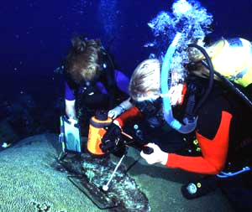
In 1992, the MMS received the report, Long-term Monitoring at the East and West Flower Garden Banks, a multiyear investigation of the overall health and dynamics of the ecosystem. This work was the result of an initial 3-year field program begun in 1989. The objectives were to document long-term changes in coral and associated communities and long-term natural variation in reef-building and associated communities. Various monitoring stations and transects were established for monitoring lateral and accretionary coral growth. Percent cover data were acquired planimetrically for all coral species, leafy algae, sponges and reef rock on the photographs. Measurements and calculations included number of colonies and relative dominance of each species, diversity and evenness, and trace metals. Growth, disease, bleaching, retreat, mortality, and mechanical damage were quantified. Fish and invertebrate populations were estimated on transects. Ancillary measurements included dissolved oxygen, salinity, temperature, light, and contaminants. The long-term monitoring of the Flower Garden Banks continues as a jointly funded effort with the NOAA’s National Marine Sanctuary Program, with additional reports being received in 1996 and 1999. Ongoing measurements of coral growth and other parameters continue. Virtually no significant long-term changes have been detected in coral reef populations, cover, or diversity at the Flower Garden Banks since quantitative surveys of the reefs began. No significant trends were observed in any parameters during the studies.

3.1.4. Northeastern Gulf of Mexico and Mississippi-Alabama Programs
In addition to the many western Gulf topographic features (primarily salt dome geology) and the Florida Middle Grounds (an accretionary system), there is a region east of the Mississippi Delta that is a transition area between the mud-silt deposits to the west and the siliceous and calcareous sediments to the east of DeSoto Canyon. Physiographically, the region known as the “Tuscaloosa Trend” or “pinnacle trend” is replete with relatively low (typically less than 15 m) “pinnacles” and benches from the middle shelf out to the shelf edge.

While not so high as the western Gulf prominences, these features present hard substrates for the attachment of epifauna and algae, and a habitat for pelagic and demersal fish populations. They are valuable for many of the same reasons as the western Gulf features but environmentally they are not capable of sustaining high diversity coral reefs. In addition to being interesting scientifically, there have also been concerns for the laying of pipelines and other infrastructure in these areas.

The program began in 1983, and the final report, Tuscaloosa Trend Data Search and Synthesis Study was completed in 1985. This report presented a regional review of known information. The field studies were conducted under a 4-year effort, Mississippi-Alabama Marine Ecosystem Study, which produced the large Atlas of High Resolution Geophysical Data and a 3-volume “Data Summary and Synthesis” (1991).

Following the initial studies, a new study administered for MMS by the USGS Biological Resources Division, the Northeast Gulf of Mexico Coastal and Marine Ecosystems Program: Ecosystem Monitoring, Mississippi/Alabama Shelf was planned to build onto the two previous MMS-sponsored studies of the Mississippi-Alabama pinnacle trend area. The initial studies had emphasized location and mapping of these features. In addition, communities were described with some ancillary correlations between physical and chemical parameters. The overall goal of this new 4-year program on the Mississippi/Alabama shelf was to characterize and monitor biological communities and environmental conditions at selected sites along the Mississippi-Alabama OCS. Specific objectives were: (1) to describe and monitor seasonal and interannual changes in community structure and zonation and relate these to changes in environmental conditions; and (2) to characterize the geological, chemical, and physical environment of the mounds as an aid in understanding their origin, evolution, present-day dynamics, and long-term fate. The program consisted of three field-year phases (1997-99) followed by analyses and final synthesis.

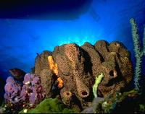
Methods included the use of ROV’s to characterize habitats and populations of epifauna and fishes, with occasional sampling for species identifications. Geological sampling was conducted with grabs, side-scan sonar, and sub-bottom profiler. Accessory measurements were made with a wide variety of hydrographic, optical and CTD’s, a variety of optical measurements at nine stations within five “megasites.” In addition, environmental moorings with current meters and other recording instrumentation were deployed and serviced regularly. This program was designed to monitor environmental conditions and dynamics at three distinct types of topographic features present along the Mississippi-Alabama OCS: (1) high profile pinnacles of greater than 10-m relief; (2) medium relief, flattop features of approximately 5 m; and (3) low relief hard bottoms of less than 5 m. Seasonal information was gathered regarding populations and diversity of biological organisms related to turbidity, zonation, and other physical environmental factors. After three annual interim reports, this program was completed in 2001 with the final synthesis.

The northeastern Gulf ecosystems studies included two additional data search, synthesis, and review-type efforts of note. The 1996, seven-volume, multidisciplinary Northeastern Gulf of Mexico Marine Ecosystem Program: Data Search and Synthesis contains some biological elements. The final natural sciences volume (Appendix E) reviews the biology of the northeastern Gulf from about Tarpon Springs, Florida to the Florida-Alabama line.

3.1.5. Southwest Florida Shelf Ecosystem Program
The study area for this program was the continental shelf from approximately St. Petersburg, south to the tip of Florida. The region is a wide carbonate platform dominated by silt, sand and gravel, and frequently encountered, low relief (<1 m) rocky outcroppings. The region varies ecologically with depth and from north to south. During the study, the several more-or-less-distinctive biotic assemblages were found to be explainable on the basis of seasonality, current regime, temperature range, depth and light penetration, nutrient upwelling, availability of rock substrate, and other variables.

The Southwest Florida (SWFL) Shelf program proceeded in several stages and was conducted under 10 separate contracts (with numerous contract modifications), and by 4 primary contractors. Ten areas (5 in southwestern Florida) were selected for geophysical characterization (sub-bottom profiling and side scan sonar). Following the primarily geological work, photographic and videographic imaging of the bottom produced early estimates of the types and amounts of biota the areas held.

Begun as a new project in 1980, the SWFL research program continued until the receipt of the final synthesis report in 1991. This study began with systematic geophysical and photo-sled surveys of the SWFL shelf from approximately St. Petersburg, FL, south to the southern tip of Florida, combined with traditional benthic samplings (box coring, dredging, trawling etc.) and accessory measurements. Without going into intricate detail year-by-year, the study began with the surveying of five east-west transects and subsequent hard- and soft-bottom stations samplings. With annual input from, and consultation with, the Florida Governor’s office and Florida scientists, the program was adjusted each year. Modifications included additions of sampling stations and movements of transect locations from year to year, until all of the suspected communities and areas of the shelf were sampled—all the way to the Florida Keys and even into some shallow State waters.

The SWFL program was one of the first in the Gulf that combined descriptive as well as true process-oriented studies. During the middle phases of this program, in situ experimental benthic arrays were deployed to understand some benthic processes: sequences of larval settlement and growth, “benthic storms”, animal behavior, and bottom hydrographic extremes. The study produced numerous scientific reports, large-format habitat atlases of communities and habitats, and multidisciplinary syntheses.

A workshop on the west Florida shelf was convened in May 1992 (final workshop report, 1994) at the Florida Institute of Oceanography, St. Petersburg. At that meeting, the immensity of the work done historically in the SWFL, MAFLA and other MMS projects in the area became evident to the 60+ attendees.

3.1.6. Texas-Louisiana Shelf Ecosystems Program
The Texas and Louisiana continental shelf is the most highly developed region in the world for offshore oil and gas drilling and production. It is also known for its abundant fisheries, productive coastal wetlands, and its offshore hard banks. Many studies supported by MMS and others have been conducted in this region. However, there had never been a synthesis of information for the whole northwest Gulf continental shelf. For the 1988 Offshore Texas and Louisiana Marine Ecosystems Data Synthesis, the study area described by Continental Shelf Associates extended over 1,000 km of coastline from the Mississippi River Delta, westward and southward to Corpus Christi Bay, Texas (the approximate center of the early STOCS Study, described above). The report reviewed the state of knowledge of the natural marine and atmospheric sciences, socioeconomics, and the effects of the oil and gas industry and other activities offshore. It also discussed information gaps and data needs and drew conceptual models. As one of the later large regional syntheses of data (this time in a non-“frontier” area), it had the advantage of working with early large data sets from the 1970’s and 1980’s.

3.2. Deep-Sea Ecosystems Studies
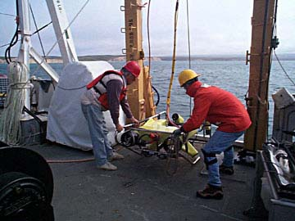
Most deep-sea animals live under conditions of total darkness, low temperature, nearly featureless mud, and sparse food resources. They are generally small and fragile and the structure of benthic communities is generally well known, if not satisfactorily explained, ecologically. Many of the same sampling and statistical methods used in shallow water apply well in the deep-sea environment. However, the costs for sea time and sample treatments are usually significantly higher. The character and rarity of many deep animals, the high species diversity, and the relative paucity of qualified systematists add to the difficulties. Another problem, not often discussed, is that relatively few marine biologists working on the well-lighted, high-productivity, high biomass, seasonally variable, and physically dynamic shelves and estuaries appreciate some aspects of the deep benthos and processes. Studies approaches are somewhat different (for example due to high diversity, diminutive and fragile animals, temporal stability, trophic structure, and slowed processes).

The accelerated interest by industry in development of the deep water of the Gulf of Mexico has proven a challenge for the exploration of hydrocarbon reserves in an environmentally sound manner. This heightened interest in the deepwater area has largely been triggered by the passage of the Deepwater Royalty Relief Act in 1995 and the development of technologies that allow for cost-effective development beyond the continental shelf. With this accelerating interest, leasing in waters deeper than 400 meters has proceeded at an unprecedented rate, with exploration and production following closely behind. The challenge is raised to ensure that the environmental information base is adequate to address management issues needed in these new areas. This offshore trend has been paralleled by MMS-sponsored research since the early 1980's with studies of the deep sea in general, and chemosynthetic communities in particular. However, if predictions of even larger reservoirs are proven true, then during the next decade the Gulf of Mexico will experience a profound change in the patterns of development.

In recent years, the oil and gas industry has drilled tracts in depths greater than 3,000 m, has drilled wells in depths almost 2,000 m, and has produced from at least ten sites from 1,150 to 2,520 m.

In the late 1970’s, it was already apparent to the BLM that the industry was encroaching onto the uppermost continental slope. Rapidly improving deep drilling and exploration technologies and large reservoir discoveries justified the higher cost.

3.2.1. Deep-Sea Information Synthesis
By 1981, the MMS had awarded a contract to Dr. Willis Pequegnat of TerEco, Inc. to review the available information on deep-sea communities of the Gulf of Mexico. Based primarily on accumulated trawl data and bottom photographs collected on the R/V Alaminos from the 1960’s through about 1980, this report was received in final form in 1983. However, systematic faunal data, except for the megafauna, was lacking for the Gulf of Mexico deep-sea communities.

3.2.2. Northern Gulf of Mexico Continental Slope Study
In 1983, the MMS awarded the first systematic study of the deep northern Gulf of Mexico. Conducted by LGL, Ecological Research Associates and TAMU, the Northern Continental Slope Study (NGOMCS) was a classical descriptive field study designed largely to test or confirm the depth zonation scheme suggested before by Pequegnat. The continental shelf studies, (see Section 3.1, above) were conducted as a series of efforts based on regional physiological and zoogeographic character. At that time the Gulf was believed to change monotonously with depth. Consequently, it was anticipated that one large descriptive study with stations placed on transects and consistent methods, would work for the deep sea. The geochemical and physiographic complexity we now recognize was unknown in the 1970’s. Consisting ultimately of stations on a few shallow-to-deep and E-W transects, the study concentrated on benthic and benthopelagic sampling. Included were sediment characteristics; meio-, macro-, and megafauna; contaminants; and hydrography with the usual comparisons of the non-biological variables and community structure.

3.2.3. Chemosynthetic Community Studies and Community Conservation
It was during the latter phases of the NGOMCS field program (late 1984) that TAMU researchers, conducting separate but concurrent research, recognized chemosynthetic species in dredge and trawl tows from an area known to have sediments containing oil, gas hydrates, and hydrogen sulfide. Carbon isotopic analyses confirmed that the tube worms and molluscs lived via a chemosynthetic strategy. This was, at the time, a remarkable finding to the investigators and MMS. In 1986, the MMS provided limited funding to the NGOMCS program for initial surveys using the Johnson-Sea-Link I research submersible. Six successful dives were made on two stations in the Green Canyon area (Blocks 184/185 and 233/234). These observations revealed the magnitude of the communities; their faunal composition; spatial variability; and relationships among the fauna, bacterial mats, seeps, and unusual geological formations.

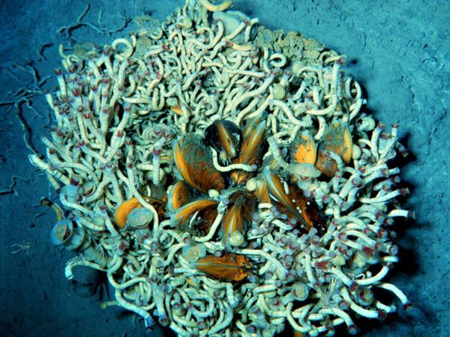
The MMS recognized the potential importance of these communities and their implication in the management of the petroleum industry. Early findings, accumulating at a rapid rate as more sites were visited, demonstrated high inter- and intra-site variability in community density and composition. The MMS concluded that protective measures and additional high-resolution information were needed.

The MMS soon held discussions with the Offshore Operators Committee (OOC), a group representing companies conducting petroleum operations in the Gulf of Mexico. In cooperation with the MMS, the OOC was instrumental in collecting and releasing geophysical information and they commissioned TAMU to conduct a trawling study at 33 carefully selected sites. Chemosynthetic animals were found in 28 of 39 (72 percent) of the samples. These findings significantly expanded the known 1986 distribution of these communities (or at least animals) across the northern Gulf.

The MMS has at its disposal, measures for the protection of valued resources. Among these measures are pre-lease stipulations and Notices to Lessees (NTL's). Stipulations are sale-specific protective measures that may or may not be adopted at each lease sale by the Secretary of the Interior. In contrast, because of its administrative nature, an NTL is exercised on all applicable leases (i.e., it is not lease-specific) and it is not an optional protective measure used at the discretion of the Secretary.

In 1988, the MMS issued NTL 88-11 (now refined as NTL 2000-G20), which became effective on February 1, 1989. It required ". . . avoidance or protection of chemosynthetic communities and avoidance of shallow hazards . . . ." It further required that, in depths greater than 400 m, operators supply geophysical data to MMS to determine the possibility of the local existence of chemosynthetic communities. Prior to approvals of applications for permit to drill and pipeline applications, operators must delineate all seafloor areas to be disturbed, as well as all available geophysical and topographic features that might support chemosynthetic communities. If the MMS review suggests that chemosynthetic communities could be harmed, the operator must (1) modify the application to relocate the operation, (2) modify the application to provide additional photographic or videotape information to determine the presence or absence of well developed communities, or (3) otherwise ensure that the operation does not impact a community (i.e., the precision placement of anchors). There have been no regulatory actions by agencies other than the MMS to protect chemosynthetic communities.

Following the early observations and imposition of protective measures, the MMS funded the first Chemosynthetic Ecosystem Study (CHEMO I) in 1990. This was a two-field-year study concentrating on community descriptions and other determinations to address the most immediate management needs which included the status of knowledge for the Gulf and literature review; the degree of community similarity to other areas; the distribution and degree of development from place to place; whether the communities are "permanent" or “ephemeral” and fragile (sensitive) or robust; and the extent to which communities can be harmed by or protected from OCS oil and gas activities.

The contract required an information synthesis (completed as a separate report in 1992), conceptual modeling, quantitative composition of chemosynthetic communities and spatial relationships among animals. Investigators used manned submersibles to allow for precision navigation, photography, sampling, and personal observation. They made the first quantitative studies of physical-chemical factors controlling the distribution, abundance and growth of chemosynthetic communities. They also investigated associated heterotrophic fauna; some geochemical, biochemical, and physiological activity; and the reliability of methods for detecting communities.

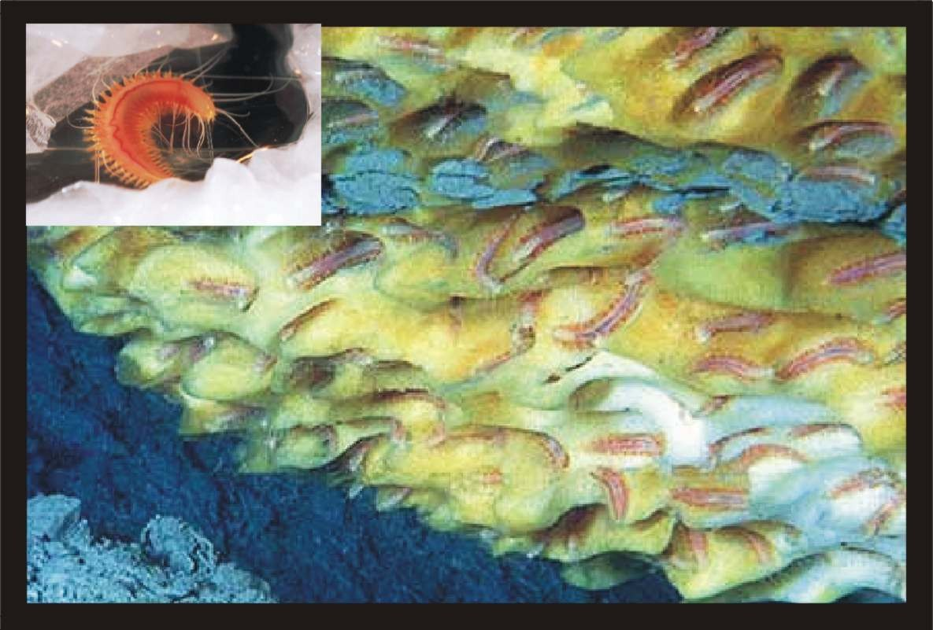
The 1995 Change and Stability in Gulf of Mexico Chemosynthetic Communities (CHEMO II) was designed to expand on the CHEMO I database. The MMS recognized that there were still few data on the ecological interactions in these communities, the temporal stability and change within the communities, and the physicochemical habitat that supports them. CHEMO II addressed both abiotic habitat and biotic questions to understand the conditions necessary for community establishment and maintenance.
The iceworm (Hesiocaeca methanicola)

In addition to furthering the general objectives of CHEMO I, CHEMO II investigated the sources (e.g., deep vs. shallow, or petrogenic vs. biogenic) of any necessary dissolved gases and the likelihood that petroleum production may ultimately deprive the animals of an energy source; the age, growth rate, turnover rates, reproduction and recruitment; the patterns of senescence and death in the dominant animals; and the recovery rates of communities damaged by physical disturbance. New experimental approaches and new instruments were deployed by submersibles and more precision measurements were taken. All of these objectives were met, some beyond expectation.

3.2.4. Northern Gulf of Mexico Continental Slope Habitats And Benthic Ecology
In 1988 when the NGOMCS final report was received, the MMS was already aware that the classical picture of the continental slope was changing. Many newer scientific findings had been made on the slope, among the most important being the discoveries of productive chemosynthetic communities in 1984, and the collection of far better information on geological structural complexity and related biogeochemical processes. It was now generally conceded that the information available on the vast northern Gulf continental slope was inadequate in light of these findings.

In addition, technological and engineering advances and economic factors had fueled the rapid expansion of the oil and gas industry into slope waters. As a result of the passage of the Royalty Relief Act, the expansion of leasing activities on the continental slope had risen dramatically since 1995, especially in water depths greater than 800 m. Furthermore, the discoveries of vast gas hydrate reserves on the slope suggested increasing industry interest.

In April 1997, an MMS-supported Workshop on Environmental Issues Surrounding Deepwater Oil and Gas Development was convened in New Orleans to identify oceanographic and sociological data gaps, and to recommend new investigations to fill them. The discussion group on deep-sea ecology focused on the state of knowledge of benthic communities, their composition and complexity, associated biogeochemical processes, habitat heterogeneity and trophic considerations.

A study initiated in FY 1999, Deepwater Program: Northern Gulf of Mexico Continental Slope Habitats and Benthic Ecology (Deep Gulf of Mexico Benthos or DGoMB) was developed with the guidance of the workshop recommendations. This study has many of the same objectives as the NGOMCS study, but there are significant differences in approach. The DGoMB study began with a series of models and testable hypotheses. The sampling scheme is designed to detect known changes in depth, topography, current features, etc. It is built on the NGOMCS study and all other available information, including the presence of seeps. In addition to the main benthic and hydrographic descriptions, it has a significant process-oriented component (e.g., respirometry and sulfate reduction) designed to supplement and explain the quantitative faunal data. As DGoMB developed, there were other fortuitous additions, notably an extension of the sampling and experiments into Mexican waters, and the deployment of the DSV Alvin to make pertinent observations.

3.2.5. Other Deep-Sea Efforts
Additional (non-field) MMS-sponsored studies discussed in the 1997 workshop included: (1) a review of management usage of deep-sea information, and (2) a Gulf of Mexico Deepwater Information Resources Data Search and Literature Synthesis. These projects were conducted by the cooperative Louisiana State University/Coastal Marine Institute (CMI) program (Dr. R. Carney) and Continental Shelf Associates, Inc. (CSA), respectively. In 2001, CSA completed a large report Deepwater Gulf of Mexico Environmental and Socioeconomic Data Search and Synthesis. Of the 11 topical chapters, 5 were devoted to various aspects of biology, including water column, benthos (seep and nonseep), protected species, and fishes and fisheries. The CMI report Management Applicability of Contemporary Deep-Sea Ecology and Reevaluation of Gulf of Mexico Studies reviewed selected historic research efforts by Federal Agencies and the works by Pequegnat and LGL (NGOMCS) in the Gulf.

4. Coastal Studies
The BLM and MMS coastal studies have produced a diverse series of reports and maps which describe the important characteristics, assets, and resources of specific segments of the coast around the Gulf of Mexico from south Florida to south Texas. Mapped topics varied from area to area reflecting regional environmental differences, for example the presence of distinctive landforms and shallow ecosystems, estuaries, seagrass beds, mangrove forests, coral reefs, and marshes. In addition to the reviews of ecological and biological resources, many of these studies included topics such as socioeconomic features; oil and gas infrastructure; climatology; minerals, soils and geological character; and coastal processes. But the studies listed below review only those of a biological nature, region by region. These study series have also been referred to as the Coastal Characterizations.

There have been several major reasons for the development of coastal environmental data. Initially, knowledge of the distribution of environmental resources is the first step in managing and protecting them. The shallow water communities and coastal lowlands are the resources most vulnerable to oil spills and other contaminants and physical disturbance (e.g., the digging of canals and pipeline corridors). They are also very productive in terms of natural carbon flow as well as the Nation’s fisheries (especially in the northern Gulf of Mexico). Ultimately, the shallow water and continental shelf production of biomass and detrital carbon feeds even the deep-sea fauna. The coastal areas also provide critical habitat for several protected species including bald eagles, osprey, bottlenose dolphins, manatees, and beach mice. Finally, coastal areas are local centers of human populations and recreational resources. The MMS coastal studies were not begun until the late 1970’s, just a few years after the early baseline marine ecosystem studies (see Section 3.). Many have been conducted by, for, or in consultation with MMS’s sister DOI agency, the U.S. Fish and Wildlife Service (FWS), and many resulted in publications with FWS report numbers. The hundreds of maps produced under the relevant MOU’s and contracts are standardized at a detailed scale of 1:100,000. Several of these reports are also mentioned in the Ecosystems studies (Section 3).

4.1. General Coastal Studies – Central Gulf Marshes
Of the most productive natural ecosystems, the coastal marshes are high on the list of coastal studies. They have been highly researched worldwide and are among the best understood in terms of their biological processes and composition value to humans. In its realization of the oil and gas industry’s partial implication in the loss of wetland habitat, MMS set out to determine the extent of the problem and possible remedies. A final report, Causes of Wetland loss in the Central Gulf of Mexico, became available in 1988. In contrast to the four, largely descriptive, regional programs that follow below, these studies were more ecosystem-specific and related to specific, known operational effects.

4.2. Texas Coastal Ecosystems Program
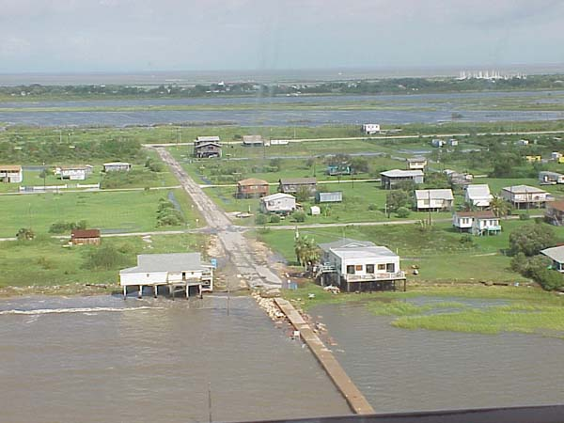
In the Texas coastal studies, the FWS focused appropriately on the Texas sandy barrier islands, estuarine lagoons, and marsh systems. From south to north, the seaward coastline changes from a medium-to-high-energy environment to a marshy region north and east of Galveston. The dynamic southern Laguna Madre environment is governed largely by a relative lack of fresh-water input and high evaporation rates. The 1981 final report, the Texas Barrier Island Regional Ecological Characterization: Environmental Synthesis Papers was followed by the 1983 three-volume, 48-map atlas of the same title. Volume II contains the biological resources narrative. In 1989, the program ended with the Texas Barrier Island Regional Characterization, which went beyond the previous characterization by (1) updating and improving upon the previous work and (2) including a large volume of conceptual ecosystem models. The Texas reports covered the entire coast from Mexico to Louisiana.
Source: Galveston County, Office of Emergency Mgmt.

4.3. Louisiana Coastal Ecosystems Program
The Louisiana coast is predominantly a low-energy coastline with extensive coastal marshes and riverine input. This notably increases rates of production for the wide continental shelf but it can also produce seasonal hypoxia and nutrient excesses. The Mississippi Deltaic Plain Region Ecological Characterization: A Habitat Mapping Study was completed by the FWS in 1980 with a companion socioeconomic report. In 1981, FWS published a review of the environmental literature, and by 1983, the FWS and others had published the final report series: a narrative report with management recommendations, a volume of ecological models, and a 72-map ecological atlas.

4.4. Northeastern and Eastern Gulf of Mexico Coastal Ecosystems Programs
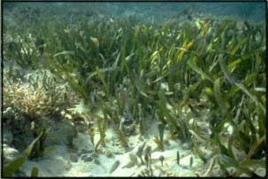
The eastern Gulf of Mexico (essentially the entire coastline east of the Mississippi River) has a wide variety of shallow ecosystems not seen elsewhere in the Gulf, or seen here in greater abundance or density. Some of these ecosystems, notably the oyster reefs, seagrasses, and mangroves, are not only highly vulnerable to oil spills, they are believed to be very sensitive, if exposed. From the barrier islands, coastal marshes and shallow bays in Alabama, Mississippi and northwest Florida, to the wide carbonate platform, mangroves, Everglades, coral reefs and tropical flora in south Florida, the eastern Gulf is generally more diverse ecologically than the western Gulf, and the MMS coastal studies program reflects this. Continuing eastward into Mississippi, Alabama and Florida the FWS and MMS focused on certain valuable environmental resources and communities in addition to the general multidisciplinary characterizations described elsewhere. No fewer than 23 coastal ecosystems studies have been published under MMS support for the eastern Gulf. These include regional characterizations, community-specific descriptive profiles, inventories, and ecological characterizations as follows:

- Alabama Coastal Region Ecological Characterization (1983);
- Ecological Characterization Atlas of Coastal Alabama (1984);
- Northwestern Florida Ecological Characterization: An Ecological Atlas (1984): 1 volume, 90 map sheets;
- Southwest Florida Ecological Characterization Atlas (1984), 100 map sheets at 1:100,000;
- Synthesis of Available Biological, Geological, Socioeconomic, and Cultural Resource Information for the South Florida Area (1990);
- An Ecological Characterization of the Lower Everglades Florida Bay and Florida Keys (1982);
- An Ecological Characterization of the Caloosahatchee/Big Cypress Watershed (1984);
- An Ecological Characterization of the Florida Panhandle (1988);
- An Ecological Characterization of the Tampa Bay Watershed (1990); and
- An Ecological Characterization of the Florida Springs Coast (1990).

The FWS published coastal Seagrass Inventories for northwest Florida (1981), Louisiana and Mississippi (1982), western peninsular Florida (1984), and south Florida (1982). In the southernmost areas, the corals were added to the inventories in the Florida Keys Seagrass and Coral Reef Inventory (1983).
Two reports discussed the many protected species harbored in southwest Florida ecosystems and possible effects of OCS activity: Rare, Threatened and Endangered Vertebrates of Southwest Florida and Potential OCS Activity Impacts (1983), and Rare, Threatened and Endangered Plant Species of Southwest Florida and Potential OCS Activity Impacts (1981).

A notable series of seven “community profiles” was published during the 1980’s and 1990’s, describing the ecology of selected ecotypes in the northern and eastern Gulf of Mexico and western peninsular Florida:
- The Ecology of the Mangroves of South Florida: A Community Profile (1982);
- The Ecology of the Seagrasses of South Florida: A Community Profile (1982);
- The Ecology of the South Florida Coral Reefs: A Community Profile (1984), 10 color map sheets at 1:30,000;
- Ecology of Flooded Salt Marshes of the Northeastern Gulf of Mexico: A Community Profile (1984);
- The Ecology of the Seagrass Meadows of the West Coast of Florida: A Community Profile (1989);
- The Ecology of Oyster Reefs of the Northern Gulf of Mexico: A Community Profile (1989); and
- The Ecology of the Live Bottom Habitats of the Northeastern Gulf of Mexico: A Community Profile (1999).

The Northeastern Gulf of Mexico Coastal Characterization and Data Information Management System (1999) is an update of older works above for all counties and parishes from Apalachicola west to the Chandeleur Islands. Data sets are categorized into two types: seagrass habitat maps and natural resource/socioeconomic features.

5. Living Marine Resources
While the “Marine Ecosystems” studies attempt to gather relevant information necessary to describe the natural complex structure and components of identifiable (usually benthic) ecotypes, the “Living Marine Resources” studies focus on the distribution, abundance, and biology of conspicuous forms protected under law, or having commercial, recreational, or “charismatic” value. “Living Marine Resources” studies may seek to estimate potential effects of anthropogenic activities or events, thus overlapping with certain “Effects” studies.

5.1. Protected Species
In response to the Marine Mammal Protection Act (MMPA) of 1972, the Endangered Species Act (ESA) of 1973, and numerous biological consultations required under Section 7 of the ESA, the ESP has funded a series of studies to obtain information on protected species possibly affected by OCS oil and gas operations. These studies have emphasized use of fixed-wing aircraft and ships to estimate distribution, relative abundance, and behavior of cetaceans.

Questions have arisen on the effects of the oilfield structures, noise, explosive detonations for the severing of platform elements for removal, pollution, lighting, seismic exploration, effluents as attractants or repellents, and the overall physical effects of industry (e.g. boat traffic, midwater structures, and pipelines) on daily cetacean movements and behavior. The need to evaluate potential impacts of offshore oil and gas activities on protected species has resulted in an aggressive MMS marine mammal and turtle research program in the Gulf of Mexico.

The MMS studies have complemented years of shallow dolphin studies completed by the National Marine Fisheries Service (NMFS) around the Gulf perimeter. Only two delphinids, the bottlenose and the Atlantic spotted dolphin are found routinely on the shelf (< 200 m). Most of the MMS concerns result from the development of deepwater tracts. The considerations here were (1) the rapid expansion of the oil and gas industry onto the slope, (2) development of new deepwater structures and technologies and (3) the deepwater distribution of most of the Gulf species. Some of the deep-water species (e.g. beaked whales and Kogia spp.) are quite rare, evasive, and difficult to identify and count. In addition, the topography, geology, current structure, and even the chemistry of the continental slope are proving to be very complex, and little is known about how deepwater forms react to these features.

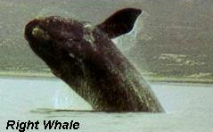
Numerous Gulf of Mexico species are protected under the ESA, MMPA, or both. While there are several species of birds protected under the ESA (e.g., the bald eagle), the MMS has not undertaken any specific field studies on them, relying instead on FWS data, for example.

The West Indian Manatee of the Caribbean and western Florida is the manatee subspecies of great interest in the region. It grazes in the shallow Gulf but spends great amounts of time in Florida estuaries and rivers. Rarely, stragglers swim into the coastal northern Gulf waters.

There are at least 27 species of cetaceans (whales and dolphins) representing five families that might be expected in the Gulf at some time or another, but there are only about 20 that might be expected regularly (there are no porpoises or river dolphins in the Gulf). All Gulf species are protected under the MMPA and six are under the ESA*:

Odontocetes, toothed whales
Physeteridae Sperm whale*, and dwarf and pygmy sperm whales
Delphinidae Dolphins, at least 14 species, very rare to common
Ziphiidae Blainville’s, Gervais’, Sowerby’s and Cuvier’s beaked whales
Mysticetes, baleen whales
Balaenidae North Atlantic Right Whale*
Balaenopteridae Rorquals; the Minke, Sei, Bryde’s*, Blue*, Fin*, and Humpback*whales

Sea turtles include the loggerhead, green, hawksbill, Kemps ridley, and leatherbacks. Of these the Kemp’s ridley is the most endangered, and the loggerhead is the most common. All are listed under the ESA.
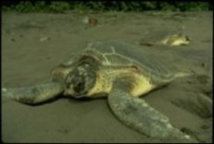
The MMS has funded literature reviews and syntheses; field studies on cetaceans, manatees, and sea turtles; and three workshops directed at cetaceans and sea turtles in 1982, 1990, and 1999. The MMS studies have greatly expanded our knowledge of the distributions, abundances, natural histories, and behaviors of many of the more common cetaceans and, to a lesser degree, turtles.

Prior to 1977, there were no large-scale efforts to survey Gulf of Mexico marine mammals – the sparse information available was a mix of opportunistic sightings, whaling records, and stranding reports. An early synthesis report by David Schmidley (1978) provided the MMS with basic information on most of the known cetaceans zoogeographically expected to occur in the Gulf.

The first dedicated field studies were conducted by the FWS with fixed-wing aircraft overflights. Beginning with a small pilot study (published in 1981) and then a larger follow-up research effort (published in 1984), the research focused simplistically on relating sightings to geographic location, depth, and distance from shore in three polygons around the Gulf. While most of the cetacean identifications are believed to be of good quality, reviewers have expressed less confidence in the bird and turtle identifications.

Another early FWS study on manatees off western peninsular Florida was published in 1981. A 1982 Proceedings of a Workshop on Cetaceans and Sea Turtles in the Gulf of Mexico: Study Planning for Effects of Outer Continental Shelf Development gave MMS guidance for a continuing protected species program.

Two regional reviews discussed the many protected species harbored in southwest Florida ecosystems and possible effects of OCS activity: Rare Threatened and Endangered Vertebrates of Southwest Florida and Potential OCS Activity Impacts (1983), and the Rare, Threatened and Endangered Plant Species of Southwest Florida and Potential OCS Activity Impacts (1981).

Following the results of these early field and review programs, continuing Section 7 consultations, and the 1982 workshop recommendations, the MMS contracted with the NMFS, Pascagoula, to conduct modest preliminary field studies (aerial and shipboard). These were aimed at (1) associations of sea turtles and petroleum platforms, (published in 1990), (2) the distribution of cetaceans and sea turtles on the slope, (published in 1991), and (3) the behavior and distribution of sea turtles in relation to the distribution of platforms. This tagging and tracking program, was cancelled due to technical difficulties. However, under a contract modification, the program produced the much-needed work-up of extensive Mexican data on Kemp’s ridley turtles: Synopsis of Data on the Kemp’s Ridley Turtle, Lepidocheles kempi. This was one of the top recommendations of the 1982 workshop.

In 1991, the MMS initiated a major field study, Distribution and Abundance of Marine Mammals in the North-Central and Western Gulf of Mexico (GulfCet I). Funding limitations and the imposition of drilling moratoria in the eastern Gulf restricted aerial aspects of this study to the Central and Western Gulf of Mexico Planning Areas from 200-m to at least 2,000-m depth. The GulfCet I study (1991-1995) was the most intense field effort to date. It was conducted jointly under a contract with TAMU, (Galveston) and an MOU with NMFS. This work elucidated distribution and relative abundance of the more common cetaceans and their habitat preferences. Observations included seasonal aerial and shipboard line transects and concurrent passive acoustic surveys. An added task supported attempts to tag and track the endangered sperm whale. While the tagging effort was unsuccessful, there were some preliminary observations on distribution and possible effects of a seismic ship on movements. Observations were analyzed through proven line-transect statistics. The addition of hydrographic surveys on TAMU ship surveys and AVHRR satellite data (sea-surface temperature) gave the investigators at least a preliminary look at Loop Current eddies, and chlorophyll a measurements gave estimates of primary productivity. Aerial observational efforts included the estimates of sea turtle numbers and recorded the presence of man-made trash and pollution. The multifaceted effort was a significant improvement over the FWS work conducted a decade earlier. However, because of the limitations in available airtime, the sparse populations of a majority of the known species, and limitations in the statistical operations, excellent estimates of population numbers existed for only the most common and ubiquitous species.

Following GulfCet I, a new program, Cetaceans, Sea Turtles, and Seabirds in the Northern Gulf of Mexico: Distribution Abundance, and Habitat Associations (GulfCet II) was conducted by the same organizations and investigators. There were renewed industry interests in the western parts of the Eastern Gulf of Mexico Planning Area so the effort in the western Gulf was reduced in favor of getting concentrated data off Pensacola and Mobile well into shallow waters, and as far east as Cape San Blas, Florida. Shipboard and aerial overflights and acoustic surveys were continued. In GulfCet I, the primary production measurements offered no insight into cetacean distribution, and it was surmised that the higher trophic levels might be more indicative of whale foraging areas. Consequently, midwater trawls were towed on “focused” cruises in the Eastern Gulf and the hydrographic effort was modified materially in GulfCet II. Satellite sea-surface temperature and dynamic height measurements, nutrient determinations, expendable bathythermographs, and acoustic Doppler current profiler measurements were made specifically to define preferred cetacean habitat. Associations were observed between sperm whale distributions and eddies, upwelling, nutrients, and paralarval cephalopod abundance.

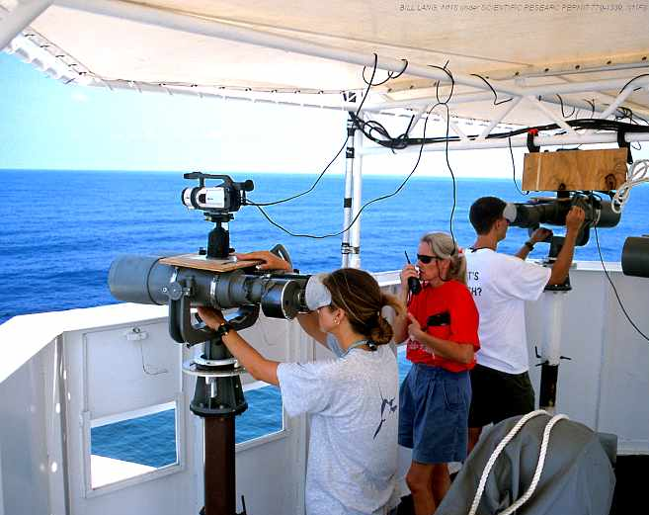
It had been increasingly obvious that a substantial sperm whale population existed in the Gulf with total modern population estimates ranging from 300 to 500 animals. During a 1989 workshop, the “Sea Turtles and Marine Mammals of the Gulf of Mexico,” a panel of experts identified the endangered sperm whale as a species of particular concern for proposed deepwater development in Gulf of Mexico waters. The continuing need for sperm whale data brought together a multi-institutional study known as the Sperm Whale and Acoustic Monitoring Program (SWAMP). This multifaceted, joint Federal Agency research program was begun in 2000. It was designed to study the resident population of sperm whales and the underwater acoustic environment. The population structure, biology, population genetics, diving and social behaviors, vocalizations, and movements are being studied using short- and long-term tags, satellites, and various acoustic receivers to determine natural behavior of the animals and the possible effects of geophysical seismic devices and other emitters. A concurrent shipboard survey continues in conjunction with NMFS ichthyoplankton surveys. Difficulties with the interagency agreement with NMFS, resulted in a new cooperative agreement with TAMU in 2002. The new Sperm Whale Seismic Study (SWSS) is researching the same parameters as SWAMP, but includes the use of a seismic survey ship, provided by industry, to directly study the effects of sound from seismic boats.

One other study directed toward protected species was an extensive literature review of the Effects of Noise on Marine Mammals (1991) which was rewritten as an authoritative hardbound volume, Marine Mammals and Noise (Academic Press, 1995).

5.2. Fishes and Fisheries
Generally, fisheries studies have been the purview of NMFS, and two research laboratories exist in the Gulf at Pascagoula, Mississippi, and Galveston, Texas. However, when MMS and NMFS interests interconnect (especially on issues pertaining to protected species and fish stocks), cooperative agreements can ensue. General descriptions of Gulf fish populations can be found in the topographic features studies. A wealth of information is found in the fishery management plans of the Gulf of Mexico Fisheries Management Council.

The BLM and MMS have supported a number of widely dissimilar studies that had fish and fishery components including the early STOCS and MAFLA benchmark programs (see Section 3.1). Many of the 1975-1979 reports, and specific volumes therein, were devoted to demersal fishes, fish eggs, ichthyoplankton, histopathology, and contaminant body burdens. Only one project, Ichthyoplankton Abundance and Diversity in the Eastern Gulf of Mexico, was devoted solely to ichthyoplankton, . Many of the fish studies were conducted by the NMFS, but substantial input came from universities. Virtually all of the large “Marine Ecosystems” projects had trawling components, and the several profiles of the ecology of petroleum platforms and natural ecosystems contained information on fishes in selected ecosystems (e.g., seagrasses and mangroves).

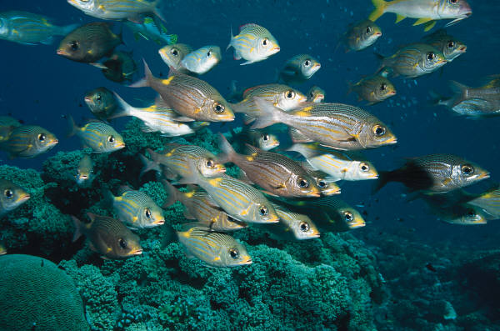
A 1983 report, Northwestern Gulf Shelf Bio-Atlas was a study of the distribution of demersal fishes (62 families of cartilagenous and bony fishes) and penaeid shrimps (12 species). The report is unique in its combination of explanatory text (species-by-species) along with detailed mappings of the calculated seasonal catches and densities for all species where data were adequate. Stations were restricted to soft-bottom habitats. Limited mappings of seasonal surface and bottom temperatures and salinities were also provided. Species were classified into different ecological groupings (e.g., nektonic, demersal, estuarine-dependent, and cryptic), and the maps showed seasonal shifts in densities, regional dominance, depth patterns, etc. The large-format report displays the area from south Texas to the Mississippi River.

A recent study, Estimation of Fisheries Impacts Due to Underwater Explosions Used to Sever and Salvage Petroleum Platforms (2000), was a field, fish-mortality study conducted by NMFS at nine platform removal sites from 1993 to 1999. It determined the species composition and abundance of fish communities at platforms and made calculations of the adverse effects of cumulative detonations to fish stock productivity, especially for the commercial red snapper (Lutjanus campechanus). A much earlier effort Study of the Effects of Oil and Gas Activities on Reef Fish Populations in the Gulf of Mexico (1982) was one of the first studies to enumerate fish outside of the several ecosystems studies. Occasional fishes and fisheries data (e.g., local fisheries values or catch statistics) were found in many of the socioeconomics studies.

5.3. Birds
The MMS Gulf of Mexico Region has supported few stand-alone studies on bird populations, but two surveys conducted by TAMU at Galveston (see Section 5.1) included seasonal surveys using the primary surface ship as an opportunistic platform for bird observations in addition to the dedicated studies of cetaceans. These studies were the Distribution and Abundance of Marine Mammals in the Northwestern Gulf of Mexico (GulfCet I, 1996) and Cetaceans, Sea Turtles, and Seabirds in the Northern Gulf of Mexico: Distribution, Abundance, and Habitat Associations (GulfCet II, 2000). As indicated above, GulfCet II placed considerable emphasis on the definition of animals’ preferred habitats, and demonstrated geographic and seasonal distributions of birds reflecting seasonal migration patterns, oceanographic features, and surface productivity. While there were earlier attempts with the 1980’s FWS cetacean surveys conducted for MMS, it has been debated whether the opportunistic aerial bird sightings could have been made with acceptable taxonomic accuracy at the adopted altitude and speed. An “Effects” study (see Section 6.1) was titled Seasonal Abundance and Habitat-Use Patterns of Coastal Bird Populations on Padre and Mustang Island Barrier Beaches. This was a distribution and abundance study completed in 1984 following Mexico’s Ixtoc I oil spill.

A nearly complete project conducted through the Gulf of Mexico CMI, Interactions Between Migrating Birds and Offshore Oil and Gas Structures, is presently using in-place radar and visual observations aboard platforms to assess the abundance of migrating neotropical birds.

6. Effects of Oil and Gas Activities
The “effects” studies are perhaps the most diverse grouping of studies in terms of issues, methods and purposes. These studies typically stem from specific issues (often quite unrelated) that are brought to the MMS’s attention in consultations, meetings, workshops, or through the National Environmental Policy Act (NEPA) process. If a given study concerns the “effects of X on Y,” the terms X and Y can be almost anything reasonably related. It is important here that X is an anthropogenic factor or event and Y is some measure of an ecological feature, natural resource or process, and the study may involve modeling or monitoring of effects. This is different from the several ecosystems modeling programs in which natural processes and variations are monitored over time to estimate trends and variability (see Marine Ecosystems, Section 3.). While some “effects” studies were begun in the early 1980’s, they tended to increase in quality and number in the later 1980’s and 1990’s. This parallels the general trend throughout the history of the ESP, which was to begin with massive descriptive field ecosystems programs and information reviews followed by smaller studies focusing on specific operations, ecological questions and living resources.

Note that there are a number of purely physicochemical studies under the general banner of “fates and effects studies.” These seek to determine the range of distribution and movements of oils, drilling muds, produced waters, industrial chemicals, trace metals, and natural radioactivity. However, they do not directly relate the fates to the biota, and they are intentionally omitted in these biological reviews.

Several opportunistic investigations have been the result of accidental oil spills on the environment or the collection of unidentified harmful materials. These opportunities have been very uncommon because of the excellent Gulf of Mexico operations safety record. The two spills thoroughly researched happened in Mexico and Panama. A number of questions have arisen about the physicochemical effects (physical presence, or the issuing of toxic products from platforms). Some have been devoted to arguably positive effects, such as reef-building and fish attractant effects. Some of the efforts have relied on field data/sampling efforts, while others are inherently information reviews or data syntheses, and still others are laboratory experiments. “Effects” studies are perhaps the most problematic group of studies done by MMS (or anyone else for that matter). The accuracy of the results and the effectiveness of their application will vary with the perceived problem. But no results are “good” unless they are based on accurate assumptions, impeccable testing and statistical methods, elimination of complicating or confusing factors, and with acceptable biological “noise.”

The “effects” investigations fall, more or less logically, under several different themes (a few which could also easily be lumped under other categories), such as those discussed below.

6.1. Effects on Biota
These studies attempt to measure the effect(s) of platform presence or exposure to contaminants on selected species or living resources. Some examples are discussed below:

Effects of Petroleum on the Survival of Marine Turtle Embryos (1982). This experiment by the FWS involved an actual exposure of eggs to crude oil with adverse effects. The results of this program have been questioned on methodological and statistical grounds. Also, spills rarely impinge far enough above the high tide mark to affect viable eggs. If that happened, the salt water alone would decimate the egg clutch.
Results from Chemical Analysis of Oily Residue Samples Taken from Stranded Juvenile Sea Turtles Collected from Padre and Mustang Islands, Texas (1983). This set of opportunistic hydrocarbon “fingerprint” analyses of weathered oils ingested by unhealthy turtle hatchlings suggested a tanker discharge.
The Investigation on the Source of Beached Tar Samples (1982). This was another chemical study with toxicological implications.
Seasonal Abundance and Habitat-Use Patterns of Coastal Bird Populations on Padre and Mustang Island Barrier Beaches (1984). This was a distribution and abundance study following Mexico’s Ixtoc I oil spill.
Study of the Effects of Oil on Marine Turtles (1986). This was a laboratory study of physiological and biochemical effects.
Association of Sea Turtles with Petroleum Platforms in the North-Central Gulf of Mexico (1990). Aerial overflight studies of sea turtle distributions were compared with platform locations.
Potential Impacts of OCS Oil and Gas Activities on Fisheries (1991). This five-volume information synthesis included various biological and operational topics, modes of exposure, and toxicity of various discharges, and other potential operational effects.

6.2. Coastal Effects
These are studies on the erosional, hydrologic, and toxic effects of infrastructure development nearshore and in coastal habitats. The study titles that follow were all approaches to the measurement (or estimation) of various ecological or physical effects on coastal habitats or biota onshore or near to shore. Causes of Wetland Loss in the Coastal Central Gulf of Mexico (1988) and Pipelines, Navigation Channels, and Facilities in Sensitive Coastal Habitats: An Analysis of OCS Impacts (1990) were investigations of the effects of navigational canals, pipeline throughways, and other marsh engineering on wetlands loss compared with subsidence, loss of sediments, and other causes.

Residual “produced” brines that are trapped in oil and gas bearing formations are brought up to the surface, separated from the petroleum, and typically discharged into the environment, sometimes on the order of thousands of barrels per day. At least three studies of produced water have been funded: Produced Waters in Sensitive Coastal Habitats: An Analysis of Impacts, Central Gulf of Mexico (1989); Fates and Effects of Nearshore Discharges of OCS Produced Waters (1991); and Bioavailability and Genotoxicity of Produced Water Discharges Associated with Offshore Production Operations (1995). A later CMI study, Long-term Effects of Contaminants from OCS Produced-water Discharges at Pelican Island Facility, Louisiana (1998) compared levels of contamination and macrofaunal community changes in a canal adjacent to the subject facility, 2 and 9 years after abandonment, to document a return near to normal.

Effects of Oil Spills of Coastal Wetlands and Their Recovery (1993) was an opportunistic study of the effects and recovery of a brackish Louisiana marsh following a 300-barrel spill from a broken pipeline in 1985, with emphasis on recovery in a multiyear program. Permanent study plots were reexamined over 4 years for plant recovery, photosynthesis, species composition, and residual oil, and were compared with nearby non-oiled areas. Land loss was measured with geographical information system techniques.

The Experimental Investigation of the Effects of Aromatic Hydrocarbons on a Sediment Food Web (1995) focused on the meiofaunal (nematode/copepod) component of the benthos and its important trophic links between the microbiota (food) and juvenile fishes (predators) taken from a Louisiana salt marsh. The laboratory microcosm experiments measured behavioral, abundance, biochemical, physiological, and reproductive indicators of effect following contamination with differing concentrations of polycyclic aromatic hydrocarbons (PAH’s).

It was demonstrated that two- and three-ring PAH’s are degraded by sediment microorganisms adapted to chronic exposure. This was the finding in another laboratory microcosm experiment, Assessment of PAH Composition of Diesel Fuel Sorbed to Marine Sediments and Their Toxicity to Aquatic Food Webs (1998). The setting of the collected samples was a marsh, but not a “marine” one.

6.3. Marine Effects
These are studies of various offshore (mainly continental shelf, as opposed to the coastal effects, above) ecological effects. While not strictly “marine effects” studies, two early general overview efforts documented the epifaunal and nektonic communities associated with shelf petroleum platforms. These were An Ecosystem Analysis of Oil and Gas Development of the Texas-Louisiana Continental Shelf (1981) and The Ecology of Petroleum Platforms in the Northwestern Gulf of Mexico (1982). In a way these are “effects” studies, which describe, largely in positive terms, the substrate and attractant effects of the physical structures.

A recent study, Estimation of Fisheries Impacts Due to Underwater Explosions Used to Sever and Salvage Petroleum Platforms (2000), was a field, fish-mortality study conducted at nine platform removal sites from 1993 to 1999. It determined the species composition and abundance of fish communities at platforms and made calculations of the adverse effects of cumulative detonations to fish stock productivity, especially for the commercial red snapper, Lutjanus campechanus (e.g., a mean of 515 snappers/removal). A much earlier effort Study of the Effects of Oil and Gas Activities on Reef Fish Populations in the Gulf of Mexico (1982) was one of the first studies to enumerate fish populations.

6.4. Rig and Platform Monitoring Program
The following projects are evaluations of effects of offshore platforms during operations or remaining effects afterwards.

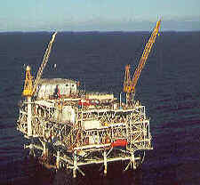
The Environmental Studies, South Texas OCS (STOCS) Rig Monitoring (1977), the MAFLA Monitoring Studies (1977), and Ecological Investigations of Petroleum Platforms in the Central Gulf of Mexico (1981) are reports of early effects monitoring around selected platforms in the respective regions. The first two were relatively minor efforts embedded into much larger regional programs. They depended largely on the measurement of habitat contamination, body burdens, and community descriptors.

Impact Assessment of Exploratory Wells Offshore South Florida (1990) was an investigation of the physical and community effects (decades after drilling and platform removals) on the shallow west Florida shelf. The primary approach was photogrametric.

The GOOMEX Program or Gulf of Mexico Offshore Operations Monitoring Experiment was a very successful, two field-year study of the sublethal effects of routine platform operations. The title of the final report (1995) Phase I: Sublethal Responses to Contaminant Exposure is somewhat misleading, in that a “Phase II” was deemed unnecessary and never pursued. Some details of this program are worthy of mention. The program was truly multifaceted, and all “facets” were carefully selected and designed to detect sublethal responses to chronic, low-level exposures to various contaminants at three sites having histories of long-term oil and gas exploration and development. Approaches were two-fold: (1) to analyze benthic sediments in conventional radial patterns to determine the contaminant field, assessing the community structures of meio- and macrofauna and aspects of their life histories and genetic diversity; and (2) to provide for near-field (impacted) and far-field (unimpacted) pairwise comparisons of a wide variety of suspected indicators of exposure; e.g., histological, contaminant burdens, detoxification responses, and bioassays. An offshoot of the GOOMEX program was the study How Does Produced Water Cause a Reduction in the Genetic Diversity of Harpacticoid Copepods? Tests for tolerance to heavy metals and PAH’s detected some differences in tolerance among genotypes of a benthic copepod.

The single deep-sea effects study to date was begun in the Gulf in 1999. Known as the Deepwater Program: Effects of Oil and Gas Exploration and Development at Selected Continental Slope Sites in the Gulf of Mexico, this study examines the fates and effects of deepwater discharges which may be much different from those on the continental shelf. New technological approaches to drilling and production may result in volumes and characteristics of discharged material quite different from those approaches used for decades in shallower water. A three-phased approach to understanding such issues involves modeling the fate of chemical discharges, establishing reliable indicators of impacts, and undertaking field studies.

6.5. Oil Spill Effects Program
These studies are efforts to assess ecological effects after exposure to spilled oil:

Ixtoc Oil Spill Assessment (1981) was a general study of the remaining biological and chemical effects of the 1979 Mexican oil spill on the Texas shelf. The results failed to clearly demonstrate benthic cause and effects on the Texas continental shelf.

Long-Term Assessment of the Oil Spill at Las Minas Panama (1993) was a large study of the biological and chemical effects of a tank farm spill in a Panama embayment. Mangroves, seagrasses, and coral reefs were special targets of the work, and the results were applied to the Gulf of Mexico with certain limitations.

6.6. Effects Modeling Program
Variously, these efforts involved the testing of animals in laboratory conditions, calculations of zones of contaminant effects, and measurements of lethal or sublethal biological effects.

A Numerical Mud Discharge Plume Model for Offshore Drilling Operations (1985) was not a biological study per se, but it did estimate the equivalent of the expected maximum range of biological effects. The Dispersed Oil Toxicity Tests with Species Indigenous to the Gulf of Mexico (1994) was a laboratory study using various concentrations of crude oil and dispersants.
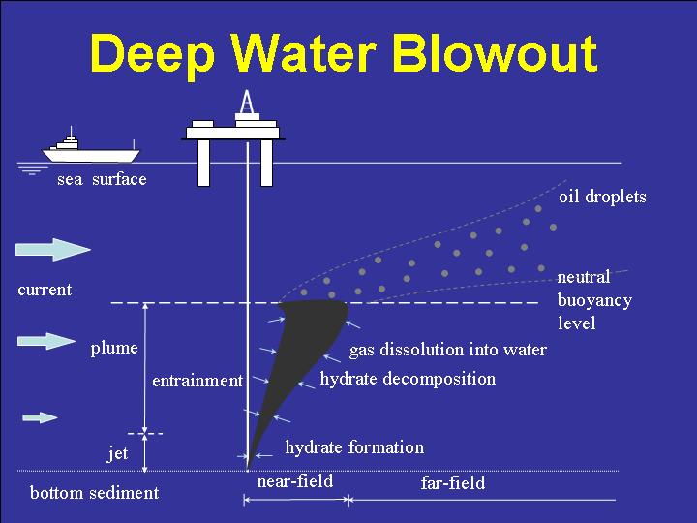

7. Miscellaneous Biological Studies and Relevant Documents

7.1. Miscellaneous Biological Studies
The studies described here are those that do not fall conveniently under any of the above categories (e.g., “Marine Ecosystems” or” Living Marine Resources”).

Historically, the study, Environmental and Socioeconomic Baseline on the Gulf of Mexico Coastal Zone and Outer Continental Shelf (1975) was one of the very first attempts at organizing existing Gulf-wide information into a synthesis. As the title suggests, this multihabitat, multidisciplinary, whole-Gulf data gathering effort was to be an initial source document for the Region. Now well-dated, the title suggests a “shotgun approach” with little early focus, but it was useful to the Government for early NEPA documents and future studies planning.

A Review and Annotated Bibliography of Benthic Studies in the Coastal Areas of Florida, with a Selected Compilation of Worldwide Benthic Methodological References and Southeastern U.S. Benthic Taxonomic References was received in 1984. This report was a mid-program review of the subject, concurrent with, but separate from, the Southwest Florida Ecosystems Program, a field effort. This procurement revealed the perceived importance of the benthic environment as a focus for MMS programs, as opposed to midwater processes and biota which are more difficult to accomplish logistically and are of lesser management use.

Some surface productivity synthesis (as opposed to field) studies were pursued and completed in 1990 and 1991: A Comparison of Marine Productivity Among Outer Continental Shelf Planning Areas (1990) and A Comparison of Marine Productivity Among Outer Continental Shelf Planning Areas; Feasibility Analysis of Secondary Measures (1991). These synthesized and compared plankton productivity values for the Gulf of Mexico and all other planning areas.

Assessment of Hurricane Damage in the Florida Big Bend Seagrass Beds (1987) was an opportunistic study to determine the extent of damage that had been inflicted by a hurricane and the natural rates of regeneration in the absence of any development.

7.2. Gulf of Mexico Region Coastal Marine Institute Program
The current CMI in the Gulf of Mexico Region was established in 1992 as a cooperative agreement between Louisiana State University and the MMS. The basic intent of the CMI is to direct the considerable research talents of a major research university towards Federal and State information needs in a State where OCS oil and gas development is a major factor. Funding for all projects undertaken has been equally divided between MMS and Louisiana resources. Dozens of projects, some biological, have been funded, employing the talents of faculty researchers, postdoctoral associates, Ph.D. and masters candidates, and undergraduate workers.

The studies tend toward the academic side, and sometimes produce rather unclassifiable miscellaneous works on methodologies, often-overlooked taxa, and critiques of past efforts using existing data. The several innovative efforts described below reflect the range of researcher interests.
Development and Characterization of Sea Anemones as Bioindicators of Offshore Resource Exploitation and Environmental Impact (1999) was designed to assess the value of common anemones from California, west Florida, and Louisiana to verify the existence of a cytochrome P450 system and other biochemical indicator responses to several contaminants including cadmium and organic toxins. This marks the interest in the measurement of sublethal responses to exposure, as did the GOOMEX program (see Section 6) and the following CMI study.

Development and Application of a Sublethal Toxicity Test to PAH Using Marine Harpacticoid Copepods (1999) tested the sensitivity of two meiofaunal species exposed to various PAH’s. It examined several reproduction, development, and feeding indicators in controlled experimental conditions. The study was a great departure from EPA-type lethal concentration or lethal dose approaches, which use relatively large animals having much longer life history cycles.

Other meiofauna, the foraminiferal protozoans are the subject of the ongoing study, Foraminiferal Communities of Bathyal and Abyssal Hydrocarbon Seeps, Northern Gulf of Mexico: A Taxonomic, Ecologic, and Geologic Study. This is a CMI investigation of community structure and tolerance of unusual or extreme conditions, primarily deep Gulf hydrocarbon and sulfide seeps. This further extends the use and value of unexamined cores taken with submersibles during the chemosynthetic community studies, CHEMO I and II (see Section 3.2.3).

The Taxonomic Guide to the Polychaetes of the Northern Gulf of Mexico was a 1984 report based on early BLM/MMS collections. The benthic macrofaunal polychaetes comprise one of the most numerous, diverse, and ecologically important groups with which systematists must contend. Upon the completion of early, large ecosystem studies, notably the MAFLA and STOCS programs, there remained questions of taxonomic consistency among workers and studies programs. This remarkable, seven-volume report was written to review and standardize the systematics of the many collections of polychaete taxa from across the Gulf up to that time. The polychaetes are also the subject of an ongoing CMI computerized effort on taxonomic error.

The CMI study Potential for Accelerated Bioremediation and Restoration of Oil-Impacted Marshes through the Selection of Superior Oil-Tolerant Vegetation (2000) was a new approach for the Gulf of Mexico (although preliminary restoration plantings have been done before). Some brackish and salt marsh (Spartina spp.) genotypes proved relatively resistant when tested for growth, leaf damage, productivity and oil degradation potential after experimental oiling in the laboratory.

The report, Spatial and Temporal Variability of Plankton Stocks on the Basis of Acoustic Backscatter Intensity and Direct Measurements in the Northeastern Gulf of Mexico (2001) investigated the utility of Acoustic Doppler Current Profilers (ADCP’s) to estimate the relative abundance and spatial and temporal variability of zooplankton stocks in the Northeastern Gulf of Mexico using backscatter intensity. Designed originally to determine current velocities and ship speed, the ADCP has been used successfully in investigating vertical migrations as well as tracking masses of advected plankton. This physical and biological oceanographic study was an integral part of the 2 year DeSoto Canyon Eddy Intrusion Study, which investigated the complexities of the regional currents in an area proposed for oil and gas development.

Management Applicability of Contemporary Deep-Sea Ecology and Reevaluation of Gulf of Mexico Studies is a 2001 CMI report reviewing and reevaluating the utility of past MMS studies for Agency decisionmaking. Two general studies from the 1970’s and 1980’s required conventional deep-sea sampling (the results of which is technique-sensitive), and two on chemosynthetic communities (CHEMO I and II) have concentrated primarily on “shallower” sites accessible to available manned submersibles (see Section 3.2.3).

7.3. Other Documents
There are three types of programmatic information documents that provide public information on studies program planning and the results of ongoing and completed research projects. These are the Gulf of Mexico Regional Studies Plans, the proceedings of the annual Information Transfer Meetings, and the proceedings of occasional topical workshops. The latter are mentioned also within the bodies of topical information given above (Sections 2 through 6).

7.3.1. Regional Studies Plans and Studies Development Plans
Regional Studies Plans were prepared by BLM and MMS to document and describe the studies planned by the ESP for the following fiscal year. In recent years, MMS has prepared a Studies Development Plan to describe studies that will address information needs during the following two fiscal years. The Regional Studies Development Plan ultimately becomes a part of the annual National Studies Plan. These have always been internal planning documents and are not published for general public consumption. However they are public documents and, as such, may be made available to those interested in the progress of the ESP. Begun in 1978 by the BLM, these documents are the records of the codified process that plans the course of the ESP. The study plans have little lasting scientific value once implemented, but they offer an insight into a process that produces scientific information for management of the offshore petroleum industry. These have recently been made available on the MMS web site for those interested. Periodically updated ongoing studies information is also available on the web.

7.3.2. Information Transfer Meeting Proceedings
The Information Transfer Meetings (ITM) are held annually to document the progress and findings of funded studies of all types (including biological ones) and provide a forum for the discussion of many other issues important to the MMS. These meetings were begun by the BLM Gulf of Mexico Regional OCS Office in 1980 as a modest midstream review of ongoing research programs, and were continued by the MMS. The ITM has since grown into a major annual meeting with several concurrent sessions. The ITM Proceedings always have some topics of interest to biologists and the information therein is at least marginally available in abstract form prior to publication of final reports.

7.3.3. Workshops and Symposia
One of the most useful processes the MMS uses in future studies planning are workshops convened in various areas of social and natural sciences. The workshops provide independent outside guidance for (and often, affirmation of) the MMS regional planning efforts, and the proceedings stand as public records against which future performance of the ESP can be measured. These have been successful in delineating the state of knowledge and identifying data gaps. Invited participants typically recommend and describe needed studies (whether or not the MMS is the appropriate agency to support the work). They also discuss appropriate objectives, methods, approaches, and timing. Workshops are scheduled according to perceived gravity, adequacy of knowledge of the subject, and anticipated funding.

The biological topic engendering the most frequent workshops has been protected species of the Gulf. A 1982 Proceedings of a Workshop on Cetaceans and Sea Turtles in the Gulf of Mexico: Study Planning for Outer Continental Shelf Development (1983) gave MMS guidance for a continuing protected species program. The proceedings of this workshop resulted in several productive studies (see Section 5.1, Protected Species). The MMS revisited the subject in a second meeting producing the report, Sea Turtles and Marine Mammals of the Gulf of Mexico: Proceedings of a Workshop, 1989 (1990). The Gulf of Mexico Marine Protected Species Workshop (2001) was held in 1999 to guide that work into the new millennium.

Three predominantly deep-sea workshops have been convened. The first, the 1989 Northern Gulf of Mexico Environmental Planning Workshop (1990) followed the first synoptic Northern Gulf of Mexico Continental Slope Study that was completed in1986. The second was the 1997 Workshop on Environmental Issues Surrounding Deepwater Oil and Gas Development (1997). This workshop was convened largely as a result of accelerated interest in deepwater leases in the 1990’s, new scientific revelations in the deep Gulf, and new offshore technologies. A separate session on deep-sea ecology directly resulted in the Northern Gulf of Mexico Continental Slope Habitats and Benthic Ecology Study initiated in 1999, the first major study with a joint U.S.-Mexico sampling effort called Joint Sampling of the Sigsbee Deep (JSSD). The third workshop Workshop on Deepwater Environmental Studies Strategy: A Five-Year Follow-Up and Planning for the Future (2003) was held in 2002 and reviewed the status of the deepwater program. Many important studies were still underway, and it was suggested that topic specific workshops be held after the completion of these studies.

A Symposium Proceedings: Gulf of Mexico and Caribbean Oil Spills in Coastal Ecosystems: Assessing Effects, Natural Recovery, and Progress in Remediation Research, 1994 (1995) focused on the ecological effects of oil spills in mangroves, coastal marshes and seagrass ecosystems, and possible remediation techniques. It is widely believed that these tropical/subtropical resources are the most vulnerable and/or sensitive compared to deeper water ecosystems, especially considering their importance as habitat for associated animal populations.
The Proceedings: An International Workshop on Offshore Lease Abandonment and Platform Disposal: Technology, Regulation, and Environmental Effects (1997) was devoted predominantly to oil and gas operations with a small section on biological pressure wave effects.

The Physical/Biological Oceanographic Integration Workshop for the DeSoto Canyon and Adjacent Shelf (2000) provided the MMS with an area-specific synthesis of physical, geological, chemical and biological understanding of a scientifically complex region in the politically sensitive Eastern Gulf of Mexico Planning Area. The conclusions have not yet produced a definitive field study, as the region in question may remain subject to a continuing drilling moratorium.

APPENDIX
The Environmental Studies Program (ESP)
AN OVERVIEW

A.1 Early History and Development of the ESP
The first open-water oil and gas drilling operations in the United States were conducted in Louisiana State waters in 1938. In 1945, President Truman signed executive papers declaring that the natural resources of submerged lands on the Outer Continental Shelf (OCS) were owned by the Nation, and that these resources would fall under the jurisdiction of the U.S. Department of the Interior (DOI). By 1947, the first oil and gas operation was installed in Federal waters out of the sight of land (in 18 feet of water, Ship Shoal Block 32). The U.S. Outer Continental Shelf Oil and Gas Program was initiated in 1953 with the passage of the Outer Continental Shelf Lands Act (OCSLA), which established Federal jurisdiction over submerged lands on the OCS. A key consideration of the Act is balancing orderly energy resource development with protection of the human, marine, and coastal environments. The OCSLA designated the Bureau of Land Management (BLM) as the DOI administrative agency for leasing and the U.S. Geological Survey (USGS) for supervising offshore activities. Section 20 of the OCSLA requires the Secretary of the Interior to “conduct a study of any area or region included in any oil and gas lease sale in order to establish information needed for assessment and management of environmental impacts on the human, marine, and coastal environments . . . .”

The legal definition of the OCS, for purposes of offshore leasing, exploration, and development, is the submerged land seaward of acreage under the respective States' jurisdictions. The Gulf of Mexico OCS begins at the Federal-State boundaries (3 miles from land off Louisiana, Mississippi, and Alabama, and 3 marine leagues—about 10 miles—off Texas and the western coast of Florida, according to the arrangements under which the respective States entered the union). The “OCS” actually extends into abyssal depths greater than 3,000 m. The Gulf of Mexico OCS occupies about 2.2 million statute square miles or 5.7 million square kilometers of ocean bottom out to the limits of the U.S. Exclusive Economic Zone. The submerged Federal lands in the Gulf of Mexico are further divided into four leasing planning areas (Western, Central, Eastern, and Straits-of-Florida) and numerous named “protraction” areas (e.g., Ship Shoal and Green Canyon), and then into thousands of numbered “lease blocks” which are nominally 3 statute miles on a side. The latter are the geographic references for all leasing and future financial, operational, and management activities.

In 1954, following the passage of the OCSLA, the BLM opened its New Orleans OCS Regional Office, and the USGS’s Conservation Division concurrently established its Gulf Coast Regional Office. Since 1954, Gulf of Mexico OCS lease sales have been conducted annually except for 1956-1958. The BLM was primarily responsible for prelease activities, notably leasing and environmental activities (impact statements and environmental studies). The USGS governed postlease activities such as inspections, permitting of operations, resource evaluation and a myriad of other functions.

The National Environmental Policy Act of 1969 (NEPA) has as its primary objective, "to declare a national policy which will encourage productive and enjoyable harmony between man and his environment; [and] to promote efforts which will prevent or eliminate damage to the environment . . . ." The Act requires that Federal Agencies prepare environmental impact statements for all of their actions having potential for significant environmental impact; it also established the Council on Environmental Quality.

In 1973, following the passage of NEPA, BLM established the Environmental Studies Program (ESP) to support the collection and analysis of information needed for the OCS leasing program. The main objectives of the ESP have been (1) to provide relevant environmental information to decisionmakers in the Service's OCS minerals management program and (2) to obtain environmental data on the direct and indirect impacts of petroleum exploration and production activities. From 1973 through 2001, studies funding in the Gulf Region has totaled roughly $180 million, about one-fourth of the $713 million expended nationwide. Of the Gulf’s $180 million, over 50 percent has been expended on biological studies, a relatively higher percentage than that spent on biology nationwide (~40%). Some biological studies have been directed toward the description of regional resources, studying manageable geographic units, usually of a relatively homogeneous habitat type. Other studies are specifically directed at the understanding of particular habitats, ecotypes, or species groups. All are intended to provide data useful for the management of OCS activities.

In 1982, under the Secretary of the Interior, James Watt, the BLM and the USGS were reorganized into the new Minerals Management Service (MMS), bringing pre- and postlease offshore activities under the same roof, a recommendation of the Administration’s “Linowes Commission.” Under the DOI, the MMS is now responsible for the regulation and permitting of most offshore oil and gas activities, the collection of leasing and royalty monies due to the Federal Government, and certain other functions on the OCS.

A.2. Regional Responsibilities and Organization
The entire OCS has been managed through four original regional BLM/MMS OCS Offices; Alaska (Anchorage), Pacific (Los Angeles, later Camarillo, CA), Atlantic (New York, NY; later Vienna and Herndon, VA), and the Gulf of Mexico (New Orleans, LA). All Regional Offices reported to the Headquarters Office (Washington, DC and Herndon, VA). At first the New Orleans Office had responsibility for both the Gulf and the southern U.S. Atlantic Planning Area (from Mexico up to Cape Hatteras, NC). The Atlantic Office later acquired responsibility for the entire east coast. Upon that office’s devolution in the 1990’s, the Gulf of Mexico [“- and Atlantic”] Office in New Orleans was assigned the responsibility for all Gulf and Atlantic Planning Areas. The descriptions of marine biological studies programs in this document are restricted regionally to the Gulf of Mexico and almost exclusively to the U.S. Exclusive Economic Zone.

A.3. Studies Planning and Selection
The MMS is mandated to manage the offshore using acquired, rather than internally-generated, data. That is, the MMS has no research arm per se. Within the funding limits of the ESP, the MMS attempts to gather descriptive, experimental, monitoring, or synthesized information to attain an understanding of the natural and socioeconomic environment that it is mandated to preserve. Procurement regulations and policy promote a culture of open, competitive procurement, especially for large programs (e.g., greater than $500,000). These studies are usually conducted by consulting firms and universities; not infrequently in cooperation with each other.

Through a formal nomination process, studies are scheduled for procurement based on available funding and perceived importance to MMS. Needed studies are proposed to MMS, through internal and external nominations. These are sorted and prioritized through MMS management, both regionally and through Headquarters, according to immediacy of scientific need, application to MMS information and operational issues, estimated cost, available funding, and practicality. Public and internal documents are prepared (e.g., Strategic Studies Plans and the Regional and National Studies Development Plans). These are reviewed annually, and a proposed study may be assigned to personnel for development and procurement, deferred, or even cancelled.

The competitive studies selection process is the norm for the MMS, and it is generally prescribed by Agency policy. There are exceptions, however. One notable (but very rare) exception is that a sole source exists, or one that has competitive advantage by virtue of patented or proprietary supplies or services.

Other exceptions to the competitive selection process have been the cooperative investigations conducted by States’ agencies and (more often) other Federal Agencies including the research arms of the U.S. Fish and Wildlife Service (FWS), bureaus of the National Oceanic and Atmospheric Administration (notably the National Marine Fisheries Service [NMFS]), and the USGS. These studies are supported by Memorandums of Understanding (MOU’s) or Interagency Agreements (IA’s) and benefit, and fall under the respective mandates of, these Agencies.

The MMS biological programs most obviously procured by research agencies have been the protected species and coastal studies MOU’s and/or IA's to the FWS, USGS, and NMFS. These Agencies have parallel interests in sea turtles, cetaceans, and manatees in all U.S. waters, and the jointly funded studies have fiscal benefits (two justifications for MOU’s and IA’s).

Various State agencies (mostly of Texas and Florida) have prepared a number of information research documents under cooperative agreements. Another notable exception to the competitive selection process has been the 1992 establishment of the Louisiana State University, Coastal Marine Institute, a State-Federal matched cooperative agreement through which nominated studies are selected.

A.4. Studies Procurement, Conduct, Completion, and Dissemination
Legal and policy decisions determine the mode of studies procurement, whether through full and open competition or not. The procurement mode is determined by the MMS Procurement Operations Branch (Headquarters) with input from the ESP. Studies are procured by a studies procurement team. An MMS regional staffer with expertise in the subject area is assigned to assess regional MMS information needs, the status and availability of information, the needs of outside State and Federal Agencies, and the specific applications of the resulting information by his/her customers—the analysts, planners and managers. The staffer who writes the technical aspects for a Request for Proposal (RFP), typically becomes the Contracting Officer’s Technical Representative (COTR) after award. A Headquarters Contracting Officer (CO) is assigned to complete legal and instructional parts of the RFP, announce it publicly, receive and distribute proposals, and preside over all aspects and stages of the procurement, including the technical and financial reviews of proposals, selection of contractor, and award of contract. The CO and COTR respectively monitor the progress of the contracted effort from the legal and scientific angles, including the mid-program recommendations of contract modifications, inspections for program conformance to the RFP and proposal content and schedule, and review and approval of expenditures.

Upon the completion of the final reports and other products, the CO formally accepts the work and closes the contract. The MMS announces the availability of the products and distributes them internally as needed, and externally through purchase from MMS Regional Public Information Offices. The MMS web site lists all reports conducted from 1992 to present, with a collection of “Technical Summaries” written as required under contract. Many reports are available also through interlibrary loan. All MMS studies reports, maps, CD’s, and other products are public property.

A number of planning documents (e.g. the Regional Studies Plan) can be found on the MMS web site, including periodically updated accounts of ongoing research projects.

