Tip Fences for Reduction of Lift-Generated Airframe Noise

These simple, easily retrofitted devices reduce drag as well as noise.

Ames Research Center, Moffett Field, California
Tip fences have been invented to reduce the noise generated in the airflows about the high-lift systems (the flaps and slats) of airplane wings. Tip fences also afford an important secondary benefit by increasing lift-to-drag ratios.
Typical modes of operation of the flaps and slats of an airplane wing are the following: In preparation for takeoff, the flaps are partly extended, and the slats are fully extended to provide a clean airflow over the main element of the wing. Shortly after takeoff, the slats are retracted to increase the lift-to-drag ratio during climbout. During landing, the slats and flaps are fully extended, and significant aerodynamic noise is generated at their tips. Tip fences can reduce the noise generated during takeoff and climbout, but more importantly during approach and landing.
Tip fences are so named because they are fencelike barriers and are mounted at or near some or all of the inboard and outboard tips of the flaps and slats (see Figure 1). These mounting locations are chosen because they are as close as possible to the aerodynamic-surface discontinuities where
Figure 1. Tip Fences can readily be added to flaps and slats to reduce noise and drag.
vortices associated with noise form when flaps and slats are extended. Tip fences can be made of any suitable rigid material (e.g., metal or composites) and can be attached to the tips of flaps and slats by riveting, welding, bolting, or other conventional means. They can be easily and inexpensively retrofitted to most pre-existing airplanes, with minimal design changes.
A tip fence can be formed from a flat plate, or, if desired, it can be fabricated as a more complex, aerodynamically contoured body. In a typical application, the tip fences would extend below the lower surface of a slat or flap, as depicted on the right side of Figure 1. However, other combinations of tip and fence configurations are also possible.
In a demonstration of the benefits of tip fences, two different versions of a wing with flap extended were tested in a wind tunnel and in flight on a Lanceair IV airplane. In one version, the flap was equipped with tip fences; in the other version, it was not. The flight data is shown in Figure 2, demonstrating that the tip fences caused less noise to be generated over a broad range of frequencies. The wind-tunnel data showed that tip fences can also reduce the profile or viscous drag significantly.
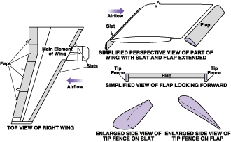
Figure 1. Tip Fences can readily be added to plaps and slats to reduce noise and drag.

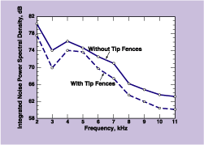
Figure 2. Less Noise Was Generated by the airflow over a wing equipped with flap tip fences than by the airflow over same wing without flap tip fences under otherwise identical test conditions.
This work was done by James C. Ross and Bruce L. Storms of Ames Research Center. For further information, access the Technical Support Package (TSP) free on-line at www.nasatech.com/tsp under the Mechanics category.
This invention has been patented by NASA (U.S. Patent No. 5,738,298). Inquiries concerning nonexclusive or exclusive license for its commercial development should be addressed to the Patent Counsel, Ames Research Center, (650) 604-5104. Refer to ARC-14009.
Tech Briefs article published February 2002.

